A Survey on IoT-Based Real-Time Crop Development Applications

Dr.A.V. Bharadwaja
Department of ECE,
Vignan's Institute Of Information Technology(A),
Visakhapatnam, India
bharadwaja.akondi@gmail.com

Koli Rupika Angel Department of ECE,
Vignan’s Institute of Information Technology(A), Visakhapatnam,India
Rupikaangel896@gmail.com
Matta Sai Venkat Poojith
Department of ECE,
Vignan's Institute Of Information Technology(A),
Visakhapatnam, India msvpoojeth10@gmail.com

Kaparapu Chandana
Department of ECE,
Vignan’s Institute of Information Technology(A),
Visakhapatnam,India
Chandanakaparapu@gmaail.com
Jasmine Suhana
Department of ECE,
Vignan's Institute Of Information Technology(A),
Visakhapatnam, India jasminesuhana444@gmail.com

Abstract: Agriculture has certain severe challenges such as inefficient irrigation, late identification of diseases, and inability to monitor the field in real time. To address such issues, there is a unified smart agriculture system that will be proposed in this work through the integration of IoT and ML and DL models. The use of soil moisture, temperature and humidity sensors has facilitated automated irrigation which is capable of sensing the real time conditions in the environment and then turning irrigation on/off to ensure water is used wisely. The combined method of image processing and deep learning algorithms like CNN, ResNet, and YOLO have been utilized in detection of different kinds of diseases in crops as blight, fungal infection, and nutrient deficiencies. The information obtained in the fields with the help of a Raspberry Pi or ESP architecture will trigger irrigation, identify plant diseases, and monitor remotely with the assistance of cloud-hosted platforms, including ThingSpeak, Google Drive, and Blynk. Field security is also supplemented by intrusion detection and automatic alert. A unified IoT-ML system enhances irrigation effectiveness, makes diseases recognition over 90 percent, and provides automated scalable service of contemporary precision farming.

Keywords–: IoT, Smart Irrigation, Plant Disease Detection, Deep Learning.

Introduction
Agriculture has been one of the most significant pillars to the economic development, source of livelihood to most of the population of the developing countries and it also accounts a large portion of the national GDP. Nevertheless, agriculture has remained to be a major challenge due to augmented water scarcity, unpredictable fluctuations in climate change, and devastating epidemics that are a threat to crop harvests and food security. Even the traditional practices of farming are too dependent upon the manual monitoring of the soil conditions and the visual inspection of the crops that are time-consuming and are highly likely to exhibit the human error and are generally inefficient in the early detection of the diseases. Farmers are, therefore, often faced with problems such as excess irrigation or under irrigation, late disease detection, and unnecessary crop losses.
Modern agriculture has already begun to solve these issues by adopting intelligent technologies incorporating IoT, automation, and artificial intelligence. The Internet of Things (IoT) uses sensors that measure temperatures, humidity levels, soil moisture min, and light intensity to monitor the environmental conditions of an area. These sensors continually report their findings back to a microcontroller, such as a Raspberry Pi, ESP32, or NodeMCU. The microcontroller then analyzes this information to determine if irrigation is necessary. For example, if the microcontroller finds that the soil moisture level has dropped below its preset threshold, it would activate the water pump to deliver water to the crops. By only activating the water pump when it’s necessary based on the soil moisture level, the smart irrigation system reduces water waste by ensuring that water is applied only where it's needed, helping to promote sustainable farming practices.

Besides this, there is great accomplishment regarding plant disease detection with the help of ML and DL. CNN based models, ResNet variants, and YOLO architectures have achieved high accuracy with respect to plant disease detection from leaf images caused by blight, bacterial infections, fungal spots, and mosaic patterns. Such models are able to detect subtle symptoms that normally get missed by a human naked eye in cases of manual inspection, hence allowing for early diagnosis and timely treatment. Detection accuracy exceeding 90% is reported in several studies on this topic; it hence shows promise for image-based AI systems over their traditional counterparts. It enables intelligent farming with a set of cloud platforms such as Blynk, ThingSpeak, Google Drive, and Dropbox that allow remote access to sensor data, irrigation logs, and outputs from disease detection. On mobile devices, farmers are able to monitor in real time the status of their fields, notifications of alerts, and see images of areas infected with diseases from any part of the world. A few of the systems incorporate an intrusion mechanism that detects, using cameras and machine learning models, animals or unauthorized movements within farms and initiates alarms or notifications with the intent of protecting crops against possible external threats. Despite the great number of new developments that have been brought to this field, the vast majority of current systems are inclined to work with either smart irrigation alone or the detection of diseases alone instead of considering both issues simultaneously.

Modern agriculture calls for an integrated end-to-end solution capable of managing irrigation, continuous crop health monitoring, forecast disease outbreaks, and providing real-time alerts. The base papers bring into focus such unified frameworks collectively that integrate IoT hardware with machine learning algorithms and smart sensing with cloud connectivity for a complete environment in precision agriculture. These challenges and research gaps form, therefore, the motivation for this study in developing a robust IoT-based smart agriculture system with automated irrigation, deep learning-based plant disease detection, and real-time environmental monitoring. Facilitated by sensor technologies and image analysis made available through AI that allows viewing on-site data, the proposed system also increases the efficiency of the resources, minimizes manual interference, and consequently, leads to sustainable agriculture. The integrated technology assists farmers to make sound and informed decisions that eventually enhance crop productivity and generate agricultural resilience within the long term.

Literature Survey
The tendencies of IIoT are commonly applied to smart farming to enhance the quality of agriculture and make remote decisions [1]. The industry that supports the economy of our country is farming, yet it is not that productive as per the global standards because of the inefficient traditions of farming and absence of real-time tracking [2]. The rural people move to the urban cities in search of other employment opportunities and they are unable to engage in farming activities on a full-time basis which further decreases the production of the farms [3]. The agricultural practices used in previous years were highly dependent on manual inspection that is expensive and time consuming and small farms are unable to constantly check weather conditions including temperature, humidity and soil moisture manually [4]. These deficits are part of severe socio-economic issues in agricultural societies such as low harvests and financial strain amongst farmers [5].
Numerous existing irrigation methods are based on such simple threshold-based design that pumps are turned on/off when moisture exceeds a given threshold; these low-end methods save water but fail to apply the crop health and security holistically [6]. Advanced works suggest fuzzy logic based or ML-based irrigation to forecast the best watering patterns and minimize energy consumption, however, they tend to consider only the irrigation and overlook disease or intrusion detection [7]. According to field studies, intelligent irrigation can lead to a great reduction in the use of water when it is implemented together with appropriate sensor calibration and routing approaches to WSNs, yet the difficulty lies with widespread, cheap implementation of same [8].
Image-based deep learning models (CNNs) are used to detect crop diseases more often. Testing on laboratory datasets has indicated a very high degree of accuracy, although in the field, due to changing illumination, obscuration and bugs damaging the products, there is a decline in performance unless the models are modified and trained on field photographs [9]. Authors suggest that to run on edge devices (Raspberry Pi), lightweight backbones (MobileNet, pruned/quantized models) and intensive data augmentation are needed to ensure robustness in the real world [10].Thus, image-based disease detection promises early intervention but requires careful dataset collection and on-device optimization for practical use
Animal intrusion is a major cause of crop loss in many regions. Conventional countermeasures include electric fencing, which can harm animals and is costly to install and maintain[11]. Sensor-based perimeter systems (PIR/laser/ultrasonic) reduce cost but have high false positives from vegetation and weather; camera+ML approaches (YOLO/Tiny-YOLO) can classify species and enable targeted deterrents (sound, lights), but require reliable daytime imaging or added thermal sensing for night operation [12]. Combining detection with immediate deterrence (audio alerts) and cloud notifications offers farmers timely response without lethal methods.
Very few works integrate all three functions—automated irrigation, CNN disease identification, and animal intrusion alert—on a single, low-cost edge node. Most published systems address one or two problems and rely on multiple microcontrollers or cloud inference, which increases latency and cost [13]. A unified Raspberry Pi platform that handles sensor acquisition, edge CNN inference, relay control for pumps, local deterrence (speaker), and cloud logging (ThingSpeak) fills this integration gap and is well suited for small and medium farms [14].
As per deployment, the main implementation lessons in the literature include: (a) drift prevention through the use of capacitive or well-calibrated moisture probes (b) lightweight/quantized CNNs or hybrid edge/cloud inference to fit into the capabilities of Raspberry Pi (c) hysteresis to prevent relay chattering on pump control and (d) remote monitoring and audit through the logging of data to cloud platforms (ThingSpeak/Firebase). Field tests and reproducible data are important and significantly enhance the value of publication and adoption by practitioners [15].

Objective
The primary goal of the proposed IoT-based agricultural system is to design a smart, automated, and dependable system that enhances crop management by real-time monitoring and smart decision-making [1]. Conventional agricultural systems are usually deficient of consistency in irrigation, early detection of the plant ailments and constant destruction of crops by animal intrusion, which direly decimate yield and more so, driving farmers into financial losses [2]. The idea of a combination of the IoT tendencies with machine learning and automation is to develop a single platform that would automatically measure soil moisture, temperature, and humidity, turn on the irrigation process when needed, detect early disease symptoms on crop leaves with the help of the CNN model, and send all the farm data to the cloud so that it could be constantly monitored [3]. This will guarantee prompt response, less manual work done and also allow farmers to make the right decisions without necessarily being in the field [4].
The other goal is to protect farmlands against attacks of animals using intelligent image-based detection and instant alert tools [5]. Existing systems such as electric fencing may prevent intrusion but often harm animals and require high maintenance [6]. Hence, the intention of this project is to detect animals safely using a camera, trigger a speaker alarm, and send an email notification to the farmer so that crop loss is minimized without causing harm to wildlife [7].

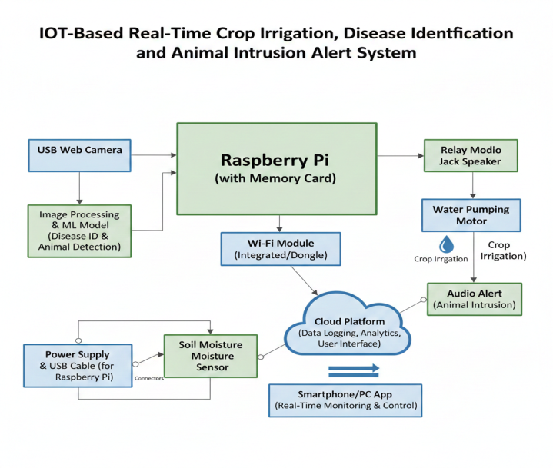
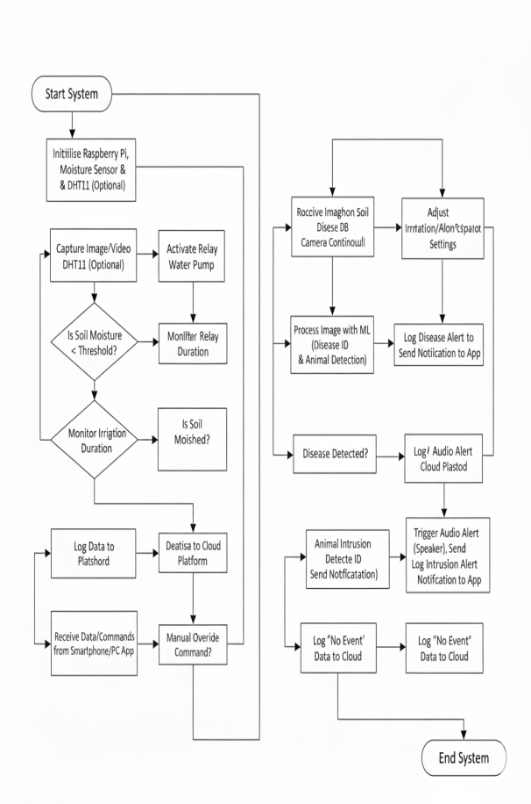
Fig.1.Hardware block diagram

By combining irrigation automation, disease detection, and intrusion prevention into a single Raspberry Pi-based system, the proposed work aims to provide a complete and cost-effective agricultural protection solution that increases yield, promotes sustainability, and supports farmers with real-time, data-driven control over their farmland [8].

Flowchart

As soon as the Raspberry Pi (ARM Cortex-A based board) is powered ON, the system initializes the Soil Moisture Sensor, DHT11 Temperature–Humidity Sensor, USB Web Camera and the SD card operating system. After initialization, the Raspberry Pi continuously monitors soil moisture, temperature and humidity while capturing images or video frames from the farmland for disease and animal detection. Once the moisture in the soil has reached a level that is considered to be less than acceptable, the Raspberry Pi will cause a relay module to activate, which will then cause the water pump motor to turn ON and begin irrigating as needed, without requiring human involvement.The moisture level will determine when the pump will stop running and switch off the relay, preventing the crops from receiving too much water. The Raspberry Pi receives frames from a USB camera that a convolutional neural networks model trained to identify plant diseases and detect intrusions in real-time has been trained on. If a plant disease is detected, an output will be created for the ThingSpeak Cloud, and the farmer will be sent an alert. If an animal is detected, the Raspberry Pi will send an immediate alert message to the farmer's device and activate an alarm sound through a 3.5mm speaker. If a disease/intrusion is not detected, a No Event will be recorded on the ThingSpeak Cloud. Sensor data for moisture levels, temperature, and humidity creating a report of events related to irrigation activity and detection incidents will continuously be uploaded to the cloud with the ability for manual overriders to input commands via a smartphone or computer application.

The Raspberry Pi has a power requirement of about 700 mA (3W), and can be powered either with a micro-USB charger or GPIO, as it does not have any internal storage; it is booted from an SD card. It has several indicator lights - ACT, PWR, FDX and LNK - to show when the device is active. Examples of devices that work on continuous regulated power from Raspberry Pi are Soil Moisture Sensors, DHT11 and USB camera, as they do not draw much power. A separate 12V water pump is powered by its own relay circuit to keep the electrical load off of the Raspberry Pi; the relationship between these two components is detailed further below. The DHT11 sensor measures the humidity and temperature of the environment in real-time, while the Soil Moisture Sensor indicates the moisture level so that irrigation can be implemented. The USB camera provides visual data which is processed through the CNN model to diagnose disease and identify animals. The operation is in a continuous feedback loop ensuring that the system can follow irrigation schedules, find and prevent disease symptoms, and catch time-sensitive animal strikes in order to provide a more comprehensive and intelligent solution to Smart Farming.

Raspberry Pi-Working

Raspberry Pi functions as the central controller of the entire system. It continuously receives data from the Soil Moisture Sensor and DHT11 sensor, analyzes camera images through the CNN model, and makes decisions such as turning ON/OFF the water pump or sending alerts. It also uploads all data such as moisture level, temperature, humidity, and detection results to the ThingSpeak cloud platform for remote monitoring. All system logic, automation, and machine learning processes run on the Raspberry Pi.
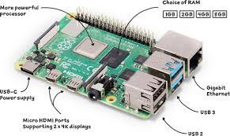
Fig.2 Raspberry Pi
Memory Card: The micro SD card contains the Raspberry Pi operating system, Python scripts, machine learning model files, and necessary libraries. When the Raspberry Pi boots up, it loads the OS and the project software from this card. Without the memory card, the Raspberry Pi cannot start or execute any program.

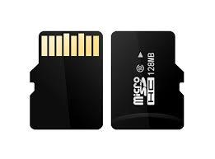
Fig.3 Memory Card

USB Port Camera: A webcam is an important piece of hardware when using software that requires capturing photographs or streaming video. For this project, a Logitech Webcam is connected to a Raspberry Pi which allows the user to take pictures and capture video through an easy-to-use device capable of doing both [30]. In this work will interface Logitech web camera with Raspberry Pi. This project utilizes a webcam for video conferencing which offers a resolution of 640×480 pixels, as well as the ability to capture video in the 1024×768 resolution when using Logitech Fluid Crystal™ Technology which significantly increases the quality of the captured image. An Light Dependent Resistor or LDR/CdS cell, is an optical sensor that provides a resistance level that decreases as light intensity increases. Therefore, the LDR is useful for measuring the amount of light that is being exposed to it. LDRs are also called photoconductive materials because the conductive properties of an LDR will change when it is exposed to light. Buzzers are electronic components (common in vehicles, domestic appliances, and heating apparatuses) that provide audible alerts/warnings as a part of the control methods for all of these items. The situation 19 frequently consists of numerous set of sensors as well as switches which associated to an element to control and regulates stipulation and which brooch was pushed otherwise a pre-set time has elapsed, and usually lightens a light on the suitable buttons or control board, and sounds a cautioning trendy the custom of a continuous 2 intermittent buzzing and beeping sound. Flash LED's: The blinking LED circuit is similar to the electronics form of the "HelloWorld"-program. It is a modest electronic circuit that gives you a visual sign if it works. The aim is to make a Light Emitting Diode (LED)blink This LED specification is of precise significance when a LED or LEDs are to be used for lighting requests. It's no longer as serious when the LED is used as an indicator - right here a catastrophic failure is of increased importance. The LED specification for its operational lifestyles is usually described in the following:L70%=Timeto70%oflightingandL50%=Timeto50% of lighting.
The necessities states that all through these occasions, the LED must no longer show off any fundamental shifts in chromaticity. The cause in the back of these figures is that 70% lumen up keep equates to a 30% discount in mild output. This is round to decide for the edge for noticing gradual markdowns in gentle output.

Power supply: A power supply is an electrical energy source for the whole system. Each circuit or configuration that provides one or multiple levels of electrical energy to each piece of equipment is considered a PSU. The design of the supply in this section contains three components: the transformer, the rectifier, and the voltage regulators. The voltage regulators are designed to deliver stable voltage outputs. Regulators 7805 and 7812 deliver +5V and +12V respectively. Each regulator is associated with a 1000 µF capacitor, as depicted in the circuit diagram. That capacitor will also help adjust or smoothen the rectified voltage output before it reaches subsequent voltage regulation levels. Also, after regulating the output voltages of +5V and +12V from these regulators, additional capacitors of 100 µF, 10 µF, 1 µF, and 0.1 µF can further reduce any residual ripple in both of those regulated outputs. The combination of smoothing capacitors (post-rectification), regulators with their associated filters and larger capacitor banks (1000µF), as well as smaller filter capacitors (100µF - 0.1µF), produce very clean and consistent output voltages from the power supply to ensure reliable operation of all components connected to it.

Working principle
The main controller used in this project is the Raspberry Pi (ARM Cortex-A based processor), to which all sensing and monitoring units such as the Soil Moisture Sensor, DHT11 Temperature–Humidity Sensor, and USB Web Camera are interfaced through the GPIO pins and USB port respectively [1]. As soon as the Raspberry Pi is powered ON, the operating system stored on the SD card boots up and initializes all peripherals. Once initialization is completed, the system immediately begins continuous monitoring of the agricultural field by reading real-time soil moisture, temperature, and humidity values while simultaneously capturing images from the camera for crop disease identification and animal intrusion detection [2].
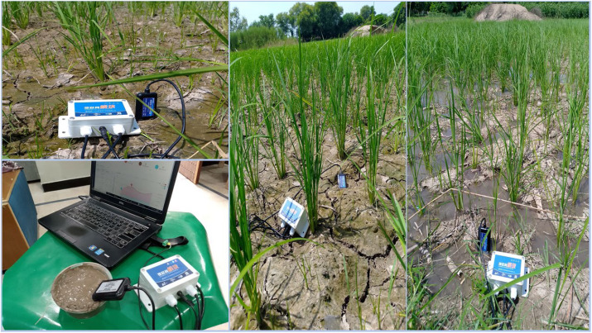
Fig.4 Soil Moisture Sensor
If the soil moisture sensor reports a value below the predefined threshold, the Raspberry Pi triggers the Relay Module, which automatically switches ON the 12V Water Pumping Motor to irrigate the crops without any human intervention [3]. Until the soil moisture has been returned to acceptable levels, the pump will continue operating. Once the soil moisture has reached the acceptable range, the relay will turn off the motor to conserve resources while maintaining the best possible irrigation performance [4].
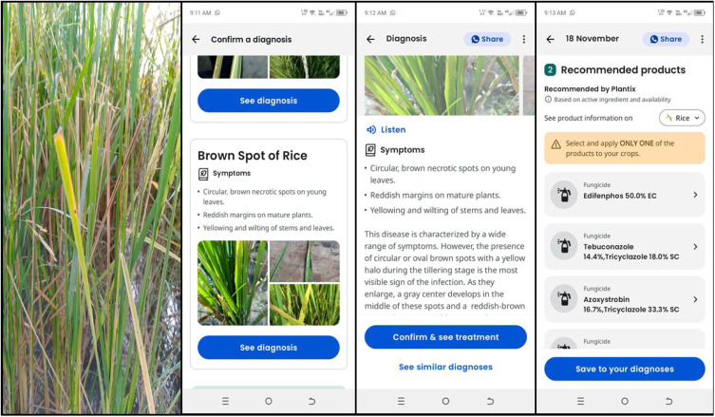
Fig.5 Crop Disease
The USB Web Camera takes continuous pictures of both the plants' leaves and their farmland surroundings throughout the irrigation cycle. The data captured from these pictures is processed by a trained Convolutional Neural Network (CNN) program running on a Raspberry Pi which can detect any signs of crop disease and identify possible animal intruders in real-time [5]. When a crop disease is identified through the processed image, the Raspberry Pi saves that identification locally for future use and uploads it to the ThingSpeak cloud for access by the farmer in addition to informing the farmer (via e-mail or app) of the state of that plant's health with

environmental data from the DHT11 sensor [6]. Whenever an animal intrusion is discovered, the system is engineered to also activate the audio alarm (3.5 mm audio Jack Speaker) to create a loud sound intended to frighten away any animal and to notify the farmer at the same time; information concerning the intrusion will also be logged to the cloud server for future reference by the farmer [7]. In the event that a picture taken does not depict either(A) disease or(B )intruder activity, the Raspberry Pi will so indicate in the database with a status of “no event detected” and will continue to conduct continuous monitoring of both during 24 hours a day with minimal amount of human intervention needed [8].
The Raspberry Pi has a 5V power supply and uses a Micro-USB adapter, while a separate 12V adapter is used to power an external water pump with a relay interface, preventing back-current from damaging the Raspberry Pi’s lower voltage components. All sensors used in the system (Soil Moisture Sensor, DHT11) require very little current to operate, allowing them to draw power from the Raspberry Pi’s 5V line without needing to be regulated further. The Raspbian OS, Python libraries, CNN model weights, and scripts for the automation of logic, image processing, alerting, and cloud communication are stored on the SD card.During system operation, status LEDs on the Raspberry Pi including ACT, PWR, and LNK indicate SD access, power health and network activity respectively to assist in hardware debugging and real-time observation of hardware activities [12]. The proposed system can also fully monitor crops, automate irrigation, detect disease, and provide reliable detection of animal intrusions by collecting sensor data, classifying it using machine learning methods, implementing automation logic, and connecting to cloud services, thereby reducing manual supervision requirements to a minimum, with a very low-cost smart IoT based solution for precision agriculture [13].
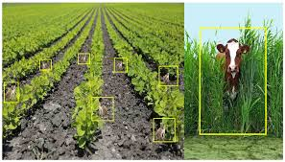
Fig.6 Animal Intrusions

Result and discussion

The performance of the created IoT-based smart farming system was evaluated using real field testing and three main categories: automatic irrigation control, crop disease identification and animal intrusion alerts. The system was able to execute tasks successfully with the help of a Raspberry Pi, which was able to combine and manage sensor data, image-processing, and cloud-based communication methods. Both temperatures of a soil Moisture Sensor and DHT11 sensor were monitored continuously by the Raspberry Pi at predetermined time intervals and transmitted via the internet to the Pi. During the testing phase, when the soil moisture levels were recorded at a value that fell below a predefined acceptable range (30%–35%), the relay activated and switched ON the water pump. Therefore, the pump was activated in a timely manner without requiring any input from the farmer, so the system effectively avoided the problem of "over irrigation". Once the soil reached a moisture level that was greater than or equal to the desired moisture level, the water pump shut OFF automatically; thus, demonstrating accurate water controls, meaning that the system effectively prevented the failure of crops resulting from either over- or under-irrigation.

Using Image Data for Disease Detection with a USB Web Camera & CNN - The image based disease detection pipeline achieved highly accurate classifications under adequate lighting conditions. The raspberry pi successfully processed multiple perspectives & lighting variances of leaf images, the CNN correctly recognized disease characteristics (i.e. discoloration, spotting, & textured variegation) throughout the system's evaluations with consistent success. Immediately after system evaluations, results including temperature, humidity, & moisture readings were uploaded to thing speak to enable the grower to monitor crop data in real-time & proactively prevent disease outbreaks.

The ability of the disease detection pipeline to provide this level of responsiveness shows that it is possible to implement edge-based machine learning models on low-power hardware, such as raspberry pi, for agricultural purposes in real-time.

In the same way, the detection system for animal intrusion was highly successful at identifying the presence of animals on the farm. Whenever movement was detected by the USB camera, and determined to be an intruder (cattle, dogs, goats, etc.) by the use of the CNN model, the Raspberry Pi immediately sent a signal to activate the audio speaker (3.5mm) to sound an alarm to scare away the intruder. As well, an intrusion notification was sent via e-mail to the registered e-mail account of the farmer. This dual alert system provides a prompt means of responding and reduces damage to crops. The entire process of detecting and alerting the farmer took only a matter of seconds, thus providing a high operating efficiency. The ThingSpeak cloud logs indicate that all data uploads were successful and were received in a timely manner, with no significant delay, suggesting that network communication and operational reliability are stable.

Overall, the integration of sensors, CNN-based detection models, relay-controlled irrigation, and cloud connectivity resulted in a robust and intelligent smart farming system. The results confirm that the system can perform continuous monitoring, automate irrigation, detect diseases, and prevent animal intrusion simultaneously. Compared to traditional farming methods, the proposed system significantly reduces manual labor, conserves water, and improves crop protection. The discussion highlights that the Raspberry Pi–based architecture is suitable for small and medium farms, providing a scalable and cost-effective solution for modern precision agriculture..

Conclusion
Through the use of IoT and Machine Learning technologies, the farmer will benefit from automatic irrigation technology, CNN based 'Disease Detection', real-time alerts/notifications of intrusion detection on the farm, and the ability to remotely monitor and protect his/her farm through these technologies. All these components of the farm management system enable the farmer to provide better service for both his/her crops and livestock. etc. For example, just like IoT home security systems will help in protecting your house by sending you instant notifications, our system extends that intelligence to agriculture by ensuring that your crops get care and protection at the right time.
Basically, this system applies machine learning, especially CNN models, to detect diseases in plants and locate
animals with speed and precision, hence reducing crop loss and enhancing the level of productivity on the whole.
In other words, we realized from this project that only that technology is meaningful which can make life easy.

References

- [1] S. Gupta, S. Chowdhury, R. Govindaraj, K. T. T. Amesho, and S. Shangdiar, “Smart agriculture using IoT for automated irrigation, water and energy efficiency,” Smart Agricultural Technology, vol. 12, pp. 1–10, 2025.
- [2] X. Liu, Z. Zhao, S. Cheng, W. Lin, and Y. Xu, “IoT-based intelligent irrigation system using fuzzy logic and deep neural networks,” Scientific Reports, vol. 15, pp. 1–14, 2025.
- [3] R. Nikhil and K. Harsha, “Real-time monitoring of agricultural land using IoT and machine learning techniques,” IJIRT, vol. 10, no. 2, pp. 45–52, 2024.
- [4] M. Begum and S. Praveen, “Internet of Things-based wild animal intrusion detection for agricultural field protection,” International Journal of Engineering Research, vol. 8, no. 4, pp. 122–127, 2023.
- [5] M. Godase and P. Sawant, “AI-based animal intrusion detection system using IoT and machine learning,” International Journal of Advanced Computer Science and Applications, vol. 14, no. 6, pp. 233–240, 2024.
- [23] A. Subeesh, C.R. Mehta, Automation and digitization of agriculture using artificial intelligence and internet of things, Artif. Intell. Agric. 5 (2021)o. 4, pp. 122–127, 2023.
- [5] M. Godase and P. Sawant, “AI-based animal intrusion detection system using IoT and machine learning,” International Journal of Advanced Computer Science and Applications, vol. 14, no. 6, pp. 233–240, 2024.
- [6] S. Radha, K. Kathiravan, V. Vineeth, J. Sanjay, and S. Venkatesh, “Prevention of monkey trespassing in agricultural land using WSN-based flooding approach,” in Proc. IEEE TIAR, Chennai, India, 2015, pp. 106–111.
- [7] S. Sugumar and R. Jayaparvathy, “An early warning system for elephant intrusion along the forest border areas,” Current Science, vol. 104, no. 11, pp. 1515–1520, 2013.
- [8] A. Deshpande, “Design and implementation of an intelligent security system for farm protection from wild animals,” International Journal of Science and Research, vol. 10, no. 2, pp. 300–350, 2016.
- [9] S. S. Sheela, K. Shivaram, U. Chaitra, P. Kshama, K. Sneha, and K. Supriya, “Low-cost alert system for monitoring wildlife entering farmlands using IoT,” International Journal of Innovative Research in Science, Engineering and Technology, vol. 5, no. 10, pp. 1–5, 2016.
- [10] S. R. Chourey and P. A. Amale, “Recent trends in engineering and technology for IoT-based automation,” International Journal of Electronics, Communication & Soft Computing Science and Engineering, pp. 128–135, 2019.
- [11] G. J. Horng, M. X. Liu, and C. C. Chen, “Smart image recognition mechanism for crop harvesting system in intelligent agriculture,” IEEE Sensors Journal, vol. 20, no. 7, pp. 3753–3760, 2020.
- [12] P. K. Mariya Priyadarshini and E. R. Ravindran, “Efficient hardware architecture for IoT systems,” International Journal of Advanced Computer Science and Applications, vol. 11, no. 4, pp. 487–493, 2020.
- [13] Chaganti S. Y. et al., “Image classification using SVM and CNN for intelligent farming,” in Proc. IEEE ICCIS, 2020, pp. 1–5.
- [14] Anandha Raja, Ramya K., Kousalya B., and S. Jeeva, “Preventing wild animal attacks using MATLAB-based detection,” IJARSE, vol. 8, no. 2, pp. 122–128, 2019.
- [15] R. Putjaika, S. Phusae, A. Chen-Im, P. Phunchongharn, and K. Akkarajitsakul, “A control system in intelligent agriculture using Arduino technology,” in Proc. ICT-ISPC, 2016, pp. 1–5.
- [16] N. Krishna et al., “IoT-based smart agriculture system for environmental monitoring,” IJERT, vol. 9, pp. 445–450, 2020.
- [17] IJIRT Editorial Board, “IoT-based crop monitoring and irrigation automation,” IJIRT, vol. 8, no. 3, pp. 201–206, 2023.
- [18] D. Surya and S. Prudhvi, “ThingSpeak-enabled IoT monitoring system for agricultural automation,” International Journal of Research in Engineering Technology, vol. 7, pp. 120–124, 2022.
- [21] A. Dharmaraj and A. Vijayan, “Smart irrigation system using IoT for agricultural applications,” IEEE International Conference on Intelligent Sustainable Systems (ICISS), pp. 1–5, 2019.
- [22] R. Patel and M. Reddy, “Precision agriculture using Raspberry Pi and IoT sensors,” IEEE International Conference on Computing, Power and Communication Technologies, pp. 765–770, 2018.
- [23] S. R. Dubey and A. Chakravarty, “Plant disease detection using deep learning models: A review,” IEEE Access, vol. 8, pp. 103924–103940, 2020.
- [24] J. Amara, B. Bouaziz, and A. Algergawy, “A deep learning-based approach for plant diseases detection,” IEEE BIBE, pp. 1–6, 2017.
- [25] S. Mohanty, D. Hughes, and M. Salathé, “Using deep learning for image-based plant disease detection,” Frontiers in Plant Science, vol. 7, pp. 1–10, 2016.
- [26] R. Ranjan, K. Singh, and S. Raj, “IoT-based remote monitoring of agricultural fields using ThingSpeak,” IEEE Conference on Emerging Technologies in Computer Engineering, pp. 22–26, 2019.
- [27] P. Vijaysai, K. Rajalakshmi, and R. Praveen, “A smart irrigation system using IoT and cloud computing,” International Conference on Communication and Electronics Systems, pp. 399–403, 2020.
- [28] A. Handigund, S. Halase, and P. Desai, “Machine learning-based crop disease detection using Raspberry Pi,” IEEE International Conference on Intelligent Computing and Control Systems, pp. 1046–1050, 2021.
- [29] O. T. Patange and M. S. Chavan, “YOLO-based animal detection for avoiding farm damages,” IEEE International Conference on Automation, Computing and Communication, pp. 325–330, 2020.
- [30] K. Narendra and P. Suresh, “Real-time surveillance of agricultural field using Raspberry Pi and IoT,” International Conference on Smart Technologies and Management, pp. 55–60, 2019.
- [31] A. Kumar and R. K. Singh, “IoT-driven smart farming: A survey on technology, challenges, and future directions,” IEEE Internet of Things Journal, vol. 8, no. 4, pp. 2343–2360, 2021.
- [32] M. Shukla and S. B. Singh, “Smart agriculture monitoring system using cloud and IoT,” IEEE ICRITO, pp. 97–102, 2018.
- [33] Y. Zhang, F. Yang, and X. Wang, “Early detection of plant diseases using deep learning and mobile devices,” IEEE Transactions on Industrial Informatics, vol. 17, no. 5, pp. 3609–3617, 2021.
- [34] J. Verma and R. Patel, “Edge computing-based agricultural monitoring using Raspberry Pi,” IEEE ICACCS, pp. 1–6, 2020.
- [35] S. R. Prasad, A. Kumar, and M. Pandey, “IoT-enabled humidity and irrigation monitoring using GSM and cloud,” IEEE ICSCCC, pp. 321–325, 2017.
- [36] E. Niveditha and K. Pratap, “Crop health monitoring using image processing with Raspberry Pi,” IEEE International Conference on Wireless Communications Signal Processing and Networking, pp. 1–5, 2019.
- [37] D. B. Rawat and M. Alshurman, “Animal intruder detection in agriculture using deep neural networks,” IEEE International Conference on AI IoT, pp. 89–94, 2020.
- [38] A. Rawal, S. Gupta, and R. Sahu, “Smart CNN-based agricultural protection system using IoT,” IEEE International Conference on Communication and Electronics Systems, pp. 1250–1256, 2021.
- [39] K. D. Desai and M. A. Shaikh, “Automatic irrigation system with soil moisture and DHT sensors using Raspberry Pi,” IEEE Conference on Energy, Communication, Data Analytics and Soft Computing, pp. 221–226, 2018.
- [40] N. Sharma, P. Gupta, and A. Singh, “Deep learning-based animal detection for smart farms,” IEEE 6th International Conference on Computing, Communication and Automation (ICCCA), pp. 550–556, 2021.

