Learning Trajectory Based on Algorithmic Sub-Constructs: Using the Arithmetic Cargo Train to Introduce Stepwise Problem-Solving in Primary School

ABSTRACT
This study aims to explore the trajectory of algorithm-based mathematics learning through the Arithmetic Cargo Train activity among elementary school students. This activity is designed to introduce step-by-step arithmetic problem-solving, integrate concrete manipulatives with symbolic representations, and foster the development of algorithmic skills such as decomposition, sequencing, operation selection, iteration, and verification.
Data was collected through classroom observations, student response records, and reflective discussions. The results show that most students were able to connect changes in the number of students in each car to arithmetic operations, write equations, verify results, and explain their strategies. This activity also supports the transition from concrete manipulatives to symbolic representations and improves mathematical communication. Analysis of student performance shows a progressive distribution, ranging from students who have not yet mastered multiplication/division to those who are able to understand and answer questions correctly.
These findings confirm that the use of real-world contexts such as the Arithmetic Cargo Train is effective in supporting step-by-step arithmetic learning and the development of algorithmic thinking skills in elementary school students.
Keywords: learning trajectories, algorithmic sub-constructs, Arithmetic Cargo Train, arithmetic problem-solving, elementary mathematics education

INTRODUCTION
Algorithmic thinking has become an essential skill for elementary students because it supports systematic problem solving in mathematics, science, and daily life. In basic terms, algorithmic thinking refers to the ability to understand a problem, break it into smaller parts, arrange ordered steps, identify repeated patterns, test a solution, and revise the procedure when needed. These processes are closely related to computational thinking, which has been widely discussed as a core competence for learners in the digital age (Grover & Pea, 2013; Shute et al., 2017; Wing, 2006). At the elementary level, algorithmic thinking should not start with formal programming syntax. It should begin with concrete tasks that help students see order, repetition, representation, and decision making in familiar learning situations.
Elementary students often learn better when abstract ideas connect with concrete actions. This is important in algorithmic thinking because students need to move from performing steps physically to explaining those steps symbolically. Learning trajectory theory offers a useful framework for this process. A learning trajectory consists of clear learning goals, a developmental progression of students’ thinking, and instructional activities that align with each stage of that progression (Cogolludo-Agustín et al., 2022).
In algorithmic thinking instruction, this means educators should not merely teach isolated tasks. They must design a sequence of tasks that gradually guides students from concrete manipulation, to verbal explanation, to symbolic representation, and finally to independent problem-solving. Recent studies indicate that learning trajectories can support computational thinking instruction in elementary education. (Luo et al., 2022) argue that computational thinking instruction and assessment require a learning trajectory perspective because students develop concepts such as sequence, decomposition, repetition, and conditionals over time. (Purnomo et al., 2021) also mapped K-8 learning trajectories for sequence, repetition, and conditionals. Their work demonstrates that students require structured experiences before they can reason with more abstract algorithmic patterns. These findings suggest that educators should design algorithmic thinking instruction as a staged progression, rather than as a single lesson or a short activity.
Research also indicates that unplugged, hands-on, and game-based activities can help young learners develop algorithmic thinking. (Hsu & Wang, 2018) found that puzzle-based game learning can foster algorithmic thinking skills, particularly when students actively generate and solve problems. (Freina et al., 2019) demonstrated that a learning path for computational thinking in the final years of elementary school can support students’ gradual development of problem-solving skills. (Cardozo Politi & Biramontes, 2024) also emphasized the role of pedagogical strategies in fostering algorithmic thinking among young learners through STEM-related activities. These studies indicate that elementary students require meaningful tasks, repeated practice, and guided reflection. They also need learning environments that reduce the cognitive load associated with abstract concepts.
Mathematics provides a strong context for developing algorithmic thinking in elementary school. Arithmetic operations require students to follow procedures, recognize repeated structures, represent quantities, and justify results. For example, multiplication can be understood as repeated addition. Division can be understood as equal grouping or repeated subtraction. These operations naturally involve sequence and repetition. When students solve arithmetic word problems, they also need to identify relevant data, decide which operation to use, and explain the steps taken to reach an answer. Therefore, integrating algorithmic thinking into arithmetic learning can make computational thinking more accessible and more relevant for elementary students.
The Arithmetic Cargo Train activity provides a concrete instructional medium for this purpose. In this activity, students use train cars and cargo as visual representations of mathematical quantities. Students take a problem card, build a train by connecting the required number of cars, place cargo or objects into each car, count the total, and write the corresponding arithmetic equation (Herreros-Torres et al., 2026) For example, when a problem states that a train has six cars and each car carries twenty passengers, students can model the situation by preparing six cars, placing twenty objects in each car, counting the total, and writing 6 × 20 = 120. This activity allows students to experience a sequence of actions before they translate the action into symbolic notation.
From an algorithmic thinking perspective, Arithmetic Cargo Train has several instructional strengths. First, it supports sequencing because students must follow ordered steps from reading the problem to writing the equation. Second, it supports decomposition because students break the problem down into the number of cars, the amount of cargo in each car, the total cargo, and the operation used. Third, it supports repetition because students can observe repeated groups in multiplication and repeated removal or sharing in division. Fourth, it supports abstraction because students transition from physical train models to mathematical symbols. These features align with the semantic wave approach, which emphasizes movement between concrete examples and abstract concepts to strengthen understanding (Ritter & Standl, 2024).
However, existing research still leaves a specific gap. Many studies discuss learning trajectories for computational thinking, unplugged activities, or game-based learning. Fewer studies examine how teachers can design a structured learning trajectory for algorithmic thinking using a low-cost arithmetic manipulative in elementary mathematics. This gap is particularly relevant for schools with limited access to digital devices that still need to foster students’ computational thinking. It is also relevant for teachers seeking practical guidance to integrate arithmetic learning, problem-solving, and algorithmic thinking into a cohesive instructional design (Dehbozorgi & Roopaei, 2024; Freina et al., 2019; Rich et al., 2017; W. Tan et al., 2026; Vanderberg et al., 2026)
Therefore, this study focuses on designing a learning trajectory to enhance algorithmic thinking skills in elementary students through the Arithmetic Cargo Train activity. The proposed learning trajectory is based on progressive learning goals, concrete-to-abstract representation, mathematical problem contexts, guided scaffolding, and formative assessment. The main research question is: How can educators design learning trajectories to enhance algorithmic thinking skills in elementary students? More specifically, this study investigates how students progress from manipulating concrete objects, to explaining ordered procedures, to representing arithmetic situations symbolically, and to solving similar problems more independently (Chioccariello et al., 2020; Ebby, 2018).
This study contributes to elementary education in three ways. First, it offers a practical model for integrating algorithmic thinking into arithmetic instruction (Akhmedov et al., 2024; Ferjan & Bernik, 2024; Haghayeghi et al., 2025; Vicente et al., 2022). Second, it provides a structured learning trajectory that teachers can use to observe students’ thinking and identify learning difficulties. Third, it extends current discussions on computational thinking by showing how algorithmic thinking can develop through contextual, hands-on, and mathematics-based activities. By connecting learning trajectory theory with the Arithmetic Cargo Train activity, this study provides an empirical and instructional basis for designing algorithmic thinking lessons that are developmentally appropriate for elementary students (Chioccariello et al., 2020; W. Tan et al., 2026; Wilson et al., 2013).

LITERATURE REVIEW
Key Concepts: Algorithmic Thinking and Computational Thinking in Primary Education
Algorithmic thinking, a fundamental component of computational thinking (CT), is defined as the ability to solve problems using systematic, stepwise processes. It includes sequencing, pattern recognition, decomposition, repetition, abstraction, and debugging (De Souza & Matias, 2020; Kadum et al., 2021). In the context of primary school mathematics, algorithmic thinking enables learners to approach arithmetic tasks logically and incrementally. Early exposure to these processes enhances both procedural fluency and conceptual understanding, particularly in repeated addition, multiplication, fractions, and division (Fischer & Fischer, 2024; Herreros-Torres et al., 2026; Zhao & Deng, 2022). Integrating CT into mathematics through manipulatives and unplugged activities allows learners to internalize step-by-step reasoning without an immediate reliance on digital tools (Chung, 2024; Mendes, 2019; Pinheiro, 2022; Sevilla et al., 2023). Table 1 presents the key algorithmic subconstructs, their descriptions, associated mathematical representations, and examples of how each is implemented using the Arithmetic Cargo Train activity.
Table 1. Key Algorithmic Subconstructs
Subconstructs | Descriptions | Mathematical Statement | Example in Arithmetic Cargo Train
Decomposition | Students break a complex problem into smaller arithmetic steps. | 6×20=20+20+20+20+20+20=120 | A train has 6 cars, each carrying 20 passengers. Students add 20 six times to find the total number of passengers.
Sequencing | Students follow the correct order of operations step by step. | Step 1:$20+20=40$  Step 2:$40+20=60$  Step 3: … | Students load the cars one by one, calculating the cumulative number of passengers after each car.
Pattern Recognition | Students identify repeated arithmetic patterns. | 20, 40, 60, 80, 100, 120 | Each car adds 20 passengers. Students predict the totals for subsequent cars.
Abstraction | Students focus on the key numerical information, ignoring irrelevant details. | Total passengers $=n×p$ | The color or type of the cars is ignored; only the number of cars and the number of passengers per car are used to solve the problem.
Algorithm Design | Students create a step-by-step procedure to solve a specific type of problem. | Multiply the number of cars by the number of passengers per car: $T=w×p$ | Students write the procedure: “Count wagons → Count passengers per wagon → Multiply → Verify total”.
Iteration | Students repeat arithmetic operations systematically. | 20 + 20 + 20 + 20 + 20 + 20 = 120 | Adding 20 passengers to each of the six cars repeatedly to reach the total.
Conditional Thinking | Students make decisions based on a condition or limit. | If the number of passengers per car$>30$ , add another car | A wagon can carry only 30 passengers. If there are 65 passengers, students split them into three wagons.
Debugging | Students check calculations and correct errors. | Wrong:$6×20=100$  Correct: $6×20=120$ | After miscalculating the total number of passengers, students recount them and correct the total using the wagons and passenger tokens.
Generalization | Students formulate rules for similar problems. | Total cargo$T=a+(n-1)d$ for an arithmetic sequence | If each wagon increases by a fixed number of boxes, students can predict the total in Wagon$n$ using the rule
Step-by-Step Problem Solving | Students integrate all steps to systematically solve a complete problem. | Understand → Plan → Calculate → Check | Students read the card problem, build the wagons, add passengers or cargo step by step, and verify the total.

Figure 1. Key Algorithmic Subconstructs

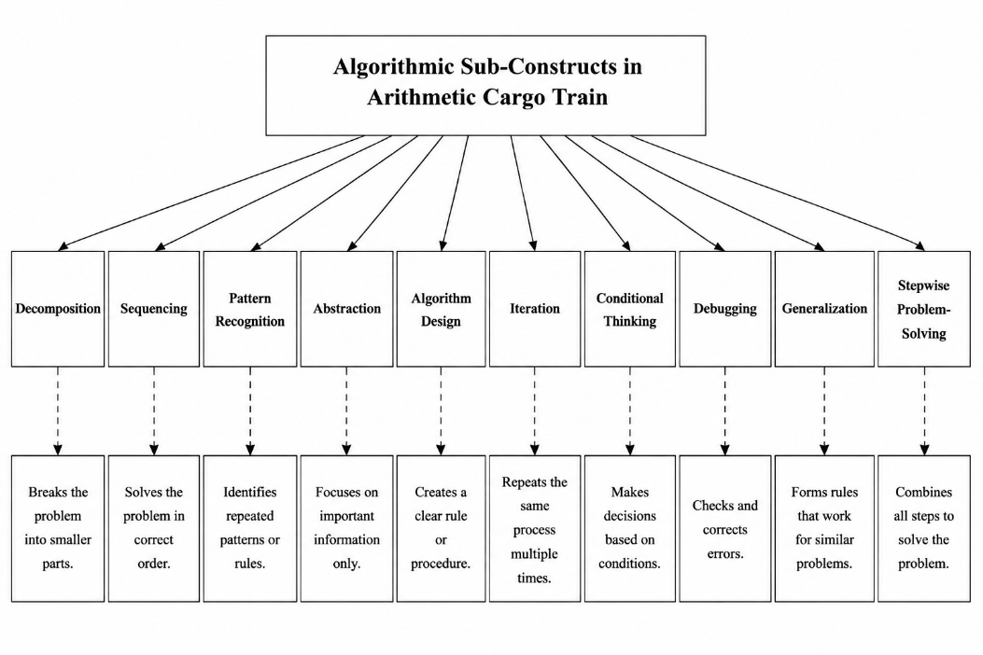
Supporting Theory: Learning Trajectories in Arithmetic
Learning trajectories (LTs) provide structured pathways that guide learners from informal strategies to formal problem-solving competence (Bowie & Graven, 2024; Pellizzoni et al., 2022). LTs facilitate the integration of algorithmic sub-constructs by sequencing skill development, anticipating common misconceptions, and scaffolding step-by-step problem-solving (Compagnoni et al., 2025; Halldorsdottir et al., 2019; Musso et al., 2020). For arithmetic learning, LTs provide teachers with a framework to structure lessons that gradually increase in complexity while reinforcing key algorithmic behaviors.
Empirical Evidence: Algorithmic Sub-Constructs and Arithmetic Learning
Several studies illustrate the impact of algorithmic sub-constructs on primary mathematics:
- Sequencing and Decomposition: Learners who practiced step-by-step problem-solving through structured activities demonstrated improved accuracy and understanding in arithmetic operations (Huerta-Zavala et al., 2026; Luo et al., 2022).
- Pattern Recognition and Repetition: Physical manipulatives and repeated problem sequences strengthened understanding of multiplication and fraction concepts (Compagnoni et al., 2025; Cornejo C. et al., 2025; J. Tan et al., 2026).
- Abstraction and Debugging: Students who engaged in error detection and correction exercises developed stronger conceptual understanding and problem-solving skills (Cornejo C. et al., 2025; Gottfried, 2019; T. Kulkarni & Sullivan, 2022; Lerkkanen et al., 2023; Mata et al., 2022; Peura et al., 2025).
4. Manipulative-Based and Unplugged Learning
Manipulatives, such as counters, fraction bars, and sequential object arrangements, support the concrete-to-abstract transition in arithmetic problem-solving. Unplugged computational thinking (CT) activities, including algorithmic games and hands-on sequences, enhance understanding of CT sub-constructs while promoting engagement (Musso et al., 2020; Zhang et al., 2020).
Game-Based and Problem-Based Approaches
Game-based learning and authentic problem contexts facilitate stepwise reasoning and algorithmic thinking. Studies indicate that coding games, tabletop games, and cargo-based manipulative tasks increase engagement and reinforce sequential problem-solving, bridging computational thinking and arithmetic learning (Zhang et al., 2020).
Integration of Learning Trajectories, Algorithmic Sub-Constructs, and Arithmetic Cargo Train
Integrating LTs, manipulatives, and CT sub-constructs provides a robust scaffolding framework. The proposed Arithmetic Cargo Train serves as a tangible, step-by-step problem-solving medium where students can physically enact sequences, groupings, and repeated operations. This approach aligns with learning trajectory principles, fosters algorithmic thinking, and provides immediate feedback for correction and reflection (Jocius et al., 2023); (Sarmasági et al., 2025).
Research Gaps
Despite extensive research on CT, manipulatives, and learning trajectories, gaps remain:
- Limited empirical studies on tangible, low-cost media like the Arithmetic Cargo Train for algorithmic reasoning.
- Lack of systematic LT-based interventions that integrate stepwise problem-solving and CT sub-constructs in primary arithmetic.
- Insufficient longitudinal evidence on the transfer effects of unplugged CT activities to mathematical reasoning (Jardim-Botelho et al., 2008).
Position of the Current Study
This study develops and validates a learning trajectory based on algorithmic sub-constructs using the Arithmetic Cargo Train to scaffold stepwise problem-solving. It integrates manipulatives, unplugged CT activities, and LT-informed instruction, providing a practical framework for developing algorithmic reasoning and arithmetic proficiency in primary school learners.
Objectives of the Study
- To examine the level of students’ understanding of algorithmic sub-constructs (sequencing, decomposition, pattern recognition, repetition, abstraction, and debugging) in primary school arithmetic.
- To investigate the effectiveness of the Arithmetic Cargo Train as a manipulative tool for teaching step-by-step problem-solving.
- To determine the relationship between students’ engagement with the Arithmetic Cargo Train and their arithmetic problem-solving performance.
- To identify challenges faced by students in applying algorithmic thinking through manipulatives.
- To explore strategies to optimize the use of manipulatives and algorithmic sub-constructs in primary school arithmetic teaching.
Research Questions
- What is the level of students’ understanding of algorithmic sub-constructs in primary school arithmetic?
- How effective is the Arithmetic Cargo Train as a tool for teaching step-by-step problem-solving?
- Is there a significant relationship between students’ engagement with the Arithmetic Cargo Train and their arithmetic problem-solving performance?
- What challenges do students face when applying algorithmic sub-constructs through manipulatives?
- What strategies can enhance the use of manipulatives and algorithmic thinking in primary school arithmetic instruction?

METHODOLOGY
The study adopted a design research approach to develop a learning trajectory based on algorithmic sub-constructs using the Arithmetic Cargo Train to enhance stepwise problem-solving in primary school arithmetic (Chioccariello et al., 2020; Dehbozorgi & Roopaei, 2024; W. Tan et al., 2026).The relationships and sequence of algorithmic sub-constructs in the Arithmetic Cargo Train activity are illustrated in Figure 2.
Figure 2. The relationships and sequence of algorithmic subconstructs in the Arithmetic Cargo Train activity
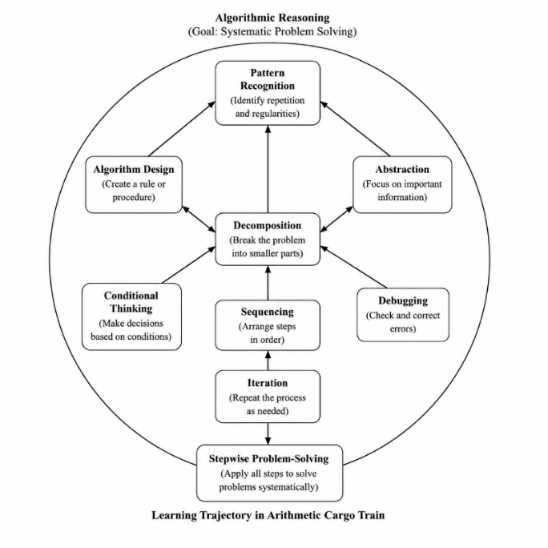
The participants consisted of 32 fourth-grade students (14 girls and 18 boys, aged 8–9 years) from a public elementary school in Deresan, Sleman, Yogyakarta, Indonesia, who had prior exposure to basic arithmetic but demonstrated limited ability in sequential problem-solving. The study was conducted in three phases: a preliminary teaching experiment to develop an initial hypothetical learning trajectory (HLT), a teaching experiment to implement the refined HLT using the Arithmetic Cargo Train across sequential learning activities, and a retrospective analysis to examine and revise the HLT based on collected data (Debevec & Kersic, 2024; Frey et al., 2024; Hulett et al., 2014; Schwartz et al., 2025). Data were collected through pre- and post-tests, unstructured interviews, classroom observations, and documentation of students’ work, with activities recorded using static and dynamic cameras (Brotman et al., 2013; Gottfried, 2019; T. Kulkarni & Sullivan, 2022; Mata et al., 2022; Musso et al., 2020). Data analysis involved examining student responses and classroom interactions to interpret learning processes, refine the HLT, and propose local instructional theories. Internal validity was ensured through triangulation of observations, interviews, and documentation, while external validity considered the applicability of the findings to similar classroom contexts (Dehbozorgi & Roopaei, 2024; Ritter & Standl, 2024; Wilson et al., 2015).
RESULTS
Each step integrates concrete manipulatives with symbolic representations and supports the development of algorithmic sub-constructs such as decomposition, ordering, operation selection, iteration, and verification. Figure 3 shows the overall flow of the Arithmetic Cargo Train activity, from the introduction of the train to students’ reflection on their strategies.
Figure 3. Arithmetic Cargo Train Activity Flow
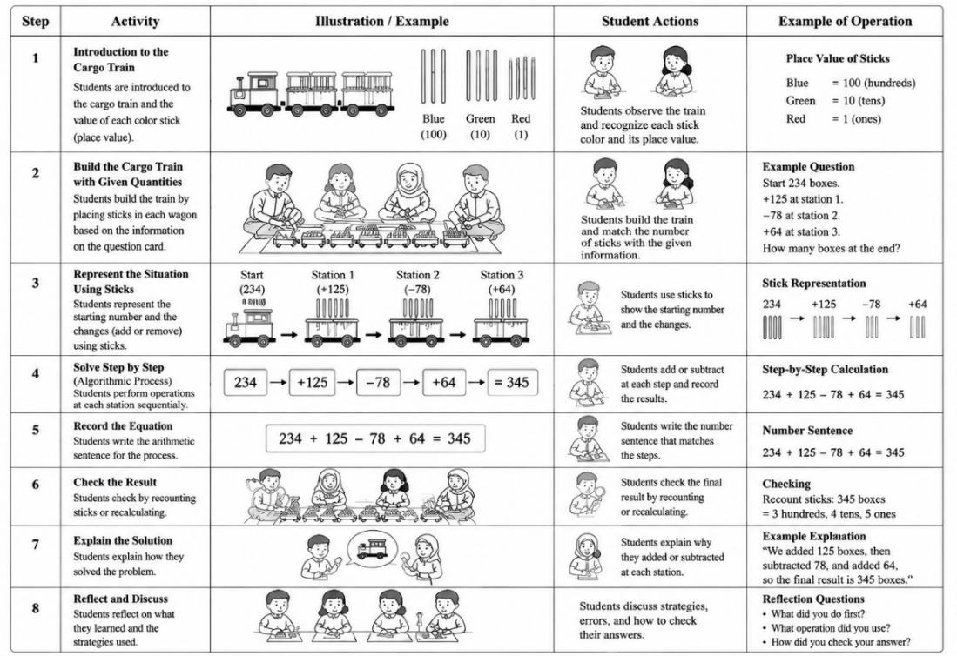
Based on this activity, we observed students’ initial understanding of arithmetic problems. In the early stages of learning, most students demonstrated varying abilities in understanding and solving arithmetic problems. Some students were able to calculate correctly but still used repeated addition, while others immediately used the multiplication symbol. The Arithmetic Cargo Train activity served as a diagnostic tool to assess students’ readiness before beginning step-by-step problem-solving. This is analyzed in further detail in the following study.
- Students’ Initial Understanding of Arithmetic Problems
In the early stages of learning, most students demonstrate varying abilities in understanding and solving arithmetic problems. Some students can calculate correctly but still use repeated addition, while others immediately use the multiplication symbol. The Arithmetic Cargo Train activity serves as a diagnostic tool to assess students’ readiness before beginning step-by-step problem-solving. This aligns with the findings of (Demers, 2020; Denvir et al., 2026; Hofkens et al., 2022; Lerkkanen et al., 2023; Listyaningrum et al., 2025), which indicate that numerical readiness influences students’ strategies for solving arithmetic problems.
Figure 4. Students’ Initial Understanding through the Arithmetic Cargo Train Activity

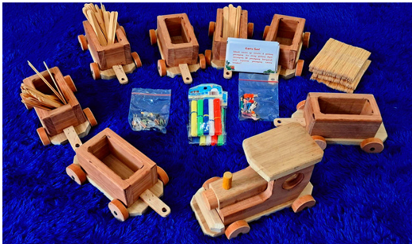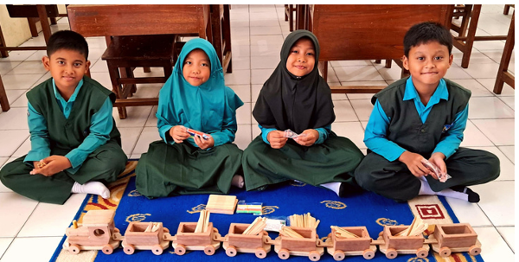
A dialogue that shows how understanding and problem-solving are demonstrated in the following conversation.
Teacher | : | “If one car holds 80 passengers and there are 6 cars, what is the total number of passengers?”
Student 1 | : | “80 + 80 + 80 + 80 + 80 + 80 = 480, Ma’am!”
Student 2 | : | “I think we can also calculate it by multiplication: 6 × 80 = 480. So the result is the same.”
Student 3 | : | “But if we use addition, we can see that each car adds 80, so the total is clearer.”
Student 4 | : | “Multiplication is faster too, but I agree with Student 3—writing it out one by one makes it easier to check.”
Student 1 | : | “Yes, that’s right. So if one of the additions is wrong, we can see which car is wrong.”
Student 2 | : | “But if we memorize the multiplication tables, we can figure out the answer right away without writing everything out.”
Teacher | : | “Great! You’ve debated and compared two ways of calculating. Some use repeated addition, others use multiplication. Both are correct. This shows that you can think algorithmically in different ways.”

Figure 5. Students’ Answers
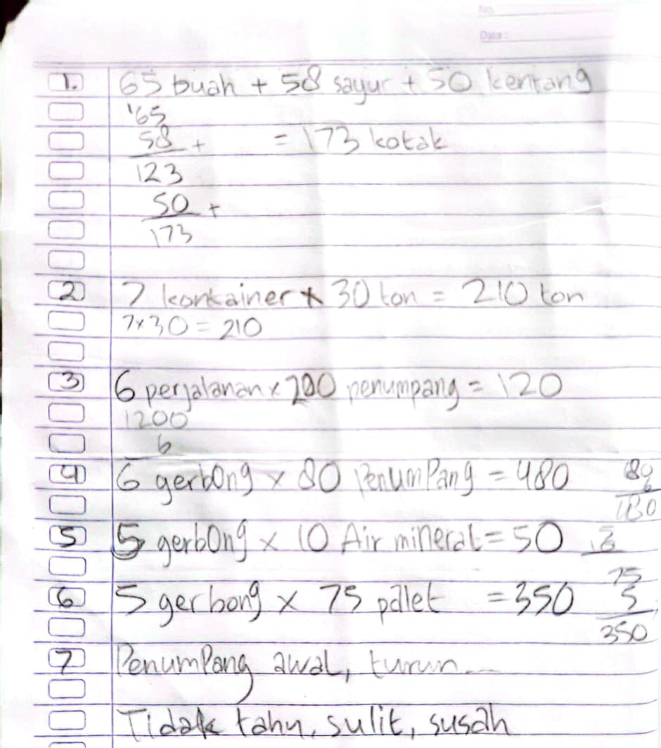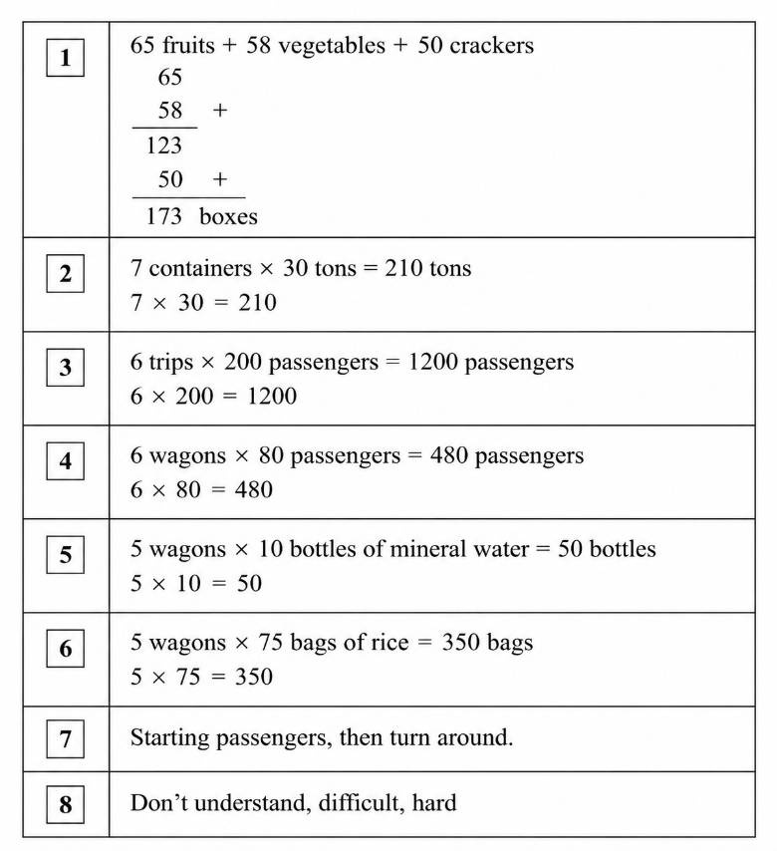
Although most students were able to follow the sequence of activities in the Arithmetic Cargo Train and solve the arithmetic problems step by step, not all students demonstrated the same level of mastery. Some students had difficulty understanding the changes in the numbers in each car and determining the correct operation. For example, some students initially continued to use repeated addition to calculate the total number of passengers or cargo, while others were able to use the multiplication symbol right away.
In addition, some students needed the teacher’s help to write down arithmetic equations or to verify their results. This indicates variations in students’ ability levels and understanding of arithmetic concepts within the class. This performance distribution aligns with the observation that: 1) Some students (Level 1) have not yet mastered multiplication and division, 2) Some students (Level 2) do not fully understand the problems, 3) Other students (Level 3) understand the concepts but still make calculation errors, 4) Only some students (Level 4) can understand and solve the problems correctly on their own.
This approach emphasizes the importance of step-by-step guidance, the use of concrete manipulatives, and reflective discussions in helping all students develop problem-solving skills and algorithmic thinking.
- Development of Step-by-Step Problem Solving
The learning trajectory shows that students begin to solve problems systematically. Each train car represents a step in an arithmetic calculation. This strategy helps students understand the importance of sequencing and decomposition. This sub-construction is important because it builds the foundation for algorithmic thinking early on (Kelz & Krammer, 2024).
Figure 6. Developing Problem-Solving Skills Through the Arithmetic Cargo Train Activity
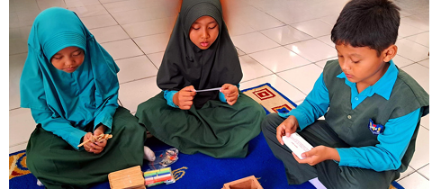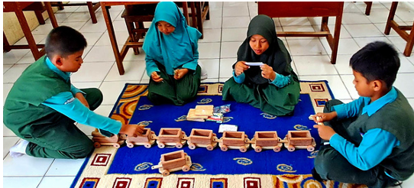
A dialogue that shows how understanding and problem-solving are demonstrated in the following conversation.
Teacher | : | “Now, count all the boxes of fruit, vegetables, and potatoes in the 3 train cars.”
Student 1 | : | “There are 65 boxes of fruit, 58 boxes of vegetables, and 50 boxes of potatoes. If we add them up, 65 + 58 + 50 = 173 boxes, Teacher.”
Student 2 | : | “I’ll count by car first. Car 1: 65, car 2: 58, car 3: 50. So 65 + 58 = 123, then 123 + 50 = 173 boxes.”
Student 3 | : | “If I use a model with sticks or mini boxes for the train cars, I can look at each car first. That makes it easy to calculate the total.”
Student 4 | : | “I was confused at first, but now I can sort the boxes by train car and count them one by one.”
Teacher | : | “Great! You’ve broken the problem down into smaller parts and worked through it step by step. Some of you used the train car model, while others just counted the numbers directly.”

- Algorithmic Sub-Constructs in Student Reasoning
This activity highlights five main sub-constructs in student reasoning:
- Decomposition – Breaking down the problem into the load of each car.
- Sequencing – Ordering arithmetic operations according to the train car steps.
- Operation Selection – Determining when to use +, −, ×, ÷.
- Iteration – Repeating similar steps in the next compartment.
- Verification & Debugging – Checking the final results and explaining the calculation process.
A dialogue that shows how understanding and problem-solving are demonstrated in the following conversation.
Teacher | : | “If there are 350 sacks and each car can hold 50 sacks, how many cars are needed?”
Student 1 | : | “350 ÷ 50 = 7 cars, Ms. Teacher.”
Student 2 | : | “I think only 6 cars are needed, because 50 × 6 = 300, which is 50 short, so 6 cars are enough.”
Student 3 | : | “But if there are only 6 cars, 350 − 300 = 50 sacks are left over. There should be an extra car so that all the cargo fits.”
Student 1 | : | “Yes, so 7 cars so that all 350 sacks fit.”
Student 2 | : | “Oh… so if there’s any left over, we have to add more cars, right, Ms.?”
Teacher | : | “That’s right! Here’s an important example: you have to check your calculations. Sometimes, if we just guess, we might get it wrong. By calculating 350 ÷ 50, we know we need 7 railcars to fit all the sacks.”
Student 3 | : | “So we can calculate step by step, then check the result. If there’s a remainder, that means we need to add more cars.”

- Transition from Concrete to Symbolic Representation
Students initially use concrete manipulatives (sticks, miniature figures, train cars) to understand quantities and operations. Next, they write arithmetic equations. This transitional stage demonstrates the development of symbolic abilities, consistent with the findings of (Gottfried, 2019).
A dialogue that shows how understanding and problem-solving are demonstrated in the following conversation,
Student 8 | : | “If there are 20 passengers in one car, 6 cars means 6 × 20 = 120 passengers.”
Teacher | : | “That’s right! Now you see the connection between direct counting and writing mathematical symbols.”
The results of the transition are illustrated in the following student responses.

Figure 7. Transition Results
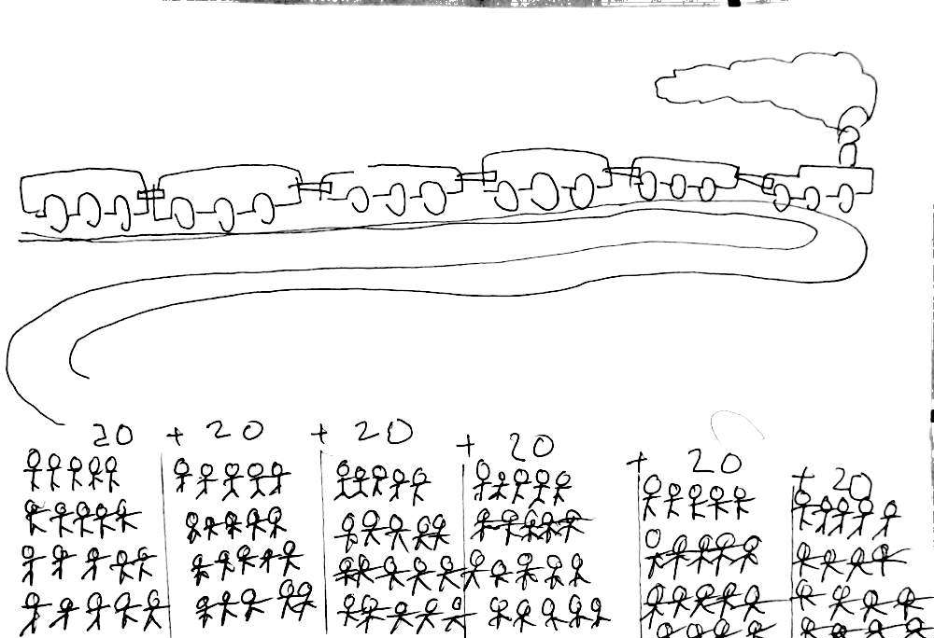 6 × 20 = 120 passengers
- Mathematical Explanation and Communication
This activity encourages students to articulate their strategies and compare their answers with their classmates. This discussion enhances conceptual understanding and mathematical communication skills, which are an important part of mathematical discourse (Kazemi & Stipek, 2001).(Bowie & Graven, 2024; Compagnoni et al., 2025; Kelz & Krammer, 2024; Pellizzoni et al., 2022).
Teacher | : | “Now tell me the steps you took to calculate the total.”
Student 9 | : | “I added 125, subtracted 78, then added 64, so the total is 345.”
Student 10 | : | “But if I add 125 and 64 first, then subtract 78, is the result still 345?”
Student 9 | : | “Yes, if calculated correctly, the result is the same, but I like to write down the steps one by one so it’s easier to check.”
Student 10 | : | “Ah, I see. If we list the steps in order, we can spot mistakes more quickly.”

- Learning Trajectories Based on Student Performance
The distribution of student answers shows a progression from initial understanding to full mastery. The four competency levels can be summarized as follows:
Table 2. LearningTrajectories Based on Student Performance
Level | Description | Number of Students
1 | Does not master multiplication/division | 2
2 | Does not understand the problem | 5
3 | Understands the concept but cannot perform the calculation | 11
4 | Understands and answers correctly | 14
The Arithmetic Cargo Train activity provides a real-world context for developing step-by-step problem-solving skills in elementary school students and explicitly facilitates learning based on a learning trajectory. Students begin by learning about the train cars and the value of each stick, then learn to connect changes in the number of sticks in each car to arithmetic operations, write equations (Al-Omar et al., 2023; Kyllonen, 2020), verify results, and explain the process. For example, students calculate the total load using addition and subtraction in sequence:
$$\text{Total }\text{Penumpang}=158-23+79=214$$
or use multiplication for a fixed total load:
$$\text{Total Kotak}=5×75=375$$
The observed learning trajectories show a gradual progression from concrete representations (sticks and blocks) to symbolic representations (arithmetic equations), reflecting algorithmic sub-constructs: decomposition, sequencing, operation selection (+, −, ×, ÷), iteration, and verification/debugging (Hofkens et al., 2022; Lerkkanen et al., 2023; Listyaningrum et al., 2025). For example, students visualize the number of passengers in each car, group the loads, and write the equation:
$$6×20=120$$
Each step in this learning trajectory builds systematic thinking skills: students identify the context of a problem, connect changes to appropriate operations, perform calculations step by step, and finally verify and explain their results (R. V. Kulkarni et al., 2025; Sevilla et al., 2023). This process enhances students’ mathematical communication and supports authentic, staged learning, consistent with the findings of (Bowie & Graven, 2024; Cardozo Politi & Biramontes, 2024), who emphasize the importance of real-world contexts in the development of arithmetic strategies among elementary school students.

CONCLUSION
Based on the research findings, it can be concluded that the Arithmetic Cargo Train activity provides an effective real-world context for developing arithmetic problem-solving skills in elementary school students in a step-by-step manner. Students demonstrated improvement in:
- Understanding the problem context and identifying the initial quantity.
- Relating changes in quantities to arithmetic operations (+, −, ×, ÷).
- Performing operations sequentially using algorithmic strategies.
- Writing equations, verifying results, and explaining the problem-solving process.
Algorithmic sub-constructs such as decomposition, ordering, operation selection, iteration, and verification developed significantly. These activities also facilitated the transition from concrete manipulatives to symbolic representations, improved students’ mathematical communication skills, and supported staged learning in real-world contexts. These results indicate that the use of real-world contexts and algorithm-based manipulatives can be effective strategies in elementary mathematics education.

REFERENCES
- Akhmedov, A. O., Umarov, A. A.-K., & Dzhulagov, S.-M. M. (2024). Development of physical qualities of high school students in the football section of the school sports club. Perspektivy Nauki i Obrazovania, 67(1), 357–368. Scopus. https://doi.org/10.32744/pse.2024.1.19
- Al-Omar, M., Alomari, S., & Amer, T. B. (2023). AN EFFICIENT CYBER SECURITY AND DATA SCIENCE FOR ANALYZING BIG MEDICAL DATA. Journal of Theoretical and Applied Information Technology, 101(24), 8305–8316. Scopus.
- Bowie, L. H., & Graven, M. H. (2024). Using games to develop number sense in early grade maths clubs. South African Journal of Childhood Education, 14(1). Scopus. https://doi.org/10.4102/sajce.v14i1.1493
- Brotman, L. M., Dawson-McClure, S., Calzada, E. J., Huang, K.-Y., Kamboukos, D., Palamar, J. J., & Petkova, E. (2013). Cluster (school) RCT of parentcorps: Impact on kindergarten academic achievement. Pediatrics, 131(5), e1521–e1529. Scopus. https://doi.org/10.1542/peds.2012-2632
- Cardozo Politi, S., & Biramontes, T. (2024). Child development lags and learning trajectories in primary school in Uruguay: Compensation or divergence? / Rezagos en el desarrollo infantil y trayectorias de aprendizaje en la enseñanza primaria de Uruguay: ¿compensación o divergencia? Infancia y Aprendizaje, 47(3), 573–597. Scopus. https://doi.org/10.1177/02103702241277756
- Chioccariello, A., Bottino, R., Panesi, S., & Freina, L. (2020). Longitudinal approach for introducing programming in italian primary school. Scopus. ACM International Conference Proceeding Series. https://doi.org/10.1145/3421590.3421599
- Chung, H.-T. (2024). Fundamental Number Sense Test for First-and Second-Grade Primary School Students. Bulletin of Educational Psychology, 55(3), 577–606. Scopus. https://doi.org/10.6251/BEP.202403_55(3).0007
- Compagnoni, M., Rechsteiner, B., Grob, U., Bayer, N., Wullschleger, A., & Merki, K. M. (2025). No Loss, No Gain? COVID-19 school closures and Swiss fifth-graders’ competencies and self-concept in mathematics. Zeitschrift Fur Padagogische Psychologie, 39(3), 221–235. Scopus. https://doi.org/10.1024/1010-0652/a000366
- Cornejo C., Felmer P., Gómez D.M., Dartnell P., Araya P., Peri A., & Randolph V. (Eds.). (2025). 48th Annual Conference of the International Group for the Psychology of Mathematics Education, PME 2025. Proceedings of the International Group for the Psychology of Mathematics Education, 1. Scopus. https://www.scopus.com/pages/publications/105013088670?origin=resultslist
- De Souza, C. F., & Matias, N. C. F. (2020). Cognitive correlates in learning mathematics: A literature review. Bolema - Mathematics Education Bulletin, 64(68), 1324–1340. Scopus. https://doi.org/10.1590/1980-4415v34n68a23
- Debevec, M. B., & Kersic, K. M. (2024). “When School Started”: A Look at the Way of Life of Children in the Era of the General School Ordinance through School Books. Solska kronika, 2024(1), 155–179. Scopus.
- Dehbozorgi, N., & Roopaei, M. (2024). Improving Computational Thinking Competencies in STEM Higher Education. Scopus. 2024 IEEE Integrated STEM Education Conference, ISEC 2024. https://doi.org/10.1109/ISEC61299.2024.10664997
- Demers, M. (2020). IMMIGRANT AND MIGRANT CHILDREN: CURRENT ISSUES AND CHALLENGES. In Immigr. And Migr. Children: Current Issues and Challenges (p. 199). Nova Science Publishers, Inc. Scopus. https://www.scopus.com/pages/publications/85133985487?origin=resultslist
- Denvir, E., Di Lonardo Burr, S., Rodgers, L. J., Mills, P., Wylie, J., & Xu, C. (2026). Related but independent: Trait math anxiety and the developmental trajectories of state anxiety and arithmetic fluency. Learning and Individual Differences, 128. Scopus. https://doi.org/10.1016/j.lindif.2026.102921
- Ebby, C. B. (2018). Using a learning trajectory to make sense of student work for instruction. In Cases of Teachers’ Data Use (pp. 44–62). Scopus. https://doi.org/10.4324/9781315165370
- Ferjan, M., & Bernik, M. (2024). Digital Competencies in Formal and Hidden Curriculum. Organizacija, 57(3), 261–273. Scopus. https://doi.org/10.2478/orga-2024-0019
- Fischer, K. J., & Fischer, C. J. (2024). A Model for Competency-Based Grading and Its Effect on Student Outcomes in a Biomechanics Course. Journal of Biomechanical Engineering, 146(5). Scopus. https://doi.org/10.1115/1.4064057
- Freina, L., Bottino, R., & Ferlino, L. (2019). A learning path in support of computational thinking in the last years of primary school. 11385 LNCS, 16–27. Scopus. https://doi.org/10.1007/978-3-030-11548-7_2
- Frey, M., Gashaj, V., Nuerk, H.-C., & Moeller, K. (2024). You can count on your fingers: Finger-based intervention improves first-graders’ arithmetic learning. Journal of Experimental Child Psychology, 244. Scopus. https://doi.org/10.1016/j.jecp.2024.105934
- Gottfried, A. E. (2019). Academic Intrinsic Motivation: Theory, Assessment, and Longitudinal Research. Advances in Motivation Science, 6, 71–109. Scopus. https://doi.org/10.1016/bs.adms.2018.11.001
- Grover, S., & Pea, R. (2013). Computational Thinking in K-12: A Review of the State of the Field. Educational Researcher, 42(1), 38–43. Scopus. https://doi.org/10.3102/0013189X12463051
- Haghayeghi, M., Moghadamzadeh, A., Ravand, H., Javadipour, M., & Kareshki, H. (2025). Development of a Cognitive Assessment Checklist for First-Grade Mathematics: Utilizing Hierarchical Cognitive Diagnostic Modeling in Elementary Education. Journal of Psychoeducational Assessment, 43(1), 88–107. Scopus. https://doi.org/10.1177/07342829241290277
- Halldorsdottir, T., Kurtoic, D., Müller-Myhsok, B., Binder, E. B., & Blair, C. (2019). Neurobiologyofself-regulation:longitudinalinfluence of FKBP5 and intimate partner violence on emotional and cognitive development in childhood. American Journal of Psychiatry, 176(8), 626–634. Scopus. https://doi.org/10.1176/appi.ajp.2019.18091018
- Herreros-Torres, D., Sanz, M. T., & Gómez-Ferragud, C. B. (2026). A study on the different representations and performance profiles on fractions as operators in primary education. Journal of Mathematical Behavior, 82. Scopus. https://doi.org/10.1016/j.jmathb.2025.101302
- Hofkens, T. L., Whittaker, J., Pianta, R. C., Vitiello, V., Ruzek, E., & Ansari, A. (2022). Pathways of mathematics achievement in preschool: Examining executive function and task orientation. Journal of Applied Developmental Psychology, 81. Scopus. https://doi.org/10.1016/j.appdev.2022.101432
- Hsu, C.-C., & Wang, T.-I. (2018). Applying game mechanics and student-generated questions to an online puzzle-based game learning system to promote algorithmic thinking skills. Computers and Education, 121, 73–88. Scopus. https://doi.org/10.1016/j.compedu.2018.02.002
- Huerta-Zavala, P., Luo, C., Matos-Cámara, R. F., & Bernárdez-Vilaboa, R. (2026). Developing university competencies through learning and exchange of ideas. A multidisciplinary approach. Cogent Education, 13(1), 2612315. https://doi.org/10.1080/2331186X.2025.2612315
- Hulett, J. L., Weiss, R. E., Bwibo, N. O., Galal, O. M., Drorbaugh, N., & Neumann, C. G. (2014). Animal source foods have a positive impact on the primary school test scores of Kenyan schoolchildren in a cluster-randomised, controlled feeding intervention trial. British Journal of Nutrition, 111(5), 875–886. Scopus. https://doi.org/10.1017/S0007114513003310
- Jardim-Botelho, A., Raff, S., De Ávila Rodrigues, R., Hoffman, H. J., Diemert, D. J., Corrêa-Oliveira, R., Bethony, J. M., & Gazzinelli, M. F. (2008). Hookworm, Ascaris lumbricoides infection and polyparasitism associated with poor cognitive performance in Brazilian schoolchildren. Tropical Medicine and International Health, 13(8), 994–1004. Scopus. https://doi.org/10.1111/j.1365-3156.2008.02103.x
- Kadum, S., Drandić, D., & Lazarić, L. (2021). Children’s readiness for school from a teacher’s perspective. Nova Prisutnost, 19(3), 583–597. Scopus. https://doi.org/10.31192/np.19.3.8
- Kelz, J., & Krammer, G. (2024). Synthesising models of primary school mathematicians by putting influencing factors of mathematics performance to the test. European Journal of Psychology of Education, 39(4), 4137–4161. Scopus. https://doi.org/10.1007/s10212-024-00836-3
- Kulkarni, R. V., Choudhari, G., Bhavik, M., Bura, R., & Bhosale, V. (2025). GAMIFYING EARLY MATH EDUCATION: AN INNOVATIVE AI GAME FOR CHILDREN. Journal of Information Technology Education: Innovations in Practice, 24, 01–21. Scopus. https://doi.org/10.28945/5595
- Kulkarni, T., & Sullivan, A. L. (2022). Academic achievement and relations to externalizing behavior: Much ado about nothing? Journal of School Psychology, 94, 1–14. Scopus. https://doi.org/10.1016/j.jsp.2022.07.004
- Kyllonen, P. C. (2020). Advances in Measuring “Hard-to-Measure” Skills. Contemporary Perspectives on Research in Educational Assessment, 67–92. Scopus. https://doi.org/10.1108/978-1-64113-939-720251005
- Lerkkanen, M.-K., Pakarinen, E., Salminen, J., & Torppa, M. (2023). Reading and math skills development among Finnish primary school children before and after COVID-19 school closure. Reading and Writing, 36(2), 263–288. Scopus. https://doi.org/10.1007/s11145-022-10358-3
- Listyaningrum, P., Retnawati, H., & Ibda, H. (2025). Realistic Mathematics Education in Digital Era Elementary Schools: A Systematic Literature Review. International Journal on Advanced Science, Engineering and Information Technology, 15(1), 67–74. Scopus. https://doi.org/10.18517/ijaseit.15.1.20123
- Luo, X., He, Q., Qin, Y., Wu, C., & He, J. (2022). Common statistical methods used in quasi-experimental studies and applications in medicine. Chinese Journal of Evidence-Based Medicine, 2022(9), 1080–1084. Scopus. https://doi.org/10.7507/1672-2531.202204020
- Mata, L., Monteiro, V., Peixoto, F., Santos, N. N., Sanches, C., & Gomes, M. (2022). Emotional profiles regarding maths among primary school children – A two-year longitudinal study. European Journal of Psychology of Education, 37(2), 391–415. Scopus. https://doi.org/10.1007/s10212-020-00527-9
- Mendes, I. A. (2019). Francisco Ferreira Vilhena Alves and the arithmetic knowledge in the journal the School: Official Journal of Teaching (1900-1905). Acta Scientiae, 21, 43–61. Scopus. https://doi.org/10.17648/acta.scientiae.v21issEid5220
- Musso, M. F., Cascallar, E. C., Bostani, N., & Crawford, M. (2020). Identifying Reliable Predictors of Educational Outcomes Through Machine-Learning Predictive Modeling. Frontiers in Education, 5. Scopus. https://doi.org/10.3389/feduc.2020.00104
- Pellizzoni, S., Cargnelutti, E., Cuder, A., & Passolunghi, M. C. (2022). The interplay between math anxiety and working memory on math performance: A longitudinal study. Annals of the New York Academy of Sciences, 1510(1), 132–144. Scopus. https://doi.org/10.1111/nyas.14722
- Peura, P., Koponen, T., Aro, T., Viholainen, H., & Aro, M. (2025). Dynamics of change in math self-efficacy, sources of self-efficacy, and math skills. Journal of Educational Psychology. Scopus. https://doi.org/10.1037/edu0001006
- Pinheiro, N. V. L. (2022). FROM THE MYTH OF THE HOMOGENEOUS CLASS TO THE INDIVIDUALIZED TEACHING OF ARITHMETIC: THE CONCEPTION OF CARLETON WASHBURNE. Historia da Educacao, 26. Scopus. https://doi.org/10.1590/2236-3459/110179
- Purnomo, Y. W., Arlini, R., Nuriadin, I., & Aziz, T. A. (2021). Learning trajectory based on fractional sub-constructs: Using fractions as quotients to introduce fractions. 13(3).
- Rich, K. M., Strickland, C., Binkowski, T. A., Moran, C., & Franklin, D. (2017). K-8 learning trajectories derived from research literature: Sequence, repetition, conditionals. 182–190. Scopus. https://doi.org/10.1145/3105726.3106166
- Ritter, F., & Standl, B. (2024). Semantic Waves: A Strategy for Algorithmic Skills in K-12 Computer Science Education. Scopus. IEEE Global Engineering Education Conference, EDUCON. https://doi.org/10.1109/EDUCON60312.2024.10578899
- Schwartz, C. J., Wibowo, H., Miner, N., Hosteng, T., & Sundararajan, S. (2025). When did Statics become so difficult? A root cause analysis of the high failure rates in a high-enrollment foundational course. ASEE Annu. Conf. Expos. Conf. Proc. Scopus. ASEE Annual Conference and Exposition, Conference Proceedings. https://doi.org/10.18260/1-2--57342
- Sevilla, D. B., Banda, D. R., & Sosa, J. J. (2023). From the expression of the ratio with two natural numbers, to its expression with a fraction. Two didactic experiences at primary school and high school. Educacion Matematica, 35(3), 82–111. Scopus. https://doi.org/10.24844/EM3503.03
- Shute, V. J., Sun, C., & Asbell-Clarke, J. (2017). Demystifying computational thinking. Educational Research Review, 22, 142–158. Scopus. https://doi.org/10.1016/j.edurev.2017.09.003
- Tan, J., Cant, A., Lewis, K., Nguyen, V., Gimeno, L., Zylbersztejn, A., Hardelid, P., Morris, J., De Stavola, B., Harron, K., & Gilbert, R. (2026). Educational Attainment of Children With Major Congenital Anomalies During Primary School in England: A Population Cohort Study. Paediatric and Perinatal Epidemiology, 40(4), 511–525. Scopus. https://doi.org/10.1111/ppe.70122
- Tan, W., Li, P., & Yun, X. (2026). Backward Design in IT Education: Fostering Higher-Order Thinking via ‘Algorithm Concepts and Description.’ 157–161. Scopus. https://doi.org/10.1145/3786709.3786732
- Vanderberg, M., Garfas-Knowles, D., Krause, G., Skuratowicz, E., & Hung, E. E. (2026). Teaching Algorithmic Thinking to Elementary Students in an Unplugged Environment. 1096–1102. Scopus. https://doi.org/10.1145/3770762.3772649
- Vicente, S., Verschaffel, L., & Ramos, M. (2022). Difficulty level of arithmetic word problems in Singaporean and Spanish textbooks. Avances de Investigacion en Educacion Matematica, (22), 137–156. Scopus. https://doi.org/10.35763/aiem22.4412
- Wilson, P. H., Mojica, G. F., & Confrey, J. (2013). Learning trajectories in teacher education: Supporting teachers’ understandings of students’ mathematical thinking. Journal of Mathematical Behavior, 32(2), 103–121. Scopus. https://doi.org/10.1016/j.jmathb.2012.12.003
- Wilson, P. H., Sztajn, P., Edgington, C., & Myers, M. (2015). Teachers’ Uses of a Learning Trajectory in Student-Centered Instructional Practices. Journal of Teacher Education, 66(3), 227–244. Scopus. https://doi.org/10.1177/0022487115574104
- Wing, J. M. (2006). Computational thinking. Communications of the ACM, 49(3), 33–35. Scopus. https://doi.org/10.1145/1118178.1118215
- Zhang, X., Hu, B. Y., Zou, X., & Ren, L. (2020). Parent–child number application activities predict children’s math trajectories from preschool to primary school. Journal of Educational Psychology, 112(8), 1521–1531. Scopus. https://doi.org/10.1037/edu0000457
- Zhao, B., & Deng, K. (2022). A study on the institutionalization of textile education in late Qing Dynasty. Journal of Silk, 59(2), 158–167. Scopus. https://doi.org/10.3969/j.issn.1001-7003.2022.02.020

