Opuntia vulgaris cladode extracts a novel source for tissue section adhesive in histology laboratory

ABSTRACT
Thermodynamic force drive cells to produces different bio molecules can be used to visualization of human tissue ultra-structure coupled with microscopic image into explainable text in histology laboratory in modern science. However, excellence of histology microscopy slide tissue section adhesive is carries a significant impact on the histology techniques for identification of abnormal cells structure and secretory functions and selection of best management method for various types of diseases in modern clinical practice. Currently using adhesive Mayer’s egg albumin concerns on slides background stain in slides therefore necessitate effective tissue section adhesive needed to histology laboratory practice. Present study aimed to evaluating the Opuntia vulgaris cladode extract on the tissue section adhesive effectiveness in liver tissues sections and using H/E staining against Aloe vera and Mayer’s egg albumin. Observed that Opuntia vulgaris extract coated stained section displayed no stain background compared with egg albumin and Aloe vera adhesive coated tissue section slides. Ultra-structural were analysed under microscopic 10x and 40x magnifications, observed that no noticeable changes in Opuntia vulgaris adhesive coated tissue section slides. Present study we reporting that Opuntia vulgaris extract suggestive alternative for Mayer’s egg albumin slide tissue section adhesive in histology laboratory.
Keyword: Histopathology, tissue adhesive, Opuntia vulgaris, egg albumin.
INTRODUCTION
Thermodynamic force drive cells to transform energy to different forms that can be utilised by organism growth, immunity, reproduction and all vital life progression. However, micro and macro molecules synthesised from cells that can be used to visualization of animal cells ultra-structure coupled with microscopic image into explainable text in histology laboratory in modern science. Though, utilization of microorganisms, plants and animal cells synthesised micro and macro molecules can be used as a tissue processing agent and stains in histopathology laboratory to identification of abnormal and normal cells structure and secretory functions and followed by assortment of best management method for various types of diseases in modern clinical practice (1). However, quality and stability of histology microscopy slide tissue section adhesive molecules and preparation are carries a significant impact on the histology techniques for microscopical analysis of stained slide outcome. The microscopic slide coting makes sure that tissue sections in the slides during different staining steps. However, poor section adhesion preparation can causes tissue section detachment, significantly in the staining procedure go through various staining and washing steps, example PAS staining and stains artefacts resulted to diagnostic errors. In these challenges, researchers putting efforts to overcome searching and formulating a different tissue section adhesive such as, albumin, gelatin and poly-L-lysine in the extant (2). Nevertheless, foremost concerns on slides background stain, toxic preservative impact on environment, require safer and effective tissue section adhesive needed to histology laboratory practice. Searching novel non-toxic, eco-friendly histology slide tissue section adhesive currently needed to fortify histology technology (3-6).
Plants are rooting, grow and flower formation in moderately dry environment are known as xerophytic plant. Xerophytic plant was tolerate and adapted to grow in adverse drought environmental location. Xerophytic plant physiologically adapted to survive on the adverse environment condition through physiological and morphological modification, notably leaf and stem highly modified known as cladode. In the xerophytes cladode was contain enzymes, micro and macro molecules was exhibits on industrial and clinical important (7). The xerophytic Opuntia vulgaris grow and habited in semi-dry environment and producing valuable enzymes have industrial wide application such as food and beverage industry (8). Present study aimed to evaluating the Opuntia vulgaris cladode extract on the tissue section adhesive effectiveness in liver tissues sections and using H/E staining against Aloe vera and Mayer’s egg albumin.
MATERIALS AND METHODS
Materials
Opuntia vulgaris were collected from semi-arid region of Puducherry, India. Present investigation using chemicals and stains were purchased from Sigma-Aldrich (St. Louis, MO, USA). All the reagent and stains preparations were used doubled distilled.
Preparation of Opuntia vulgaris extract
Plant cladodes were removed carefully followed by surface sterilization carried out followed by the cuticular layer removed at the sterile condition, cladode were chopped into smaller pieces than homogenized using waring blendor in in phosphate buffer (pH 7.0) to prepare 10 % (w/v) homogenate. Followed by the homogenate filtered using muslin cloth and centrifuged at 10,000 rpm for 35 min. The resulted clear supernatant was transferred to new tube and using a source of tissue section adhesive (Figure 1) (8, 11).
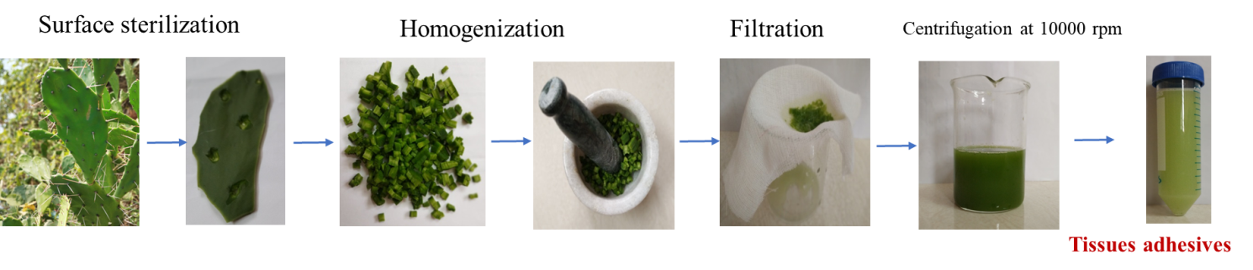
Figure 1. Shown the preparation of Opuntia vulgaris cladodes extract on tissue section adhesive
Preparation and coating of slides
Paraffin embedded rat liver tissue block were used and 4µm size sections were taken with help of semi-automated microtome. The sections cutting were carried out from the Department Of Biochemistry and Molecular Biology, Pondicherry University, once acquired consent from Institutional Ethical Committee (IAEC/No.01/2011). 10 slides were pre-coated with serially diluted plant extract with phosphate buffer (1:1 to 10:0) at 0.5mL, along with Mayer’s egg albumin and aloe vera 0.5mL each slides. All the slides once the tissue sections taken on to slide followed by kept for drying in incubator for 1 hour (8).
Haematoxylin/Eosin Staining
The standard protocol were adapted to Haematoxylin/Eosin (H/E) staining of the slides are follow, deparaffinise the sections adapted by xylene treatment for 15 mins followed by rehydration using different concentration of alcohol and each set given 2 mins followed by the slides were washed 10 mins in running tap water. Tissue sections were covered fully by haematoxylin stain and given for 10 mins than carefully washed in tap water, followed by the slides were dipped one time in acid-alcohol and ammonia solution than carefully washed in tap water known as bluing. The eosin stain covered slides and given for 1 min than tissue sections were dehydrated by using a different percentage concentration of alcohol than tissue sections were carried out by clearing using xylene followed by stained tissue section mounted with DPX (5, 8).
Results and discussion
A 10 tissue sections slides were attached with coated with plant extract, parallely one slide attached with Mayer’s egg albumin coted and one slide tissue section were attached with Aloe vera coted. All the different histological tissue section coted slides were investigated tissue section detachment during multiple steps in H/E staining. Opuntia vulgaris extract initially carried out a serial dilution with distilled water from 1:1% to 10:0%. 1mL of Opuntia vulgaris with 9mL of distilled water, like wise serial dilution carried out at 10.0% of Opuntia vulgaris extract in the current investigation. Followed by 0.2mL of diluted extract solution were used to coating 10 tissue section slides. Than routine staining protocol were carried out, observed that at dilution 4:6% to 10:0% shown tissue section adhesiveness effects compared with egg albumin and Aloe vera adhesive coated slides (Table 1 and Figure 2).
Table 1. Serial dilution Opuntia vulgaris for tissue adhesive
Extract volume (mL) | D.H₂O (mL) | % of extract dilution | Total volume (mL)
1 | 9 | 1:9 | 10
2 | 8 | 2:8 | 10
3 | 7 | 3:7 | 10
4 | 6 | 4:6 | 10
5 | 5 | 5:5 | 10
6 | 4 | 6:4 | 10
7 | 3 | 7:3 | 10
8 | 2 | 8:2 | 10
9 | 1 | 9:1 | 10
10 | 0 | 10:00 | 10

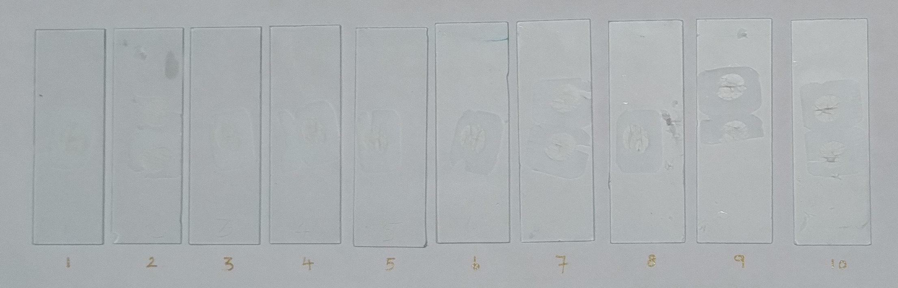
Figure 2. Shown serial diluted Opuntia vulgaris extract effects on tissue section adhesive.
All the stained slides were analysed under the microscopy and observed that Opuntia vulgaris extract coated stained section displayed no stain background compared with egg albumin and Aloe vera adhesive coated tissue section slides (8, 9). Ultra-structural and cells stains uptake were analysed under microscopic 10x and 40x magnifications, observed there was no noticeable changes in Opuntia vulgaris and egg albumin and Aloe vera adhesive coated tissue section slides (Figure 3 and Table 2). However, stains background observed in both albumin and Aloe vera adhesive coated tissue section slides, although, in the effects absent in Opuntia vulgaris extract coated stained tissue section. In the observation indicative of Opuntia vulgaris extract can be used eco-friendly, non-toxic, cost effective histological tissue section adhesive compared to existing histopathological tissue section adhesive (Figure 4) (9).
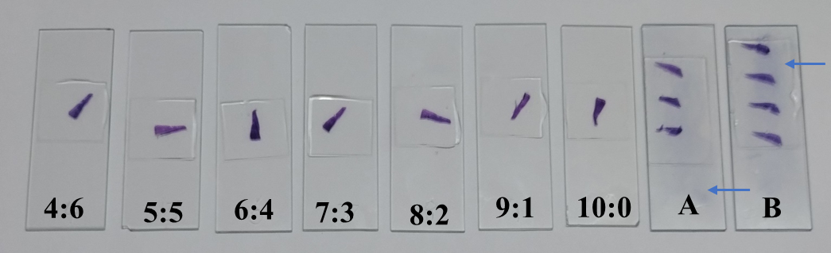
Figure 3. Shown Opuntia vulgaris (4:6-10:0) no stain background but the egg albumin (A) and Aloe vera (B) adhesives tissue sections shown staining background, the arrow indicated the staining artefact by using H/E staining.
Table 2. Opuntia vulgaris adhesiveness effects evaluated by H/E
% of extract dilution | Tissues Adhesiveness | Tissues structural changes | Stain background
1:9 | Not-effective | - | -
2:8 | Not-effective | - | -
3:7 | Not-effective | - | -
4:6 | Effective | Un-altered | Not found
5:5 | Effective | Un-altered | Not found
6:4 | Effective | Un-altered | Not found
7:3 | Effective | Un-altered | Not found
8:2 | Effective | Un-altered | Not found
9:1 | Effective | Un-altered | Not found
10:00 | Effective | Un-altered | Not found
Egg albumin | Effective | Un-altered | Found
Alo vera | Effective | Un-altered | Found

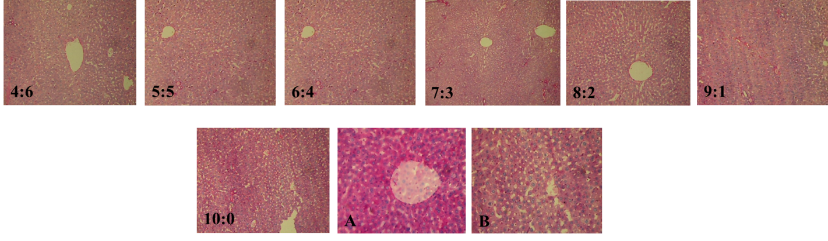
Figure 4. Opuntia vulgaris (4:6 – 10:0) shows clear staining background, egg albumin (A) and Aloe vera (B) stained slides shown background stain in H/E staining.
Earlier study in our laboratory shown xerophytic plant had potential to tissue adhesive and in the present investigation comparative evolution was undertaken with egg albumin and Aloe vera formulations. Pervious study Aloe vera and egg albumin formulation reported that stained tissue slides had staining background and in the present investigation also noticed stain background in the egg albumin coated tissue section slide (8-10). Present study we reporting that Opuntia vulgaris extract suggestive alternative for egg albumin slide tissue section adhesive in histology laboratory.
CONCLUSION
Our study is the first to reporting use Opuntia vulgaris extract a novel source for histology slide tissue section adhesive. Compared to egg albumin and Aloe vera tissue section adhesives coted slides the Opuntia vulgaris extract coted histology slide tissue section noted absence of background staining greatly valued in histology laboratory diagnostic outcome.
Acknowledgments
The authors acknowledge the Department of Biochemistry and Molecular Biology, Pondicherry University, Puducherry for provided facilities to carry out in this work.
REFERENCES
1. Rastogi A. Changing role of histopathology in the diagnosis and management of hepatocellular carcinoma. World journal of gastroenterology. 2018 Sep 9;24(35):4000.
2. Sompuram SR, McMahon D, Vani K, Ramanathan H, Bogen SA. A novel microscope slide adhesive for poorly adherent tissue sections. Journal of histotechnology. 2003 Jun 1;26(2):117-23.
3. Priman J. Blood serum as an adhesive for paraffin sections. Stain Technology. 1954 Jan 1;29(3):105-7.
4. Bissing DR. Haupt's gelatin adhesive mixed with formalin for affixing paraffin sections to slides. Stain Technology. 1974 Jan 1;49(2):116-7.
5. Bancroft JD, Gamble M, editors. Theory and practice of histological techniques. Elsevier health sciences; 2008.
6. Luna LG. Manual of histologic staining methods of the armed forces institute of pathology. McGrow-Hill book company. 1968.
7. Velan Athithan, Kotteazeth Srikumar. Phytohormone induced changes on bone histology in normal and diabetic male rat. Int J Pharm Pharm Sci 2017;9(2):287-291.
8. Velan Athithan. CEREUS PTEROGONUS PLANT CLADODE EXTRACT A NOVEL TISSUE SECTION ADHESIVE IN HISTOPATHOLOGY LABORATORY. International Journal of Scientific Research. 2024;13(10):74-76.
9. Al-Shammary HA. An inexpensive alternative to routine section adhesives for histology: the mucilaginous substance of the Assyrian plum. Biotechnic & Histochemistry. 2014 May 1;89(4):256-8.
10. Sood R. Medical laboratory technology. JAYPEE BROTHERS PUBLISHERS; 2005.
11. Kumar GN, Srikumar K. Biophysical characterization of thermophilic laccase from the xerophytes: Cereus pterogonus and Opuntia vulgaris. Cellulose. 2013 Feb;20(1):115-25.
12. Chan JK. The wonderful colors of the hematoxylin–eosin stain in diagnostic surgical pathology. International journal of surgical pathology. 2014 Feb;22(1):12-32.

