From an Infection to a Catastrophe: A COVID-19 Epidemiological Assessment of the Philippines from January 1 to March 13 of 2022 and 2023
Lopez, Blessie Grace J., Cepe, Blezy Rose A., Gacutan, Stella Marie Y., Gallano, Hugh Angelo A., Garcia, Hannah Jane P., Leong-on, Ma. Socorro G., Jamili, JC John T.
College of Pharmacy and Medical Technology, University of San Agustin, Iloilo, Philippines

ABSTRACT
This epidemiological assessment analyzes the COVID-19 situation in the Philippines from January 1 to March 13 of 2022 and January 1 to March 13 of 2023. The study evaluates six epidemiological parameters: incidence, prevalence, total cases, daily deaths, total deaths, and daily case fatality rate. Publicly available data from the Department of Health (DOH), World Health Organization (WHO), Worldometer, and Andra Farm were utilized for comparison. Findings reveal that 2022 recorded significantly higher daily incidence in the thousands compared to 2023, where cases were mostly in the hundreds or below. Prevalence ranged from 17,000 to 291,000 in 2022, while in 2023 it ranged from 8,000 to 13,000. Total cases increased by 823,408 from January 1 to March 13, 2022, compared to only 13,223 during the same period in 2023. A total of 6,065 deaths were recorded from January to March 13, 2022, whereas 820 deaths were recorded during the same period in 2023. The highest daily case fatality rate was 0.75% on January 1, 2022, and 0.67% in 2023. The data demonstrate a marked decline in COVID-19 severity in 2023 compared to 2022, potentially attributed to increased vaccination coverage, improved case management, and adherence to minimum public health standards. Despite declining trends, continued vigilance remains necessary.
Keywords: COVID-19, Philippines, epidemiological trends, incidence, prevalence, case fatality rate

INTRODUCTION
Maintaining a safe and healthy environment is essential to protect individual well-being. The Organization for Economic Co-operation and Development (OECD) states that exposure to both ambient and indoor air pollution elevates the risk of cardiovascular, respiratory, and developmental illnesses, increases premature mortality, and heightens vulnerability to COVID-19.
COVID-19, caused by the novel coronavirus SARS-CoV-2, emerged in Wuhan, China, and rapidly evolved into a global pandemic and public health emergency. The pandemic resulted in millions of confirmed cases worldwide and hundreds of thousands of deaths, generating unprecedented health and economic disruptions. These circumstances underscored the urgency for effective preventive strategies, diagnostic tools, and treatment modalities to reduce the impact of COVID-19 on individuals and communities.
Scientific investigations have focused on understanding SARS-CoV-2 transmission and identifying measures to control the spread. Research findings have played a critical role in guiding public health policies, strategies, and interventions. The pandemic has also emphasized the indispensable role of healthcare systems and frontline healthcare workers in outbreak response and in maintaining access to quality care.
By 2023, the Philippines began transitioning toward normalcy following the outbreak in 2020. Educational institutions, public events, and large gatherings resumed operations, although adherence to health protocols remained necessary, especially in crowded environments. The Department of Health (DOH) reported a continued decline in COVID-19 cases as epidemiologists observed the reduction of the Omicron subvariant across many regions. Infectious disease expert Dr. Rontgene Solante stated that the most severe phase of the Omicron surge had subsided in most areas, though potential future surges in 2023 remained possible.
Multiple factors contributed to the decrease in cases, including increased vaccination coverage, implementation of social distancing and quarantine protocols, improvements in healthcare infrastructure, and public awareness campaigns encouraging mask usage and hand hygiene. Expanded testing and contact tracing also helped contain localized outbreaks. While natural immunity from prior exposure may have played a role, reliance solely on natural immunity poses significant risks and may trigger future outbreaks. Sustained vaccination efforts and continued preventive measures remain essential to minimize resurgence and prevent new variant emergence.

RESULTS AND DISCUSSION
Incidence
Incidence refers to the number of newly reported COVID-19 cases within a defined population over a specified period, serving as a key indicator of ongoing disease transmission and epidemic dynamics. In this study, daily incidence values were derived from reported COVID-19 case counts from January 1 to March 13, 2022, and 2023.
Figure 1. Incidence cases of 2022 and 2023 for dates January 1 to March 13

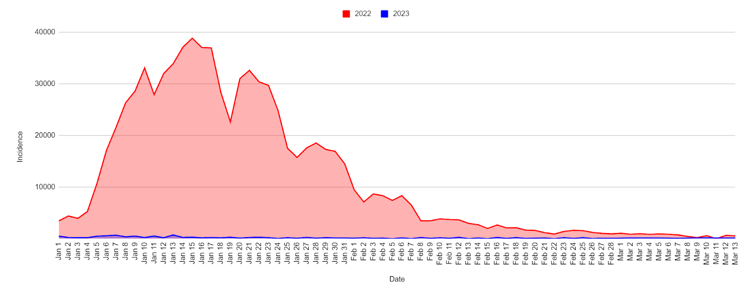
During 2023, daily incidence ranged from 0 to 730 cases, with 730 cases recorded on January 13, representing the highest daily incidence within the observation period. Conversely, zero cases were reported on February 13, 15, and 22, 2023, reflecting temporary interruptions in reported transmission or potential reporting delays. From January to early February 2023, daily incidence showed a general upward trend interspersed with short-term fluctuations. Around February 5, a notable decline was observed, followed by a further drop on February 7. After this period, incidence gradually increased, reaching a secondary peak around February 12. Following mid-February, daily case counts declined and stabilized, remaining consistently below 180 cases per day from February 17 to March 13, 2023.
Several short-term increases were also documented, notably on February 14 (134 cases), February 16 (251 cases), February 18 (216 cases), and February 23 (209 cases). These episodic rises may reflect localized transmission events, testing variability, or delayed reporting, consistent with observations from Our World in Data regarding reporting lags and batch validation of case records. Overall, the 2023 incidence profile demonstrates substantial day-to-day variability but a general declining trend, indicating effective epidemic control.
In comparison, daily incidence in 2022 was markedly higher, with counts consistently in the thousands, particularly during early January. The incidence curve for 2022 reflects the Omicron-variant-driven surge, characterized by rapid viral transmission and widespread community exposure. Although incidence began to decline toward the latter part of the study period, daily case counts in 2022 remained significantly higher than those observed in 2023.
The stark contrast between the two years highlights a substantial reduction in disease transmission during 2023, likely attributable to expanded vaccination coverage, improved population immunity, strengthened public health interventions, and continued adherence to minimum public health standards, including mask-wearing, physical distancing, and hygiene protocols (Department of Health [DOH], 2023; World Health Organization [WHO], 2023).
Prevalence
Prevalence refers to the total number of active COVID-19 cases at a specific point in time, reflecting the current disease burden within the population. Prevalence is influenced by incident cases, recovery rates, and mortality, and may therefore increase or decrease over time.
Figure 2. Prevalence cases of 2022 and 2023 for dates January 1 to March 13

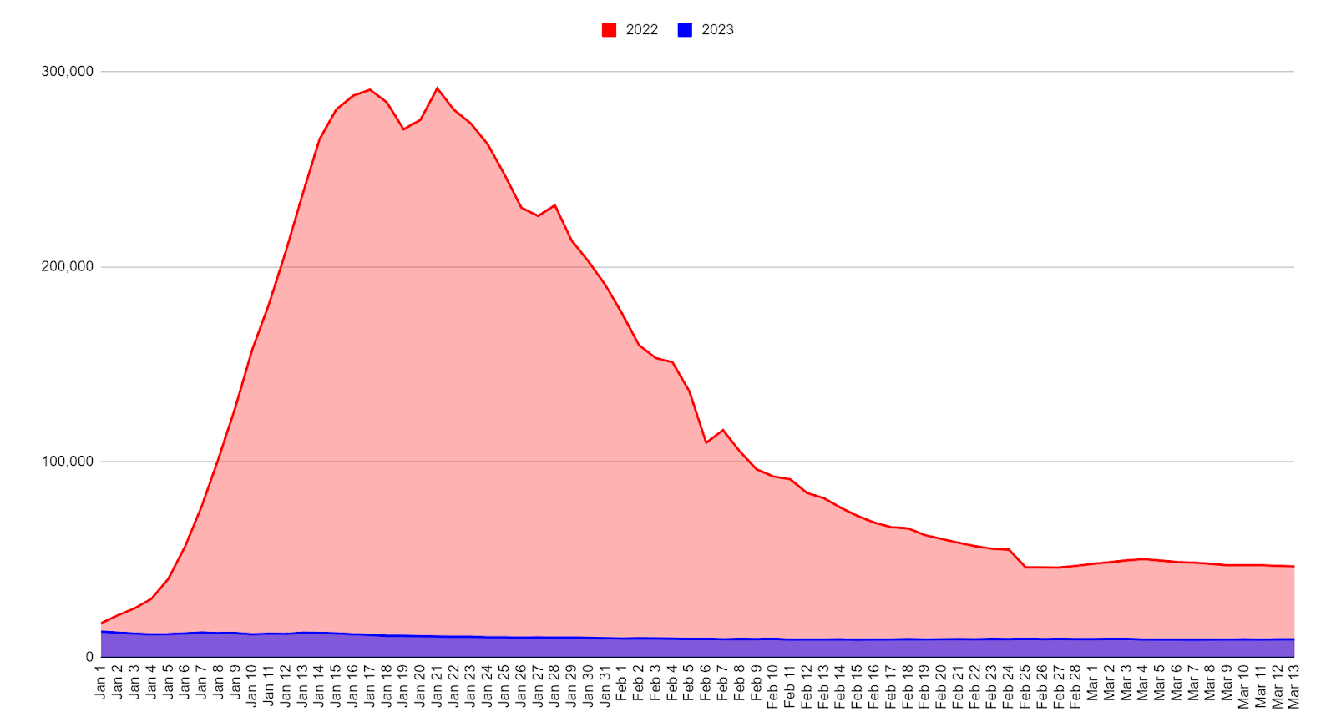
On January 1, 2022, the Philippines recorded 17,378 active cases. This figure rose dramatically, reaching the second-highest peak on January 17, 2022, followed by a slight decline and a subsequent absolute peak on January 21, 2022, with approximately 291,000 active cases. Thereafter, prevalence generally trended downward, with occasional fluctuations, until March 13, 2022.
In contrast, prevalence in 2023 demonstrated a consistently declining pattern. On January 1, 2023, active cases were recorded at 13,806, with a steady decrease observed throughout the study period. From January 30 to March 13, 2023, prevalence stabilized at approximately 9,000 active cases, with minor transient increases observed on February 11, February 15, and March 5–8, 2023.
Comparative analysis reveals a substantial difference in disease burden between the two years, with prevalence ranging from 17,000 to 291,000 cases in 2022, compared to only 8,000 to 13,000 cases in 2023. This dramatic reduction underscores the effectiveness of nationwide vaccination campaigns and public health measures. According to the Embassy of the Philippines, by February 2023, 67,928,954 individuals (60.9% of the population) had received at least one vaccine dose, 62,199,764 (55.7%) were fully vaccinated, and 9,489,120 (8.5%) had received booster doses. Furthermore, the Philippine News Agency reported that 94.5% of the target population had been vaccinated as early as 2023, likely contributing significantly to the observed decline in prevalence.
Nevertheless, the Department of Health (DOH) cautions that actual prevalence may be underestimated, as many individuals opt for self-testing using antigen kits or forego confirmatory testing, thereby limiting official case reporting.
Total Cases
Figure 3. Cumulative cases of 2022 and 2023 for dates January 1 to March 13

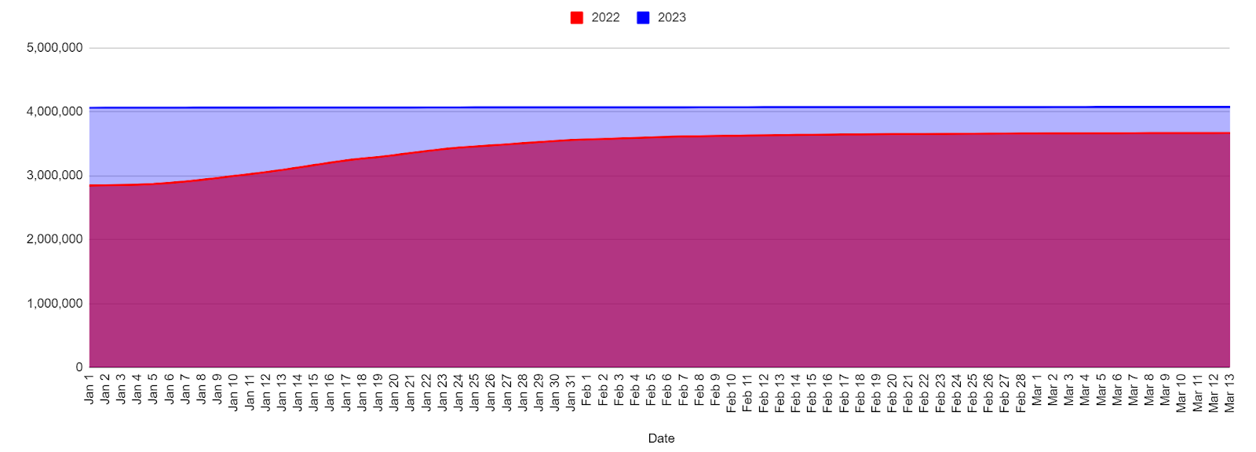
Total cases represent the cumulative number of laboratory-confirmed COVID-19 infections, regardless of recovery or mortality. On January 1, 2022, cumulative cases stood at 2,847,331. By March 13, 2022, total cases had risen to 3,670,739, reflecting an increase of 823,408 cases over a 72-day period. This steep rise coincided with the Omicron surge, characterized by high transmissibility and widespread community exposure.
In comparison, cumulative cases in 2023 increased modestly from 4,064,804 on January 1 to 4,078,027 on March 13, corresponding to a net increase of only 13,223 cases. Notably, no increase in cumulative totals occurred on February 14–15 and February 21–22, coinciding with zero reported incidence on these dates.
The markedly slower increase in total cases in 2023 reflects substantial epidemic control, likely driven by high vaccination coverage, improved public health compliance, and strengthened healthcare system preparedness. A direct proportional relationship between daily incidence and total cases is evident, as days with zero incidence corresponded to unchanged cumulative totals, while days with higher incidence resulted in abrupt increases, exemplified by the surge in cumulative cases following February 16, 2023 (251 new cases)
Daily Deaths
Daily deaths represent the number of fatalities attributed to COVID-19 reported per day, serving as a key indicator of disease severity and healthcare system performance. In 2023, daily deaths ranged from 0 to 88, with the highest daily mortality recorded on January 1, 2023, at 88 deaths. From January 1 to January 5, deaths declined from 88 to 6, followed by zero deaths on January 6 and 7. Mortality then rose to 25 deaths on January 8, with fluctuating values between 4 and 20 deaths, culminating in a secondary peak of 64 deaths on January 15. During late January, daily deaths remained variable, reaching a peak of 32 deaths on January 29.
Figure 4. Daily deaths cases of 2022 and 2023 for dates January 1 to March 13
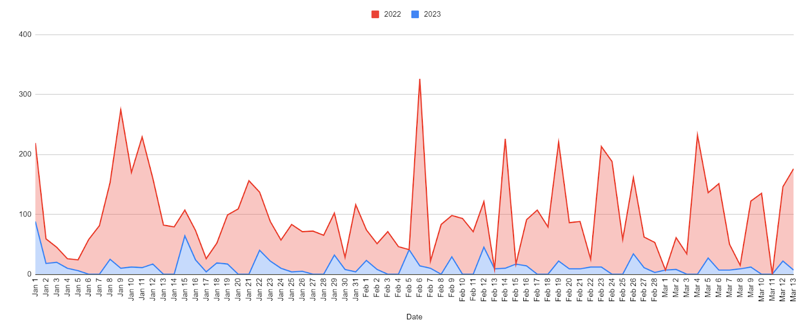
In February, an overall declining trend was observed, with multiple days reporting zero deaths, although isolated increases occurred, including 45 deaths on February 12 and 34 deaths on February 26. March followed a similar pattern, characterized by generally low daily deaths interspersed with minor fluctuations. These irregular patterns likely reflect reporting delays, retrospective data adjustments, and batch updates, consistent with observations from Our World in Data.
By contrast, daily deaths in 2022 were substantially higher, peaking at 264 deaths on January 9, 2022, with consistently elevated mortality throughout the study period and no zero-death days recorded. Both years demonstrated a declining mortality trend from January to March; however, the decline in 2023 was markedly steeper and more sustained. According to the Department of Health (DOH), the lower mortality in 2023 is attributed to reduced incidence of severe disease, enhanced hospital preparedness, improved case management strategies, availability of antiviral therapies, and high vaccination coverage.
Total Deaths
From January 1 to March 13, 2022, cumulative COVID-19 deaths in the Philippines increased by 6,065, reflecting substantial mortality during the Omicron surge. In contrast, during the same period in 2023, cumulative deaths rose by only 820, with totals increasing from 65,397 to 66,217. This marked reduction in mortality underscores the combined effects of widespread vaccination, improved clinical care, enhanced hospital readiness, and increased public awareness.
Figure 5. Total deaths cases of 2022 and 2023 for dates January 1 to March 13

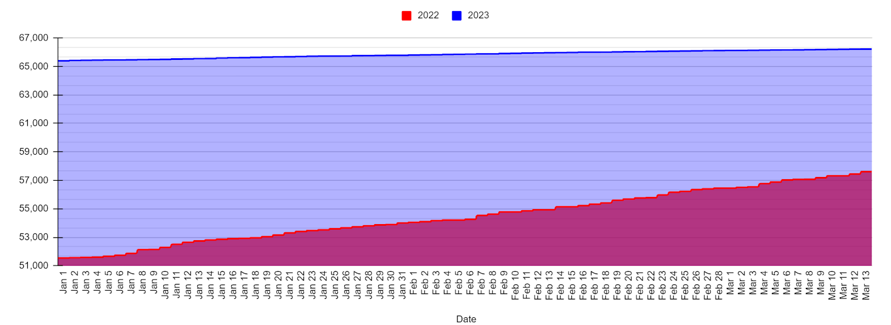
The higher total deaths in 2022 compared to 2023 can be attributed to the greater severity and rapid spread of COVID-19 during that year. Supporting this, the study “Excess Deaths Associated with the COVID-19 Pandemic in the Philippines” by Kristine Joy S. Briones and Michael Dominic C. del Mundo, in collaboration with UNFPA, indicates that confirmed COVID-19 deaths are only part of the picture. The study also considers deaths among suspected COVID-19 patients who were either untested or received inconclusive results, increased fatalities from other causes due to a weakened healthcare system, deaths of individuals who avoided or were unable to access hospital care or received insufficient funding for treatment, and reductions in deaths from other causes resulting from mobility restrictions.
Daily Case Fatality Rate
Figure 6. Daily case fatality rate of 2022 and 2023 for dates January 1 to March 13

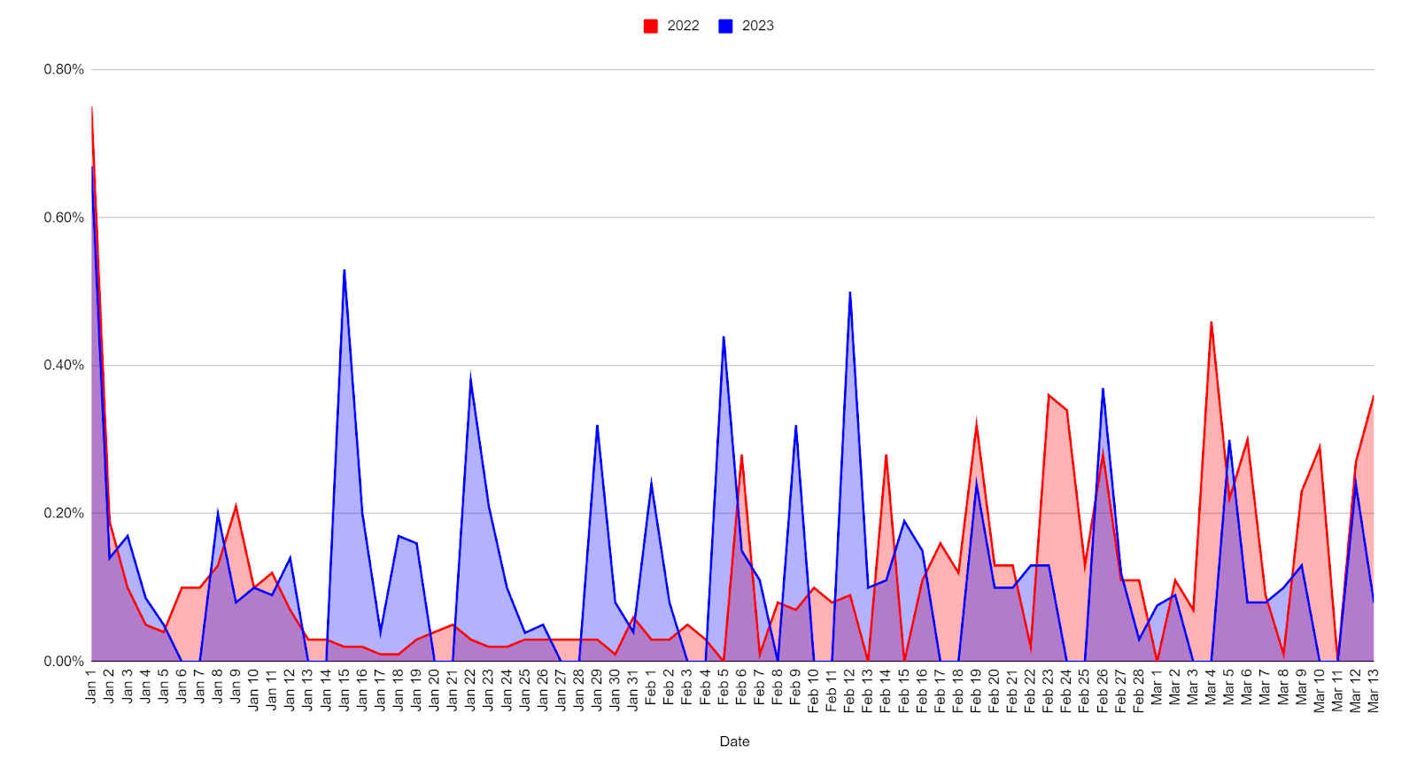
The daily case fatality rate (CFR) represents the proportion of daily deaths relative to the number of active COVID-19 cases. In 2023, CFR values ranged from 0% to 0.67%, with the highest rate recorded on January 1, coinciding with the peak daily death count of 88. Several dates reported a CFR of 0%, reflecting days with zero daily mortality.
In comparison, 2022 experienced higher CFR values, reaching 0.75% on January 1, 2022, and maintaining elevated levels throughout much of the study period. Notably, March 4, 2022, recorded 131 deaths, contributing to a high daily CFR. Daily CFR values are inherently influenced by fluctuations in both daily deaths and the number of active cases, resulting in variable patterns. A clear relationship exists between daily deaths and CFR, with higher mortality corresponding to elevated CFR values.
However, CFR may underestimate the true fatality risk due to under-detection of mild and asymptomatic cases, reporting delays, and testing variability. Despite these limitations, the lower CFR observed in 2023 reflects improvements in case detection, clinical management, vaccination coverage, and therapeutic availability, all of which help mitigate disease severity and mortality.

CONCLUSION

This comparative epidemiological assessment of COVID-19 in the Philippines from January 1 to March 13, 2022 and 2023 provides a comprehensive evaluation of temporal trends in incidence, prevalence, cumulative cases, daily deaths, total mortality, and daily case fatality rate (CFR), offering critical insights into the evolving dynamics of the pandemic and the effectiveness of public health interventions.

The findings demonstrate a substantial and consistent decline across all epidemiological parameters in 2023 compared with 2022, reflecting marked improvements in pandemic control. In 2022, the Philippines experienced a high-transmission phase dominated by the Omicron variant, characterized by daily incidence consistently in the thousands, peak prevalence approaching 291,000 active cases, cumulative case increases exceeding 823,000 within 72 days, daily deaths reaching as high as 264, and total deaths amounting to 6,065. These indicators collectively reflected widespread community transmission, significant healthcare system strain, and elevated mortality risk, particularly among vulnerable populations.

In contrast, 2023 exhibited markedly reduced transmission intensity and disease burden. Daily incidence was limited to a maximum of 730 cases, prevalence stabilized between 8,000 and 13,806 active cases, cumulative case increases were restricted to only 13,223, daily deaths ranged from 0 to 88, and total deaths totaled only 820. Additionally, daily CFR values in 2023 consistently remained below 0.67%, compared with higher and more variable CFR values in 2022, signifying improved clinical outcomes and reduced disease severity.

These pronounced improvements can be attributed to the combined effects of extensive nationwide vaccination coverage, booster dose administration, increasing population-level immunity, enhanced diagnostic capacity, improved clinical management protocols, and sustained implementation of minimum public health standards. High vaccine uptake, particularly among high-risk populations, substantially reduced severe disease, hospitalization rates, and mortality, while improved hospital preparedness and treatment availability strengthened healthcare system resilience.

Despite these encouraging trends, persistent challenges remain, including underreporting of mild and asymptomatic cases, reduced confirmatory testing, and reporting delays, which may contribute to underestimation of the true disease burden. Moreover, the potential emergence of novel SARS-CoV-2 variants, waning immunity, and relaxation of public health measures pose ongoing risks for future resurgences, underscoring the need for continued epidemiological surveillance and adaptive public health strategies.

Overall, this study underscores the critical role of integrated pandemic response strategies—particularly vaccination, surveillance, healthcare system strengthening, and evidence-based public health interventions—in mitigating the impact of COVID-19. The findings provide valuable epidemiological evidence to guide policy formulation, resource allocation, and preparedness planning, offering a robust framework for managing future infectious disease outbreaks in the Philippines and comparable low- and middle-income country settings.

REFERENCES

- Andra Farm. (n.d.). Summary of the development of the COVID-19 (Coronavirus) cases in the Philippines: Details of the Coronavirus cases in Philippines each day. Retrieved from https://m.andrafarm.com/_andra.php?i=daftar-corona&__en=ENGLISH&noneg=140&urut=2&asc=01100000000
- Department of Health. (2022, April 14). DOH continuous decline in MPHS compliance could lead to as high as half a million active COVID-19 cases. DOH. Retrieved May 17, 2023, from https://doh.gov.ph/press-release/DOH-CONTINUOUS-DECLINE-IN-MPHS-COMPLIANCE-COULD-LEAD-TO-AS-HIGH-AS-HALF-A-MILLION-ACTIVE-COVID-19-CASES
- Department of Health (DOH), Philippines COVID-19 Tracker. Retrieved from https://doh.gov.ph/covid19tracker
- Mathieu, E., et al. (2020). Coronavirus pandemic (COVID-19). Our World in Data. Retrieved from https://ourworldindata.org/coronavirus
- Khachfe, H. H., Chahrour, M., Sammouri, J., Salhab, H., Makki, B. E., & Fares, M. (2020, March 18). An epidemiological study on COVID‑19: A rapidly spreading disease. Cureus, 12(3), e7313. https://doi.org/10.7759/cureus.7313
- Worldometer. (n.d.). Philippines COVID-19 coronavirus. Retrieved from https://www.worldometers.info/coronavirus/country/philippines/

