FINITE ELEMENT MODELING AND ANALYSIS OF HOT TURNING OPERATION
Anandan Kanagaraj¹, Arun Gopi², Saravanan Durai³, RajkumarIlamurugan⁴.
^{1, 2, 3&4} Department of Mechanical Engineering, P S V College of Engineering and Technology,Krishnagiri.
TamilNadu India.
*Corresponding author: anandandmeena@gmail.com; Tel: +9444494360; Fax: +9445055991
HIGHLIGHTS
- Hot turning reduces cutting forces and tool wear rate for high manganese steel
- FEM analysis predicts temperature, effective strain and stress at chip-tool interface
- Chip-tool interface temperature increases with higher cutting speed
- Workpiece preheating to 600°C significantly reduces tool wear compared to 200°C
- DEFORM-2D and ANSYS successfully simulate hot turning of hard-to-cut materials

ABSTRACT
Hot turning is an effective machining technique for hard-to-cut materials such as high manganese steel, wherein the workpiece is preheated prior to cutting to reduce shear strength and improve machinability. In this study, finite element modeling (FEM) and analysis of hot turning operation were performed using DEFORM-2D and ANSYS software. The workpiece material was high manganese steel (Hadfield steel) with a cylindrical geometry of 500×50 mm. Experimental trials were conducted on a central lathe with flame (LPG+O₂) heating at temperatures of 200°C and 600°C under varying cutting speeds (21 and 43 m/min), feeds (0.05 and 0.7 mm/rev), and depths of cut (0.5 and 1.5 mm). Temperature distribution across the workpiece was modeled using computational fluid dynamics (CFD), and chip-tool interface parameters including temperature, effective strain, and effective stress were analyzed. Tool wear rate was also assessed through FEM contour plots. Results show that increasing workpiece temperature from 200°C to 600°C decreases cutting forces and tool wear rate, while chip-tool interface temperature increases with cutting speed. Effective strain decreases with increasing cutting speed but increases with workpiece temperature. The study confirms that hot machining is a viable and economical approach for processing hard materials that are difficult to machine under conventional conditions.
Keywords: hot turning; finite element modeling; high manganese steel; chip-tool interface; tool wear; DEFORM-2D

- INTRODUCTION
With the advent of mass production technology, metal cutting processes have become indispensable to modern manufacturing. A significant proportion of material is lost as chips or scrap during these operations, and selecting appropriate tooling and cutting conditions is critical to minimizing costs and improving product quality [1]. From an industrial perspective, machinability and its economic implications remain central concerns for researchers and process engineers alike [2].

Manufacturing industries continuously seek to reduce operating costs while improving product quality. In metal cutting, quantitative estimation of tool life, cutting forces, power consumption, and surface finish is essential for the design and optimization of machine tools and cutting tools. Tool wear, in particular, is one of the most critical factors affecting production continuity [2].

Over the past two decades, there has been growing industrial interest in the machining of hard-to-cut materials, particularly superalloys and high-strength steels required by the aerospace, defense, chemical, and nuclear industries [3,4]. These materials demand high dimensional accuracy and satisfactory surface quality, and their processing presents significant challenges. In conventional machining, achieving satisfactory surface finish and tool life with high-strength, corrosion-resistant, and wear-resistant materials requires expensive cutting tools, and non-conventional processes are often limited to low material removal rates [4].

Hot machining offers an attractive alternative for bulk material removal from hard-to-cut materials. By preheating the workpiece, the material's shear strength is reduced, cutting forces decrease, and the machinability improves substantially [5]. This paper presents a finite element modeling (FEM) and analysis approach to hot turning of high manganese steel, examining temperature distribution, chip-tool interface behavior, effective strain, effective stress, and tool wear rate under varying process conditions.

- HOT MACHINING
Hot machining was first introduced by Tigham in 1889, and since then it has attracted considerable interest among researchers and industry practitioners. In this method, the workpiece is preheated before the cutting operation to reduce its shear strength, making it easier to machine and thereby reducing tool wear and cutting forces [5]. Softening the workpiece through preheating is considered more effective than simply strengthening the cutting tool, as is done in conventional machining.

Earlier research demonstrated that proper selection of the heating method can eliminate undesirable metallurgical changes in the workpiece while reducing machining costs. For machining hard steels, the cutting tool material must still be harder than the workpiece; however, preheating reduces the severity of the machining conditions substantially [4]. The principal effects of hot machining include:
- Increased tool life
- Reduced cutting forces
- Lower power consumption
- Greater productivity due to higher material removal rate (MRR)
- Reduced strain hardenability and flow stresses in the workpiece
- Reduced wear and abrasion of the cutting tool
- Improved surface quality
- Especially effective for brittle ceramic materials

2.1 Materials
Materials commonly processed by hot machining include: hardened steel, high manganese steel, Ni-Hard steel (NH4), superalloys, high chromium white cast iron, ceramic materials, Hyper-Chrome cast iron alloys, Cr-Mo white cast iron, stainless steel, S-816 alloy, X-alloy, Timken 16-25-6, Navy grade steel, Inconel-X, Ni-Cr steel, and alloys of tungsten, molybdenum, titanium, and tantalum.

2.2 Heating Methods
Successful hot machining requires a suitable heating method that limits the heat-affected zone to the immediate cutting area, prevents excessive penetration into the workpiece bulk, and avoids metallurgical changes from overheating. Methods available for preheating the workpiece include:
- Furnace heating
- Resistance heating
- Flame heating (oxy-acetylene, oxy-LPG)
- Arc heating
- Plasma arc heating
- Induction heating
- Laser-assisted heating
- Radio frequency heating

Key requirements for workpiece heating include: localization of heat at the cutting zone just ahead of the cutting edge; limitation of heat to a small area to control dimensional accuracy; avoidance of metallurgical changes or contamination on the machined surface; ability to provide rapid temperature response at the tool face; low initial investment and operating costs; operator safety; and accurate temperature control [5].

- FINITE ELEMENT ANALYSIS
Finite Element Analysis (FEA) was developed in 1943 by R. Courant, who applied the Ritz method of numerical analysis and variational calculus to obtain approximate solutions for vibration problems. A landmark 1956 paper by Turner, Clough, Martin, and Topp established a broader definition of numerical analysis centered on the stiffness and deformation of complex structures [6].

FEA consists of a computer model of a material or structural design that is stressed and analyzed for specific results. It is used in both the design of new products and the refinement of existing ones, enabling verification of proposed designs against specifications prior to fabrication. In the case of structural failure, FEA can be used to determine necessary design modifications [6].

Two primary modeling approaches exist in industry: 2D modeling, which conserves computational resources but provides less accurate results, and 3D modeling, which yields higher accuracy at greater computational cost [6]. In the context of metal cutting, two formulation types are used to describe the continuous medium: Lagrangian and Eulerian. The Lagrangian formulation, in which the mesh deforms with the material, is widely used because it can simulate chip formation stages including entry, exit, intermittent, and discontinuous chip formation. The Eulerian formulation, in which the grid is fixed in space, avoids mesh distortion but cannot simulate intermittent or discontinuous chip formation [9].

Commercial FEM software used in metal cutting research includes NIKE2, ABAQUS/Standard, MARC, ABAQUS/Explicit, DEFORM-2D, FLUENT, FORGE-2D, ALGOR, and LS-DYNA [7]. In this study, ANSYS and DEFORM-2D were employed for modeling and analysis.

- LITERATURE REVIEW
Research in metal cutting spans more than a century. Cocquilhat [10] conducted early investigations into drilling in 1851, and Tresca [11] first attempted to explain chip formation mechanisms in 1873. Ernest and Merchant developed the first simplified cutting model in 1941, which was subsequently refined by Lee and Shaffer [12] and Kobayashi and Thomsen [13]. Oxley and Welsh [14] introduced the first parallel-sided shear zone model for a predictive theory of chip formation.

The application of FEM to metal cutting began with Klamecki [15], who developed one of the first 3D Lagrangian elasto-plastic finite element models in 1973. Usui and Shirakashi [16] produced the first 2D FE simulation of orthogonal machining using an iterative convergence method in 1982. Strenkowski and Carroll [17] developed a numerical model for orthogonal cutting without a preformed chip using large deformation updated Lagrangian formulation in 1985. Komvopoulos and Erpenbeck [18] investigated chip formation using a tolerance criterion for chip separation in 1991, and Lin and Lin [19] studied residual stresses and temperature distribution using a deformation energy separation criterion in 1992.

With advances in hardware and commercial FEM codes, Ceretti [20] developed a model that eliminated elements upon reaching a critical damage value. Bil et al. [21] compared three commercial FEM codes (MSC Marc, Third Wave Advantage, and DEFORM-2D) for 2D metal cutting simulation. Özel [22] and Filice et al. [22] used DEFORM-2D to study friction model effects on cutting results. Attanasio et al. [23] incorporated advanced tool-chip interface heat transfer modeling in 3D deformation analysis, and Davim and Maranhao [24] investigated plastic deformation and strain rate effects during high-speed machining using MSC Marc.

- EXPERIMENTAL SETUP
The experiment was conducted on a central lathe equipped with an automated flame heating arrangement. The workpiece comprised a cylinder of 500×50 mm made of high manganese steel. Turning was performed using an SNMG carbide insert. Heating was achieved with an LPG+O flame torch mounted on a servo-motor-driven shaft, with a thermocouple-based feedback system maintaining the workpiece surface temperature to the desired set point. This ensured uniform and consistent heating across a 10 mm zone along the circumference. A thermocouple with analog-to-digital signal conversion displayed temperature continuously; the torch automatically withdrew and re-engaged as temperature fell, maintaining a steady heat source.

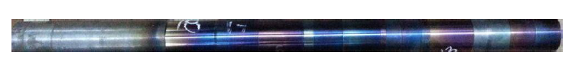  1. (a) Workpiece | 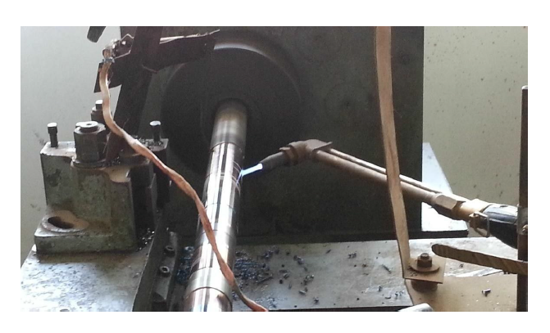  1.(b)Tool
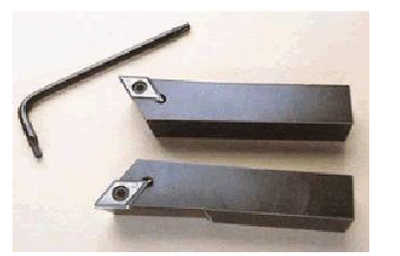  1.(c) Torch heating the workpiece | 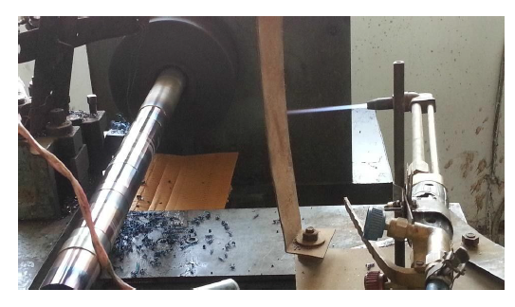  - (d)Torch withdrawn

Figure 1 (a) (b) (c) and (d) Experimental Setup

5.1 Workpiece Material Properties
Table 1. Chemical composition of high manganese steel workpiece (wt.%)
C | Si | Mn | S | P | Cr | Fe
1.13 | 0.40 | 13.0 | 0.003 | ≤0.20 | 1.6 | 84.23

Table 2. Mechanical properties of high manganese steel workpiece
Property | Value
Brinell Hardness No. | 220
Yield Strength | 380 MPa
Ultimate Tensile Strength | 940 MPa

Table 3. Physical properties of high manganese steel workpiece
Property | Value
Density | 7.88 g/cc
Expansion coefficient (0–600°C) | 21.5 × 10⁻⁶ /°C
Specific Heat | 502 J/kg°C
Electrical Resistivity | 75 μΩm
Thermal Conductivity | 13 W/m°C
Magnetic Permeability | 1.002

5.2 Experimental Design
Experiments were conducted across 16 runs with varying cutting speed (Vᴄ: 21 and 43 m/min), feed (S: 0.05 and 0.7 mm/rev), depth of cut (D: 0.5 and 1.5 mm), and workpiece temperature (200°C and 600°C), as presented in Table 4.

Table 4. Experimental conditions for hot turning trials
No. | Cutting Speed Vc (m/min) | Feed S (mm/rev) | Depth of Cut D (mm) | Temperature (°C)
1 | 21 | 0.05 | 0.5 | 200
2 | 21 | 0.05 | 0.5 | 600
3 | 21 | 0.7 | 0.5 | 200
4 | 43 | 0.05 | 0.5 | 200
5 | 21 | 0.7 | 0.5 | 600
6 | 43 | 0.05 | 0.5 | 600
7 | 21 | 0.05 | 1.5 | 200
8 | 21 | 0.7 | 1.5 | 600
9 | 43 | 0.7 | 0.5 | 200
10 | 21 | 0.7 | 1.5 | 200
11 | 43 | 0.7 | 0.5 | 600
12 | 43 | 0.7 | 1.5 | 600
13 | 43 | 0.7 | 1.5 | 200
14 | 21 | 0.05 | 1.5 | 600
15 | 43 | 0.05 | 1.5 | 200
16 | 43 | 0.05 | 1.5 | 600

- FINITE ELEMENT MODELLING AND ANALYSIS
6.1 Temperature Distribution of the Workpiece
The problem was defined as a cylindrical workpiece of 50 mm diameter and 500 mm length, rotating at 600 rpm in a turning center and continuously heated by a moving LPG+O₂ flame source. The FEM model was developed in CFD to determine temperature distribution across the workpiece, tool, and chip. The material properties used for modeling are listed in Table 5.

Table 5. Work material properties used in FEM simulation
Material | Density (kg/mm³) | Specific Heat Cp (J/kg·K) | Thermal Conductivity (W/mm·K)
High Manganese Steel | 7.8 × 10⁻⁶ | 420 + 0.67T | 0.05

Temperature distribution was analyzed along three paths at y = 0, y = -15, and y = -25 mm (x = 0 to 100 mm), and also from y = 0 to y = -25 mm along paths at x = 0, x = 25, and x = 50 mm. Table 6 presents the measured temperature variation with increasing distance from the heat-affected zone at a maintained surface temperature of 200°C.

Table 6. Temperature variation with distance from heat source at 200°C surface temperature
0 mm | 5 mm | 10 mm | 25 mm | 50 mm | 100 mm
200°C | 162°C | 105°C | 60°C | 37°C | 35°C

Note: A minor discrepancy was observed between simulated and experimental temperature profiles. The FEM model assumed a room temperature of 22°C, while the actual room temperature during experimentation exceeded 30°C.

6.2 Chip-Tool Interface Analysis
A representative point at the chip-tool interface was selected, and its temperature, effective strain, and effective stress were evaluated for different cutting speeds and workpiece temperatures, with feed (0.05 mm/rev) and depth of cut held constant. The cutting speeds were Vᴄ = 21 m/min and 43 m/min, and workpiece temperatures were 200°C and 600°C.

6.3 Chip-Tool Interface Temperature
The FEM results indicate that chip-tool interface temperature increases with increasing cutting speed, consistent with greater heat generation at higher material removal rates. This trend was observed at both workpiece temperature levels.
6.4 Effective Strain
Effective strain at the chip-tool interface decreases with increasing cutting speed when other parameters are held constant. However, for a given cutting speed, effective strain increases with increasing workpiece temperature, suggesting that higher temperatures enhance plastic deformation in the workpiece material during the cutting process.
6.5 Effective Stress
Effective stress at the chip-tool interface increases with increasing workpiece temperature. This is attributed to the greater degree of thermal softening and associated plastic flow in the workpiece material at elevated temperatures.
6.6 Tool Wear Rate
FEM contour plots of tool wear rate at 200°C reveal a localized high-wear region (indicated in red) near the tool cutting edge. When the workpiece temperature is increased to 600°C, this high-wear region disappears, confirming that higher workpiece temperatures lead to a measurable reduction in tool wear rate. Similarly, FEM analysis of cutting and thrust forces demonstrates that increasing workpiece temperature results in decreased cutting forces, consistent with experimental observations reported in the literature [5].

Table 6.Final variations distance and temperature
Distance from the source (in mm)  Temperature in o C | 0 | 5 | 10 | 25 | 50 | 100
Distance from the source (in mm)  Temperature in o C | 200 | 162 | 105 | 60 | 37 | 35
Distance from the source (in mm)  Temperature in o C | 0 | 12.5 | 25 | 37.5 | 50 | 62.5
Distance from the source (in mm)  Temperature in o C | 22 | 50 | 75 | 100 | 125 | 150
Distance from the source (in mm)  Temperature in o C | 0 | 12.5 | 25 | 37.5 | 50 | 62.5
Distance from the source (in mm)  Temperature in o C | 55.831 | 75 | 100 | 125 | 150 | 175
Distance from the source (in mm)  Temperature in o C | 0 | 4 | 8 | 12 | 16 | 20
Distance from the source (in mm)  Temperature in o C | 33.179 | 34 | 35 | 36 | 37 | 38
Distance from the source (in mm)  Temperature in o C | 0 | 4 | 8 | 12 | 16 | 20
Distance from the source (in mm)  Temperature in o C | 22.666 | 22.68 | 22.72 | 22.76 | 22.8 | 22.84
Distance from the source (in mm)  Temperature in o C | 0 | 4 | 8 | 12 | 16 | 20

Figure 2 Distance vs Temperature

Temperature Distribution  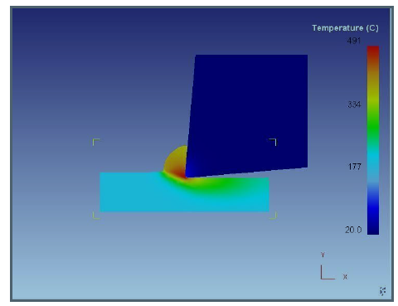  200 o C | Temperature Distribution  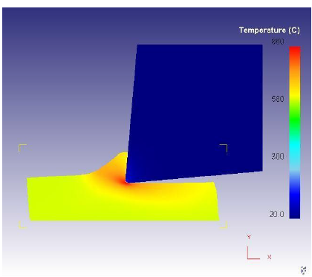  600 o C
Effective Strain  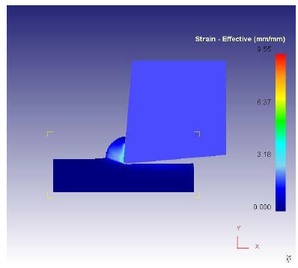  200 o C | Effective Strain  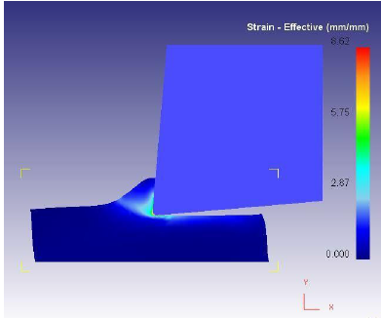  600 o C
Tool Wear Rate  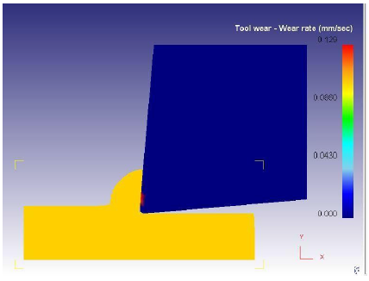  200 o C | Tool Wear Rate  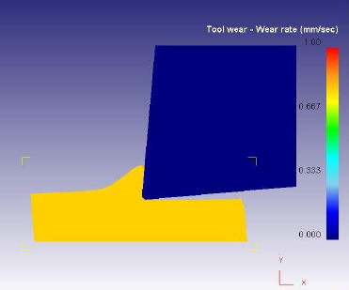  600 o C

Figure 3 Temperature distribution, strain, tool wear rate
- RESULTS AND DISCUSSION
The FEM simulation of the hot turning process on high manganese steel yielded the following principal findings:

Temperature distribution across the workpiece followed a clear gradient from the heat source outward, with the surface temperature dropping from 200°C to approximately 35°C at 100 mm from the source. This temperature gradient confirms that flame heating effectively localizes heat at the cutting zone, which is the primary requirement for hot machining.

Chip-tool interface temperature rose with cutting speed, which is consistent with known thermomechanical behavior in metal cutting: higher cutting velocities increase the rate of plastic deformation energy conversion to heat. At Vᴄ = 43 m/min, interface temperatures were higher than at 21 m/min for both workpiece temperatures tested.

The inverse relationship between effective strain and cutting speed is likely attributable to the reduced contact time at higher cutting velocities, which limits the duration of plastic deformation per unit length. Conversely, the positive relationship between workpiece temperature and effective strain reflects the greater ductility of the material at elevated temperatures.

The increase in effective stress with temperature may appear counterintuitive; however, it reflects the redistribution of stress within the material as thermal softening encourages larger deformation zones, increasing the overall stress state at the chip-tool interface under the FEM boundary conditions applied.

The most practically significant finding is the reduction of tool wear rate at 600°C relative to 200°C. The disappearance of the high-wear zone in FEM contour plots at the higher temperature confirms that hot machining provides real benefits in terms of tool life. This is consistent with the literature, which reports significant extensions in tool life when machining hard-to-cut materials at elevated temperatures [2,3,5]. Reduced cutting forces at higher temperatures further support the economic viability of the hot machining approach.

- CONCLUSION
The following conclusions are drawn from the finite element modeling and analysis of hot turning operation on high manganese steel:

- Chip-tool interface temperature increases with increasing cutting speed.
- Effective strain decreases with increasing cutting speed but increases with increasing workpiece temperature for a given cutting speed.
- Effective stress at the chip-tool interface increases with increasing workpiece temperature.
- Tool wear rate decreases significantly when workpiece temperature is increased from 200°C to 600°C.
- Cutting forces decrease with increasing workpiece temperature, confirming the machinability benefits of hot machining.
- Hot machining is a technically viable and economically advantageous process for hard-to-cut materials such as high manganese steel; however, it requires a suitable automated heating arrangement, trained personnel for flame handling, uniform heat distribution across the workpiece cross-section, and careful control of heating to avoid metallurgical changes in the work material.

9. NOMENCLATURE
D – Depth of cut (mm)
FEA – Finite Element Analysis
FEM – Finite Element Method
MRR – Material Removal Rate
S – Feed (mm/rev)
T – Temperature (°C)
Vᴄ – Cutting Speed (m/min)

- ACKNOWLEDGMENTS
The authors acknowledge the support of the Department of Mechanical Engineering and the use of laboratory facilities for experimental and simulation work.

11. REFERENCES
[1] E.O. Ezugwu, Int. J. Mach. Tools Manuf. 45 (2005) 1353–1367.
[2] N. Tosun, L. Ozler, J. Mater. Process. Technol. 124 (2002) 99–104.
[3] K.P. Maity, P.K. Swain, J. Mater. Process. Technol. 198 (2008) 344–349.
[4] M. Davami, M. Zadshakoyan, World Acad. Sci. Eng. Technol. 22 (2008).
[5] S. Ranganathan, T. Senthilvelan, Int. J. Adv. Manuf. Technol. 56 (2011) 455–462.
[6] www.sv.vt.edu/classes/MSE2094_NoteBook/97ClassProj/num/widas/history [accessed June 2013].
[7] J. Zouhar, M. Piska, Modelling the Orthogonal Machining Process Using Cutting Tools with Different Geometry, Technical Report (2007).
[8] T. Özel, E. Zeren, Finite Element Method Simulation of Machining of AISI 1045 Steel with a Round Edge Cutting Tool, Proceedings of ESDA (2004).
[9] C. Corina, D. Vlad, 3D FEM Analysis of Cutting Processes, Advances in Visualization, Imaging and Simulation (2010).
[10] M. Cocquilhat, Ann. Trav. Publ. En Belgium 10 (1851) 199.
[11] H. Tresca, Proc. I. Mech. E. Lond. 1 (1878) 301–345.
[12] E.H. Lee, B.W. Shaffer, J. Appl. Mech. 18 (1951) 405–413.
[13] S. Kobayashi, E.G. Thomsen, J. Eng. Ind. 84 (1962) 71–80.
[14] P.L.B. Oxley, M.J.M. Welsh, Proceedings of the Fourth International Conference on Machine Tool Design and Research 4 (1963) 73–86.
[15] B.E. Klamecki, Incipient Chip Formation in Metal Cutting - A Three Dimensional Finite Element Analysis, PhD Thesis, University of Illinois at Urbana-Champaign (1973).
[16] E. Usui, T. Shirakashi, ASME Publication PED 7 (1982) 13–55.
[17] J.S. Strenkowski, J.T. Carroll, Trans. ASME J. Eng. Ind. 107 (1985) 349–354.
[18] K. Komvopoulos, S.A. Erpenbeck, Trans. ASME J. Eng. Ind. 113 (1991) 253–267.
[19] Z.C. Lin, S.Y. Lin, J. Eng. Mater. Technol. 114 (1992) 31–48.
[20] E. Ceretti, P. Fallbohmer, W.T. Wu, T. Altan, J. Mater. Process. Technol. 59 (1996) 169–180.
[21] H. Bil, S.E. Kilic, A.E. Tekkaya, Int. J. Mach. Tools Manuf. 44 (2004) 933–944.
[22] L. Filice, F. Micari, S. Rizutti, D. Umbrello, Int. J. Mach. Tools Manuf. 47 (2007) 709–714.
[23] A. Attanasio, E. Ceretti, S. Rizzuti, D. Umbrello, F. Micari, CIRP Ann. Manuf. Technol. 57 (2008) 61–64.
[24] J.P. Davim, C. Maranhao, Mater. Des. 30 (2009) 160–165.

