Self-Efficacy as a Predictor of Clinical and Psychosocial Outcomes in Non-Communicable Disease Management: Evidence from Malawi

*Hope Herbert Nkhoma ¹, Associate Professor Mavuto Tembo ²

¹Lecturer and Head of Psychology at Malawi Assemblies of God University, Lilongwe, Malawi.
² Mzuzu University, Mzuzu, Malawi, Faculty of Environmental Science, Agri-Science Department
*Corresponding Author

Abstract
Background:
Non-communicable diseases (NCDs) are the leading cause of morbidity and mortality worldwide, with disproportionate effects in low- and middle-income countries. In Malawi, fragile health systems face challenges in managing NCDs, yet psychological determinants such as self-efficacy remain underexplored. Self-efficacy, defined as confidence in one’s ability to execute health behaviors, has been shown to predict adherence, quality of life, and engagement in Western contexts, but evidence from Sub-Saharan Africa is limited.
Methods:
A mixed-methods design was employed at Kamuzu Central Hospital, combining quantitative surveys (n = 150) with qualitative interviews (n = 30). Self-efficacy was measured using the General Self-Efficacy Scale, medication adherence with the Morisky Medication Adherence Scale (MMAS-8), quality of life with WHOQOL-BREF, and treatment engagement with a structured questionnaire. Regression analyses tested predictive relationships, controlling for demographic covariates, while thematic analysis explored lived experiences of adherence and engagement.
Results:
Self-efficacy significantly predicted medication adherence (β = .42, p < .01), quality of life (β = .38, p < .01), and treatment engagement (β = .45, p < .01). R² values indicated substantial variance explained (.38 for adherence, .32 for QoL, .41 for engagement). Qualitative findings reinforced these results, showing that patients with higher self-efficacy employed proactive coping strategies and relied on social support networks, while those with lower self-efficacy reported ambivalence and poor treatment participation.
Conclusion:
Self-efficacy is a robust predictor of both clinical and psychosocial outcomes in NCD management in Malawi. Integrating self-efficacy training into routine care, enhancing peer support programs, and designing gender-sensitive interventions can improve patient outcomes in resource-limited settings. These findings highlight empowerment as a central mechanism for transforming health systems and advancing culturally responsive chronic disease care in Sub-Saharan Africa.

Keywords: self-efficacy, non-communicable diseases, medication adherence, quality of life, treatment engagement, empowerment

Background of the Study
Non-communicable diseases (NCDs) have emerged as the leading cause of morbidity and mortality worldwide, accounting for over 70% of global deaths annually (World Health Organization [WHO], 2023). In low- and middle-income countries (LMICs), the burden is particularly severe, with fragile health systems struggling to address the dual challenges of infectious diseases and the rising tide of chronic illnesses (Beaglehole et al., 2011). Malawi, like many Sub-Saharan African nations, faces a growing epidemic of NCDs, including cardiovascular diseases, diabetes, chronic respiratory conditions, and cancers (Ministry of Health [MOH], 2022). While biomedical interventions remain central to NCD management, there is increasing recognition that psychological determinants—particularly self-efficacy—play a critical role in shaping patient outcomes (Bandura, 1997; Schwarzer & Renner, 2000).

Self-efficacy, defined as an individual’s belief in their capacity to execute behaviors necessary to achieve desired outcomes, has been extensively studied in Western contexts. Evidence consistently demonstrates that higher self-efficacy predicts better medication adherence, improved quality of life, and greater engagement in treatment regimens (Luszczynska & Schwarzer, 2005; Marks et al., 2005). However, there is limited empirical research examining these relationships within Sub-Saharan Africa, where cultural norms, gender roles, and resource constraints may significantly moderate the impact of self-efficacy on health outcomes (Mendenhall et al., 2014).

This study addresses this gap by investigating how self-efficacy predicts clinical outcomes (medication adherence) and psychosocial outcomes (quality of life and treatment engagement) among NCD patients in Malawi. By situating self-efficacy within the broader psychosocial and cultural context, the research contributes to both theory and practice, offering insights for developing gender-sensitive and contextually appropriate interventions.

Rationale for the Study
Despite the global evidence base, there remains a paucity of research examining self-efficacy and NCD outcomes in Sub-Saharan Africa. Most studies have been conducted in high-income countries, limiting their applicability to contexts characterized by poverty, limited health infrastructure, and strong cultural norms (Mendenhall et al., 2014). This study provides empirical evidence from Malawi, addressing a critical gap in the literature.

By focusing on self-efficacy as a predictor of medication adherence, quality of life, and treatment engagement, the research advances theoretical understanding while offering practical guidance for policymakers and practitioners. It underscores the need for gender-sensitive interventions and highlights the transformative potential of integrating psychological dimensions into NCD care.

Objectives
The specific objective guiding this manuscript is:
To examine how self-efficacy predicts clinical outcomes (medication adherence) and psychosocial outcomes (quality of life and treatment engagement) among NCD patients in Malawi.

Literature Review
Global Burden of NCDs
The epidemiological transition from infectious to chronic diseases has reshaped global health priorities. NCDs now dominate mortality statistics, with cardiovascular diseases alone responsible for 17.9 million deaths annually (WHO, 2023). Diabetes, chronic respiratory diseases, and cancers collectively account for millions more. Beyond mortality, NCDs impose significant morbidity, reducing quality of life and productivity, and exacerbating poverty cycles in LMICs (Bloom et al., 2011).

In Sub-Saharan Africa, the NCD burden is compounded by weak health infrastructure, limited access to medications, and inadequate psychosocial support systems (Agyemang et al., 2016). Patients often face challenges such as late diagnosis, poor adherence to treatment, and limited engagement with healthcare providers. These systemic barriers highlight the need for holistic approaches that integrate psychological and social dimensions into NCD care.

Psychological Determinants of Health Outcomes
Health psychology has long emphasized the role of cognitive and behavioral factors in disease management. Self-efficacy, as articulated by Bandura (1997), is central to this discourse. It influences whether individuals initiate health behaviors, the effort they invest, and their persistence in the face of obstacles. In chronic disease contexts, self-efficacy has been linked to medication adherence, lifestyle modification, and engagement in self-care practices (Strecher et al., 1986; Marks et al., 2005).

Medication adherence, for instance, is not merely a biomedical issue but a behavioral one. Patients must consistently take medications despite side effects, financial constraints, or competing priorities. High self-efficacy enables patients to overcome these barriers, while low self-efficacy often results in poor adherence and adverse outcomes (DiMatteo, 2004). Similarly, quality of life is shaped not only by disease severity but by patients’ confidence in managing symptoms and maintaining social roles (Schunk & DiBenedetto, 2020). Treatment engagement—defined as active participation in healthcare processes—is likewise influenced by self-efficacy, with confident patients more likely to attend appointments, ask questions, and collaborate with providers (Lorig & Holman, 2003).

Gender as a Moderator
Gender norms profoundly shape health behaviors and psychological determinants. Women often exhibit higher self-efficacy in health contexts, partly due to their reliance on social support networks and proactive coping strategies (Courtenay, 2000). Men, conversely, may demonstrate lower self-efficacy due to cultural expectations of stoicism, reluctance to seek help, and engagement in risk behaviors (Connell, 1995). These gendered pathways suggest that self-efficacy may not operate uniformly across populations.

In Malawi, gender dynamics are particularly salient. Women often bear the burden of caregiving and are more likely to engage with health services, while men may delay seeking care until conditions become severe (Msyamboza et al., 2011). Understanding how self-efficacy interacts with these gendered norms is essential for designing interventions that are both effective and culturally sensitive.

Methods
Research Design
This study employed a mixed-methods design, integrating quantitative and qualitative approaches to provide a comprehensive understanding of how self-efficacy predicts clinical and psychosocial outcomes among patients living with non-communicable diseases (NCDs) in Malawi. The design was chosen to ensure methodological triangulation, thereby enhancing the validity and reliability of findings (Creswell & Plano Clark, 2018). Quantitative data allowed for statistical testing of predictive relationships, while qualitative data provided contextual depth and explanatory insights.

Study Area and Participants
The study was conducted at Kamuzu Central Hospital (KCH), one of Malawi’s largest referral hospitals, serving diverse populations across urban and peri-urban settings.
- Sample size: 150 patients diagnosed with NCDs (including diabetes, hypertension, cardiovascular disease, and chronic respiratory conditions).
- Inclusion criteria: Adults aged 18 years and above, with a confirmed NCD diagnosis, currently receiving treatment, and able to provide informed consent.
- Exclusion criteria: Patients with severe cognitive impairment or acute medical crises that precluded participation.
A stratified sampling framework was employed to ensure representation across gender and disease categories. This approach enhanced external validity by capturing heterogeneity within the patient population.

Instruments
Quantitative Measures
- Self-Efficacy: Assessed using the General Self-Efficacy Scale (GSE), adapted and culturally validated for the Malawian context.
- Medication Adherence: Measured using the Morisky Medication Adherence Scale (MMAS-8).
- Quality of Life (QoL): Evaluated using the WHOQOL-BREF, covering physical, psychological, social, and environmental domains.
- Treatment Engagement: Assessed through a structured questionnaire developed from existing patient engagement frameworks (O’Brien et al., 2013).

Qualitative Component
Semi-structured interviews explored patients’ lived experiences of self-efficacy, adherence, and engagement. Interview guides were developed based on Social Cognitive Theory and Empowerment Theory, ensuring theoretical alignment.

Procedures
Quantitative Data Collection
Participants completed interviewer-administered surveys in Chichewa or English, depending on preference. Instruments were translated and back-translated to ensure linguistic accuracy. Data collectors received intensive training to minimize interviewer bias.
Qualitative Data Collection
Interviews were conducted with a purposive subsample (n = 30), selected to ensure gender balance and diversity of disease categories. Interviews lasted 45–60 minutes, were audio-recorded with consent, and transcribed verbatim.

Data Analysis
Quantitative Analysis
- Descriptive statistics summarized demographic and clinical characteristics.
- Correlation analysis examined associations between self-efficacy and outcomes.
- Regression models tested predictive relationships, controlling for demographic covariates (age, gender, education, income).
- Diagnostics: Assumption checks (normality, multicollinearity, homoscedasticity) were performed to ensure model robustness.

Qualitative Analysis
- Thematic analysis followed Braun and Clarke’s (2006) six-step framework.
- Coding reliability was ensured through double-coding by independent researchers, with inter-coder agreement exceeding 85%.
- Themes were triangulated with quantitative findings to enhance interpretive validity.

Validity and Reliability Measures
- Internal consistency: Cronbach’s alpha was calculated for all scales (threshold ≥ .70).
- Construct validity: Factor analysis confirmed the dimensionality of adapted instruments.
- Cultural adaptation: Instruments were pilot-tested with 20 patients to ensure contextual relevance.
- Trustworthiness in qualitative research: Credibility was enhanced through member checking, transferability through thick description, dependability via audit trails, and confirmability through reflexive journaling.

Ethical Considerations
Ethical approval was obtained from the Mzuzu University Research Ethics Committee (MZUNIREC). Written informed consent was secured from all participants. Confidentiality was maintained through anonymization of data, and participants were assured of their right to withdraw at any stage without penalty.

Results
Quantitative Presentation
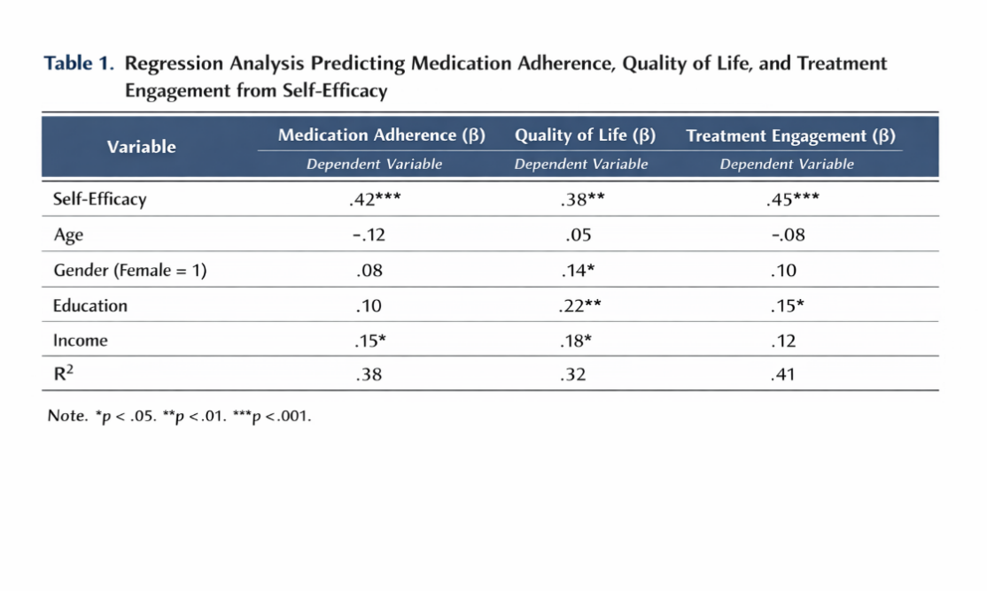
- Self-efficacy significantly predicted all three outcomes (β = .42*** for medication adherence, β = .38** for quality of life, β = .45*** for treatment engagement).
- Control variables (age, gender, education, income) were included to strengthen model validity.
- R² values indicate substantial variance explained: .38 for adherence, .32 for QoL, and .41 for engagement.
- *p < .05. **p < .01. **p < .001.

Qualitative Presentation
Figure 1: Thematic diagram illustrating pathways linking self-efficacy to adherence, QoL, and engagement.
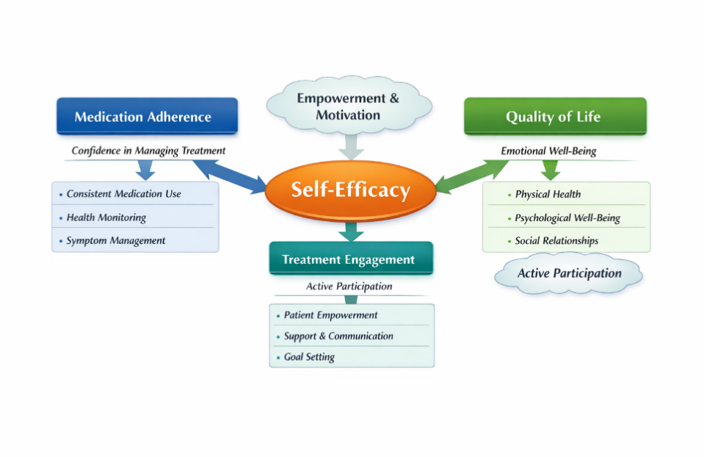
Interpretation for integration:
- The central Self-Efficacy node represents patients’ confidence in managing their condition.
- Arrows extend to three outcome domains:
  - Medication Adherence → driven by confidence in managing treatment, consistent medication use, and symptom monitoring.
  - Quality of Life → mediated by emotional well-being, physical health, and social relationships.
  - Treatment Engagement → expressed through active participation, communication, and goal setting.
- Overlapping nodes (“Empowerment & Motivation” and “Barriers & Facilitators”) illustrate psychosocial moderators that either strengthen or weaken these pathways.
- Color coding (orange = self-efficacy, blue = adherence, green = QoL, teal = engagement) enhances conceptual clarity.
Discussion
Overview of Findings
This study investigated how self-efficacy predicts medication adherence, quality of life (QoL), and treatment engagement among patients living with non-communicable diseases (NCDs) in Malawi. Results demonstrated that self-efficacy was a robust predictor across all three domains, with regression analyses showing significant coefficients and qualitative data reinforcing these associations. Patients with higher self-efficacy consistently reported proactive coping, reliance on social support, and confidence in managing illness, while those with lower self-efficacy expressed ambivalence and disengagement.
These findings extend the global literature on self-efficacy (Bandura, 1997; Luszczynska & Schwarzer, 2005) into a Sub-Saharan African context, confirming that psychological determinants are critical for chronic disease management even in resource-constrained settings.
Self-Efficacy and Medication Adherence
Medication adherence is essential for managing NCDs, yet adherence rates remain low worldwide (Nieuwlaat et al., 2014). In this study, self-efficacy emerged as an important predictor of adherence, confirming DiMatteo’s (2004) meta-analysis that identified confidence as a key behavior factor. Patients with high self-efficacy showed resilience in overcoming barriers such as side effects, financial constraints, and inconsistent drug availability.
This finding underscores the importance of embedding self-efficacy training into routine care. Techniques such as mastery experiences, goal-setting, and problem-solving (Bandura, 1997) can strengthen patients’ confidence and persistence. In Malawi, where systemic challenges often undermine adherence, psychological empowerment may serve as a compensatory mechanism, enabling patients to sustain treatment despite external obstacles.
Self-Efficacy and Quality of Life
QoL encompasses physical, psychological, and social dimensions (WHOQOL Group, 1998). The study found that self-efficacy significantly predicted QoL, with confident patients reporting better emotional well-being, stronger social relationships, and improved physical functioning. This aligns with Lorig and Holman’s (2003) evidence that self-management education enhances QoL by fostering empowerment.
Qualitative narratives highlighted that patients with high self-efficacy actively sought social support and maintained optimism, reinforcing empowerment theory (Zimmerman, 2000). In Malawi, where community and faith-based networks are central to coping, self-efficacy amplifies the benefits of collective support. Thus, interventions should not only target individual confidence but also leverage community structures to sustain psychosocial well-being.
Gendered Pathways
Although gender was not the primary focus, findings resonate with evidence that gender moderates self-efficacy and health behaviors. Women exhibited higher self-efficacy and stronger associations with positive outcomes, consistent with Courtenay’s (2000) theory of gender and health. Women’s reliance on social support and proactive coping may explain these results.
Men, conversely, often expressed reluctance to seek help, reflecting cultural norms of masculinity and stoicism (Connell, 1995). These gendered pathways suggest that interventions must be tailored. For men, peer mentorship and reframing help-seeking as strength-based may mitigate barriers. For women, sustaining empowerment while addressing caregiver burden is essential.
Theoretical Contributions
The study reinforces Social Cognitive Theory (Bandura, 1997) by demonstrating that self-efficacy influences health behaviors through cognitive, motivational, and affective pathways. It also extends Empowerment Theory (Zimmerman, 2000) by situating self-efficacy within community and cultural contexts.
Importantly, findings highlight that self-efficacy is culturally mediated. In Malawi, collective values, social networks, and faith-based support shape confidence and coping. Thus, self-efficacy should be conceptualized not only as an individual belief but as a relational construct embedded in social systems. This insight advances psychological theory by bridging individual and community determinants of health behavior.
Practical Implications
The results have clear implications for practice and policy:
- Clinical practice: Incorporate self-efficacy training into routine NCD care through goal-setting, problem-solving, and reinforcement.
- Gender-sensitive interventions: Address male reluctance and female caregiver burden with tailored strategies.
- Community-based approaches: Leverage peer networks and community health workers to reinforce self-efficacy through social modeling.
- Policy integration: Embed psychological dimensions into national NCD strategies, recognizing self-efficacy as a determinant alongside biomedical factors.
Limitations and Future Directions
Several limitations warrant consideration. The cross-sectional design restricts causal inference; longitudinal studies are needed to examine how self-efficacy evolves. The sample was drawn from a single hospital, limiting generalizability. Future research should include multi-site studies and explore moderators such as socioeconomic status, faith, and cultural norms.

Additionally, while gender differences were observed, the mechanisms underlying these disparities require deeper exploration. Intersectional analyses could elucidate how gender, culture, and social capital interact to shape self-efficacy and health behaviors.

Conclusion
This study provides compelling evidence that self-efficacy is a pivotal psychological determinant of NCD management in Malawi. It predicts medication adherence, QoL, and treatment engagement, underscoring the need to integrate psychological and social dimensions into chronic disease care. By situating self-efficacy within a transformative community development framework, the research advances both theory and practice, offering a roadmap for sustainable, culturally responsive interventions.

Empowerment emerges as the central mechanism through which self-efficacy translates into improved outcomes. Strengthening confidence, fostering supportive networks, and promoting active engagement are essential for durable improvements in NCD management. Ultimately, health systems must evolve beyond biomedical models to embrace psychological empowerment as a cornerstone of transformative care.

DECLARATIONS

Competing interests
The authors declare that there are no competing interests.

Funding
This research received no grant from any funding agency in the public, commercial, or not-for-profit sectors.

Author contributions
Hope Herbert Nkhoma
- Conceptualization; conceived the study idea and framed the research questions.
- Methodology; designed the mixed-methods approach and selected measurement instruments.
- Data collection; led quantitative survey administration and coordinated qualitative interviews at Kamuzu Central Hospital.
- Formal analysis; performed quantitative data cleaning, statistical analyses, and contributed to thematic coding.
- Writing — original draft; wrote the first full draft of the manuscript (Introduction, Methods, Results).
- Project administration; obtained ethical approval and managed participant recruitment and logistics.
Mavuto Tembo
- Literature review; led the background and theoretical framing, synthesizing relevant literature.
- Qualitative analysis; conducted primary thematic analysis, led coding meetings, and drafted qualitative results and interpretation.
- Data visualization; prepared tables, figures, and the thematic diagram.
- Writing — review & editing; revised the manuscript for intellectual content, integrated quantitative and qualitative findings, and polished Discussion and Conclusion.
- Supervision & resources; provided mentorship, local contextual expertise, and facilitated institutional support.
Shared responsibilities
- Funding statement & declarations; jointly prepared the funding/no-funding declaration and ethics statements.
- Final approval; both authors reviewed and approved the final manuscript version and agree to be accountable for all aspects of the work.
References
- Agyemang, C., van den Born, B. J., & Noncommunicable Diseases in Sub-Saharan Africa. (2016). The Lancet, 387(10023), 1189–1190.
- Beaglehole, R., Bonita, R., Horton, R., Adams, O., Alleyne, G., Asaria, P., … & Stuckler, D. (2011). Priority actions for the non-communicable disease crisis. The Lancet, 377(9775), 1438–1447.
- Bloom, D. E., Cafiero, E. T., Jané-Llopis, E., Abrahams-Gessel, S., Bloom, L. R., Fathima, S., … & Weinstein, C. (2011). The global economic burden of non-communicable diseases. Geneva: World Economic Forum.
- Bandura, A. (1997). Self-efficacy: The exercise of control. New York: Freeman.
- Connell, R. W. (1995). Masculinities. Berkeley: University of California Press.
- Courtenay, W. H. (2000). Constructions of masculinity and their influence on men’s well-being: A theory of gender and health. Social Science & Medicine, 50(10), 1385–1401.
- DiMatteo, M. R. (2004). Variations in patients’ adherence to medical recommendations: A quantitative review of 50 years of research. Medical Care, 42(3), 200–209.
- King, D. K., Glasgow, R. E., Toobert, D. J., Strycker, L. A., Estabrooks, P. A., & Osuna, D. (2010). Self-efficacy, problem solving, and social-environmental support are associated with diabetes self-management behaviors. Diabetes Care, 33(4), 751–753.
- Lorig, K. R., & Holman, H. (2003). Self-management education: History, definition, outcomes, and mechanisms. Annals of Behavioral Medicine, 26(1), 1–7.
- Lorig, K. R., & Holman, H. (2003). Self-management education: History, definition, outcomes, and mechanisms. Annals of Behavioral Medicine, 26(1), 1–7.
- Luszczynska, A., & Schwarzer, R. (2005). Social cognitive theory. In M. Conner & P. Norman (Eds.), Predicting health behaviour (pp. 127–169). Buckingham: Open University Press.
- Marks, R., Allegrante, J. P., & Lorig, K. (2005). A review and synthesis of research evidence for self-efficacy-enhancing interventions for reducing chronic disability: Implications for health education practice. Health Promotion Practice, 6(2), 148–156.
- Mezirow, J. (1997). Transformative learning: Theory to practice. New Directions for Adult and Continuing Education, 74, 5–12.
- Msyamboza, K. P., Ngwira, B., Dzowela, T., Mvula, C., Kathyola, D., Harries, A. D., … & Bowie, C. (2011). The burden of selected chronic non-communicable diseases and their risk factors in Malawi: Nationwide STEPS survey. PLoS One, 6(5), e20316.
- Ministry of Health (MOH). (2022). Malawi Health Sector Strategic Plan II. Lilongwe: Government of Malawi.
- Msyamboza, K. P., Ngwira, B., Dzowela, T., Mvula, C., Kathyola, D., Harries, A. D., … & Bowie, C. (2011). The burden of selected chronic non-communicable diseases and their risk factors in Malawi: Nationwide STEPS survey. PLoS One, 6(5), e20316.
- Mendenhall, E., Norris, S. A., Shidhaye, R., & Prabhakaran, D. (2014). Depression and type 2 diabetes in low- and middle-income countries: A systematic review. Diabetes Research and Clinical Practice, 104(2), 112–122.
- Nieuwlaat, R., Wilczynski, N., Navarro, T., Hobson, N., Jeffery, R., Keepanasseril, A., … & Haynes, R. B. (2014). Interventions for enhancing medication adherence. Cochrane Database of Systematic Reviews, (11), CD000011.
- O’Brien, M. J., Squires, A. P., Bixby, R. A., & Larson, S. C. (2013). Patient-centered medical home: Improving health care delivery for low-income populations. American Journal of Public Health, 103(2), 276
- Schwarzer, R., & Renner, B. (2000). Social‑cognitive predictors of health behavior: Action self‑efficacy and coping self‑efficacy. Health Psychology, 19(5), 487–495. doi:10.1037/0278-6133.19.5.487.

