Investigating Trace Element (Micronutrient) Availability/Contamination in Soils within Niger State using Geospatial Techniques
Moses Omitunde Omirinde, Dr. Emmanuel Omomoh, Dr. Sunday Nannim, Dr. Rogers Rengje Danlami Gujahar, Boyi Mairiga, Gwamzhi Ponsah Emmanuel.

Abstract
Trace elements are chemical elements found in small concentrations within soil. They are also known as minor elements or micronutrients. While present in small amounts, they play vital roles in plant and animal nutrition and can have significant environmental impacts if levels become too high. Many trace elements are essential for healthy plant growth and development, acting as building blocks for enzymes and facilitating crucial processes. Transfer of trace elements between soil phases can be considered as the main processes controlling their behavior and bioavailability. This study examines the distribution of trace elements in soils within Lapai and Agaie, Niger state. The ever-increasing pressure on land for agriculture, mining and several other activities continuously interrupts the balance, concentrations and mobility of various trace elements. In many cases, deficiency or toxicity of micronutrients affect plants, reducing yield, stunting growth and causing leaves to drop prematurely among many other symptoms. A total of fifty soil samples were systematically collected from different sites across some mining areas of Lapai and Agaie LGAs. The collected soil samples were transported to the Centre for Dryland Agriculture where comprehensive chemical analysis was conducted. The laboratory results were then subjected to Inverse Distance Weighted (IDW) analysis to examine the spatial distribution patterns of trace elements across the study area. For copper a range of 1.1 to 3 ppm was observed during the study. Within the study area, the concentrations of zinc ranges from around 2 to 14 mg/kg while the observed range of iron concentration lies between 147 and 240 ppm. Concentrations of manganese in the study area are generally less than typical, ranging between 17 and 32 mg/kg. Trace element levels in soils present in the study area are generally adequate. These are fertile soils with no trace element toxicity detected and only minor deficiencies of manganese, copper and zinc. Management of manganese levels may be required to for optimum soil and plant health.
Keywords: Trace element, micronutrient, soil health, toxicity, deficiency.

1.0 Introduction
Trace elements are chemical elements found in small concentrations within soil. They are also known as minor elements or micronutrients. Examples include boron, copper, iron, manganese, molybdenum, and zinc. Some trace elements, like arsenic, cadmium, and lead, can be toxic at elevated levels. Trace elements in soil are chemical elements found in very small concentrations, typically less than 0.1% or 1000 ppm. While present in small amounts, they play vital roles in plant and animal nutrition and can have significant environmental impacts if levels become too high. Many trace elements are essential for healthy plant growth and development, acting as building blocks for enzymes and facilitating crucial processes. Some trace elements, such as copper, cobalt, iodine, selenium, and zinc, are also essential for animal health. While some trace elements are beneficial, others can be harmful at higher concentrations. Elevated levels can be toxic to plants, animals, and humans. Some sources of trace elements in soils include rocks, minerals, and volcanic eruptions which contributes trace elements to the soil (from natural sources). Mining, smelting, industrial processes, use of fertilizers, industrial wastewater (anthropogenic/human sources), can also introduce trace elements into soils. Soil pH, organic matter content, and redox potential (drainage) influence how trace elements are bound and released in the soil. Different plants have varying abilities to absorb and utilize trace elements and, thus, affect availability of trace elements. Interactions between plant roots and soil particles play a crucial role in trace element uptake. Plants can suffer from deficiencies if trace elements are present in insufficient amounts. Excessive levels of certain trace elements can lead to toxicity in plants, animals, and humans. Human activities can lead to soil contamination with trace elements, potentially affecting ecosystems and human health.
The soil–plant transfer of trace elements is a part of chemical element cycling in nature. It is a very complex process governed by several factors, both natural and anthropogenic. Several factors control the processes of mobility and availability of elements; in general, they are of geochemical, climatic and biological origin. Thus, the prediction of trace element uptake by plants from a given growth media should be based on several biotic and abiotic parameters that control their behavior in soil. The risk to both the environment and human health of a given trace element is a function of its mobility and Phyto-availability. Therefore, the behavioral properties of these elements in soils are a current issue in environmental studies. The transfer of trace elements within the soil–plant chain is a part of the biochemical cycling of chemical elements—it is an element flow from nonliving to the living compartments of the biosphere. Several factors control the processes of mobility and availability of elements; in general, they are of geochemical, climatic, biological, as well as of anthropogenic origin. Soil is the main source of trace elements for plants both as micronutrients and pollutants. Some exceptions are in situations of heavy atmospheric deposition of pollutants or from flooding by contaminated waters. Soil conditions play a crucial role in trace element behavior. It can be generalized that in well-aerated (oxidizing) acid soils, several trace metals, especially Cd and Zn, are easily mobile and available to plants, while in poorly aerated (reducing) neutral or alkaline soils retard mobility of most trace elements.
Transfer of trace elements between soil phases can be considered as the main processes controlling their behavior and bioavailability. However, the soil liquid phase (soil solution) is constantly and rapidly changing in amount and chemical composition due to the contact with the highly diverse soil solid phase and by the uptake of ions and water by plant roots. The chemistry of the soil solution provides useful information on soil processes that are important to agricultural and environmental research and practice.
Plants require 18 essential nutrients to grow and survive, classified by their importance into macronutrients and micronutrients. These 18 elements can be further classified into several sub groups. Macronutrients are used in large quantities by plants and are sub divided into: Structural nutrients: Carbon (C), Hydrogen (H), Oxygen (O); Primary nutrients: Nitrogen (N), Phosphorus (P), Potassium (K) and Secondary nutrients: (Calcium Ca), Magnesium (Mg), Sulphur (S). Micronutrients: are, conversely, used in small quantities by the plant and include Iron (Fe), Boron (B), Copper (Cu), Chlorine (Cl), Manganese (Mn), Molybdenum (Mo), Zinc (Zn), Cobalt (Co), Nickel (Ni). Nutrients may be mobile or immobile in the plant and in the soil, which influences redistribution of nutrients and display of deficiency symptoms, and the fertilization of crops. Nutrient demands change throughout the life of the plant, in general increasing during vegetative growth but decreasing during reproductive development.
This study intends to examine the distribution of trace elements in soils within Lapai and Agaie, Niger state. This aim was achieved through quantifying the concentration of trace elements in soils, identifying areas of deficiency or toxicity in soils within the area, determining the relationship of the trace elements concentration with the mining activities and recommending methods of soil quality augmentation to address deficiencies or toxicity in soils.
2.0 The Study Area
The study area encompasses portions of Lapai and Agaie Local Government Areas (LGAs) in Niger State, west-central Nigeria. These LGAs are strategically positioned within the Niger River basin system, with Lapai lying in the southeastern part of Niger State and Agaie located in the west-central region. The area is bounded by coordinates 6°35'0"E to 6°40'0"E longitude and 9°0'0"N to 9°5'0"N latitude, covering approximately 36 square kilometers.
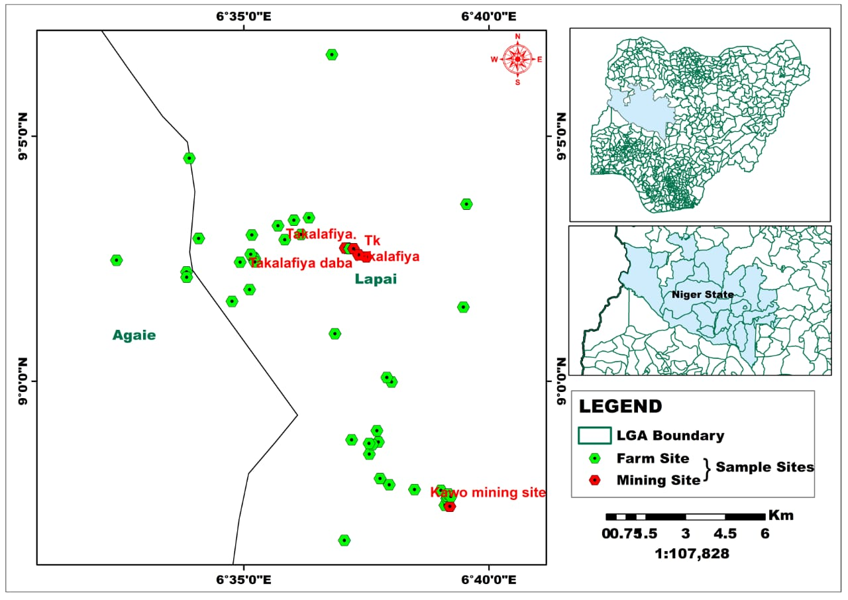
Figure 1: Map of study area

Lapai lies near the Gurara River, which is a tributary to the Niger River, while Agaie town lies at the intersection of roads from Bida, Baro, Tagagi, Lapai, and Ebba. This strategic positioning places the study area within a significant hydrological and transportation network that has historically influenced settlement patterns and economic activities in the region.
2.1 Geological Setting and Mineral Potential
The study area falls within the Nigerian basement complex, which is characterized by Precambrian crystalline rocks that have undergone various degrees of metamorphism and deformation. The geological framework of the region is conducive to the occurrence of various mineral deposits, including trace elements that are the focus of this study. Lead is usually found along with other minerals such as zinc, silver, copper and gold during mining, with majority of zinc deposits associated with galena (lead sulphide, PbS). This polymetallic nature of mineralization in the broader regional context suggests that the study area may contain complex assemblages of trace elements associated with both primary mineralization and secondary weathering processes.
3.0 Methodology
3.1 Field Work Preparation and Reconnaissance
Prior to field sampling, comprehensive field work preparations and reconnaissance activities were conducted across the mining areas of Lapai and Agaie LGAs. This preliminary phase involved the identification of potential sampling sites, assessment of accessibility, and evaluation of safety considerations in the mining environments. The reconnaissance survey provided essential information about the geological characteristics, topographical features, and existing mining activities in the study area, which informed the subsequent sampling strategy and site selection procedures.
3.2 Field Sampling
A total of fifty soil samples were systematically collected from different sites across the two local government areas of interest. The sampling strategy was designed to ensure representative coverage of the study area, with particular emphasis on locations where mining activities were prevalent. Each sampling site was georeferenced using GPS coordinates to enable accurate spatial analysis and mapping. The samples were collected using standard soil sampling techniques, with appropriate depth considerations to capture the soil horizons most likely to be affected by mining activities. All samples were properly labeled, documented, and stored in sterile polythene bags to prevent contamination during transportation and storage.
3.3 Soil Chemical Analysis
The collected soil samples were transported to the Centre for Dryland Agriculture at Bayero University Kano, Kano State, Nigeria, where comprehensive chemical analysis was conducted. The samples underwent preparation procedures including air-drying, grinding, and sieving to achieve uniform particle size distribution suitable for analytical procedures. Standard laboratory protocols were followed for the determination of trace elements concentrations using appropriate analytical instruments and methodologies. Quality control measures were implemented throughout the analytical process, including the use of certified reference materials, blank samples, and duplicate analyses to ensure accuracy and precision of results.
3.4 Inverse Distance Weighted Analysis
Following the completion of chemical analysis, the laboratory results were subjected to Inverse Distance Weighted (IDW) analysis to examine the spatial distribution patterns of trace elements across the study area. The IDW interpolation technique was employed to predict trace element concentrations at unsampled locations based on the measured values at the sampled sites. This geostatistical approach assumed that the influence of measured points decreases with increasing distance, thereby providing a weighted average estimation for unknown locations. The analysis considered various parameters including search radius, number of neighboring points, and power function to optimize the interpolation accuracy.
3.5 Reprojection and Resampling
The analytical results and spatial data underwent reprojection and resampling procedures to enhance the robustness of the dataset. This phase involved the cross-verification of spatial coordinates such that all generated results will be in the same map projection for ease of handling, statistical analysis and better representation. Resampling techniques were applied to set the spatial resolution of all analysis layers to a uniform value (in this case, 10m) to ensure the uniformity of results produced and also to ease areal calculations and statistical analysis.
3.6 Creation of Thematic Maps
Thematic maps were generated using ArcGIS 10.8 software to visualize the spatial distribution of trace elements across some mining areas of Lapai and Agaie. The IDW interpolation results were used as the basis for creating detailed contour maps and color-coded distribution maps for each trace element analyzed. The mapping process involved the selection of appropriate classification schemes, color ramps, and symbology to effectively communicate the spatial patterns and concentration gradients. Legend design and map layout were optimized to ensure clear interpretation and professional presentation of the spatial data.
3.7 Comparative Analysis
The final phase of the methodology involved comprehensive comparative analysis of the trace element distribution patterns, statistical parameters, and thematic maps. This analysis examined the relationships between trace element concentrations and mining activities, identified hotspots of contamination, and assessed the overall environmental impact of mining operations on soil quality. The comparative approach included evaluation of trace element levels against established environmental standards and guidelines, comparison of concentrations between different mining sites, and assessment of spatial clustering patterns. The integration of statistical analysis, spatial interpolation results, and thematic mapping provided a holistic understanding of trace element distribution and their environmental implications in the study area.

Field Work Preparation/Reconnaissance
Field Sampling
Soil Chemical Analysis
Reprojection
Inverse Distance Weighted (IDW) Analysis
Extraction of Statistics
Creation of Thematic Maps
Comparative Analysis
Resampling

Figure 2: Flow Diagram.
4.0 Presentation of Results
The findings of this study are divided into major and trace elements and presented in the form of thematic maps and statistical tables. The study focuses on the availability of trace elements and their effects on soil for agriculture. The maps depict the spatial variation of the various soil qualities, while the tables demonstrate the numerical relationship between the various classes of each parameter.
4.1 Soil pH
Table 1 shows the pH value distribution across the research region, ranging from 5.7 to 6.5. The map (Figure 3) divides the area's soil pH into five (5) categories: very strongly acidic, strongly acidic, slightly acidic, acidic and neutral. The map demonstrates that in the research region, slightly acidic soils account for over 48%, strongly acidic soils for slightly more than 25%, and very strongly acidic soils for almost 8%. Acidic and neutral soils make up 15.16% and 2.77%, respectively, of the total area (Table 1). Though the reactions of soils in the area were graded into various acidic ranges, it is important to bear in mind that the overall range of about 5.7 to 6.5 is within the required, if not optimum, range for most crops. In terms of pH, therefore, the soils within the area are reasonably healthy and raise little or no concern. Central areas, straddling the local government border, and the north eastern portion of the area are the most acidic regions and may need some vigilance to prevent further acidification which may be dangerous for soil health.

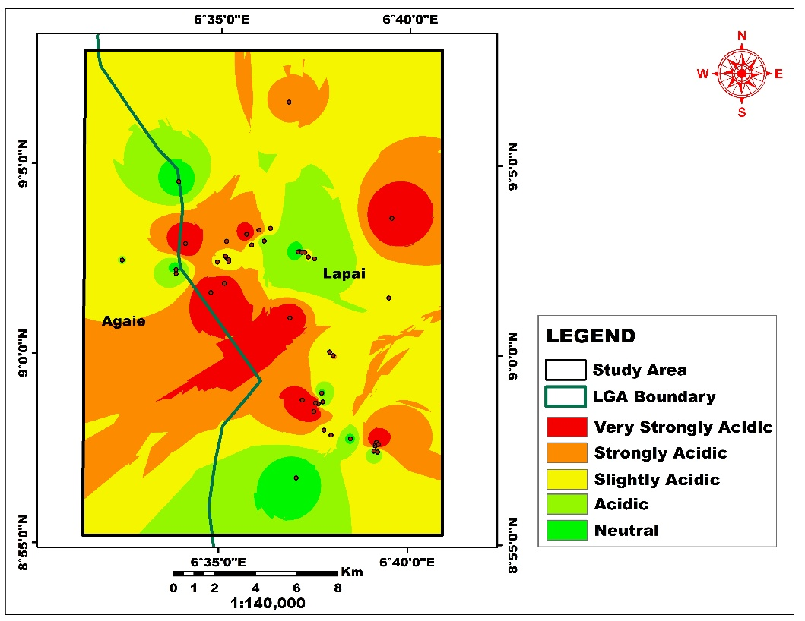
Figure 3: Spatial Distribution of soil pH
Table 1: Area (Km²) coverage and percentage of each category of Soil pH
pH |  | Area Km² | Area (%)
5.7 - 5.9 | Very Strongly Acidic | 32.86 | 7.99
5.9 - 6.1 | Strongly Acidic | 103.82 | 25.24
6.1 - 6.2 | Slightly Acidic | 200.88 | 48.84
6.2 - 6.3 | Acidic | 62.34 | 15.16
6.3 - 6.5 | Neutral | 11.39 | 2.77
 | Total | 411.28 | 100

4.2 Organic Carbon (OC)
The regional distribution of organic carbon content in soil revealed intermittent contrast. The study region has a diverse spatial distribution of soil organic carbon content, with moderate to high levels (OC) accounting for 39.1% and 32.6% of the total area (Figure 12). While areas with very low levels occupied 42.97 Km², accounting for 10.5%. The map suggested that locations with a high amount of organic carbon had the least coverage (4.3%). In addition, sections of 55.53 Km², accounting for 13.5% of the total area, showed minimal organic carbon variability (Table 2).
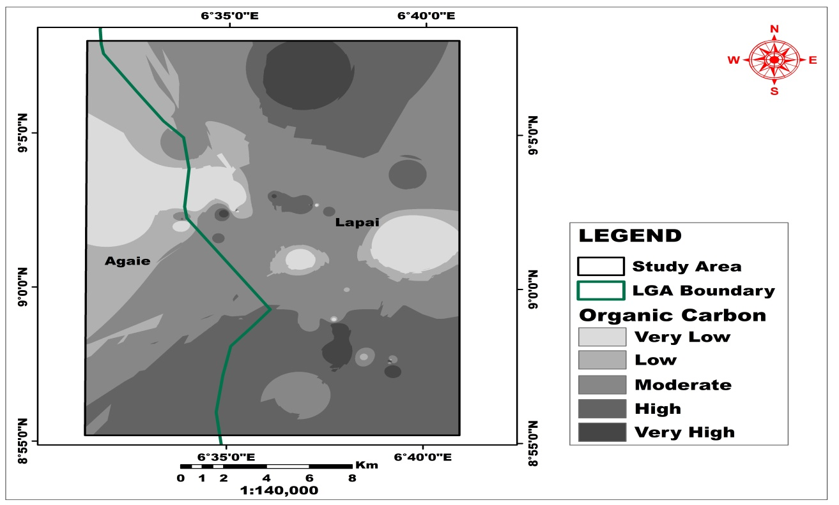 Figure 4: Spatial Distribution of Soil Organic Matter

Table 2: Area (Km²) coverage and percentage of each category of Soil Organic Matter (OM)
Class Area (Km²) Percentage (%)
Very low 42.97 10.45
Low 55.53 13.50
Moderate 160.95 39.13
High 134.22 32.63
Very High 17.61 4.28
Total 411.28 100

4.3 Distribution of Some Major Elements in the Soil
4.3.1 Total Nitrogen (N)
The spatial distribution of nitrogen (N) levels in the research area ranges from 0.04 to 0.061. The IDW map showed a moderate (0.052) amount of available N dispersed in the north, middle, and southern sections, which spanned more than half of the research area with a spatial coverage of 223.37, or 54.3% (Figure 5 and Table 3). While very low and very high appear to have the least coverage, they occupy 29.71 and 4.04 Km² of the research, accounting for 7.2% and 0.9% of the total area, respectively (Table 3).
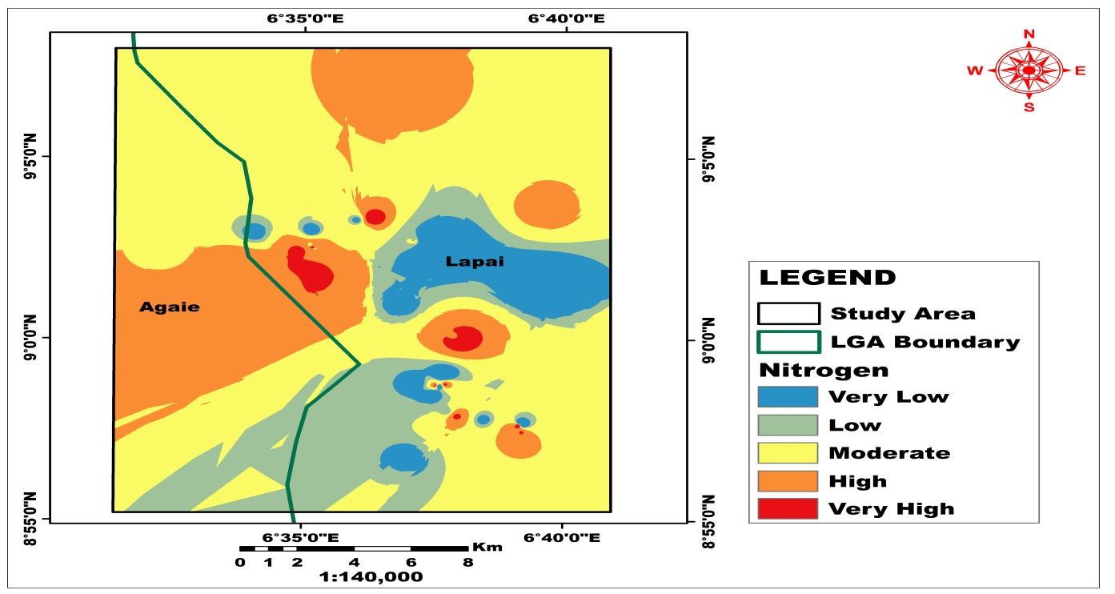Figure 5: Spatial Distribution of Total Nitrogen (N)
Table 3: Area (km²) coverage and percentage of each category of Total Nitrogen (N)
Class Area (Km²) Percentage (%)
Very low 29.71 7.22
Low 62.11 15.10
Moderate 223.37 54.31
High 92.05 22.38
Very High 4.04 0.98
Total 411.28 100

4.3.2 Available Phosphorus (P)
The study found that accessible phosphorus in the soil ranged from 2.4001 to 7.019 mg kg⁻¹. The geographical distribution of P appeared to have roughly comparable concentrations at the low (34.4%), moderate (32.1%), and high levels (28.6%), which accounted for more than 84%, as shown in Table 4 and Figure 6. The IDW map of accessible P (Figure 6) revealed that soil with very low and very high P content covers the least amount of total area, accounting for 2% and 1.7%, respectively (Table 4).
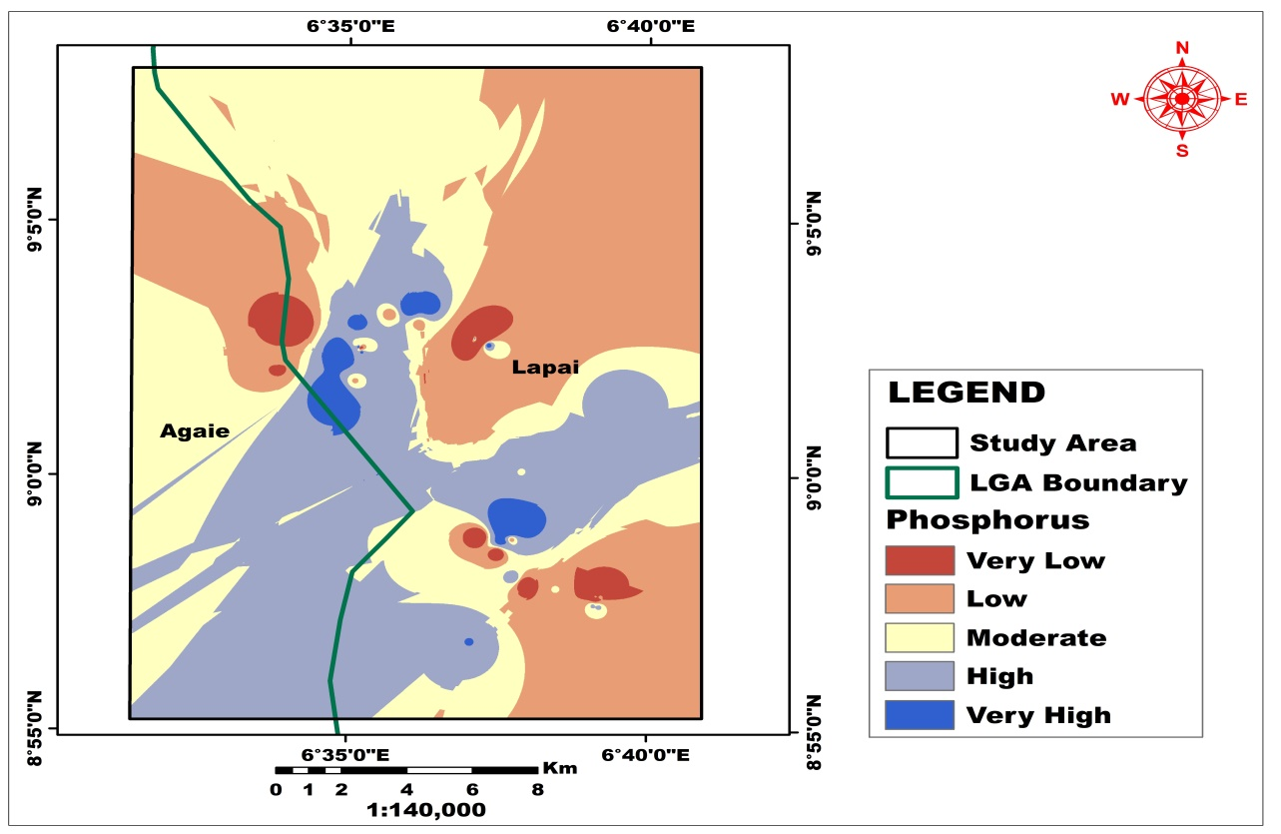
Figure 6: Spatial Distribution of Phosphorus (P)
Table 4: Area (km²) coverage and percentage of each category of available Phosphorus (P)
Class Area (Km²) Percentage (%)
Very low 8.37 2.04
Low 141.81 34.48
Moderate 136.22 33.12
High 117.97 28.68
Very High 6.92 1.68
Total 411.28 100

4.3.3 Potassium (K)
The geographical distribution of accessible potassium varies between 0.13 and 0.24 cmol(+)/kg. The distribution goes from extremely low, low, moderate, high, and very high (Figure 7). The low, moderate, and high amounts of accessible potassium account for more than 85% of the research area, with spatial coverage of 140.09, 129.03, and 96.39 Km² (34.1%, 31.4%, and 23.2%, respectively) (Table 5). While very low and very high variability of available potassium had the lowest areal coverage, accounting for 4.5% and 6.8% of the total area, the geographical distribution of K corresponded to P at low, moderate, and high values (Tables 5 and 4).
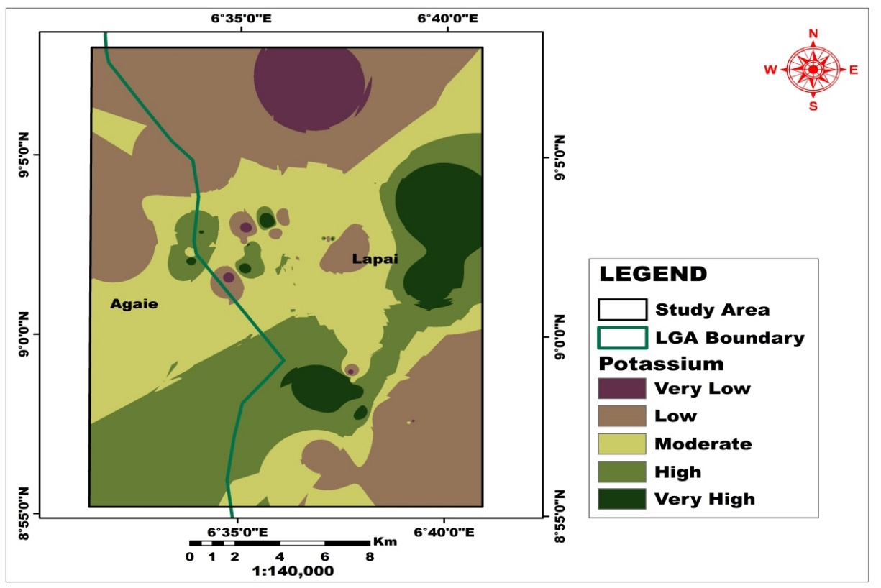
Figure 7: Spatial Distribution of Potassium (K)
Table 5: Area (Km²) coverage and percentage of each category of Potassium (K)
Class Area (Km²) Percentage (%)
Very low 18.689 4.54
Low 140.09 34.06
Moderate 129.03 31.37
High 95.39 23.19
Very High 28.07 6.82
Total 411.28 100

4.3.4 Magnesium (Mg)
Magnesium distribution in the research region is nearly evenly distributed at the low, moderate, and high levels (Figure 8), with geographical coverages of 152.83, 136.34, and 92.11 Km², accounting for 37.2%, 33.2%, and 22.4%, respectively (Table 6). The map generated revealed the lowest Magnesium concentration in the northeast part, which covers 126.04 Km² or 9.26% of the research area (Figure 8). Magnesium concentrations are moderate in the area's south-west, north-east, and north-west (Figure 8). The map revealed that the regional distribution of Mg appears to have almost identical concentrations at low, moderate, and high levels (Table 6).
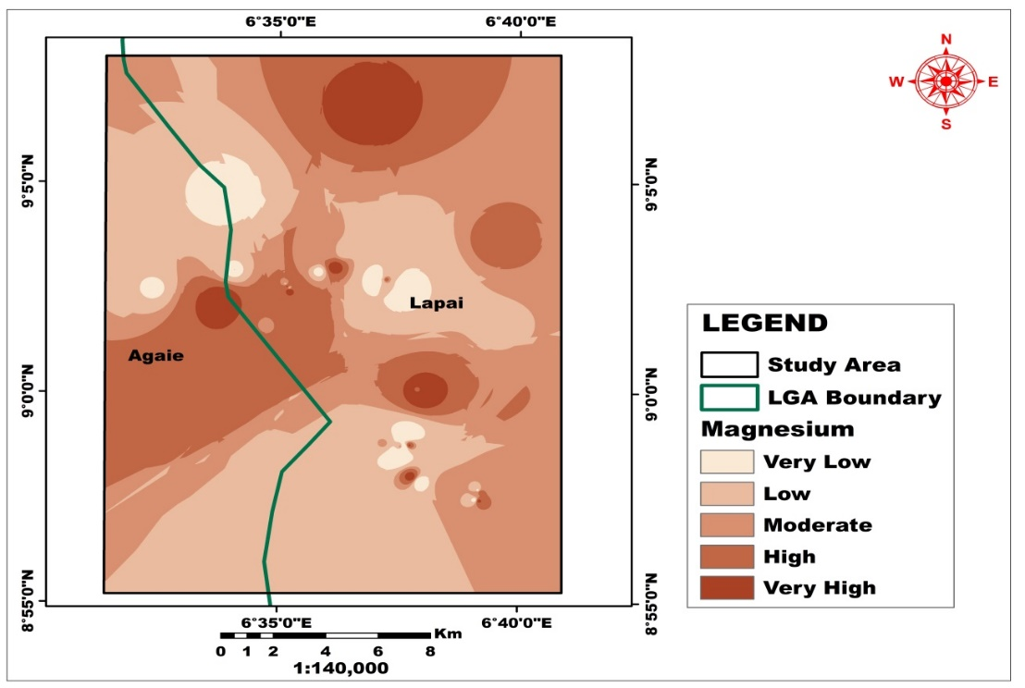
Figure 8: Spatial Distribution of Magnesium

Table 6: Area (Km²) coverage and percentage of each category of Magnesium (Mg)
Class Area (Km²) Percentage (%)
Very low 13.72 3.34
Low 152.83 37.16
Moderate 136.34 33.15
High 92.11 22.39
Very High 16.28 3.96
Total 411.28 100

4.4 Trace Elements Occurrence
4.4.1 Available Manganese (Mn)
Figure 9 illustrates the regional distribution of accessible manganese, which ranges from very low to very high. The map shows that low to moderate concentrations of accessible manganese in the soil cover of 115.17 Km² and 163.23 Km², which constituted 28.01% and 39.70% of the total area, respectively (Table 7), were distributed in the north, center, and south. These accounted for more than half (65%) of the whole area, while 73.62 and 43.69 Km² of the research area appear to have very low and high Mn levels, accounting for 17.9% and 10.6% of the total area, respectively. The weathering of rock-forming minerals and crustal elements is the primary source of manganese in Lapai's soil. Extremely high manganese concentrations in soil can be harmful to plant growth, causing nutritional imbalances, reduced photosynthesis, and oxidative stress in plants. Similarly, high manganese content can change soil qualities by altering the pH, perhaps increasing acidity and exacerbating toxicity. It can make soil hard when dry and clay-like when wet. Manganese contamination in soil could result from both natural and human activity. Natural sources include the weathering of rocks and minerals, while human activities such as mining, industrial processes, and inappropriate waste disposal can release large amounts of manganese into the environment. These sources can cause high manganese levels in the soil, affecting plant growth and posing dangers to human and environmental health.
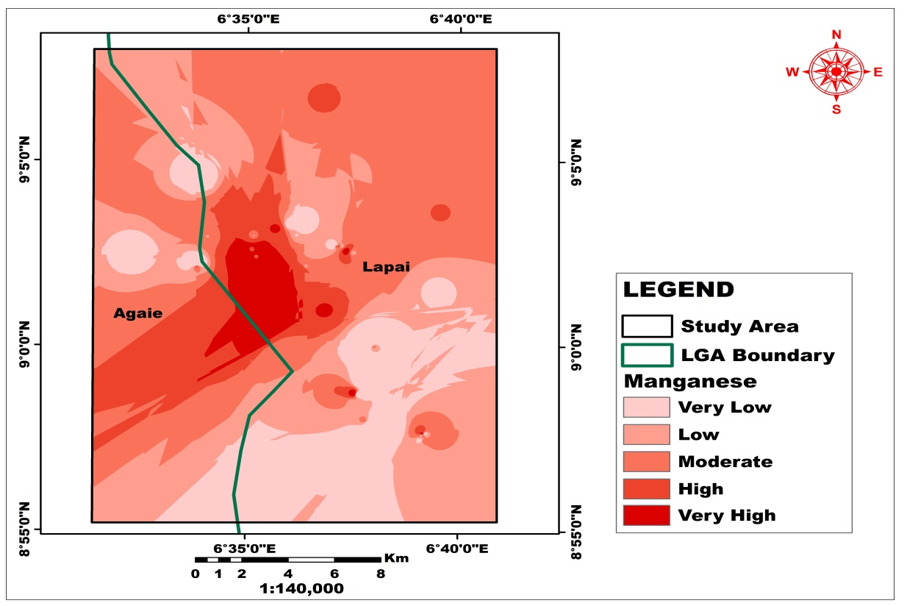
Figure 9: Spatial Distribution of Manganese

Table 7: Area (Km²) coverage and percentage of each category of Manganese (Mn)
Class Area (Km²) Percentage (%)
Very low 73.62 17.89
Low 115.17 28.01
Moderate 163.29 39.70
High 43.69 10.63
Very High 15.49 3.77
Total 411.28 100

4.4.2 Available Zinc (Zn)
Zinc (Zn) has a spatial distribution that ranges from very low, low to moderate, high to very high (Figure 10 and Table 8). Low, moderate, and high zinc concentrations are nearly homogeneous and randomly scattered over the research area. Figure 10 shows that the extreme northern, middle, and southern regions of the area under consideration have moderate and extremely high concentrations, accounting for 20.6% and 35.04%, respectively. These occupy more than 50% of the region, and their presence in the soil may be linked to pockets of surface mining along the pegmatitic zones, which can release Zn into the environment, damaging soils and water.
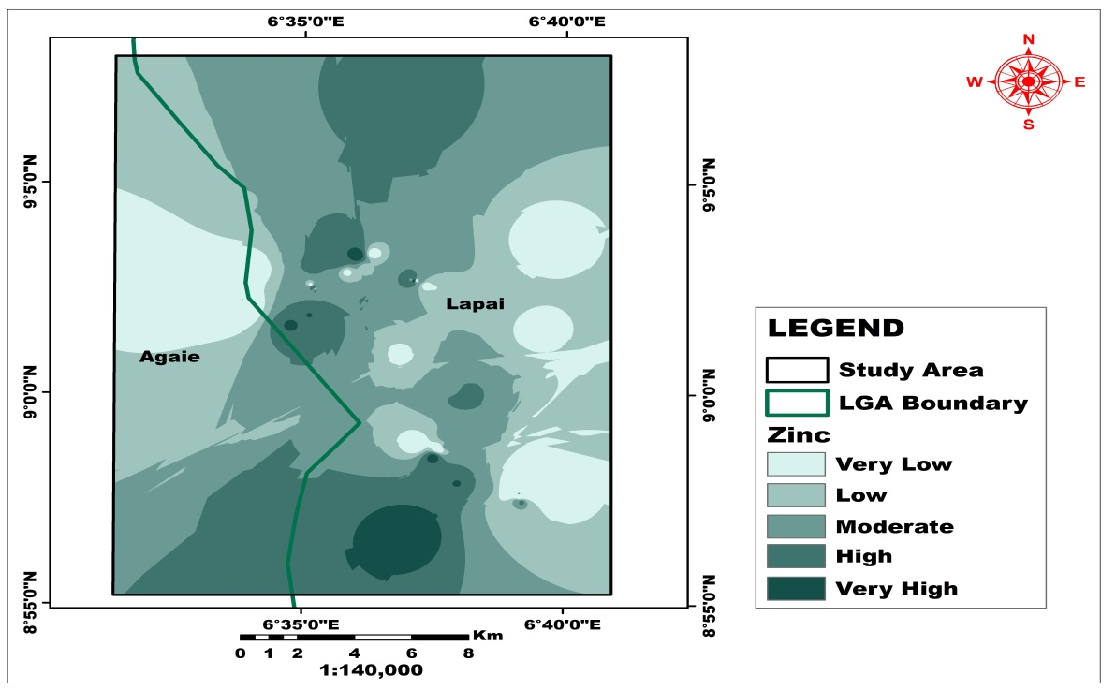
Figure 10: Spatial Distribution of Zinc

Table 8: Area (Km²) coverage and percentage of each category of Zinc (Zn)
Class Area (Km²) Percentage (%)
Very low 56.95 13.85
Low 116.53 28.33
Moderate 144.11 35.04
High 84.90 20.64
Very High 8.79 2.14
Total 411.28 100

4.4.3 Available Copper (Cu)
Copper's spatial distribution ranges from very low, low, moderate, high to very high (Figure 11and Table 9). The area contains a predominantly moderate copper content, accounting for 41.9% of the studied area. While high and very high amounts (24.3% and 14.3%, respectively) are visible in the south-west, there are pockets in the south-east and north-east areas of the area under research, as illustrated in Figure 11. These take up more than 38.6% of the area. However, high copper concentrations can restrict root growth, limiting the plant's ability to absorb water and nutrients. In addition, copper in contaminated soils can disrupt the photosynthetic process, resulting in chlorosis (leaf yellowing) and lower biomass. Furthermore, excess copper can cause oxidative stress in plants, destroying cell structures and impeding growth. It can also interfere with the absorption of other vital nutrients, resulting in imbalances that harm plant health.
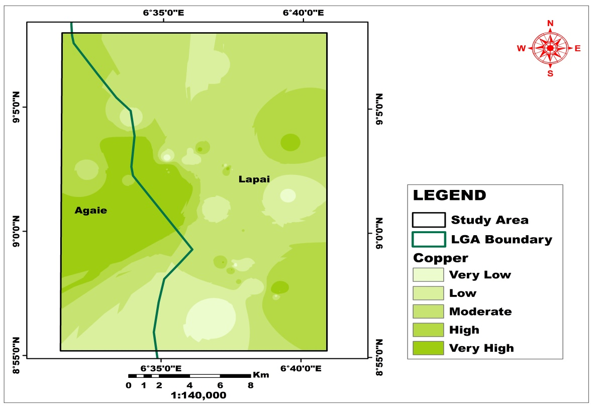
Figure 11: Spatial Distribution of Copper

Table 9: Area (Km²) coverage and percentage of each category of Copper (Cu)
Class Area (Km²) Percentage (%)
Very low 9.38 2.28
Low 70.76 17.21
Moderate 172.52 41.95
High 99.75 24.25
Very High 58.86 14.31
Total 411.28 100

4.4.4 Iron (Fe)
Figure 12 displays the regional distribution of iron in the research area. The area has a predominantly moderate to high content, accounting for more than 60% (36.5% and 29.2% of the examined area). While very significant levels (6.6%) are apparent in the middle region of the area under investigation, as shown in Figure 12. However, the iron concentration appears to be low and very low in the western and northern regions of Lapai and Agaie, accounting for 16.7% and 10.9%, respectively. These cover up to 27.6% of the region.
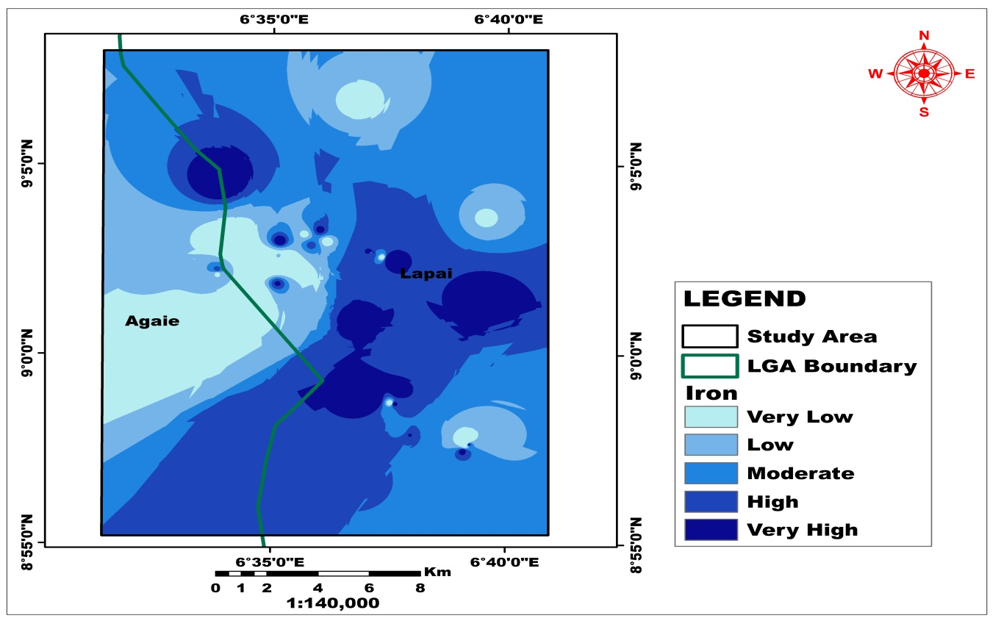
Figure 12: Spatial distributions of Iron

Table 10: Area (Km²) coverage and percentage of each category of Iron (Fe)
Class Area (Km²) Percentage (%)
Very low 45.07 10.96
Low 68.59 16.67
Moderate 150.39 36.57
High 119.95 29.16
Very High 27.28 6.63
Total 411.28 100

5.0 Discussion of Results
5.1.1 Copper
Copper (Cu) is an essential micronutrient for plants and other organisms, but it can also be toxic at high concentrations. In soils, copper exists in various forms, primarily bound to minerals and organic matter. While it is not very mobile and tends to accumulate in topsoil, excessive copper can negatively impact soil health and plant growth. The largest fraction of copper is found within the crystal structures of primary and secondary minerals. A significant portion is, also, adsorbed to and bound by organic matter in the soil. Copper can also be adsorbed to inorganic and organic negatively charged groups on soil particles. Only a small amount of copper is dissolved in the soil solution where it is most readily available for plant use. Copper is crucial for various enzymatic activities in plants, including chlorophyll and seed production. It also plays a role in nutrient cycling, particularly nitrogen and phosphorus mineralization. Copper concentrations in soils typically range from 2 to 100 parts per million (ppm), with an average of around 30 ppm. A range of 1.1 to 3 ppm was observed during the study. This range of concentration is quite reasonable and poses no threat to the environment, plants, animals and human beings, though it is on the low side. Soil copper concentrations are largely determined by the composition of the parent rock and soil formation processes. The type of rock from which the soil was formed significantly impacts copper levels. For example, soils derived from mafic igneous rocks tend to have higher copper content than those from felsic rocks. Sources of copper in soils include parent material, agricultural practices and industrial activities. Copper-containing fungicides and fertilizers, as well as manure and sewage sludge, can also contribute to elevated copper levels in agricultural soils. In addition, mining and smelting activities can also release copper into the environment, potentially contaminating soils.
It is necessary to note the inverse relationship between copper and iron within the study area. Areas with high concentrations of copper show lower concentrations of iron and vice versa (figures 11 and 12). This is as a result of the peculiar chemical relationship between the two elements and their reactivity in solution. They are direct replacements for each other in reaction and therefore tend to replace each other, even in nature, depending on the prevailing physical conditions.
5.1.2 Zinc
Zinc (Zn) is an essential micronutrient for both plants and animals, and its presence and availability in soils are crucial for healthy ecosystems and food production. Soils naturally contain zinc, but its concentration and availability to plants can vary widely. The concentration of zinc in the study area shows a marked spatial correlation to the concentrations of organic carbon, magnesium and nitrogen while displaying an inverse relationship with iron and potassium. This is particularly true in the northernmost part of the study area. It also shows a weak inverse relationship with copper and similarly weak direct relationship with manganese. These all tie in together with soil pH levels across the area of study. The concentration of zinc loosely follows the levels of acidity of the soil, increasing with decreased pH (increased acidity) and vice versa. Although the scope of this study did not include several trace elements, the presence of zinc is a pointer to infer concentrations of lead (Pb) and, loosely, those of arsenic (As) and other trace elements that crystallize from the same fraction of rock melts or hydrothermal fluids. This is quite important because several of these elements (e.g. Pb, As) are quite toxic even in small quantities.
Soil zinc levels can vary significantly based on geographic location and parent material. Total zinc content in uncontaminated agricultural soils generally ranges from 10 to 300 mg/kg, with an average around 50-55 mg/kg. Within the study area, the concentrations of zinc range from around 2 to 14 mg/kg with only the high and very high registering levels within the optimal concentrations. The greater portion of the area under consideration can, therefore, be said to be in need of several interventions due to deficiency of zinc. Zinc deficiency is a widespread problem in many agricultural soils worldwide, affecting crop yields and nutritional value. It affects various crops, especially high-yielding varieties of cereals, leading to reduced yields and nutritional value. Zinc is vital for plant growth and development, playing a role in enzyme systems, protein synthesis, and overall plant health. Zinc availability in soil is influenced by factors like soil pH, organic matter content, and the presence of other nutrients. Zn deficiency in plants can lead to stunted growth, reduced yields, and impaired nutritional quality. Deficiency of Zn can result from low zinc solubility, high zinc fixation (binding to soil particles), or insufficient zinc input through fertilizers. Soil testing is crucial to identify zinc deficiency and determine appropriate management practices. Measures for management of Zn deficiency include, use of Zinc fertilizers, improved agronomic practices and bio-fortification. Practical actions such as applying zinc fertilizers can help correct deficiencies and improve crop yields. Adjusting soil pH, managing organic matter, and optimizing other nutrient levels can also enhance zinc availability. Breeding crops with higher zinc content in edible tissues can also help address human zinc deficiency.
5.1.3 Iron
Iron makes up about 5% by weight of the earth’s crust and is invariably present in all soils. The greatest part of soil Fe usually occurs in the crystal lattices of numerous minerals. The primary minerals in which Fe is present include the ferromagnesian silicates such as olivine, augite, hornblende and biotite. By weathering of these minerals Fe oxides such as goethite, haematite, and ferrihydrate are formed. The solubility of these Fe(III) oxides is extremely low (Schwertmann 1991). Goethite (α-FeOOH) is the most widespread iron mineral in soils. Together with other iron oxides it greatly influences soil colour which is between yellowish brown and brown (Allen and Hajek 1989). As a consequence of their high stability, iron oxides accumulate during oxidative weathering as hydrous oxides in the clay fraction. Thus in soils at an advanced stage of oxidative weathering, as is the case of lateritic soils, these oxides together with aluminum oxides and kaolinite predominate in the profile. Haematite (α-Fe₂O₃) is also a widespread Fe oxide in soils particularly in well-drained tropical soils. In Oxisols and Ultisols it represents a significant proportion of the clay fraction. Iron (Fe) is a crucial micronutrient for plant growth and is present in most soils. While abundant in the Earth's crust, its availability to plants can be limited in certain soil conditions. Iron plays vital roles in plant processes like respiration, photosynthesis, nitrogen fixation and chlorophyll production. It can also affect the uptake of other nutrients like zinc and phosphorus.
Iron is the fourth most abundant element in the Earth's crust and is present in various soil minerals. However, it's often found in forms like Fe(III) oxides that are insoluble in neutral and alkaline soils, making it less accessible to plants. Iron exists in two oxidation states, Fe(II) and Fe(III), and can switch between them, making it important for redox reactions in soil and plant systems. Iron redox reactions (Fe(III) reduction and Fe(II) oxidation) are linked to the cycling of carbon and nitrogen in soil. The solubility of iron oxides/hydroxides decreases in the following sequence: Fe(OH)₃ amorphous > Fe(OH)₃ in soils > γ-Fe₂0₃ maghaemite > γ-FeOOH lepidocrocite > α-Fe₂O₃ haematite > α-FeOOH goethite.
The normal range of Fe concentration in soil is 50 to 300 ppm. For most plants, levels of between 100 and 200 ppm are optimal. Concentrations of iron above 300 ppm can be considered excessive, especially if it leads to toxicity symptoms in plants, such as chlorosis (yellowing of leaves) or stunted growth. Iron deficiency in plants primarily manifests as interveinal chlorosis, where the leaves develop yellowing between the green veins, especially noticeable in new growth. Severe cases can lead to overall yellowing or even whitening of leaves, with browning and scorching of edges as cells die. In the study area, the observed range of iron concentration lies between 147 and 240 ppm. Even though this is not exactly the optimal condition, it is very close to optimal. As such, iron concentrations within the area can be inferred to be sufficient for healthy use.
5.1.4 Manganese
Manganese (Mn) is important for plant growth and development and sustains metabolic roles within different plant cell compartments. The metal is an essential cofactor for the oxygen-evolving complex (OEC) of the photosynthetic machinery, catalyzing the water-splitting reaction in photosystem II (PSII). Its concentration in plants growing on typical agricultural soils range from 30 to 500 mg/kg, but, because of the influence of soil reaction, values outside this range can also be recorded. It is an essential micronutrient for plant growth, but its availability in soil is influenced by various factors, including soil pH, redox potential, and organic matter content. While soils generally contain sufficient total manganese, much of it may not be in a plant-available form. It occurs in several forms in soils, including primary minerals, secondary minerals (oxides), and as soluble Mn²⁺ ions, often complexed with organic matter. The most readily available form for plant uptake is Mn²⁺.
Concentrations of manganese in the study area are generally less than typical, ranging between 17 and 32 mg/kg. Several factors may be responsible for this. These factors include soil pH, Redox potential, organic matter interactions and the concentration of some other nutrients. Manganese availability is generally higher in acidic soils (soils with low pH) and can become toxic at very low pH (below 5.0). This is obvious from the comparison of figures 11 and 16. As pH increases (becomes more alkaline), manganese solubility decreases. The Redox potential of soils indicates their level of drainage. Waterlogged or poorly drained soils can lead to reduced Mn oxides, making manganese more available. Furthermore, high organic matter can bind manganese, especially in the form of chelates, making it less available. In addition, high concentrations of copper (Cu), iron (Fe), or zinc (Zn) can reduce manganese uptake.
Manganese is an essential nutrient as a cofactor for enzymes involved in photosynthesis, antioxidant synthesis, and defense against pathogens as a result, its deficiency can be quite concerning. It also plays a role in soil carbon storage, microbial activity, and the breakdown of organic matter. Manganese deficiency is most often observed in well drained neutral or calcareous soils. However, other soils may display manganese deficiency, particularly as a result of heavy fertilizer usage. Naturally low manganese soils and those with high organic matter may also present a deficiency of the nutrient. In managing manganese levels, regularly testing soil for its concentration, especially when considering specific crops or soil types, is crucial. A second method of maintaining healthy soil manganese levels involves ensuring optimal soil pH for plant growth. Manganese can also be applied through fertilizer or other soil amendments, but excessive application should be avoided to prevent toxicity.
5.2 Mobility of the Elements within the Environment
The mobility of trace elements in the environment is significantly influenced by chemical and physical processes that determine how readily they move through soil, water, and other media. Factors like oxidation state, pH, the presence of organic matter, and the formation of mineral phases all play a crucial role in regulating their mobility. Understanding these factors is essential for assessing the potential environmental impact of trace elements, including their bioavailability and toxicity. Oxidation and reduction reactions can alter the chemical form of trace elements, changing their solubility and, therefore, their mobility. For example, some elements are more mobile in their reduced form, while others are more mobile in their oxidized form. The acidity or alkalinity of the environment (pH) significantly affects the solubility of many trace elements. Acidity can increase the solubility and mobility of some elements, while alkalinity can decrease it. The type of minerals present in the soil or sediment can also play a role. For example, some minerals, sulfides, can act as sinks for trace elements, while others, like feldspars and micas, can release them. Manganese (Mn) is often more mobile due to its reduction to the soluble Mn(II) form. However, in oxic (oxygen-rich) conditions, it can be less mobile as it can precipitate as solid manganese oxides. The mobility of trace copper (Cu) is influenced by various factors, including soil properties, solution chemistry, and the presence of other elements. In general, copper mobility is low in alkaline soils due to the formation of insoluble copper carbonates. However, in acidic and reducing conditions, copper can become more mobile and potentially toxic. The mobility of Zinc (Zn) is highly variable and depends on several factors, including pH, redox conditions, the presence of organic matter, and the specific chemical forms (speciation) of zinc in the soil or sediment. Generally, acidic conditions and the presence of dissolved organic carbon can enhance zinc's mobility, while alkaline conditions and the presence of organic matter can lead to its immobilization. The mobility of iron (Fe) and manganese (Mn) is strongly influenced by redox conditions. Under oxidizing conditions, they tend to precipitate as oxides, while under reducing conditions; they can become soluble and mobile.
6.0 Conclusion
Trace element levels in soils present in the study area are generally adequate. These are fertile soils with no trace element toxicity detected and only minor deficiencies of manganese, copper and zinc. Though copper and zinc may not need any urgent interventions, management of manganese levels may be required to for optimum soil and plant health. Regular soil tests can be carried out to ascertain the levels of these three elements and their respective associated elements. Despite the fact that no toxicity was identified, the presence of mining activities in the area indicates that there is still likelihood of trace element contamination in soil and water in the future. As such, necessary vigilance must be accorded soil and water quality within the study area and environs.
7.0 Recommendation
Most of the lands within the study area possess, in abundance, capacity to produce high yields which will contribute to reduction of hunger and the management of nutritional maladies such as malnutrition. Though the soil is generally healthy and fertile, continuous monitoring of trace element concentrations is of great import. Particularly, manganese levels must be augmented via application of manganese-rich fertilizers, pH management and organic content modifications. Furthermore, mining activities must be regulated and monitored, possibly, by earmarking mining zones and restricting extractive activities to such tracts of land so as to prevent contamination of land, water and food products. These measures, among others, will enhance the capacity of the land to further contribute towards food security both in the immediate area and across the region.
References
Abubakar, M. D., Ibrahim, Y., & Usman, N. (2014). GIS-based study on zinc deficiency in Nigerian soils. Journal of Environmental Management, 34(5), 281-289.
Adamu, M. A., & Yaro, A. A. (2019). Soil types and micronutrient distribution in Niger State, Nigeria. Nigerian Journal of Soil Science, 56(3), 103-110.
Akinmoladun, O. T., Ayotunde, E. O., & Oyetade, A. S. (2019). Geospatial assessment of soil contamination in northern Nigeria. Environmental Pollution, 232(3), 756-764.
Aliyu, M. O., Yusuf, M. O., & Ibraheem, A. S. (2020). Agricultural practices and soil fertility in Niger State: A review. African Journal of Agricultural Research, 18(7), 322-330.
Alloway, B. J. (2008). Micronutrient deficiencies in soils and crops. Springer.
Girish, M., & Mani, S. (2018). Geospatial techniques for soil nutrient mapping in agricultural regions. Remote Sensing in Agriculture, 24(4), 237-245.
Graham, R. D., Welch, R. M., & Bouis, H. E. (2001). Addressing micronutrient malnutrition through soil and crop management. Food and Nutrition Bulletin, 22(4), 285-299.
Iklaki, A., Okwu, D., & Anya, F. (2015). Soil contamination in Nigeria: Case studies and health impacts. Journal of Environmental Science and Pollution Research, 23(2), 432-440.
Kochian, L. V., Piñeros, M. A., & Liu, J. (2004). Soil micronutrients and plant root uptake. Plant and Soil, 267(1-2), 145-160.
Muhammad, L. O., Usman, A. I., & Dahiru, M. (2018). Assessment of soil properties in Niger State, Nigeria: Implications for crop production. Nigerian Journal of Environmental Science, 35(2), 123-131.
Omotayo, A. M., Odebiyi, J. A., & Adejumo, O. J. (2020). Nutrient management strategies for enhancing micronutrient availability in tropical soils. Soil Science and Plant Nutrition, 29(1), 20-35.
Palmer, J. S., Murphy, L., & Bishop, L. (2013). Advances in Remote Sensing and GIS for soil mapping and monitoring. Soil Technology, 27(5), 399-407.

