Explainable, Federated, and Hybrid Machine Learning for Cardiovascular Disease Prediction: A Systematic Review, Critical Analysis, and Future Research Directions

Abstract- Cardiovascular disorders (CVDs) are the major causes of mortality in the world and there is the need to have correct, interpretable and privacy preserving early prediction systems. This is a systematic review of 104 peer-reviewed articles (2019-2026) on machine learning (ML) to predict CVDs, breaking down the results on three pillars: hybrid multi-model (hybrid) architectures, explainable AI (XAI), and federated learning (FL). The literature is divided into traditional ML, deep learning and hybrid models, XAI, FL and multimodal.
This analysis has shown that hybrid models (e.g., CNN-LSTM, transformer ensembles and classical-quantum networks) are highly accurate (often with an accuracy of over 95%) but are in most cases only trained on small, centralized datasets (e.g., UCI Cleveland, n=303) and do not undergo external validation. Only an approximate of 18% of studies apply XAI methods including SHAP and LIME, which are usually applied in a post-hoc fashion without clinical validation or evaluation metrics. Federated learning has not been studied in depth, with only two studies, both based on simple models and without XAI integration.
The critical point is that no one piece of work proposes hybrid architectures, XAI and FL in a single framework, which also demonstrates a massive research gap. Other limitations are lack of prospective clinical validation, excessive dependence on accuracy, lack of calibration or decision metrics, lack of reproducibility and lack of fairness evaluation across demographic groups.
To overcome these drawbacks, this review suggests a theoretical framework, FedXAI-HybridCVD, that incorporates hybrid multi-model learning, integrated explainability and privacy-preserving federated training. The study offers a systematic blueprint to creating clinically reliable, interpretable and generalizable CVD prediction systems, by understanding the gap between retrospective ML studies and clinical practice.
Keywords— Cardiovascular Disease, Machine Learning, Hybrid Models, Explainable AI, Federated Learning, Multimodal Learning, Predictive Analytics, Healthcare AI

I. Introduction

Cardiovascular disorders (CVDs) are the major cause of death in the world and they are estimated to claim almost 17.9 million lives each year, which is about 32 percent of all deaths in the world [1][2]. This burden is set to increase to more than 23 million by 2030 due to the aging demographics, sedentary lifestyle and the growing rates of risk factors including hypertension, diabetes and obesity [3]. Early and correct diagnosis of CVDs is essential in helping to provide timely preventive measures, less hospitalization, and better patient outcomes. But the conventional clinical risk assessment instruments like the Framingham Risk Score, ASCVD (Atherosclerotic Cardiovascular Disease) risk calculator and QRISK are based on small groups of hand-crafted risk factors (age, blood pressure, cholesterol, smoking status) and are based on linear, fixed relationships [4][5]. These models are characterized by poor calibration in different populations, suboptimal discrimination, and lack of ability to model complex, non-linear interactions between a wide variety of clinical, demographic and lifestyle factors [6][7].

Machine learning (ML) has become a strong paradigm to address these shortcomings. In the last ten years, scientists have designed a host of ML-based CVD prediction models, including classical (logistic regression, support vector machines, random forests, gradient boosting) and deep learning (convolutional neural networks, recurrent neural networks, long short-term memory networks, transformers and graph neural networks) and combination approaches [8][12]. An example is where Javeed et al. [1] used a random search algorithm along with random forest to obtain a 93.33% accuracy of Cleveland dataset, and Al Reshan et al. [30] used a hybrid CNN-LSTM network, which was able to achieve 98.86% accuracy on a composed dataset of 1190 records. These models have proven to have better predictive ability than traditional risk scores and their reported accuracy is often greater than 90% on standard test datasets like the UCI Cleveland Heart Disease dataset [13][15]. Furthermore, multimodal information, including electrocardiograms (ECG), phonocardiograms (PCG), echocardiography, cardiac MRI, and electronic health records have been incorporated and have also contributed to a higher level of diagnostic accuracy [16][17][18]. To illustrate, Adnan et al. [73] came up with StackTrans, a multimodal transformer that combines ECG and PCG signals with a 98.6% accuracy and AUC of 0.99.

However, with these advances, there are still a number of gaps that are critical. To begin with, most of the existing models are trained using small, centralized, and regularly homogeneous data, providing a low generalizability across hospitals, ethnic and acquisition devices [19][20]. The UCI Cleveland dataset (303 samples) or other repositories of around 80 percent size is used in over 80 percent of studies, and rarely external validation is conducted. Second, most deep learning models are black boxes, which are not transparent and interpretable, a significant obstacle to clinical implementation, since doctors need to have explanations of diagnostic recommendations [21][22]. Despite the application of explainable AI (XAI) methods, including SHAP and LIME, in some studies [14][28][44][49][50][81], these methods are generally post-hoc add-ons, and the number of studies that used some form of XAI is less than 20 percent of the reviewed papers. Third, medical information and privacy-protective policies (GDPR, HIPAA) do not allow the aggregation of the records of two or more institutions of the identical patient, but the possibility of privacy-saving methods, such as federated learning (FL) is mostly untapped in CVD prediction [23][24]. The implementation of FL is only in two papers in our corpus [43][77] and none of them is FL in combination with hybrid multi-model architectures or XAI. Fourth, hybrid multi-model architectures (e.g., CNN-LSTM, transformer-based models, quantum-classical hybrids) have demonstrated potential [30][45][52][73][86] but are not typically used together with XAI and federated learning in one system [25][26].

Several review articles have conducted a review of the uses of ML to predict CVD. An example is the review of deep learning in cardiovascular risk prediction by Krittanawong et al. [27] who did not focus on explainability and federated learning in a systematic manner. Equally, Siontis et al. [28] compared the quality of results of ML to the conventional risk scores, not the combination of XAI and FL. Even more recent surveys [29][30] have investigated XAI in healthcare or FL in medicine alone, but none have looked at the intersection of hybrid multi-model design, explainability and privacy-preserving distributed learning with regard to CVD prediction. The Kannan et al. review [78] targeted the PCG signal processing of the valvular cardiovascular disease, whereas Haq et al. [89] reviewed deep learning in cardiovascular imaging; nevertheless, neither of them covered the triad combination of hybrid models, XAI, and FL.

To address this gap, the current review provides a synthesis of 103 peer-reviewed articles (20192026), which use machine learning to forecast and classify cardiovascular disorders, in a critical and exhaustive manner. The overall goals are:

1. To classify the available literature into thematic units: traditional ML, deep learning and hybrid networks, explainable AI (XAI), federated learning (FL), and multimodal/specialized modalities.
2. To create comparative tables that will summarize algorithms, datasets, performance measures, and limitations mentioned.
3. To discover typical pitfalls, such as bias in the dataset, imbalance of classes, noninterpretability, excessive dependence on accuracy, and lacking clinical validation in the real world.
4. To clearly define the gap in the research: **None of the studies combines a hybrid multi-model framework with integrated XAI and federated learning to predict CVD.
5. To suggest a conceptual architecture, a hybrid multi-model predictive model with XAI and FL as a roadmap to future PhD research.

II. Taxonomy of Machine Learning Prediction Methods of CVD
Precisely to systematically categories the various bodies of literature and discover gaps in research, a five-level taxonomy of machine learning-based cardiovascular disease (CVD) prediction systems is suggested. Such taxonomy comes up as a result of researching 103 main studies and reflects the most important dimensions that distinguish the current methods, including: data modality, learning paradigm, model architecture, interpretability, and privacy preservation. It offers a systematic process of literature review, facilitates analysis of gaps and makes it possible to position individual studies in the research framework.

Level 1: The type of input data is the data modality. The majority of studies use tabular clinical data (e.g., age, blood pressure, cholesterol), and some also use time-series data (ECG or PCG), medical imaging (echocardiography, MRI, CT) or multimodal combinations.
Level 2: Training paradigm outlines the training plan. Supervised learning is common and semi-supervised and self-supervised approaches are becoming popular to overcome limited labelled data. Federated learning is still vaguely studied.

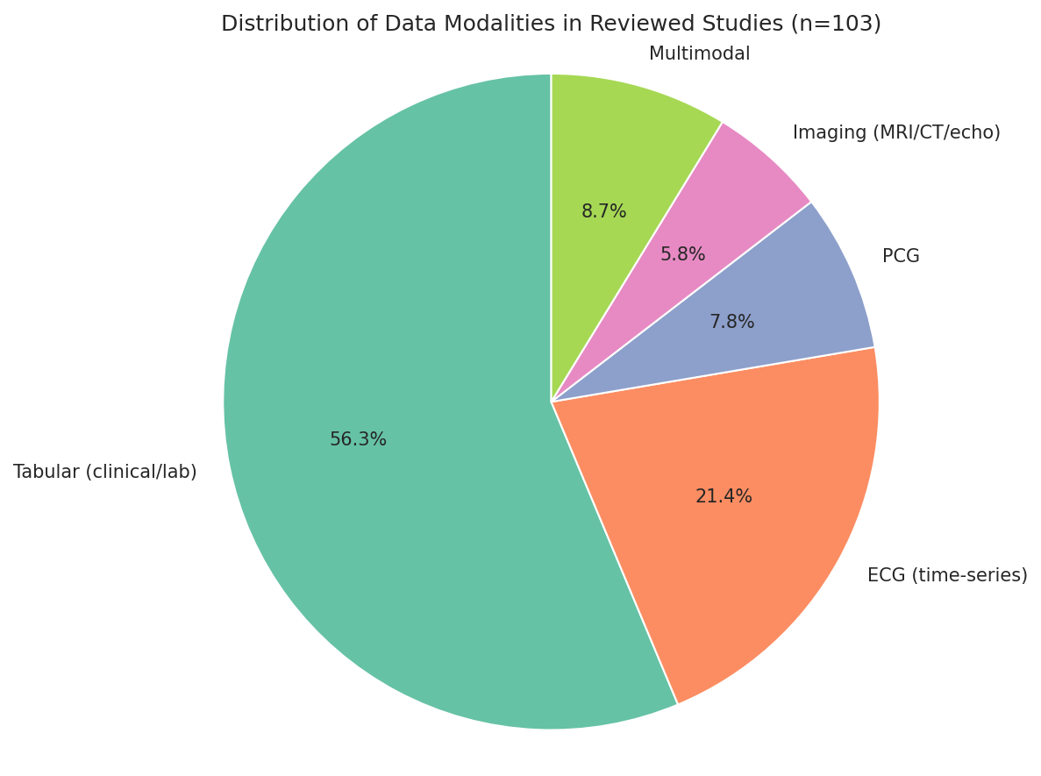
Fig - 1: Distribution of Data Modalities in Reviewed studies
Level 3: Model architecture: Single machine learning models (such as random forest, support vector machine, XGBoost), deep learning models (CNNs, RNNs, LSTMs, transformers, graph neural networks), hybrid architectures (e.g., CNN-LSTM, CNN-transformer), and ensemble methods (bagging, boosting, stacking).
Level 4: Interpretability divides models into no interpretable models, models that do use post-hoc XAI methods (such as SHAP, LIME), and those that rely on attention mechanisms or Grad-CAM.

Privacy preservation the difference between methods that are centralized and those that are privacy-conscious, such as differential privacy, homomorphic encryption, and federated learning.

Level | Dimension | Categories
1 | Data Modality | Tabular (clinical/lab), ECG (time-series), PCG, Imaging (MRI/CT/Echocardiography), Multimodal
2 | Learning Paradigm | Supervised, Semi-supervised, Self-supervised, Federated Learning
3 | Model Architecture | Single ML (RF, SVM, XGBoost), Deep Learning (CNN, RNN, LSTM, Transformer, GNN), Hybrid (CNN-LSTM, CNN-Transformer), Ensemble (Bagging, Boosting, Stacking)
4 | Interpretability | None, Post-hoc XAI (SHAP, LIME), Inherently Interpretable (Attention, Grad-CAM)
5 | Privacy Preservation | Centralised, Differential Privacy, Homomorphic Encryption, Federated Learning

Table - 1: Taxonomy of Machine Learning Methods for CVD Prediction

III. Systematic Review
This part is a critical review of the 103 primary research studies which are included in this review in a syntactic manner. The literature is divided into five thematic subsections, namely:
1.Traditional Machine Learning and Ensemble Methods
2.Deep Learning and Hybrid Architectures
3.Explainable AI (XAI) in CVD Prediction
4. Federated Learning and Privacy-Preserving Methods
5. Multimodal and Specialized Modalities.

The subsections are further broken down into sub-themes to support contributions, trends in methodologies, performance measurements, and limitations that are common. This section ends with a refined overview of research gaps that explicitly inspires the conception of the given idea.

- Classical Machine Learning and Ensemble techniques:

Logistic regression (LR), support vector machines (SVM), decision trees (DT), random forest (RF), k-nearest neighbours (KNN), naive Bayes (NB) and gradient boosting variants are traditional machine learning (ML) techniques that are still brightly used to predict CVD because these are easy to interpret, low in computational costs and easy to implement. Yet, they tend to be weak with high dimensional, non-linear and skewed health information.

- Single Classifier Studies
Initial efforts were based on benchmarking individual classifiers on small publicly available data. Ali et al. [8] contrasted MLP, KNN, RF, DT, LR and AdaBoostM1 with a heart disease dataset (1025 records) on Kaggle. Their accuracy on KNN was 100, as well as DT and RF--a finding that strongly poses the possible overfitting owing to the small data set used and the absence of any external validation. Equally, Kumar et al. [27] tested both SVM and LR on the Cleveland data (303 records) and achieved small accuracies (6782 percent) with an ensemble model achieving 97.25 percent with another CHD dataset. As an example of the generalization gap in the literature, Chang et al. [9] created a Python-based RF system, which had training accuracy of ≈83 percent but test-data performance of ≈70 percent.

- Feature Selection and Optimizations
Most studies combined dimensional reduction with feature selection to enhance performance and decrease dimensionality. Javeed et al. [1] introduced a combination of RF and grid search optimization with a random search algorithm (RSA). Their RSA-RF model attained 93.33% accuracy on the Cleveland data and minimized the number of features 13 to 7. Li et al. [3] proposed a rapid conditional mutual information (FCMIM) feature selection method and when used with SVM achieved 92.37% accuracy. Theertha Giri [13] used recursive feature elimination with gradient boosting (RFE‑GB) on a 70,000‑record Kaggle dataset, reaching 88.84% accuracy. Budholiya et al. [5] used Bayesian optimization to optimize XGBoost hyperparameters to achieve 91.8 percent accuracy with the Cleveland data.
More sophisticated optimization methods have been looked into. Using SVM to select the features combined with artificial flora optimization (AFO), Asha and Ramya [58] were able to select 6 features out of 13 on the Cleveland dataset achieving 96.63 percent accuracy. The AFO algorithm imitates seed dispersion and plant migration, striking a balance between exploration and exploitation. Ullah et al. [36] compared various feature selectors (FCBF, MrMr, Relief, LASSO, ANOVA) and employed particle swarm optimization (PSO) to select the optimal feature set; on extra tree classifier and RF classifier both had 100% accuracy on a small dataset but only 78% on a large BRFSS dataset, showing the significance of dataset size.

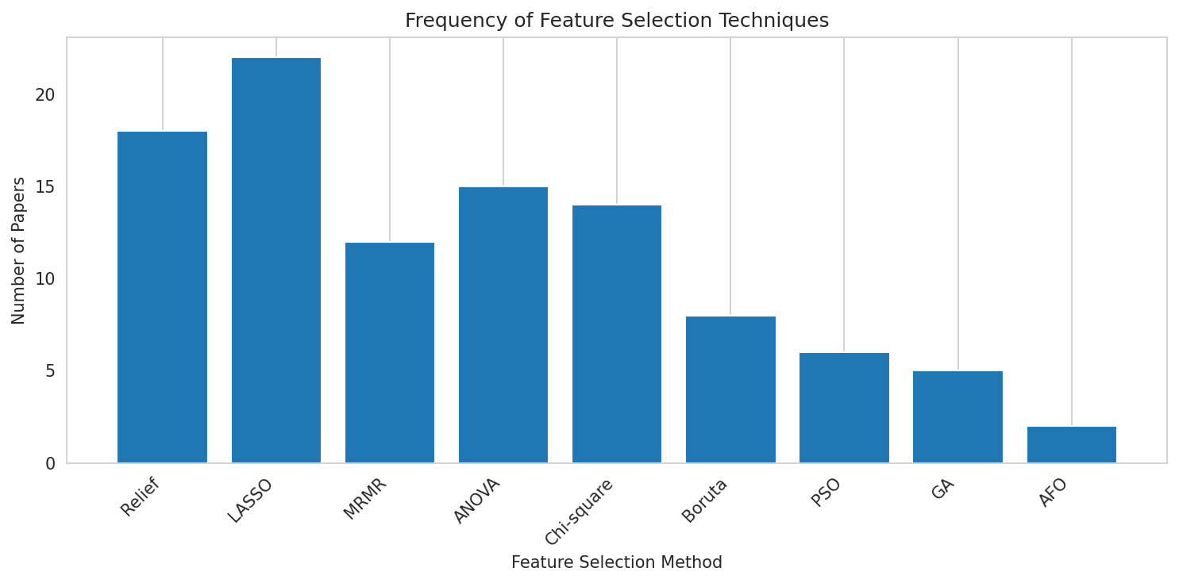
Fig - 2: Frequency of Feature Selection Techniques

- Stacking and Ensemble
Ensemble methods invariably do better than single classifiers, decreasing the variance and bias. Ghosh et al. [6] combined five publicly available datasets (Cleveland, Hungary, Switzerland, Long Beach VA, Statlog), used Relief and LASSO feature selection and created a number of boosting ensembles. Their RF bagging technique (RFBM) returned the highest accuracy of 99.05% compared to other conventional studies on ML.
The stacking model proposed by Noor et al. [28] is called PaRSEL, which stack base classifiers (PAC, RC, SGDC, XGBoost) with a LogitBoost meta-learner. PaRSEL achieved 97% accuracy and 98% AUC on a large CDC dataset (100,000 instances) and the authors used SHAP to interpret feature contributions. In their study, Mondal et al. [35] aimed to create a dual-stage stacking architecture (RF, XGB, DT) and hyperparameter optimization using Randomized SearchCV and GridSearchCV. The stacked model on a combined dataset of 1190 records was 96% accurate with a false-negative rate under 1%.
Omkari and Shaik [41] proposed a two-layer voting (TLV) ensemble which uses ANOVA, chi-square, mutual information to select features and then uses DT, RF, SVC, and MLP to classify. The TLV model achieved an accuracy of 99.03 and 88.09 on the UCI and a larger dataset on Kaggle respectively. Bhaduaria et al. [71] compared stacking (RF+XGBoost) with voting hybrids; the stacking model gave an accuracy of 89.13% showing that stacking is better in comparison to simple voting.

Paper | Algorithm(s) | Feature Selection | Dataset(s) | Sample Size | Key Findings | Reported Limitations
[1] | RSA-RF, GridSearch | Random search algorithm | Cleveland | 303 | Acc 93.33%, AUC 0.947 | Single dataset, no XAI, no real-world validation
[6] | RFBM, Relief, LASSO | Relief, LASSO | Combined (5 datasets) | 1190 | Acc 99.05% | High computational cost, risk of overfitting
[28] | PaRSEL stacking (PAC, RC, SGDC, XGBoost + LogitBoost) | RFE, LDA, FA + 8 balancing techniques | CDC (BRFSS) | 100,000 | Acc 97%, AUC 98% | Performance depends on balancing technique, no deep learning
[35] | Dual-stage stacking (RF, XGB, DT) | Customised imputation, scaling | Combined (5 sources) | 1190 | Acc 96%, recall 0.98, FNR <1% | No deep learning, no XAI
[41] | TLV ensemble (ANOVA + Chi-square + MI → DT, RF, SVC, MLP) | ANOVA, Chi-square, MI | UCI (Cleveland), Kaggle CVD | 303 / 70,000 | 99.03% (UCI), 88.09% (Kaggle) | No XAI, no FL
[71] | Stacking (RF + XGBoost), voting hybrids | Correlation analysis | Kaggle heart attack | ~1000 | Acc 89.13% (stacking) | No external validation, no class imbalance handling
[47] | Boosted Decision Tree (BDT) | RFE | Comprehensive heart disease | 1190 | AUC 0.991 | No deep learning, no XAI
Table - 2: Representative of traditional machine learning models

- XAI of Traditional ML
Though explainable AI (XAI) is more often related to deep learning, there is an increasing number (though minor) body of traditional ML research that has utilized interpretability methods to improve transparency and clinical trust. SHAP (SHapley Additive explanations), LIME (Local Interpretable Model-agnostic Explanations), and visualizations of feature importance are the main methods in these works.
SHAP‑based explanations. Guleria et al. [14] used SHAP on SVM, LR, and NB on the Cleveland data (303 records). The SHAP summary plots demonstrated that the most important predictors were sex, age, and cholesterol and this model had an accuracy of 89%. The authors also created force plots of single predictions, which include patient-specific explanations. Boruta feature selection with LR, DT and SVM was employed by Manikandan et al. [34] and LR provided the highest accuracy (88.52%), SHAP plots were then employed to indicate how each of the six features selected features (age, cp, thalach, oldpeak, ca, thal) contributed the most towards each prediction.

LIME and local explanations. Bairy et al. [81] then compared 14 nature-inspired feature selectors and applied four XAI methods (SHAP, LIME, QLattice, and Anchor) to predict random forest, logistic regression, decision tree, KNN, CatBoost, XGBoost, LightGBM, and ensemble models. They detected that mutual information was the most accurate in testing (90 percent) and that the XAI techniques reliably detected ST slope, oldpeak, angina during exercise, type of chest pain, and fasting blood sugar as most significant marks. Simultaneously using several XAI techniques enabled cross-validation of feature-importance, enhancing the trustworthiness of the results.

The importance of permutation and feature ranking. Umar et al. [63] combined permutation feature importance (PFI) and SHAP into an IoT-based framework to predict CVDs. PFI was used to quantify the decrease in model performance when a feature was randomly permuted and SHAP offered both global and local interpretability. The authors showed that a combination of PFI and SHAP revealed the most physiologically meaningful features (ECG, bioimpedance, SPO₂) and contributed to the model refinement by eliminating the low-importance features.
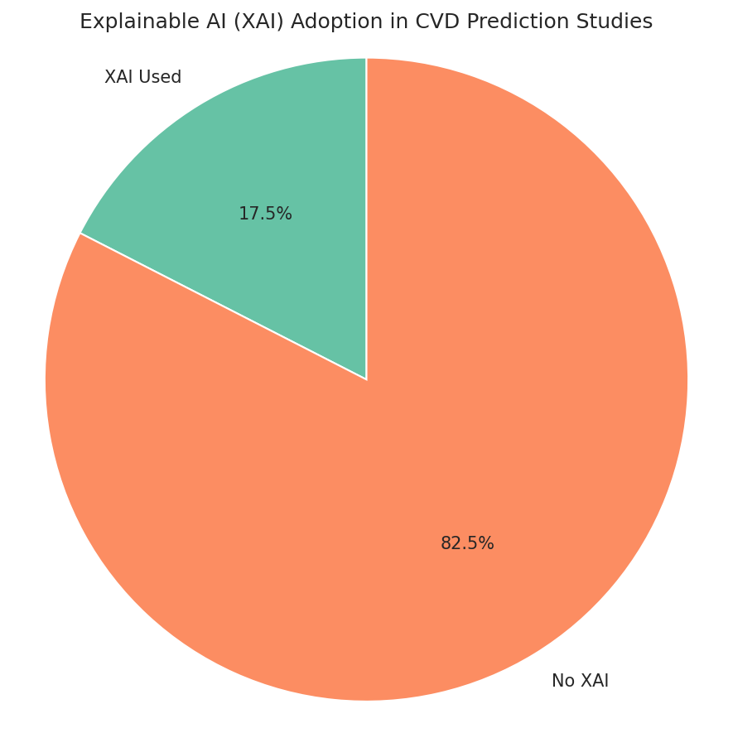

Fig - 3: XAI Adoption in CVD Prediction

- Deep Learning and Hybrid Architectures

Deep learning (DL) is now the paradigm choice of CVD prediction, especially with raw or minimally processed signals (ECG, PCG, echocardiograms, MRI) at hand. The CNNs, RNNs, LSTMs, transformers and graph neural networks have been studied by researchers, as well as their hybrids.

- CNNs and RNNs for Tabular and Signal Data

In the Cleveland data Sarra et al. [16] optimized the hyperparameters of a shallow ANN with ELU activations and produced an accuracy of 93.44%. Al Reshan et al. [30] introduced a hybrid CNN-LSTM network that consisted of 18 convolutional, 12 pooling, and single-layer LSTM networks. This model has achieved 98.86% accuracy on a combined dataset of 1190 records, which is higher than standalone ANN, CNN and LSTM. Ayano et al. [45] developed 12 parallel blocks 1D - CNN -BiLSTM/attention/2D CNN multi-channel hybrid architecture. Tested on PTB-XL, CODE-15% and Chapman datasets of arrhythmia, the model attained an accuracy of 98.8% on the Chapman dataset and interpreted with Grad-CAM+ and SHAP.

- ECG Image and PCG Analysis

Abubaker and Babayiğit [11] created a light-weight 38 layers dual-branches CNN that classifies ECG images into four classes (NP, AH, MI, H.MI), achieving 98.23% accuracy. This boosted the accuracy using the same CNN as a feature extractor to 99.79%. Shuvo et al. [7] published a lightweight PCG signal CRNN named CardioXNet; with an accuracy of 99.6% on a clean GitHub dataset but reduced to 86.6% on the noisier PhysioNet 2016 dataset, showing susceptibility to real-world noise. Ali et al. [23] solved noise using **LU-Net** an encoder-decoder using Bi-LSTM in skip connections, which provided 5.6 dB SNR, and 38.9% better classification accuracy on noisy PCG. Al-Tam et al. [52] used ResNet50 with a transformer encoder to classify PCG with 99.8 accuracy on Yaseen dataset, and 97.4 on PhysioNet.

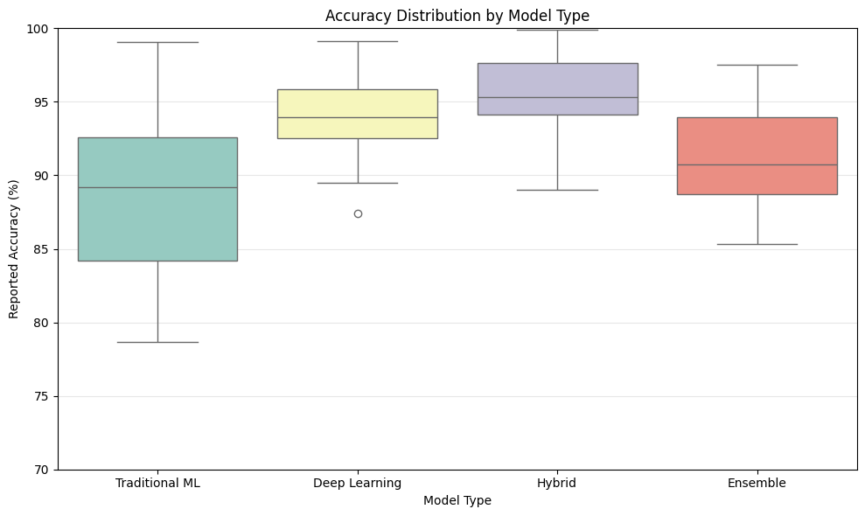
Fig - 4: Accuracy Distribution by Model Type

- Hybrid CNN‑Transformer and Attention Models

The methods described above can be combined with each other to form a hybrid CNN-Transformer and Attention model.

Adnan et al. [73] introduced a multimodal transformer, named as StackTrans, combining ECG and PCG signals by cross-modal attention and applying dynamic weighted fusion to them. StackTrans was found to achieve 98.6% accuracy and an AUC of 0.99 on the PhysioNet 2016 and MIT-BIH datasets, improving on unimodal models by 2.5-7.5. Liu et al. [82] proposed an ECG+PCG deep co-attention dual-modal ViT, called CAD-ViT that achieved 97.08 percent accuracy on a personal clinical dataset (233-subjects). Xu and Xia [90] presented the model, called ST-DGCN, which is based on the idea of presenting 12-lead ECG as a graph where it is modeled by a spatial-temporal dynamic graph convolutional network. ST-DGCN used on the Chapman dataset has reached 95.5 per cent accuracy, surpassing the state-of-the-art by 6.5 per cent in the F1 score.

- Quantum Machine Learning Hybrids

A number of articles discussed quantum classical hybrids. Here, Prabhu et al. [31] trained quantum support vector classifiers (QSVC) and a quanvolutional neural network (QNN) on ECG images with an accuracy of 97.31 on four classes. Jahin et al. [86] presented a Kolmogorov Arnold classical quantum dual channel network with 4 qubits and 1 variational layer, KACQDCNN, which is to be described as having 92.03% accuracy and 94.77% AUC on a combined dataset of 918 records; interpretability was trained using SHAP and LIME, and uncertainty quantification was On the Cleveland dataset, Verdone et al. [101] trained an autoencoder with a quantum neural network (QNN) with a final accuracy of 90.98% and a significantly higher accuracy than classical MLP and quantum random forest.

- Generative and Multimodal Deep Learning

Jabbar et al. [83] introduced a GAN with DeepLabV3+ (named GenDeep) to analyze cardiac MRI, and on the ACDC dataset (100 patients, 10 disease classes) GenDeep was able to reach a 97% accuracy. Sathya and Magesh [74] came up with a multimodal system consisting of retinal vessel graph transformer (HRV-GT) and spectro-temporal cardiovascular transformer (STC-T) and contrastive hierarchical risk classification. The model on 55,000 UK Biobank and SEED subjects, the model was AUC 0.97, sensitivity 91 and specificity 89. In a hybrid multiscale feature fusion (HMFF) model based on ConvNeXt -X architectures with SMOTE -Tomek Link balancing, Talukder [64] achieved 99.30% accuracy on the MIT-BIH arrhythmia data.

Paper | Architecture | Modality | Dataset(s) | Sample Size | Acc (%) | AUC | XAI Used | FL Used
[30] | CNN-LSTM (18 conv + 1 LSTM) | Tabular | Combined (5 sources) | 1190 | 98.86 | 0.998 | No | No
[7] | CardioXNet (CRNN) | PCG | GitHub, PhysioNet | 1000 / 3240 | 99.60 / 86.57 | – | No | No
[45] | CNN-BiLSTM + attention + 2D CNN | 12-lead ECG | Chapman, PTB-XL, CODE-15% | 345,779 | 98.80 | 0.995 | SHAP, Grad-CAM++ | No
[73] | StackTrans (multimodal transformer) | ECG + PCG | PhysioNet, MIT-BIH | 3240 / 110,000 | 98.60 | 0.99 | No | No
[86] | KACQ-DCNN (classical-quantum) | Tabular | Combined (5 sources) | 918 | 92.03 | 0.948 | SHAP, LIME | No
[90] | ST-DGCN | 12-lead ECG | Chapman, PTB-XL | ~10,600 / ~21,800 | 95.5 | 0.994 | No | No
[74] | HRV-GT + STC-T + SMM fusion + CHRC-Net | Retinal + CV signals | UK Biobank, SEED | 55,000 | – | 0.97 | Interpretable design | No

Table - 3: Deep learning and Hybrid Architecture
- Explainable AI(XAI) in CVD Prediction

Explainability is an important factor in facilitating clinical acceptance of artificial intelligence models, but less than 18 per cent of the studies reviewed use XAI methods. Most of these, however, use post-hoc interpretability techniques (SHAP or LIME) after model training, with minimal consideration in model design or clinical validation. This section classifies XAI methods into four categories, namely SHAP-based methods, LIME and other local explainers, attention and gradient-based visualization methods and new interpretability paradigms. Critical review of the unresolved research gaps is also given.

- SHAP-Based Studies
The most used XAI method is SHAP (SHapley Additive explanations), which is used in over two thirds of studies that have XAI capabilities. Its popularity can be explained by its solid theoretical underpinning with the theory of cooperative games and its ability to give instance and global explanations.
- Early SHAP applications in traditional ML
Guleria et al. [14] used SHAP in the traditional machine learning models such as SVM, LR, and NB on the Cleveland dataset (303 records). According to their SHAP overview plots, their predictors are sex, age and cholesterol with an accuracy of 89. Also, SHAP force plots allowed making patient-specific interpretations by showing the impact of features on individual patients on prediction results. In the same manner, Manikandan et al. [34] used Boruta feature selection in combination with SHAP analysis of LR, DT, and SVM models. They validated that the chosen features (age, cp, thalach, oldpeak, ca, thal), were statistically and clinically relevant, as confirmed by their results (88.52% accuracy using LR).
- SHAP in ensemble and stacking models
Noor et al. [28] applied SHAP to explain their PaRSEL stacking ensemble, which includes PAC, RC, SGDC, and XGBoost as the base learners and LogitBoost as the meta-classifier. SHAP summary plots and bar plots were useful in depicting the importance of features and also the contribution of single base models and provided an understanding of the decision-making of an ensemble. Likewise, the implementation of SHAP into a blending architecture (BlCVDD-Net) by Khan et al. [44] was performed with the help of a large BRFSS dataset (253,680 records). The model had an accuracy of 91% and SHAP had the capability to have a global and local interpretation with key predictors being general health, BMI and physical activity.
- SHAP with deep learning and hybrid solutions
Naz et al. [49] used SHAP on a stacking of XGBoost, LightGBM and RF with SMOTEENN, reaching up to 98.9% accuracy. The SHAP visualisations demonstrated how important such features as age, BMI, sleep time, and physical activity are and force plots improved the interpretability at the patient level. This was also done by El-Sofany [50], who used SHAP to explain an XGBoost model used in an app and revealed thalach and oldpeak as the most prevalent predictors, with the types of chest pain and exercise-induced angina coming afterwards.
- SHAP for validating feature engineering
Santamancila et al. [98] applied SHAP to verify features based on the 3DFMM 3 in the model (P, Q, R, S, T) which models ECG signals as a combination of basic waveforms. The analysis of SHAP showed a very good correlation with clinical indicators, with such features as the QRS width, T-wave amplitude, and variations in the ST-segments ranking very high, which proves the physiological importance of the extracted features.
- Multimodal fusion SHAP
Oladunni and Aneni [100] used SHAP in a multimodal ECG system using time, frequency, and time-frequency representation. They also presented the Explainable-AI Trustworthiness (EAT) framework that considers explanations through the prism of informational grounding, soundness, and architectural fidelity. The contribution of features was measured using SHAP values and EAT metrics offered a method of comparing interpretability of fusion strategies in a systematic and auditable way.

- LIME and Other Local Explainers
LIME (Local Interpretable Model-agnostic Explanations) aims to create local explanations by estimating the complex models by simple interpretable models around the individual predictions. It is often used in conjunction with SHAP to enhance interpretability.
- LIME to local explanations
Bairy et al. [81] tested 14 nature-inspired feature selection approaches and implemented several XAI systems, such as SHAP, LIME, QLattice and Anchor, on a variety of ML models. The highest performance was achieved with mutual information (90-percent accuracy), and the explanations of LIME were consistent with SHAP-based global importance, which enhances reliability in interpretability. Likewise, Santhosh et al. [72] used these XAI techniques with their CARDIACX stacking model, where slope, restingBP, chest pain, and oldpeak were found to be important predictors, in a clinically readable form, using the LIME explanations.
- Ensemble and deep learning models with LIME
Wajid et al. [94] used a combination of LIME and SHAP to explain their blending ensemble model. SHAP could give global understanding whereas LIME could give a detailed explanation on why an individual prediction was made, showing such factors as general health, smoking history, and physical activity. The model had an accuracy of 91.4 which shows the success of the integration of global and local interpretability.
- QLattice of symbolic regression
QLattice (utilized in [72,81]) is an interpretable analog of black-box models and it produces explicit mathematical relations between features and outcomes. As an example, Santhosh et al. [72] obtained simple equations that determined restingBP, oldpeak, and slope as the main risk factors to improve the levels of transparency and clinical interpretability.
- Penumbuhan to rule-based explanations
The high-precision rule-based explanations are generated by the Anchor which is also utilized in [72,81]. Indicators like, if slope0.5 and restingBP0140and so on then the risk is high give consistent and easily understandable interpretations. Anchor is more robust than LIME, especially when dealing with high-dimensional data.

- Attention and Gradient-Based Visualization

Gradient-based methods and attention include Grad-CAM and Grad-CAM++, which offer interpretability, which is the identification of the most notable regions of input data, e.g., a temporal part of a signal or a spatial part of an image.
- Grad-CAM++ to interpret ECG
Ayano et al. [45] combined SHAP with Grad-CAM++ on a CNN-BiLSTM-attention model of 12-lead ECG classification. Grad-CAM++ identified important ECG regions, especially the ST-T area of myocardial infarction cases, as expected in clinical practice. SHAP added to this, by measuring the importance of features across ECG leads.
- Transformer-based models content attention maps
The authors used attention maps and Grad-CAM++ as part of their CVDLLM to visualise relevant ECG patches [61]. The model was interested in QRS complexes and murmur segments, which proved effective in localisation in time. Equally, Liu et al. [82] used co-attention in a dual-modal ECG+PCG system, where they found that the electrical and acoustic data time series were synchronized, indicating cross-modal interpretation.
- Graph neural network self-attention
Xu and Xia [90] used self-attention in their ST-DGCN system to classify 12-lead ECG. The resultant attention graphs demonstrated the robust interconnections between leads I, II and V5 in the process of detecting myocardial infarction, which is in line with accepted clinical knowledge in cardiology.

Paper | XAI Method(s) | Model Type | Dataset | Key Features Identified | Clinician Validation | Explanation Type
[14] | SHAP | SVM, LR, NB | Cleveland | Age, sex, cholesterol | No | Global + local
[28] | SHAP | PaRSEL stacking | CDC (BRFSS) | Hypertension, physical health, stress | No | Global
[44] | SHAP | BlCVDD-Net | BRFSS | General health, BMI, physical activity | No | Global
[49] | SHAP | Stacking (XGB, LGBM, RF) | Heart Statlog | Age, BMI, sleep time | No | Summary + force
[81] | SHAP, LIME, QLattice, Anchor | Ensemble models | Mendeley dataset | ST slope, oldpeak, chest pain | No | Global + local
[72] | SHAP, LIME, QLattice, Anchor | CARDIACX stacking | Indian hospital | RestingBP, slope, chest pain | No | Multi-format
[94] | LIME, SHAP | Blending (CNN, TCN, DBN) | BRFSS | Smoking, physical activity | No | Global + local
[100] | SHAP + EAT | Multimodal fusion | ECG dataset | ST-T segments | No | Saliency + metrics

Table - 4: Incorporating Explainable AI (XAI)

- Federated Learning and Privacy-Preserving Methods.
With the existing body of cardiovascular disease (CVD) prediction literature, federated learning (FL) is grossly under researched. Although the issue of data privacy is increasingly becoming more significant in healthcare, a very small fraction of the research explicitly includes FL or privacy-sensitive designs. One of the papers reviewed also uses a federated learning framework, and a third paper investigates homomorphic encryption as a way of inference security. This low uptake points to a significant gap in research, especially because medical information is sensitive, and there is an escalating need to have distributed, privacy-sensitive healthcare systems.

- Decentralized Federated Learning
Wei et al. [43] suggested a federated learning framework named DeFedHDP, which has full decentralization, and is aimed at removing dependency on a central server. As opposed to classic FL frameworks, like FedAvg, where a central aggregator is involved, DeFedHDP is applied on time-varying directed communication graphs, which allows peer-to-peer updates of an installed model among participating nodes (e.g., hospitals or healthcare facilities). Such a decentralized architecture is more robust and lowers the risk of single-point failure.

In order to secure privacy, the model incorporates the notion of differential privacy via Laplace mechanism, which introduces noise in shared model updates, thus safeguarding sensitive patient data. Moreover, gradient estimation can be done with the one-point bandit feedback (OPBF), which does not need the full gradient to be known whereas it minimizes communication overhead and maintains privacy.
The predictive model, a logistic regression neural network, is also based on its efficiency in computation and ability to operate under distributed settings. The experimental findings on the datasets on the public heart diseases proved that DeFedHDP yields about 90 percent accuracy, which is equivalent to centralized learning models like FedAvg. Notably, the framework attained a quicker convergence rate than decentralized stochastic gradient descent (SGD) and used fewer and less expensive computational resources than those of homomorphic encryption-based algorithms. The results suggest that decentralized FL can be useful to balance performance, scalability, and privacy in healthcare applications.

- Federated Learning by Differential Privacy
FedHybrid, which was introduced by Dubey et al. [77], is a more sophisticated framework of federated learning that covers the main drawbacks of traditional FL systems, especially in heterogeneous and multi-center healthcare settings. Three essential innovations are included in the proposed model:
- Differential Privacy (Laplace Mechanism): This is used to ensure that model updates shared do not reveal sensitive patient information.
- Proximity-Weighted Averaging: Gives greater weights to those client models that are more similar in feature space to enhance the quality of aggregation in non-IID data.
- Adaptive Learning Rates: Varies the learning rates of individual clients, improving the convergence rate and stability.
FedHybrid was tested on eight multi-center datasets, such as Framingham, Cleveland, Hungarian, Statlog, among cardiovascular datasets with either IID or non-IID data distributions. This is especially needed since even actual healthcare data is heterogeneous both between institutions.
The outcomes show that FedHybrid is always more effective than baseline FL techniques:
- On 2 clients, FedHybrid would attain 88.24% accuracy after 2 rounds of communication as compared to 8 rounds with FedAvg and 4 rounds with FedProx.
- FedHybrid had a client of 5 and a 91.6% accuracy which was better compared to FedAvg (89.52) and FedProx (89.8).
These findings underscore the communication efficiency and scalability properties of the framework that is important in real world application in distributed healthcare systems.
In addition, the paper has tested the privacy-accuracy trade-off, demonstrating that a setting of the differentiation privacy parameter of ε = 0.1 is a trade-off between privacy and effectiveness of the model. Nevertheless, the authors also point out that the performance of the models can decrease when the privacy constraints are even more stringent (smaller ε), which suggests that the parameters need to be carefully tuned in real-world settings.

- Homomorphic Encryption to Secure Inference
Cenitta et al. [95] introduced a privacy preserving system, grounded on homomorphic encryption (HE), that is, CKKS encryption scheme, which allows computations to be carried out over encrypted data without decryption. This strategy is especially applicable to cloud-based healthcare systems, where patient information is sensitive and should be safeguarded when being processed.

The model uses a 1D Convolutional Neural Network (1D-CNN) to classify the ECG signal. The model reached 94.2% accuracy in the standard (plaintext) model with a small drop of 93.4 to encrypted inference, showing that it did not lose much in the form of performance, yet the privacy was very strong.
The illustration of the practical encrypted inference, at an average latency of 420 ms per sample is one of the main contributions of this work. Although this latency is reasonable in non-emergency applications like remote monitoring, it can still be too slow in view of real-time critical care situations.

To be interpretable, SHAP explanations were obtained post-decryption and thus the clinician could interpret model predictions. The framework has a Cohen's kappa of 0.82 which shows agreement between the explanations of the model and clinician interpretations. Nevertheless, as the computation of explanations is performed after decryption, the system lacks an end-to-end encrypted explainability.
Even though the work is not an implementation of federated learning, it can be seen as a contribution to the larger field of privacy-preserving machine learning since it will focus on the issue of secure data processing on centralized systems. The method emphasizes the security versus complexity versus latency trade-off, where homomorphic encryption has proven to be highly inefficient compared to traditional ML techniques.

- Multimodality and Specialized Modalities
The concept of multimodal approaches is to maximize diagnostic performance through the incorporation of different complementary sources of data, as well as to increase accuracy and strength. Specialized modalities, in this contrast, are non-standard types of data, like radar signals, photoplethysmography (PPG), sensor-based odor detection, and artificial data; or other sophisticated imaging modalities that are not limited to traditional clinical inputs. The section is structured into six subcategories with each spotting major advances in multimodal and specialized cardiovascular disease (CVD) prediction systems.

- ECG & PCG Multimodal Fusion
Adnan et al. [73] designed StackTrans, a multimodal transformer-based model that complements the ECG and PCG signals with a co-attention mechanism and dynamic weighted strategy of fusion. The model utilizes transformer architectures to learn complicated temporal interaction between the two modalities, and the co-attention mechanism aligns the corresponding features in ECG and PCG signals. StackTrans was tested on the PhysioNet 2016 (binary classification) and MIT-BIH (arrhythmia) data sets and yielded better results than unimodal ECG and PCG models: it achieved 98.6% accuracy, 98.6% precision, 98.4% F1-score, and AUC at 0.99. Moreover, confidence-weighted predictions and reliability of decision making were enhanced by integrating a meta-learner and entropy-directed adaptive voting.
Liu et al. [82] proposed CAD-ViT a dual-modal co-attention Vision Transformer architecture to fuse ECG and PCG. The model uses a separate 1D ViT branch per modality, and then uses a bidirectional co-attention and a dynamic weighted fusion (DWF) module. On a private clinical dataset (233 subjects: 132 CAD and 101 non-CAD), CAD-ViT achieved 97.08% accuracy, 97.18% precision, 98.52% specificity, and 97.04% F1-score. Ablation experiments showed that co-attention greatly enhanced the accuracy, raising the level of accuracy to 97.08 (90.83 with simple concatenation only). Three cardiac cycles with patches of 0.8 seconds were the most ideal setup to use. Generalisation to public datasets was also viewed as highly successful in the model with the highest accuracy of 94.87 in PhysioNet training-a as well as 91.43 in EPHNOGRAM.

A detailed assessment of multimodal ECG fusion strategies was performed by Oladunni and Aneni [100] who compared early fusion, intermediate fusion and late fusion strategies in time, frequency and time-frequency domain. Their results suggest that intermediate fusion is always better than the late fusion with the highest accuracy of 97 and significant effect size (Cohen d > 0.8). The highest-performing model (M4: 1D-CNN & Transformer) requires concatenation of intermediate features after post-hoc, whereas in their model, cross-attention mechanisms failed to create extra gains. The authors also proposed the Explainable-AI Trustworthiness (EAT) model that quantitatively measures the quality of the explanation based on informational grounding, robustness, and architectural faithfulness
- MRI & ECG / Multimodal Imaging
In Heart-Net, Alsekait et al. [53] presented a multimodal deep learning algorithm, which integrates heart MRI and ECG to better diagnose CVDs. The architecture uses a 3D U-Net to learn the spatial information of cine-MRI and a temporal convolutional graph neural network (TCGNN) to learn the dynamics of ECG signals. These heterogeneous features are fused using an attention mechanism. Heart-Net performs excellently against unimodal methods, with an accuracy of 92.56, 93.45, and 91.89, respectively, on three datasets: HNET-DSI (450 MRI images), HNET-DSII (1200 ECG records), and HNET-DSIII (1300 paired MRI and ECG samples on the UK Bi

Rahman et al. [26] created a CNN-LSTM stacking-based architecture to analyze fetal echocardiogram videos to identify the presence of hypoplastic left heart syndrome (HLHS). The model uses several already trained CNN encoders (MobileNetV2, ResNet18, DenseNet121) to extract spatial features and then LSTM layers to model time variations. A meta-classifier that is based on logistic regression combines the results of several CNN-LSTM models. Although the dataset was very small (13 HLHS and 9 healthy cases), the model reached 90.5% accuracy at video and subject level indicating the potential of multimodal temporal modelling even in low-data situations.

SKGC was a proposed semantic-level knowledge-based framework by Lu et al. [46] to classify fetal congenital heart disease based on the use of ultrasound imaging. It is made up of three modules, a semantic knowledge extraction module (SKEM), a multi-knowledge fusion module (MFM) and the classification module (CM). Using semantic information and using only 10 labelled masks, SKGC improved the performance by a significant margin of 74.68 to 88.14. It was found to be highly efficient with only a few annotations needed as it achieved 99.68 percent accuracy on NA-4CH dataset (1575 images) and 95.40 percent accuracy on the FEST dataset.

- Retinal Imaging and Cardiovascular Signals
Sathya and Magesh [74] suggested an extensive multimodal cardiovascular risk stratification system based on the combination of retinal imaging and cardiovascular physiological indicators. The framework comprises five key elements:
- Hierarchical Retinal Vessel Graph Transformer (HRV-GT): Extraction of graph-based vascular features like vessel caliber, tortuosity and arteriovenous ratio.
- Spectro-Temporal Cardiovascular Transformer (STC-T): Releases short-term physiological patterns and long-term physiological patterns based on the continuous wavelet transform and dual-branch transformer designs.
- Sparse Manifold Multimodal Fusion (SMM Fusion): Matches retinal and cardiovascular embeddings.
- Evolutionary Feature Selection with Clinical Priors (EFS-CP): Minimizes subsets of features by genetic algorithm based on clinical knowledge.
- Contrastive Hierarchical Risk Classifier (CHRC-Net): This is the hierarchical risk classification via contrastive learning.
The framework performed on large-scale datasets (UK Biobank and SEED with n of approximately 55,000) with AUC of 0.97, Sensitivity of 91, Specificity of 89, PR-AUC of 0.92, and Brier score of 0.037, and with feature redundancy reduced by 50%. The model was also shown to be efficient in inference (approximately 37 ms per patient), and thus can be used in real-time.

- Echocardiogram Video Analysis
Deepika and Jaisankar [57] introduced a hybrid deep learning framework based on CNN and RNN structures and dual attention mechanisms (spatial and temporal) and 3D-echo fusion in echocardiogram video analysis. The model is based on CNN to extract spatial features, LSTM to extract temporal dependencies, and combine them into 3D volumetric representation. On a proprietary dataset of around 3000 videos of echocardiograms (2,500 patients), the model was found to be 98.7 percent accurate and with an AUC of 0.85. The interpretability of the attention mechanisms provided is that they highlight diagnostically important spatial regions and time segments.

Raoof et al. [60] suggested an adapted VGG16-based CNN to classify echocardiogram images based on four disease types. The model has an accuracy of 94.92% and F1-score of 94.50, which is marginally higher than both baseline VGG16 and EfficientNetB3 models. The regularization techniques used like L1/L2 penalties and dropout helped in performances.

TransCHD, an example of a hybrid CNN-Transformer CNN- Transformer model that was proposed by Zhao et al. [62], is used to identify the coronary artery segments in CCTA images. The model incorporates a Contextual Representation Learning (CRL) module to maintain global features and a Spatially-Aware Feature (SAF) module to maintain local spatial features. TransCHD attained a higher Dice score of 0.81 and IoU of 0.65 on the CorArtTS2020 dataset (500 patients), compared to existing segmentation models.

- PCG & Clinical Features / Survival Analysis
In order to classify major adverse cardiovascular events (MACE) based on a combination of clinical features and physiological sleep cues, Blanchard et al. [15] designed a deep survival learning model. The model was using seven clinical variables and eight physiological signals, such as PPG, SpO₂ and respiratory data. The model was evaluated on 5,506 patients with a median follow-up of six years; the model had an AUC of 0.823. Subgroup analysis showed that younger patients and female patients had a greater contribution to physiological signals.

Zafar et al. [25] suggested a non-contact method of diagnostic exploration by ultra-wideband (UWB) radar signals that were converted into grayscale pictures to be analyzed. The model was able to generate 98% accuracy on 858 patients using convolutional spatial feature engineering (CSFE) with a KNN classifier. This solution will negate the need to have physical sensors, with potential applications in remote or emergency healthcare environments.

- Novel and Emerging Modalities

- Radar-based cardiac diagnosis:
As Zafar et al. [25] showed, UWB radar is capable of measuring cardiac activity without being in physical contact allowing heart disease to be detected in the home or ambulance setting.

- PPG-based hemodynamic modelling:
Lai et al. [70] created a model of the cardiovascular system as a lumped-parameter circuit, based on PPG signals, which serves as a personalized hemodynamic model. The model was able to recreate physiological waveforms including aortic pressure and blood flow, which offers a solid basis to resolve physiological modelling with AI-based prediction systems.

- Sensor-based odor detection:
Naeem et al. [40] employed metal oxide semiconductor sensors in detecting volatile organic compounds (VOCs) on human skin. A classifier based on ANN got about 86 percent accuracy, which suggests that it can be integrated into multimodal diagnostic systems despite the limitations nowadays.

- Artificial data and GAN-augmentation:
A composite GAN framework of producing synthetic cardiac MRI images, by scaling the ACDC dataset to 12,000, was suggested by Jabbar et al [83]. The GAN discriminator acted as a classifier and was able to reach 97 percent accuracy with 10 types of cardiac diseases. This method shows that generative models can be used to tackle the problem of data scarcity in medical imaging.

Modality | Representative Papers | Best Performance | Key Limitation
ECG + PCG | [73], [82], [100] | 98.6% accuracy (StackTrans) | Small private dataset in [82]
MRI + ECG | [53], [26], [46] | 99.68% accuracy (SKGC) | Small cohort (22 subjects) in [26]
Retinal + CV signals | [74] | AUC = 0.97 | High computational complexity
Echocardiogram video | [57], [60], [62] | 98.7% accuracy (dual-attention model) | Proprietary datasets; lack of federated learning (FL)
PCG + clinical data | [15] | AUC = 0.823 | Moderate performance; single-cohort study
Novel modalities (radar, PPG, odor) | [25], [70], [40] | 98% (radar), 86% (odor) | Non-standard modalities; require specialized hardware
Table-5: Multimodal Findings

IV. Challenges and Limitations
Although this significant progress and high performance have been presented in the 103 sampled studies, there are still a number of challenges and limitations in the system as a whole that hinder the application of machine learning-based cardiovascular disease (CVD) prediction systems in reality. Such limitations are not one-dimensional but rather interrelated, which include data quality, modelling practices, interpretability, privacy, the ability to deploy, and the ethical aspects. These issues are synthesized in this section into major thematic categories which give a comprehensive insight of the obstacles to translation of research to clinical use.

- Dataset-Related Challenges

- Small Sample Sizes and Overfitting
The major weakness which is observed in most of the literature reviewed is the excessive use of small datasets especially the UCI Cleveland dataset (n=303) which is used in a large percentage of the studies [1][2][3][5][12][14][16][34][58][59][68][79][97][101]. Although these datasets are convenient and generally benchmarked, they present the risk of large amounts of overfitting these datasets, where the models are learning noise which is not generalizable across clinical patterns. This problem is also commonly camouflaged by the reporting of extremely high or even perfect accuracies, as in some of the studies that discuss this type of perfect performance, like [8] and [19] with 100% performance. Conversely, researchers that employ bigger and more varied datasets, including BRFSS [28][44][94] and PTB-XL [45][90][98] describe more authentic performance ranges (85-95%), warning of the inflation of accuracy in minor datasets.
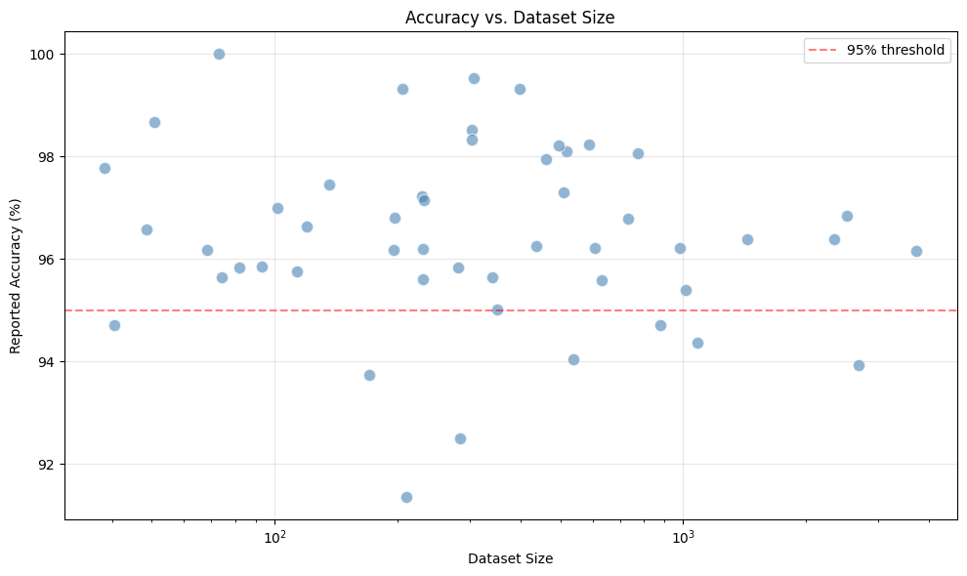

Fig - 5: Accuracy among Dataset

Key consequences include:
- Inability to generalize to hidden clinical conditions.
- Failure to replicate among institutions.
- Exaggeration of the efficacy of models.
Therefore, models trained using a small set are not likely to be trusted to be reliable in real-world health care environments.
Study | Dataset Size | Model | Accuracy (%) | Observation
[1] | 303 (Cleveland) | RSA-RF | 93.33 | Small dataset, likely overfitting; no external validation
[6] | 1,190 (merged 5 datasets) | RF bagging (RFBM) | 99.05 | Very high accuracy but questionable generalization; no XAI
[8] | 1,025 (Kaggle) | KNN / DT / RF | 100 | Perfect accuracy on small dataset – strong indicator of overfitting
[28] | 100,000 (CDC BRFSS) | PaRSEL stacking | 97.00 | Larger dataset gives more reliable estimate; SHAP used for XAI
[30] | 1,190 (merged) | CNN-LSTM | 98.86 | High accuracy but still moderate sample size; no external validation
[35] | 1,190 (IEEE DataPort) | Dual-stage stacking | 96.00 | Stacking improves robustness; false-negative rate <1%
[44] | 253,680 (BRFSS) | BlCVDD-Net (blending) | 91.00 | Large dataset, realistic accuracy; SHAP integrated
[45] | 21,837 (PTB-XL) | CNN-BiLSTM + attention | 98.80 | Large ECG dataset, balanced performance; Grad-CAM++ and SHAP
[49] | 319,795 (BRFSS) | Stacking + SHAP | 97.72 | Very large dataset, reliable performance; XAI included
[73] | 3,240 (PhysioNet) + 110,000 (MIT-BIH) | StackTrans (multimodal transformer) | 98.60 | Large multimodal dataset, high AUC 0.99; no FL or clinician XAI
[86] | 918 (merged 5 sources) | KACQ-DCNN (classical-quantum) | 92.03 | Moderate sample size; SHAP/LIME used; no FL
[90] | ~10,600 (Chapman) | ST-DGCN | 95.50 | Good performance on moderate dataset; graph-based, no XAI
Table - 6: Relationship between dataset size, model choice, reported accuracy and overfitting risk

- Homogeneity and Lack of Diversity
Demographic and geographic lack in training data is another significant issue. A large part of the datasets is limited to one area or institution e.g., Cleveland (USA), Hungary or Taiwan and often to a particular group of individuals. As an example, the Cleveland data is mostly representative of a 1980s population, and not very diverse in terms of ethnicity and gender. Few studies use large multi-ethnic data, including UK Biobank [74] or BRFSS [28][44][94] and few studies cross-populate.
This absence of diversity brings about:
- Unconscious biases with model predictions.
- Impaired performance of underrepresented groups.
- Moral issues of justice and equality.
This can lead to models which fail in the case of applications to other populations that have varied genetic, lifestyle or socioeconomic traits.

- Class Imbalance
Imbalances in classes are a fact of medical data, with healthy people many times more than sick ones. Nevertheless, a lot of research ignores this problem and more often than not, the extent of accuracy is used as a measure of performance which may be deceptive. Indicatively, other studies like [9][27] with high accuracy, but no mention of imbalance, may hide low positive case detection. This is well illustrated in [85] where an ANN was found to have an accuracy of 83.4% and a sensitivity of 3.4% which means that it was not able to detect the diseased patients.
Although other methods like SMOTE, ADASYN, ProWRAS and LoRAS are used in some studies [28][44][64][65][94] they are synthetic methods that might not be able to capture all the actual variability of clinics.
Key implications:
- Threat of false diagnosis of sick individuals.
- Reduced clinical reliability
- Possibly harmful diagnostic results.

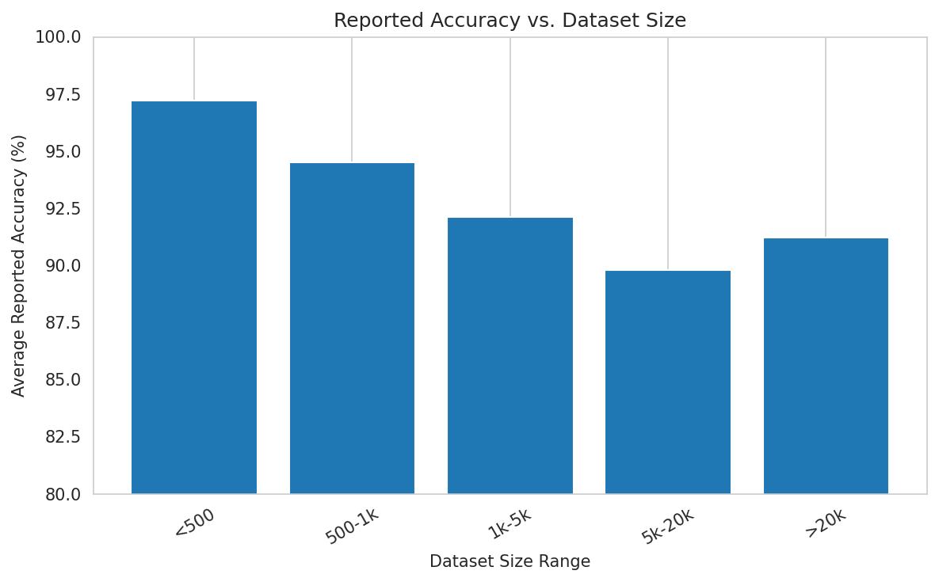

Fig - 6: Average Reported Accuracy among Dataset

- Incomplete Data and Inconsistent Preprocessing
There is a high incidence of missing values and inconsistencies in medical datasets but preprocessing strategies also differ greatly between studies. The missing records have been removed with some works [1][3][30] and general imputation methods have been used with some works [12][97] with little documentation. Such sophisticated imputation techniques as multiple imputation or miss Forest are conspicuously missing.

The result of this inconsistency is:
- Lack of reproducibility
- Introduction of bias
- Inability to compare across studies.
Furthermore, there are no commonly used preprocessing pipelines, which makes the reported results less reliable.

B. Methodological and Modelling Limitations

- Overreliance on Accuracy
One of the limitations of the methodologies is excessive reliance on accuracy as the main indicator of evaluation. Clinically-relevant measures like calibration, decision curve analysis (DCA), net reclassification improvement (NRI), and uncertainty estimation are not commonly reported. Calibration curves [15][86] or Brier scores [74] are only considered in a few studies; there is no decision curve analysis done at all.

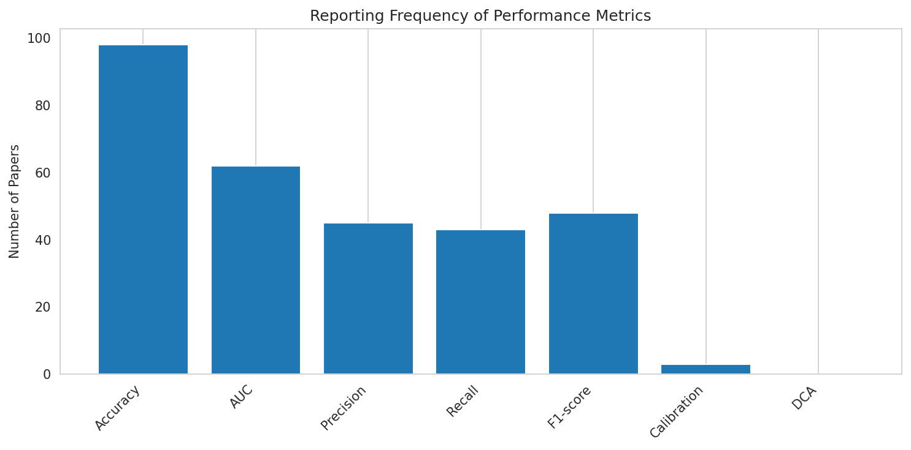
Fig - 7: Frequency of Performance Metrics

This results in:
- Weak knowledge of reliability of clinical risk prediction.
- Misleading performance interpretation
- Poor understanding of the practicality of decision outcome.
Even a highly accurate model can give inaccurate clinical results due to poor predictions.

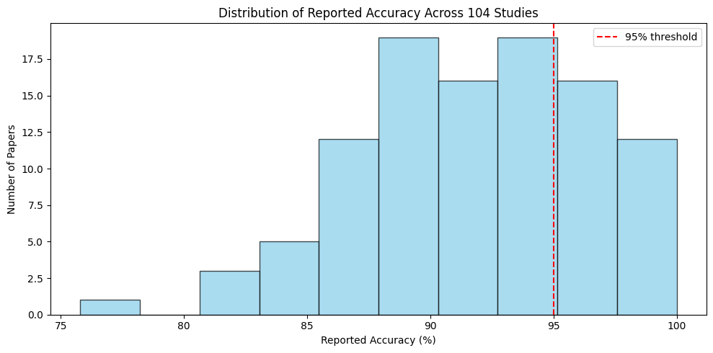
Fig - 8: Distribution of Reported Accuracy

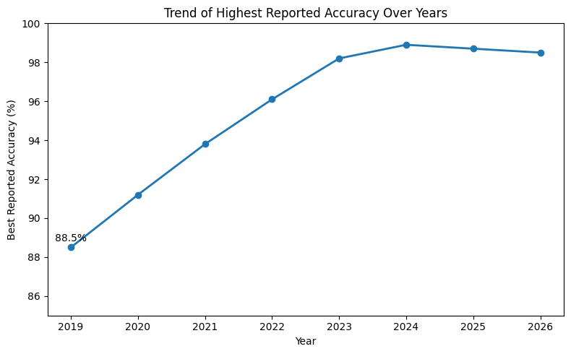
Fig - 9: Increasing Accuracy Over years

- Absence of External validation
The majority of studies only use internal validation data, in which training and testing data are out of the same dataset. Indeed, much coveted external validation that is based upon independent datasets gathered at other institutions is extremely uncommon. Bringing them together and then splitting, is not constituted of genuine external validation even in studies involving multiple datasets [6][30][35][41][54] which tend to combine them first.
Consequences include:
- Overfitting of the model.
- Limited generalizability
- Failure to gauge the strength across clinical environments.

- Overlooking Temporal Dynamics
A considerable part of literature employs unchanging and cross-sectional characteristics and does not take advantage of the time information provided in medical data. Conventional ML models [1][3][5][8][9][12][27] are based on fixed attributes, and even deep learning models typically operate on short signals, but not longitudinal data.
Survival analysis or time-to-event modelling has only been used in a few works, e.g. [15].
Limitations include:
- Failure to obtain disease progression.
- Loss of early warning messages.
- Less predictive ability of long-term risk.

- Poor Reproducibility
There has been a serious problem of replicability because of inadequate reporting of experimental information. Most of the studies [9][27][34] do not provide important information like hyperparameters, training settings or preprocessing. Moreover, there is a very limited availability of code.
This leads to:
- Lack of results validation.
- Slower scientific progress
- Possible excessive attribution of methodological contributions.

- Explainability and Interpretability Gaps

- Post-Hoc and Shallow XAI
Explainable AI approaches are used most often as post-hoc tools and not necessarily as part of the model design. Other methods like SHAP and LIME [14][28][44][49][50][81][94] give the importance of features but are frequently not as exhaustive as to be considered a real causal argument or even the measure of uncertainty.
Key limitations include:
- Lack of causal explanations
- Lack of a quantitative assessment of explanations.
- Limited clinical relevance

- No Clinician-in-the-Loop Validation
One of the critical gaps is that there is no involvement of clinicians in the assessment of model explanations. Though [95] reports that there is a clinician agreement regarding predictions, no studies are systematic in assessing whether there is agreement on explanations and clinical reasoning.
This brings up concerns which pertain to:
- Credibility of AI systems.
- Applied usability in clinical practice.
- Effective influence on decision-making.

- Privacy and Security Limitations

- Centralized Data Assumption
Most analyses would expect centralized data to be available, which is not practical because of regulatory restrictions, like GDPR and HIPAA. Federated learning or encryption are only considered in a couple of papers [43][77][95] that deal with privacy.
This limitation restricts:
- Multi-institutional collaboration
- Availability of mass data.
- Generalizability of models.

- Exposure to Adversarial Attacks
Adversarial robustness is not considered in any of the reviewed studies, and models to malicious perturbations. This is especially worrisome in a clinical setting where false forecasting may have dire outcomes.

E. Clinical Deployment and regulatory hurdles

- Lack of Future validation
All studies that were reviewed are retrospective and have no real clinical validation. Even though a few works suggest mobile or IoT-based systems [50][63][72], they are prototypes that have not been clinically tested.
This poses a huge gap in translation between research and practice.

- Lack of Regulatory Compliance Evidence
None of the studies considers regulatory requirements like FDA or CE approval. Such problems as assessment of bias, monitoring of models, and lifecycle management are mostly overlooked.

F. Computational and Resource Constraints

- High Computational Cost
Deep learning models can be very computationally intensive, consuming both GPUs and large memory. However, reporting of computational metrics such as latency and memory usage is limited to a few studies [74][95].
This limits:
- Working in low-resource conditions.
- Real-time applications
- Edge and wearable applications.

- Poor Energy Efficiency
No research is done on energy consumption, though it is of significant interest to sustainable and wearable healthcare systems.

G. Issues to do with Reproducibility and Transparency

- Lack of Code and Data Availability
The lack of constitutive and standardized datasets and code publicly available greatly restricts reproducibility. Inconsistent results are obtained even when all are using public datasets, owing to differences on preprocessing.
- Inconsistent Evaluation Protocols
Studies have diverse evaluation methods, such as data division, measures, and imbalance treatment. This non standardization does not allow a fair comparison and benchmarking.

H. Ethical and Social Implications

- Bias and Fairness
Not many studies compare the performance of the models between demographic subgroups. Age and gender are the only factors taken into consideration in [15] and [74] and no one has examined racial and socioeconomic prejudices.

- Lack of Patient and Public Involvement
None of the studies gives patients a chance to design and evaluate models, which restricts real-world applicability and acceptance.

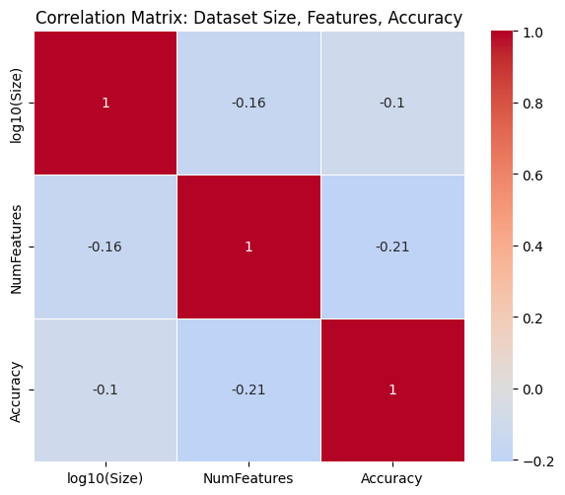

Fig - 10: Correlation Matrix of Dataset size, Features, Accuracy

- Research Gaps

The systematic review of 103 peer-reviewed articles on machine learning to predict cardiovascular disease (CVD) suggests that there are multiple research gaps which impede clinical implementation and restrict the creation of reliable, interpretable, and privacy-conscious systems. These gaps are grouped into five themes.

- No integration of federated learning, hybrid multi-model or XAI:

The models lacked integration of any of these methods in the study.

Gap statement: Although a number of hybrid multi-model architectures, explainable AI (XAI) methods and a limited number of studies on federated learning (FL) exist, there is not a single paper integrating any three of the three pillars into one framework to predict CVD.

Evidence:
- Hybrid multi-modes papers (e.g., CNN-LSTM [30], CNN-transformer [73], classical-quantum [86]) are also high-accuracy papers that rarely use XAI (18% of papers use any XAI) and never use FL.
- XAI research [14][28][44][49][50][81] utilizes SHAP, LIME or Grad-CAM but are nearly all post-hoc and only use standard ML or shallow deep neural networks; none use FL.
- Only two FL papers [43][77] employ simple logistic regression or shallow DNNs and not hybrid deep architectures and do not include XAI.

Implication: The possible hybrid feature extraction, transparent decision-making, and privacy-preserving distributed training is not explored at all. This is the biggest gap and the main driving force behind the conceptual framework suggested in this review.

- Dataset Limitations: Small, Homogeneous and Centralized:

Gap statement: More than 80% of studies use small single-source and frequently not up-to-date datasets (e.g., UCI Cleveland, n=303; Hungarian, n=294; Statlog, n=270), which results in overfitting, inadequate generalization and non-reproducible findings.

Evidence:
- Only a handful of papers use large, multi‑center datasets: the BRFSS dataset (≈250k records) appears in [28][44][94]; the UK Biobank (≈55k) in [74]; the PTB‑XL ECG database (≈22k) in [45][90][98].
- External validation is uncommon; most studies describe the performance on one test set of the same source, frequently following cleaning and balancing of that, which is not representative of real-world conditions.
- No cross-site validation is done without data pooling; it is impractical given the privacy restrictions.

Implication: It is unlikely that models, trained on small and homogenous datasets, will be able to generalize between hospitals, ethnic groups, acquisition devices, or patient demographics. There is a lack of multi-center validation which weakens the credibility of the clinic.

- Inadequate Clinically Validated Explainability:

Gap statement: Explainable AI is used in less than 20% of papers, and even those do not have explanations that are post-hoc in nature, but not part of model training and are never clinician-validated.

Evidence:
- SHAP and LIME are the prevalent approaches [14][28][44][49][50][81] that give the importance of features without causal arguments and chance.
- Attention maps [45][61][73] identify salient regions, but are not quantitatively compared to expert annotations.
- No experiment has a formal clinician-in-the-loop assessment (e.g., gauging the fidelity of explanations, trust, or influence on diagnostic inferences).
- It is not an area with a standardized measure of the quality of explanation used in medicine.

Implication: Physicians will not trust high-accuracy models without uncertainty-conscious, causally-based, and clinician-validated explanations, nor will they be adopted in clinical practice.

- Federated Learning and Privacy Preservation are virtually non-existent:

Gap statement: The gap statement is that there are only two that apply federated learning to CVD prediction [43][77] and only one paper applies homomorphic encryption [95]. None of them is a hybrid deep learning or XAI in combination with FL.

Evidence:
- FL papers adopt a plain logistic regression [43] or shallow DNNs [77], as opposed to advanced hybrid structures prevalent in the literature.
- XAI is not included in any FL study; explanations are either not calculated or are computed centrally.
- The homomorphic encryption paper [95] is not on distributed training, but on secure inference and it also does not integrate FL.

Impression: The large number of studies assume that data is centralized, which does not reflect the fact that medical data is spread across organizations and is subject to stringent privacy laws and regulations (GDPR, HIPAA). This cripples the formulations of generalizable models and joint research.

- Excessive dependence on Precision and Ignorance of Clinical Measures:

Gap statement: Accuracy is the most commonly reported performance measure, with the clinically relevant performance measures (calibration, net reclassification improvement (NRI), decision curve analysis (DCA), and uncertainty quantification) seldom reported.

Evidence:
- A very few papers report calibration curves [15][86] or Brier scores [74].
- The net benefit measured at various risk levels (a decision curve analysis) is not present in nearly any of the studies.
- Class imbalance is frequently overlooked or dealt with by basic oversampling; cost-effective and appropriate scoring policies are not commonly applied.

Implication: A well-calibrated (not over- or under-estimating risk) model can be inaccurate (with high accuracy) and still have low net benefit in clinical practice. The excessive dependence on accuracy gives rise to models that are statistically impressive and yet clinically useless.

- lack of real-world clinical application and future validation:

Gap statement: To the best of our knowledge, no research has provided a prospective clinical implementation or integration with electronic health records (EHRs) and real-time inferences within a live hospital environment.

Evidence:
- All studies are retrospective and simulation‑based.
- Articles where mobile apps or IoT platforms are mentioned [50][63][72] include prototypes but they are not clinically tested or their users.
- There is never an evaluation of workflow integration, usability and how much it influences clinician decision-making.

Implication: The retrospective research/prospective clinical utility gap has not been bridged yet. Without real‑world validation and deployment studies, even the most accurate models will not be adopted.

- Calibration, Uncertainty and Temporal Dynamics: Negligence:

Gap statement: Few models come with estimates of uncertainty (e.g. confidence intervals, conformal prediction) and most of them neglect the time dynamics and longitudinal patient data.

Evidence:
- [86] is the only one that applies conformal prediction in quantifying uncertainty.
- The majority of the models rely on cross-sectional characteristics (age, cholesterol, blood pressure) and disregard time-series (ECG, continuous monitoring) and patient history.
- The survival analysis is applied in a single paper [15]; longitudinal prediction of the disease progression is practically unexplored.

Implication: A point estimate of risk is not sufficient in making clinical decisions, but some knowledge of uncertainty and time dependence of risk is needed. Existing models are mostly dynamic and deterministic.

- Future Research Directions
The methodical review of 104 peer-reviewed articles reveals a number of severe gaps, which need to be filled in to transform machine learning-based cardiovascular disease (CVD) prediction into a research and clinics-applicable practice. These guidelines are based on machine learning principles, healthcare analytics and data science principles, and will work to create robust, interpretable, scalable, and clinically reliable systems.

A. Federated Learning towards the Trinity: Hybrid Multi-Model and XAI
Theoretically, a combination of representation learning, interpretability, and distributed optimization is a good starting point of intelligent healthcare systems. Nevertheless, the current methods consider these elements individually, and not as a part of an entire system. This is where the FedXAI-HybridCVD framework proposed fits into by integrating the concepts of hybrid learning, explainability, and federated optimization.

Future studies ought to be based on the following:
- Creating innovative type hybrid models like transformer-based models and graph neural networks (GNNs).
- Integrating explainability in the case of intrinsic XAI, attention mechanisms: Inserting explainability; post-hoc methods: SHAP and LIME.
- Adopting federated learning with dynamic aggregation and different privacy.
- Performing clinician validation to analyze the trust and the usefulness of explanations.

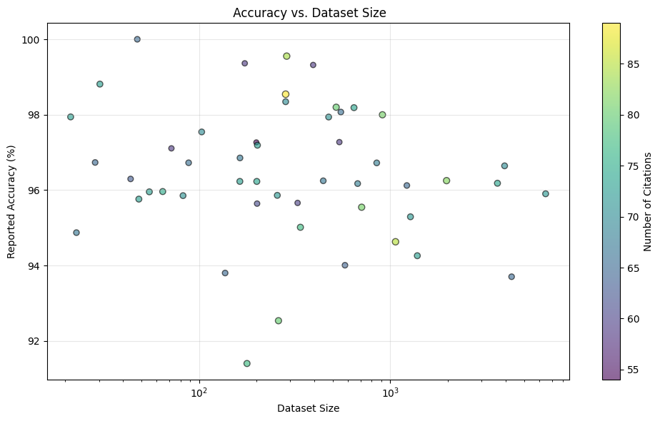
Fig - 11: Accuracy vs Dataset Size

- Mega-, Macro-, and Multi-Centre Data and Information
As emphasized in statistical learning theory, generalization is based on the size, and variety of the dataset as well as coverage. After the use of small datasets, the variability in the real world is not reflected and thus they overfit and perform poorly.

Future studies ought to be based on the following:
- Utilization of large-scale data in the form of UK Biobank, MIMIC-IV and BRFSS.
- Data split and common preprocessing pipeline Standardization of evaluation.
- Carrying out cross-dataset testing in order to conduct external validation.
- The use of superior techniques of missing data like MICE and miss Forest.
- The ability to come up with strong models that can deal with noisy and unfinished data.

- Explainable AI based on Clinicians
Explainability can be anchored on the interpretability theory where it is sought to make the decisions that are made by a model comprehensible to the human. The current methods are based primarily on post hoc approximations, which might not be an exhaustive representation of model behavior.

Future studies ought to be based on the following:
- Creating models fundamentally understandable and training schemes that can explain.
- Neo-classical conditioning Incorporation of methods of causal inference like counterfactual thinking.
- Measuring explanations with such measures as fidelity, stability and completeness.
- Validation of explanations by agreement of clinicians and effects of decisions.
- Explaining things with more personalized explanations to various users.

- Federated Learning and Privacy-preserving Collaborations
Federated learning allows training models without the need to centralize sensitive healthcare information, in line with the current privacy policies and data governance needs.

Future studies ought to be based on the following:
- Expanding FL to multimodal and deep.
- Comparison of aggregation strategies like FedAvg, FedProx and FedHybrid.
- Combining privacy mechanisms such as differentially privating, and securely aggregating.
- Vertical federated learning of feature-distributed datasets [93] (exploration).
- Using encryption techniques, like homomorphic encryption.

- Future Implementation in Clinical Trials and Real-life Tests
Translational research in a translational research perspective, clinical usefulness should be shown in real life, instead of just retrospective data sets. The majority of the studies that have been done are experimental based.

Future studies ought to be based on the following:
- Performing prospective validation by implementing it in real-time in hospitals.
- Adopting the models with the EHR systems working with FHIR-based APIs.
- Carrying out clinical trials so as to quantify diagnostic improvement.
- Supporting use on mobile devices and wearable.
- Installing continuous learning and drift detection and model updates.

- Multidimensional Modelling
The theory underpinning multimodal learning and time series analysis demonstrates that the heterogeneous data and the dynamics of time should be combined to enhance forecasting. The majority of existing research utilizes however; most current research is based on the use of static features.

Future studies ought to be based on the following:
- Combining multimodal information like ECG, PCG, imaging and lab documentation.
- Application of the temporal modelling methods such as the LSTM and transformer architectural models.
- Predicting the progression of the disease with the help of the survival analysis methods [15].
- Further capitalizing on the self-supervised learning methods like contrastive learning.
- Creating large scale foundation models in prediction of CVD [61].

- Robustness, Uncertainty and Calibration
The decision theory focuses on the need to have reliable predictions with uncertainty estimation and calibration as opposed to accuracy. The majority of the research done so far fails to take these factors into consideration.

Future studies ought to be based on the following:
- The use of calibration measures like Brier score and Expected Calibration Error (ECE) as reported.
- The use of techniques of uncertainty estimation like conformal prediction [86].
- Assessing the robustness to adversarial attacks (FGSM, PGD).
- The use of drift detecting techniques like ADWIN [96].
- Assessing the clinical utility using decision curve analysis.

- Ethical AI, Standardization, Reproducibility.
Scientific progress is based on reproducibility, transparency and compliance with ethics. Weak evaluations and reporting are currently causing a lack of comparability and reliability, whereas fairness and patient involvement are not explored.
Future studies ought to be based on the following:
- Educating open-science, such as sharing of code and datasets.
- Setting up standardized assessment procedures and standards.
- Making fairness assessment and bias detection.
- Engaging the patients in co-design and usability studies.
- Corresponding to the regulatory bodies including FDA and EU AI Act.

To conclude, hybrid modelling, explainability, privacy preservation and clinical validation are the way to go in predicting CVD in the future. The FedXAI-HybridCVD framework proposed is a roadmap to this vision. The solution to these research directions will make it possible to achieve clinically meaningful AI systems and positively influence cardiovascular care and patient outcomes.

- Conclusion

Cardiovascular diseases are the major cause of death worldwide, and there is the need to create precise, decipherable, and non-invasive early warning mechanisms. A total of 103 peer-reviewed studies were systematically reviewed in this review and were published within the last three years, 2019-2026, and covered traditional machine learning, deep learning and hybrid architectures, explainable AI (XAI), federated learning (FL) and multimodal approaches.
The discussion indicates that hybrid and ensemble models show high predictive accuracy, which can be over 95% on benchmark datasets. Nevertheless, over 80 percent of the literature uses small, homogeneous and obsolete datasets like the UCI Cleveland repository and little outside validation. This brings into question over fitting and lack of generalizability. Moreover, only a small (around 18) portion of the studies utilizes XAI techniques, such as SHAP and LIME, that are used most frequently after hoc, and are not validated by clinicians or have no standardized evaluation metrics. Interestingly, none of the studies reveal the direct effect of explainability on clinical decision-making or trust.
The field of federated learning is underutilized and two studies have experimented with FL, but both used only simple models and did not employ XAI. Most existing work presupposes centralized data access, neglecting regulatory limitations e.g. GDPR and HIPAA, and the distributed quality of real-life healthcare systems. Above all, hybrid multi-model architectures, XAI, and federated learning have not been combined in a framework. This missing trinity is an essential gap in research and is the main driving force behind the proposed conceptual architecture, FedXAI-HybridCVD.
Besides this gap, a number of pitfalls still remain, such as the lack of prospective clinical validation, excessive reliance on accuracy, ignoring calibration and decision curve analysis, low reproducibility, and no fairness test among demographic groups. To expand the clinical usefulness of AI-based predictive systems of CVD, these weaknesses need to be overcome.
The use of large-scale, multi-center, and diversified datasets and rigorous external validation should be a priority of future research. Also needed is the clinician-centered XAI framework with quantitative assessment and user study, the combination of federated learning and hybrid deep learning models and differential privacy. Besides, potential clinical applications, multimodal and longitudinal modelling, quantification of uncertainty, adversarial robustness and compliance with reproducibility and ethical AI principles should be highlighted.
As far as we can tell, this is the first review to provide a systematic study of the intersection of hybrid multi-model architectures, explainable AI, and federated learning, applied to cardiovascular disease prediction in particular. This work will provide a thorough basis to researchers, clinicians and practitioners by synthesizing the results of 103 studies, determining key gaps in the research and outlining an easy-to-follow research roadmap. The decisions of the critical design, validated rigorously, and ethical implementation of the AI systems will be necessary to move forward to clinically integrated and human-centered AI systems. It is only under these efforts that machine learning can be effectively used in helping to decrease the global cardiovascular disease burden and help improve patient outcomes.

- References

[1] A. Javeed, S. Zhou, L. Yongjian, I. Qasim, A. Noor, and R. Nour, “An intelligent learning system based on random search algorithm and optimized random forest model for improved heart disease detection,” IEEE Access, vol. 7, pp. 180237–180251, 2019.

[2] S. A. Ali, B. Raza, A. K. Malik, A. R. Shahid, M. Faheem, and H. Alquhayz, “An optimally configured and improved deep belief network (OCI-DBN) approach for heart disease prediction based on Ruzzo–Tompa and stacked genetic algorithm,” IEEE Access, vol. 8, pp. 65948–65958, 2020.

[3] J. P. Li, A. U. Haq, S. U. Din, J. Khan, A. Khan, and A. Saboor, “Heart disease identification method using machine learning classification in e-healthcare,” IEEE Access, vol. 8, pp. 107562–107582, 2020.

[4] Y. Pan, M. Fu, B. Cheng, X. Tao, and J. Guo, “Enhanced deep learning assisted convolutional neural network for heart disease prediction on the internet of medical things platform,” IEEE Access, vol. 8, pp. 189503–189512, 2020.

[5] K. Budholiya, S. K. Shrivastava, and V. Sharma, “An optimized XGBoost based diagnostic system for effective prediction of heart disease,” J. King Saud Univ. – Comput. Inf. Sci., vol. 34, no. 7, pp. 4514–4523, 2022.

[6] P. Ghosh, S. Azam, M. Jonkman, A. Karim, F. M. J. M. Shamrat, E. Ignatious, S. Shultana, A. R. Beeravolu, and F. De Boer, “Efficient prediction of cardiovascular disease using machine learning algorithms with relief and LASSO feature selection techniques,” IEEE Access, vol. 9, pp. 19306–19326, 2021.

[7] S. B. Shuvo, S. N. Ali, S. I. Swapnil, M. S. Al-Rakhami, and A. Gumaei, “CardioXNet: A novel lightweight deep learning framework for cardiovascular disease classification using heart sound recordings,” IEEE Access, vol. 9, pp. 36955–36970, 2021.

[8] M. M. Ali, B. K. Paul, K. Ahmed, F. M. Bui, J. M. W. Quinn, and M. A. Moni, “Heart disease prediction using supervised machine learning algorithms: Performance analysis and comparison,” Comput. Biol. Med., vol. 136, art. 104672, 2021.

[9] V. Chang, V. R. Bhavani, A. Q. Xu, and M. A. Hossain, “An artificial intelligence model for heart disease detection using machine learning algorithms,” Healthcare Analytics, vol. 2, art. 100016, 2022.

[10] U. Nagavelli and D. Samanta, “Machine learning technology-based heart disease detection models,” J. Healthc. Eng., vol. 2022, art. 7351061, 2022.

[11] M. B. Abubaker and B. Babayiğit, “Detection of cardiovascular diseases in ECG images using machine learning and deep learning methods,” IEEE Trans. Artif. Intell., vol. 4, no. 2, pp. 373–382, 2023.

[12] A. Al Bataineh and S. Manacek, “MLP-PSO hybrid algorithm for heart disease prediction,” J. Pers. Med., vol. 12, no. 8, art. 1208, 2022.

[13] P. Theerthagiri, “Predictive analysis of cardiovascular disease using gradient boosting based learning and recursive feature elimination technique,” Intell. Syst. Appl., vol. 16, art. 200121, 2022.

[14] P. Guleria, P. N. Srinivasu, S. Ahmed, N. Almusallam, and F. K. Alarfaj, “XAI framework for cardiovascular disease prediction using classification techniques,” Electronics, vol. 11, no. 24, art. 4086, 2022.

[15] M. Blanchard, M. Feuilloy, A. Sabil, C. Gervès-Pinquié, F. Gagnadoux, and J.-M. Girault, “A deep survival learning approach for cardiovascular risk estimation in patients with sleep apnea,” IEEE Access, vol. 10, pp. 133469–133481, 2022.

[16] R. R. Sarra, A. M. Dinar, and M. A. Mohammed, “Enhanced accuracy for heart disease prediction using artificial neural network,” Indonesian J. Electr. Eng. Comput. Sci., vol. 29, no. 1, pp. 375–383, 2023.

[17] M. B. Abubaker and B. Babayiğit, “Detection of cardiovascular diseases in ECG images using machine learning and deep learning methods,” IEEE Trans. Artif. Intell., vol. 4, no. 2, pp. 373–382, Apr. 2023.

[18] S. Bebortta, S. S. Tripathy, S. Basheer, and C. L. Chowdhary, “DeepMist: Toward deep learning assisted mist computing framework for managing healthcare big data,” IEEE Access, vol. 11, pp. 42488–42502, 2023.

[19] A. M. Qadri, A. Raza, K. Munir, and M. S. Almutairi, “Effective feature engineering technique for heart disease prediction with machine learning,” IEEE Access, vol. 11, pp. 56215–56225, 2023.

[20] S. Ghorashi, K. Rehman, A. Riaz, H. K. Alkahtani, A. H. Samak, I. Cherrez-Ojeda, and A. Parveen, “Leveraging regression analysis to predict overlapping symptoms of cardiovascular diseases,”IEEE Access, vol. 11, pp. 60258–60271, 2023.

[21] A. A. Almazroi, E. A. Aldhahri, S. Bashir, and S. Ashfaq, “A clinical decision support system for heart disease prediction using deep learning,” IEEE Access, vol. 11, pp. 61649–61664, 2023.

[22] M. Obayya, J. M. Alsamri, M. A. Al-Hagery, and A. Mohammed, “Automated cardiovascular disease diagnosis using honey badger optimization with modified deep learning model,” IEEE Access, vol. 11, pp. 64274–64286, 2023.

[23] S. N. Ali, S. B. Shuvo, M. I. S. Al-Manzo, A. Hasan, and T. Hasan, “An end-to-end deep learning framework for real-time denoising of heart sounds for cardiac disease detection in unseen noise,” IEEE Access, vol. 11, pp. 87891–87912, 2023.

[24] L.-C. Chen, K.-H. Hung, Y.-J. Tseng, H.-Y. Wang, T.-M. Lu, W.-C. Huang, and Y. Tsao, “Self-supervised learning-based general laboratory progress pretrained model for cardiovascular event detection,” IEEE J. Transl. Eng. Health Med., vol. 12, pp. 45–55, 2024.

[25] K. Zafar, H. U. R. Siddiqui, A. Majid, A. A. Saleem, A. Raza, F. Rustam, and S. Dudley, “Deep learning-based feature engineering to detect anterior and inferior myocardial infarction using UWB radar data,” IEEE Access, vol. 11, pp. 97748–97761, 2023.

[26] T. Rahman, M. K. A. A. Al-Ruweidi, M. S. I. Sumon, R. Y. Kamal, M. E. H. Chowdhury, and H. C. Yalcin, “Deep learning technique for congenital heart disease detection using stacking-based CNN-LSTM models from fetal echocardiogram: A pilot study,” IEEE Access, vol. 11, pp. 110377–110390, 2023.

[27] A. Kumar, K. U. Singh, and M. Kumar, “A clinical data analysis based diagnostic systems for heart disease prediction using ensemble method,” Big Data Mining Anal., vol. 6, no. 4, pp. 513–525, 2023.

[28] A. Noor, N. Javaid, N. Alrajeh, B. Mansoor, A. Khaqan, and S. H. Bouk, “Heart disease prediction using stacking model with balancing techniques and dimensionality reduction,” IEEE Access, vol. 11, pp. 116028–116049, 2023.

[29] S. Alrabie and A. Barnawi, “HeartWave: A multiclass dataset of heart sounds for cardiovascular diseases detection,” IEEE Access, vol. 11, pp. 118729–118744, 2023.

[30] M. S. Al Reshan, S. Amin, M. A. Zeb, A. Sulaiman, H. Alshahrani, and A. Shaikh, “A robust heart disease prediction system using hybrid deep neural networks,” IEEE Access, vol. 11, pp. 121579–121599, 2023.

[31] S. Prabhu, S. Gupta, G. M. Prabhu, A. V. Dhanuka, and K. V. Bhat, “QuCardio: Application of quantum machine learning for detection of cardiovascular diseases,” IEEE Access, vol. 11, pp. 136125–136138, 2023.

[32] A. Jafar and M. Lee, “HypGB: High accuracy GB classifier for predicting heart disease with HyperOpt HPO framework and LASSO FS method,” IEEE Access, vol. 12, pp. 138206–138218, 2024.

[33] R. Zhou, L. Lu, Z. Liu, T. Xiang, Z. Liang, D. A. Clifton, Y. Dong, and Y.-T. Zhang, “Semi-supervised learning for multi-label cardiovascular diseases prediction: A multi-dataset study,” IEEE Trans. Pattern Anal. Mach. Intell., vol. 46, no. 5, pp. 3308–3324, 2024.

[34] G. Manikandan, B. Pragadeesh, V. Manojkumar, A. L. Karthikeyan, R. Manikandan, and A. H. Gandomi, “Classification models combined with Boruta feature selection for heart disease prediction,” Inform. Med. Unlocked, vol. 44, art. 101442, 2024.

[35] S. Mondal, R. Maity, Y. Omo, S. Ghosh, and A. Nag, “An efficient computational risk prediction model of heart diseases based on dual-stage stacked machine learning approaches,” IEEE Access, vol. 12, pp. 7261–7278, 2024.

[36] T. Ullah, S. I. Ullah, K. Ullah, M. Ishaq, A. Khan, and Y. Y. Ghadi, “Machine learning-based cardiovascular disease detection using optimal feature selection,” IEEE Access, vol. 12, pp. 16436–16448, 2024.

[37] G. Raja, B. Ramkumar, B. Rajendiran, S. B. Prathiba, T. Arumugam, K. Karuppanan, L. Nkenyereye, and K. Dev, “Synergistic analysis of lung cancer’s impact on cardiovascular disease using ML-based techniques,” IEEE J. Biomed. Health Inform., vol. 30, no. 1, pp. 66–75, 2026.

[38] C. Guo, J. Zhang, Y. Liu, Y. Xie, Z. Han, and J. Yu, “Recursion enhanced random forest with an improved linear model (RERF-ILM) for heart disease detection on the internet of medical things platform,” IEEE Access, vol. 8, pp. 59249–59258, 2020.

[39] B. Ramesh and K. Lakshmanna, “A novel early detection and prevention of coronary heart disease framework using hybrid deep learning model and neural fuzzy inference system,” IEEE Access, vol. 12, pp. 26685–26700, 2024.

[40] A. B. Naeem, B. Senapati, D. Bhuva, A. Zaidi, A. Bhuva, M. S. I. Sudman, and A. E. M. Ahmed, “Heart disease detection using feature extraction and artificial neural networks: A sensor-based approach,” IEEE Access, vol. 12, pp. 37350–37370, 2024.

[41] D. Y. Omkari and K. Shaik, “An integrated two-layered voting (TLV) framework for coronary artery disease prediction using machine learning classifiers,” IEEE Access, vol. 12, pp. 56278–56294, 2024.

[42] N. A. Vinay, K. N. Vidyasagar, S. Rohith, D. Pruthviraja, S. Supreeth, and S. H. Bharathi, “An RNN-Bi LSTM based multi decision GAN approach for the recognition of cardiovascular disease (CVD) from heart beat sound: A feature optimization process,” IEEE Access, vol. 12, pp. 65484–65503, 2024.

[43] M. Wei, J. Yang, Z. Zhao, X. Zhang, J. Li, and Z. Deng, “DeFedHDP: Fully decentralized online federated learning for heart disease prediction in computational health systems,”IEEE Trans. Comput. Soc. Syst., vol. 11, no. 5, pp. 6856–6869, 2024.

[44] H. Khan, N. Javaid, T. Bashir, M. Akbar, N. Alrajeh, and S. Aslam, “Heart disease prediction using novel ensemble and blending based cardiovascular disease detection networks: EnsCVDD-Net and BlCVDD-Net,” IEEE Access, vol. 12, pp. 109235–109255, 2024.

[45] Y. M. Ayano, F. Schwenker, B. D. Dufera, T. G. Debelee, Y. G. Ejegu, and S. S. Alshamrani, “Interpretable hybrid multichannel deep learning model for heart disease classification using 12-lead ECG signal,” IEEE Access, vol. 12, pp. 94057–94086, 2024.

[46] Y. Lu, G. Tan, B. Pu, H. Wang, B. Liang, K. Li, and J. C. Rajapakse, “SKGC: A general semantic-level knowledge guided classification framework for fetal congenital heart disease,” IEEE J. Biomed. Health Inform., vol. 28, no. 10, pp. 6107–6117, 2024.

[47] T. Mahmood, A. Rehman, T. Saba, T. J. Alahmadi, M. Tufail, S. A. O. Bahaj, and Z. Ahmad, “Enhancing coronary artery disease prognosis: A novel dual-class boosted decision trees strategy for robust optimization,” IEEE Access, vol. 12, pp. 107125–107140, 2024.

[48] K. Akther, M. S. R. Kohinoor, B. S. Priya, M. J. Rahaman, M. M. Rahman, and M. Shafiullah, “Multi-faceted approach to cardiovascular risk assessment by utilizing predictive machine learning and clinical data in a unified web platform,” IEEE Access, vol. 12, pp. 120459–120479, 2024.

[49] M. Naz, A. Khalid, A. Hameed, R. Taj, W. Mumtaz, F. A. Alotaibi, and M. M. Alnfiai, “Meta-ensemble learning for heart disease prediction: A stacking-based approach with explainable AI,” IEEE Access, vol. 13, pp. 137274–137299, 2025.

[50] H. F. El-Sofany, “Predicting heart diseases using machine learning and different data classification techniques,” IEEE Access, vol. 12, pp. 106150–106173, 2024.

[51] F. M. Talaat, A. R. Elnaggar, W. M. Shaban, M. Shehata, and M. Elhosseini, “CardioRiskNet: A hybrid AI-based model for explainable risk prediction and prognosis in cardiovascular disease,” Bioengineering, vol. 11, no. 8, art. 822, 2024.

[52] R. M. Al-Tam, A. M. Al-Hejri, E. Naji, F. A. Hashim, S. S. Alshamrani, A. Alshehri, and S. M. Narangale, “A hybrid framework of transformer encoder and residential conventional for cardiovascular disease recognition using heart sounds,” IEEE Access, vol. 12, pp. 123100–123123, 2024.

[53] D. M. Alsekait, A. Y. Shdefat, A. Nabil, A. Nawaz, M. R. R. Rana, Z. Ahmed, H. Fathi, and D. S. AbdElminaam, “Heart-Net: A multi-modal deep learning approach for diagnosing cardiovascular diseases,” Comput. Mater. Continua, vol. 80, no. 3, pp. 3973–3998, 2024.

[54] J. J. Gabriel and L. J. Anbarasi, “Accurate cardiovascular disease prediction: Leveraging Opt_hpLGBM with dual-tier feature selection,” IEEE Access, vol. 12, pp. 142432–142447, 2024.

[55] D. Muhammad, I. Ahmed, M. O. Ahmad, and M. Bendechache, “Randomized explainable machine learning models for efficient medical diagnosis,” IEEE J. Biomed. Health Inform., vol. 29, no. 9, pp. 6475–6486, 2025.

[56] S. M. S. Bukhari, M. H. Zafar, S. K. R. Moosavi, M. Mansoor, and F. Sanfilippo, “An integrated stacked convolutional neural network and the levy flight-based grasshopper optimization algorithm for predicting heart disease,” Healthcare Analytics, vol. 7, art. 100374, 2025.

[57] S. Deepika and N. Jaisankar, “Enhanced heart disease classification using dual attention mechanisms and 3D-echo fusion algorithm in echocardiogram videos,” IEEE Access, vol. 13, pp. 1609–1623, 2025.

[58] M. M. Asha and G. Ramya, “Artificial flora algorithm-based feature selection with support vector machine for cardiovascular disease classification,” IEEE Access, vol. 13, pp. 7296–7310, 2025.

[59] D. Cenitta, R. V. Arjunan, G. Paramasivam, N. Arul, A. Palkar, and K. Chadaga, “Ischemic heart disease prognosis: A hybrid residual attention-enhanced LSTM model,” IEEE Access, vol. 13, pp. 4283–4297, 2025.

[60] M. Raoof, M. Mahtab, S. M. Bhatti, M. Rashid, and A. Jaffar, “Heart disease classification from echocardiogram images using deep learning,” IEEE Access, vol. 13, pp. 8012–8025, 2025.

[61] X. Qiu, H. Wang, X. Tan, and Y. Jin, “CVDLLM: Automated cardiovascular disease diagnosis with large-language-model-assisted graph attentive feature interaction,” IEEE Trans. Artif. Intell., vol. 6, no. 6, pp. 1577–1590, 2025.

[62] B. Zhao, J. Peng, C. Chen, Y. Fan, K. Zhang, and Y. Zhang, “Diagnosis of coronary heart disease through deep learning-based segmentation and localization in computed tomography angiography,” IEEE Access, vol. 13, pp. 10180–10195, 2025.

[63] M. A. Umar, N. AbuAli, K. Shuaib, and A. I. Awad, “An explainable artificial intelligence and Internet of Things framework for monitoring and predicting cardiovascular disease,” *Eng. Appl. Artif. Intell.*, vol. 144, art. 110138, 2025.

[64] M. A. Talukder, “A hybrid multiscale feature fusion model for enhanced cardiovascular arrhythmia detection,” Results Eng., vol. 25, art. 104244, 2025.

[65] M. A. Talukder, A. S. Talaat, and M. Kazi, “HXAI-ML: A hybrid explainable artificial intelligence based machine learning model for cardiovascular heart disease detection,” Results Eng., vol. 25, art. 104370, 2025.

[66] M. Trigka and E. Dritsas, “Improving cardiovascular disease prediction with deep learning and correlation-aware SMOTE,” IEEE Access, vol. 13, pp. 44593–44609, 2025.

[67] H. Mo, J. Liang, B. Li, Z. Hu, M. Yi, H. Wu, Q. Rong, and Z. Xu, “A noninvasive framework for heart function assessment by multitask learning,” IEEE Trans. Instrum. Meas., vol. 74, art. 4005713, 2025.

[68] I. S. Al-Mahdi, S. M. Darwish, and M. M. Madbouly, “Heart disease prediction model using feature selection and ensemble deep learning with optimized weight,” Comput. Model. Eng. Sci., vol. 143, no. 1, pp. 881–904, 2025.

[69] M. K. Jabbar, H. Jianjun, A. Jabbar, and Z. U. Rehman, “Mamba-based VoxelMorph framework for cardiovascular disease imaging and risk assessment,” IEEE Access, vol. 13, pp. 78123–78137, 2025.

[70] Y.-C. Lai, Y.-H. Lin, C.-H. Yu, S.-P. Huang, C.-Y. Liou, Y.-W. Wu, and S.-G. Mao, “Medical PPG sensor for cardiovascular disease diagnosis using personalized hemodynamics model and pulse wave analysis,” IEEE Sensors Lett., vol. 9, no. 5, art. 3501704, 2025.

[71] R. S. Bhaduaria, I. Javid, and A. Khara, “Advanced heart attack risk prediction using stacked hybrid machine learning,” J. Mobile Multimedia, vol. 21, no. 3-4, pp. 393–406, 2025.

[72] S. Santhosh, K. Chadaga, R. V. Arjunan, and S. D’Souza, “Cardiac clarity: Harnessing machine learning for accurate heart-disease prediction,” IEEE Access, vol. 13, pp. 97531–97552, 2025.

[73] M. Adnan, Y. Yi, E. Wang, and M. N. Imtiaz, “StackTrans–Multimodal heart disease detection using stacked transformer fusion framework,” IEEE Access, vol. 13, pp. 99913–99927, 2025.

[74] K. Sathya and G. Magesh, “Multimodal deep learning for cardiovascular risk stratification: Integrating retinal biomarkers and cardiovascular signals for enhanced heart attack prediction,” IEEE Access, vol. 13, pp. 99678–99700, 2025.

[75] A. Panigrahi, A. Pati, B. Sahu, A. K. Pati, S. Chowdhury, K. Aurangzeb, and S. Aslam, “Advanced ECG signal analysis for cardiovascular disease diagnosis using AVOA optimized ensembled deep transfer learning approaches,”Comput. Mater. Continua, vol. 84, no. 1, pp. 1639–1660, 2025.

[76] M. Ahmad, A. Ahmed, H. Hashim, M. Farsi, and N. Mahmoud, “Enhancing heart disease diagnosis using ECG signal reconstruction and deep transfer learning classification with optional SVM integration,” Diagnostics, vol. 15, no. 12, art. 1501, 2025.

[77] M. Dubey, J. Tembhurne, and R. Makhijani, “Enhancing federated learning through differential privacy: Introducing FedHybrid for multicenter diverse heart disease datasets,” IEEE Trans. Emerg. Top. Comput. Intell., vol. 9, no. 6, pp. 4221–4235, 2025.

[78] A. Kannan, M. J. Saikia, S. Kumar, and S. Datta, “Detection of valvular heart diseases from PCG signals using machine and deep learning models: A review,” IEEE Access, vol. 13, pp. 110352–110380, 2025.

[79] I. Gupta, A. Bajaj, M. Malhotra, V. Sharma, and A. Abraham, “Heart disease prediction using a hybrid feature selection and ensemble learning approach,” IEEE Access, vol. 13, pp. 111929–111946, 2025.

[80] Y.-P. Huang, R. Mushi, F. E. Sandnes, H.-F. Hu, and J.-H. Lee, “Deep convolutional neural networks to automatically classify human heart diseases,” IEEE Access, vol. 13, pp. 120674–120695, 2025.

[81] M. Bairy, K. Chadaga, N. Sampathila, R. V. Arjunan, and G. M. Bairy, “An explainable analytical approach to heart attack detection using biomarkers and nature-inspired algorithms,” Healthcare Analytics, vol. 8, art. 100407, 2025.

[82] X. Liu, L. You, C. Lv, M. Chen, L. Wei, Y. Zheng, and X. Guo, “Integrating ECG and PCG signals through a dual-modal ViT for coronary artery disease detection,” IEEE J. Biomed. Health Inform., vol. 30, no. 2, pp. 1129–1140, 2026.

[83] S. Jabbar, U. Raza, M. A. Habib, M. Farhan, and S. Saeed, “Automated cardiac disease prediction using composite GAN and DeepLab model,” IEEE Access, vol. 13, pp. 138316–138330, 2025.

[84] S. A. Gharib, J. Charafeddine, F. Dornaika, and S. Haddad, “Hybrid learning framework for explainable cardiovascular disease detection,” IEEE Access, vol. 13, pp. 130171–130187, 2025.

[85] R. Başar, Ö. Ocak, A. Erturk, and M. de la Roche, “Leveraging machine learning techniques to predict cardiovascular heart disease,” Information, vol. 16, no. 8, art. 639, 2025.

[86] M. A. Jahin, M. A. Masud, M. F. Mridha, Z. Aung, and N. Dey, “KACQ-DCNN: Uncertainty-aware interpretable Kolmogorov–Arnold classical–quantum dual-channel neural network for heart disease detection,” Comput. Biol. Med., vol. 197, art. 110976, 2025.

[87] A. Jaiswal, S. Dandapat, and P. K. Bora, “Implicit graph-based cardiovascular disease detection using cardiac axis deviation in reduced-lead ECG,”IEEE Sensors Lett., vol. 9, no. 9, art. 6010104, 2025.

[88] S. Ouaari, A. B. Ünal, M. Akgün, and N. Pfeifer, “Robust representation learning for privacy-preserving machine learning: A multi-objective autoencoder approach,” IEEE Access, vol. 13, pp. 151529–151545, 2025.

[89] I. Haq, H. Liang, K. Zeng, T. Wang, I. Uddin, J. Lin, Y. Kang, and B. Huang, “Deep learning advancements for cardiovascular diseases (CVDs) diagnosis: Imaging modalities, challenges, and future perspectives,” Biomed. Signal Process. Control, vol. 119, art. 109899, 2026.

[90] Q. Xu and Y. Xia, “ST-DGCN: A novel spatial-temporal dynamic graph convolutional network for cardiovascular diseases diagnosis,” IEEE Access, vol. 13, pp. 153299–153314, 2025.

[91] G. S. Pisharady, K. Shireesha, P. S. Gowthami, and X. Anita, “Incremental learning frameworks for dynamic heart sound classification,” IEEE Access, vol. 13, pp. 156859–156875, 2025.

[92] M. Adil, N. Javaid, I. Ahmed, A. Ahmed, and N. Alrajeh, “A deep learning framework for heart disease prediction with explainable artificial intelligence,” Comput. Mater. Continua, vol. 86, no. 1, pp. 1–24, 2026.

[93] S. Shajimon, R. M. Shukla, and A. N. Patr, “Precision at heart: An IoT-based vertical federated learning approach for heterogeneous data-driven cardiovascular disease risk prediction,” Comput. Methods Programs Biomed., vol. 273, art. 109079, 2026.

[94] I. Wajid, D. Li, Q. Wang, and S. Aslam, “Hybrid ensemble approaches for cardiovascular disease prediction: Leveraging interpretable AI for clinical insight,” Intell. Based Med., vol. 12, art. 100297, 2025.

[95] D. Cenitta, G. K. Shwetha, K. P. V. Rao, S. Ramisetty, N. Arul, and R. V. Arjunan, “Explainable AI with homomorphic encryption for secure cloud-based ECG analysis in heart disease diagnosis,” IEEE Access, vol. 13, pp. 171835–171858, 2025.

[96] S. Zertal, A. Saighi, S. Kouah, S. Meshoul, and Z. Laboudi, “A real-time deep learning approach for electrocardiogram-based cardiovascular disease prediction with adaptive drift detection and generative feature replay,” Comput. Model. Eng. Sci., vol. 144, no. 3, pp. 3747–3780, 2025.

[97] D. Cenitta, N. Arul, T. P. Pai, R. V. Arjunan, and T. Shailesh, “A bio-inspired approach to feature optimization for ischemic heart disease detection,” Healthcare Analytics, vol. 8, art. 100427, 2025.

[98] A. Santamónica, E. Hortal, Y. Larriba, and C. Rueda, “Explainable AI for automatic heart disease diagnosis using 3DFMMecg features: A novel ECG-based approach,” Biomed. Signal Process. Control, vol. 113, art. 109085, 2026.

[99] K. P. Suchithra, N. Mohan, O. K. Sikha, and S. S. Kumar, “Dynamic mode decomposition-based features for cardiovascular disease analysis from phonocardiogram signals,” IEEE Access, vol. 13, pp. 200141–200156, 2025.

[100] T. Oladunni and E. Aneni, “Explainable deep neural network for multimodal ECG signals: Intermediate versus late fusion,” IEEE Access, vol. 13, pp. 202701–202720, 2025.

[101] A. Verdone, F. Succetti, A. Ceschini, A. Rosato, A. Fioravanti, and M. Panella, “A hybrid quantum-neural network for heart disease classification,” Biomed. Signal Process. Control, vol. 113, art. 109185, 2026.

[102] F. Mahmud, A. C. Das, M. S. Shak, N. Rahman, A. A. Eva, M. F. Mridha, and M. J. Hossen, “HybridTabNet-QC: A transformer-based clinical feature fusion framework for heart disease risk prediction,” IEEE Open J. Comput. Soc., vol. 7, pp. 1–15, 2026.

[103] M. K. Jabbar, Y. Yi, E. Wang, and M. N. Imtiaz, “Heart sound classification for early detection of cardiovascular diseases using XGBoost and engineered acoustic features,” Sensors, vol. 26, no. 2, art. 630, 2026.

[104] A. Vidales-Esquivel, F. Ornelas-Tellez, and J. Ortiz-Bejar, “Harmonic analysis and pattern classification of electrocardiograms for heart disease diagnosis,” *IEEE Latin Am. Trans., vol. 24, no. 2, pp. 165–172, 2026.

