Implementation of Incremental Conductance MPPT in Photovoltaic System with Dc-Dc Boost Converter
SNEHA JAYADEV GANJIHAL¹, HEMAVATHI R², UMAVATHI M³
¹PG Scholar Department of Electrical Engineering, UVCE, K R Circle Bengaluru-560001, India
²Associate Professor, Department of Electrical Engineering, UVCE, K R Circle Bengaluru-560001, India
³Associate Professor, Department of Electrical Engineering, BMS College of Engineering, Bengaluru-560019, India.
ABSTRACT:
This paper presents the implementation of Incremental Conductance (IC) Maximum Power Point Tracking (MPPT) for photovoltaic (PV) system integrated with a DC-DC boost converter to enhance energy harvesting efficiency. Output power varies with environmental conditions such as solar irradiance and temperature due to the nonlinear characteristics of PV modules. To address this challenge, The IC MPPT technique is employed to accurately track the maximum power point (MPP) under both steady-state and rapidly changing environmental conditions. Unlike conventional methods, the incremental conductance approach determines the MPP by comparing IC (dI/dV) with the instantaneous conductance (I/V), reduced oscillations and improved tracking speed.
The proposed system consists of a PV array, an IC based MPPT controller and a boost converter that steps up the output voltage to a required level for efficient load utilization. The boost converter is controller through pulse width modulation (PWM) signals generated by the MPPT algorithm, enabling optimal power extraction from the PV panel. MATLAB/Simulink is used to model and simulate the system, validating its performance under varying irradiance conditions.
Simulation outcome indicates that the IC MPPT technique achieves improved efficiency, quicker tracking of MPP and minimizes steady-state fluctuations when compared to conventional approaches like Perturb and Observe (P&O) method. The system ensures reliable and stable operation, making it suitable for renewable energy applications. Overall, the integration of the IC MPPT with a boost converter significantly improves the performance and efficiency of photovoltaic energy systems.
Keywords: Photovoltaic system, Incremental Conductance, DC-DC boost converter.
INTRODUCTION:
The growing penetration of renewable energy sources has intensified the adoption of photovoltaic (PV) systems for distributed power generation. Despite their advantages, PV modules exhibit nonlinear current-voltage (I-V) and power-voltage (P-V) characteristics that vary with solar irradiance and cell temperature. This nonlinearity leads to a unique operating point, known as the maximum power point (MPP), at which the PV system delivers maximum output power. However, without appropriate control, the operating point may shift away from the MPP, resulting in suboptimal energy conversion. To ensure optimal power extraction, Maximum Power Point Tracking (MPPT) algorithms are incorporated into PV systems. Among various techniques, the Incremental Conductance (IC) method is widely recognized for its improved dynamic response and steady-state accuracy. The IC algorithm determines the MPP by evaluating the condition where the incremental conductance equals the negative of instantaneous conductance, enabling precise tracking under rapidly varying environmental conditions while minimizing oscillations around the operating point.
A DC–DC boost converter is typically employed as an interface between the PV array and the load to regulate and step up the output voltage. The duty cycle of the converter is dynamically controlled by the MPPT algorithm to maintain operation at or near the MPP. This coordinated control enhances system efficiency and ensures stable performance. In this work, a PV system integrated with an Incremental Conductance MPPT controller and a DC–DC boost converter is modeled and simulated using MATLAB/Simulink. The proposed approach is evaluated under variable irradiance conditions to analyze tracking accuracy, convergence behavior and overall system efficiency.
LITERATURE REVIEW:
Several studies have focused on improving the performance of Incremental Conductance(IncCond) based MPPT techniques for photovoltaic (PV) systems operating under dynamic environmental conditions. In [1], an enhanced IncCond algorithm is proposed to address the inherent limitations of conventional implementations, particularly slow convergence and oscillatory behavior near the MPP. The modified approach improves tracking precision by refining the decision-making mechanism under varying irradiance and temperature, resulting in better steady-state stability and reduced power loss. The work presented in [2] investigates the effectiveness of the IncCond method under rapidly changing atmospheric conditions. The study demonstrates that the algorithm can accurately estimate the MPP by utilizing the slope of the PV curve, thereby achieving improved dynamic response and reduced oscillations compared to traditional MPPT strategies. In [3], a performance evaluation of the IncCond algorithm is carried out under fast irradiance variations. The results indicate that while the method maintains acceptable tracking accuracy, minor steady-state oscillations and transient delays still exist, highlighting the need for further optimization.
To overcome these issues, a variable step-size IncCond technique is introduced in [4], where the step size is adaptively adjusted based on the operating region of the PV system. This approach enables faster convergence during transient conditions while ensuring minimal oscillations around the MPP during steady-state operation, thereby enhancing overall efficiency. A system-level optimization is presented in [5], where a single-stage IncCond-based MPPT is integrated with a flyback inverter topology. This configuration reduces system complexity and improves energy conversion efficiency by eliminating intermediate conversion stages while maintaining effective MPP tracking. Furthermore, adaptive enhancements such as step-size control combined with holding mechanisms have been explored in [6] to suppress unnecessary perturbations near the MPP. This method significantly improves tracking stability and reduces power fluctuations under rapidly varying conditions. Hebchi et al. [7] proposed an improved version of the IC algorithm aimed at enhancing tracking accuracy and reducing steady-state oscillations. Their work demonstrates better performance compared to conventional IC, particularly during rapid changes in solar irradiance. Hemavathi et al. [8] focused on defect detection in polycrystalline solar cells using electroluminescence imaging. Their study highlights how identifying defects can significantly improve the reliability and efficiency of PV systems, indirectly supporting better MPPT performance. Chawda et al. [9] introduced a hybrid approach combining Incremental Conductance with Particle Swarm Optimization (PSO) to address the issue of multiple power peaks under partial shading conditions. The proposed method effectively tracks the global maximum power point, overcoming the limitations of traditional IC algorithms.
Elgendy et al. [10] conducted a detailed performance analysis of the IC MPPT algorithm, emphasizing its advantages such as accuracy and stability. However, the study also points out challenges like complexity and slower response under certain dynamic conditions. Putri et al. [11] implemented the IC method for MPPT and demonstrated its effectiveness in achieving stable and accurate tracking of the maximum power point. Their results confirm that IC performs better than simpler methods like Perturb and Observe under steady-state conditions. In another study, Hemavathi et al. [12] explored the simulation of a SEPIC DC–DC converter using LabVIEW. Their work highlights the importance of efficient power converters in PV systems, as they play a key role in implementing MPPT algorithms effectively.
Overall, the reviewed literature indicates that although the conventional IncCond algorithm provides reliable MPP tracking, recent advancements primarily focus on adaptive control strategies to enhance dynamic response, minimize steady-state oscillations and improve overall system efficiency.
METHODOLOGY:
The system consists of a photovoltaic (PV) array, an IC MPPT controller, a DC-DC boost converter, and a load. The PV voltage and current are continuously measured to determine the maximum power point using the condition dI/dV= -I/V. Based on this, the IC algorithm adjusts the duty cycle to ensure optimal power extraction with minimal oscillations. The PWM pulses control the boost converter to regulate and increase the output voltage (Vout) and current (Iout). The complete system is modeled in MATLAB/Simulink to analyze performance under varying environmental conditions.
Block diagram:
Solar
PV
Array
DC-DC
Boost
Converter
Duty cycle control (PWM)
Incremental Conductance MPPT controller
Load
D
(PWM Signal)
Vout
Iout

Vpv, Ipv
MATLAB/Simulink
Simulation
Monitoring & Analysis
Figure 1: Block Diagram
PV array modelling:
The photovoltaic (PV) array is represented using a single-diode equivalent circuit, which captures the nonlinear electrical characteristics of a solar cell. The model consists of a current source, a diode, and series (Rs​) and shunt (Rp​) resistances to account for internal losses. The output current of the PV cell is expressed as:
$$I= I_{ph}- I_{o}\left[exp\left(\frac{V+ {IR}_{s}}{aV_{t}}\right)-1 \right]- \frac{V+ {IR}_{s}}{R_{p}}$$
where Iph​ is the photo-generated current, Io​ is the diode saturation current, a is the diode ideality factor and 𝑉𝑡= 𝑁𝑠𝐾𝑇/𝑞 represents the thermal voltage.
Photo current calculation:
The photo-current depends on irradiance and temperature, given by:
$$I_{ph}= \frac{G}{G_{n}} \left[I_{ph,n}+ K_{i }\left(T-T_{n}\right)\right]$$
Where G is the Actual irradiance, Gn​ is the Nominal irradiance, T is the Cell temperature, Tn​ is the Reference temperature and Ki​ is the Temperature coefficient.
Diode saturation current:
The diode reverse saturation current varies with temperature and is modeled as
$$I= I_{o,n}{\left(\frac{T}{T_{n}}\right)}^{3}exp\left[q\frac{E_{g}}{ak} \left(\frac{1}{T_{N}}-\frac{1}{T}\right)\right]$$
Where: q = Electron charge, k = Boltzmann constant and Eg​ = Bandgap energy
Nominal saturation current calculation:
$$I_{o,n}= \frac{I_{sc,n}}{exp\left(\frac{V_{oc,n}}{aV_{t,n}}\right){-1}}$$
where, 𝑉oc is the nominal open circuit voltage, Vt is the nominal thermal voltage of the cell and Isc is the short-circuit current
PV array configuration:
For practical applications, PV cells are connected in series and parallel to form an array. The array output current is expressed as
$$I=N_{p}I_{pv}-N_{p}I_{o}\left[exp\left(\frac{V+IR_{s}\left(\frac{N_{s}}{N_{p}}\right)}{aV_{t}N_{s}}\right)-1\right]- \frac{V+IR_{s}\left(\frac{N_{s}}{N_{p}}\right)}{R_{p}\left(\frac{N_{s}}{N_{p}}\right)}$$

where Ns​ and Np​ represent the number of series and parallel connected modules, respectively.
The PV module parameters such as Vmpp​, Imp​, Voc​, and Isc​ are defined under standard test conditions (25°C, 1000 W/m²) and are used for system design and MPPT implementation.

MPPT CONTROL USING INCREMENTAL CONDUCTANCE METHOD
Maximum Power Point Tracking (MPPT) is essential for maximizing energy extraction from photovoltaic (PV) systems under varying irradiance and temperature. The Incremental Conductance (IC) method determines the maximum power point (MPP) by evaluating the slope of the power–voltage characteristic, which becomes zero at the MPP:
$$\frac{dP}{dV}=0 ⇒ \frac{dI}{dV}= -\frac{I}{V}$$
By comparing incremental conductance (dI/dV) with instantaneous conductance (I/V), the algorithm identifies the operating region. When dI/dV= -I/V, the system operates at MPP; if dI/dV>-I/V, the operating point is left of MPP, and if dI/dV<-I/V, it is right of MPP. The controller measures PV voltage and current, computes incremental changes and updates the duty cycle of the DC-DC converter accordingly. This adaptive adjustment enables fast convergence and reduces steady-state oscillations, improving overall tracking efficiency.

Algorithm steps
- Acquire the instantaneous PV voltage V(k) and current I(k).
- Determine incremental variations:
ΔV=V(k)-V(k-1), ΔI=I(k)-I(k-1)
- If ΔV=0:
  - ΔI=0 → system operates at MPP
  - ΔI>0 → increase duty cycle
  - ΔI<0 → decrease duty cycle
- If ΔV≠0:
  - Evaluate ΔI/ΔV and compare with −I/V
  - Update duty cycle to shift operating point toward MPP
- Repeat the process continuously for real-time tracking.
$${di}_{pv}=i_{pv}\left(k\right)-i_{pv}\left(k-1\right)$$
$${dv}_{pv}=v_{pv}\left(k\right)-v_{pv}\left(k-1\right)$$

Measure
$$v_{pv}\left(k\right) and i_{pv}(k)$$
$${dv}_{pv}=0$$
$$\frac{{di}_{pv}}{{dv}_{pv}}= \frac{i_{pv}}{v_{pv}}$$
$${di}_{pv}=0$$
$$\frac{{di}_{pv}}{{dv}_{pv}}>\frac{i_{pv}}{v_{pv}}$$
$${di}_{pv}>0$$
$${v*}_{pv}\left(k\right)={v*}_{pv}\left(k-1\right)+Δv$$

$${v*}_{pv}\left(k\right)={v*}_{pv}\left(k-1\right)-Δv$$

${v*}_{pv}\left(k\right)={v*}_{pv}\left(k-1\right)+Δv$

$${v*}_{pv}\left(k\right)={v*}_{pv}\left(k-1\right)-Δv$$

Return
Figure 2: Incremental Conductance Algorithm

DC-DC BOOST CONERTER:
A DC-DC boost converter is utilized to elevate the output voltage of the photovoltaic (PV) array to a higher level suitable for load and battery requirements. It enables efficient power transfer by regulating the voltage through controlled switching action. The converter stores energy in the inductor during the ON state of the switch and transfers it to the load during the OFF state, resulting in an output voltage higher than the input.

Modes of operation:
The converter operates in two conduction modes:
- Continuous conduction mode (ccm):
The inductor current remains non-zero throughout the switching cycle, ensuring lower ripple and stable operation.
- Discontinuous conduction mode (dcm):
The inductor current drops to zero within a switching period, typically under light load conditions, leading to increased ripple.

Control strategy:
The duty cycle of the boost converter is governed by the Incremental Conductance (IC) MPPT algorithm. The controller processes real-time PV voltage and current to locate the maximum power point (MPP). The computed duty ratio is refined using a PI controller to enhance dynamic response and stability, and is then applied to a PWM generator to control the switching device.

Design relations:
The voltage gain of the boost converter is given by:
$$D=1-\frac{V_{in}}{V_{out}}$$
The output current is expressed as:
$$I_{out}=\frac{P}{V_{out}}$$
The inductor current ripple and output voltage ripple are approximated as:
$$ΔI_{L}=0.01×I_{out(max)}×\left(\frac{V_{out}}{V_{in}}\right)$$
$$ΔV_{o}=0.01×V_{out}$$
The required inductance and capacitance values are:
$$L= \frac{V_{in}(V_{out}- V_{in})}{V_{out}×f_{s}×{ΔI}_{L}}$$
$$C= \frac{I_{out(max)}(1- \frac{V_{in}}{V_{out}})}{f_{s}×{ΔV}_{o}}$$
The load resistance is given by:
$$R= \frac{V_{out}}{I_{out(max)}}$$

Performance analysis:
The boost converter effectively raises the PV output voltage to the required level (e.g., 48 V). When integrated with the IC MPPT controller, the system demonstrates improved tracking accuracy, minimized steady-state oscillations, enhanced efficiency under varying conditions and stable output suitable for charging applications.

MATLAB/SIMULINK MODEL
The proposed system is developed in MATLAB/Simulink by integrating key functional blocks, including the PV array subsystem, Incremental Conductance (IC) MPPT controller, PWM generator and DC-DC boost converter. The PV subsystem provides real-time voltage and current signals, which are processed by the MPPT controller to determine the optimal operating point. The IC algorithm computes the required duty cycle based on these inputs, which is then converted into PWM pulses to control the switching of the boost converter, ensuring efficient power transfer to the load
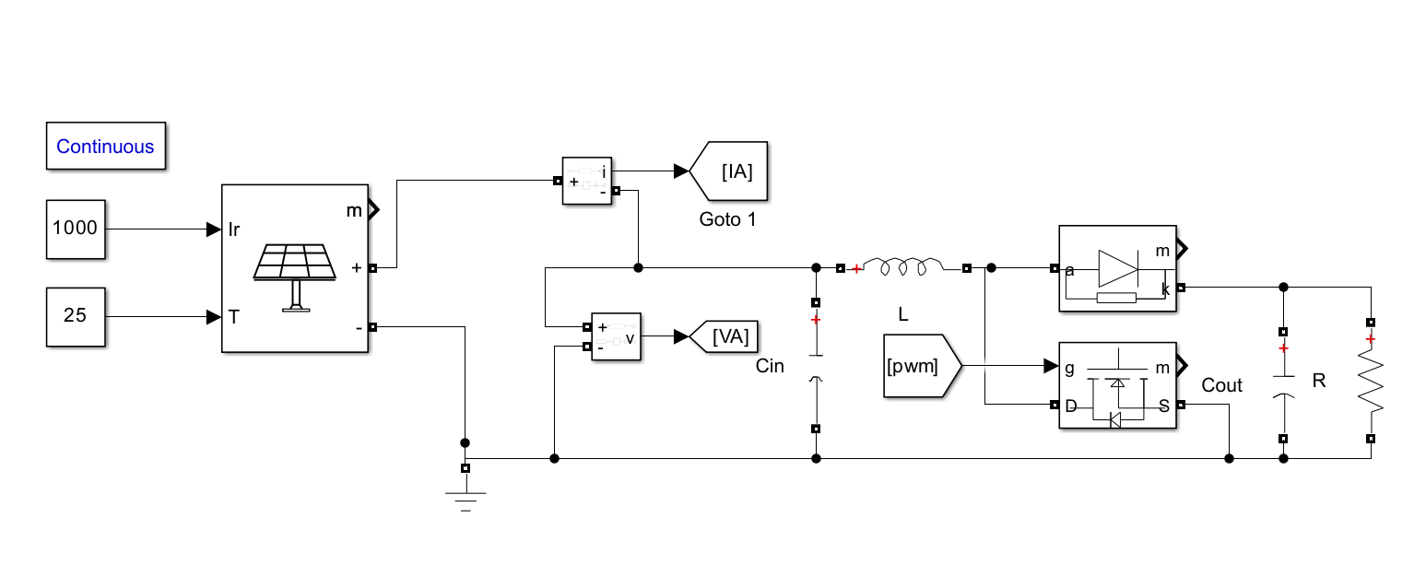
Figure 3: Boost Circuit
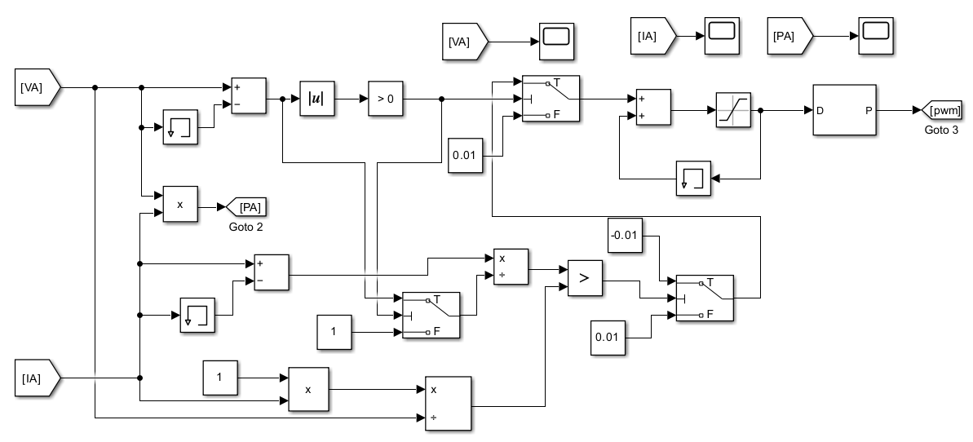
Figure 4: PWM generator block
SIMULATION RESULTS ANALYSIS:
The figure shows the dynamic response of the photovoltaic system using the Incremental Conductance (IC) MPPT algorithm. It consists of three plots representing output power, voltage, and current.

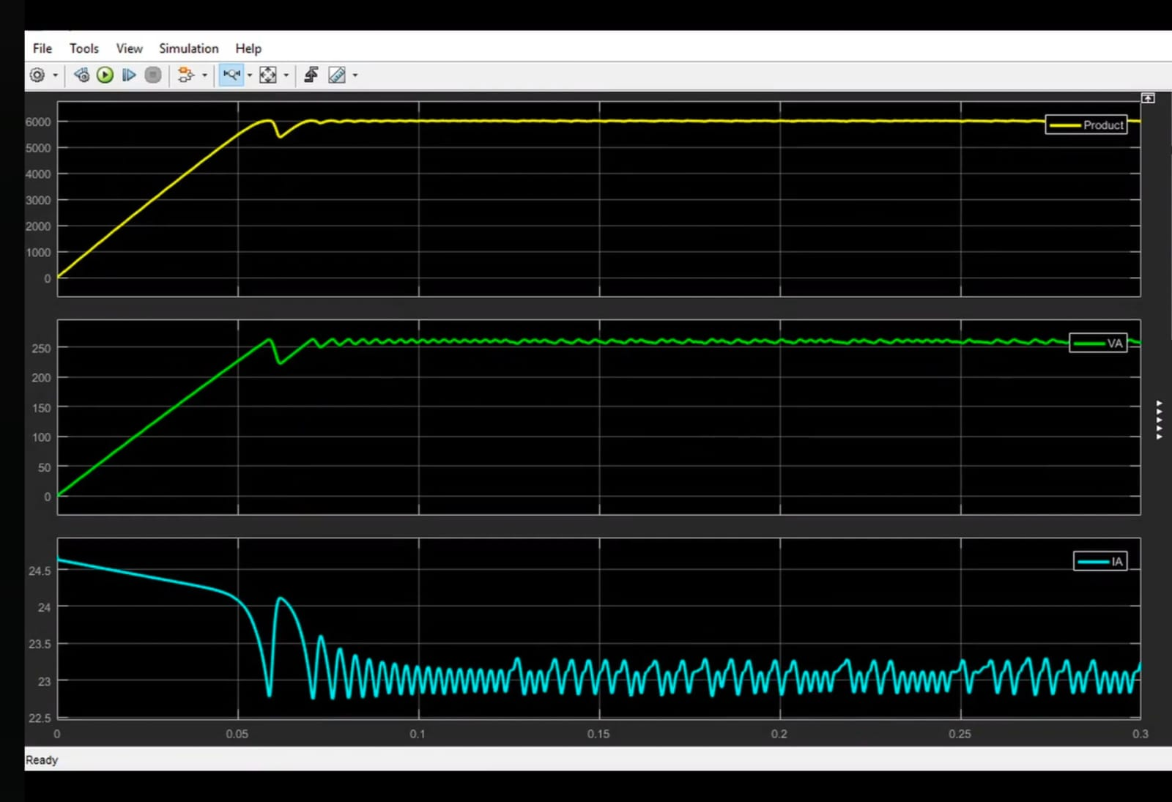

Figure 5: Incremental Conductance MPPT controller output power, output voltage and output current

The results confirm that the Incremental Conductance algorithm achieves fast convergence to the maximum power point with improved stability and reduced oscillations. The system maintains efficient operation after reaching MPP, validating the effectiveness of the proposed MPPT control strategy.

CONCLUSION:
This work presented the implementation of an Incremental Conductance (IC) based MPPT technique integrated with a DC–DC boost converter for photovoltaic applications. The proposed approach effectively tracks the maximum power point under varying environmental conditions by utilizing real-time voltage and current measurements. The boost converter ensures proper voltage regulation and efficient power transfer to the load. Simulation results demonstrate fast convergence, improved tracking accuracy, and reduced steady-state oscillations compared to conventional methods. Overall, the system achieves enhanced energy extraction and stable operation, making it suitable for practical renewable energy applications.
REFERENCES:
- Asnil, K., et al. (2024). “Enhanced Incremental Conductance Maximum Power Point Tracking Algorithm for Photovoltaic System in Variable Conditions.” Journal Europeen des Systemes Automatises.
- D. A. Asoh, B., et al. (2022). “Maximum Power Point Tracking Using the Incremental Conductance Algorithm for PV Systems Operating in Rapidly Changing Environmental Conditions.” Smart Grid and Renewable Energy.
- Asnil, R., et al. (2024). “Performance Analysis of an Incremental Conductance MPPT Algorithm for Photovoltaic Systems Under Rapid Irradiance Changes.” TEM Journal, 1087–1094.
- Owusu-Nyarko, M., et al. (2021). “Modified Variable Step-Size Incremental Conductance MPPT Technique for Photovoltaic Systems.” Electronics.
- I. M. Ali, Z., et al. (2022). “An Efficient MPPT Technique-Based Single-Stage Incremental Conductance for Integrated PV Systems Considering Flyback Central-Type PV Inverter.” Sustainability.
- Nazir, K., et al. (2025). “Enhanced Incremental Conductance MPPT for Photovoltaic System Using Adaptive Step Size and Holding Strategy for Improved Performance.” IOP Conference Series: Earth and Environmental Science.
- M. Hebchi, A., et al. (2021). “Improved incremental conductance algorithm for MPPT in photovoltaic system.” in Proc. 18th Int. Multi-Conf. Systems, Signals and Devices (SSD), 1271–1278.
- Hemavathi R., et al. “Electroluminescence Imaging for Defect Analysis in Polycrystalline Solar Cells” Metall. Mater. Eng, 1279-1288.
- G. S. Chawda, O., et al. (2020). “Incremental conductance based particle swarm optimization algorithm for global maximum power tracking of solar-PV under non uniform operating conditions.” Applied Sciences, 4575.
- M. A. Elgendy, B., et al. (2013). “Assessment of the incremental conductance maximum power point tracking algorithm.” IEEE Transactions on Sustainable Energy, 108–117.
- R. I. Putri, S., et al. (2015). “Maximum power point tracking for photovoltaic using incremental conductance method.” Energy Procedia, 22–30.
- Hemavathi R., et al. (2019). “Simulation of SEPIC DC-DC Converter using LABVIEW.” International journal of creative and research in all studies, 2581-5334.

