AN ANALYSIS OF CONSUMER KNOWLEDGE AND ATTITUDES REGARDING ELECTRICITY AND HEATING TARIFFS

Abstract
The energy sector serves as the fundamental pillar of national development. It is difficult to envision a country’s progress without a robust energy sector, as economic growth is heavily dependent on well-developed infrastructure—particularly the energy supply. Public services such as the production, transmission, and distribution of electricity and thermal energy constitute a major part of the infrastructure and are considered a strategically significant sector due to their pivotal role in the national economy. In Mongolia, energy policies and the methodologies for setting electricity and heat tariffs are established by high-level state administrative authorities in accordance with the Law on Energy.
Keywords: Energy, price tariffs, consumer, energy sector, consumer
I. INTRODUCTION

The obsolescence of equipment and technological lag in electricity and heat production, transmission, and distribution is increasing annually (International Energy Agency, 2023). While rising consumption demands the introduction of new sources and modern technologies (Energy Regulatory Commission, 2024), these issues remain unresolved due to limitations in national budget investment planning, financial shortages, and political conditions (Bartolomey & Pazderin, 2019; ISO, 2018). Electricity tariffs for consumers have remained unchanged since 2019. Consequently, the energy sector incurred operating losses of 59 billion MNT in 2019, 92 billion MNT in 2020, and 78 billion MNT in 2021; the deficit is expected to reach 168.2 billion MNT based on 2022 performance (State Great Khural, 2015). Despite a 28% increase in the foreign exchange rate and a 34.5% rise in the Consumer Price Index (CPI) since 2019, production tariffs have not been adjusted since 2024 (Ministry of Energy, 2024).
The failure to increase tariffs has prevented Thermal Power Plants (TPPs) from performing essential maintenance on primary and auxiliary equipment, leading to increased malfunctions. To meet peak winter loads, plants are operating at full capacity without standby equipment, creating a high risk of system-wide failures, nationwide blackouts, and critical energy shortages (Urgamalsuvd & Altanzul, 2019; UN ESCAP, 2022). Furthermore, coal mining companies and the Ulaanbaatar Railway, which transports coal to these plants, continue to operate at a loss annually (Ministry of Energy, 2024). Accordingly, we conducted and analyzed a survey of 124 consumers to determine public perception and attitudes toward energy tariff adjustments (Ministry of Energy, 2024).
Research Purpose and Objectives
Investigating consumer perceptions of electricity and heat tariffs is essential for identifying effective strategies to prepare the public for future price adjustments and policy changes.
Research Methodology
The survey questionnaire was developed using the KAP (Knowledge, Attitude, and Practice) framework to determine consumer understanding and perspectives regarding energy tariffs (Soyoltsetseg & Erdenetsetseg, 2025). Data collection was conducted through a structured survey method, and the results were analyzed using quantitative techniques to express the findings numerically.
1. DEMOGRAPHIC CHARACTERISTICS OF SURVEY PARTICIPANTS
The following survey was conducted to assess consumer knowledge regarding electricity and heat tariffs. Investigating consumer perceptions of energy pricing (International Energy Agency, 2023) is essential for identifying effective ways to prepare the public for future tariff adjustments and policy changes.

Figure 1. Demographic profile of survey participants
Demographic Analysis of Participants
Regarding the age distribution of the survey participants, 16.1% were aged 18–25, 44.4% were aged 26–35, 25.8% were aged 36–45, 9.7% were aged 46–55, and 5.6% were aged 56 or older. In terms of gender, 54% of the respondents were male and 46% were female.
In terms of housing types, the majority of participants (74.2%) reside in apartments, while 15.3% live in detached private houses, 9.7% live in gers, and 0.8% live in rental housing.
2. CONSUMER KNOWLEDGE REGARDING ELECTRICITY TARIFFS
Figure 2. Consumer Perception of Electricity and Heat Tariffs, by percentage
Regarding the understanding of electricity and heat payments, 10.5% of the surveyed consumers responded that they have "Excellent" knowledge, 26.6% stated "Very Good," 44.4% responded with "Average," and the remaining 18.5% answered that they "Do not know well enough." The survey results indicate that consumers' self-assessment of their knowledge regarding price tariffs is generally rated as average to above average.
Table 1. Consumer prioritization of energy usage
Ranking of Consumption Priorities | 1-рт | 2-рт | 3-рт | 4-рт | 5-рт
Fuel (Gasoline/Petrol) | 3.2% | 14.5% | 23.4% | 42.7% | 16.1%
Electricity and thermal energy | 52.4% | 21.8% | 13.7% | 6.5% | 5.6%
Essential Groceries (Meat, Flour, Food) | 24.2% | 38.7% | 16.9% | 12.1% | 7.3%
Housing, tuition, mobile/internet, and other utilities | 11.3% | 23.4% | 41.9% | 20.2% | 3.2%
Other | 8.9% | 1.6% | 4.0% | 18.5% | 67.7%

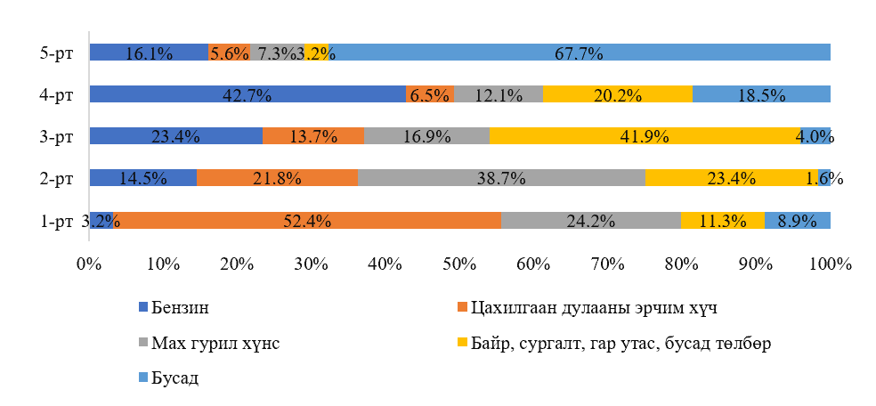
Figure 3. Consumer Prioritization of Household Expenditures
According to the survey results, when asked to rank their most essential needs, 52.4% of respondents identified electricity and thermal energy as their primary (first) priority. This was followed by:
Second priority: Essential groceries (meat, flour, food) at 38.7%. Third priority: Housing, tuition, and mobile/internet fees at 41.9%. Fourth priority: Fuel and gasoline at 42.7%. Fifth priority: Other expenses at 67.7%. In conclusion, more than half of the participants (52.4%) consider electricity and thermal energy to be their most critical daily necessity. Consumer Perception of Domestic Tariffs vs. International Rates. When asked how Mongolia’s electricity and heat prices compare to those of other countries: 28.2% believe prices are low. 34.7% believe prices are average. 12.1% believe prices are high.25.0% responded that they do not know. These findings suggest that consumer understanding of energy tariff levels is insufficient. Therefore, it is necessary to implement measures to improve public awareness and provide clearer information regarding energy pricing and its global standing.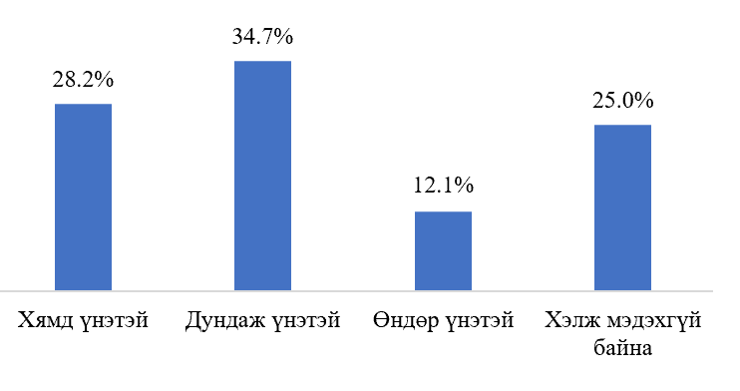
Figure 4. Consumer Opinion on Domestic Energy Tariffs Compared to Other Countries
When respondents were asked, "How do you think the price of energy delivered to consumers compares to its actual production cost?" the results were as follows: 36.3% believe it is cheaper than the production cost. 23.4% believe it is higher than the production cost. 8.1% believe it is equal to the production cost. 32.3% responded that they do not know. From these results, it can be concluded that there is a significant lack of understanding among consumers regarding the actual cost structure of electricity and thermal energy production.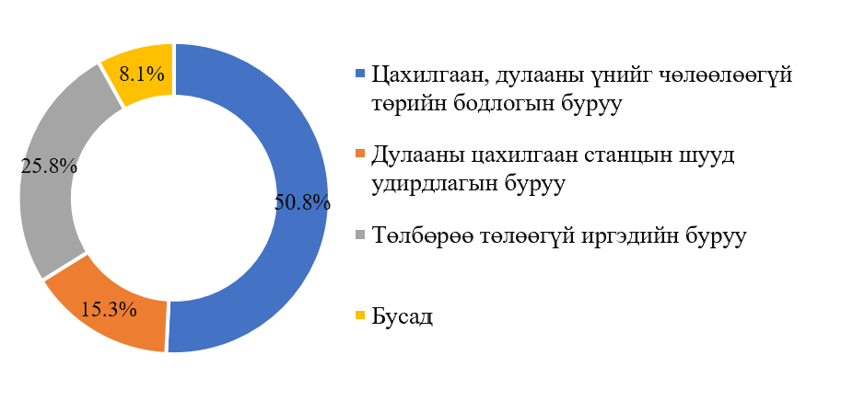
Figure 5. Respondent Opinions on Responsibility for Potential System Failures
In response to the question, "If Thermal Power Plants (TPPs) fail to perform necessary maintenance due to insufficient funding, leading to a system-wide blackout, who is to blame?" the participants responded as follows:
50.8% attributed it to government policy failures (specifically the failure to liberalize electricity and heat prices). 25.8% blamed citizens who do not pay their utility bills.
15.3% attributed the blame to the management of energy organizations. 8.1% chose "Other" reasons. Among the 8.1% who selected "Other," respondents noted that the issue is directly related to Mongolia's low GDP per capita and low household income compared to other countries. They further commented on flawed national planning and policies, the failure to calculate tariffs based on actual costs, and the view that the total costs incurred should ultimately be covered by both citizens and businesses.
Conclusion: The survey results indicate that consumers increasingly recognize the necessity of adjusting energy tariffs to reflect actual production costs.
Figure 6. Consumer Opinions on Price Liberalization
To ensure energy reliability and enable the sector to operate according to market principles, respondents were asked: "What is your opinion on liberalizing electricity and heat prices, whereby citizens and businesses pay for their actual consumption based on market rates?" 58.1% responded that it is correct. 17.7% responded that it is incorrect.
24.2% responded that they do not know. The results show that the majority of surveyed consumers agree that price liberalization is a necessary step.

3. CONSUMER BEHAVIOR AND ATTITUDES TOWARD ENERGY CONSUMPTION

Figure 8. Survey findings on consumer electricity and heat usage

Regarding the daily electricity consumption habits of the survey participants, the average user spends 1–4 hours charging mobile phones and tablets, 1–3 hours cooking, 3–4 hours watching television, 5–8 hours in rooms with active lighting, and 7–8 hours working at a computer each day.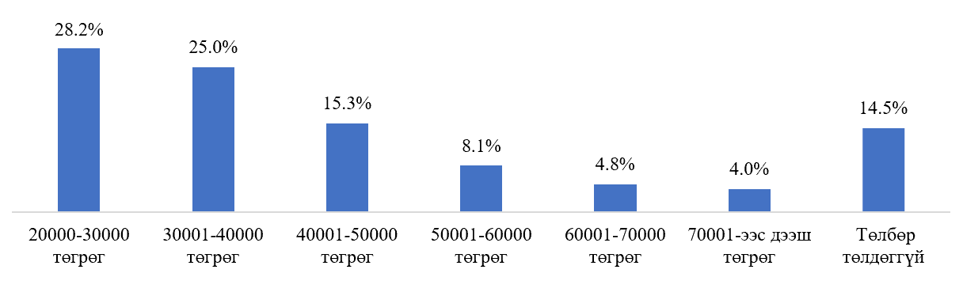
Figure 9. Average monthly electricity expenditure
In response to the question, "How much do you pay on average per month for electricity?" the participants reported the following: 28.2% pay between 20,000 – 30,000 MNT. 25.0% pay between 30,001 – 40,000 MNT. 15.3% pay between 40,001 – 50,000 MNT.
Table 2. Monthly Electricity Expenses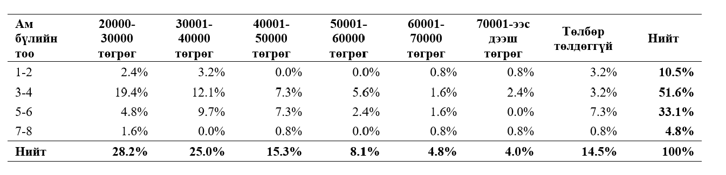
Furthermore, households with 3–4 members pay an average of 35,000–40,000 MNT per month for electricity. This equates to approximately 333 MNT per person per day, illustrating the extreme undervaluation of electricity in the country.
III. CONSUMER KNOWLEDGE OF ENERGY PRODUCTION AND GOVERNMENT SUBSIDIES
When asked about the supply chain of electricity and heat production, 48.4% responded that they were unaware of the process, while 51.6% claimed some knowledge but admitted it was insufficient. Among those who claimed knowledge, most understood that energy is generated at Thermal Power Plants (TPPs) and delivered to households through transmission and distribution networks, noting that it is produced under difficult conditions.
Regarding government subsidies, respondents were asked: "Are you aware that the government currently covers a certain percentage of your electricity and heat costs?" 56.5% were unaware, and 45.5% were aware but lacked detailed information. Opinions on the Appropriate Level of Government Subsidies:
In response to an open-ended question about the ideal level of state support, participants provided the following perspectives:
Targeted Support: Subsidies should only target the very poor or those living below the poverty line, as price increases are hardest on them.
Shared Cost: A 70/30 split is appropriate (Citizens pay 70%, Government pays 30%).
Emergency Only: State coverage was helpful during COVID-19 and should only be used during extraordinary circumstances.
Total Liberalization: Government subsidies are incorrect; they create a culture of over-reliance on welfare. Citizens should pay 100% of their consumption.
Conservation through Pricing: Higher prices are necessary to teach citizens to save energy.
Regional Subsidies: It is appropriate to set higher tariffs for state institutions to subsidize imported energy in western provinces and local thermal plants in rural areas.
Income-Linked: Current tariffs are appropriate for current salaries. Prices should only rise if wages increase.
Minimal State Role: Some respondents suggested the government should cover only a symboli
IV. CONCLUSION
Educational Integration: Because consumer understanding of energy production is insufficient, the basics of energy systems and costs should be integrated into the secondary school curriculum.
Law Enforcement & Awareness: Greater attention must be paid to the implementation, monitoring, and promotion of the Law on Energy Efficiency.
Diversification: New and diverse energy sources must be introduced to the national grid to ensure security.
Efficiency: Consumers should be encouraged to phase out appliances and equipment with high electricity consumption.
Accurate Costing: It is essential to conduct precise and transparent calculations of the actual unit cost of energy production.
References
Legalinfo.mn. (n.d.). Constitution of Mongolia https://legalinfo.mn/mn/detail/60
Legalinfo.mn. (n.d.). Law on Energy https://legalinfo.mn/mn/detail/11488

Energy Regulatory Commission of Mongolia. (n.d.). Energy efficiency policy, legal environment, and the Energy Regulatory Commission
International Organization for Standardization. (2018). Energy management systems — Requirements with guidance for use (ISO Standard No. 50001:2018).
State Great Khural of Mongolia. (2015). Law on Energy Efficiency
International Energy Agency. (2023). World energy outlook.
United Nations Economic and Social Commission for Asia and the Pacific (UN ESCAP). (2022). Energy efficiency trends in Asia.
Ministry of Energy of Mongolia. (2024). Compendium of energy statistics
Bartolomey, P. I., Pazderin, A. A., & Pazderin, A. V. (2019). Directions for improving the payment system for electricity transmission services taking into account international experience. Electric Power. Transmission and Distribution, 5(56), 66–70.
Urgamalsuvd, N., & Altanzul, G. (2019). Direct and indirect effects of electricity price changes on other goods and general price levels Research Work Booklet 18.
Soyoltsetseg, O., & Erdenetsetseg, B. (2025). Process management strategies to improve energy conservation and energy efficiency Collection of Scientific Works. ISSN 1560-8794.

