Triadic Semiotic Representations and Didactic Engineering: An Articulation for Teaching School Physics in Secondary Education

ABSTRACT
The teaching of school physics in secondary education faces a structural semiotic challenge: its phenomena are inaccessible to direct perception, so that all learning depends on the quality of the representations used to make them intelligible. This article analyzes seven didactic sequences designed and implemented by pre-service teachers from the Universidad de Sucre under the methodology of didactic engineering (Artigue, 1988, 1995), with approximately 240 secondary students in Sincelejo, Sucre, across two semesters (November 2025 and May 2026). The analytical lens was the theory of registers of semiotic representation (Duval, 1993, 2006). The results show a mean normalized Hake gain of ⟨g⟩ = 0.643 (range: 0.328–0.810); three of the seven cases reach high gain (⟨g⟩ ≥ 0.70). The semiotic route R3 Analogical → R2 Figural → R1 Verbal proves the most productive for conceptual understanding; R5 Symbolic-algebraic is resisted when introduced without that prior route and successful when it follows it. The concept of semiotic a priori analysis is proposed as a tool that integrates both frameworks for designing school physics sequences.
Keywords: didactic engineering · semiotic representations · school physics · secondary education · teacher training · Hake gain
INTRODUCTION
School physics occupies a paradoxical place in Colombian secondary education: it is scientifically central, technologically ubiquitous, and pedagogically marginal. This marginality has didactic rather than curricular roots: teachers present formulas without adequate representational support, work within a single register—generally the verbal or the symbolic-algebraic—and do not design activities that promote transitions between different ways of representing the phenomenon (Castiblanco & Nardi, 2022; Ostermann & Moreira, 2000). The result is fragmented learning, with alternative conceptions that persist even after instruction (Gil Pérez et al., 2005).
The challenge is semiotic in nature before it is conceptual. School physics studies phenomena that cannot be observed directly: from universal gravitation to nuclear fission, including wave-particle duality and the relativity of time. All access to these phenomena necessarily occurs through representations. From a semiotic standpoint, Peirce (1931/1965) conceptualized the sign as an irreducible triadic relation among the representamen (the form the sign takes), the object (that to which the sign refers), and the interpretant (the cognitive effect the sign produces). This triad implies that scientific understanding does not depend on the sign itself, but on the operations the student performs when relating it to the object it represents. In school physics, a diagram of the double-slit experiment is the representamen; the phenomenon of quantum interference is the object; and the understanding the student constructs from the diagram is the interpretant (Peirce, 1931/1965).
Duval (1993) operationalizes this perspective through the theory of registers of semiotic representation (RSR), which constitutes the analytical foundation of this study. A semiotic register is a representational system that allows not only the designation of an object but also operations on its representation. Duval (1993, 2006) distinguishes two fundamental cognitive operations on registers: treatment, the transformation of a representation within the same register (for example, rewriting an equation in an equivalent form), and conversion, the transformation of a representation from one register to another while preserving the object represented (for example, moving from a diagram to an equation, or from an analogy to a verbal description). Duval’s (2006) central thesis, empirically grounded in studies with mathematics and science students, is that conceptual understanding requires the coordination of at least two distinct registers, and that conversion—not treatment—is the central cognitive mechanism of scientific learning. A student who masters the object in only one register has not fully understood the phenomenon (Duval, 2006).
Duval (1993) identifies six registers that are particularly relevant for secondary-level science teaching: the verbal register (oral and written explanations in natural language), the figural register (diagrams, schemes, and illustrations), the analogical register (manipulable physical models and everyday metaphors), the graphical register (curves, tables, and Cartesian graphs), the symbolic-algebraic register (equations and formal notation), and the audiovisual register (videos, simulators, and animations). In school physics, these six registers coexist and become articulated in ways that traditional teaching rarely designs explicitly (Lemke, 1998). Rodríguez and Morcillo (2021) document the productive role of analogical representations for microscopic phenomena; Domínguez et al. (2022) identify the specific difficulties of conversion between the graphical and symbolic-algebraic registers in wave physics.
To design teaching sequences that systematically promote conversions between registers and to validate them empirically, Artigue’s (1988, 1995) didactic engineering (DE) offers an appropriate methodological scaffold. DE is a research and design methodology that articulates the construction of teaching situations with the rigorous analysis of learning processes (Artigue, 1988). It is organized into four phases: (1) preliminary epistemological analysis and diagnosis of prior knowledge; (2) conception and a priori analysis, in which explicit predictions about didactic behavior are formulated; (3) classroom experimentation; and (4) a posteriori analysis and internal validation through the contrast between anticipated hypotheses and observed results (Artigue, 1995). Validation in DE is internal, not statistical: a sequence is validated when the observed results are consistent with the predictions of the a priori analysis, including predictions about difficulties (Brousseau, 1986). Chevallard (1991) complements this framework with the concept of didactic transposition—the distance between scholarly knowledge and taught knowledge—which DE seeks to reduce without sacrificing epistemic rigor.
The recent state of the art (2021–2026) reveals a twofold gap. On one hand, studies applying DE to school physics in Colombia rarely incorporate explicit semiotic analysis of the registers employed (Castiblanco & Nardi, 2022; Góndola, 2023). On the other hand, studies on semiotic representations in science education frequently lack a systematic design protocol that would allow their findings to be operationalized. Coutinho et al.’s (2024) review of trends in modern physics teaching (2015–2023) confirms that the explicit articulation between semiotic frameworks and rigorous didactic design remains infrequent in the Latin American context. Barcellos and Guerra (2022) describe the specific semiotic barriers in the transposition of quantum physics to Brazilian secondary education, noting that teachers do not know how to make formal registers accessible without distorting essential physical content.
This article proposes and tests the concept of Semiotic A Priori Analysis (SAPA): an extension of Artigue’s (1988) a priori analysis that explicitly incorporates Duval’s (1993) map of the semiotic registers to be activated at each moment of the sequence, the register conversions students are expected to perform, the direction of each conversion, and the registers expected to elicit the greatest resistance. SAPA integrates DE and RSR into a single design and analysis instrument. The impact of the interventions is assessed through Hake’s (1998) normalized gain, a metric that standardizes learning effects across groups with differing prior knowledge and that has been widely used in physics education research.
This study is situated within the first author’s research line on reflective didactics and teacher training (Iriarte Pupo, 2011; Iriarte Pupo & Sierra Pineda, 2011; Iriarte Pupo et al., 2021). The research question is: how does the articulation between triadic semiotic representations and didactic engineering foster conceptual understanding of school physics in secondary students when implemented by pre-service teachers? The general objective is to analyze this articulation through seven sequences designed and implemented across two academic semesters (November 2025 and May 2026) in Sincelejo, Sucre, Colombia. The specific objectives are: (a) to characterize the semiotic registers employed in each sequence following Duval’s (1993) classification; (b) to identify register conversions and their relationship to learning gain; (c) to assess conceptual impact through Hake’s (1998) gain; (d) to contrast a priori predictions with the a posteriori analysis in Artigue’s (1988) sense; and (e) to propose and test SAPA as a didactic design tool.
METHODOLOGY
Research Design
A mixed design of predominantly qualitative nature was adopted, complemented by descriptive quantitative analysis. The specific design is a multiple-case study (Yin, 2014) comprising seven cases organized into two temporal cohorts—semester S1 (November 2025) and semester S2 (May 2026)—which adds a quasi-longitudinal dimension. The cases share the same methodological framework (DE), the same supervising instructor, and the same institutional context, but differ in content, school grade, and number of sessions. This structure allows both in-depth analysis of each case and systematic comparison to identify cross-case patterns. The generalization sought is analytic (Yin, 2014), not statistical: the findings enrich the theory of the DE–SR articulation rather than inferring population prevalence.
Participants, Context, and Coding
The implementers of the sequences were seven final-year pre-service teachers from the Physics Teaching Program (Licenciatura en Física) at the Universidad de Sucre, enrolled in Physics Didactics V under the supervision of the first author. To protect their identity, the alphanumeric coding system DF-Sx-NN was adopted (DF = pre-service teacher; S1/S2 = semester; NN = sequential number), used consistently throughout the article. The secondary students belonged to 10th- and 11th-grade groups from two public institutions in Sincelejo, Sucre: Institución Educativa Policarpa Salavarrieta (IEPS) and Institución Educativa Normal Superior de Sincelejo (IENSS). Table 1 characterizes the seven cases.
Table 1
Characterization of the Seven-Case Didactic Engineering Corpus
Code | Topic | Branch | Sem. | Grade | Institution | N | Sessions
Semester 1 (November 2025)
DF-S1-01 | Universal Law of Gravitation | Classical | Nov. 2025 | 10th | IE Policarpa Salavarrieta | 34 | 1 (2h)
DF-S1-02 | Simultaneity in Special Relativity | Relativity | Nov. 2025 | 11th | IE Policarpa Salavarrieta | 25ᵃ | 2 (2h ea.)
Semester 2 (May 2026)
DF-S2-01 | Compton Effect | Quantum | May 2026 | 10th | IE Policarpa Salavarrieta | 43ᵃ | 1 (2h)
DF-S2-02 | Atomic and Nuclear Physics | Nuclear | May 2026 | 10th | IE Policarpa Salavarrieta | 30ᵃ | 4 (90 min ea.)
DF-S2-03 | Nuclear Fission | Nuclear | May 2026 | 10th | IE Policarpa Salavarrieta | 35 | 1 (2h)
DF-S2-04 | Cosmology | Cosmology | May 2026 | 10th | IE Policarpa Salavarrieta | 40 | 1 (2h)
DF-S2-05 | Double-Slit Experiment | Quantum | May 2026 | 10th | IE Normal Superior de Sincelejo | 33ᵃ | 1 (2h)
Note. The DF-Sx-NN code identifies the pre-service teacher (DF), semester (S1 = Nov. 2025; S2 = May 2026), and sequential number (NN). IEPS = IE Policarpa Salavarrieta; IENSS = IE Normal Superior de Sincelejo. ᵃThe N value is estimated from the report data. Sem. = implementation semester.
Documentary Corpus and Analytical Procedure
Each pre-service teacher produced a didactic engineering report that included, following Artigue’s (1988) protocol: a preliminary epistemological analysis, an a priori analysis with explicit predictions, a classroom observation journal, quantitative pre-test and post-test results, an a posteriori contrast, and a reconstructed sequence. These reports constitute the primary documentary corpus of the study.
The quantitative analysis was carried out using the normalized Hake gain, defined as ⟨g⟩ = (post% − pre%) / (100% − pre%), with levels of high (⟨g⟩ ≥ 0.70), medium (0.30 ≤ ⟨g⟩ < 0.70), and low (⟨g⟩ < 0.30) gain according to Hake’s (1998) classification, derived from his analysis of more than 6,000 introductory physics students. This metric standardizes conceptual impact across cases with instruments of different scale and item count. The qualitative analysis was based on a coding matrix of Duval’s (1993) semiotic registers, with four dimensions: presence of the register (full/partial/absent), identified conversions, direction of conversion, and level of resistance observed in the classroom journal.
Preliminary methodological limitations: (a) heterogeneity of instruments across cases; (b) the DF-S2-05 pre-test possibly overestimated due to cell-phone use during administration, which depresses ⟨g⟩; (c) values for DF-S1-02, DF-S2-01, and DF-S2-02 estimated from qualitative data, marked with superscript a in the tables; (d) absence of control groups; and (e) convenience sampling, so results should be interpreted as analytic rather than statistical generalization.
RESULTS
Conceptual Impact and Semiotic Profiles
Table 2 presents the semiotic profiles and Hake gain for the seven cases. Registers are classified following Duval (1993): R1 = Verbal, R2 = Figural, R3 = Analogical, R4 = Graphical, R5 = Symbolic-algebraic, R6 = Audiovisual. The SR full column indicates the number of registers with full presence.
Table 2
Semiotic Profiles and Normalized Hake Gain by Case
Code | Pre% | Post% | ⟨g⟩ | R1 | R2 | R3 | R4 | R5 | R6 | SR full
Semester 1 (November 2025)
DF-S1-01 | 30.0% | 85.0% | 0.786 | F | F | F | F | F | P | 5
DF-S1-02 | 66.4%ᵃ | 92.0%ᵃ | 0.762ᵃ | F | F | F | F | F | F | 6
Semester 2 (May 2026)
DF-S2-01 | 52.0%ᵃ | 78.0%ᵃ | 0.542ᵃ | F | F | F | P | A | F | 4
DF-S2-02 | 25.0%ᵃ | 72.5%ᵃ | 0.633ᵃ | F | F | P | F | P | F | 4
DF-S2-03 | 56.4% | 84.3% | 0.639 | F | F | F | F | P | P | 4
DF-S2-04 | 25.2% | 85.8% | 0.810 | F | F | F | F | A | F | 5
DF-S2-05 | 57.9%ᵃ | 71.7%ᵃ | 0.328ᵃ | F | F | P | F | P | F | 4
Note. ⟨g⟩ = normalized Hake gain according to the formula ⟨g⟩ = (post% − pre%) / (100% − pre%) (Hake, 1998). ᵃEstimated value based on qualitative description in the report. R1 = Verbal; R2 = Figural; R3 = Analogical; R4 = Graphical; R5 = Symbolic-algebraic; R6 = Audiovisual (Duval, 1993). SR full = number of registers with full presence. F = full presence; P = partial presence; A = absent. S1 = November 2025 semester; S2 = May 2026 semester.
The set as a whole obtains a mean gain of ⟨g⟩ = 0.643. Cases DF-S1-01 (⟨g⟩ = 0.786), DF-S1-02 (⟨g⟩ = 0.762), and DF-S2-04 (⟨g⟩ = 0.810) reach high gain according to Hake (1998); the remaining four obtain medium gain. All cases exceed the 0.30 threshold. R1 and R2 are present in all seven cases (7/7). R5 has full presence exclusively in the two semester-S1 cases; in the five semester-S2 cases it appears partially or is absent. Figures 1, 2, and 3 visualize, respectively, the pre-post difference, the classification of normalized gain, and the presence profile of semiotic registers.
Figure 1
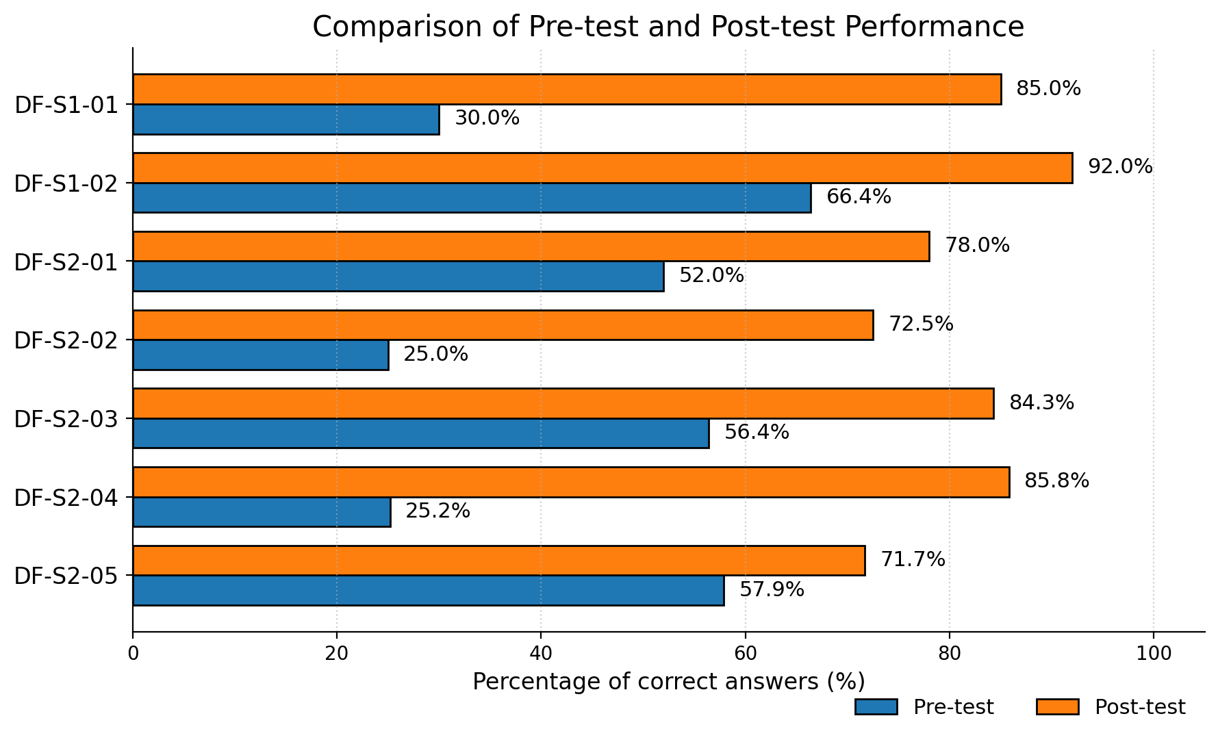
Percentage performance before and after the didactic sequences. Note. Values with superscript a in Table 2 correspond to data estimated from qualitative descriptions in the report.
Figure 2
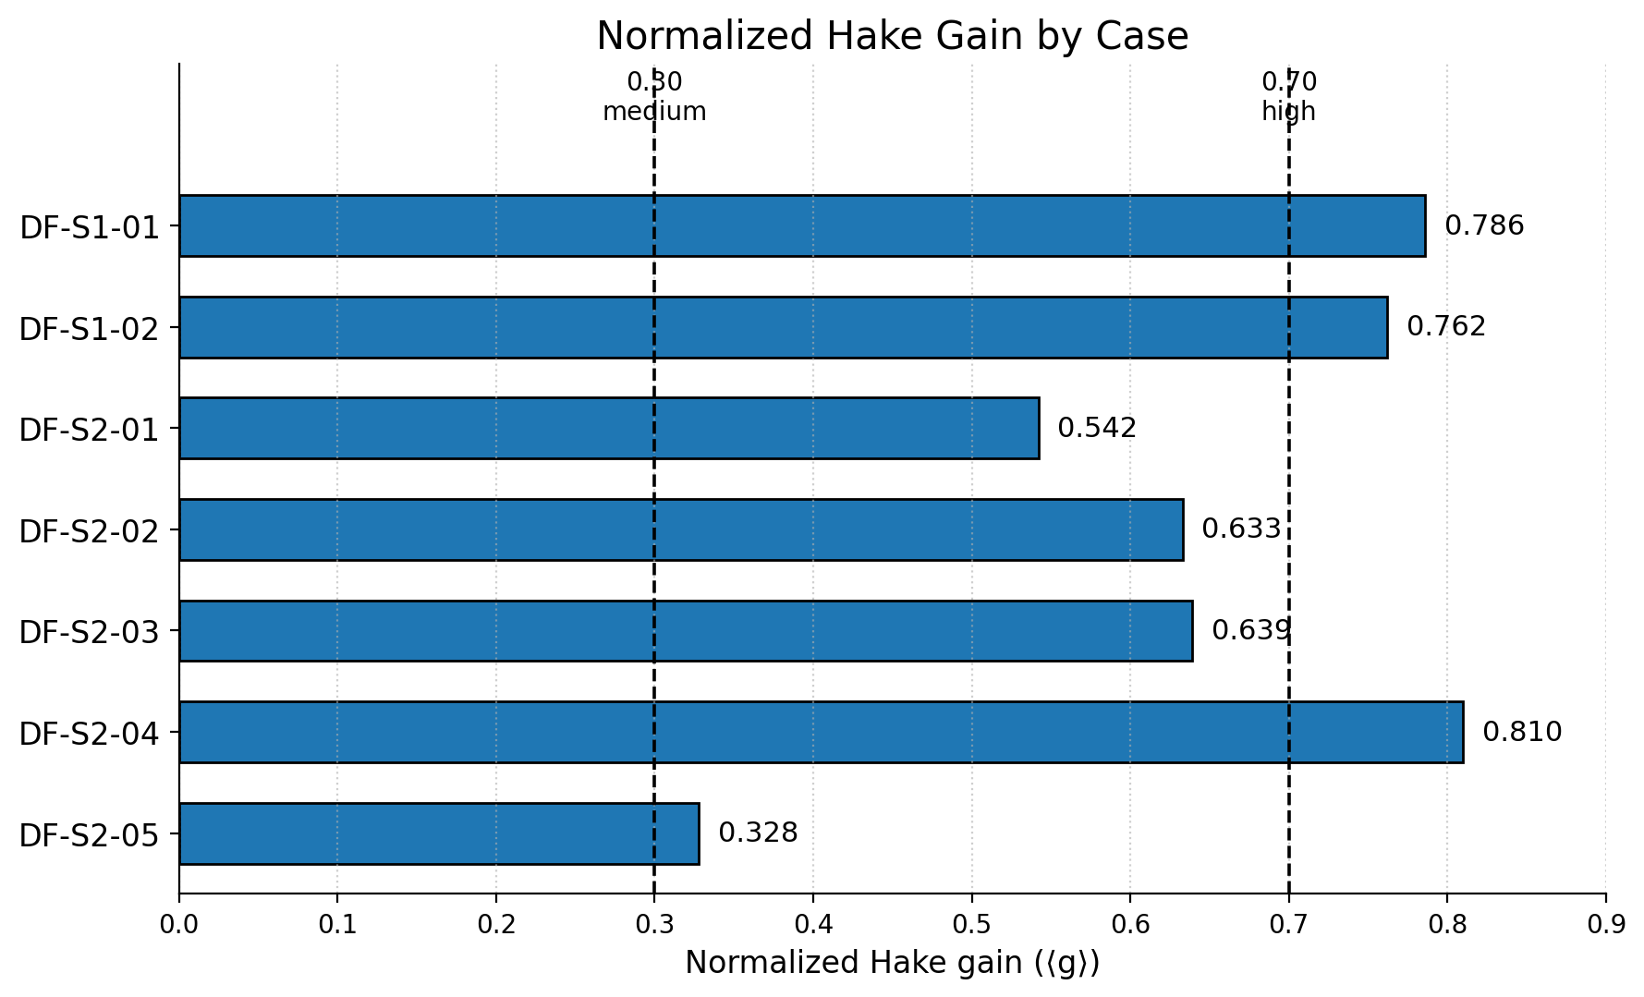
Classification of normalized Hake gain by case. Note. The lower line marks the medium-gain threshold (0.30) and the upper line the high-gain threshold (0.70), according to Hake (1998).
Figure 3
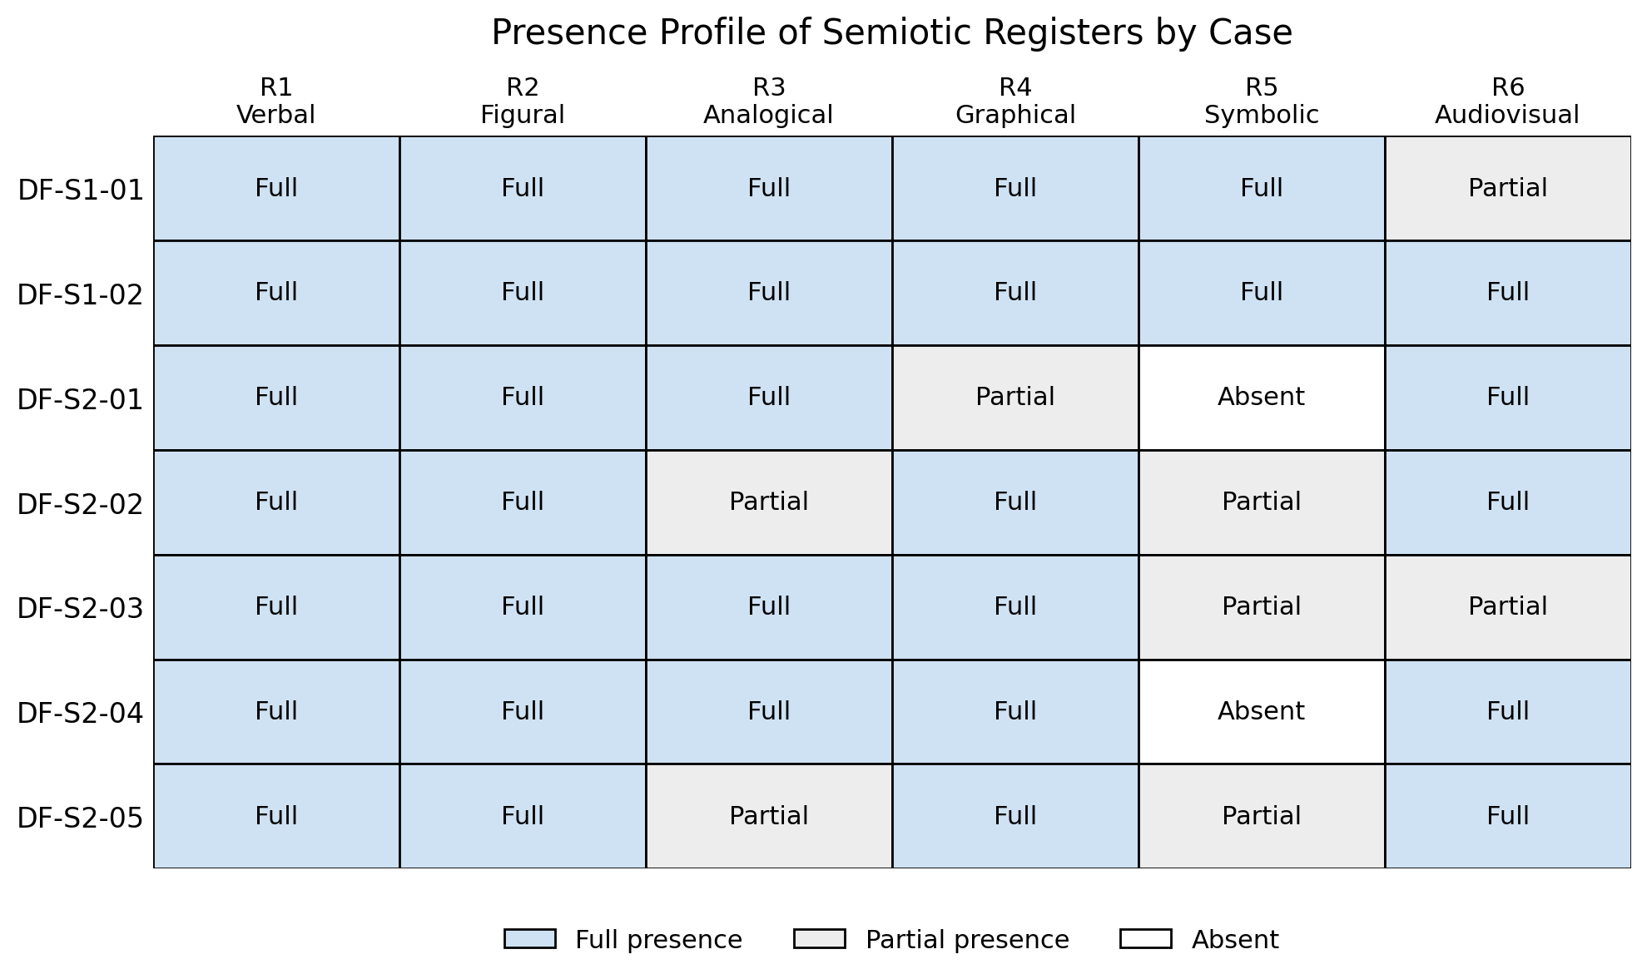
Full, partial, or absent presence of semiotic registers by case. Note. Each cell indicates whether the register had full, partial, or absent presence. The visualization shows that the difference between cases lies not only in the number of registers but in their articulation.
H1: Conceptual gain does not appear to be explained solely by the number of semiotic registers activated. All cases work with between five and six registers when full and partial presences are considered; the analytical difference lies, rather, in the quality, sequence, and direction of the conversions. The high-gain cases first consolidate an analogical-figural-verbal mediation, or forgo algebraic formalization when it is not necessary for the immediate conceptual objective.
H2: R5 Symbolic-algebraic has full presence only in the two semester-S1 cases, both with high gain. In the five semester-S2 cases where R5 was partial or absent, attempts at algebraic formalization generated the greatest resistance observed in each case.
Conversions Between Semiotic Registers
Table 3 presents the inventory of the 22 conversions identified in the corpus, along with the didactic mechanism that triggered them according to the observation journals, the evidence of achievement, and the level of resistance reported in each report.
Table 3
Inventory of Conversions Between Semiotic Registers by Case
Case | Conversion | Didactic mechanism | Evidence of achievement | Resistance
DF-S1-01 | R3→R2 | Ball-and-string → planetary-orbit diagram | Analogy spontaneously cited by students | Low
 | R2→R4 | Orbit diagram → F vs. r² graph | Improvement on force-distance variation items | Medium
 | R1→R5 | Verbal description → equation F = Gm₁m₂/r² | 85% correct on post-test | Medium
DF-S1-02 | R3→R2 | Light clock (Bob/Pat) → train-light-rays diagram | Written verdicts from the “judge of school time” | Low
 | R2→R4 | Train diagram → spacetime (Minkowski) diagram | Individual construction on graph paper | Medium
 | R6→R1 | Simulator → written argued verdicts | Qualitative evolution in open-ended responses | Low
 | R4→R5 | Minkowski diagram → Lorentz factor γ | Partial understanding; difficulty with scientific notation | High
DF-S2-01 | R3→R2 | Billiard-balls/marbles analogy → photon-electron collision diagram | Appropriation reported in oral feedback | Low
 | R6→R1 | Introductory video → brainstorming (memes) | Documented activation of prior knowledge | Low
 | R3→R1 | Moon-Earth analogy → explanation of energy levels | 18/43 with perfect post-test score | Medium
DF-S2-02 | R2↔R1 | Atomic-model diagrams ↔ historical oral debate | Drawings of the atom as artifacts of appropriation | Low
 | R1→R2 | Oral explanation → student’s own atomic drawing | Graphic evidence included in the report | Low
 | R2→R5 | Nuclear diagram → fission/fusion equation | Persistent difficulty explicitly reported | High
DF-S2-03 | R3→R2 | Dominoes + marbles → chain-reaction diagram | Analogy spontaneously cited when explaining fission | Low
 | R2→R4 | Nuclear diagram → energy-release graph | P1–P5: from 17–19 to 26–33 correct | Medium
 | R1→R5 | Verbal description → formal nuclear equation | P6: from 7 to 19 correct (greatest difficulty in this case) | High
DF-S2-04 | R3→R2 | Inflating balloon → universe-expansion diagram | Big Bang as expansion: P5 from 44.1% to 76.5% | Low
 | R2→R4 | Geocentric scheme → comparative model table | P1 (epicycles): from 2.9% to 94.1% | Low
 | R4→R1 | Comparative table → geocentrism/heliocentrism debate | Active participation documented in journal | Low
DF-S2-05 | R6→R2 | Experiment video → interference-pattern diagram | Improvement on conceptual post-test items | Low
 | R2→R1 | Slit diagram → oral description of interference | Active oral participation reported | Low
 | R2→R5 | Interference pattern → symbol λ (wavelength) | Post-test P8: from 45% to 64% | High
Note. Register nomenclature follows Duval (1993): R1 = Verbal; R2 = Figural; R3 = Analogical; R4 = Graphical; R5 = Symbolic-algebraic; R6 = Audiovisual. The Case column is left blank when conversions correspond to the same case as the previous row. ↔ indicates bidirectional conversion. High resistance = conversion explicitly reported as a persistent difficulty in the pre-service teacher’s report.
Figure 4
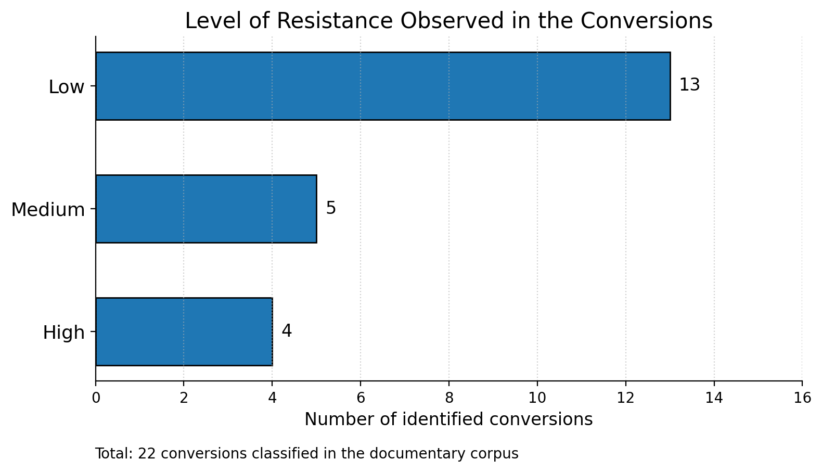
Distribution of the level of resistance observed in the conversions. Note. High resistance is concentrated in conversions toward R5, especially when symbolic-algebraic formalization was not preceded by consolidated analogical and figural mediations. The count matches the inventory of 22 conversions reported in Table 3: 13 of low resistance, 5 of medium resistance, and 4 of high resistance.
H3: The R3 Analogical → R2 Figural mediation, followed by conceptual verbalization in R1, emerges as a productive pattern in the corpus. In the cases where the analogy was appropriated, students cited it spontaneously when explaining the phenomenon; this constitutes evidence of register coordination, in Duval’s (2006) sense, and of more stable conceptual understanding.
H4: Conversions toward R5 show high resistance in all semester-S2 cases where they were attempted (DF-S2-02: R2→R5; DF-S2-03: R1→R5; DF-S2-05: R2→R5). In the two semester-S1 cases where R5 was full, the resistance of R4→R5 (DF-S1-02) did not block learning because it was preceded by three consolidated conversions.
Contrast Between the A Priori and A Posteriori Analyses
Table 4 synthesizes, for the seven cases, the contrast between the a priori predictions—formulated prior to implementation following Artigue’s (1988) protocol—and the results observed in the a posteriori analysis.
Table 4
Contrast Between the A Priori and A Posteriori Analyses by Case
Case | Confirmations | Disconfirmations | Emergent findings
DF-S1-01 | Mass/weight difficulty confirmed. Ball-and-string analogy successful as predicted. | 85% on post-test exceeded expectations. R5 integrated without blockage. | Analogy spontaneously mentioned: lasting semiotic appropriation.
DF-S1-02 | Persistent absolute-time conception confirmed. R4→R5 resisted. | Verdicts from the “judge of school time” deeper than expected. | Judge activity: direct evidence of conversion in an everyday context.
DF-S2-01 | Absorption/emission difficulty confirmed. Analogies increased motivation. | 18/43 with perfect score: higher than predicted. | Spontaneous contrast with previous classes as an indicator of methodological change.
DF-S2-02 | Nuclear equations as the greatest difficulty confirmed. Visual SR successful. | Debate on nuclear energy as an unanticipated motivational catalyst. | Collaborative work as a peer self-correction mechanism.
DF-S2-03 | Domino/marble analogy successful as predicted. | Mass-energy equivalence persisted despite the intervention. | Students spontaneously cited the analogy when explaining fission.
DF-S2-04 | Big Bang as expansion (not explosion) improved significantly. | Inconsistency between report tables: unanticipated limitation. | Spontaneous interest in extraterrestrial life as a motivational gateway.
DF-S2-05 | Principle of quantum observation resisted (7/33 on both tests). | Improvement in experiment authorship greater than expected (+17 students). | Pre-test compromised by cell-phone use: unanticipated contextual variable.
Note. Confirmations = a priori predictions that were fulfilled as formulated (Artigue, 1988). Disconfirmations = predictions that were not fulfilled; mostly positive in sign (the result exceeded expectations). Emergent findings = aspects of the learning process not anticipated in the a priori analysis that contribute new didactic knowledge.
H5: In all seven cases, predictions about conceptual difficulties were confirmed. Disconfirmations were mainly positive in sign: the result exceeded the initial expectation. The two semester-S1 cases (DF-S1-01 and DF-S1-02), which included greater semiotic detail in the a priori analysis, produced more precise contrasts and richer emergent findings, suggesting the reflexive function of SAPA.
Persistent Conceptual Difficulties
Three difficulties resisted instruction transversally across multiple cases. First: conversion toward the R5 Symbolic register when not preceded by a consolidated semiotic route (DF-S2-02, DF-S2-03, DF-S2-05). Second: mass-energy equivalence, present in DF-S2-02 and DF-S2-03, resisted in both despite the intervention. Third: the principle of quantum observation in DF-S2-05 (7/33 correct on both pre-test and post-test), epistemological in nature, requiring a break with intuitive determinism that exceeds what is attainable in a single session.
H6: The persistent difficulties share a common semiotic characteristic in Duval’s (2006) sense: they demand conversions that involve R5 or imply a break with the analogical-intuitive register from which students approach the phenomenon. The limit of the DE–SR articulation within a single session is not the didactic design but the depth of the semiotic transformations that certain concepts require.
DISCUSSION AND CONCLUSIONS
Interpretation of Findings
The mean gain of ⟨g⟩ = 0.643 places the set in the upper portion of the range reported by Hake (1998) for active-engagement methods in introductory physics (0.35–0.69), with the particularity that the sequences were implemented by pre-service teachers, under real classroom conditions, and across two different semesters. This result suggests that the DE–SR framework, when taught rigorously at the undergraduate level, can produce interventions with meaningful conceptual impact in school physics.
The central finding—that gain depends not solely on the number of registers but on the quality and direction of the conversions—provides empirical evidence for Duval’s (2006) thesis in a Latin American school-physics context. The analogical-figural-verbal route emerges as a semiotic anchor: the analogy renders the invisible visible and manipulable; the diagram stabilizes that visibility; and the verbal description turns what is stable into something communicable and reflective.
The finding regarding R5 (H2, H4) helps to refine the difficulty of algebraic formalization: R5 is not inherently difficult, but difficult because of its position in the sequence of conversions. Ostermann and Moreira (2000) and Domínguez et al. (2022) report algebraic formalization as a difficulty in school physics; this corpus allows a distinction between R5 placed after sufficient semiotic mediation and R5 introduced without that prior foundation.
The descriptive association between the quality of the a priori analysis and the precision of the a posteriori contrast (H5) functionally supports SAPA. The two semester-S1 cases—which include explicit tables of semiotic registers in their reports—produce more precise contrasts and richer emergent findings. This connects with the first author’s metacognitive perspective: making registers and conversions explicit before entering the classroom strengthens didactic awareness of one’s own design.
Temporal replication—patterns observed in both S1 and S2—and disciplinary replication—classical and modern physics—strengthen analytic validity in Yin’s (2014) sense. The DF-S1-01 case (classical physics, gravitation) reproduces patterns similar to those of the modern-physics cases, suggesting that the semiotic patterns are not specific to a given content area but to physics learning mediated by representations.
Limitations
Four limitations should be considered. The heterogeneity of instruments precludes comparing raw scores—Hake’s (1998) normalization partially mitigates this limitation. The estimated values in three cases reduce quantitative precision for those data points. The absence of control groups precludes establishing causality between the intervention and the improvement. The size of the corpus (7 cases, ~240 students) limits statistical generalization, though not analytic generalization (Yin, 2014).
Conclusions
Based on the analysis of the seven cases, the conclusions are formulated descriptively and comparatively, in keeping with the methodological scope of the study: no statistical causality is claimed, but rather an analytic generalization supported by the convergence among quantitative results, semiotic profiles, and the a posteriori contrast.
First, the articulation between didactic engineering and registers of semiotic representation shows a meaningful formative effect on the understanding of school physics: the mean Hake gain was ⟨g⟩ = 0.643, with three cases at the high level and four at the medium level. This result approaches the ranges that Hake (1998) associates with active-engagement strategies, but with a particularity: the sequences were designed and implemented by pre-service teachers in real secondary-school classrooms. The contribution of the study therefore does not lie solely in the post-test improvement, but in showing that didactic training can produce conceptually structured and evaluable designs.
Likewise, the R3 Analogical → R2 Figural → R1 Verbal route emerges as the most consistent mediation for making physically invisible or counterintuitive phenomena comprehensible. This finding engages directly with Duval (1993, 2006), for whom conceptual understanding depends on the coordination among registers rather than on the isolated mastery of a single representation. It also resonates with Peirce (1931/1965), insofar as the analogy functions as an initial iconic sign, the diagram stabilizes the represented object, and verbalization allows for the construction of more elaborate interpretants.
Likewise, the resistance of the symbolic-algebraic register should not be interpreted as a natural or inevitable difficulty of school physics, but as a difficulty dependent on its didactic placement. When R5 is introduced after a consolidated analogical, figural, and verbal route, its incorporation becomes more manageable; when it appears without prior mediation, it tends to block understanding. This result qualifies what is reported by Ostermann and Moreira (2000) and by Domínguez et al. (2022), who identify formalization and graphical-symbolic conversion as frequent difficulties but do not always distinguish the effect of the sequencing in which the formal register appears.
Furthermore, R1 Verbal and R2 Figural behave as necessary, though not sufficient, registers. Their presence in all seven cases confirms that all physics teaching requires naming, describing, diagramming, and visually organizing the phenomenon; however, their presence alone does not explain the differences in gain. This conclusion is consistent with Lemke (1998), who notes that learning science requires handling several specialized languages, and extends that perspective by pointing out that what is decisive is not merely the diversity of languages but the intentional conversion among them.
Furthermore, the Semiotic A Priori Analysis (SAPA) strengthens the methodological potential of Artigue’s (1988, 1995) didactic engineering, because it requires the teacher to anticipate not only content and activities but also registers, expected conversions, and possible resistances. In this sense, SAPA complements the internal validation inherent to didactic engineering and aligns with Brousseau (1986), by allowing didactic hypotheses to be contrasted with what actually occurred in the classroom. It is also related to Iriarte Pupo’s (2011) metacognitive perspective, since it requires teachers to make their representational decisions explicit prior to the intervention.
Finally, the repetition of patterns across two semesters and across different branches of physics supports, within the scope of Yin (2014), an analytic generalization: the results do not represent a statistical population, but they do offer a transferable explanation of how semiotic representations can organize the learning of complex school phenomena. Accordingly, future research should strengthen the design with comparison groups, explicit SAPA rubrics, retention analysis, and direct qualitative evidence from student productions.
Implications and Future Research Lines
For physics teacher-education programs, it is recommended to incorporate SAPA as an explicit tool in didactics courses: requiring that the a priori analysis include a map of semiotic registers (Duval, 1993) and anticipated conversions; and using didactic engineering reports (Artigue, 1988) as a corpus for formative research. The most relevant future research lines are: (a) a longitudinal study to examine the retention of consolidated conversions; (b) comparison with control groups; (c) development and validation of an explicit SAPA rubric; (d) application in basic and introductory university education; (e) research on the characteristics that make an analogy effective as a semiotic anchor in Peirce’s (1931/1965) sense.
ETHICAL CONSIDERATIONS
Ethical approval. This study was conducted within the framework of the supervised pedagogical practicum of the Physics Teaching Program at the Universidad de Sucre. The didactic sequences were implemented as part of the regular curricular activities of the participating educational institutions, with the approval of the program coordination and the corresponding school authorities. Student identities were protected through the DF-Sx-NN alphanumeric coding system, and no individually identifiable data are reported.
Conflict of interest. The author declares no conflict of interest.
DATA AVAILABILITY
The data analyzed in this study consist of didactic engineering reports produced by the participating pre-service teachers, which contain information related to identifiable educational institutions and minors. For this reason, the data are not publicly available. Anonymized excerpts or aggregated data may be made available by the corresponding author upon reasonable request and subject to institutional approval.
ACKNOWLEDGMENTS
The author thanks the seven pre-service teachers from the Physics Teaching Program at the Universidad de Sucre, whose classroom work and reflective disposition made this research possible. Thanks are also extended to Institución Educativa Policarpa Salavarrieta and Institución Educativa Normal Superior de Sincelejo for facilitating access for the pedagogical practicum.
REFERENCES
1. Artigue, M. (1988). Ingénierie didactique. Recherches en Didactique des Mathématiques, 9(3), 281–308.
2. Artigue, M. (1995). Ingeniería didáctica. In P. Gómez (Ed.), Ingeniería didáctica en educación matemática (pp. 33–59). Grupo Editorial Iberoamérica.
3. Barcellos, M., & Guerra, A. (2022). Inovação curricular e física moderna: da prescrição à prática. Ensaio: Pesquisa em Educação em Ciências, 17(2), 329–350.
4. Brousseau, G. (1986). Fondements et méthodes de la didactique des mathématiques. Recherches en Didactique des Mathématiques, 7(2), 33–115.
5. Castiblanco, O., & Nardi, R. (2022). Didáctica de la Física (3rd ed.). Editorial Escrituras.
6. Chevallard, Y. (1991). La transposición didáctica: del saber sabio al saber enseñado. Aique.
7. Coutinho, F. A. et al. (2024). Tendências atuais sobre o ensino de física moderna. Revista Educar Mais, 8(1).
8. Domínguez, J. M., Ezquerra, Á., & Burgos, J. M. (2022). Dificultades de conversión entre registros gráfico y simbólico en física ondulatoria. Enseñanza de las Ciencias, 40(2), 87–106.
9. Duval, R. (1993). Registres de représentation sémiotique et fonctionnement cognitif de la pensée. Annales de Didactique et de Sciences Cognitives, 5, 37–65.
10. Duval, R. (2006). A cognitive analysis of problems of comprehension in a learning of mathematics. Educational Studies in Mathematics, 61(1–2), 103–131.
11. Gil Pérez, D., Senent, F., & Solbes, J. (2005). La introducción a la física moderna: un ejemplo paradigmático de cambio conceptual. Enseñanza de las Ciencias, 6(3), 209–216.
12. Góndola, Enseñanza y Aprendizaje de las Ciencias. (2023). La formación de profesores de física en Colombia [Editorial]. Góndola, 18(1), 1–6.
13. Hake, R. R. (1998). Interactive-engagement versus traditional methods: A six-thousand-student survey. American Journal of Physics, 66(1), 64–74.
14. Iriarte Pupo, A. J. (2011). Desarrollo de la competencia resolución de problemas desde una didáctica con enfoque metacognitivo. Zona Próxima, (14), 2–21.
15. Iriarte Pupo, A. J. (2020). Fenomenología-hermeéutica de la investigación formativa, hacia el Ubuntu. RIDI, 10(2), 311–322.
16. Iriarte Pupo, A. J., Campo Landines, K., Barreto Martínez, C. A., & Domínguez De La Ossa, E. (2021). La inteligencia espiritual como estrategia para afrontar el estrés laboral docente. REIFOP, 24(1), 101–113.
17. Iriarte Pupo, A. J., & Sierra Pineda, I. A. (2011). Estrategias metacognitivas en la resolución de problemas matemáticos. Universidad de Córdoba.
18. Lemke, J. L. (1998). Teaching all the languages of science. In M. Espinet (Ed.), Documents del Seminaris de Ciències. UAB.
19. Moebs, W., Ling, S. J., & Sanny, J. (2021). Física universitaria volumen 3. OpenStax.
20. Ostermann, F., & Moreira, M. A. (2000). Uma revisão bibliográfica sobre a área de pesquisa ‘física moderna e contemporânea no ensino médio’. Investigações em Ensino de Ciências, 5(1), 23–48.
21. Otero, M. R., Arlego, M., & Guzmán, E. A. M. (2019). ¿Cómo y por qué estudiar la relatividad de la simultaneidad en la escuela secundaria? Góndola, 14(2), 303–321.
22. Peirce, C. S. (1931/1965). Collected Papers of Charles Sanders Peirce (Vols. 1–6). Harvard University Press.
23. Porras, Y., Tuay, N., & Ladino, Y. (2020). Desarrollo de la habilidad argumentativa en educación media. Tecné, Episteme y Didaxis, 48, 143–161.
24. Rodríguez, M. A., & Morcillo, J. G. (2021). El rol de las representaciones analógicas en educación secundaria. Enseñanza de las Ciencias, 39(3), 45–66.

