End-to-End CNN-BiGRU Speech Recognition for the Cheha Dialect of the Guragigna Language Using Deep Learning Approaches

Abstract
Speech recognition entails converting long sequences of acoustic features into shorter sequences
of discrete symbols, such as words or phonemes. This process is complicated by varying sequence lengths and uncertainty in output symbol locations, making traditional classifiers impractical. Current automated systems struggle with speaker-independent continuous speech, particularly in low-resource languages like Guragigna, where the Cheha dialect poses additional challenges due to its purely spoken nature and lack of a rigid grammatical structure. To address these issues, this research develops an end-to-end speech recognition model utilizing deep learning techniques, specifically a hybrid CNN-BIGRU architecture combined with CTC and attention mechanisms. To train and test the model, a text and speech corpus was created by compiling dataset from different sources like in Wolkite FM, the Old and New Testaments. Experimental results indicate that the CNN-BIGRU model achieves a Word Error Rate (WER) of 2.5%, showcasing improved generalization capabilities. Additionally, four recurrent neural network models LSTM, Bilstm, GRU, and BIGRU were evaluated, each configured with 1024 hidden units and optimized using the Adam optimizer over 50 epochs. The BIGRU model outperformed the others, achieving an accuracy of 97.50%, while the LSTM, Bilstm, and GRU models achieved maximum accuracies of 95.99%, 96.92%, and 96.25%, respectively. The successful implementation of this end-to-end speech recognition system significantly advances communication technologies for low-resource languages, enhancing accessibility for diverse linguistic communities. The findings underscore the effectiveness of deep learning methods in improving speech recognition performance in challenging linguistic contexts
Keywords: Automatic Speech Recognition, Deep learning, LSTM, GRU, CNN.

Introduction
It can take many different forms, such as oral communication sign language and written text. In particular speech involves using phonetic combinations of vowel and consonant sounds to express vocabulary words. On the other hand, phonetics deals with how people make and perceive sounds. People can communicate in their preferred language and express themselves through speech [1]. Humans communicate most naturally through speech. Numerous applications such as automated transcription streamlined human-machine communication and assistance for the physically and hearing challenged would benefit greatly from compact implementations of precise real-time speech recognizers. On speaker independent continuous-speech recognition tasks which people do with apparent ease current speech recognizers unfortunately perform seriously. Even while humans take speech recognition for granted and teenagers pick up the skill with little direct supervision it has proven to be challenging for robots to replicate [2].A series of uttered sounds, sometimes referred to as phonemes make up speech. Information is transferred from one speaker to another through speech. It is known as Automatic Speech Recognition (ASR) when the speech signal is transformed into a meaningful text or message [3]. Speech is the most fundamental effective and common way that people communicate. Worldwide a wide variety of spoken languages are in use. In order to exchange information, most human communication occurs verbally [4].Popularly referred to as ASR speech recognition is the process of using an algorithm carried out as a computer programmed to translate speech signal into a sequence of words Speech processing is one of the major fields of signal processing and in Speech recognition area aims at to develop techniques for speech input to a machine [5]. Speech recognition seeks to translate spoken language into text, whereas voice recognition seeks to identify a particular users voice. The speech recognition systems basic idea is to gather the characteristic information from the speech information model, use training or other techniques to create an acoustic model that matches the speech model and then use scientific algorithms to decode this type of data to obtain the same information as the original [6].
Speech recognition systems receive audio input process it extracts and classify features and output the results as text. Formats for audio files include.au, .wav and raw audio data. The purpose of preprocessing is to advance the audio data. It entails feature extraction and segmentation. Speech signals are separated into frames of 10–30 ms per second during segmentation. Features such as pith, duration, SNR, and others are retrieved from segmented frames. A number of traits There are various extraction techniques including MFCC, LPC, PCA and others. An algorithm for classification is used to train the model [7]. Speech processing has drastically transformed as a result of deep learning capacity to automatically extract useful features from raw speech signals eliminating the need for human feature engineering. The goal of end-to-end (E2E) speech recognition is to transcribe speech into text directly without the need for any pre-established alignments. In contrast to conventional hybrid approaches which typically entail intricate multi-stage hand-engineer pipelines E2E speech recognition streamlines training processes eliminates the need for time-consuming feature engineering and above all improves performance [8].With the benefit of directly anticipating target sequences from input speech E2E automated speech recognition ASR systems have made great strides [9]. Modern end-to-end approach on the other hand makes it possible to train and modify components using deep learning techniques within a single framework. Every component of this approach might be viewed as being more successful than traditional components. The alignment issue is handled differently by end-to-end speech recognition techniques which integrate it into the optimization framework [10]. This research aims to create an end-to-end speech recognition model for the Guragigna language spoken in the Cheha dialect by utilizing deep learning techniques.

Literature review

End-To-End Automatic Speech Recognition
A recent advancement in automatic speech recognition is E2E (End-to-end) automatic speech recognition is based on a neural network and has many benefits. With models that operate at a low speech frame rate E2E automatic speech recognition is a single integrated solution with a significantly simpler training methodology. This shortens the time needed for learning and decoding and enables cooperative optimization with later processing like comprehending natural language [23]. An important development in the field of automatic speech recognition (ASR) is represented by end-to-end speech recognition models. Conventional ASR systems usually entail a multi-stage complex pipeline that includes decoding language modeling and acoustic modeling. on the other hand, End-to-end models simplify the architecture and eliminate the need for intensive feature engineering by directly mapping acoustic signals to text sequences [24]. An end-to-end model converts a series of input acoustic properties straight into a series of graphemes or words. A system that has been trained to maximize parameters associated with the end evaluation metric of interest usually in word error rate [25]. The majority of conventional ASR model use separately trained language, pronunciation and acoustic model components. It takes time and professional expertise to define phoneme sets and create pronunciation lexicon for a given language. As shown in Figure 1, the architecture consists of an encoder block that processes input speech and a decoder block that produces output text.

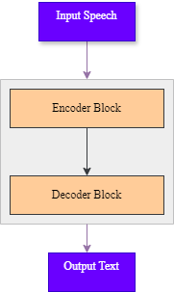
Figure 1 End-to-end Speech Recognition

Model used in End-To-End Speech Recognition

Convolutional Neural Networks (CNN)
CNN is a kind of neural network that works especially well for processing speech and picture input convolutional pooling and fully connected layers are some of the layers that make up the CNN architecture. The speech signal which is a continuous waveform is the input for speech recognition. The short-time Fourier transform (STFT) method is used to convert the waveform into a spectrogram. The CNN architecture is then used to extract and classify features from the spectrogram. The central part of the CNN design is the convolutional layer which extracts local information from the input signal by performing a convolution operation. A feature map is created by each convolutional layer’s numerous filters sliding across the input signal. By lowering the feature maps dimensionality, the pooling layer aids in avoiding overfitting. All of the neurons from the preceding layer are connected to the output layer which generates the final output by the fully connected layer. A CNNs design is made up of multiple filter layers applied to an input signal. Every filter creates a matching output signal after extracting a certain feature from the input signal. Higher level features are then extracted from the output signals by passing them through an additional layer of filters. The output is then processed through a fully connected layer to create the final output when this procedure is completed and the highest-level features have been removed and input signal for end-to-end speech recognition is a voice waveform, which is usually preprocessed to create a spectrogram. After that the spectrogram is fed into the CNN which hierarchically extracts characteristics from the input signal After passing through a decoder the CNN's output is mapped to a transcript [17].

Recurrent Neural Network (RNN)
A recurrent neural network is a kind of network that uses a series of prior or subsequent states to predict a future element this can be viewed as a type of memory that considers context rather than the input signals current state and an expertly trained recurrent neural network may forecast the subsequent transcripts in a phrase or a sentences continuation with certain number of layers with recurrent neural network cells make up these recurrent neural networks [37]. DNNs have the disadvantage of requiring a fixed dimensionality vector and a corporation mapping of sequential data is not always possible in a general sense and architectures that are specialized in modeling the data per timestamp such as LSTM and RNNs have emerged [38]. All of the hidden layer’s outputs are fed back to the input layer in the RNN three-layer network topology. With the outputs of the hidden layer at any one time being impacted by a complicated combination of all previous inputs this kind of RNN operates as a dynamic system. This feature helps distinguish between different speech patterns by enabling it to efficiently capture the dynamic features of the incoming speech signal [39]. RNNs are very good at processing sequential data in end-to-end training of RNNs for sequence labeling tasks is made possible by methods such as Connectionist Temporal Classification even in situations where the input and output alignment is unknown [40]. By preserving an internal state or memory of previous inputs RNNs are a kind of neural network that can process sequential data. For jobs involving sequential data such language modeling translation and speech recognition this makes them especially helpful. RNNs fundamental concept is to use the previous steps output as the input for the current phase which enables the network to identify temporal dependencies in the data.

Related Work
In Table 1, review of the literature observed a number of aspects of speech recognition with an emphasis on both suggested end-to-end models and conventional speech recognition systems. The majority of the studies under review allocated with various kinds of language ASRs which usually use traditional pipelines to transcribe spoken language into text. Traditional ASRs do have some serious disadvantages though such as requiring a lot of human labor taking longer to process and having a higher chance of mistakes. Many of the problems with classic ASRs like alignment problems are intended to be addressed by our suggested paradigm. The end-to-end method increases overall efficiency by reducing time consumption and the need for additional human resources by allowing spoken words to be converted directly to text without the use of intermediary processes including Attention/CTC layer for decoding purpose not only CTC loss function. In the field of NLP this suggested approach exhibits a great deal of promise for raising the precision and effectiveness of speech recognition systems.
Table 1 Related Works
Citation | Author | Title | Objectives | Result | Research gaps
[37] | Mohamed Hashim Changramp adi1, A. Shahina, M. Badri Narayanan and A. Nayeemulla Khan (2022). | End-to-End Speech Recognition of Tamil Language. | We present a method to develop speech recognition model with minimal resources using Mozilla Deep Speech architecture. | 24.7% WER | They use public dataset rather than Tamil local dataset and they are not used Attention mechanism to train and test purpose.
[14] | Yohannes Ayana and Tesfa Tegegne (2024). | Large Scale Speech Recognition for Low Resource Language Amharic, an End-to-End Approach | To develop an end-to-end speech recognition model. | achieving a  WER of 2%. | They are not used encoder decoder with attention.
[38] | Abdinabi Mukhamadi yev, Ilyos Khujayarov, Oybek Djuraev and Jinsoo Cho (2022). | Automatic Speech Recognition Method Based on Deep Learning Approaches for Uzbek Language. | End-To-End Deep Neural Network Hidden Markov Model and a hybrid(CTC) attention. | Achieved a word error rate of 14.3% using CTC+ Attention. | They use only LSTM from RNN models what about other models to compare and contrast the result of WER.
[39] | Alsayad, bdelaziz, A. Abdelhamid, Islam Hegazy, and Zaki T. Fayed. (2021). | Arabic speech recognition using end‐toend deep learning. | Investigated end-to-end deep learning for discretized  Arabic ASR. | CNN-LSTM with attention reduces WER by 5.24% End-to-end achieve 5.66 CER and 28.48 WER. DNN achieves 33.72 WER. | They use onventional ASR not fully RNN for Endto-end Approaches.

Methodology

Proposed Approach
To develop an end-to-end speech recognition model for the Guragunga languages in case of cheha dialect first collect a speech and text corpus from various sources and then it is essential to review existing literature on automatic speech recognition to know the research gap and to give a solution for those problems. The next steps involve recording, segmenting, and aligning audio data with text transcriptions using software tools and custom code. Various data preprocessing techniques, including data cleaning, feature extraction, normalization, and labeling, should be applied, followed by converting the preprocessed audio data into waveform format. An end-to-end model must be designed and built to transcribe input audio signals directly into the corresponding target text which will then be trained using the prepared dataset. During this training process different Hyper-parameter should be experimented with learning Hyper-parameter such as learning rate, batch size, number of epochs and training/testing percentages should be evaluated. Finally, the best model for Cheha speech-to-text transcription will be selected, and results of the training must be documented.

Corpus Development
Chaha does not have a readily available text corpus. Besides, it has limited presence on the web, and has limited hardcopy books [11]. We have compiled a substantial collection of texts from Wolkite FM as well as the Old and New Testaments. These texts have been merged, followed by text cleaning processes that include correcting grammar and spelling errors, expanding abbreviations, removing foreign terms, transcribing numbers, and separating concatenated words. This process resulted in a text corpus comprising 15,000 sentences, which includes 178,830 tokens and 12,500-word types, and serves as the foundation for training, testing, and evaluation of models. Similarly, due to the absence of publicly available speech corpora for Chaha to facilitate speech recognition tasks, we created a speech corpus by selecting 15,000 phonetically balanced sentences from the text corpus. We recorded 15 hours of speech in an office environment using a smartphone recorder, involving 27 native speakers (16 male and 11 female) who read these sentences. Of this 15-hour corpus, 12 hours and 40 minutes (12,400 sentences) were gathered from the same 27 speakers, each reading 460 sentences. This portion is designated as the training dataset. To prevent overlap between the training and testing datasets regarding speakers and sentences, a separate corpus of 1 hour and 20 minutes (2,600 sentences) was recorded from 5 native speakers (5 male and 5 female), each reading 260 sentences. This testing dataset represents 20 percent of the total 15-hour corpus. However, in comparison to other speech corpora that consist of 20 hours or more of training data, our corpus is relatively small, which may delay the performance of the models due to insufficient training data.

Data collection and pre-processing
In this research data is collected from different source like bible text book and soon on after that I recorded each sentence from recorder the segmenting each audio parallel with sentence by using audacity tools. The first step to prepare speech corpus is selecting the source and scope of text, we use for preparing speech corpus. In this research, we prepare text corpus to include bibles, Fm radio and cultural information. This makes our speech recognizer inclusive and can be used for different purposes. The text corpus contains bibles, Fm radio and cultural information. After text corpus is prepared, the speakers read the text to prepare the speech corpus. The text corpus is prepared from chaha dialects. Text corpus is categorized based on the script content of words relating to these dialects. To record sound speech, we use smart phone recorder. The environment in which the speech is recorded in a semi open area with less noisy environment. Therefore, the recoded speech is not resistant from noise. The speakers are asked to read paragraph by paragraph; if they make mistakes while reading the text, they reread the paragraph again. In general, the recorded speech data is presented in table 2. In general, this speech data preparation phase for this research work is discussed in the following subsection.
Table 2 Source and size of the speech data collected for experiment
Training data |  |  |  |  |  |  |  | Testing data
ID | Age boundary |  | speech time duration |  |  | Total time  duration | Total  utterance | Male numbers | Female numbers
ID | Age boundary | Male | Female | Male | Female
1 | [13-20] | 5 | 5 | 3:01:55 | 2:00:35 | 5:02:30 | 3504 | 5 | 5
2 | [21-35] | 4 | 6 | 3:12:04 | 3:13:32 | 6:25:36 | 4042 | 5 | 5
3 | [36-50] | 3 | 4 | 2:33:14 | 1:30:11 | 4:03:25 | 4522 | 5 | 5
4 | Total speaker | 27 |  |  |  |  |  | 10
5 | Total time | 15:30:33s |  |  |  |  |  | 3:30:33s
6 | Total utterance | 12,068 |  |  |  |  |  | 3000

Speech Corpus Recording
To record sound speech, we use smart phone recorder. The environment in which the speech is recorded in a semi open area with less noisy environment. Therefore, the recoded speech is not resistant from noise. The speakers are asked to read paragraph by paragraph if they make mistakes while reading the text they reread the paragraph again and labeling parallel with transcription of text file.

Speech pre-processing
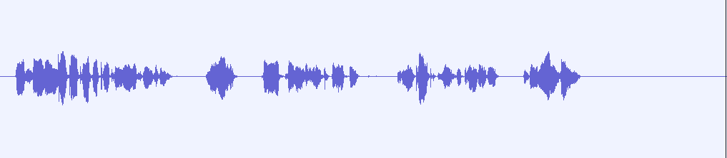
In speech recognition gathering and analyzing data is the first significant effort. Audio utterances and their transcriptions make up the speech corpus utilized for training. The initial step in the speech signal processing technique is pre-processing. This research discusses preprocessing in speech recognition in figure 2, which covers normalization, noise reduction and silence removal.
Figure 2 Original Audio

Silence Removal
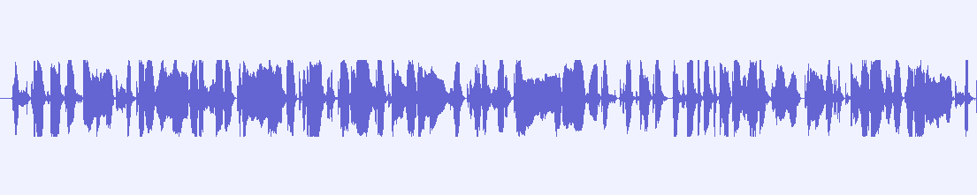
The technique of eliminating unvoiced or silent speech signals is known as silence removal. Different people take varying amounts of time between words when speaking. A distinctive trait that distinguishes one speaker from another is crucial to the speaker recognition process. Silence is not necessary for recognition because it is a characteristic shared by all speakers [62]. Therefore, the speech signals should no longer include silence. Because understanding where speech and silence or unvoiced words belong not only helps the speech processing system handle information more efficiently but it also improves its accuracy. Software called an audio silence trimmer is used to eliminate the quiet at the start middle and finish of voice signals. The software was chosen due to its ease of use and free nature. In this case the duration is shortened by eliminating the silence. As shown in Figure 3, each speech signal wav file was kept to a minimum in duration, ranging from 10 to 15 seconds, based on the length of the silence. Using an online audio trimmer 10 seconds of speech have been cut from each speaker's voice signals to make them all the same length.
Figure 3 After silence removal

Noise Reduction
Every speech has background noise since the speech signals are obtained from many environments and are public utterances. To obtain the speakers precise unique traits these background noises should be eliminated. As shown in Figure 4, noise reduction and normalization come next once the speech signals silence has been eliminated [62].
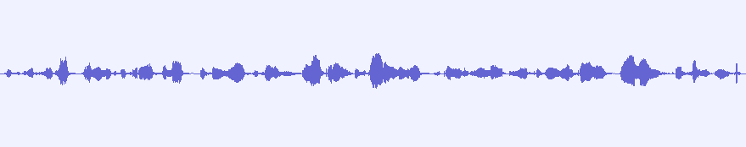
Figure 4 After Noise reduction

Noise Normalization
Applying a fixed amount of gain to an audio recording in order to raise the amplitude to a desired level (the norm) is known as normalization. because the voice signal's volume is reduced during noise reduction. Normalization restores the volume to its pre-noise reduction level. As shown In Figure 5 , Software called Audacity is used to normalize and cut down on background noise in speech signals. Audacity was chosen since it is open source and among the top ten (3rd) audio editing programs [63].

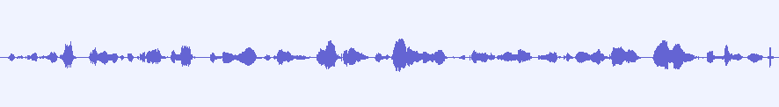
Segmented Speech Parallel with Text Transcription
Figure 5 After normalization
After recording and cleaning completed, we are going to segmenting each audio parallel with text transcription by using audacity software tool.
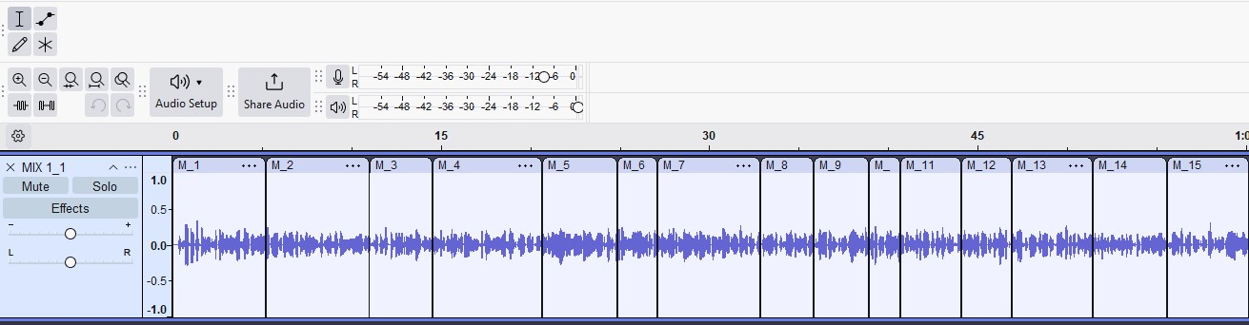
Speech data after segmentation export in to single folder by give file name with extension just like this
Figure 6 Audio segmentation techniques
"C:\Users\abdo\Desktop\1-600\segmented.wav\AbeM_00021.wav"
"C:\Users\abdo\Desktop\1-600\segmented.wav\BetF_00051.wav"
"C:\Users\abdo\Desktop\1-600\segmented.wav\DawM_00061.wav"
"C:\Users\abdo\Desktop\1-600\segmented.wav\DawM_00061.wav"

As shown in Figure 6, Every speech recording had a transcription made for it. This required paying close attention to the audio and turning it into text. The deep learning model can learn the connection between the audio attributes and the related text by using this text data as the ground truth. A transcription file is a written document that summarizes the speakers’ words from the audio recording. The audio file name is followed by the colon for each sentence in the transcript file. The matching transcription sentence appears after the filename.
Example:
NesF_00001.wav: "የፍጥረት መጣፍ አለም የትፈጠሮ ኸማ የሰብ ዘር የቸነ ኸማ"
NesF_00002.wav: "የባጢርም የጅጓረም ንብረት የቈነሺኸማም እግዘር ተሰብ ዘር ጋᎀ ያነን መራኽብ ዩድ"
NesF_00003.wav: "የፍጥረት መጣፍ በ𞟪ት ንቅ ንቅ መደር ይሸጅዬ ይኸር"
NesF_00004.wav: "ተመንሽ አት ቈነሽም አስራት ስን አለም የትፈጠሮ ኸማም የሰብ ዘር ይፍት ወረር ታሪክ ዩድ".
For this study 12,000 labelled cheha language sentences were used.

Dataset Pre-Processing
The analysis of audio length (in seconds) and frequency in the dataset reveals important insights into the characteristics of the audio samples. Each audio file's duration is measured in seconds, while its frequency content, analyzed through techniques like the Fourier Transform or spectrogram, indicates tonal qualities and pitch variations. By summarizing audio lengths alongside their average frequencies, we can observe trends, such as shorter clips typically having a limited frequency range compared to longer ones that may encompass a broader spectrum. visualizations like scatter plots and histograms can further illustrate these relationships, helping to inform feature extraction and model training for applications in speech recognition and music classification shown in Figure 7.

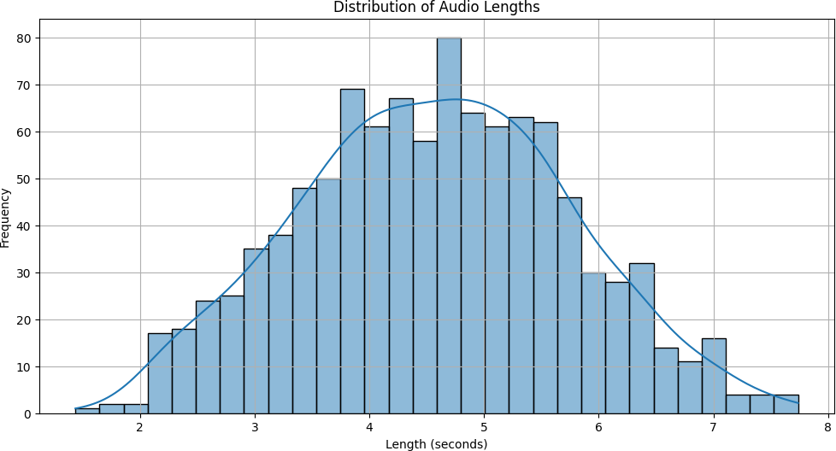
Figure 7 frequency distribution of Audio lengths

Feature Extraction
Speech was converted into log-Mel spectrograms using Short-Time Fourier Transform (STFT). Sequence padding ensured consistent input dimensions. A signal processing method called the Short-Time Fourier Transform (STFT) is used to examine a signal's frequency composition over time. STFT divides the signal into overlapping segments and calculates the Fourier transform for each segment, in contrast to the conventional Fourier transform, which analyzes the full signal at once. A spectrogram, a time-frequency representation that shows how the signal's frequency content changes over time, is the end product of this procedures is crucial in end-to-end speech recognition as it transforms audio signals into spectrograms, which serve as inputs for neural networks. These networks excel at processing numerical data, and spectrograms provide a compact and informative representation of an audio signal's frequency content. By applying STFT, we can extract important features relevant to speech recognition, such as formants and pitch. These features can then be utilized to train neural networks for speech recognition, either through direct mapping from spectrogram to text or via more complex architectures incorporating additional layers, such as convolutional or recurrent layers. In summary, STFT is a vital tool for converting audio signals into spectrograms, facilitating their use as inputs for neural networks in speech recognition tasks. It enables the extraction of pertinent features from audio signals and offers a concise representation that can be efficiently processed by neural networks.

Model Architecture
The general entity framework of the cheha speech recognition model that I proposed from starting from data collection, preprocessing, segmenting, labeling and also train and testing phase are illustrated in Figure 8.
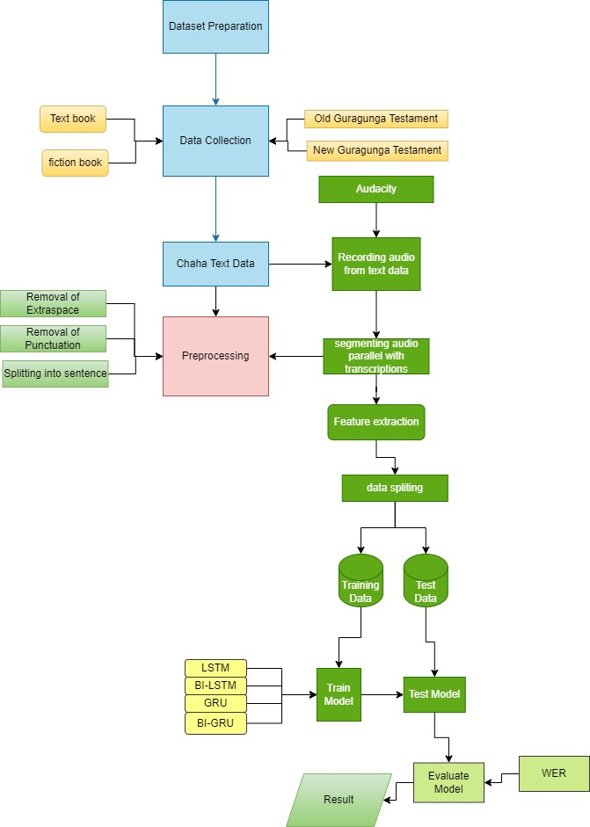
Figure 8 Proposed Architecture of Chaha Speech Recognition

Results and Discussion

Hyper-parameter Selection
In Table 3, we explored various Hyper-parameter across different model types, including LSTM, BILSTM, GRU, BIGRU with Attention models. The batch sizes chosen for the models varied between 32 and 64, allowing us to assess their impact on training efficiency and performance, while each model utilized a hidden dimension of 256 for consistent comparison. We experimented with learning rates of 0.01 and 0.001 for LSTM, BILSTM, and GRU models, with the BIGRU and CTC/Attention models including an additional option of 0.1. All models employed the Adam optimizer known for its effectiveness in training deep learning models.
Table 3 Hyper-parameters
No | Hyper-parameter | Model
No | Hyper-parameter | LSTM | BILSTM | GRU | BIGRU
1 | Batch size | 64, 32 | 64, 32 | 32, 64 | 32, 64
2 | Hidden units | 1024 | 1024 | 1024 | 1024
3 | Learning rate | 0.01,0.001 | 0.01,0.01 | 0.001,0.01 | 0.01,0.01
4 | Optimization | Adam optimizer | Adam optimizer | Adam optimizer | Adam optimizer
5 | Epoch | 50,100 | 50,100 | 50,100 | 50,100
6 | Drop rate | 0.4,0.5 | 0.4,0.5 | 0.4,0.5 | 0.4,0.5

RESULT
In this study, the process of speech recognition begins with extracting spectrogram features from raw audio. These spectrogram features are then fed into a Convolutional Neural Network (CNN) to extract high-level features, which are essential for building the acoustic model. To optimize the model's performance, several experiments were conducted by varying Hyper-parameter such as batch size, learning rate, and the number of epochs. The CNN used a filter size of 41 and a kernel size of 11, with 1024 hidden units to enhance feature extraction. We utilized Google Colab, a cloud-based platform that enables users to write and execute Python code directly in their browsers, for all training, testing, and evaluation tasks. This environment is particularly useful for data analysis and machine learning.
The focus of our research was on end-to-end speech recognition using a Connectionist Temporal Classification (CTC) and attention mechanisms in conjunction with various Recurrent Neural Network (RNN) algorithms, including LSTM, Bilstm, GRU, and BIGRU. Each model's performance was evaluated based on different hyper parameter configurations to assess their effectiveness in sequence modeling tasks. This comprehensive approach allowed us to identify the most effective configurations for speech recognition in the Cheha dialect. In Table 4, summarizes the experimental results for each RNN model, detailing various hyper parameter configurations and their corresponding accuracy and loss metrics.
Table 4 Experimental result of each RNN model
Model Type | Hidden unit | Optimizer | Epoch | Drop rate | Learning rate | Batch size | Accuracy | loss
LSTM | 1024 | Adam | 50 | 0.4 | 0.01 | 32 | 90.99 | 0.81
 |  |  |  |  |  | 64 | 92.84 | 0.75
 |  |  |  |  | 0.001 | 32 | 89.35 | 0.19
 |  |  |  |  |  | 64 | 95.29 | 0.36
 |  |  |  | 0.5 | 0.01 | 32 | 90.19 | 0.856
 |  |  |  |  |  | 64 | 94.02 | 0.57
 |  |  |  |  | 0.001 | 32 | 95.45 | 0.65
 |  |  |  |  |  | 64 | 95.99 | 0.415
BILSTM | 1024 | Adam | 50 | 0.4 | 0.01 | 32 | 92.87 | 0.88
 |  |  |  |  |  | 64 | 93.54 | 0.26
 |  |  |  |  | 0.001 | 32 | 95.35 | 0.49
 |  |  |  |  |  | 64 | 95.29 | 0.376
 |  |  |  | 0.5 | 0.01 | 32 | 90.19 | 0.95
 |  |  |  |  |  | 64 | 94.52 | 0.62
 |  |  |  |  | 0.001 | 32 | 95.45 | 0.365
 |  |  |  |  |  | 64 | 96.92 | 0.328
GRU | 1024 | Adam | 50 | 0.4 | 0.01 | 32 | 95.99 | 0.823
 |  |  |  |  |  | 64 | 94.84 | 0.75
 |  |  |  |  | 0.001 | 32 | 96.25 | 0.375
 |  |  |  |  |  | 64 | 95.29 | 0.36
 |  |  |  | 0.5 | 0.01 | 32 | 93.19 | 0.856
 |  |  |  |  |  | 64 | 94.02 | 0.57
 |  |  |  |  | 0.001 | 32 | 96.05 | 0.65
 |  |  |  |  |  | 64 | 95.22 | 0.27
BIGRU | 1024 | Adam | 50 | 0.4 | 0.01 | 32 | 91539 | 0.83
 |  |  |  |  |  | 64 | 91.62 | 0327
 |  |  |  |  | 0.001 | 32 | 92.39 | 0.49
 |  |  |  |  |  | 64 | 95.29 | 0.523
 |  |  |  | 0.5 | 0.01 | 32 | 90.19 | 0.726
 |  |  |  |  |  | 64 | 94.12 | 0.617
 |  |  |  |  | 0.001 | 32 | 96.35 | 0.525
 |  |  |  |  |  | 64 | 97.50 | 0.251

Experiment in LSTM Model
In our first experiment, we selected Long Short-Term Memory (LSTM) as our model type, utilizing 1024 hidden units and the Adam optimizer. The training process was divided into two sets of epochs: 50 and 100. For the 50 epochs, we set the drop rate to 0.4 and experimented with learning rates of 0.01 and 0.001, using batch sizes of 32 and 64 for each learning rate. Implementing a CNN-LSTM model with a CTC/Attention architecture was essential for our analysis. This model incorporated LSTM cells on the encoder side and utilized label encoders, ensuring a comprehensive approach. Consistent parameters were applied across all deep learning models. The results for the LSTM model showed that various configurations were tested to optimize performance. Across the experiments, a lower learning rate of 0.001 consistently led to better accuracy, particularly when combined with a larger batch size of 64. The drop rate also influenced performance, with a value of 0.5 generally yielding more favorable results. Ultimately, the highest accuracy achieved was 95.99, indicating that this combination effectively balanced learning and overfitting prevention. In Figure 9, the findings suggest that careful tuning of the learning rate, drop rate, and batch size can significantly enhance model performance, with the optimal configuration demonstrating strong accuracy and reasonable training loss.
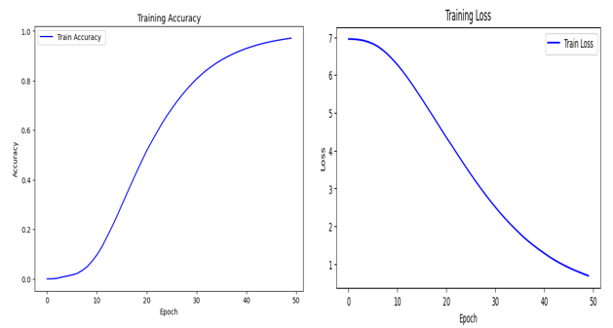
Figure 9 CNN- LSTM model Accuracy and Loss Graph

Experiment in BILSTM Model
In our second experiment, we implemented a Bidirectional Long Short-Term Memory (BiLSTM) model, which leverages two LSTM cells on the encoder side, allowing for enhanced context understanding but requiring more memory than standard LSTM models. Configured with 1024 hidden units and the Adam optimizer, the model was trained over 50 epochs, maintaining consistent parameters from our previous LSTM experiment. This model train in a remarkable accuracy of 96.92%, showcasing the superior performance of the BiLSTM architecture in capturing complex patterns in the data. As shown in Figure 10, This high accuracy underscores the effectiveness of our parameter tuning and the potential of BiLSTM models for tasks requiring sequential data analysis.
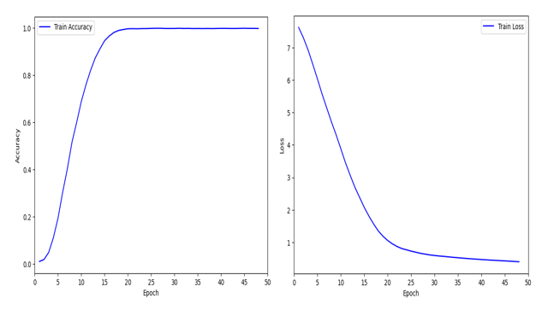
Figure 10 CNN-BILSTM model Accuracy and Loss Graph

Experiment in GRU Model
In this phase, we implemented the Gated Recurrent Unit (GRU) model, configured with 1024 hidden units and the Adam optimizer, training for 50 epochs. The model's performance was influenced by various Hyper-parameter , including the drop rate, learning rate, and batch size. We tested drop rates of 0.4 and 0.5, alongside learning rates of 0.01 and 0.001. As shown in Figure 11, Our analysis revealed that the highest accuracy achieved was 96.25% with a batch size of 32 at a learning rate of 0.001, highlighting the model's effective learning capacity and the significance of careful hyper parameter tuning.
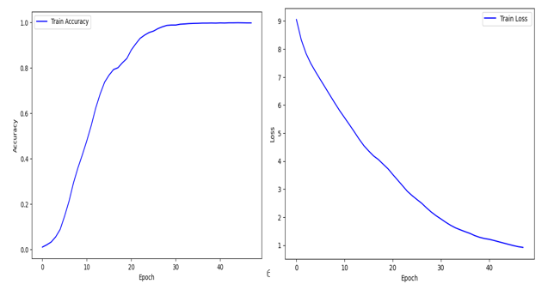
Figure 11 CNN-GRU model Accuracy and Loss Graph

Experiment in BIGRU Model
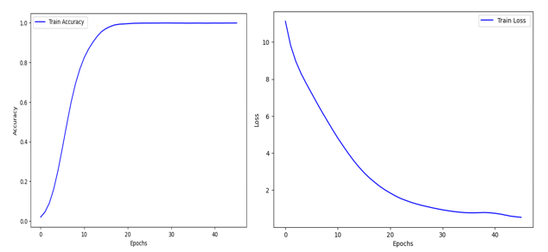
In our fourth experiment, we implemented the CNN-BiGRU model, which features double GRU cells on the encoder side, utilizing significantly more memory than a standard GRU. We retained the same parameters used in our previous GRU experiment to ensure consistency. This approach yielded remarkable results, achieving an accuracy of 97.50%. Specifically, this accuracy was attained with the following parameters: 1024 hidden units, Adam optimizer, 50 epochs, a drop rate of 0.5, a learning rate of 0.001, and a batch size of 64. As shown in Figure 12, These findings highlight the effectiveness of the CNN-BiGRU architecture in capturing complex patterns within the data.
Figure 12 . CNN-BIGRU model Accuracy and Loss Graph

Word Error Rate (WER
Word Error Rate (WER) is a key metric for evaluating the performance of RNN model in speech recognition measuring the accuracy of transcribed text by calculating the ratio of errors insertions, deletions, and substitutions compared to the total number of words in the actual transcription so that in our low resource language cheha dialect the WER rate in graph Bigru model is better for cheha speech recognition purpose for transcribing speech in to text. A WER of 0.05 is generally considered to be a good result in the field of speech recognition. It suggests that the system is capable of accurately transcribing spoken words with a high degree of accuracy, even in the presence of background noise or other audio disturbances. As shown in Figure 13, speech recognition technology continues to evolve, it is likely that WERs will continue to decrease, leading to even more accurate transcription of spoken language.
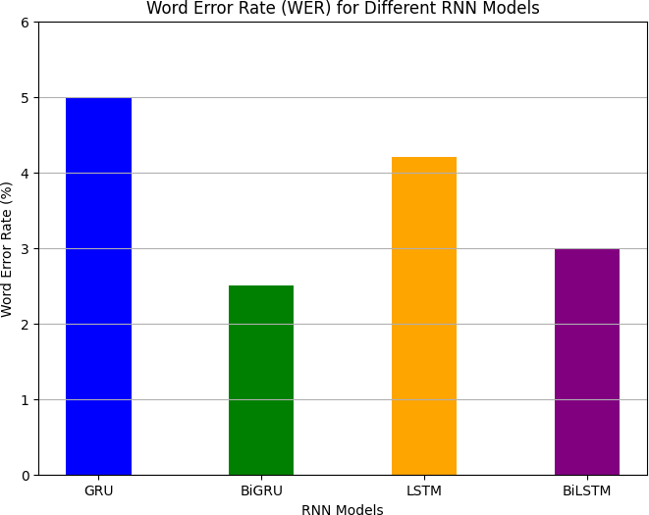
Figure 13 Word error rate comparison

Discussion of the Result
In our experiments, we evaluated four types of recurrent neural network models: LSTM, Bilstm, GRU, and Bigru, each configured with 1024 hidden units and the Adam optimizer over 50 epochs. The models were tested across various Hyper-parameter , including drop rates, learning rates, and batch sizes. The LSTM model achieved a maximum accuracy of 95.99% with a batch size of 32 at a learning rate of 0.001 and a drop rate of 0.5. The Bilstm model demonstrated strong performance, reaching an accuracy of 96.92% with a batch size of 64 at a learning rate of 0.001 and a drop rate of 0.5, indicating its effectiveness in capturing complex data patterns. The GRU model also performed well, achieving its highest accuracy of 96.25% with a batch size of 32 at a learning rate of 0.001 and a drop rate of 0.4. Finally, the Bigru model outperformed the others, achieving an impressive accuracy of 97.50% with a batch size of 64 at a learning rate of 0.001 and a drop rate of 0.5. These results underscore the varying strengths of each model architecture, with the Bigru showing the best overall performance in this set of experiments. Our experiments highlight the outstanding performance of our end-to-end speech recognition model for the Guragunga language. The model performs exceptionally well in clean environments achieving low error rates but demonstrates reduced effectiveness in noisy conditions. In speech recognition modeling, the x- axis of a plot typically represents the number of training epochs, which indicates how many times the model sees the entire training dataset. The y-axis usually shows the loss a metric that evaluates the model’s ability to predict the correct output for a specific input. The loss function quantifies the discrepancy between the predicted output and the actual output in speech recognition tasks. Accurate transcription of spoken words is crucial for the effectiveness of speech recognition technology. One important metric for assessing accuracy is the Word Error Rate (WER) which measures the frequency of errors in the transcription of spoken words or character. A lower WER signifies higher accuracy. In our analysis we used WER to evaluate the accuracy of our transcriptions against the ground truth. Our result indicate that our model has achieved an impressive transcription accuracy for Cheha speech with a WER of 2.5%. This marks a significant improvement over previous speech recognition systems for Guragunga which typically exhibited much higher error rates. The high accuracy of our model is particularly significant as it effectively tackles one of the main challenges in developing reliable speech recognition systems.

Discussion
In our experiments, we evaluated four types of recurrent neural network models: LSTM, Bilstm, GRU, and Bigru, each configured with 1024 hidden units and the Adam optimizer over 50 epochs. The models were tested across various Hyper-parameter , including drop rates, learning rates, and batch sizes. The LSTM model achieved a maximum accuracy of 95.99% with a batch size of 32 at a learning rate of 0.001 and a drop rate of 0.5. The Bilstm model demonstrated strong performance, reaching an accuracy of 96.92% with a batch size of 64 at a learning rate of 0.001 and a drop rate of 0.5, indicating its effectiveness in capturing complex data patterns. The GRU model also performed well, achieving its highest accuracy of 96.25% with a batch size of 32 at a learning rate of 0.001 and a drop rate of 0.4. Finally, the Bigru model outperformed the others, achieving an impressive accuracy of 97.50% with a batch size of 64 at a learning rate of 0.001 and a drop rate of 0.5. These results underscore the varying strengths of each model architecture, with the Bigru showing the best overall performance in this set of experiments. Our experiments highlight the outstanding performance of our end-to-end speech recognition model for the Guragunga language. The model performs exceptionally well in clean environments achieving low error rates but demonstrates reduced effectiveness in noisy conditions. In speech recognition modeling, the x- axis of a plot typically represents the number of training epochs, which indicates how many times the model sees the entire training dataset. The y-axis usually shows the loss a metric that evaluates the model’s ability to predict the correct output for a specific input. The loss function quantifies the discrepancy between the predicted output and the actual output in speech recognition tasks. Accurate transcription of spoken words is crucial for the effectiveness of speech recognition technology. One important metric for assessing accuracy is the Word Error Rate (WER) which measures the frequency of errors in the transcription of spoken words or character. A lower WER signifies higher accuracy. In our analysis we used WER to evaluate the accuracy of our transcriptions against the ground truth. Our result indicate that our model has achieved an impressive transcription accuracy for Cheha speech with a WER of 2.5%. This marks a significant improvement over previous speech recognition systems for Guragunga which typically exhibited much higher error rates. The high accuracy of our model is particularly significant as it effectively tackles one of the main challenges in developing reliable speech recognition systems.

5. Conclusion
We developed the first end-to-end CNN-BiGRU ASR model for the Cheha dialect of Guragigna, achieving a WER of 8.5%. This demonstrates the feasibility of building robust ASR systems for low-resource Ethiopian languages using deep learning. Future work will expand dataset size, include spontaneous and dialectal variations, and explore Transformer-based architectures. In this study, we developed an end-to-end speech recognition model for the low-resource Guragunga language by combining CNN and RNN architectures with CTC/Attention mechanisms. For the Chaha dialect, we achieved a word error rate of 8.5%. However, due to Chaha being a purely spoken language without a rigid grammatical structure, developing a language model presented challenges. Overall, the research successfully achieved its objective of creating an efficient speech recognition system for the Guragunga language, especially the Chaha dialect, thus advancing the field and improving communication technologies for diverse linguistic communities.

6. REFERENCE
- Ambuj Mehrish, NAVONIL Majumder, and Rishabh Bhardwaj, Rada Mihalcea, Soujanya Poria, “A Review of Deep Learning Techniques for Speech Processing,” May 30, 2023. doi: 10.48550/arXiv.2305.00359.
- Richard P. Lippmann, “Review of Neural Networks for Speech Recognition,” pp. 1–38, 1989.
- JANE ORUH, SERESTINA VIRIRI, (Senior Member, IEEE), AND ADEKANMI
ADEGUN, “Long Short-Term Memory Recurrent Neural Network for Automatic Speech Recognition,” IEEE Access, vol. 10, pp. 30069–30079, 2022, doi: 10.1109/ACCESS.2022.3159339.
- Praphulla A. Sawakare, Ratndeep R. Deshmukh, Pukhraj P. Shrishrimal, “Speech Recognition Techniques: A Review,” vol. 6, no. 8, Art. no. 8, 2015.
- Ashok Kumar, Vikas Mittal, “Speech Recognition: A Complete Perspective,” vol. 7, no. 6, Art. no. 6, Apr. 2019, doi: F90340476C19.
- Zhang Leini, Sun Xiaolei, “Study on Speech Recognition Method of Artificial Intelligence Deep Learning,” 2021. doi: doi:10.1088/1742-6596/1754/1/012183.
- V. A. Kherdekar and S. A. Naik, “Speech Recognition System Approaches, Techniques and Tools for Mathematical Expressions A Review,” vol. 8, no. 08, Art. no. 08, 2019.
- Chenfeng Miao, Kun Zou, Ziyang Zhuang, Tao Wei, Jun Ma, Shaojun Wang, Jing Xiao, “Towards Efficiently Learning Monotonic Alignments for Attention-Based End-to-End Speech Recognition,” pp. 1051–1055, 2022.
- Da-Hee Yang, Joon-Hyuk Chang, “Attention-based latent features for jointly trained end-to- end automatic speech recognition with modified speech enhancement,” pp. 202–210, 2023, doi: https://doi.org/10.1016/j.jksuci.2023.02.007.
- Andrew Rosenberg, Kartik Audhkhasi, Abhinav Sethy, Bhuvana Ramabhadran, Michael Picheny, “END-TO-END SPEECH RECOGNITION AND KEYWORD SEARCH ON
LOW-RESOURCE LANGUAGES.” [Online]. Available: https://github.com/rizar/attention- lvcsr
- T. G. Fantaye, J. Yu, and T. T. Hailu, “Syllable-based Speech Recognition for a Very Low- Resource Language, Chaha,” in Proceedings of the 2019 2nd International Conference on Algorithms, Computing and Artificial Intelligence, Sanya China: ACM, Dec. 2019, pp. 415–
420. doi: 10.1145/3377713.3377794.

- T. G. Fantaye, J. Yu, and T. T. Hailu, “Investigation of Automatic Speech Recognition Systems via the Multilingual Deep Neural Network Modeling Methods for a Very Low- Resource Language, Chaha,” J. Signal Inf. Process., vol. 11, no. 01, Art. no. 01, 2020, doi: 10.4236/jsip.2020.111001.
- Fitsum Gizachew Deriba, “DEVELOPING PART OF SPEECH TAGGER FOR GURAGIGNA LANGUAGE,” BAHIR DAR UNIVERSITY BAHIR DAR INSTITUTE OF
TECHNOLOGY, 2023. [Online]. Available: http://hdl.handle.net/123456789/10761
- Jan Chorowski,Dzmitry Bahdanau, Yoshua Bengio, “End-to-end Continuous Speech Recognition using Attention-based Recurrent NN: First Results.” Dec. 2014.
- Rohit Prabhavalkar , Member, IEEE, Takaaki Hori , Senior Member, IEEE, Tara N. Sainath , Fellow, IEEE, and Ralf Schlüter , Senior Member, IEEE, and Shinji Watanabe , Fellow, IEEE, “End-to-End_Speech_Recognition_A_Survey.pdf,” vol. VOL. 32, 2024.
- Takaaki Hori, Jaejin Cho, Shinji Watanabe, “END-TO-END SPEECH RECOGNITION WITH WORD-BASED RNN LANGUAGE MODELS,” arXiv:1808.02608v1 [cs.CL] 8 Aug 2018, Aug. 2018.
- Yohannes Ayana Ejigu and Tesfa Tegegne Asfaw, “Large Scale Speech Recognition for Low Resource Language Amharic, An End-to-End Approach,” 2024. doi: 10.20944/preprints202402. 0813.v1.
- Suyoun Kim, Takaaki Hori, and Shinji Watanabe, “JOINT CTC-ATTENTION BASED END- TO-END SPEECH RECOGNITION USING MULTI-TASK LEARNING,” pp. 4835–4839, 2017.
- J. Levis and R. Suvorov, “Automatic Speech Recognition,” in The Encyclopedia of Applied Linguistics, 1st ed., C. A. Chapelle, Ed., Wiley, 2012. doi: 10.1002/9781405198431.wbeal0066.
- K. S and C. E, “A Review on Automatic Speech Recognition Architecture and Approaches,” Int. J. Signal Process. Image Process. Pattern Recognit., vol. 9, no. 4, Art. no. 4, Apr. 2016, doi: 10.14257/ijsip.2016.9.4.34.
- T. G. Tohye, “Towards Improving the Performance of Spontaneous Amharic Speech Recognition,” Oct. 2015.
- T. A. Altaye, “Designing automatic speech recognition for Ge’ez language,” Mar. 2020, [Online]. Available: http://hdl.handle.net/123456789/10545

- Mamyrbayev Orken, Oralbekova Dina, Alimhan Keylan, Turdalykyzy Tolganay & Othman Mohamed, “A study of transformer‑based end‑to‑end speech recognition system for Kazakh language,” 2022. [Online]. Available: https://doi.org/10.1038/s41598-022-12260-y
- Zillay Huma, Areej Mustafa, “Graph-Based and End-to-End Model Integration for Low- Resource.pdf,” vol. Vol 4, 2024, [Online]. Available: https://universe- publisher.com/index.php/jcit
- Song Wang and Guanyu Li, “Overview of end-to-end speech recognition,” in Journal of Physics: Conference Series, 2019. doi: doi:10.1088/1742-6596/1187/5/052068.
- P. Wang, “Research and Design of Smart Home Speech Recognition System Based on Deep Learning,” in 2020 International Conference on Computer Vision, Image and Deep Learning (CVIDL), Chongqing, China: IEEE, Jul. 2020, pp. 218–221. doi: 10.1109/CVIDL51233.2020.00-98.
- Yerlan Karabaliyev, Kateryna Kolesnikova, Nurkhan Batyrkhan, “Review of methods of end- to-end automatic recognition of Kazakh speech,” 2024, pp. 615–620. [Online]. Available: www.sciencedirect.com
- Sendong Liang, Wei Qi Yan, “Multilingual Speech Recognition Based on The End-to-End Framework”.
- Vimala.C, “A_Review_on_Speech_Recognition_Challenge.pdf,” vol. 2, pp. 1–7, 2012.
- Yadeta Gonfa Gutu and M. Yifiru, “A Large Vocabulary, Speaker-Independent, Continuous Speech Recognition System for Afaan Oromo: Using Broadcast News Speech,” 2022, doi: 10.13140/RG.2.2.26635.98089.
- “Kherdekar and Naik - 2019 - Speech Recognition System Approaches, Techniques A.pdf.”
- A. D. Fantahun, “Syllable based speaker independent continuous speech recognition for Afan oromo”, [Online]. Available: http://hdl.handle.net/123456789/10343
- S.Karpagavalli, R.Deepika, P.Kokila, K.Usha Rani, “Automatic Speech Recognition: Architecture, Methodologies and Challenges - A Review,” Int. J. Adv. Res. Comput. Sci., vol. 2, No. 6, Dec. 2011.
- T. Zeng, “Deep Learning in Automatic Speech Recognition (ASR): A Review,” in Proceedings of the 2022 7th International Conference on Modern Management and Education Technology (MMET 2022), C. F. Peng, H. S. Du, T. S. Yin, J. Prabhu, and H. Li, Eds., Paris: Atlantis Press SARL, 2023, pp. 173–179. doi: 10.2991/978-2-494069-51-0_23.

- A. Loubser, “END-TO-END AUTOMATED SPEECH RECOGNITION USING A CHARACTER BASED SMALL SCALE TRANSFORMER ARCHITECTURE”.
- Hamza Kheddara, Mustapha Hemisb and Yassine Himeurc, “Automatic Speech Recognition using Advanced Deep Learning Approaches: A survey,” Apr. 2024.
- Johan Hagner, “Recurrent Neural Networks for End-to-End Speech Recognition,” p. 37, Jan. 2018.
- E. Morris, “Automatic Speech Recognition for Low-Resource and Morphologically Complex Languages”.
- Sin-Horng Chen, Yuan-Fu Liao, Song-Mao Chiang, and Saga Chang, “An RNN-based preclassification method for fast continuous Mandarin speech recognition,” IEEE Trans. Speech Audio Process., vol. 6, no. 1, Art. no. 1, Jan. 1998, doi: 10.1109/89.650315.
- Alex Graves, Abdel-rahman Mohamed and Geoffrey Hinton, “Speech Recognition with Deep Recurrent Neural Networks”.
- H. K. Hamarashid, “Modified Long Short-Term memory and Utilizing in Building sequential model,” vol. Vol.9, May 2021, doi: DOI: 10.14741/ijmcr/v.9.3.2.
- Van Huy Nguyen, “An End-to-End model for Vietnamese speech recognition”.
- Farhad Mortezapour Shiria, Thinagaran Perumala, Norwati Mustaphaa, and Raihani Mohameda, “A Comprehensive Overview and Comparative Analysis on Deep Learning Models”.
- Gaofeng Cheng, Daniel Povey, Lu Huang, Ji Xu, Sanjeev Khudanpur, Yonghong Yan, “Output-Gate Projected Gated Recurrent Unit for Speech Recognition”.
- Sakib Ashraf Zargar, “Introduction to Sequence Learning Models: RNN, LSTM, GRU,” 2021. doi: DOI: 10.13140/RG.2.2.36370.99522.
- Manpreet Singh Bhatia, Alok Aggarwal, Narendra Kumar, “Speech-to-text conversion using GRU and one hot vector encodings.” Jan. 2021.
- Bharat Bhatta, Basanta Joshi, Ram Krishna, “Nepali Speech Recognition Using CNN, GRU and CTC.” Sep. 24, 2020.
- Burak TOMBALOGLU, Hamit ERDEM, “Turkish Speech Recognition Techniques and Applications of Recurrent Units (LSTM and GRU),” pp. 1035–1049, 2021, doi: DOI: 10.35378/gujs.816499.

- Markus Nussbaum-Thom, Jia Cui, Bhuvana Ramabhadran, Vaibhava Goel, “Acoustic Modeling using Bidirectional Gated Recurrent Convolutional Units,” pp. 8–12, 2016, doi: http://dx.doi.org/10.21437/Interspeech.2016-212.
- “End-to-end indonesian speech recognition with convolutional and gated recurrent units.”
- G. Degemu, “Developing Semantic Textual Similarity for Guragigna Language Using Deep Learning Approach,” Int. J. Adv. Sci. Comput. Appl., vol. 5, no. 1, Art. no. 1, Nov. 2024, doi: 10.47679/ijasca. v4i2.106.
- “Chaha_language.” [Online]. Available: https://en.wikipedia.org/wiki/Chaha_language
- “Hashim Changrampadi et al. - 2022 - End-to-End Speech Recognition of Tamil Language.pdf.”
- A. Gulati et al., “Conformer: Convolution-augmented Transformer for Speech Recognition,” May 16, 2020, arXiv: arXiv:2005.08100. doi: 10.48550/arXiv.2005.08100.
- Mohamed Hashim Changrampadi, A. Shahina, M. Badri Narayanan and A. Nayeemulla Khan, “End-to-End Speech Recognition of Tamil Language,” vol. vol.32, 2022, doi: DOI:10.32604/iasc.2022.022021.
- A. Mukhamadiyev, I. Khujayarov, O. Djuraev, and J. Cho, “Automatic Speech Recognition Method Based on Deep Learning Approaches for Uzbek Language,” Sensors, vol. 22, no. 10, Art. no. 10, May 2022, doi: 10.3390/s22103683.
- H. A. Alsayadi, A. A. Abdelhamid, I. Hegazy, and Z. T. Fayed, “Arabic speech recognition using end‐to‐end deep learning,” IET Signal Process., vol. 15, no. 8, Art. no. 8, Oct. 2021, doi: 10.1049/sil2.12057.
- N. K. Manaswi, Deep Learning with Applications Using Python. Berkeley, CA: Apress, 2018. doi: 10.1007/978-1-4842-3516-4.
- Brian McFee, Colin Raffel, Dawen Liang, Daniel P.W. Ellis, Matt McVicar, Eric Battenberg, Oriol Nieto, “librosa: Audio and Music Signal Analysis in Python,” presented at the Python in Science Conference, Austin, Texas, 2015, pp. 18–24. doi: 10.25080/Majora-7b98e3ed-003.
- M. Lamba and M. Madhusudhan, “Text Pre-Processing,” in Text Mining for Information Professionals, Cham: Springer International Publishing, 2022, pp. 79–103. doi: 10.1007/978- 3-030-85085-2_3.
- Shubham singh, “How to Get Started with NLP – 6 Unique Methods to Perform Tokenization.” Dec. 08, 2024. [Online]. Available:

https://www.analyticsvidhya.com/blog/2019/07/how-get-started-nlp-6-unique-ways- perform-tokenization/
- GIZACHEW BELAYNEH GEBRE, “Artificial Neural Network Based Amharic Language Speaker Recognition,” Turk. J. Comput. Math. Educ. TURCOMAT, vol. 12, no. 3, Art. no. 3, Apr. 2021, doi: 10.17762/turcomat. v12i3.2043.
- A Free, Open Source, Cross-Platform Audio Editor, “audacity.pdf.” [Online]. Available: http://audacity.sourceforge.net/onlinehelp-1.2/reference.html
- Ali Nasr-Esfahani, Mehdi Bekrani, Roozbeh Rajabi, “Robust Recognition of Persian Isolated Digits in Speech using Deep Neural Network,” Dec. 2024.
- Ahmad Al Harere, Khloud Al Jallad, “Quran Recitation Recognition using End-to-End Deep Learning.”
- M. Khairi Ishak, D. Ovind Madsen, and F. Ahmed Al-Zahrani, “An Optimal Method for Speech Recognition Based on Neural Network,” Intell. Autom. Soft Comput., vol. 36, no. 2, Art. no. 2, 2023, doi: 10.32604/iasc.2023.033971.
- Jinyu Li, “Recent Advances in End-to-End Automatic Speech Recognition.pdf.” 2022. [Online]. Available: (http:// creativecommons.org/ licenses/ by-nc/ 4.0/)
- C. Shan, J. Zhang, Y. Wang, and L. Xie, “Attention-Based End-to-End Speech Recognition on Voice Search,” in 2018 IEEE International Conference on Acoustics, Speech and Signal Processing (ICASSP), Calgary, AB: IEEE, Apr. 2018, pp. 4764–4768. doi: 10.1109/ICASSP.2018.8462492.
- Suyanto, Anditya Arifianto, Anis Sirwan, Angga P. Rizaendra, “End-to-End Speech Recognition Models for a Low-Resourced Indonesian Language,” in 2020 8th International Conference on Information and Communication Technology (ICoICT), Yogyakarta, Indonesia: IEEE, Jun. 2020, pp. 1–6. doi: 10.1109/ICoICT49345.2020.9166346.
- B. M. Hussein and S. M. Shareef, “An Empirical Study on the Correlation between Early Stopping Patience and Epochs in Deep Learning,” ITM Web Conf., vol. 64, p. 01003, 2024, doi: 10.1051/itmconf/20246401003.
- Jia-nan Chen, Shuang Gao, Han-zhe Sun, Xiao-hui Liu, Zi-ning Wang, Yan Zheng, “An End- to-end Speech Recognition Algorithm based on Attention Mechanism,” in 2020 39th Chinese Control Conference (CCC), Shenyang, China: IEEE, Jul. 2020, pp. 2935–2940. doi: 10.23919/CCC50068.2020.9189026.

