ASSESSMENT OF HOUSING ENVIRONMENT SUSTAINABILITY IN THE PERI-URBAN PRECINCTS OF IBADAN, NIGERIA

ABSTRACT
Rapid urbanization in Nigeria has resulted in cities expanding into the surrounding rural areas. This has led to the formation of peri-urban settlements characterized by rapid population growth, increasing housing demand and pressure on housing environment systems. Peri-urban areas are strategically important for accommodating urban growth but are often associated with weak development control, environmental degradation and unsustainable housing outcomes.
This study assessed the housing environment in the peri-urban areas of Ibadan, Nigeria, with a view to promoting urban sustainability. Specifically, the study identified the peri-urban areas and their characteristics, assessed the socio-economic characteristics of the residents, evaluated housing environment sustainability indicators and compliance with development control regulations, and evaluated housing environment sustainability.
The research design was mixed methods. Primary data were collected using structured questionnaires administered to residents in selected peri-urban communities in six Local Government Areas (Akinyele, Egbeda, Ido, Lagelu, Oluyole and Ona Ara). This was supplemented with field observations and stakeholder assessment. For data analysis, descriptive statistics, cross-tabulation, Chi-square test and Analysis of Variance (ANOVA) were used.
The findings revealed that the sustainability of housing environment in peri-urban areas of Ibadan is shaped by a complex interaction of physical, socio-economic, institutional and governance factors. The ANOVA results showed significant spatial differences in housing environment sustainability among the six Local Government Areas; reflecting uneven peri-urban development patterns.
The study revealed that inadequate infrastructure, ineffective development control implementation and environmental management challenges in the peri-urban settlements of Ibadan have been constraining sustainable urban outcomes. It recommends strengthening development control institutions, prioritizing investment in infrastructure for peri-urban communities, enhancing community participation in environmental management and raising public awareness of planning regulations. The study provides a framework for assessing housing environment sustainability in peri-urban areas, and defining empirical relationships between socio-economic characteristics, governance effectiveness, regulatory compliance and housing environment sustainability.
Keywords: Housing Environment, Peri-Urban Development, Urban Sustainability, Ibadan, Nigeria
INTRODUCTION
Housing is one of the basic needs for human life and has been widely recognized as a fundamental human right in international debates (Ersan, 2025; Lucherini, 2025). Housing is not merely shelter, but a complex system consisting of the physical structure, supporting services, and the larger environmental setting in which residential activities take place. Accordingly, the housing concept extends beyond the dwelling unit to include the housing environment, which comprises the physical (natural and built) and social conditions affecting the health, safety, and quality of life of residents (Schneider-Skalska, 2019; Hegde et al., 2024; Udoh & Essien, 2025).
In particular, urbanization has drastically changed housing development patterns around the world. The rapid growth of urban populations in many developing countries has exacerbated the demand for housing and the expansion of residential development beyond established urban boundaries into transitional zones known as peri-urban areas.
Peri-urban areas are typified by ongoing spatial change, mainly instigated by urban expansion and the pressure of population in city cores. As cities grow, the original urban boundary shifts slowly outwards, creating new peri-urban frontiers by incorporating spill-over residential development (Toku et al., 2024; Ayeni et al., 2025). These transitional zones are therefore important sites for urban growth and have important roles in the future structure of cities.
Thus, the housing environment created through such processes may exhibit various environmental and social deficiencies such as poor road networks, inadequate drainage systems, limited access to basic services and increased susceptibility to environmental hazards such as flooding and erosion (Echendu, 2023). These challenges demonstrate the need to evaluate housing environments beyond housing supply, but also in terms of their sustainability and long-term implications for urban development.
The assessment of housing environment is often undertaken based on sustainability indicators representing various dimensions of residential development such as building characteristics, infrastructure provision, environmental quality, social cohesion, and economic conditions (Poortinga et al., 2021). Such types of assessments have specific significance at the neighborhood level, which is the fundamental building block of urban systems (Rodríguez et al., 2022).
In this context, peri-urban housing environments need to be carefully assessed, as they are emerging urban neighbourhoods with development patterns that will have a strong impact on future urban sustainability. In this regard, investigating the elements that affect housing environments in such transitional zones is important to inform appropriate planning policies and sustainable urban development.
The study therefore assesses the peri-urban housing environment development patterns in Ibadan, Nigeria with a view to identifying the existing challenges and evaluating the sustainability outcome of the housing environment.
Research Problem Statement
Peri-urban areas are emerging as important sites of urban change but are often inadequately integrated into formal urban planning processes. Saxena and Vyas (2015) found that one of the biggest challenges for modern cities is the management of peri-urban transformation into sustainable urban environments. Likewise, Kingsella (2019) noted that housing development policies often do not sufficiently address the environmental consequences of residential expansion.
The peri-urban areas have become attractive for residential development due mainly to the availability of relatively cheap land in Nigeria. These areas often provide housing opportunities for low- and medium-income households outside congested urban centres (Adedire et al., 2017; Adu-Gyamfi et al., 2022). However, such changes are often informal, with little regard to planning regulations and development standards.
For Ibadan, the expansion of housing development into peri-urban areas has been accompanied by major planning and governance challenges. The implementation of existing development control policies seems to be weak, and the institutional capacity to monitor and regulate peri-urban development remains limited (Jimoh & Olagunju, 2022; Adeyemi et al., 2023). Besides, dearth of credible data on land use patterns, provision of infrastructure and demographic characteristics hinders effective planning and management of these areas.
Many studies have explored housing development, urban expansion, and informal settlements (Adaku, 2014; Igwe et al., 2017; Soyebo et al., 2017) but few have specifically examined the sustainability of housing environments in peri-urban areas, particularly in the Nigerian context.
This knowledge gap indicates the need for context-specific studies to investigate peri-urban housing environment dynamics and implications for sustainable urban development. The present study attempts to fill this gap by assessing patterns of development of housing environment in selected peri-urban neighbourhoods of Ibadan and assessing challenges affecting their sustainability.
Aim and Objectives of the Study
The study seeks to assess the challenges and sustainability of housing environment development in the peri-urban areas of Ibadan.
The specific objectives are to:
- Determine the peri-urban areas and their features in the study area.
- Evaluate the socio-economic characteristics of the inhabitants in these areas.
- To study stakeholders’ perception in implementation of development control policies.
- Evaluate the indicators of the sustainability of the housing environment and adherence to development rules.
- Identify the main problems of the housing environment in the study areas.
- Assess housing environment outcomes to re-evaluate environmental sustainability.
The Need for this Study
The patterns of development in peri-urban areas are very important for the sustainability of urban environments and these areas are the future expansion zones of the city. Poor coordination of urban development in Ibadan has been linked to a number of environmental problems such as flooding, erosion, inadequate infrastructure and poor residential environments.
The rapid growth of peri-urban areas makes the knowledge of the conditions of the housing environments of increasing importance for sustainable urban growth. Understanding these environments will help to identify the underlying causes of environmental challenges and inform policy interventions to improve development outcomes.
Scope of the Study
The study area is located in selected local government areas outside the Ibadan metropolitan core that have been identified as peri-urban zones (Adelekan et al., 2014). The study evaluates the conditions of the housing environment, the availability of infrastructure and sustainability indicators in these areas, in order to understand the development patterns and the challenges related to them, and their sustainability outcomes.
LITERATURE REVIEW
Global concerns about environmental sustainability, climate change and rapid urbanization have raised scholarly interest in the sustainability of human settlements. Housing environments are at the center of these discussions because they are the immediate spatial interface between human activities and the natural environment (Dossa et al., 2025).
But the increasing urban population growth has led to an unprecedented demand for housing, particularly in developing countries. This demand has led to cities expanding into the so-called peri-urban areas.
Peri-urban spaces are becoming critical sites where urban expansion, environmental change and housing development meet. But the rapid rate, and often-unregulated nature of development in these areas raises serious concerns about sustainability, the provision of infrastructure, environmental management and the effectiveness of governance. This study therefore reviews the relevant literature on peri-urbanization, housing environments, sustainability frameworks, socio-economic determinants of housing conditions and development control mechanisms. The aim is to place the current study within the existing literature and to identify areas that need further research.
Peri-Urbanization and Housing Development
Peri-urbanization refers to the spatial and socio-economic change that occurs at the interface between urban and rural areas. The main driver for peri-urban expansion is widely recognized as rapid urbanization. Urbanization is the process of increasing population concentration and growth into urban areas due to both natural increase and migration (Echendu, 2023). Urban growth and the associated development pressures tend to radiate outward into surrounding rural areas, creating transition zones with mixed land uses and dynamic social change (Wandl & Magoni, 2017; Salem et al., 2025).
Peri-urban areas often combine rural livelihood practices with urban economic activities (Haldar et al., 2024; Ayeni et al., 2025). These areas are often subject to rapid land conversion, especially from agricultural uses to residential development.
In peri-urban regions, land use generally revolves around the development of housing. Peri-urban settlements in many developing countries are home to low- and middle-income households looking for affordable land away from the expensive urban centers (Adedire et al., 2017; Adedire & Adegbile, 2018). Such development, however, often happens informally and incrementally with little planning oversight and inadequate provision of infrastructure (Soyebo, 2017).
Housing Standards and Environment
Housing environment refers to the physical and social conditions in which residential life happens. It comprises the dwelling unit, the surrounding infrastructure, neighbourhood facilities and environmental quality (Schneider-Skalska, 2019; Hegde et al., 2024; Udoh & Essien, 2025). A functional housing environment typically includes: adequate road networks, drainage systems, potable water supply, sanitation facilities, open spaces and access to community services such as schools and health centers. All these factors combined impact health, safety and quality of life.
Governments and international organizations have, therefore, developed housing standards to ensure that residential development meets minimum requirements of safety, habitability and environmental sustainability (DIN, 2021; Kim et al., 2023). Such standards are effected through development control instruments, zoning regulations and building codes.
Physical Terrain and Housing Environment
The physical terrain has a great influence on the performance of the housing environment. Landforms characteristics such as slope, elevation and drainage patterns affect land suitability for residential development (Li et al., 2022; Chiaka et al., 2024).
The topography influences various factors in housing development including building stability, infrastructure construction, stormwater management, and micro-climate conditions (Smith & Jones, 2021; Chen & Zhao, 2024; Gao et al., 2022). Neglecting terrain considerations in housing development can increase exposure to environmental hazards such as flooding, erosion and landslides.
The importance of terrain in determining settlement patterns is reflected in the physical landscape of Ibadan. The city is characterized by rolling hills and valleys formed by geological weathering processes (Oladunjoye et al., 2021). The land forms influence the patterns of drainage and the distribution of settlement in the metropolitan region (Areola, 2022).
Urbanization and Housing Problems
Urbanization process is one of the most important socio-economic transformations of the modern era. It provides opportunities for economic development and improved access to services but also has significant challenges of housing and environment (Peerzado et al., 2018; UN-Habitat, 2020).
The rapid increase of urban populations often results in housing shortages, overcrowding, lack of infrastructure and environmental deterioration (Rivas et al., 2023; Somorija, 2025). These challenges are particularly acutely felt in developing countries where urban planning systems are struggling to keep pace with population growth.
To address these challenges, governments have employed policy interventions, including housing regulations, development control policies, and environmental impact assessments (Odoyi & Riekkinen, 2022). These policy instruments aim to promote orderly urban development and sustainable housing environments.
Housing Environment Assessment and Sustainability
Sustainability has emerged as a core concept in urban planning and environmental management. It generally refers to the ability of systems to maintain ecological balance while supporting human development over time (Hamman, 2017; Topal et al., 2021).
The most common definition of sustainable development is that which emphasizes the need to meet the needs of the present without compromising the ability of future generations to meet their own needs (Moore et al., 2017; Hamann et al., 2018). Sustainable housing environments therefore need to balance environmental protection, economic viability and social well-being.
A number of sustainability assessment frameworks have been used to assess the environmental performance of housing environments. These include tools such as BREEAM, LEED, and SBTool that assess environmental indicators such as energy efficiency, water management, waste reduction, and environmental impact (Doan et al., 2017; Illankoon et al., 2017; Berardi, 2018).
More recent frameworks consider neighbourhood-level sustainability indicators like infrastructure provision, accessibility, community well-being, and environmental quality (Sharifi et al., 2021) instead of considering individual buildings only. An example is SUCCEED (Sustainable Composite Cities Environmental Evaluation and design Toolkit) Neighborhood Sustainability Assessment Tool (Momoh et al., 2024).
Gap in the Literature
Although a large amount of research has been conducted on urbanization, housing development and environmental sustainability, a number of voids is still apparent in the literature.
First, most studies have primarily concentrated on housing conditions in established urban centers, while relatively little attention has been given to the sustainability of housing environments in peri-urban areas. The peri-urban are rather, the key areas for city expansion in rapidly developing cities.
Second, existing research often focuses on housing quality or environmental conditions in isolation, failing to integrate physical terrain characteristics, socio-economic conditions, and governance mechanisms within a holistic sustainability analytical framework.
Third, existing studies on development control policies have a tendency to focus on regulatory compliance but rarely assess the influence of such governance structures on sustainability outcomes of housing environments in peri-urban contexts.
Finally, there is a dearth of empirical studies in the Nigerian context that have specifically investigated housing environment sustainability in the peri-urban areas of Ibadan. The rapid spatial expansion and complex terrain conditions of the city require comprehensive assessment frameworks capable of evaluating the sustainability of the housing environments of these emerging residential areas.
METHODOLOGY OF RESEARCH
The study employs a mixed method research design combining model-based, qualitative and survey research approaches. This combination of methods enables a comprehensive assessment of complex relations of spatial features, governance structures, socio-economic factors and housing environment sustainability.
The conceptual framework derived from the literature was applied to delineate peri-urban areas using the model-based approach. This approach guided the spatial identification of the study area and the sampling framework.
The qualitative methodology included structured interviews with officials of the State Urban Board and relevant Local Government authorities and focus group discussions with community stakeholders. Content analysis was used to analyze the qualitative data that emerged from these interactions.
The survey method involved administering questionnaires to selected respondents in neighbourhood communities in the study area. Quantitative data were analyzed through the use of descriptive and inferential statistics including frequencies, measures of central tendency, correlation analysis, regression analysis and Analysis of Variance (ANOVA).
The study unit of analysis is the neighbourhood community, a cluster of residential housing units with social and infrastructural facilities. Neighbourhood communities are widely accepted as the basic spatial units of urban settlements and thus are suitable for the assessment of the housing environment conditions.
Study Area
The study area is the peri-urban precincts of Ibadan in six Local Government Areas (LGAs) of Oyo State, Nigeria, namely Akinyele, Egbeda, Ido, Lagelu, Oluyole and Ona-Ara. Ibadan is the capital of Oyo State in southwestern Nigeria, some 119 km northeast of Lagos and about 120 km east of the Nigeria-Benin international border (Figure 1).
Geographically, the city is situated between latitude 7°03′ and 7°45′ North and longitude 3°30′ and 4°08′ East (Figure 2).
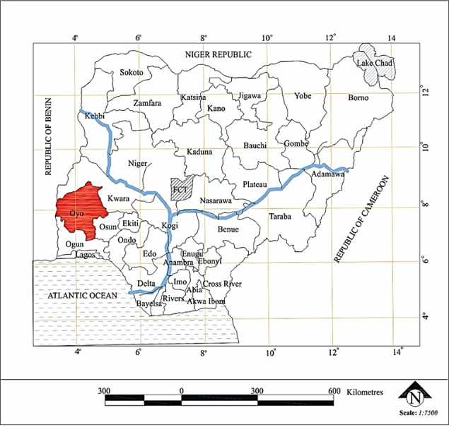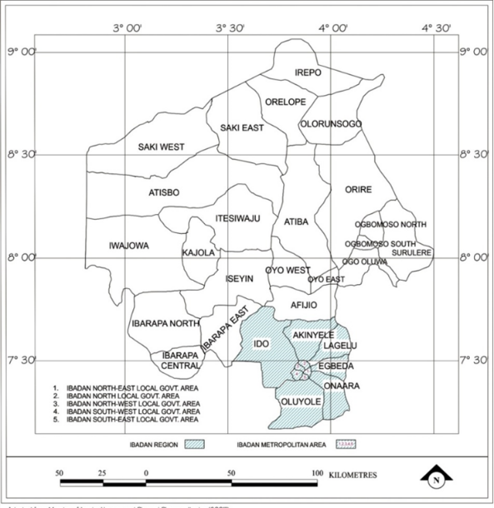

Figure 1: Oyo State in National Context
Source: Ministry of Lands, Housing and Physical
Planning, Ibadan (2007)
Figure 2: Present-Day Ibadan within Oyo State Context
Source: Adapted from Ministry of Lands, Housing and Physical Planning, Ibadan (2007
Sampling Frame, Sample Size and Sampling Method
The study employed a multi-stage sampling technique.
Stage 1: Selection of the Sampling Frame
The first step was to define the spatial extent of peri-urban areas based on conceptual models from previous studies. Jurgenson et al. (2017) and Karg et al. (2019) found that peri-urban zones generally lie between 10 km and 30 km from city centers, depending on the spatial growth patterns of cities (Figure 3).
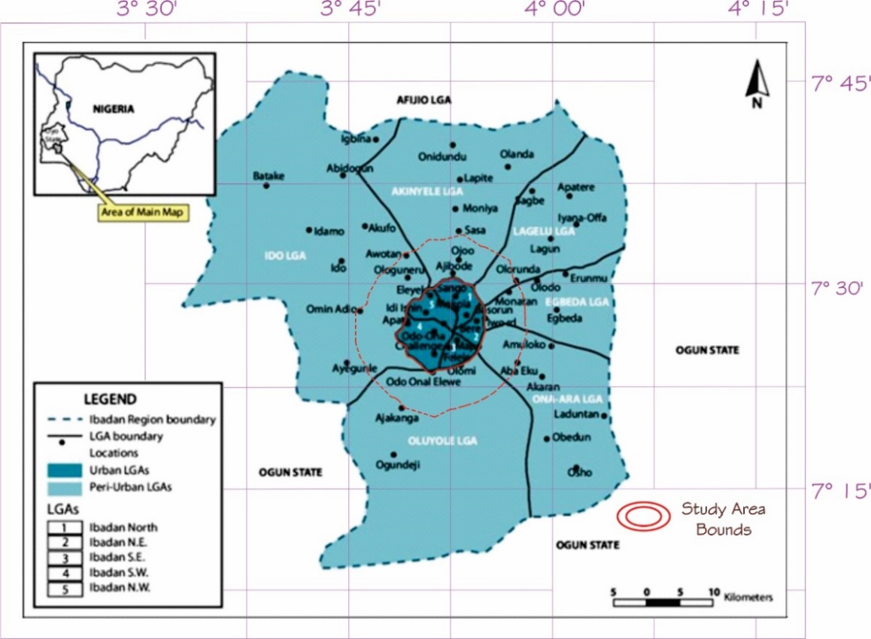
Figure 3: Map of Ibadan Region Showing the limits and bounds of the Study Areas
Source: Adapted from Adelekan et al.,2014.

On the basis of this conceptual framework the study defined the peri-urban study area within 10-15 km radius from the city center of Ibadan with Mapo Hall as reference point. The spatial boundaries of the study area were validated using satellite imagery and digital mapping tools (Google Satellite Imagery) (Figure 4 and Figure 5).
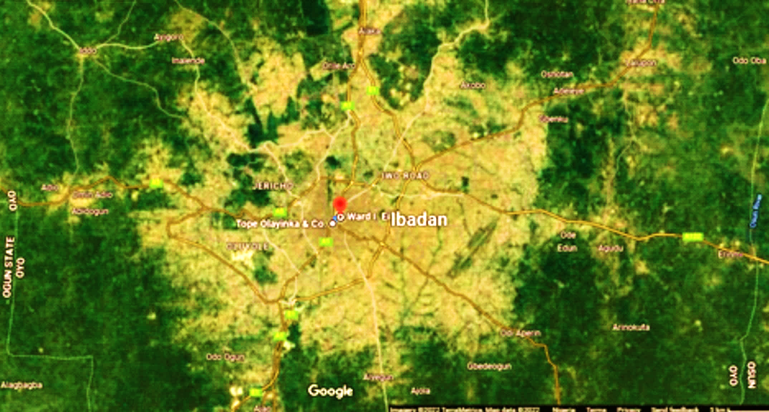
Figure 4: Satellite Map of the Development Areas of Ibadan
Source: Google Satellite Imageries 2024.
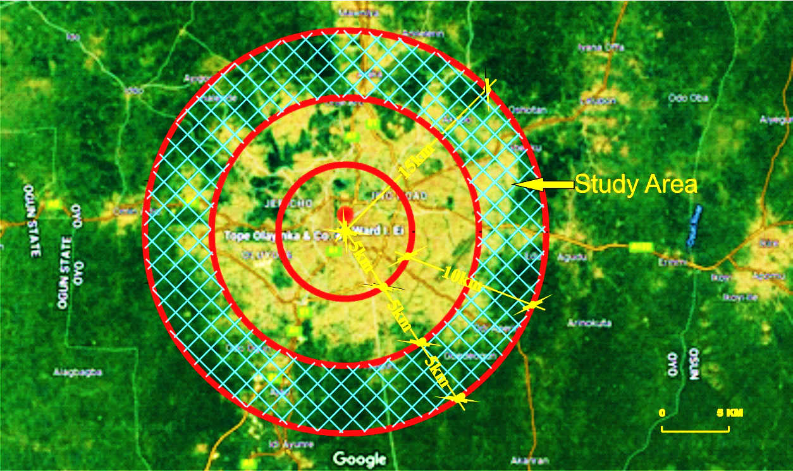
Figure 5: Satellite Map Showing the Radius of Development of Ibadan Relative to Ward I. Ei (Assumed City Center) Source: Adapted from Google Satellite Imageries 2024.
This spatial delineation led to the identification of 10 political wards in the six local government areas within the peri-urban band.
Stage 2: Selection of Local Communities
The second stage was cluster sampling by the number of polling units of INEC that represent neighbourhood communities in the selected wards. In total 136 communities were identified in the wards selected.
The study sample was selected using the proportional sampling techniques recommended by Memon et al. (2020) and Mweshi & Sakyi (2020), thus, 45percent of the communities (totaling 67 communities) were selected (Table 1).
Table 1: Selected Political Wards and Neighbourhoods across the Study Area (Sample Size: by Cluster and Proportional Sampling respectively)
S/N | LOCAL GOVT. AREA | NUMBER OF SELECTED POLITICAL WARDS | NAME OF SELECTED POLITICAL WARDS | RELATIVE DISTANCE FROM CITY CENTER (KM) | NUMBER OF COMMUNITY NEIGHBOUR-HOOD | NUMBER OF SELECTED NEIGHBOR-HOODS
1 | Akinyele | 2 | - Ojo-Emo/Moniya | 15 | 18 | 8
1 | Akinyele | 2 | - Ojoo/Ajibode/Laniba | 11 | 49 | 22
2 | Egbeda | 1 | - Olodo/Kumapayi I | 14 | 15 | 7
3 | Ido | 3 | - Apete/Ayegun/Awotan | 12 | 12 | 5
3 | Ido | 3 | - Fenwa/Oganla/ Elenusonso | 13 | 08 | 4
3 | Ido | 3 | - Ogundele/Alaho/Siba/ Idi-ahun | 15 | 13 | 6
4 | Lagelu | 1 | - Ajara/Opeodu | 12 | 09 | 4
5 | Oluyole | 2 | - Idi-Osan/Egbeda-Atuba | 10 | 06 | 3
5 | Oluyole | 2 | - Odo-ona Nla | 14 | 10 | 5
6 | Ona Ara | 1 | - Odi Odeyale/Odi Aperin | 12 | 06 | 3
TOTAL |  | 10 |  |  | 136 | 67
Author’s sampling 2025: adapted from INEC Nigeria (2015)
Stage 3: Selection of the Respondents
The third step was the selection of respondent(s) from each of the sampled communities. Community leaders or neighbourhood representatives were selected through purposive sampling and other respondents were selected randomly.
A total of 10 respondents were selected from each community making a total of 670 respondents in the study area.
Data Analysis Methods
The Likert scale was used to measure respondents’ perceptions and indicators of sustainability of the housing environment. The Statistical Package for the Social Sciences (SPSS) was used for data analysis.
These analytical methods were used by the study to integrate and identify relationships between socio-economic characteristics, policy compliance, provision of infrastructure, and housing environment sustainability outcomes.
RESULTS AND DISCUSSION
This section presents and analyses the empirical findings of the study on housing environment conditions in the peri-urban precincts of Ibadan.
The presentation of results is based on the study objectives, namely:
- Identification and characteristics of peri-urban areas
- Population socio-economic characteristics
- Development control policy implementation perceptions of stakeholders
- Assessment of sustainability indicators of housing environment
- Challenges of housing environment analysis
- Assessment of sustainability outcomes in the study area

Ibadan Peri-Urban Characteristics
The Ibadan region comprises eleven Local Government Areas out of which five are the metropolitan core and the other six are the peri-urban region. The peri-urban local government areas are Akinyele, Egbeda, Ido, Lagelu, Oluyole and Ona-Ara (Agbola & Alabi, 2010; Adelekan et al.,2014).
In the study, peri-urban areas were defined as settlements located around 10 - 15 km from the city center, using criteria based on the conceptual models proposed by Jurgenson et al. (2017) and Karg et al. (2019). This spatial framework was used to identify and sample neighborhood communities within the study area.
Field observations show that peri-urban settlements are characterized by hybrid spatial characteristics that combine rural land uses, such as agriculture, with expanding residential development. This transitional character is a reflection of the rapid growth of urban areas around Ibadan.
Socio-Economic Profile of the Residents
The socio-economic profile of the respondents is crucial in giving insights into the development dynamics of the peri-urban housing environments.
The survey results indicate that the residents are predominantly low- and middle-income households, traders, artisans, civil servants and small-scale entrepreneurs. Educational background of respondents ranges from primary to tertiary education.
The quality of the housing environment and the provision of infrastructure depended to a large extent on occupation and income levels. Higher income households are more likely to build durable housing structures, and are more compliant with planning regulations.
Table 2, Table 3, all show frequency distributions of Education Level of Respondents, and Monthly Income Levels.
Table 2: Frequency Table of Education Levels
Education Level
 |  | Frequency | Percent | Valid Percent | Cumulative Percent
Valid | No formal Education | 23 | 3.6 | 3.6 | 3.6
Valid | Primary School | 26 | 4.0 | 4.0 | 7.6
Valid | Secondary School | 242 | 37.4 | 37.4 | 45.0
Valid | Tertiary Level | 356 | 55.0 | 55.0 | 100.0
Valid | Total | 647 | 100.0 | 100.0
Source: Authour’s Analysis 2025
Table 3: Frequency Table of Income Levels per Month
Income per month
 |  | Frequency | Percent | Valid Percent | Cumulative Percent
Valid | N10,001 - N30,000 | 5 | .8 | .8 | .8
Valid | N30,001 - N50,000 | 39 | 6.0 | 6.0 | 6.8
Valid | N50,001 - N100,000 | 87 | 13.4 | 13.4 | 20.2
Valid | N100,001 - N200,000 | 220 | 34.0 | 34.0 | 54.3
Valid | N200,001 - N300,000 | 161 | 24.9 | 24.9 | 79.1
Valid | N300,001 - N400,000 | 107 | 16.5 | 16.5 | 95.7
Valid | N400,001 - N500,000 | 23 | 3.6 | 3.6 | 99.2
Valid | Above N500,000 | 5 | .8 | .8 | 100.0
Valid | Total | 647 | 100.0 | 100.0
Source: Authour’s Analysis 2025
This finding is in line with previous studies which indicate that socio-economic characteristics have a strong influence on housing quality and environmental conditions (Agbola & Kassim, 2007; Daramola et al.,2018).
The results therefore confirm that housing environment outcomes are closely related to the socio-economic capacity of residents, particularly in terms of infrastructure provision and environmental management.
Indicators of the Housing Environment
The sustainability of the housing environment was analyzed by means of several indicators that reflect the physical, environmental, social and institutional conditions of the neighbourhood communities.
These indicators include:
- Road infrastructure
- Drainage and stormwater management
- Waste disposal systems
- Electricity supply
- Water provision
- Environmental pollution
- Security and community governance structures
The findings show that infrastructure provision in the study area is still inadequate. The result of the Chi-square test in Table 4 also reveals strong and consistent significant differences in environmental challenges across the various local government areas.
Table 4: Chi-square test of Housing Environment Challenges Across the LGAs
Component | Pearson χ² | Df | Sig. (p-value) | Interpretation
Road Condition | 91.565 | 15 | 0.000 | Significant variation
Storm Water/Flooding | 208.719 | 15 | 0.000 | Very large LGA differences
Waste Disposal | 178.144 | 15 | 0.000 | Varies significantly
Electricity Supply | 48.441 | 10 | 0.000 | Significant differences
Water Supply | 163.980 | 15 | 0.000 | Varies widely
Environmental Pollution | 279.333 | 15 | 0.000 | Very high variation
Security | 144.528 | 15 | 0.000 | Varies significantly
Community Governance | 127.409 | 15 | 0.000 | Significant differences
Source: Authour’s Analysis 2025
Integrated Sustainability Assessment
Multiple housing environment indicators were used to develop a composite Sustainability Rounded Mean Score to assess overall sustainability performance of the study area.
The results show that the majority of peri-urban housing environments are in a weak sustainability condition.
The dominance of the “Poorly Sustainable” category (66.5 percent) suggests that most neighbourhoods are characterized by poor infrastructure, weak environmental management and limited regulatory enforcement (Table 5).
Table 5: Frequency Distribution of Sustainability Scores Across Study Area
Sustainability Category | Frequency | Percent | Valid Percent | Cumulative Percent
Non-Sustainable | 10 | 1.5 | 1.5 | 1.5
Poorly Sustainable | 430 | 66.5 | 66.5 | 68.0
Fairly Sustainable | 207 | 32.0 | 32.0 | 100.0
Total | 647 | 100.0 | 100.0 | —
Source: Authour’s Analysis 2025
While about 32percent of communities are classified as “Fairly Sustainable,” this designation represents only moderate levels of environmental performance, not fully sustainable conditions.
In conclusion, based on cumulative analysis, 68percent of the study area is located in the non-sustainable or poorly sustainable categories, which shows a considerable deficit in sustainability.
Sustainability Performance of Local Government Areas
The average sustainability score of the study area was 2.3045, which means the housing environment is between “Poorly Sustainable” and “Fairly Sustainable”.
However, there are large spatial differences between local government areas (Table 6).
Table 6: Mean Sustainability Scores by Local Government Area
Local Government Area | Mean Score | N | Std. Deviation
Akinyele | 2.1911 | 293 | 0.39386
Egbeda | 2.5909 | 66 | 0.49543
Ido | 2.2117 | 137 | 0.56139
Lagelu | 2.9268 | 41 | 0.26365
Oluyole | 2.2963 | 81 | 0.45947
Ona Ara | 2.3793 | 29 | 0.49380
Overall Mean | 2.3045 | 647 | 0.49301
Source: Authour’s Analysis 2025
Of these areas, Lagelu Local Government Area had the highest sustainability score (2.93) which denotes relatively better provision of infrastructure and environmental management.
Conversely, Akinyele Local Government Area had the lowest sustainability score, implying poorer infrastructure condition and weak environmental management.
The One-Way ANOVA test results in Table 7 presented Between-group Sum of Squares value of 26.407, Within-group Sum of Squares value of 130.610 with degrees of freedom 5 (for between groups) and 641(for within groups). F-statistic results yielded 25.920 while Significance (p-value) is .000 (p < .001).
Table 7: ANOVA Table of Sustainability by Local Government Area
ANOVA Table
 |  | Sum of Squares | df | Mean Square | F | Sig.
Sustainability RndMean Score * Local Govt. Areas | Between Groups (Combined) | 26.407 | 5 | 5.281 | 25.920 | .000
Sustainability RndMean Score * Local Govt. Areas | Within Groups | 130.610 | 641 | .204
Sustainability RndMean Score * Local Govt. Areas | Total | 157.017 | 646
Source: Authour’s Analysis 2025
The results indicate that there are substantial variations attributable to group differences, but more variations exist within groups than between them. The ANOVA results indicate a statistically significant difference in mean sustainability scores across the Local Government Areas (p < .001). This confirms that sustainability conditions vary meaningfully by location, rather than being uniform across the study area.
The F-Statistics value of 25.920 which is very large, indicate greater separation among group means relative to within-group variability. This shows that group means differ substantially and not merely due to chance.
The findings of this study show that the peri-urban areas of Ibadan are rapidly expanding spatially but without adequate infrastructure and planning control.
The widespread poor sustainability conditions suggest that the existing urban governance frameworks are not adequate to address the development pressures in the urban fringe.
These findings affirm earlier research that pointed to infrastructural deficiencies, weak governance capacity and poor environmental management as key barriers to the peri-urban sustainability in Nigerian cities (Adelekan et al.,2017; UN-Habitat, 2020).
Moreover, the spatial variations across the six local government areas show that sustainability outcomes are not uniform but rather shaped by local development dynamics.
Without strategic planning interventions, these peri-urban settlements are likely to become poorly serviced urban environments with long-term environmental and socio-economic consequences.
CONCLUSION
The findings of this study highlight the structural challenges affecting on the sustainability of housing environment in the peri-urban Ibadan.
Firstly, peri-urban areas have become important sites for urban expansion and housing development. However, the pace of residential development in these areas has not been matched with adequate provision of infrastructure, effective regulatory enforcement or coordinated planning interventions. As a result, many neighbourhoods show signs of environmental stress, lack of infrastructure and declining housing quality.
Second, the study provides evidence that sustainability of housing environment is closely related to the socio-economic characteristics of the residents. Income levels, education and occupation, affect households’ ability to invest in sustainable housing construction and environmental management practices.
Third, the study finds that weak enforcement of development control is a major contributor to unsustainable housing environments. Although regulatory frameworks exist, monitoring and enforcement are often patchy, leading to the proliferation of informal or poorly planned developments in peri-urban settlements.
Fourth, the findings suggest that sustainability outcomes differ across the six Local Government Areas due to variations in administrative capacity, infrastructure provision and local governance effectiveness. The spatial variation indicates that generic policy interventions are not suitable to address peri-urban sustainability challenges and that planning strategies need to be tailored to local contexts.
Finally, the study concludes that the achievement of sustainable housing environments in peri-urban Ibadan needs a departure from reactive development control to proactive, integrated and participatory planning approaches. For sustainable urban development in the city, strengthening institutional capacity, improving infrastructure investment and promoting active community participation in environmental management will be essential.
RECOMMENDATIONS
The results of the study lead to the following recommendations:
Government and Policy Suggestions
- Strengthening Development Control: State and local governments should strengthen development control mechanisms by better monitoring, inspecting and enforcing building regulations in peri-urban areas.
- Peri-Urban Planning Policies: Urban development planning policies should clearly designate peri-urban areas as strategic areas for growth and offer planning frameworks that are attuned to their unique socio-economic and environmental contexts.
- Infrastructure Investment: Boost investment in critical infrastructure, including roads, drainage systems, waste management facilities, water supply, and electricity services in peri-urban communities.
Institutional and Governance Issues
- Inter-agency collaboration: Effective management of peri-urban development requires better coordination among planning authorities, environmental agencies, housing institutions and local governments.
- Capacity Building: Technical and administrative capacity building programs for planning officers and local government officials should be organized.
- Transparent Governance Systems: Institutionalized transparent procedures for development approvals and infrastructure planning should be institutionalized to improve accountability and public trust.
Community Level
- Public Awareness Programmes: Government agencies and community organizations should promote public awareness campaigns on environmental consciousness, building regulations and sustainable housing environment practices.
- Community Participation: Residents’ association should be empowered to participate in activities of environmental management such as drainage maintenance, waste management and neighbourhood monitoring.
- Household Sustainability Practices: Households need to embrace sustainable practices such as proper disposal of waste, environmental maintenance and collective action against environmental degradation.

REFERENCES
- Adaku, E. (2014). Urban Sprawl: A View from Developing and Developed Countries. African Journal of Geography and Regional Planning Vol. 1 (6), pp. 193-207, June, 2014. Available online at www.internationalscholarsjournals.org
- Adedire, F. M., Iweka, A. and Adebamowo, M. A. (2017). Factors Influencing Housing Development in Lagos Peri-Urban Settlements: Cases of Ibeju-Lekki and Ikorodu. ATBU Journal of Science, Technology and Education, (JOSTE); Vol. 5(3), 31-40. ISSN: 2277-0011. Retrieved from http://www.atbuftejoste.com/index.php/joste/article/view/397
- Adedire, F. M. and Adegbile, M. B. (2018). The Impact of Peri-Urbanisation on Housing Development: Environmental Quality and Residents' Productivity in Ibeju-Lekki, Lagos. Journal Of Contemporary Urban Affairs, Volume 2, Number 2, pages 60–70
- Adelekan, I. O., Johnson, C., & Matyas, D. (2017). Inevitable Limits? Urban Flooding, Climate Change and Infrastructure in West African Cities. Environment and Urbanization, 29(1), 23–42. https://doi.org/10.1177/0956247816677771
- Adelekan, I., Olajide-Taiwo, L., Ayorinde, A., Ajayi, D. and Babajide, S. (2014). Building Urban Resilience: Assessing Urban and Peri-urban Agriculture in Ibadan, Nigeria. [Padgham, J. and J. Jabbour (eds.)]. United Nations Environment Programme (UNEP), Nairobi, Kenya.
- Adeyemi, S. A., Popoola, A. S., Onifade, V. A., & Jimoh, H. (2023). Residents’ Compliance with Physical Planning Standards and Regulations Across Residential Zones of Osogbo, Osun State, Nigeria. FUOYE Planning Journal, 1(1), 84–95.
- Adu-Gyamfi, A., Owusu-Addo, E., & Inkoom, D. K. (2022). Peri-urban interface: An alternative residential location of low-income migrants in Kumasi, Ghana. Cities, 123, 103570. https://doi.org/10.1016/j.cities.2022.103570
- Agbola, T. and Alabi, M. (2010). The Politics of Illegality in Human Settlement in Ibadan,
  - Nigeria, The Lagos Journal of Environmental Studies, 7(2), 1–8.
- Agbola, T. and Kassim, F (2007). Conceptual and Theoretical Issues in Housing In Tunde Agbola, Layi Egunjobi, C. O. Olatubara (ed.) Housing Development and Management: A Book of Readings (pp. 1-12). Ibadan: Department of Urban and Regional Planning, Faculty of the Social Sciences, University of Ibadan, Nigeria. ISBN 978-245-416-8, pp. 15-69.
- Areola, A. A. (2022). Environmental Justice and Green Spaces in Ibadan Metropolis, Nigeria: Implications on Sustainable Development in Urban Construction. Environmental Sciences Proceedings, 15(1), 57. https://doi.org/10.3390/environsciproc2022015057
- Ayeni, A. O., Aborisade, A. G., Aiyegbajeje, F. O., & Soneye, A. S. O. (2025). The Dynamics of Peri-Urban Expansion in Sub-Saharan Africa: Implications for Sustainable Development in Nigeria and Ghana. Discover Sustainability, 6, Article 290. https://doi.org/10.1007/s43621-024-00742-0
- Berardi, U. (2018). Sustainability Assessment of Buildings, Communities, And Cities. Sustainability, 10(2), 1–20. https://doi.org/10.3390/su10020404
- Chen, L., and Zhao, Y. (2024). Topographic Constraints and Urban Form: A Case Study of Hillside Communities. Cities, 145, 104602.
- Chiaka, J. C., Zhen, L., Xiao, Y., Hu, Y., Wen, X., & Muhirwa, F. (2024). Spatial Assessment of Land Suitability Potential for Agriculture in Nigeria. Foods, 13(4), 568. https://doi.org/10.3390/foods13040568
- Daramola, O. P., Olowoporoku, A. O., & Aturamu, A. O. (2018). Environmental Sanitation and Housing Quality in Residential Areas of Ibadan, Nigeria. Journal of Environmental Studies and Management, 11(2), 159–169.
- DIN Deutsches Institut für Normung e. V. (2022, February 27). Standards and Sustainability. www.din.de/en/about-standards/standards-and-sustainability.
- Doan, D. T., GhaffarianHoseini, A., Naismith, N., Zhang, T., & Tookey, J. (2017). A Critical Comparison of Green Building Rating Systems. Building and Environment, 123, 243–260. https://doi.org/10.1016/j.buildenv.2017.07.007
- Dossa, K. F., Miassi, Y. E., Bakary, S., & Ogou, F. K. (2025). Drowning in Urban Growth: Rethinking Flood Resilience and Spatial Equity in Lagos, Nigeria. Frontiers in Sustainable Resource Management, 4, Article 1659930. https://doi.org/10.3389/fsrma.2025.1659930
- Echendu, A. J. (2023). Flooding and Waste Disposal Practices of Urban Residents in Nigeria. GeoHazards, 4(4), 350–366. https://doi.org/10.3390/geohazards4040020
- Ersan, S. (2025). Housing as a Human Right: Analysing Legal Mechanisms and Standards at the UN and Regional Systems. Journal of Human Rights Law, 74, 675–695
- Gao, Y., Zhang, W., & Li, H. (2022). The Effect of Topographic Shading on Energy Consumption in High-Density Housing. Energy and Buildings, 254, 111634.
- Haldar, S., Chatterjee, U., Bhattacharya, S., Paul, S., Bindajam, A. A., Mallick, J., & Abdo, H. G. (2024). Peri-Urban Dynamics: Assessing Expansion Patterns and Influencing Factors. Ecological Processes, 13, Article 58. https://doi.org/10.1186/s13717-024-00533-5
- Hamman, P. (2017). Definitions and Redefinitions of Urban Sustainability: A Bibliometric Approach. Environnement Urbain, 11. https://doi.org/10.7202/1050496ar
- Hamann, R., April, K., & Holt, D. (2018). One Sustainability or Many? A Review of Sustainability Concepts in International Development. Sustainable Development, 26(4), 453–465. https://doi.org/10.1002/sd.1739
- Hegde, M. V., Park, S., Zhu, X., & Lee, C. (2024). Multi-family Housing Environment and Physical Activity: A Systematic Review of The Literature. American Journal of Health Promotion, 39(1), 127–140. https://doi.org/10.1177/08901171241254940
- Igwe, P.U., Okeke, C.A., Onwurah, K.O., Nwafor, D.C., Umeh, C.N. (2017) A Review of Housing Problems. International Journal of Environment, Agriculture and Biotechnology (IJEAB) Vol-2, Issue-6, ISSN: 2456-187. Pp 3092-3099 http://dx.doi.org/10.22161/ijeab/2.6.40
- Illankoon, I. M. C. S., Tam, V. W. Y., Le, K. N., & Shen, L. (2017). Key Credit Criteria Among International Green Building Rating Tools. Journal of Cleaner Production, 164, 209–220. https://doi.org/10.1016/j.jclepro.2017.06.206
- Jimoh, U. U., & Olagunju, D. K. (2022). Resident’s Compliance with Colonial Planning Regulations in Peri-Urban Area of Ibadan, Nigeria. Journal of Inclusive Cities and the Built Environment, 2(4), 37–52. https://doi.org/10.54030/2788-564X/2022/sp1v1a4
- Jurgenson, E., Sikk, K., Hass, H. and Maasikamae, S. (2017). Methodology for the Determination of Peri-Urban Areas on the basis of Data of Land Type and Use by Example of the Town of Tartu. In Proceedings of the International Conference on Economic Science for Rural Development (pp. 110-117). No 45 Jelgava, LLU ESAF
- Karg, H., Hologa, R., Schlesinger, J., Axel Drescher, A., Kranjac-Berisavljevic, G. and Glaser, R. (2019). Classifying and Mapping Peri-urban Areas of Rapidly Growing Medium-Sized Sub-Saharan African Cities: A Multi-Method Approach Applied to Tamale, Ghana. Land 2019, 8, 40; doi:10.3390/land8030040. www.mdpi.com/journal/land
- Kim, J., Lee, S., & Park, M. (2023). A Study on Recommendations for Improving Minimum Housing Standards. Buildings, 13(11), 2708. https://doi.org/10.3390/buildings13112708
- Kingsella, M. (2019). Housing is the Environmental Issue of Our Time. Up For Growth. http://www.upforgrowth.org/news/housing-environmental-issue-our-time
- Li, L., Chen, X., Zhang, J., Sun, D., & Liu, R. (2022). Landslide susceptibility-oriented suitability evaluation of construction land in mountainous areas. Forests, 13(10), 1621. https://doi.org/10.3390/f13101621
- Lucherini, F. (2025). A Right to Have Housing Rights? Reappraising the Constitutional Gravity of Shelter Claims in India. Asian Journal of Comparative Law, 20(1). https://doi.org/10.1017/asjcl.2025.10008
- Memon, M.A., Ting, H., Cheah, J., Thurasamy, R., Chuah, F., and Cham, T. H. (2020). Sample Size for Survey Research: Review and Recommendations. Journal of Applied Structural Equation Modeling: 4(2), i-xx. eISSN: 2590-4221
- Momoh, J., Ige, O., Seidu, R., Ogbenjuwa, L., Young, B., & Ibraheem, Y. (2024). Urban Sustainability Assessment: an Analysis of how Weighting and Aggregating Coefficient System was Used in the Development of SUCCEED Assessment Tool for Developing Countries. Frontiers in Built Environment, 10, Article 1413757. https://doi.org/10.3389/fbuil.2024.1413757
- Moore, J. E., Mascarenhas, A., Bain, J., & Straus, S. E. (2017). Developing a Comprehensive Definition of Sustainability. Implementation Science, 12, 110. https://doi.org/10.1186/s13012-017-0637-1
- Mweshi, G. K., & Sakyi, K. (2020). Application of Sampling Methods for the Research Design. Archives of Business Research, 8(11). 180-193. DOI: 10.14738/abr.811.9042.
- Odoyi, E. J., & Riekkinen, K. (2022). Housing policy: An Analysis of Public Housing Policy Strategies for Low-Income Earners in Nigeria. Sustainability, 14(4), 2258. https://doi.org/10.3390/su14042258
- Oladunjoye, M. A., Adefehinti, A., & Akinrinola, O. R. (2021). Integrated Geophysical Investigation for The Characterisation of Valley Bottom Soil at Ilora, Southwestern Nigeria. NRIAG Journal of Astronomy and Geophysics, 10(1), 110–124. https://doi.org/10.1080/20909977.2020.1859668
- Peerzado, M. B., Magsi, H., and Sheikh, M. J. (2018). Land Use Conflicts and Urban Sprawl: Conversion of Agriculture Lands into Urbanization in Hyderabad. Pakistan, Journal of the Saudi Society of Agricultural Sciences, 18(2019), 423–428.
- Poortinga, W., Calve, T., Jones, N., Lannon, S., Rees, T., Rodgers, S. E., & Lyons, R. A. (2021). Neighbourhood Quality and Attachment: Validation of The Residential Environment Assessment Tool. Environment and Behavior, 53(3), 255–282. https://doi.org/10.1177/0013916516634403
- Rivas, W., Santiago, J., Carlson, S., & Dunn, J. (2023). Urbanization and Environmental Degradation in African Cities. Journal of African Development, 4(1). https://doi.org/10.61336/jad/25-04-01
- Rodríguez, L., García, D., & Sosa, M. (2022). Environmental Performance Assessment of Social Housing: Comparative Analysis of Sustainability Indicators. Cleaner Environmental Systems, 5, 100077. https://doi.org/10.1016/j.cesys.2022.100077
- Salem, M. S., Ravetz, J., Divigalpitiya, P., Rajan, S. C., & Sahana, M. (2025). Editorial: Land-use Management in Peri-Urban Areas. Frontiers in Sustainable Cities, 7, Article 1586052. https://doi.org/10.3389/frsc.2025.1586052
- Saxena, Manita and Vyas, Supriya (2015). A Review of Concept of Peri-urban Area and Its Identification. International Journal of Combined Research and Development (IJCRD) eISSN:2321-225X; pISSN:2321-2241 Volume: 4; Issue: 4
- Schneider-Skalska, G. (2019). Healthy Housing Environment in Sustainable Design. IOP Conference Series: Materials Science and Engineering, 471, 092083. https://doi.org/10.1088/1757-899X/471/9/092083⁠
- Sharifi, A., Dawodu, A., & Cheshmehzangi, A. (2021). Neighborhood Sustainability Assessment Tools: A Review of Success Factors. Journal of Cleaner Production, 293, 125912. https://doi.org/10.1016/j.jclepro.2021.125912
- Smith, J., and Jones, R. (2021). Geotechnical Considerations for Housing Development in Sloped Terrains. Geotechnical Engineering, 44(3), 210068.
- Somorija, F. C. (2025). Urban slums and overpopulation in Nigeria: A demographic review. International Journal of Law, Politics and Humanities Research, 7(6). https://doi.org/10.70382/caijlphr.v7i6.012
- Soyebo, O. O (2017). The Incidence of Informal Housing – Reflections in Nigeria. EPRA International Journal of Multidisciplinary Research (IJMR) ISSN (Online): 2455 -3662. Volume 3, Issue 11, pp 71-77
- Soyebo, O. O., Joseph J. O., Ajayi, O. (2017). Sprawl Developments: Measurement Indicator and Projections in Selected Nigerian Cities. International Journal of Advanced Engineering Management and Science (IJAEMS), ISSN: 2454-1311, Vol-3, Issue-1, PP: 079-089
- Toku, A., Amoah, S. T., N-yanbini, N. N., Sarfo, A. K., & Tornyeviadzi, P. (2024). Analysis of Land-Use and Livelihood Transformations in Peri-Urban Areas: Insights from North-Western Ghana. Heliyon, 10 (19), e38467. https://doi.org/10.1016/j.heliyon.2024.e38467
- Topal, H. F., Hunt, D. V. L., & Rogers, C. D. F. (2021). Exploring Urban Sustainability Understanding and Behaviour: A Systematic Review Towards a Conceptual Framework. Sustainability, 13(3), 1139. https://doi.org/10.3390/su13031139
- Udoh, U. P., & Essien, K. A. (2025). Housing Quality, Infrastructure and Residents’ Satisfaction in Uyo Metropolis, Akwa Ibom State, Nigeria. International Journal of Developing Country Studies, 7(2), 1–22. https://doi.org/10.47941/ijdcs.2726
- UN-Habitat. (2020). World Cities Report 2020: The Value of Sustainable Urbanization. United Nations Human Settlements Programme. https://unhabitat.org
- Wandl, A. and Magoni, M. (2017). Sustainable Planning of Peri-Urban Areas: Introduction to the Special Issue. Planning Practice and Research, 32:1, 1-3, DOI:10.1080/02697459.2017.1264191

