Comprehensive Analysis of Mobile Banking Trends in Bangladesh: Data-Driven Insights on Growth, Seasonal Patterns, and the Impact of COVID-19
NHM Hassan Imam Chowdhury¹, Faria Zahan Sarna², Abdullah Al Himel³, SMM Jafor Imam Chowdhury⁴
¹ Senior Officer, ICT Division, Standard Islami Bank PLC, Dhaka, Bangladesh
² Lecturer, School of Business, Primeasia University, Dhaka, Bangladesh
³ Department of Industrial and Production Engineering, Military Institute of Science and Technology, Dhaka, Bangladesh
⁴ School of Business, Seneca College, Toronto, Ontario

Corresponding Author: NHM Hassan Imam Chowdhury

ABSTRACT

This study analyzes mobile banking trends in Bangladesh from January 2016 to April 2024, employing data mining techniques to uncover key insights into the growth and transformation of the sector. The analysis shows steady growth across all mobile banking agents, subscribers, transactions, and transaction value metrics. It is observed through data mining methods such as time-series forecasting, moving averages, and correlation analyses that the COVID-19 pandemic catalyzed fast-tracking the adoption of digital financial services. Cultural and religious events, such as Eid, Pahela Boishakh, and Durga Puja, create huge seasonal spikes in transaction volumes. The study shows strong links of positive correlation between mobile banking agents, subscribers, transactions, and transaction amounts, indicating that these metrics are interrelated. A comparative analysis across the pre-COVID, COVID, and post-COVID periods shows a sharp rise in mobile banking activity during the pandemic, followed by a slight deceleration in the post- pandemic phase. The moving average analysis confirms a long-term upward trajectory, smoothing out short-term fluctuations. The findings suggest that mobile banking has become integral to financial transactions in Bangladesh, with important implications for financial inclusion, security, and service innovation, all analyzed through advanced data mining techniques.

Keywords: Mobile Banking, Data Mining, Trend Analysis, COVID-19 Impact, Seasonal Patterns, Financial Inclusion

INTRODUCTION

Mobile banking has rapidly evolved into a critical mode of financial transactions in Bangladesh, revolutionizing how individuals access and manage financial services. The rapid growth of mobile phones and the development of digital technology has made mobile banking a key component of the country's financial system (Rahman, 2020). Data mining has empowered mobile banking services to improve user experiences and enabled users to execute various financial activities remotely from mobile devices (Ngai, Xiu, & Chau, 2009). Such services facilitate convenience and ensure accessibility and efficiency. Mobile banking, characterized by the availability of digital new banking solutions (Saeed et al., 2017; Gómez—Salgado et al., 2021), has contributed significantly to increasing the access to financial services to the unbanked and underbanked people, thus playing a key role in the financial inclusion process in Bangladesh (Akhtaruzzaman et al., 2017), as the operations of some key players such as bKash, Rocket and Nagad dominate the mobile banking sector. Clustering and segmentation are examples of data mining algorithms, as they have been used in many aspects of the domain by analyzing transaction patterns to predict user behaviors and find patterns of clustered data that can be the basis of personal financial offerings (Hu 2005). Mobile banking is vital in improving and fostering financial inclusion and empowering people who cannot access the traditional banking infrastructure to access financial transactions (Khan, 2015). Insights derived from big data regarding mobile banking trends have proven to be helpful in minimizing transaction costs and time in financial transactions and enabling access to payments, remittances, and savings (Pathak & Mishra, 2019). Processing high volumes of transactional data has enabled mobile banking platforms to enhance service efficiency and recognize growth opportunities (Donner & Tellez, 2008). Lockdowns and social distance measures globally forced more people to seek contact-free and remote financial services, thus boosting the shift towards mobile-oriented banking solutions, with the COVID-19 outbreak said to be not unrelated to the overall change (Jebun, 2020). These times also underscored the essential nature of mobile banking for ensuring access to tools of financial intermediation in crisis (Weber & Darbellay, 2010). Data mining techniques like abnormality detection and pattern mining helped identify abnormal patterns in transactions, providing quick and secure financial services during the pandemic (Auer & Böhme, 2020). There are many reasons why understanding mobile banking trends is important. It aids in understanding growth patterns, concerns, and progress. Data mining of the mentioned trends gives us a clear understanding of user patterns and preferences and how external factors like COVID-19 affect the user adoption and consumption of mobile banking (Mousumi & Jamil, 2010).

These insights are essential for policymakers, financial institutions, and other stakeholders in devising strategies to enhance mobile banking services and promote broader financial inclusion (Huda & Chowdhury, 2017). Additionally, data mining helps uncover hidden patterns in transactional data that can inform improvements in mobile banking systems, ensuring a more reliable and accessible service to users (Rahman, 2019). Moreover, studying mobile banking trends through data mining techniques reveals the industry's successes, particularly in reducing financial exclusion and driving economic participation (Islam, 2016). However, it also uncovers challenges, such as service reliability, accessibility, and customer education, which must be addressed to ensure mobile banking systems' continued growth and sustainability (Sarker, Podder, & Alam, 2020). By understanding these trends and applying advanced data mining methods, future innovations and improvements to mobile banking platforms can be guided to meet the needs of diverse user groups (Baten et al., 2010).

This study aims to provide valuable data-driven insights into Bangladesh's evolving mobile banking landscape. It will use data mining techniques to uncover trends, correlations, and patterns, offering a foundation for future strategic decisions, innovations, and policy formulations within the sector.

LITERATURE REVIEW

The evolution of mobile banking has had a profound impact on the global financial landscape, particularly in enabling financial inclusion through digital technologies. Mobile banking in developed countries concentrates on user experience by using more sophisticated technologies like mobile wallets, peer-to-peer payment strategies, and connecting mobile banking platforms with digital banking platforms (Smith et al., 2019). Methods like clustering and classification algorithms, which fall under the category of data mining techniques, have been utilized for analyzing the behavior of users, predicting transaction behaviors, and customizing banking services (Ngai, Xiu, & Chau, 2009). The study finds that mobile banking enhances the speed of transactions, lowers the operational cost of financial institutions, and enhances financial inclusion in rural and urban contexts (Rahman, 2020). Especially in developing nations, mobile banking has become an even more crucial component of financial inclusion by providing services to the unbanked. Mobile banking through services like M-Pesa in Kenya, GCash in the Philippines, and bKash in Bangladesh has proven effective at reducing poverty and increasing economic participation and quality of life (Aker & Mbiti, 2010). However, despite its wide growth, mobile banking has challenges such as security, user trust, and the absence of sufficient infrastructure (Kumar et al., 2017). Mobile banking in Bangladesh has been growing unprecedentedly and has prevailed in services like bKash, Rocket, and Nagad. Mobile banking has expanded very fast in Bangladesh (both number of users and number of agents) because traditional banking is not accessible in remote areas, including those in Bangladesh, according to Bangladesh Bank (2020). Mobile banking in Bangladesh is the means for bringing financial services to excluded groups (i.e., (a) rural dwellers, (b) women, and (c) low-income people) (Rahman, 2019). Research like Hossain et al. Using data mining techniques, (2020) studied mobile banking transaction data and discovered patterns that explain how mobile banking eliminates transaction costs and brings us closer to financial services. Transaction behaviors have been predicted to improve service delivery and make better, cheaper substitutes to conventional banking using machine learning and data mining models (Pathak & Mishra, 2019). Despite the extensive investigations done into this platform- based payment business model through previous literature, customer Education, trust, and digital illiteracy barriers remain major challenges containing the values of this business model (Islam et al., 2019). The unavailability of proper care for mobile banking usage in rural areas is impacted by mobile network coverage, device accessibility, and user literacy problems (Rahman & Khan, 2021). Data mining methods like anomaly detection and association rule mining can assist in uncovering hidden patterns and problems in these regions (Mousumi & Jamil, 2010). The Previous research by Akter & Ray (2021) indicated that mobile banking experienced exponential growth amidst the pandemic (even in countries like Bangladesh, where there was a digital gap before the pandemic) with increasing reliance on mobile money for remittances, payments, and management as a whole. In predicting transaction volumes and analyzing the effect of the pandemic on mobile banking trends that is, whether the trends the authors see are in line with or at the expense of traditional banking, data mining techniques like time-series forecasting and regression analysis were essential (Auer & Böhme, 2020). The Covid pandemic, which took a massive toll on the economy, made mobile banking an indispensable service and highlighted the importance of digital financial services in stabilizing the economy in times of crisis. Still, mobile banking users, especially those in rural areas, cannot escape from rampant issues faced by neither the general population nor banks, like network congestion, fraud, and the digital divide. However, growing pains, including infrastructure and regulatory shortages (Bangladesh Bank, 2021), have accompanied this.

Existing literature covers mobile banking growth in developing countries but lacks analysis of specific metrics like transaction amounts, agent numbers, and seasonal variations. Comparative studies across pre-COVID, COVID, and post-COVID periods are missing, crucial to understanding the pandemic's impact. A comprehensive data-driven analysis would provide valuable insights into factors driving mobile banking success and inform future growth strategies (Madhavi, 2012).

THEORETICAL FRAMEWORK

The theoretical framework for this study is based on data collected from Bangladesh Bank, supplemented by advanced data mining techniques for in-depth analysis. The framework integrates various components designed to uncover key insights from the data:
- Adoption and Usage Metrics: Adoption and usage metrics like the number of mobile banking agents, subscribers, transactions, and transaction amounts are analyzed using various data mining (clustering, regression, etc.) techniques. This identifies adoption and usage behavior shifts over time, revealing otherwise elusive patterns in user engagement and financial activity (Sarna and Chowdhury, 2024). It enables more complex insights into the factors underpinning growth in mobile banking (Ngai et al., 2009; Xiu & Chau, 2011).
- Seasonal Analysis: Seasonal patterns in mobile banking metrics are explored using time- series analysis and seasonal decomposition methods. These techniques identify recurring trends and fluctuations across different months, revealing how holidays, festivals, and economic cycles influence transaction volumes and user engagement (Rahman & Khan, 2021).
- Impact of External Factors: The study specifically focuses on the impact of the COVID- 19 pandemic, utilizing comparative analysis to evaluate key metrics across the pre-COVID, COVID-19, and post-COVID periods. By applying data mining methods such as anomaly detection and trend analysis, the study captures the surge in mobile banking usage during the pandemic and the subsequent shifts in user behavior (Auer & Böhme, 2020).
- Correlation Analysis: Correlation analysis and association rule mining are applied to evaluate the relationship between mobile banking metrics (agents, subscribers, transactions, and transaction amounts). These data mining techniques help find strong dependencies between metrics, which can give insight into the impact of a metric when changed on others (Khan, 2015).
- Growth Trends: Year-over-year growth rates are calculated and visualized using data visualization tools and predictive modeling techniques. This analysis highlights long-term growth trends, offering data-driven insights into the factors driving the evolution of mobile banking in Bangladesh (Weber & Darbellay, 2010).
By leveraging data from Bangladesh Bank and applying data mining techniques (Chowdhury et al, 2025), this study aims to provide a comprehensive analysis of mobile banking trends. The framework ensures that the research offers valuable insights for policymakers, financial institutions, and stakeholders, informing strategies for service improvement and financial inclusion (Huda & Chowdhury, 2017).

Figure 1: Research Framework
Growth Trends
Correlation Analysis
Mobile Banking
Impact of External Factors
Seasonal Analysis
Adoption and Usage Metrics

Source: Author’s own elaboration

METHODOLOGY

Data Collection
The dataset for this study, regarding mobile banking, was collected from Bangladesh Bank from January 2016 to April 2024. Core statistics are available on mobile banking agents, subscribers, transactions, and volume in crore Taka (Bangladesh Bank, 2020). These measures give a longer- term insight into the scale of services and activity in mobile banking. The total data were collected with the help of open sources from official reports and publications of Bangladesh Bank. Each metric is documented month-to-month, making it suitable for such extensive data mining (Rahman, 2020), where the dataset is well organized and very careful accuracy is ensured.

Data Processing
Data pre-processing involved several steps to ensure dataset suitability for analysis. Libraries such as pandas, numpy, matplotlib, seaborn, and statsmodels were used for data manipulation and visualization. The dataset was loaded into a pandas DataFrame for ease of analysis. An initial inspection ensured correct formatting, and the dataset was checked for missing values, none was found, ensuring completeness. Outlier detection was performed using visualizations like boxplots and scatter plots. Significant anomalies were reviewed to confirm whether they were valid data points or errors. Genuine outliers were retained, as they could provide valuable insights into mobile banking trends (Madhavi, 2012).

Analytical Techniques
The objective of this study was to develop reflection-based analytical techniques using data mining methods that would thoroughly investigate mobile banking trends in the country of Bangladesh. Data visualization methods such as trend lines, bar charts, and heatmaps were used to identify patterns and relationships in the data (Mousumi & Jamil, 2010) process. Time-series decomposition decomposes the data into trend seasonal and residual by applying seasonal decomposition of time series (STL) (Islam et al., 2019). Using correlation analysis we used heat-map to visualize the correlation matrix we found some relationship between agent, subscriber, transaction, and transaction amount metrics (Khan, 2015). In addition, association rule mining investigated potential interactions between variables, revealing dependency information (Ngai, Xiu, & Chau, 2009). Moving averages for 7-month and 12-month intervals were used to emphasize long-term patterns of main transactions to smooth a distorted short-term behavior (Weber & Darbellay, 2010). The impact of the crisis represented by the pandemic was thus measured by analyzing the time-series nature of data from pre-COVID, COVID-19, and post- COVID periods using a time-series forecasting model and anomaly detection models (Jebun, 2020). Renderer, anchored on year-over-year growth, depicted growth trends and seasonal effects, as well as the effect of events such as COVID-19 on mobile banking metrics (Rahman, 2020). Monthly trend analysis identified seasonal patterns, offering deeper insights into consistent trends. These combined techniques provided a comprehensive understanding of mobile banking growth, seasonal fluctuations, and the impact of the COVID-19 pandemic (Huda & Chowdhury, 2017).

RESULTS

Visualizing Key Mobile Banking Trends
From January 2016 to April 2024, mobile banking in Bangladesh experienced significant growth. The number of agents increased from about 586,901 to over 1.8 million, and subscribers surged from 33 million to more than 220 million, showing widespread adoption. The number of transactions increased from 117 million to almost 600 million, demonstrating a move towards mobile banking for financial transactions. Using data mining methods, including anomaly detection and seasonal decomposition, we found that the transaction amount increased to over 140,000 crore Tk from 16,600 crore Tk, with peaks in the Eid and Pahela Boishakh period.

Figure 2: Key Mobile Banking Trends 2016-2024

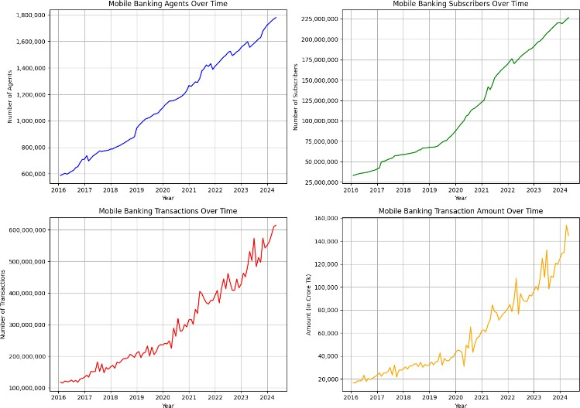
Source: Author’s own elaboration, based on collected data (2025).

These trends point to an increasing dependency on mobile banking services in Bangladesh. These increases in agents, subscribers, transactions, and transaction values reflect the transition to digital financial services. The peaks in transaction registration indicate that some events or economic factors increase the turnover of funds in the area, and they can be considered significant phases of development for the vector. These trends have been uncovered from data mining, allowing us better to understand the growth pattern of mobile banking in Bangladesh.

Decomposition of Time Series
The decomposition of time series data on mobile banking transactions provides valuable insights into transaction patterns, analyzed using data mining and time-series techniques. The decomposition consists of three components: Trend, Seasonal, and Residual. Results show that upward movements of the trend components between 2016 and 2024 indicate an increasing adoption of mobile banking services in Bangladesh, modeled from trend analysis and regression techniques. The seasonal component, which reveals recurring movements driven by holidays, festivals, and economic cycles, peaks during holidays such as Eid and Pahela Boishakh and is modeled using seasonal decomposition and time-series forecasting. The residual component represents random noise or other data irregularities and is identified using anomaly detection and outlier analysis to spot short-term disturbances or anomalies. The decomposition shows cyclical behavior driven by cultural and economic factors and some random spikes.
Figure 3: Trend, Seasonal, and Residual over time (2016-2024)

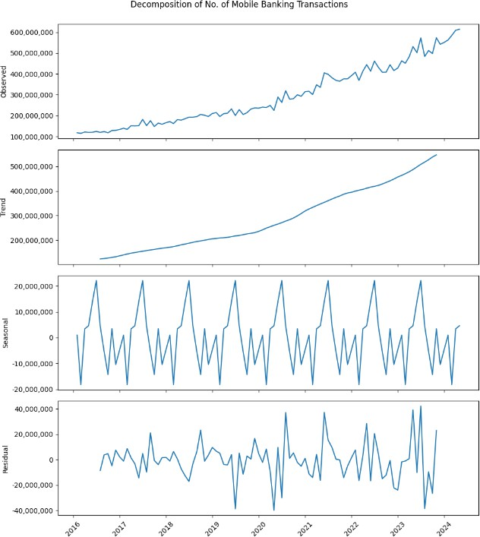
Source: Author’s own elaboration, based on collected data (2025).

The analysis in Figure 3 underscores the strong upward trend in mobile banking transactions, likely driven by the increasing popularity and use of mobile banking platforms in Bangladesh. Seasonality suggests repeated phenomena, which may or may not be associated with a specific economic event or calendar effect, such as holiday spending. This leaves the residual component as random noise and confirms that random anomalies or events also drive some variations in transaction volumes. Given the complexity of the mobile banking ecosystem, data mining techniques offer further insights to help identify observable trends and explain outliner variations in growth over time.

Correlation Analysis
The position of the correlation matrix of mobile banking metrics (Figure 4) indicates substantial positive relationships between the key variables. The mining processes depict the high associations among the mobile banking agents, subscribers, transactions, and transaction amounts. Since the correlation across agents with subscribers is 0.98, it highlights that more agents are directly proportional to more subscribers, showing agents as key in extending mobile banking. Furthermore, the relationship between the number of transactions and total transaction volumes is 0.99, which is strong evidence that you have a lot of transaction value when you have many transactions. Subscribers and transaction amounts correlated at 0.97, which is, of course, to be expected since total transaction volume will scale with the number of subscribers.

Figure 4: Correlation matrix of mobile banking metrics

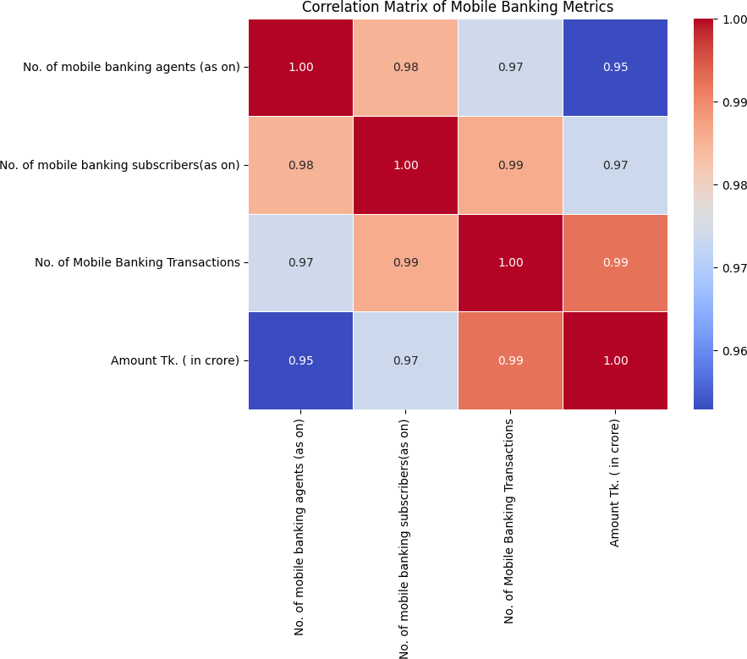
Source: Author’s own elaboration, based on collected data (2025).
These major correlations indicate that mobile banking metrics tend to be interlinked. Some examples would be a rise in mobile banking agents leading to an increase in subscribers and the number of transactions, increasing the transaction value. This interconnectivity makes data mining potentially useful in analyzing multidimensional metrics to elucidate many mobile banking trends. This also implies that if one factor, such as increasing the number of agents, is influenced, other factors are also positively influenced, leading to the overall development of mobile banking services.

Year-over-Year Growth Visualization
Key mobile banking metrics in Bangladesh from 2016 to 2024 reveal significant growth, including the average monthly number of mobile banking agents, subscribers, transactions, and total transaction amounts in crore Taka. As shown in the first plot, the number of mobile banking agents steadily increased from around 586,901 in early 2016 to over 1.7 million by 2024. A noticeable spike occurred post-2020, likely due to the COVID-19 pandemic, which increased demand for mobile banking agents as physical distancing measures restricted in-person banking. The number of mobile banking subscribers, depicted in the second plot, also showed rapid growth, rising from 33 million in January 2016 to more than 220 million by 2024. This surge was especially pronounced in 2020 and 2021, as many individuals, unable to access traditional banking due to lockdowns, increasingly turned to mobile banking for their daily financial needs. This contributed significantly to the rise in the subscriber base during the pandemic.

Figure 5: Yearly growth of mobile banking in Bangladesh

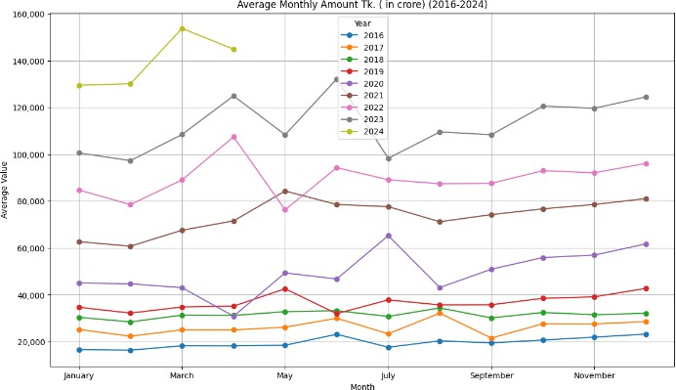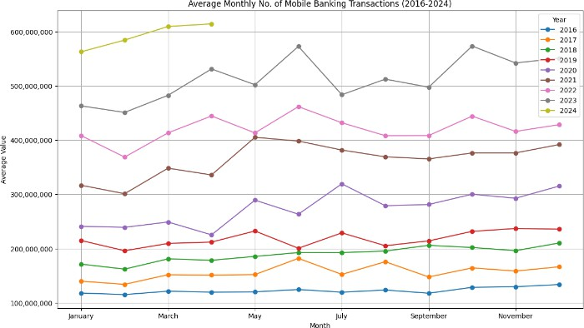

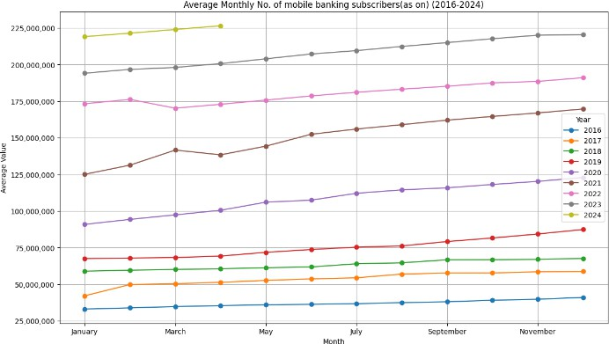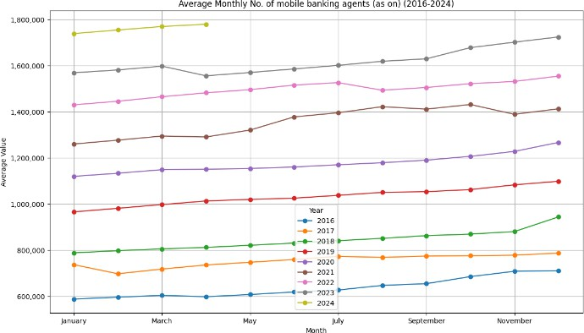
Source: Author’s own elaboration, based on collected data (2025).

As shown in the third plot, the average monthly number of mobile banking transactions was over 117 million transactions a month in 2016 and exploded to over 600 million by 2024. The largest spike is between 2020 and 2021, mainly driven by the pandemic. This meant that as brick-and- mortar businesses and offices shut their doors, everything from bill payments to money transfers continued to go through with the help of mobile banking. Likewise, as illustrated in the fourth plot, the average monthly transaction size (in crore Taka) followed an upward trajectory from 16,600 crore Taka in 2016 to over 140,000 crore Taka by 2024. Similar to other metrics, this rise was particularly more pronounced in 2020 and 2021 due to bigger deals such as government handouts and transactions between businesses. All in all, these four metrics tell the story of Bangladesh's fast-expanding mobile banking sector. The COVID-19 pandemic has accelerated this growth considerably, with increased agents, subscribers, transactions, and transaction amounts through 2020 and 2021. The data underscores a substantial shift towards digital financial services, which served as a solution during the pandemic and solidified mobile banking as a vital tool for financial inclusion and economic resilience in the years to come.
Moving Average Calculation
The moving average analysis, shown in Figure 6, smooths out short-term fluctuations in mobile banking transaction amounts, revealing the underlying long-term trends. The plot displays the 7- month and 12-month moving averages alongside the actual transaction amounts. By calculating these averages, short-term volatility is filtered out, highlighting the steady growth in transaction amounts over time. The 7-month and 12-month moving averages exhibit a clear upward trend from 2016 to 2024, indicating sustained growth in mobile banking transactions. While the actual transaction amounts (represented by the orange line) show short-term fluctuations, the moving averages (green for 7 months and blue for 12 months) provide a smoother curve, emphasizing the overall positive trajectory. These fluctuations, influenced by seasonal changes, economic events, or other irregular factors, do not detract from the long-term growth confirmed by the moving averages.

Figure 6: Moving average of mobile banking transection amount

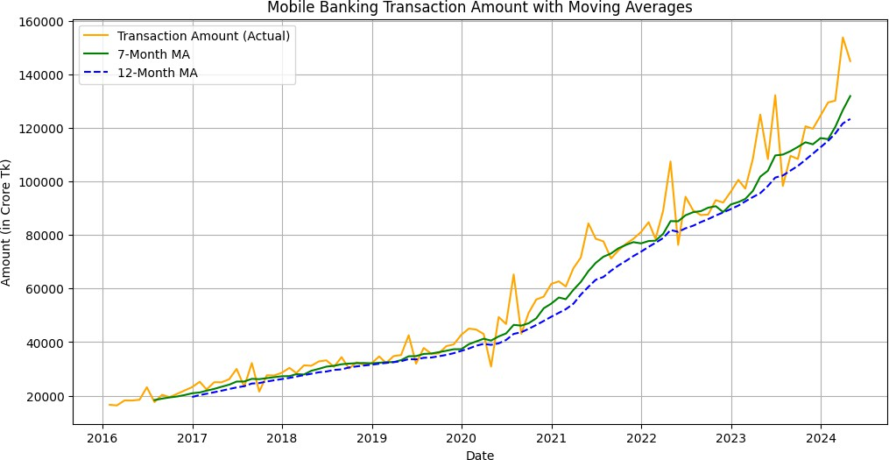
Source: Author’s own elaboration, based on collected data (2025).

The 7-month and 12-month moving averages clearly show a consistent growth trend in mobile banking transaction amounts. While the actual transaction amounts exhibit some volatility, particularly during specific months, the moving averages offer a more stable data view. This indicates that mobile banking transactions in Bangladesh have experienced sustained and robust growth despite short-term fluctuations. The moving averages reinforce the idea that this upward trend is driven by the increasing adoption of mobile banking and broader digital financial practices, which are expected to persist in the coming years.

Comparative Analysis (Pre-COVID, COVID, Post-COVID)
The comparison of mobile banking trends across the pre-COVID, COVID-19, and post-COVID periods in Figure 7 highlights significant growth in all key metrics, with the COVID-19 pandemic acting as a major catalyst for change. Mobile banking had been experiencing consistent growth before COVID: 828085 agents in the provided were registered, and by the year-end 58. Seven million agents registered for mobile banking were sending a monthly average of 174.3 million transactions valued at 29,176 crore Taka. This was the beginning of the mobile banking steps. During the COVID time, the adoption of mobile banking use cases became larger exponentially; number of agents reached 1.28 million, and subscribers reached 133 million as the mobile banking use case surged due to COVID and lockdown fear for safety and comfortable steps to bank mobile.

The monthly transactions soared more than twofold to 326 million, and the transaction value soared to 63,145 crore Taka. After COVID-19, the mobile banking sector also continued to experience a slight decline in growth, where agents reached 1.59 million, subscribers grew to 198.3 million, and transactions averaged 485 million. The amount of money transacted increased from 82,817 crore Taka to 106,687 crore Taka, a 128% increase, which implies that the stickiness of mobile banking during the pandemic did not go away as new users and habits acquired during the peak of the pandemic remained. The comparison shows that the COVID-19 pandemic has driven the growth of mobile banking in Bangladesh. The biggest jumps in all three metrics occurred during the pandemic: 450,000 more agents joined the fold, the number of subscribers had more than doubled, and transactions and transaction amounts increased significantly. The continued high growth rates during the post-COVID period signified that extreme pandemic-related factors largely drove the volatility observed during COVID, as post-COVID growth persisted at a lower, but still high, level.

Figure 7: Mobile-banking trends across three distinct periods, Pre-COVID, COVID, and Post-COVID

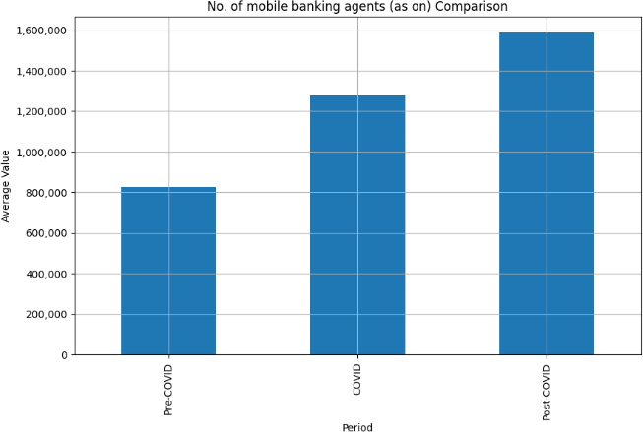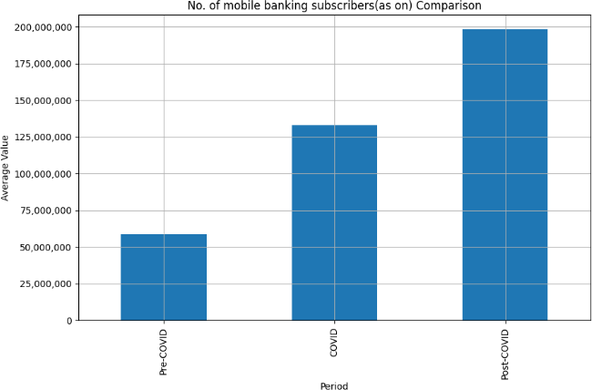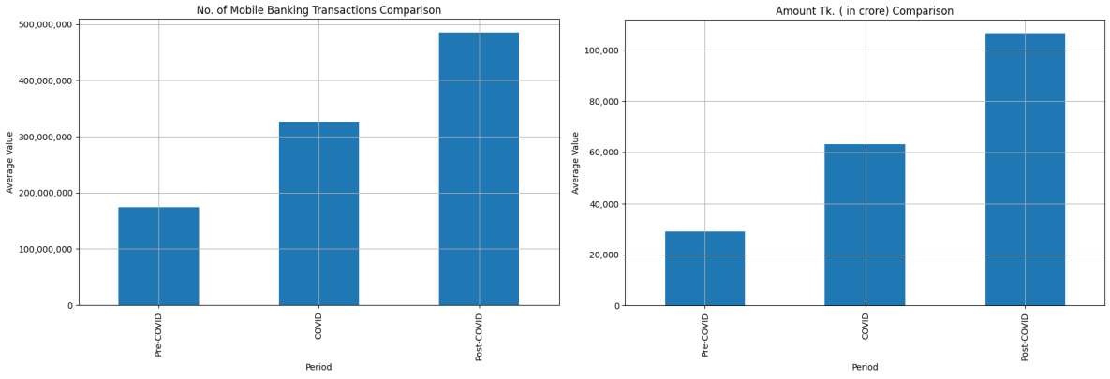
Source: Author’s own elaboration, based on collected data (2025).

The continued high growth rates in the post-COVID period highlight that mobile banking is now a permanent feature of the financial landscape, with the shifts in user engagement during the pandemic having enduring effects.

Monthly Trend Analysis
The monthly trend analysis of mobile banking metrics reveals significant seasonal fluctuations and event-driven spikes in the usage of mobile banking services in Bangladesh. Similar spikes can be observed in data related to mobile banking agents, subscribers, transactions, and transaction amounts, as shown below, where we can match the trends with cultural and religious events during the year. The latter can be observed in Figure 8, where the values peak in December, indicating a higher presence of mobile banking agents. December marks the end of the calendar year, which often hosts festivities involving increased consumer spending and, in many locations, a high diversity of cultures and traditions with related festivities, which will likely spark demand for mobile banking agents. The same goes for mobile banking subscribers, where many subscribers fall in December, probably because of end-of-year promotions or providers' campaigns to bring new subscribers on board. New 'scanning people are also associated with this seasonal uptick during the holidays. The numbers data in March and April suggest improvements, which stand out for mobile banking transactions due to Eid ul Fitr (March-April) and Pahela Boishakh (Bengali New Year). Eid ul Fitr lands around the same Arabic time each year according to the Islamic lunar calendar, Eids, which in 2016-24 fells between March and July but mostly March and April. All these events usually fuel more expenditure on gifts, food items, and celebrations. The day Pahela Boishakh is on 14 April each year, and it also witnesses a significant rise in mobile banking transactions due to family gatherings, special purchases, and cultural functions organized to celebrate the Bengali New Year. We can see that transaction amounts follow similar patterns, where we also see peaks in March, April, and October. Pahela Boishakh explains that the peak in

April, while the peak in October coincides with the Hindu festival of Durga Puja, where much money gets spent on religious rituals, gifting, and community gatherings. Eid ul Adha, which comes two months after Eid ul Fitr and is linked to the Islamic lunar calendar, also leads to spikes in August or September, depending on moon sighting, because of large expenses on animal sacrifices, charity, and the like.
Figure 8: Monthly trend analysis of mobile banking metrics

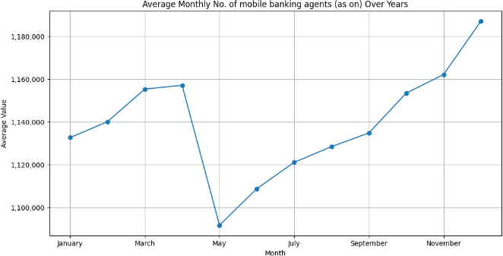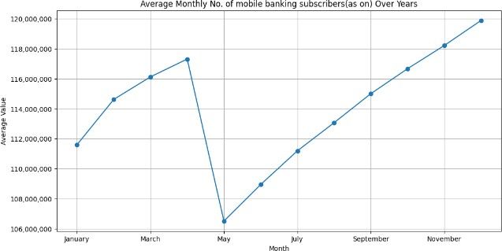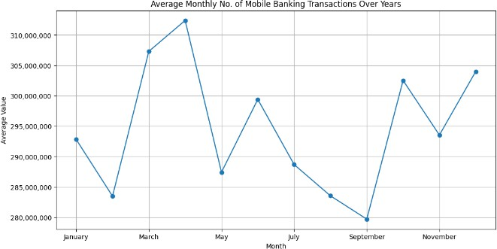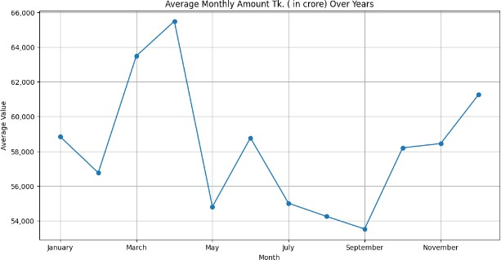
Source: Author’s own elaboration, based on collected data (2025).

The data indicates that cultural and religious events, such as Eid ul Fitr, Eid ul Adha, Durga Puja, and Pahela Boishakh, significantly influence mobile banking activity. These festivals lead to spikes in financial transactions and mobile banking engagement, especially around March, April, August, September, and October. Fixed events like Pahela Boishakh and Durga Puja show more predictable peaks, while lunar events, such as Eid ul Fitr and Eid ul Adha, cause fluctuations based on the moon sighting. These seasonal patterns provide a comprehensive understanding of mobile banking trends, shedding light on how external cultural and religious events influence financial behavior. They also offer valuable insights for designing targeted strategies to manage mobile banking services during peak seasons.

DISCUSSION

This study provides an in-depth analysis of mobile banking trends in Bangladesh from January 2016 to April 2024, revealing consistent growth in key metrics such as mobile banking agents, subscribers, transactions, and transaction amounts. Data mining techniques such as time-series forecasting and moving average analysis reveal a robust upward trend, punctuated by peaks in transaction amounts, driven by seasonal drivers such as festivals. For example, correlation analysis shows the relationships between metrics, indicating that an increase in mobile banking agents leads to higher numbers of subscribers, more transactions, and greater value of transactions. This highlights the importance of increasing the agent network for the adoption of mobile banking. The COVID-19 pandemic has acted as a booster for its benefits and advantages. Over 40% of the additional 781187 codes added after COVID required agents, as agents skyrocketed to 1.59 million (up from 828,085 prior to COVID) and subscribers became 198.3 million (up from 58.7 million). At this time, transactions grew over 2x, validating the trend of digital financial services gaining traction in the absence of traditional banking systems where they became constrained. The underlying causes of this shift, which combines necessity and convenience, are also partly visible in the anomaly detection methods, where usage spikes align with lockdowns and social distancing measures. Moving average analysis does not only confirm long-run growth, it eliminates sudden bends, showing a clear upward trend in mobile banking Elements The data shows that both agents and subscribers have their peak activity in December while the peak transaction amounts are seen in March and April due to cultural events, such as Eid and Pahela Boishakh. Around seasonal decomposition, these patterns give you information about recurring trends, which can further assist in predicting future demand. Overall, the study emphasizes mobile banking's role in financial inclusion in Bangladesh. However, continuous security, financial literacy, and service innovation improvements are crucial for sustaining growth. This research provides valuable insights into external factors, such as the pandemic, offering a comprehensive framework for future mobile banking development strategies.

LIMITATIONS AND FUTURE STUDY

While this study offers valuable insights, there are several limitations. Although reliable, the dataset is sourced from Bangladesh Bank, which may not capture all aspects of mobile banking activities. Key factors such as regional variations, customer feedback, and service usage patterns were not included (Bangladesh Bank, 2020). The study also limits the date range from January 2016 to April 2024 and does not account for future trends or historical data before 2016. This short data span before 2016 means the long-term trend of mobile banking adoption cannot be understood (Rahman, 2020). Additionally, the examination remains largely limited to core measures, including mobile banking agents, subscribers, transactions, and transaction value, without adequately considering external influences such as economic environment, technological development, or changes in consumer behavior (Sarker, Podder & Alam, 2020). While seasonal analysis identifies patterns, the underlying reasons for these fluctuations remain unexplored, necessitating further qualitative research (Islam et al., 2019). To extend this research, future studies should include more recent data and historical trends before 2016, offering a broader view of mobile banking trends (Kumar et al., 2017). In other words, proper mobile banking performance will also consider customer satisfaction, the number of transaction failures, and the number of fraud clips, so it would be more comprehensive if mobile banking performance included all of these (Madhavi, 2012). Examples include, but are not limited to, qualitative research, such as FB interviews with users; agents would give a lot of insight into user behavior and preferences (Mousumi & Jamil, 2010). Furthermore, research on how emerging technologies such as blockchain, artificial intelligence, and 5G will affect the adoption of mobile banking will also be significant since these technologies are the future of mobile banking as they can change how the banking sector works (Aker & Mbiti, 2010). Comparing mobile banking trends in Bangladesh with other countries, particularly in South Asia and similar developing economies, will provide insights into best practices and areas for improvement (Rahman & Khan, 2021). Analyzing the impact of regulatory changes and government policies on the sector’s growth will help understand how interventions shape mobile banking adoption (Huda & Chowdhury, 2017). By addressing these limitations and exploring future research areas, a more comprehensive understanding of mobile banking trends can be achieved, enabling the development of effective strategies and policies to enhance the sector’s growth and contribution to financial inclusion and economic stability in Bangladesh (Weber & Darbellay, 2010).

CONCLUSION

This study thoroughly investigates mobile banking mode in Bangladesh from January 2016 to April 2024 —exclusively using a data mining approach. It brings out the growth in mobile banking agents, subscribers, transactions, and transaction value, as well as the convenience, accessibility, and contactless transactions driving them, especially during the pandemic. The correlation analysis shows a strong correlation among these metrics, which illustrates the cohesiveness of the mobile banking ecosystem and the impact that mobile banking agents have on other metrics. The COVID-19 period marked a turning point, with substantial increases in all metrics, reflecting the accelerated shift towards digital banking solutions. The Post-COVID period continued to show strong growth, indicating that the changes in financial behavior during the pandemic had lasting effects. Seasonal patterns were identified in the data, with peaks in mobile banking activities during specific months, suggesting regular fluctuations influenced by seasonal factors. The analysis of the long-term increase was reinforced by time-series prediction and moving opportunity investigation, and it continued to support the extended development of versatile financial administration. The findings have important implications for the mobile banking sector in Bangladesh. Policymakers and financial institutions should focus on enhancing security, promoting financial literacy, and encouraging innovation to support the continued expansion of mobile banking. Efforts should be made to reach underserved and unbanked populations, ensuring financial inclusion for all. Overall, this study contributes to the understanding of mobile banking trends in Bangladesh and offers a foundation for future research, policy-making, and strategic planning in the mobile banking sector.

REFERENCES

- Aker, J. C., & Mbiti, I. M. (2010). Mobile banking and economic development: Linking adoption, impact, and use. Asian Journal of Communication, 18(4), 318-322.
- Akter, S., & Ray, P. (2021). Mobile banking adoption in Bangladesh: The role of COVID-19 in accelerating digital finance. Journal of Financial Services Marketing, 26(1), 40-50.
- Akhtaruzzaman, M., Islam, M. E., Islam, M. S., -Ul-Islam, S. R., Bhuiyan, M. R., Tareq, M., et al. (2017). An impact study on mobile financial services (MFSs) in Bangladesh. Research, Bangladesh Bank and Dhaka University, Dhaka.
- Auer, R., & Böhme, R. (2020). The technology of retail central bank digital currency. BIS Quarterly Review, March.
- Bangladesh Bank. (2020). Mobile financial services. Dhaka, Bangladesh Bank.
- Baten, Md. Azizul, Kamil, Anton Abdulbasah, & Parveen, Sanjida. (2010). Adoption of e-banking in Bangladesh: An exploratory study. African Journal of Business Management, 4(13), 2718-2727.
- Chowdhury, N. H. I., Islam, Md. E., Hasan, Md. S., & Abdullah Al Mehedi. (2025). AI-Powered Behavior-Based Malware Detection Using Advanced Temporal and Process-State Features: A Robust Explainable Framework. Cuestiones de Fisioterapia, 54(3), 3883–3902. https://doi.org/10.48047/z6pyk694
- Donner, J., & Tellez, C. (2008). Mobile banking and economic development: Linking adoption, impact, and use. Asian Journal of Communication, 18(4), 318-322.
- Hu, X. (2005). A data mining approach for retailing bank customer attrition analysis. Applied Intelligence, 22, 47–60.
- Huda, F., & Chowdhury, T. A. (2017). Prospect of e-banking in Bangladesh: A new way to make banking electronic. Asian Economic and Financial Review, 7(5), 509-518.
- Islam, M. Z. (2016). Mobile banking sees stellar growth. Dhaka: The Daily Star.
- Jebun, N. (2020). COVID-19 brings blessing for digital transformation, The Financial Express, August 19, 2020.
- Khan, B. S. (2015). Regulatory guidelines for mobile financial services (MFS) in Bangladesh. Dhaka: The Daily Star.
- Madhavi, S. (2012). The prediction of churn behavior among Indian bank customers: An application of data mining techniques. International Journal of Marketing, Financial Services & Management Research, 1(2), 11-19.
- Mousumi, F., & Jamil, S. (2010). Push-pull service offering SMS-based mobile banking system in context of Bangladesh. International Arab Journal of e-Technology, 1(3), 79-88.
- Ngai, E. W. T., Xiu, L., & Chau, D. C. K. (2009). Application of data mining techniques in customer relationship management: A literature review and classification. Expert Systems with Applications, 36(2), 2592–2602.
- Pathak, A., & Mishra, S. (2019). Consumer behavior and attitude towards mobile banking: An empirical analysis. International Journal of Innovative Technology and Exploring Engineering (IJITEE), 494-499.
- Rahman, A. (2019). bKash vs. Bank-led Option: Factors influencing customer’s preferences. Journal of Banking and Financial Economics, (1(13)), 51-69.
- Rahman, A. M. (2020). Voluntary insurance for ensuring risk-free on-the-go banking services in market competition: A proposal for Bangladesh. The Journal of Asian Finance, Economics, and Business, 5(1), 17-27.
- Rahman, A., & Khan, R. (2021). Mobile banking in rural Bangladesh: Challenges and opportunities. Journal of Rural Development, 12(3), 134-145.
- Sarker, B., Podder, P., & Alam, R. (2020). Progression of Internet Banking System in Bangladesh and its Challenges. International Journal of Computer Applications, 975, 8887.
- Sarna, F. Z. & Chowdhury, N. H. I. (2024). Mediating Role of Brand Perception and Big Data Analytics between Consumer Experiential Components and Consumer Behavior, International Journal of Science and Business, 42(1), 193-211. DOI: https://doi.org/10.58970/IJSB.2492
- Smith, J., Walker, S., & Thompson, R. (2019). Mobile banking adoption and financial inclusion in developed economies. International Journal of Digital Finance, 4(2), 118-130.
- Weber, R. H., & Darbellay, A. (2010). Legal issues in mobile banking. Journal of Banking Regulation, 11, 129-145.
- World Bank. (2020). COVID-19 and digital finance: The role of mobile banking in times of crisis. World Bank Blog.

