Spatio-Temporal Evolution in Urban Green Spaces in the Buea and Limbe Urban Space Drivers and implications on sustainable urban Development, Cameroon (1995–2025)
Buntuh Petra Enow enowpetra@gmail.com
* Prof. Cornelius Mbifung Lambi cmlambi20@gmail.com
*Assoc. Prof. Tepoule Joseph tepoule.n@ubuea.cm

Abstract
Urban green spaces are important to sustainable urban development by providing essential ecosystem services, promoting social well-being, and regulating environmental hazards. Continuous urbanisation in Sub-Saharan Africa has resulted in significant transformations in urban land use, negatively affecting natural vegetation. This study, therefore, investigates the spatio-temporal dynamics of urban green spaces in the Buea and Limbe urban areas of Cameroon between 1995 and 2025. It employs both remote sensing data (Landsat 5 and Landsat 8 imagery) and GIS-based land-use and land-cover (LULC) classification, as well as field surveys, which include household questionnaires and key informant interviews. The study examines evolution in formal green spaces, informal green spaces, farmlands, and built-up areas and their implications on sustainable urban development. Findings of this study reveal a significant decline in informal green spaces, driven by population growth and urban expansion, with a steady increase in built-up areas and minimal growth in the integration of formal green spaces into urban structures. This has resulted in impacts such as flooding, increased urban heat islands, loss of recreational opportunities, health effects, stress-related diseases, and a decline in landscape beauty. This continuous reduction in natural vegetation caused by urban expansion is not greatly accompanied by the integration of formal green spaces, especially in public areas. The study, therefore, highlights the importance of an integrated urban planning, the conservation of natural vegetation, and the integration of green infrastructure into urban development in order to ensure both ecological and social wellbeing

Keywords: Urban Green Space, Land-Use Change, LULC Dynamics, Sustainable Urban Development

1. Introduction
Urbanisation is widely regarded as one of the most transformative forces of the 21st century, reshaping social, economic, and environmental systems worldwide (Watson, 2016). The increase in human activities, especially in urban settlements, continues to accelerate environmental change and contributes to the emergence of the Anthropocene epoch (Griggs et al., 2013; Maes et al., 2019). This makes it difficult to achieve sustainable urban development, especially in Africa. This results from the difficulty of balancing environmental protection, economic growth, and social well-being alongside urban development (Benedict & McMahon, 2002; Martyna, 2013). Greening provides a path toward this goal, which is a core principle of eco-city development, focusing on ecological sustainability, environmental management, and improved urban liveability (Rafeq, 2006). Urban green spaces (UGS), including parks, gardens, urban forests, and other vegetated areas, are essential components of sustainable urban systems. Historically, these spaces have existed since ancient civilisations, providing aesthetic, recreational, and cultural benefits. In contemporary urban planning, green spaces continue to play multifunctional roles, including ecological regulation, climate mitigation, social cohesion, and economic development (Kabisch et al., 2016; Wolch et al., 2014), as they have become integral to land-use planning and sustainable development strategies worldwide.
On a global scale, developed regions such as Europe and the United States have integrated green infrastructure into planning systems through policy frameworks and institutional support, while countries like Singapore promote multi-stakeholder participation, including private developers and local communities. However, many African cities are slow to integrate green spaces effectively into their spatial planning systems, despite rapid urban population growth projected to double by 2050 (United Nations Economic Commission for Africa, 2024). Consequently, green spaces are often undervalued, poorly managed, or encroached upon, despite their critical role in enhancing urban resilience and mitigating environmental risks.
In Cameroon, efforts to develop and conserve urban green spaces are evident in cities such as Yaoundé, Douala, and Limbe (Ndzifon & Fogwe, 2017). However, rapid urbanisation continues to drive land-use change, particularly in the Fako Division, where the towns of Buea and Limbe are experiencing significant urban expansion. The loss and fragmentation of green spaces contribute to environmental challenges such as flooding, pollution, climate variability, and urban water crises. These issues indicate that current urban development trends in Buea and Limbe are not fully sustainable, largely because green space planning is inadequately integrated into urban management frameworks. Moreover, green spaces in these towns are often incidental, existing as remnants of natural vegetation.
It is therefore important to monitor the spatio-temporal trends of urban green spaces, their drivers and their environmental and socio-economic impacts. Therefore, this study seeks to examine the spatio-temporal trends in urban green space and their implications for urban development in the Buea and Limbe urban spaces.
Location of the Study Area
The study focuses on the urban spaces of Buea and Limbe Sub-Divisions in Fako Division, located in the South West Region of Cameroon. Buea is the regional capital. It is located on the eastern slopes of Mount Cameroon between latitudes 4°12′ and 4°31′ North and longitudes 9°09′ and 9°12′ East, bounded by Mount Cameroon to the west, Tiko to the east, Muyuka to the north, and Limbe to the south.
Limbe Sub-Division is situated along the Atlantic coast at the southern foot of Mount Cameroon and covers an area of about 549 km², stretching from Batoke in the west to Mboko Creek in the east. Limbe I, the main urban centre, comprises neighbourhoods such as Down Beach, Mile One, Bota, New Town, and Ngeme. It lies approximately between latitude 4°01′ North and longitude 9°12′ East, bounded by Bimbia to the east, Bonadikombo to the north, Mukundange to the west, and the Atlantic Ocean to the south (Map 1).

Map 1: spatial layout of the study area
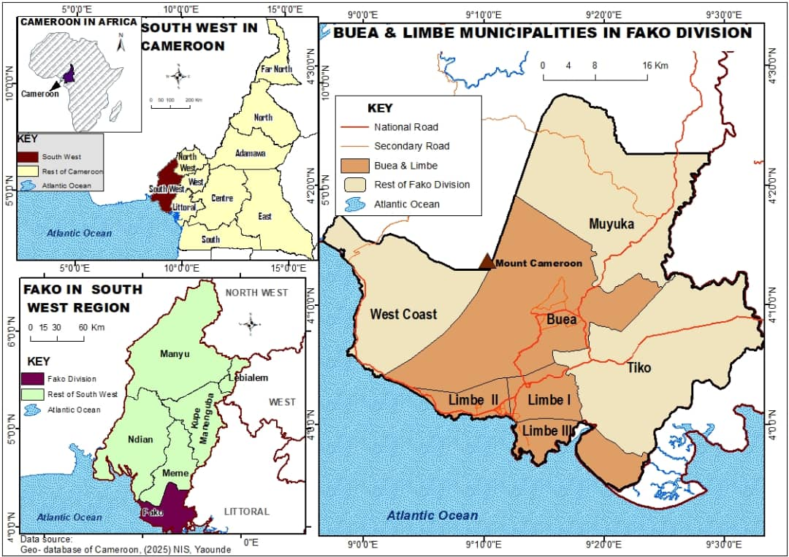
While both Buea and Limbe are located at the foot of Mount Cameroon, Buea is predominantly upland, whereas Limbe lies within a low-lying coastal basin. This difference in topography, combined with their proximity, plays a significant role in shaping their rapid urban development patterns and environmental dynamics alongside their fast-growing urban population.
2. Literature Review
Interest in the spatial and temporal dynamics of urban green spaces (UGS) as an aspect of sustainable urban planning has attracted scholars worldwide. As urban areas continue to expand, green spaces undergo transformation, fragmentation, and decline, reflecting changing land use. Studies continue to show that UGS dynamics vary across space and time, and these changes are closely linked to urbanisation processes. Zh et al. (2019) and Liu (2024) analysed changes in Shanghai using land-use and land-cover data from 1980 to 2015 and found a significant decline in green space from 84.8% in 1990 to 61.9% in 2015, alongside an increase in built-up areas from 15.0% to 36.5%. However, urban and island green spaces declined, while the city centre experienced a gradual recovery, indicating spatial heterogeneity in green space dynamics. A similar pattern is observed in the Buea and Limbe urban spaces, where green space decline is more pronounced toward the periphery, with only a minor increase in central areas in the long run. Qian et al. (2018) employed image analysis in Beijing to identify multiple processes, including expansion, shrinkage, creation, and loss of green space patches. Their findings revealed that 9.25% (6179 ha) of green space resulted from patch expansion, while 5.36% (3582 ha) was lost through shrinkage. Additionally, 0.91% (607 ha) was completely removed, whereas 1.23% (821 ha) was newly created. Smaller patches (<1 ha) were particularly vulnerable to disappearance, an indication that increasing fragmentation of urban green spaces. This approach is significant as it captures informal and residual green spaces, which are often minimised but are relevant in the Buea and Limbe context.
Evidence from African cities further indicates widespread decline of urban green spaces. Nero (2017) reported that Kumasi experienced a fourfold decline in green space between 2009 and 2014 compared with earlier periods, accompanied by uneven spatial distribution. Also, Namwinbrown et al. (2024) found increasing fragmentation and a decline in green spaces in Jamale, Ghana, driven by urban encroachment and population growth. These cases are not different from conditions in Buea and Limbe, where rapid urban expansion continues to exert pressure on green spaces. Spatial inequalities in the distribution of green space are also widely documented. Ghosh and Singh (2022) observed uneven reductions in green and blue spaces in Chandannagar, India, with greater losses in central and eastern zones. Likewise, Sathyakumar et al. (2020) revealed that green spaces in Mumbai declined, fragmented, and became more dispersed between 2001 and 2011, with the most severe degradation occurring in the western suburbs. These variations are largely attributed to patterns of urban sprawl, which similarly characterise the expansion of Buea and Limbe.
Furthermore, socio-economic and policy factors play an important role in shaping UGS dynamics. Zhai et al. (2024), in a study of 107 Chinese cities, found significant greening in long-term built-up areas (10,667.52 km²), non-built-up areas (529,310.47 km²), and newly built-up areas (25,110.43 km²). Approximately 65% of cities showed increasing greening trends between 2010 and 2019. Similarly, Wan et al. (2021) found a positive relationship between economic growth and green space expansion in long-established urban areas, enhanced by effective greening policies. However, in non-built-up areas, climate-related factors were more influential. In contrast, in Buea and Limbe, despite limited policy-driven greening, they still do not implement the available basic greening policies. Urban policies have therefore proven to significantly influence green space outcomes. Kong and Nakagoshi (2005) further reported a 27.7% increase in green space area in Jinan City between 1996 and 2004 (from 4,337.7 ha to 5,538.6 ha), attributed to deliberate greening initiatives such as park expansion. Wu et al. (2023) and Zhou et al. (2011) showed that urban greening policies can remedy earlier declines in green spaces caused by rapid urbanisation. However, efforts still remain limited in Buea and Limbe, where green space planning is still weak.
Urban expansion driven by population growth remains the most significant cause of urban green space decline globally (Sharifi & Hosseingholizadeh, 2019; Nor et al., 2017; Haaland & Bosch, 2015). This process leads to the conversion of vegetated land into built-up areas, thereby reducing both the quantity and quality of green spaces (Liu et al., 2021). Population growth further intensifies this trend by increasing demand for land and infrastructure (Li et al., 2019; Halder et al., 2022). In Buea and Limbe, rapid population growth and outward urban expansion are also the main factors contributing to the loss and fragmentation of green spaces. Regarding fragmentation and spatial inequality, Nazombe and Nambazo (2023) reported increased patch density and reduced patch size in Malawian cities, both of which are associated with high fragmentation.
3. Methods
This study adopted a mixed-methods research design, integrating quantitative and qualitative approaches to examine the dynamics of urban green spaces, their drivers, and their implications for sustainable urban development in the Buea and Limbe urban areas. This is an attempt to overcome the limitations of a single approach by linking spatial analysis of land-use change with field-based evidence on its implications.
To monitor land-use and land-cover (LULC) change dynamics using geospatial techniques. This involved the use of remote sensing and Geographic Information Systems (GIS) to analyse spatial and temporal transformations in urban green spaces over a 30-year period (1995-2025). Moderate-resolution satellite imagery from Landsat platforms (Landsat 7 ETM+, Landsat 8 OLI, and Landsat 9 OLI/TIRS) was obtained from the United States Geological Survey (USGS). These datasets were selected due to their consistency, temporal coverage, and suitability for long-term environmental monitoring.
The image processing workflow involved several stages. The radiometric and geometric corrections were applied to ensure consistency and comparability across datasets by removing atmospheric and sensor-related distortions. This was followed by band selection and layer stacking, which enhanced the identification of key land cover features, particularly vegetation. The images were then subset to the study area using a defined Region of Interest (ROI) that covered the urban areas of Buea and Limbe. A supervised classification approach, specifically the Support Vector Machine (SVM) algorithm, was employed to classify images into four major land-use classes: built-up areas, agricultural land, formal green spaces, and informal green spaces. Training samples for classification were derived from field surveys, high-resolution imagery, and expert knowledge. Post-classification refinement techniques, including filtering, were applied to improve classification accuracy and reduce errors, such as isolated-pixel noise.
To ensure reliability, an accuracy assessment was conducted using confusion matrices based on ground-truth data collected via GPS points and field verification. Accuracy indicators, including overall accuracy, user’s and producer’s accuracy, and the Kappa coefficient, were computed, with acceptable thresholds set at 85% or higher. Change detection analysis was performed using a post-classification comparison method. This involved overlaying classified images from different years (1995, 2000, and 2025) to identify transitions between land use classes. The magnitude, percentage, and annual rates of change were calculated to quantify the extent and direction of land transformations. This approach enabled the identification of key trends, particularly the conversion of green spaces into built-up areas, thereby providing a clear understanding of urban expansion patterns and the decline of green spaces.
In addition to geospatial analysis, primary field data were collected to assess the drivers and implications of these land-use changes for sustainable urban development. A sample size of 400 households was selected through a combination of stratified and random sampling across 13 neighbourhoods in Buea and Limbe, ensuring representation of different urban densities and levels of green space integration.
Questionnaires, interviews, cameras and GPS were the main instruments for primary data collection. The questionnaires were semi-structured and administered to household heads or their representatives who had lived in the area for at least 2-3 years. The questionnaires captured data on residents’ perceptions of green space changes, their roles (economic, social, and ecological), drivers and the challenges associated with their management. Responses were measured on a four-point Likert scale, enabling quantitative analysis of attitudes and perceptions. The collected data were analysed using the Statistical Package for the Social Sciences (SPSS), yielding descriptive and inferential statistics to support the study objectives.
In complement to the questionnaires, field observations played a critical role in validating and enriching the data. Observations were conducted throughout the study period, and a handheld GPS was used to record the spatial locations of green spaces and other relevant features. This process facilitated ground-truthing of satellite imagery and supported the mapping of the spatial distribution and characteristics of different green space types. Field observations also provided more information on the physical condition, usage patterns, and level of integration of green spaces within the urban fabric, while cameras captured key photos.
4. Results/Discussions

Change detection of Urban Green space land use /cover changes from 1995 to 2025
The results shows that within the past 30 years (1995-2025) under study, there have been steady changes in land use across the study area presenting noticeable, transformations, at different times and magnitude In Buea farmlands has expanded, from 330.84 ha (4.54%) to 2,355.28 ha (32.36%), a growth of 2,024.44 ha (27.82%), while in Limbe it rose from 547.18 ha (18.71%) to 720.05 ha (24.61%), an increase of 172.87 ha (5.90%). Informal green spaces declined in Buea from 6,181.79 ha (84.88%) to 1,811.51 ha (24.89%), a reduction of 4,370.28 ha (59.99%), and in Limbe from 1,800.98 ha (61.57%) to 491.62 ha (16.80%), a loss of 1,309.36 ha (44.77 %).
Formal green spaces/open spaces which forms part of the built up also increased alongside the built-up area in if Buea rose from 658.90 ha (9.54%) to 1,581.83 ha (21.73%), an expansion of 922.93 ha (12.19 %), and in Limbe they increased from 7.01 ha (0.24%) to 531.69 ha (18.17%), an increase of 524.68 ha (17.93).
Built-up areas have significantly expanded over the past 30 years. In Buea, built-up land increased from 111.08 ha (1.53%) in 1995 to 1,530.76 ha (21.03%) in 2025, reflecting a growth of 1,419.68 ha (19.50%). Similarly, in Limbe, built-up areas increased from 570.11 ha (19.49%) to 1,182.49 ha (40.42%), representing a gain of 612.38 ha (20.93%). These changes illustrate urban expansion and the shrinking of informal vegetated land in both urban spaces. Table 1 presents the Magnitude of change per landcover class for each period in the study area.

Table 1: Magnitude of change per land cover/land use for each period
LULC |  | 1995-2010 |  | 2010 -2025 |  | 1995-2025
 |  | Buea | Limbe | Buea | Limbe | Buea | Limbe
FGS/OS | Area | -18.97 | 52.19 | 941.90 | 472.48 | 922.93 | 524.68
FGS/OS | % | -2.88 | 744.34 | 147.19 | 798.09 | 140.07 | 7484.31
FL | Area | -0.06 | 133.03 | 2024.50 | 39.84 | 2024.44 | 172.87
FL | % | -0.02 | 24.31 | 612.04 | 5.85 | 611.91 | 31.59
IGS | Area | -519.52 | -574.30 | -3850.76 | -735.06 | -4370.28 | -1309.4
IGS | % | -8.40 | -31.89 | -68.01 | -59.91 | -70.70 | -72.73
BU | Area | 537.84 | 389.69 | 881.84 | 222.69 | 1419.68 | 612.38
BU | % | 484.19 | 68.36 | 135.89 | 23.20 | 1278.07 | 107.39
Source: Extracted from Landsat 1995,2010, and 20225
According to Table 1, the magnitude of change varies across land-use and land-cover classes over the 30-year study period. Built-up areas, accompanied by formal green and open spaces, are increasing, while natural vegetation in informal green spaces is decreasing. Informal green spaces indicate a remarkable decrease across the study area with a decline of 4,370.28 ha (-70.70%) in Buea and 1,309.40 ha (-72.73%) in Limbe, indicating continues rapid land conversion substantiated by an increase magnitude of built up from 1,419.68 ha (1278.07%) in Buea and 612.38 ha (107.39%) in Limbe, confirming the dominance of urban expansion over the three decades. By implication, as built-up areas continue to expand, natural green vegetation will retreat rapidly. Therefore, it is necessary to ensure the sustainability of green spaces as part of sustainable urban development through conscious planning. Most formal green spaces exhibiting increasing trends are the result of small-scale attached greenery accompanying built-up areas in some planned residential developments. Map 2 and Figure 1 presents the land use and cover from 1995 to 2025.

Figure 4.4 Summarised land use and Land Cover situations (1995 -2025)

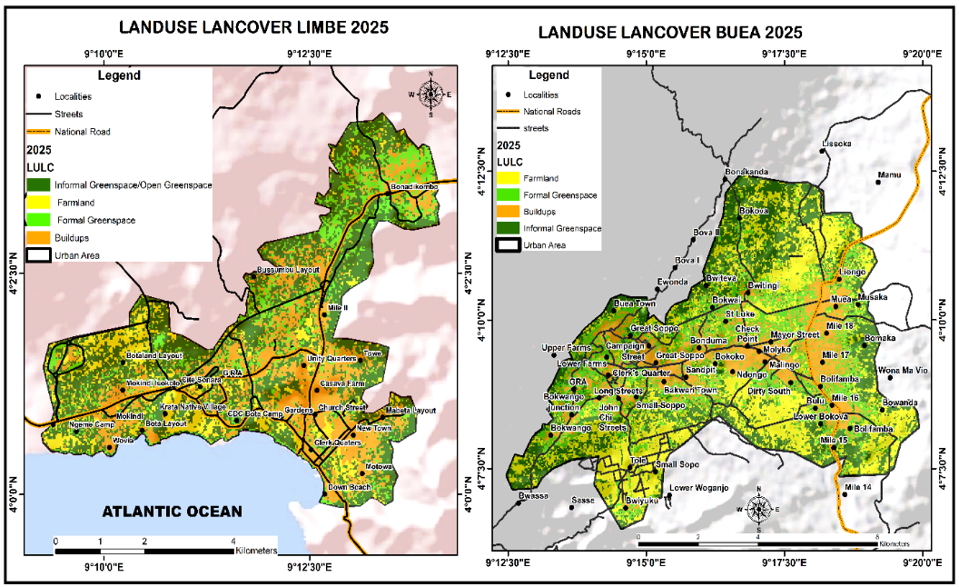
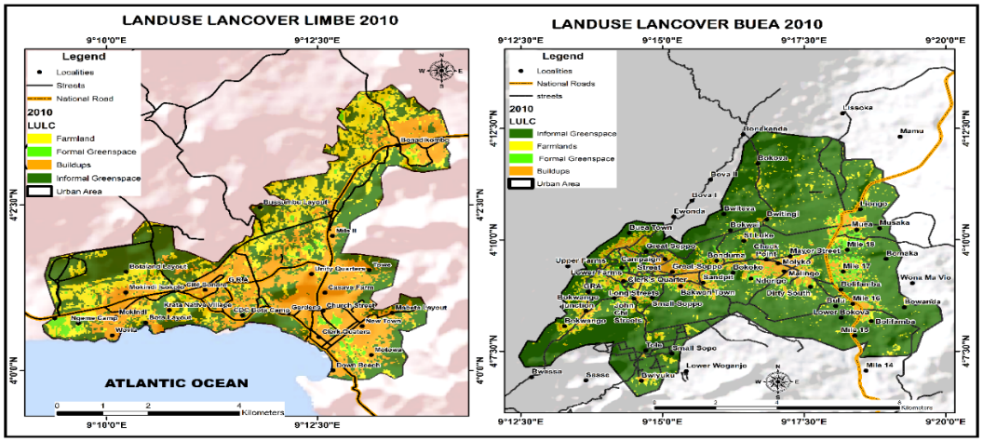
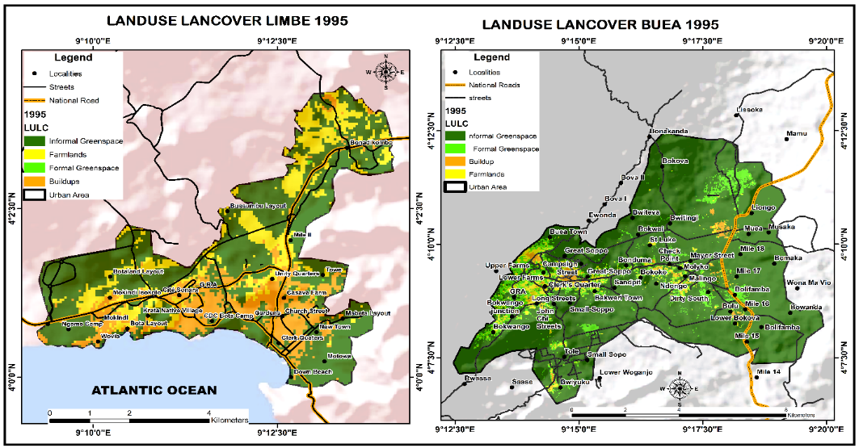

Map 2: Summarised Land Use and Land Cover situations in 1995, 2013 and 2022
From Map 2 and Figure 2, the land-use situation for 1995, 2010, and 2025 shows an increasing trend in built-up areas, accompanied by limited growth in landscaped or formal green spaces and an increase in patches of maintained green spaces close to built-up areas. Farmland exhibits an increasing but fluctuating trend because more informal green spaces are being continuously transformed into farmland plots, which are then further converted into built-up areas. This explains why the informal vegetation in forests and grasslands has steadily decreased. In the Limbe wetland, riparian greenery, including mangroves, has declined, particularly between 2010 and 2025. One of the primary reasons is that mangrove forests are cut down for fish smoking and for the construction of fishing canoes. Moreover, the sudden emergence of housing structures in uninhabited areas of wild vegetation is becoming a common and persistent phenomenon in the study area, as confirmed by a house owner behind the stadium in Buea.
“When I first moved here 20 years ago, I did not have close neighbours, the place was deserted, and my children used to be scared to come out at night. All we could hear was the sound of birds and the wind swishing through the trees. Some of the plots were farmland, while others were covered in wild vegetation. However, as time passed, many people began constructing, and more individuals continued to acquire land. This is why the neighbourhood is more developed today, and I now have close neighbours. I really miss the quiet, fresh, calm, and natural environment I used to enjoy. However, I am happy I have neighbours to talk and laugh with, and my family now feels more secure with the presence of many houses.” (House owner in Buea, 2024.
Plate 4.1 depicts the increasing built-up in Buea in 2024, which is occurring amid many existing structures and on land formerly covered by crops and patches of natural vegetation.
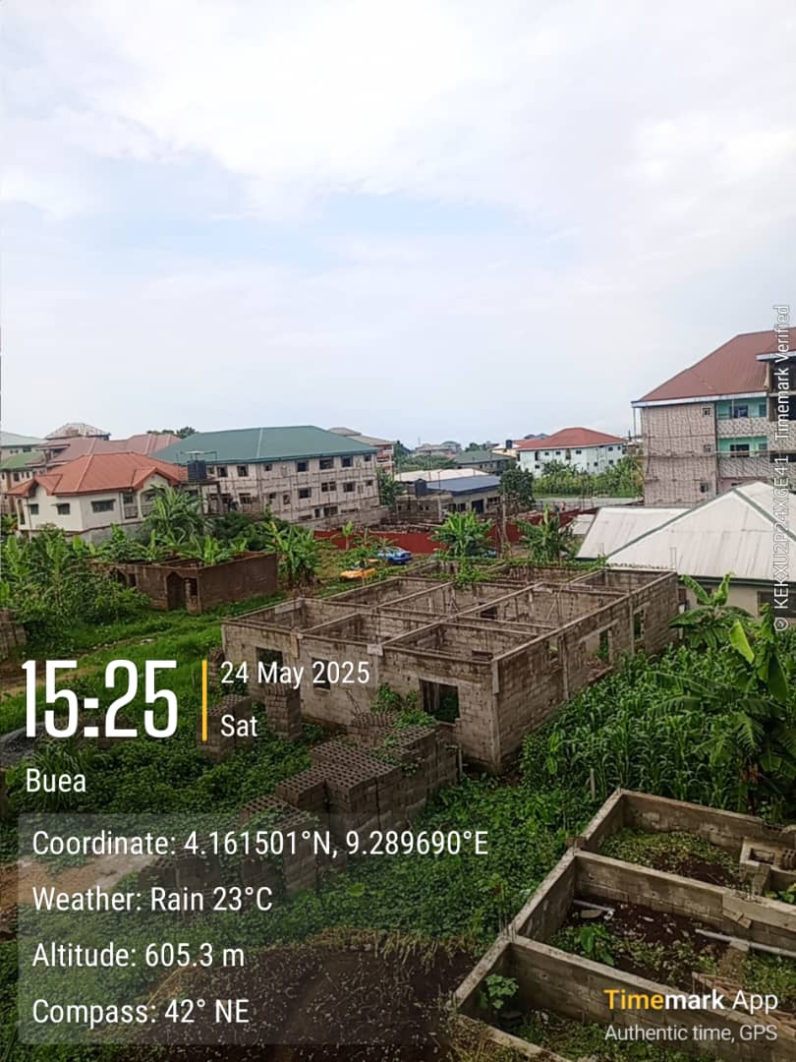
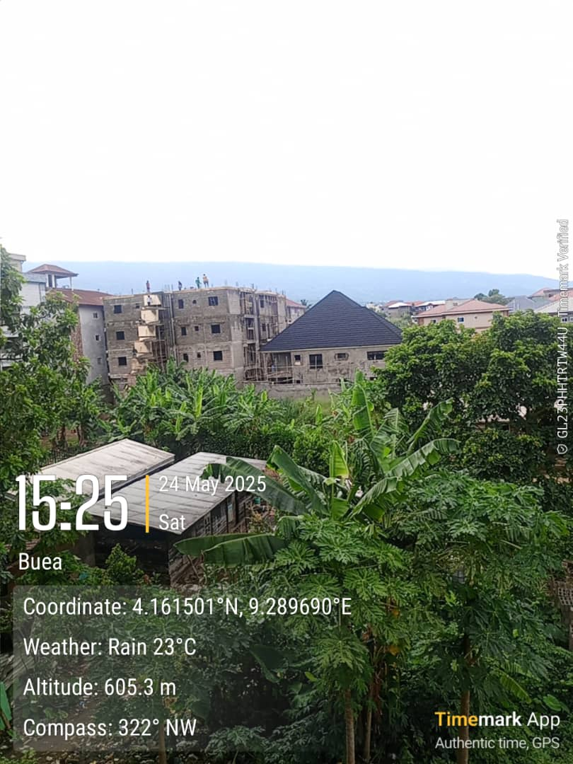
A

B

Plate 1: Built up in Progress in Buea. A: a foundation awaiting building, B: an ongoing high-rise building
Source: Field work,2024
The dominance of plantain plants indicates the remains of plantain and banana plants after the transformation of the plantain plantation, located behind the checkpoint, into food crop farmlands and subsequently into settlements. This occurred after some plantations were leased to the population for settlement.
Therefore, field respondents' observations on Land Use and Land Cover Changes, along with land use and land cover maps derived from satellite imagery, continue to indicate and illustrate a continuous decline in informal green spaces in urban areas, accompanied by limited integration of designated or formal green spaces, as seen in Table 2.

Table 2: Respondents' views on land use and land cover change
observation | Number of responses |  | Percentages |  | Total (N) | Total (%)
observation | Buea | Limbe | Buea | Limbe | Total (N) | Total (%)
Farmland to build up | 70 | 117 | 43.8 | 48.8 | 187 | 46.8
Natural vegetation to build up | 20 | 35 | 12.5 | 14.6 | 55 | 13.8
Natural vegetation to farmland | 65 | 80 | 40.6 | 33.3 | 145 | 36.3
Natural vegetation/ farmland to formal green or recreation | 4 | 9 | 2.1 | 3.2 | 13 | 3.3
Total | I60 | 240 | 100 |  | 400 | 100
Source: Field Work (2024)
From Table 2, the pattern from natural vegetation/farmland to green and recreational spaces, such as parks, gardens, and green plazas, is quite timid, at 2.1% in Buea and 3.2% in Limbe. Even though Limbe shows a slightly higher percentage, given that it is more of a coastal and tourist town, this suggests timid development of public urban green space. The general pattern, therefore, shows a transition from natural vegetation to farmland, and from farmland to built-up areas. This implies that some of the natural vegetation complementing urban green spaces is presently ephemeral and holds little promise for the future, as it is transforming.
4.4. Drivers of urban green space fragmentation and transformation
The complexity and dynamism of human actions and natural forces are responsible for the continuous fragmentation and decline of green spaces in the study area. The continuous segmentation of a large expanse of natural vegetation, farmland, and built-up areas has been driven by human action in urban development and, to some extent, by natural factors. Humans undertake urban development for their own benefit, which requires some form of land transformation to meet human needs. About 96.2% of the population affirmed that the transformation of natural green space is driven by urban development. Figure 4.8. presents the relative influence of drivers of natural green space fragmentation and transformation in the study areas.

Figure 2: Rate of Influence of Drivers of Natural Greenspace Transformation
Source: Field work 2024
As illustrated in Figure 2, various factors contribute to the fragmentation and transformation of urban greenspace within the broader context of urban development. These factors are Demographic, Socio-Economic, and natural.

4.4.1 Population Growth
The demographic drivers result from both the natural birth rate and immigration into the study area. Population growth as a driver of urban development and of green space transformation, fragmentation, and reduction has been confirmed, with 30.4% in Limbe and 26.3% in Buea. This indicates that the study areas have experienced population growth over the years, driven by both natural increase and immigration. These towns are regarded as fast-growing, cosmopolitan centres because they are both educational and tourist destinations. These towns, therefore, have the potential to attract immigrants from across the country and even abroad for educational, business, and administrative purposes, given that Buea is the administrative capital of the Southwest Region. This implies that a greater proportion of the population is immigrants, which accounts for the study area's cosmopolitan nature (Figure 3).

Figure Origin of Respondents
Source: Field Work 2024
The demographic composition of respondents by origin indicated that the majority of the population are internal immigrants (68.8%). These migrants come from different regions of the country, especially the Northwest and Southwest regions. They come for education, especially in Buea, as well as for business, work, and tourism. Many also came during the colonial era to work in the plantations and to exploit the fertile volcanic soils at the foot of Mount Cameroon. For the past eight years, there has been a noticeable influx of immigrants from the Northwest and many parts of the Southwest, especially from rural areas, due to the Anglophone crisis. This is because these towns (Buea and Limbe) have been relatively calm during this ongoing crisis. While some of the crisis migrants came to live with relatives, a significant number of them eventually rented houses, bought land, and settled, with little prospect of returning. Indigenous residents make up only 25.5% of the respondents, and external migrants comprise 5.7%. This suggests that internal and external migrants far exceed the indigenous population, contributing significantly to the overall population growth in the study area.
This explains why Settlements exert the strongest pressure, on natural greenspace conversion as accounted by the respondents (40.6% in Buea and 30.8% in Limbe), this shows a very close link with population as the second driver of greenspace conversion which indicates that as the population increases there is the need for shelter as a necessity for the growing urban population and that is why residential built up exerts a lot of pressure on land in the study areas. This growth in settlements, therefore, results from rural-urban migration, student inflows in Buea, and tourism-related housing in Limbe, all of which demand more land for accommodation. This was further confirmed by a worker at the Regional Delegation of Housing and Urban Development in Buea, in an interview, who said, and I quote:
“As a result of the ongoing Anglophone crisis, many families have moved from different villages, towns and regions into several neighbourhoods like Clerks Quarters, Bakwango, Sandpit, New Town, and New Layout seeking safety and survival opportunities. There has been an increasing demand for housing. In response to this demand, many property developers and private landlords have constructed houses even in marginal zones.
Socio-economic and administrative Drivers
Socio-economic structures and policies significantly influence urban growth and development, which, in turn, greatly impact green space segmentation and transformation. According to Mensa (2014), urbanisation is the primary driver of the loss of urban green spaces, manifested in the physical expansion of settlements and the socio-economic structures. These structures, by themselves, are attractive forces driving rural-urban migration into the study area, driven by employment, education, and business opportunities. Although the study area is not highly industrialised, the presence of major economic, social, and administrative structures, as perceived by respondents (Limbe: 27.9% and 17.5% in Buea), has impacted the transformation of green spaces. Administratively, Buea, being the regional Capital of the South West Region, hosts many administrative structures, including the various regional delegations that represent the state Ministries. Socioeconomic structures, such as schools, roads, businesses, markets, and hospitals, are essential to a growing urban area and can stimulate further development. This is because when the population is empowered and healthy, with access to socio-economic opportunities, they themselves become agents of development; however, this must be accompanied by sustainability goals. Buea is considered an administrative and educational town. This is because the presence of the University of Buea in Molyko has not only attracted other higher institutions but also all other social and economic structures, including housing, especially for students who flock to this town, but has made Molyko a hub of development, where most economic activities thrive. However, in terms of natural and human-maintained greenery, this neighbourhood has the least, as there is a high demand for land for hostels and other urban uses. However, on the university campus itself, some efforts have been made to establish a well-structured, formal green space network for the institution. Limbe, as a tourist town and destination, also attracts economic development, especially in recreation and hospitality. Greenery, including even wetland greenery, has been encroached upon and transformed into hotel settlements and businesses to meet the needs of both permanent residents and visitors, as well as tourists who come in and out of this town daily. Even the Botanic Garden, as the central urban forest greenspace, has been threatened by encroachment due to economic development pressures, as confirmed by the interview with the manager of the garden's biodiversity conservation department. Among the socio-economic drivers of green space transformation, road construction often attracts other development, affirming the common saying that ‘when a road passes, development follows.’ The opening and tarring of some neighbourhood roads has set the impetus for the massive transformation of green space and farmland in these neighbourhoods in the study area.
Natural Factors
Natural factors appear to have the least influence on the transformation of green spaces, as reported 2.1% in Limbe and 9.4% in Buea of the entire population. This indicates that environmental processes such as erosion, landslides, or climatic variations play a relatively minor role compared to human-driven forces. The slightly higher value observed in Buea may be linked to its unique physical environment, which is strongly influenced by the volcanic slopes of Mount Cameroon. In such mountainous terrains, natural processes such as slope instability, heavy rainfall, and soil erosion may occasionally contribute to vegetation loss or landscape modification. Nevertheless, the relatively small overall contribution of natural factors suggests that the fragmentation and decline of urban green spaces in the BLUS are predominantly anthropogenic, driven largely by urbanisation rather than by natural environmental changes. This indicates that natural factors are secondary, while human-induced factors are at the forefront.
Formal green recreational and conservation infrastructure, which is supposed to accompany this unstoppable urban growth and expansion, is relatively insignificant (6.3% in Buea and 8.8% in Limbe). Green infrastructure in this context includes the construction of roads, drainage networks, public facilities, and other urban services necessary for city functioning. Designated green spaces are essential because they preserve natural green areas, maintain a natural feel, and offer potential for social, mental, and economic well-being, alongside ecological benefits. The conscious integration of greenery into urban planning in the study area remains low, resulting in minimal impact on land cover changes. Although these developments are essential for improving accessibility, mobility, and urban service delivery, they can also result in clearing or modifying natural vegetation and the fragmentation of existing green spaces. Despite their important role in sustainable urban development, their development is, however, very limited in the study area so too is their impact on natural green spaces

4.3 Implications of Unsustainable Green Space Segmentation and Transformation
The continuous decline in urban greenery has contributed to negative externalities, such as flooding and urban heat waves, and, consequently, to the well-being of the urban population. This was affirmed by approximately 92% of the sampled population. Figure 4.8 illustrates respondents' views on the implications of unsustainable urban greenspace fragmentation and transformation for the environment and human well-being, extending beyond the loss of connectivity and the presence of patches with no definite function.

Table 3: Implications Ratings of unsustainable green space segmentation and transformation
Implications of unsustainable urban green space fragmentation and transformation | Implication rating
 | Mean |  | Standard deviation
 | Buea | Limbe | Buea | Limbe
Environmental implications
Increasing urban heat island | 2.01 | 3.03 | 1.153 | 1.051
Increasing floods | 2.72 | 3.41 | 1.207 | 0.127
Biodiversity loss | 2.31 | 2.6 | 1.135 | 1.235
Social Implications
Loss of recreation opportunities | 2.6 | 2.8 | 0.961 | 1.231
Health effects and stress-related diseases | 1.91 | 2.4 | 1.24 | 1.1
Decline in landscape beauty | 2.7 | 2.5 | 0.961 | 0.942
Source: Field Work 2024

4.3.1 Environmental Implications
The increasing urban heat effect is a reality in the study area, especially during the dry season. In Buea, the mean score is 2.01, while in Limbe it is 3.03 on a 4-point scale. Limbe shows a higher rate of urban heat island than Buea. This, however, results in Buea's climate being cooler than Limbe's due to its natural location. In Buea, the urban heat island is particularly pronounced in Molyko, the highest, most built-up neighbourhood. Residents across the study area confirm that there has been an increase in heat stress linked to unsustainable fragmentation and transformation of green spaces as an older woman in Molyko, Buea, further stated.
Over the past few years, I have noticed that Molyko has become much hotter, especially during the dry season. More buildings are being constructed, and many of the green spaces and banana plantations that used to be located at Malingo and Checkpoint, as well as those moving towards Bwitingwi, have been replaced by buildings. These plantation trees and vegetation help bring fresh air into our neighbourhood. It has become so hot that almost everyone now uses fans.
Urban green space fragmentation and transformation have also contributed to increased urban flooding in the study area. According to Table 4.7, Buea reports a mean of 2.72, and Limbe a mean of 3.41, on a scale of 4; this indicates a strong affirmation that green space loss reduces runoff moderation. A higher mean value for Limbe indicates a higher flood frequency, driven by sea overflows and poor drainage and runoff during heavy rainfall. Continuous biodiversity loss was recognised as one of the implications of urban greenspace transformation, with mean scores of 2.31 in Buea and 2.60 in Limbe. Residents observe declines in bird, tree, and small-animal species, often due to mangrove clearing and deforestation for urban development.

4.3.2 Social Implications
Concerning social consequences, respondents report moderate concern for the impacts of green space loss on recreation, health, and landscape aesthetics. The loss of recreational opportunities is measured at 2.6 in Buea and 2.8 in Limbe, reflecting that urbanisation reduces the availability of spaces for leisure and outdoor activities, although experiences vary across neighbourhoods. This results from the fact that remaining green spaces are of low quality and low connectivity, becoming small and fragmented, with little or no specific functions. Additionally, many neighbourhoods' open spaces and large tree canopies, which provide relaxation and shade, have been cut down. In most cases, these trees are not replaced, even by ornamental trees. Health effects and stress-related diseases are rated lowest, with means of 1.91 in Buea and 2.4 in Limbe, suggesting that residents are less aware of or less directly affected by the health outcomes of green space fragmentation, despite its potential long-term implications.
Degradation in landscape beauty receives moderate recognition, with Buea at 2.7 and Limbe at 2.5, likely reflecting Buea’s more scenic, vegetated environment, where aesthetic changes are more noticeable. Standard deviations across these social indicators indicate that while some impacts, such as recreation loss and aesthetics, are widely agreed upon, perceptions of health impacts remain more varied. Generally, the residents in both towns acknowledge the social consequences of green space transformation, but environmental effects, particularly heat and flooding, are viewed as more glaring.
5. Discussions and conclusions
The spatio-temporal dynamics of urban green spaces in Buea and Limbe show a continuous pattern of urban land transformation observed across Cameroon, Africa, and beyond. Studies highlight a significant decline in vegetated areas, particularly forests, wetlands, and agricultural lands, alongside a steady expansion of built-up surfaces driven by rapid urbanisation, which is not complemented by designated formal green spaces. In Limbe, substantial forest loss and fluctuating agricultural decline between 1986 and 2020 show how urban growth directly encroaches on natural landscapes (Enomah et al., 2025). Similarly, studies in Yaoundé reveal a dramatic 50% reduction in vegetated surfaces between 2000 and 2020, indicating intense land conversion (Nkwemoh, 2017), while Balgah and Kemengsi (2016) also documented a sharp decline in wetland vegetation in Bamenda in favour of residential expansion.
These findings are similar to broader regional and global trends. In Kumasi, Ghana, urban green space coverage declined drastically within a short period, accompanied by spatial inequalities in distribution (Nen, 2017). Likewise, Wan et al. demonstrated significant spatio-temporal transformations in green spaces across 107 Chinese cities, characterised by fragmentation and uneven distribution. Similar patterns have been reported by Seto et al., who highlighted the rapid conversion of natural land to urban areas globally, and by McDonald et al., who emphasised the ecological implications of urban expansion for green spaces and biodiversity. Furthermore, Kabisch et al. noted that urban green spaces in many cities are increasingly under pressure despite their critical role in enhancing urban resilience and human well-being.
The observed patterns are driven by demographic pressures, socio-economic demands, and governance challenges, all of which are interconnected. Rapid population growth, increased demand for housing and infrastructure, and weak enforcement of land-use regulations contribute significantly to the decline and fragmentation of green spaces (Seto et al., 2012; McDonald et al., 2018). At the same time, the Buea and Limbe study provides a nuanced perspective by incorporating both formal and informal green spaces, revealing that while overall green space is declining, there are emerging efforts to integrate formal green elements into urban development. This aligns with the findings of Kong and Nakagoshi (2025), who documented increases in certain categories of formal green spaces, such as parks, plazas, and residential greenery, reflecting policy-driven efforts to promote urban greening.
These findings reveal that an unsustainable process of urbanisation, driven by population growth and human behaviour, alongside weak urban policies and limited follow-up, does not adequately address green space development as a significant component of urbanisation. It is clear that urbanisation, in both its physical expansion and development, leads to the fragmentation and depletion of green space. It is important because it meets the needs of the urban population by providing employment, increasing property values, and improving physical and psychological well-being through improvements in living standards; therefore, it cannot be undervalued or discouraged. However, when urban development at its initial stage fails to maintain a fair balance with green space development by omitting it from its development plan, it results in adverse effects. To address the ongoing decline and fragmentation of urban green spaces and their negative consequences in Buea and Limbe, a comprehensive, integrated approach to urban planning and management is needed. This requires the involvement of local communities in the planning, management, and conservation of green spaces to promote sustainability and a sense of ownership. Municipal authorities should also adopt nature-based solutions, such as urban afforestation and ecosystem restoration, and create new sites to enhance environmental resilience.
Conclusion
The study of spatio-temporal trends in urban green spaces in Buea and Limbe reveals a clear pattern of decline and transformation driven by rapid urbanisation, consistent with trends observed across Cameroon and globally. While the expansion of built-up areas continues to exert pressure on natural landscapes, emerging efforts to incorporate formal green spaces signal a shift towards more sustainable urban planning practices. However, without strong governance, effective policy implementation, and inclusive planning approaches, the continued loss and fragmentation of green spaces will exacerbate environmental degradation and reduce urban livability. Therefore, achieving sustainable urban development in Buea and Limbe requires a balanced approach that prioritises the protection, restoration, and integration of green spaces alongside urban growth. Such an approach will not only mitigate environmental challenges but also enhance the socio-economic well-being of local urban residents and visitors.

BIBLIOGRAPHY
- Balgah, R. A., & Kemengsi, J. N. (2016). Urbanisation and wetland loss in Bamenda, Cameroon. Journal of Environmental Planning and Management, 59(8), 1–18.
- Benedict, M. A., & McMahon, E. T. (2002). Green infrastructure: Smart conservation for the 21st century. Renewable Resources Journal, Autumn, 12–17.
- Benedict, M. A., & McMahon, E. T. (2006). Green infrastructure: Linking landscapes and communities. Island Press.
- Cilliers, E. J. (2015). The importance of green infrastructure for sustainable development in South Africa. Environment, Development and Sustainability, 17(5), 1025–1040. https://doi.org/10.1007/s10668-014-9587-2
- Colding, J., & Barthel, S. (2020). The role of urban green spaces in resilience and sustainability. Nature Sustainability, 3(5), 366–373.
- Ellis, J. B. (2013). Sustainable surface water management and green infrastructure in UK urban catchment planning. Journal of Environmental Planning and Management, 56(1), 24–41. https://doi.org/10.1080/09640568.2011.647232
- Enomah, L. D., et al. (2025). Urban expansion and loss of agricultural land and forest cover in Limbe, Cameroon (1986–2020). Land Use Policy, 145, 106789.
- Ghosh, S., & Singh, K. (2022). Spatio-temporal changes in green and blue spaces in Chandannagar city, India.
- Griggs, D., Stafford-Smith, M., Gaffney, O., Rockström, J., Öhman, M. C., Shyamsundar, P., Steffen, W., Glaser, G., Kanie, N., & Noble, I. (2013). Sustainable development goals for people and planet. Nature, 495(7441), 305–307. https://doi.org/10.1038/495305a
- Haaland, C., & Bosch, C. K. (2015). Challenges and strategies for urban green-space planning in cities undergoing densification. Urban Forestry & Urban Greening, 14(4), 760–771.
- Halder, B., et al. (2022). Urbanisation and the scarcity of green space in cities.
- Kometa, S. S., Lambi, C. M., & Tata, E. S. (2019). Laissez-faire environmental policy implementation and Fako urban blight, Cameroon. Environmental Management and Sustainable Development, 8(1), 95–110. https://doi.org/10.5296/emsd.v8i1.14264
- Kong, F., & Nakagoshi, N. (2005). Changes of urban green spaces and their driving forces: A case study of Jinan City, China. Urban Forestry & Urban Greening, 3(2), 97–110.
- Kong, F., & Nakagoshi, N. (2025). Spatio-temporal dynamics of urban green spaces and policy implications in Chinese cities. Landscape and Urban Planning, 240, 104456.
- Lambi, C. M., Kimengsi, J. N., Kometa, C. G., & Tata, E. S. (2012). The management and challenges of protected areas and the sustenance of local livelihoods in Cameroon. Environment and Natural Resources Research, 2(3), 10–23. https://doi.org/10.5539/enrr.v2n3p10
- Li, X., et al. (2019). Population growth and dynamics of urban green space.
- Liu, Y. (2024). Spatio-temporal dynamics of urban green spaces and economic factors.
- Liu, Y., et al. (2021). Urbanisation impacts on green space quality.
- McDonald, R. I., Kareiva, P., & Forman, R. T. T. (2008). The implications of current and future urbanisation for global protected areas and biodiversity conservation. Biological Conservation, 141(6), 1695–1703. https://doi.org/10.1016/j.biocon.2008.04.025
- McDonald, R. I., Mansur, A. V., Ascensão, F., et al. (2018). Research gaps in knowledge of the impact of urban growth on biodiversity. Nature Sustainability, 1(7), 329–339.
- Namwinbrown, J., et al. (2024). Land-use and green space fragmentation in Jamale, Ghana.
- Natural England. (2012). Green infrastructure guidance. Natural England.
- Nazombe, M., & Nambazo, J. (2023). Spatial-temporal fragmentation of urban green spaces in Malawi.
- Nen, L. (2017). Urban green space dynamics and spatial distribution in Kumasi, Ghana. Urban Forestry & Urban Greening, 24, 1–10.
- Nero, B. F. (2017). Spatio-temporal dynamics and distributional inequalities of urban green spaces in Kumasi, Ghana.
- Nkwemoh, C. (2017). Urban land use change and vegetation dynamics in Yaoundé, Cameroon. African Geographical Review, 36(3), 1–15.
- Nor, A. N. M., et al. (2017). Urban expansion as a driver of green space loss.
- Qian, Y., et al. (2018). Dynamics of urban green space at the patch level in Beijing using object-based image analysis.
- Sathyakumar, V., et al. (2020). Geospatial assessment of urban green space distribution in Mumbai.
- Seto, K. C., Güneralp, B., & Hutyra, L. R. (2012). Global forecasts of urban expansion to 2030 and direct impacts on biodiversity and carbon pools. Proceedings of the National Academy of Sciences, 109(40), 16083–16088.
- Sharifi, A., & Hosseingholizadeh, R. (2019). Urban expansion and green space reduction.
- United Nations Economic Commission for Africa. (2024). Africa’s urbanisation dynamics report 2024. UNECA.
- United Nations. (2018). The United Nations World Water Development Report 2018: Nature-based solutions for water. UNESCO.
- United States Environmental Protection Agency. (2009). Green infrastructure action strategy. U.S. EPA.
- Wan, C., et al. (2021). Spatio-temporal dynamics of urban green spaces and socio-economic drivers in Chinese cities.
- Wan, Y., et al. (2012). Spatio-temporal changes of urban green spaces in 107 Chinese cities. Landscape Ecology, 27(7), 1–14.
- Watson, V. (2016). Locating planning in the new urban agenda of the urban sustainable development goal. Planning Theory, 15(4), 435–448. https://doi.org/10.1177/1473095215624757
- Wolch, J. R., Byrne, J., & Newell, J. P. (2014). Urban green space, public health, and environmental justice. Landscape and Urban Planning, 125, 234–244. https://doi.org/10.1016/j.landurbplan.2014.01.017
- Wu, J., et al. (2023). Urban greening policies and expansion of green spaces in China.
- Zhai, W., et al. (2024). Urban green space dynamics and policy drivers in Chinese cities.
- Zhou, W., et al. (2011). Changes in urban green space in Kunming under urbanisation and policy influence. Landscape and Urban Planning, 100(4), 361–368.
- Zhu, Z., et al. (2019). Spatio-temporal changes in urban green spaces in Shanghai.

