Adaptive Game Algorithms: Enhancing Procedural Generation and Dynamic Difficulty Adjustment for Smarter Gameplay

INTRODUCTION
One problem with video games lies in the re-playability of its contents, or a balanced player experience. Procedural Content Generation (PCG) enhances re-playability by being able to create large amounts of content using a relatively small amount of human authoring, but not all procedural pipelines understand what the player is building his or her skills or story. Things can leave one with boring missions, unsmooth flow, and unexpected escalation that is not smooth that may appear disjointed. Dynamic Difficulty Adjustment (DDA) approaches, however, vary the variables of the game, whether it be enemy difficulty or enemy frequency or resource amounts, but never change the content or plot that the gamer must work through. Much of the past literature has dealt with the two issues separately. Template-based and grammar-based generators of question have been applied to create plausible scaffoldings of narratives [3, 4], but graph-based and rewrite-based generators are applied to arrange modifications in stories [2]. More modern systems are contextual story-telling based on learned models and agent techniques [6]-[8], DDA studies have proven that player modeling and adaptive systems can keep users engaged with time [10], [13], [14]. However, the reviews also suggest that there is a substantial missing component: there are quite a few systems that have a feedback mechanism on which content generation and difficulty adjustment can continuously inform each other [20], [21]. We aim to bridge that gap. Our Adaptive Quest Generation Framework has a persistent world representation (a World Graph), a World History Manager (WHM) which holds and uses events, a player logging/modeling layer, a rule-based Dynamic Difficulty Adjustment Module (DDAM) and a Quest Generation System (QGS) which is part of synthesis of follow-ups. The WHM stores entities and time variation in a way that the game can recall what has already occurred; DDAM rates the threat of an entity in relation to the player and offers a physical manifestation through deltas of difficulty, hints of spawning, etc., which the QGS can consider in its quest development. To avoid the startling changes in the story, the Story Director and the QGS have some bare bones of a narrative-stability system so that long-term arcs do not get broken by you-only-once difficulty tweaking. The premise of our work is straightforward: the notions of difficulty and storytelling are not independent knobs but they are related components of the player experience - the meaning of a quest and difficulty has to shape each other. Practically, this means that any betrayal, that makes the side of an NPC an enemy, will be accompanied by missions more rewarding, challenging or closer to those goals, and the accomplishments in negotiations will be compensated by missions that are more about negotiations and intrigues than actual combats. This is not a solution to all balance problems, but it makes the process of adaptation less diegetic, showing not the sliders on the screen but the elements of the game world.

RELATEDWORK
Relationship between procedural content generation (PCG) and dynamic difficulty adjustment (DDA) has been researched in several threads on game-AI research, but has seldom been approached collectively as a challenge. The two subjects have been running parallel within the last couple of years as PCG researchers have been focusing on variety and structure, and DDA researchers have been focusing on balancing challenge. Only somewhat more recently have people started doubting that one system can simultaneously produce content and respond to the dynamic competence or experience of a gamer. A. Making Procedural Questions and Narratives. Incidents Early procedural quest work, grammars and templates. The structural analysis that Doran and Parberry gave subsumed MMORPG quests into repeating patterns (collect, rescue, defeat), and developed a prototype generator that recreated the repeating patterns effectively, but was incapable of responding to player performance [3]. Dormans applied parallel grammars to split mission logic and spatial layout, a useful design pattern which is still useful in many generation tools but need not be suitable to the challenge of establishing a balance between these two aspects [4]. Kybartas and Verbrugge proposed a graph-rewriting approach called ReGEN, in which the states of the story and transitions explicitly rewrite the world how we think the world should be reactive in our effort to support it here [2]. Planning- or evolution-based systems (as a branching quest work) that were based on narrative diversity and consistency also did not appear to have an explicit model of how a player skill level or frustration were produced as part of their iteration mechanism [5], [6]. More recent models have put PCG more directly motivated by more natural-sounding, and richer, quests driven by language models and agents based on memory. Vartinen et al. trained GPT-2 on ingredient lists as short quest text and received promising but inaccurate human scores [1], transformer-based encoders and decoders were followed up with systems to make quests context-sensitive [7], and agent-based designs or memory-based designs gave NPCs the chance to create quests based on their own personal goals and histories [8]. Such enhancements make it far more realistic and provide a clue that a generator can take into account the context of players too, but the vast majority of such systems do not go as far as to adjust difficulty based on it. B. Adaptive Difficulty and Modelling Choices and Difficulty of the players. DDA is also slightly more history-based with the action and arcade-based games as compared to narrative. According to surveys and reviews, DDA approaches can be organized into probabilistic, scripted and machine-learning families and it is important to note that good DDA should seem natural to players. Such practices are conveniently categorized by the review by Zohaib and are highlighted as having invisibility as a design goal. [9]. Follow-ups in practice showed that, full-automatic adaptation can actually increase the feeling of immersion, however, the player agency is maintained through manual control a contradiction that can be directly generalized in the context of our concept of adapting story content and numerical values [10]. Deep player behavior models (DPBMs) have also taken the field of reinforcement-learning techniques to the level of customization. Pfau et al. could demonstrate that learned models could be used to model and predict player behavior and that long duration scales could be utilized to shape difficulty to increase motivation and retention [11], [12]. Hybridized approaches - fuzzy-Q learning, physiology-based adaptations or rapid individualization demonstrate that DDA can consider a wide set of signals (performance, stress, short-term skill) and learn within a short time frame [13]-[16]. However, most of this kind of work does not change the contents of the games (enemy health, spawn rates, rewards) but only the shapes and plotlines that the players experience. C. The Attempts to Integrate PCG and DDA. A smaller body of literature directly tries to integrate generation and adaptation. The difficulty variable that was used in polymorph and suchlike projects is level geometry or topography, which is in fact exploiting level layout as a parameter of the adaptive than a fixed asset [17], [18]. The platform level integrated generators react to performance of the player just like using integrated generators [21]. Through narrative oriented studies RL-based curriculum, text worlds generated programmatically, it is believed that systems can become more complex with time as the agent (or player) becomes more competent [22]. The surveys in which experience-driven PCG is put in the context of a review mention, that the notion has a favorable future but is not researched adequately [20]. The existing experimental data of retention and classification of skills show that the acquired DDAs can be more effective than the static heuristics that is why the idea of closer interaction between the generation and the adaptation is practical [17], [19]. C. World Reactivity and Narrative Coherence. Finally, there is a little literature that dwells on the issue of coherence of changing worlds of procedural nature. In order to have the fiction be at least believable as the world develops, heuristic grammars and graphical verification of consistency ground generated content based on spatial layout and non-player character incentives [2], [23]. The strands are particularly relevant to our activity, because it is easy to produce the content outcomes that are capricious or outrageous when difficulty has its play upon content (or the other way about); causality and motivational consistency is therefore a major factor. Synthesis – research gap. This tendency is also present in those threads: PCG has grown significantly more expressive (planning, graphs, and language models) and DDA has become smarter (deep models, RL, physiological inputs). It is however, the middle-ground, systematically generative systems, which are at the same time self-adaptively demanding, in other words, systems which inform one another in a self-sustaining cycle, which are sparsely inhabited. This paper will address this gap with a pragmatic, modular prototype where a World Graph, a World History Manager, a rule-based DDAM, and a quest generator would work together to produce context-appropriate quests without altering the story.

METHODOLOGY
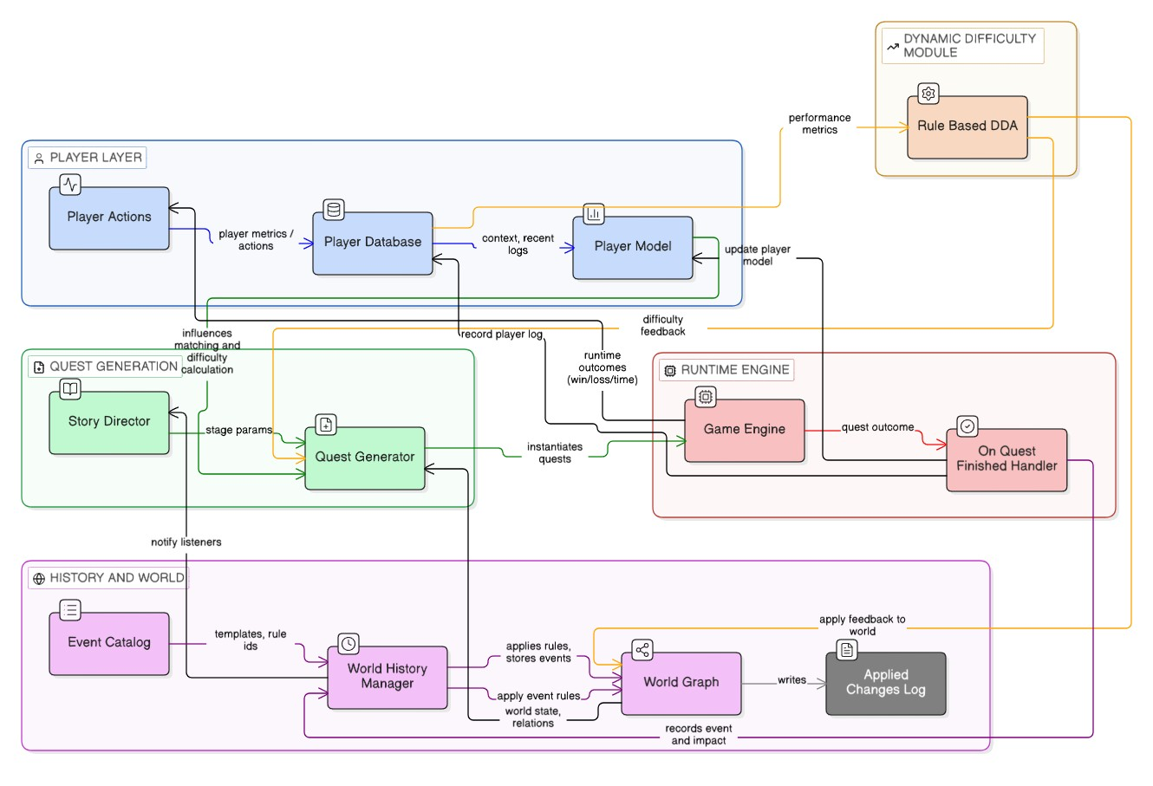
FIGURE 1: Installed network of concrete modules and processes. onquestfinished processes the outcome -> WorldHistoryManager makes WorldGraph rules (and tracks changes). RuleBasedDDA gives QuestGenerator feedback of difficulty and can optionally make world-level changes. Player DB and PlayerModel feed both DDA and QGS. Forwarding of information in a continual feedback cycle: The player activities are reflected across into the DB of the Player and DDAM that condition the QGS via the WHM/World Graph. The Game Engine takes the form of Quests, and their outcomes transform the world and make the world complete the cycle.
Our experimental design involved investigation of the experience of the interaction between procedural quest generation and dynamic difficulty adjustment (DDA) to determine how they affected each other and relied on the generation of an emergent game world. It was developed under the influence of two expediency principles: mirror the world as a system of valuable relationships, and leave events, not written scripts, to initiate the story and the challenge. Concretely, we generated 6 co-operating components, namely a World Graph, a World History Manager (WHM), a Story Director, a Quest Generator, a Player Model and Log, and a Rule-Based DDA. These components are similar to graph-based story system techniques [2], structural query techniques [3], and surveyed DDA techniques [9],[11]. World graph represents entities (i.e. NPCs, locations, items, enemies, etc.) as nodes and the semantic relationships (such as hates, alliance, threatens, etc.) as weighted edges. The attributes on the nodes are secondary and they maintain a temporal state (base HP, spawncount, danger) and the events can be used to update the state attributes.
Danger_{new} = min(1.0, Danger_{old} +I_{e} ×α)
The WHM maintains WorldEvents (type, importance, priority, decay) and rules based on data (JSON), which update nodes/edges without causing the graph and history to break. These time-decays of events are linear hence significant incidents that are recent are salient when it comes to the construction of quests.
W_{e}(t)= max(0, I_{e} −(t −t_{e})·d_{e})
where
W_{e}(t) : effective weight of the event at time t I_{e} : initial importance of the event t_{e} : time at which the event occurred d_{e} : decay rate of the event
The constraint is imposed by a Story Director on the stages (we used Freytag-like stages) and hears WHM events. It evaluates triggers at every stage, filters by event type, story tags, importance, sequences / count-in-window checks and captures some history of triggers in order that we can later find out what actually caused the story. The choice is biased by the director because the Quest Generator (accepted arcs, minimal relation weights, stage rating) does offer a small amount of structure to the narrative flow without determining the results, but it is an emergent process, akin to systems of StoryWorld style [7]. Candidate events are compared with templates by the Quest Generator. To combine tag overlap, relation checks against the world graph, event effective weight (after decay) and a stagerating furnished by the director, there are different implemented formulas (some of which are detailed below) used in template matching and scoring.
Smatch = Stags +Srelations +0.2·Ie ·(0.5+0.5·Rs)
Sfinal = 0.55·Smatch +0.30·We(t)·Rs +Spriority +Splayer
where
S_{final} : final event selection score S_{match} : template matching score
S_{tags} : story tag overlap score
S_{relations} : valid relation match score
W_{e}(t) : effective event weight
I_{e} : event importance
R_{s} : current story stage rating
S_{priority} : bonus for high-priority events
S_{player} : player-style adjustment (combat / exploration bias)
Instantiated quests possess objectives, involved parties, estimation of difficulty and metadata (generatorscore, seedeventimportance). This renders the generation grounded on the world state and narrative preference nudged in the selection. In order to adjust to it, we have employed a Rule-Based DDA that analyses the outcomes of quests as well as the Player Model (combat skill, success rate, exploration tendency). It makes comparisons of set rules, and gives aggregated feedback-difficulty deltas, enemy hp multipliers, spawn count deltas, hints, etc. The DDA can provide a feed back to the quest object and the graph of the world (apply feedback to world) can therefore just encourage attempts in the future, without restricting the world state (e.g. reduce enemy base_hp). In this case we would apply rule-based adaptation since it is more transparent and reproducible, one of the possible extensions would be to apply ML-based models which we will cover later. Player Logs are represented by WHM event IDs and the results of those events, as well as by the effort values; the Player Model is updated on the basis of the latest logs and defines the preferences of the generation. We document the choices on DDA and modifications on applied world to reproducibility of experiments. A few design remarks: we did not use opaque models, but interpretable data-driven rules where the emerging behavior can be diagnosed easier. That said, the modular design does not dismiss the possibility that, in the future, DDA can be substituted by the machine learning or reinforcement learning. To experiment that we will generate a test world (7-10 NPCs, 2-3 locations, various enemies/objects) and will run many seeds and analyze the co-evolution of quests, difficulty, and narrative triggers.
TABLE 1: Core System Components and Their Roles
Component | Role
World Graph | Entity / relations state
WHM Event | Event recording + rule application
Story Director | Stage control + triggers
Quest Generator | Template matching & scoring
Rule-Based DDA | Interpretable adaptation
Player Model / Logs | Behavior tracking & personalization
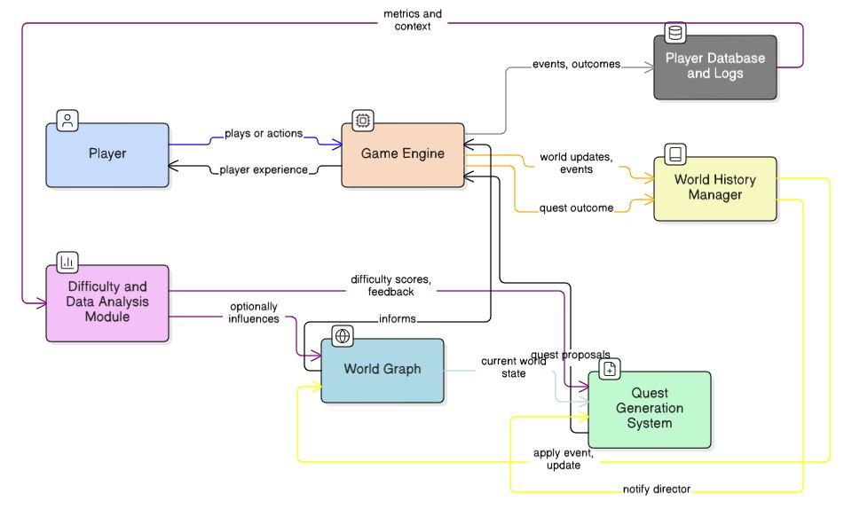
FIGURE 2: The following figure represents the end-to-end data flow of the suggested adaptive framework that displays how player activity is captured, processed and returned to quest generation and world updates. The behavior of the players affects the difficulty adjustment and quest choice in a continuous feedback and then the world state naturally changes with time.

RESULT
We did two simple tests of analysis on logged runs of the prototype to query the possibility that (a) world changes created by occasions cause more various quests, and (b) that DDA feedback causes observable instantaneous enhancement in player achievement. Already the prototype captures event-driven mutations of the world (WorldGraph), generates quests based on the Quest Generator System (QGS) and yields rule-based DDA feedback, which is fed into generated quests. Using those experiment logs, the two analyses below were done. Test A was an evaluation of the seed-event level in which the evaluation determined whether seeds that produced larger average world changes were also those that produced more unique quest templates. The scatter plot (Figure 3) and Pearson correlation indicate that there is very weak correlation (Pearson r = 0.06, n = 5 seeds in this run). In non-technical words: in this little sample there are no substantial indicators that larger world edits are reliable in generating more variety in templates. In that context, the test in question is informative, in the sense that it indicates that the way our generator is currently predisposed is to reuse a small template set, and that world mutations, as they are nowadays, do not necessarily result in increased template diversity. This implies two easy solutions (which are explained later): enlarge the template library and raise the sensitivity of template-matching (e.g. enlarge the required relation checks, add semantic tags or NLP steering). Test B investigated the short-term effectiveness of DDA by contrasting between the success rate of the quest directly after a DDA action that alleviated difficulty with actions that did not alleviate the difficulty. Based on the logged data (Figure 4) one can observe a distinct trend in the data: When the DDAM reduced the difficulty (difficulty_delta < 0), the sought-out quest was observed to have a higher success rate (mean next-quest success = 1.00, n = 3), than when the DDAM increased or maintained the difficulty levels (mean = 0.524, n = 21). This is, at least, encouraging because our rule-based DDAM seems to have an encouraging immediate impact on the success of players, in later quests. Practically, the size of the sample of the ease condition is small (three delta-next pairs), and this experiment was not random, thus this finding is to be considered as initial evidence instead of evidence. Nevertheless, it confirms the integration pipeline: DDAM generates some feedback, quests accept and store the feedback, and the outcomes of players are modified in a manner that is measurable through the logs. This generally is encouraging to the fundamental objectives of the project engineering. We were able to introduce a working loop where events change the WorldGraph, those changes affect quest selection and a rule-based DDAM can change the quest difficulty with the effects visible instantly. Simultaneously, the tests demonstrate that the current prototype has some obvious weaknesses: mainly, low template diversity and small sample sizes of logged DDA-easing cases, which we will discuss in subsequent experiments.

DISCUSSION
What we have created and the result of it. To complete a working loop, we have the World History Manager adjust a persistent World Graph based on events, the Quest Generator since it consults the world (and the player model) to choose or instantiate follow-up queries, and a rule-based DDAM provides concrete feedback which is applied to quests and, where relevant, to world state. Our two hurriedly rudimentary tests were wittingly small and narrow: Test A was whether larger, logged world changes were more apt to earn more template diversity; Test B was whether a DDAM action of effort was more apt to bring instantaneous success on the next quest. Taken together, these experiments do not present general claims but they act as sanity checks. The system has been wired in, and measurable, which, in the case of a prototype that interfaces PCG world reactivity and DDA, is non-trivial engineering accomplishment. Test A low template diversity signal interpretation. Our scatter and correlation (Pearson r = 0.06) in the available data indicates that the correlation between mean world-change activity and the number of distinct templates generated per seed are significantly non-linear. This is likely due to some few reasons. Firstly, our generator still operates on the relatively small and conservative set of templates and very restrictive matching conditions; moreover, the world edit variants are more likely to revert to the same templates, rather than truly different quest shapes. Second, the current logic of template-matching is strategically conservative to narrative consistency (the QGS is focused on story consistency), which reduces spurious variation and reduces diversity. These two results are consistent with the literature: grammar- and graph-based systems can be created with coherent missions [3], [4], [2], and are constrained by the paucity of richer semantics or templates. Practically, this translates into the concept not being flawed, but rather, that the current implementation needs to be expanded with more template coverage and more lenient matching (more permissive semantic tags, or even less dense NLP advice) in order to change perturbations to the world into a larger space of quests. Test B (early positive DDA). The bar chart shows that the greatest success in next-quest under analysis at first is when the DDAM reduced the difficulty. This is inspirational and aligns with the prior study that adaptive difficulty can have adverse impacts on both the short-term involvement or the short-term achievement outcome in case of cautious use [10], [11], [15]. That being said, the ease group of samples was extremely small in this run and the log data are neither randomized nor controlled trial, therefore we should not be as sure that we can causally interpret this data. However, the major thing is that it is structural: the end to end feedback loop works. Actionable deltas are created by the DDAM and received and documented by quests with personal results presented in a quantifiable format. That is, we now possess instrumentation and hypothesis testing pipeline and this is what you desire prior to scaling to larger controlled studies. The Weaknesses and Improvement Areas. It suffers limitations that are mostly (a) dataset size and experimental control, (b) low diversity of templates and template-matching sensitivity, (c) low expressiveness of the rule-based DDAM. To solve (a), seeded trials should be executed and variations to be controlled (e.g. fixed trials where DDAM behavior would only change) should be added. In (b) we might simply scale up the template library, or mark semantic stories, or hook up the light NLP steering, such that minor variation of the world has the effect of varying the template (as in recent PCG work [1], [6]) with transformer-based procedures enhancing contextual relevance). In case (c), a modular design guarantees that in future studies it is simple to substitute the rule-based module with learned DDAs (player-behavior model, Bayesian or RL-based adaptor), the literature presents good examples of both supervised behavior models [11], [12] and RL curricula to introduce complexity to stages [22]. Broader implications. Given the state it already has, the idea of adding a WorldGraph-based memory to the generation
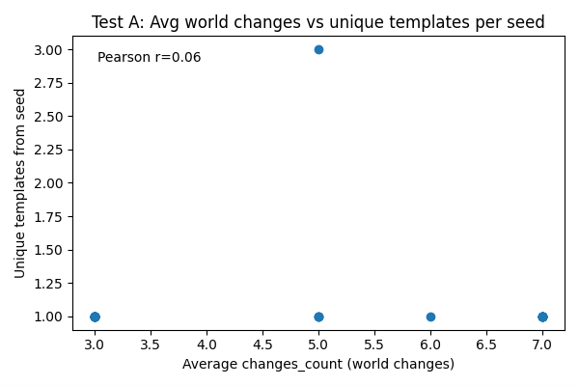
FIGURE 3. Test A -Mean world variability versus distinctive templates per seed. Scatterplot of seed-level averages of mean number of world-change operations applied to quests generated by a seed and the number of different quest templates generated by a seed (n = 5 seeds). Pearson correlation r = 0.06, which implies that there is no linear correlation between the two variables in this sample. The output is limited diversity of the template (Formulation: current generator and template-matching generate limited diversity of template relative to changes recorded in the world)
and difficulty control seems to be a feasible concept to make the impression of adaptation appear diegetic, created by the events that are happening in the story as opposed to being created by some unseen slider. This is an extension of earlier proposals of experience-based PCG in which generational guidance is informed by the behavior of the player [20]. This architecture can become a solvable system in the future with more template richness and larger controlled experiments able to compare rule based and learned DDAs in narrative contexts or even to experiment how story sensitive alterations to long-term motivation can enhance success not just short term success. Final note. We do not testify that we have finished with the existing prototype, but it is a sign of a scaffold, which affirms usefulness, as well as shows physical future activity. Expanding the generator, to better the logic of matching, and to conduct controlled experiments, would be the next evident, useful actions.
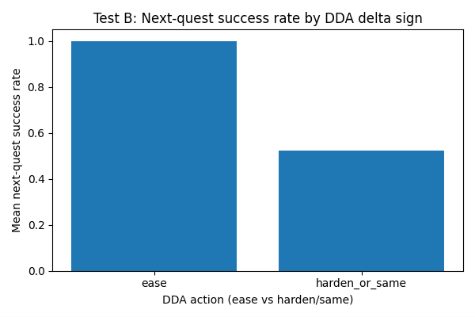
FIGURE 4. Test B DDA delta sign success rate on Next-quest. Mean success rate on the quest immediately after a DDA action, by the DDA reducing difficulty (difficultydelta < 0) or the DDA increasing difficulty (difficultydelta >= 0). Easing: mean next question success = 1.00 (n =3). Harden/same: = 0.524 (n = 21) next-quest success. Not causal (There is preliminary evidence that the easing is positively related to increased success in the short-term, however, causation is not possible, due to small sample sizes and a non-random group assignments).

CONCLUSION
As can be seen in the prototype, procedural quest generation and live difficulty adjustment can be conveniently bound: we implemented both a persistent World Graph and a World History Manager, storing both world state and player state, a Quest Generation System, which reads both world state and player state to generate context-sensitive quests and a rule-based DDAM, which emits actionable feedback, which the generator then accepts. The pipeline is also endto-end instrumented, i.e. events can change the world, event modification commands choose quest selection, event modification is represented by DDA feedback and output is recorded to be examined. In a few words, the project proves that the concept is realistic, and not a mere thought experiment, but provides a testbed that operates design concepts and DDA plans.
The list of concrete, cordial actions to pursue is very long, and it has been literally open to give way to other scholars and architects. One of the potential directions is to expand the content side: more templates and further enrichment of the event type and story tags and an extended repertoire of seed scenarios would relieve template replay and enable world changes to provide genuinely different quests. The second complementary step is to make the matching layer so that the generator is directed by semantic hints (tag propagation, lightweight NLP prompts or knowledge-graph features) rather than the strict relation checks, that will tend both to be coherent and to allow a more rich variation. On the difficulty side, the current rule-based DDAM can be interpreted intentionally, and the architecture can be easily expanded to add learned alternatives, e.g. supervised classifiers, reinforcement learners, or meta-learning approaches and their behavior can be compared on the same environment. Finally, the analysis should be stricter: larger, randomised research, more objective (success, time, retries) and subjective (perceived fairness, narrative engagement) data will bring the work beyond the indicators of prototypes to the plausible results.
The code and design are modular; therefore, it is a great platform to perform community-based work: the designers will be able to add templates and arcs, engineers can test new DDA modules, and researchers can conduct controlled research. Should the community expand the content base, polish corresponding strategies and carry out larger and controlled experiments, the strategy would help get the games not only to adjust their numbers, but also to adjust their stories, which would make it appear like a part of the fiction and not a mechanic. We are optimistic: the plumbing is in place, the preliminaries are promising and there is an apparent and helpful road-map to turn the prototype into a sound research base.

REFERENCES
- T. Värtinen, T. Kärkkäinen, and J. Holopainen, “QuestVille: Procedural Quest Generation Using NLP Models,” Procedia Computer Science,vol. 207, pp. 112–121, 2022.
- M. Kybartas and C. Verbrugge, “Analysis of ReGEN as a Graph-Rewriting System for Procedural Story Generation,” Entertainment Computing, vol. 12, no. 2, pp. 39–51, 2016.
- J. Doran and I. Parberry, “A Prototype Quest Generator Based on a Structural Analysis of Quests from Four MMORPGs,” Proceedings of the2nd Workshop on Procedural Content Generation in Games, 2011.
- J. Dormans, “Adventures in Level Design: Generating Missions and Spaces for Action Adventure Games,” Proceedings of the 2010 Workshopon Procedural Content Generation in Games, 2010.
- R. Lima, T. Falcão, and J. Santos, “Procedural Generation of Branching Quests for Games,” Entertainment Computing, vol. 41, pp. 100–113,2022.
- A. Al-Nassar, M. Iqbal, and M. Y. Al-Debagy, “QuestVille+: Contextual Procedural Quest Generation Using Transformer-Based LanguageModels,” Procedia Computer Science, vol. 220, pp. 56–65, 2023.
- S. Pérez-López, D. G. Llanes, and R. A. Palacios, “StoryWorld: Procedural Quest Generation Rooted in Variety and Believability,” Entertainment Computing, vol. 40, pp. 100–117, 2023.
- T. Ashby, “Personalized Quest and Dialogue Generation in Role-Playing Games: A Knowledge Graph- and Language Model-based Approach,”
- M.Sc. Thesis, University of Bath, 2023.
- A. Zohaib, “Dynamic Difficulty Adjustment (DDA) in Computer Games: A Review,” Artificial Intelligence Review, vol. 53, no. 4, pp.2663–2697, 2020.
- D. Ang and A. Mitchell, “Comparing Effects of Dynamic Difficulty Adjustment Systems on Video Game Experience,” Proceedings of the 9thACM Conference on Human Factors in Computing Systems (CHI Play), 2018.
- J. Pfau, D. Mal, and P. Kallio, “Deep Player Behavior Models: Evaluating a Novel Take on Dynamic Difficulty Adjustment,” Proceedings ofthe 2020 IEEE Conference on Games (CoG), 2020.
- J. Pfau and D. Mal, “Enemy Within: Long-Term Motivation Effects of Deep Player Behavior Models for Dynamic Difficulty Adjustment,”Proceedings of the 2021 IEEE Conference on Games (CoG), 2021.
- A. Damastuti, H. Sutanto, and D. Nurjanah, “Dynamic Level of Difficulties Using Q-Learning and Fuzzy Logic,” Procedia Computer Science,vol. 179, pp. 451–458, 2021.
- C. Fisher and A. Kulshreshth, “Exploring Dynamic Difficulty Adjustment Methods for Video Games,” Game AI Research Journal, vol. 7, pp.88–99, 2019.
- H.-S. Moon, “Dynamic Difficulty Adjustment via Fast User Adaptation,” IEEE Transactions on Games, vol. 12, no. 4, pp. 302–314, 2020.
- Y. Sulyma, “Dynamic Difficulty Algorithms as a Tool for Enhancing Player Retention: An Empirical Study in a Gaming Environment,” M.Sc.Thesis, University of Warsaw, 2021.
- M. Jennings-Teats, G. Smith, and N. Wardrip-Fruin, “Polymorph: Dynamic Difficulty Adjustment Through Level Generation,” Proceedingsof the 2010 Workshop on Procedural Content Generation in Games, 2010.
- S. Mourato, J. Reis, and A. Machado, “Integrated System for Automatic Platform Game Level Creation with Difficulty and Content Adaptation,” Entertainment Computing, vol. 39, pp. 100–113, 2021.
- L. Romero-Méndez, F. Ledesma, and E. Ramírez, “The Use of Deep Learning to Improve Player Engagement in a Video Game through aDynamic Difficulty Adjustment Based Skill Classification,” IEEE Access, vol. 8, pp. 22466–22475, 2020.
- N. Paraschos and V. Koulouriotis, “Game Difficulty Adaptation and Experience Personalization: A Literature Review,” Computers in HumanBehavior Reports, vol. 6, pp. 100–133, 2022.
- P. Ammanabrolu, M. Cheong, and M. Riedl, “Situated Dialogue Learning through Procedural Environment Generation,” Proceedings of the2021 AAAI Conference on Artificial Intelligence and Interactive Digital Entertainment (AIIDE), 2021.
- J. Mourato, S. Lopes, and L. Silva, “Toward Supporting Stories with Procedurally Generated Game Worlds,” Entertainment Computing, vol.41, pp. 100–116, 2023.
- H. Prithviraj, “Toward Automated Quest Generation in Text Adventure Games,” Procedural Generation in Games Workshop (PCG 2022),2022.

