CloudBite: A Cloud Kitchen Exclusive Food Delivery Platform

Tanavi Kadam
Department of Information Technology Usha Mittal Institute of Technology SNDT Women’s University
Mumbai, India tanavi1704@gmail.com

Samriddhy Lade
Department of Information Technology Usha Mittal Institute of Technology SNDT Women’s University
Mumbai, India samriddhivsl@gmail.com

Prof. Prachi Dhannawat
Department of Information Technology Usha Mittal Institute of Technology SNDT Women’s University
Mumbai, India 400049 prachi.dhanawat@umit.sndt.ac.in

Maitree Pandey
Department of Information Technology Usha Mittal Institute of Technology SNDT Women’s University
Mumbai, India pandeymaitree03@gmail.com

Abstract—This study examines the rapid growth of cloud kitchens and hyperlocal delivery systems and their impact on the food service industry. With increasing digital adoption and changing consumer behavior, traditional restaurants are shift- ing toward technology-driven, delivery-focused models. Cloud kitchens operate without dine-in facilities, reduce operational costs, and rely heavily on online platforms. Hyperlocal delivery improves convenience through faster service within limited areas. While this model offers scalability and lower investment risk, challenges such as competition and quality control remain. Over- all, cloud kitchens are reshaping the future of the food industry by providing cost-effective and technology-enabled solutions.
Index Terms—Cloud Kitchen, Food Ordering System, Spring Boot, ReactJS, RESTful API, Role-Based Access Control (RBAC), Finite State Machine (FSM), JWT Authentication, MySQL Database, Recommendation System

- Introduction
The global food service sector has undergone a radical structural paradigm shift, transitioning from traditional dine- in establishments to a digitally-mediated ecosystem [6]. This transformation is driven by high smartphone penetration, ubiquitous internet connectivity, and the proliferation of so- phisticated food delivery applications (FDAs) that prioritize consumer convenience and logistical speed [14]. Central to this evolution is the emergence of cloud kitchens—delivery-centric culinary units operating without physical storefronts—and hy- perlocal delivery systems designed for rapid, geographically- constrained order fulfillment [4], [5].
Cloud kitchens, also termed “ghost” or “virtual” kitchens, leverage a lean operational model to minimize overhead costs associated with prime real estate and front-of-house man- agement [2], [8]. By utilizing centralized digital platforms for order processing and payment orchestration, these entities can scale rapidly and manage multiple virtual brands from a single facility [12]. Consequently, the competitive landscape has shifted from physical ambiance to digital visibility, where
search algorithms, real-time data analytics, and platform-based consumer ratings dictate market success [7], [10].
The integration of hyperlocal delivery logistics further en- hances this ecosystem by utilizing localized supply chains and route optimization to ensure food freshness and minimal latency [3], [9]. This model gained unprecedented momen- tum during the COVID-19 pandemic, as mobility restrictions forced a behavioral pivot toward contactless, online-only con- sumption [11]. While the model offers significant advantages in capital efficiency and menu flexibility, challenges remain regarding quality assurance, consumer trust, and the trans- parency of remote food preparation environments [1], [15].
The digital transformation of the industry has intensified the importance of role-based web applications and centralized management platforms to handle multi-stakeholder interac- tions efficiently [12], [13]. This paper explores the technical and operational frameworks required to optimize cloud kitchen management through an integrated system.
The remainder of this paper is organized as follows: Sec- tion II presents the literature review along with the problem statement and objectives of the study. Section III describes the methodology adopted for system design and workflow analysis. Section IV discusses the proposed CloudBite system design and operational workflow. Section V explains the system architecture and implementation details. Section VI presents testing observations and system analysis. Finally, Section VII concludes the paper and outlines potential future enhancements.

- Literature Review
The food service industry has undergone a paradigm shift driven by pervasive digitalization and the evolution of online food delivery platforms (OFDPs) [6]. As consumer preferences pivot toward on-demand accessibility, cloud kitchens and

hyperlocal delivery systems have emerged as disruptive busi- ness models that decouple culinary production from physical storefronts [11].
- Evolution of Cloud Kitchens: Research identifies cloud kitchens—variously termed dark, ghost, or virtual kitchens—as delivery-centric facilities that optimize opera- tional efficiency by eliminating front-of-house overhead [4]. Studies by Sharma et al. and Mehta highlight that these models benefit from reduced capital expenditure (CAPEX) and geographical flexibility, allowing for rapid scalability [4], [8]. However, Hakim et al. note that the absence of physical consumer interaction necessitates a heavy reliance on digital trust signals and platform credibility [1]. Furthermore, the dependency on third-party aggregators often erodes profit margins and fragments brand identity [2].
- Hyperlocal Logistics and Real-time Systems: Hyperlocal delivery platforms operate within granular geographic con- straints to minimize the ”last-mile” latency [5]. John empha- sizes that post-COVID consumption patterns in India have solidified the necessity for these localized supply chains [3]. Technically, this requires the integration of real-time order tracking and route optimization to maintain food quality and service reliability [9]. Roy and Banerjee suggest that modern web technologies are essential to handle the high-concurrency demands of these real-time systems [10].
- Stakeholder Coordination and Platform Integration: Re- cent literature underscores the role of centralized management in multi-stakeholder ecosystems [12]. Patel and Joshi argue that the integration of administrators, kitchen operators, and delivery partners into a unified digital framework reduces op- erational friction [12]. Role-based access control (RBAC) and decentralized digital structures further enhance system security and transparency [13], [15]. Despite these advancements, a gap remains for a streamlined, integrated platform that reduces third-party dependency for emerging entrepreneurs.
- Objective
The primary objective of this research is to architect and implement “CloudBite,” a centralized hyperlocal management system designed to mitigate current operational inefficiencies. The study aims to:
  - Develop a unified digital ecosystem connecting admin- istrators, kitchen operators, delivery personnel, and cus- tomers through dedicated role-specific dashboards [13].
  - Implement real-time status synchronization to reduce communication latency between kitchen production and delivery dispatch.
  - Design a modular and scalable architecture that supports multi-brand management and future integration of pre- dictive analytics for demand forecasting.
- Problem Statement
Most existing food delivery platforms function primarily as intermediaries, offering limited integration into internal kitchen workflows and operational management [10]. Cloud kitchens relying on third-party aggregators face reduced profit
margins, restricted brand autonomy, and limited access to customer data [2]. Small and emerging operators are further hindered by fragmented management tools and insufficient technical infrastructure, making efficient multi-stakeholder co- ordination difficult [4]. These gaps highlight the need for a dedicated, centralized platform tailored specifically to cloud kitchen operations.
Proposed Solution: To address these limitations, Cloud- Bite proposes a centralized digital platform that directly connects administrators, kitchen owners, delivery partners, and customers within a unified ecosystem [12]. The system eliminates dependency on third-party aggregators by man- aging order processing, delivery coordination, and customer interaction in-house. Role-specific dashboards ensure efficient multi-stakeholder management, while real-time order tracking enhances transparency and customer trust [9]. The platform’s modular architecture further supports scalability, making it accessible for small and emerging cloud kitchen operators.
- Methodology
The development of the CloudBite platform follows a structured Software Development Life Cycle (SDLC) to en- sure systemic integration of multi-stakeholder requirements. The methodology encompasses requirement elicitation, archi- tectural design, implementation of core logic, and rigorous validation. The system is architected into four discrete mod- ules: Admin, Kitchen Owner, Delivery Partner, and Customer, with seamless data flow facilitated by the following technical frameworks.
- Algorithmic Framework and System Modules
To ensure operational efficiency and security within the hyperlocal ecosystem, specific algorithms were implemented across the system’s core modules. The relationship between these modules and their corresponding algorithmic imple- mentations is summarized in Table I.
  - Role-Based Access Control (RBAC) for Secure Autho- rization: To maintain data integrity and prevent unauthorized cross-module access, a Role-Based Secure Authentication and Authorization Algorithm is utilized [13]. This algorithm per- forms a multi-stage validation:
    - Credential Verification: Hashed password comparison against the central database.
    - Token Generation: Issuance of unique session identifiers upon successful login.
    - Middleware Validation: Intercepting HTTP requests to verify the user’s role (e.g., Role ∈ {Admin, Kitchen, Delivery, Customer}) before granting access to specific API endpoints.
  - Finite State Machine (FSM) for Order Lifecycle: The order management workflow is modeled using a Fi- nite State Machine (FSM) to ensure state consistency [12]. An order O transitions through a set of predefined states S = {Pending, Confirmed, Ready, Dispatch, Delivered} based on discrete trigger events E.
S_{t+1} = δ(S_{t}, E)

where δ is the transition function. This prevents logical errors, such as a delivery partner marking an order as ”Delivered” before it has been marked ”Out for Delivery” by the kitchen [9].
  - Personalized Frequency-Based Top-K Recommendation: To enhance user engagement, the system implements a Frequency-Based Top-K Recommendation Algorithm. This module analyzes a user’s order history H by:
    - Frequency Counting: Using a Hash Map to store dish
D_{i} and its purchase count C_{i}.
    - Linear Traversal and Sorting: Processing the map to identify items where C_{i} is maximized.
    - Ranking: Displaying the top K dishes in the customized slider to reduce decision latency for the customer [14].
  - Analytics and Predictive Modeling: The Analytics mod- ule utilizes **K-Means Clustering** and **Regression Anal- ysis** to provide data-driven insights. K-Means is employed to segment the customer base into clusters based on ordering frequency and average order value (AOV), while Regression models analyze historical temporal data to predict peak de- mand periods [15]. This allows kitchen owners to optimize inventory and staffing levels ahead of high-traffic hours.
- Implementation and Testing
The implementation phase involved developing role-specific dashboards with real-time synchronization using WebSocket or periodic polling mechanisms to ensure low-latency up- dates [10]. Testing was conducted in three tiers: Unit Testing (individual module logic), Integration Testing (inter-module communication between Kitchen and Delivery), and System Testing (end-to-end workflow validation from order placement to final delivery).
TABLE I: Algorithmic Framework of System Modules
Module / Feature | Algorithm Used | Purpose
Role-Based Auth.  & Authorization | Role-Based Access  Control (RBAC) | Ensures secure, role-  specific dashboard access via token and middleware validation.
Customized  Recommended Slider | Personalized  Frequency-Based Top-K | Generates dish  recommendations by ranking historical order frequency via hashing.
Analytics and Re-  ports | K-Means Clustering,  Regression Analysis | Segments customer data  and predicts demand trends for data-driven insights.
Order Lifecycle  Management | Finite State Machine  (FSM) | Manages synchronized  transitions through predefined order states (Pending to Delivered).

- System Architecture
The CloudBite platform is built using a organized three- layer setup designed to handle many users at once while keeping information updated in real-time. As shown in Fig. 1, the system connects four main groups—Admin, Kitchen Owner, Delivery Partner, and Customer—into one digital space
where orders move smoothly and data stays accurate. The design is split into the Presentation, Application, and Data layers to keep the different parts of the app independent and easy to manage.
- Presentation Layer (The User Dashboards)
This is the ”front-end” of the app that users actually see and touch. It is built with React.js to make sure the screens are fast and work well on different devices. The system provides four specific dashboards:
  - Customer Portal: Where users can look at menus, manage their cart, and place orders.
  - Kitchen Owner Dashboard: Where chefs can set up their menus and keep track of orders they are cooking.
  - Delivery Partner Interface: A simple screen for drivers to find deliveries and update their status instantly.
  - Admin Panel: A control center for the person running the platform to watch over everything and manage the different users.
- Application Layer (The Brain of the System)
This is the ”back-end” that does all the heavy lifting and thinking. It uses Spring Boot to handle the business logic and communication between the users and the database. Its main jobs include:
  - Security: Checking logins and making sure users can only see the information they are allowed to see.
  - Service Management: Running specific small programs (microservices) that handle things like menu updates, tracking orders, and real-time updates.
  - Payments: Connecting safely to external services like Stripe to handle money and keep digital receipts.
- Data Persistence Layer (The Memory)
This layer uses a MySQL database to store all the important information safely. It keeps track of user profiles, food menus, order history, and payment logs. Because all the data is kept in one central place, it is easy for the system to create reports and help owners predict which days will be the busiest.
- System Workflow
The CloudBite platform follows a clear step-by-step process to make sure everyone knows what is happening with an order. As shown in the flowchart (Fig. 1), the process follows these four main stages:
- Starting an Order: A user picks their food on the app. The request is sent through an ”API Gateway,” which acts like a front door that checks if the request is valid before letting it into the system.
- Processing the Request: The Spring Boot backend takes over. It uses nine different small services to handle parts of the order simultaneously—like checking if the kitchen is open or updating the cart—to make sure the app stays fast and doesn’t crash.
- Saving Data and Payments: The system saves the order details in the MySQL database so it’s never lost. At

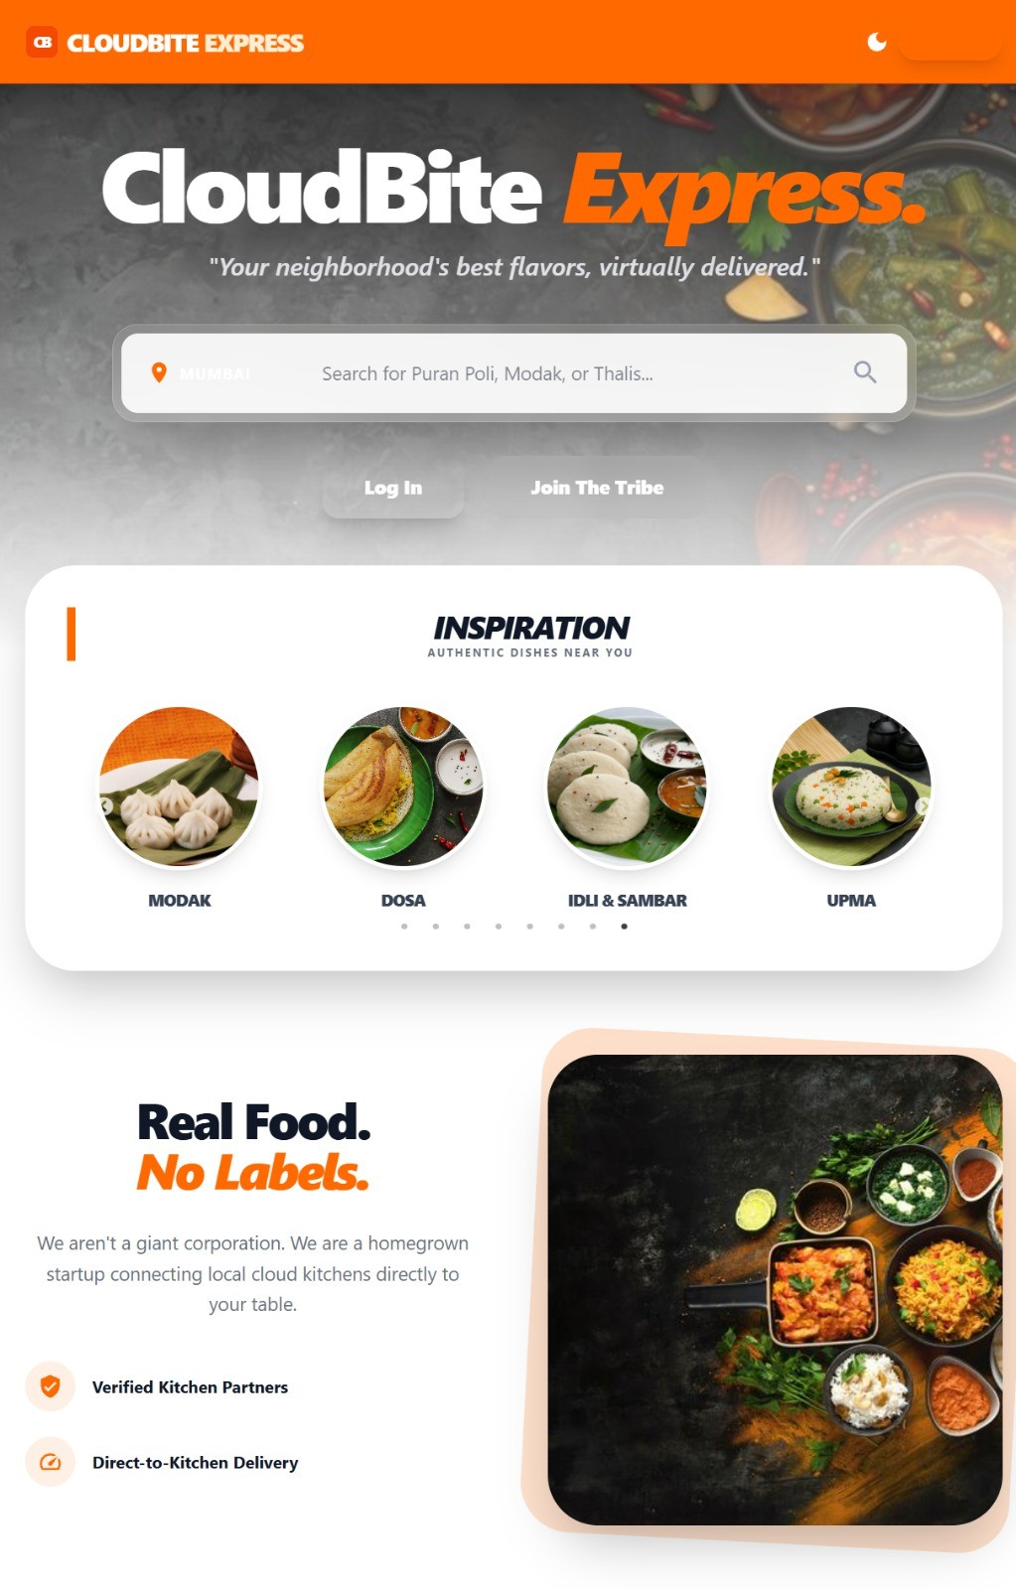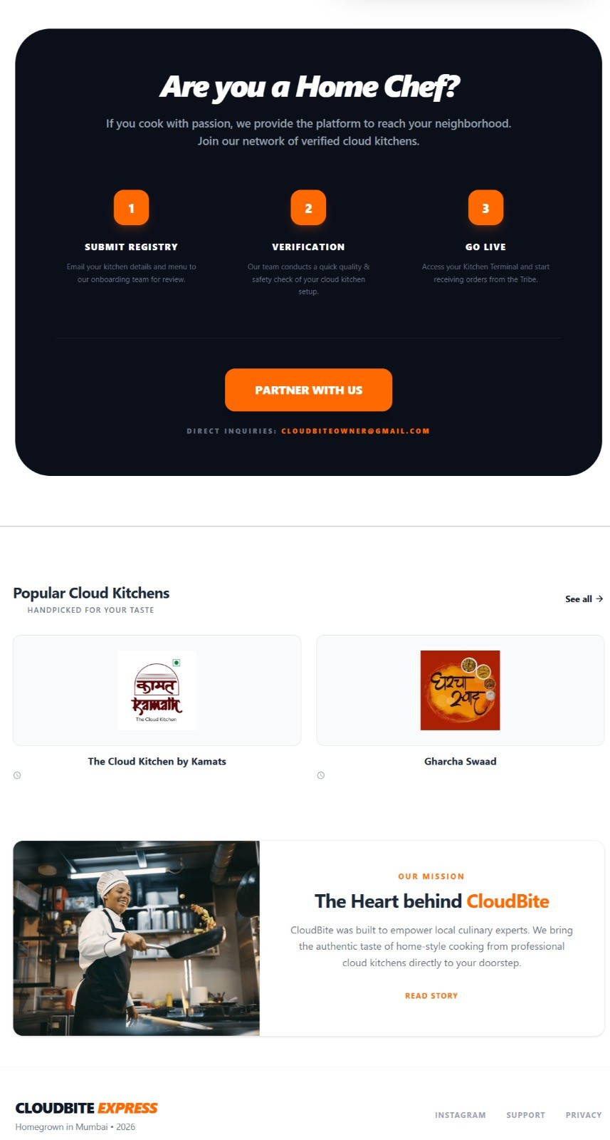

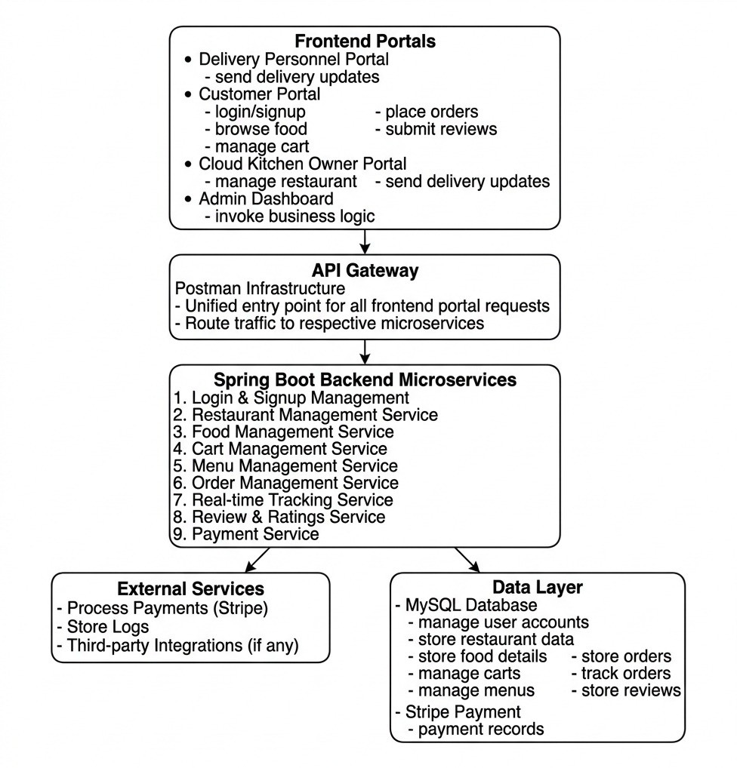
Fig. 1: Overall System Flowchart of CloudBite Platform

the same time, it talks to the Stripe API to handle the payment safely and quickly.
- Live Updates: Once the order is saved, the system sends a live alert to everyone. The kitchen sees the new order, the customer sees that their food is being prepared, and later, the delivery driver sees that it’s ready for pickup.

- Implementation

The implementation of the CloudBite platform translates the theoretical architecture into a functional web-based ecosystem. By integrating React.js for the frontend and Spring Boot for the backend, the system provides a seamless experience for all four stakeholder roles. The focus was to create high- impact, easy-to-use dashboards that communicate in real-time through secure RESTful APIs, ensuring that everyone from the customer to the admin is always in sync.

- Customer Dashboard: Browsing and Ordering

The Customer Dashboard is designed for simplicity and speed. It allows users to easily explore various cloud kitchens and menus. As shown in Fig. 2, the public interface provides a clean entry point. Once logged in, as seen in Fig. 3, the system suggests dishes to make the process personalized. Customers can monitor their active requests through the live interface shown in Fig. 4.
Fig. 2: Public Landing Page: First touchpoint for users.
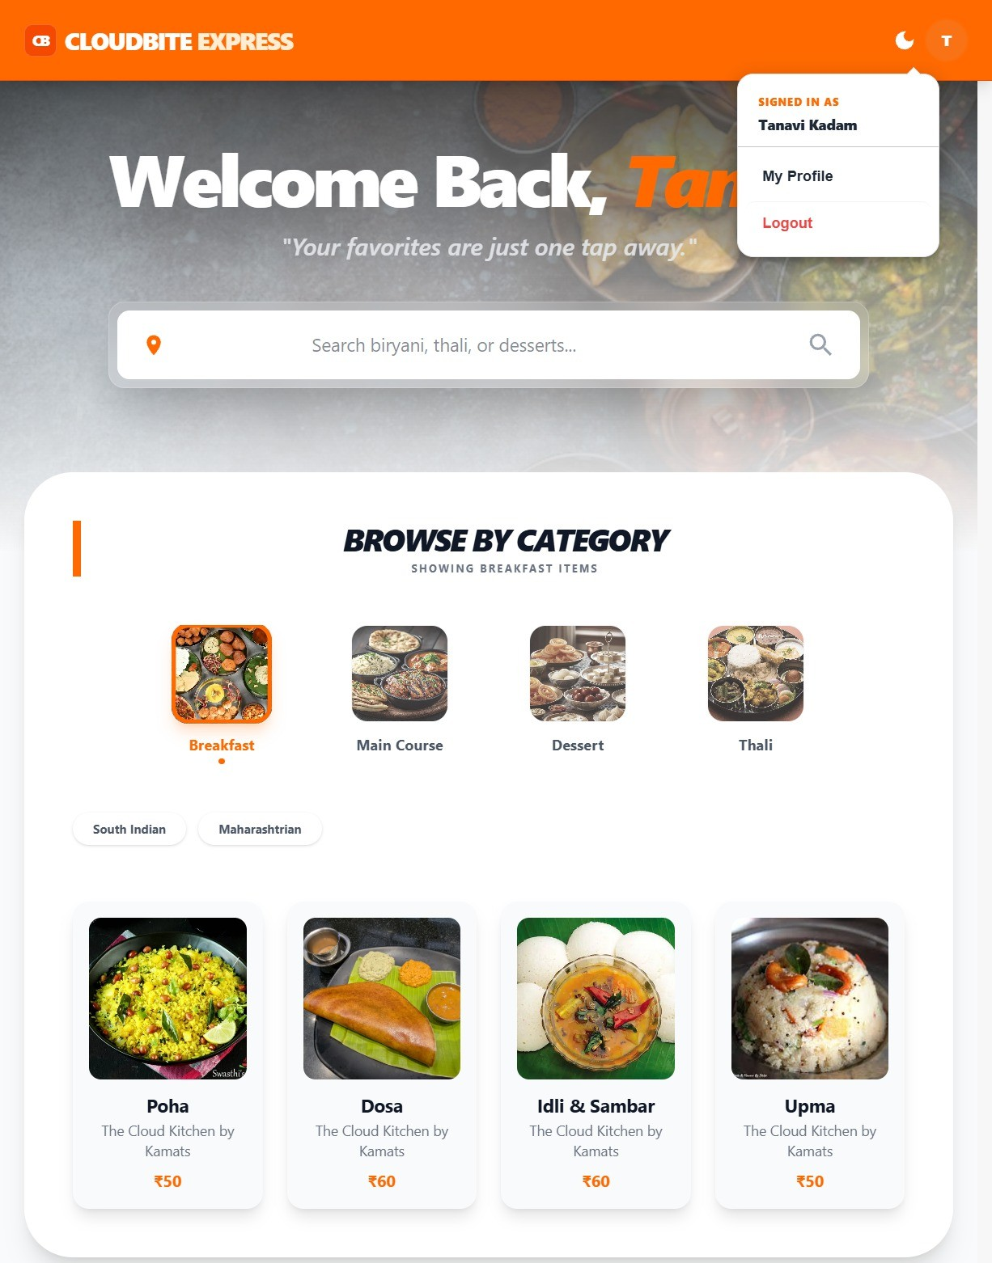
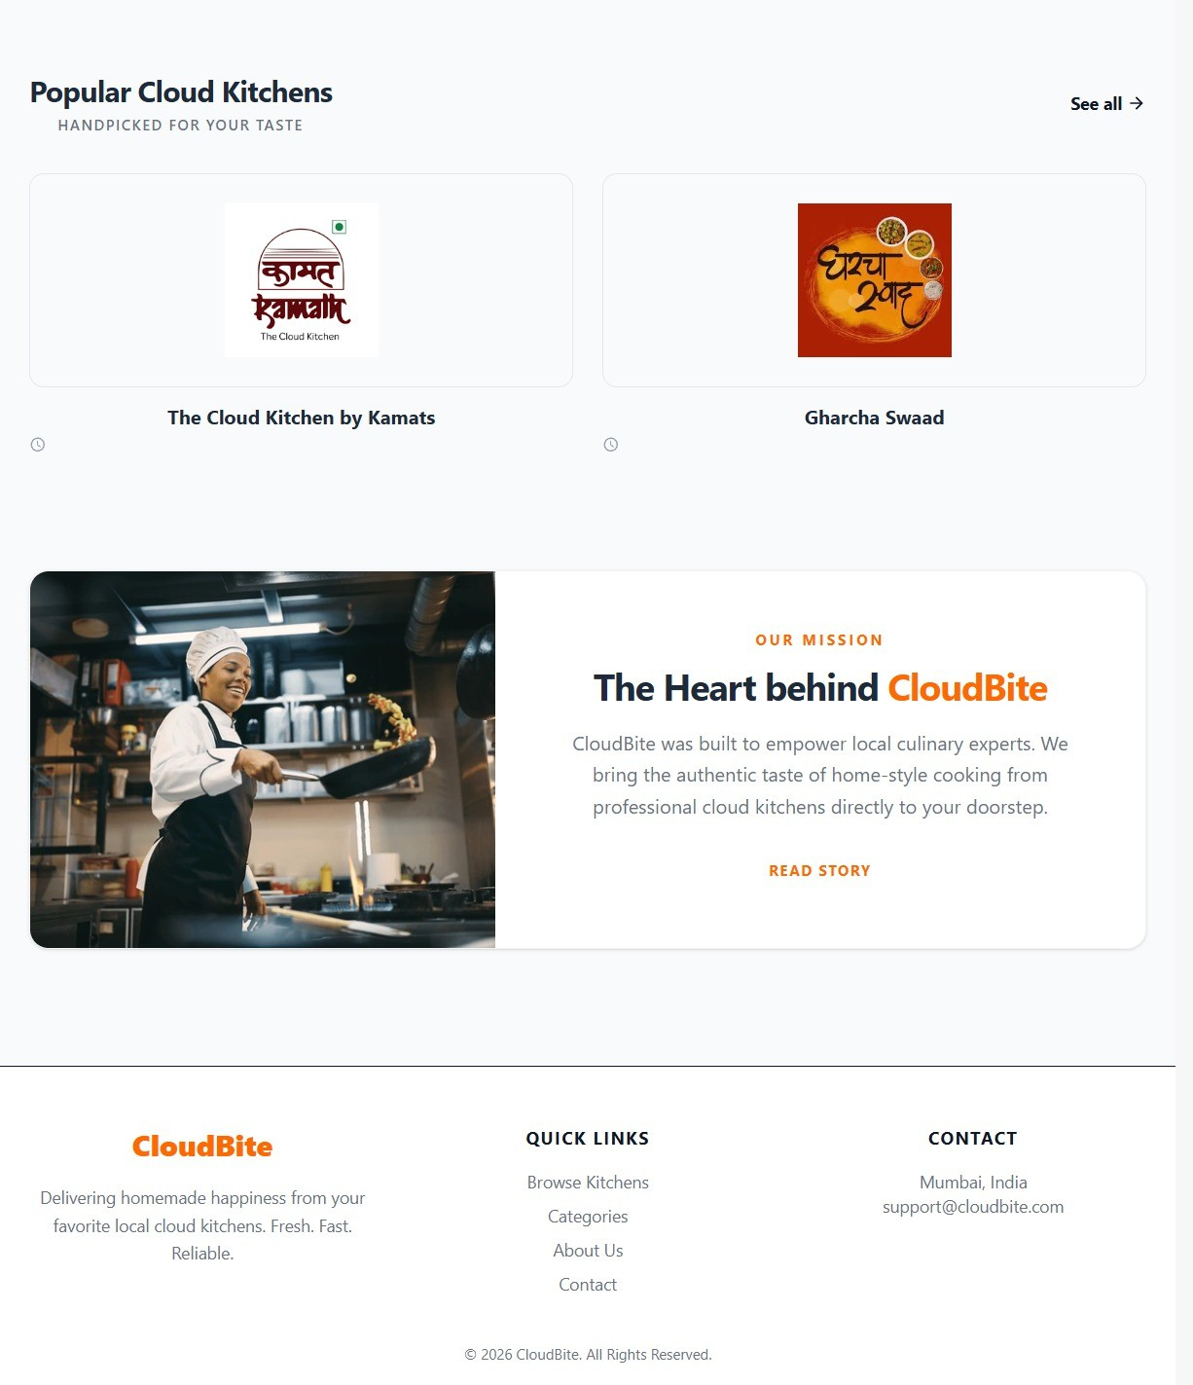
Fig. 3: Authenticated User View: Personalized menu and profile access.
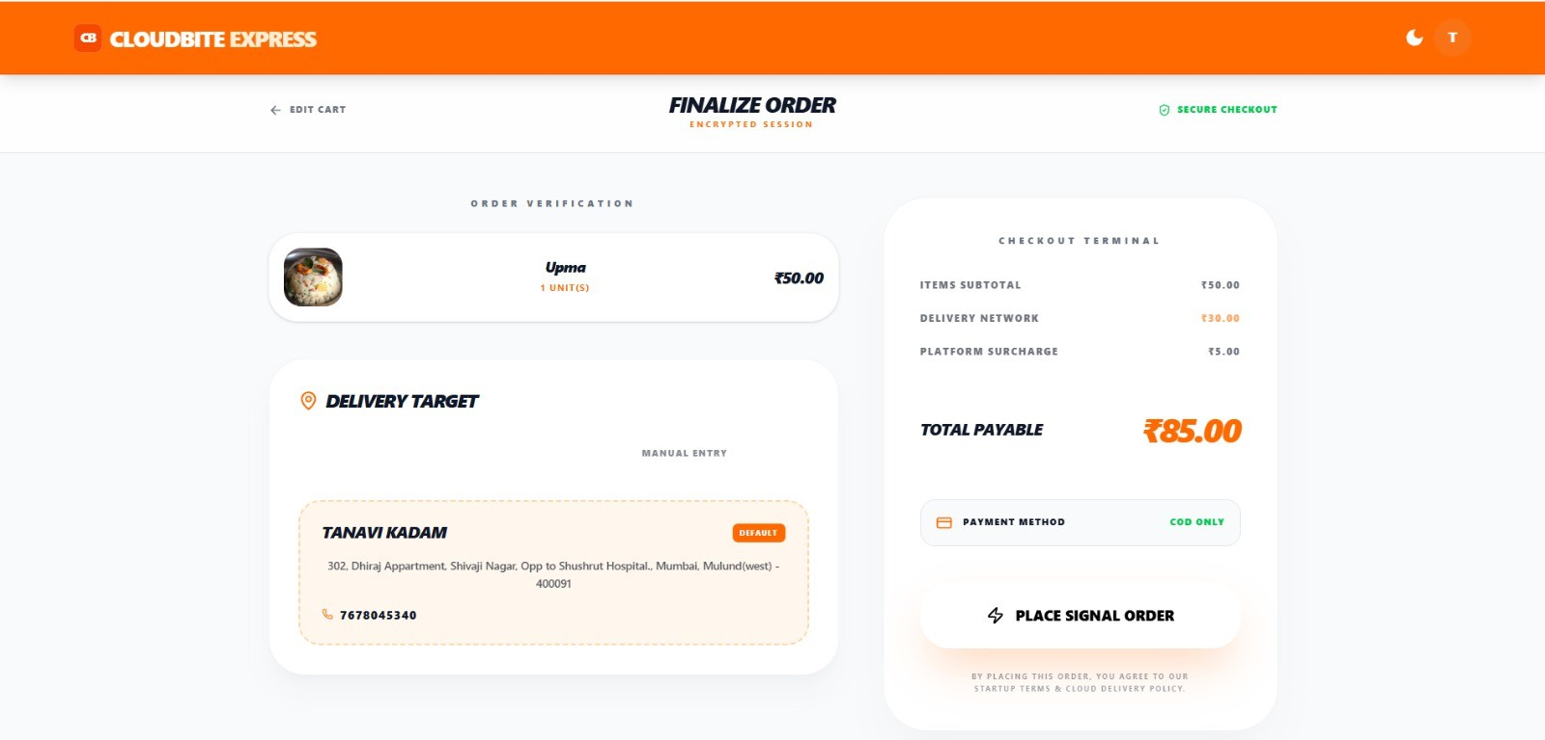
Fig. 4: Order Tracking: Real-time status visibility for the customer.

- Kitchen-Owner Dashboard: Order Management
The Kitchen Owner Dashboard acts as a digital kitchen manager. It allows owners to update their digital menus in-

stantly and track incoming orders as they happen. The interface illustrated in Fig. 5 allows the kitchen owner to ”Accept” and ”Prepare” the meal, with every status change automatically notifying the other stakeholders.

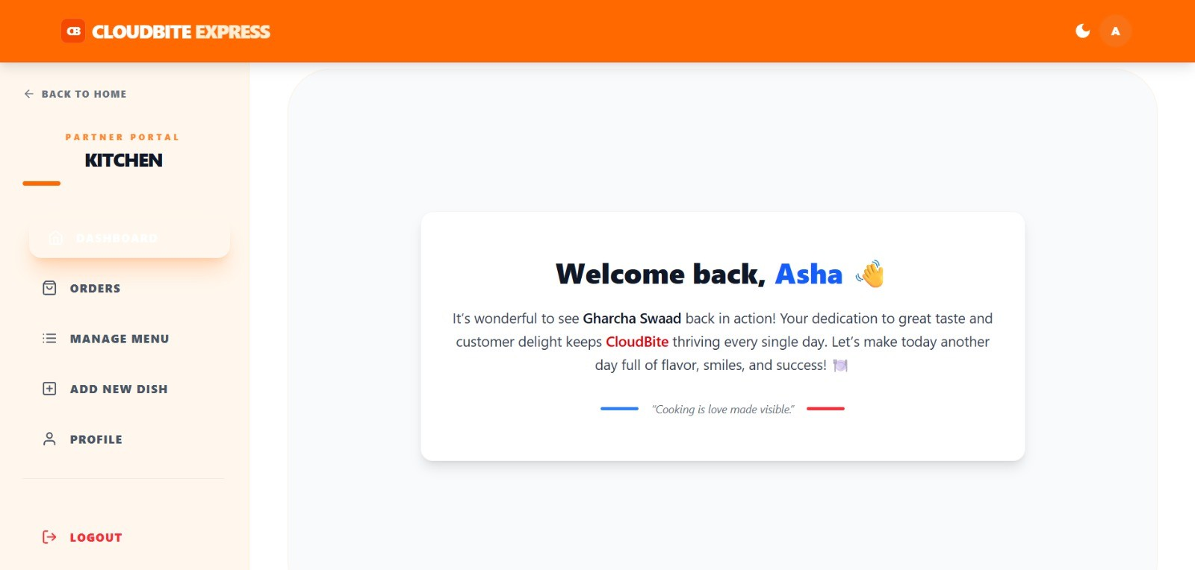
Fig. 5: Kitchen Management Interface: Real-time order pro- cessing.

- Delivery Partner Dashboard: Real-Time Dispatch

For drivers, the interface is built for efficiency. It focuses on the essentials: seeing assigned orders and updating delivery milestones as they move from the kitchen to the customer’s doorstep. The specific layout for these updates is displayed in Fig. 6.

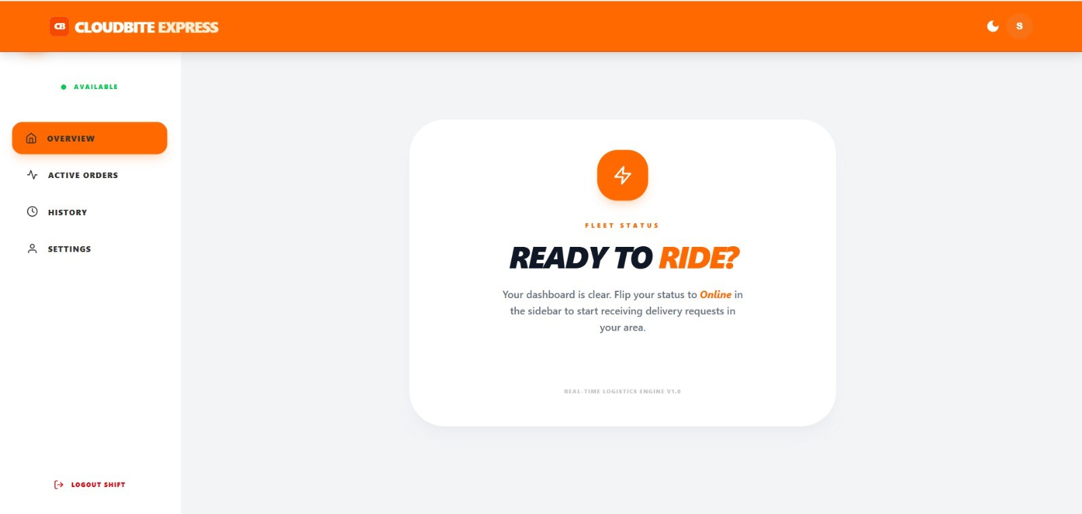
Fig. 6: Delivery Partner View: Geographic dispatch and status updates.

- Admin Dashboard: System Oversight

The Admin Dashboard is the control center of the operation. As shown in Fig. 7, it provides the high-level authority needed to manage the entire ecosystem securely.
  - Identity Management: The Admin creates and secures login credentials for kitchen owners and drivers.
  - Business Onboarding: New kitchens are registered with key details like location and contact info to expand the platform.
  - Operational Health: The admin has a consolidated view of all orders to monitor overall system performance.

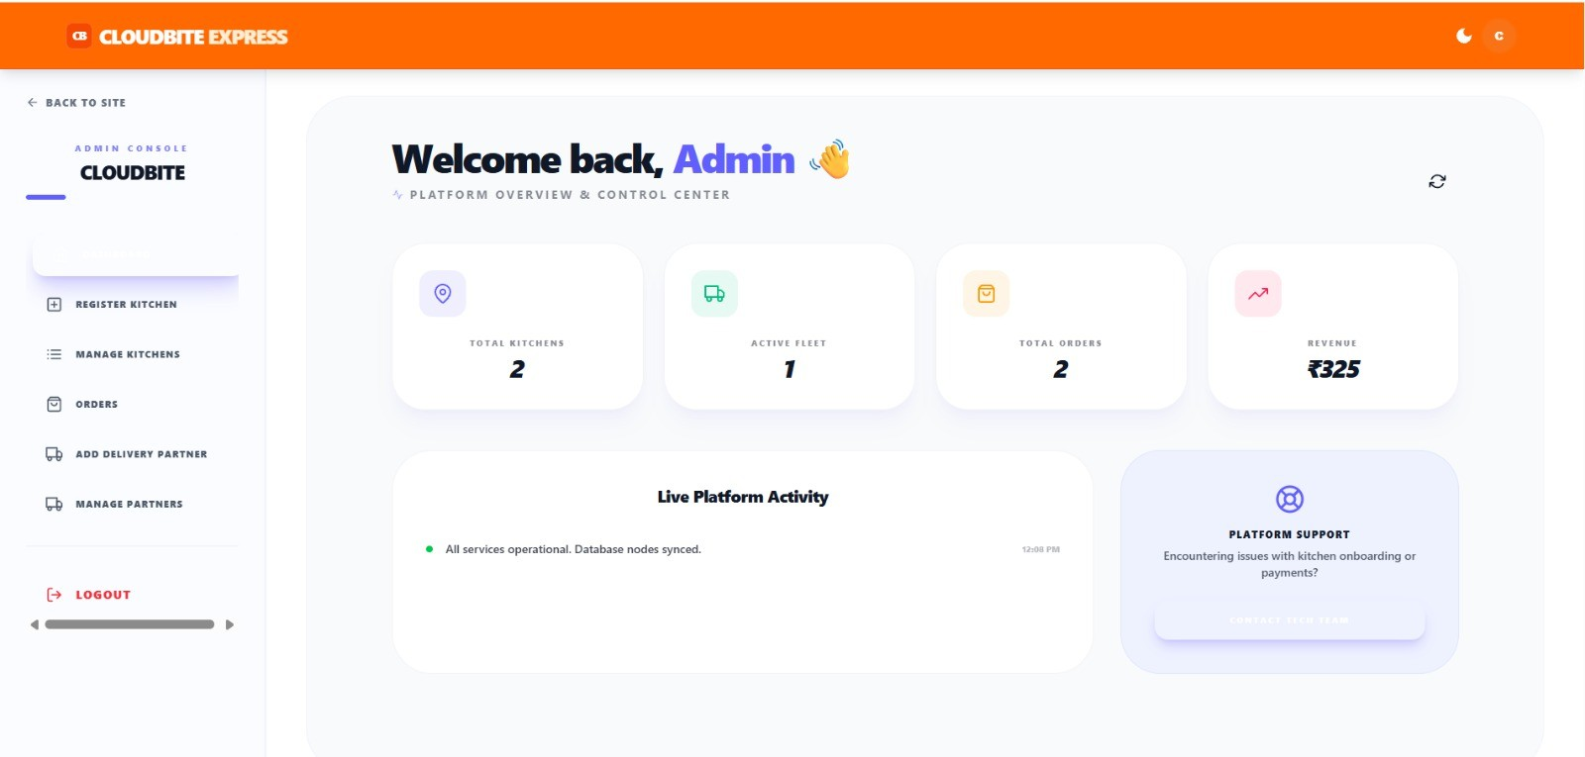
Fig. 7: Admin Central Control: Managing users, kitchens, and system-wide orders.

- Results and Discussion

The implementation of CloudBite resulted in a fully func- tional prototype that successfully brings together order man- agement, menu handling, and delivery coordination into one easy-to-use web platform. The system proved that a centralized design can effectively manage the busy day-to-day operations of a cloud kitchen while keeping all users connected in real- time [12].
During our testing, the security module worked perfectly, ensuring that customers, cooks, and drivers could only see the information meant for them [13]. Kitchen owners were able to update their menus instantly, and customers could browse and place orders without any noticeable lag or technical issues [10].
The heart of the system—the order workflow—accurately moved every order through each stage: from ”Pending” to ”Confirmed,” ”Ready,” and finally ”Delivered.” This step-by- step process made sure there was no confusion between the kitchen and the driver, providing total transparency for the customer [9].
Key observations from our testing phase included:
  - Smooth Coordination: Drivers received instant notifi- cations and could update their status on the go, which solved the common problem of communication gaps in delivery [5].
  - Real-Time Sync: By using modern web tools (Web- Sockets), updates appeared on all dashboards at once. This helped build customer trust because they could see exactly where their food was at any moment [14].
  - System Stability: Even when many orders were placed at the same time, the MySQL database and backend stayed stable. While we noticed very small delays during extremely high traffic, the system overall proved it could scale up as the business grows [15].
Overall, the results show that CloudBite is a reliable and clear platform for running a cloud kitchen. By putting everything in one place—from the first click to the final delivery—the system fixes the typical delays and high costs found in older delivery platforms [2], [4].

- Conclusion
The CloudBite platform serves as a comprehensive proof- of-concept for how modern digital ecosystems can resolve the inherent inefficiencies of traditional food delivery, particularly within the burgeoning cloud kitchen and hyperlocal sectors. By replacing fragmented, manual processes with a single, centralized digital framework, this project demonstrates that a unified platform can significantly enhance operational speed, clarity, and organization for all stakeholders involved.
The system successfully integrates four distinct user groups—Administrators, Kitchen Owners, Delivery Partners, and Customers—into a single, frictionless workflow. The Admin module ensures a secure environment and controlled growth, while kitchen owners are empowered with specialized tools to manage production without logistical confusion. Si- multaneously, customers benefit from a simplified ordering and real-time tracking experience, while delivery partners utilize live status updates to optimize their dispatch efficiency.
From a technical perspective, the combination of a Spring Boot backend and a MySQL database provided a resilient, secure, and scalable foundation capable of supporting future business expansion. The inclusion of intelligent features, such as frequency-based recommendations and data-driven analyt- ics, elevates the platform from a simple management tool to a strategic business asset. Ultimately, CloudBite proves that integrating the right technology stack can make cloud kitchens more profitable, delivery operations more reliable, and customers more engaged in today’s rapidly evolving digital marketplace.
- Future Scope
While the current version of CloudBite provides a strong foundation, there are several exciting ways the platform can grow. One major focus for the future is the development of dedicated mobile applications. Moving beyond the web-based system to native apps would make it even easier for customers to order on the go and for delivery partners to receive instant alerts directly on their phones.
To make the system even smarter, we plan to integrate AI-driven delivery tools. This would include automatic route planning to find the fastest paths and intelligent partner allo- cation to assign the best driver for every order, further cutting down on wait times. We also see a big opportunity in using advanced analytics to help kitchen owners. By studying past order trends, the system could predict which dishes will be popular next week, helping owners manage their ingredients and staff better.
Finally, the platform could be expanded to support larger business needs. This includes adding multi-brand kitchen sup- port—allowing one kitchen to manage several different virtual restaurants from a single dashboard—and connecting directly with inventory management systems to track stock levels in real-time. By adding more payment options and deeper data- driven dashboards, CloudBite will evolve into a complete, intelligent ecosystem that can stay ahead of the fast-changing trends in the digital food industry.
References
- M. P. Hakim, V. M. Dela Libera, L. D. Zanetta, L. G. P. Nascimento, and D. T. Cunha, “Food Research International,” Multidisciplinary Food and Health Laboratory, State University of Campinas, Brazil, 2022.
- S. Lahiri, I. Bose, and A. Majumdar, “Rebel Foods’ cloud kitchen technologies: Food for thought?,” Indian Institute of Management Ahmedabad, 2024.
- K. T. John, “Digital disruption: Hyperlocal delivery and cloud kitchen–driven food services in post-COVID India,” Department of Management Studies, Indian Institute of Technology Madras, India, 2021.
- M. Sharma and R. Gupta, “Cloud kitchen business model and its impact on the food service industry,” International Journal of Hospitality Management, vol. 92, pp. 1–9, 2021.
- S. Kapoor and A. Vij, “Hyperlocal delivery systems and last-mile logistics in food services,” Journal of Retail and Consumer Services, vol. 60, pp. 102–115, 2021.
- P. Kumar and S. Singh, “Digital transformation in the restaurant industry: Emerging trends and challenges,” Procedia Computer Science, vol. 181,
pp. 934–941, 2021.
- N. Verma and K. Sinha, “Food delivery platform integration and consumer behavior analysis,” Journal of Business Research, vol. 134,
pp. 567–575, 2022.
- R. Mehta, “Cloud kitchens and the future of food entrepreneurship,” International Journal of Management Studies, vol. 10, no. 3, pp. 45–53, 2022.
- J. Chen et al., “Real-time order tracking systems in e-commerce appli- cations,” IEEE Access, vol. 9, pp. 12345–12357, 2021.
- S. Roy and D. Banerjee, “Web-based food ordering systems using mod- ern web technologies,” International Journal of Engineering Research and Technology, vol. 9, no. 6, pp. 410–416, 2020.
- Z. Ali and H. Khan, “Impact of COVID-19 on online food delivery behavior,” Journal of Retailing and Consumer Services, vol. 64, 2022.
- K. Patel and M. Joshi, “Centralized management platforms for multi- stakeholder service ecosystems,” IEEE Transactions on Services Com- puting, vol. 15, no. 4, pp. 2300–2312, 2022.
- A. Gupta and S. Arora, “Role-based web applications for multi-user service platforms,” International Journal of Computer Applications, vol. 176, no. 37, pp. 1–6, 2020.
- T. Brown and L. Wilson, “Digital customer engagement in online food delivery platforms,” Journal of Marketing Analytics, vol. 9, no. 2, pp. 134–145, 2021.
- P. Ozili, “Decentralized digital platforms and future of service ecosys- tems,” Journal of Banking and Financial Technology, vol. 6, no. 2, pp. 117–133, 2022.

