Smartphone-Based Driver Behaviour Monitoring and Family Alert System.

Kichagari Sruthi Ediga Shivaji Goud Putluru Pujitha
Assistant Professor Department Of CSE Department Of CSE
Department of CSE Annamacharya Institute of Annamacharya Institute of
Annamacharya University Technology and sciences Technology and sciences
Rajampet,India Rajampet,India Rajampet,India
kichagarisruthi@gmail.com shivajigoud970@gmail.com ppujitha548@gmail.com

Gopaldas Prasanna Kumar Mude Siva Sankar Naik
Department Of CSE Department Of CSE
Annamacharya Institute Of Annamacharya Institute Of
Technology and Sciences Technology and Sciences
Rajampet,India Rajampet,India
Kumargprasanna686@gmail.com mudesivasankar19@gmail.com

Abstract: Aggression, distraction, fatigue and drowsiness are some of the behaviors that affect the issue of safe driving. In the current smart transportation systems, the ability to survey the drivers in the vehicle and notice unusual behaviors as anomalies can help minimize road accidents greatly. Although a lot of literature on the methods of identifying the driver behavior by numerous sensing methods is present, the existing literature also does not have a complete coverage of the relationship between the abnormal driving patterns and the physical state of a driver and the state of a car. The work gives a systematic review of existing approaches, studies the results of the analysis, and defines the existing challenges. It offers the research on the question of driver behavior modeling and the ability to predict abnormal behavior by means of AI-based image analysis, signal processing methods, and classical algorithmic methods. The discourse involves the approaches that are based on driver well-being and detection of their vehicles to improve the safety of their driving. This paper provides a distinct taxonomy by dividing the current approaches into mathematical models, machine learning algorithms, and deep learning structures and summarizes the best features of each one. This analysis assists in identifying the limitation and the gaps in the research, and finally stating the challenges that researchers should work on to create more effective and innovative solutions to the problems of more road safety.

Keywords: Machine Learning, Prediction, Driver behaviour modelling.
1.Introduction
With the current digital age, most of the citizens are highly dependent on high-speed internet-enabled smartphones. Such devices are applied in their daily routine to include online banking, shopping, and social media interaction. The more the smartphones have become part and parcel of daily life, the more the risk factors that would be related to smartphone dependency have been identified and elucidated. To overcome this problem, machine learning algorithm, which was selected due to its capacity to capture complex and non-linear relationships, was used as a solid method of analysis. Smartphone Addiction Questionnaire (SAQ) questionnaire was distributed to 1,143 respondents and the data were assembled in the form of face-to-face questionnaires. There are 40 features in the dataset, with 39 of them being input variables elemental of behavioral and demographic characteristics, and one of them being an output variable that denotes the degree of smartphone addiction. The output category is between 1 and 5 with each mark representing a definite group of addiction or its level of seriousness.
As the volume of data is growing rapidly, the use of machine learning models towards behavioral assessment has grown as well. In the present work, the representative sample data was used to train and evaluate the selected model. In order to make the model as reliable as possible, cross-checking and validation processes were carried out. The analysis indicates that the model had an accuracy of prediction of 92.4 schemes implying that it has done very well in categorizing people into the various categories of smartphone addiction. The use of monitoring behavior in drivers has taken center stage in the field of research because road accidents are gradually involving attributes of human factors like distraction, fatigue, intoxication, and unsafe maneuvers. As the world is slowly turning to intelligent vehicles, advanced driver assistance systems (ADAS), and autonomous driving technologies, it is necessary to know what the driver is doing in real time to reduce the risk of accidents and enhance the safety of transportation. Contemporary research reveals that the traditional single- sensor or rule-based systems are no more positive in the context of road driving to state the probability of specific behavioral patterns. To manage this, the recent studies incorporate a multi-sensor fusion, embedded systems and deep learning models that can be used to identify drowsiness, alcohol influence, unsafe gestures and abnormal operating behavior with high accuracy. It has been demonstrated that approaches both relying on acceleration, eye-blink detector, alcohol awareness units and vehicle telemetry can be used to improve behavioral classification reliability, whereas computer-vision-based methods relying on CNNs, YOLO, BiFPN, and ResNet variations can more effectively identify visual signals such as phone use, fatigue, or unattentive posture. Also, the context based models have been possible through big real-world driving datasets and connected vehicle data, which demonstrate that the lighting conditions, environmental factors, and driver behaviors can influence risk levels. This shift is leading to the integration of sensor fusion, deep learning, and embedded hardware technologies into the field to be computing as hybrid, real-time, intelligent systems to offer proactive warnings and communicative risk analysis in the name of road safety.
- Related Work
Numerous studies have been done on the problem of sensing and computing unsafe or abnormal driver behavior to detect it. The systems based on sensor fusion have comprised alcohol sensor, accelerators and eye-blink modules with embedded systems such as arduino and lab view infrastructure to measure alertness, intoxication and speed in heavy vehicle operations. The vision-based models are also given focus and a number of works have suggested a deep learning structure to effectively detect driver behavior in rail transit and road-going vehicles, which include MobileNetV4, BiFPN feature fusion, Dynamic Head, and universal inverted bottleneck modules. YOLO model-based systems have been employed to identify distractions, e.g. cellphone use, lack of seatbelt use, or smoking using Raspberry Pi and camera inputs to detect contents that describe distractions in real-time. Other papers had presented ResNet-based systems, including ResBoot-50, which uses bootstrap cross-validation to decrease overfitting and improve robustness in a wide variety of datasets, including StateFarm and Drive&Act. Cutting edge driver behavior datasets have been reviewed and made comparisons between visual and non-visual stimuli, as well as presenting issues of multi-modal driver monitoring. Other studies have studied the effect of other environmental conditions like the lighting conditions, temperature, and rains on the drivers response through the real-life driving records. Several techniques have been performed to profile drivers into behavioral types among children such as aggressive or cautious using connected-vehicle information by clustering. Additionally, the research of the drivers of electric buses and of the collision-preventing situations demonstrates that intelligent algorithms and time-delay neural networks are effective to shape the decision-making and steering behavior of the driver. Collectively, these publications highlight the continuous transition to multi-sensor, deep-learning, and contextualized systems to provide proper and real-time evaluation of the driver behavior.
- Existing System
The different schemes of detecting the behaviors of the on-road drivers using the sensing data are included in the existing surveys. The gap which exists in the correlation between the health of the driver or the condition of his/her vehicle and abnormal behaviors which are not yet addressed has been identified. The driver safety in the current vehicle monitoring systems is taken care of by the rule-based approach to such a safety control based on predetermined limits like speed, sudden acceleration, or harsh braking events. They are simply based on the basic telematics data already available when the device is on the car, based on the GPS and the vehicle OBD-II sensors, used to monitor the driving pattern. Although they are effective in raising simple alerts such as the warning beeps or a dashboard notification; they are mostly reactive by nature and only signal to the driver after a danger has been attempted. Furthermore, they are narrow systems because they fail to incorporate multi-modal data sources that include video-based driver monitoring, road situation, or weather data. The alerts are usually limited to the drivers and there is almost no facility of sending alerts in real time to any family members or guardians. They tend to give false positives or not adjust to other driving styles and environments because they rely on set limits. Consequently, the current system does not have predictive intelligence, personalization, and increased safety awareness, and it limits its performance in preventing accidents and the safety of passengers and families.
Disadvantages
- Not able to change to other styles of drivers or road conditions.
- Limited data sources
- None of the family/guardian alert integrations.
- Insufficient reach to accident prevention.

- PROPOSED SYSTEM
We introduce safe smart drive, an all rounded transportation tracking system that will identify and analyze vital conditions in the driving environment, and at the same time be able to monitor the driver behavior. The system is designed in four major layers, which include perception, filtering and preparation, detection and classification, and alert. According to the challenge, we have divided the state-of-the-art into two major domains and these include environmental and driver-behaviour. In the environmental area, we are targeting the articles connected with the traffic element detection, damage detection, and traffic-risk analysis. Under the driver behavior category, we are interested in articles related to the grouping of driver behaviors in relation to the predicaments linked to the vehicle and the drivers.
Advantages
- Simple & low cost
- Works with only telematics
- Gives fundamental driver notifications.
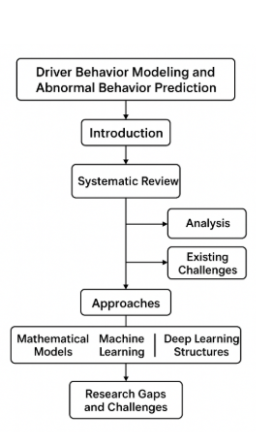

Fig 1. System Architecture

- SYSTEM MODULES
Data Collection
The actual process of developing a machine learning model, which calls for data collection. This is an important action that will have a cascading effect on the model's overall quality. The more data we have, the better our model will work. The data can be collected using a variety of methods, including web scraping, manual interventions, and etc.
Dataset
There are 125974 distinct data in the dataset. The dataset contains 42 columns, which are listed below.
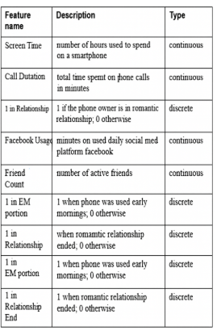
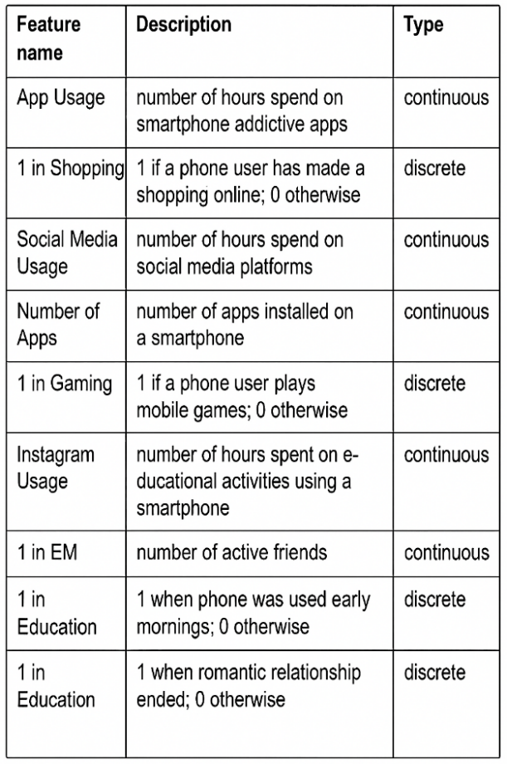

Data Preparation
We will alter the data by removing some columns and the data that is missing. By making a list of the names of the columns that we want to keep or remove, we can divide the data set into two sets, one for training and the other for one for evaluation. The remaining columns, if any, are then dropped or removed. Last but not least, we eliminate or drop the rows from the data set with missing values.
Model Selection
The method that is utilized, particularly for reducing the dataset's dimension, is analysis of the principal components Reducing data dimensions in one of the most efficient and precise ways is principal component analysis, and it yields the desired outcomes. The aspects of the given dataset are broken down using this technique into principal components, or attributes.
Since the dataset has a large number of attributes and a large dimension, the dataset for this method is the entire input. This method reduces the information set via placing all statistics factors on the identical axis. Data points circulate alongside the axis as main components completed.
PCA is carried out with the aid of following the following steps:
- Consider a data set consisting of all measurements d.
- It is vital to find the imply vector of each amount T.
- It is essential to calculate the covariance matrix for the complete information set.
- Determine the eigenvalues ​​(v1, v2, v3, vd) and the eigenvectors (e1, e2, e 3... Ed).
- Sort the eigenvalues ​​in descending order and pick out the n eigenvectors with the largest eigenvalues ​​to shape a matrix with d*n=M.
- Using this M, create a wholly new version area.
- The ensuing pattern areas shapes the important additives.
Random Forest is one of machine learning's most efficient approaches to classification issues. The supervised classification algorithm category includes the random forest. The first stage of this algorithm involves creating a forest from the given dataset, and the second stage involves making predictions using the classifier.

Prediction and Evaluation
We include the actual statistics set with the nine best features chosen;
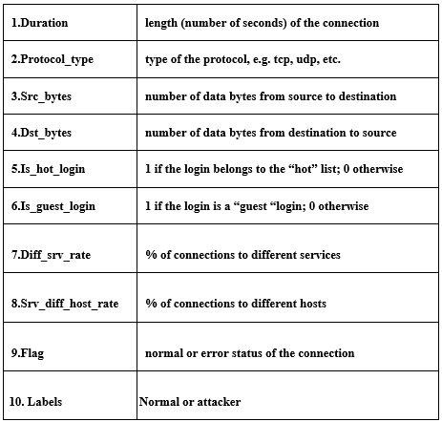
Validity of the test set
Our accuracy at the check set was 99.1%.
Keeping the Trained Model Alive.
Using Pickle, a library that allows you to save your trained and tested model as a.h5 or.pkl file when you are finished, is the first step. confident enough to use it in the production-ready environment. Check to see that Pickle is already installed in your environment. Let's import the module and load the model into a. pkl file as the next step.
- SYSTEM METHODOLOGIES
The system methodology consists of the initial continuous observation of driver actions and vehicle states that are observed as visual, physiological, and sensor-related inputs. These raw signals are then subjected to preprocessing to get noise and useful patterns of distraction and aggression, fatigue and drowsiness. Subsequently, the image analysis methods, such as signal processing algorithms and AI-based image recognition, are used to extract the behavioral patterns and changes in the conditions of a driver or car. These characteristics are then implemented with a mixture of mathematical solutions, machine learning techniques and deep learning networks to learn the normal driving behaviors and detect abnormalities that portray abnormality. The integrated model uses actual data sent through processing, types behaviors, and shows any anomalies based on the comparison of driver well-being and vehicle performance parameters. Lastly, the system produces diagnostic outputs or alerts that indicate unsafe conditions, which, in addition to giving actionable information, can allow viewing the limitations that are present without intimidating and directing improvement of the system to enhance road safety in the future.
- .CONCLUSION
This paper highlights the need to identify and know about abnormal driver behavior to improve the road safety in general. Through the revision of a large number of sensing methods, analytical processes, and intelligent detection approaches, the work shows the significance of driver health conditions and states of the cars to impact such unsafe behaviors as distraction, fatigue, aggression, and drowsiness. The taxonomy provided in this research groups the current methods as incumbent of mathematical, machine learning and deep learning; it provides a clear understanding of the strengths, weaknesses, and applicability. In this analysis several gaps in the research were understood including the necessity of integrated systems that link indicators of driver well-being to data on vehicle performance that can be more effective in detection. The results indicate that future studies should center on the need to develop powerful, real-time and context-aware models that can be used to predict anomalies at the early stages so as to reduce the risk of accidents. Finally, the research gives a basis of coming up with improved, precise and smarter driver monitoring systems, which can greatly help towards safer means of transportation.
REFERENCES

- K. S, S. S. Nath, N. T and B. S. M, "Enhancing Heavy Vehicle Safety with Intelligent Driver Behaviour Monitoring via Multi-Sensor Fusion and Embedded Systems," 2024 International Conference on System, Computation, Automation and Networking (ICSCAN), PUDUCHERRY, India, 2024, pp. 1-5, doi: 10.1109/ICSCAN62807.2024.10894289.
- F. M. A. Ali, M. J. Alnuaimi, S. A. Alawadhi and S. Abdallah, "Abnormal Driver Behavior Detection Using Deep Learning," 2024 7th International Conference on Signal Processing and Information Security (ICSPIS), Dubai, United Arab Emirates, 2024, pp. 1-4, doi: 10.1109/ICSPIS63676.2024.10812606.
- Z. Liu, L. Zhang, X. Wang and G. Yao, "Research on Subway Driver Behavior Recognition Method Based on Multi-Scale Feature Fusion CNN," 2025 5th International Conference on Artificial Intelligence, Big Data and Algorithms (CAIBDA), Beijing, China, 2025, pp. 800-804, doi: 10.1109/CAIBDA65784.2025.11182629.
- D. Tan, W. Tian, C. Wang, L. Chen and L. Xiong, "Driver Distraction Behavior Recognition for Autonomous Driving: Approaches, Datasets and Challenges," in IEEE Transactions on Intelligent Vehicles, vol. 9, no. 12, pp. 8000-8026, Dec. 2024, doi: 10.1109/TIV.2024.3405990.
- R. Mohsin, M. Khalid, Y. Yao, J. Chandroth, J. Ali and B. -H. Roh, "Real-Time Driver Behavior Detection for Alert Using Bootstrapped Cross-Validation and Optimized Resnet-50," 2025 International Conference on Information Networking (ICOIN), Chiang Mai, Thailand, 2025, pp. 552-556, doi: 10.1109/ICOIN63865.2025.10992842.
- X. Li, C. Zhuge and B. Yu, "Analysis on the Impact of Illegal Driver Behaviors on Road Traffic Accidents Case Study on China," 2019 11th International Conference on Intelligent Human-Machine Systems and Cybernetics (IHMSC), Hangzhou, China, 2019, pp. 250-253, doi: 10.1109/IHMSC.2019.00065.
- C. Zink, E. Lenz, J. Kaste, D. Dobkowitz, F. Kallmeyer and R. Findeisen, "Real-World Data-Driven Analysis of Environment- and Context-Dependent Driving Behavior," 2025 IEEE Intelligent Vehicles Symposium (IV), Cluj-Napoca, Romania, 2025, pp. 2459-2466, doi: 10.1109/IV64158.2025.11097456.
- S. K, K. A, D. M and D. R. C, "Hybrid Deep Learning for Proactive Driver Risk Prediction and Safety Enhancement," 2025 International Conference on Multi-Agent Systems for Collaborative Intelligence (ICMSCI), Erode, India, 2025, pp. 1572-1577, doi: 10.1109/ICMSCI62561.2025.10894603.
- H. Chen, F. Zhao, K. Huang and Y. Tian, "Driver Behavior Analysis for Advanced Driver Assistance System," 2018 IEEE 7th Data Driven Control and Learning Systems Conference (DDCLS), Enshi, China, 2018, pp. 492-497, doi: 10.1109/DDCLS.2018.8516059.
- N. Hassan, H. Zamzuri and M. H. M. Ariff, "Modelling of driver's steering behaviour control in emergency collision avoidance by using focused time delay neural network," 2018 International Conference on Information and Communications Technology (ICOIACT), Yogyakarta, Indonesia, 2018, pp. 730-734, doi: 10.1109/ICOIACT.2018.8350750.
- B. Mei, "Research on a DSM-YOLO-Based Detection System for Dangerous Driver Behavior in Auto-Driving," 2025 8th International Conference on Advanced Algorithms and Control Engineering (ICAACE), Shanghai, China, 2025, pp. 713-716, doi: 10.1109/ICAACE65325.2025.11020376.
- Q. Xue, L. Lu, Y. Wang, Y. Zhou, Y. Li and J. Hang, "Characterizing Driver Behavior Patterns with Driver Assistance Systems under Different Lighting Conditions: A Driving Simulator Study," 2025 8th International Conference on Transportation Information and Safety (ICTIS), Granada, Spain, 2025, pp. 2016-2020, doi: 10.1109/ICTIS68762.2025.11215005.
- A. Berrouachedi, R. Jaziri and G. Bernard, "Driver Behavior Profiling: Clustering Techniques for Enhanced Road Safety and Personalized Mobility," 2025 IEEE 5th International Conference on Smart Information Systems and Technologies (SIST), Astana, Kazakhstan, 2025, pp. 1-6, doi: 10.1109/SIST61657.2025.11139175.
- X. Fang, "Identification and Assessment of Electric Bus Driver's Driving Behavior Based on Computer Vision and Intelligent Algorithms," 2024 IEEE 16th International Conference on Computational Intelligence and Communication Networks (CICN), Indore, India, 2024, pp. 896-900, doi: 10.1109/CICN63059.2024.10847342.
- L. Zhang, J. Wang, F. Yang and K. Li, "A quantification method of driver characteristics based on Driver Behavior Questionnaire," 2009 IEEE Intelligent Vehicles Symposium, Xi'an, China, 2009, pp. 616-620, doi: 10.1109/IVS.2009.5164348.

