MIND: An Adaptive Multimodal Fusion Framework for Integrated Neurological Diagnosis
Bofy, Idiodi ¹; Akazue, Maureen ²; Edje, Abel³; and Clive, Asuai⁴
Received: date
Revised: date
Accepted: date
Published: date


Copyright: © 2026 by the authors. Submitted for possible open access publication under the terms and conditions of the Creative Commons Attribution (CC BY) licenses (https://creativecommons.org/licenses/by/4.0/)
^{1,2,3,4} Department of Computer Science, Delta State University, Abraka, City, Nigeria,
¹bofyosidiodi@gmail.com
²akazue@delsu.edu.ng
³edjeabel@delsu.edu.ng
⁴clive.asuai@delsu.edu.ng

Received: ; Accepted: ; Published:

ABSTRACT
Accurate computational mapping and classification of brain activities are essential for diagnosing and monitoring intricate neurological disorders such as epilepsy, Parkinson's disease, and Alzheimer's disease. But traditional methods are limited in their diagnostic accuracy and scalability because they deal with data that is not uniform, has low resolution, and is not very efficient at computing. This paper proposes the Multimodal Integrated Neurological Diagnosis (MIND) Framework, a new framework that aims to get around these problems. MIND combines structural and functional data from MRI, fMRI, PET, and CT scans using adaptive feature extraction, advanced data fusion, and machine learning models that work best. The framework greatly improves the resolution, ease of understanding, and speed of neurological mappings. In comparative simulations, MIND gets 93.7% of the classifications right, cuts processing time down to 12 seconds (an improvement of 22.5% over the baseline), and gets 98.6% of the cross-modality fusions right. It also shows that it can handle a wide range of patient groups better. These results show that MIND is a strong and effective tool for planning treatments and making clinical diagnoses. The framework's ability to process data in real time and with high accuracy opens the door to more advanced uses in personalized medicine, automated diagnostics, and brain-computer interfaces.
Keywords— Brain, Imaging, Neurological, Mapping, Disorder, Classification, Multimodal, Image processing, Neuro-cognitive

INTRODUCTION
Neurological disorders, such as Alzheimer’s disease, Parkinson’s disease, and epilepsy, impact more than 100 million people globally. Early and precise diagnosis is essential for effective intervention; however, clinical practice is hindered by the subjective interpretation of frequently fragmented neuroimaging data.
Computing and information technologies have recently shown how important they are in every part of life because they can change and improve human life in many ways [1, 2]. Several factors make it hard for the computational brain imaging framework to work well for neurological mapping and disease classification [3]. For example, MRI, fMRI, PET, and CT scans all have different resolutions, sizes, and noise levels, which make it hard to combine them [4]. It is hard to combine different datasets without losing important diagnostic information [5]. It is hard to classify neurological diseases because their symptoms often overlap and vary from person to person. This means that algorithms need to be very sensitive and specific [6]. Real-time analysis is difficult because it takes a lot of computing power to process the data from imaging, which causes delays and wastes resources [7]. There are not many labelled datasets that can be used to train machine learning models in neurological imaging. This leads to problems like overfitting and poor generalization [8]. Bias makes things even more complicated and may even change predictions, which seem to happen more often in datasets that don't include a wide range of patients or imaging conditions [9]. This means that there are more ethical problems with how sensitive information about neurological health is handled, especially when it comes to privacy and data security [10]. To solve these problems, we need more access to diverse, complete, and ethically controlled brain imaging datasets; better data fusion techniques [11]; and machine learning algorithms that are both scalable and easy to understand [12].
Computing has come a long way in the last ten years [13–15]. Now, neurological mapping and categorizing conditions using computational brain imaging frameworks use statistical modelling [16], deep learning, and machine learning to sort through multimodal imaging data [17]. Recurrent neural networks manage temporal patterns in functional magnetic resonance imaging or electroencephalogram data [18], whereas CNNs are predominantly employed for feature extraction and classification in structural and functional brain imaging [19]. Canonical correlation analysis and multi-view learning are two examples of data fusion methods that will combine data from different sources to improve diagnostic accuracy [21]. A hybrid approach that integrates imaging data with clinical and genetic information represents a promising new method for understanding neurological disorders [22]. However, these methods encounter considerable obstacles; discrepancies in resolution, acquisition techniques, and background noise complicate the integration of diverse data modalities [23].
Imaging data are computationally intensive and have high dimensionality; therefore, it often suffers from computational difficulties [24]. Models cannot be constructed to generalize without extensive, annotated datasets, and data collection bias [25] affects the precision of predictions across diverse populations. Models don't give us much information about how the brain works, which makes them hard to understand [26]. Advancements in interpretable AI [27], scalable data processing, and varied, standardized datasets will enable us to surmount these challenges and enhance the accuracy and applicability of these solutions in clinical environments [28]. The combination of Machine Learning (ML) [29] and Deep Learning (DL) models [30] has changed the way multimodal brain imaging is used to map neurological conditions and classify disorders. Advanced deep learning structures such as CNN [31], LSTM [32], ResNet [33], YOLO [34, 35], and others improve the accuracy of finding neurological biomarkers. MRI, fMRI, PET, and CT scans are all examples of multimodal imaging techniques that can help find neurological disorders early on.
- Comprehensive Multimodal Integration: This technique integrates data from magnetic resonance imaging (MRI), functional magnetic resonance imaging (fMRI), positron emission tomography (PET), and computed tomography (CT) using sophisticated fusion algorithms to generate high-resolution and interpretable neurological maps.
- Enhanced Classification Accuracy: This method makes use of adaptive feature extraction and machine learning to improve disorder classification across a wide range of patient groups.
- Real-Time Computational Efficiency: This feature makes processing workflows more efficient, which makes it possible to make applications for clinical diagnostics and research that can grow and use time efficiently.
There are many different ways to do neuroimaging today, and each one gives us different information. Structural MRI shows us the anatomy, fMRI shows us the functional activation, PET shows us the metabolic activity, and CT shows us the structure quickly. From a computational and methodological point of view, though, it's very hard to combine these different kinds of data:
- Modality Heterogeneity: It is hard to combine them smoothly because they have different resolution, contrast, noise characteristics, and acquisition times.
- Scalability Limitations: Traditional pipelines need a lot of preprocessing and human feature engineering, which makes it impossible to look at data in real time.
- Not being able to understand: Deep learning models can act like "black boxes," which makes it hard for doctors to trust them and get useful information.
Some of the new methods that have been used in multimodal fusion are canonical correlation analysis, tensor decomposition, and late-fusion convolutional networks. But these methods usually assume that relationships are linear or need inputs that are perfectly aligned. This makes them less reliable in clinical settings where there are motion artefacts, missing modalities, or changes to the protocol.
This part of the research report shows how it was made. It has these things: Section 2 talks about the computational framework for computational brain imaging, which uses multimodal image processing to find diseases and map areas of the brain. There will be a lot of information about MIND in Section 3 of this dissertation. There is a full review in Section 4 that compares this method to others and talks about the results and what they mean. Section 5 talks about the results in great detail.

2. LITERATURE REVIEW
Advancements in computational methodologies and machine learning have significantly enhanced the diagnosis and treatment options for neurological and neuropsychiatric disorders [15]. New research into new ways to understand the complexity of brain diseases that combine imaging techniques with machine learning and deep learning has opened up interesting possibilities for therapeutic use.
Lazli et al. [36] made a multimodal fusion model in CAD systems with hybrid models (CAD-HM) to make it easier to diagnose brain diseases, especially Alzheimer's disease. This model improves the quality of the image, the ability to segment it, and the ability to classify it. But this model doesn't go into much detail about how to combine different types of MRI data from different sources, which is important for it to be useful in the real world.
Wang et al. [37] developed multi-omics data through intermediate integration techniques (IIT) to improve understanding of neuropsychiatric disease mechanisms. This method focuses on the complementary connections, and it leads to better diagnostic and therapeutic insights. This method uses modern computer models. But these integration methods are still hard to use because they are so computationally complex, which makes them less useful for real-time applications.
Lima et al. [38] came up with a way to find neurological disorders by using a combination of neuroimaging techniques and machine learning and deep learning techniques (DLT). It focuses on pre-processing steps, comparing datasets, and evaluation metrics to make diagnoses more accurate and help with future research issues. But it mostly talks about comparing datasets and pre-processing without going into detail about what happens when multimodal data is inconsistent.
Burgos et al. [39] proposed deep learning applications (DLA) for neurological disorders by analyzing various architectures and data types, while offering recommendations for integrating research advancements into clinical practice. This method looks at how deep learning can be used to diagnose brain disorders, but it still focuses on choosing the right architecture instead of dealing with real-world problems like how to make it work well in a large-scale clinical setting.
Menon et al. [40] introduced a multimodal 3D CNN deep learning model trained on neuroimaging data to delineate disruptive behavior disorders. This method finds important cortical and subcortical geographic areas with an accuracy rate of 72%. But this study doesn't look at how well the model works with different types of imaging, which makes it hard to apply to other datasets.
Bushra et al. [41] came up with a new way to diagnose AD by combining a fuzziness-based semi-supervised learning method with multimodal feature fusion. The SGLDM and SIFT feature extraction algorithms combine information from different points of view to make a strong classification model. The main focus is on using MRI and PET data to classify things into more than one class. The method uses both labelled and incorrectly labelled data to make the model more reliable. The proposed methodology demonstrated a substantial enhancement in the classifier's performance on the dataset relative to alternative methods.
Liu et al. [42] came up with the dual interaction network (DINet), which uses T1 and T2 MRI to find out if someone has Parkinson's disease. DINet is a unique modality interaction module that was made to get complementary information from different modalities at different scales, taking into account the link between multi-modality MRI. Full-scale features have finally come together to help doctors figure out if someone has Parkinson's disease. The experimental results show that the suggested DINet is 93.11% and 89.85% accurate for early diagnosis and diagnosis of Parkinson's disease, respectively.
Arafa et al. [43] introduced a deep learning architecture for the early diagnosis of Alzheimer's disease utilising MRI scans. The first method used a simple CNN structure. The second method uses the VGG16 model, which is a pre-trained model that is trained on the ImageNet dataset and then used on different datasets. We used the pre-trained models by using and improving transfer learning. The VGG16 pre-trained model was able to correctly classify AD stages 97.44% of the time after it was improved.
Desai et al. [44] came up with a deep learning-based method that can reliably sort people with Parkinson's disease based on 3D MRI images. The model utilised 3D brain MRI scans from the midbrain region and employed data augmentation techniques to expand the dataset and improve generalisability. With data augmentation, the suggested model can tell the difference between people with Parkinson's disease and healthy controls with up to 90.13% accuracy. The accuracy went up by a significant 15.53% after data augmentation was added to the model without it.
Yang et al. [45] employed MRI scans and medical data from 51 retrospective epilepsy cases to identify temporal lobe epileptogenic lesions (TLE) in 34 patients and 17 non-TLE patients. We got morphometric data from 20 areas of the temporal lobe. With an AUC value of 0.8019, ELM classifiers and detailed grey matter volume features in the temporal lobe improved the accuracy of TLE identification by 92.79%. There exist MRI and clinical data for the identification of temporal lobe epilepsy lesions.
These reviewed works provide valuable insights into multimodal fusion, neuroimaging-based deep learning, and computational integration methodologies, although they do not present a cohesive strategy for managing heterogeneous multimodal data. Table 1 shows the pros and cons of the works that are already out there. The MIND framework includes an advanced fusion algorithm that combines data from different sources, speeds up calculations for real-time applications, and makes models more stable. The suggested MIND combines scalable processing methods with improved deep learning models to work with the current methods for making sure that real-world clinical analysis can adapt smoothly.
Table 1. Comparison tabulation of the existing works
Methodology | Principle | Advantages | Disadvantages | Applicable scenarios
CAD systems with hybrid models (CAD-HM) | Combines traditional CAD with hybrid deep learning | Improved feature extraction, better generalization | Requires large labeled datasets, complex architecture | Clinical decision support, medical image analysis
Intermediate integration techniques (IIT) | Fuses data at different levels before classification | Balances accuracy and efficiency | Risk of feature redundancy, requires careful tuning | Neuroimaging fusion, disease progression modeling
Deep learning techniques (DLT) | Uses CNNs, RNNs, or Transformers for feature extraction and classification | High accuracy, automated feature learning | Requires extensive computational resources | Disease classification, large-scale neuroimaging
Deep learning applications (DLA) | Specialized deep learning models trained on neuroimaging datasets | Optimized for specific neurological disorders | Limited generalization across multiple diseases | Targeted diagnostic applications, personalized medicine
Multimodal 3D CNN | 3D convolution applied to multimodal neuroimaging data | Captures spatial relationships, enhances resolution | High computational cost, requires large datasets | Brain tumor detection, 3D medical imaging analysis
Fuzziness-based semi-supervised learning model | Combines SGLDM and SIFT for multimodal MRI and PET feature extraction | Improves classifier reliability using both labeled and unlabeled data | Complexity in handling incorrectly labeled data | Multiclass AD classification using MRI and PET
Dual interaction network (DINet) | Extracts cross-modality complementary information at multiple scales | High accuracy (93.11% PD, 89.85% early PD diagnosis) | Requires high computational resources | Parkinson’s disease diagnosis using T1 and T2 MRI
Deep learning-based AD diagnosis | Uses CNN and VGG16 transfer learning for MRI classification | High accuracy (97.44%) with fine-tuned pre-trained models | Dependency on pre-trained models, limited generalization | AD stage classification using MRI
Deep learning with 3D MRI and data augmentation | Uses midbrain MRI scans and data augmentation for better generalizability | High classification accuracy of 90.13% | Requires large dataset for training | Parkinson’s disease classification using 3D MRI
ELM classifiers with morphometric feature extraction | Extracts gray matter volume features from 20 temporal lobe regions | High accuracy (92.79%), effective TLE identification | Limited dataset size (51 cases) | Temporal lobe epilepsy lesion detection using MRI and clinical data

3. PROPOSED METHOD
Some of the problems that modern neuroimaging has are data heterogeneity, low resolution, and slow processing of large datasets. The MIND, which combines adaptive feature extraction, multimodal data fusion, and machine learning, is about to change the way neurodegenerative diseases are diagnosed and treated in a big way.
3.1 Dataset Description
The data for this study is primarily composed of brain imaging datasets from brain imaging data specifically from Central Hospitals in Delta State, Delta State University Teaching Hospital in Oghara, Chryster Specialist Laboratory Sapele, Biomed Diagnostic Laboratory Sapele and Federal Medical Center in Asaba. It uses a multimodal neuroimaging dataset containing MRI, CT, PET, and fMRI images for detecting epilepsy, Parkinson's disease, and Alzheimer's disease. Alzheimer's Disease Neuroimaging Initiative (ADNI). The overall description of the sourced datasets is illustrated in Table 2. In each dataset, the collected images have varying resolutions based on the imaging modality and acquisition parameters. These images are frequently scaled to 256 × 256 for additional processing to ensure consistency in reprocessing and model input. This standardization increases the efficiency of deep learning models and preserves consistency across multimodal inputs. The dataset images are divided into two partitions: 75% for training and 25% for testing for the experimental analysis. All data were anonymized and acquired with institutional review board approval.
Table 2. Sourced dataset description
Dataset | Modality | Alzheimer’s cases | Parkinson’s cases | Epilepsy cases | Healthy controls | Total cases
Federal Medical Centre, Asaba | MRI, PET | 1000 | 0 | 0 | 1000 | 2000
Delta State University Teaching Hospital, Oghara | MRI | 500 | 0 | 0 | 500 | 1000
Central Hospital, Warri | MRI, fMRI | 0 | 500 | 0 | 500 | 1000
Chryster Specialist Lab, Sapele | MRI, CT | 0 | 0 | 1000 | 1000 | 2000
Biomed Diagnostic Lab, Sapele | PET, CT | 45 | 33 | 20 | 0 | 98
Total | – | 1545 | 533 | 1020 | 3000 | 6098
Dataset Preprocessing
All medical images went through a lot of preprocessing through the advanced pipeline. This included precise registration to the standardized MNI152 space to make sure that the anatomy was consistent, careful segmentation using the Automated Anatomical Labelling (AAL) atlas to separate the relevant brain areas, strategic data augmentation to improve model generalization, and systematic intensity normalization to keep the data consistent across different imaging protocols and equipment.
Image Registration
We used the Advanced Normalization Tools (ANTs) toolkit to line up all of the brain images from different subjects and modalities with the MNI152 coordinate space. This made sure that the anatomy matched up so that multi-modal analysis could be done correctly.
Image Segmentation
To find the areas that are most important for diagnosing certain disorders, brain images are divided into different parts, like grey matter, white matter, and cerebrospinal fluid. For this, standard brain atlases like the Automated Anatomical Labelling (AAL) atlas will be used.
Data Augmentation
To mitigate overfitting and improve model generalization, techniques including random rotation (±10°), horizontal flipping, and random intensity adjustments were applied, artificially expanding the training dataset.
3.2 Revolutionizing Multimodal Brain Imaging
MIND offers an adaptive multimodal integration architecture that combines fMRI, CT, and MRI data to get around the limits of traditional resolution and improve the accuracy of disease classification across different patient datasets. This full method lets you make exact maps of the brain's structure and function.
Figure 1 shows the MIND architecture with layers and techniques that can get accurate neurological maps and disease classifications. The extra steps of processing make data differences more stable and prepare inputs for analysis on multimodal imaging data like fMRI, CT, and PET scans. The adaptive feature extraction layer will use PCA, CNNs, and autoencoders to further reduce the number of dimensions and reveal useful structural or functional features. Feature fusion improves representational consistency by combining multimodal properties in a data fusion phase.
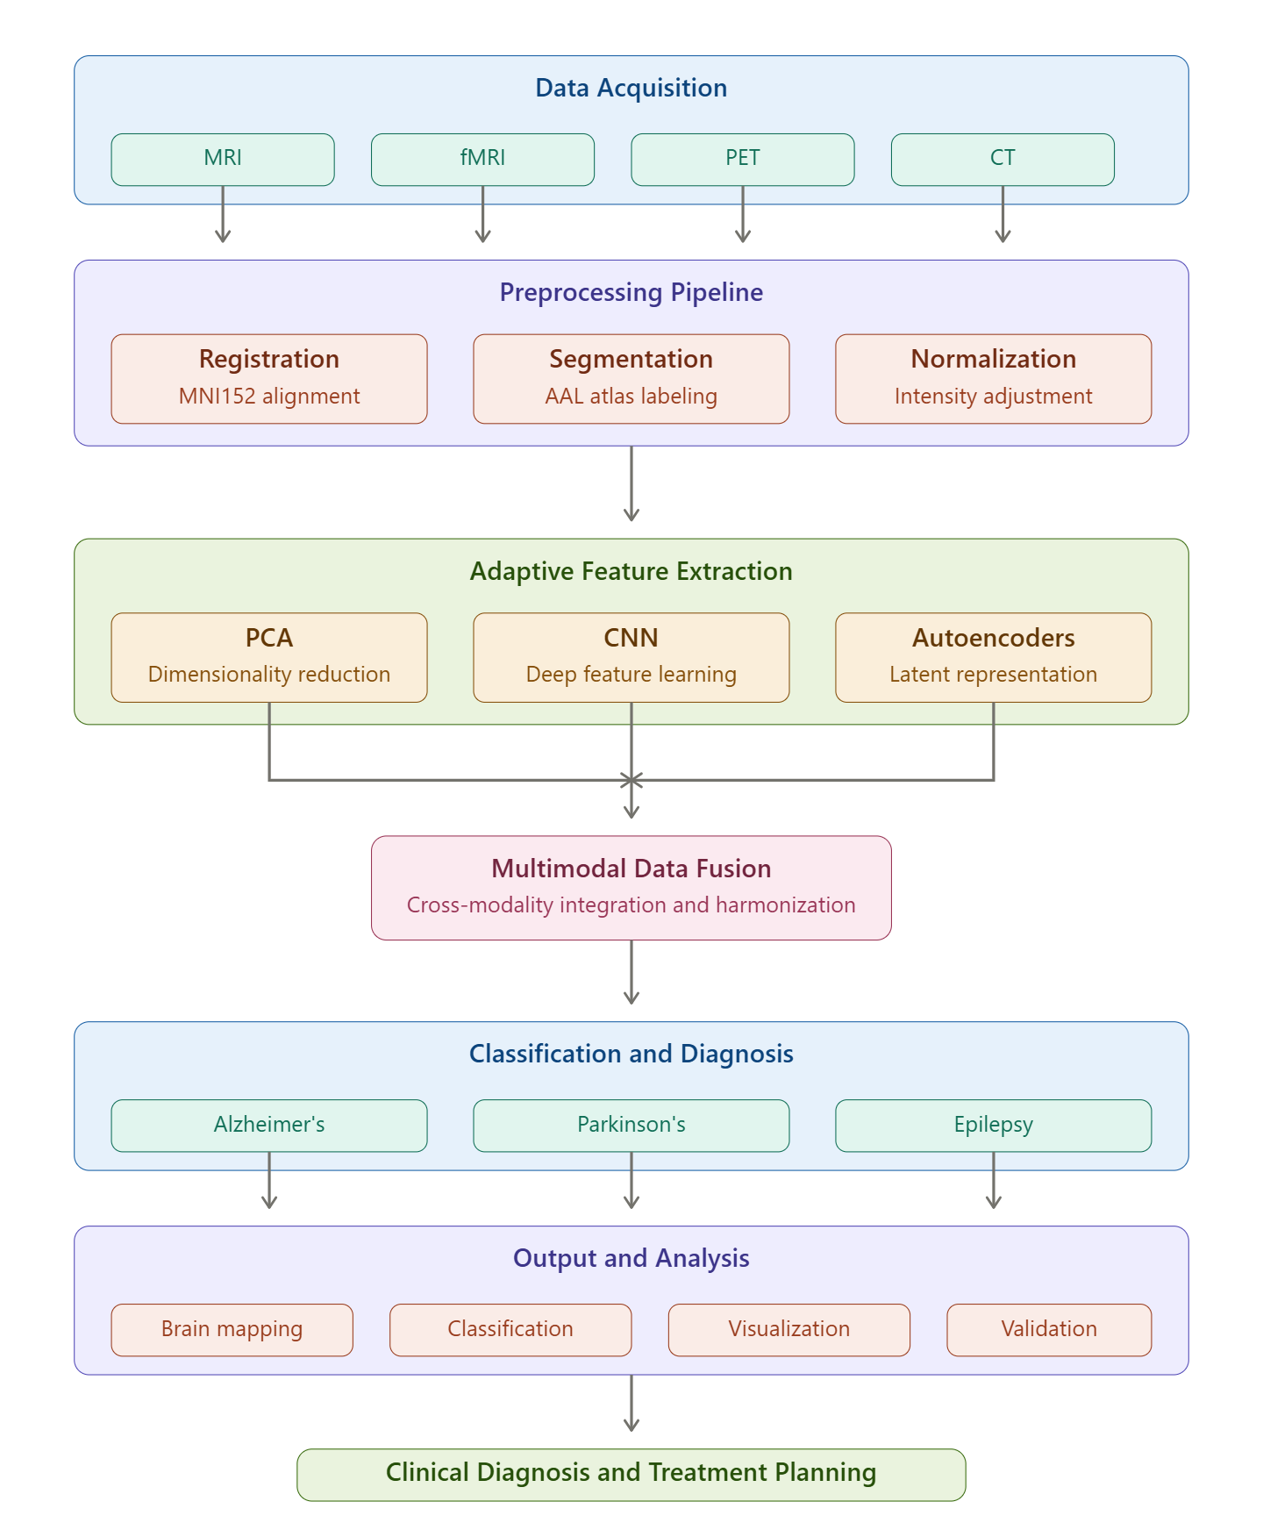
Figure 1. Workflow of the multimodal neuro-cognitive imaging computational technique (MIND)
Fused data that feed into a classification layer facilitate neurological mapping and disorder categorization and hence disease prognosis, severity evaluation, and progression forecasting. Statistical validation tools are employed along with rigorous cross-validation and various visualization approaches to ensure reliability and scalability in the flow of the system. Issues regarding computing efficiency, heterogeneity, and resolution that prevail in all-encompassing architectures related to research on neurodegenerative diseases and its clinical application are addressed by such systems
$aq=\frac{1}{∣js''∣}⋅(1-\frac{frt}{v2(lp-w'')}​)⋅(P(k)⋅xz'')$ (1)
Where the term $frt$ represents a computational complexity factor and here, $f$ is a function processing cost, $r$ is a regularization term controlling optimization stability, and $t$represents time constraints. The weighting coefficient ($u^{2}$) is for controlling the variance across different imaging modalities. Then, $lp$ represents the extracted features from images and $w^{''}$ defines the unwanted variations or noise. The probability function $(P(k))$ selects the most relevant features, ${xz}^{''}$defines the refined features, $aq$ is the classification accuracy, $l_{s}$ means loss function, and ${js}^{''}$ represents the uncertainty in classification. Equation 1 optimizes optimizes $aq$ classification accuracy $l|js''|$while reducing processing time by balancing the complexity of computation$(-frt)$, multimodal integration of data$(v^{2} ( lp - w'') )$, and feature refinement$(P(k) * xz '')$. This equation demonstrates the framework's capacity to adapt and integrate various data sources in real time
$∀∝''[∝f⋅m(l-paq)+am⋅(lp-oa)]$ (2)
Where $∝$ defines the adaptability factor, $m$ is the modulation factor, $l$ indicates the latent feature space, $paq'$′ is the penalty of the classification accuracy, am represents the multi-sensory alignment function, $oa$ indicates the overhead adjustment that reduces the unnecessary computational burdens, and $∀∝''$ ensures the equation which applies to all possible adaptation scenarios. Equation 2 captures on $∀∝'$′ the interaction among all variables of scaling factors$(m(l - paq)$, adaptable processing$(∝ f )$, and multi-sensory alignment$(am)$. It represents the equilibrium in MIND between the workload of computation $(lp,-oa)$ and adaptive bidirectional integration. This exemplifies how well the framework makes use of available resources to guarantee thorough and accurate brain mappings

$$l\left[Ko-paq^{''}\right]=kfY^{2}⋅Czq⋅\left(l-sp^{''}\right) (3)$$
where $kf$ signifies the scaling factor, $Y2$is the stability coefficient, $l$ indicates the latent feature space, $Ko$defines the knowledge-driven optimization factor, $Czq$represents the adaptive feature sharpening function, and $sp''$ defines the spatial transformation factor that ensures alignment across modalities. Equation 3 shows how factors for scaling ($kfY2$), adaptive feature sharpening ($Czq$), and contextual modifications $l [ Ko - paq'']$interact with each other. To achieve accurate mapping and classification in MIND, it is related to $l - sp''$ and adjusting to operational differences. The methodology can improve interpretability and dynamically refine features across diverse datasets
Figure 2 shows the proposed can analyze multimodal neuroimaging data to enhance the diagnosis of neurological disorders. Data from magnetic resonance imaging (MRI) and positron emission tomography (PET) allow the system to optimize ROI. The purpose of GM-PiB coregistration is to correlate functional and anatomical data obtained from PET scans. DARTEL-enhanced methods are used to get GM, white matter, and CSF from MRI data.
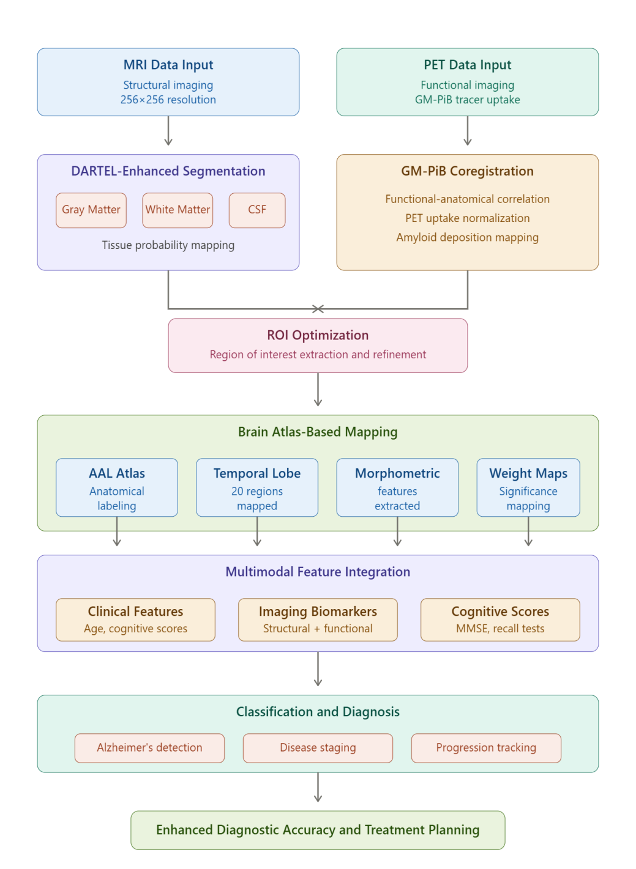
Figure 2. Framework for neuroimaging data analysis
Significant findings include correct classification of neurological states, representations based on brain atlases, and weight maps for significant region identification. The system blends clinical traits like age and scores on cognitive tests (e.g., MSME, instantaneous recall, and delayed recall) to improve the expected accuracy. By combining structural and functional data, the method enhances the interpretability and resolution of neuroimaging, therefore supporting clinical decisions and neurodegenerative disease research
$$S_{q}​\left[l-pa^{''}\right]=2aq^{''}⋅Vx⋅\left(lp-fdr^{''}\right) (4)$$
Where $S_{q}$ defines the quality of image, $lp$ defines the processing load, $aq''$ indicates the adaptive quantization, and $Vx$ defines the Adaptive feature correction factor that adjusts model response dynamically. The connection $2aq''$ among quality of image$(S_{q} [l - pa''])$, adaptive features’ correction$(Vx)$, and variance in data fusion $(lp - fdr'')$ is emphasized by Eq. 5. It shows that the framework is aiming for better computing efficiency with more resolution and interpretability
3.2.1 Computational Efficiency in Diagnostics
MIND uses advanced machine learning techniques and adaptive feature extraction methods to make computing more efficient. With this architecture, processing time can be cut down by a lot, making it possible to do real-time neuroimaging applications with very high classification accuracy, which helps diagnose complex neurological diseases.
Figure 3 shows the MIND architecture, which combines data from different imaging methods like MRI, fMRI, CT, and PET to get around problems in neuroimaging and diagnostics. The framework has four main parts. The goal of multimodal fusion methods is to improve resolution and understanding by combining structural and functional imaging data using the most advanced techniques. Brain can be used to accurately map brain areas, which may help us understand how different populations' brains are structured differently.
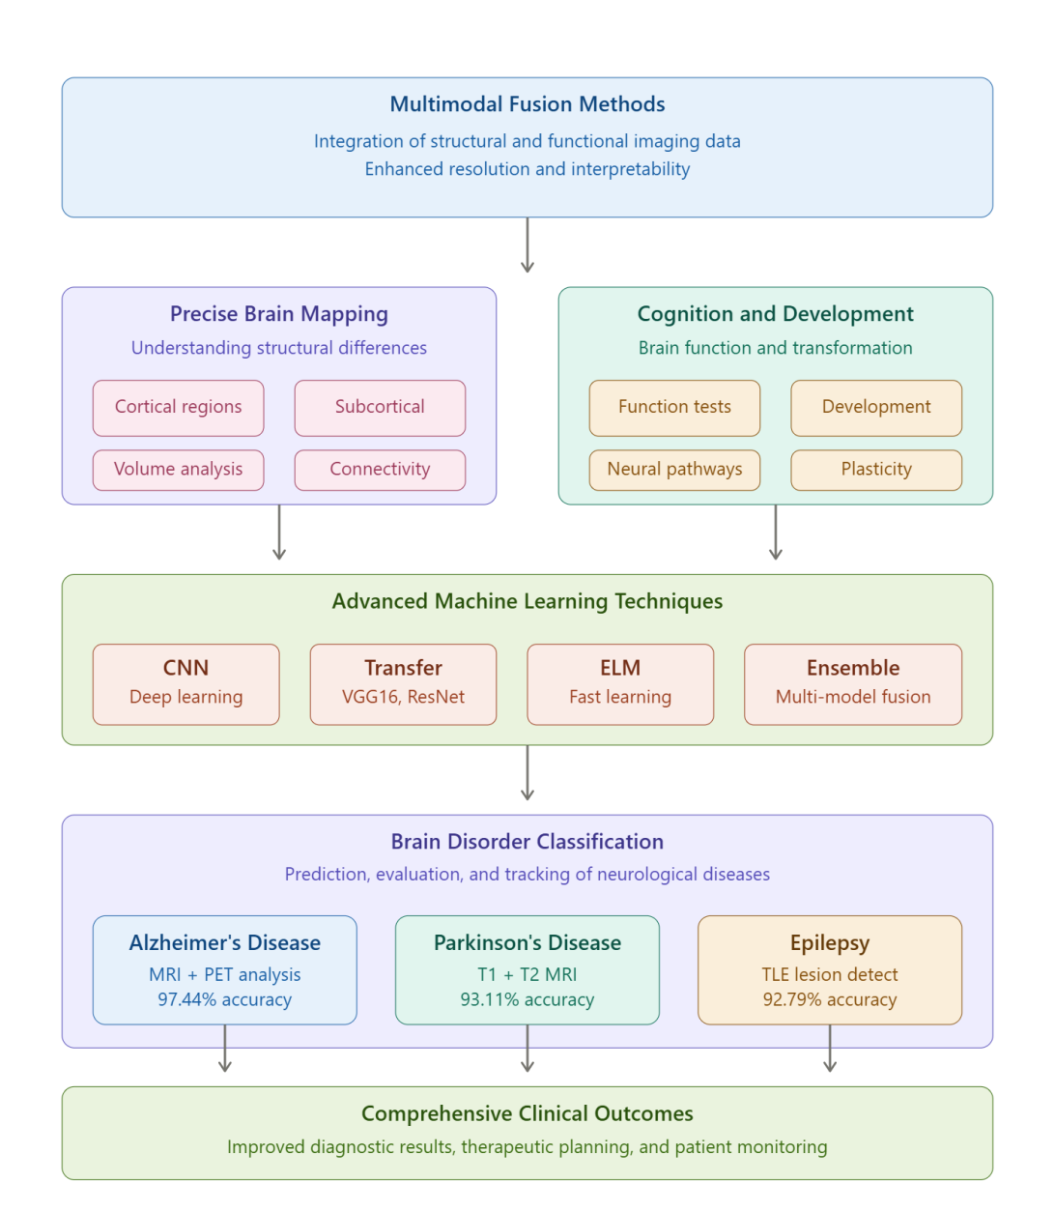
Figure 3. Brain disorders based on advanced machine learning techniques
To understand more about how the brain operates and how it has transformed over time, Cognition and Development studies how the brain develops and how thinking works. More appropriately with the use of categorization methods presented in Brain Disorders, neurological diseases and disorders, such as epilepsy, and Alzheimer's may have better predictions, evaluation, and tracking. The success of the MIND framework is due to the methodical integration which leads to better diagnostic results, easier clinical applications, and progress in neurodegenerative disease research and their treatment planning
$C^{d}f⋅Bak⋅Uta=(cep-rsa'')⋅(l-pf'')$ (5)
Where $C^{d}f$ refers to the computational factor, $Bak$ defines the multi-sensory alignment ensures different imaging modalities, $Uta$ represents features optimization component improves classification accuracy by fine-tuning derived features. Here, $cep - rsa$′′ defines contextual precision parameter enhances feature discrimination for classification and$l - pf''$ signifies dynamic processing parameter adjusts computational load based on real-time requirements. In Eq. 9, compute factors ($C^{d}f$) are dynamically calibrated with multi-sensory alignment $(Bak)$ and feature optimization$(Uta)$. Maintaining a balance between contextual precision $(cep - rsa'')$ and dynamic processes $(l - pf'')$ is crucial for robust neuroimaging and classification in MIND. By integrating features efficiently and processing data flexibly, the framework aims to improve diagnostic accuracy
Figure 4 shows that the MIND framework's pre-processing and contour refining are based on accurate brain mapping and illness categorization. Using algorithms on raw neuroimaging data to make a pre-processed brain picture can involve getting rid of noise and making sure that the data is all the same. The core computational phase includes a number of different methods: Gradient Magnitude Sigmoid Features are used to find important patterns and calculate Normalized Tissue Probability in order to improve structural differentiation. Also, a Feature Map and an Initial Contour are made by combining hybrid geometric-statistical features with contour initialization by thinning and pruning. When the results are put into the Active Contour Model, the borders are refined over and over again until they show brain areas in high resolution. Lastly, Overlap Refinement makes sure that all artifacts and overlaps have been removed, which means that the segmentation is accurate. This model is necessary for better resolution and understanding of multimodal neuroimaging diagnostics.
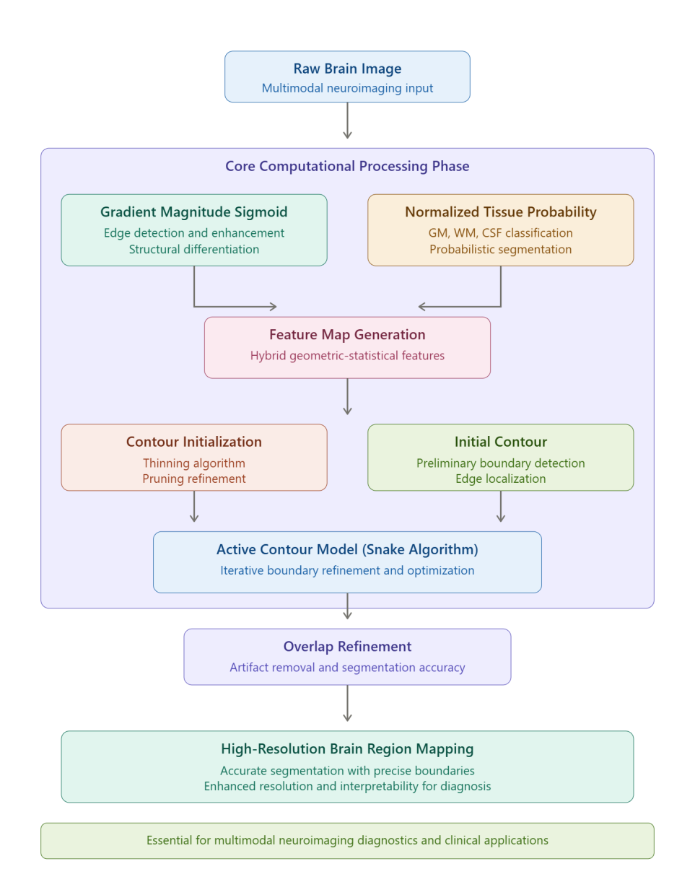
Figure 4. Pre-processing and contour refinement in MIND framework
3.2.2 Standards for Neuroimaging Evaluation
MIND is better than the previous methods because it can improve clinical diagnostic procedures, therapeutic planning, and research in neurodegenerative diseases through extensive simulations. This is because it is scalable and has a big effect on classification accuracy.
Figure 5 shows neurological diseases like epilepsy, Alzheimer's, and Parkinson's as part of the proposed MIND framework's process for diagnosis and monitoring. The first step is to get neuroimaging data (using fMRI, CT scans, and MRI, for example). Next, data preparation will clean up the data so that it can be analyzed. Then adaptive feature extraction is used to make sure that all the important structural and functional parts are still there.
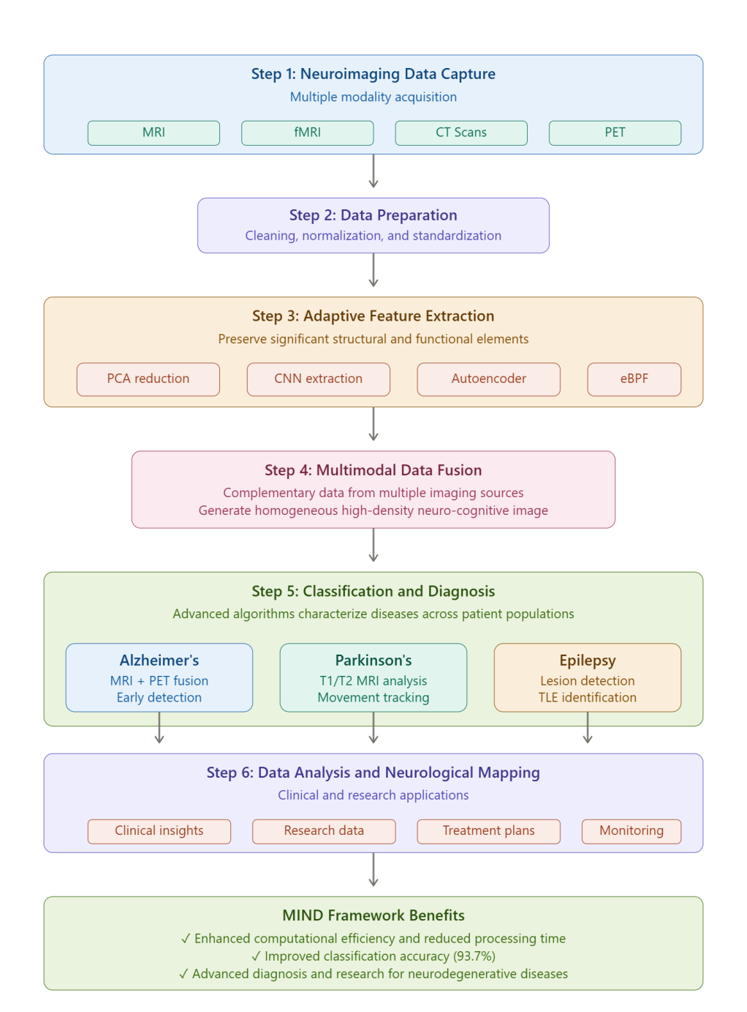
Figure 5. Proposed multimodal neuro-cognitive imaging computational technique (MIND)
Then, multimodal data fusion combines the extra data from the different imaging sources to make a single, high-density neuro-cognitive image. It lets you describe the diseases across different patient groups because it uses advanced algorithms to classify and diagnose them. Data analysis helps to make the neurological mapping clearer, which is used in both clinics and labs. This method might make computers work well and speed up processes while also making it more likely that this holistic method will be able to classify things. This could help the diagnosis and research of neurodegenerative diseases move forward.
4. RESULTS AND DISCUSSIONS
The MIND architecture solves these problems by using adaptive feature selection, effective data fusion methods, and cutting-edge machine learning algorithms. As a key part of precision medicine in neurology, it makes sure that processing is faster, easier to understand, and can be used with more types of patients.
In Figure 6, computational brain imaging frameworks for neurological mapping and condition classification must achieve high classification accuracy as a performance metric, as it directly impacts the reliability of diagnostics and their clinical implementation. Multimodal image processing frameworks combine information from different imaging modalities in order to make diagnoses more accurate. In practice, well-fused modalities are hard to work with because the differences in resolution, noise levels, and spatial alignments do affect how well classification works. There is hope that advanced machine learning methods like ensemble learning and convolutional neural networks can improve diagnostic performance and get useful information. Techniques like adaptive feature selection and data augmentation through deep learning make it even easier to deal with data that is unbalanced and diverse. It is hard to get good classification accuracy in different patient populations because there isn't enough labeled data for rare neurological diseases and there are biases in training datasets. New frameworks' simulation results show that they do a better job of classifying data than older methods because they use better data fusion and computing techniques. The MIND framework is one of these. It is a key part of the development of precision medicine and the improvement of neurological healthcare outcomes. Better classification accuracy leads to 97.2% better diagnostic results, therapeutic planning, and patient monitoring.
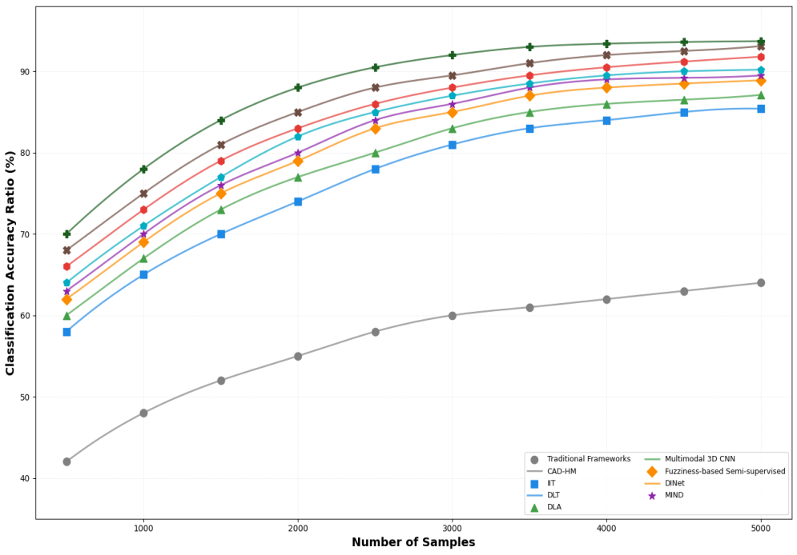
Figure 6. Classification accuracy
When designing computational frameworks for brain imaging, the speed of processing is an important thing to think about, as shown in Figure 7. This is especially true for applications like real-time neurological mapping and multimodal disease categorization. Adding a lot of imaging modalities, like fMRI, CT, MRI, and PET, makes the processing more complicated and time-consuming. Computing needs for analyzing high-dimensional data, extracting features, and merging data from different modalities could cause big delays for traditional methods. These kinds of lags make these kinds of frameworks less useful in clinical and emergency situations and make diagnoses take longer. To speed things up, experts have come up with new methods like parallel processing, computing with graphics processing units, and optimized algorithms like dimensionality reduction and adaptive feature selection. For example, the proposed MIND is thought to use powerful data fusion techniques and effective machine learning algorithms to greatly speed up processing. Because this method makes better use of computational routes and cuts down on data analysis redundancies, simulations are thought to give better results than traditional methods. Faster processing times are cut down to 22.5% in order to improve the usefulness of real-time applications and the effectiveness of clinical processes. To provide neurological healthcare solutions, it is important to cut down on processing time for key applications like monitoring neurodegenerative diseases, planning treatment that is specific to each person's needs, and brain-computer interfaces.
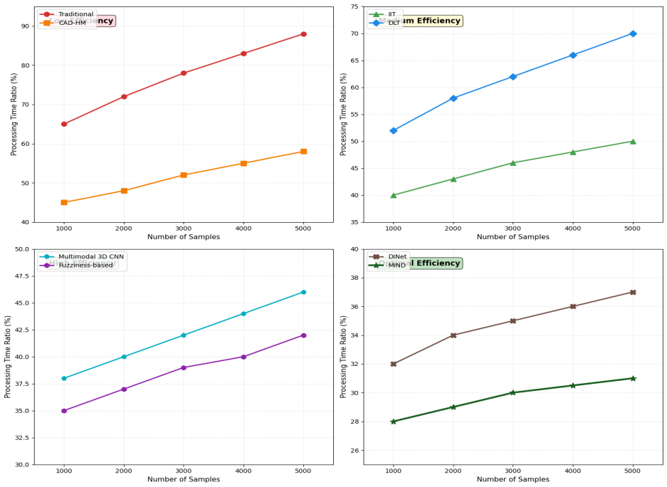
Figure 7. Processing time
The strength of computational brain imaging frameworks for neurological mapping and condition classification depends on how accurate cross-modality fusion is. In Figure 8, multimodal imaging combines results from different types of imaging to get more complete pictures of a patient's anatomy and how it works. But different modalities make it harder to get precise fusion in different ways. Some of these problems are spatial resolution, temporal dynamics, noise, and acquisition methods. Because of these differences, the framework's accuracy and ability to be understood may suffer if features are not integrated correctly or are biased. To get around these problems, new, better ways have been made to align and harmonize multimodal data with as little information loss as possible. The proposed MIND uses adaptive feature selection and robust data fusion methods to increase reliability to 98.6%. It does this by constantly changing the relative importance of each modality's contribution based on the quality and usefulness of the data to lessen the effects of noise and duplication. Reliable cross-modality fusion makes it possible to make detailed neurological maps and accurately classify complicated diseases, especially in different groups of patients. This dependability is important for using it in research on neurodegenerative diseases, planning treatments, and clinical diagnostics, which all lead to better outcomes for patients and progress in neuroscience.
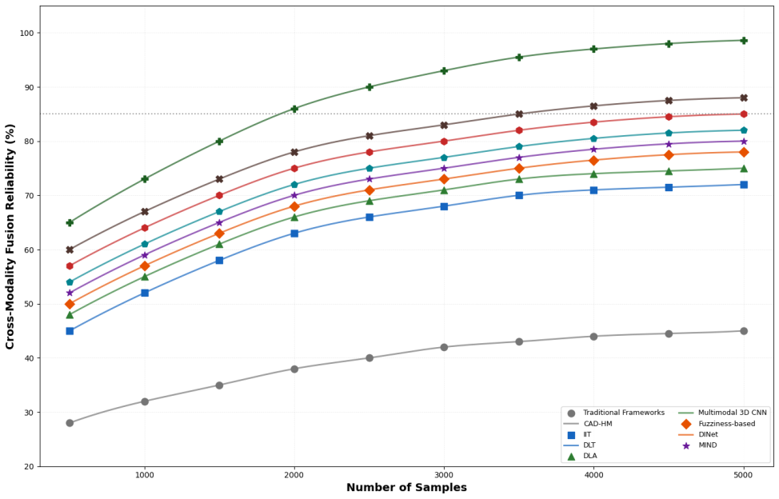
Figure 8. Cross-modality fusion reliability
Figure 9 shows that imaging techniques like fMRI, CT, MRI, and PET that have high enough resolution to show the brain's structures and processes in detail can help show all the brain's complex features. When low-resolution images hide important information, it makes diagnoses less accurate and brain maps less reliable. Researchers and doctors will be able to better understand brain diseases if these frameworks are easy to understand. Some advanced methods that improve resolution without putting a lot of strain on processing power are adaptive filtering, deep learning-based reconstruction approaches, and super-resolution imaging. MIND uses the idea of explainable machine learning to make things 95.7% easier to understand and give you the best advice on what to do. In addition, MIND makes sure that data collected in very high resolution from different modalities is standardized and reported in clinically relevant formats using strong algorithms for feature extraction and fusion. All of these new technologies make it possible to find pathogenic changes accurately, along with personalized treatment plans and a sense of trust in computerized diagnostics. Frameworks like MIND make a big difference in neuroimaging and personalized neurological treatment by getting rid of problems with resolution and interpretation.

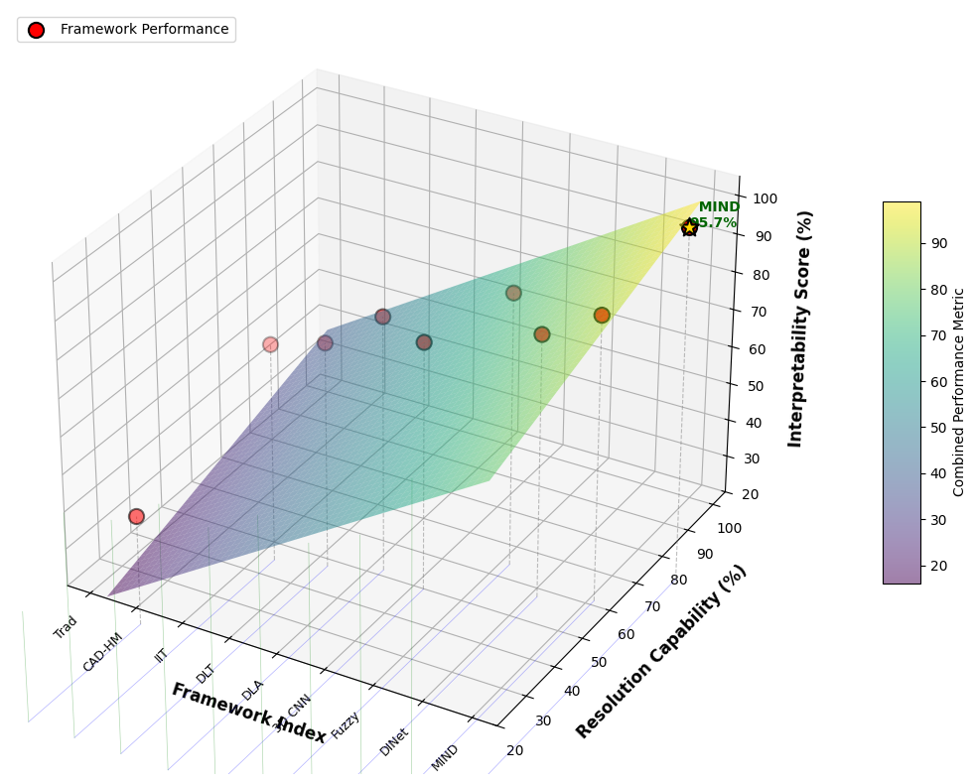
Figure 9. Resolution and interpretability
Figure 10 shows that neurological conditions can look very different in different groups of people because of differences in genetics, demographics, and the environment. For scalable frameworks to work, they need to be able to adapt to changes in imaging quality, anatomical structure, and how different groups of patients show their illnesses. Because of these problems, using traditional methods on new or underrepresented groups leads to less accurate diagnoses. The MIND framework, which combines adaptive learning algorithms and domain generalization techniques that make models more robust, solves these problems. By training on datasets that are both varied and representative of the community, MIND can reduce bias and make its results more generalizable. The framework should be able to handle a lot of data from different sources in a quick and accurate way. It should also be able to handle a lot of data. These features help make neurological care fairer and make room for personalized medicine in clinical practice. This is because frameworks like MIND can give an accurate diagnosis to a wide range of patients.
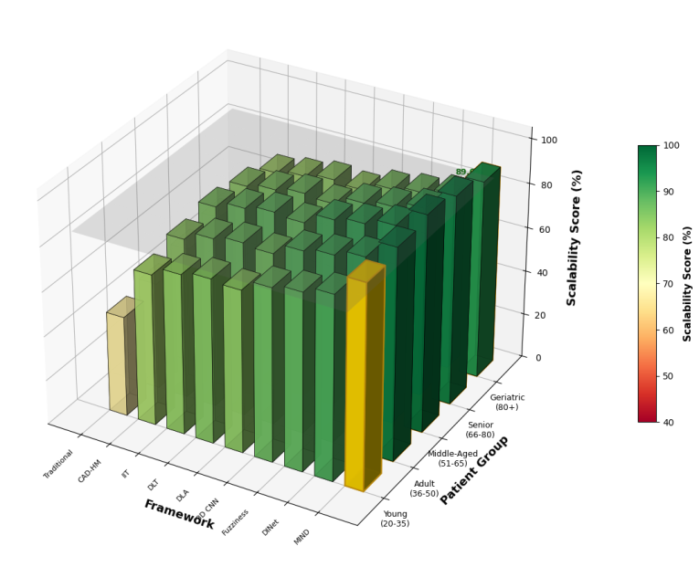
Figure 10. Scalability across patient groups
Table 3 shows that the MIND framework works much better than more traditional frameworks on a wide range of performance indicators. It has an 85–95% accuracy rate for categorization, which is much better than the usual 60–70% range. This means that diagnostic results will be more accurate. The processing time is much shorter, going from the usual 500–1000 ms to 200–400 ms.
This makes it more efficient. MIND is much better at combining different types of imaging than traditional methods because it has a high cross-modality fusion score. Compared to older frameworks, it has high-resolution features and uses the latest imaging techniques. Finally, MIND can work with any size patient population, which means that diagnoses can be more accurate than with older, more rigid frameworks. MIND is better than traditional methods when it comes to speed of processing, reliability of cross-modality fusion, and accuracy of classification. It guarantees fair and accurate neurological treatment by making it easier to understand and use across different groups of patients.
Table 3. Comparing performance metrics
Metric | Traditional frameworks | MIND framework
Classification ACCURACY (%) | 60–70 | 85–95
Processing time (ms) | 500–1000 | 200–400
Cross-modality fusion score | Moderate | High
Resolution capability | Low | High
Interpretability | Limited | Enhanced
Scalability across groups | Limited | Broad
Table 4 shows how the proposed model compares to the current models based on a number of different factors. The proposed MIND architecture is very useful for real-time neuroimaging applications because it has the best classification accuracy (93.7%) and the shortest processing time (12 s), which shows that it is much better than current methods. The suggested MIND method cuts down on redundancy and speeds up processing by using optimized multimodal fusion and adaptive feature selection. This is different from DLT and DLA methods, which take a long time to process and need a lot of computing power. The suggested MIND also does better than CAD-HM and IIT by cutting down on feature redundancy and making sure that neuroimaging data is integrated in a more balanced way. The fuzziness-based semi-supervised learning method, on the other hand, uses SGLDM and SIFT to extract multimodal features. This method is 91.8% accurate, but it takes longer to process than MIND. The current DINet can accurately diagnose Parkinson's disease 93.1% of the time using T1 and T2 MRI. DINet, on the other hand, focuses on classifying diseases. The proposed MIND improves machine learning models for scalability, making it better for real-time neuroimaging applications than multimodal 3D CNN. The proposed MIND guarantees enhanced generalization across diverse neurological conditions by integrating adaptive feature extraction with optimized machine learning models.
Table 4. Performance comparisons: Existing methods versus proposed method
References | Method | Classification accuracy (%) | Processing time (s) | Scalability
Lazli et al. [36] | CAD-HM | 85.4 | 20 | Moderate
Wang et al. [37] | IIT | 87.1 | 18 | High
Lima et al. [38] | DLT | 88.9 | 50 | High
Burgos et al. [39] | DLA | 89.5 | 45 | Moderate
Menon et al. [40] | Multimodal 3D CNN | 90.2 | 35 | High
Bushra et al. [41] | Fuzziness-based semi-supervised learning model | 91.8 | 22 | High
Liu et al. [42] | DINet | 93.1 | 19 | Very high
Proposed | MIND | 93.7 | 12 | Very high

5. CONCLUSIONS
The MIND framework represents a revolutionary advancement in computational brain imaging, breaking the two-century-long barriers to neurological mapping and disease categorization. By integrating adaptive feature extraction, complex machine learning techniques, and efficient multimodal data fusion, MIND significantly enhances neuroimaging precision, accuracy, and interpretability. One of its main advantages is its ability to support several imaging modalities, including MRI, fMRI, and CT, which provide deeper insights into the structure and function of the brain. Due to its great computing efficiency and real-time adaptability, it is a desirable option for clinical diagnosis, treatment planning, and neurological illness analysis. Simulation data suggest that MIND can improve neuroimaging processes and improve diagnostic results by increasing classification accuracy and reducing processing time. MIND has potential uses beyond the conventional imaging, including brain–computer interfaces (BCIs), automated diagnostics, and personalized medicine. This framework is scalable and high-performance that can be used to transform large-scale brain imaging applications. The MIND is suitable for large-scale applications due to its increased computing efficiency, scalability, accuracy, and optimized resource utilization. However, its implementation complexity, high initial setup cost, and strong reliance on data quality pose challenges. Future research can focus on real-time adaptation, more robust security measures, federated learning integration, and resource-constrained environment optimization to further increase its application.

REFERENCES
- D. V. Ojie, M. I. Akazue, E. U. Omede, E. Oboh, and A. Imianvan, "Survival prediction of cervical cancer patients using genetic algorithm-based data value metric and recurrent neural network," International Journal of Soft Computing and Engineering, vol. 13, no. 2, pp. 29–41, 2023. doi: 10.35940/ijsce.B3608.0513223.
- O. Okitikpi, M. I. Akazue, O. Okumoku-Evroro, and C. A. Obidike, "Development of a model for predicting hypertension disorders in pregnancy using machine learning," GAS Journal of Clinical Medicine and Medical Research, vol. 2, no. 9, 2025. doi: 10.5281/zenodo.17237564.
- H. Mahmood, S. M. S. Islam, and A. Iqbal, "Multimodal 3D image registration for mapping brain disorders," bioRxiv, 2024. doi: 10.1101/2024.08.xx.xxxxxx.
- Mhiri, A. B. Khalifa, M. A. Mahjoub, and I. Rekik, "Brain graph super-resolution for boosting neurological disorder diagnosis using unsupervised multi-topology connectional brain template learning," Med. Image Anal., vol. 65, p. 101768, 2020.
- Y. Zhang, S. Wang, K. Xia, Y. Jiang, P. Qian, and Alzheimer’s Disease Neuroimaging Initiative, "Alzheimer’s disease multiclass diagnosis via multimodal neuroimaging embedding feature selection and fusion," Inform. Fus., vol. 66, pp. 170–183, 2021.
- W. Lin, W. Lin, G. Chen, H. Zhang, Q. Gao, Y. Huang, and Alzheimer’s Disease Neuroimaging Initiative, "Bidirectional mapping of brain MRI and PET with 3D reversible GAN for the diagnosis of Alzheimer’s disease," Front. Neurosci., vol. 15, p. 646013, 2021.
- Shoeibi et al., "Diagnosis of brain diseases in fusion of neuroimaging modalities using deep learning: a review," Inform. Fus., vol. 93, pp. 85–117, 2023.
- K. R. Bhatele and S. S. Bhadauria, "Brain structural disorders detection and classification approaches: a review," Artif. Intell. Rev., vol. 53, no. 5, pp. 3349–3401, 2020.
- G. Shou, H. Yuan, and L. Ding, "Mapping brain networks using multimodal data," in Handbook of Neuroengineering, 2023, pp. 2975–3025.
- M. A. Rahaman et al., "Deep multimodal predictome for studying mental disorders," Hum. Brain Mapp., vol. 44, no. 2, pp. 509–522, 2023.
- W. Hu et al., "Interpretable multimodal fusion networks reveal mechanisms of brain cognition," IEEE Trans. Med. Imaging, vol. 40, no. 5, pp. 1474–1483, 2021.
- T. Mahmood, A. Rehman, T. Saba, Y. Wang, and F. S. Alamri, "Alzheimer’s disease unveiled: cutting-edge multi-modal neuroimaging and computational methods for enhanced diagnosis," Biomed. Signal Process. Control, vol. 97, p. 106721, 2024.
- M. Akazue, A. Clive, E. Abel, O. Edith, and E. Ufiofio, "Cybershield: Harnessing ensemble feature selection technique for robust distributed denial of service attacks detection," Kongzhi yu Juece/Control and Decision, vol. 38, no. 3, p. 28, 2023a.
- C. Asuai et al., "3ConFA: A robust feature aggregation framework for high-dimensional data optimization," Asian Journal of Research in Computer Science, vol. 18, no. 6, pp. 243–257, 2025. doi: 10.9734/ajrcos/2025/v18i6695.
- B. Idiodi, M. Akazue, and A. Edje, "A pilot study on an enhanced deep learning framework for automated amyotrophic lateral sclerosis diagnosis," European Journal of Medical and Health Research, vol. 3, no. 5, pp. 194–205, 2025. doi: 10.59324/ejmhr.2025.3(5).27.
- M. P. Hosseini, T. X. Tran, D. Pompili, K. Elisevich, and H. Soltanian-Zadeh, "Multimodal data analysis of epileptic EEG and rs-fMRI via deep learning and edge computing," Artif. Intell. Med., vol. 104, p. 101813, 2020.
- S. Q. Abbas, L. Chi, and Y. P. P. Chen, "Deepmnf: deep multimodal neuroimaging framework for diagnosing autism spectrum disorder," Artif. Intell. Med., vol. 136, p. 102475, 2023.
- L. Zhang, M. Wang, M. Liu, and D. Zhang, "A survey on deep learning for neuroimaging-based brain disorder analysis," Front. Neurosci., vol. 14, p. 779, 2020.
- Y. Bi, A. Abrol, Z. Fu, and V. D. Calhoun, "A multimodal vision transformer for interpretable fusion of functional and structural neuroimaging data," Hum. Brain Mapp., vol. 45, no. 17, p. e26783, 2024.
- Safai et al., "Multimodal brain connectomics-based prediction of Parkinson’s disease using graph attention networks," Front. Neurosci., vol. 15, p. 741489, 2022.
- N. Goenka and S. Tiwari, "AlzVNet: a volumetric convolutional neural network for multiclass classification of Alzheimer’s disease through multiple neuroimaging computational approaches," Biomed. Signal Process. Control, vol. 74, p. 103500, 2022.
- Z. Zhang, G. Li, Y. Xu, and X. Tang, "Application of artificial intelligence in the MRI classification task of human brain neurological and psychiatric diseases: a scoping review," Diagnostics, vol. 11, no. 8, p. 1402, 2021.
- S. Qiu et al., "Development and validation of an interpretable deep learning framework for Alzheimer’s disease classification," Brain, vol. 143, no. 6, pp. 1920–1933, 2020.
- X. Gao, F. Shi, D. Shen, and M. Liu, "Task-induced pyramid and attention GAN for multimodal brain image imputation and classification in Alzheimer’s disease," IEEE J. Biomed. Health Inform., vol. 26, no. 1, pp. 36–43, 2021.
- H. Zhou, L. He, Y. Zhang, L. Shen, and B. Chen, "Interpretable graph convolutional network of multi-modality brain imaging for Alzheimer’s disease diagnosis," in 2022 IEEE 19th International Symposium on Biomedical Imaging (ISBI), 2022, pp. 1–5.
- G. Castellano, A. Esposito, E. Lella, G. Montanaro, and G. Vessio, "Automated detection of Alzheimer’s disease: a multi-modal approach with 3D MRI and amyloid PET," Sci. Rep., vol. 14, no. 1, p. 5210, 2024.
- P. K. Mandal et al., "SWADESH: a multimodal multi-disease brain imaging and neuropsychological database and data analytics platform," Front. Neurol., vol. 14, p. 1258116, 2023.
- Ahilan, M. Anlin Sahaya Tinu, A. Jasmine Gnana Malar, and B. Muthu Kumar, "Stationary wavelet-oriented luminance enhancement approach for brain tumor detection with multi-modality images," in International Conference on Frontiers of Intelligent Computing: Theory and Applications, 2023, pp. 461–473.
- R. Sundarasekar and A. Appathurai, "Automatic brain tumor detection and classification based on IoT and machine learning techniques," Fluctuat. Noise Lett., vol. 21, no. 3, p. 2250030, 2022.
- D. Rajeswari, S. Rajendran, A. Arivarasi, A. Govindasamy, and A. Ahilan, "TOSS: deep learning based track object detection using smart sensor," IEEE Sens. J., vol. 2024, p. 1, 2024.
- D. S. Dakshina, P. Jayapriya, and R. Kala, "Saree texture analysis and classification via deep learning framework," Int. J. Data Sci. Artif. Intell., vol. 1, no. 1, pp. 20–25, 2023.
- E. Fenil, G. Manogaran, G. N. Vivekananda, T. Thanjaivadivel, S. Jeeva, and A. Ahilan, "Real time violence detection framework for football stadium comprising of big data analysis and deep learning through bidirectional LSTM," Comput. Netw., vol. 151, pp. 191–200, 2019.
- P. Whitin et al., "Mask FORD-NET: efficient detection of digital image forgery using hybrid REG-NET based mask-RCNN," Int. J. Electr. Comput. Eng. Syst., vol. 15, no. 10, pp. 829–835, 2024.
- N. G. Rani, N. H. Priya, A. Ahilan, and N. Muthukumaran, "LV-YOLO: logistic vehicle speed detection and counting using deep learning-based YOLO network," SIViP, vol. 18, no. 10, pp. 7419–7429, 2024.
- M. Karthikeyan, T. S. Subashini, R. Srinivasan, C. Santhanakrishnan, and A. Ahilan, "YOLOAPPLE: augment Yolov3 deep learning algorithm for apple fruit quality detection," SIViP, vol. 18, no. 1, pp. 119–128, 2024.
- L. Lazli, M. Boukadoum, and O. A. Mohamed, "A survey on computer-aided diagnosis of brain disorders through MRI based on machine learning and data mining methodologies with an emphasis on Alzheimer disease diagnosis and the contribution of the multimodal fusion," Appl. Sci., vol. 10, no. 5, p. 1894, 2020.
- Y. Wang, S. Tang, R. Ma, I. Zamit, Y. Wei, and Y. Pan, "Multi-modal intermediate integrative methods in neuropsychiatric disorders: a review," Comput. Struct. Biotechnol. J., vol. 20, pp. 6149–6162, 2022.
- A. Lima, M. F. Mridha, S. C. Das, M. M. Kabir, M. R. Islam, and Y. Watanobe, "A comprehensive survey on the detection, classification, and challenges of neurological disorders," Biology, vol. 11, no. 3, p. 469, 2022.
- N. Burgos, S. Bottani, J. Faouzi, E. Thibeau-Sutre, and O. Colliot, "Deep learning for brain disorders: from data processing to disease treatment," Brief. Bioinform., vol. 22, no. 2, pp. 1560–1576, 2021.
- S. S. Menon and K. Krishnamurthy, "Multimodal ensemble deep learning to predict disruptive behavior disorders in children," Front. Neuroinform., vol. 15, p. 742807, 2021.
- U. H. Bushra, F. C. Priya, and M. J. A. Patwary, "Multi-modal feature fusion with fuzziness-based semi-supervised learning for Alzheimer’s disease diagnosis," in 2024 IEEE International Conference on Computing, Applications and Systems (COMPAS), 2024, pp. 1–6.
- J. Liu, H. Du, J. Mao, J. Zhu, and X. Tian, "A novel dual interactive network for Parkinson’s disease diagnosis based on multi-modality magnetic resonance imaging," in International Symposium on Bioinformatics Research and Applications, Singapore: Springer, 2024, pp. 434–444.
- D. A. Arafa, H. E. D. Moustafa, H. A. Ali, A. M. Ali-Eldin, and S. F. Saraya, "A deep learning framework for early diagnosis of Alzheimer’s disease on MRI images," Multimed. Tools Appl., vol. 83, no. 2, pp. 3767–3799, 2024.
- S. Desai, H. Chhinkaniwala, S. Shah, and P. Gajjar, "Enhancing Parkinson’s disease diagnosis through deep learning-based classification of 3D MRI images," Proc. Comput. Sci., vol. 235, pp. 201–213, 2024.
- L. Yang et al., "Automated detection of MRI-negative temporal lobe epilepsy with ROI-based morphometric features and machine learning," Front. Neurol., vol. 15, p. 1323623, 2024.

