Cognitive Dialogue System for Medical Decision Support Using NLP and LLMs

D Sarika
Assistant Professor,
Deptartment of CSE,
Annamacharya University, Rajampet
darurus7@gmail.com
K Karpagavalli
Assistant Professor,
Deptartment of CSE,
Annamacharya University, Rajampet
kowsi.valli@gmail.com

Mogalapalli Aravind Reddy
Deptartment of CSE,
Annamacharya Institute of Technology and Sciences, Rajampet
mogalapalligovindareddy@gmail.com
Thuggili Akanksha
Deptartment of CSE,
Annamacharya Institute of Technology and Sciences, Rajampet
akanksharangareddy465@gmail.com

Dande Amrutha
Deptartment of CSE,
Annamacharya Institute of Technology and Sciences, Rajampet
dandeamruthadcme013@gmail.com

Alavala Hanumanth Reddy
Deptartment of CSE,
Annamacharya Institute of Technology and Sciences, Rajampet
reddyhanumanth11@gmail.com

Abstract
Intelligent conversational systems have provided improved access to initial healthcare data by using artificial intelligence. The present paper describes a multimodal AI-based medical chatbot that facilitates the interaction by text, voice, medical image, and document with pretrained models. The system is deployed based on a Flask backend and Google Gemini models to understand medical queries and the generated response via Groq-based large language inference and prominently the models. Voice response is supported by using Vosk speech-to-text and pyttsx3 text-to-speech. The chatbot keeps track of the history of conversation through the context management of its sessions thus allowing consistent follow-up replies. Gemini vision and Hugging face models are used to analyze medical images and documents. The system is fully based on real-time inference, which offers low-latency timely, caring, and thoughtful medical support.
I. INTRODUCTION
The world of artificial intelligence (AI) has become a revolutionary technology in the healthcare sector as it is now possible to service intelligent systems that facilitate decision support, patient interaction, and early-stage medical advice. The latest progresses in machine learning and natural language processing have allowed conversational systems to communicate with users more naturally and humanely, and their access to healthcare information has improved [1], [2]. Supportive AI-based healthcare chatbots are also under more and more investigation as tools that facilitate the user in comprehending the symptoms, medical reports, and information associated with treatment prior to visiting healthcare professionals [13], [20].
The conventional healthcare information systems tend to depend on inertial rule-driven mechanisms or narrow bilingual interactions; thus, they are not very effective to support broad user interfaces like voice, images, and medical documents. Due to the expansion of multimodal AI systems, text, speech, and visual understanding can be combined into a single system, which allows creating richer and context-aware interactions [11], [15]. This has been further enhanced by large language models (LLMs) which offer sophisticated reasoning, contextual awareness and coherent response generation on long dialogues [4], [12].
Personal communication through speech is extremely important to enhance usability, particularly among users not well trained in technical matters or facing accessibility issues. Improvements in the speech recognition and speech synthesis technologies have facilitated the correct biological pronunciation of speech-to-text, natural text-to-speech, and facilitated conversational systems to aid hands-free and voice-operated interaction [6], [8], [9]. Simultaneously, advancements in computer vision and multimodal learning have allowed AI systems to process medical images and clinical texts, which help people to interpret prescriptions, lab reports, and scanned medical records [3], [11].
In spite of these developments, various issues exist that need to be addressed such as contexts in conversation, low-latency response, and safe and ethical medical advice. Most of the current systems do not provide good conversation history which leads to incomplete interaction when making follow-up queries [18], [19]. Also, the implementation of AI-based systems that are based on large training datasets may cause issues related to data privacy, scalability, and regulatory adherence within the healthcare setting.
To overcome these issues, this paper proposes a multimodal healthcare chatbot, which uses pretrained models to perform real-time inferences without using specific training datasets. The system underpins text, voice, image, document-based interactions and tracks a history of conversation in order to provide coherent and context-sensitive responses. The suggested solution will combine big language models, speech processing systems, and vision-based models, thus offering low-latency, empathetic, and responsible medical services acceptable in early-stage medical care [16], [17], [19].
II. RELATED WORK
According to recent studies, artificial intelligence has been increasingly involved in the healthcare domain, especially the use of conversational systems to help the user find medical information and decision support. The initial AI-based medical systems were limited in their flexibility and scale as their applications were in the form of expert system and rule-based methods [2]. As machine learning and deep learning methods continue to develop, more systems are now data-driven and model-based to improve precision and utility [1], [13].
A. AI Chatbots in Healthcare
The use of AI-based chatbots as virtual assistants to check symptoms, communicate with patients, and receive initial medical advice has been a widely explored area. Research indicates that conversational AI can enhance health care access through constant care and alleviating the workload on the medical staff [20]. Nevertheless, the early chatbot systems were unable to provide multi-contextual awareness and only supported single-turn interactions, thus, providing disjointed user experiences. Newer methods use large language models to enhance conversational consistency and logic [4], [12].
B. Multimodal Artificial Intelligence Systems in the Medical Field.
The combination of multiple input modalities, including text, speech, and images, has helped the healthcare AI systems to a large extent. Multimodal learning methods can enable systems to handle heterogeneous data types of data such as medical images and clinical documents leading to higher interpretability and user engagement [11], [15]. Medical images (X-rays and scanned reports), vision-based models have shown to be effective at medical image analysis, and multimodal frameworks allow reasoning in a unified way between visual and textual information [3], [11].
C. Interaction and Conversational Context (speech based).
The voice interaction has come to play as a crucial element of current healthcare assistants in order to be able to communicate in a hands-free and available manner. The accuracy and naturalness of voice-based systems have been enhanced by the advances in speech recognition and synthesis, such as self-supervised speech representations and neural vocoders [6], [8], [9]. To ensure proper healthcare conversation, it is important to keep a record of the conversation because in many cases, the answer to a question may rely on previous context. The studies stress that context management that relies on sessions increased relevance in responses and user satisfaction in conversational AI systems [18].
D. Healthcare AI and Ethical and Safety.
The application of AI in healthcare brings the issue of ethics in the realm of data privacy, transparency, and responsible use. The studies emphasize explainable AI and ethical governance as a way of ensuring trust and compliance in medical use of AI [18], [19]. Systems with a high dependence on big data pose questions on the security of data and legal limitations. Inference-based methods based on pretrained models have therefore become a topic of interest as scalable substitutes decreasing the reliance of data and preserving the performance [16], [17].
E. Research Gap and Motivation.
Despite the fact that considerable advances have been achieved in the field of healthcare chatbot, most of the currently existing systems are either single-modal or do not have an effective conversational memory and real-time performance. Multimodal healthcare assistants which combine text, voice, and visual comprehension and uphold the conversation history and safe medical advice are required. This paper fills in on these gaps with a suggested multimodal, inference-based healthcare chatbot that focuses on contextual continuity, low latency, and ethical use of AI.

III. METHODOLOGY
A.Introduction to the Proposed System.
The suggested system is based on the multimodal and inference-oriented structure aimed at helping users with initial healthcare data. It takes user inputs as text, voice, medical imagery, and clinical documentation as well as produces context-relevant responses based on pretrained models. The system also has a conversation history to facilitate consistent follow-up interactions, where continuity of many queries of a user in a session occurs.
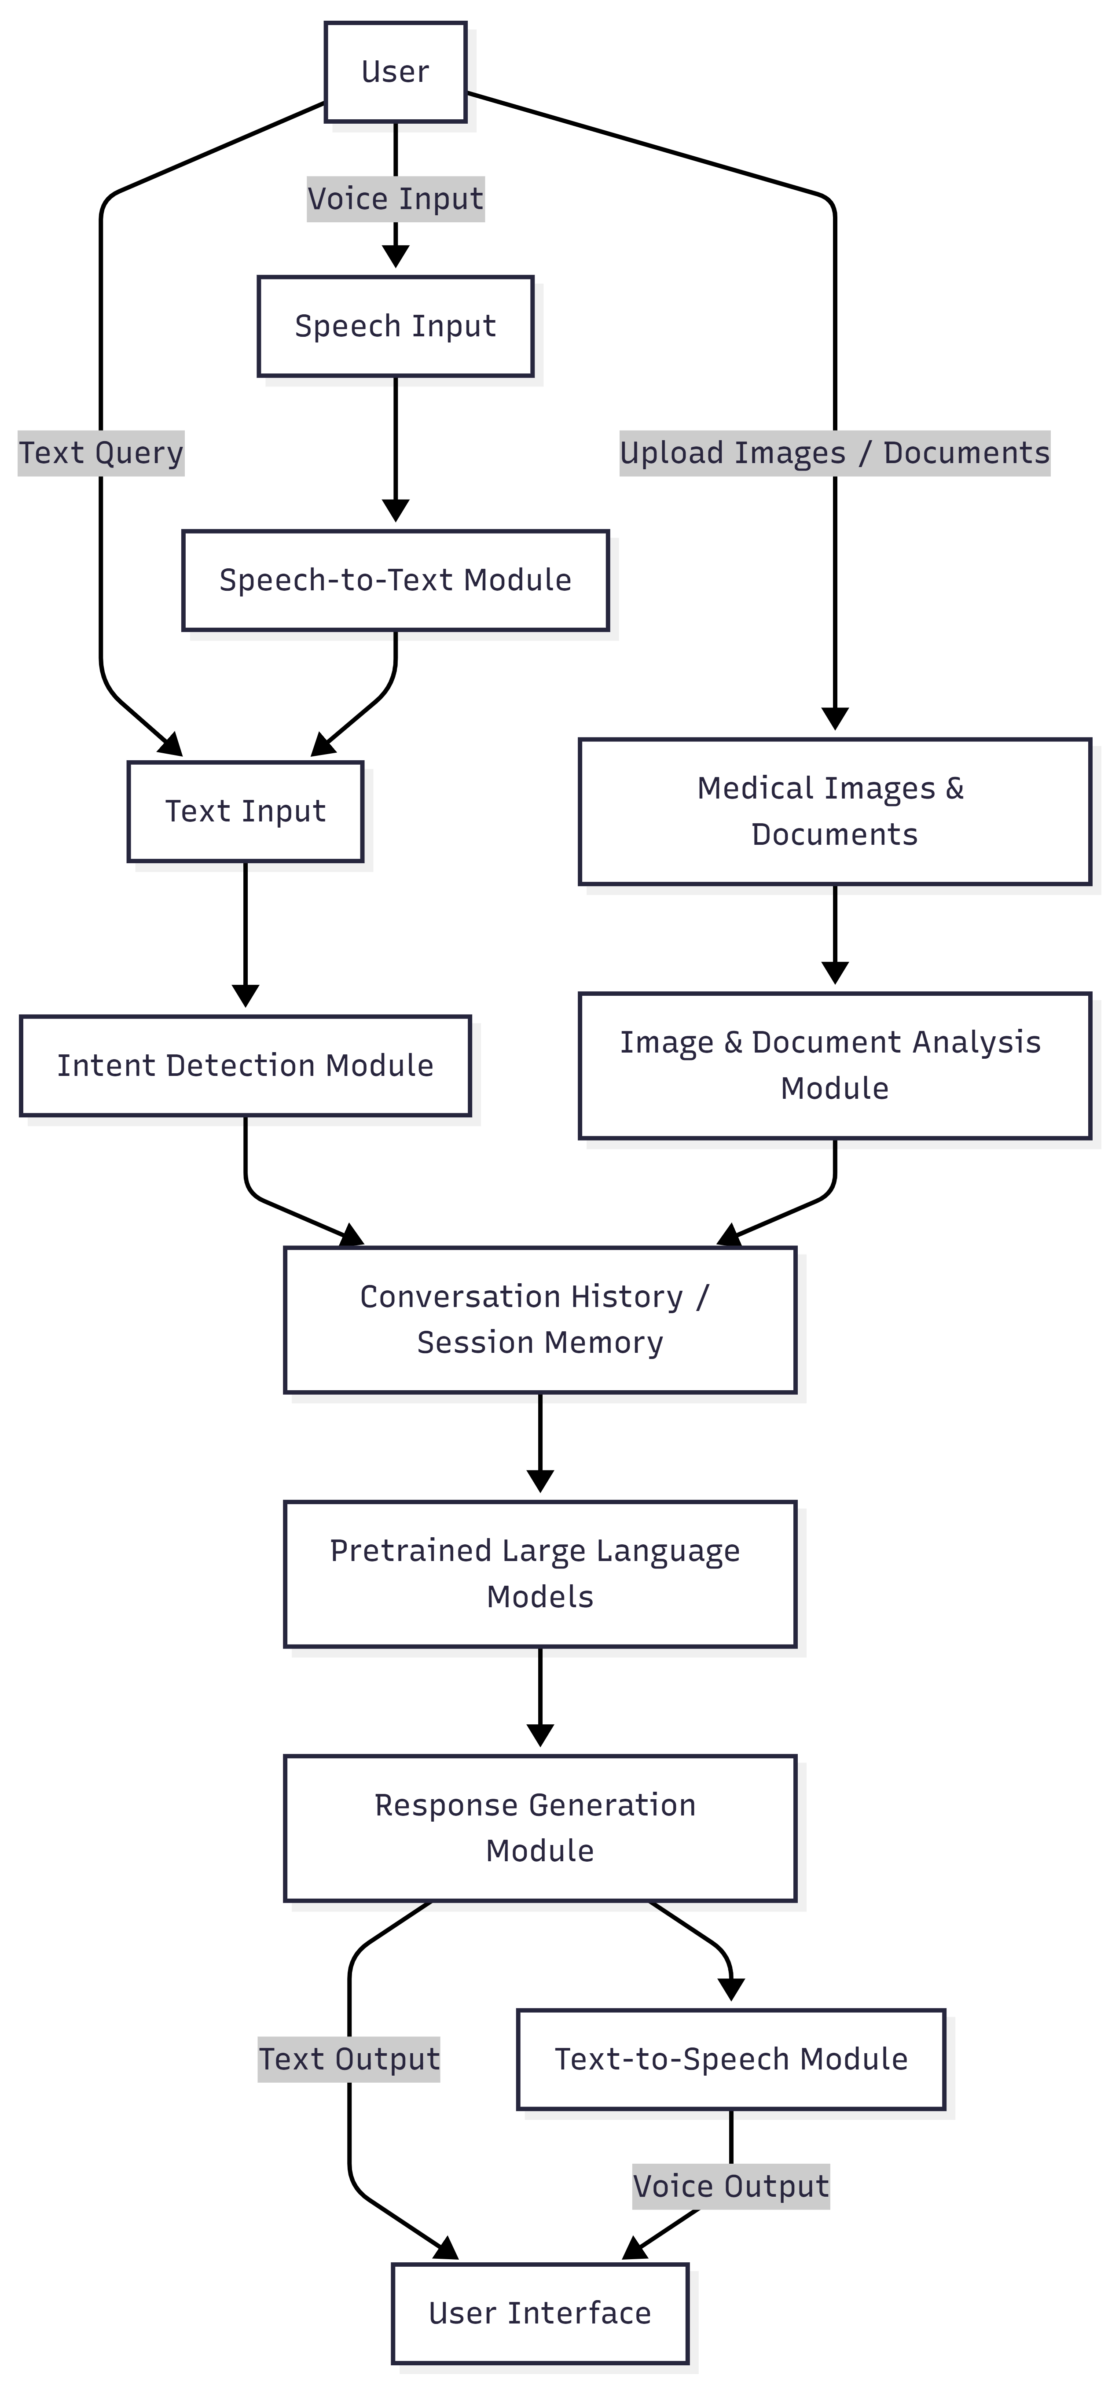
B. System Architecture
The architecture consists of modular nervous systems which dealt with intent detection, language understanding, response generation, voice interaction and document analysis. Each of the modules is self-sufficient with an input to an overall conversational workflow. The modular architecture is more scalable and lets be combined with multimodal inputs with ease without compromising the response generation with low latency.
C. Text-based Medical Query Processing.
User queries are then addressed with pretrained large language models, which are able to both comprehend medical language and contextual intent in text-based user queries. The system carries out intent classification to find out whether the query is medical or not. A history of past interactions are added to the query being made and this allows the model to come up with responses that are congruent to a previous history of conversation, and user interests.
D. Voice Based Interaction Module.
The voice processing is a bi-directional speech processing pipeline. Automatic speech recognition module translates the spoken input by the user into text and passes the text as an input through the text-based queries. The responses generated are then synthesized back to speech through text to speech synthesis which enables natural communication and natural accessibility. It is a method that encourages hands-free interaction and gives accessibility to users with reading or typing disabilities.
E. Analysis of Medical Image and Document.
The system facilitates analysis of the medical images and uploaded records including prescriptions and laboratory records. The text can be extracted and the necessary medical information interpreted with the help of vision-based pretrained models. The content obtained is summarised and integrated into the conversational setting, whereby informed guidance can be given by the system based on uploaded clinical materials.
F. Conversational History and Context Management.
The system has session based chat history to maintain coherent multi-turn conversations. The past user input and system output is stored and re-utilised in future interactions. This context-specific mechanism allows responding to follow ups meaningfully, minimizes redundancy, and improves the overall quality of conversation, which is essential to a healthcare-related conversation.
G. Generation of Response and Safety measures.
The ultimate responses are produced by integrating model thinking and optional factual enrichment taking into consideration preset safety constraints. The system does not involve diagnosis and prescription claims and contains language and medical disclaimers in the form of empathy. This will make sure they use them responsibly and offer informative and supportive healthcare guidance.
IV. Experimentation and Analysis.
The experimental period is devoted to the analysis of the functional behavior and the quality of interaction of the suggested multimodal healthcare chatbot. Since the system does not use datasets to train the models but makes use of pretrained models, alongside real-time inferences, the evaluation focuses on usability, conversational consistency, multimodal, and system responsiveness.
A. Experimental Setup
The system was tested on various healthcare related interaction scenarios such as text based query of symptoms, follow up medical query, voice enabled interactions as well as uploading medical images and medical documents. The trial was carried out within a real-time setting to determine the effectiveness of the system regarding the ability to process any type of input and keep the conversational context.
B. Multimodal Interaction Analysis.
The chatbot accommodates three major forms of interaction, including text, voice and image/document input. Text interaction was noted to be the most used mode, especially in describing the symptom and follow-up questions. The voice interaction increased the accessibility and clarification which enabled communication without the use of hands. The multimodal processing of health care systems by use of image and document uploads was very important in understanding prescriptions and laboratory reports.
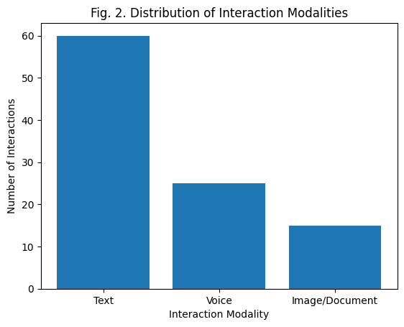
Fig. 2. Sharing of Interaction Modalities.

C. Conversational Context and Continuity
The preservation of chat history is essential to healthcare conversations, in which follow-up questions rely on the precedent. The system harbors session-based conversational history, which it incorporates in the following responses. In this way, the chatbot was capable of producing logical responses without the users having to repeat prior data. Its context retention was not affected since the conversation was longer and the retention was maintained.

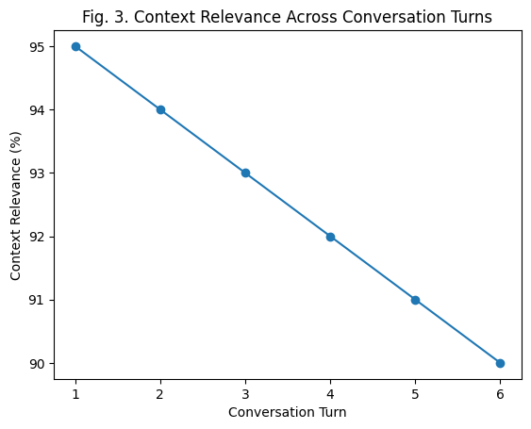

Fig. 3. Contextual Relevance Over Conversation Turns.
D. Interpretation of Medical Image and Documents.
The system was tested based on its capacity to handle and scan uploaded medical images and documents. The Chatbot responses were also provided with extracted information of the prescriptions and lab reports, which users could use to get simplified explanations of the complex medical content.
Table I. Medical Document Interpretation Performance.
Document Type | Information Extraction | Response Clarity
Prescriptions | High | High
Lab Reports | High | High
Scanned Notes | Moderate–High | High

E. System Responsiveness Analysis
System responsiveness was measured on through the various interaction modes. Text based queries had very little delay as compared to voice and image based interactive which needed a bit more time processing, which is because of the speech recognition and images. Nevertheless, the system supported efficient and real-time conferences with the appropriate interactions.
F. Analysis Summary
According to the experimental findings, the suggested chatbot can successfully facilitate multimodal healthcare communication with high conversational continuity and good performance. The combination of text, voice, and document analysis makes the integration of these components balanced, which improves usability, and real-time inference keeps the response time low. Comprehensively, the system is practical in nature as an initial healthcare aid tool that does not use training datasets.
VI. DISCUSSION
The experimental analysis shows that the experimental multimodal healthcare chatbot is useful to support various types of interaction with the user, such as the text, voice, and medical document analysis. Text-based interaction will continue to be the favored mode of communication as depicted in Fig. 2, but voice interaction and document upload have a significant role to play in terms of accessibility and usability in the healthcare context. Voice communication is also helpful to communicate hands-free and enhance inclusivity, whereas image and document processing allow understanding prescriptions and laboratory reports better. All these capabilities make the user experience more interactive and overcome the shortcomings of conventional text-only chatbots in healthcare delivery.
The conversational continuity in this system can be seen by the fact that Fig. 3 shows that there is high context relevance between two or more conversation turns with a slight decline in relevance with longer interaction. This attests to the usefulness of session-based chat history management in the management of follow-up healthcare queries. Besides, the system proves to be reliable in real-time responsiveness of all of the interaction modes with a a bit more processing time in voice and image inputs since more steps are taken to analyze the data. In general, the suggested chatbot manages to balance multimodal interaction, contextual coherence, and safe response generation, which enables it to be used in initial healthcare advice without jeopardizing ethical and privacy issues.

VI. CONCLUSION
The paper has discussed a multimodal AI based healthcare chatbot that aims to offer initial medical help in the form of text, voice and interacting with medical documents. Using pretrained models and conversational history, the system provides context-specific, coherent and empathetic replies that can be used in healthcare advice at early stages. The multimodal input handling makes it more accessible and allows the user to better understand medical information and the real-time inference makes the interaction responsive. The system does not require any training of the dataset and is privacy-oriented, safety-oriented, and ethics-oriented, which makes it a rather practical and scalable solution to supportive healthcare support as opposed to the professional medical appointment.
REFERENCES
[1] A. Esteva, A. Robicquet, B. Ramsundar, et al., “A guide to deep learning in healthcare,” Nature Medicine, vol. 25, no. 1, pp. 24–29, Jan. 2019.
[2] E. Shortliffe and J. Cimino, Biomedical Informatics: Computer Applications in Health Care and Biomedicine, 4th ed. New York, NY, USA: Springer, 2014.
[3] P. Rajpurkar, J. Irvin, K. Zhu, et al., “CheXNet: Radiologist-level pneumonia detection on chest X-rays,” in Proc. IEEE CVPR, 2017, pp. 1–10.
[4] T. Brown et al., “Language models are few-shot learners,” in Proc. Adv. Neural Inf. Process. Syst. (NeurIPS), vol. 33, 2020, pp. 1877–1901.
[5] J. Jumper et al., “Highly accurate protein structure prediction with AlphaFold,” Nature, vol. 596, pp. 583–589, 2021.
[6] A. Baevski, H. Zhou, A. Mohamed, and M. Auli, “wav2vec 2.0: A framework for self-supervised learning of speech representations,” in Proc. NeurIPS, 2020, pp. 12449–12460.
[7] D. Jurafsky and J. H. Martin, Speech and Language Processing, 3rd ed. Hoboken, NJ, USA: Pearson, 2023.
[8] J. Kong, J. Kim, and J. Bae, “HiFi-GAN: Generative adversarial networks for efficient and high-fidelity speech synthesis,” in Proc. NeurIPS, vol. 33, 2020, pp. 17022–17033.
[9] A. Radford et al., “Robust speech recognition via large-scale weak supervision,” arXiv:2212.04356, 2022.
[10] E. Casanova et al., “YourTTS: Towards zero-shot multi-speaker TTS and zero-shot voice conversion,” in Proc. ICML, 2022, pp. 2709–2720.
[11] S. Minaee, Y. Boykov, F. Porikli, et al., “Image segmentation using deep learning: A survey,” IEEE Trans. Pattern Anal. Mach. Intell., vol. 44, no. 7, pp. 3523–3542, Jul. 2022.
[12] J. Devlin, M.-W. Chang, K. Lee, and K. Toutanova, “BERT: Pre-training of deep bidirectional transformers for language understanding,” in Proc. NAACL-HLT, 2019, pp. 4171–4186.
[13] R. Miotto, L. Li, B. Kidd, and J. Dudley, “Deep learning for healthcare: Review, opportunities and challenges,” Briefings in Bioinformatics, vol. 19, no. 6, pp. 1236–1246, 2018.
[14] S. Ruder, “An overview of multi-task learning in deep neural networks,” arXiv:1706.05098, 2017.
[15] Google Research, “Gemini: A family of multimodal models,” Google AI Blog, 2023.
[Online]. Available: https://ai.google
[16] Groq Inc., “Groq API Documentation: LLM inference and real-time AI,” 2024.
[Online]. Available: https://groq.com
[17] Hugging Face, “Hugging Face inference API documentation,” 2024.
[Online]. Available: https://huggingface.co/docs
[18] A. Holzinger, “Explainable AI and multi-modal causability in medicine,” i-com, vol. 18, no. 3, pp. 181–186, 2019.
[19] World Health Organization, “Ethics and governance of artificial intelligence for health,” WHO, Geneva, Switzerland, Tech. Rep., 2021.
[20] N. Jiang, S. Zhang, and L. Shen, “Conversational AI in healthcare: A systematic review,” IEEE Access, vol. 10, pp. 11535–11548, 2022.

