DEVELOPMENT OF SPATIAL AND LAND PLANNING APPLICATIONS IN NORTH SUMATRA PROVINCE

ABSTRACT :
The development of information technology drives digital transformation in the implementation of spatial planning, particularly in the management of spatial data and the provision of information to the public. The management of Regional Spatial Planning (RTRW) data that is still scattered across various documents makes the process of information retrieval and public services less effective. This study aims to develop a WebGIS-based application of the North Sumatra Spatial Planning and Land Information System (SIPINTAR SUMUT) as a medium for integrating spatial and non-spatial data to support the planning, utilization, and control of spatial utilization in North Sumatra Province. The study uses the Design Science Research (DSR) method which includes the stages of problem identification, goal determination, system design and development, demonstration, evaluation, and communication of results. The research data consists of base maps, thematic maps, plan maps, RTRW documents, and other supporting data integrated into the WebGIS-based system. The results show that SIPINTAR SUMUT has been successfully developed with main features such as a homepage, interactive maps, information on spatial structure, spatial patterns, forest areas, marine zones, user authentication, and a public complaint page that supports public participation in monitoring spatial utilization. The application's implementation can improve ease of access to spatial planning information, accelerate spatial data retrieval, support transparency in public services, and increase the efficiency of spatial planning data management within the North Sumatra Provincial Government. Therefore, SIPINTAR SUMUT can serve as a model for implementing WebGIS-based spatial planning digitization, supporting effective, transparent, and participatory governance.
Keywords: Land Spatial Planning; WebGIS; SIPINTAR SUMUT; Design Science Research.

INTRODUCTION
Article 13 of Law Number 26 of 2007 concerning spatial planning states that one form of spatial planning development is the development of a spatial planning information and communication system and the dissemination of spatial planning information to the public. The dynamics of land use are currently relatively rapid, triggering a lot of growth in activities in many sectors and various activities that utilize space. This spatial utilization should be controlled and directed to comply with the Regional Spatial Plan that has been prepared to avoid negative development impacts. Ratna, N. L. M. D., Mulyanto, B., & Munibah, K. (2023). The Role of Land Administration in the Development of the South Tangerang City Region. Journal of Regional and Rural Development Planning, 7(2), 215–234. https://doi.org/10.29244/jp2wd.2023.7.2.215-234 Examining the relationship between land administration and regional development and spatial planning. Mustofa, F. C. (2020). Evaluation of Land Information System Development in the National Land Agency. BHUMI: Jurnal Agraria dan Pertanahan, 6(2). https://doi.org/10.31292/bhumi.v6i2.412 Although published in 2020, this article serves as a primary reference for the development of the Land Information System at the ATR/BPN and remains highly relevant as a research basis. A spatial planning information system application is needed that can integrate data/information so that required information related to spatial and land planning can be obtained quickly and effectively.
The purpose of this research is to improve the value, quality, and performance of spatial planning implementation, which will be achieved through a spatial planning information system. The objective is to develop a web-based spatial planning and land information system application at the Public Works and Spatial Planning Office of North Sumatra Province that can be accessed online. Several previous related studies are as follows: Arman, R. (2025). Web-Based Application Development for Textual Data Management and Automation of Land Technical Consideration Documents. Land Journal, 15(2), 121–141. https://doi.org/10.53686/jp.v15i2.296, Discusses the development of web-based applications for land administration and documents that support the digitalization of ATR/BPN services. Pamungkas, A. N., & Aditya, T. (2025). Designing an Augmented Reality Application for 3D Visualization of Land and Spatial Planning Information in the Urban Area of ​​Yogyakarta. JGISE: Journal of Geospatial Information Science and Engineering, 8(2), 144–154. https://doi.org/10.22146/jgise.102702, Developing an AR application for visualization of geospatial-based spatial and land information.
The goal is that the implementation of spatial planning in North Sumatra Province can be easy and accurate in carrying out planning, utilization and control of spatial utilization. Development of WebGIS-based spatial planning and land application data on the North Sumatra Province Spatial Plan. Availability of data management facilities on the North Sumatra Province Spatial Plan that can provide ease of presentation of information. Availability of public access to North Sumatra Province Spatial Plan data related to information on spatial structure plans and spatial patterns As a medium for delivering information on the profile of the North Sumatra Province region. Facilitate the implementation of planning, utilization and control of spatial utilization in North Sumatra Province, Facilitate the presentation of information on the North Sumatra Province Spatial Plan, Facilitate access to spatial planning and land applications related to data on the North Sumatra Province Spatial Plan. because it is WebGIS-based, Provide public access to information on the North Sumatra Province Spatial Plan related to information on spatial structure plans and spatial patterns.

II. RESEARCH METHOD
2.1 Research Approach and Type
This research employed the Design Science Research (DSR) method, a research method oriented toward the design and development of an artifact in the form of a WebGIS-based Spatial Planning and Land Information System (SIPINTAR SUMUT) application. This method was chosen because it aims to produce technological solutions that address problems in spatial planning implementation, particularly related to spatial data management, the presentation of Regional Spatial Planning (RTRW) information, and improving public services through an integrated information system.
Design Science Research consists of six stages: problem identification, defining development objectives, application design and development, system demonstration, evaluation, and communication of research results. Through these stages, the developed application is expected to improve the effectiveness of spatial planning data management and provide easy access to information for both the government and the public.
2.2 Data Collection Techniques
The data collection techniques used in this research include:
1. Literature Review, which examines various regulations, books, scientific journals, and documents related to spatial planning, geographic information systems, and WebGIS-based application development.
2. Observation, namely observing the spatial planning data management process at the Public Works and Spatial Planning Office of North Sumatra Province.
3. Documentation, namely collecting data in the form of RTRW maps, thematic maps, Regional RTRW Regulation documents, technical materials, and other spatial data used in application development.

III. RESULTS AND DISCUSSION
3.1. Results of the Development of the Spatial Planning and Land Application (SIPINTAR)
SIPINTAR in North Sumatra refers to several digital services developed by the provincial government and educational institutions for spatial planning and academic services. The two main systems most widely recognized in the region are: Spatial Information Management System (SIPINTAR Sumut)
An official portal managed by the Public Works and Spatial Planning (PUPR) Department of North Sumatra Province to facilitate public access to maps, spatial planning information, and related permits. SIPINTAR V2.0, Information System at UIN North Sumatra. At the State Islamic University (UIN) of North Sumatra, the "SIPINTAR" system is used by certain study programs (such as Islamic Guidance and Counseling/BPI) as a Seminar Participant Information System and for academic management of SIPINTAR-BPI UINSU students. Figure 1 shows the image display of the si PINTAR application, and Figure 2 shows the second page of the si PINTAR application.
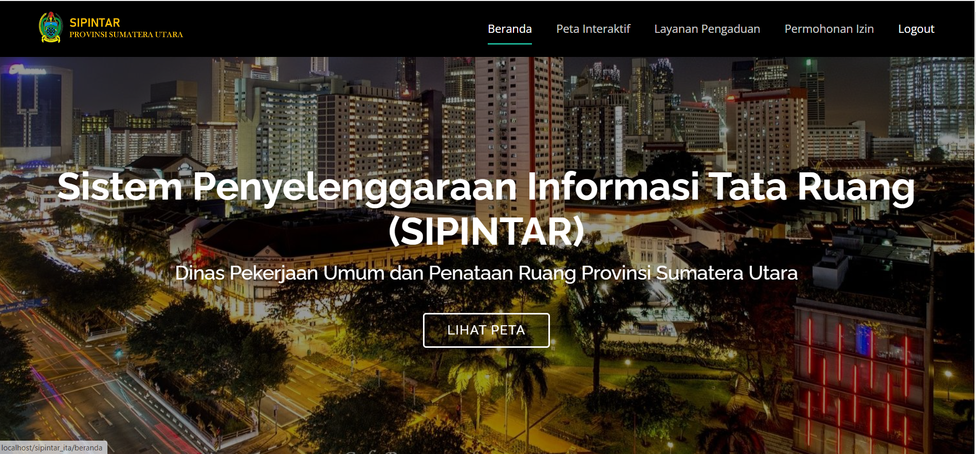
Figure 1. siPINTAR Application Display
Source: Personal Document, 2026
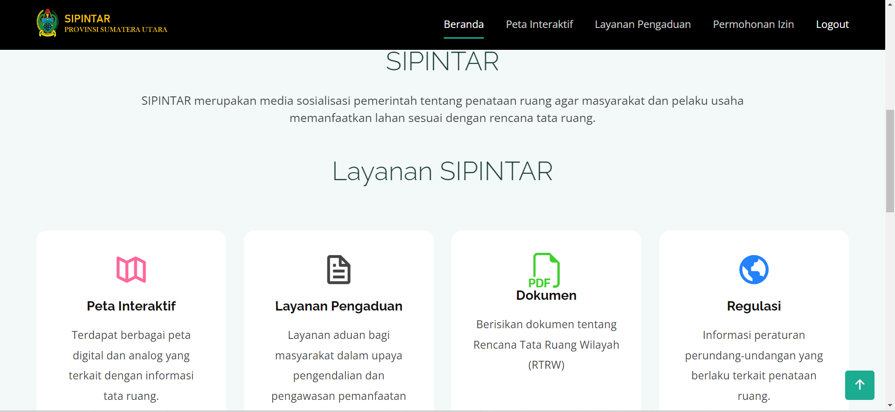
Figure 1. Second view of the siPINTAR application
Source: Personal Document, 2026

This research produces a WebGIS-based Spatial Planning and Land Information System Application (Sipintar Sumut) developed to support the implementation of spatial planning in North Sumatra Province. The system is built as a media for integrating various spatial and non-spatial data so that all information regarding the Regional Spatial Planning (RTRW) can be accessed digitally via the internet network. The application development is carried out by integrating geospatial data in the form of base maps, thematic maps, plan maps, and RTRW documents in digital formats (SHP, PDF, and JPG). This integration allows users to obtain spatial information more quickly than conventional methods that still use printed documents. The implementation results show that the application has provided several main menus, namely: (1) Home Page (2) WebGIS Interactive Map (3) Spatial Pattern Plan Information (4) Spatial Structure Plan Information (5) Supporting Data (Sea Zone and Forest Area) (6) Authentication Page (7) Public Complaints Page. All of these features have been able to display spatial information interactively so that users can navigate, search for locations, and identify spatial allocation zones directly.

3.2 Implementation of WebGIS in Spatial Planning Management
The implementation of WebGIS technology was one of the main findings of this research. Through WebGIS, spatial data previously stored separately was successfully integrated into a single digital platform. Figure 3 shows an interactive map of Simalungun Regency.
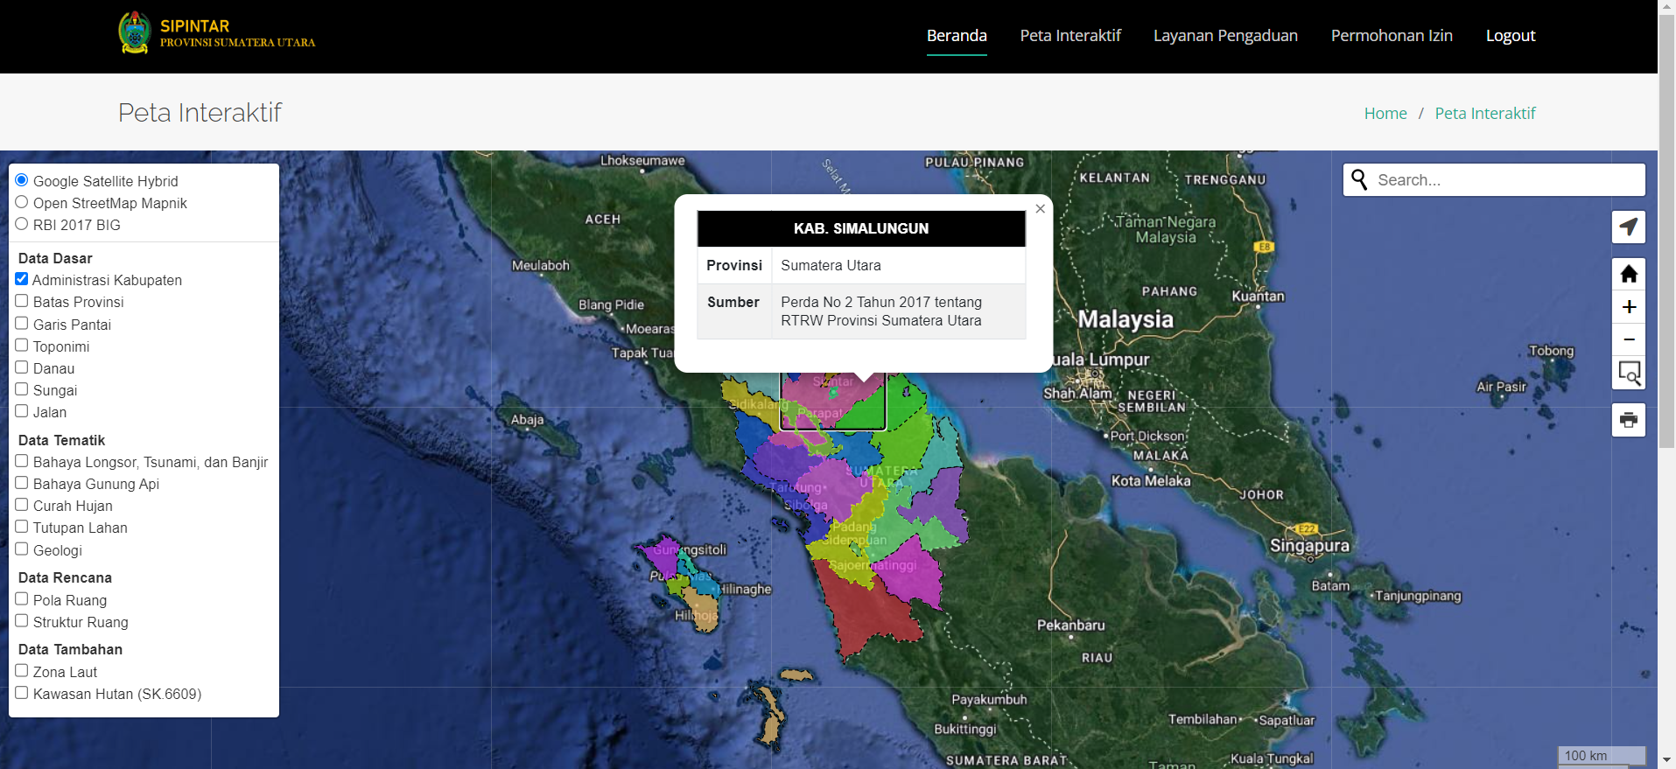
Figure 3. Interactive map display of Simalungun Regency
Source: Personal Document, 2026

The advantages of the resulting system include: information can be accessed anytime via the internet; more interactive map visualization; accelerated retrieval of spatial planning information; increased efficiency of RTRW data management; and support for decision-making processes. Compared to manual systems, WebGIS can reduce information search time because all data is stored in an interconnected spatial database.

3.3 System Feature Analysis
The development results show that each feature has a distinct function in supporting spatial planning.
Table 1. System Feature Functions
No. | Feature | Function
1 | Home | Displays general application information
2 | Interactive Map | Displays spatial data for the RTRW
3 | Spatial Structure | Displays infrastructure networks and activity centers
4 | Spatial Pattern | Displays spatial utilization zoning
5 | Marine Zone | Displays coastal and marine areas
6 | Forest Area | Displays areas based on Forestry Decrees
7 | Complaints | Community communication tools
8 | Login | Administrator data management
The presence of a complaints menu demonstrates that the application functions not only as an information medium but also as a public service medium that supports public participation in monitoring spatial utilization. Figure 5 shows a spatial plan.
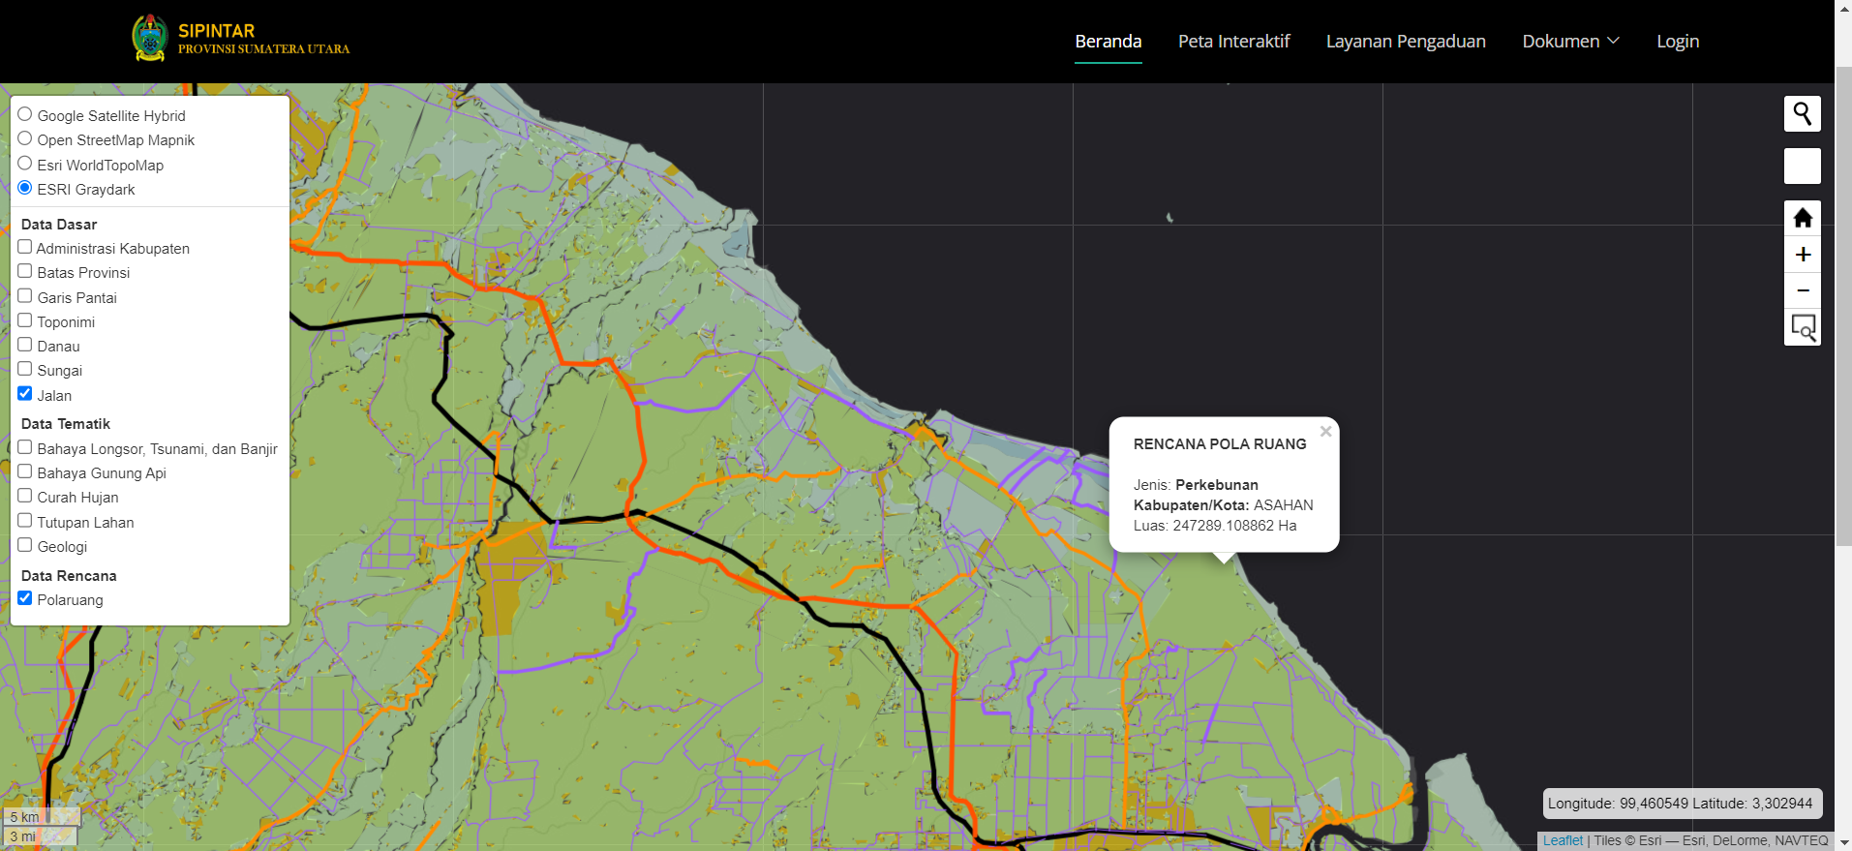
Figure 4. Plan view of the spatial pattern
Source: Personal Documents, 2026
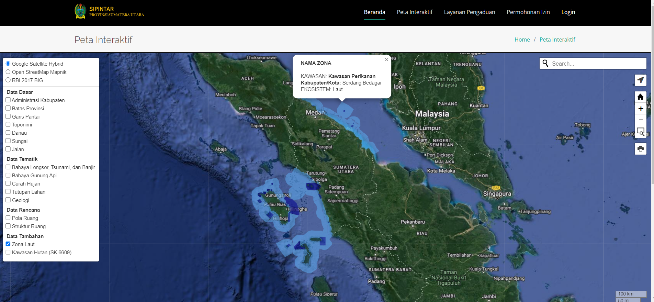
Figure 5. Plan view of the Marine Fisheries Zone
Source: Personal Document, 2026

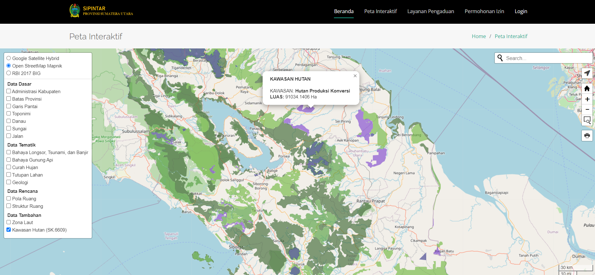
Figure 6. Plan view of the Production Forest Area
Source: Personal Document, 2026

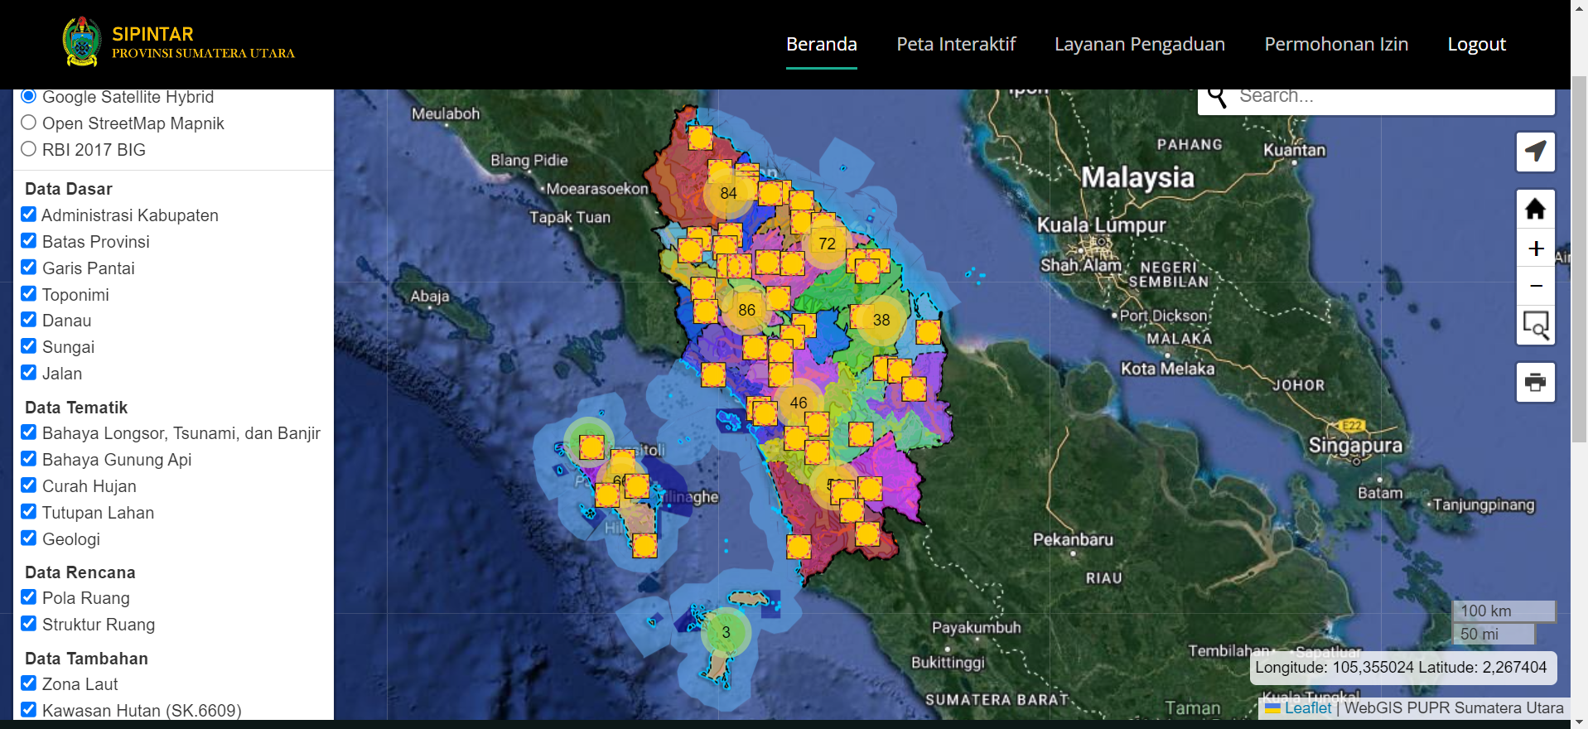
Figure 7. Baseline View
Source: Personal Document, 2026

The authentication page is a security gateway used to verify user identity before gaining access to certain features within the SIPINTAR SUMUT application. This module ensures that only authorized users can manage spatial planning and land data, ensuring data security, integrity, and confidentiality. Figure 10 shows the Si Pintar authentication display.

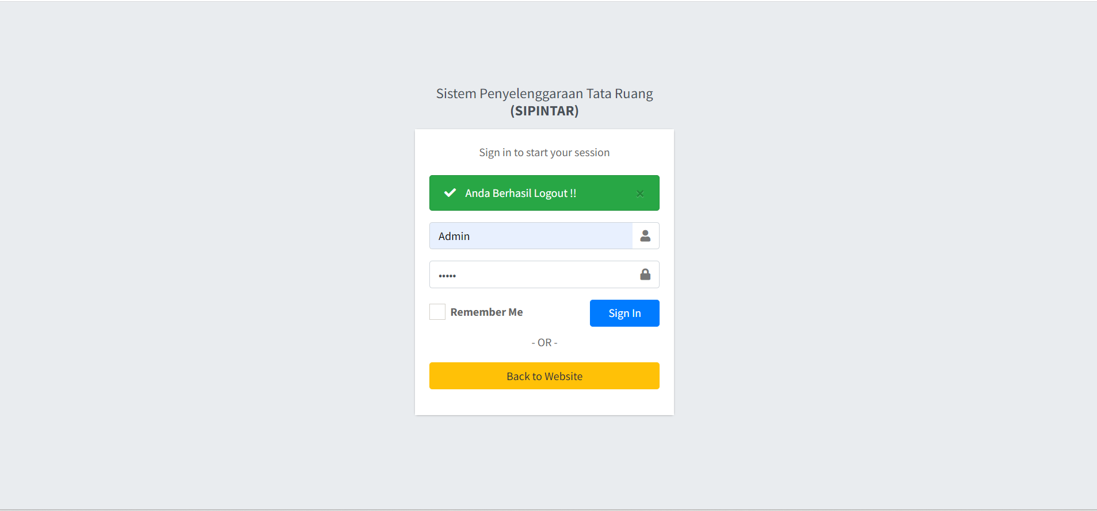
Figure 8. Authentication Page Display
Source: Personal Document, 2026

SIPINTAR SUMUT also has a Complaints Page module, so this feature needs to be included in the Results and Discussion section as one of the public service innovations. One of the features developed in the SIPINTAR SUMUT application is the public complaints page. This feature is designed as a two-way communication medium between the public and the North Sumatra Provincial Government in the implementation of spatial planning. Through the complaints page, the public can submit reports, input, and complaints related to alleged violations of spatial use, non-compliance of land use with the Regional Spatial Plan (RTRW), and various other spatial planning issues. All complaints received can then be managed by the administrator for evaluation and follow-up according to the authority of the relevant agency.
3.4 Discussion
The research results show that the digitalization of spatial planning through SIPINTAR SUMUT provides significant changes compared to conventional systems. Before the application, the process of searching for RTRW information was done through printed documents, thus requiring a relatively long time. After being developed into a WebGIS application, information can be obtained simply by searching for locations on a digital map. This is in line with the concept of e-Government, namely the use of information technology to improve the quality of public services. In addition to increasing service efficiency, the application also increases information transparency. The public can find out the function of space, spatial structure, and protected areas without having to come to government offices. From the local government perspective, the application helps in: (1) monitoring space utilization; (2) preparing recommendations for spatial suitability; (3) evaluating development; (4) synchronizing data between sectors.
3.5 System Strengths and Weaknesses
Based on the implementation results, the system has several advantages. (1) Integrated: All RTRW data is in one system, making it easier to manage. (2) WebGIS-based: No application installation required, so it can be accessed from various devices. (3) User-friendly: Simple interface, easy to use by both the public and the government. (4) Transparent: Spatial planning information can be accessed openly. (5) Supports Smart Province: The system supports the digital transformation of the North Sumatra Provincial Government towards Smart Government. Despite its benefits, this study still found several limitations. (1) Data is not updated in real time. (2) Integration with the ATR/BPN system is not yet available. (3) Automatic land suitability analysis is not yet available. (4) Mobile applications (Android/iOS) are not yet available. (5) Artificial Intelligence technology for land use change analysis is not yet used..
3.6 Future System Development
Based on the research results, several recommended developments include: (1) integration with ATR/BPN digital land data; (2) utilization of high-resolution satellite imagery; (3) use of drones for spatial data updates; (4) development of mobile applications; (5) application of Artificial Intelligence (AI) to detect changes in land use; (6) integration with Building Information Modeling (BIM) to support digital-based development planning; (7) development of an analytical dashboard as a decision support system.

IV. CONCLUSION
This research successfully developed a WebGIS-based North Sumatra Spatial Planning and Land Information System (SIPINTAR SUMUT) as a digital medium to support spatial planning implementation in North Sumatra Province. The system was developed using a Design Science Research (DSR) approach by integrating spatial and non-spatial data, including base maps, thematic maps, plan maps, Regional Spatial Planning (RTRW) documents, and other supporting data, into a single web-based platform.
The results show that the SIPINTAR SUMUT application provides several key features, including a homepage, interactive maps, information on spatial structure plans, spatial pattern plans, forest area data, marine zones, user authentication, and a public complaints page. The integration of these features allows users to obtain spatial information more quickly, accurately, and easily accessible via the internet, thereby supporting more effective planning, utilization, and control of spatial use. In addition to serving as a medium for presenting geospatial information, SIPINTAR SUMUT also provides a public complaints feature that strengthens public participation in monitoring spatial use. The presence of this feature supports the principles of transparency, accountability, and public participation (good governance) in spatial planning implementation, enabling the application to serve not only as an information system but also as a digital public service platform.
Overall, the implementation of SIPINTAR SUMUT contributes to increased efficiency in spatial planning data management, facilitates access to RTRW information, and supports the digital transformation of local government towards Smart Governance. However, further development is still needed, including integration with the national land system, real-time data updates, the development of mobile applications, and the addition of spatial analysis features and decision support systems to enhance the effectiveness of spatial planning management in the future.

REFERENCE
[1] Aronoff, S. (1989). Geographic Information Systems: A Management Perspective. Ottawa: WDL Publications.
[2] Darman, R. (2025). Pengembangan Aplikasi Berbasis Web untuk Pengelolaan Data Tekstual dan Otomatisasi Dokumen Pertimbangan Teknis Pertanahan. Jurnal Pertanahan, 15(2), 121–141. https://doi.org/10.53686/jp.v15i2.296
[3] Hevner, A. R., March, S. T., Park, J., & Ram, S. (2004). Design Science in Information Systems Research. MIS Quarterly, 28(1), 75–105.
[4] Kementerian Agraria dan Tata Ruang/Badan Pertanahan Nasional. (2022). Pedoman Penyelenggaraan Informasi Geospasial Bidang Pertanahan dan Tata Ruang. Jakarta: ATR/BPN.
[5] Longley, P. A., Goodchild, M. F., Maguire, D. J., & Rhind, D. W. (2015). Geographic Information Science and Systems (4th ed.). Hoboken, NJ: John Wiley & Sons.
[6] Pamungkas, A. N., & Aditya, T. (2025). Perancangan Aplikasi Augmented Reality untuk Visualisasi 3D Informasi Pertanahan dan Tata Ruang di Wilayah Urban Yogyakarta. Journal of Geospatial Information Science and Engineering (JGISE), 8(2), 144–154. https://doi.org/10.22146/jgise.102702
[7] Pemerintah Republik Indonesia. (2007). Undang-Undang Republik Indonesia Nomor 26 Tahun 2007 tentang Penataan Ruang. Jakarta: Sekretariat Negara Republik Indonesia.
[8] Pemerintah Republik Indonesia. (2021). Peraturan Pemerintah Nomor 21 Tahun 2021 tentang Penyelenggaraan Penataan Ruang. Jakarta: Sekretariat Negara Republik Indonesia.
[9] Presiden Republik Indonesia. (2020). Peraturan Presiden Nomor 39 Tahun 2019 tentang Satu Data Indonesia. Jakarta: Sekretariat Kabinet Republik Indonesia.
[10] Ratna, N. L. M. D., Mulyanto, B., & Munibah, K. (2023). Peran Administrasi Pertanahan dalam Perkembangan Wilayah Kota Tangerang Selatan. Journal of Regional and Rural Development Planning, 7(2), 215–234. https://doi.org/10.29244/jp2wd.2023.7.2.215-234

