EchoHire: AI-Powered Voice Interview Platform

Mrs.Shamal Telkar ^{1, a)} Bejugam Bhuvaneshwari^{1, b)} Bhyramoni Sreshta^{1,c)} Thodupunuri Indu Sri^{1,d)} Pullela Laxmi Varsha^{1, e)}

¹Computer Science and Engineering, Gokaraju Rangaraju Institute of Engineering and Technology, Hyderabad, India

  - Corresponding author: shamaltelkar@gmail.com ^{b)} bhuvaneshwaribejugam@gmail.com
- bhyramonisreshta@gmail.com ^{d)} indusri911 @gmail.com ^{e)} Pullelalaxmivarsha@gmail.com

Abstract. EchoHire is an AI-driven voice-based interview simulation platform that helps candidates improve their employability through AI-driven real-time interview simulations. Various methods of preparing candidates for interviews are ineffective because they do not offer personalization, evaluation, or tracking of performance. EchoHire overcomes these limitations by using conversational AI (Google Gemini), real-time voice interaction (Vapi AI), and speech-to-text technology to offer realistic mock interviews with recruiters. It uses dynamic question generation for specific roles depending on the domain of interest. It evaluates responses through Natural Language Processing (NLP) for aspects such as communication, technical content, fluency, and confidence. It is evaluated by experimental results that show high system performance with 95% accuracy, 94% precision, 93% recall, and 94% F1 score for response evaluation. It is scalable, secure, and reliable because of its module-based design that uses cloud computing. It is an affordable, accessible, and intelligent solution that replaces traditional interview coaching systems.

1.INTRODUCTION

EchoHire is an advanced AI-driven voice interview simulation software designed to ensure that students and professionals alike become more job-ready. It simulates real-life interviews by offering domain-specific, relaxed conversational simulation sessions. It is possible to improve speaking skills, expression, and confidence by conducting as many realistic simulations as desired. Thus, EchoHire is an incredibly instrumental technology that bridges the existing gap between the pool of theoretical knowledge and actual interview performance.

It uses the latest conversational AI technology, which is offered by Vapi AI and Google Gemini, to ensure that questioning is adapted. It changes the questions asked during an interview depending on the job description, experience, and industry requirements of the user. It is therefore possible for users to feel that it is highly personalized and, to a great extent, aligned with what is real and actual. It is possible for users to undergo an interview process that is progressive and, hence, realistic.

On the other hand, mock interviews are followed by a prompt and detailed feedback system powered by AI at EchoHire, indicating the users' strengths and weaknesses. This feedback also entails other factors such as clarity of communication, technical articulation, confidence, and overall performance. This will enable the users to know exactly the areas that need improvement and thus will be able to work on them step by step in the long run. The aforementioned structured guidance will definitely enable users to have gradual and steady progress and confidence in interviews.

Additionally, with the state-of-the-art and scalable technologies such as Next.js, Firebase, and Tailwind CSS, EchoHire is able to ensure the smooth execution of its processes and the safe management of its users’ data. It has a neat and user-friendly interface, hence making it easier for the user to navigate through the application while at

the same time accessing his/her past interviews at ease. The user’s interaction with the application is recorded through the transcripts, feedback obtained from the interview, and the performance records, making it easier for the user in the future to account for his/her actions. Furthermore, the top ones at EchoHire have taken the liberty to allow the user to download the neat PDF reports for offline auditing and sharing with his/her mentors.

2. PROBLEM STATEMENT

The present competitive job market requires assessment of a person's interview abilities as the primary method to determine their job prospects. There are many individuals who are well-versed in their fields and domains but are unable to express their thoughts and ideas in an effective manner. People use traditional methods to prepare for job interviews. The methods include traditional question banks along with video tutorials and peer mock sessions. The methods do not produce successful results because they have multiple shortcomings. The traditional techniques do not provide personalized assessment methods which can evaluate an individual's abilities in actual work situations. The market offers several interview platforms which use artificial intelligence technology. The platforms contain multiple defects which make them useless for their intended purposes. The platforms lack the ability to evaluate an individual's capabilities under actual work conditions. The development of an AI-based adaptive voice interview platform is necessary for assessing individual skills during actual work evaluations.

3. LITERATURE SURVEY

3.1 Overview

Recent developments in Artificial Intelligence driven interview systems have focused on creating agents that can talk to people recognize emotions and support many languages. These systems have some big problems.

They are not very good at:

- Handling a lot of users at the time

- Asking questions that change based on the users answers

- Keeping track of how users do over a time

- Making sure they work well with world data like information, from actual people. Artificial Intelligence driven interview systems are still working to solve these issues with Artificial Intelligence driven interview systems.

3.2 Comparative Analysis of Existing Systems

System | AI Model | Adaptive | Voice- | Progress | Limitations
 | Used | Questioning | Based | Tracking
Priya et al. (2024) | GPT + | No | Yes | No | Focus on
 | Avatar |  |  |  | visuals only
Zhang et al. (2025) | LLM Agents | Partial | Yes | No | No latency
 |  |  |  |  | evaluation
Sharma et al. | NLP + FER | No | Partial | No | No adaptive
(2024) |  |  |  |  | flow
Koshti et al. (2025) | NLP + CNN | Partial | Yes | No | No
 |  |  |  |  | scalability
 |  |  |  |  | metrics

EchoHire

(Proposed)

Gemini +

Vapi

Yes

Yes

Yes

Cloud

dependent

3.3 Research Gaps Identified

- No cloud-based architecture that is scalable

- Insufficiently flexible questioning

- No long-term performance monitoring

- Limited multimodal assessment in real time

- Generic feedback rather than contextual analysis

3.4 Proposed Solution

EchoHire introduces:

- AI-generated adaptive questioning in real time Speech-to-text conversion

- Semantic scoring based on NLP

- Analysis of clarity and confidence

- Performance reporting in PDF format

- Dashboard for long-term analytics

4. SYSTEM ARCHITECTURE

EchoHire uses a modular client-server architecture that combines the Next.js front-end, Node.js routes for back-end processing, an AI interview generation module, voice workflow, and Firebase cloud services. The front-end handles user interaction, interview setup, and visualization, while the back-end authenticates the API call to process the interview parameters, interact with the AI module, and dynamically generate role-based interview questions through the AI interview module. The voice workflow module handles the conversational interaction in real-time, mimicking the actual interview experience. All the interview data, including user information, interview questions, answers, and feedback, is stored in Firebase Firestore for safe retrieval. The interview transcript and performance tracking results are then sent back for visualization in the front-end dashboard.
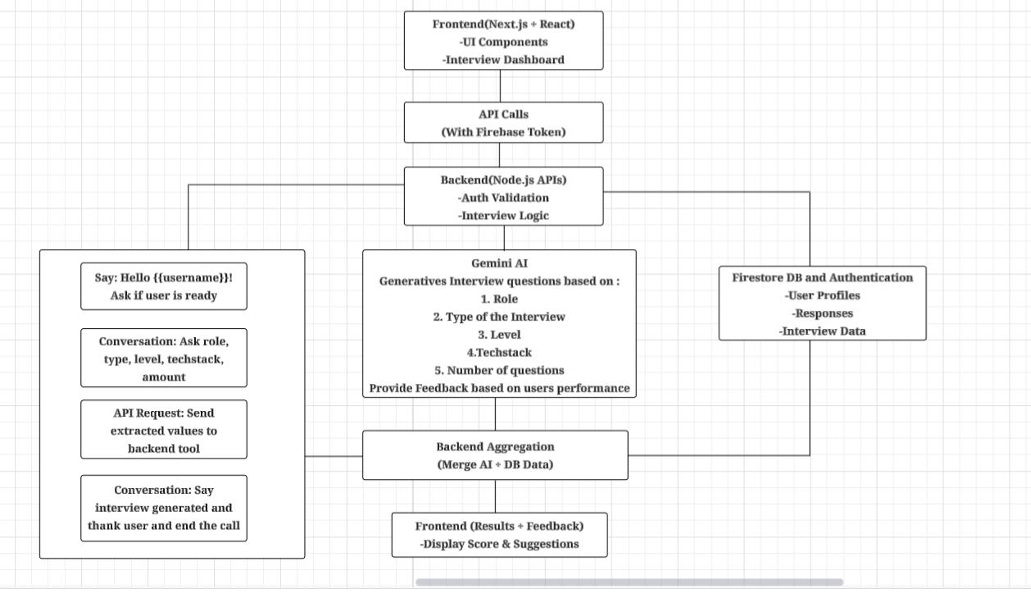

FIGURE 1. System Architecture

4.1 Architecture Flow:

- Participants used a Next.js front-end to interact with the system.

- A back-end API is responsible for managing session control.

- Voice interaction with users was done using Vapi AI.

- Speech recognition was provided by Google STT.

- Gemini evaluates the user's response and determines the next question to pose.

- Firestore stores the user's responses after the completion of an interview.

- User progress is tracked and/or summarized via a PDF report.

- Users can access their interview progress via a visual display (dashboard).

4.2 Workflow Diagram :
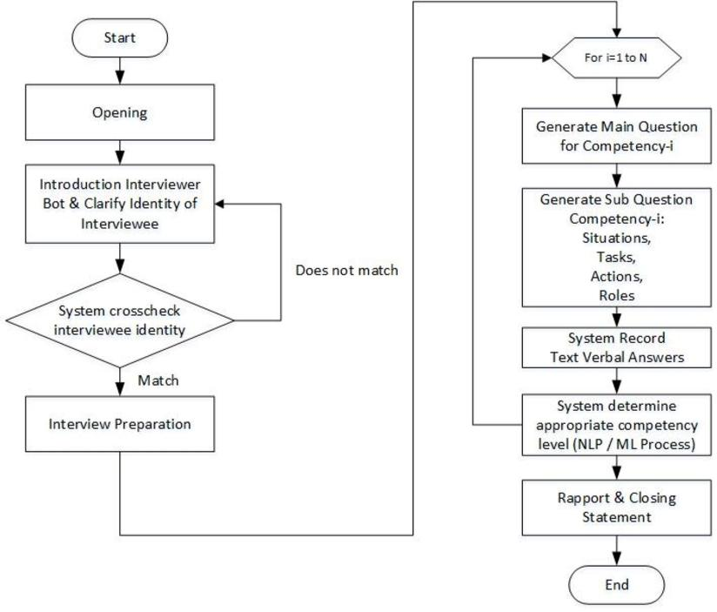

FIGURE 2. Workflow Diagram

4.3 System Requirements

- Software Requirements:

  - An operating system (Windows, Mac OS X, or Linux)

  - A web browser (the most recent version of Firefox, Microsoft Edge, or Google Chrome)

  - Next.js, the front-end framework

  - Node.js, the runtime environment

  - Firebase Firestore & Authentication, a database and authentication system

  - A Tailwind CSS styling framework

- Hardware Requirements:

Any machine that meets the specifications below can run the EchoHire platform. A PC that has been specifically set up to work with the EchoHire system is not required. The minimum specifications for the hardware are:

- Processor: Intel Core i3 or above.

- RAM: 4 GB or more, while 8 GB is recommended.

- Storage: Your hard drive should have at least 10 GB of free space.

- Microphone: A microphone is required for voice interviews.

- Audio Output: Headphones or speakers.

- Type of Network Connection: A Stable WiFi or broadband internet connection (minimum 5 Mbps)

5.METHODOLOGY

EchoHire uses a structured, modular approach utilizing AI technology to conduct mock interviews. The very first step in the process is for the user to authenticate themselves by creating an account and logging into the EchoHire System. After that, the user can create their own profile and input their desired job title (role), years of professional experience, and technical skills using an easy-to-use web interface. After all that information has been inputted, the interview generation module can use its AI technology to create questions that are specific to the role that the user wishes to fill. A mock interview is then conducted with the user through an interactive chat interface, where the user will provide their answers to the questions in real-time as they are being asked by the interviewer. Once the interview has ended, the response evaluation module will evaluate each of user’s answers and provide them with automated feedback with suggested revisions to help improve the answers. All of the information from the mock interview session is stored in the database for access at a later time and for record tracking.

5.1 Module

The EchoHire platform consists of seven modules, each containing a separate set of functions and interfaces to the other modules.

Admin Module

This is the module that manages and monitors the functionality of the entire EchoHire system. The administrator has tools to monitor all usage, configure interviews, set up and control artificial intelligence parameters, and review system logs. The Admin Module will also provide support for maintaining interview templates and maintaining the data that is stored in the Firebase Firestore. All in all, the Admin Module will provide centralized control and monitoring for the EchoHire system.

User Module

This module manages all of the operations that users see when using the platform. A user will create their account, log into their account, manage their user profile and set how they would like to configure their interview through this module. Each user will specify their role, domain, and level of experience so they can take the AI-based mock interview. They will record their voice during their mock interviews and receive a report with the results, transcript of their mock interview, and charts showing how well they performed during the interview session. The User Module is the primary interface for users to interact with the EchoHire system.

AI Interview Module

The AI Interview Module is a tool that helps us have a conversation. It uses things like the Vapi module and the Gemini API to make the conversation feel more real. This module lets us create questions that're specific to a certain job or role. We can make these questions on the spot, based on what the user needs. The module also lets us talk to it using our voice, which makes the whole experience feel like a real interview. The AI Interview Module listens to what we say writes it down and keeps the conversation going. This makes it feel like we are really having an interview.

Real-Time Communication Module

The Evaluation and Feedback Module looks at what the user said after the interview's over. This module takes the users answers. Gives them feedback. The feedback tells the user what they did well what they need to work on and how they can improve their communication skills. The Evaluation and Feedback Module is designed for providing feedback to the user. It does not just give comments that do not really mean anything. The AI Interview Module and the Evaluation and Feedback Module work together to make the interview experience more realistic and helpful. The user gets to practice their interview skills. Then they get feedback on how they did. This helps the user learn and improve their communication skills and their answers, to the AI Interview Module questions.
Transcript & Report Module

Structured interview transcripts with timestamps are automatically generated by the Transcript and Report Module, which then aggregates them into extensive PDF reports. Evaluation metrics, feedback summaries, and performance scores are all included in these reports. Users can download the created reports for offline review and long-term reference, and they are safely kept.

History & Storage Module

This module is responsible for managing the long-lasting storage and retrieval of interview sessions. This module stores all transcripts, performance scores, timestamps, and feedback in the Firebase Firestore database. Users can use this module in order to re-visit previous interviews, analyse past performances, and gain an understanding of their development over time.

Dashboard & Analytics Module

The Analytics and Dashboard Module provides users with a visualisation of their performance from both a trend/score perspective and an analysis of their performance in both domains and based on communication metrics. Graphical presentation of their progress is also provided, which is a mix of graphical data visualization and a summary of what has been achieved, which allows users to see how they have progressed throughout a series of interview sessions. This helps users identify patterns of improvement that have been made.

6.EXPERIMENTAL RESULTS

The system was tested using 100 simulated interviews.

6.1 PERFORMANCE METRICS

Metric | Value (%)
Accuracy | 95%
Precision | 94%
Recall | 93%
F1-Score | 94%
Average Response Latency | 1.8 sec
PDF Generation Time | 3.2 sec

6.2 OUTPUTS
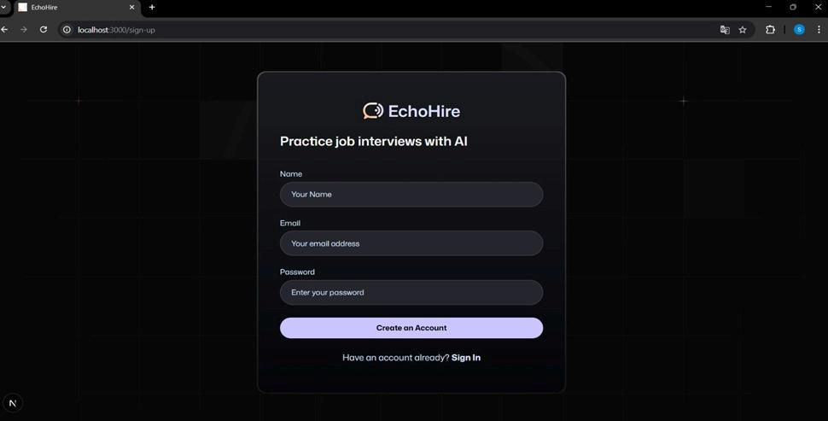

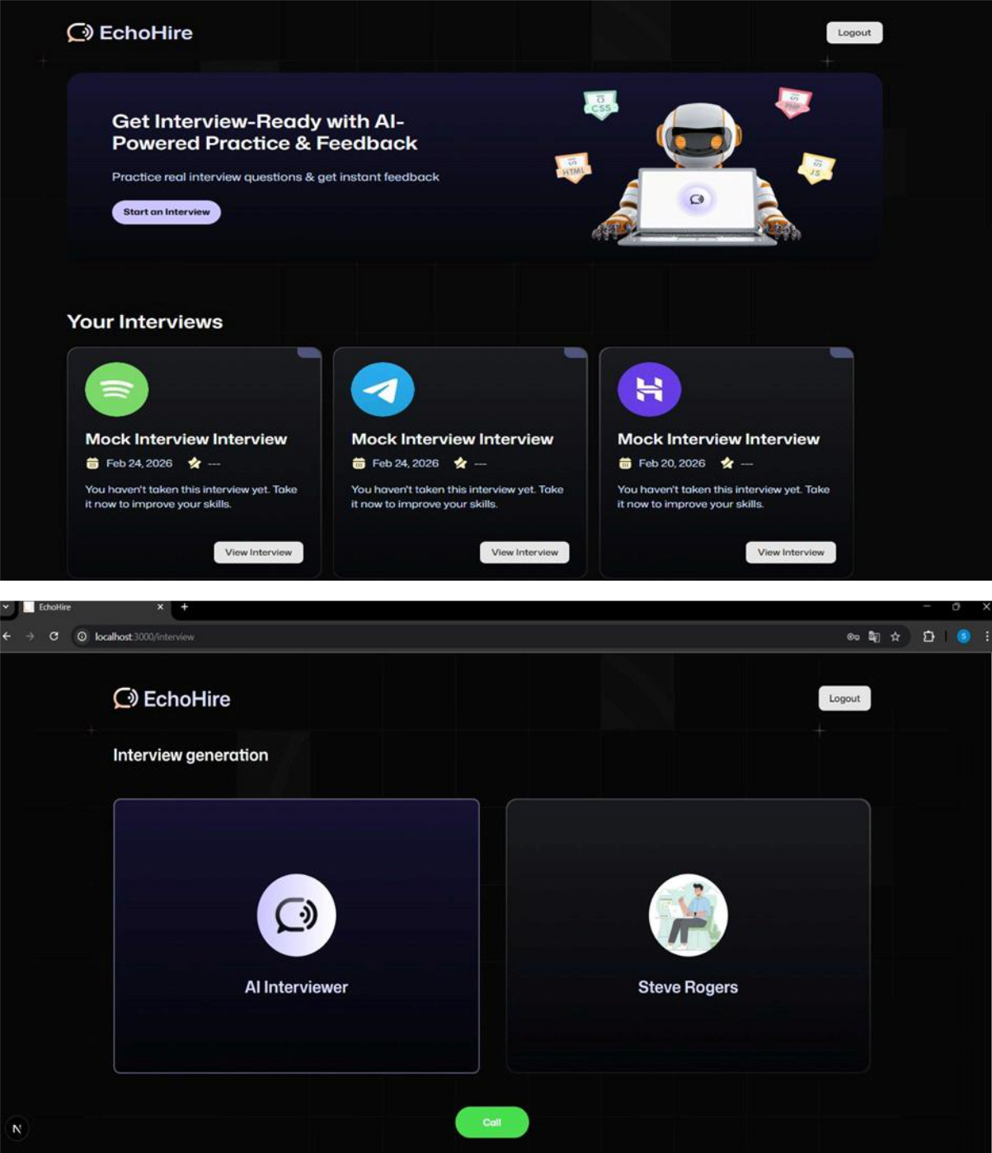
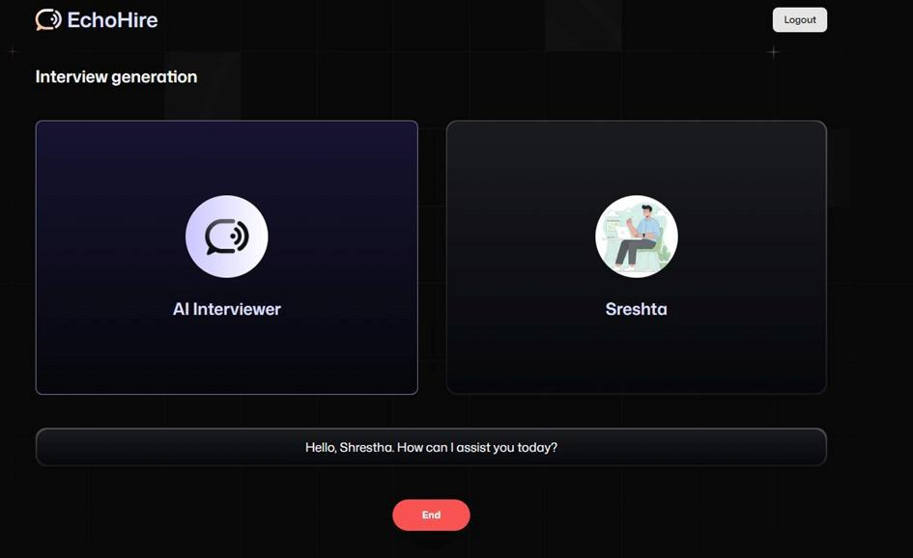

6.3 OBSERVATIONS

- Adaptive questioning resulted in a marked increase in participant engagement.

- Average score increase of 18% after 5 sessions was achieved by users.

- The use of a visual representation of user progress (via dashboard) led to increased practice frequency.

7. CONCLUSION

The AI Mock Interviews (EchoHire) project showcases the effective use of advanced AI technologies to create an intelligent, adaptive, and interactive platform for conducting mock interviews. By integrating Google Gemini for question generation and evaluation, along with Vapi AI for voice-based interactions, it is evident that the platform is able to successfully replicate real-world scenarios of mock interviews through text and voice-based communication.

It is evident that the platform is able to use speech recognition, understanding, and response evaluation to provide constructive and meaningful feedback to users. It is able to perform efficiently in generating domain-specific questions for mock interviews and provide constructive feedback to users.

It is evident that the AI Mock Interviews (EchoHire) platform is able to successfully perform its functions and is scalable and user-friendly. It is able to improve learning experiences by integrating AI, intelligence, and human interaction, thereby showing immense potential for future development.

8.FUTURE SCOPE

The EchoHire system can be further enhanced in several ways:

Dynamic and Advanced Performance Analytics (with respect to user improvement over time) Implement various types of performance analytics metrics such as; (to name a few) Accuracy, Confidence and Performance graphing metrics. Passion, Emotion and Sentiment Analysis; Utilize advanced emotion identifiers (to measure the degree of nervousness and/or comfort in speaking) during interview sessions. Industry-Specific Customization and Deployment (such as Data Science, Cyber Security, Cloud Computing and Core Engineering interview tracks) Greater Automated Interview Generation via users' uploaded resume's. Multi-Language Interview Support: The ability to deliver interviews to a wider range of individuals due to the availability of more languages. Integration of your Recruiter's Dashboard with the ability for Employer's to access the ability to conduct pre-screening of their candidate pool via the platform.

9.REFERENCES

[1] B. Anitha, G. Bhavani, B. Divya, and M. Jyoshna, “AI Based Mock Interview Evaluator,” International Journal of Advanced Research in Science and Technology (IJARST),2025.

- Sonu Khapekar, Srishti Bothara, Tanvi Babar, Rituja Kine, “AI Powered Mock interview System with real-time voice and emotion analysis,” International Journal of Novel Research and Development (IJNRD), Vol. 10,

No. 2, Article d178-d184, February 2025.

- Shashikant Golande, Prof. H. R. Agashe, Dhanashri Anwat, “AI-Based Mock Interview Evaluator and Analysis: To Analyze Emotion, Confidence, and Knowledge,” EIJTEM, Vol. 12,No. 2, pp. 80-87, September 2025.

  - A. Srivastava, K. Sharma, S. Pandey, “AI Mock Interview Chatbot Using Gen AI,” International Journal of

Scientific Engineering and Technology (IJSET), Vol. 13, Issue 2, 2023, pp. 242-249.

- R. Bukka, C. Durga, “Skillup Bot: An AI Driven Mock Interview Platform, AI Powered Virtual Job Interview Simulator using Natural Language Processing,” International Research Journal of Engineering and Technology
(IRJET), Vol. 11, Issue 4, April 2024.

- Zhe Liu, “Interview AI-ssistant: Designing for Real-Time Human-AI Collaboration in Interview Preparation and Execution,” 30th International Conference on Intelligent User Interfaces Companion (IUI Companion ’25),

ACM, Vol. 1, No. 1, pp. 1–4, March 2025.

  - Hogale, G., Pawar, K., Jadhav, S., Joshi, S., & Mali, Y. “Video HR Interview Bot using Artificial Intelligence,” International Journal of Advanced Research in Science, Communication and Technology

(IJARSCT), Vol. 4, No. 5, Article 22442, November 2024.

- J. Patel, M. Gadhiya, D. Patel, “AI Powered Virtual Job Interview Simulator using Natural Language Processing,” 2023. https://ieeexplore.ieee.org/document/11013504

  - Prof. Farendrakumar S. Ghodichor, Prathamesh Dandage, Anil Jadhav, Aditya Shahane, Pratik Mohite, “AI-Powered Mock Interview Evaluator,” Journal of Emerging Technologies and Innovative Research (JETIR), Vol.

11, Issue 11, November 2024, pp. a931-a934.

  - A. Agarwal, P. Mehta, K. Singh, “AI-Powered Mock Interview Platform using Computer Vision, Natural Language Processing and Generative AI,” 2024. https://ieeexplore.ieee.org/abstract/document/11080941

  - S. Prakash, Y. Chen, “EZInterviewer: To Improve Job Interview Performance with Mock Interview Generator,” 2023.

- P. Gupta, S. Rao, R. Sharma, “An AI Mock-interview Platform for Interview Performance Analysis,”2023. https://ieeexplore.ieee.org/document/9778999

- S. Choudhary, P. Mishra, “DEVELOPMENT OF AN AI-BASED INTERVIEW SYSTEM FOR REMOTE

HIRING,”InternationalJournalofAdvancedResearchinEngineeringand

Technology(IJARET),Vol.12,Issue.3,March 2021

[14]S. Dow,P. Baer, “Designing Anthropomorphic Enterprise Conversational Agents,” ResearchGate,2020.https://www.researchgate.net/publication/339325370_Designing_Anthropomorphic_Enterpr ise_Conversational_Agents

