

Can We Outsmart the Limits of Artificial Intelligence?
To infinity and beyond!” .. Buzz Lightyear
AI tools come with a massive potential to the human, to the point that we have come to believe Buzz Lightyear when he said: “To infinity and beyond!”
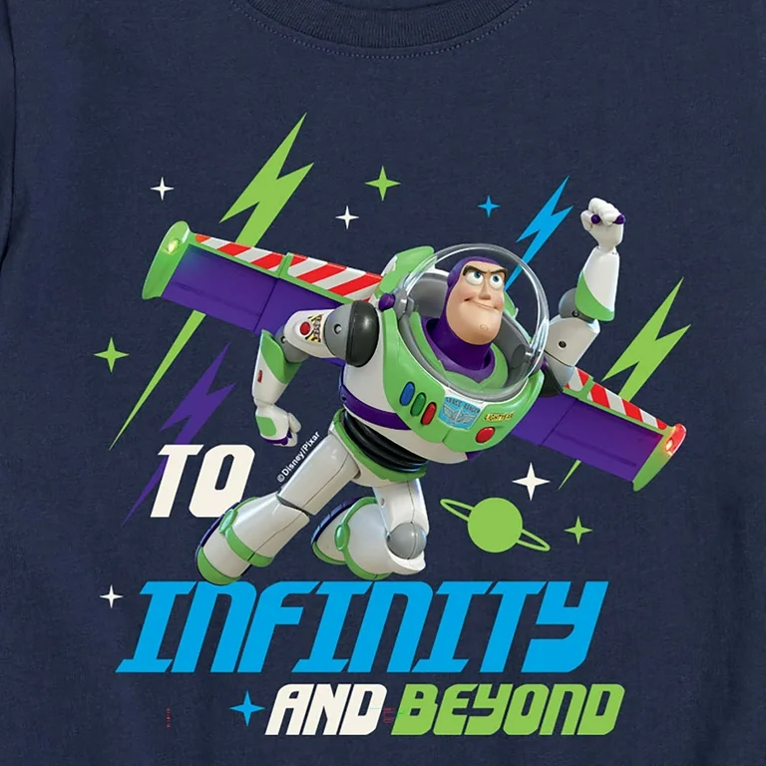
Well, in real world it can help programmers to turn spaghettis code into clean code, students to write full scientific research with reference cited with APA, moms with creative food recipe from available ingredients, and you know what? I’ve actually seen people use AI tools to get advice on how to handle conflicts with their partners when they clash!
The problem is not the why they use AI tools, the problem is that the AI tools could offer the right answer, the right advice most of time and guess what, People have started blindly following the outputs of AI, completely forgetting about the hallucinations, biases, privacy, transparency & mistakes that often come with these results.
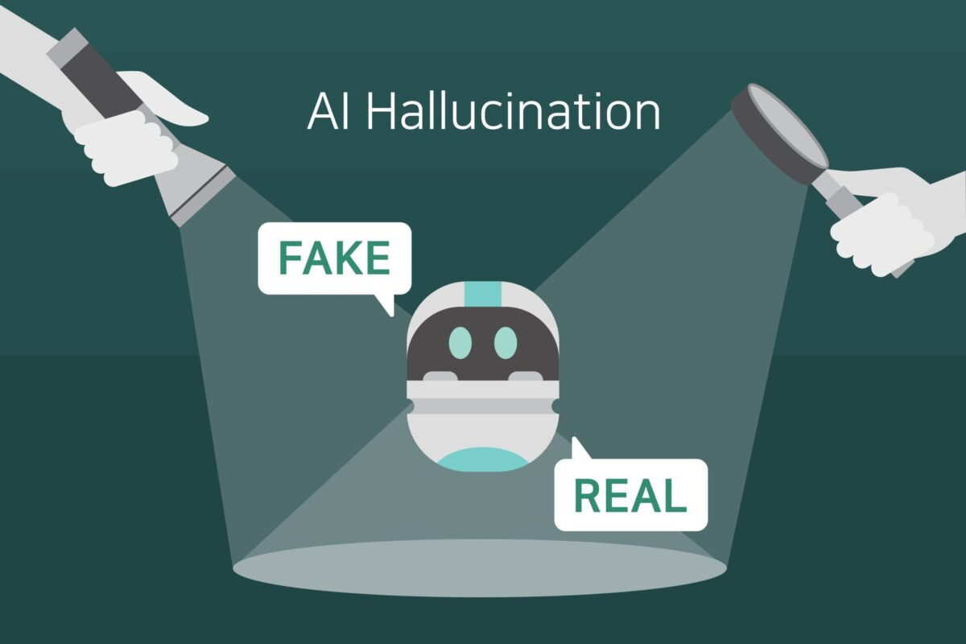
This suggests to stop dealing with AI, absolutely not. In fact, the creator obviously smarter then the creature itself. We create AI tools then we create tools to overpower its weakness.

What is AI hallucination?
RIGHT answer or SMART result
if you ask AI a question, and it generates a result deviates from reality this is " Hallucination". the hallucination may be in several forms like: wrong facts, non-existing examples or references, or incorrect information that appears accurate, well-researched, and trustworthy on the surface.

Is AI Hallucination Proof That Machines Are Starting to Dream or Imagine?
Simple answer is "NO" but deeply, it can build strange internal associations that can lead to unexpected and sometimes comically wrong outputs sounding like a very confident toddler making up wild stories! Hold on this idea and follow me:
the following screenshot taken from deepseek:

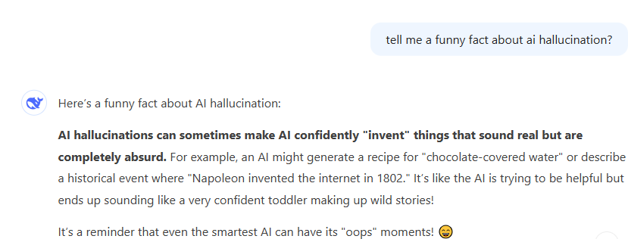
look at the part of describing the AI hallucination as: " It’s like the AI is trying to be helpful but ends up sounding like a very confident toddler making up wild stories!"
I take the same sentence but replace "AI" with "Kid" >> It’s like the kid is trying to be helpful but ends up sounding like a very confident toddler making up wild stories!"
then went back to deepseek, asked it to describe this kid with wild stories and get the following result:
- dreaming up
- wild ideas make perfect sense
- imagining scenarios
- weaving a fantastical narrative
- their mind is wandering through a playful
- untamed landscape of thoughts

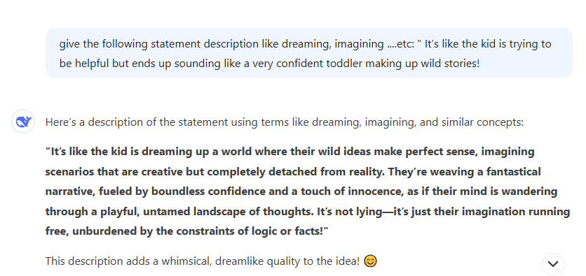
Again, as " the creator obviously smarter then the creature itself.", scientists reject this idea and offer alternative three whys of AI hallucination which are:
- AI generate outputs as facts based on their training data however it simply does not understand the meaning of "fact"
- AI models programmed to conquer the gaps on data trained on by generate a reasonable answer filling gaps
- the simplifying approach used by AI to discover the patterns, sometimes results in false connections regarding to exaggeration in simplification
- Finally, AI tool DO NOT verify the accuracy of my outputs. and let's the deepseek explain this:
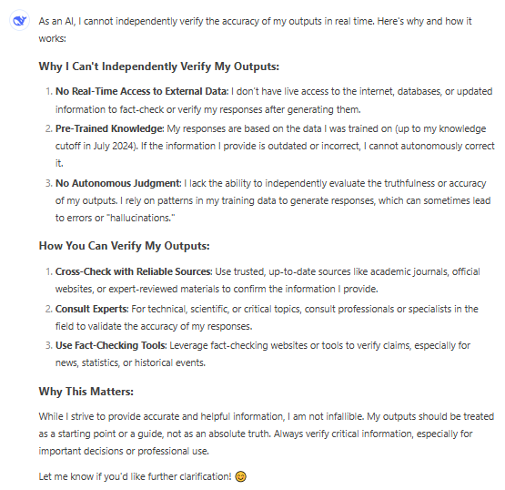

How to overpower the weakness of AI?
" Learn" is the magic solution"
First, learn about the AI platforms. limitations. second, believe that avoiding is not a solution. many research prove that AI revolutionize the way we learn and life prove that, AI makes some jobs replaced by intelligent machines & produces new jobs.
Just asking AI a question, and copying and pasting its answer doesn’t mean you’re using AI. The real use of AI comes when you understand the answer, double-check it , use it correctly in the right context, and finally mention that AI helped you to generate this result. . AI is a powerful tool, but it can not replace the human critical thinking or our personal analysis perspective to things.

Human + AI = Superhuman
Technology never ceases to amaze us—it’s a magician whose tricks never run out
To outsmart human an AI abilities, you have to know how to use AI tools wisely. Here, I suggest the following steps to become a superhuman " A an armed with AI"
1. Learn prompt engineering. Prompt engineering is the art of generating safe, exact, successful, efficient, & robust prompts. and here are the most useful courses to learn online free. the first one is my own youtube playlist of prompt engineering for everyone the content in Arabic: https://www.youtube.com/watch?v=8wlPmRhqGwg&list=PLom-SoOv_It6_jA69NuDnt7_SvBapIgLu - IBM course "Introduction to prompt Engineering": https://www.edx.org/learn/artificial-intelligence/ibm-introduction-to-prompt-engineering - Cognitive class course " Prompt Engineering for everyone": https://cognitiveclass.ai/courses/prompt-engineering-for-everyone
2. Keep your knowledge updated by checking new AI tools released periodically. As of now, there are numerous AI tools developed by various organizations and companies like: OpenAI - Google - Microsoft - Anthropic - Facebook - Hugging Face - DeepMind. These are just a few examples, the field is rapidly evolving with new tools being released regularly. each release has its own unique features and applications, contributing to the diverse landscape of AI technology. this article discuss more than 5000 AI models, yes FIVE THOUSAND https://medium.com/@maximilian.vogel/5000x-generative-ai-intro-overview-models-prompts-technology-tools-comparisons-the-best-a4af95874e94. I recommended AI Career Essential course from ALX: https://www.alxafrica.com/programme/career-ready-skills-training/?utm_source=google&utm_medium=pmax&utm_campaign=egc_2024q&utm_term=tofu-applications-aice-eg&utm_content=aice&gad_source=1&gclid=CjwKCAiA5pq-BhBuEiwAvkzVZftimVkmeMb9d2ZzMkKoRhKG4rcnk0b9Ok885joZ748tJKZj0PyemxoCxlEQAvD_BwE
3. Learn about AI limitation. You can check IBM course " Ethical AI Applications of Deep Learning and Computer Vision": https://www.ibm.com/impact/ai-ethics- Microsoft " Embrace responsible AI principles and practices": https://learn.microsoft.com/en-us/training/modules/embrace-responsible-ai-principles-practices/
4. Build your own technique when using AI.for me I develop a technique consists of 5 steps: Know, Set, Claim, Check, and Detect. KNOW: Me, I do an online research by using trusted search engine such as " Google Schooler" https://scholar.google.com/ to be familiar with main terminology of subject I am gonna to work on. SET: most of AI tools have several modes which determine the degree of creativity or the "imagination" of the generated output. For example, Microsoft copilot has 3 modes: Precise (use when you want more information and less fluff), Creative (when you want elements like wordplay, rhyming, and a general touch of writing flair to take precedence over facts and figures) , and Balanced ( if you don't know which approach to choose or you want a short, to-the-point response with a touch of creativity). CLAIM: Ask AI for a suggestion not an answer, as for steps to follow not full project. CHECK: Use fact check tool to check the output like: Yes, there are several free tools and platforms available for fact-checking, similar to Google Fact Check Explorer. Here are some notable ones: Google Fact Check Explorer (tool by Google that aggregates fact checks from various sources.) https://toolbox.google.com/factcheck/explorer - Snopes (One of the oldest and most reputable fact-checking websites.) https://www.snopes.com - FactCheck.org (checks the accuracy of political claims) https://www.factcheck.org - PolitiFact (rates the accuracy of claims by politicians and pundits) https://www.politifact.com - AP Fact Check (fact-checking service) https://www.apnews.com/hub/ap-fact-check - Lead Stories (debunking trending hoaxes and false stories) https://www.leadstories.com - TruthOrFiction.com (Checks the veracity of rumors, fake news, and viral stories) https://www.truthorfiction.com. Detect: at this point you already get the final result but you need to be sure that the most of the work is free of AI. this can be handle by using one of the AI detectors like: Originality.AI- GPTZero - Turnitin - Copyleaks - Citation Machine - Winston AI - Writer.com - Crossplag - BrandWell - Smodin - Quill.org

