Teachers' Competencies and Attitudes Towards the Philippine Professional Standards for Teachers as Predictors of Their Performance

Abstract
This study examined the relationship between teachers' competencies and attitudes toward the Philippine Professional Standards for Teachers (PPST) as predictors of teaching performance. Using Partial Least Squares Structural Equation Modeling (PLS-SEM), the research explores key competency factors such as Content Knowledge and Pedagogy (CKP), Curriculum Development and Planning (CDP), Learning Environment (LE), and Professional Growth and Professional Development (PGPD). The findings indicate that (LE) exerts the strongest influence on teacher competence, reinforcing the importance of a conducive learning environment in enhancing instructional effectiveness. Additionally, the study reveals that teacher competence significantly impacts teaching performance. At the same time, attitude plays a complex moderating role—directly improving performance but exhibiting a negative interaction effect when combined with competence. These insights contribute to refining competency-based teacher development strategies and emphasize the need for enhanced training programs, resource allocation, and institutional support to strengthen PPST integration and improve student learning outcomes.
Keywords: Teacher competencies, Teaching performance, Learning environment, Professional development, Teacher attitudes.

INTRODUCTION
Teachers are at the heart of educational development, holding a key role in both academic achievement and the personal formation of students. As principal agents of knowledge transfer and skill acquisition, their qualifications, practices, and outlook are integral to the quality of instruction students receive. In the Philippine context, the Philippine Professional Standards for Teachers (PPST) were introduced to define and elevate the professional benchmarks expected of educators (Mantos et al., 2025)
The PPST framework positions teacher competency and professional attitude as vital components of effective instruction and student engagement. It identifies the foundational elements—ranging from subject mastery to pedagogical design and inclusive classroom strategies—that teachers must acquire to ensure meaningful learning. These competencies are not only technical but also relational and contextual, reflecting the evolving demands of modern education Pamon & Oco 2024).
Structured into progressive career stages, the PPST provides clear expectations for teachers across various phases of their profession. Beginning Teachers receive foundational guidance and mentorship, while Proficient Teachers operate with greater autonomy in implementing effective teaching techniques. Highly Proficient Teachers go further by leading innovations and offering peer support, and Distinguished Teachers stand out as educational leaders, setting exemplary standards and influencing institutional growth (May Evangelio & Joy Escote, 2024).
The impact of PPST extends beyond competence—it significantly contributes to improved student learning outcomes when embraced effectively. Teachers' attitudes toward the framework play a pivotal role in its practical adoption. A constructive mindset enhances implementation, fostering stronger commitment and instructional performance, while negative perceptions often limit the framework’s impact (Joy A. Estrada & L. Gumban, 2024).
As schools confront increasingly complex educational challenges, there is a growing emphasis on sustained professional development. Several studies highlight the critical role of ongoing training in reinforcing PPST competencies. However, the effectiveness of implementation varies across schools. While some benefit from structured support, others face limitations such as scarce resources, minimal training, and lack of institutional backing. This disparity highlights the need for equitable and well-funded PPST adoption strategies. Comparatively, nations like Finland, Singapore, and South Korea have demonstrated the power of continuous teacher development in achieving high-quality education (Canuto et al., 2024).
This study examined how key factors, such as instructional planning, assessment, content expertise, collaboration, and self-growth, collectively influenced professional competence and its effect on performance and attitude. Findings supported that strengthening these areas improved effectiveness and behavior, aligning with recent research on the impact of structured teacher development (Satur et al., 2025)
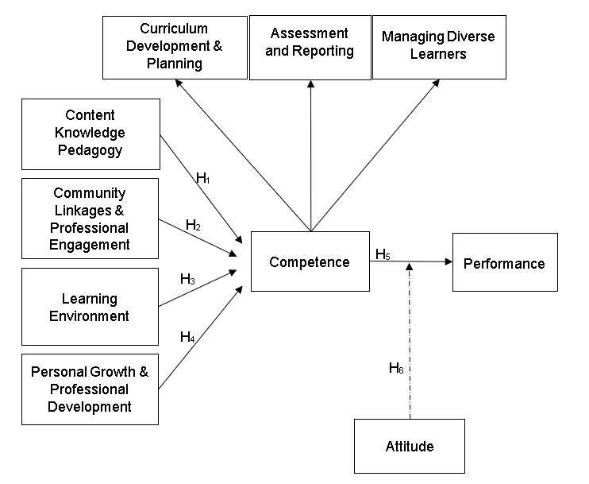
Research Model and Hypothesis

Figure 1. Research Model

The research model in Figure 1 illustrates the interconnectedness of teachers’ competencies, their attitudes toward the Philippine Professional Standards for Teachers (PPST), and their overall teaching effectiveness, reflecting recent findings on how these elements interact to influence educational practice (Gepila Jr., E. C. 2020). This conceptual framework organizes the relationship among core factors that collectively define professional competence, behavior, and performance within the teaching profession. At the foundation of the diagram, competence is influenced by four distinct elements: engagement with the community and professional networks, mastery of subject content combined with effective teaching strategies, the overall learning environment, and continuous personal and professional development (Jorilla, C. D., & Bual, J. M. 2021). Therefore, we conceptualize the following hypothesis:

H1: How do Content Knowledge and Pedagogy (CKP), Curriculum and Learning Planning (CLP), Learning Environment (LE), and Professional Growth and Professional Development (PGPD) influence teacher competence?
H2: To what extent does teacher competence affect teaching performance (TP)?
H3: What is the role of teacher attitudes (ATT) in moderating the relationship between competence and teaching performance?
H4: Which of the factors (CKP, CLP, LE, PGPD) has the most significant impact on teacher competence?
H5: How do Curriculum and Planning, Assessment and Reporting, and Managing Diverse Learners contribute to measuring teacher competence?

Competence is systematically mapped through H1 to H4, illustrating its direct influence on key educational components, including curriculum planning, assessment practices, and managing diverse learners, which are essential for professional effectiveness (Navarro, & Lumabi 2022). The direct effect of competence on performance, represented by H5, highlights how an individual's expertise translates into measurable outcomes, reinforcing the significance of professional mastery (PPST Domain 4: Curriculum & Lesson Planning. Furthermore, the diagram underscores the role of attitude in shaping both competence (H6) and performance, emphasizing the importance of mindset and disposition in achieving success (Barni et al., 2019). By presenting a structured visualization, the diagram effectively demonstrates how various psychological, social, and professional factors interact to support holistic professional growth and effectiveness.
METHODOLOGY
Procedure and Participants
A questionnaire was administered to 151 prospective teacher respondents, encompassing various academic environments within designated Seventh-day Adventist schools in Mindanao. To test the research hypotheses. The study gathered responses from 109 participants, encompassing a broad spectrum of educational leadership positions within the academic system. The sample included individuals serving as vice principals, curriculum coordinators, directors overseeing Pathfinder programs, a guidance facilitator, department heads, and instructional staff from both primary and secondary education levels. Their collective insights provide a comprehensive perspective on administrative and pedagogical practices across varied institutional contexts. The data gathering procedures for this study were designed to ensure a comprehensive and representative collection of information from educators across various Seventh-day Adventist institutions in Mindanao. The process began with the identification of participating schools, followed by an assessment of the total population of teachers at each institution. To facilitate a systematic sampling process, Cochran’s formula was applied to calculate the appropriate sample size, allowing for a precise determination of how many teachers to include from each school. The resulting sample was then proportionally allocated based on each school's teacher population, ensuring that diverse educational contexts and teaching practices were adequately represented.
To initiate the study, a letter was drafted to request permission to conduct research within the selected institutions. This communication will outline the research objectives and significance while detailing the expected roles of the schools and their teaching staff. By highlighting the value of the study, the letter aims to promote mutual understanding and cooperation, which are essential for the efficient execution of data-gathering activities in the selected schools. Furthermore, the distribution of carefully adapted questionnaires will capture essential information regarding teacher competencies and professional development, contributing to a comprehensive understanding of the educational landscape within the Seventh-day Adventist school system in Mindanao.
Upon receiving approval from school administrators, the researcher will initiate the distribution of the survey questionnaires. These will be provided to the respondents either through in-person meetings during their available times or electronically via email or Facebook Messenger. Respondents were given the option to submit the completed questionnaires either immediately or at a time convenient to them within the designated data collection period. The survey will be structured using a Likert scale to assess teachers’ competencies in alignment with the domains of the Philippine Professional Standards for Teachers (PPST) and their attitudes toward its implementation.
The researcher retrieved the questionnaires either personally or via predetermined communication methods. All gathered information was then securely stored in preparation for analysis. To ensure accuracy and integrity, any missing or inconsistent responses will be addressed by following up with the respective teachers or school staff. This process is vital for ensuring the reliability and validity of the study's findings.

Measures
Table 1 presents the constructs, each comprising distinct items. Each criterion is evaluated using a four-tier rating system, with scores categorized as follows: 1 for Beginning Teachers, 2 for Proficient Teachers, 3 for Highly Proficient Teachers, and 4 for Distinguished Teachers.
Table 1. Measurement Items
Constructs | Items | Sources
Competence | 3 | (Pamon, E. Q., & Oco, R. M. 2024)
Attitude | 3 | (Riegle-Crumb et al., 2023)
Community Linkages & Prof. Engagement | 4 | (Dumaguing 2023)
Learning Environment | 6 | (Macawili et al., 2025)
Personal Growth & Prof. Development | 3 | (Talafian, et al., 2023)
Teachers’ Performance | 4 | (Llantos et al., 2025)
ATT. x Competence | 1 | (Gonzaga, 2024)
Content Knowledge & Pedagogy | 6 | (Faye Hazel, n.d.-b)

Data Analysis
Partial Least Squares Structural Equation Modeling (PLS-SEM) is a variance-based approach to structural equation modeling that prioritizes prediction and the maximization of explained variance. Among the tools available for implementing PLS-SEM, SmartPLS is one of the most widely used software programs due to its user-friendly interface and concrete analytical capabilities (Memon et al., 2021). SmartPLS allows researchers to estimate complex models with latent variables, making it particularly useful for exploratory research, small sample sizes, and non-normal data. It supports both reflective and formative measurement models and enables structural model evaluation through path coefficient analysis, bootstrapping, and explained variance (R²). The software also provides reliability and validity assessments, including Cronbach’s Alpha, Composite Reliability, Average Variance Extracted (AVE), Fornell-Larcker criterion, and cross loadings for discriminant validity.

RESULTS AND DISCUSSION
Model Measurements
Measurement validation emphasizes assessing the outer model before examining the structural connections among constructs. This process ensures that latent variables are precisely and consistently captured through their respective indicators, such as survey items or variables. Establishing measurement reliability at this stage is essential to prevent erroneous interpretations arising from inaccurately measured data.
Table 2. Validity and Reliability
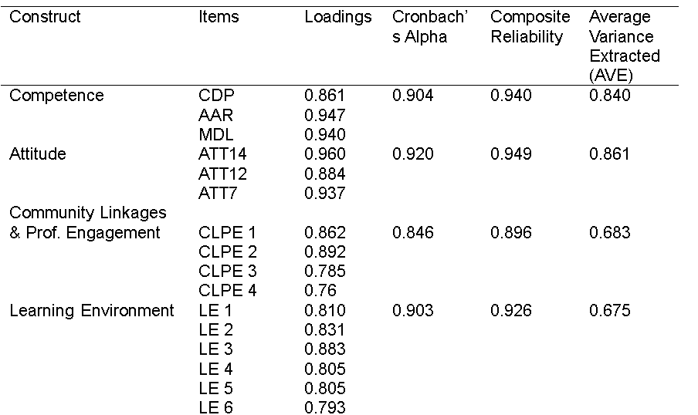
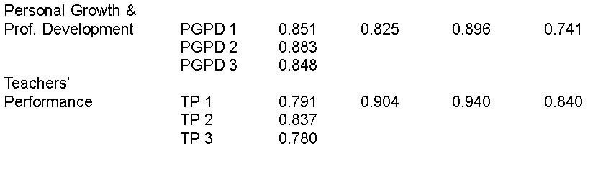
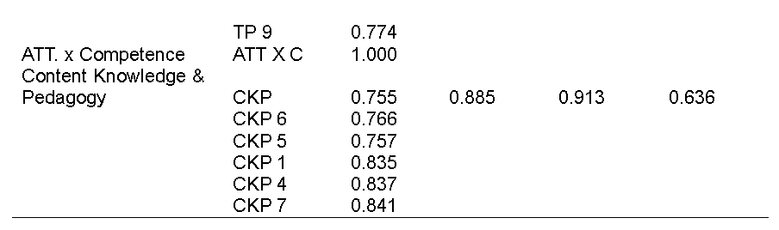

The Table 2 is statistical results presented in the table examine the relationships between key constructs in an educational framework, specifically focusing on teaching performance (TP) and its influencing factors. The findings indicate that attitude (ATT) has a significant positive impact on TP (0.341, p = 0.001), emphasizing the crucial role of a teacher’s mindset in shaping instructional effectiveness. Similarly, competence significantly contributes to TP (0.347, p = 0.004), reinforcing the importance of professional skills and knowledge in enhancing teaching outcomes. Interestingly, the interaction between attitude and competence negatively affects TP (-0.249, p = 0.037), suggesting a nuanced dynamic where certain attitudinal aspects may counteract competency-driven benefits. Furthermore, competence is shaped by multiple factors, with content knowledge (CKP) (0.234, p = 0.006), curriculum knowledge (CLP) (0.287, p = 0.000), learning environment (LE) (0.315, p = 0.000), and pedagogical knowledge (PGPD) (0.184, p = 0.023) all playing significant roles in developing a teacher’s expertise. These findings highlight the interconnected nature of competencies in education and underscore the need for a balanced approach that integrates both technical expertise and a conducive learning environment. By considering these insights, professional development efforts can be refined to enhance teaching performance effectively.
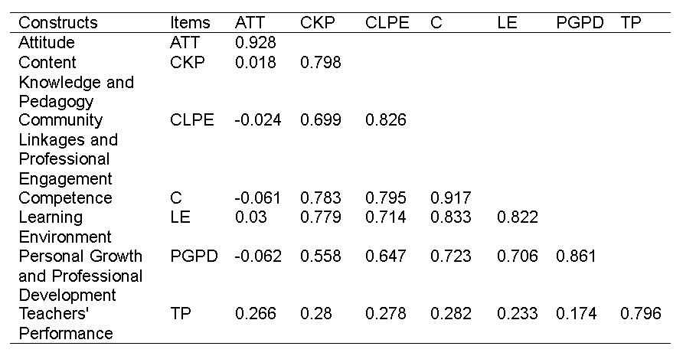
Table 3. Convergent Validity (Fornell-Larcker Criterion)

Table 3 presents the discriminant validity of various constructs using the Fornell-Larcker criterion, which assesses whether each construct is distinct from the others in a structural model. The diagonal values represent the square root of the average variance extracted (AVE), ensuring that each construct shares more variance with its indicators than with other constructs. The Attitude (ATT) construct demonstrates strong validity with a value of 0.928, indicating that it is well-defined within the study. Other constructs, such as Competence (0.917) and Personal Growth and Professional Development (PGPD) (0.861), also show solid discriminant validity, affirming their uniqueness within the framework. Meanwhile, Teachers' Performance (TP) holds a lower discriminant validity score (0.796), suggesting moderate but acceptable differentiation from related constructs. Notably, the correlation values between constructs indicate interconnected relationships, particularly between Content Knowledge and Pedagogy (CKP) and Community Linkages and Professional Engagement (CLP), which share relatively high correlations. These results suggest that while distinct, certain constructs are interrelated, reflecting their real-world overlap in educational contexts. Proper refinement and additional validation can further strengthen the model’s robustness.

Table 4. R-Square Overview
Variance | R-Square
Competence | 0.808
Teachers' Performance | 0.203

The table 5, it presents R-square (R²) values, which indicate how well the independent variables explain the variance in the dependent variables. The R-square value for "Competence" is 0.808, meaning it accounts for 80.8% of the variance, suggesting a strong predictive relationship. In contrast, "Teachers' Performance" has an R-square value of 0.203, meaning it explains only 20.3% of the variance, indicating a weaker predictive relationship. This suggests that "Competence" plays a more significant role in influencing outcomes compared to "Teachers' Performance." These insights are essential for evaluating the effectiveness of these variables in educational research, particularly in assessing how well competence aligns with expected teacher performance standards.

Structural Model
Table 5 presents the statistical results evaluating the relationships between various factors influencing teachers' performance (TP) and competence. The path coefficients indicate the strength and direction of each relationship, while the t-values and p-values determine statistical significance. Notably, all hypotheses were accepted, suggesting that the tested variables have significant predictive power. For instance, "Competence" positively influences TP with a path coefficient of 0.347, reinforcing its essential role in effective teaching. This aligns with findings by Wirawan et al. (2024), who reported a significant direct relationship between teacher competence and performance, with a path coefficient of 0.480 and a p-value of 0.004.

Table 5. Hypothesis Testing
Hypothesis | Relationship | Path Coefficient | T- values | P- values | Remark
H1 | ATT->TP | 0.341 | 3.225 | 0.001 | Accepted
H2 | ATT x Competence ->TP | -0.249 | 2.089 | 0.037 | Accepted
H3 | CKP->Competence | 0.234 | 2.732 | 0.006 | Accepted
H4 | CDP->Competence | 0.287 | 4.340 | 0.000 | Accepted
H5 | Competence->TP | 0.347 | 2.917 | 0.004 | Accepted
H6 | LE->Competence | 0.315 | 3.898 | 0.000 | Accepted
H7 | PGPD->Competence | 0.184 | 2.271 | 0.023 | Accepted

Additionally, the interaction between "Attitude" (ATT) and "Competence" negatively impacts TP, as seen in the path coefficient of -0.249, implying a moderating effect. This suggests that while positive attitudes enhance performance, they may also reduce reliance on competence alone, possibly compensating with enthusiasm and adaptability. Such dynamics are supported by studies emphasizing the complex interplay between teacher attitudes and performance outcomes.

Meanwhile, factors such as "Content Knowledge Pedagogy" (CKP), "Curriculum Development and Planning" (CDP), "Learning Environment" (LE), and "Personal Growth and Professional Development" (PGPD) all positively contribute to competence, highlighting their importance in shaping teachers' abilities. These findings are consistent with recent research underscoring the multifaceted nature of teacher competence and its impact on instructional quality.

Table 6. Mediating Effect
Pathway | Coefficient | t-values | p-value | Remarks
CKP->Competence->TP | 0.081 | 1.830 | 0.067 | Rejected
CLP->Competence->TP | 0.100 | 2.450 | 0.014 | Accepted
LE->Competence->TP | 0.110 | 2.428 | 0.015 | Accepted
PGPD->Competence->TP | 0.064 | 1.726 | 0.084 | Rejected

Table 6 statistical analysis examines how various factors indirectly influence teacher performance (TP) through competence, highlighting the significance of professional expertise in shaping instructional effectiveness. The CKP → Competence → TP pathway, with an effect size of 0.081, a T-statistic of 1.830, and a p-value of 0.067, suggests a marginally significant relationship. However, since the p-value exceeds the conventional threshold of 0.05, this hypothesis is rejected, aligning with recent studies that emphasize the necessity of stronger content knowledge proficiency for meaningful improvements in teaching effectiveness (Mafa-Theledi, 2024).

In contrast, the CLP → Competence → TP pathway demonstrates a more substantial indirect effect (0.100) with a T-statistic of 2.450 and a p-value of 0.014, indicating a statistically significant impact. As the p-value falls below 0.05, this hypothesis is accepted, reinforcing contemporary research on curriculum leadership, which highlights its role in enhancing teacher competency and student learning outcomes.

Similarly, the LE → Competence → TP relationship exhibits an indirect effect of 0.110, with a T-statistic of 2.428 and a p-value of 0.015, underscoring the importance of the learning environment in fostering professional growth. Given that the p-value is below 0.05, this hypothesis is accepted, consistent with studies emphasizing the role of structured learning environments in improving teacher effectiveness (Talafian et al., 2023)

Lastly, the PGPD → Competence → TP pathway shows an indirect effect of 0.064, with a T-statistic of 1.726 and a p-value of 0.084, indicating a weaker but still notable influence. Since the p-value exceeds 0.05, this hypothesis is rejected, reflecting recent literature that highlights the importance of professional growth and personal development in sustaining long-term instructional quality (Zhang & Wong, 2021). These findings collectively illustrate the interconnected nature of competence and teacher performance, reinforcing the need for targeted interventions to enhance professional effectiveness.

Implications
The findings of this study emphasize the critical role of teacher competence in shaping instructional effectiveness and overall performance. The significant impact of curriculum leadership and the learning environment on competence suggests that structured pedagogical planning and a supportive educational atmosphere are essential for professional growth (Hermoso & Brobo, 2023). Additionally, the moderating effect of attitude on competence and performance underscores the need for targeted interventions that balance technical expertise with positive behavioral dispositions. These insights reinforce the necessity of continuous professional development programs that integrate competency-building strategies with mindset enhancement to optimize teaching outcomes (Yayuk & Haqqi, 2024).
Furthermore, the study highlights the interconnected nature of teacher competencies, demonstrating that content knowledge, curriculum planning, and professional development collectively contribute to instructional effectiveness. The strong predictive relationship between competence and teacher performance suggests that refining competency-based training models can lead to sustained improvements in educational quality (Pamon & Oco, 2024) The findings also indicate that while professional growth and development play a role in shaping competence, their indirect effect on performance is relatively weaker, suggesting that additional support mechanisms may be necessary to maximize their impact.
Lastly, the PGPD → Competence → TP pathway shows an indirect effect of 0.064, with a T-statistic of 1.726 and a p-value of 0.084, indicating a weaker but still notable influence. Since the p-value exceeds 0.05, this hypothesis is rejected, reflecting recent literature that highlights the importance of professional growth and personal development in sustaining long-term instructional quality. These findings collectively illustrate the interconnected nature of competence and teacher performance, reinforcing the need for targeted interventions to enhance professional effectiveness.
Conclusions
This study affirms that teacher competence, particularly in key domains identified in the Philippine Professional Standards for Teachers (PPST), significantly influences teaching performance. The findings reveal that Content Knowledge and Pedagogy, Curriculum and Planning, Learning Environment, and Personal Growth and Professional Development each play a distinct role in shaping overall competence, which subsequently predicts teaching effectiveness. These results are consistent with recent investigations highlighting the direct relationship between standards-based competencies and teacher output.

Furthermore, the role of teacher attitudes as a moderating variable demonstrates the complexity of professional behavior. Teachers with more favorable attitudes toward continuous improvement and reflective practice tend to exhibit stronger teaching performance, corroborating research that emphasizes the affective dimension of teacher quality (Siahaan, E. (2020).

In light of the predictive associations identified in this study, educational institutions should invest in structured, needs-based, and attitude-sensitive professional development programs. Doing so will not only address current gaps in teacher competency but also cultivate a culture of lifelong learning that supports school improvement. This aligns with the broader goals of the Department of Education in enhancing instructional quality across diverse school contexts.

Finally, this research contributes to the growing body of literature advocating for a holistic approach to teacher development—one that integrates cognitive, behavioral, and affective domains to produce high-quality instruction that positively impacts student outcomes.

REFERENCES

Anwar, S. (2023). The Influence of Teacher Professional Competence on Education Quality Through Infrastructure as an Intervening Variable. Tafkir: Interdisciplinary Journal of Islamic Education. https://pasca.jurnalikhac.ac.id/index.php/tijie/article/view/269.

Barni, D., Danioni, F., & Benevene, P. (2020). Teachers’ self-efficacy: The role of personal values and motivations for teaching. Frontiers in Psychology, 10, 1645.

Cabradilla, M. T. (2025). Teachers’ Competency Based on the Philippine Professional Standards for Teachers I-III: Basis for a Training Program. International Journal of Multidisciplinary Research and Analysis, 8(4). https://doi.org/10.47191/ijmra/v8-i04-64IJMRA

Canuto, P. P. L., Choycawen, M., & Pagdawan, R. (2024). The influence of teaching competencies on teachers' performance and students' academic achievement in primary science education. Problems of Education in the 21st Century, 82(1), 29–47. https://doi.org/10.33225/pec/24.82.29.

Department of Education [DepEd]. (2019). Philippine Professional Standards for Teachers (PPST): A framework for quality teaching. https://www.deped.gov.ph.

Estrada, M. J. A., & Gumban, J. L. (2024). School head’s competence and teacher’s performance in the light of Philippine Professional Standards for Teachers. International Journal of Research and Innovation in Social Science, 8(3), 3256–3263. https://dx.doi.org/10.47772/IJRISS.2024.803232S.

EUDL. (2019). The Effect of Pedagogical Competence, Attitude Towards Profession And Motivation on Teachers Performance. EAI Endorsed Transactions on e-Learning. https://eudl.eu/doi/10.4108/eai.21-11-2018.2282241.

Evangelio, M. M. C., & Escote, M. J. V. (2024). Teacher competence and performances of beginning and seasoned teachers: A comparative study. International Journal of Research and Innovation in Applied Science, 9(7), 633–646. https://doi.org/10.51584/IJRIAS.2024.907053.

Gao, J., & Liu, L. (2021). Teacher attitudes and instructional performance: The mediating role of psychological capital. Teaching and Teacher Education, 105, 103428. https://doi.org/10.1016/j.tate.2021.103428.

Gepila Jr., E. C. (2020). Assessing Teachers Using Philippine Standards for Teachers. Universal Journal of Educational Research, 8(3), 739–746. https://www.researchgate.net/publication/340697970_Assessing_Teachers_Using_Philippine_Standards_for_TeachersScribd+2ResearchGate+2SciePub+2.

Hermoso, J. R., & Brobo, M. A. (2023). Influence of teaching competencies to performance: Basis for professional development. Asian Journal of Education and Social Studies, 44(4), 33–46. https://doi.org/10.9734/ajess/2023/v44i4969.

Jorilla, C. D., & Bual, J. M. (2021). Assessing the Teachers’ Competence in Diocesan Catholic Schools Relative to the Philippine Professional Standards for Teachers. Philippine Social Science Journal, 4(2), 71–79. https://doi.org/10.52006/main.v4i2.343Philippine Social Science Journal+2Philippine Social Science Journal+2Philippine Social Science Journal+2

Mafa-Theledi, O. (2024). Teachers’ Pedagogical Content Knowledge and Subject Matter Content Knowledge: Is the Framework Still Relevant in Teaching of STEM. International Journal of Research and Innovation in Social Science, 8(4), 836–846.

Mahulae, A. V., Lumbanraja, P., & Siahaan, E. (2020). Effect of Professionalism and Competence of Teachers on Teacher Performance and Its Impact on Student Learning Outcomes at Harapan Mandiri College. International Journal of Research and Review, 7(11), 38–46. https://www.researchgate.net/publication/351424484_Effect_of_Professionalism_and_Competence_of_Teachers_on_Teacher_Performance_and_Its_Impact_on_Student_Learning_Outcomes_at_Harapan_Mandiri_College.

Malunes, R. E., & Dioso, D. P. D. (2020). Teaching Competence of Public School Teachers in the Light of the Philippine Professional Standards for Teachers. Philippine Social Science Journal, 3(2), 43–44. https://doi.org/10.52006/main.v3i2.179Philippine Social Science Journal.
Mantos, M. A. P., Anor, N. L., Binoya, M. B., Bontia, D. M. R., Lawas, P. J. M., Obejero, C. B., Patiga, C. L. S., & Quinco-Cadosales, M. N. (2025). Teachers’ continuing professional development based on the Philippine Professional Standards for Teachers. International Journal of Social Science and Humanities Research, 8(5). https://doi.org/10.47191/ijsshr/v8-i5-28.

Navarro, R. C. S., & Lumabi, M. T. L. (2022). Competence and commitment of teachers in relation to their performance. International Journal of Educational Management and Development Studies, 3(1), 1–18.

Pamon, E. Q., & Oco, R. M. (2024). Teachers’ competence and learners’ academic performance. International Journal of Multidisciplinary Research and Analysis, 7(3). https://doi.org/10.47191/ijmra/v7-i03-63.

Pillay, H., & Tan, L. S. (2021). Teacher identity and the influence of psychological and organizational factors on professional development. Asia Pacific Journal of Education, 41(4), 607–624.
Satur, C. D., Labadan, C. B., Elbanbuena, C. O., & Comon, J. D. (2025). Teaching-learning skills on teachers’ performance: Basis for Learning Action Cell training design. American Journal of Arts and Human Science, 4(2). https://doi.org/10.54536/ajahs.v4i2.4231.

Siahaan, E. (2020). The Impact of Teachers’ Personality Competence and Students’ Attitudes on the Quality of Learning. Journal Emerging Technologies in Education. https://journal.ypidathu.or.id/index.php/jete/article/view/1502.

Talafian, H., Lundsgaard, M., Mahmood, M., Shafer, D., Stelzer, T., & Kuo, E. (2023). Responsive Professional Development: A Facilitation Approach for Teachers' Development in a Physics Teaching Community of Practice. arXiv preprint arXiv:2310.11375.

Wahyuni, S., & Hasanah, U. (2022). Exploring the moderating effects of teacher attitudes on competence and performance. International Journal of Instruction, 15(4), 467–482.
Yayuk, E., & Haqqi, Y. A. (2023). Maximizing teacher competence and performance: The influential factors across individuals, organizations, leadership, and environment – A comprehensive systematic review and model. AL-ISHLAH: Jurnal Pendidikan, 15(1), 1–12. https://journal.staihubbulwathan.id/index.php/alishlah/article/view/4408.

Zhang, X., & Wong, M. (2021). Exploring the Effects of Professional Learning Experiences on In-Service Teachers’ Growth: A Systematic Review of Literature. Education Sciences, 11(2), 146.

