Concurrent Validation and Statistical Analysis of Novel Bi-layer Floating Tablet of Sucralfate and Metoprolol succinate
Dr .Sreedhar Ranjan Das^{1*}, Dr Santosh Kumar Bala² , Dr kalakar Bala³ _{Somya Ranjan Sahoo}
2- Professor and Principal, Sontoshi institute of Pharmaceutical sciences, , Cuttack., Odisha
3-Associate Proffessor , Pharmacy wing, SCB Medical college , Cuttack
4- Associate Professor, Sontoshi institute of Pharmaceutical sciences, , Cuttack., Odisha
*Corresponding Author:¹
Dr.Sreedhar Ranjan Das
Professor,
Sontoshi institute of Pharmaceutical sciences,
Manguli, Cuttack., Odisha, India
Email ID:sreedhardas2009@gmail.com

Abstract:
The research work is based on validation and statistical analysis of Bilayer Floating Tablet containing bilayer floating tablet of Sucralfate and Metoprolol Succinate .First the initially formulated and evaluated Bi layer floating tablet of Sucralfate and Metoprolol succinate (DSFMS). We performed the stability study as per the ICH guideline. Then evaluation of the tablets according to Concurrent validation process. Then final resultant value compared with the initial resultant values and checked the equivalency with the acceptance criteria of Bilayer Floating Tablet. Then statistical analysis were done by calculating mean deviation and standard aviation. Then compared statistical parameters a over limit or under limit.
After stability study and Concurrent validation of (DSFMS) it is confirmed that the formulation fulfill all the acceptance criteria of Bilayer floating tablet . It is confirmed that the formulation (DSFMS) satisfying all acceptance criteria of Bilayer floating tablet. The statistical parameters are under limit.
Keyword:
Ulcer protective, Sucralfate, Antihypertensive, Metoprolol Succinate, Bilayer floating tablet
Introduction:
During pregnancy antacid is a common problem. Hypertension ² causes complications in pregnancy.
Ulcer protective Sucralfate ⁴ is used in treatment both Duodenal and Gastric ulcer.
Metoprolol Succinate⁵ is used in treatment of hypertension.
Between Sucralfate and MetoprololSuccinate having minor drug interaction. ^{6.}
Concurrent validation is defined as the process of detecting the steps of manufacturing . ¹⁰ Statistical analysis ¹¹is the collection and interpretation of data in order to uncover patterns and trends.
The present study focusing on Concurrent validation and statistical analysis of of the Bilayer floating tablet .

Material and Methods:
Selection of the initially prepared Bi Layer Floating Tablet of formulation (DSFMS)
Table-1:
Composition of the selected formulation of Sucralfate and Metoprolol Succinate.(DSFMS)
SL NO | INGREDIENTS | QUANTITY  PER TABLET (MG) | INGREDIENTS | QUANTITY PER TABLET (MG)
1 | SUCRALFATE | 100mg | METOPROLOL SUCCINATE | 50mg
2 | CROSS POVIDONE | 7mg | HPMC K 100 | 25mg
3 | AEROSIL | 1mg | SODIUMBICARBONATE | 15mg
4 | LACTOSE MFL | 31.250mg | AEROSIL | 3mg
5 | MCC PH101 | 43.5750mg | EUDRAGIT-RSPO | 20mg
6 | SODIUM BICARBONATE | 15mg | EUDRAGIT-RLPO | 7.50mg
7 | POLYSORBATE 80 | 7mg | EUDRAGIT-RS100 | 5mg
8 | HPC-1 | 5mg | NA CMC | 17.50mg
9 | MAGNESIUM STEARATE | 3.750mg | SODIUM ALGINATE | 15mg
10 ( | SUNSETYELLOW ( 0.25%) | 0.31250mg | HPC | 12.50mg
11 | PURIFIED WATER | qs | ETHYL CELLULOSE | 10mg
 | TOTAL WEIGHT | 214mg | PVPK -90 | 2.5mg
12 |  | TALC | 3
13 |  | IPA | Quantity sufficient
14 |  | PURIFIED WATER | Quantity sufficient
15 |  | TOTAL WEIGHT | 186mg

Stability Study ¹²
Stability study is method of determining existence of the drug product at particular temperature and humidity condition as per the ICH guideline.

Comparison Study
The present resultant values of stability studies compared with compared the initial resultant values the specification of acceptance criteria.

Determination of floating lag time
Single tablet is taken from the prepared formulation (DSFMS). It is put into the 200 ml beaker containing Ph 1.2. solution. The time required to start floating of the tablet is determined.

Determination of total floating time
A single tablet is taken from the prepared formulation. (DSFMS) . It is put into the 200ml beaker containing solution of Ph 1.2. Then the time of existence of the tablet is observed.

Statistical analysis
10 tablets the formulation (DSFMS) are taken. Floating lag time is tested of each tablet..
Then the time is noted.

Statistical analysis.
10 tablets of the formulation (DSFMS) are taken. Total Floating Time is tested of each tablet.
Then the time is noted and the mean deviation and standard deviations are calculated.

Result:
Stability study:

Table-2: Evaluated parameters.
1 | Average weight (mg) | 402 | 403 | 390-410
2 | Friability. | 0.20 | 0.191 | less than 1
3 | Hardness. | 3.10 | 3.61 | 4-6kg/cm²
4 | Drug content (%)
4 | Sucralfate | 91.960 | 100.05 | 94%-102%
4 | Metoprolol Succinate | 98.760 | 96.90 | 91%-102%

Statistical analysis
Table-03: Statistical parameters of of Bilayer Floating tablet (DSFMS)
Sl No | (Floating Lag Time) in Second | (x-µ)
1 | 26 | -1.8
2 | 28 | 0.2
3 | 29 | 1.2
4 | 27 | -0.8
5 | 28 | 0.2
6 | 29 | 1.2
7 | 27 | -0.2
8 | 28 | 0.2
9 | 27 | -0.2
10 | 29 | 1.2
n=10 | ∑x= 278 | ∑(x-µ) =1.2

Calculation of Mean deviation and standard deviation of Floating Lag Time

- µ=∑x/n =278/10=27.8

- ∑( x-µ)=1.2
- Mean Deviation =
∑(x-µ)/µ

- Mean Deviation = 1.2/27.8=0.043 =less than 1
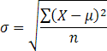
- Standard deviation=

    - ( x-µ)² =1.44

- Standard Deviation = √ 1.44/10 = √0.144=0.379
- less than 1

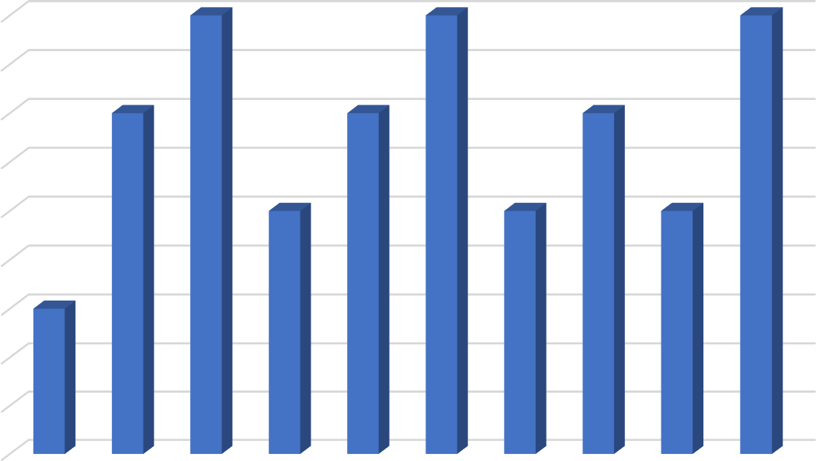

29

28.5

28

27.5

27

26.5

26

25.5

25

24.5
10
Figure-1: Statistical graph of (FLT) of (DSFMS).
Table-4: Statistical parameters of (F.L.T) of (DSFMS)

SL No | x ( Floating Lag Time) in hours | ( x-µ)
1 | 18.13 | 0.005
2 | 18.15 | 0.015
3 | 18.13 | 0.005
4 | 18.15 | 0.015
5 | 18.13 | 0.005
6 | 18.10 | -0.029
7 | 18.15 | 0.015
8 | 18.13 | 0.005
9 | 18.15 | 0.015
10 | 18.13 | 0.005
n=10 | ∑x= 181.35 | ∑( x-µ)=0.056

- µ=∑x/n =181.35/10=18.135
    - ∑( x-µ)=0.056
∑( x-µ)/µ
- Mean Deviation =

- Mean Deviation = 0.056/18.135= 0.003= less than 1

- Standard deviation=

- ( x-µ)² =0.003136
- Standard Deviation= √ 0.003136/10 = √0.003136 = 0.017
- less than 1

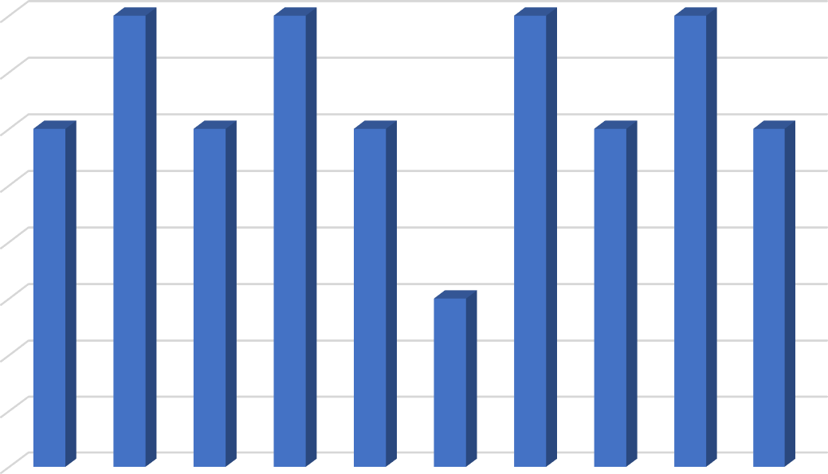

18.15

18.14

18.13

18.12

18.11

18.1

18.09

18.08

18.07
10

Fig:2-Statitical graph of (TFT) of 10 tablets of (DSFMS)

Conclusion:
The comparison between present resultant values of stability studies and the initial resultant values shows better equivalency and it fulfill all the acceptance criteria of Bilayer floating tablet.
The Floating lag time (FLT) is produced as 25 second and total Floating Time TFT is more than 18 hours after 90 days of stability study.
The analytical deviation of all parameters remain less than 1. The statistical values are under limit.
The drug content of Sucralfate is 99.23% and Metoprolol Succinate is 100.06%.
So the Bi layered Floating Tablet (DSFMS) can be determined as an acceptable formulation as Gastro Retentive Drug Delivery System.

Reference
- Kaushik.H, Stomach Ulcer During Pregnancy - Causes, Symptoms, Diagnosis & Treatment Publication available at: https://www.momjunction.com/articles/peptic-ulcerduring- pregnancy_00372291/[ Accessed March 27, 2019]
2-Berg CJ, Henderson Z ,Callaghan WM, Severson C. Mortality related in Pregnancy in the UnitedStates. Obstetric Gynecology, 2010 ;116(6):1302–1309. doi: 10.1097/AOG.0b013e3181fdfb11
3. Ayala DE, Hermida RC. Monitoring of Early Identification of Hypertension in Pregnancy. Chronobiol Int. 2012; Sep 24. DOI: 10.3109/07420528.2012.714687.
4-Tripathy KD, Essential of Medical Pharmacology. Fifth edition, New Delhi, India: Jaypee brothers’ medical publishers ltd; Page-596.
5-Metoprolol Succinate, Medically reviewed by Drugs.com. Avilable at: https:// www.drugs.com. [Accessed February 25, 2019]
6-Drug-Drug Interactions . Medically reviewed by Edward Flynn New Jersey Medical School, Newark, US. AvailableEhttps://www.sciencedirect.com/sdfe/pdf/download/eid/3-s2.0- B9780080552323600376/first-page-pdf. [ Accessed April , 2007]
7-Das SR, Panigrahi BB, Pani M. Development of Bi layered floating tablet of Sucralfate and Metoprolol succinate. Int. J. Adv. Res 2019; 7(5), 832-849, DOI:10.21474/IJAR01/9105.
8-Arora S, Ali J , Ahuja A, Khar R.K, Mabota S. Floating Drug Delivery System ; A review. AAPS Pharma Science tech .2005;3: E 372-89 . DOI:10.21474/IJAR01/9105.
9-Das SR, Panigrahi BB, Pani M. Development of s of Bi- layered Floating tablet of Sucralfate and Metoprolol succinate. Int. J. Adv. Res.2019; 7(5), 890-896 DOI: 10.21474/IJAR01/9111
10-Four Types of Validation Used In The Life Sciences https://learnaboutgmp.com/good-validation-practices/the-four-types-of-validation-used-in-the-life-sciences/
11-Statistical analysis :https://whatis.techtarget.com/definition/statistical-analysis September 2020
12-Stability testing of active pharmaceutical ingredients and finished pharmaceutical products (ms) , Availablehttp://www.who.int/medicines/areas/quality_safety/quality_assurance/regulatory_standards/en/.[ Accessed January 2017]

Conflict of Interest:
The author declare that there is no conflict of interest regarding the publication of the paper.

