Ectopic Thyroid Tissue Presenting as Thoracic Extradural Cystic Lesion in a Child: A Rare Case Report
Abstract
Ectopic thyroid tissue is a rare developmental anomaly resulting from aberrant migration of the thyroid gland during embryogenesis. Although ectopic thyroid tissue is most commonly identified in the lingual region, it may rarely occur at distant anatomical sites. We report a rare case ectopic thyroid tissue presenting as a thoracic extradural cystic lesion in a 12-year-old girl.
The patient presented with progressive difficulty in walking, bilateral lower limb weakness, and stool incontinence of one month's duration. Magnetic resonance imaging revealed a loculated extradural cystic lesion extending from D2 to D8 vertebral levels, causing significant spinal cord compression and radiologically suggestive of an arachnoid cyst. The patient underwent D3–D7 laminectomy and excision of the lesion. Histopathological examination demonstrated thyroid tissue composed of colloid-filled follicles. Immunohistochemistry showed strong positivity for thyroid transcription factor-1 (TTF-1) and thyroglobulin, with focal cytoplasmic,membranous positivity for CK19 and CD56 and reduced galectin expression , supporting the diagnosis of ectopic thyroid.
Extensive evaluation to identify a primary thyroid malignancy, including thyroid function tests, ultrasonography, contrast-enhanced computed tomography of the neck, positron emission tomography-computed tomography, and subsequent thyroidectomy, to rule out any malignancy within the orthotopic thyroid gland. The patient showed neurological improvement following surgical decompression.
This case highlights an exceptionally rare presentation of ectopic thyroid n a pediatric patient and underscores the importance of histopathological examination and immunohistochemistry in establishing the diagnosis of unusual spinal lesions.
Keywords: Ectopic thyroid tissue; Thoracic extradural lesion; Spinal cord compression; Immunohistochemistry.

Introduction
Ectopic thyroid tissue is a rare developmental anomaly resulting from aberrant embryological migration of the thyroid gland from the foramen cecum to its normal pretracheal position. The reported prevalence is approximately 1 per 100,000–300,000 individuals, with most cases occurring in the lingual region. Ectopic thyroid tissue may occasionally be found in unusual locations such as the mediastinum, heart, lungs, gastrointestinal tract, and spinal region. challenge, particularly when located at distant sites and in the absence of any lesion within the orthotopic thyroid gland. Spinal involvement is exceptionally rare, especially in children, and may mimic more common benign lesions radiologically. Establishing the diagnosis requires careful correlation of histopathological findings, immunohistochemistry, and comprehensive evaluation to exclude any metastatic disease from a primary thyroid carcinoma.
We report a rare case of ectopic thyroid tissue presenting as a thoracic extradural cystic lesion in a 12-year-old girl with progressive paraparesis. The lesion was initially diagnosed radiologically as an arachnoid cyst, highlighting the diagnostic complexity and the importance of considering ectopic thyroid tissue in the differential diagnosis of unusual spinal lesions.
Case Presentation
Clinical History
A 12-year-old female presented with progressive difficulty in walking and weakness of both lower limbs for one month. The weakness was insidious in onset and gradually progressive. There was associated stool incontinence. There was no history of trauma, fever, constitutional symptoms, neck swelling, dysphagia, hoarseness of voice, or symptoms suggestive of thyroid dysfunction.
Neurological examination revealed spastic paraparesis involving both lower limbs with exaggerated deep tendon reflexes. Sensory examination was unremarkable. No cervical lymphadenopathy or palpable thyroid swelling was identified.
Radiological Findings
Magnetic resonance imaging (MRI) of the thoracic spine demonstrated a loculated extradural cystic lesion extending from D2 to D8 vertebral levels in the posterior spinal canal. The lesion caused compression and anterior displacement of the spinal cord. Multiple septations were present within the lesion. Based on the radiological appearance, a provisional diagnosis of arachnoid cyst was considered.
Because of progressive neurological deficits and cord compression, surgical excision was planned.
Surgical Findings
The patient underwent D3–D7 laminectomy with excision of the cystic lesion.
Intraoperatively, a multiloculated extradural cystic lesion extending from D3 to D8 vertebral levels was identified. The lesion contained clear fluid and showed multiple septations with lateral gutter extensions. An exophytic solid component was noted and submitted separately for histopathological examination.
Histopathological Examination
Gross Examination
The specimen received consisted of multiple grey-white to grey-brown soft tissue fragments admixed with cyst wall tissue. Representative sections were processed routinely and stained with hematoxylin and eosin.
Microscopic Examination
Histological sections revealed thyroid tissue composed of variably sized follicles filled with eosinophilic colloid. Intervening stroma was fibrovascular.
The presence of benign thyroid tissue favours ectopic thyroid tissue rather than metastatic disease.
Immunohistochemical Findings
To determine the lineage of the tumor and confirm the diagnosis, immunohistochemical studies were performed.
The neoplastic cells demonstrated:
Marker | Result | Interpretation
TTF-1 | Strong nuclear positivity | Thyroid follicular epithelial origin
Thyroglobulin | Diffuse cytoplasmic positivity | Confirms thyroid differentiation
CK19 | Focal positivity | Supports benign thyroid lesion
Galectin-3 | Negative | Supports benign thyroid lesion.
CD56 | Diffuse membranous staining | Characteristic of benign thyroid lesion.
The immunophenotypic profile confirmed thyroid origin .
Pathological Differential Diagnosis
Several differential diagnoses were considered.
Metastatic Papillary Thyroid Carcinoma
This was the most important differential diagnosis because papillary thyroid carcinoma commonly metastasizes to distant sites. However, extensive clinicoradiological evaluation failed to demonstrate any primary lesion within the thyroid gland.
Benign Ectopic Thyroid Tissue
The presence of characteristic papillary architecture together with classical nuclear features and supportive immunohistochemistry excluded a benign ectopic thyroid rest.
Metastatic Follicular Thyroid Carcinoma
The absence of a predominant follicular growth pattern, together with the presence of classical papillary nuclear features and CK19/Galectin-3 positivity, ruled out follicular carcinoma.
Evaluation of Orthotopic Thyroid Gland
To exclude the possibility of an occult primary thyroid malignancy, comprehensive investigations were undertaken.
Thyroid Function Tests
The patient was euthyroid with normal thyroid function tests.
Ultrasonography
Ultrasonography of the neck demonstrated a normally located thyroid gland without nodules, suspicious calcifications, or abnormal cervical lymph nodes.
Contrast-Enhanced CT Neck
CT examination revealed a normal thyroid gland within the thyroid bed and no evidence of cervical lymphadenopathy or ectopic thyroid tissue.
PET-CT Scan
Whole-body FDG PET-CT showed postoperative changes in the thoracic spine but no metabolically active lesion in the thyroid gland or elsewhere in the body. No FDG-avid cervical lymphadenopathy or distant metastasis was identified.
Final Pathological Diagnosis
Based on the characteristic histomorphological features, thyroid-specific immunohistochemical marker expression, absence of malignancy within the orthotopic thyroid gland, and negative metastatic workup, a diagnosis of:
Ectopic Thyroid Tissue Presenting as a Thoracic Extradural Cystic Lesion
was rendered.
Follow-Up
The patient showed neurological improvement following surgical decompression. Subsequent thyroidectomy performed to exclude any primary thyroid carcinoma revealed no evidence of malignancy, further supporting the diagnosis of ectopic thyroid tissue.

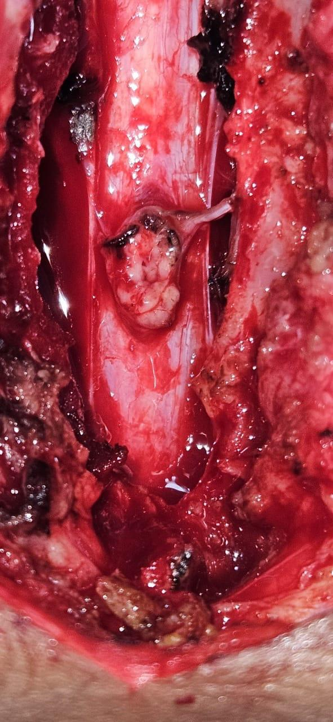
Figure 1. Intraoperative photograph of the thoracic extradural lesion
Intraoperative image showing a well-circumscribed nodular lesion arising within the thoracic extradural compartment following laminectomy. The lesion was associated with a cystic cavity and appeared attached to the surrounding dura, correlating with the radiologically suspected arachnoid cyst.

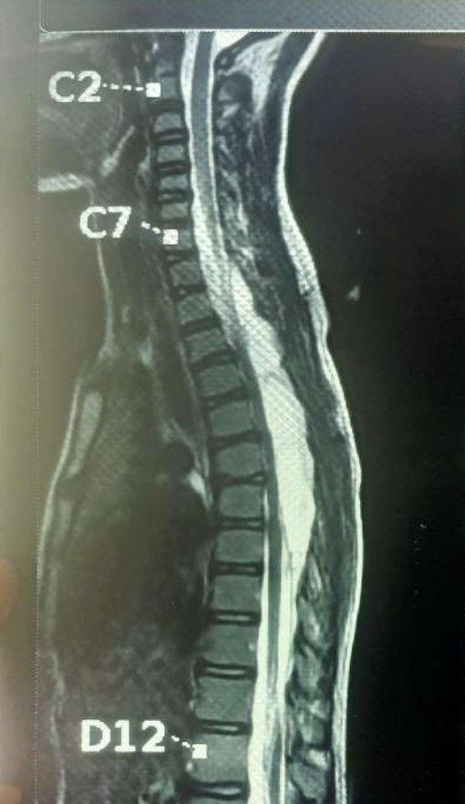
Figure 2. Magnetic resonance imaging of the thoracic spine
Sagittal T2-weighted magnetic resonance image demonstrating a large loculated extradural cystic lesion extending from D2 to D8 vertebral levels in the posterior spinal canal, causing significant anterior displacement and compression of the thoracic spinal cord. The lesion was radiologically interpreted as an arachnoid cyst.
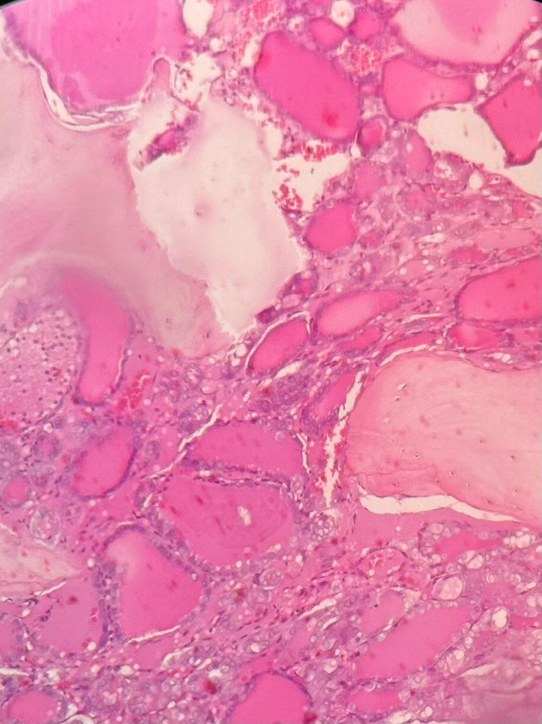
Figure 3 Histopathological Examination (H&E, ×100)
Legend:
Photomicrograph showing thyroid tissue composed of variably sized colloid-filled follicles lined by follicular epithelium and separated by fibrovascular stroma, consistent with ectopic thyroid tissue
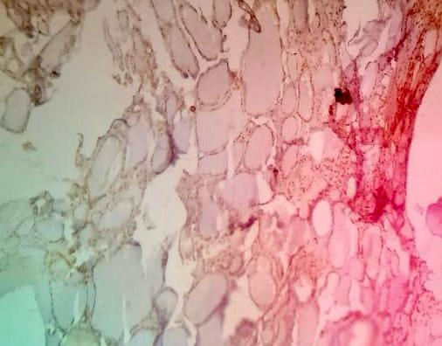
Figure 4. Immunohistochemical staining for TTF-1 (IHC, ×200)
Tumor cells showing strong nuclear positivity for thyroid transcription factor-1 (TTF-1), confirming thyroid follicular epithelial origin and supporting the diagnosis of a thyroid-derived neoplasm.

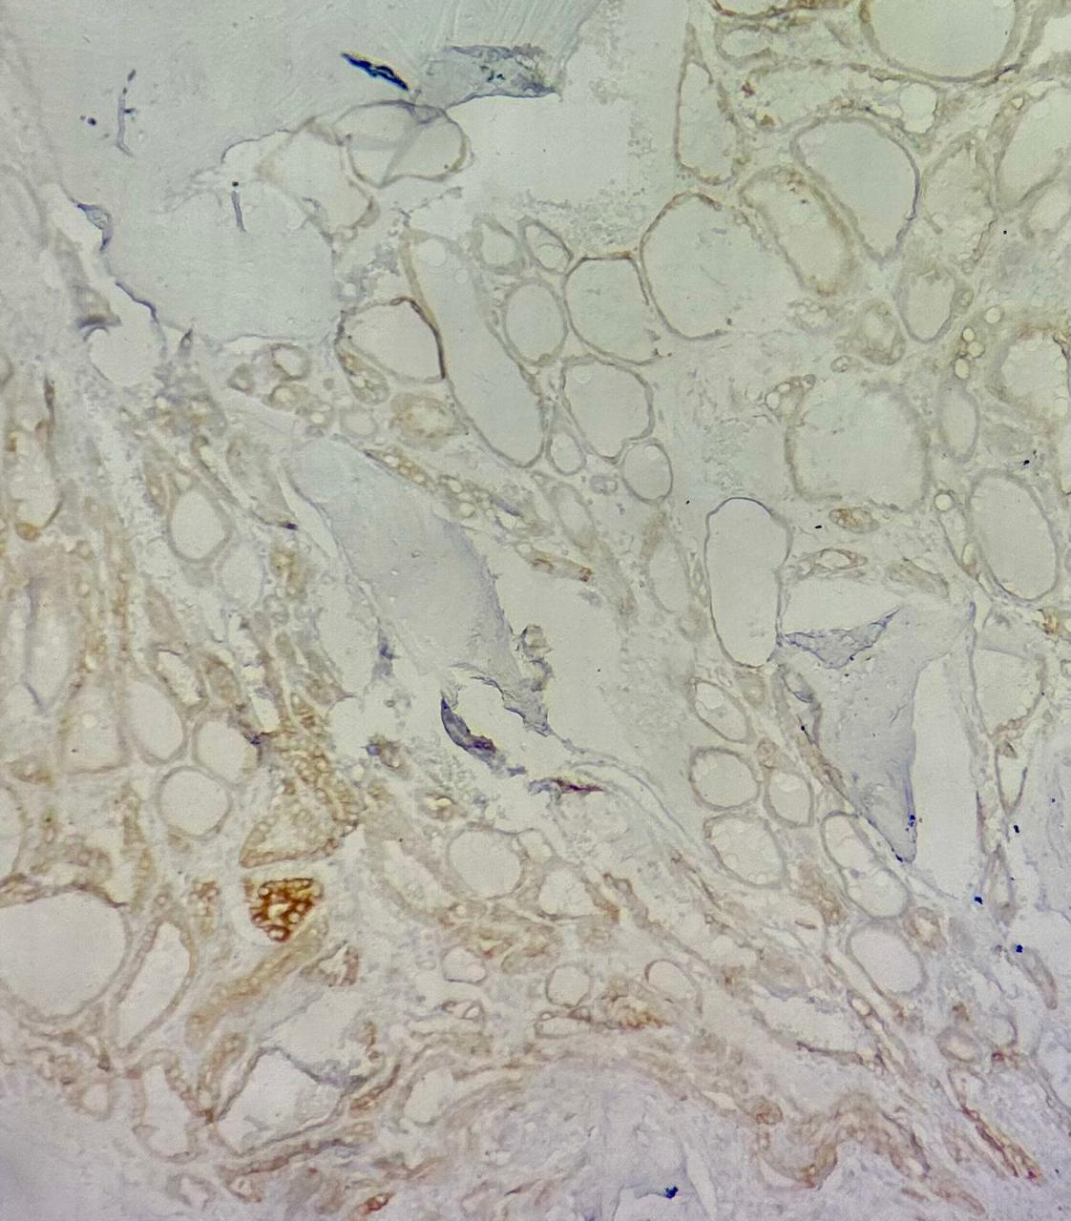
Figure 5. Immunohistochemical staining for CK19 (IHC, ×200)
Tumor cells showing focal membranous and cytoplasmic positivity for Cytokeratin 19 (CK19), supporting the diagnosis of ectopic thyroid.CK19 expression is characteristically increased in papillary thyroid carcinoma and aids in distinguishing it from benign thyroid follicles.

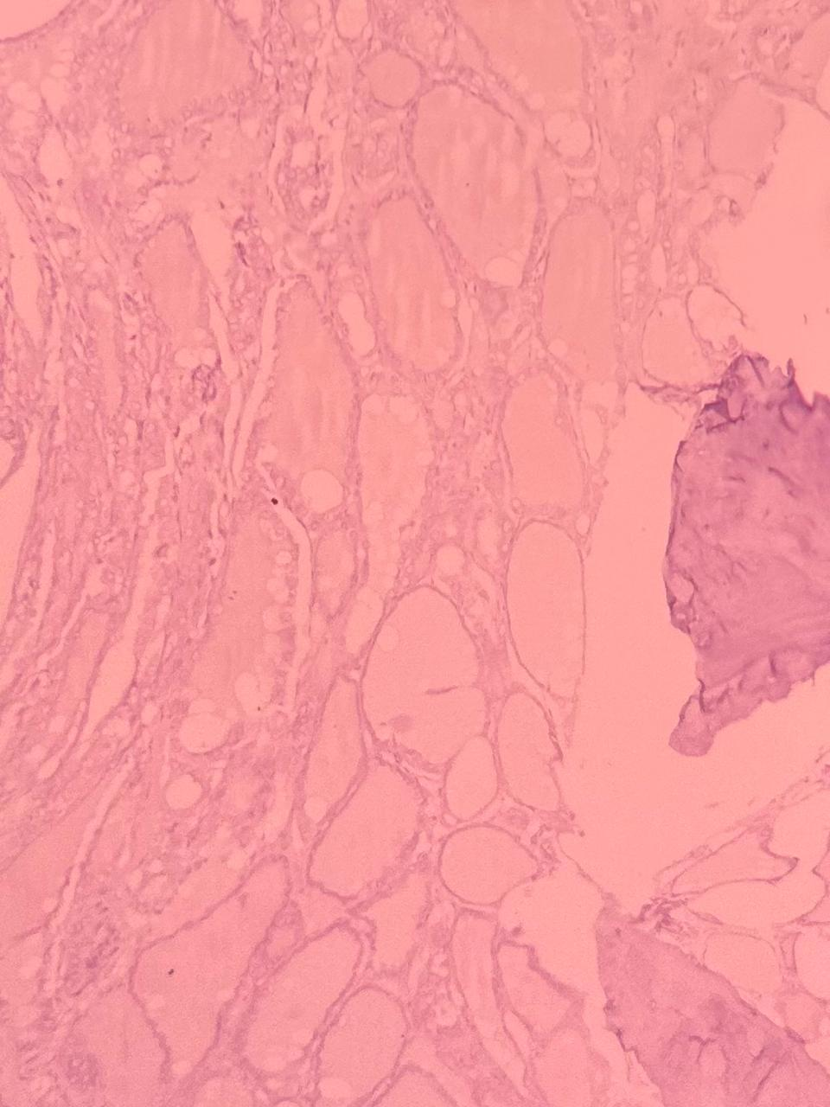
Figure 8. Immunohistochemical staining for CD56 (IHC, ×200)
Tumor cells show loss of CD56 expression (negative staining), while residual non-neoplastic thyroid follicles demonstrate retained membranous positivity. Loss of CD56 expression supports the diagnosis of papillary thyroid carcinoma.

Discussion
Ectopic thyroid tissue is an uncommon developmental anomaly caused by aberrant migration of the thyroid anlage during embryogenesis. Although ectopic thyroid tissue is most frequently encountered in the lingual region, malignant transformation remains rare. Fu et al. [1] reviewed the available literature and noted that papillary thyroid carcinoma is the most common malignancy arising in ectopic thyroid tissue. Similar to their observations, our patient demonstrated papillary thyroid carcinoma arising within ectopic thyroid tissue; however, the lesion occurred at an exceptionally rare thoracic extradural location.
The present patient was a 12-year-old female who presented with progressive paraparesis of one month's duration. MRI demonstrated a loculated extradural cystic lesion extending from D2 to D8 vertebral levels causing spinal cord compression. Radiologically, the lesion was interpreted as an arachnoid cyst. This differs from the cases described by Fu et al. [1], where most patients presented with a localized mass at the ectopic site. In our case, neurological manifestations secondary to cord compression dominated the clinical presentation.
Alzahrani et al. [2] reported an adult patient with primary intrathoracic ectopic papillary thyroid carcinoma associated with thoracic spinal involvement. Although both cases involved the thoracic region, important differences exist. Their patient was an adult and had intrathoracic disease with spinal extension, whereas our patient was a child with a primary thoracic extradural lesion extending from D2 to D8. Furthermore, no primary thyroid malignancy was identified in our patient despite extensive evaluation.
Hernández-Utrera et al. [3] emphasized the importance of histopathological examination in establishing the diagnosis of ectopic papillary thyroid carcinoma. Similar findings were observed in the present case. Histological examination demonstrated colloid-filled thyroid follicles admixed with papillary proliferations showing nuclear enlargement, overlapping, chromatin clearing, and nuclear grooves. The identification of benign thyroid follicles adjacent to malignant papillary structures strongly supported malignant transformation within ectopic thyroid tissue.
Li et al. [4] reported ectopic thyroid carcinoma occurring in the central airway despite the presence of a normally located thyroid gland. Likewise, our patient had a normal orthotopic thyroid gland on ultrasonography and contrast-enhanced CT of the neck. Thyroid function tests were within normal limits, and PET-CT revealed no FDG-avid lesion within the thyroid gland or elsewhere. These findings significantly strengthened the diagnosis of primary ectopic thyroid carcinoma.
The pediatric occurrence of ectopic papillary thyroid carcinoma is particularly uncommon. Kremer et al. [5] described a 15-year-old girl with ectopic papillary thyroid carcinoma presenting as a lateral neck mass. In contrast, our patient was younger (12 years) and presented with spinal cord compression rather than a cervical mass. Both cases highlight the diagnostic challenge of differentiating primary ectopic thyroid carcinoma from metastatic papillary thyroid carcinoma.
Pal et al. [6] highlighted the pivotal role of histopathology and immunohistochemistry in confirming ectopic papillary thyroid carcinoma. In our case, immunohistochemical analysis showed strong positivity for TTF-1 and thyroglobulin, confirming thyroid follicular epithelial differentiation. In addition, CK19 and galectin-3 positivity with reduced CD56 expression supported the diagnosis of papillary thyroid carcinoma. These findings were concordant with the established immunoprofile of papillary thyroid carcinoma reported in the literature.
Tirkaso et al. [7] reported papillary thyroid carcinoma in an 8-year-old child, emphasizing the rarity of thyroid malignancy in the pediatric age group. Our case extends this spectrum further by documenting papillary thyroid carcinoma arising in ectopic thyroid tissue within the thoracic extradural spinal compartment. To our knowledge, pediatric thoracic extradural papillary carcinoma arising from ectopic thyroid tissue has been reported only exceptionally rarely.
A major strength of the present case lies in the exhaustive clinicopathological evaluation. Ultrasonography of the thyroid, contrast-enhanced CT neck, thyroid function tests, PET-CT imaging, and subsequent thyroidectomy all failed to identify malignancy within the orthotopic thyroid gland. The combination of a D2–D8 thoracic extradural lesion, characteristic papillary thyroid carcinoma morphology, thyroid-specific immunohistochemical marker expression, and absence of a primary thyroid malignancy established the diagnosis of primary papillary carcinoma arising in ectopic thyroid tissue.

References
1. Fu G, Luo Y, Chen B, et al. Diagnosis and treatment of ectopic thyroid carcinoma: A case report and literature review. Front Oncol. 2022;12:1072607. doi:10.3389/fonc.2022.1072607.
2. Alzahrani AS, Alqahtani SM, Alghamdi AA. Primary intrathoracic ectopic papillary thyroid carcinoma presenting with thoracic spine metastasis: a case presentation and literature review. Cureus. 2024;16(3):e55363.
3. Hernández-Utrera JE, Domínguez-Valdez L, Lara-Mejía A, et al. Ectopic papillary thyroid cancer: About a case. Cureus. 2024;16(10):e72072.
4. Li C, Zhou W, Chen M, et al. Ectopic thyroid carcinoma in central airway with normally located goiterous thyroid gland: A case report. BMC Pulm Med. 2024;24:579. doi:10.1186/s12890-024-03395-x.
5. Kremer MEB, van Trotsenburg ASP, Engelsman AF, et al. A 15-year-old girl with a lateral neck mass turning out to be papillary thyroid carcinoma: Lateral ectopic papillary thyroid carcinoma or lymph node metastasis? J Clin Res Pediatr Endocrinol. 2025;17(2):231-236.
6. Pal S, Ojha A, Gupta P. A rare occurrence of papillary carcinoma in ectopic thyroid tissue: A case report. J Compr Clin Pract. 2024;18(2):69-72.
7. Tirkaso BH, Tadele TB, et al. Papillary thyroid carcinoma in an 8-year-old Ethiopian child: A case report. J Med Case Rep. 2024

