Metabolic Interactions and Differences Between Hypertension and Deep Vein Thrombosis: An Insight into Metabolic Landscape and Diagnostic Biomarkers Discovery

Abstract
Hypertension (HTN) and deep vein thrombosis (DVT) are interrelated cardiovascular conditions, yet their metabolic interactions and diagnostic biomarkers remain poorly understood. This study employed a comparative LC-MS-based metabolomics approach integrated with machine learning analyses to characterize the distinct and shared metabolic signatures of HTN, DVT, and their comorbidity (HTN&DVT). Among 483 detected metabolites, 44 were differentially associated with disease states. Shared metabolites across all three groups included arachidonic acid, L-palmitoylcarnitine, 5,6-DHET, hypoxanthine, gamma-aminobutyric acid, and 2-methoxyestrone 3-glucuronide. Pathway analysis revealed that HTN&DVT uniquely enriched the AMPK signaling, sphingolipid, pentose phosphate, pyruvate, and tryptophan metabolism pathways; DVT alone showed alterations in the TCA cycle, glycolysis/gluconeogenesis, TRP channel regulation, and tyrosine metabolism; while both HTN and HTN&DVT exhibited dysregulation in retrograde endocannabinoid signaling, glycerophospholipid metabolism, and histidine metabolism. Using Random Forest and logistic regression with 10-fold cross-validation, we established three disease-specific four-metabolite diagnostic panels. The HTN panel (2-oxoarginine, LysoPC(18:2), citrulline, D-ornithine) achieved an AUC of 0.983. The DVT panel (indoxyl sulfate, pipecolic acid, hypoxanthine, 9,10-DHOME) achieved an AUC of 0.960. The HTN&DVT panel (indoleacetic acid, L-carnitine, arachidonic acid, 5,6-DHET) achieved an AUC of 0.946. These panels consistently outperformed single-metabolite classifiers across training and independent test sets. Our findings reveal both shared and disease-specific metabolic disturbances, provide novel insights into the metabolic linking HTN and DVT, and offer robust, multi-biomarker diagnostic frameworks for precise identification of each clinical condition.
Key words: Metabolic signature; Hypertension; Deep vein thrombosis; Network analysis, Biomarkers; Metabolites
Introduction
Hypertension (HTN) and Deep vein thrombosis (DVT) are globally prevalent cardiovascular diseases with a complex bidirectional relationship. Research indicates that HTN prevalence among Chinese adults’ ranges from 13.6% to 27.2% (Wang et al., 2024). DVT is a medical condition characterized by the abnormal formation of blood clots within the deep veins, leading to significant morbidity and mortality. This can result in luminal constriction, obstruction, and the development of extensive collateral venous return (J. et al., 2018). The occurrence of DVT as a consequence of trauma has long been identified as a critical clinical challenge affecting the adult population (Geerts et al., 1994).
A previous study reported that hypertension may promote DVT (Huang et al., 2016), and may be an independent risk factor of DVT occurrence (Waheed et al., 2023.). There is also substantial evidence demonstrating a significant overlap between cardiovascular risk factors and the pathogenesis of DVT (Prandoni, 2009). These cardiovascular risk factors, include age, obesity, smoking, heart disease, dyslipidemia, diabetes mellitus, cancer, family history, hormonal factor, immobility, genetic predisposition and the metabolic syndrome, all of which have been linked to metabolic dysregulation (Ageno et al., 2008).
HTN and DVT share pathophysiology involving a hypercoagulable state. Hypertension increases blood viscosity, endothelial dysfunction, and inflammation, contributing to clot formation and venous stasis (Huang et al., 2016). Inflammation and oxidative stress are unifying factors (Higashi, 2022). CRP, a liver-synthesized inflammatory marker (Libby, 2012), is involved in HTN and venous thrombosis (Grimnes et al., 2018). Population studies link circulating CRP to future risk of HTN (Hage, 2014) and venous thromboembolism (VTE) (Olson et al., 2014).
The metabolic connections between HTN and DVT remain unknown. Metabolomics enables identification of metabolome composition, disease-related metabolite trends, and integration of metabolic and pathological data to reveal key pathways (Liu et al., 2021). Human plasma metabolomic analysis is highly valuable for studying disease mechanisms (Garcia-Fontana et al., 2016). Previous studies have explored dysregulated metabolites in DVT (Cao et al., 2024; Zhang et al., 2024) and HTN (Deng et al., 2021; Onuh & Qiu, 2021), ), identifying numerous endogenous biomarkers. However, a significant research gap remains regarding metabolic interplay between hypertensive patients and those with DVT, highlighting the need for focused investigation. Accordingly, this study aimed to investigate the connections and differences in metabolic profiles and disease pathways among HTN, DVT, and HTN&DVT. Additionally, the research sought to identify potential diagnostic biomarkers for auxillary diagnosis of these three conditions while providing a theoretical foundation for preventive and therapeutic strategies in HTN patients.
METHODS
Study Population
The study population comprised four distinct groups: (i) patients with Hypertension (HTN: n=117), (ii) patients with Deep vein thrombosis (DVT: n=112), (iii) patients exhibiting both HTN and DVT (HTN&DVT: n=80), and (iv) healthy controls (HC, n=107). All participants were recruited from Honghui Hospital Xi’an (China). Hypertensive patients were identified according to the World Health Organization for the Prevention and Treatment of Hypertension, established in 2010 (Joint Committee for Guideline, 2019; Shi et al., 2019); the diagnostic criteria for hypertension are systolic blood pressure ≥140 mmHg and/or a diastolic blood pressure ≥ 90 mmHg. All patients with a history of hypertension were on a regular antihypertensive regimen and had controlled blood pressure at the time of enrollment. The DVT was due to trauma and the DVT cases were subjects diagnosed with distal DVT in the lower extremities using Doppler ultrasound.
Using this prospective cohort, we selected samples for our study by applying strict inclusion and exclusion criteria. To minimize potential confounding factors from underlying metabolic conditions, we excluded participants with osteoporotic fractures or those undergoing anti-osteoporosis medication. Also, prior to sampling, none of the patients received antiplatelet or anticoagulant drugs. Study participants included adults (>18 years) of both sexes. Although sex was not a specific focus of our initial study design, we accounted for its potential influence by including it as a covariate in all our statistical models. Therefore, separate sex-based analyses were not conducted. Specifically, we excluded individuals with significant health conditions or established metabolic disorders, such as type 2 diabetes, obesity etc. Additionally, participants on long-term medications known to affect metabolic function—such as hormone replacement therapy or corticosteroids. Healthy control (HC) subjects met stringent criteria including unremarkable medical history, normal blood pressure measurement and negative DVT screening. The HTN&DVT group was defined by concurrent satisfaction of diagnostic criteria for both HTN and DVT conditions. The design of the study is illustrated in Figure 1.
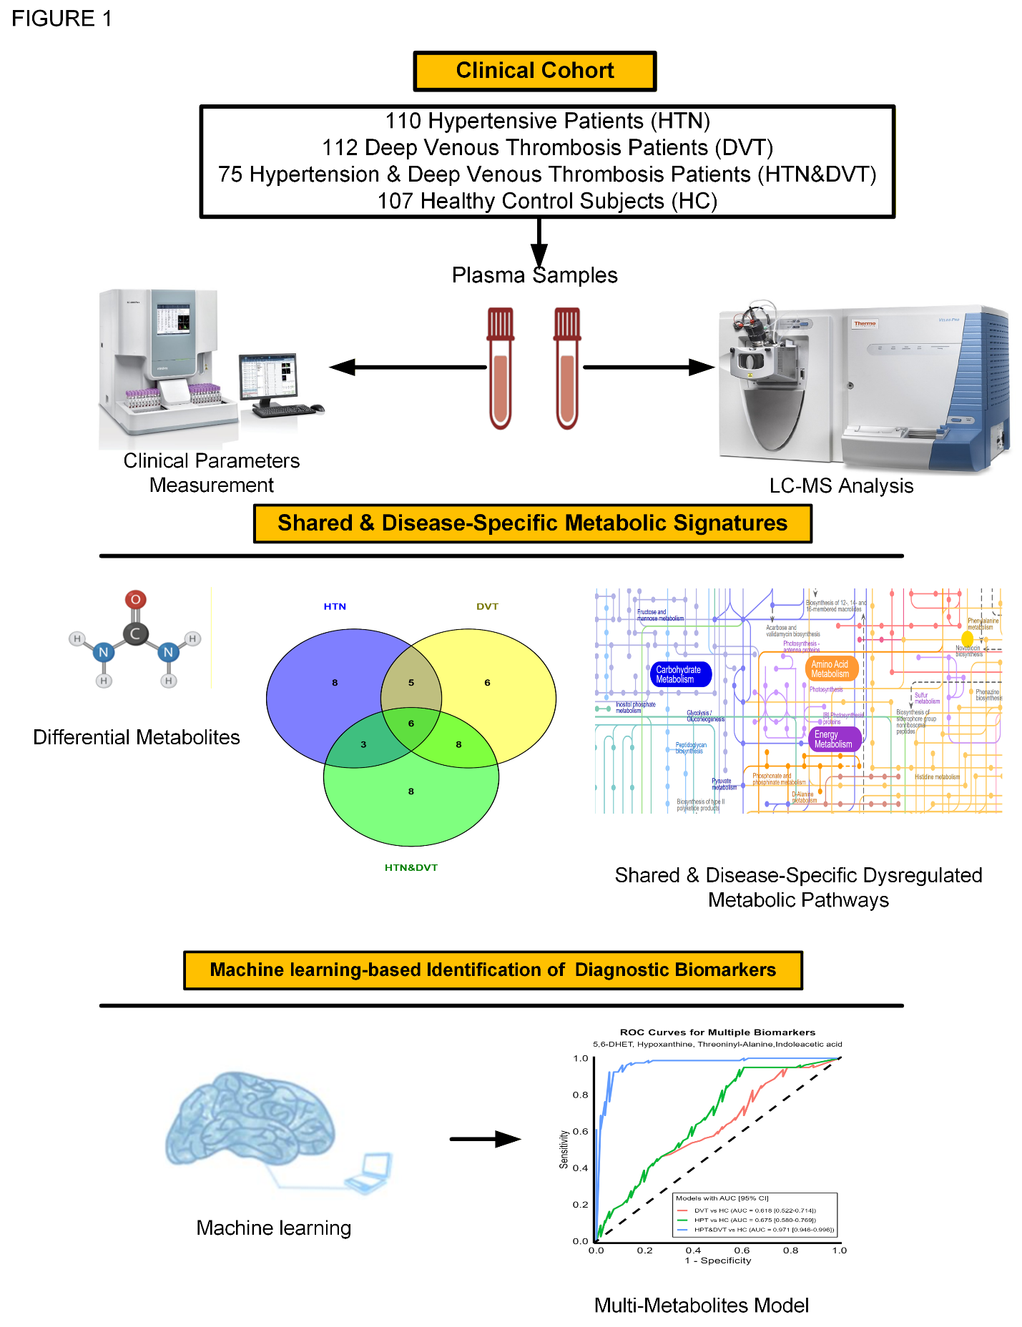
Figure 1. Flow chart of this study created using Visio software.
Collections of Blood Sample and Metabolites Extraction
Clinical and demographic data were recorded within 24 hours of patient admission. Blood sample from each subject following overnight fast was collected into a EDTA anticoagulated tube. Subsequently, the tubes containing samples were centrifuged at 1500 g for 10 min at 4°C to obtained plasma which was then stored at −80°C for further analysis. Metabolites were extracted according to the method adopted by (Zhang et al., 2024).
LC-MS analysis
LC-MS analysis used a Vanquish UHPLC system with a UPLC BEH Amide column (2.1 mm × 100 mm, 1.7 μm) coupled to an Orbitrap Q Exactive™ HF-X mass spectrometer (Thermo Fisher, Germany). Column temperature was 25°C, autosampler 4°C, with a 3 μL injection volume. The mobile phase contained (A) 25 mmol/L ammonium acetate and 25 mmol/L ammonium hydroxide (pH 9.75), and (B) acetonitrile. MS/MS spectra were acquired in IDA mode using Xcalibur software. For quality control, segmented IDA acquisition (top 12 precursor ions) was used, while experimental samples ran in full-scan mode. Sample order was randomized with QC injections every 10 samples. Raw data were converted to mzXML and processed using an R-based XCMS platform (Colin A. Smith, 2006). Metabolite annotation used BiotreeDB with a 0.4 similarity cutoff. Both pipeline and database have been validated (Gong et al., 2021). After noise reduction, peak intensities were normalized to internal standard, log-transformed, and batch-corrected via median-centering. Only metabolites detected across all batches were retained.
Covariate adjustment
To minimize confounding effects, metabolite profile data were initially adjusted for covariates including gender, age and thrombus location. Specifically, a multiple linear regression model was applied, with the relative abundance of each metabolite as the dependent variable and gender, trauma time, and age as independent variables.
Multivariate and Univariate statistical analyses
Multivariate statistical analyses and univariate analyses were carried out to identify differences between groups. Principal component analysis (PCA) was employed to evaluate instrument stability, sample clustering, and group separation, as well as identifying outliers. To achieve a more distinct group separation and a deeper insight into classification variables, supervised Orthogonal partial least squares discriminant analysis (OPLS-DA) was employed. The quality and reliability of these models were assessed by three parameters, including R²X, R²Y, and Q². Variable importance in projection (VIP) was calculated from OPLSDA model (Bergner et al., 2023). Univariate statistical analysis was conducted on every metabolite identified, followed by a 2-tailed Student t-test with a Benjamini-Hochberg correction for multiple testing (adjusted p-value). An adjusted p-value of <0.05 was defined as significant.
Screening and Identification of Differential Metabolites
The VIP calculated from OPLS-DA model was used as the metric for screening of differential metabolites. Metabolites with VIP >1, adjusted p value < 0.05 and FC > 1.33 or < 0.75 were identified as differential metabolites. These differential metabolites identified in HTN vs. HC, DVT vs. HC and HTN&DVT vs. HC were visualized in stem plot.
Metabolic Pathway Analysis
The over-representation analysis (ORA) of metabolic pathways was performed using the IMPaLA web tool (http://impala.molgen.mpg.de/) (Kamburov et al., 2011).
Selection of Diagnostic Biomarkers for HTN, DVT and HTN&DVT and Establishment of Diagnostic Models
For the selection of potential biomarkers that could distinguish HTN, DVT and HTN&DVT from HC subjects, we applied Random Forest algorithm on differential metabolites identified. We constructed a multi-biomarkers diagnostic model based on the selected biomarkers using logistic regression (R function lm) and Random Forest after covariate adjustment. Receiver operating characteristic (ROC) analysis was used to assess the performance of the selected biomarkers and diagnostic models constructed. To reduce selection bias and increase predictive accuracy, a 10-fold cross-validation was used to improve the precision and reduce the selection bias. Also, to prevent overfitting and ensure the reliability of our model, the data was randomly divided into 70% and 30% as train data and test data to train the model and evaluate the performance of the model, respectively (Xia Shen, 2021). The area under the ROC curve (AUC) and confidence intervals (CI) were calculated with the pROC R package (Robin et al., 2011). A p < 0.05 was considered to be statistically significant. All analyses were performed using R software (version 4.3.2, http://www.R-project.org).
RESULTS
Demographic and Clinical Features of Participants at Baseline
The baseline characteristics of the study groups are presented in Table 1. Most baseline and demographic parameters—including sex, age —were similar across all groups. Further, cardiovascular parameters and Coagulation profiles of HTN, DVT, HTN&DVT and HC groups were presented.
Metabolite Profiles for Disease Characterization
We detected 483 metabolites across all disease groups and HC, and grouped into ten functional categories, in addition to an unknown set (Figure 2A), including energy & carbohydrates, amino acids, nucleobases & related, vitamins & cofactors, hormones, carboxylic acids, amines, amides, lipids, peptides and others. Multivariate analyses, including PCA and OPLS-DA were conducted to investigate the separation of metabolites in HTN vs. HC, DVT vs. HC and HTN&DVT vs. HC groups.
Table 1: Baseline and Clinical Characteristics
Parameters | HTN (110) | DVT (112) | HTN&DVT (75) | HC (107)
Gender:  Male n (%) | 53 (48.2) | 64 (55.4) | 47 (58.6) | 69 (64.5)
Age  (Mean ± SD) | 66.1 (17.1) | 64.7 (±22.6) | 62.1 (± 11.2) | 65.2 (±13.5)
Blood Type n(%)
A | 30 (27.3) | 23 (20.5) | 12 (16.0) | 33 (30.8)
B | 39 (35.4) | 34 (30.4) | 18 (24.0) | 29 (27.1)
AB | 18 (16.3) | 15 (13.4) | 19 (25.3) | 21 (19.6)
O | 23 (20.9) | 40 (35.7) | 26 (34.7) | 24 (22.4)
Cardiovascular parameters
Mean (± SD)
Heart Rate (BPM) | 80.0 (± 5.0) | 83.2 (± 7.0) | 85.4 (± 8.5) | 84.0 (± 6.3)
SBP (mmHg) | 131.4 (± 13.2) | 126.3 (± 11.8) | 134.4 (± 11.5) | 128.4 (± 9.0)
DBP (mmHg) | 83.2 (± 8.3) | 79.6 (± 10.0) | 81.2 (± 13.2) | 77.5 (± 11.0)
Coagulation Parameters
Mean (± SD)
PT(S) | 13.3 (±2.0) | 6.5 (±3.2) | 7.4 (±1.0) | 12.7 (±1.4)
PT-INR | 1.8 (±0.08) | 0.7 (±0.04) | 0.6 (±0.07) | 2.0 (±0.03)
APTT (S) | 31.50 (±4.1) | 18.1 (±5.6) | 15.2 (±2.8) | 30.7 (±3.4)
TT (S) | 17.30 (±1.6) | 7.52 (±2.4) | 9.4 (±1.4) | 18.6 (±2.5)
Fbg (g/L) | 2.3 (±0.8) | 4.5 (±0.6) | 4.8 (±1.2) | 2.1 (±0.3)
DD (mg/L) | 1.9 (±0.7) | 5.1 (±0.5) | 4.5 (±0.8) | 1.3 (±0.2)
FDP (mg/L) | 15.0 (±1.3) | 10.4 (±2.2) | 11.1 (±1.7) | 16 (±2.2)
NB: HTN, Hypertension; deep venous thrombosis, DVT; HTN&DVT, Hypertension with deep venous thrombosis and HC, healthy control. SBP, systolic blood pressure; DBP, diastolic blood pressure; PT, prothrombin time; TT, thrombin time; Fbg, fibrinogen; DD, D-Dimer; FDP, fibrinogen degradation products; PT-INR, prothrombin time-international normalized ratio; APTT, activated partial thromboplastin time.

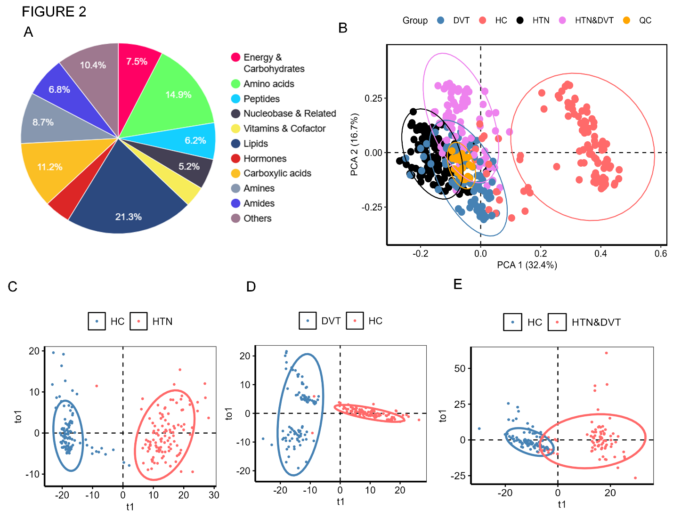
Figure 2. Comparative plasma metabolomic profiles of patients versus healthy controls. (A) Classification of metabolites detected via untargeted metabolomics analysis in plasma. (B) Principal component analysis PCA (C-E) OPLS-DA scores plots of HTN vs HC, DVT vs. HC and HTN&DVT vs. HC
The PCA and OPLS-DA scores plot revealed separation between disease patients and HC (Figures 2B–E). The OPLS-DA models demonstrated strong predictive validity, with R²Y and R²X values, confirming the robustness and reliability of the OPLS-DA models in distinguishing patient groups from healthy control. Screening of differentially expressed metabolites was carried out based on multi-dimensional statistics with VIP > 1, adjusted p-value < 0.05 and FC > 1.33 or < 0.75. Based on this, we identified 22, 27, and 25 disease-associated potential differential metabolites in the HTN, DVT, and HTN&DVT groups, respectively and is presented in stem plot (Figures 3A-C).
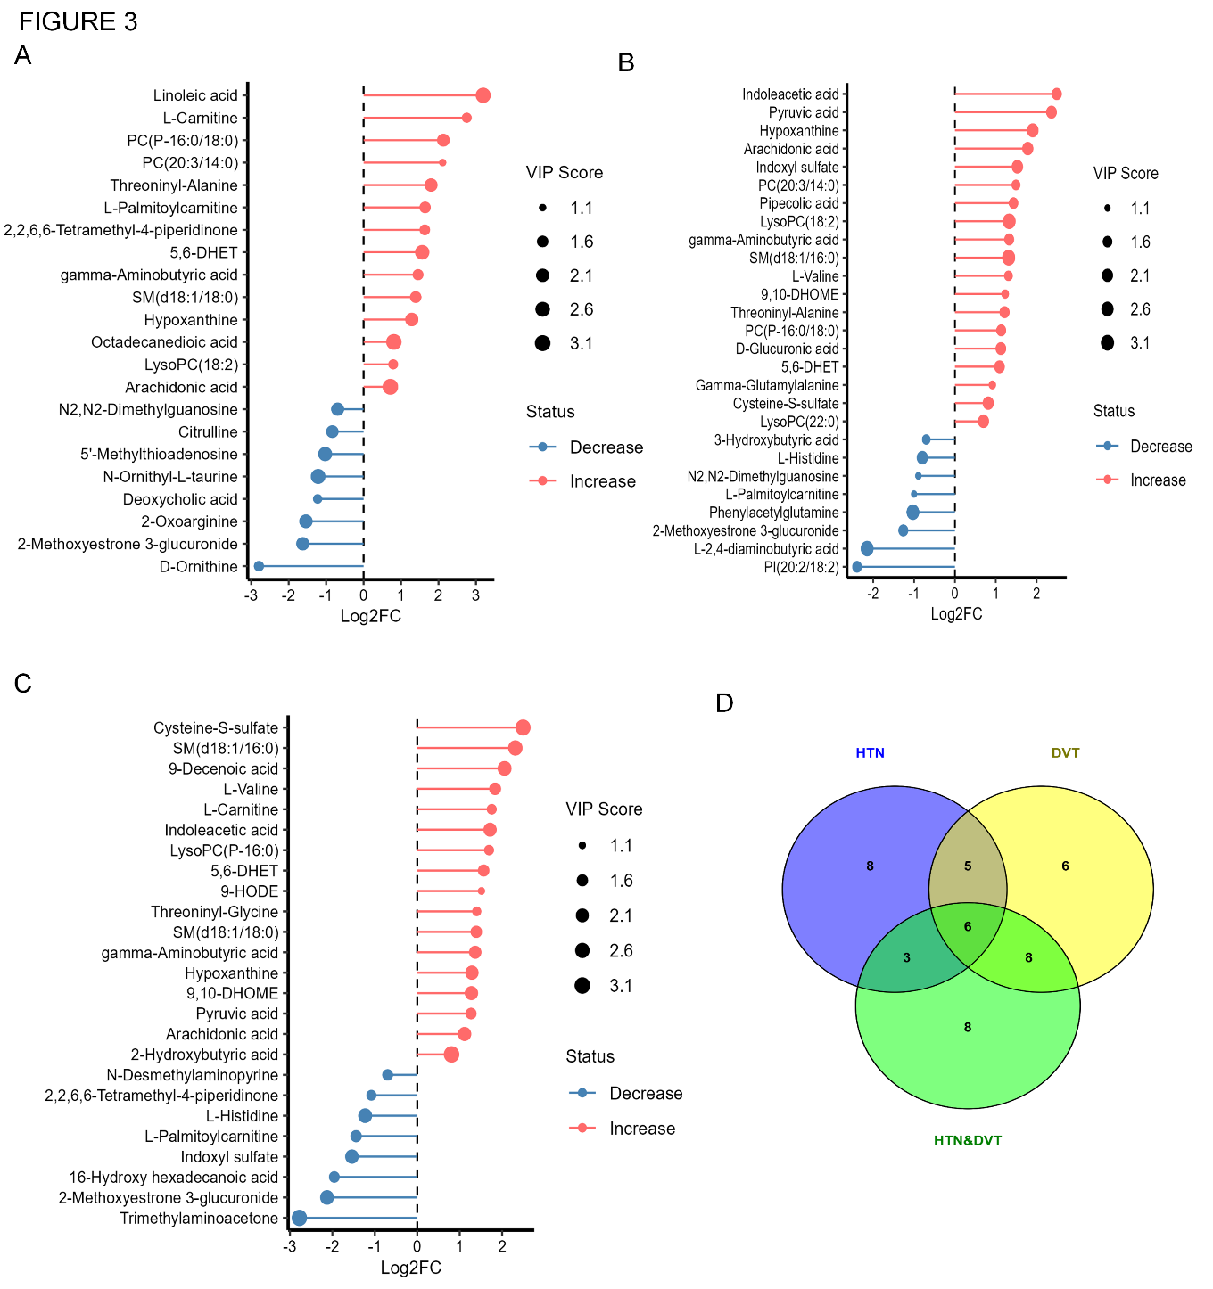
Figure 3. Stem plot showing log2FC and the corresponding VIP values of all differential metabolites identified in HTN vs. HC, DVT vs. HC and HTN&DVT vs. HC. (C) Venn diagram showing the distribution of the differential metabolites in the HTN vs. HC, DVT vs. HC and HTN&DVT vs. HC groups. HTN, Hypertension; DVT, Deep vein thrombosis; HTN&DVT, Hypertension with Deep vein thrombosis: HC, healthy control.
Using Venn diagram (Figure 3D), six metabolites - arachidonic acid, L-palmitoylcarnitine, 5,6-DHET, hypoxanthine, gamma-Aminobutyric acid and 2-Methoxyestrone 3-glucuronide- were common to all three disease groups. Additionally, eight other metabolites (L-valine, SM(d18:1/16:0), 9,10-DHOME, cysteine-s-sulfate, indoxyl sulfate, L-histidine, pyruvic acid and indoleacetic acid) were shared between the DVT and HTN&DVT groups. Analysis also revealed distinct metabolic profiles across disease groups (Table 2).
Table 2: List of metabolites with changes between HTN and HC group, DVT and HC group, and HTN&DVT and HC group
Metabolite | HTN vs. HC | DVT vs. HC | HTN&DVT vs. HC
2-Oxoarginine |  | - | -
Deoxycholic acid |  | - | -
Linoleic acid |  | - | -
Octadecanedioic acid |  | - | -
D-Ornithine |  | - | -
Citrulline |  | - | -
5'-Methylthioadenosine |  | - | -
N-Ornithyl-L-taurine |  | - | -
LysoPC(22:0) | - |  | -
3-Hydroxybutyric acid | - |  | -
Phenylacetylglutamine | - |  | -
Pipecolic acid | - |  | -
L-2,4-diaminobutyric acid | - |  | -
D-Glucuronic acid | - |  | -
Threoninyl-Glycine | - | -
Trimethylaminoacetone | - | -
N-Desmethylaminopyrine | - | -
16-Hydroxy hexadecanoic acid | - | -
LysoPC(P-16:0) | - | -
2-Hydroxybutyric acid | - | -
9-Decenoic acid | - | -
9-HODE | - | -
Threoninyl-Alanine |  |  | -
LysoPC(18:2) |  |  | -
PC(20:3/14:0) |  |  | -
N2,N2-Dimethylguanosine |  |  | -
PC(P-16:0/18:0) |  |  | -
2,2,6,6-Tetramethyl-4-piperidinone |  | -
L-Carnitine |  | -
SM(d18:1/18:0) |  | -
L-Valine | -
SM(d18:1/16:0) | -
9,10-DHOME | -
Cysteine-S-sulfate | -
Indoxyl sulfate | -
L-Histidine | -
Pyruvic acid | -
Indoleacetic acid | -
L-Palmitoylcarnitine
5,6-DHET
Arachidonic acid
Hypoxanthine
gamma-Aminobutyric acid
2-Methoxyestrone 3-glucuronide

Exploring Metabolic Pathways Across Diseases
Metabolic pathway analysis (Figures 4A–C) identified multiple significantly dysregulated metabolic pathways common to all disease groups.
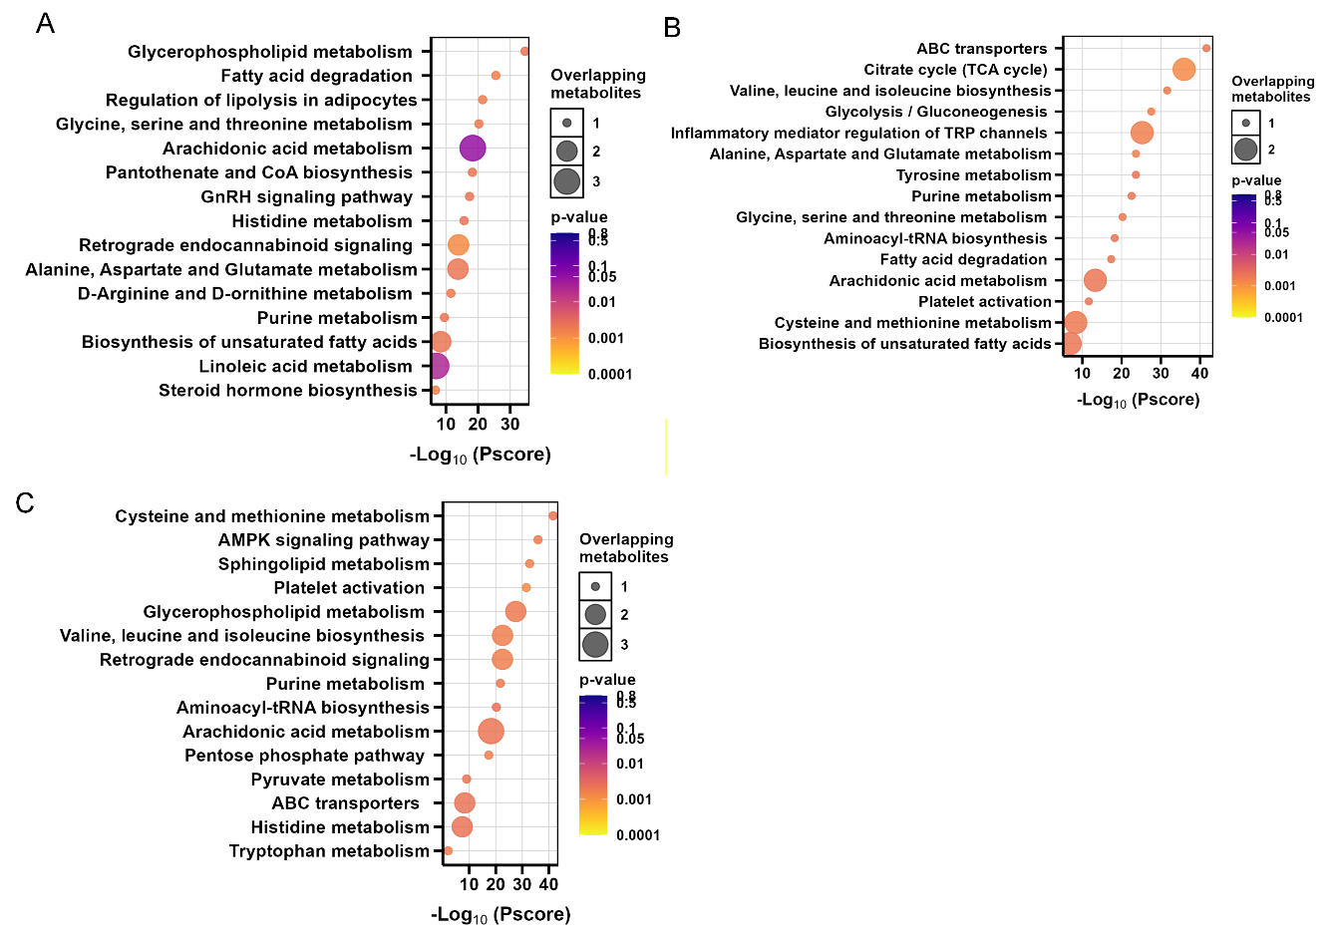
Figure 4. (A-C) The dysregulated metabolic pathways induced by HTN (B), DVT (C), and HTN&DVT (D). The p-value for the pathways shown is below 0.05, as determined by the ORA filtering process.
Multi-Biomarker Signatures for Diagnostic Support
Ramdom forest selected four for diagnostic biomarkers for each condition (Figure 5A-C), and the diagnostic performance of disease-specific biomarkers was evaluated using ROC curve analysis (Figure 5D-F). For HTN, D-ornithine demonstrated the highest AUC, followed by LysoPC(18:2), 2-oxoarginine, and citrulline (Figure 6D). For DVT, the highest AUC was observed for pipecolic acid, followed by indoxyl sulfate, hypoxanthine, and 9,10-DHOME (Figure 6B). For combined HTN&DVT, arachidonic acid showed the highest discriminatory power, followed by indoleacetic acid, L-carnitine, and 5,6-DHET (Figure 6C). Collectively, these disease-specific biomarkers exhibited robust diagnostic potential, as indicated by their high AUC values, suggesting their potential utility in distinguishing between disease states.
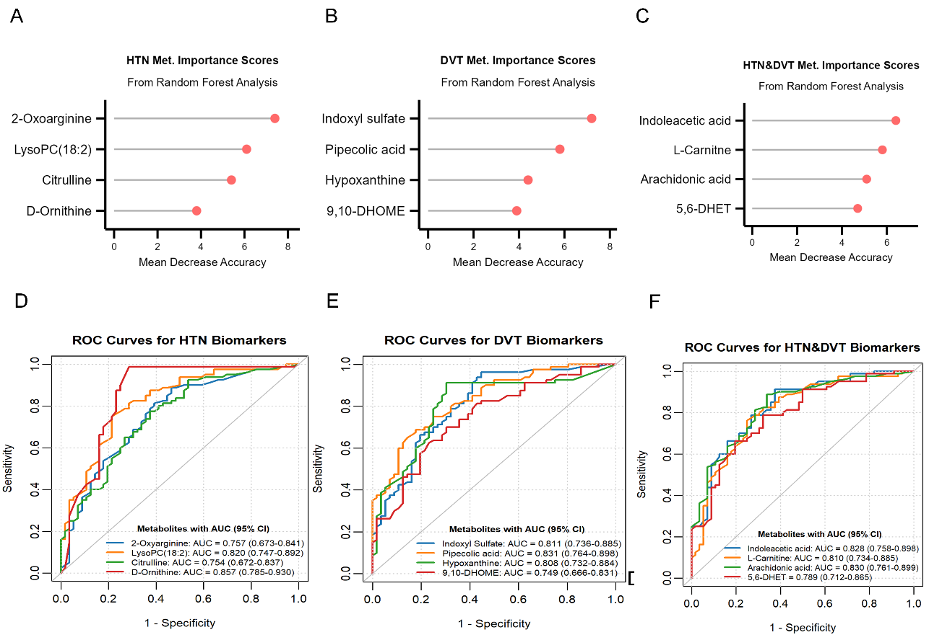

Figure 5. Identifying possible biomarkers that are specific to each disease (A-C) Selection of diagnostic biomarkers for HTN, DVT and HTN&DVT using Random Forest Analysis. (D-F) Assessing the diagnostic value of the biomarkers unique to each disease. ROC analyses of HTN, DVT and HTN&DVT specific metabolites as potential biomarkers.

To leverage the complementary strengths of individual biomarkers, this study developed three disease-specific four-metabolite panels with excellent diagnostic performance. The first panel (2-oxoarginine, LysoPC(18:2), citrulline, and D-ornithine) discriminated HTN from HC with an AUC of 0.983, 92.5% sensitivity, and 94.6% specificity, performing best for HTN vs. HC (Figure 6A, Table 3 and Table S3).
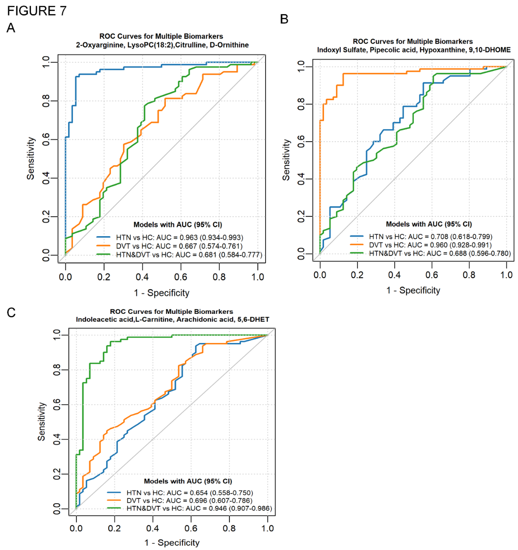
The second panel (indoxyl sulfate, pipecolic acid, hypoxanthine, and 9,10-DHOME) distinguished DVT from HC with an AUC of 0.960 showing superior performance for DVT vs. HC (Figure 6B). The third panel (indoleacetic acid, L-carnitine, arachidonic acid, and 5,6-DHET) differentiated combined HTN&DVT from HC with an AUC of 0.946, 96.2%.

Figure 6 Diagnostic utility of multi-biomarker panels for disease stratification. ROC curves demonstrate the performance of a logistic regression classifier built from disease-specific biomarkers to differentiate patient groups from healthy controls. Classifiers were developed on a training set and validated on an independent test set for (A) HTN, (B) DVT, and (C) HTN&DVT.

Discussion
To better understand the metabolic interactions and distinctions between HTN and DVT, we conducted comprehensive plasma metabolomic profiling to identify shared and disease-specific metabolic signatures in HTN and DVT. Our metabolomic analysis revealed significant alterations in several metabolic pathways, which both corroborate prior research and unveil novel mechanistic insights into HTN pathogenesis.
Consistent with previous reports, we observed dysregulation in pathways involved in vascular tone, oxidative stress, and lipid homeostasis, including steroid hormone biosynthesis (Zhao et al., 2018), linoleic acid metabolism (Deng et al., 2021), fatty acid degradation (Zhao et al., 2018), glycine, serine and threonine metabolism, alanine, aspartate and glutamate metabolism, biosynthesis of unsaturated fatty acids, glycerophospholipid metabolism (Goita et al., 2020), and histidine metabolism (Deng et al., 2021). Our study also identified novel pathways in HTN, including retrograde endocannabinoid signaling, arachidonic acid metabolism, purine metabolism, regulation of lipolysis in adipocytes, and GnRH signaling. These findings suggest links between inflammatory lipid mediators, vascular function (Asakura et al., 2023). energy dynamics, and systemic metabolic dysfunction, offering new directions for HTN research.
Our metabolomic findings reveal pathway dysregulations that expand current understanding of DVT pathophysiology. We observed significant perturbations in core energy metabolism, including the citrate cycle and glycolysis/gluconeogenesis (Zhang et al., 2024), reflecting the hypermetabolic state of activated platelets. Our data corroborate involvement of amino acid metabolism (tyrosine; glycine, serine, threonine; alanine, aspartate, glutamate; valine, leucine, and isoleucine biosynthesis) and lipid metabolism (fatty acid degradation; biosynthesis of unsaturated fatty acids) (Cao et al., 2024), processes integral to endothelial integrity and oxidative stress. We also confirm the role of purine metabolism (Zhang et al., 2024) and the involvement of aminoacyl-tRNA biosynthesis (Cao et al., 2018), potentially linking translational regulation and cellular stress responses to thrombus formation.
Our study unveils novel DVT-associated pathways, including TRP channel regulation, arachidonic acid metabolism (Badimon et al., 2021), cysteine and methionine metabolism, and ABC transporters (Wang & Westerterp, 2020). These findings suggest unexplored links between inflammatory signaling, redox disruption, and vascular health, offering promising directions for biomarker validation and therapeutic targeting in venous thrombosis.
Based on our study, we identified key metabolites linked to arachidonic acid metabolism—including arachidonic acid itself, 5,6-DHET, and 9,10-DHOME—consistent with prior research (Sonnweber et al., 2018). Notably, arachidonic acid metabolic dysregulation was evident in both HTN, DVT and HTN&DVT. Elevated arachidonic acid and its derivatives have been associated with higher venous thromboembolism risk (Yuan et al., 2022). Beyond thrombosis, arachidonic acid influences coagulation, inflammation, and hormonal regulation (e.g., testosterone), contributing to atherosclerotic cardiovascular disease (Zhang et al., 2021). Its metabolites also integrate metabolic and immune pathways, implicating arachidonic acid -driven inflammation in cardiovascular disease initiation and progression (Asakura et al., 2023).
Altered L-valine levels indicate disrupted valine-related amino acid metabolism. L-valine was identified as a differential metabolite in DVT and HTN&DVT. Prior research links BCAAs to cardiovascular diseases (White & Newgard, 2019). Valine regulates glycolipid metabolism, glucose, apoptosis, and autophagy (Neinast et al., 2019). BCAA intake increases platelet activity and arterial thrombosis, with valine catabolism playing a key role (Jiang et al., 2024). Thus, elevated L-valine may exacerbate coronary damage and venous thrombosis.
Our analysis identified significant tryptophan metabolism disruptions in HTN&DVT, involving the kynurenine, serotonin, and indole/AhR pathway (Agus et al., 2018). The gut microbiota actively participates in host tryptophan metabolism. The kynurenine pathway is implicated in inflammatory diseases (Anlu et al., 2019), while the indole/AhR pathway regulates bacterial processes (Agus et al., 2018). The gut microbiota plays a pivotal role in metabolic disorders (Moon et al., 2018). Our network analysis revealed key metabolic disturbances underlying HTN-to-HTN&DVT progression and identified critical interactions between these conditions.
Using Random Forest analysis, three distinct four-metabolite diagnostic panels were developed with specific applications. The first panel (2-oxoarginine, LysoPC(18:2), citrulline, D-ornithine) performed best at distinguishing HTN from healthy controls but was ineffective for identifying DVT or combined HTN&DVT. The second panel (indoxyl sulfate, pipecolic acid, hypoxanthine, 9,10-DHOME) excelled at discriminating DVT from healthy controls with high sensitivity and specificity. The third panel (indoleacetic acid, L-carnitine, arachidonic acid, 5,6-DHET) was optimal for identifying combined HTN&DVT from healthy controls, outperforming its ability to detect either condition alone. Thus, each panel is specifically tailored for diagnosing its respective disease state.
Conclusion
This study highlights key metabolic differences between HTN, DVT, and their combination (HTN&DVT). It identifies nine potential risk factors (e.g., arachidonic acid, L-carnitine, GABA) that may drive HTN progression to HTN&DVT. Four distinct multi-biomarker panels were developed to diagnose each condition. These biomarkers are linked to key pathways—such as arachidonic acid, pyruvate, and purine metabolism—offering new diagnostic and therapeutic targets to slow disease progression.
Data availability
The raw metabolomics data generated in this research are available from the corresponding author, Mukhtar Aliyu (maliyu1@fudutsinma.edu.ng), and can be requested reasonably.
Conflict of Interests Disclosure
The authors declare no competing interests.

References
Ageno, W., Becattini, C., Brighton, T., Selby, R., & Kamphuisen, P. W. (2008). Cardiovascular Risk Factors and Venous Thromboembolism. Circulation, 117(1), 93-102. https://doi.org/10.1161/circulationaha.107.709204

Agus, A., Planchais, J., & Sokol, H. (2018, Jun 13). Gut Microbiota Regulation of Tryptophan Metabolism in Health and Disease. Cell Host & Microbe, 23(6), 716-724. https://doi.org/10.1016/j.chom.2018.05.003

Anlu, W., Dongcheng, C., He, Z., Qiuyi, L., Yan, Z., Yu, Q., Hao, X., & Keji, C. (2019, Apr). Using herbal medicine to target the "microbiota-metabolism-immunity" axis as possible therapy for cardiovascular disease. Pharmacological Research, 142, 205-222. https://doi.org/10.1016/j.phrs.2019.02.018

Asakura, K., Minami, Y., Nagata, T., Katamine, M., Katsura, A., Hashimoto, T., Kinoshita, D., & Ako, J. (2023, Jan-Feb). Impact of the eicosapentaenoic acid to arachidonic acid ratio on plaque characteristics in statin-treated patients with coronary artery disease. Journal of Clinical Lipidology, 17(1), 189-196. https://doi.org/10.1016/j.jacl.2022.11.011

Badimon, L., Vilahur, G., Rocca, B., & Patrono, C. (2021, Jul 27). The key contribution of platelet and vascular arachidonic acid metabolism to the pathophysiology of atherothrombosis. Cardiovascular Research, 117(9), 2001-2015. https://doi.org/10.1093/cvr/cvab003

Bergner, R. T., Onida, S., Velineni, R., Spagou, K., Gohel, M. S., Bouschbacher, M., Bohbot, S., Shalhoub, J., Holmes, E., & Davies, A. H. (2023, Feb 1). Metabolic Profiling Reveals Changes in Serum Predictive of Venous Ulcer Healing. Annals of Surgery, 277(2), e467-e474. https://doi.org/10.1097/SLA.0000000000004933

Cao, J., An, G. S., Li, R. Q., Hou, Z. J., Li, J., Jin, Q. Q., Du, Q. X., & Sun, J. H. (2024, Sep 10). Novel Strategy for Human Deep Vein Thrombosis Diagnosis Based on Metabolomics and Stacking Machine Learning. Analytical Chemistry, 96(36), 14560-14570. https://doi.org/10.1021/acs.analchem.4c02973

Cao, J., Jin, Q. Q., Wang, G. M., Dong, H. L., Feng, Y. M., Tian, J. S., Yun, K. M., Wang, Y. Y., & Sun, J. H. (2018, May 18). Comparison of the serum metabolic signatures based on (1)H NMR between patients and a rat model of deep vein thrombosis. Scientific Reports, 8(1), 7837. https://doi.org/10.1038/s41598-018-26124-x

Colin A. Smith, E. J. W., Grace O’Maille, Ruben Abagyan, and Gary Siuzdak. (2006). XCMS: Processing Mass Spectrometry Data For Metabolite Profiling-Using Nonlinear Peak Alignment. Analytical Chemistry, 78, 779-787.

Deng, Y., Huang, C., Su, J., Pan, C. W., & Ke, C. (2021, Feb 8). Identification of biomarkers for essential hypertension based on metabolomics. Nutrition, Metabolism, and Cardiovascular Diseases, 31(2), 382-395. https://doi.org/10.1016/j.numecd.2020.11.023

Garcia-Fontana, B., Morales-Santana, S., Diaz Navarro, C., Rozas-Moreno, P., Genilloud, O., Vicente Perez, F., Perez del Palacio, J., & Munoz-Torres, M. (2016). Metabolomic profile related to cardiovascular disease in patients with type 2 diabetes mellitus: A pilot study. Talanta, 148, 135-143. https://doi.org/10.1016/j.talanta.2015.10.070

Geerts, W. H., Code, K. I., Jay, R. M., Chen, E. L., & Szalai, J. P. (1994). Prospective-Study of Venous Thromboembolism after Major Trauma. New England Journal of Medicine, 331, 1601-1606.

Goita, Y., Chao de la Barca, J. M., Keita, A., Diarra, M. B., Dembele, K. C., Chabrun, F., Drame, B. S. I., Kassogue, Y., Diakite, M., Mirebeau-Prunier, D., Cisse, B. M., Simard, G., & Reynier, P. (2020, May 5). Sexual Dimorphism of Metabolomic Profile in Arterial Hypertension. Scientific Reports, 10(1), 7517. https://doi.org/10.1038/s41598-020-64329-1

Gong, Y., Ji, P., Yang, Y. S., Xie, S., Yu, T. J., Xiao, Y., Jin, M. L., Ma, D., Guo, L. W., Pei, Y. C., Chai, W. J., Li, D. Q., Bai, F., Bertucci, F., Hu, X., Jiang, Y. Z., & Shao, Z. M. (2021, Jan 5). Metabolic-Pathway-Based Subtyping of Triple-Negative Breast Cancer Reveals Potential Therapeutic Targets. Cell Metabolism, 33(1), 51-64 e59. https://doi.org/10.1016/j.cmet.2020.10.012

Grimnes, G., Isaksen, T., Tichelaar, Y., Brox, J., Braekkan, S. K., & Hansen, J. B. (2018, Jul). C-reactive protein and risk of venous thromboembolism: results from a population-based case-crossover study. Haematologica, 103(7), 1245-1250. https://doi.org/10.3324/haematol.2017.186957

Hage, F. G. (2014, 2014/07/01). C-reactive protein and Hypertension. Journal of Human Hypertension, 28(7), 410-415. https://doi.org/10.1038/jhh.2013.111

Higashi, Y. (2022, Sep 30). Roles of Oxidative Stress and Inflammation in Vascular Endothelial Dysfunction-Related Disease. Antioxidants (Basel), 11(10). https://doi.org/10.3390/antiox11101958

Huang, L., Li, J., & Jiang, Y. (2016). Association between hypertension and deep vein thrombosis after orthopedic surgery: a meta-analysis. European Journal of Medical Research, 21(1). https://doi.org/10.1186/s40001-016-0207-z

J., C., Lu, X., Li, Y., Jin, Q., Chu, X., Wang, Y., & Sun, J. H. (2018). Study on Urinary Metabolic Profile in Rats with Deep Venous Thrombosis Based on Pattern Recognition. Journal of Forensic Medicine, 34(3).

Jiang, W., Yang, L., Dang, Y., Jiang, X., Wu, L., Tong, X., Guo, J., & Bao, Y. (2024, Apr). Metabolomic profiling of deep vein thrombosis. Phlebology, 39(3), 154-168. https://doi.org/10.1177/02683555231215199

Joint Committee for Guideline, R. (2019, Mar). 2018 Chinese Guidelines for Prevention and Treatment of Hypertension-A report of the Revision Committee of Chinese Guidelines for Prevention and Treatment of Hypertension. Journal of Geriatric Cardiology, 16(3), 182-241. https://doi.org/10.11909/j.issn.1671-5411.2019.03.014

Kamburov, A., Cavill, R., Ebbels, T. M., Herwig, R., & Keun, H. C. (2011, Oct 15). Integrated pathway-level analysis of transcriptomics and metabolomics data with IMPaLA. Bioinformatics, 27(20), 2917-2918. https://doi.org/10.1093/bioinformatics/btr499

Libby, P. (2012, Sep). Inflammation in atherosclerosis. Arteriosclerosis, Thrombosis, and Vascular Biology, 32(9), 2045-2051. https://doi.org/10.1161/ATVBAHA.108.179705

Liu, W., Guo, P., Dai, T., Shi, X., Shen, G., & Feng, J. (2021, May 7). Metabolic Interactions and Differences between Coronary Heart Disease and Diabetes Mellitus: A Pilot Study on Biomarker Determination and Pathogenesis. Journal of Proteome Research, 20(5), 2364-2373. https://doi.org/10.1021/acs.jproteome.0c00879

Moon, J. Y., Zolnik, C. P., Wang, Z., Qiu, Y., Usyk, M., Wang, T., Kizer, J. R., Landay, A. L., Kurland, I. J., Anastos, K., Kaplan, R. C., Burk, R. D., & Qi, Q. (2018, Nov). Gut microbiota and plasma metabolites associated with diabetes in women with, or at high risk for, HIV infection. EBioMedicine, 37, 392-400. https://doi.org/10.1016/j.ebiom.2018.10.037

Neinast, M., Murashige, D., & Arany, Z. (2019, Feb 10). Branched Chain Amino Acids. Annual Review of Physiology, 81, 139-164. https://doi.org/10.1146/annurev-physiol-020518-114455

Olson, N. C., Cushman, M., Lutsey, P. L., McClure, L. A., Judd, S., Tracy, R. P., Folsom, A. R., & Zakai, N. A. (2014). Inflammation markers and incident venous thromboembolism: the REasons for Geographic And Racial Differences in Stroke (REGARDS) cohort. Journal of Thrombosis and Haemostasis, 12(12), 1993-2001. https://doi.org/10.1111/jth.12742

Onuh, J. O., & Qiu, H. (2021, Oct 7). Metabolic Profiling and Metabolites Fingerprints in Human Hypertension: Discovery and Potential. Metabolites, 11(10). https://doi.org/10.3390/metabo11100687

Prandoni, P. (2009). Venous and arterial thrombosis: Two aspects of the same disease? Clinical Epidemiology 1, 1-6.

Robin, X., Turck, N., Hainard, A., Tiberti, N., Lisacek, F., Sanchez, J.-C., & Müller, M. (2011). pROC: an open-source package for R and S+ to analyze and compare ROC curves. BMC Bioinformatics, 12(77), 1-8.

Shi, X. J., Li, M. N., Xuan, L., Li, H., Chen, B., Zhang, J., & Wang, H. J. (2019, Jul). Clinical characteristics of patients with premature acute coronary syndrome and adverse cardiovascular events after PCI. Experimental and Therapeutic Medicine, 18(1), 793-801. https://doi.org/10.3892/etm.2019.7618

Sonnweber, T., Pizzini, A., Nairz, M., Weiss, G., & Tancevski, I. (2018, Oct 23). Arachidonic Acid Metabolites in Cardiovascular and Metabolic Diseases. International Journal of Molecular Sciences, 19(11). https://doi.org/10.3390/ijms19113285

Waheed, S. M., Kudaravalli, P., & Hotwagner, D. T. (2023., January, 19, 2023.). Deep Vein Thrombosis.

Wang, N., & Westerterp, M. (2020). ABC Transporters, Cholesterol Efflux, and Implications for Cardiovascular Diseases. Advances in Experimental Medicine and Biology, 1276, 67-83. https://doi.org/10.1007/978-981-15-6082-8_6

Wang, Z., Wang, S., Lin, H., Wang, C., & Gao, D. (2024). Prevalence of hypertension and related risk factors in older Chinese population: a meta-analysis. Frontiers in Public Health, 12. https://doi.org/10.3389/fpubh.2024.1320295

White, P. J., & Newgard, C. B. (2019). Branched-chain amino acids in disease Are BCAAs a biomarker, causal agent, or both in cardiometabolic disease? Metabolism: Clinical and Experimental, 363 (6427), 582 -583.

Xia Shen, C. W., Ningning Liang, Zhen Liu, Xinde Li, Zheng-Jiang Zhu, Tony R. Merriman, Nicola Dalbeth, Robert Terkeltaub, Changgui Li, and Huiyong Yin. (2021). Serum Metabolomics Identifies Dysregulated Pathways and Potential Metabolic Biomarkers for Hyperuricemia and Gout. Arthritis & Rheumatology, 73(9), 1738–1748. https://doi.org/10.1002/art.41733

Yuan, S., Li, X., Morange, P. E., Bruzelius, M., Larsson, S. C., & On Behalf Of The Invent, C. (2022, Aug 16). Plasma Phospholipid Fatty Acids and Risk of Venous Thromboembolism: Mendelian Randomization Investigation. Nutrients, 14(16). https://doi.org/10.3390/nu14163354

Zhang, K., Wang, P., Huang, W., Tang, S.-H., Xue, H., Wu, H., Zhang, Y., Rong, Y., Dong, S.-S., Chen, J.-B., Zou, Y., Tian, D., Yang, N., Liang, Y., Liu, C., Li, D., Zhang, K., Yang, T.-L., & Guo, Y. (2024). Integrated landscape of plasma metabolism and proteome of patients with post-traumatic deep vein thrombosis. Nature Communications, 15(1). https://doi.org/10.1038/s41467-024-52262-0

Zhang, T., Au Yeung, S.-L., & Schooling, C. M. (2021). Associations of Arachidonic Acid Synthesis with Cardiovascular Risk Factors and Relation to Ischemic Heart Disease and Stroke: A Univariable and Multivariable Mendelian Randomization Study. Nutrients, 13(5). https://doi.org/10.3390/nu13051489

Zhao, H., Liu, Y., Li, Z., Song, Y., Cai, X., Liu, Y., Zhang, T., Yang, L., Li, L., Gao, S., Li, Y., & Yu, C. (2018, Nov). Identification of essential hypertension biomarkers in human urine by non-targeted metabolomics based on UPLC-Q-TOF/MS. Clinica Chimica Acta, 486, 192-198. https://doi.org/10.1016/j.cca.2018.08.006

