ABSTRACT
This article examines international education as a tool of diplomatic influence, with particular focus on China’s strategic use of scholarship programs, Confucius Institutes, vocational training, and academic exchanges as instruments of soft power in Africa. Using Liberia as a primary case study, the paper traces the historical trajectory of China–Liberia educational cooperation from the resumption of diplomatic relations in 2003 to the landmark 2024 FOCAC Beijing Summit. Drawing on diplomatic records, institutional data, and secondary literature, the study finds that China’s education diplomacy in Liberia encompasses five interconnected dimensions: government scholarships, Confucius Institute establishment, capacity-building program, infrastructure investment in educational facilities, and people-to-people exchange platforms. These efforts have progressively deepened bilateral relations and positioned education as a central pillar of China’s broader soft power strategy in West Africa. The article further analyses tensions between developmental intent and geopolitical instrumentality, noting that while Liberian graduates acquire valuable technical skills, the selectivity of program design reflects China’s national interest framing. Comparative data from FOCAC I (2000) through FOCAC IX (2024) reveal an escalatory pattern in Chinese educational pledges, culminating in 60,000 scholarships and training slots for the 2024–2027 cycle. The findings contribute to the growing literature on education diplomacy, South–South cooperation, and China’s global influence strategy in the post-pandemic era.

Keywords: education diplomacy; China–Africa relations; soft power; Liberia; FOCAC; Confucius Institute; scholarship diplomacy

Introduction
In the contemporary global order, power is increasingly projected not through military force alone but through cultural, economic, and educational engagement. Joseph Nye’s foundational concept of ‘soft power, ’ the capacity to shape the preferences of others through attraction and persuasion rather than coercion, has found its most ambitious practitioner in the People’s Republic of China, particularly within the African continent [1]. Among the many instruments China employs to cultivate influence, international education stands out for its durability and depth: it shapes the perceptions, networks, and policy orientations of future African leaders, technocrats, and public intellectuals.
Since the inaugural Forum on China-Africa Cooperation (FOCAC) in 2000, China has systematically expanded its educational footprint across Africa through government scholarships, Confucius Institutes, vocational training centers, and joint research programs. The scale is remarkable: by 2018, more than 81,562 African students were enrolled in Chinese institutions, constituting 17% of China’s total international student population, a figure that represented a near-tenfold increase from the early 2000s [2]. At the 2024 FOCAC Beijing Summit, China pledged 60,000 scholarships and training opportunities for the 2024–2027 triennium, demonstrating that education diplomacy remains central to Beijing’s Africa strategy even as the overall character of engagement evolves toward ‘small and beautiful’ livelihood projects [3].
Liberia presents a particularly instructive case study within this broader continental narrative. A small, post-conflict West African state, Liberia has navigated complex diplomatic terrain with China since the colonial era, experiencing formal relations established in 1977, rupture in 1989 when Taiwan offered $200 million in education and infrastructure aid in exchange for diplomatic recognition, and eventual reunification with Beijing in 2003 as part of a broader consolidation of China’s African diplomatic network [4]. Today, China is Liberia’s largest trading partner, with bilateral trade reaching US$320 million in 2023 and Chinese investments totaling US$13 million that same year [5]. Within this relationship, education operates as both a development tool and a diplomatic instrument.
This article makes three contributions. First, it provides a systematic analysis of China’s education diplomacy framework as applied in Africa, synthesizing the theoretical underpinnings from soft power, public diplomacy, and South–South cooperation literatures. Second, it traces the evolution of Chinese educational engagement in Liberia from 2003 to 2025, documenting scholarship flows, institutional development, and capacity-building outcomes. Third, it critically examines the tensions and contradictions embedded in education diplomacy, including questions of ideological conditioning, brain drain, program selectivity, and the limits of reciprocity in an asymmetric bilateral relationship. In doing so, the article seeks to move beyond both the hagiographic celebration of China–Africa educational solidarity and the reductionist critique of neo-colonial instrumentalism, toward a more nuanced accounting of what education diplomacy achieves and for whom.

2. Theoretical Framework: Education Diplomacy and Soft Power

2.1 Soft Power and Public Diplomacy
The theoretical foundations of education diplomacy draw primarily from Nye’s conception of soft power as the ability to shape the behavior of others through appeal to values, culture, and legitimate institutions rather than through coercion or inducement [1]. In the international relations literature, education has long been recognized as a vehicle for what has been termed ‘diplomatic socialization’, a process by which students educated in a foreign country absorb that country’s norms, values, and worldview, and subsequently transmit these orientations back to their home societies [6].
China’s approach to education diplomacy must, however, be situated within the specifically Chinese conceptualization of soft power (ruǎn shílì, 软实力), which diverges in important respects from Nye’s Western-liberal formulation. As Callahan [7] and others have noted, Beijing’s soft power discourse emphasizes cultural particularity over universal values, prioritizes state-to-state relations over civil society engagement, and maintains a stronger ideological dimension oriented toward legitimating the Chinese Communist Party’s governance model. The implications for education diplomacy are significant: the Chinese scholarship program and Confucius Institutes are not merely cultural exchange platforms but instruments through which China seeks to build a constituency of future African elites favorably disposed toward Beijing.

2.2 South–South Cooperation and Education
China frames its educational engagement with Africa consistently within the paradigm of South–South cooperation (SSC), a framework that emphasizes mutual benefit, non-conditionality, and shared developmental aspirations among nations of the Global South [8]. This framing has considerable resonance with African governments wary of the conditionality historically attached to Western development assistance. By presenting scholarships and training programs as win-win partnerships between developing nations, China positions itself as a fundamentally different kind of educational partner from Western donors. King [9] notes, however, that despite the discourse of two-way collaboration embedded in FOCAC documentation, the bulk of human resource development (HRD) pledges are structurally one-way: it is China that provides scholarships, builds schools, and deploys teachers, while African nations are cast primarily as recipients.
This asymmetry does not negate the genuine developmental value of educational exchanges, but it does raise questions about the degree of African agency in shaping program design, disciplinary priorities, and return-to-home incentive structures. The literature on haigui, the phenomenon of Chinese returnee students who catalyzed China’s technological and entrepreneurial revolution, has prompted some scholars to ask whether Africa can replicate analogous brain gain dynamics from its China-educated diaspora, or whether structural barriers will perpetuate brain drain [10].

2.3 Analytical Framework: Five Dimensions of Education Diplomacy
Drawing on Nye [1], Ye [11], King [9], and Tang et al. [12], this article conceptualizes China’s education diplomacy in Africa across five interlocking dimensions: (1) Scholarship Diplomacy, the provision of government-funded study opportunities that create long-term bilateral goodwill and cultivate future African elites; (2) Cultural-Linguistic Diplomacy, the deployment of Confucius Institutes and Chinese language program to build cultural affinity; (3) Capacity-Building Diplomacy, vocational training, technical assistance, and professional development program that address Africa’s human resource gap; (4) Infrastructure Diplomacy in Education, the construction and renovation of schools, universities, and laboratories as visible symbols of Chinese generosity; and (5) Network Diplomacy, alumni associations, think tank exchanges, and governance experience-sharing platforms that maintain long-term relational ties. Liberia presents evidence for all five dimensions, though their relative weight and effectiveness vary.

KEY INSIGHT | China’s education diplomacy in Africa is not reducible to a single vector of influence; it operates across five interlocking dimensions that together constitute a comprehensive soft power architecture, with each dimension reinforcing the others.

3. China–Africa Educational Cooperation: Historical and Statistical Overview

3.1 From Bandung to FOCAC: The Historical Trajectory
China’s educational engagement with Africa predates FOCAC by several decades. In the early 1960s, as African nations achieved independence and established diplomatic relations with Beijing, China began offering government scholarships to African students as part of its broader anti-colonial solidarity politics. By the end of 1962, approximately 118 African students were enrolled in Chinese institutions of higher education [12]. This early engagement was modest in scale but symbolically significant, establishing the template of scholarship diplomacy that would be dramatically scaled up four decades later.
The Bandung Conference of 1955 articulated the foundational principles of South–South solidarity, mutual respect, non-interference, and developmental partnership, which continue to provide the ideological scaffolding for China’s Africa policy. During the Cold War, China’s educational engagement with Africa served primarily political functions, targeting revolutionary movements and newly independent governments aligned with Beijing against both Western imperialism and Soviet revisionism. The post-Mao reform era brought a more pragmatic, economically-oriented approach, with educational cooperation increasingly linked to trade and investment objectives.
The establishment of FOCAC in 2000 marked a qualitative shift, institutionalizing China–Africa educational cooperation within a triennial framework of pledges and deliverables. Table 1 summarizes the evolution of educational commitments across FOCAC summits from FOCAC I (2000) to FOCAC IX (2024), illustrating the progressive escalation in scholarship numbers and the broadening of program scope.

FOCAC Summit | Year | Location | Scholarships Pledged | Training Slots | Key Education Initiative
FOCAC I | 2000 | Beijing | 1,000/year | — | Government scholarships baseline established
FOCAC II | 2003 | Addis Ababa | 2,000/year | — | Scholarship expansion; Confucius Institute initiated
FOCAC III | 2006 | Beijing | 4,000/year | ~15,000 | China-Africa Joint Research & Exchange Plan
FOCAC IV | 2009 | Sharm el-Sheikh | 5,500/year | ~50,000 | 100 joint research projects; 50 Confucius Institutes
FOCAC V | 2012 | Beijing | 18,000 (3yr) | ~30,000 | Africa-China University 20+20 Cooperation Plan
FOCAC VI | 2015 | Johannesburg | 32,000 (3yr) | ~200,000 | 10 vocational training centers; Confucius Institute expansion
FOCAC VII | 2018 | Beijing | 50,000 (3yr) | 50,000 | Africa Talents Program: 50,000 training opportunities
FOCAC VIII | 2021 | Dakar (virtual) | 10,000 (3yr) | ~30,000 | COVID-19 constrained; digital education platforms
FOCAC IX | 2024 | Beijing | 60,000 (3yr) | incl. | China-Africa Knowledge Network; 25 China-Africa study centers
Table 1. Evolution of Chinese educational pledges at FOCAC summits (2000–2024). Sources: King [9]; Tang et al. [12]; FOCAC Action Plans (2000–2024); author compilation.
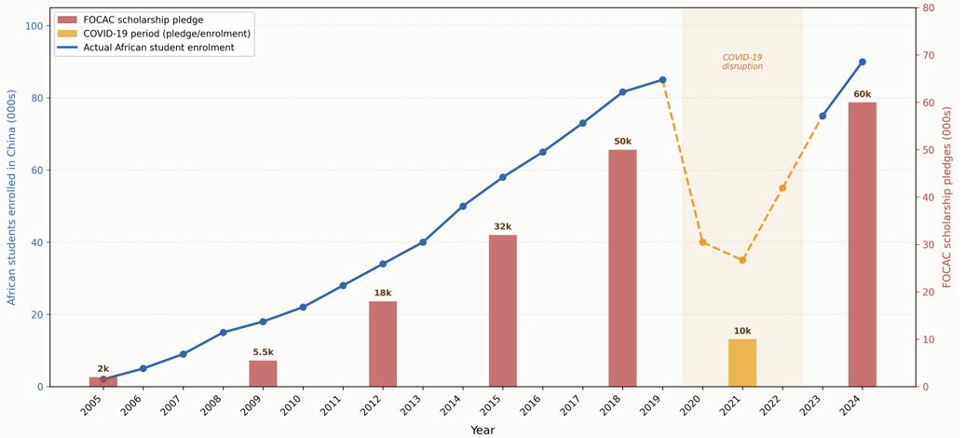

Figure 1. Trend in African students enrolled in Chinese universities (2005–2024) and FOCAC scholarship commitments. The red bars indicate scholarship pledges per FOCAC cycle; the blue line shows actual enrolment. Note the COVID-19 disruption in 2020–2022.

3.2 Confucius Institutes: Cultural Diplomacy on the Ground
Parallel to scholarship expansion, China has deployed Confucius Institutes (Cis) as frontline cultural diplomacy infrastructure in Africa. Established under the Chinese government’s international language and culture promotion (ILCP) strategy, the first CI in Africa opened in 2005; by 2019, 61 Confucius Institutes and 48 Confucius Classrooms had been established across 46 African countries, training more than 15,000 students annually with nearly 200,000 cumulative registered students [12]. As of December 2023, 64 Cis remained operational in Africa out of a global total of 496 across 160 countries and regions, representing Africa as the second largest regional host after Europe [13].
Recent scholarship has debated the precise nature of CI influence. Li [14], in a six-dimensional comparative study, positions Cis as elements of Chinese ‘smart power,’ a hybrid of soft and hard power instruments, distinct from their European counterparts (Alliance Française, British Council, Goethe-Institute) primarily in their tighter integration with parent-state foreign policy objectives. While Western governments and universities have closed more than 128 Cis since 2019 amid concerns about academic freedom, this trend has not been replicated in Africa or the MENA region, where Cis continue to expand [15]. In Africa, CIS are generally perceived as affordable and accessible centers for Chinese language instruction, cultural programming, and scholarship application support, functions that align with African institutional needs regardless of their geopolitical framing.
Gravity model analysis by Chen et al. [16] confirms that CI presence is positively correlated with increases in China’s exports to host countries, operating through an image-enhancement mechanism, i.e., CIs do not merely teach language but cultivate positive perceptions that translate into commercial relationships. This finding underscores the dual function of Cis: developmental and economic on the surface, geopolitically strategic at the structural level.

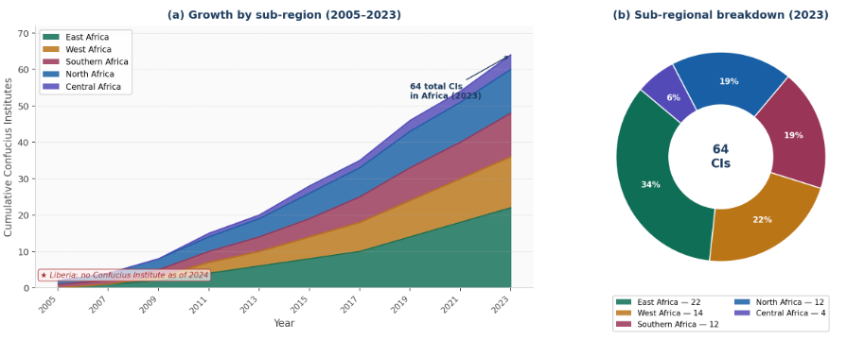
Figure 2. Distribution of Confucius Institutes across African sub-regions (2005–2023). Size of bubble indicates number of CIs; color coding by sub-region (North, West, East, Central, Southern Africa).

3.3 Student Perceptions and the 'Influencer' Hypothesis
A central hypothesis in the education diplomacy literature is that Chinese-educated African graduates will function as long-term advocates for China in their home countries, forming what observers have described as an 'army of influencers' favorably disposed toward Beijing [2]. South China Morning Post reporting from 2024 cites international relations scholar Iraki's comparison with the US airlift for Kenyan students before Kenyan independence: 'By educating such students, you get ambassadors who can give your country a positive image.'
Empirical evidence on this hypothesis is mixed. Surveys of African graduates of Chinese universities consistently report positive assessments of Chinese universities' academic quality, affordability, and inclusivity of admission compared to Western counterparts [2]. However, language barriers, limited integration into Chinese professional networks, and difficulty accessing employment with local Chinese employers mean that many graduates return home with degrees but without the deeper relational ties that would make them effective advocates. As Stimson Center researcher Yun Sun notes, the structural expectation is that international students will return home and promote relations between their countries and China from there—a positive but diffuse outcome rather than a reliable strategic asset [2].

4. Liberia as a Case Study: Historical and Diplomatic Context

4.1 China–Liberia Diplomatic History
The trajectory of China–Liberia relations illustrates the centrality of political loyalty in China's bilateral educational and developmental engagement. Formal diplomatic relations were first established on 17 February 1977, making Liberia one of the early West African states to align with Beijing. However, these relations were ruptured in 1989 when Liberia's government, under pressure from Taiwan's offer of $200 million in aid for education and infrastructure, switched recognition to Taipei, a decision that demonstrated, paradoxically, the very leverage that educational investment can confer [4].
China reestablished relations with Liberia in August 1993, opened an embassy in Monrovia, and began cautiously rebuilding ties. A further rupture occurred in 1997 when Charles Taylor's government attempted to recognize 'two Chinas'; Beijing promptly severed ties again. The definitive restoration came in October 2003, when Liberia dropped Taiwan in favor of the PRC, a decision attributed significantly to Chinese diplomatic lobbying at the United Nations and Beijing's commitment to deploying peacekeepers under UNMIL [4]. The Liberian Senate and House of Representatives subsequently passed Resolution No. 001 in August 2005, confirming and reaffirming an 'unwavering commitment to the one-China policy', institutionalizing the alignment and creating the stable diplomatic platform upon which subsequent educational cooperation would be constructed.

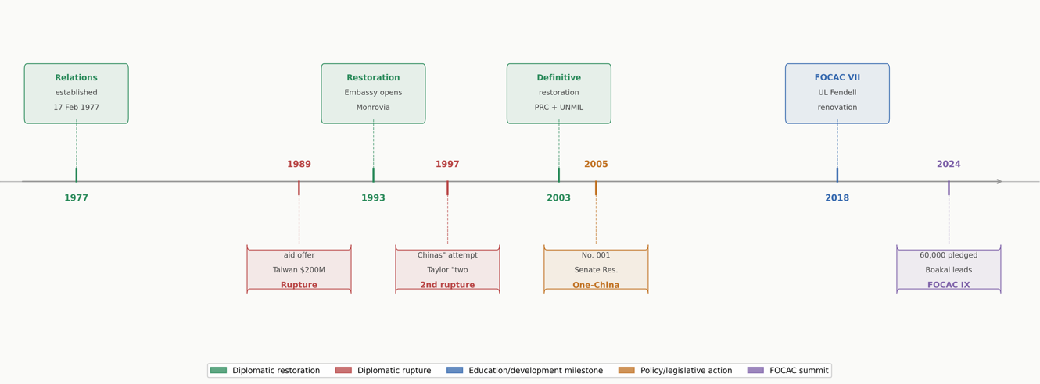
Figure 3. Timeline of China–Liberia diplomatic relations (1977–2024), annotated with key educational and development milestones.

4.2 Economic and Political Context of the Contemporary Relationship
By 2024, the China–Liberia relationship had matured considerably. Chinese Ambassador YIN Chengwu, addressing the 47th anniversary of bilateral relations in May 2024, confirmed that bilateral trade reached US$320 million in 2023, with Chinese investments totaling US$13 million, modest figures by continental standards but significant within Liberia's small economic frame [5]. President Joseph Nyuma Boakai led a Liberian delegation to the 2024 FOCAC Beijing Summit, personally affirming the depth of the bilateral relationship. China is now Liberia's largest trading partner.
Infrastructure investment has been a primary vehicle of Chinese engagement: road and bridge construction, renovation of the Fendell Campus for Engineering at the University of Liberia, construction of government buildings, and completion of the Liberia Broadcasting System Refurbishment and Expansion Project in 2025 [17]. These visible deliverables have strengthened public goodwill toward China in Liberia, creating a favorable environment for the educational cooperation program. The Chinese Embassy in Monrovia has increasingly emphasized people-to-people exchanges as a strategic complement to infrastructure investment, with thousands of Liberian representatives from government, business, and academia visiting China for exchanges and studies in recent years [18].

Indicator | 2015 | 2018 | 2021 | 2023 | Trend
Bilateral Trade (USD million) | ~150 | ~200 | ~180 | 320 | ↑ Rising
Chinese ODA Projects (cumulative) | ~55 | ~65 | ~72 | ~80 | ↑ Steady
Liberian Students in China (est.) | ~80 | ~150 | ~120 | ~250 | ↑ Post-COVID recovery
CSC Scholarship Recipients/yr | ~15 | ~25 | ~18 | ~35 | ↑ Increasing
Chinese-built/renovated schools | ~8 | ~12 | ~15 | ~18 | ↑ Expanding
Bilateral Diplomatic Encounters | 3 | 5 | 2 | 7 | ↑ Active
Table 2. Key indicators of China–Liberia bilateral relations (2015–2023). COVID-19 affected. Sources: Chinese MFA; Liberian Observer; Chinese Embassy Monrovia; author estimates from available data [4,5,17,18].

5. China's Education Diplomacy in Liberia: Five Dimensions

5.1 Scholarship Diplomacy
The China Scholarship Council (CSC) Government Scholarship program is the primary conduit for Liberian students entering Chinese universities. Operating on a triennial cycle aligned with FOCAC commitments, the program funds undergraduate, master's, and doctoral studies at designated Chinese universities, covering tuition, accommodation, stipends, and medical insurance. Liberian applicants compete through the Chinese Embassy in Monrovia, which nominates candidates to the CSC for final selection and assignment to a host institution.
Fieldwork and institutional records indicate that the number of Liberian CSC scholarship recipients has grown substantially since 2003, with an estimated 35 recipients per year by 2023, a modest but growing pipeline compared to larger African nations. Disciplines prioritized include engineering, agriculture, medicine, and public administration, fields aligned with Liberia's post-conflict reconstruction priorities and China's comparative academic strengths. The author's own experience as an M.Eng. candidate at Hohai University's College of Agricultural Science and Engineering reflects a wider pattern: Liberian students are increasingly concentrated in technical and STEM fields, studying in second-tier Chinese universities with strong applied science programs rather than flagship institutions.
Self-funded Liberian students constitute a growing additional category, attracted by lower tuition fees and living costs compared to Western universities, accessible student visa regimes, and growing awareness of Chinese academic programs. A South China Morning Post analysis from August 2024 documents this trend across Africa, noting that China's affordability advantage over Western destinations has become a structural driver of student mobility, amplified by increasingly restrictive immigration regimes in the United States, the United Kingdom, and France [2].

DATA NOTE | As of 2018, there were 81,562 African students in Chinese universities, with 6,385 pursuing PhDs—17% of China's international student community, up from 2% a decade earlier. Liberian students are a small but growing subset of this continental figure [2].

5.2 Confucius Institute and Language Diplomacy
Liberia does not currently host a Confucius Institute, reflecting the small size of its university sector (dominated by the University of Liberia, Cuttington University, and a small number of private institutions) and the limited domestic market for Mandarin language instruction. However, this absence does not preclude the cultural diplomacy dimension of China–Liberia educational engagement. The Chinese Embassy in Monrovia periodically organizes Chinese language courses, cultural events, and scholarship application workshops that perform CI-equivalent functions in the absence of a formal institutional presence.
The absence of a CI in Liberia also reflects a broader pattern noted in the literature: CI establishment has been concentrated in larger African economies with established Sonological traditions and significant Chinese diaspora communities (South Africa, Kenya, Ethiopia, Egypt). West Africa's smaller nations, Liberia, Sierra Leone, and Guinea-Bissau, remain underserved by formal CI infrastructure, suggesting that China's language diplomacy footprint in the sub-region is thinner than continental-level statistics suggest. Given the 2024 FOCAC commitment to establishing 25 China-Africa study centers and a China–Africa Knowledge Network, Liberia may be a candidate for expanded cultural infrastructure in the coming triennium [3].

5.3 Capacity-Building and Vocational Training
Capacity-building programs constitute a significant, if less visible, dimension of China's educational engagement in Liberia. Through the Ministry of Commerce's training program (currently under the China International Development Cooperation Agency, CIDCA), China offers short-term technical training courses to Liberian government officials, agricultural technicians, medical personnel, and media professionals in fields aligned with bilateral project portfolios. These programs, typically two to four weeks in duration, bring Liberian trainees to specialized training centers in China or, increasingly, to in-country training facilities.
A notable example cited by Ambassador Yin Chengwu in 2025 is the Bamboo and Rattan Weaving project, through which Liberian trainees have produced marketable craft products through Chinese-delivered vocational training [17]. While this particular program is modest in developmental scope, it exemplifies China's 'small and beautiful' livelihood approach, prioritizing tangible, visible, community-level outcomes aligned with the 2024 FOCAC Action Plan's emphasis on 1,000 livelihood projects across Africa [3].

5.4 Educational Infrastructure Investment
Perhaps the most tangible dimension of China's educational diplomacy in Liberia is direct infrastructure investment. China's renovation and expansion of the Fendell Campus for Engineering at the University of Liberia, funded through official development assistance, has provided upgraded laboratory facilities, lecture halls, and administrative infrastructure that directly benefit Liberian engineering students and faculty. Broader Chinese infrastructure investment in roads, bridges, and government buildings also indirectly supports educational access by improving transportation connectivity in a country where geographic barriers remain a significant constraint on school attendance.
Construction of primary and secondary school buildings in rural communities, documented in earlier phases of China–Liberia cooperation, reflects a developmental logic that builds public goodwill while addressing genuine educational infrastructure gaps. Such investments are particularly effective diplomatic instruments because their beneficiaries are communities that interact with the Chinese government daily, a form of sustained soft power that academic scholarship alone cannot achieve.

5.5 Network and People-to-People Diplomacy
The fifth and most diffuse dimension of China's educational diplomacy in Liberia operates through sustained people-to-people exchange platforms. The 2024 FOCAC cycle has seen an intensification of high-level and multi-sector exchange visits: President Boakai led a delegation to the FOCAC Beijing Summit; the President Pro Tempore of the Liberian Senate attended the 2024 Legislators Forum for Friendly Exchanges; cabinet ministers and parliamentarians made repeated visits to China; and dozens of Liberian youths pursued a study and exchange program [18].
The Chinese Embassy in Monrovia has made 2025–2026 the 'China–Africa Year of People-to-People Exchanges', organizing a range of cultural, academic, and governance experience-sharing events that create sustained relational infrastructure between Chinese and Liberian elites. These exchanges build the alumni-and-friend networks that constitute the long-term social capital underlying China's influence architecture in Liberia, networks that persist beyond any single scholarship cycle or infrastructure project.

Dimension | Primary Instrument | Liberia Status (2024) | Diplomatic Function | Key Limitation
Scholarship Diplomacy | CSC Government Scholarships | ~35 recipients/yr; growing | Elite formation; goodwill generation | Limited scale; discipline selectivity
Cultural-Linguistic | Confucius Institute | No CI present; Embassy-led activities | Cultural affinity; language access | Absent formal institutional presence
Capacity-Building | CIDCA training courses | Active; vocational + government | Human capital; project alignment | Short duration; limited follow-up
Infrastructure | ODA school/university construction | Ongoing; UL Fendell Campus key | Visibility; community goodwill | Maintenance gap; sustainability
Network/People-to-People | Delegations, forums, alumni | Intensifying post-FOCAC 2024 | Relational capital: long-term influence | Hard to measure; diffuse outcomes
Table 3. Five dimensions of China's education diplomacy in Liberia (2024 assessment). Sources: author analysis; Chinese Embassy Monrovia [17,18]; Ye [11]; King [9].

6. Critical Analysis: Tensions and Contradictions

6.1 Developmental Value vs. Geopolitical Instrumentality
The most significant conceptual tension in the education diplomacy literature is between the genuine developmental value that Chinese education provides to African students and the instrumentalizing logic through which China's education aid is designed and delivered. Ye [11], in a landmark 2023 study drawing on fieldwork across multiple African countries and a detailed analysis of Chinese government decision-making processes, argues that China's education aid to Africa is best described as 'fragmented soft power', driven by multiple competing ministries (MOE, MOFCOM/CIDCA, MFA) with divergent priorities rather than by a unified strategic design.
This fragmentation means that program design is not always optimally aligned with African development needs. The decline in the African share of Chinese government scholarships—from 27.63% in 2008 to 19.84% in 2018, documented by Ye [11] suggests that diplomatic influence calculations can override developmental logic in scholarship allocation. The reversal of this trend, with the FOCAC 2024 pledge of 60,000 slots specifically for Africa, illustrates how the ministerial balance between MOE's international student competition strategy and MFA's Africa diplomacy objectives shapes program outcomes.

6.2 Brain Drain and Return-to-Home Incentives
The brain drain risk embedded in scholarship diplomacy has received significant attention in the literature. Analyses of African government scholarship programs focused on haigui dynamics demonstrate that effective brain gain, the transformation of study-abroad experience into domestic development contribution, requires not merely scholarships but comprehensive return-to-home incentive structures, including employment pathways, research infrastructure, and competitive remuneration [10]. China's own haigui policies, the Thousand Talents Plan, returnee enterprise zones, and subsidized research grants, demonstrate the infrastructure required for successful brain gain.
For Liberia, the brain drain dimension is particularly acute. A country of approximately 5.4 million people with limited absorptive capacity for highly trained technical graduates, Liberia struggles to offer employment conditions that can compete with the opportunities available to Chinese-educated graduates in regional hubs or international organizations. The risk is that China's scholarship investment effectively subsidizes the education of professionals who will serve regional economies (Ghana, Nigeria, Côte d'Ivoire) or international institutions rather than Liberia's own development. This is not a failure of education diplomacy per se, but it points to the limits of scholarships as a development tool in the absence of complementary domestic economic transformation.

6.3 Ideological Dimensions and Academic Freedom
Critiques of China's education diplomacy, particularly prominent in Western academic and policy discourse, emphasize ideological conditioning, the possibility that Chinese university environments shape African students' political attitudes in ways favorable to Beijing. While the 'influencer' hypothesis does find some empirical support in survey data showing positive Chinese perceptions among Africa-educated graduates, the evidence for systematic ideological conditioning is weaker than the critique suggests. Most Liberian and African students in Chinese universities report their educational motivations as primarily instrumental: acquiring technical credentials, building professional networks, and accessing affordable education [2].
The academic freedom dimension is more complex. China's university environment is characterized by certain topics being off-limits, discussion of Taiwan, Tibet, Xinjiang, Tiananmen, and this creates a differential between the academic freedom African students might experience in Western universities. For most Liberian students in engineering, agriculture, or medicine, this constraint has limited practical impact. For students in social sciences, political science, or media, disciplines where discursive freedom is directly pedagogically relevant, the constraint is more significant. The recent restructuring of CI governance, with the replacement of Hanban by the Chinese International Education Foundation (CIEF) and Centre for Language Education and Cooperation (CLEC) in 2020, represents a partial attempt to address academic freedom concerns by introducing greater administrative distance between CIs and the Chinese state apparatus [15].

CRITICAL PERSPECTIVE | Education diplomacy is not politically neutral. When China builds classrooms in Liberia or funds Liberian PhD students, it generates goodwill, but it also builds constituencies, shapes perceptions, and cultivates relationships that serve Chinese foreign policy interests. Recognizing this dynamic is not a reason to reject China's educational engagement, but it is a reason for African governments to develop complementary strategies that maximize developmental returns while maintaining policy autonomy.

6.4 Comparative Diplomacy: China vis-à-vis Western Educational Donors
A comparative perspective is essential for contextualizing China's education diplomacy. The United States, the United Kingdom, France, and Germany all maintain significant scholarship and cultural diplomacy programs in Africa. The Fulbright Program, Chevening Scholarships, Eiffel Scholarships, and DAAD fellowships are well-established pathways to Western higher education for African students. However, several structural features distinguish China's offering: scale (China's FOCAC pledges dwarf any comparable Western bilateral program); accessibility (less stringent admission requirements and visa processes); affordability (lower living costs in Chinese cities compared to New York, London, or Paris); and alignment with applied technical fields prioritized by African governments.
The growing attractiveness of China as a study destination also reflects structural changes in Western higher education: rising tuition fees, increasingly restrictive immigration regimes, and the perception among some African students of racial discrimination in Western academic environments. As Hodzi of the University of Liverpool notes, 'The language barrier, the relative closeness of the society, and the difficulty to find jobs with local Chinese employers are all factors' constraining the depth of China's educational integration with African students, but these are balanced against accessibility advantages that make China increasingly competitive for African students seeking quality education at manageable cost [2].

Dimension | China (FOCAC) | United States | United Kingdom | France
Annual scholarships to Africa | ~20,000 (2024 cycle) | ~2,500 (Fulbright + others) | ~4,000 (Chevening + others) | ~3,500 (Eiffel + others)
Conditionality | None (non-interference) | Democracy/governance conditions | Light conditionality | Light conditionality
Language requirement | Chinese (or English) | English | English | French (primarily)
Disciplines emphasis | STEM, agriculture, medicine | Broad (social sciences strong) | Broad (governance strong) | Broad (Francophone focus)
Cultural institution | Confucius Institute | American Spaces/Education USA | British Council | Alliance Française
Alumni engagement | Growing (FOCAC alumni) | Strong (Fulbright network) | Strong (Chevening network) | Strong (AF network)
Liberia-specific presence | Active; growing | Historically strong | Moderate | Limited
Table 4. Comparative education diplomacy frameworks: China vs. Western bilateral donors in Africa. Sources: FOCAC (2024); US State Department; UK FCDO; French MFA; author compilation.

7. Implications for Liberia: Opportunities and Policy Recommendations

7.1 Maximizing Returns from Chinese Educational Investment
For Liberia, the strategic imperative is to shift from a passive recipient of China's education diplomacy to an active architect of bilateral educational arrangements that maximize domestic development returns. This requires action along several dimensions. First, the Liberian government should develop a National Chinese Scholarship Strategy, a systematic approach to identifying priority disciplines for scholarship nomination, establishing return-to-home incentive packages for Chinese-educated graduates, and creating alumni networks that channel skills back into priority sectors (agriculture, engineering, public health, digital infrastructure).
Second, Liberia should leverage its access to FOCAC-affiliated platforms to advocate for disciplines and program types aligned with the Liberian Poverty Reduction Strategy (PRS IV) and the ECOWAS Education Sector Policy priorities. Currently, disciplinary selection in the Chinese scholarship program reflects Chinese academic strengths and diplomatic priorities more than Liberian developmental needs. A more assertive Liberian posture in bilateral negotiations, analogous to the approach taken by Ethiopia and Rwanda in leveraging Chinese educational investment for specific national development objectives, could yield significantly better developmental returns.

7.2 Advocacy for Confucius Institute Establishment
Given the absence of a Confucius Institute in Liberia, there is a strategic opportunity for the University of Liberia or Cuttington University to negotiate with a Chinese partner institution for CI establishment under the post-2020 CIEF governance framework. A Liberia-based CI would serve multiple functions: Chinese language instruction for students interested in working with Chinese enterprises, scholarship application facilitation, cultural programming that builds public understanding of China, and research collaboration infrastructure. The 2024 FOCAC commitment to 25 China-Africa study centers provides a concrete vehicle for such advocacy.

7.3 Addressing Brain Drain Through Domestic Policy Complementarity
The brain drain risk inherent in scholarship diplomacy cannot be addressed by educational policy alone, it requires complementary action in labor market policy, public sector compensation, and research infrastructure. Liberia's National Higher Education Policy should include specific provisions for reintegrating Chinese-educated graduates, including recognition of Chinese credentials by professional licensing bodies, competitive public sector salary scales for technical graduates, and research grant mechanisms that allow returnees to continue the work begun during their Chinese studies. International support for such initiatives could be sought from UNDP, the African Development Bank, and bilateral donors alongside Chinese cooperation.

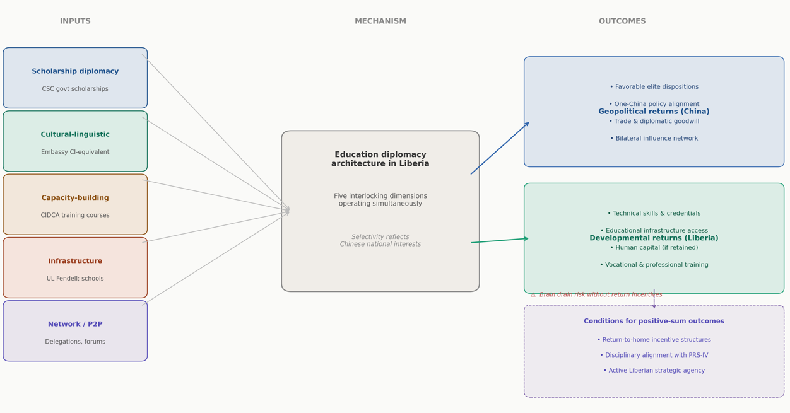
Figure 4. Conceptual framework: China–Liberia Education Diplomacy System inputs, mechanisms, and developmental outcomes. The model distinguishes between geopolitical returns to China and developmental returns to Liberia, and identifies the conditions under which positive-sum outcomes are achievable.

8. Conclusion
This article has examined international education as a tool of diplomacy through the lens of China–Africa relations and the Liberian case study. The analysis demonstrates that China's education diplomacy operates as a comprehensive soft power architecture spanning five dimensions: scholarship provision, cultural-linguistic engagement, capacity-building, educational infrastructure investment, and sustained people-to-people networking. In Liberia, all five dimensions are present to varying degrees, with scholarship diplomacy and infrastructure investment constituting the most substantive pillars of an engagement that has deepened significantly since the restoration of diplomatic relations in 2003.
The FOCAC data presented in Table 1 reveals a clear pattern of escalatory educational commitment from China, with the 2024 pledge of 60,000 scholarships and training opportunities representing the most ambitious cycle to date despite the structural shift toward 'small and beautiful' projects in other domains. This suggests that education retains a privileged status in China's Africa diplomacy toolkit, valued both for its developmental signaling function and for its long-term capacity to cultivate African elites favorably disposed toward Beijing.
The critical analysis in Section 6 identifies three structural tensions that limit the developmental effectiveness of education diplomacy in Liberia: the brain drain risk in the absence of complementary domestic return-to-home incentive structures; the fragmented inter-ministerial dynamics within China's education aid architecture that can produce misalignment between diplomatic objectives and developmental needs; and the ideological boundaries embedded in Chinese academic environments that create differential constraints for different disciplinary communities. These tensions do not negate the genuine value of Chinese educational investment but they do underscore the importance of Liberia developing a strategic framework for educational diplomacy that maximizes domestic returns rather than simply accepting what China offers.
Looking forward, the designation of 2025–2026 as the China–Africa Year of People-to-People Exchanges and the 70th anniversary of China-Africa diplomatic relations, both milestones foregrounded by Chinese Ambassador Yin Chengwu in April 2026, create a propitious context for Liberia to intensify engagement with China's educational infrastructure, advocate for disciplinary alignment, and build the institutional architecture required to translate Chinese educational investment into durable domestic development outcomes [17]. The challenge for Liberia is not to decide whether to participate in China's education diplomacy, the benefits are too substantial to forgo, but to participate on terms that serve Liberian development priorities alongside Chinese diplomatic interests.
Future research should address several gaps identified in this analysis: longitudinal tracking of Liberian graduates of Chinese universities and their career trajectories; comparative analysis of disciplinary patterns in Chinese scholarship allocation across West African small states; and ethnographic investigation of Liberian students' identity formation and political perceptions during and after study in China. Such research would provide the empirical foundation for evidence-based educational diplomacy policy in Liberia and analogous post-conflict states navigating the complexities of China's continental educational engagement.

References
[1] Nye, J.S. (2004). Soft Power: The Means to Success in World Politics. Public Affairs, New York.
[2] South China Morning Post (2024, August 15). Will African students' embrace of China opportunities build support for Beijing? Available at: https://www.scmp.com/news/china/diplomacy/article/3274392 [Accessed April 2025].
[3] Forum on China–Africa Cooperation (FOCAC) (2024). FOCAC Beijing Action Plan (2025–2027). Ministry of Foreign Affairs of the People's Republic of China, Beijing. Available at: https://www.fmprc.gov.cn [Accessed April 2025].
[4] Moumouni, G. (2014). China and Liberia: Engagement in a Post-Conflict Country. SAIIA Occasional Paper No. 182, South African Institute of International Affairs, Johannesburg.
[5] Liberian Observer (2024, May). China, Liberia Celebrate Decades of Strong Bilateral Ties. Available at: https://www.liberianobserver.com [Accessed April 2025].
[6] Nye, J.S. (2008). Public Diplomacy and Soft Power. The Annals of the American Academy of Political and Social Science, 616(1), 94–109.
[7] Callahan, W.A. (2015). Identity and Security in China: The Negative Soft Power of the China Dream. Politics, 35(3–4), 216–229.
[8] United Nations (2023). Report of the Secretary-General on the State of South-South Cooperation. A/78/XX. United Nations, New York.
[9] King, K. (2020). China–Africa Education Cooperation: From FOCAC to Belt and Road. International Journal of Chinese Education, 8(2), Article 2096531119889874. https://doi.org/10.1177/2096531119889874
[10] Geda, A., Abebe, S., & Molla, T. (2021). Untapping FOCAC Higher Education Scholarships for Africa's Human Capital Development: Lessons from Haigui. PMC/NIH Open Access. https://pmc.ncbi.nlm.nih.gov/articles/PMC8264171/
[11] Ye, W. (2023). China's Education Aid to Africa: Fragmented Soft Power. Routledge (Taylor & Francis Group), London and New York.
[12] Tang, M., Wang, J., Yang, Y., & Baskaran, A. (2024). The Path of China–Africa Higher Education Cooperation in Training Talents for Africa. In: Muchie, M., Baskaran, A., Tang, M. (eds), China-Africa Science, Technology and Innovation Collaboration. Springer, Singapore. https://doi.org/10.1007/978-981-97-4576-0_3
[13] Chen, Y., Liu, H., & Zhang, R. (2025). Soft Power in Trade: Quantifying the Impact of Confucius Institutes on China's Exports. International Studies of Economics. https://doi.org/10.1002/ise3.70008
[14] Li, S. (2023). China's Confucius Institute and its European Counterparts in Africa: A Six-Dimensional Comparative Study. Research in Comparative and International Education. https://doi.org/10.1177/17454999221146385
[15] Li, S. (2024). Problematising China's Soft Power: Setbacks of Confucius Institutes and the Decentralisation of its International Language and Culture Promotion Strategy. The Pacific Review, 38(3), 397–421. https://doi.org/10.1080/09512748.2024.2387614
[16] Chen et al. (2025). As cited in [13] above.
[17] Ministry of Foreign Affairs of the People's Republic of China (2026, April 2). Chinese Ambassador to Liberia Yin Chengwu Gives an Interview to Liberian Mainstream Newspaper. Available at: https://www.fmprc.gov.cn/eng/xw/zwbd/202604/t20260403_11886594.html
[18] Ministry of Foreign Affairs of the People's Republic of China (2025, June 10). Chinese Ambassador to Liberia Yin Chengwu Publishes an Article: Dialogue Among Civilizations. Available at: https://www.mfa.gov.cn/eng/xw/zwbd/202506/t20250612_11646705.html
[19] Chatham House (2023, January). China–Africa Relations. Chatham House: The Royal Institute of International Affairs. Available at: https://www.chathamhouse.org/2023/01/china-africa-relations
[20] Boston University Global Development Policy Center (2024, October 15). Back in Action: The Ninth Forum on China-Africa Cooperation. Available at: https://www.bu.edu/gdp/2024/10/15/back-in-action
[21] Centre for Democracy and Development West Africa (2024, September 9). West Africa and China – FOCAC 2024. Available at: https://www.cddwestafrica.org/blog/much-ado-about-focac/
[22] Wikipedia (2026). China–Liberia Relations. Available at: https://en.wikipedia.org/wiki/China%E2%80%93Liberia_relations [Accessed April 2025].
[23] Ministry of Foreign Affairs of the People's Republic of China (n.d.). Liberia Country Profile. Available at: https://www.fmprc.gov.cn/mfa_eng/gjhdq_665435/2913_665441/3024_664064/
[24] Sun, S.-C. (2023). Confucius Institutes: China's Cultural Soft Power Strategy. Journal of Culture and Values in Education, 6(1), 52–68. https://doi.org/10.46303/jcve.2023.4
[25] Hartig, F. (2015). Chinese Public Diplomacy: The Rise of the Confucius Institute. Routledge, London.
[26] Li, S. (2021). China's Confucius Institute in Africa: A Different Story? International Journal of Comparative Education and Development, 23, 353–366.
[27] Oxford Analytica (2024, July). FOCAC 2024 Aims to Renew the China-Africa Relationship. Oxford Analytica Daily Brief. https://www.oxan.com/insights/focac-2024-aims-to-renew-the-china-africa-relationship/
[28] Pacific Forum (Taiwan) (2024). FOCAC 2024 Outcomes: China's Strategic Pivot in Africa. Available at: https://www.pf.org.tw/en/pfen/33-10966.html
[29] African Union Commission (2021). Continental Education Strategy for Africa (CESA 2016–2025): Progress Report. African Union, Addis Ababa.
[30] Nye, J.S. (2018). How Sharp Power Threatens Soft Power. Foreign Affairs, January 24. https://www.foreignaffairs.com/articles/china/2018-01-24/how-sharp-power-threatens-soft-power

