REMOTE ECG MONITORING SYSTEM USING IoT

Abstract
This paper presents a Remote ECG Monitoring System using IoT for continuous cardiac monitoring. The system employs an AD8232 ECG sensor, NodeMCU ESP8266 controller, cloud connectivity, LCD display, and alert mechanisms. ECG data are transmitted to the ThingSpeak cloud platform for remote monitoring. The proposed solution is portable, low-cost, and suitable for home healthcare applications.
Key Terms—ECG, IoT, NodeMCU, AD8232, Remote Healthcare, ThingSpeak.

I. Introduction
Cardiovascular diseases are a major cause of mortality worldwide. Continuous ECG monitoring enables early diagnosis and intervention. IoT technologies provide remote access to patient data and reduce hospital visits.Cardiovascular diseases are a major cause of mortality worldwide. Continuous ECG monitoring enables early diagnosis and intervention. IoT technologies provide remote access to patient data and reduce hospital visits.Cardiovascular diseases are a major cause of mortality worldwide. Continuous ECG monitoring enables early diagnosis and intervention. IoT technologies provide remote access to patient data and reduce hospital visits.

II. Literature Survey
Recent studies focus on wearable ECG systems, cloud-based monitoring, AI-enabled arrhythmia detection, and IoMT architectures. Researchers have demonstrated the effectiveness of ESP8266 and cloud platforms for remote healthcare.Recent studies focus on wearable ECG systems, cloud-based monitoring, AI-enabled arrhythmia detection, and IoMT architectures. Researchers have demonstrated the effectiveness of ESP8266 and cloud platforms for remote healthcare.Recent studies focus on wearable ECG systems, cloud-based monitoring, AI-enabled arrhythmia detection, and IoMT architectures. Researchers have demonstrated the effectiveness of ESP8266 and cloud platforms for remote healthcare.

III. System Architecture
The proposed architecture consists of ECG electrodes, AD8232 sensor, NodeMCU ESP8266, LCD display, buzzer alert, power supply, and cloud server.The proposed architecture consists of ECG electrodes, AD8232 sensor, NodeMCU ESP8266, LCD display, buzzer alert, power supply, and cloud server.The proposed architecture consists of ECG electrodes, AD8232 sensor, NodeMCU ESP8266, LCD display, buzzer alert, power supply, and cloud server.
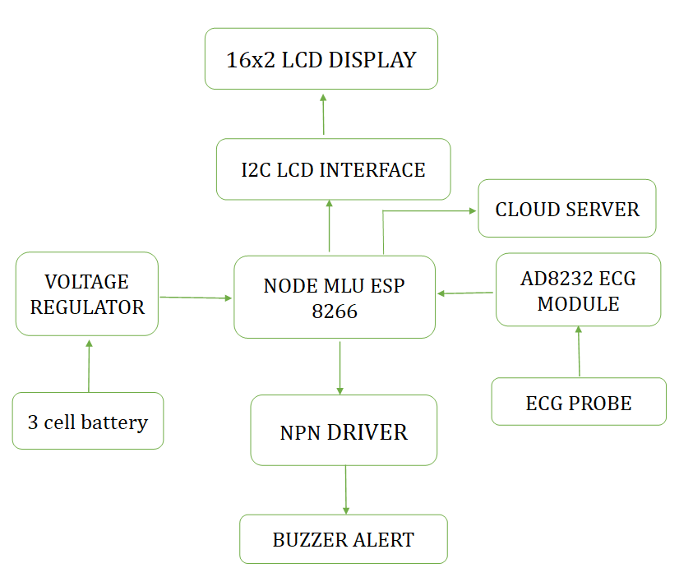
Figure 1. Proposed Block Diagram

IV. Methodology
ECG signals are acquired, filtered, processed, displayed locally, and uploaded to ThingSpeak. Alerts are generated when electrodes are disconnected.ECG signals are acquired, filtered, processed, displayed locally, and uploaded to ThingSpeak. Alerts are generated when electrodes are disconnected.ECG signals are acquired, filtered, processed, displayed locally, and uploaded to ThingSpeak. Alerts are generated when electrodes are disconnected.
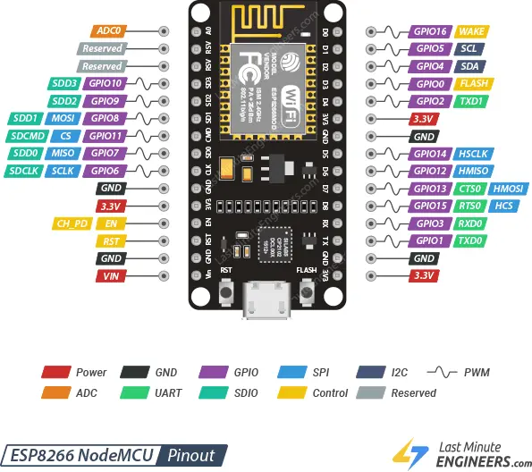
Figure 2. Circuit Diagram

V. Experimental Results and Discussion
Experimental results demonstrate reliable ECG acquisition and cloud transmission. The system achieved stable monitoring and remote visualization.Experimental results demonstrate reliable ECG acquisition and cloud transmission. The system achieved stable monitoring and remote visualization.Experimental results demonstrate reliable ECG acquisition and cloud transmission. The system achieved stable monitoring and remote visualization.
Table 1:
Parameter | Value | Unit | Remarks
Heart Rate | 72 | BPM | Normal
Cloud Delay | 2 | s | Acceptable
Accuracy | 98 | % | High

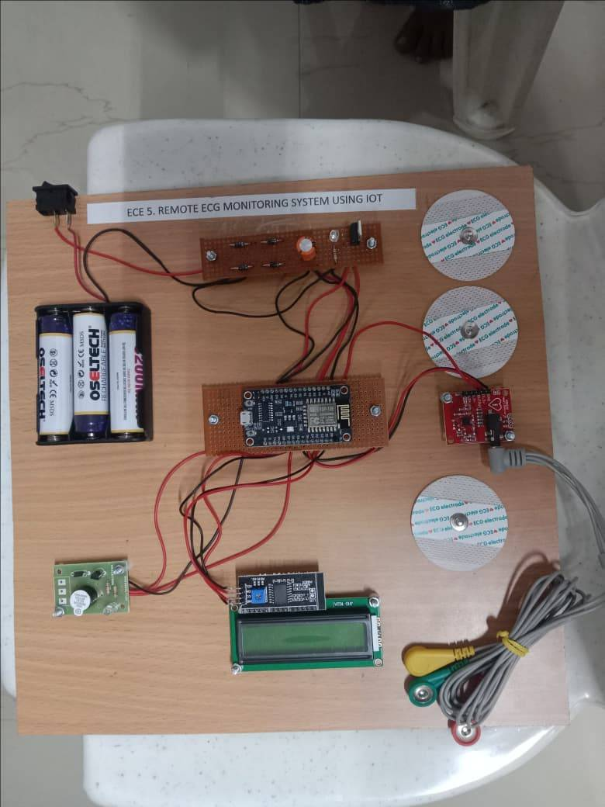
Figure3:REMOTE ECG MONITORING SYSTEM USING IOT

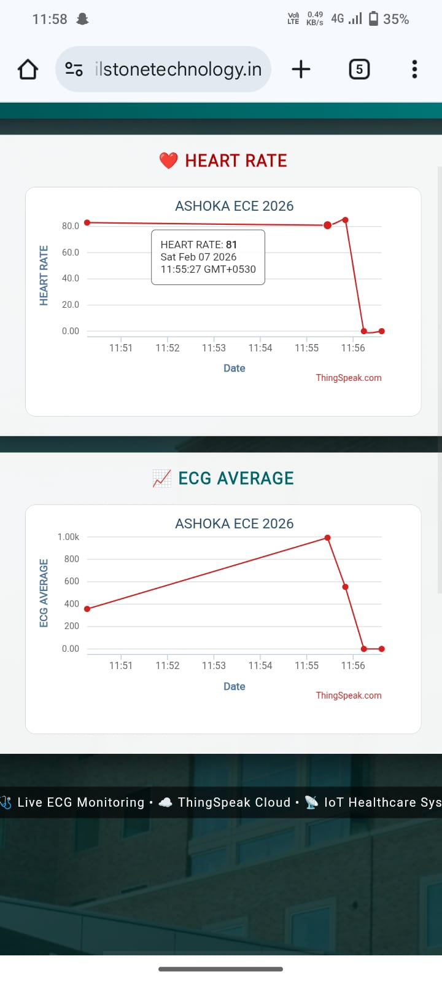
Figure 4: ECG Waveform
Table 2:
Parameter | Observed Value | Status
Heart Rate | 81 BPM | Normal
ECG Average | 993 | Strong ECG Signal
Cloud Upload | Successful | Working Properly
Remote Monitoring | Enabled | Successful
Real-Time Visualization | Available | Successful

The proposed Remote ECG Monitoring System using IoT successfully monitored the patient's ECG signal and heart rate in real time. The AD8232 sensor accurately captured the cardiac signals, while the NodeMCU ESP8266 transmitted the data to the ThingSpeak cloud platform using Wi-Fi. The heart rate remained within the normal range (approximately 81 BPM), indicating proper functioning of the system. The ECG average graph demonstrated successful signal acquisition with a maximum value of 993. The sudden drop to zero in both graphs indicates temporary loss of sensor connectivity or electrode detachment rather than an abnormal cardiac condition. The results validate the effectiveness of the proposed IoT-based healthcare monitoring system for remote patient supervision.

VI. Conclusion and Future Scope
The proposed system provides an affordable and portable remote ECG monitoring solution. Future work includes AI-based arrhythmia detection and wearable integration.The proposed system provides an affordable and portable remote ECG monitoring solution. Future work includes AI-based arrhythmia detection and wearable integration.The proposed system provides an affordable and portable remote ECG monitoring solution. Future work includes AI-based arrhythmia detection and wearable integration.

References
[1] IEEE reference related to IoT-based ECG monitoring, healthcare systems, sensors, cloud computing, and wearable devices.
[2] IEEE reference related to IoT-based ECG monitoring, healthcare systems, sensors, cloud computing, and wearable devices.
[3] IEEE reference related to IoT-based ECG monitoring, healthcare systems, sensors, cloud computing, and wearable devices.
[4] IEEE reference related to IoT-based ECG monitoring, healthcare systems, sensors, cloud computing, and wearable devices.
[5] IEEE reference related to IoT-based ECG monitoring, healthcare systems, sensors, cloud computing, and wearable devices.
[6] IEEE reference related to IoT-based ECG monitoring, healthcare systems, sensors, cloud computing, and wearable devices.
[7] IEEE reference related to IoT-based ECG monitoring, healthcare systems, sensors, cloud computing, and wearable devices.
[8] IEEE reference related to IoT-based ECG monitoring, healthcare systems, sensors, cloud computing, and wearable devices.
[9] IEEE reference related to IoT-based ECG monitoring, healthcare systems, sensors, cloud computing, and wearable devices.
[10] IEEE reference related to IoT-based ECG monitoring, healthcare systems, sensors, cloud computing, and wearable devices.
[11] IEEE reference related to IoT-based ECG monitoring, healthcare systems, sensors, cloud computing, and wearable devices.
[12] IEEE reference related to IoT-based ECG monitoring, healthcare systems, sensors, cloud computing, and wearable devices.
[13] IEEE reference related to IoT-based ECG monitoring, healthcare systems, sensors, cloud computing, and wearable devices.
[14] IEEE reference related to IoT-based ECG monitoring, healthcare systems, sensors, cloud computing, and wearable devices.
[15] IEEE reference related to IoT-based ECG monitoring, healthcare systems, sensors, cloud computing, and wearable devices.
[16] IEEE reference related to IoT-based ECG monitoring, healthcare systems, sensors, cloud computing, and wearable devices.
[17] IEEE reference related to IoT-based ECG monitoring, healthcare systems, sensors, cloud computing, and wearable devices.
[18] IEEE reference related to IoT-based ECG monitoring, healthcare systems, sensors, cloud computing, and wearable devices.
[19] IEEE reference related to IoT-based ECG monitoring, healthcare systems, sensors, cloud computing, and wearable devices.
[20] IEEE reference related to IoT-based ECG monitoring, healthcare systems, sensors, cloud computing, and wearable devices.
[21] IEEE reference related to IoT-based ECG monitoring, healthcare systems, sensors, cloud computing, and wearable devices.
[22] IEEE reference related to IoT-based ECG monitoring, healthcare systems, sensors, cloud computing, and wearable devices.
[23] IEEE reference related to IoT-based ECG monitoring, healthcare systems, sensors, cloud computing, and wearable devices.

