Modelling the Effect of Foreign Direct Investment on Poverty Reduction in Nigeria: Application of Cochrane Orcutt Techniques (COET).

Abstract:
The study examined modelling the effect of foreign direct investment and poverty reduction in Nigeria. Cochrane Orcutt Estimating Techniques (COET) was adopted as a tool in fitting the model where poverty reduction (POV) measured by GDP per capital served as response variable, while Direct Foreign Investment (FDI), Inflation rate (INFR), Federal Government Expenditure (FGE) and Unemployment rate (UEMPR) served as explanatory variables. The data used were collected from the Central Bank of Nigeria statistical bulletin, (published 2025, chn.gov.ng), and World Bank group (data.worldbank.org) for the period of 34 years, from 1991 to 2024. SPSS Software Package (version 25) was used to carry out the analysis. At the initial stage of the analysis least square regression was estimated. However, Durbin-Watson statistic has identified the presence of autocorrelation in the error terms of the model, this necessitated the application of Cochrane Orcutt transformation. The transformation of the model improved the Durbin-Watson statistic and increased the coefficient of determination${ R}^{2}$, confirmed a better model fit. The findings suggest that increased inflows of FDI can serve as a building block for poverty reduction in Nigeria through employment generation, technology transfer, capital formation, and increased productive activities. Finally, the study recommends establishment of investment- approachable polices, practical economic management, inflation control measure and strategic public spending to reduce poverty level and improve sustainable economic growth in Nigeria.
Keywords: Poverty Reduction, Foreign Investment, Cochrane Orcutt Techniques, Economic Growth, Inflation Rate, Government Expenditure.
1.0 Introduction:
The relevancy of Foreign Capital to the developing countries is well renowned. It contributes to their domestic savings which is often accompanied with the technology and managerial skills, the outcome of it is indispensable in economic development. Foreign Direct Investment (FDI) is an index that contributes significantly in breaking the poverty vicious circle. Hence, there lies the hope of Nigeria. The government of Nigeria hopes that FDI can make up domestic capital shortfalls, provide technology, managerial skills, facilitate access to foreign market and generate both technological and efficient spillovers to local firms. However, FDI is expected to improve the integration of continent global economy, spur economy growth and alleviate poverty, if access to external markets, transforming technology and building capacity in the local firms are generally provided. Direct foreign investment has been characterized as the best form of foreign finance. The packages of FDI comes with finance, technology and highly skilled personnel (Lau and Streeton 1977).
In reality, Nigeria being in the third world countries, FDI happens to be the main channel through which the Import-Substitution, Industrialization Strategies were prosecuted. It is quite noted that given the host-country policies and a basic level of development, always add value to the economy growth. The benefits that might accrue from FDI include employment creation, the acquisition of new technology and knowledge, likewise increased tax revenue from cooperate profit generated from FDI. All of these forms of benefits are expected to contribute to higher economic and employment growth, which is most important and effective tool for achieving improvements in human wellbeing for alleviating poverty in Nigeria,
The ability of Nigeria to alleviate poverty depends on the adequate inflow of foreign investment resources. The country has been experiencing difficulties in her effort to alleviate poverty for decades now. Presently, majority of Nigerians are living below the poverty level. Usman (1998) highlighted reason for the slow economic progress in Nigeria to include monoculture economy, high population growth rate, import dependency, political instability etc. as a result of the above scenario it has been observed that there exist a gap between the domestically available supply of savings, foreign exchange government revenue and skills and planned level of the resources necessary to achieve development targets that leads to poverty alleviation in Nigeria.
The flow capital funds across national boundaries is not a new development, since the 16th century, business entrepreneurs had engaged in business activities that involved movement of capital funds from one nation to another (Richardo Robinson 1973).
However, earlier forms of national fund across the borders was commercially motivated, at that time business entrepreneurs from far away Europe were in search of personal fortunes in the foreign land of Asia and Africa. These businessmen brought certain items like spices, precious stone and resold them. They made much profit from this act. The nature and manner the pioneers of foreign business enterprises carried out their activities led Robinson to describe their activities as “legalized piracy”. Though these early foreign business enterprises with other national countries did not result to direct foreign investment in actual sense.
Moreover, with the above industrial revolution in the second half of the 19th century, interest shifted just bringing of exotic articles to promotion of final goods which at times demanded that business enterprises to set up in these countries are management directed by those foreign entrepreneurs with the requisite skills.
The study of foreign direct investment for development attempts primarily to focus on the overall effects of FDI on macroeconomic growth and other welfare enhancing processes on the channels through which this benefits take effect. FDI triggers technology spillovers, assist human capital formation, contributes to international trade integration, help create a more competitive business environment and enhance enterprise development.
1.1 Poverty Alleviation:
A concise universally accepted definition of poverty is exclusively large because it affects many aspect of the human conditions. This involves physical, moral and psychological aspect. Distinct criteria have been used to conceptualize poverty. Most analyses follow the conventional view of poverty as a result of insufficient income for securing basic goods and services. Some experts see poverty in a very bad terms, such as being unable to meet basic need (physical; food, healthcare, education, shelter etc. and non-physical participation, identity etc) requirement for a meaningful life (World Bank 1996)
Broadly, poverty can be seen in four ways; these are lack of access to basic needs, lack of access to productive resources and result of “exclusive mechanism”. Poverty is lack of access to basic needs/goods that are essentially economic in nature.
Basic goods are nutrition, shelter/housing, water, health-care, access to productive resources including education, working skills and civil rights to participate in decision concerning social economic conditions (streeten and Burki, 1978). The first three are the basic needs/goods necessary for survival. Inadequate endowment of human capital is also a major cause of poverty. Generally, impaired access to resources shifts the focus on poverty and it curtails the capability of individual to convert available productive resources to a higher quality of life. (Sen, 1977) and Adeyeye, 1987).
A noted poor nation exhibits features of widespread or mass penury reflected in the pauperization of the working and professional classes including artisans. In such a nation the phenomena of unemployment and under-employment are widespread. Another major feature of a poor nation is poor infrastructural facilities characterized by inadequate supply of clean water, inadequate and poor housing facilities, inadequate transportation facilities especially road network, poor telecommunication system and inadequate supply of electric power for both house hold and business uses.
A major requirement for alleviating poverty in any country is the pursuit and maintenance of a strong economic growth. The depth and severity of the poverty of a nation cannot be alleviated where acute inequality of income distribution not only persist but worsen over time.
It has come increasingly to see FDI as a source of economic development modernization, income growth, employment and so poverty reduction.
Poverty is almost invariably linked to how or stagnated economic growth and unemployment. It is generally argued that FDI is essential for generating economic growth and hence creating new job opportunities and thus also alleviating poverty.
Although in literature several studies related to relationship between FDI and poverty reduction in Nigeria has been carried out by different authors. For example, Ogunniyi & Igberi (2014) employed the method of ordinary least square (OLS) regression and data from 1980 to 2012. Their results showed that FDI has positive relationship with poverty reductionist but statistically insignificance.
In same vein, Olusegun et al. (2021) adopted Autoregressive distributed lag (ADRL) model approach and their findings showed that human capital significantly strengthened the poverty-reducing impact of FDI in Nigeria. Moreover, ADRL framework was adopted by Nkoro & Nko (2022). Their findings showed that FDI reducing poverty indirectly through economic growth. However, its direct impact remained adverse.
Recently, Nathan et al. (2024) utilized Error Correction Model (ECM) technique to examine the Sectorial FDI and poverty in Nigeria. The findings showed mixed effect of FDI on poverty reduction. Anthony et al. (2025) adopted Nonlinear Autoregressive Distributed Lag (NARDL) model and using data from 1970-1924. The results revealed that FDI, trade openness and economic growth significantly reduce poverty in the short run while sustained economic growth measured by GDP per capital emerged as a key long-term factor in poverty alleviation.
Despite the above contributions, earlier studies focused on OLS, ADRL and ECM of estimation approaches with little or no attention to serial autocorrelation, one of the classical assumptions of the least square regression that must be satisfied. Consequently, this study adopt the Cochrane-Orcutt approach to address the problem of autocorrelation often associated with annual macroeconomic time series in Nigeria.
2.0 Methodology
2.1 Source of Data
The study relies on existing macroeconomic time series data relating to foreign direct investment (FDI) and poverty indicator for the periods of 34 years between 1991 and 2024 in Nigeria which extracted from Central Bank of Nigeria statistical bulletin, (published 2025, chn.gov.ng), and world bank group (data.worldbank.org). The variables include poverty level (measured by GDP per capital in N), foreign direct investment (FDI, in US$’ Million), Economic growth (measured by GDP growth rate), inflation rate (INFR), Government expenditure (GE in N ‘Billion) and unemployment rate (UEMPR).
2.2 Estimation Technique
Firstly, the study used the Ordinary least square (OLS) to estimate regression model
${ Y}_{t}=β_{i}X_{it}+∈_{t} i=0,…,p$and$t=1,…,n$ (1)
where $Y_{t}$ is the dependent variable, $X_{it}$ are the explanatory variables and $∈_{t}$is the white noise error term.
However, because the time series data often exhibit autocorrelation, the study further employed Cochrane-Orcutt estimation method to correct the serial autocorrelation in the error term. This method assumes that the error term $∈_{t}$ follows first order autoregressive process and given by
$μ_{t}=ρμ_{t-1}+∈_{t}$ (2)
where $ρ$ is the autocorrelation coefficient. If serial autocorrelation exist, the variables are transformed using Cochrane-Orcutt procedure and the transformed regression given by
$Y_{t}-ρY_{t-1}=β_{0}\left(1-ρ\right)+β_{1}\left(X_{1t}-ρX_{1t-1}\right)+⋯+β_{p}\left(X_{pt}-ρX_{pt-1}\right)+∈_{t}$ (3)
Where $ρ$ is the autocorrelation coefficient, $Y_{t}$ is the dependent variable, $X_{t}$ is the independent variables and $∈_{t}$is the white noise error term. The equation (3) is estimated repeatedly until the autorotation problem minimized

2.3 Model Specification
The functional relationship for FDI and poverty reduction with modification to suit the goal of the study is specified and given by
$$POV=f(FDI, GR, INF, GEX, UNEMP)$$
where POV is poverty level, FDI is foreign direct investment, GR is gross domestic product growth rate, INF is the inflation rate, GEX is the government expenditure and UNEMP is the unemployment rate. The econometric and transformed model are given by
$${P{OV}_{t}=β_{0 }+β_{1 }FDI}_{t}+ β_{2 }{GR}_{t}+ β_{3 }{IFR}_{t}+β_{4 }{GEX}_{t}+{β_{5 }UNEMP}_{t}+∈_{t}$$

$${P{OV}_{t}-ρP{OV}_{t}=β_{0 }\left(1-ρ\right)+β_{1 }(FDI}_{t}-ρ{FDI}_{t-1})+ β_{2 }{(GR}_{t}-ρ{GR}_{t-1})+ β_{3 }{(IFR}_{t}$$
$-ρ{IFR}_{t-1})+β_{4 }({GEX}_{t}-{ρGEX}_{t-1})+{β_{5 }(UNEMP}_{t}-{ρUNEMP}_{t-1})+∈_{t}$
where $β_{0}$ is the intercept, $β_{1},…,β_{5}$ are the coefficients of the explanatory variables

3.0 ANALYSIS AND RESULTS
3.1Data Description
Table 1 and figure 1 presented the descriptive statistics and histograms for the variables used in this study for the periods of 34 years (1991-2024). These include Poverty reduction (POV), Foreign Direct Investment (FDI), Economic Growth (EG), Inflation rate (INFR), Federal Government Expenditure (FGE) and Unemployment rate (UEMPR). The output (Table 1) comprises the minimum and maximum values of the variables, the mean which shows the average value of each variable, the standard deviation measure variability and skewness and kurtoses that measures the symmetry and peakness of data distribution, respectively. The histograms indicates that majority of the variables are positively skewed except the Economic Growth variable that is appropriately normal and the Unemployment rate that slightly skewed with moderate concentration around the mean .
Table 1; Descriptive Statistics
Variables | Min | Maxi | Mean | SD | Skewness | Kurtosis
POV | 12850.00 | 1602302.00 | 564977.7059 | 540370.03740 | .733 | -.957
FDI | 1005.00 | 8841.00 | 3541.3824 | 2236.56997 | 1.072 | .218
EG | -6.37 | 15.33 | 3.8553 | 3.98942 | .079 | 1.586
INFR | .22 | 76.76 | 19.5244 | 16.68816 | 2.096 | 4.170
FGE | 66.58 | 28900.00 | 5222.1356 | 6678.84161 | 2.059 | 4.463
UEMPR | 3.05 | 5.71 | 4.0297 | .58509 | 1.361 | 1.972
Source: Analysis (SPSS version 25)

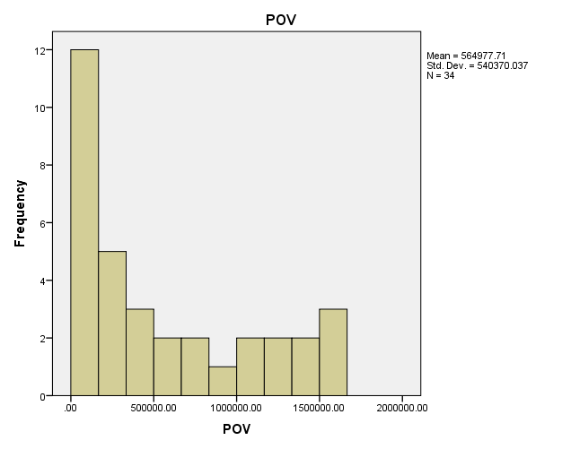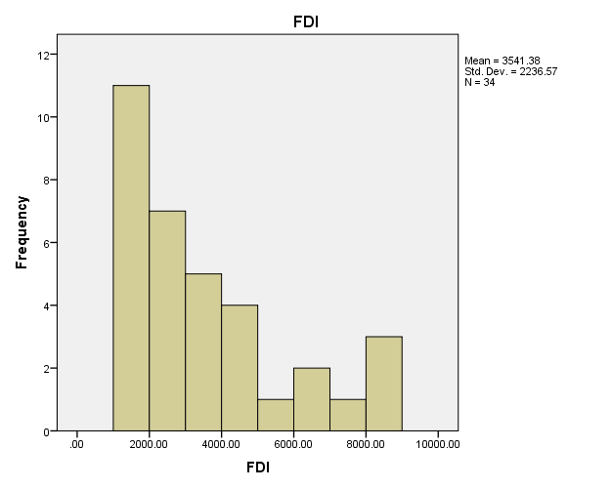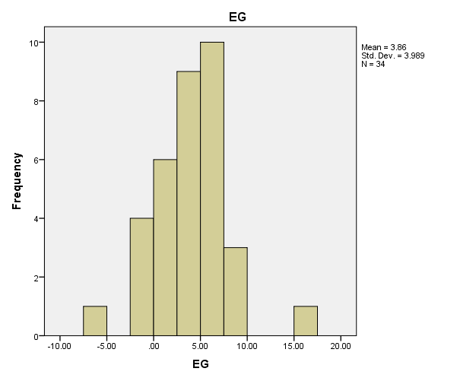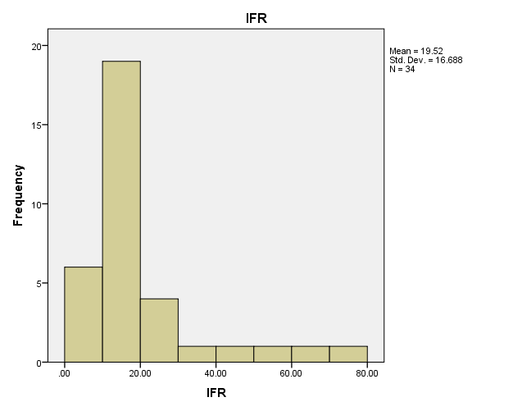
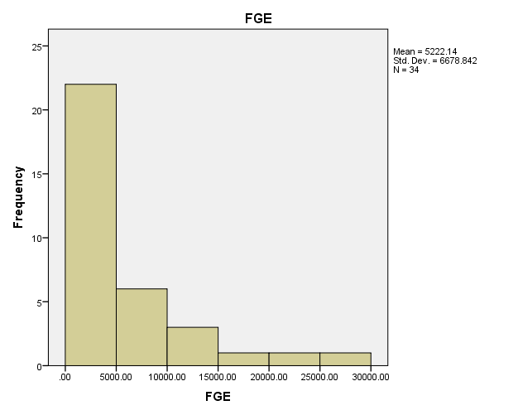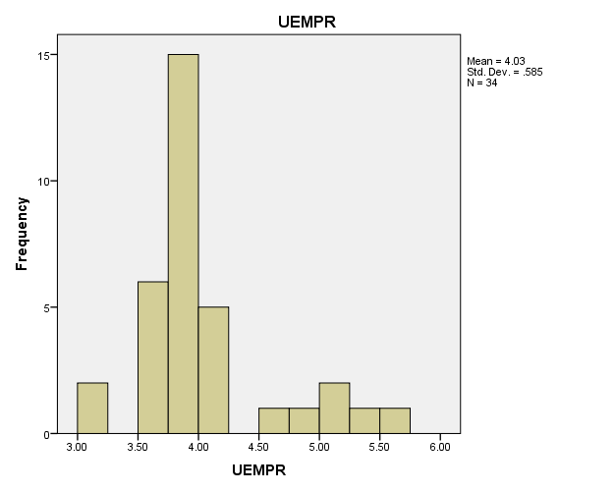
Figure1: Histogram of the variables within the study periods

3.2 Estimation of the Variable Parameters
For the purpose of the parameter estimation, least square regression method was employed and the results were presented in Table 2. The poverty reduction model given by;
$${P\hat{O}V}_{i}=Exp(3.55+0.000076{FDI}_{i}+0.0215{EG}_{i}-0.0094{INFR}_{i}+0.00069{FGE}_{i}+0.34{UEMPR}_{i}+ϵ_{i})$$
Examine the results, it can be seen that only the coefficients of Economic Growth found to be statistically insignificant$(P=0.199>0.05)$. This suggests that $EG$ has no significant effect on poverty reduction among the variables considered for the study while other variables ($FDI, INFR, FGE and UEMPR$) have significant effect on poverty reduction since there P-values less than 5% significant. The multiple correlation coefficient (R) shows that the correlation between the variables is significantly high what of 92.5%. Likewise, the$R^{2}$, which measure the coefficient of determination indicates that 85.6% of the selected explanatory variables account for the variations in Poverty reduction (POV). However, the result may not reliable due to Dutbin-Watson statistic ($0.76≠2$) which indicates the presence of autocorrelation in the residual of the estimated model. To avoid confusion, the study proceed to apply Cochrane-Orcutt transformation.

Table 2: Parameter Estimates of the coefficients
 | $$β$$ | $$SE$$ | $$t$$ | $$P-value$$ | $$R$$ | $$R^{2}$$ | $$DW$$
(Constant) | 3.550 | 0.502 | 7.070 | 0.000 | 0.925 | 0.856 | 0.76
FDI | 0.000076 | 0.000 | 3.570 | 0.001
EG | 0.0215 | 0.016 | 1.315 | 0.199
INFR | -0.0094 | 0.003 | -2.867 | 0.008
FGE | 0.000069 | 0.000 | 10.482 | 0.000
UNEMPR | 0.341 | 0.101 | 3.365 | 0.002
Source: Analysis (SPSS version 25)

Therefore, the autocorrelation coefficient ($ρ)$ was estimated as 0.342 by regressing the current residual on its lag value. Subsequently the following transformed variables were generated. ${L(POV}_{i}^{*})={L(POV}_{i})-0.34{L(POV}_{i-1})$, ${FDI}_{i}^{*}={FDI}_{i}-0.34{FDI}_{i-1}$, ${EG}_{i}^{*}={EG}_{i}-0.34{EG}_{i-1}$, ${INFR}_{i}^{*}={INFR}_{i}-0.34{PINFR}_{i-1}$, ${FGE}_{i}^{*}={FGE}_{i}-0.34{FGE}_{i-1}$, ${UNEMPR}_{i}^{*}={UNEMPR}_{i}-0.34{UNEMPR}_{i-1}$

Table 3: Parameter Estimates from Cochrane-Orcutt Procedure
 | $$β$$ | $$SE$$ | $$t$$ | $$P-value$$ | $$R$$ | $$R^{2}$$ | DW
(Constant) | 3.704 | 0.4987 | 7.428 | 0.000 | 0.946 | 0.896 | 1.626
$${FDI}_{i}^{*}$$ | 0.0000704 | 0.0000 | 3.807 | 0.001
$${EG}_{i}^{*}$$ | 0.0193 | 0.0172 | 1.121 | 0.272
$${INFR}_{i}^{*}$$ | -0.0108 | 0.0031 | -3.501 | 0.002
$${FGE}_{i}^{*}$$ | 0.0000692 | 0.0000 | 11.569 | 0.000
$${UNEMPR}_{i}^{*}$$ | 0.320 | 0.0976 | 3.281 | 0.003
Source: Analysis (SPSS version 25)

Table 3 presents the Cochrane-Orcutt results and the Poverty reduction model can be write as;

$${POV}_{i}^{*}=Exp\left\{3.704+0.0000704{FDI}_{i}^{*}+0.0193{EG}_{i}^{*}-0.0108{INFR}_{i}^{*}+{0.0000692FGE}_{i}^{*}+0.320{UNEMPR}_{i}^{*}+ϵ_{i}\right\}$$

The results in Table 3 revealed that only the Economic growth (EG) is not statistically significant among the explanatory variables considered for the study periods. It is obvious from the results that a unit increase in the explanatory variables like foreign direct investment (FDI), Federal government expenditure (FGE) and unemployment (UEMPR) will cause an increase of 0.00704%, 0.00692% and 32% in poverty reduction, respectively. While a unit increase in Inflation rate (INFR) will cause a decrease of 1.08% in poverty reduction as expected. The constant value (3.704) serve as base level for poverty reduction model when the explanatory variables assume to be zero. However, the positive sign of the unemployment is contrary to economic expectation, suggesting that higher unemployment is associated to poverty reduction. The reason behind the sign could be due to the increased level of emigrants. These emigrants engage in activities or jobs that earn them a living. From these, they send to their family members at home who in turn invest it into one business or the other and then earn a living from such project or investment. The model exhibit high explanatory power ($R^{2}=0.896)$ suggesting that the selected variables account for 89.6% of the variations in poverty reduction. In addition the Durbin-Watson statistic of 1.64 suggests that the autocorrelation problem has been substantially corrected through the Cochrane-Orcutt procedure. It is obvious that the Cochrane-Orcutt transformation slightly increases the explanatory power ($R^{2}=0.896)$ of the poverty reduction model compared to that of least square procedure ($R^{2}=0.856)$ due to the existing of serial correlation in the residual of the model.
4.0 Summary and Conclusion
This study assess the effect of Foreign Direct Investment (FDI) on poverty reduction in Nigeria using the Cochrane-Orcutt Estimation Technique (COET) to handle autocorrelation in time-series data considered. The study used annual data covering the period of 34 years (1991–2024). Poverty reduction was measured by GDP per capita, while Foreign Direct Investment (FDI), Economic Growth (EG), Inflation Rate (INFR), Federal Government Expenditure (FGE), and Unemployment Rate (UEMPR) served as explanatory variables. Descriptive statistics shown substantial variations among the variables within the study period. The Ordinary Least Squares (OLS) estimation initially showed a high explanatory power with an $R^{2}$ of 0.856. However, the Durbin-Watson statistic of 0.76 indicated the presence of positive serial autocorrelation, thereby not satisfying one of the assumptions of the traditional linear regression model. To overcome this challenge, the Cochrane-Orcutt technique was employed. The transformed model produced an improved $R^{2}$ value of 0.896 and a Durbin-Watson statistic of 1.626, indicating that the autocorrelation problem had been substantially corrected. The findings revealed that: FDI and FGE exhibited a positive and statistically significant effect on poverty reduction in Nigeria while Inflation Rate (INFR) negatively and significantly affected poverty reduction, suggesting that rising inflation deteriorates poverty conditions. However, EG showed a positive but statistically insignificant effect on poverty reduction during the study period, suggests that growth alone may not automatically translate into improved welfare unless it is inclusive and accompanied by policies that directly benefit the poor. In addition, Unemployment Rate (UEMPR) exhibited a positive and significant coefficient, contrary to economic prospects, implying the possibility of external factors such as transfer of funds and informal sector activities affecting household wellbeing. The explanatory variables mutually accounted for about 89.6% of the variations in poverty reduction in Nigeria. Therefore, the study concludes that increased inflows of FDI can serve as a building block for poverty reduction in Nigeria through employment generation, technology transfer, capital formation, and increased productive activities. However, the poverty reducing benefits of FDI can be optimized only within a steady economic characterized by low inflation, effective public expenditure and supportive institutional structure. Therefore, creating an enabling environment for foreign investment, maintaining macroeconomic stability, and promoting effective public expenditure remain essential for sustainable poverty reduction in Nigeria.

REFERENCES
ADB (2000), ‘’ Assessment of poverty in Indonesia’’ Manila, Asian Development Bank
Adeyeye and Ajakaye (2001): The Nature of poverty in Nigeria technical Report. NISER, Ibadan.
Balasubramayan et al. (1996); “Foreign Direct and Growth in countries”
Bhorat et al. (2003): “Employment and Household property: The effect of Trade, Investment and Technology in South Africa” Discussion paper No. 14 Global Property, Development Policy Research unit, University of Cape Town.
Blomstrom and Magnus (1990): Transnational Corporations and Manufacturing Export from Development Countries. New York, center on Transnational Corporations.
Borenzatein et al. (1998): How does Foreign Direct Investment Affect Economic Growth? Journal of International Economics No. 45.
Chris E.N (1997) Structural Adjustment issues in Nigeria.
Cockcroft and Ridell (1991):” Foreign Direct Investment in Sub-Sahara Africa” World Bank Working paper 619.
Damodar H. Gujarati and Dawn C. Porter (2009) Basic Econometrics. Fifth Edition. Published by Mcgraw-Hill/Irwin, a business unit of the McGraw-Hiu Companies, Inc. 1221 Avenue of the Americans New York 10020.
Hernandez-Cata, E. (2000) “Raising Growth and Investment in Sub-Saharan Africa. What can be done? IMF Policy Discussion paper PDP 004.
Jenkns et.al (2002) Foreign Investment in Southern Africa; “Determinates Characteristics and Implementations for Economic Growth and Poverty Alleviation” Final Report, October, Globalization and Poverty Project Centre for the study of African Economics, University of Oxford.
Jigan, M.L. (1997): The Economic of Development and Planning Delhi: Vrinda Publication ltd.
Morisst, J. (2000): “Foreign Direct Investment in Africa, Policies and Matters”. World Bank Working Paper .
Moses, M.I. (2003): Foreign Direct Investment, Technology transfer and poverty alleviation Africa’s hope and Dilemma. ATPS special paper series no 16.
Nkoro, E., Uko, A. K. (2022). Foreign Direct Investment in the Quest for Poverty Reduction in Nigeria. – Economic Studies (Ikonomicheski Izsledvania), 32(1), pp. 109-125.
Obadan, M.I. (2004): Financing Development, Foreign Borrowing and Investment Versus Domestic Sources, Ibadan: NCEMA
Ogunniyi, M. B., Igberi, C. O. (2014). The impact of foreign direct investment on poverty reduction in Nigeria. – Journal of Economics and Sustainable Development, No. 5(14).
Olusegun A. Orija and Abiodun O. Folawewo (2021) Does Human Capital Matter for FDI’s Effect on Poverty? An Evidence from Nigeria. Nigerian Journal of Economic and Social Studies, Volume 63, No. 1, 2021
United Nation Development Programme (1990) “Human Development Foreign Borrowing and Investment versus Domestic Sources”.
UNTAD (2003): World Investment Report, Geneva, United Nations.
UNTAD (2004): World Investment Report, Geneva, United Nations.
World Bank (1990): “World Development Report”
World Bank (2003): World Development, Washington, DC.

