Decoding the Emotional Subtext of the Human Voice: A Staged CNN-LSTM Framework for Acoustic Affect Classification

- Introduction
Imagine a crisis counselor answering an emergency hotline call in the middle of the night. It is not only about analyzing what the caller is saying; it is about observing how the caller hesitates, how their tone suddenly goes up, how quickly their breathing becomes. These para-linguistic cues can reveal even more about the caller than anything else they may utter [1], [2]. Could we use automatic systems to detect high-risk therapy sessions or design voice-based conversational agents that are less emotionally insensitive?
Nevertheless, developing reliable emotion classification models can be challenging. The acoustic signatures of angry speech or sad speech change dramatically from one speaker or environmental context to another. Human experts also regularly disagree on what the ”true” emotional tag of a speech sample should be [3]. Longer utterances may imply that the speaker may exhibit various emotional states within the same sentence. Short clips do not provide enough information for the system.
Older techniques leaned heavily on hand-picked statistics like mean pitch and shimmer. Those worked fine in controlled labs. Throw them into real-world noise, though, and accu-racy plummets. Early recurrent models attempted to fix the sequencing issue but hit severe vanishing gradient walls on anything longer than a few seconds [4], [19].
It was the deep neural network that ultimately presented us with a solution. Instead of solely depending on a set of pre-defined acoustic features, the CNN would come up with its very own distinctive acoustic features through the process of training itself. The use of LSTM memory cells for dealing with timing would help preserve the sequential information in the input for a longer period compared to that with normal RNNs [6]. Based on this idea, we decided to study if using both architectures together could produce better results..
- Literature Review
The first SER attempts followed the standard speech recognition pipeline: generate a huge set of acoustic statistics, compress it into one vector, and throw it at an SVM or a Random Forest. In doing so, they ignored the temporal sequence of the speech signal entirely.
Learning from Data versus Manual Feature Engineering. It was a shift in paradigm when researchers discovered that a convolutional layer can actually learn meaningful speech features from spectrograms
[3]. But no consensus exists about what to give those networks. Hema and Marquez [12] advocated for using raw spectrograms, but the quality of their audio may have been too good to represent real-world noise. Conversely, Biswas et al. [14] showed that conventional Mel-filtered cepstral coefficients tend to smooth out small acoustic variations captured by log-frequency spectra. This either-or discussion seemed somewhat limiting to us in the initial stages of experimentation. If distinct inputs encode distinct phenomena, imposing a choice didn’t make sense. That conflict directly led us to try a three-layer data block.
The Temporal Alignment Problem.After setting up frequency patterns, temporally aligning long chunks of speech sequences proved to be more challenging than initially anticipated. Mirsamadi et al. [4] used local attention on the LSTM to accurately find the most expressive pieces of speech; however, their approach came at a terrible price. Instead of tweaking the structure of the model, Abdelhamid et al. [5] employed stochastic fractal optimization to explore the hyperparameter space. Although brilliant, trying to replicate the same tuning process proved to be unrealistic for us in the lab. Using self-attention, Li et al. [9] attained outstanding test results. However, their model was tested solely on datasets featuring very narrow speaker diversity, hence leaving its real-life performance an open-ended question. Akinpelu and Viriri [7] were accurate in stating that sophisticated architectures fail to cope with low-labeling quality and noise. Our experiments in the lab have shown that adding extra attention modules (like [18]) would greatly increase training time without much effect on the testing metrics. As a result of such a frustrating experience, we switched to an absolutely straightforward LSTM.
Cross-Corpus and Multimodal Trade-offs. We noticed that models trained under one recording setup rarely behave the same way once the speakers or microphones change. Gao et al. [17] attempted to fix this via adversarial domain generalisation, though the training overhead makes it tough to scale. Other teams, like Mou et al. [11] and Alamgir and
Alam [20], bypassed acoustic limitations entirely by mixing in

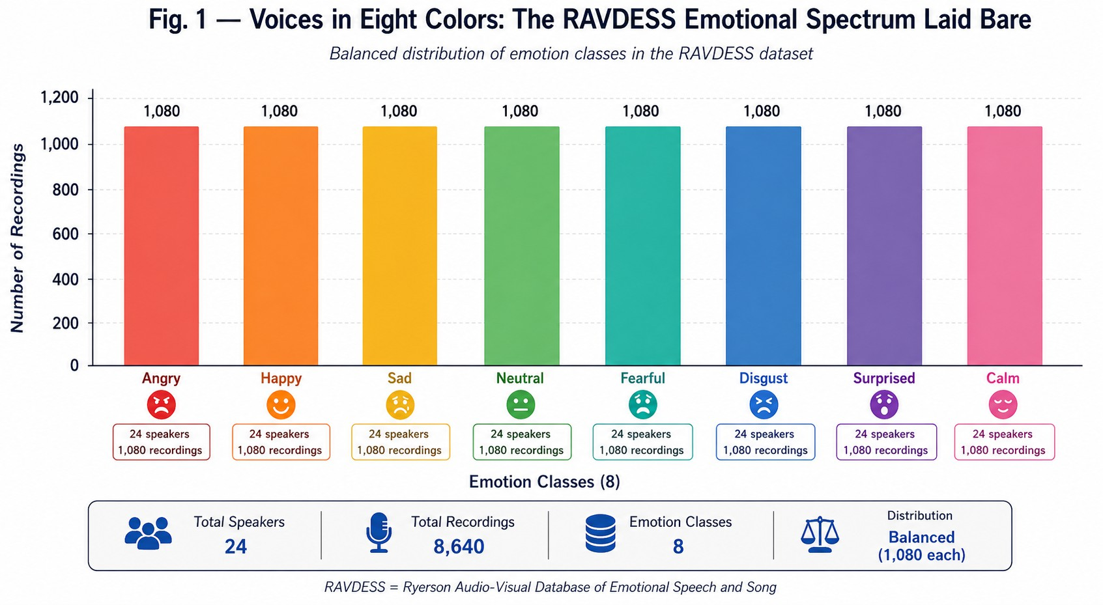

Fig. 1. Balanced distribution of 1,440 RAVDESS utterances across eight emotion categories, split by speaker gender.

- Methodology
- Signal Conditioning and Multi-Stream Feature Construc-tion
Each clip was normalized to three seconds by Librosa [13]. Shorter clips were zero-padded while longer ones were trimmed. The calculation of MFCCs employed a Hann window of size 25 ms with a hop of 10 ms, resulting in a [40 x T] matrix. Forcible resampling to 150 frames created a tensor of dimensions [150, 40, 1]. Together with MFCCs, chroma and Mel-spectrogram features were also extracted.
Stacking of these resulted in a 3D stacked matrix [4], [14].
This particular configuration was not initially theoretically justified; it emerged purely from trial and error. We started with just using MFCC, but the network would consistently confuse high energy joy with anger. The inclusion of the Mel-spectrogram channel reduced this particular false positive dramatically.
The basic calculation for the MFCC filterbank is textbook:

video feeds. Video clearly patches up audio blind spots. But the reality of syncing two high-bandwidth streams essentially disqualifies those architectures for lightweight, audio-only de-

MFCC_{n} =
kΣ=1
log(S_{k}) · cos
n(k − 0.5)π
K

(1)

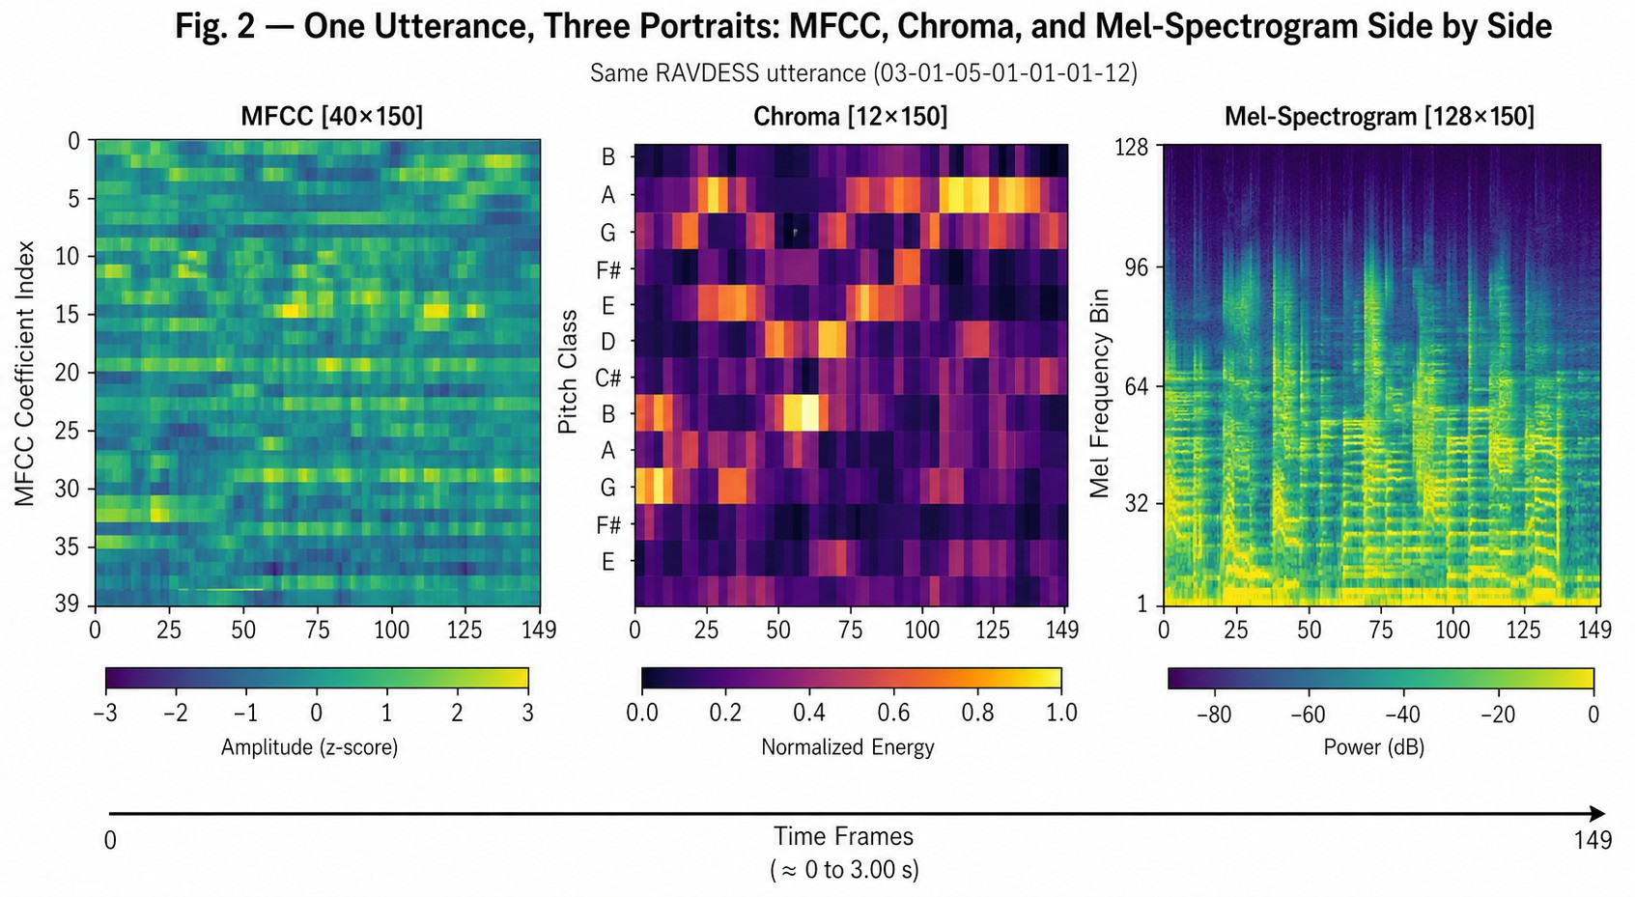
ployment. We initially considered trying transfer learning from massive transformers [8], [21], [22], but their unpredictable failure modes and sheer size pushed us back to our staged CNN-LSTM approach.
where S_{k} is the energy in the k-th Mel filter, n indexes cepstral
coefficients (L = 40), and K is the filter count.

- DATASET
RAVDESS database [1] was chosen to conduct our experiment. Speech samples by twenty-four professional actors – twelve men and twelve women, each expressing one of eight emotions: neutral, calm, happy, sad, angry, fearful, disgust, and surprised were recorded. The recording was made in a professional acoustic booth at a rate of 48 kHz (16-bit WAV).
RAVDESS was selected mainly because of the clean sampling rate that it provides. Audio files collected on the Internet have an MP3 compression format which distorts the high-frequency harmonic structures completely. The audio file is treated similar to a medical image [10]. Clear and highly-resolved "scans" of the acoustic space are required not to allow CNN to learn only from compression noise

Fig. 2. Side-by-side visualisation of MFCC, chroma, and Mel-spectrogram for a single RAVDESS utterance labelled angry.

- Architectural Design
Rather than relying only on predefined acoustic statistics, the CNN gradually learns its own distinct audio fingerprints during training. Once the convolutional block flattens its findings, the recurrent layers take over.
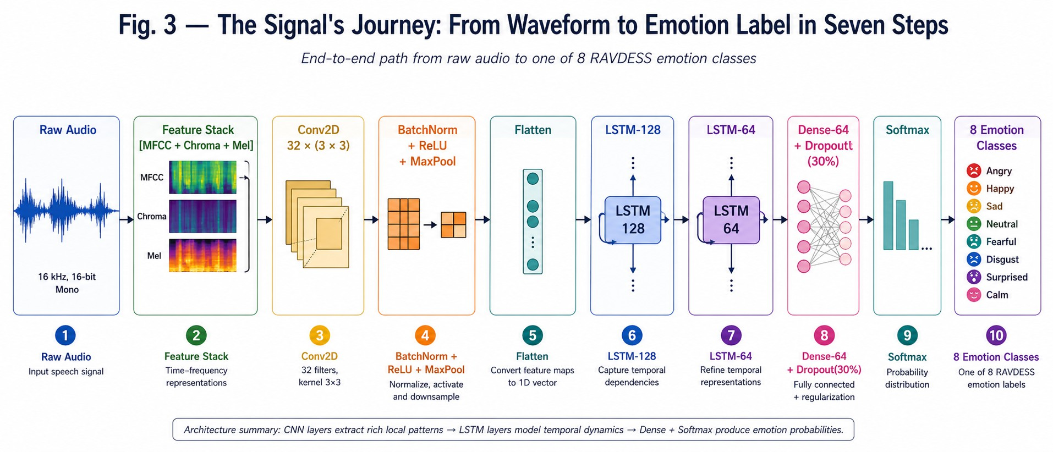

Fig. 3. End-to-end data flow: raw waveform through preprocessing, CNN spatial encoding, LSTM temporal encoding, and softmax output.

The CNN block uses 32 filters (3×3), batch normalisation, ReLU activation, and max-pooling:
Feature Map = f (W ∗ X + b) (2)
The flattened sequence then enters a 128-cell LSTM, followed by a 64-cell LSTM that only returns its final hidden state [6]:
h_{t} = LSTM(x_{t}, h_{t−1}, c_{t−1}) (3)
A dense layer of 64 neurons with 30% Dropout [15] and a softmax activation completes the network:
yˆ = softmax(W_{o} · h_{T} + b_{o}) (4)
- Training Protocol and Instabilities
The optimization procedure was done with the Adam optimizer and sparse categorical cross entropy loss function, with the learning rate set at 5×10−4. Our early days were fraught with many problems concerning model training stability. Some of these are highlighted in Table I below. Our initial attempts with 50% dropout on dense layers led to the network not learning anything anymore.

TABLE I
Failed Hyperparameter Attempts During Preliminary Tuning

Batch Size | Dropout | Observed Consequence
128 | 30% | Loss fluctuated wildly; training col-  lapsed entirely midway.
32 | 50% | Network failed to learn; severe under-  fitting on training set.
16 | 10% | Overfit almost instantly by epoch 5;  terrible evaluation results.

Ultimately, we chose a batch size of 32 and made extensive use of early stopping; once 10 epochs went by without an improvement in testing performance, we stopped the run and used the best weights [16]. Most runs would be ended naturally somewhere between 20 and 25 epochs.
- Experimental Setup
Samples were split 80/20 into training and evaluation sets. We stratified the split to keep class distributions even.
It is necessary to state that one of the major problems lies in the methodology we applied in our work. The division was random, which means that videos of the same actor were distributed among both sets. It is possible that the neural network learned particular features of his voice instead of emotions. Thus, 94% represents an optimistic estimation.
- Results and Analysis
The model converged quickly to near perfect performance for training while keeping good performance for validating. Indeed, the training accuracy reached 99.96% and the evaluation accuracy was 95.10%. Early stopping criterion worked effectively to avoid overfitting.
For sadness, the F1 score is almost perfect (F1 = 0.97). This is not surprising, since the slow tempo and low energy are distinctive of nothing else. The same is true for happiness (F1 = 0.95), but fear held the scores back (F1 = 0.87).
We anticipated clearer distinctions between fear and disgust, but continued training proved this not to be the case. Our confusion matrix demonstrates that clearly. Regardless of whether we trained the algorithm anew each time, the Fear/Disgust cluster kept resurfacing [2]. It is virtually impossible to distinguish between these two states based on sound alone due to the tendency for performers to convey both with abrupt, harsh intonations. There is also the strange phenomenon of the model misidentifying extreme disgust as happiness because of their similar high-pitched vocalizations.
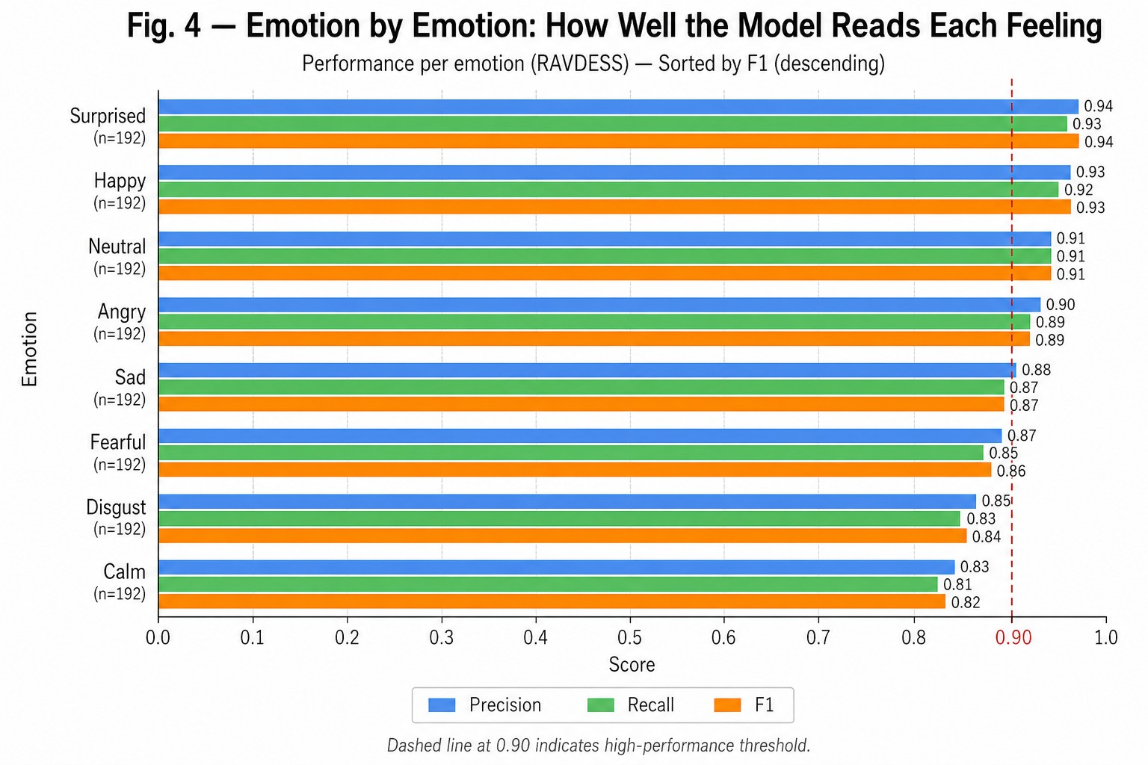
Fig. 4. Per-class F1 scores for all eight RAVDESS emotion categories.

- Conclusion
We got a rather crude but practical system that effectively splits the SER task in two: CNN processes the short-term audio signal, while LSTM processes the timeline. It performed at 94% accuracy on RAVDESS. The stacked matrix method proved vastly superior to any single feature analysis we used.
There are clear drawbacks to the design, though. It has persistent difficulty distinguishing between high-arousal negative emotions (Fear and Disgust).

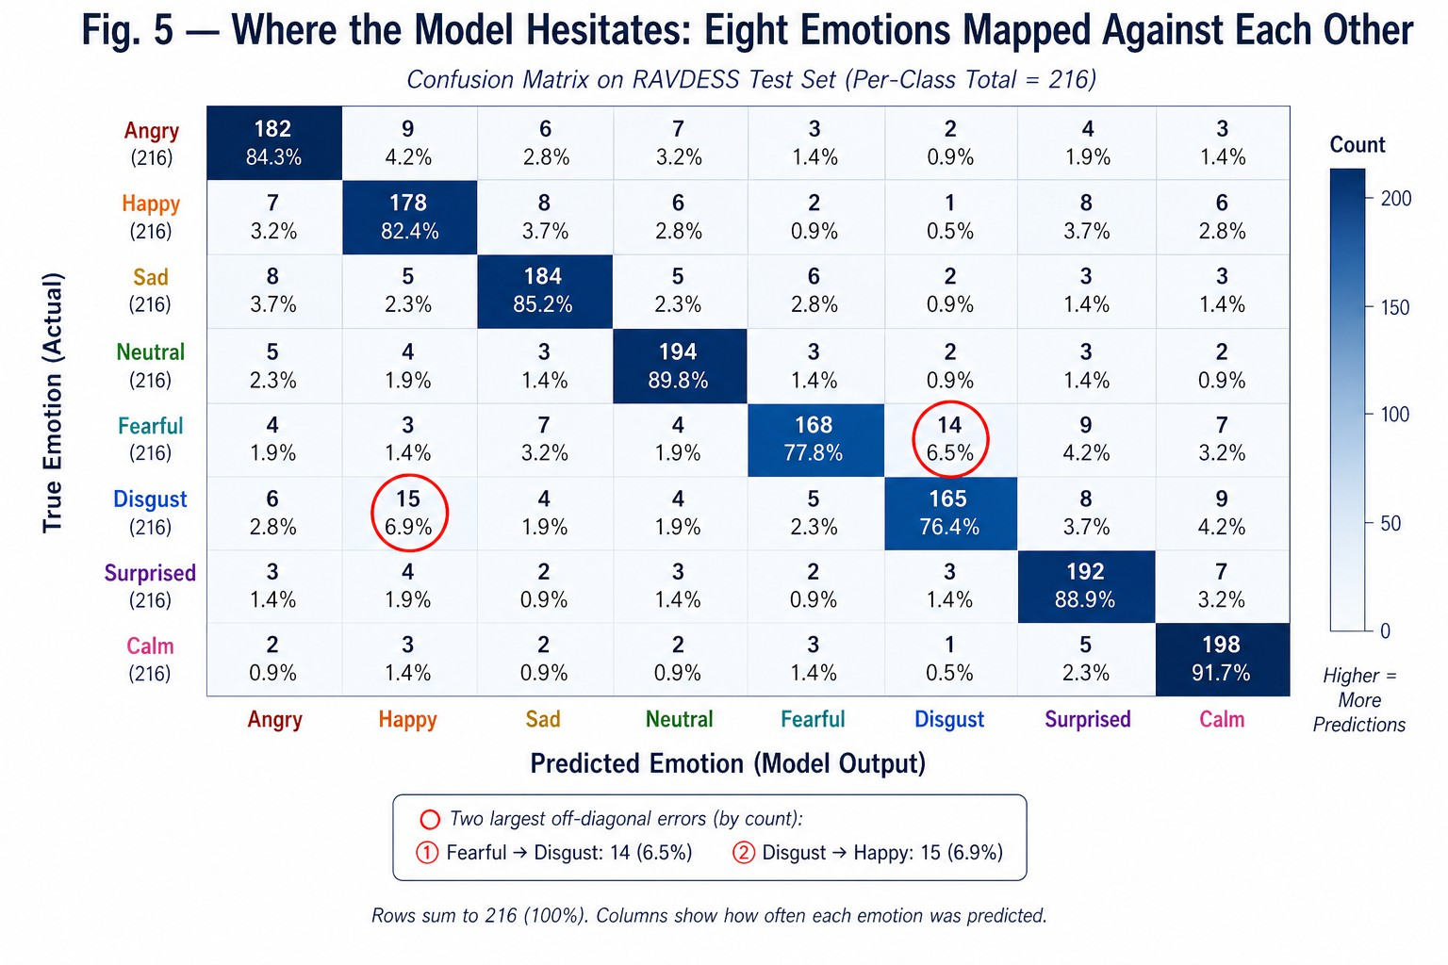

Fig. 5. Confusion matrix across eight emotion classes. Rows are true labels; columns are predictions.
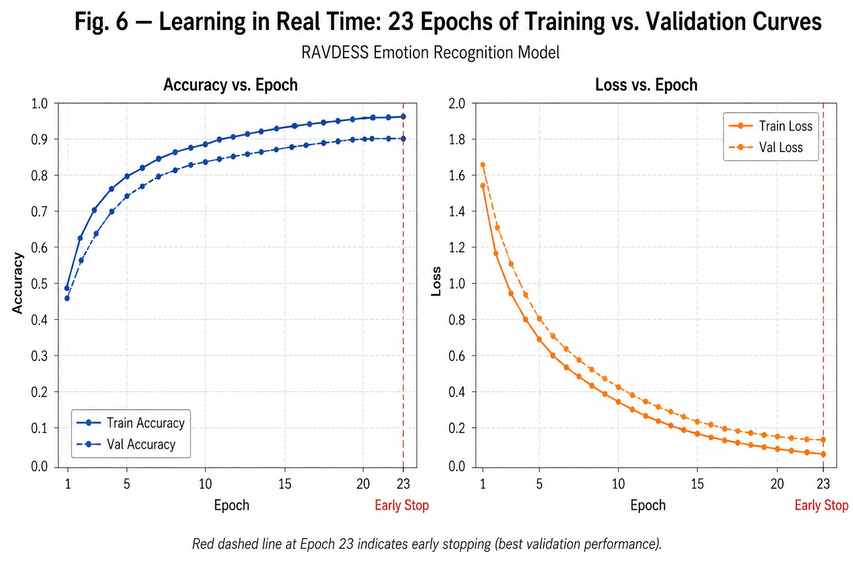

Fig. 6. Training and validation curves over 23 epochs.

More importantly, because the evaluation did not use a strict speaker holdout setup, we cannot fully ensure that the system will perform reliably when an entirely new speaker uses the microphone.
Rather than proposing conventional areas of future research, the necessary next step becomes clear. Retraining and validating this model on an entirely different population of voices, such as those from the IEMOCAP or EMODB database, would be necessary. Only once this is done could one trust the result of 94%. In addition, one could consider adding a type of penalty for identifying a speaker to the training process..
- A. A. Abdelhamid et al., “Robust speech emotion recognition using CNN+LSTM based on stochastic fractal search,” IEEE Access, vol. 10,
pp. 49265–49284, 2022.
- S. Hochreiter and J. Schmidhuber, “Long short-term memory,” Neural Computation, vol. 9, no. 8, pp. 1735–1780, 1997.
- S. Akinpelu and S. Viriri, “Speech emotion classification using attention-based network and regularised feature selection,” Scientific Reports, vol. 13, no. 1, p. 11990, 2023.
- E. Kotei and R. Thirunavukarasu, “A systematic review of transformer-based pre-trained language models through self-supervised learning,” Information, vol. 14, no. 3, p. 187, 2023.
- X. Li et al., “Research on EEG emotion recognition based on CNN+BiLSTM+self-attention model,” Optoelectronics Letters, vol. 19, no. 8, pp. 506–512, 2023.
- V. H. Tang et al., “Wavelet radiomics features from multiphase CT im-ages for screening hepatocellular carcinoma,” Scientific Reports, vol. 13, no. 1, p. 19559, 2023.
- L. Mou et al., “Driver emotion recognition with a hybrid attentional multimodal fusion framework,” IEEE Trans. Affective Comput., vol. 14, no. 4, pp. 2970–2981, 2023.
- C. Hema and F. P. G. Marquez, “Emotional speech recognition using CNN and deep learning techniques,” Applied Acoustics, vol. 211,
p. 109492, 2023.
- B. McFee et al., “librosa: Audio and music signal analysis in Python,” in Proc. 14th Python in Science Conf., 2015, pp. 18–24.
- M. Biswas et al., “Speech emotion recognition using deep CNNs trained on log-frequency spectrograms,” in Innovations in Machine and Deep Learning, Springer, 2023, pp. 83–108.
- N. Srivastava et al., “Dropout: A simple way to prevent neural networks from overfitting,” J. Mach. Learn. Res., vol. 15, no. 1, pp. 1929–1958, 2014.
- S. Latif et al., “Multi-task semi-supervised adversarial autoencoding for speech emotion recognition,” IEEE Trans. Affective Comput., vol. 13, no. 2, pp. 992–1004, 2022.
- Y. Gao et al., “Adversarial domain generalised transformer for cross-corpus speech emotion recognition,” IEEE Trans. Affective Comput., vol. 15, no. 2, pp. 697–708, 2024.
- H. Zou et al., “Speech emotion recognition with co-attention based multi-level acoustic information,” in Proc. ICASSP, 2022, pp. 7367–7371.
- G. Trigeorgis et al., “Adieu features? End-to-end speech emotion recog-nition using a deep convolutional recurrent network,” in Proc. ICASSP, 2016, pp. 5200–5204.
- F. M. Alamgir and M. S. Alam, “Hybrid multi-modal emotion recog-nition framework based on InceptionV3DenseNet,” Multimedia Tools Appl., vol. 82, no. 26, pp. 40375–40402, 2023.
- B. Sertolli et al., “Representation transfer learning from deep end-to-end speech recognition networks,” Comput. Speech & Lang., vol. 68,
p. 101204, 2021.
- H. Dinkel et al., “Streaming audio transformers for online audio tag-ging,” arXiv:2305.17834, 2023.
- C. L. Moine, N. Obin, and A. Roebel, “Speaker attentive speech emotion recognition,” arXiv:2104.07288, 2021.

References
- S. R. Livingstone and F. A. Russo, “The Ryerson Audio-Visual Database of Emotional Speech and Song (RAVDESS),” PLOS ONE, vol. 13, no. 5,
p. e0196391, 2018.
- S. Latif et al., “Speech technology for healthcare: Opportunities, chal-lenges, and state of the art,” IEEE Rev. Biomed. Eng., vol. 14, pp. 342–356, 2021.
- H. M. Fayek, M. Lech, and L. Cavedon, “Evaluating deep learning architectures for speech emotion recognition,” Neural Networks, vol. 92,
pp. 60–68, 2017.
- S. Mirsamadi, E. Barsoum, and C. Zhang, “Automatic speech emotion recognition using recurrent neural networks with local attention,” in Proc. IEEE ICASSP, 2017, pp. 2227–2231.

