Computational Identification of Natural Phytochemical Inhibitors Against α-Glucosidase for Type 2 Diabetes Mellitus Control

Abstract
Introduction
Type 2 Diabetes Mellitus is a major metabolic disorder characterised by persistent hyperglycemia and impaired glucose metabolism. α-glucosidase is a key enzyme involved in the final stage of carbohydrate digestion, making it an important therapeutic target for controlling postprandial blood glucose levels. Natural phytocompounds have gained increasing attention as safer alternatives to synthetic anti-diabetic drugs.
Materials and Methods
In the present study, Feruperine and Quercetin were evaluated as potential α-glucosidase inhibitors using computational approaches. Virtual screening was performed using Dr. Duke’s Phytochemical and Ethnobotanical Databases. Molecular docking analyses were conducted using PyRx and SwissDock, while binding pocket and interaction analyses were performed using PyMOL and UCSF Chimaera. Molecular dynamics simulation and Normal Mode Analysis were performed using the iMODS server. ADMET prediction was performed using ADMETlab 3.0 to evaluate pharmacokinetic and toxicity profiles.
Results
The selected phytocompounds demonstrated favourable binding affinity and stable interaction profiles against α-glucosidase. Important catalytic residues including GLU196, GLU579, TYR609, and ARG608 contributed to ligand stabilization within the active site Molecular dynamics analyses indicated acceptable conformational stability and flexibility of the docked complexes. ADMET prediction further suggested favourable drug-likeness, pharmacokinetic suitability, and acceptable toxicity profiles of the compounds.
Conclusion
The present study suggests that Feruperine and Quercetin possess promising potential as natural α-glucosidase inhibitors for the management of Type 2 Diabetes Mellitus. Their favourable binding affinity, interaction stability, and pharmacokinetic properties support their possible therapeutic application. However, further experimental validation through in vitro and in vivo studies is required to confirm their anti-diabetic efficacy.
Keywords: α-glucosidase; Type 2 Diabetes Mellitus; Feruperine; Quercetin; Molecular Docking; Phytocompounds

1. Introduction
1.1. Diabetes Mellitus: A Global Metabolic Disorder
Type 2 Diabetes is one of the most rapidly increasing chronic metabolic disorders worldwide and represents a major public health concern[1-3]. The disease is primarily characterised by persistent hyperglycemia resulting from impaired insulin secretion, insulin resistance, or both. Prolonged elevation of blood glucose levels can lead to severe complications, including cardiovascular disorders, nephropathy, neuropathy, retinopathy, and impaired wound healing[4]. According to global epidemiological reports, the prevalence of diabetes continues to rise due to sedentary lifestyles, unhealthy dietary habits, obesity, and genetic predisposition[5].
Postprandial hyperglycemia is considered a critical factor in the progression of diabetic complications. Therefore, controlling blood glucose levels immediately after carbohydrate intake has become an important therapeutic strategy in diabetes management[1-4].

1.2. Role of α-Glucosidase in Carbohydrate Digestion
α-Glucosidase is a key digestive enzyme located in the brush border membrane of the small intestine. The enzyme catalyzes the final stage of carbohydrate digestion by converting oligosaccharides and disaccharides into absorbable glucose molecules[6-7]. During digestion, dietary carbohydrates are initially broken down into smaller intermediates by salivary and pancreatic amylases, after which α-Glucosidase hydrolyzes these intermediates to release glucose for intestinal absorption[8].

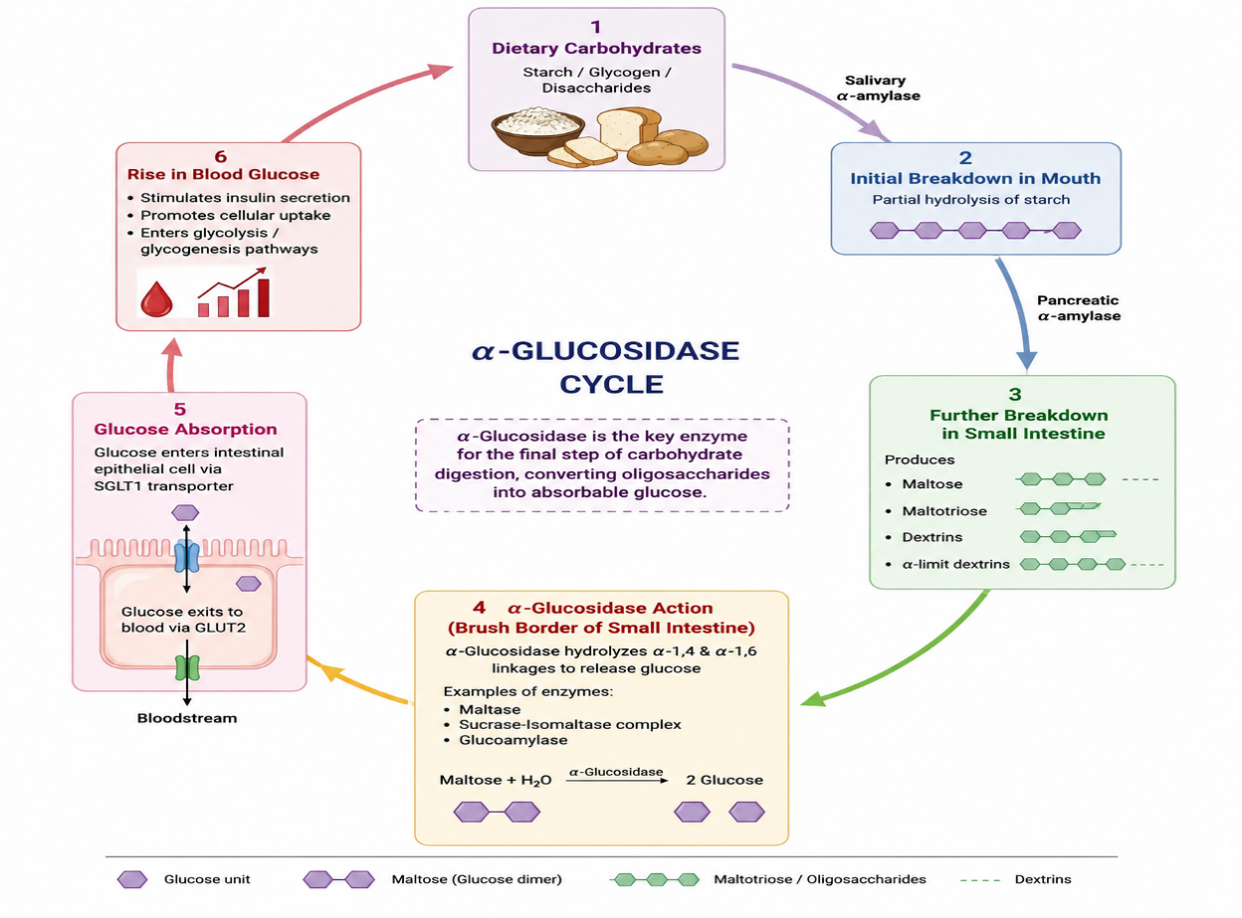
Figure 1. Biochemical pathway illustrating the role of α-Glucosidase in carbohydrate digestion and glucose absorption.
Excessive α-Glucosidase activity contributes to rapid glucose release into the bloodstream, resulting in elevated postprandial blood sugar levels [9]. Consequently, inhibition of this enzyme has emerged as an effective therapeutic target for controlling hyperglycemia in patients with diabetes[10].

1.3. Therapeutic Importance of α-Glucosidase Inhibitors
α-Glucosidase inhibitors delay carbohydrate digestion and reduce intestinal glucose absorption, thereby lowering postprandial blood glucose levels. Clinically used inhibitors such as Acarbose, Miglitol, and Voglibose are widely used to manage Type 2 Diabetes[11-12].
However, prolonged use of synthetic inhibitors is often associated with gastrointestinal side effects, including abdominal discomfort, diarrhoea, bloating, and flatulence. These limitations have encouraged researchers to identify safer, naturally derived inhibitors with improved pharmacological and toxicological profiles[13].
Natural phytochemicals have attracted considerable attention due to their antioxidant, anti-inflammatory, and anti-diabetic properties[14-15]. Several plant-derived compounds have demonstrated promising Α-Glucosidase inhibitory activities with reduced adverse effects[16-17].

1.4. Feruperine and Quercetin as Potential Natural Anti-Diabetic Compounds
Feruperine, a phytochemical associated with black pepper, and Quercetin, a naturally occurring flavonoid found in neem and garlic, have been reported to possess significant antioxidant and metabolic regulatory properties. These phytocompounds exhibit the potential to interfere with glucose metabolism and enzymatic pathways associated with diabetes progression.
Quercetin is particularly recognized for its free radical scavenging activity, anti-inflammatory effects, and ability to regulate glucose homeostasis. Feruperine has also demonstrated promising biological activities including enzyme inhibition and molecular stabilization properties. Due to their phytopharmacological potential, both compounds were selected as candidate inhibitors against α-Glucosidase in the present investigation.

1.5. Mechanism of α-Glucosidase Inhibition by Selected Phytocompounds
The selected phytocompounds are predicted to regulate diabetes through dual inhibitory mechanisms. Firstly, they interfere with the conversion of maltose and oligosaccharides into glucose by inhibiting Α-Glucosidase activity. Secondly, they reduce glucose transport and absorption across intestinal epithelial cells, thereby decreasing glucose entry into the bloodstream.
The proposed inhibitory mechanism of Feruperine and Quercetin is illustrated below:
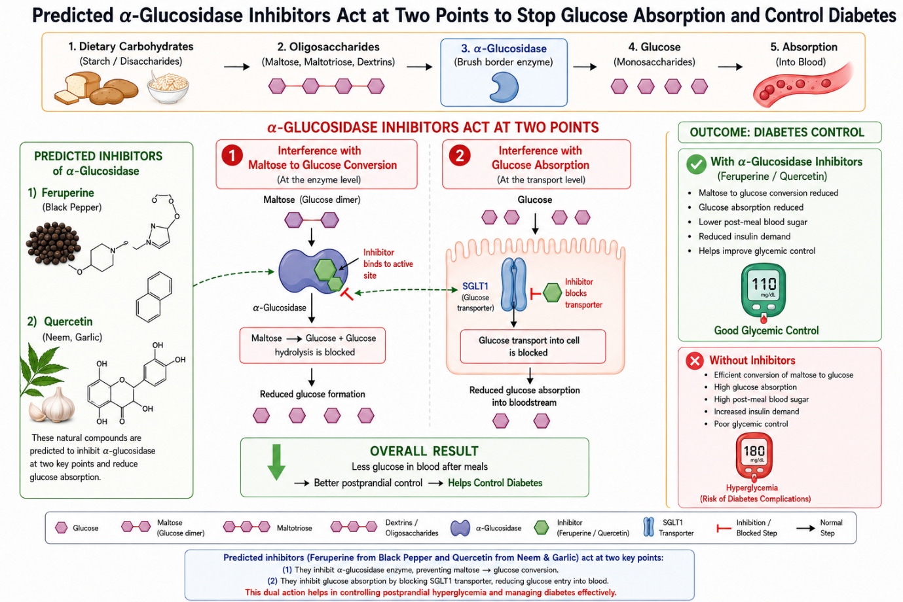
Figure 2. Proposed dual inhibitory mechanism of Feruperine and Quercetin against α-Glucosidase -mediated glucose production and glucose absorption.

This dual inhibitory action may contribute to improved postprandial glycemic control and reduced diabetic complications.

1.6. Importance of Computational Drug Discovery Approaches
Recent advances in computational biology and bioinformatics have significantly accelerated drug discovery and molecular screening. In silico techniques such as molecular docking, molecular dynamics simulations, pharmacophore modelling, interaction analysis, and ADMET prediction enable rapid identification and evaluation of promising therapeutic compounds.
Molecular docking provides insight into ligand–protein binding affinity and interaction stability, while molecular dynamics simulations help evaluate conformational flexibility and structural stability of protein–ligand complexes. Pharmacophore analysis further identifies critical intermolecular interactions contributing to biological activity. Additionally, ADMET prediction helps evaluate drug-likeness, pharmacokinetic suitability, and toxicity profiles of candidate molecules.
These computational approaches reduce experimental cost, time, and resource requirements while improving the efficiency of therapeutic candidate selection.

1.7. Aim and Objective of the Present Study
The present study aimed to investigate the anti-diabetic potential of Feruperine and Quercetin as natural α-Glucosidase inhibitors using comprehensive computational approaches. The study focused on virtual screening, molecular docking, binding pocket analysis, molecular dynamics simulation, pharmacophore evaluation, interaction profiling, and ADMET prediction to assess the therapeutic suitability of the selected phytocompounds.
The primary objective was to identify phytochemical inhibitors with strong binding affinity, structural stability, effective inhibitory potential, and suitable pharmacokinetic properties against α-Glucosidase for potential application in diabetes management.

2. Materials and Methods

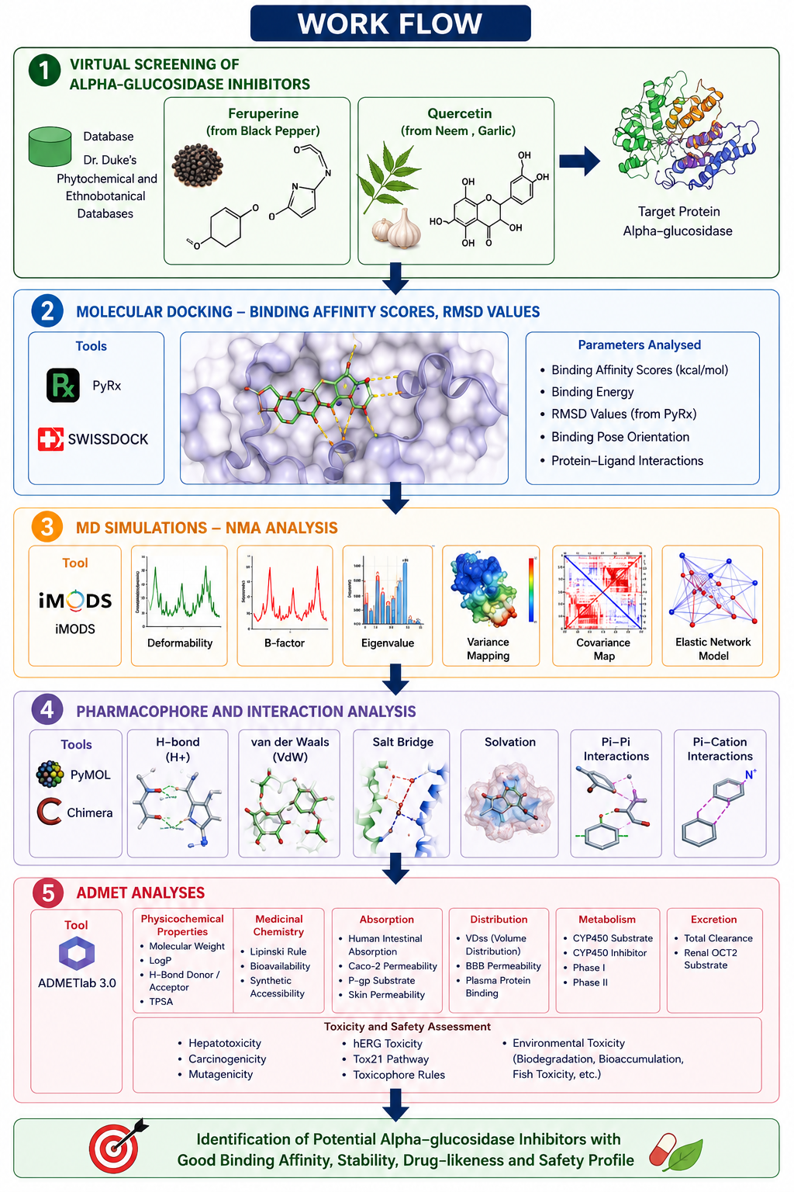
Figure 3. The entire Methodology is summarized diagrammatically as above

2.1. Selection and Virtual Screening of Phytocompounds
Potential phytochemical inhibitors of α-Glucosidase were identified through virtual screening using the Dr. Duke’s Phytochemical and Ethnobotanical Databases. Feruperine and Quercetin were selected based on their previously reported anti-diabetic, antioxidant, and enzyme inhibitory properties. The selected compounds were retrieved in suitable structural formats for subsequent computational analyses.
The three-dimensional (3D) structures of the phytocompounds were prepared and optimized prior to docking analysis. Ligand preparation included energy minimization and conversion into compatible docking formats.

2.2. Protein Preparation
The target protein, α-Glucosidase (PDB ID 5NN8), was obtained from the Protein Data Bank (PDB). Protein preparation involved removal of water molecules, heteroatoms, and unwanted ligands followed by addition of polar hydrogen atoms and Kollman charges. The prepared protein structure was subsequently utilized for molecular docking studies.

2.3. Binding Pocket Analysis and Identification of Interactive Residues
Binding pocket analysis was performed prior to molecular docking in order to identify the active site residues and probable ligand interaction regions of α-Glucosidase.
The active binding pockets were analysed using PyMOL [18-20] and UCSF Chimaera [21-25] by examining the surface topology, cavity regions, and amino acid residue distribution around the protein's catalytic region. Important interactive residues involved in ligand accommodation and stabilization were identified through proximity analysis and pocket visualisation.
Residues including GLU196, GLU579, TYR609, ARG608, GLY359, and LYS195 were observed to participate within the major interaction pocket and were considered during docking and interaction analyses. The identified binding-pocket residues were subsequently used to define docking regions and evaluate ligand–protein interactions.

2.4. Molecular Docking Analysis
Molecular docking studies were performed using PyRx[26-29] and SwissDock[30-33] to evaluate the binding affinity of Feruperine and Quercetin against α-Glucosidase.
Docking simulations were carried out by defining the active binding pocket of the target protein. Binding affinity scores (kcal/mol), docking conformations, and ligand orientation within the active site were analysed. RMSD values generated using PyRx were used to assess the docking reliability and conformational stability of the ligand–protein complexes. Swiss-Dock Full Fitness and estimated ΔG values were also considered to validate docking efficiency.
The docked complexes exhibiting the most favourable binding energies and stable conformations were selected for further interaction and dynamic analyses.

2.5. Molecular Dynamics Simulation and Normal Mode Analysis
The structural stability and flexibility of the docked protein–ligand complexes were investigated using the iMODS server[34-35] through Normal Mode Analysis (NMA).
Several dynamic parameters, including deformability, B-factor, eigenvalues, variance mapping, covariance matrix analysis, and elastic network modelling, were evaluated to assess the intrinsic motions and stability of the complexes. Lower eigenvalues were interpreted as indicators of enhanced flexibility and reduced energy requirement for molecular deformation.
The covariance matrix was utilised to identify correlated and anti-correlated atomic motions, while elastic network modelling provided insight into residue connectivity and structural rigidity within the complexes.

2.6. Pharmacophore and Interaction Analysis
Protein–ligand interaction analyses were performed using PyMOL and UCSF Chimaera.
The docked complexes were analysed for hydrogen-bonding interactions, van der Waals interactions, salt-bridge formation, hydrophobic interactions, solvation effects, Pi–Pi stacking, and Pi–cation interactions. These interaction profiles were used to identify critical amino acid residues that contribute to ligand binding and stabilization within the active site of α-Glucosidase. Pharmacophoric features associated with favourable ligand binding were also interpreted based on the observed intermolecular interaction patterns.

2.7. ADMET and Toxicological Analysis
Pharmacokinetic and toxicity profiles of the selected phytocompounds were predicted using ADMETlab 3.0[36-38].
Physicochemical properties, including molecular weight, LogP, hydrogen-bond donor/acceptor counts, and topological polar surface area (TPSA), were analysed. Drug-likeness and medicinal chemistry parameters such as Lipinski’s Rule of Five, bioavailability, and synthetic accessibility were also evaluated.
Absorption, distribution, metabolism, and excretion (ADME) characteristics, including intestinal absorption, blood–brain barrier permeability, cytochrome P450 interactions, and clearance, were assessed. Toxicological analyses included hepatotoxicity, carcinogenicity, mutagenicity, hERG toxicity, Tox21 pathway analysis, toxicophore rules, and environmental toxicity prediction.
The ADMET evaluation was performed to determine the safety, pharmacokinetic suitability, and drug-likeness potential of the selected compounds for anti-diabetic therapeutic applications.
3. Results and Discussion
3.1 Virtual Screening of Phytocompounds
Virtual screening of selected plant-derived phytocompounds was performed to identify potential α-glucosidase inhibitors, a key therapeutic target associated with postprandial hyperglycemia in Type 2 Diabetes Mellitus. The phytochemicals were selected based on their previously reported antioxidant, antidiabetic, and pharmacological significance. Structural preparation and visualization of the ligands were carried out prior to molecular docking analysis.
Feruperine and Quercetin were among the shortlisted compounds selected for further computational evaluation due to their favourable structural characteristics and reported biological activities. The optimized three-dimensional structures of both compounds are presented in Figure 1 and Figure 2, respectively.
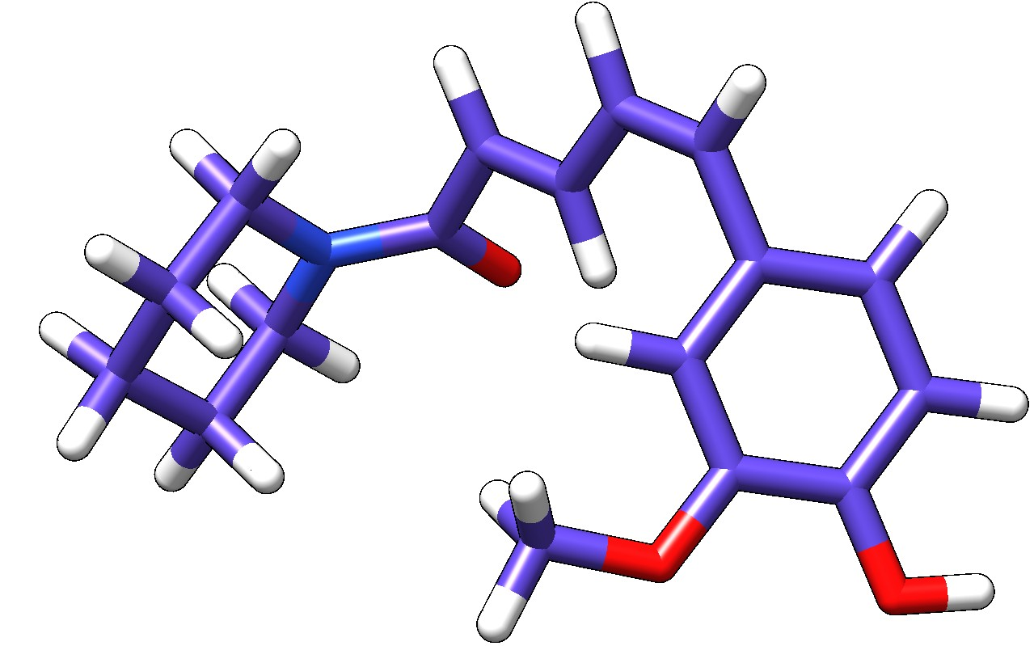
Figure 4. Three-dimensional optimized structure of Feruperine used for virtual screening against α-glucosidase.
The molecular architecture of Feruperine reveals multiple cyclic groups and heteroatoms that may contribute to stable intermolecular interactions within the active site of α-glucosidase. The compound possesses functional groups capable of participating in hydrogen bonding and hydrophobic interactions, thereby increasing its probability of effective enzyme binding.
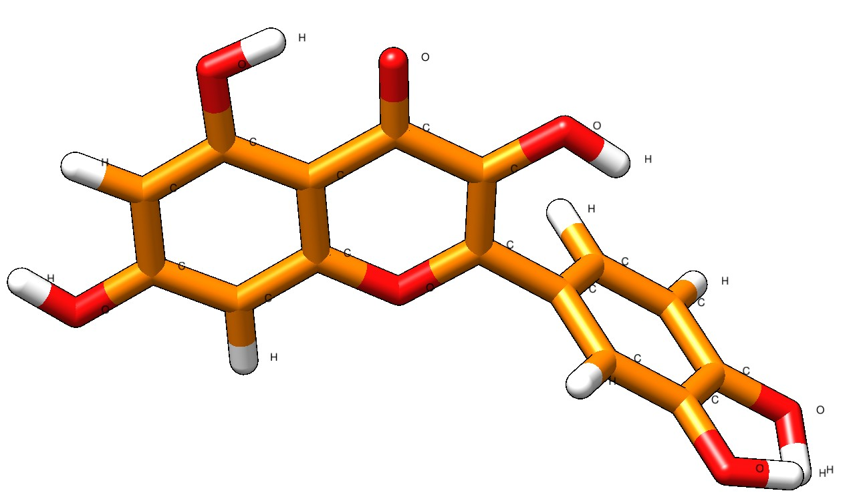
Figure 5. Three-dimensional optimized structure of Quercetin used for virtual screening against α-glucosidase.
Quercetin, a well-known flavonoid phytocompound, exhibited a structurally stable aromatic framework enriched with hydroxyl functional groups. The abundance of hydroxyl moieties may facilitate strong hydrogen-bond interactions with catalytic amino acid residues of α-glucosidase. In addition, the conjugated aromatic system of Quercetin may facilitate π–π stacking and hydrophobic interactions within the enzyme-binding pocket.
The preliminary virtual screening analysis indicated that both Feruperine and Quercetin possess structural features favourable for enzyme inhibition. These observations justified their selection for subsequent molecular docking, interaction analysis, and pharmacokinetic evaluation.
3.2 Protein Preparation
The three-dimensional structure of α-glucosidase was prepared prior to molecular docking studies to ensure structural stability and accurate ligand-binding prediction. Protein preparation is a crucial step in computational drug discovery, as improper structural optimization may significantly affect docking accuracy and interaction analysis.
The retrieved macromolecular structure was subjected to preprocessing procedures including removal of unwanted molecules, correction of bond geometries, and structural optimization. Water molecules and non-essential heteroatoms were eliminated to minimize steric hindrance and avoid non-specific interactions during docking simulations. Hydrogen atoms were added to stabilize the protein structure and to facilitate accurate hydrogen-bond interaction analysis with the selected phytocompounds.
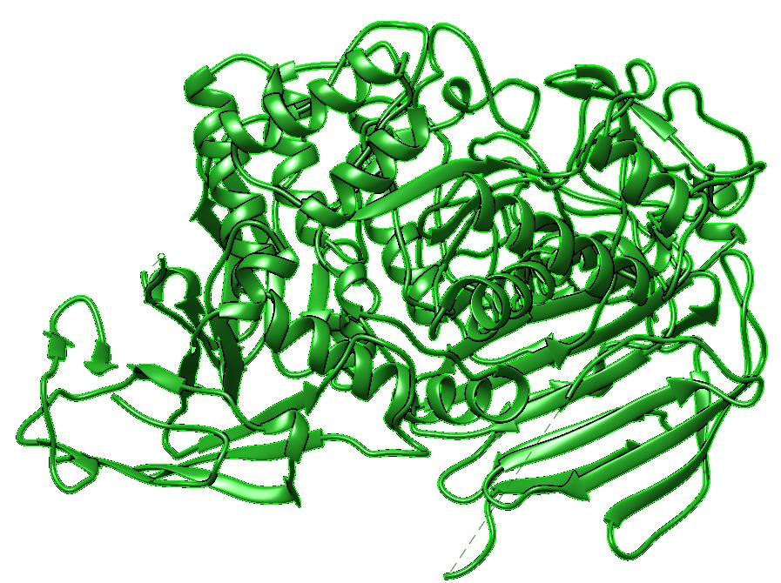
Figure 6. Optimized three-dimensional structure of α-glucosidase used for molecular docking studies.
The prepared α-glucosidase structure exhibited a well-defined arrangement of α-helices, β-sheets, and loop regions forming the characteristic catalytic architecture of the enzyme. The structural integrity of the protein was maintained after optimization, indicating suitability for subsequent docking analyses.
Proper protein preparation enhances the reliability of computational screening by improving ligand accommodation within the active site region. The optimized enzyme structure therefore served as the receptor model for evaluating the binding affinity and inhibitory potential of Feruperine and Quercetin against α-glucosidase.
3.3 Binding Pocket Analysis and Identification of Interactive Residues
Binding pocket analysis was performed to investigate the accommodation of the selected phytocompounds within the active site region of α-glucosidase and to identify the amino acid residues involved in ligand stabilization. Molecular docking studies revealed favourable binding orientations for both Feruperine and Quercetin within the binding pocket of the enzyme.
Interaction Analysis of Feruperine with α-Glucosidase
The docked complex of Feruperine with α-glucosidase demonstrated stable occupancy within the enzyme binding pocket, as illustrated in Figure 4.
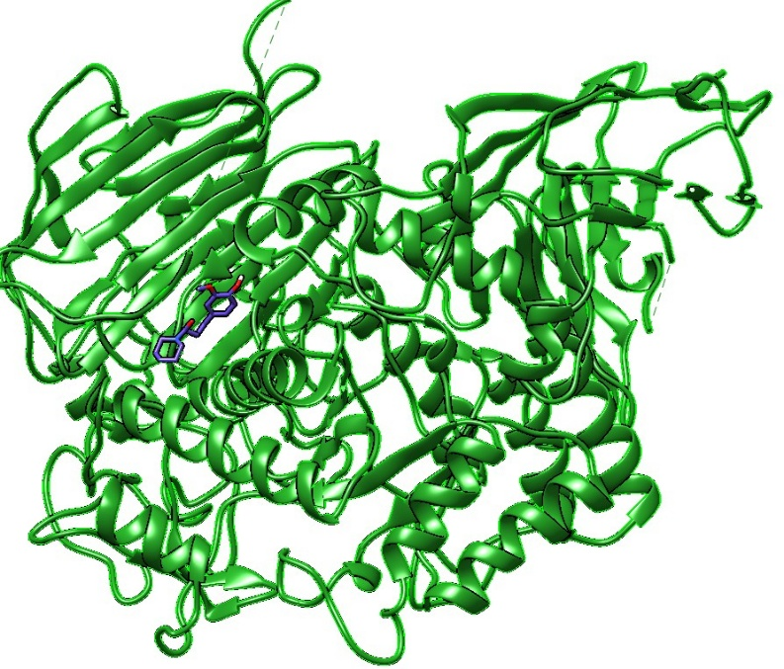
Figure 7. Overall docked conformation of Feruperine within the active site of α-glucosidase.
The enlarged interaction view further revealed that Feruperine was surrounded by several important amino acid residues including GLU196, GLY359, TYR609, ARG608, LEU195, and GLU579, indicating effective accommodation of the ligand within the catalytic region of the protein.
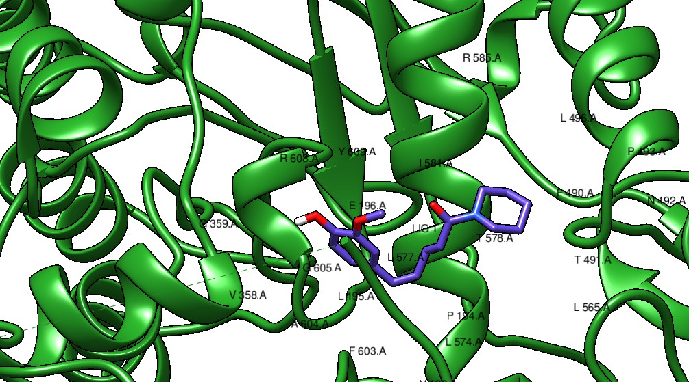
Figure 8. Enlarged view of Feruperine–α-glucosidase interactions showing neighbouring amino acid residues within the active site cavity.
Binding pocket visualization indicated that the ligand was deeply embedded inside the active groove of α-glucosidase, where both polar and hydrophobic interactions contributed to stabilization of the complex.

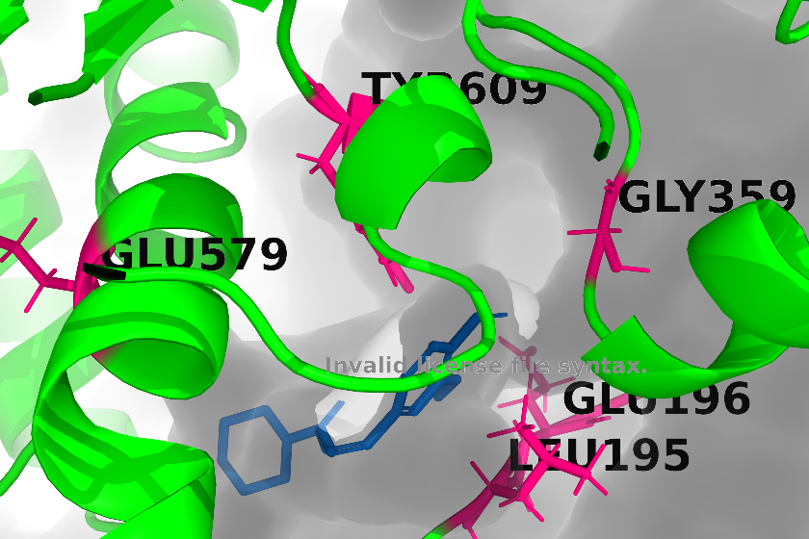
Figure 9. Binding pocket representation showing interactive residues associated with Feruperine binding.
Among the identified residues, GLU196 and GLU579 are particularly important because glutamate residues are commonly associated with catalytic activity in glycosidase enzymes. Interaction with these residues suggests a potential inhibitory effect of Feruperine on α-glucosidase activity. TYR609 and ARG608 may additionally contribute through hydrophobic stabilization and electrostatic interactions. The observed binding orientation therefore indicates strong molecular compatibility between Feruperine and the catalytic pocket of α-glucosidase.

Interaction Analysis of Quercetin with α-Glucosidase
Quercetin also demonstrated favourable docking within the active-site cavity of α-glucosidase, occupying a similar catalytic region, as shown in Figure 7.
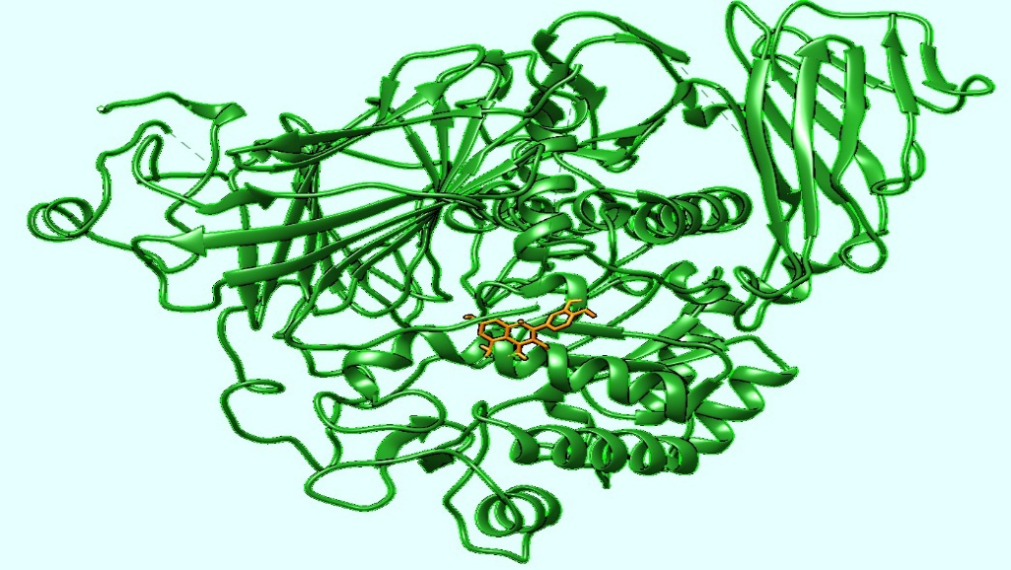
Figure 10. Overall docked conformation of Quercetin within the α-glucosidase binding cavity.
Detailed interaction analysis revealed the involvement of several neighboring residues including GLU579, TYR609, ARG608, LEU577, and surrounding hydrophobic amino acids contributing to ligand stabilization.
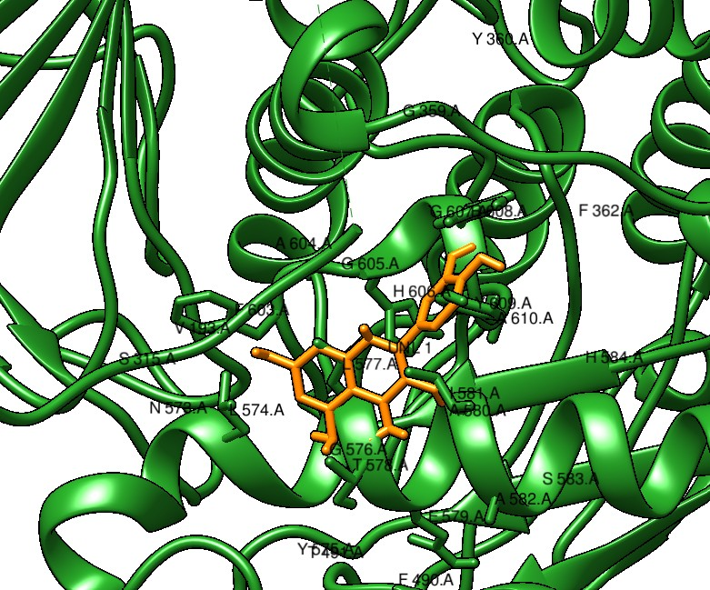
Figure 11. Enlarged interaction view of Quercetin within the active site of α-glucosidase.
Binding pocket analysis further confirmed that Quercetin was effectively accommodated inside the catalytic groove of the enzyme through multiple stabilizing interactions.
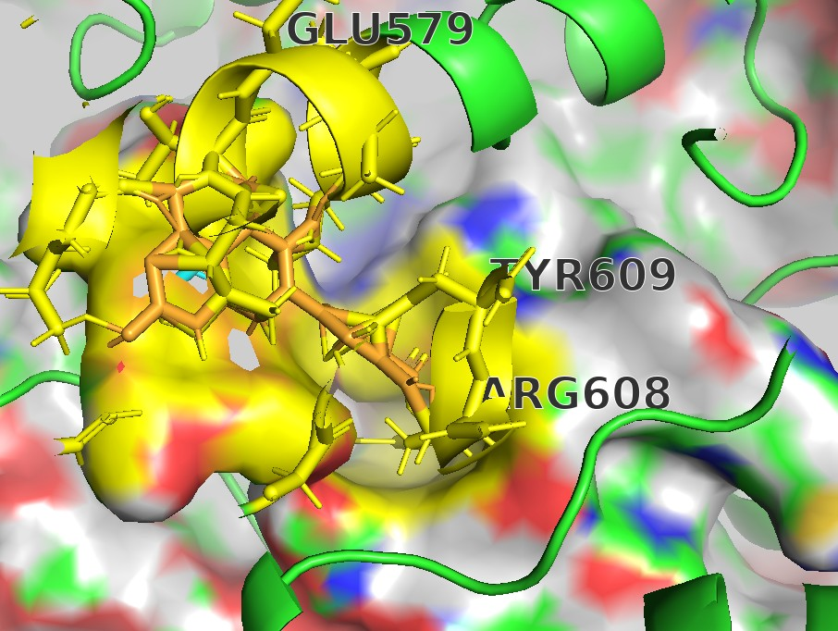
Figure 12. Binding pocket representation showing key interactive residues involved in Quercetin binding.
The polyhydroxylated aromatic structure of Quercetin likely enhanced its interaction potential through hydrogen bonding and π-mediated interactions within the binding pocket. Residues such as GLU579 and ARG608 appeared to play crucial roles in maintaining ligand stability inside the binding pocket. The presence of aromatic rings together with hydroxyl functional groups may therefore contribute to the inhibitory efficiency of Quercetin against α-glucosidase.
Comparative analysis of both phytocompounds suggested that Feruperine and Quercetin possess favourable binding orientations and significant interactions with catalytically relevant amino acid residues. These findings support their potential role as natural α-glucosidase inhibitors for the management of Type 2 Diabetes Mellitus.
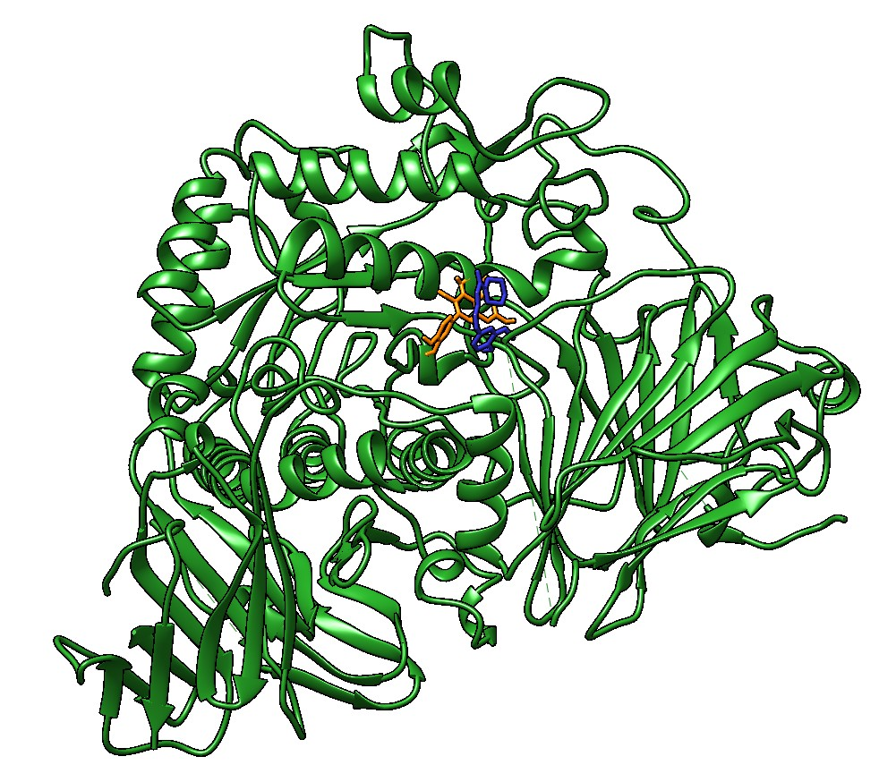
Figure 13. Comparative binding orientation of Feruperine and Quercetin within the catalytic pocket of α-glucosidase.
A comparative visualization of both phytocompounds within the α-glucosidase active site revealed that Feruperine and Quercetin occupied closely associated regions inside the binding pocket. The overlapping binding orientations suggest that both compounds may interact with functionally important residues involved in substrate recognition and catalytic activity. The ligands' ability to fit stably within the enzyme pocket further supports their potential role as competitive inhibitors of α-glucosidase.
The comparative docking profile additionally indicated that the aromatic and heterocyclic frameworks of the phytocompounds contributed to favourable accommodation inside the binding groove through hydrophobic stabilization and hydrogen-bond interactions. Such interactions may interfere with normal substrate access to the catalytic region, thereby reducing enzymatic activity associated with carbohydrate hydrolysis and postprandial glucose elevation.
3.4 Molecular Docking Analysis
Molecular docking analysis was performed to evaluate the binding affinity and interaction characteristics of selected phytocompounds against α-glucosidase using the AutoDock Vina algorithm implemented through the SWISSDOCK platform. Docking simulations were designed to predict favourable ligand conformations within the enzyme's binding pocket and to identify key amino acid residues involved in ligand stabilisation and inhibitory activity.
A two-stage docking strategy was employed in the present investigation. Initially, Feruperine was docked directly to α-glucosidase to evaluate its primary interaction behaviour within the enzyme's catalytic site. Subsequently, Quercetin was docked against the preformed Feruperine–α-glucosidase complex to investigate comparative interaction behaviour and possible stabilisation within the modified binding environment.
The docking parameters used for both docking stages are summarized in Table 1
Table 1. Docking Grid Parameters Used for Molecular Docking Simulations
Docking Stage | Docking Complex | Tool Used | Docking Method | Grid Box Size (Å) | Grid Center Coordinates (X, Y, Z) | Exhaustiveness
Stage 1 | Feruperine + α-Glucosidase | SWISSDOCK | AutoDock Vina | 32 × 20 × 27 | −4.0, −28.0, 83.0 | 8
Stage 2 | Quercetin + Feruperine–α-Glucosidase Complex | SWISSDOCK | AutoDock Vina | 26 × 27 × 20 | 0.0, −26.0, 72.0 | 8
The selected docking grid parameters enabled efficient exploration of the catalytic binding region of α-glucosidase. Appropriate grid dimensions and center coordinates ensured accurate ligand accommodation and reliable conformational sampling during docking simulations.
3.4.1 Docking Analysis of Feruperine with α-Glucosidase
The first-stage molecular docking simulation between Feruperine and α-glucosidase demonstrated stable ligand accommodation within the enzyme's catalytic binding cavity. The docking results revealed stable binding patterns involving catalytically important amino acid residues, including GLU196, GLU579, ARG608, TYR609, and GLY359.
Feruperine occupied the active site groove effectively, indicating strong structural compatibility with the receptor cavity. The presence of heterocyclic groups and hydrogen bond-forming functional moieties likely contributed to stabilization of the ligand within the enzyme pocket through hydrophobic interactions, electrostatic attraction, and hydrogen bonding.
Interactions involving GLU196 and GLU579 are particularly significant because glutamate residues frequently participate in catalytic mechanisms of glycosidase enzymes. Therefore, the observed interaction profile suggests that Feruperine may interfere with substrate accessibility and catalytic functioning of α-glucosidase, thereby supporting its potential antidiabetic activity.
3.4.2 Docking Analysis of Quercetin with the Feruperine–α-Glucosidase Complex
The second-stage docking analysis demonstrated that Quercetin was successfully accommodated within the binding cavity of the Feruperine–α-glucosidase complex. The ligand exhibited stable binding orientations with neighbouring catalytic residues, including GLU579, ARG608, TYR609, and surrounding hydrophobic amino acids.
The polyhydroxylated aromatic framework of Quercetin facilitated stable interactions within the catalytic groove through hydrogen bonding and π-mediated stabilization. The docking results indicated that Quercetin occupied a closely associated region near the pre-bound Feruperine molecule, suggesting possible cooperative stabilization within the enzyme pocket.
The observed docking behaviour supports the hypothesis that both phytocompounds possess favourable inhibitory potential against α-glucosidase and may contribute synergistically toward suppression of carbohydrate hydrolysis associated with postprandial hyperglycemia in Type 2 Diabetes Mellitus.

3.4.3 Molecular Docking Binding Affinity Analysis
Binding affinity analysis was performed to evaluate the stability and interaction strength of the docked phytocompounds with α-glucosidase. The binding scores generated by AutoDock Vina provided important insights into the energetic favourability of ligand accommodation within the enzyme's catalytic pocket. In molecular docking studies, more negative binding affinity values generally indicate stronger ligand–receptor interactions and enhanced complex stability.
The first-stage docking analysis involving Feruperine and α-glucosidase demonstrated favourable binding affinity values throughout the generated docking conformations. The best docking pose exhibited the lowest binding energy among all predicted conformers, indicating stable accommodation of Feruperine within the catalytic groove of α-glucosidase.

Figure 14. Binding affinity scores obtained during first-stage docking analysis of Feruperine with α-glucosidase.
The binding affinity values for the Feruperine–α-glucosidase complex ranged approximately from −6.3 kcal/mol to −3.8 kcal/mol. The progressive distribution of docking scores suggested the presence of multiple energetically favourable conformations within the active site cavity. The lower energy conformers indicated enhanced interaction stability mediated through hydrogen bonding, hydrophobic interactions, and electrostatic stabilization with catalytically important residues.
The second-stage docking analysis involving Quercetin with the Feruperine–α-glucosidase complex also demonstrated favourable energetic behaviour and stable ligand accommodation within the modified catalytic environment.

Figure 15. Binding affinity scores obtained during second-stage docking analysis of Quercetin with the Feruperine–α-glucosidase complex.
The binding affinity values obtained for the Quercetin docking stage ranged approximately from −7.1 kcal/mol to −4.8 kcal/mol. The comparatively lower binding energy values observed during the second-stage docking analysis suggested stronger interaction stability and enhanced binding compatibility within the catalytic pocket. The polyhydroxylated aromatic framework of Quercetin likely contributed to the improved interaction profile through hydrogen bonding and π-mediated stabilization.
Comparative analysis of both docking stages indicated that Quercetin exhibited relatively stronger binding affinity toward the Feruperine–α-glucosidase complex when compared with the initial Feruperine docking stage alone. These findings support the possibility of cooperative stabilization and enhanced inhibitory potential of the selected phytocompounds against α-glucosidase. The observed interaction profiles therefore suggest that Feruperine and Quercetin may serve as promising natural candidates for the modulation of carbohydrate metabolism associated with Type 2 Diabetes Mellitus.
3.4.4 Root Mean Square Deviation (RMSD) Analysis
RMSD analysis was performed to evaluate the stability and conformational variation of the docked ligand–protein complexes. Both RMSD/ub and RMSD/lb values were analyzed for the generated docking conformations.

Figure 16. RMSD values obtained after molecular docking simulations.
The RMSD/ub values ranged from approximately 0.34 Å to 10.22 Å, while the RMSD/lb values ranged from approximately 0.34 Å to 8.10 Å. Several docking conformations exhibited comparatively lower RMSD values, indicating stable ligand accommodation and minimal structural deviation within the catalytic pocket of α-glucosidase.
The presence of low-RMSD conformers together with favourable binding affinity scores supports the stability and reliability of the docking interactions observed for Feruperine and Quercetin.

3.5 Normal Mode Analysis and Molecular Dynamics Simulation
Normal Mode Analysis (NMA) of the docked complex was performed using the iMODS server to evaluate structural flexibility, deformability, and stability of the ligand–protein interaction system.
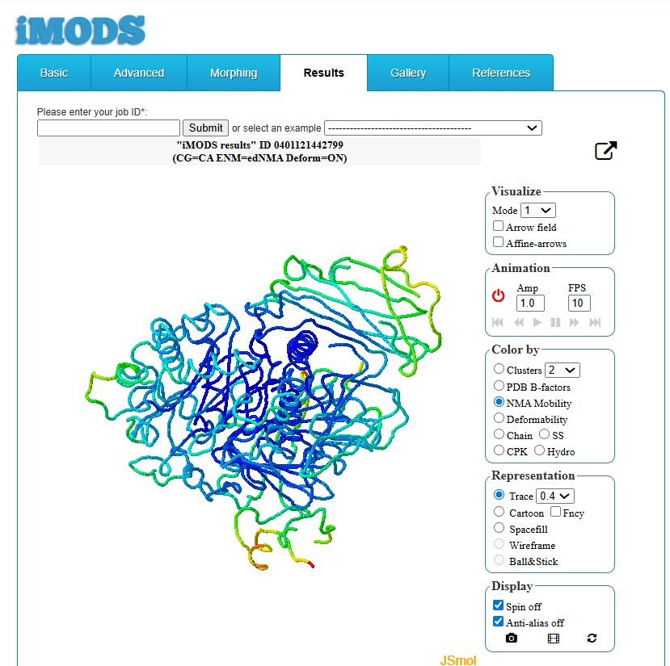
Figure 17. NMA mobility visualization of the docked α-glucosidase complex generated using iMODS.
The deformability profile demonstrated limited fluctuations across most residue positions, indicating overall structural stability of the docked complex. Similarly, the calculated B-factor profile showed good agreement with the NMA-predicted mobility pattern.
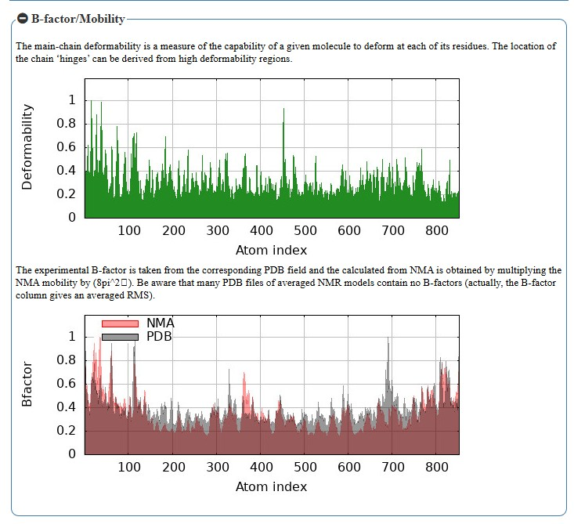
Figure 18. Deformability and B-factor analysis of the docked complex.
The calculated eigenvalue for the complex was 1.735131e−04, suggesting a low energy requirement for molecular deformation and stable conformational behaviour during motion simulation. Variance analysis indicated the cumulative contribution of multiple motion modes toward structural dynamics.
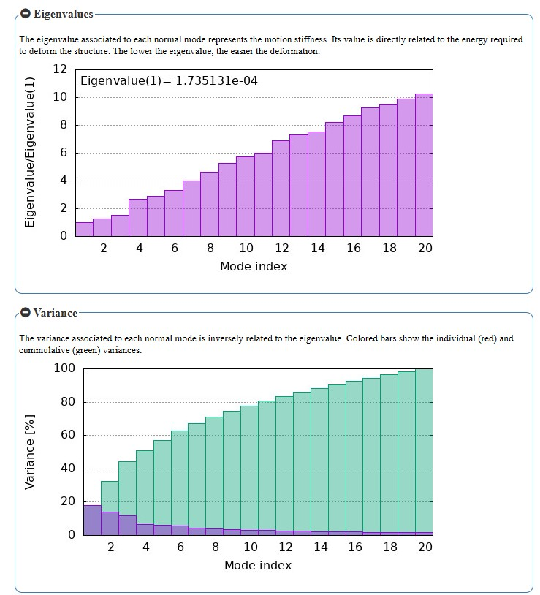
Figure 19. Eigenvalue and variance analysis obtained from iMODS.
Covariance matrix analysis revealed correlated, anticorrelated, and uncorrelated residue motions within the protein structure, reflecting coordinated internal dynamics of the docked complex.
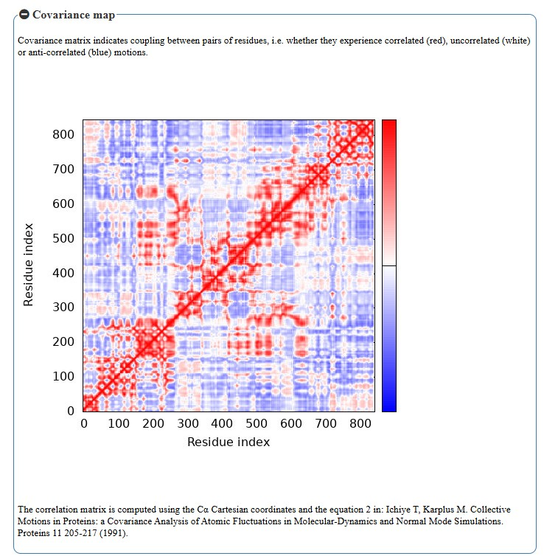
Figure 20. Covariance matrix map representing residue motion correlations.
The elastic network model demonstrated appropriate distribution of interatomic connections and stiffness throughout the protein structure, further supporting the stability of the ligand-bound complex.
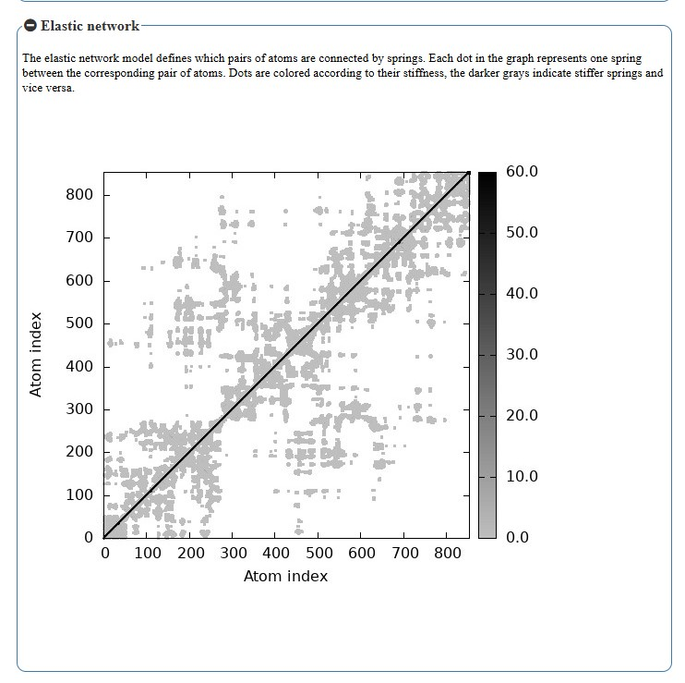
Figure 21. Elastic network analysis of the docked α-glucosidase complex.
Overall, the NMA and molecular dynamics findings suggested that the docked phytocompound complex maintained favourable structural stability and dynamic behaviour within the catalytic region of α-glucosidase.

3.6 Pharmacophore and Interaction Analysis
Pharmacophore and interaction analyses were performed to investigate the molecular interactions responsible for stabilization of the docked phytocompounds within the binding pocket of α-glucosidase. The analyses included the evaluation of van der Waals interactions, salt-bridge formation, π-mediated interactions, and solvation-associated contacts with surrounding amino acid residues.
The interaction profiles demonstrated favourable accommodation of Feruperine and Quercetin inside the active site region through multiple non-covalent interaction networks. Van der Waals contacts and hydrophobic interactions contributed significantly to ligand stabilization, while electrostatic salt bridge interactions further enhanced binding stability within the catalytic pocket. In addition, π-interactions associated with the aromatic frameworks of the phytocompounds supported effective molecular packing and interaction compatibility. Solvation-related interactions also indicated favourable ligand exposure and stabilization within the receptor environment.
Overall, the pharmacophore and interaction analyses supported the stable binding behaviour and potential inhibitory activity of the selected phytocompounds against α-glucosidase.
3.6.1 Van der Waals Interaction Profile
Van der Waals interaction analysis revealed extensive non-covalent contacts between the docked phytocompounds and surrounding amino acid residues within the α-glucosidase binding cavity. These interactions contributed significantly to stabilization and favourable accommodation of the ligand–protein complexes.

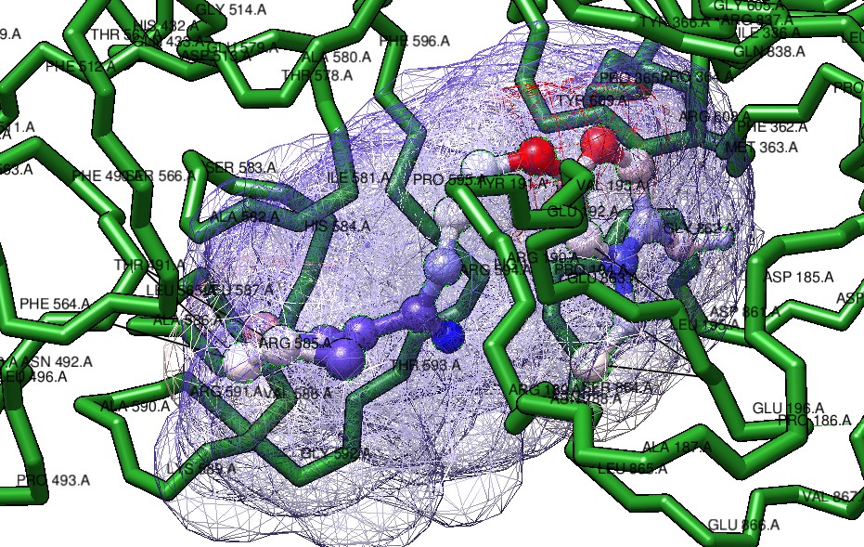
Figure 22. Van der Waals interaction profile of Feruperine within the α-glucosidase binding cavity within 3Å.
Feruperine demonstrated extensive van der Waals interactions with surrounding amino acid residues, including ARG608, TYR609, GLU579, and neighbouring hydrophobic residues. These interactions contributed to stabilization of the ligand within the catalytic groove of α-glucosidase.
Possible hydrogen-bond interactions were additionally observed near TYR609 and neighbouring residues within the binding pocket, which may further contribute to stabilization of the docked phytocompound complex.

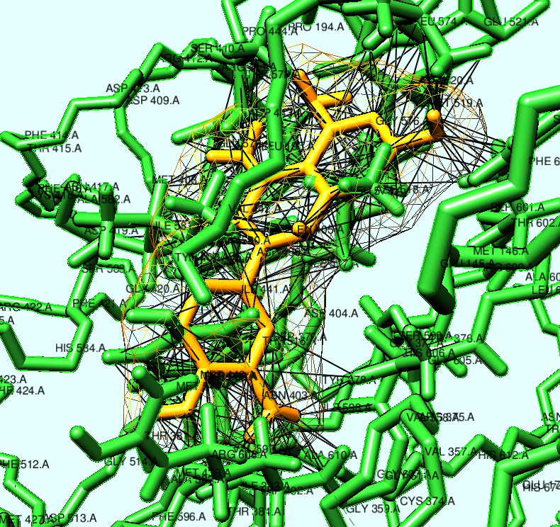
Figure 23. Van der Waals interaction profile of Quercetin within the α-glucosidase binding cavity within 3Å.
Similarly, Quercetin exhibited multiple van der Waals contacts with catalytic and surrounding residues within the active-site pocket. The aromatic scaffold and hydroxyl-containing framework of Quercetin supported stable accommodation through hydrophobic and intermolecular interaction networks.
Overall, the interaction analyses indicated favourable molecular compatibility of both phytocompounds with the α-glucosidase active site, supporting their potential inhibitory role against Type 2 Diabetes Mellitus-associated enzymatic activity.

3.6.2 Salt Bridge Interaction Analysis
Salt bridge interaction analysis was performed to evaluate electrostatic stabilization within the docked α-glucosidase complex.
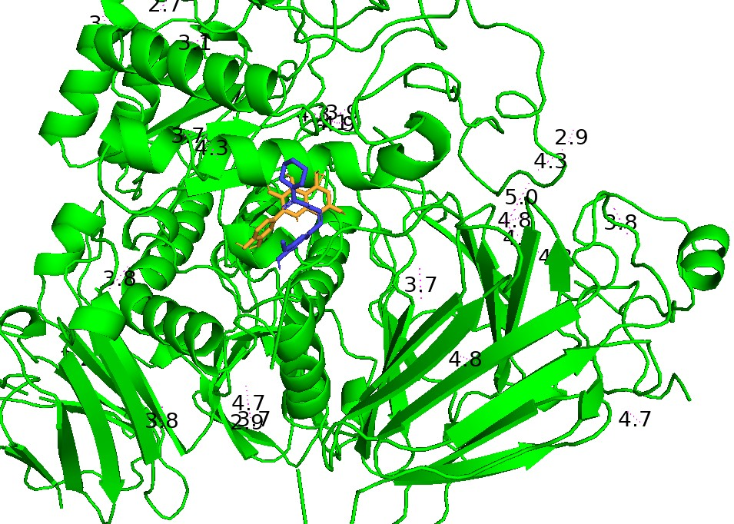
Figure 24. Salt bridge interaction analysis of Feruperine and Quercetin within the α-glucosidase binding cavity.
The analysis demonstrated the presence of favourable electrostatic interactions between the docked phytocompounds and surrounding amino acid residues inside the catalytic pocket. These interactions contributed to stabilization of the ligand–protein complex and supported effective accommodation of both Feruperine and Quercetin within the active site region of α-glucosidase.
The observed salt bridge interactions, together with van der Waals and hydrophobic contacts, further strengthened the overall stability of the docked complexes.

3.6.3 π-Interaction Analysis
π-interaction analysis was performed to evaluate aromatic interaction networks contributing to stabilization of the docked phytocompounds within the α-glucosidase binding cavity.
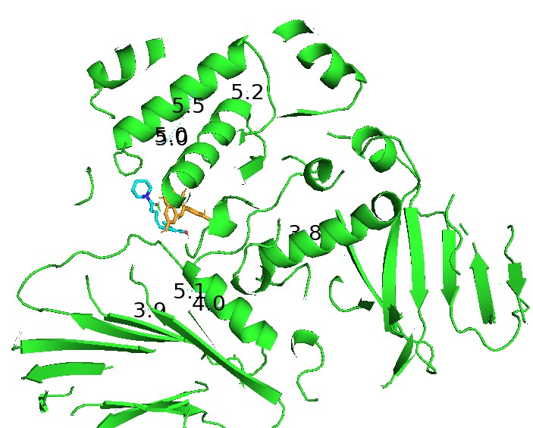
Figure 25. π-cation interaction analysis of the docked phytocompounds within the α-glucosidase active site.
The analysis revealed favourable π-cation interactions between the aromatic regions of the ligands and positively charged amino acid residues present in the catalytic environment. These interactions contributed to electrostatic stabilization and enhanced ligand accommodation within the binding pocket.
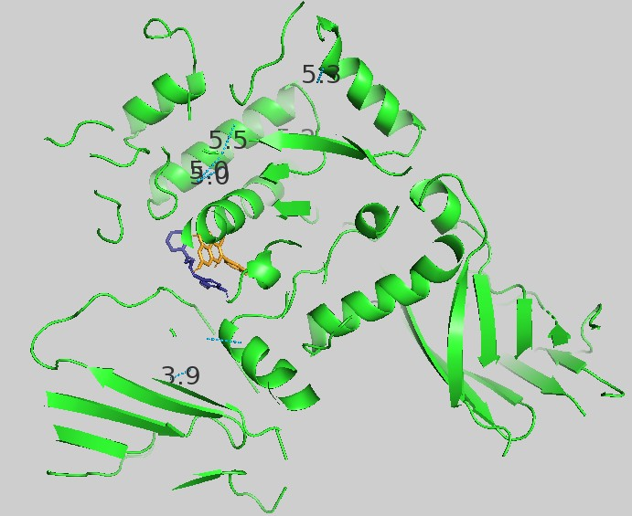
Figure 26. π–π stacking interaction analysis of the docked phytocompounds within the α-glucosidase binding cavity.
The presence of π–π stacking interactions further supported stable molecular packing between the aromatic frameworks of the phytocompounds and neighbouring aromatic residues of α-glucosidase. Together, these π-mediated interactions strengthened the overall stability of the ligand–protein complexes.
3.6.4 Solvation Analysis
Solvation analysis was performed to evaluate the solvent accessibility and environmental stabilization of the docked phytocompounds within the α-glucosidase binding cavity.
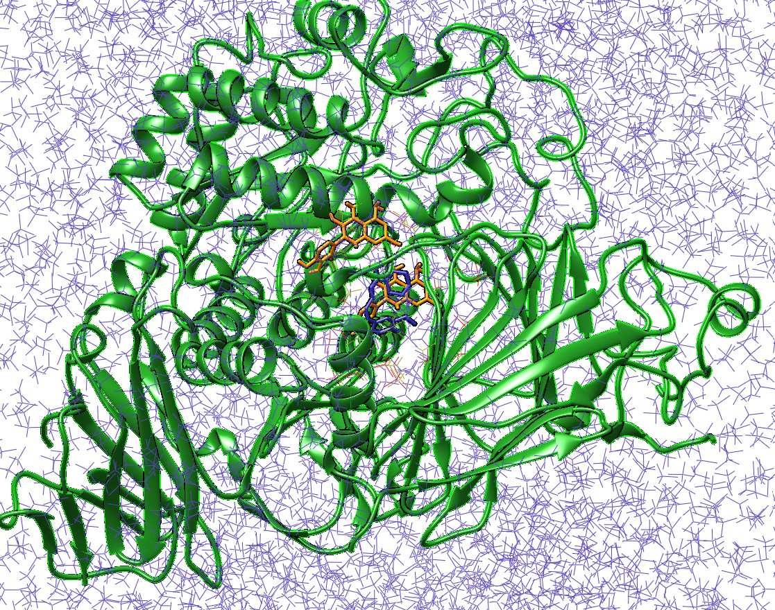
Figure 27. Solvation profile of the docked α-glucosidase–phytocompound complex.
The analysis indicated favourable ligand accommodation within the receptor environment, with stable solvent-associated interactions surrounding the catalytic region. The observed solvation behaviour further supported the structural stability of the docked complexes.

3.7 ADMET Profile Analyses
The ADMET properties of Feruperine and Quercetin were evaluated using ADMETlab 3.0 to assess their pharmacokinetic behaviour, drug-likeness, and toxicity profiles. Both phytocompounds satisfied Lipinski’s rule of five, with acceptable molecular weights, hydrogen-bond parameters, and bioavailability scores, suggesting favourable drug-like characteristics. Feruperine exhibited comparatively higher gastrointestinal absorption and BBB permeability, whereas Quercetin demonstrated higher polarity and lower blood–brain barrier penetration.
Both compounds exhibited acceptable solubility and moderate plasma clearance. Toxicity prediction indicated low hERG-related cardiotoxicity risk and acceptable acute oral toxicity profiles. However, moderate hepatotoxicity and AMES mutagenicity probabilities were predicted for both compounds, which may require further experimental validation. Overall, the ADMET analyses supported the potential pharmacological suitability of Feruperine and Quercetin as candidate α-glucosidase inhibitory phytocompounds.
The predicted ADMET properties of Feruperine and Quercetin are summarized in Table 2.
Table 2. Predicted ADMET properties of Feruperine and Quercetin using ADMETlab 3.0
Parameter | Feruperine | Quercetin
Molecular Weight (g/mol) | 287.35 | 302.24
GI Absorption | High | High
BBB Permeability | Yes | No
Lipinski Rule | Passed | Passed
Bioavailability Score | 0.55 | 0.55
Water Solubility | Soluble | Soluble
CYP Inhibition | Moderate | Moderate
hERG Toxicity | Low | Low
Hepatotoxicity | Moderate | Moderate
AMES Toxicity | Moderate | Moderate
Synthetic Accessibility | 2.72 | 3.23

4. Conclusion
The present study demonstrated the potential anti-diabetic efficacy of Feruperine and Quercetin as natural α-glucosidase inhibitors through comprehensive computational analyses. Virtual screening, molecular docking, binding pocket analysis, molecular dynamics simulation, pharmacophore evaluation, interaction profiling, and ADMET prediction collectively indicated favourable therapeutic properties of the selected phytocompounds against α-glucosidase.
Molecular docking studies revealed significant binding affinity and stable interactions between the compounds and the active site of α-glucosidase. Important interactive residues, including GLU196, GLU579, TYR609, ARG608, GLY359, and LYS195, contributed to ligand stabilization through multiple intermolecular interactions, including hydrogen bonding, van der Waals interactions, hydrophobic interactions, and π-π interactions. Binding pocket analyses further confirmed effective accommodation of the selected phytocompounds within the catalytic region of the target protein.
Normal Mode Analysis using the iMODS server [34-35] demonstrated acceptable conformational flexibility and structural stability of the docked complexes, supporting the reliability of the ligand–protein interactions. Furthermore, pharmacophore analyses highlighted molecular features associated with inhibitory activity and complex stability.
ADMET prediction results [36-38] suggested favourable drug-likeness, pharmacokinetic suitability, and acceptable toxicity profiles of the selected compounds, indicating their potential safety for therapeutic applications. The dual inhibitory mechanism predicted for Feruperine and Quercetin, involving interference with both glucose formation and glucose absorption, may contribute to improved postprandial glycemic regulation.
Overall, the present investigation highlights Feruperine and Quercetin as promising natural α-glucosidase inhibitory candidates that warrant further experimental validation for anti-diabetic drug development. However, further in vitro, in vivo, and clinical investigations are necessary to validate their pharmacological efficacy, elucidate the molecular mechanisms, and assess their therapeutic applicability in diabetic treatment strategies.

5. References
- Deepthi B, Sowjanya K, Lidiya B, Bhargavi RS, Babu PS. A modern review of diabetes mellitus: an annihilatory metabolic disorder. J In Silico In Vitro Pharmacol. 2017;3(1).
- Piero MN, Nzaro GM, Njagi JM. Diabetes mellitus-a devastating metabolic disorder.
- Hameed I, Masoodi SR, Mir SA, Nabi M, Ghazanfar K, Ganai BA. Type 2 diabetes mellitus: from a metabolic disorder to an inflammatory condition. World journal of diabetes. 2015 May 15;6(4):598.
- Nagesh MR, Vijayakumar N, Bhavani K. A review on diabetes mellitus-an annihilatory metabolic disorder. Journal of Pharmaceutical Sciences and Research. 2020 Feb 1;12(2):232-5.
- Fraser R. Metabolic disorders in diabetes. British Medical Journal. 1972 Dec 9;4(5840):591.
- Gray GM. Carbohydrate digestion and absorption. Gastroenterology. 1970 Jan 1;58(1):96-107.
- Ren M, Ai Q, Mai K, Ma H, Wang X. Effect of dietary carbohydrate level on growth performance, body composition, apparent digestibility coefficient and digestive enzyme activities of juvenile cobia, Rachycentron canadum L. Aquaculture Research. 2011 Sep;42(10):1467-75.
- Miltko R, Belzecki G, Kowalik B, Skomial J. Presence of carbohydrate-digesting enzymes throughout the digestive tract of sheep. Turkish Journal of Veterinary & Animal Sciences. 2016;40(3):271-7.
- Newcomer AD. Surface digestion of carbohydrates. InMayo Clinic Proceedings 1973 Sep 1 (Vol. 48, No. 9, pp. 620-623). Elsevier.
- Qi X, Al‐Ghazzewi FH, Tester RF. Dietary fiber, gastric emptying, and carbohydrate digestion: A mini‐review. Starch‐Stärke. 2018 Sep;70(9-10):1700346.
- Lebovitz HE. Α-Glucosidase inhibitors. Endocrinology and metabolism clinics of North America. 1997 Sep 1;26(3):539-51.
- Kalra S. Alpha glucosidase inhibitors. JPMA. The Journal of the Pakistan Medical Association. 2014 Apr 1;64(4):474-6.
- Kumar S, Narwal S, Kumar V, Prakash O. α-glucosidase inhibitors from plants: A natural approach to treat diabetes. Pharmacognosy reviews. 2011 Jan;5(9):19.
- Derosa G, Maffioli P. α-Glucosidase inhibitors and their use in clinical practice. Archives of medical science: AMS. 2012 Nov 7;8(5):899.
- Van de Laar FA. Α-Glucosidase inhibitors in the early treatment of type 2 diabetes. Vascular health and risk management. 2008 Dec 1;4(6):1189-95.
- Dirir AM, Daou M, Yousef AF, Yousef LF. A review of α-Glucosidase inhibitors from plants as potential candidates for the treatment of type-2 diabetes. Phytochemistry Reviews. 2022 Aug;21(4):1049-79.
- Akmal M, Patel P, Wadhwa R. Alpha glucosidase inhibitors. InStatPearls [internet] 2024 Feb 28. StatPearls Publishing.
- DeLano WL, Bromberg S. PyMOL user’s guide. DeLano Scientific LLC. 2004;629.
- Yuan S, Chan HS, Hu Z. Using PyMOL as a platform for computational drug design. Wiley Interdisciplinary Reviews: Computational Molecular Science. 2017 Mar;7(2):e1298.
- DeLano WL. Pymol: An open-source molecular graphics tool. CCP4 Newsl. protein crystallogr. 2002 Mar;40(1):82-92.
- Meng EC, Pettersen EF, Couch GS, Huang CC, Ferrin TE. Tools for integrated sequence-structure analysis with UCSF Chimera. BMC bioinformatics. 2006 Jul 12;7(1):339.
- Pettersen EF, Goddard TD, Huang CC, Couch GS, Greenblatt DM, Meng EC, Ferrin TE. UCSF Chimera—a visualization system for exploratory research and analysis. Journal of computational chemistry. 2004 Oct;25(13):1605-12.
- Chen JE, Huang CC, Ferrin TE. RRDistMaps: a UCSF Chimera tool for viewing and comparing protein distance maps. Bioinformatics. 2015 May 1;31(9):1484-6.
- Meng EC, Goddard TD, Pettersen EF, Couch GS, Pearson ZJ, Morris JH, Ferrin TE. UCSF ChimeraX: Tools for structure building and analysis. Protein Science. 2023 Nov;32(11):e4792.
- Sgro JY. UCSF chimera-I-introduction. Dasher Wustl Edu. 2017 Oct 10.
- Pawar RP, Rohane SH. Role of autodock vina in PyRx molecular docking. Asian Journal of Research in Chemistry. 2021 Mar 1;14(2):132-4.
- Dallakyan S, Olson AJ. Small-molecule library screening by docking with PyRx. InChemical biology: methods and protocols 2014 Dec 22 (pp. 243-250). New York, NY: Springer New York.
- Kondapuram SK, Sarvagalla S, Coumar MS. Docking-based virtual screening using PyRx Tool: autophagy target Vps34 as a case study. InMolecular docking for computer-aided drug design 2021 Jan 1 (pp. 463-477). Academic Press.
- Kumar P, Alpana A, Dinesh C, Abhinav B. In silico screening and molecular docking of bioactive agents towards human coronavirus receptor. GSC Biol Pharm Sci. 2020;11:132-40.
- Bugnon M, Röhrig UF, Goullieux M, Perez MA, Daina A, Michielin O, Zoete V. SwissDock 2024: major enhancements for small-molecule docking with Attracting Cavities and AutoDock Vina. Nucleic acids research. 2024 Jul 5;52(W1):W324-32.
- Grosdidier A, Zoete V, Michielin O. SwissDock, a protein-small molecule docking web service based on EADock DSS. Nucleic acids research. 2011 May 28;39(suppl_2):W270-7.
- Bitencourt-Ferreira G, de Azevedo Jr WF. Docking with swissdock. InDocking screens for drug discovery 2019 Aug 27 (pp. 189-202). New York, NY: Springer New York.
- Patil NS, Rohane SH. Organization of Swiss Dock: in study of computational and molecular docking study. Asian Journal of Research in Chemistry. 2021 Mar 1;14(2):145-8.
- López-Blanco JR, Aliaga JI, Quintana-Ortí ES, Chacón P. iMODS: internal coordinates normal mode analysis server. Nucleic acids research. 2014 Jul 1;42(W1):W271-6.
- Lopéz-Blanco JR, Garzón JI, Chacón P. iMod: multipurpose normal mode analysis in internal coordinates. Bioinformatics. 2011 Oct 15;27(20):2843-50.
- Yergaliyeva E, Khamit A, Zakiriyanova G, Kolbaeva Z. APPLICATION OF ADMETlab-3.0 FOR PREDICTION OF PHARMACOKINETICS AND TOXICITY OF CHEMICAL COMPOUNDS IN THE EDUCATIONAL PROCESS. 3i: intellect, idea, innovation-интеллект, идея, инновация. 2025;2(4):84-94.
- Fu L, Shi S, Yi J, Wang N, He Y, Wu Z, Peng J, Deng Y, Wang W, Wu C, Lyu A. ADMETlab 3.0: an updated comprehensive online ADMET prediction platform enhanced with broader coverage, improved performance, API functionality and decision support. Nucleic acids research. 2024 Jul 5;52(W1):W422-31.
- Agrawal S, Pandey P, Jacob A, Tiwari V, Dixit RK, Kumar R. In silico ADMET: Supporting new drug discovery. Future Health. 2026 Apr 15.

