DESIGN AND IMPLEMENTATION OF A CENTRALIZED MOSQUE MANAGEMENT PORTAL FOR MASJID ANGULLIA

- Introduction
Places of worship like mosques are not only used for worshiping, but they also act as community centers responsible for religious events, announcements, financial transactions, and community engagement. Current studies have shown that app-based solutions can enhance these tasks while minimizing manual burdens. For instance, mosque administration systems that include mobile connectivity and automation have been shown to enhance user engagement and minimize administrative workload through real-time push notifications and mobile reporting. This reflects a documented shift toward Android-based platforms to facilitate activities in various mosque settings, allowing administrators and congregants to interact seamlessly on the go.
Despite the presence of digital technology, many mosques still rely on fragmented social media platforms, spreadsheets, and paper-based systems to manage announcements and attendance. These fragmented systems lead to inefficiencies and delayed communication. The integration of a centralized mobile application can automate data collection and offer a single point of access to all organizational information, specifically enhancing administrative efficiency through mobile-integrated event calendars and financial trackers.
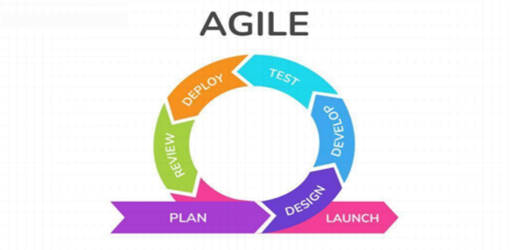
Currently, Masjid Angullia, located in Brgy. Pogo, Alaminos City, Pangasinan, has served as a vital spiritual landmark for the local community since its establishment in 1995. The mosque accommodates an average of 40 to 50 worshippers for daily prayers, with the congregation growing significantly to approximately 200 to 300 people during Friday (Jumu'ah) services and weekend Madrasah activities. Despite its central role, the mosque currently manages its operations through Facebook posts, Microsoft Excel, and paper forms. Interviews with mosque administrators reveal that this non-integrated approach causes delays in information distribution, difficulty in tracking volunteers, and issues with donation transparency.
In response to these issues, this research proposes the Design and Implementation Centralized Mosque Management Portal for Masjid Angulia. The proposed system will provide a centralized mobile platform combining real-time announcements, event schedules, donation tracking, and attendance monitoring. By focusing on the unique needs of Masjid Angullia, this project aims to improve transparency, reduce administrative work, and increase community engagement by putting a reliable source of real-time information directly into the hands of the community.
- Methodology
To ensure that the application remains flexible and responsive to user needs, the Agile methodology was used during the development process. Agile methodology allows the system to be developed in phases, making it easier to improve features based on user feedback. After every development cycle, feedback from mosque administrators and selected users was gathered to evaluate the functionality and usability of the application. During the Planning Phase, comprehensive data gathering was conducted through interviews, surveys, and direct observation with mosque administrators, volunteers, and selected community members.
Figure 1. Agile Methodology
The system uses a standard three-tier architecture:
- Presentation Tier: Serves as the user interface of the system, including login forms, dashboards, event calendars, and donation record displays, designed to accommodate administrators, officers, and community members.
- Application Tier: Functions as the processing and logic layer built with web development technologies such as Next.js, Tailwind CSS, Framer Motion, and Firebase. It processes user requests, validates inputs, organizes event schedules, and ensures only authorized users can access administrative features.
- Data Tier: Acts as the storage and database management layer, containing essential records such as user accounts, member profiles, announcements, and financial records, while supporting backup and recovery processes to protect important data.
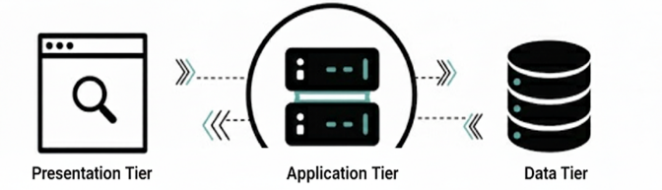
Figure 2. Three-Tier Architecture
Primary data for the study were collected from selected respondents of Masjid Angullia, located in Barangay Pogo, within Alaminos City, Philippines. The respondents consisted of the mosque head, members, and an IT expert who provided relevant information regarding current management processes and system requirements.
Respondents | Number of Respondents
Head | 1
Members | 50
IT Expert | 1
Total Respondents | 52
Table 1. Respondents of the Study
To evaluate the effectiveness and acceptability of the proposed system, a rating scale was used, allowing the researchers to interpret user feedback in measurable terms regarding usability, functionality, and overall performance.
Likert Scale Description | Likert Scale Interval
Strongly Agree | 4.21 – 5.00
Agree | 3.41 – 4.20
Neutral | 2.61 – 3.40
Disagree | 1.81 – 2.60
Strongly Disagree | 1.00 – 1.80
Table 2. Likert Scale
Quantitative data from the usability survey were analyzed using the Average Weighted Mean to determine the level of system acceptability. Qualitative data from interviews were summarized and grouped into common themes related to efficiency, transparency, and coordination to support the quantitative findings. Participation in the study was voluntary, and respondents were informed of the purpose of the research. All collected data were treated with confidentiality and used solely for academic and system improvement purposes.
- Result and Discussion
Based on the data gathered at Masjid Angullia, it was observed that the mosque administration previously relied heavily on manual and disconnected processes. Announcements were commonly posted through Facebook, financial records were maintained using Microsoft Excel spreadsheets, and attendance was monitored through paper-based sign-in sheets. This non-centralized setup caused an increased administrative workload, delayed information dissemination, manual financial computations, and limited data transparency.
To address these inefficiencies, the Centralized Mosque Management Portal was developed to integrate mosque operations into a single digital platform. The portal features automated financial computation, centralized record storage, secure authentication, structured announcement management, and consolidated reporting tools. Through iterative development cycles, system features were incrementally designed, tested, evaluated, and refined based on feedback from intended users, particularly mosque administrators.
The developed system was subsequently evaluated using the ISO/IEC 25010 software quality model to assess its overall software quality and user acceptability. The evaluation focused on key domains including functionality, usability, reliability, performance efficiency, and maintainability. Evaluation results indicated that the developed portal is highly acceptable in terms of functional suitability, usability, performance efficiency, reliability, security, maintainability, and portability. This indicates that the system effectively meets the needs of Masjid Angullia, providing an accessible and efficient management process that minimizes data inconsistencies and manual workloads.
Domain | Average Weighted Mean | Description
Functional Suitability | 4.37 | Excellent
Performance Efficiency | 4.46 | Excellent
Compatibility | 4.65 | Excellent
Usability | 4.72 | Excellent
Reliability | 4.52 | Excellent
Security | 4.65 | Excellent
Maintainability | 4.44 | Excellent
Portability | 4.61 | Excellent
Overall Weighted Mean | 4.6 | Excellent

Table 3. Overall Weighted Mean of System Evaluation

- Conclusion
The objectives of this research were successfully accomplished, demonstrating that the Centralized Mosque Management Portal has strong potential as an effective administrative solution for Masjid Angullia. The system was designed and developed to overcome the drawbacks of the mosque's previous manual processes, which were characterized by fragmented record-keeping, reliance on paper forms and spreadsheets, and inefficient social media announcements.
By providing integrated tools such as a digital donation tracker, automated attendance monitoring, and centralized announcement dissemination, the system directly resolves issues of delayed communication and high administrative workload. The evaluation results confirmed that the developed portal is highly acceptable regarding functionality, usability, and performance efficiency. Ultimately, the study proves that implementing this centralized digital solution enhances operational transparency, strengthens accountability, and supports better community engagement within the local mosque.
Reference
Abubakari, M. S., Zakaria, G. A. N., & Musa, J. (2024). Smart Mosque Information System (SMIS): A framework for Digital Daʿwa and religious tourism in Malaysia. International Journal of Academic Research in Business and Social Sciences, 14(6), 1102–1115.
Adityo, R., et al. (2025). Mobile-based mosque administrative work and real-time data integration. Sebatik, 29(1), 112–120.
Alghamdi, A., et al. (2018). Integrating static analysis tools into Agile development cycles to improve software quality. Journal of Systems and Software, 144, 495–508.
Al-Khulaifi, A., et al. (2021). Automation of prayer schedules and financial reporting in religious institutions: A Qatari perspective. IEEE Access.
Al-Mutairi, H., et al. (2025). Optimized event conflict resolution algorithms in community management platforms. Journal of King Saud University - Computer and Information Sciences.
Bautista, J. (2024). The Digital Ummah in the Philippines: Networking religious identity in Northern Luzon. Philippine Studies: Historical & Ethnographic Viewpoints, 72(2), 201–225.
Bora, M. A., et al. (2025). Optimizing Da'wah through the MASJIDA application: A cognitive ergonomics approach to enhance user experience. International Journal of Computational Methods and Experimental Measurements, 13(4), 45–58.
Chen, L., & Malik, A. (2025). The shift from social media groups to centralized portals for official mosque governance. Journal of Media and Religion.
Fauzi, M., & Rahmawati, S. (2024). E-Philanthropy: Enhancing trust through digital mosque donation portals. Journal of Islamic Philanthropy and Social Finance.
Hassan, M., et al. (2025). Scalability and security of cloud-based mosque management systems in high-traffic periods. Cloud Computing and Religious Technology Journal.
Ibrahim, R., et al. (2024). Centralized ledger systems for financial auditing in non-profit religious organizations. Emerald Open Research.
Kadir, A. B., & Ismail, Z. (2025). Performance analysis of real-time database synchronization in localized religious portals. Springer Proceedings in Computer Science.
LUMEN Publishing. (2025). Digital Ummah and the transformation of faith practices: A systematic review. International Journal of Social Sciences.
MDPI Buildings. (2025). Assessing mosque energy efficiency using smart occupancy sensors and digital management tools. Buildings, 15(6), 935.
Mohammed, S., et al. (2025). Harnessing Artificial Intelligence for mosque development: Strategic administrative approaches. Journal of Islamic Management.
Munibi, M. (2025). Faith in the digital era: How language and AI technology reshape religious practices. SMART Journal, 11(1).
Prasetyo, H., et al. (2025). UI/UX design for religious non-profits: A focus on elderly accessibility and intuitive navigation. Proceedings of the CHI Conference on Human Factors in Computing Systems.
Republic Act No. 9997. (2010). An act creating the National Commission on Muslim Filipinos. Official Gazette of the Republic of the Philippines.
RSIS International. (2025). Interactive Da'wah mediums and localized digital engagement during community crises. International Journal of Research and Innovation in Social Science (IJRISS).
Rusmiati, E. T., et al. (2025). Data-driven administrative accuracy in religious hubs using automated management tools. Global Journal of Al-Thaqafah.
Sukya, A., & Nurfarida, S. (2025). Design and development of a web platform portal for mosque financial management. Journal of Applied Information Technology, 5(1), 1–9.
Wahyuningsih, S., et al. (2025). Digital transformation of mosque governance for community engagement. Tatho Institute Journal of Islamic Studies, 3(1), 15–24.
Yaakub, M. F., et al. (2025). Mobile-based mosque management system for enhancing administrative efficiency in regional hubs. Journal of Information and Knowledge Management.

