Designing the Sudawil E-Module for Moral Values Education: A SADDIECT Framework Approach

ABSTRACT
This study developed the Sudawil e-module, traditional Kadazandusun quatrain, to deliver moral education to primary school students. The e-module was developed using the SADDIECT framework, integrating systematic approaches and cognitive learning theories in instructional design. Employing a developmental design approach, the study encompassed five phases: analysis, design, development, implementation, and evaluation. Content evaluation by six experts using the Content Validity Index (CVI) revealed that all 20 items achieved an I-CVI of 1.00, indicating high content validity. The findings demonstrate that the Sudawil e-module is an effective educational technology innovation, suitable for application in the Kadazandusun language education system in Sabah.
Keywords: Sudawil, moral values, e-module, Kadazandusun language, SADDIECT,

INTRODUCTION
The effectiveness of learning can be assessed through both the process and the outcomes. A key determinant of the learning process is the teacher, who designs instruction and facilitates active student participation. The instructional strategies employed by teachers shape how students acquire and comprehend new concepts, which are also influenced by students’ cognitive development. Careful planning promotes efficient collaboration between teachers and students. The integration of digital tools and online platforms can enhance engagement, improve learning outcomes, and optimize time and resources. This approach is especially beneficial in teaching essential values, such as those embedded in traditional Kadazandusun folk poetry, which are increasingly overlooked by younger generations. Developing interactive and user-friendly digital lessons helps students understand and appreciate moral values more effectively. Each community preserves unique cultural practices and artistic expressions that have been passed down through generations, such as sudawil, which embodies significant moral and cultural knowledge. Sudawil reflects the community’s beliefs, sustains cultural identity, and serves as a medium to impart positive values in modern educational contexts. E-modules developed using the SADDIECT framework apply theoretical principles to facilitate engaging value-based education, simultaneously supporting cultural preservation and moral development.

SUDAWIL AS CULTURAL HERITAGE AND LEARNING MEDIUM
Research has highlighted the educational and cultural significance of quatrain or talaala in preserving Kadazandusun heritage while conveying moral lessons. Rosliah Kiting et al. (2016) systematically recorded 199 talaala quatrains from 20 participants in Tamparuli, Sabah, demonstrating that these oral traditions transmit ethical guidance beyond mere verbal communication. Documenting and analyzing these forms is crucial to safeguarding intangible cultural heritage. Recent studies have also emphasized the use of technology in teaching quatrain Hassan et al. (2021) reported that engaging online lessons improved students’ comprehension of traditional values, with digital tools such as tablets and computers enhancing learning proficiency. Similarly, Lim, Tan, and Ng (2022) found that structured and interactive quatrain instruction deepens students’ understanding of cultural identity and moral principles. These findings support the application of modern pedagogical approaches, including multimedia and interactive learning, which present pantun as both historical literature and an effective tool for cultural and moral education.

METAPHORS AND AESTHETIC VALUES IN ORAL POETRY
Norjietta (2019) examined metaphorical elements within traditional Kadazandusun oral poetry, offering insights into its aesthetic and educational dimensions. Using the cognitive metaphor framework proposed by Lakoff and Johnson, the study found that symbolism drawn from flora and fauna enhances linguistic beauty while transmitting moral guidance. Pungin (2020) corroborated these findings, illustrating that natural motifs, such as the lomiding plant in sudawil, operate as metaphors for affection, responsibility, and social norms. Collectively, these studies demonstrate that Kadazandusun oral poetry functions not only as a medium of cultural expression but also as a semiotic system conveying implicit moral and cultural values.

PANTUN AS A PEDAGOGICAL TOOL
Nordiana et al. (2019) explored the use of aesthetic quatrain in classrooms, examining teachers’ and students’ perceptions. Their findings indicate that pantun promotes critical thinking, enhances vocabulary, and improves communication skills. Similarly, Ismail et al. (2015) emphasized that musical elements in sudawil, including rhyme and rhythm, support memory retention and comprehension. Hence, the linguistic structure of quatrain provides benefits in both language acquisition and long-term cognitive retention.

IMPLEMENTATION OF MORAL VALUES IN EDUCATION
In the context of value education, Rusini (2017) studied how preschool teachers implement moral education based on the National Preschool Standard Curriculum (KSPK), identifying key values such as kindness, discipline, honesty, and respect. However, traditional teaching methods lacked the integration of digital tools or e-modules, limiting their effectiveness in modern learning environments. Florina (2018) examined the role of tangon-tangon (Kadazandusun folktales) in character formation for primary students. While these folktales effectively impart moral lessons, their passive and traditional delivery methods are less responsive to 21st-century pedagogical needs. In this regard, the development of a semiotic- and technology-based sudawil e-module, as proposed in this study, provides a more interactive, systematic, and measurable approach to teaching moral values.

CHALLENGES AND THE NEED FOR PEDAGOGICAL INNOVATION
Suppiah Nachiappan et al. (2017) identified major challenges in moral education, including teachers’ difficulties in connecting values to real-life scenarios and the shortage of effective teaching materials. These findings underscore the importance of introducing innovations such as multimedia resources and e-modules to ensure contextualized and effective value education. Teoh Jane Siew Theng (2024) further highlighted that a supportive and conducive learning environment is essential for helping students internalize moral principles.

PROBLEM STATEMENT
Each ethnic group in Sabah maintains distinct oral traditions, among which sudawil is prominent within the Kadazandusun community. These traditional quatrains transmit knowledge, impart moral lessons, and preserve cultural heritage. Their content, rich in advice, admonition, and satire, guides young people in understanding appropriate behavior and moral principles (Hassan, Abdullah & Mohd Ali, 2021; Lim, Tan & Ng, 2022; Salleh & Yahya, 2023). However, contemporary youth are increasingly engaged with modern music and global media, resulting in reduced exposure to sudawil. Additionally, the use of complex figurative language, including metaphors and satire, poses comprehension challenges, making it more difficult for students to grasp embedded moral lessons (Rahman, 2021). Globalization and popular culture have further marginalized sudawil, while limited exposure and the erosion of cultural identity contribute to its decline (Ahmad & Lim, 2022; Salleh & Yahya, 2023). Despite the introduction of Kadazandusun language instruction in schools, teaching resources for sudawil remain scarce. Teachers face difficulties in developing materials that are user-friendly and sustainable, as most traditional resources are neither durable nor suitable for classroom use. This situation highlights the urgent need for innovative pedagogical approaches that facilitate effective teaching and learning of sudawil (Salleh & Yahya, 2023).

METHODOLOGY
An integrated research design combining both quantitative and qualitative methods was adopted in this study, guided by the SADDIECT instructional development framework. The model comprises five key stages: Analysis, Design, Development, Implementation, Evaluation, and the Integration of Learning Theory. This structured approach was chosen to ensure that the sudawil e-module is developed systematically, incorporating pedagogical principles, technological tools, and culturally relevant content. The schematic below presents the SADDIECT framework as applied to the creation of the sudawill e-module for the purpose of teaching moral values.
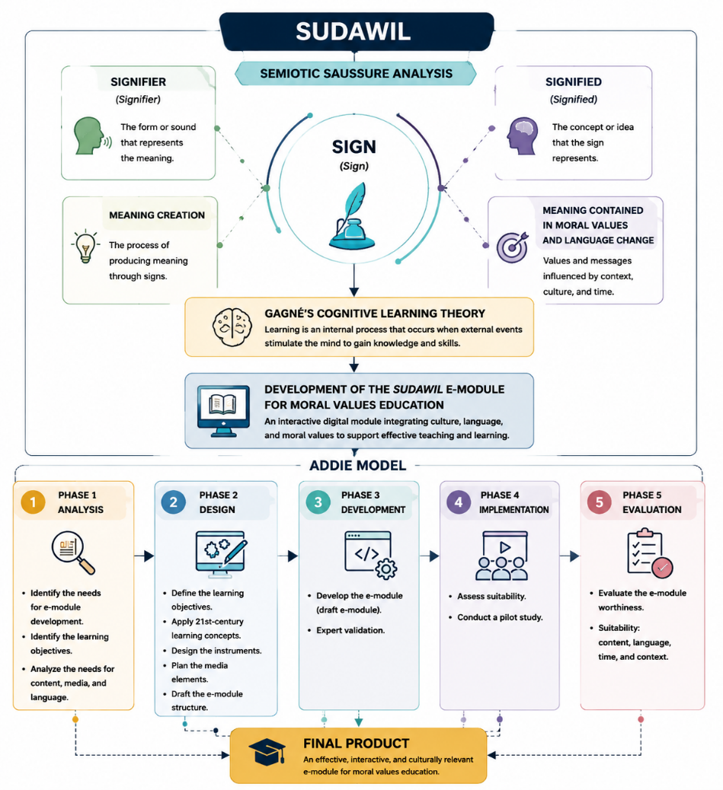
Figure 1. SADDIECT Framework
Adapted from Lu and Sides (2025) and Georgakopoulou and Smyrnaiou (2025)
Phase 1: Analysis
The initial phase focused on conducting a needs analysis to identify the essential requirements for the e-module. A structured questionnaire was distributed to 44 Kadazandusun language teachers serving in primary schools in the Beluran district of Sabah. The instrument, created using Google Forms, was divided into sections covering teacher demographics, the need for teaching resources, and the suitability of incorporating technology into Kadazandusun language teaching and learning. To enhance the reliability and validity of the instrument, a pilot study was conducted, and the questionnaire was refined based on feedback from teachers and expert review.

Phase 2: Design
The design phase involved creating the e-module structure based on the insights gathered during the analysis phase. Instructional planning followed Gagné’s (1985) cognitive learning theory, which emphasizes nine instructional events to sequence content systematically. Additionally, the design integrated 21st-century learning strategies, particularly the 4C approach (Creativity, Critical Thinking, Collaboration, Communication). Multimedia elements—including text, graphics, audio, and animation—were incorporated to enhance understanding and engagement. Storyboards and interactive navigation layouts were developed to ensure that the e-module would be user-friendly for both students and teachers.

Phase 3: Development
During the development phase, content from traditional sudawil oral sources was collected and transformed into digital format. The moral lessons embedded in the sudawil were analyzed and structured as interactive activities appropriate for Year Two students. Digital development platforms were used to create the e-module, with content evaluated by subject-matter experts. Preliminary testing of the draft e-module was conducted to identify technical and pedagogical improvements before wider implementation.

Phase 4: Implementation
The implementation phase involved a small-scale pilot study with Year Four students of the Sungai ethnic group during Kadazandusun language lessons. This phase aimed to assess the e-module’s initial effectiveness in improving students’ comprehension of sudawil and their understanding of moral values. Lessons were conducted in real classroom settings under the supervision of researchers and teachers. Qualitative data were collected through classroom observations, informal interviews, and teacher feedback regarding the module’s usability and instructional impact.

Phase 5: Evaluation
The evaluation phase assessed the content validity of the e-module using the Content Validity Index (CVI). Six experts in Kadazandusun language education and educational technology evaluated 20 items across three categories: presentation and delivery, content accuracy, and language appropriateness. A two-point scale (1 = suitable, 0 = not suitable) was used, and all items achieved an I-CVI of 1.00, indicating a high level of content validity and confirming the module’s suitability for classroom use.

Integration of Methods and Final Development
By combining quantitative and qualitative methods, the study ensured that both the content and design of the e-module were accurate and pedagogically sound. The active involvement of teachers, students, and experts facilitated the creation of a culturally responsive educational tool. The resulting sudawil e-module represents an innovative instructional resource that aligns with students’ needs, preserves cultural heritage, and supports the teaching of moral values in primary education within Sabah.

CONTENT VALIDITY OF THE SUDAWIL E-MODULE
The content validity of the sudawil e-module was evaluated to ensure that each item met pedagogical requirements and supported the objectives of moral values education in the Kadazandusun language curriculum. This assessment involved six expert panelists, including lecturers specializing in Kadazandusun language education and educational technology. Each expert received an evaluation form comprising 20 items, organized into three primary domains: (1) E-Module Presentation and Delivery, (2) E-Module Content, and (3) Language Use. To determine content validity, the Content Validity Index (CVI) method was employed, following the guidelines proposed by Polit and Beck (2006). Experts were asked to rate each item as either 1 (appropriate) or 0 (not appropriate). The Item-Level Content Validity Index (I-CVI) for each item was calculated by dividing the number of experts rating the item as appropriate by the total number of experts. All 20 items achieved an I-CVI of 1.00, indicating unanimous agreement among the panelists that the e-module items were appropriate and met established pedagogical criteria.

Table 1. Content Validity of the Sudawil E-Module Based on Expert Evaluation (N = 6)
No | Evaluation Aspect | I-CVI
1 | E-module title aligns with objectives | 1.00
2 | Text is presented clearly | 1.00
3 | Presentation appropriate for Year Two teachers | 1.00
4 | Content organization is easy to follow | 1.00
5 | Images are relevant to the text | 1.00
6 | User-friendly presentation | 1.00
7 | Suitable as a teaching aid for Kadazandusun language | 1.00
8 | Activities facilitate lesson planning | 1.00
9 | Content arranged from simple to complex | 1.00
10 | Introduction activities motivate students | 1.00
11 | Activities enhance teachers’ knowledge | 1.00
12 | Activities improve teachers’ skills | 1.00
13 | Activities support student mastery | 1.00
14 | Activities are appropriate for students’ development | 1.00
15 | Activity steps are systematically organized | 1.00
16 | Activity duration is appropriate | 1.00
17 | Writing style is clear and readable | 1.00
18 | Word spelling is correct | 1.00
19 | Language is easily understood | 1.00
20 | Writing is suitable for teachers | 1.00
 | Average I-CVI | 1.00

DISCUSSION
The findings confirm that all 20 items in the sudawil e-module met the criteria for content validity comprehensively. This indicates that the e-module development process carefully considered pedagogical principles, user needs, and the competency levels of both teachers and primary school students. According to Lynn (1986), an I-CVI exceeding 0.78 is regarded as valid; therefore, the perfect score of 1.00 for each item demonstrates exceptionally high content quality. Comprehensive content validation is essential to ensure the module’s effectiveness in actual classroom implementation. It aligns with the study’s objective of enhancing students’ understanding of sudawil and promoting moral education through educational technology. The evaluation also confirms that the e-module meets high standards in terms of presentation, content, and language, all of which are critical for successfully teaching moral values to Year Two students. These results support the importance of developing systematic teaching aids, consistent with Suppiah Nachiappan et al. (2017), who highlighted the lack of interactive and appropriate materials as a major challenge in moral education. The strength of the sudawil e-module lies in its integration of educational technology with Kadazandusun cultural values embedded in sudawil. This aligns with the findings of Rosliah Kiting et al. (2016) and Norjietta (2019), emphasizing that oral traditions and metaphors in poetry not only hold aesthetic value but also possess high educational potential when implemented through modern pedagogical approaches. The e-module offers digital learning activities while simultaneously preserving local cultural identity, supporting the development of students’ self-identity. Furthermore, the use of the SADDIECT framework, which integrates semiotic theory, the six development phases (analysis, design, development, implementation, evaluation), and Gagné’s learning theory, renders the e-module comprehensive and structured. The uniqueness of this approach lies in balancing educational technology needs with traditional cultural content. Content mapping based on cognitive learning principles and the 4C strategies (Creativity, Critical Thinking, Communication, Collaboration) ensures that students engage actively rather than passively in the learning process. The high I-CVI values further indicate strong endorsement from both teachers and educational experts, confirming that a systematically developed, locally-based value module can be widely accepted and has a significant positive impact on mastery of lesson content, particularly in the context of ethnic-language-based moral education.

CONCLUSION
Overall, the findings of this study indicate that the development of the sudawil e-module, based on the SADDIECT framework and Gagné’s cognitive learning theory, demonstrates strong content validity. All 20 items evaluated by six experts achieved an I-CVI of 1.00, confirming the module’s high potential as a teaching aid for Kadazandusun language instruction. The successful development of this e-module illustrates that integrating local cultural elements with educational technology can produce effective instructional innovations that are relevant to 21st-century educational needs. Furthermore, the e-module contributes to the preservation of the Kadazandusun community’s intangible cultural heritage through its adaptation within the formal education system.
IMPLICATIONS OF THE STUDY
This study makes a significant contribution to value education by demonstrating the effective use of technology, specifically in the form of e-modules grounded in local cultural traditions, such as Sudawil (Kadazandusun quatrain). The main implication is the importance of leveraging technology to enhance students’ understanding of moral values while simultaneously preserving cultural heritage that is at risk of being forgotten. The development of the e-module using the SADDIECT framework has been shown to positively impact learning effectiveness, improve students’ information processing skills, and introduce a more interactive and contextualized approach to teaching the Kadazandusun language.The success of the Sudawil e-module provides a model for the development of additional modules in value and cultural education at the primary school level, particularly within broader ethnic contexts. By combining pedagogical strategies, technological tools, and local cultural content, this approach can serve as a scalable framework for integrating traditional heritage into modern education while fostering moral and cultural understanding among students.

REFERENCES

Ahmad, A., & Lim, S. Y. (2022). Cultural identity and language learning in Sabah: Challenges and opportunities. Journal of Ethnic Education, 12(2), 45–58.
Ahmad, A., & Lim, S. Y. (2022). Globalization and the erosion of local oral traditions among youth in Sabah. Journal of Ethnic and Cultural Education, 11(2), 88–101.
Florina, F. (2018). The role of Kadazandusun folktales (tangon-tangon) in character formation among primary school students. International Journal of Early Childhood Education, 20(1), 33–47.
Gagné, R. M. (1985). The conditions of learning and theory of instruction (4th ed.). Holt, Rinehart & Winston.
Hassan, R., Abdullah, N., & Mohd Ali, H. (2021). Integrating technology in teaching traditional Kadazandusun pantun: A case study in Sabah. Asian Journal of Education Technology, 15(3), 102–115.
Ismail, S., Rahman, F., & Osman, N. (2015). Musical elements in oral poetry and memory retention among primary school students. Journal of Language and Literature, 18(2), 77–89.
Lim, C. H., Tan, H. K., & Ng, W. T. (2022). Interactive instruction in Kadazandusun pantun for cultural and moral education. International Journal of Multicultural Education, 24(4), 121–135.
Lynn, M. R. (1986). Determination and quantification of content validity. Nursing Research, 35(6), 382–385.
Norjietta, J. (2019). Metaphorical elements in traditional Kadazandusun oral poetry: A cognitive perspective. Malaysian Journal of Cultural Studies, 7(1), 58–72.
Polit, D. F., & Beck, C. T. (2006). The content validity index: Are you sure you know what’s being reported? Critique and recommendations. Research in Nursing & Health, 29(5), 489–497.
Pungin, M. (2020). Symbolism in Kadazandusun oral poetry: Flora and fauna as metaphors for social norms. International Journal of Cultural Heritage, 14(1), 15–28.
Rosliah Kiting, A., et al. (2016). Documentation and analysis of talaala in Tamparuli, Sabah: Preserving intangible heritage. Sabah Cultural Studies Journal, 10(2), 25–41.
Salleh, N., & Yahya, A. (2023). Innovative approaches in teaching Kadazandusun language using digital modules. Malaysian Journal of Education Technology, 20(1), 41–58.
Suppiah Nachiappan, P., Lim, L. H., & Tan, R. (2017). Challenges in moral education: Teacher perspectives and teaching resources. Journal of Moral Education, 46(3), 276–290.
Teoh, J. S. T. (2024). Creating a conducive learning environment to enhance moral value internalization among students. Asian Journal of Educational Research, 16(1), 59–73.

