Creative Minds for a Sustainable Future: Embedding Creative Studies in Design Education to Foster Innovation as a case study in OCMT
¹Dr. Mohamed Alnejem1,²Ms. Maram AL-Hinai, ³Ms. Fatema Al-Akhzami
Department of Design, Oman College for Management and Technology, Oman
¹Email Address: malnejem@ocmt.edu.om
²Email Address: malhinai@ocmt.edu.om
³Email Address: falakhzam@ocmt.edu.om

Abstract. As sustainability and innovation continue to shape the future of the creative industries, design education is increasingly expected to move beyond the teaching of aesthetics and toward the stimulation of transformative thinking. This study explores the integration of a purposefully designed Creative Studies course within a design program, aimed at inspiring student innovation, fostering sustainable mindsets, and developing creative confidence. Grounded in experiential learning and interdisciplinary collaboration, the course encouraged students to progress from surface-level problem-solving to deeper, concept-driven, and impact-oriented design practices. Through open-ended briefs, real-world design challenges, and iterative studio-based activities, students engaged with core Course Learning Outcomes (CLOs) focused on ideation, originality, critical reflection, and sustainability. Using student feedback alongside performance data, including project outcomes and CLO assessments, the findings demonstrate notable growth in students’ ability to generate innovative and socially responsible design solutions. These improvements were evident not only in classroom projects but also in students’ senior capstone projects and professional portfolios. Ultimately, this research reframes creativity as more than a skill, presenting it as a mindset that is essential for preparing designers to innovate sustainably and contribute meaningfully to the creative industries of the future.

Keywords: Creativity, Design, Sustainability, Curriculum Design, OCMT.
- Introduction
Creativity constitutes a fundamental element of interior design education, as it enables students to develop innovative solutions that respond to diverse design requirements. Hennessey and Amabile describe creativity as a central driver of societal and civilizational advancement [1]. Similarly, Stein defines creativity as a process that results in the production of something novel and that is perceived as valid, useful, or aesthetically pleasing by a particular group within a specific temporal context [2]. Established educational frameworks further underscore the critical role of creativity within design and educational disciplines [3]. In the context of interior design, creativity extends beyond visual appeal to include conceptual development and effective problem-solving strategies [4]. Therefore, fostering creativity among students is a crucial educational objective. However, many interior design students encounter challenges in comprehending and applying creative principles in their work. Accordingly, the present study examines student creativity in interior design, with particular emphasis on learning outcomes achieved through the Creative Studies course.
- Literature Review
  - Creativity in the Omani design-education context
Creativity plays a fundamental role in design education; however, its interpretation and implementation vary across cultures and educational institutions. In the Omani context, creativity in higher education is influenced by cultural traditions, instructional practices, and societal norms. AL-Balushi (2019) notes that although creativity is widely acknowledged within Omani graphic design education, it is not always effectively cultivated through existing pedagogical approaches. Many academic programs continue to rely on conventional, instructor-centered teaching methods, which restrict opportunities for experimentation and independent thinking [6]. Nevertheless, ALBalushi [9] highlights that Omani students can demonstrate strong creative potential when provided with appropriate guidance, encouragement, and opportunities for exploration. Despite this potential, the education system tends to prioritize technical proficiency and fixed outcomes rather than open-ended and exploratory creative processes, resulting in a disconnect between the recognized value of creativity and its practical application in the classroom. These findings indicate that promoting creativity in Oman requires a more supportive educational environment that fosters risk-taking, problem-solving, and innovation [6]. Within the context of OCMT, this research provides important insights by emphasizing the need for well-defined and structured strategies to effectively nurture creativity in design education. It argues that creativity should be integrated into design curricula not only as an artistic competency but also as a tool for addressing contemporary challenges, including sustainability and social responsibility. Consequently, there is a clear need to reconsider the organization and instructional methods of creative courses within the Interior Design program at OCMT.
  - Linking Creativity and Innovation Education with the Sustainable Development Goals
In recent years, higher education institutions have increasingly sought to align their academic practices with the United Nations Sustainable Development Goals (SDGs). Within this context, creativity and innovation are recognized as critical drivers for achieving these objectives, particularly in design-related disciplines. The Sustainability-Oriented Creativity, Innovation, and Entrepreneurship (SOCIE) Education Framework proposed by Lozano et al. [8] presents a structured approach for embedding sustainability within creative education. This framework underscores the importance of directing creative efforts toward addressing practical sustainability challenges rather than treating creativity as a purely academic exercise [8]. Furthermore, it promotes an educational model that integrates creative thinking, innovation, and entrepreneurship while emphasizing ethical responsibility. The SOCIE framework encourages project-based learning and interdisciplinary collaboration in alignment with the SDGs [8]. Within design education, it offers practical guidance for structuring coursework and assessments to reflect sustainability objectives, preparing students to act as change agents capable of producing socially and environmentally responsible design solutions. This approach is particularly relevant for OCMT, as it facilitates the integration of Interior Design projects and learning outcomes with specific SDGs [8]. Implementing the SOCIE framework can strengthen OCMT’s curriculum by promoting sustainable development through creative design education, establishing it as a central theoretical foundation for both this research and the proposed curriculum enhancements [8].
  - Sustainable development competencies in design education
Although creativity is a fundamental element of design education, it must be complemented by clearly defined sustainability competencies to achieve meaningful learning outcomes. According to [7], sustainability education should develop specific knowledge, skills, and attitudes that enable students to effectively address complex environmental and social challenges. The authors highlight key competencies including systems thinking, critical reflection, ethical responsibility, and collaborative problem-solving as essential components of education for sustainability [7]. The authors stress that design students should not only comprehend sustainability concepts but also be able to apply them in practical contexts. Achieving this requires the systematic integration of sustainability principles into learning outcomes, project briefs, and assessment strategies. The study further underscores the importance of aligning course objectives with competencies that promote critical evaluation of the environmental implications of design decisions. This perspective offers valuable guidance for enhancing the Interior Design curriculum at OCMT by strengthening the alignment between creativity-focused courses and broader Program Learning Outcomes (PLOs) and Course Learning Outcomes (CLOs) related to sustainability. Adopting a competency-based approach enables OCMT to ensure that creative assignments are not only innovative but also socially responsible. In addition, Giangrande et al. (2019) provide practical assessment tools to evaluate whether students are developing the targeted sustainability competencies, which is particularly relevant for embedding sustainability outcomes within creativity-oriented design courses [7].

  - Sustainability attitudes among interior design students in the Middle East
Gaining insight into students’ perspectives on sustainability is essential for informing curriculum development in design education. Alawneh et al. examined the attitudes of interior design students in Jordan and neighboring countries and found that although students generally held positive attitudes toward sustainability, their understanding and practical application of sustainable design principles remained limited [5].
This gap can largely be attributed to the limited integration of sustainability concepts within interior design curricula, where sustainability is frequently addressed as a theoretical topic rather than embedded in practical design projects. As a result, graduates often lack the necessary skills to effectively implement sustainable design solutions. This issue is particularly relevant to the context of OCMT, as Omani students may be aware of sustainability challenges but remain insufficiently prepared to address them in professional practice. The study therefore highlights the need for curricular reforms that more effectively integrate creativity with sustainability Incorporating sustainability-oriented creative approaches into Interior Design courses can assist OCMT in addressing this gap while underscoring the importance of aligning creative education with environmental responsibility within the Middle Eastern context [5].
- Case Study: Interior design program at OCMT
  - OCMT:
OCMT, established in 2004, is a medium-sized higher education institution specializing in computer science, business administration, and design. The Design Department enrolls approximately 150 students, the majority of whom are female. Admission to the institution is selective and primarily targets academically qualified students holding an Omani high school diploma. The Interior Design Department offers both diploma and bachelor’s degree programs, equipping students with fundamental creative and technical competencies.
  - Study plan:
The program emphasizes space arrangement, construction techniques, and furniture design for both residential and commercial environments and is structured into several categories, including:
- Faculty Requirement Compulsory: ( 12 ) Hour / Hours
- Faculty Requirement Optional: ( 3 ) Hour / Hours
- Department Requirement Compulsory: ( 24 ) Hour / Hours
- Supporting Requirement Compulsory: ( 72 ) Hour / Hours
- Supporting Requirement Optional: ( 6 ) Hour / Hours
The Department of Design decided to introduce an additional optional supporting course aimed at enhancing the integration of creativity and technology within teaching and learning strategies. This course, titled Creative Study, carries a total of 3 credit hours.
  - Creative study course:

Course Description
This course addresses the interpretation of concepts from multiple disciplines and the development of design solutions that maintain spatial coherence. Basic design courses function as the primary platform through which students analyze problems, communicate their design concepts, and translate ideas into practical applications. In addition, design education incorporates fundamental design principles such as color, proportion, balance, and contrast to achieve visual coherence and proportional harmony. Students’ participation in observation, research, and experiential learning activities enhances the development of creative abilities. Basic design courses seek to enhance students’ perceptual awareness, experiential learning, and creative development.

Course in study plan:
The Creative Study course is offered in the Bachelor of Interior Design curriculum as a supporting elective, as presented in Table 1.
Table 1. Supporting Requirement Optional: ( 6 ) Hour / Hours.
Course Code | Course name | Credit Hours
603209 | Arabic Calligraphy | 3
603310 | Creative Study | 3
603311 | History of photography | 3
603401 | Seminar in Design Methodology | 3
603403 | Special Topics in Photography | 3
603407 | Special Topics in Graphic Design | 3
603408 | Special Topics in Textile Design | 3
603409 | Advanced Studies In photography | 3
603410 | Technology of Textile Design | 3

Program Learning Outcomes PLOs:
The Interior Design program defines nine Program Learning Outcomes (PLOs), which are outlined as follows:
- PLO 1: Demonstrate the ability to apply specialized knowledge in professional practice.
- PLO 2: Identify professional challenges and propose appropriate solutions.
- PLO 3: Communicate effectively, both individually and collaboratively within teams.
- PLO 4: Recognize the importance of self-development and engage in continuous learning.
- PLO 5: Act in accordance with principles of integrity, credibility, and professional ethics.
- PLO 6: Contribute to community development and promote environmental sustainability.
- PLO 7: Effectively organize and manage available resources.
- PLO 8: Make informed decisions based on available data and evidence.
- PLO 9: Design and conduct scientific research relevant to the field of study.

Course Learning Outcomes CLOs:
The Creative Study course is designed with six Course Learning Outcomes (CLOs), which are outlined as follows:
- CLO 1: Identify the principles of concept development and the theoretical foundations that inform concept design.
- CLO 2: Demonstrate advanced knowledge of concept techniques and strategies for concept development.
- CLO 3: Enhance academic research skills within the field of creative interior design concepts.
- CLO 4: Develop solutions for a variety of conceptual design challenges.
- CLO 5: Produce accurately drafted concept plans utilizing concept techniques to satisfy both functional and design criteria.
- CLO 6: Create reflective models and generalized concepts suitable for creative design enterprises.

Course Topic Titles:
According to the course specification, the Creative Study course will cover the following topics throughout the semester, as presented in Table 2.
Table 2. Course topic titles.
Indicator | Topic Titles
1 | Introduction to the course material
2 | Introduction to Basic Design
3 | Principles of Concept Development
4 | Advanced Concept Techniques
5 | Color Theory and Proportion
6 | Research Skills for Creative Design
7 | Problem-Solving in Design
8 | Creating Design Concepts
9 | Midterm Review and Exam Preparation
10 | Communication in Design
11 | Concept Planning Techniques
12 | Model Production
13 | Final Project Work
14 | Final Project Work
15 | Final Presentations
16 | Final submission of project
- Discussion:
The Department of Design has been offering the Creative Study course for the past three semesters. To evaluate the outcomes of this course in relation to student grades as well as the attainment of Course Learning Outcomes (CLOs) and Program Learning Outcomes (PLOs), the following tables provide a detailed analysis.
  - Grading mark students:
Student performance in the Creative Study course over four semesters is presented in Table 3 and Figure 1.
Table 3. Grading mark student for four semesters.
Indicator per section | 20251 | 20244 | 20242 | 20241
% pass | 100% | 100% | 100 % | 100%
Standard Deviation | 7.24 | 9.07 | 7.67 | 3.46
Coefficient of Variation (C.V): | 9% | 10% | 9% | 4%
Skewness | -1.27 | -0.99 | -0.54 | -1.73
Correlation | 0.60 | 0.95 | 0.373514 | 0.55
Class Average | 83 | 89 | 87 | 86
- The pass rate for this semester, as well as for previous semesters, was 100%, indicating that all students successfully met the minimum requirements of the course.
- The observed standard deviation (7.24) and coefficient of variation (9%) reflect a moderate distribution of marks, demonstrating slightly greater consistency in results compared to certain previous semesters.
- The negative skewness value (-1.27) indicates that a larger proportion of students scored above the mean, reflecting overall strong performance.
- The correlation between in-course and final exam results 0.60 indicates a moderate positive relationship, suggesting that in-course assessments moderately reflect final exam performance. This correlation is lower than in some previous semesters, implying greater variation between continuous assessment and final project outcomes.
- The end-of-semester GPA was 83, slightly lower than the previous semesters 89, yet consistent with trends observed in earlier semesters, reflecting stable academic performance.
Fig. 1. Students marks for 20251,20244,20242,20241
  - CLOs Achievements:
The performance of students in achieving the Course Learning Outcomes (CLOs) for the Creative Study course over four semesters is illustrated in Figure 2.

Fig. 2. CLOs Achievement for 20251,20244,20242,20241

- All Course Learning Outcomes (CLOs) were successfully achieved, with attainment percentages ranging from 93.78% to 98.44%, demonstrating that students effectively met the intended learning objectives.
- High-Performing CLOs:
- creation of a reflective model and a generic concept for creative enterprises was accomplished with an attainment rate of 98.44%.
- Identifying the principles of concept development and the theoretical foundations influencing concept design was achieved at 96.09%.
- These results indicate that students demonstrated strong ability in translating conceptual understanding into practical and creative outputs.
- Slightly Lower CLOs:
- Demonstrate proficient knowledge of concept development approaches and techniques, achieving a rate of 93.78%.
- Produce a precise concept plan based on concept development techniques, with an achievement rate of 95.35%.
Although the results remain strong, they indicate a minor opportunity to enhance the translation of advanced conceptual strategies into precise visual representations.
  - PLOs Achievements:

Fig. 3. PLOs Achievement for 20251,20244,20242,20241
Student attainment of the Program Learning Outcomes (PLOs) for the Creative Study course over four semesters showed high achievement levels, particularly in the semesters 2025/1, 2024/4, and 2024/1, where all related PLOs exceeded 80%.
The results demonstrate that students were able to identify professional problems and propose appropriate solutions, communicate effectively both individually and in teams through systematic and professional practice, support community development and environmental preservation, and make informed decisions based on available information to design and conduct scientific research in the field. The corresponding achievement percentages are presented in Figure 3.
  - Samples of student works:
Over four semesters, students in the Creative Study course undertook a variety of assessments and project-based activities, as presented in Figure 4.
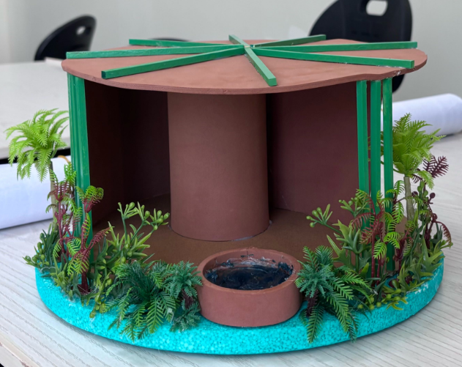 | 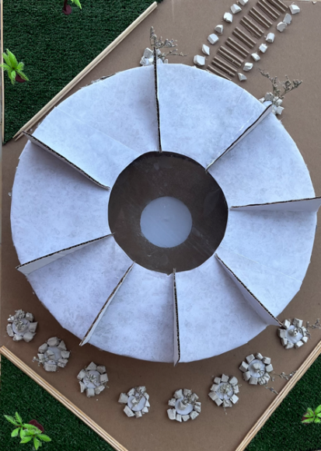 | 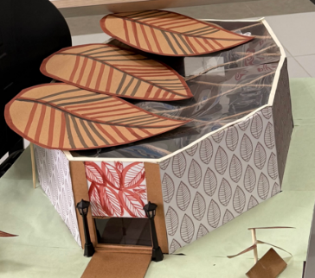
Fig. 4. Samples of student works
- Conclusion:
In conclusion, the incorporation of Creative Studies within design education at Oman College for Management and Technology represents a forward-looking approach to preparing future designers with the competencies and perspectives required for sustainable innovation. Through experiential learning and a curriculum aligned with the Sustainable Development Goals, students are encouraged to move beyond traditional approaches and actively engage in meaningful, concept-driven projects.
The demonstrated development of students’ creativity and social responsibility highlights the importance of cultivating an educational environment that promotes risk-taking, critical thinking, and collaborative problem-solving. This study not only emphasizes the potential for transformative development within the Omani design education context but also provides a reference model for institutions globally seeking to strengthen their creative programs. By adopting the principles of the Sustainability-Oriented Creativity, Innovation, and Entrepreneurship (SOCIE) Education Framework, OCMT is strategically positioned to respond to contemporary global challenges while fostering creative confidence among its students. Ultimately, redefining creativity as an essential mindset enables future designers to make meaningful contributions to their professions, ensuring they become not only proficient practitioners but also responsible advocates for sustainability and innovation within the creative industries.

References
- Hennessey, B. A., & Amabile, T. M. (2010).Creativity. Annual Review of Psychology, 61, 569-598.
- Stein, M. I. (1953). Creativity and culture. The journal of psychology, 36(2), 311- 322.
- Hirani, A. (2014). Creativity of Interior Design Students: Understanding the Relationship Between Cognitive Style, Personality Style, Motivational Orientation, and Creativity of Interior Design Students (Doctoral dissertation, University of Minnesota).‏
- Al-Khalidi, A. S. R., & Adas, A. K. (2024). Problem Solving Methods for Design Ideation: Building Creativity in Interior Design Projects. Al-Academy, (111), 35-52.
- Alawneh, R., Ghazali, F., Ali, H., & Asif, M. (2018). Exploration of sustainability attitudes among interior design students in Jordan and the Middle East. International Journal of Sustainability in Higher Education, 19(4), 692–710.
- Al-Balushi, K. (2019). Creativity in Omani graphic design education. Journal of Design Education Research, 12(2), 45–60.
- Giangrande, N., White, R., East, M., Jackson, R., Clarke, T., Coste, M., & Penha-Lopes, G. (2019). Sustainable development competencies in design education. International Journal of Sustainability in Higher Education, 20(5), 932–951.
- Lozano, R., Merrill, M., Sammalisto, K., Ceulemans, K., & Lozano, F. (2017). Sustainability-oriented creativity, innovation, and entrepreneurship education framework. Journal of Cleaner Production, 172, 1–13.

