DEVELOPMENT OF A HIGHER EDUCATION INSTITUTIONS

Introduction | 1
Background of the Study | 3
Objectives of the Study | 4
Significance of the Study | 5
Scope and Limitations | 7
Chapter 2 CONCEPTUAL FRAMEWORK
Review of Literature and Studies | 8
Research Literature | 16
Conceptual Model of the Study | 80
Operational Definition of Terms | 81
Chapter 3 METHODOLOGY
Research Design | 83
Project Development | 84
Planning | 84
Design | 84
Prototype Design | 85
Implementation | 86
Deployment | 87
Testing | 88
Unit Testing | 89
Security Testing | 90
Penetration Testing | 91
System Configuration | 93
Evaluation Procedure | 101
Chapter 4 RESULTS AND DISCUSSION
Project Technical Description | 114
System Architecture | 115
Functional Requirements | 122
Non-Functional Requirements | 126
Infrastructure Costs | 152
Chapter 5 SUMMARY OF FINDINGS, CONCLUSIONS AND RECOMMENDATIONS
Summary of Findings | 156
Conclusions | 158
Recommendations | 160
Bibliography | 162
Appendix A | 167

LIST OF FIGURES

Figure | Description | Page
 | Blockchain Technology | 15
 | The Difference Between a Public and Private Cloud | 22
 | IaaS vs. PaaS vs. SaaS | 24
 | Transaction flow throughout the Network | 45
 | Proof of History sequence | 48
 | Inserting data into Proof of History | 51
 | Verification using multiple cores | 52
 | Two Generators synchronizing | 54
 | Input with a back reference | 57
 | Sequential CBC encryption | 68
 | System Architecture | 72
 | Generator network limits | 74
 | Conceptual Model of the Digital Accreditation System using Blockchain Technology | 80
 | System Map of the System | 85
 | Entity-Relationship Diagram of the System | 86
 | Online Vulnerability Test | 91
 | Online Penetration Testing Results | 92
 | System Architecture Diagram | 115
 | Overview System Flow | 118
 | System Access | 119
 | System Configuration | 119
 | Document / Project Creation | 120
 | Blockchain Technology | 120
 | Accreditation System Flow | 121
 | Login Screen of the System | 133
 | Authentication Screen | 134
 | System Admin Landing Page | 134
 | User Maintenance | 135
 | Document Type View | 135
 | Document Project View | 136
 | System Access Logs | 136
 | Settings | 137
 | Blockchain History | 137

LIST OF TABLES

Table | Description | Page
 | PoH Sequence with 2 Events | 50
 | User Stories of the System | 88
 | The 5-point scale with its mean range and verbal interpretation | 91
 | Schedule of Activities | 106
 | Functional Requirements | 117
 | System Persona | 121
 | User Stories | 123
 | Data Schema | 125
 | System Test Results | 138
 | Alpha Test Results using FURPS of the Web Application | 146
 | Beta Test Results using FURPS of the Web Application | 148
 | Infrastructure Cost | 151
 | Cost Component | 152
 | Total Cost | 152

ABSTRACT
The global pandemic of 2020 accelerated digital transformation across various sectors, including academia. This study addresses the need for digital transformation in the accreditation process within higher education institutions. Traditional manual processes for accreditation are time-consuming and prone to human error, resulting in delays and inefficiencies. This research proposes a digital accreditation system leveraging blockchain technology and smart contracts to streamline and secure the process.
The study's general objective is to develop a system that automates and improves the accreditation process for both local and international accrediting bodies, such as AACUP, PACUCOA, and ISO. The system integrates blockchain technology to ensure document security, traceability, and integrity. Smart contracts facilitate real-time data access and communication, reducing the risk of unauthorized access and tampering. The system's functionalities include document management, progress monitoring, and robust authentication and security measures.
The proposed digital accreditation system is developed using JavaScript for the frontend, Microsoft Azure for cloud hosting, and Solana for blockchain smart contracts. The integration of these technologies ensures a scalable, secure, and efficient solution. The system's performance is evaluated based on usability, functionality, security, reliability, and compliance. Usability testing yielded positive results, confirming the system's effectiveness and user-friendliness.
The findings highlight the value of leveraging advanced technologies and collaborative methods to achieve tangible improvements and innovation. The commitment to quality and continuous development positions the project for future growth and scalability.
This digital transformation not only enhances the accreditation process by making it more efficient and transparent but also sets a precedent for future technological advancements in the educational sector. By leveraging blockchain technology, the system ensures that all participants have complete certainty about the accreditation status and history, fostering trust and transparency. The study concludes that the adoption of this digital accreditation system can significantly improve administrative processes and provide a robust framework for future innovations in educational accreditation.

v
Chapter 1

THE PROBLEM AND ITS BACKGROUND

Introduction

The Global pandemic of 2020 has resulted in a Digital shift in every business globally. The academic industry is not exempted from this shift from a Zoom Meeting or Online Classes for both students and teachers. It is now imperative or needed for the academe to start a Digital Transformation, though some aspects of the Academe have moved digitally another department such as the Accreditation department is being left behind.
Digital Transformation (DT or DX) refers to the use of digital technology to transform services or businesses by replacing non-digital or manual processes with digital processes or outdated digital technology with newer digital technology (Wikipedia).
Accreditation in academe is one of the standards for the HEIs to be acknowledged both locally and globally. It is the process of assessing and improving the quality of higher education institutions through self-evaluation and peer review. A system of evaluation will ensure and improve the quality of education by adhering to the norms of a recognized certifying institution. This will result in the institution to be recognized if granted accredited status by an accrediting agency as well as providing public recognition and information on educational quality.
In any accreditation procedure, whether it be local or international, there are different departments that need to be followed up and reminded to submit their pending’s to make it within the deadline. Even after submission, the submitted documents should be checked and reviewed to make sure every document is compliant with the standard or specific requirement of the accrediting body. Manual checking of bulk documents tends to miss some essential details that might cause the program not to be accredited or not get a minimum requirement or score for the next level of accreditation. In the accreditation process, an external group examines and evaluates an educational program or institution to ensure that it meets the standards published by an accrediting body. Experts in the field typically establish these standards.
One of the measures that adhere to the government's "contactless process" and help prevent the spread of viruses is the paperless standard that we currently have. Having a blockchain smart contract in place will ensure that all submitted documents are secured and that every change can be tracked from start to finish. According to r3.com, blockchain technology enables all participants in a transaction to have complete certainty about what happened and when it happened and confirm other parties are seeing the same thing without needing an intermediary to provide assurance, and without needing to reconcile afterward.
Background of the study
It has long been standard practice to handle documents manually. According to the guidelines set forth by the accrediting body, all papers must be prepared. It requires effort to prepare and submit documentation. It also takes time to review and assess the submitted documents. When doing things manually, it is extremely important to synchronize files and maintain a history of modifications. Furthermore, because each stage is prone to human mistake and logistical difficulties, the subsequent submission, verification, and examination of these papers entails further delays.
Implementing an accreditation system using Smart Contracts Blockchain, offers a powerful upgrade for handling documents and processes. A smart contract works like an automatic agreement, once the set conditions are met, it runs by itself without needing people to check or approve it manually. When used with blockchain, this creates a secure and transparent system where documents can be submitted, tracked, and verified across a shared network managed by many participants, not just a central authority.
A key part of how blockchain works is through hashing. Think of hashing like giving each document its own unique digital fingerprint, a special code made by running the document’s details through complex math. If anyone even tries to change a small part of the document, the fingerprint changes completely, making any tampering immediately obvious. This makes sure that once the document is saved on the blockchain, its integrity is locked in and cannot be secretly altered.
Another important feature is the consensus mechanism. Before adding anything new to the blockchain, the computers or people in the network (called nodes or validators) must first agree that the data is valid. This shared approval process, whether through Proof of Work (like Bitcoin) or Proof of Stake (used by newer systems), prevents fraud and mistakes because no single person can control the system on their own. Since Satoshi Nakamoto introduced blockchain in 2008 (Marr, 2018), it has proven useful not just in finance, but also in industries like supply chain, healthcare, and now education, offering real-time data access, tamper-proof records, and smoother digital workflows that reduce manual work and paperwork.

Objectives of the Study
General Objective
The general objective of the study is to develop a digital accreditation system leveraging Blockchain technology.

Specific Objectives:
- To design a system that enhances and automates the accreditation process for both local and international accrediting agencies (such as AACUP, PACUCOA, and ISO), making it deployable and usable by any educational institution with the following functionality:
  - Document management;
  - Progress monitoring;
  - Authentication and Security;
- To design the system using Microsoft Azure cloud for SQL Database, and Solana for Blockchain Smart contracts.
- To create and deploy a framework for integrating smart contracts into the accreditation process, covering all development stages from ideation to a production-ready product while promoting stakeholder collaboration through real-time data access and communication features.
- To evaluate the system's performance and effectiveness using the ISO/TR 23455:2019 blockchain.
  - Functionality
  - Security
  - Reliability
  - Performance
  - Compliance
  - Documentation and Traceability

Significance of the Study
The proposed system makes the accreditation process easy. Any education institution can go through the online accreditation process, which is smooth and easy. The security of the documents exchanged in this accreditation process is managed by blockchain technology.
This study intends to develop a system that makes the monitoring, checking, and synchronizing of the documents more accessible, especially on the part of the assigned heads and the accreditors or assessors of an accrediting agency. Reducing the massive amount of paperwork is also crucial for the institutions.
For Educational Institutions. Higher education institutions (HEIs) will gain a great deal from using smart contracts for accreditation. The procedure will be quicker and more transparent thanks to blockchain technology, which will cut expenses and administrative labor. Faster and more precise renewals and checks will free up institutions to concentrate on providing high-quality instruction. The irreversible records of blockchain technology guarantee the security and reliability of all accrediting documents, augmenting the organizations' legitimacy.
For Accrediting Agencies and Regulatory Bodies. Intelligent contract implementation will be highly advantageous to regulatory and accrediting bodies. Using technology, the accreditation process will be streamlined and standardized, guaranteeing that every institution will receive impartial and standard evaluations. The transparency of blockchain technology will facilitate real-time certification process monitoring and auditing, hence facilitating the identification and resolution of non-compliance and fraud concerns. This effectiveness will free up funds that may be utilized to raise educational standards and establish new accreditation requirements.
For Students & Prospective Students. An intelligent contract-based accreditation system will help students and those considering higher education by increasing openness and trust in schools' accreditation status. This clarity enables them to make better judgments regarding their education, selecting verifiably recognized and credible institutions. Furthermore, the system's speed and stability can result in more dynamic and responsive educational environments, allowing for faster implementation of modifications and upgrades.
For Employers and Industry Stakeholders. Employers and industry stakeholders will benefit from knowing that graduates of certified institutions have been recognized by accrediting agencies and met specific educational and training standards. This can also improve collaboration between educational institutions and enterprises, ensuring academic programs align with current industry needs and standards.
For Researchers. Introducing smart contracts in accreditation systems opens up new opportunities for research and innovation within the academic community. Researchers can study the impact of blockchain technology on educational quality assurance and further develop innovations to enhance the accreditation process.
For Policymakers and Government Agencies. Intelligent contracts will improve oversight and data accuracy for policymakers and government agencies in charge of higher education funding. The system's capacity to provide real-time accreditation status data will help policymakers make informed decisions about financing and strategic planning. This can lead to improved governance and the promotion of excellent educational standards nationwide.
Scope and Limitations of the Study
The study utilized prototyping and simulation as primary research design methodologies to develop a high-standard digital accreditation system. The prototyping phase involved creating, testing, and refining an initial model to validate the feasibility and functionality of using Blockchain technology. This process gathered real-time feedback from stakeholders, ensuring that the final product met their diverse needs. The simulation phase tested the system's performance in a controlled environment to assess scalability, security, and reliability. This phase refined the system to meet performance standards before deployment.
The scope of the study covered CHED-recognized mobility for local and international accrediting agencies. It specifically included PACUCOA accreditation for private schools, such as the University of Perpetual Help, and AACUP accreditation for public schools, like the Technological University of the Philippines. Both institutions had been granted ISO Certification, an international standard for quality management.
The study faced several limitations. The application ran in a low-end cloud environment due to resource constraints, which may have impacted its performance and scalability. Solana was used as the blockchain provider because of its speed, but this choice potentially limited the system's connectivity to other blockchain providers, as maintaining a secure environment was a priority. These constraints shaped the study's outcomes and highlighted areas for future improvement.

Chapter 2
CONCEPTUAL FRAMEWORK
This chapter contains information related to the study. It includes a review of related literature and studies, a conceptual model of the study, and an operational definition of terms.
Review of Literature and Studies
Accreditation has never been easier than it is today. Before the new trending technology, this process was labor-intensive and took plenty of time. According to accreditation.org, accreditation protects the interests of students, their parents, the academic institutions themselves, and potential employers by ensuring that the educational programs offered have attained a level that meets or exceeds the standards that experts in the field developed. Additionally, it states that although accreditation does not guarantee the success of every graduating student in their professional career, it does verify that the student has exhibited a specific set of skills and abilities that align with the accreditation standards. However, it should be noted that while this is not a complete requirement for achieving professional success, it is an essential prerequisite in specific fields. There are two types of accreditation: (1) Accreditation for Private Institutions refers to a voluntary certification of all higher education institutions subject to the Commission on Higher Education policies. Voluntary accrediting agencies in the private sector are the Philippine Accrediting Association of Schools, Colleges and Universities (PAASCU), the Philippine Association of Colleges and Universities Commission on Accreditation (PACUCOA), and the Association of Christian Schools, Colleges and Universities Accrediting Association Inc. (ACSCU-AAI) which all operate under the umbrella of the Federation of Accrediting Agencies of the Philippines (FAAP), which itself is the certifying agency authorized by CHED. Accreditation can be for programs or institutions.
(2) Accreditation for Public Institutions refers to an accreditation of all public institutions. Accrediting agencies for government-supported institutions are the Accrediting Agency of Chartered Colleges and Universities in the Philippines (AACCUP) and the Association of Local Colleges and Universities Commission on Accreditation (ALCUCOA). Together, they formed the National Network of Quality Assurance Agencies (NNQAA) as the certifying agency for government-sponsored institutions. However, NNQAA does not certify all government-sponsored institutions. Like private institutions, satellite campuses of non-system public institutions of higher learning are subject to separate accreditation.
Programs offered by satellite campuses of non-system higher education institutions are subject to separate accreditation of these accrediting agencies. (Wikipedia)
Blockchain Technology
Blockchain technology is one of the trending technologies that have an importance to society towards decentralization. Blockchain, sometimes referred to as Distributed Ledger Technology (DLT), makes the history of any digital asset unalterable and transparent through the use of decentralization and cryptographic hashing.
A better way to understand blockchain technology is to compare it to how a document is disseminated rather than copied or transmitted when we use Google Docs to share it with a group of people. Everyone gains simultaneous access to the document through the creation of a decentralized distribution chain. All changes to the papers are recorded in real-time, ensuring complete transparency, and no one else is left or waiting for updates from another party during this distributed time.
In order to properly understand the history of blockchain technology, it is essential to start discussing the role of Bitcoin (Marr, 2018). Soon after Nakamoto published his whitepaper, Bitcoin was made available to the open-source community in 2009. The blockchain technology offers a solution to the issue of digital trust by securely storing critical information in a transparent and immutable public ledger. The system is characterized by transparency, time-stamping, and decentralization.
“Blockchain is to Bitcoin, what internet is to email. A big electronic system, on top of which you can build applications. Currency is just one, “Sally Davies, an FT Technology reporter.”
Those who started to realize by 2014 that blockchain could be used for more than cryptocurrency started to invest in and explore how this technology could alter many different kinds of operations that is because many believe that Bitcoin and blockchain are the same.

Public vs. Private Blockchains
There are two types of blockchains; the Public and the Private blockchains. On a basic level, public blockchains are cryptocurrencies such as Bitcoin, enabling peer-to-peer transactions and, therefore, a revolution in seamless global payments. It requires tokens to fundamentally interact with public blockchains. It comes with its own rules of engagement, agreed upon by the peer-to-peer (P2P) network. A public blockchain is permissionless (Sharma, 2019). Anyone can join the network; can read, write, or participate within the blockchain. It is decentralized and does not have a single entity that controls the network. The data in the public blockchain is very secure as it is not possible to modify or alter data once they have been validated on the blockchain. A well-known example of this is Bitcoin and Ethereum.
While the private blockchain (those being built by distributed ledger consortium) uses blockchain-based application development platforms such as Ethereum or blockchain-as-a-service (BaaS) platforms such as those offered by Microsoft and IBM, running on private cloud infrastructure. A private blockchain is a permissioned blockchain (Sharma, 2019). It works based on access controls that restrict the people who can participate in the network. There are one or more entities that control the network and this leads to reliance on third parties to transact. Only the entities participating in a transaction will have knowledge about it, whereas the other will not be able to access it. Hyperledger Fabric of Linux Foundation is a perfect example of a private blockchain.

Blockchain: The Invisible Technology That's Changing the World
Blockchain networks, decentralized apps, and distributed ledgers are now a big part of your digital world. A new, unchangeable digital technology is transforming the internet without you even noticing it (Marvin, 2017).
He mentioned that a blockchain is not a household buzzword like the cloud or the Internet of Things (IoT). It is not a tangible innovation that we can see and touch as easily as a smartphone or a package delivery. Thus, in a world where anyone can edit a Wikipedia entry, this technology is the answer to questions we have been asking since the dawn of the internet age: How can we collectively trust what happens online?
Every year in our everyday lives - more core functions of our governments, economies, and societies – are based on the Internet. We do banking online, shop online, and log into apps and services that make up our digital selves send communication, and wait for the response online. Think of blockchain as a historical fabric underneath recording everything that happens in digital transactions; exchange of value, goods, and services; or private data as it occurs. Then the chain stitches that data into encrypted blocks that can never be modified and scatters the pieces across a worldwide network of distributed computers or "nodes."
Blockchain for Beginners
People often have a hard time with the technology complex when trying to understand the blockchain, but the basics of it are simple and universal. There are facts and information we do not want to have accessed, copied, or tampered with, but on the internet, a possibility is always there like in hacking or modifying. Blockchain gives us a constant-a bedrock we know we cannot change once we put something on it and where a transaction will be verified only if it follows the rules.
The Nakamoto (2008) white paper explains the basics of “mining” data into a block, then using a hash (a time-stamped link) to chain those blocks together across a decentralized network of “nodes” that verify each and every transaction. The other key innovation in the white paper is using what is known as the proof-of-work (PoW) model to create a distributed “trustless” consensus and solve the double-spend problem (ensuring cryptocurrency is not spent more than once). A “trustless system” does not mean it is a system we cannot trust. Quite opposite. Because the blockchain verifies each transaction through PoW, this means no trust is required between participants in a transaction. Where does the proof or work come from? The miners. A P2P network of Bitcoin “miners” generates PoW as they have blocks together, verifying transactions that then go into the ledger.
Hashing in Blockchain for Digital Forensics
Ruan, Carthy, Kechadi, and Crosbie (2011) explored how the hashing process plays a crucial role in digital forensics, particularly when it comes to proving the integrity and authenticity of data. Their study showed that by applying hash functions, investigators can confidently demonstrate that digital files or records have remained unchanged, meaning they have not been tampered with or altered in any way. This makes hashing an essential tool in handling digital evidence, especially in blockchain systems, where maintaining trust and proving data authenticity is critical.
Blockchain Revolution: How the Technology Behind Bitcoin is Changing Money, Business, and the World
In the book written by Tapscott (2016), he explained Nakamoto’s Bitcoin model as succinctly as one can:
“Bitcoin or other digital currency isn’t saved in a file somewhere; it's represented by transactions recorded in a blockchain- kind of like a global spreadsheet or ledger, which leverages the resources of a large P2P network to verify and approve each Bitcoin transaction. Each blockchain, like the [Bitcoin blockchain] is distributed: it runs on a computer provided by volunteers around the world. There is no central database to hack. The blockchain is public: anyone can view it any time because it resides on the network... and the blockchain is encrypted… it uses public and private keys (rather like a two-key system to access a safety deposit box) to maintain virtual security.”
It explained that nothing is completely unhackable, especially when you do not intend to use it. The blockchain’s security works because it is decentralized not only because it is encrypted. It was mentioned that there were victims of the biggest blockchain breaches and cryptocurrency heists in 2014 and 2016 were targeted and pilfered clean because they tried to centralize a decentralized system. Ethereum has seen several hacks and security incidents as well; the more recent were South Korea’s largest Ethereum exchange was hacked and the hijacked of the Israeli startup’s initial coin offering (ICO) during the hacking of their website. Figure 1 below shows the presentation of this explanation.
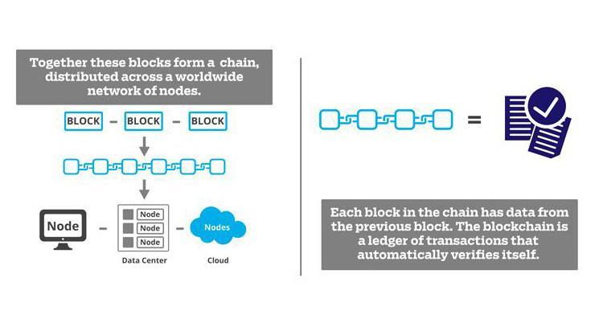

Figure 1. Blockchain Technology
Why does a blockchain get stronger the longer it gets? Where does the immutability come in?
In the same book written by Tapscott (2016), the explanations for these were:
“Every ten minutes, like the heartbeat of the Bitcoin network, all the transactions conducted are verified, cleared, and stored in a block which is linked to the preceding block, thereby creating a chain. Each block must refer to the preceding block to be valid. The structure permanently time-stamps and stores exchanges of value, preventing anyone from altering the ledger… so the blockchain is a distributed ledger representing a network consensus of every transaction that has ever occurred. Like the World Wide Web of information, it’s the World Wide Ledger of value… This new digital ledger can be programmed to record virtually everything of value and importance to humankind: birth and death certificates, marriage licenses, deeds, and titles of ownership, educational degrees, financial accounts, medical procedures, insurance claims, votes, provenance of food, or anything else that can be expressed in code”.
Thus maybe, the concept of immutability is the most crucial to understanding the blockchain and why it is important. An object that once created can never be changed has infinite value in our editable, ephemeral digital world. The more nodes a blockchain is distributed over, the stronger and more trusted it becomes.
Research Literature
Decentralized Accreditation of Educational Attainments Using Blockchain
This research paper said that there has been tremendous growth in Blockchain and its applications in recent years. This includes financial sectors, healthcare, supply chain, and digital identity management systems that have been built that ensure secrecy, privacy, transparency, and decentralization. An example of the famous digital currency which uses Blockchain as its core is Bitcoin.
The research proposed a model that will help to set up a streamlined administration process in the educational institute to solve the variety of issues that are there in legacy educational organizations/ institutes. Administration processes such as tracking records in the cloud, fraud certification detection, keeping identity digital under the control of authentic sources, and transferring over the internet securely, eliminating the need to verify them by third-party sources.
Decentralized Network Governance: Blockchain Technology and the Future of Regulation
In this research article, it said that an example of advancements in the digital domain is blockchain technology, another is data, and machine learning which increasingly shapes the lives of individuals, groups, organizations, and societies. These developments call for effective governance to protect the basic interests and needs of these actors, says Zwitter (2020). The study proposed a new mode of governance based on the regulation of new power relationships between the state and actors in the digital domain. Thus, blockchain technology can play in what we call decentralized network governance.
Datafication and Blockchain Technology
The creation, collection, dissemination, and distribution of all communications were no longer on social processes but increasingly on technology. Blockchain technology is promising to reform digital currency, in order to improve logistics and help manage digital identity in a decentralized and trustless manner (Zwitter, 2018). Thus, these kinds of algorithms were developed by private actors.
Blockchain technology and digital ledger technology (DLT) can be defined as decentralized and trustless ledgers, that record transactions across a peer-to-peer network. These features create the potential to provide transparency as well as accountability. Such technologies could impact not only the financial sector (e.g., Bitcoin, Libra) but also diverse fields such as supply chain management, digital identity, smart contracts, voting (e.g., liquid democracy), health records, water management, and much more.
In a simplified manner, a blockchain is a decentralized database that stores a registry of assets and transactions across a peer-to-peer network. The “asset” may not only be money or transactional information, but also information regarding ownership, contracts, goods, and any other information (Warburg, 2016). A blockchain is no duplication of value that is being transferred, like other peer-to-peer networks, but it registers that a value has been transferred from one to another. Moreover, DLT does not require any central control system, and it stores the transaction history in blocks of data that are cryptographically locked together. As it is replicated on every node in the blockchain network, it becomes an immutable and transparent historical record of all transactions (Balva, 2017).
The Benefits of Applying Blockchain Technology in any Industry
Blockchain technology has greatly evolved since Bitcoin debuted in 2008, the first decentralized peer-to-peer electronic cash system. Today, more innovators from different fields realized the importance and the benefits of the technology behind Bitcoin. From medicine to finance, many sectors are looking for ways to integrate blockchain into their infrastructures (Koksal, 2019).
There are numerous benefits that this technology can present to businesses in many different industries, both for distributed and decentralized nature.

Greater Transparency
Blockchain’s greatest feature is the fact that its transaction ledger for public addresses is openly viewed. Thus, this features an unprecedented layer of accountability, holding each sector of business responsible to act with integrity towards the company’s growth, its community, and customers is an addition for financial systems and business factors.
Increased Efficiency
Since blockchain is decentralized in nature, it removes the need for middlemen in many operation processes for fields such as payments and real estate. In traditional financial services, blockchain facilitates faster transactions with a digital currency. Property management processes are made more efficient with a unified system of ownership records, and smart contracts.
Better Security
This technology is far more secure than other record keeping systems. Each new transaction is encrypted and linked to the previous transaction. Blockchain is formed by a network of computers coming together to confirm a ‘block’, this block is then added to a ledger, which forms a ‘chain’. The decentralized nature also gives it a unique quality of being ‘trustless’ – meaning that parties do not need trust to transact safely.
Improved Traceability
With the blockchain ledger, each time an exchange of goods is recorded on a Blockchain, an audit trail is present to trace where the goods came from. This will not only be helping to improve security and prevent fraud in exchange-related businesses, but it can also be helping to verify the authenticity of the traded assets. An example is in the medicine industry, it can be used to track the supply chain from manufacturer to distributor, or in the art industry to provide an irrefutable proof of ownership.
Consensus Mechanisms in Blockchain for Secure Recordkeeping
Zheng et al. (2018) explored how consensus mechanisms like Proof of Work (PoW) and Proof of Stake (PoS) help create secure and tamper-proof records within blockchain systems. Their study showed that these mechanisms work by ensuring all participants in the network agree on which records are valid before anything new is added. This shared agreement process is what makes blockchain so reliable and resistant to tampering. The researchers highlighted that this approach is especially useful for applications like educational accreditation, where it is critical that records, such as grades, certificates, or credits, are authentic and trustworthy. By using consensus, the system guarantees that no single party can manipulate the data, making it a strong fit for managing sensitive academic records.
Computing Technology
Microsoft Azure, (2021) discussed that “cloud computing is the distribution over the Internet ("the cloud") of information services, including servers, storage, databases, networking, applications, analytics and intelligence, to provide quicker innovation, scalable resources and economies of scale”. In addition, it allows people, via their internet-connected devices, access to storage, data, applications, and servers: laptops, smartphones, tablets, and wearables. In a place independent from end users, cloud storage services store and process data, (Sales Force, 2020).
As described by Frankenfield and Mansa, (2020) there can be both public and private cloud computing. For a subscription, public cloud providers offer their services over the Internet. On the other hand, private cloud providers offer services only to a certain number of individuals. These systems are a series of networks providing services that are hosted. The hybrid alternative, which incorporates elements of both public and private services, is also available.
Cloud Computing
Microsoft Azure, (2021) said that “Not all clouds are the same, and for all, not one form of cloud computing is right”. In deciding the type of cloud implementation for cloud computing, first know the cloud services that can be implemented in three different ways: on a public cloud, a private cloud, or a hybrid cloud.
Public clouds. These are owned and managed by providers of third-party cloud services that distribute their computing resources over the Internet, such as servers and
storage. An example of a public cloud is Microsoft Azure. For a public cloud, the cloud provider owns and maintains all hardware, applications, and other supporting resources.
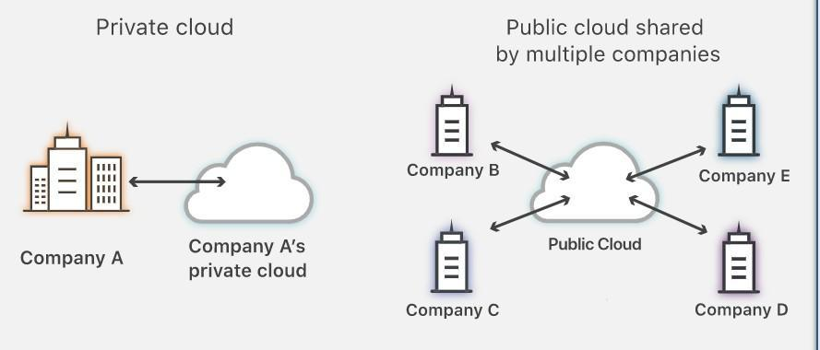
Private Cloud. These refer to services used solely by a specific entity or agency in cloud computing. A private cloud in an organization's data center can be located onsite. Some businesses often pay third-party service providers for their private cloud hosting. It is one in which, on a private network, the services and infrastructure are managed.

Source: www.cloudflare.com

Figure 2. The Difference Between a Public and Private Cloud

The above figure demonstrates the difference between the public cloud which is a service that shares computing services among different customers. Although each customer’s data applications running in the cloud remain hidden from each customer. On the other hand, the private clouds which are offered by a third-party cloud provider and internal where managed and maintained by an organization internally.
Hybrid clouds. A combination of public and private clouds, connected by technology enables the sharing of data and apps between them. A hybrid cloud allows the organization greater versatility, and more implementation options, and helps leverage current infrastructure, security, and enforcement by enabling data and applications to migrate between private and public clouds.
Cloud Services

Cloud computing, like a microchip or a cellphone, is not a single piece of technology. Instead, it is a system that consists mainly of three services: software-as-a-service (SaaS), infrastructure-as-a-service (IaaS), and platform-as-a-service (PaaS) (Frankenfield and Mansa, 2020).
Software-as-a-service (SaaS). It requires licensing clients for a software program. Licenses are normally supplied via a pay-as-you-go or on-demand model (Frankenfield and Mansa, 2020). Moreover, the underlying hardware and operating system are not applicable to the end-user who uses a web browser or app to access the service; it is mostly purchased on a per-seat or per-user basis. There is a huge range of applications delivered through SaaS, from CRM such as Salesforce to Office 365 from Microsoft (Ranger, 2018).
Infrastructure-as-a-service (IaaS). According to Frankenfield and Mansa, (2020), it provides a framework for providing everything as part of an on-demand service, from operating systems to servers and storage via IP-based networking. In an outsourced, on-demand service, clients may eliminate the need to buy software or servers and procure these services instead.
Infrastructure as a Service (IaaS) is the practice of delivering a full compute stack including servers, storage, networking and operating software as an abstract, virtualized construct (Berg, 2020). According to IBM Cloud Education, (2019) IaaS is commonly used for development and test environments, customer-facing websites and web applications, data storage, analytics and data warehousing workloads, and backup and recovery, particularly for on-premises workloads.
Platform-as-a-service (PaaS). The most complex of the three layers of cloud-based computing is known to be platform-as-a-service (PaaS). PaaS has some similarities with SaaS, the key difference being that it is simply a platform for developing software that is distributed via the Internet instead of delivering software online (Frankenfield and Mansa, 2020).
Violino, (2019) explained that PaaS can be delivered through public, private, or hybrid clouds, with this the customer controls software deployment while the cloud provider delivers all the major IT components needed to host the applications, including servers, storage systems, networks, operating systems, and databases.

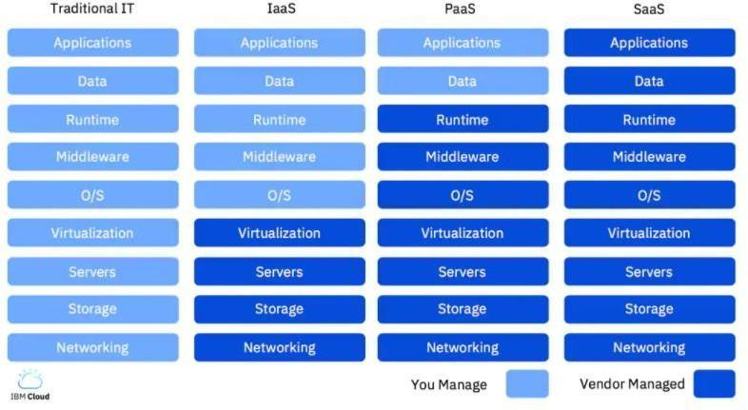

Source: IBM Cloud, 2019

Figure 3. IaaS vs. PaaS vs. SaaS

As seen in Figure 3, there is a description of how the following categories of cloud services differ from one another. As shown in Column 1, in the traditional IT setting, the end user manages the whole stack end-to-end from physical hardware for servers and networking, up through virtualization, operating systems, middleware, and so on. The column of IaaS, PaaS, and SaaS each offers a progressive layer of abstraction. The IaaS idea is away from the physical computing, network, storage, and the technology needed to virtualize the resources. On the other hand, PaaS is a step further and the idea is away the management of the operating system, middleware, and runtime while SaaS provides the entire end-user application as Software-a-Service.
Cloud Storage. This cloud computing strategy makes use of an online data storage provider to store data on the internet. Known as Amazon Web Services, Inc. (2021), it oversees and runs data storage as a service. Unlike conventional hardware and software, which require large investments for equipment purchase, repair, and operation, cloud computing allows enterprises to stay at the forefront of technology (Sales Force, 2020).
Software Requirements
There are several software available that could be used in developing the proposed system:
Hypertext Markup Language (HTML). Serves as the foundation of web development, which offers a standardized markup system for structuring and presenting content on the World Wide Web. HTML plays a critical role in the development of the accreditation system, by providing a standardized framework for structuring and presenting content. It is important because the content structure for the developers in arranging the hierarchical fashion content. Making the accrediting system easier for users to understand and use. The user interaction which allows users to interact with the system, providing input, submitting data, and engaging with various functionalities. The accessibility provides meaningful structure and context to assistive technologies, ensuring that the accreditation system is usable by individuals with disabilities. Search Engineer Optimization (SEO) provides search engines with valuable information about the content and structure of web pages, enhancing their visibility and ranking in search results. And ensures that the cross-platform compatibility allows the accreditation system to be accessed and displayed consistently across different devices and web browsers.
Cascading Style Sheets (CSS). Cascading Style Sheets (CSS). Known as the style sheet language known that is used to specify how HTML and XML texts are presented. It gives web developers complete control over how web pages look, including the layout, fonts, colors, and other design components. The CSS is one of the most popular programming languages for creating dynamic and interactive websites. JavaScript is essential for adding interactivity, handling client-side validation, and enabling server connection in the context of the accreditation system. Within the interface of the accreditation system, DOM manipulation is utilized to generate interactive elements, update content dynamically, and react to user inputs.
JavaScript adds interactivity to the accreditation system's interface, enabling dynamic content updates, interactive forms, and responsive user interactions. It facilitates client-side form validation, improving the user experience by providing immediate feedback on input errors and preventing invalid submissions.
Next.js. is a frontend framework known because of its strong capabilities that improve online application development and user experience. Integration with Blockchain technology for the front end of a digital accreditation system can greatly expedite development and enhance application performance. Here, we examine the salient characteristics and advantages of utilizing Next.js for front-end development, specifically within the framework of this project. The SSR features of Next.js are well known; with each request, HTML is generated on the server. This functionality is essential for increasing search engine optimization (SEO) and speeding up page loads. SEO is especially helpful for public-facing accrediting systems that must be simple to find and use.
Another Next.js features provides static site creation, in which pages are pre-rendered and provided as static HTML This method works well for sites in the accrediting system, such informational pages regarding accreditation standards and guidelines and static reports, that don't need to be updated often.
Benefits for a Blockchain-Based Accreditation System
Enhanced User Experience. To provide an excellent user experience, Next.js ensures that the digital accreditation system is fast and responsive. and that is good especially for a frequent interaction by users.
Seamless Development Experience. Next.js's support for both frontend and backend capabilities in a unified framework reduces complexity and streamlines the development process.
Scalability and Reliability. Vercel’s deployment solutions for Next.js ensure that the accreditation system can handle varying loads, which is crucial during busy periods like accreditation review cycles.
Security. Next.js prioritizes secure application development with features like automated HTTPS, vital for protecting sensitive accreditation data and user information.
Node.js. Using Node.js as the backend for a smart contracts blockchain accreditation system can offer various technical and strategic advantages. Node.js, known for its high efficiency and scalability, aligns nicely with the requirements of a robust digital accrediting platform.
Node.js as a well-suited for applications is an event-driven, non-blocking architecture which requires a lot of I/O. In order to preserve responsiveness in a digital accreditation system as it interfaces with Blockchain networks, this functionality guarantees that the system can manage several concurrent queries without slowing down.
Figma. Integration of Figma in the development of the system provides benefits in the collaborative design, prototyping, and iterative development. Figma is a cloud-based design tool that enables teams to create, share, and collaborate on user interface (UI) and user experience (UX) designs in real-time.
Solana Blockchain
In 2020, Solana Blockchain emerged as a decentralized, high-performance blockchain platform which was created to tackle the scalability issues that current blockchain networks were encountering. Anatoly Yakovenko, a former Qualcomm software engineer, started the project with the goal of developing a blockchain protocol that could support decentralized financial (DeFi) ecosystems and applications on a worldwide scale.
At the beginning of Solana's voyage the realization of scalability trilemma asserts that current blockchain networks must choose between scalability, security, and decentralization. In order to get around this restriction and achieve fast throughput, low latency, and low transaction costs without compromising security or decentralization, Solana adopted cutting-edge technologies and architectural ideas.
Network Design

As shown in Figure 4, at any given time a system node is designated as Leader to generate a Proof of History sequence, providing the network global read consistency and a verifiable passage of time. The Leader sequences user messages and orders them such that they can be efficiently processed by other nodes in the system, maximizing throughput. It executes the transactions on the current state that is stored in RAM and publishes the transactions and a signature of the final state to the replication nodes called Verifiers. Verifiers execute the same transactions on their copies of the state, and publish their computed signatures of the state as confirmations. The published confirmations serve as votes for the consensus algorithm.
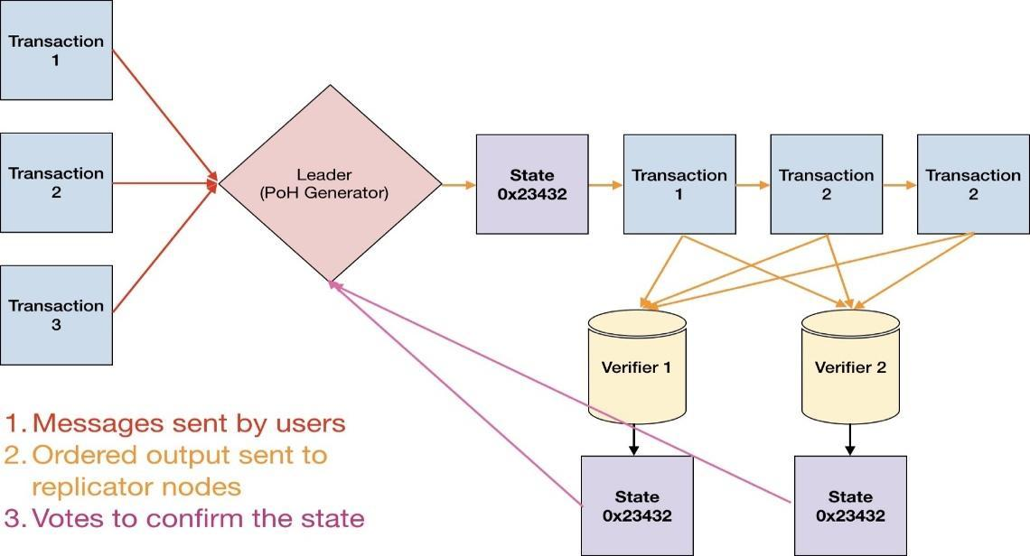

Figure 4. Transaction flow throughout the network
In a non-partitioned state, at any given time, there is one Leader in the network. Each Verifier node has the same hardware capabilities as a Leader and can be elected as a Leader, this is done through PoS based elections. Elections for the proposed PoS algorithm are covered in depth in Section 5.6. In terms of CAP theorem, Consistency is almost always picked over Avail- ability in an event of a Partition. In case of a large partition, this paper proposes a mechanism to recover control of the network from a partition of any size.
Proof of History
Proof of History is a sequence of computation that can provide a way to cryptographically verify passage of time between two events. It uses a cryptographically secure function written so that output cannot be predicted from the input, and must be completely executed to generate the output. The function is run in a sequence on a single core, its previous output as the current input, periodically recording the current output, and how many times it’s been called. The output can then be re-computed and verified by external computers in parallel by checking each sequence segment on a separate core. Data can be timestamped into this sequence by appending the data (or a hash of some data) into the state of the function. The recording of the state, index and data as it was appended into the sequences provides a timestamp that can guarantee that the data was created sometime before the next hash was generated in the sequence. This design also supports horizontal scaling as multiple generators can synchronize amongst each other by mixing their state into each other’s sequences. Horizontal scaling is discussed in depth in.
Description
The system is designed to work as follows. With a cryptographic hash function, whose output cannot be predicted without running the function (e.g. sha256, ripemd, etc.), run the function from some random starting value and take its output and pass it as the input into the same function again. Record the number of times the function has been called and the output at each call. The starting random value chosen could be any string, like the headline of the New York times for the day.
For example: | PoH Sequence
Index | Operation | Output Hash
1 | sha256(”any random starting value”) | hash1
2 | sha256(hash1) | hash2
3 | sha256(hash2) | hash3
Where hashN represents the actual hash output.
It is only necessary to publish a subset of the hashes and indices at an interval.
For example:
 | PoH Sequence
Index | Operation | Output Hash
1 | sha256(”any random starting value”) | hash1
200 | sha256(hash199) | hash200
300 | sha256(hash299) | hash300
As long as the hash function chosen is collision resistant, this set of hashes can only be computed in sequence by a single computer thread. This follows from the fact that there is no way to predict what the hash value at index 300 is going to be without actually running the algorithm from the starting value 300 times. Thus we can thus infer from the data structure that real time has passed between index 0 and index 300.
In the example in Figure 5, hash 62f51643c1 was produced on count 510144806912 and hash c43d862d88 was produced on count 510146904064. Following the previously discussed properties of the PoH algorithm, we can trust that real time passed between count 510144806912 and count 510146904064.
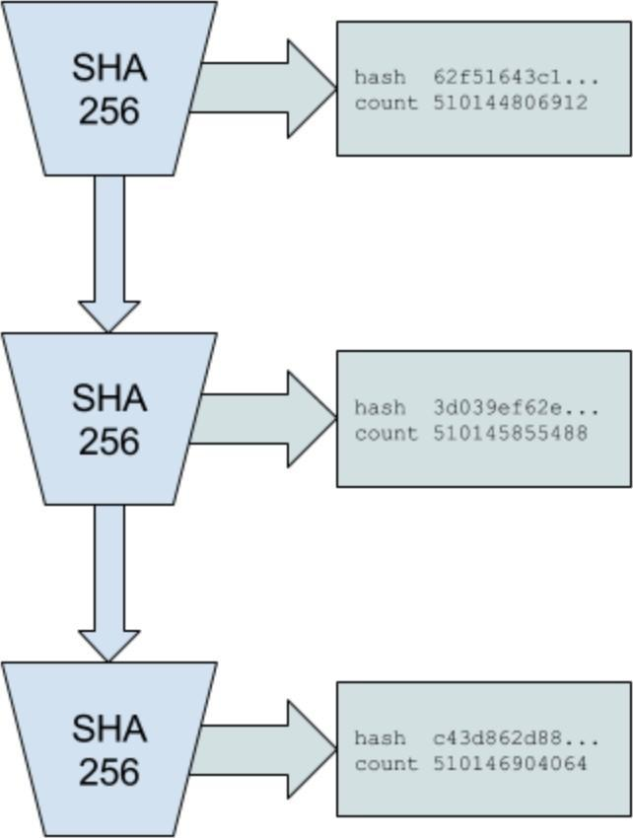

Figure 5. Proof of History sequence

Timestamp for Events
This sequence of hashes can also be used to record that some piece of data was created before a particular hash index was generated. Using a ‘combine ‘function to combine the piece of data with the current hash at the current index. The data can simply be a cryptographically unique hash of arbitrary event data. The combine function can be a simple append of data, or any operation that is collision resistant. The next generated hash represents a timestamp of the data, because it could have only been generated after that specific piece of data was inserted.
For example:

PoH Sequence
Index Operation Output Hash
1 | sha256(”any random starting value”) | hash1
200 | sha256(hash199) | hash200
300 | sha256(hash299) | hash300

Some external event occurs, like a photograph was taken, or any arbitrary digital data was created:
PoH Sequence with Data
Index | Operation | Output Hash
1 | sha256(”any random starting value”) | hash1
200 | sha256(hash199) | hash200
300 | sha256(hash299) | hash300
336 | sha256(append(hash335, photograph sha256)) | hash336

Hash336 is computed from the appended binary data of hash335 and the sha256 of the photograph. The index and the sha256 of the photograph are recorded as part of the sequence output. So anyone verifying this sequence can then recreate this change to the sequence. Because the initial process is still sequential, we can then tell that things entered into the sequence must have occurred sometime before the future hashed value was computed.
Table 1: PoH Sequence with 2 Events
 | POH Sequence
Index | Operation | Output Hash
1 | sha256(”any random starting value”) | hash1
200 | sha256(hash199) | hash200
300 | sha256(hash299) | hash300
336 | sha256(append(hash335, photograph1 sha256)) | hash336
400 | sha256(hash399) | hash400
500 | sha256(hash499) | hash500
600 | sha256(append(hash599, photograph2 sha256)) | hash600
700 | sha256(hash699) | hash700

In the sequence represented by Table 1, photograph2 was created before hash600, and photograph1 was created before hash336. Inserting the data into the sequence of hashes results in a change to all subsequent values in the sequence. As long as the hash function used is collision resistant, and the data was appended, it should be computationally impossible to pre-compute any future sequences based on prior knowledge of what data will be integrated into the sequence.
The data that is mixed into the sequence can be the raw data itself, or just a hash of the data with accompanying metadata.
In the example in Figure 6, input cfd40df8... was inserted into the Proof of History sequence. The count at which it was inserted is 510145855488 and the state at which it was inserted it is 3d039eef3. All the future generated hashes are modified by this change to the sequence, this change is indicated by the color change in the figure. Every node observing this sequence can determine the order at which all events have been inserted and estimate the real time between the insertions.

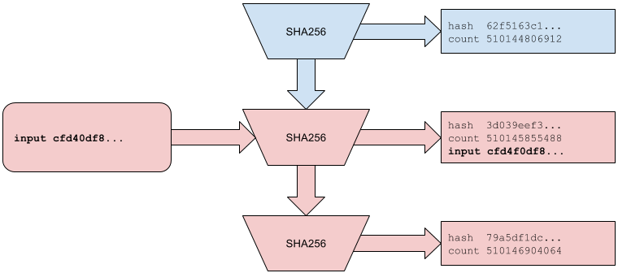
Figure 6: Inserting data into Proof of History

Verification

The sequence can be verified correct by a multicore computer in significantly less time than it took to generate it.

For example: | Core 1
Index |  | Data |  | Output Hash
200 |  | sha256(hash199) |  | hash200
300 |  | sha256(hash299) |  | hash300
 |  | Core 2

Index | Data | Output Hash
300 | sha256(hash299) | hash300
400 | sha256(hash399) | hash400

Given some number of cores, like a modern GPU with 4000 cores, the verifier can split up the sequence of hashes and their indexes into 4000 slices, and in parallel make sure that each slice is correct from the starting hash to the last hash in the slice. If the expected time to produce the sequence is going to be:
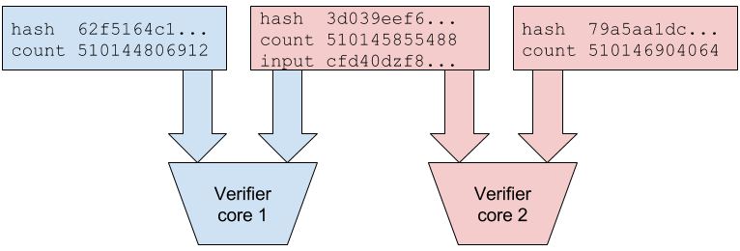

Figure 7. Verification using multiple cores

Total number of hashes: Hashes per second for 1 core
The expected time to verify that the sequence is correct is going to be:
Total number of hashes
(Hashes per second per core * Number of cores available to verify)
In the example in Figure 7, each core is able to verify each slice of the sequence in parallel. Since all input strings are recorded into the output, with the counter and state that they are appended to, the verifiers can replicate each slice in parallel. The red colored hashes indicate that the sequence was modified by a data insertion.
Horizontal Scaling
It is possible to synchronize multiple Proof of History generators by mixing the sequence state from each generator to each other generator, and thus achieve horizontal scaling of the Proof of History generator. This scaling is done without sharding. The output of both generators is necessary to reconstruct the full order of events in the system.

PoH Generator A  Index Hash Data |  |  |  | PoH Generator B  Index Hash Data
1 | hash1a |  |  | 1 | hash1b
2 | hash2a | hash1b |  | 2 | hash2b | hash1a
3 | hash3a |  |  | 3 | hash3b
4 | hash4a |  |  | 4 | hash4b
Given generators A and B, A receives a data packet from B (hash1b), which contains the last state from Generator B, and the last state generator B observed from Generator A. The next state hash in Generator A then depends on the state from Generator B, so we can derive that hash1b happened sometime before hash3a. This property can be transitive, so if three generators are synchronized through a single common generator A ↔ B ↔ C, we can trace the dependency between A and C even though they were not synchronized directly.
By periodically synchronizing the generators, each generator can then handle a portion of external traffic, thus the overall system can handle a larger amount of events to track at the cost of true time accuracy due to network latencies between the generators. A global order can still be achieved by picking some deterministic function to order any events that are within the synchronization window, such as by the value of the hash itself.
In figure 8, the two generators insert each other’s output state and record the operation. The color change indicates that data from the peer had modified the sequence. The generated hashes that are mixed into each stream are highlighted in bold. The synchronization is transitive. A ↔ B ↔ C There is a provable order of events between A and C through B. Scaling in this way comes at the cost of availability. 10 × 1 gbps connections with availability of 0.999 would have 0.99910 = 0.99 availability.
Consistency
Users are expected to be able to enforce consistency of the generated sequence and make it resistant to attacks by inserting the last observed output of the sequence they consider valid into their input.
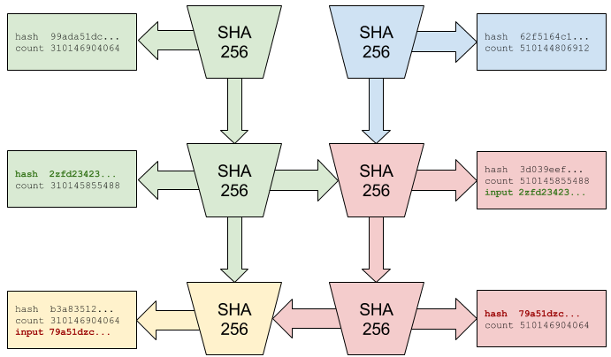

Figure 8. Two Generators synchronizing

Index | PoH Sequence A  Data Output Hash
0 |  | hash10a
20 | Event1 | hash20a
30 | Event2 | hash30a
40 | Event3 | hash40a
PoH  Index | Hidden  Data | Sequence B  Output Hash
10 |  | hash10b
20 | Event3 | hash20b
30 | Event2 | hash30b
40 | Event1 | hash40b

A malicious PoH generator could produce a second hidden sequence with the events in reverse order, if it has access to all the events at once, or is able to generate a faster hidden sequence.
To prevent this attack, each client-generated Event should contain within itself the latest hash that the client observed from what it considers to be a valid sequence. So when a client creates the” Event1” data, they should append the last hash they have observed.
PoH Sequence A
Index | Data | Output Hash
10 |  | hash10a
20 | Event1 = append(event1 data, hash10a) | hash20a
30 | Event2 = append(event2 data, hash20a) | hash30a
40 | Event3 = append(event3 data, hash30a) | hash40a

When the sequence is published, Event3 would be referencing hash30a, and if it is not in the sequence prior to this Event, the consumers of the sequence know that it is an invalid sequence. The partial reordering attack would then be limited to the number of hashes produced while the client has observed an event and when the event was entered. Clients should then be able to write software that does not assume the order is correct for the short period of hashes between the last observed and inserted hash.
To prevent a malicious PoH generator from rewriting the client Event hashes, the clients can submit a signature of the event data and the last observed hash instead of just the data.
PoH Sequence A
Index Data Output Hash
10 hash10a
20 Event1 = sign(append(event1 data, hash10a),
Client Private Key)
30 Event2 = sign(append(event2 data, hash20a),
Client Private Key)
40 Event3 = sign(append(event3 data, hash30a),
Client Private Key)
hash20a hash30a
Verification of this data requires a signature verification, and a lookup of the hash in the sequence of hashes prior to this one.
Verify:
(Signature, PublicKey, hash30a, event3 data) = Event3 Verify(Signature, PublicKey, Event3)
Lookup(hash30a, PoHSequence)

hash40a
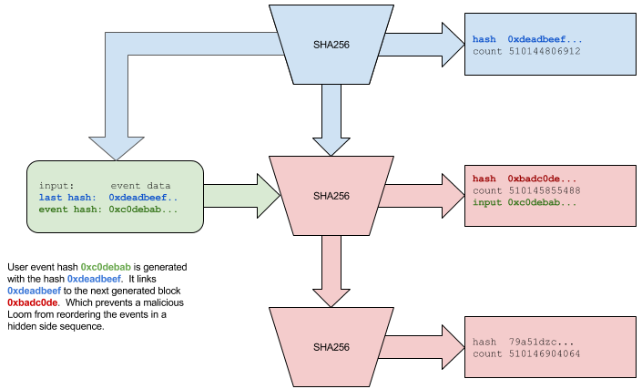
In Figure 9, the user-supplied input is dependent on hash 0xdeadbeef... existing in the generated sequence sometime before its inserted. The blue top left arrow indicates that the client is referencing a previously produced hash. The client's message is only valid in a sequence that contains the hash 0xdeadbeef.... The red color in the sequence indicates that the sequence has been modified by the clients’ data.

Figure 9. Input with a back reference

Overhead
4000 hashes per second would generate an additional 160 kilobytes of data, and would require access to a GPU with 4000 cores and roughly 0.25-0.75 milliseconds of time to verify.
Attacks
Reversal. Generating a reverse order would require an attacker to start the malicious sequence after the second event. This delay should allow any non-malicious peer to peer nodes to communicate about the original order.
Speed. Having multiple generators may make deployment more resistant to attacks. One generator could be high bandwidth, and receive many events to mix into its sequence, another generator could be high speed low bandwidth that periodically mixes with the high bandwidth generator. The high speed sequence would create a secondary sequence of data that an attacker would have to reverse.
Long Range Attacks. Long range attacks involve acquiring old discarded client Private Keys, and generating a falsified ledger. Proof of History provides some protection against long range attacks. A malicious user that gains access to old private keys would have to recreate a historical record that takes as much time as the original one they are trying to forge. This would require access to a faster processor than the network is currently using, otherwise the attacker would never catch up in history length.
Additionally, a single source of time allows for construction of a simpler Proof of Replication. Since the network is designed so that all participants in the network will rely on a single historical record of events. PoRep and PoH together should provide a defense of both space and time against a forged ledger.
Proof of Stake Consensus. This specific instance of Proof of Stake is designed for quick confirmation of the current sequence produced by the Proof of History generator, for voting and selecting the next Proof of History generator, and for punishing any mis- behaving validators. This algorithm depends on messages eventually arriving to all participating nodes within a certain timeout.
Terminology
Bonds. are equivalent to a capital expense in Proof of Work. A minor buys hardware and electricity, and commits it to a single branch in a Proof of Work blockchain. A bond is a coin that the validator commits as collateral while they are validating transactions, slashing. The proposed solution to the nothing at stake problem in Proof of Stake systems. When a proof of voting for a different branch is published, that branch can destroy the validator's bond. This is an economic incentive designed to discourage validators from confirming multiple branches.
Super majority. A super majority is 2 rds of the validators weighted by their bonds. A super majority vote indicates that the network has reached consensus, and at least 1 rd of the network would have had to vote maliciously for this branch to be invalid. This would put the economic cost of an attack at 1 rd of the market cap of the coin.
Bonding. A bonding transaction takes an amount of coin and moves it to a bonding account under the users’ identity. Coins in the bonding account cannot be spent and have to remain in the account until the user removes them. The user can only remove stale coins that have timed out. Bonds are valid after super majority of the current stakeholders have confirmed the sequence.
Voting. It is anticipated that the Proof of History generator will be able to publish a signature of the state at a predefined period. Each bonded identity must confirm that signature by publishing their own signed signature of the state. The vote is a simple yes vote, without a no.
If a super majority of the bonded identities have voted within a timeout, then this branch would be accepted as valid.
Unbonding. Missing N number of votes marks the coins as stale and no longer eligible for voting. The user can issue an unbonding transaction to remove them. N is a dynamic value based on the ratio of stale to active votes. N increases as the number of stale votes increases. In the event of a large network partition, this allows the larger branch to recover faster than the smaller branch.
Elections. Election for a new PoH generator occurs when the PoH generator failure is detected. The validator with the largest voting power, or highest public key address if there is a tie is picked as the new PoH generator.
A super majority of confirmations are required on the new sequence. If the new leader fails before a super majority confirmations are available, the next highest validator is selected, and a new set of confirmations is required. To switch votes, a validator needs to vote at a higher PoH sequence counter, and the new vote needs to contain the votes it wants to switch. Otherwise the second vote will be slashable. Vote switching is expected to be designed so that it can only occur at a height that does not have a super majority.
Once a PoH generator is established, a Secondary can be elected to take over the transactional processing duties. If a Secondary exists, it will be considered as the next leader during a Primary failure. The platform is designed so that the Secondary becomes Primary and lower rank generators are promoted if an exception is detected or on a pre-defined schedule.
Election Triggers
Forked Proof of History generator. PoH generators are designed with an identity that signs the generated sequence. A fork can only occur in case the PoH generator's identity has been compromised. A fork is detected because two different historical records have been published on the same PoH identity.
Runtime Exceptions. A hardware failure or a bug, or an intentional error in the PoH generator could cause it to generate an invalid state and publish a signature of the state that does not match the local validator's result. Validators will publish the correct signature via gossip and this event would trigger a new round of elections. Any validators who accept an invalid state will have their bonds slashed.
Network Timeouts. A network timeout would trigger an election.
Slashing. Slashing occurs when a validator votes two separate sequences. A proof of malicious vote will remove the bonded coins from circulation and add them to the mining pool.
A vote that includes a previous vote on a contending sequence is not eligible as proof of malicious voting. Instead of slashing the bonds, this vote removes remove the currently cast vote on the contending sequence. Slashing also occurs if a vote is cast for an invalid hash generated by the PoH generator. The generator is expected to randomly generate an invalid state, which would trigger a fallback to Secondary.
Secondary Elections
Secondary and lower ranked Proof of History generators can be proposed and approved. A proposal is cast on the primary generators sequence. The proposal contains a timeout, if the motion is approved by a super majority of the vote before the timeout, the Secondary is considered elected, and will take over duties as scheduled. Primary can do a soft handover to Secondary by inserting a message into the generated sequence indicating that a handover will occur, or inserting an invalid state and forcing the network to fallback to Secondary. If a Secondary is elected, and the primary fails, the Secondary will be considered as the first fallback during an election.
Availability. Partition-tolerant CAP systems are faced with the choice between ensuring Consistency or Availability. Our technique ultimately selects Availability as the primary factor, but also considers Consistency within tolerable human timeouts due to the objective measure of time. Evidence of Stake verifiers immobilize a certain quantity of coins in a stake, enabling them to cast votes for a certain group of transactions. Locking up coins involves initiating a transaction within a Proof of History (PoH) stream, similar to any other transaction. In order to cast a vote, a Proof-of-Stake (PoS) verifier must digitally sign the hash of the state, which is calculated after processing all transactions up to a particular point in the Proof-of-History ledger. This vote is also recorded as a transaction in the Proof of History (PoH) stream. By examining the PoH ledger, we can deduce the duration between each vote and determine the length of time each verifier was unavailable in the event of a partition.
In order to handle partitions within a reasonable timescale, we suggest implementing a dynamic technique to unstake verifiers that are currently unavailable. When the number of verifiers exceeds 2, the unstaking procedure can be expedited. The ledger requires a relatively small number of hashes to be generated before the stake of the verifiers who are now absent is completely unstaked and they are no longer considered for consensus.
When the number of verifiers is between 1 and 2 rounds (rds), the unstaking timer is increased by 3, making it 2 times slower. This results in a higher number of hashes that need to be generated before the missing verifiers can be unstaked. When there is a significant partition, such as one that lacks one or more of the verifiers, the process of unstaking becomes notably sluggish. While transactions can still be added to the stream and verifiers can still vote, achieving full two-round consensus will require generating a significant number of hashes and unstaking the currently unavailable verifiers. The variation in the time it takes for a network to restore functionality enables us, as users of the network, to select a certain partition that we wish to continue utilizing within our own time constraints.
Recovery. In the system we propose, the ledger can be fully recovered from any failure. That means, anyone in the world can pick any random spot in the ledger and create a valid fork by appending newly generated hashes and transactions. If all the verifiers are missing from this fork, it would take a very long time for any additional bonds to become valid and for this branch to achieve 2 rds super majority consensus. So full recovery with zero available validators would require a very large amount of hashes to be appended to the ledger, and only after all the unavailable validators have been unstaked will any new bonds be able to validate the ledger.
Finality. PoH allows verifiers of the network to observe what happened in the past with some degree of certainty of the time of those events. As the PoH generator is producing a stream of messages, all the verifiers are required to submit their signatures of the state within 500ms. This number can be reduced further depending on network conditions. Since each verification is entered into the stream, everyone in the network can validate that every verifier submitted their votes within the required timeout without actually observing the voting directly.
Attacks
Tragedy of Commons. The PoS verifiers simply confirm the state hash generated by the PoH generator. There is an economic incentive for them to do no work and simply approve every generated state hash. To avoid this condition, the PoH generator should inject an invalid hash at a random interval. Any voters for this hash should be slashed. When the hash is generated, the network should immediately promote the Secondary elected PoH generator.
Each verifier is required to respond within a small timeout - 500ms for example. The timeout should be set low enough that a malicious verifier has a low probability of observing another verifier vote and getting their votes into the stream fast enough.
Collusion with the PoH generator
A verifier that is colluding with the PoH generator would know in advance when the invalid hash is going to be produced and not vote for it. This scenario is really no different than the PoH identity having a larger verifier stake. The PoH generator still has to do all the work to produce the state hash.
Censorship. Censorship or denial of service could occur when a 1 rd of the bond holders refuse to validate any sequences with new bonds. The protocol can defend against this form of attack by dynamically adjusting how fast bonds become stale. In the event of a denial of service, the larger partition will be designed to fork and censor the Byzantine bond holders. The larger network will recover as the Byzantine bonds become stale with time. The smaller Byzantine partition would not be able to move forward for a longer period of time.
3
The algorithm would work as follows. A majority of the network would elect a new Leader. The Leader would then censor the Byzantine bond holders from participating. Proof of History generator would have to continue generating a sequence, to prove the passage of time, until enough Byzantine bonds have become stale so the bigger network has a super majority. The rate at which bonds become stale would be dynamically based on what percentage of bonds are active. So the Byzantine minority fork of the network would have to wait much longer than the majority fork to recover a super majority. Once a super majority has been established, slashing could be used to permanently punish the Byzantine bond holders.
Long Range Attacks
PoH provides a natural defense against long range attacks. Recovering the ledger from any point in the past would require the attacker to overtake the valid ledger in time by outpacing the speed of the PoH generator.
The consensus protocol provides a second layer of defense, as any attack would have to take longer than the time it takes to unstake all the valid validators. It also creates an availability gap in the history of the ledger. When comparing two ledgers of the same height, the one with the smallest maximum partition can be objectively considered as valid.
ASIC Attacks
Two opportunities for ASIC attacks exist in this protocol - during partition, and cheating timeouts in Finality. For ASIC attacks during Partitions, the Rate at which bonds are unstaked is non-linear, and for networks with large partitions the rate is orders of magnitude slower than expected gains from an ASIC attack.
For ASIC attacks during Finality, the vulnerability allows for byzantine validators who have a bonded stake to wait for confirmations from other nodes and inject their votes with a collaborating PoH generator. The PoH generator can then use its faster ASIC to generate 500ms worth of hashes in less time, and allow for network communication between the PoH generator and the collaborating nodes. But, if the PoH generator is also byzantine, there is no reason why the byzantine generator would not have communicated the exact counter when they expect to insert the failure. This scenario is no different than a PoH generator and all the collaborators sharing the same identity and having a single combined stake and only using 1 set of hardware.
Algorithm
As shown in Figure 10, CBC encryption encrypts each block of data in sequence, using the previously encrypted block to XOR the input data. Each replication identity generates a key by signing a hash that has been generated, Proof of History sequence. This ties the key to a replicator's identity, and to a specific Proof of History sequence. Only specific hashes can be selected.
The data set is fully encrypted block by block. Then to generate a proof, the key is used to seed a pseudorandom number generator that selects a random 32 bytes from each block. A merkle hash is computed with the selected PoH hash prepended to each slice. The root is published, along with the key, and the selected hash that was generated. The replication node is required to publish another proof in N hashes as they are generated by the Proof of History generator, where N is approximately 1 the time it takes to encrypt the data.
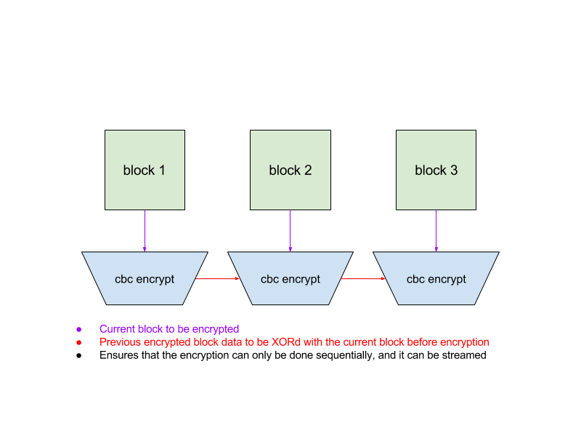

Figure 10. Sequential CBC encryption
The Proof of History generator will publish specific hashes for Proof of Replication at a predefined period. The replicator node must select the next published hash for generating the proof. Again, the hash is signed, and random slices are selected from the blocks to create the merkle root. After a period of N proofs, the data is re-encrypted with a new CBC key.
Verification. With N cores, each core can stream encryption for each identity. Total space required is 2blocks ∗ Ncores, since the previous encrypted block is necessary to generate the next one. Each core can then be used to generate all the proofs that derived from the current encrypted block.
Total time to verify proofs is expected to be equal to the time it takes to encrypt. The proofs themselves consume few random bytes from the block, so the amount of data to hash is significantly lower than the encrypted block size. The number of replication identities that can be verified at the same time is equal to the number of available cores. Modern GPUs have 3500+ cores available to them, the clock speed of a CPU albeit at 1-1.
Key Rotation. Without key rotation the same encrypted replication can generate cheap proofs for multiple Proof of History sequences. Keys are rotated periodically and each replication is re-encrypted with a new key that is tied to a unique Proof of History sequence. Rotation needs to be slow enough that its practical to verify replication proofs on GPU hardware, which is slower per core than CPUs.
Hash Selection. Proof of History generator publishes a hash to be used by the entire network for encrypting Proofs of Replication, and for using as the pseudorandom number generator for byte selection in fast proofs.
Hash is published at a periodic counter that is roughly equal to 1 the time it takes to encrypt the data set. Each replication identity must use the same hash, and use the signed result of the hash as the seed for byte selection, or the encryption key.
2
The period that each replicator must provide a proof must be smaller than the encryption time. Otherwise the replicator can stream the encryption and delete it for each proof. A malicious generator could inject data into the sequence prior to this hash to generate a specific hash.
Proof Validation
The Proof of History node is not expected to validate the submitted Proof of Replication proofs. It is expected to keep track of number of pending and verified proofs submitted by the replicators identity. A proof is expected to be verified when the replicator is able to sign the proof by a super majority of the validators in the network.
The verifications are collected by the replicator via p2p gossip network, and submitted as one packet that contains a super majority of the validators in the network. This packet verifies all the proofs prior to a specific hash generated by the Proof of History sequence, and can contain multiple replicator identities at once.
Attacks
Spam. A malicious user could create many replicator identities and spam the network with bad proofs. To facilitate faster verification, nodes are required to provide the encrypted data and the entire merkle tree to the rest of the network when they request verification.
The Proof of Replication that is designed in this paper allows for cheap verification of any additional proofs, as they take no additional space. But each identity would consume 1 core of encryption time. The replication target should be set to a maximum size of readily available cores. Modern GPUs ship with 3500+ cores.
Partial Erasure
A replicator node could attempt to partially erase some of the data to avoid storing the entire state. The number of proofs and the randomness of the seed should make this attack difficult.
For example, a user storing 1 terabyte of data erases a single byte from each 1-megabyte block. A single proof that samples 1 byte out of every megabyte would have a likelihood of collision with any erased byte 1 − (1 − 1/1, 000, 0000) 1,000,000 = 0.63. After 5 proofs the likelihood is 0.99.

Collusion with PoH generator
The signed hash is expected to be used to seed the sample. If a replicator could select a specific hash in advance, then the replicator could erase all bytes that are not going to be sampled.
A replicator identity that is colluding with the Proof of History generator could inject a specific transaction at the end of the sequence before the predefined hash for random byte selection is generated. With enough cores, an attacker could generate a hash that is preferable to the replicators identity. This attack could only benefit a single replicator identity. Since all the identities have to use the same exact hash that is cryptographically signed with ECDSA (or equivalent), the resulting signature is unique for each replicator identity, and collision resistant. A single replicator identity would only have marginal gains.
Denial of Service
The cost of adding an additional replicator identity is expected to be equal to the cost of storage. The cost of adding extra computational capacity to verify all the replicator identities is expected to be equal to the cost of a CPU or GPU core per replication identity.
This creates an opportunity for a denial of service attack on the network by creating a large number of valid replicator identities. To limit this attack, the consensus protocol chosen for the network can select a replication target, and award the replication proofs that meet the desired characteristics, like availability on the network, bandwidth, geolocation and more.
Tragedy of Commons
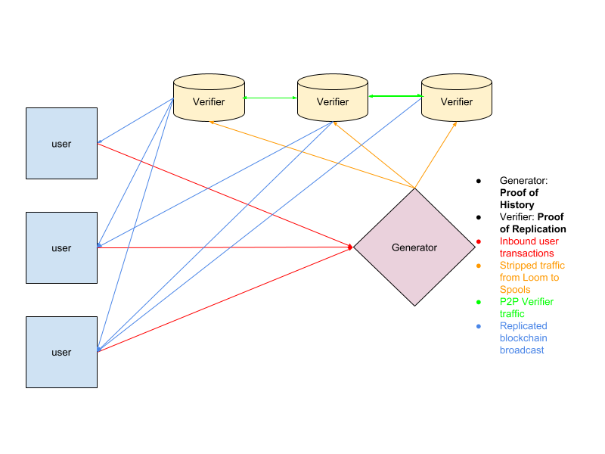
The PoS verifiers could simply confirm PoRep without doing any work. The economic incentives should be lined up with the PoS verifiers to do work, like by splitting the mining payout between the PoS verifiers and the PoRep replication nodes. To further avoid this scenario, the PoRep verifiers can submit false proofs a small percentage of the time. They can prove the proof is false by providing the function that generated the false data. Any PoS verifier that confirmed a false proof would be slashed.

Figure 11. System Architecture

System Architecture. Components Leader, Proof of History generator
The Leader is an elected Proof of History generator. It consumes arbitrary user transactions and outputs a Proof of History sequence of all the transactions that guarantees a unique global order in the system. After each batch of transactions, the Leader outputs a signature of the state that is the result of running the transactions in that order. This signature is signed with the identity of the Leader.
State. A naive hash table indexed by the users’ address. Each cell contains the full users address and the memory required for this computation. For example, Transaction table contains:
0 31 63 95 127 159 191 223 255
Ripemd of Users Public Key | Account | unused

For a total of 32 bytes.
Proof of Stake bonds table contains:

0 31 63 95 127 159 191 223 255
Ripemd of Users Public Key |  | Bond
Last Vote
unused

For a total of 64 bytes.

Verifier. State Replication
The Verifier nodes replicate the blockchain state and provide high availability of the blockchain state. The replication target is selected by the consensus algorithm, and the validators in the consensus algorithm select and vote the Proof of Replication nodes they approve of based on off-chain defined criteria. The network could be configured with a minimum Proof of Stake bond size, and a requirement for a single replicator identity per bond.
Validators. These nodes are consuming bandwidth from Verifiers. They are virtual nodes, and can run on the same machines as the Verifiers or the Leader, or on separate machines that are specific to the consensus algorithm configured for this network.
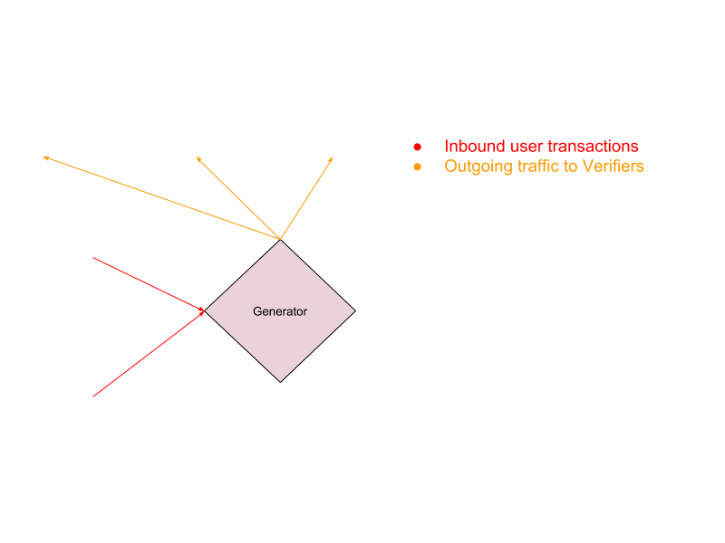
Network Limits. Leader is expected to be able to take incoming user packets, orders them the most efficient way possible, and sequences them into a Proof of History sequence that is published to downstream Verifiers. Efficiency is based on memory access patterns of the transactions, so the transactions are ordered to minimize faults and to maximize prefetching as shown in figure 12.

Figure 12. Generator network limits

Computational Limits
Each transaction requires a digest verification. This operation does not use any memory outside of the transaction message itself and can be parallelized independently. Thus throughput is expected to be limited by the number of cores available on the system. GPU based ECDSA verification servers have had experimental results of 900k operations per second.
Memory Limits. A naive implementation of the state as a 50% full hashtable with 32 byte entries for each account, would theoretically fit 10 billion accounts into 640GB. Steady state random access to this table is measured at 1.1 ∗ 107 writes or reads per second. Based on 2 reads and two writes per transaction, memory throughput can handle 2.75m transactions per second. This was measured on an Amazon Web Services 1TB x1.16xlarge instance.

High Performance Smart Contracts
Smart contracts are a generalized form of transactions. These are programs that run on each node and modify the state. This design leverages extended Berkeley Packet Filter bytecode as fast and easy to analyze and JIT bytecode as the smart contracts language.
One of its main advantages is a zero cost Foreign Function Interface. Intrinsic, or functions that are implemented on the platform directly, are callable by programs. Calling the intrinsic suspends that program and schedules the intrinsic on a high performance server. Intrinsics are batched together to execute in parallel on the GPU.
In the above example, two different user programs call the same intrinsic. Each program is suspended until the batch execution of the intrinsics is complete. An example intrinsic is ECDSA verification. Batching these calls to execute on the GPU can increase throughput by thousands of times.
This trampoline requires no native operating system thread context switches, since the BPF bytecode has a well-defined context for all the memory that it is using.
Key Technological Innovations:
1. Proof of History (PoH)
Solana's breakthrough innovation, Proof of History (PoH), serves as a cryptographic clock that timestamps events and orders transactions within the network. By leveraging PoH, Solana achieves accurate ordering and sequencing of transactions, enabling fast and efficient consensus without the need for costly computational work.
2. Tower BFT (Turbo)
Tower BFT is Solana's consensus mechanism, which combines the security of Byzantine Fault Tolerance (BFT) with the scalability of Proof of History. Tower BFT enables Solana to achieve consensus in a decentralized and permissionless manner while maintaining high throughput and fast finality.
3. Gulf Stream
Gulf Stream is Solana's block propagation mechanism, designed to ensure rapid dissemination of blocks across the network. By optimizing block propagation, Solana minimizes block propagation times and reduces the risk of network congestion, enhancing overall network efficiency.
4. Sealevel
Sealevel is Solana's parallel smart contracts runtime, which allows for the execution of multiple smart contracts concurrently. By parallelizing smart contract execution, Solana maximizes resource utilization and throughput, enabling efficient processing of decentralized applications (dApps) and complex computational tasks.
Impact and Adoption
Since its inception, Solana has gained significant traction and adoption within the blockchain and cryptocurrency community. Its high throughput, low latency, and low transaction costs have made it an attractive platform for building decentralized applications, DeFi protocols, and Web3 ecosystems. Solana's native cryptocurrency, SOL, has seen a surge in demand and value, reflecting growing confidence in the platform's capabilities and potential.
System Performance Measures
When the system is already functioning properly in accordance with the requirements stated by the user, we turn to the way in which those functions are performed. Thus, functional testing addresses the functional requirements of the system, and performance testing addresses the non-functional requirements (Pfeeleger, 1998).
The evaluation instrument to be used is based on the ISO/TR 23455:2019 Blockchain and distributed Ledger technologies, standards in the field of blockchain and smart contracts.
ISO/TR 23455:2019 provides guidelines for the evaluation of smart contracts systems. This outlines a structured approach to assess the functionality, security, reliability, and performance of smart contracts. These characteristics are further broken down into sub-characteristics. The model includes both software and computer systems (ISO, 2018).
Functionality Evaluation. This step is about making sure the smart contract system does what it’s supposed to do.
Security Evaluation. Security is crucial for smart contracts because they are immutable and decentralized. This evaluation aims to spot vulnerabilities like reentrancy attacks, overflow/underflow issues, and unauthorized access. Common techniques include security audits, code reviews, and penetration testing.

Reliability Evaluation. This evaluates how the system is trustworthy and robust is. This involves the checking of error-handling mechanisms, resilience to unexpected inputs or conditions, and recovery procedures for failures.
Performance Evaluation. This measures how efficient and scalable the smart contract system is. It includes looking at transaction throughput, latency, gas consumption (for Ethereum-based contracts), and resource use under different workloads.
Compliance Evaluation. The system needs to check if it follows all the necessary rules and laws such as industry standards or regulations like GDPR for data protection or AML for preventing money laundering.

Documentation and Traceability. According to ISO/TR 23455, it’s important to keep detailed records throughout the evaluation process. This means writing down what you’re checking, how you’re checking it, what you find, and any suggestions you have. This ensures everything is clear and can be reviewed later.
Conceptual Model of the Study
The conceptual process for the development of Higher Education Institutions Accreditation System Thru Smart Contracts has three (3) system elements, which consist of input, process, and output. These elements of the system must be integrated with a common purpose to achieve the main objective of the study.
INPUT PROCESS OUTPUT

Knowledge Requirements
Accreditation
Digital Accreditation
Structured Programming
Types of Accreditations
Blockchain

Software Requirements
Vue JavaScript
Microsoft Azure
Solana

Hardware
Requirements
Pentium-based processor
At least 8 GB memory
At least 50 GB free hard disk space

Planning

System Design

Programming

Solana Configuration

Testing and Improvement

HIGHER
EDUCATION INSTITUTIONS ACCREDITATION SYSTEM THRU
SMART
CONTRACTS

Figure 13. Conceptual Model of HEIs Accreditation System Thru Smart Contracts

Figure 13 presents the Input Process Output chart of the Digital Accreditation System thru Smart Contracts. The inputs to the system are the knowledge requirements and software requirements of the system. The process is represented by the planning, system design, programming, Solana configuration, and testing & improvement. The output is the Higher Education Institutions Accreditation System Thru Smart Contracts.

Operational Definition of Terms
Development is a catch-all term for the entire process of creating software, from specifying the requirement all the way through to testing and user acceptance.

Digitalization can be referred to as data transformation or the increasing adoption of digital technologies.
Accreditation is a third-party attestation related to a conformity assessment body (such as certification body, inspection body or laboratory) conveying formal demonstration of its competence to carry out specific conformity assessment tasks (such as certification, inspection and testing).
Blockchain is a growing list of records, called blocks, that are linked together using cryptography. Each block contains a cryptographic hash of the previous block, a timestamp, and transaction data.
Datafication is a technological trend turning many aspects of our life into data which is subsequently transferred into information realized as a new form of value.
Decentralized system in a systems theory is a system in which lower level components operate on local information to accomplish global goals. It is one in which complex behaviour emerges through the work of lower level components operating on local information, not the instructions of any commanding influence.
Azure Web App platform-as-a-service (PaaS) offering is designed for hosting and managing web applications. It provides a fully managed environment for building, deploying, and scaling web apps seamlessly. The service lets you define compute resources for your web app, manage deployments, and configure deployment slots.
Azure SQL Database is a relational database-as-a-service in the cloud, Azure SQL Database shares its code base with the Microsoft SQL Server database engine.
Microsoft Entra ID is a cloud-based identity and access management service, Entra ID enables employees to access cloud applications developed for your organization securely.
Azure Monitor is a solution that collects, analyzes, and acts on logs and metrics across your environments, providing comprehensive monitoring and insights.
Azure Key Vault supports secrets management, key management, and certificate management. It can securely store application secrets, such as database connection strings.
Security and Compliance protects sensitive accreditation data and ensure compliance with data privacy regulations such as GDPR and FERPA, the system will implement security measures including encryption, access controls, and data masking.
Performance and Scalability of the system employs performance optimization techniques, including caching, indexing, and query optimization, to enhance responsiveness and reduce latency in data retrieval and processing. Horizontal scaling using Kubernetes clusters will ensure high availability and fault tolerance, allowing the system to manage increased loads and traffic spikes during peak accreditation periods. Monitoring and alerting tools, such as Azure Monitor and Prometheus, will provide real-time insights into system performance, resource utilization, and application health, enabling proactive management and troubleshooting.
Integration and Interoperability is RESTful APIs enables integration with external systems and services, allowing seamless data exchange and interoperability with existing accreditation workflows and information systems. Webhooks and event-driven architecture will support asynchronous communication and event handling, providing real-time updates and notifications for stakeholders involved in accreditation processes.
Development Methodology project follows Agile development methodologies, such as Scrum or Kanban, to enable iterative and incremental delivery of features, prioritize stakeholder feedback, and adapt to changing requirements. Sprint planning, daily stand-ups, and retrospective meetings will foster collaboration, transparency, and accountability among cross-functional development teams, ensuring alignment with project goals and timelines.
System Admin is the one who controls everything in the system like management of the User, Document, assigning the task / document, Reports, and the Transactions.
Document Reviewer is the one who checks and approves the uploaded documents if it meets the necessary requirements. He / She provides feedback and progress report status of the documents.
Admin Assistant is the one who is responsible for uploading the required documents or evidences needed. He / She acts as the main support in preparing and organizing the necessary content for review.
Accreditor is the one who validates the documents, provides feedback and input scores. He / She ensures that the institution apply meets the accreditation or certification standards.

Chapter 3
METHODOLOGY
This chapter provides a comprehensive overview of the research design, detailing the methodologies and approaches used to guide the study. It also delves into the project development phase, outlining the steps and strategies employed to create the system. Additionally, the chapter describes the operational and testing procedures, explaining how the system was implemented, tested, and refined. Finally, it presents the evaluation process, highlighting the criteria and methods used to assess the system's effectiveness and performance.
Research Design
This development study integrates blockchain technology into digital accreditation systems, offering a transformative approach to enhance transparency, security, and efficiency in accreditation processes. The study focuses on creating a digital accreditation system using blockchain technology, with prototyping and simulation as the primary research methodologies. These methodologies facilitate systematic and iterative refinement, ensuring the system meets the high standards required for effective accreditation (Nielsen, 1993; Schrage, 1999).
Prototyping is a crucial phase in this research, involving the creation, testing, and refinement of an initial system model. This phase allows researchers to validate the feasibility and functionality of using blockchain technology for accreditation, identify potential issues early, and gather real-time feedback from stakeholders such as educational institutions, accrediting agencies, and students. By iteratively improving the prototype based on this feedback, the development process ensures the final product is user-friendly and meets the diverse needs of all stakeholders (Nielsen, 1993).
The simulation phase involves creating a digital model of the proposed accreditation system and testing it in a controlled environment. This phase is crucial for evaluating the system's performance under various conditions, ensuring it can handle large volumes of data and multiple simultaneous transactions. Simulation also helps assess the system's scalability and identify potential risks, including security threats and operational failures. By refining the system through these simulations, developers can ensure it meets performance and security standards before deployment, resulting in a reliable, efficient, and secure digital accreditation system that can revolutionize the accreditation process for educational institutions worldwide (Banks, 1998; Law & Kelton, 2000).
Project Development

In the process of the development of the system, it will focus on iterative and incremental development cycles which fall under the agile scrum methodology. The system requirements would be broken down into smaller tasks or user stories, prioritized by their importance to the accreditation process. The developers, including stakeholders, closely collaborate throughout the project development to ensures the constant feedback and adaptation.
Regular sprint cycles, typically lasting 2-4 weeks, would allow for continuous improvement and flexibility in responding to changing needs. Daily stand-up meetings would facilitate communication and transparency within the team. Ultimately, SCRUM Agile methodology would enable the creation of a responsive and adaptable accreditation system tailored to the evolving needs of educational institutions.
The development of a digital accreditation system using blockchain technology will revolutionize the accreditation process by making it more secure, transparent, and efficient. The implementation of blockchain ensures the integrity and authenticity of accreditations, fostering trust among stakeholders.
The following outline covers the essential technical aspects of the project, providing a clear roadmap for development and implementation.
  - Planning
The researcher being part of the accreditation team collected data from different stakeholders. Check also the feasibility of the study to assess the technical and economic viability of the project.
  - System Design
The system development of a Higher Education Institutions (HEIs) accreditation system thru smart contracts involves creating a robust secure, and transparent framework. The system uses blockchain technology to automate and improve the accreditation process, ensuring its immutability and efficiency.
The system consists of numerous components and modules that work together seamlessly to manage the accreditation process. A blockchain network (such as Solana), smart contracts, a web-based interface, and different user roles (System Admin, Document Reviewer, Admin Assistant, and Accreditor) are all essential components.
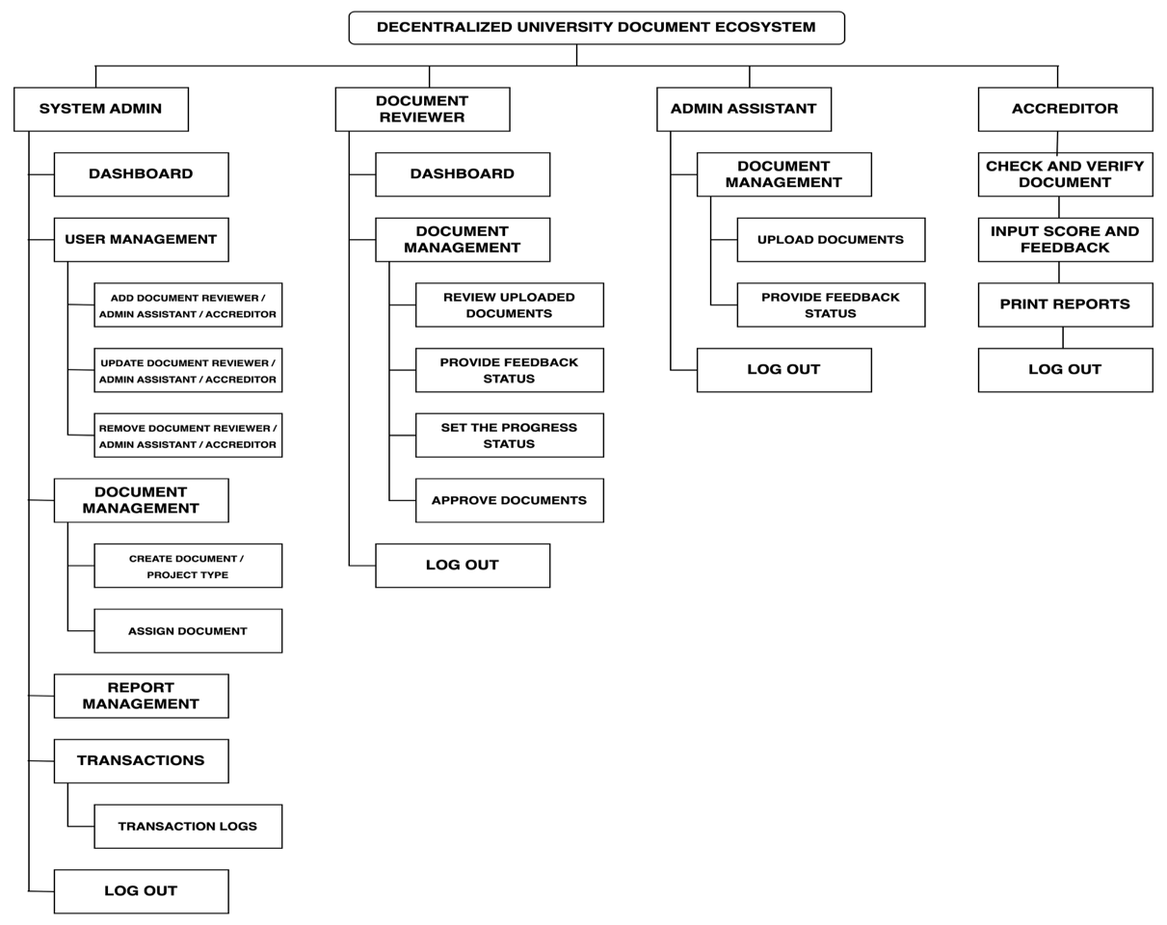
Figure 14 illustrates the site map of the system that consists of four modules designed to meet the study’s objectives. These modules include the System Admin, Document Reviewer, Admin Assistant, and Accreditor. This hierarchical structure ensures a well-defined, role-based workflow that promotes accountability, efficient document handling, and streamlined communication across the accreditation process.
Figure 14. Site Map of the System
The System Admin module serves as the central control point of the entire accreditation system. It enables the administrator to manage user roles, such as adding, editing, or removing Document Reviewers, Admin Assistants, and Accreditors, depending on the needs of the organization. Beyond user management, the admin also oversees document-related transactions by creating document tasks and assigning them to the appropriate users. A key feature of this module is the ability to track progress through real-time monitoring and the generation of progress reports, ensuring that all document preparations are on schedule. Additionally, every major transaction such as document uploads, task assignments, and approvals can be recorded and viewed through the blockchain ledger. This integration adds a layer of transparency and security, making the accreditation process not only efficient but also tamper-proof and verifiable.
The module of the Admin Assistant, starts when he/she uploads documents based on the provided document information. This step also includes giving initial feedback and status updates to support the review process. Once the documents are uploaded, the Document Reviewer takes over. Through their dashboard, reviewers carefully evaluate the submitted documents, provide more detailed feedback and status updates, and ultimately approve the documents once they meet the required standards. This collaborative workflow ensures that each document is reviewed thoroughly and efficiently.
Lastly, the Accreditor module handles the final stage of the process. It allows accreditors to review and verify the submitted documents, assign scores based on evaluation criteria, provide their final feedback, and generate printable reports. This ensures that all documentation meets accreditation standards before being finalized. Each user type also has access to a logout function, reinforcing session security.

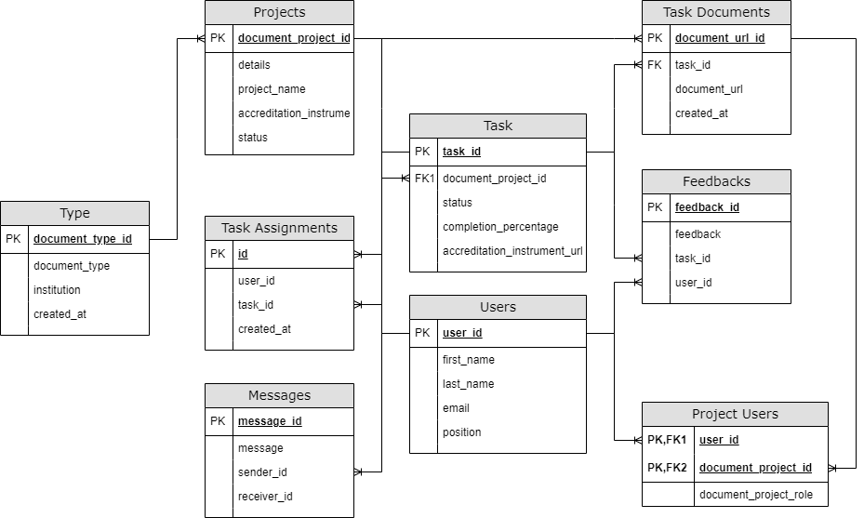

Figure 15. Entity-Relationship Diagram of the System

The entity-relationship diagram (ERD) illustrates the core components of a system, showing how various tables interact to support project management and workflow as shown in Figure 15. The Projects table serves as the central element, storing key project details. Linked to it is the Task table, which tracks the progress of individual tasks under each project, including their status and completion percentage. The Users table stores personal and role-based information about individuals involved in the system, while the Task Assignments table connects these users to specific tasks. Documents related to these tasks are stored in the Task Documents table, capturing URLs and timestamps. Feedback provided by reviewers or other users is recorded in the Feedbacks table, while the Messages table facilitates internal communication between users. The Type table categorizes document types and the institutions they belong to, adding organizational context.
Finally, the Project Users table links users to projects, identifying their roles within each. Together, these interconnected tables form a comprehensive system for managing accreditation documentation, user responsibilities, document uploads, communication, and feedback.
Implementation
Development Environment Setup
To commence the endeavor, it is imperative to configure the development environment adequately. This involves installing the Solana Command Line Tools and Rust programming language. These tools serve as the foundational elements for creating and deploying smart contracts on the Solana network.
Smart Contract Development / Deployment
Smart contracts, termed as programs within the Solana ecosystem, constitute the core logic of the blockchain application. They are crafted primarily in Rust, leveraging Solana's Software Development Kit (SDK). The development phase encompasses the design and implementation of smart contract functionalities in accordance with the blockchain's specifications.
Upon the completion of smart contract development, the deployment process ensues. This stage entails the utilization of deployment tools to deploy the compiled smart contracts onto the Solana blockchain network. The deployment process necessitates interaction with the Solana network via transactions to instantiate and execute the smart contracts securely.

Validator Node Configuration
The establishment of a validator node assumes paramount significance in ensuring the integrity and security of the Solana blockchain network. Validator nodes play a pivotal role in processing transactions, participating in the consensus mechanism, and fortifying the network against potential adversarial threats. Configuring a validator node involves installing the Solana software and configuring it to synchronize with the Solana network seamlessly.
Network Parameter Tuning
Effective network parameter configuration is indispensable for optimizing the performance and scalability of the Solana blockchain. Parameters such as block time, block size, and transaction fees necessitate meticulous calibration to align with the requirements of the blockchain application.
Testing
Thorough testing and debugging are imperative to rectify potential anomalies and vulnerabilities within the blockchain application. Utilizing Solana's testnet or local development environment facilitates rigorous testing to ascertain the robustness and reliability of the system prior to deployment on the mainnet.
Unit Testing
To ensure that the system functions as intended, unit testing was conducted. Table 2 lists the development task for the system that were used in the testing. The system’s functionality is shown in the Module column, while the second column lists each individual task. The third column displays the systems’ development priority level, with high representing the highest priority, medium representing the second highest priority, and low representing the lowest priority
Table 2. Development Task and Priority Level of the System
Module | Task | Priority
Dashboard Module | View User Overview (No of: System Admins, Reviewers, Document Admins, Accreditors, Users) | Medium
Dashboard Module | View Access Logs | Medium
Dashboard Module | View Blockchain Utilization | Medium
Dashboard Module | View Total Document Projects | Medium
Dashboard Module | View of Total Number of Document Type (ISO, PACUCOA and QStar etc) | Medium
Dashboard Module | View of Total Number of Document Type Usage  Sample ISO - 2 Document Project  E.g. ISO_August_2023 - 5 User, Status Completed  ISO_January_2024 - 8 User, Status: Ongong | Medium
Dashboard Module | View of Total Pendings for Review | Medium
Dashboard Module | View of Total Assigned Number of Document Type (ISO, Pacucoa and QStar etc) | Medium
Dashboard Module | View of Total Assigned Number of Document Type Usage  Sample ISO - 2 Document Project  E.g. ISO_August_2023 - 5 User, Status Completed  ISO_January_2024 - 8 User, Status: Ongong | Medium
Dashboard Module | View Total Pending for Updates | Medium
User Module | Search Users | Low
User Module | Filter Users | Low
User Module | Reset Search And Filter | Low
User Module | Add New User | High
User Module | Edit User | High
Document Type Module | Search Document Type | Low
Document Type Module | Filter Document Types | Low
Document Type Module | Reset Search Filter | Low
Document Type Module | View Document Type | High
Document Type Module | Create Document Type | High
Document Type Module | Edit Document Type | High
Document Project Module | Search Document Project | Medium
Document Project Module | Filter Document Project | Medium
Document Project Module | Reset Search And Filter | Medium
Document Project Module | View Document Project | High
Document Project Module | Create Document Project | High
Document Project Module | Edit Document Project | High
Document Project Module | Add New Task | High
Document Project Module | Update Task | High
Document Project Module | Delete Task | High
Document Project Module | Add Feed Back | High
Messaging Module | View Conversations | Medium
Messaging Module | Send a Message | Medium
Other Features | Login | High
Other Features | Logout | High
Other Features | View Icon and School Name | High

Security Testing
The application was submitted to an online vulnerability site to check its compliance to standard security testing and penetration testing. The following outline the benefits of having a vulnerability site check.
Finding Weaknesses. Vulnerability scanning assists in locating possible gaps or weak points in the security posture of your online application. These could be misconfigured systems, out-of-date software, or known vulnerabilities in the frameworks or libraries you're utilizing.
Compliance Requirements. Regulations requiring regular security assessments may apply depending on your sector and region. You may assure compliance with these standards and prevent fines or legal difficulties by conducting regular vulnerability scans.
Safeguarding Customer Data. You are accountable for securing any sensitive customer data that your web application manages, including financial or personal information. By preserving the security and integrity of this data, vulnerability assessments help you build users' confidence.
Keeping Up with Emerging Threats. New attack vectors and vulnerabilities appear on a regular basis, causing the threat landscape to continuously change.
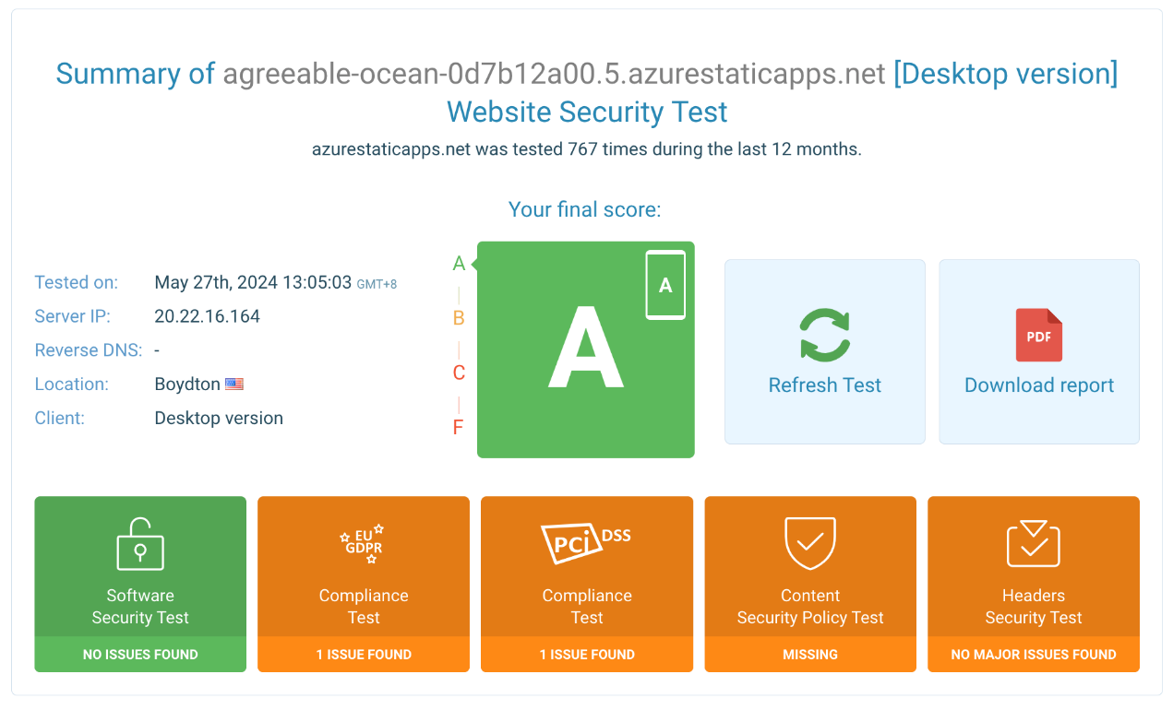
By keeping your defenses current, regular vulnerability assessments help you remain ahead of these threats.

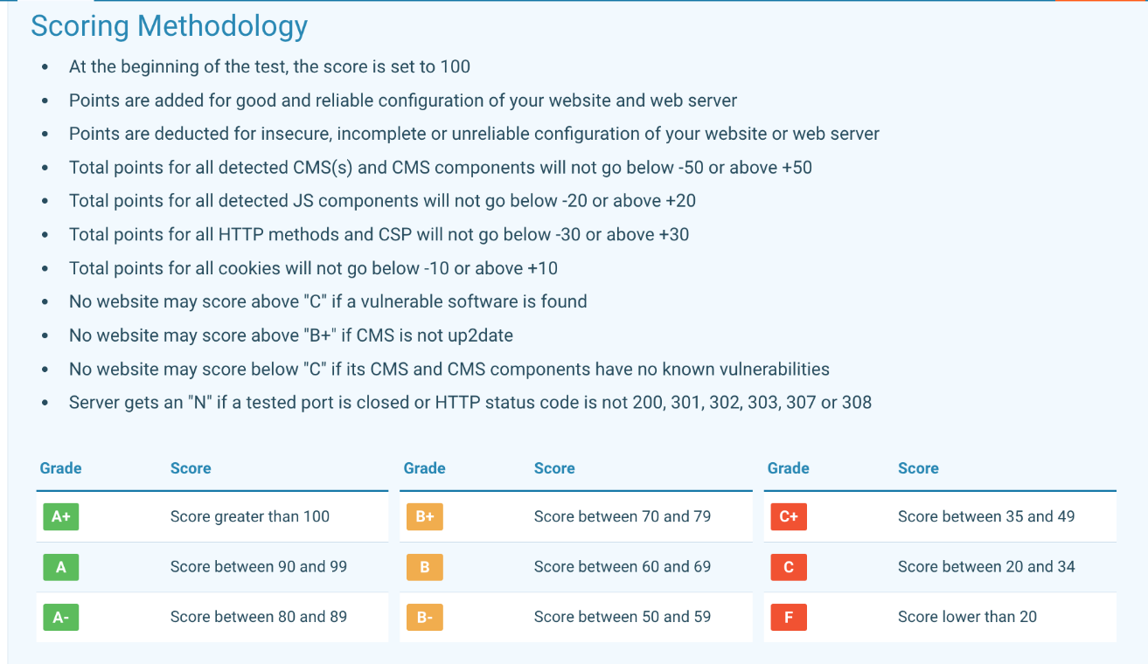
Figure 16. Online Vulnerability Test
Figure 16 outlines the scoring methodology for assessing the configuration and security of websites and web servers. Starting with an initial score of 100, points are added for good and reliable configurations and deducted for insecure, incomplete, or unreliable setups. The scoring factors include detected CMS (Content Management System) components, which can range between -50 and +50 points, and JS (JavaScript) components, ranging between -20 and +20 points. Additionally, HTTP methods and CSP (Content Security Policy) contribute between -30 and +30 points, while cookies affect the score by -10 to +10 points. No site can score above a 'C' if any vulnerable software is found, above 'B+' if the CMS is outdated, or above 'C' if the CMS and its components have known vulnerabilities. Servers receive an 'N' grade if any tested ports are closed or if the HTTP status code is not among 200, 301, 302, 303, 307, or 308. The resulting score determines the grade, ranging from A+ (above 100) to F (below 20), with specific score ranges assigned to intermediate grades such as A, B, and C. This shows that the online vulnerability test states that no security threat is found on the system, and it is being graded as A which is the highest security compliance rating of the site.
Penetration Testing
The system was submitted to Integra.cz, an online Penetration testing tool which uses OpenVAS security scanner launches in the background, which checks the susceptibility of your application or server to various types of attacks. After running the test, different types of automated attacks are performed on your server and application as they would be performed by a potential attacker. The scanner will access your systems from IP address 178.238.36.101. It is important to note that these attacks can affect the operation of the tested application. However, most applications should not restrict this test in their normal operation. Figure 17 shows the results of the online Penetration testing.
Overall Vulnerability Assessment and Penetration Testing (VAPT) is a crucial step in ensuring the security of the web application. VAPT are necessary for web application systems to provide strong security protocols. VAPT facilitates the identification of system flaws and vulnerabilities that an attacker might exploit. Organizations are able to proactively identify and resolve security vulnerabilities prior to their malevolent exploitation by carrying out routine evaluations. In order
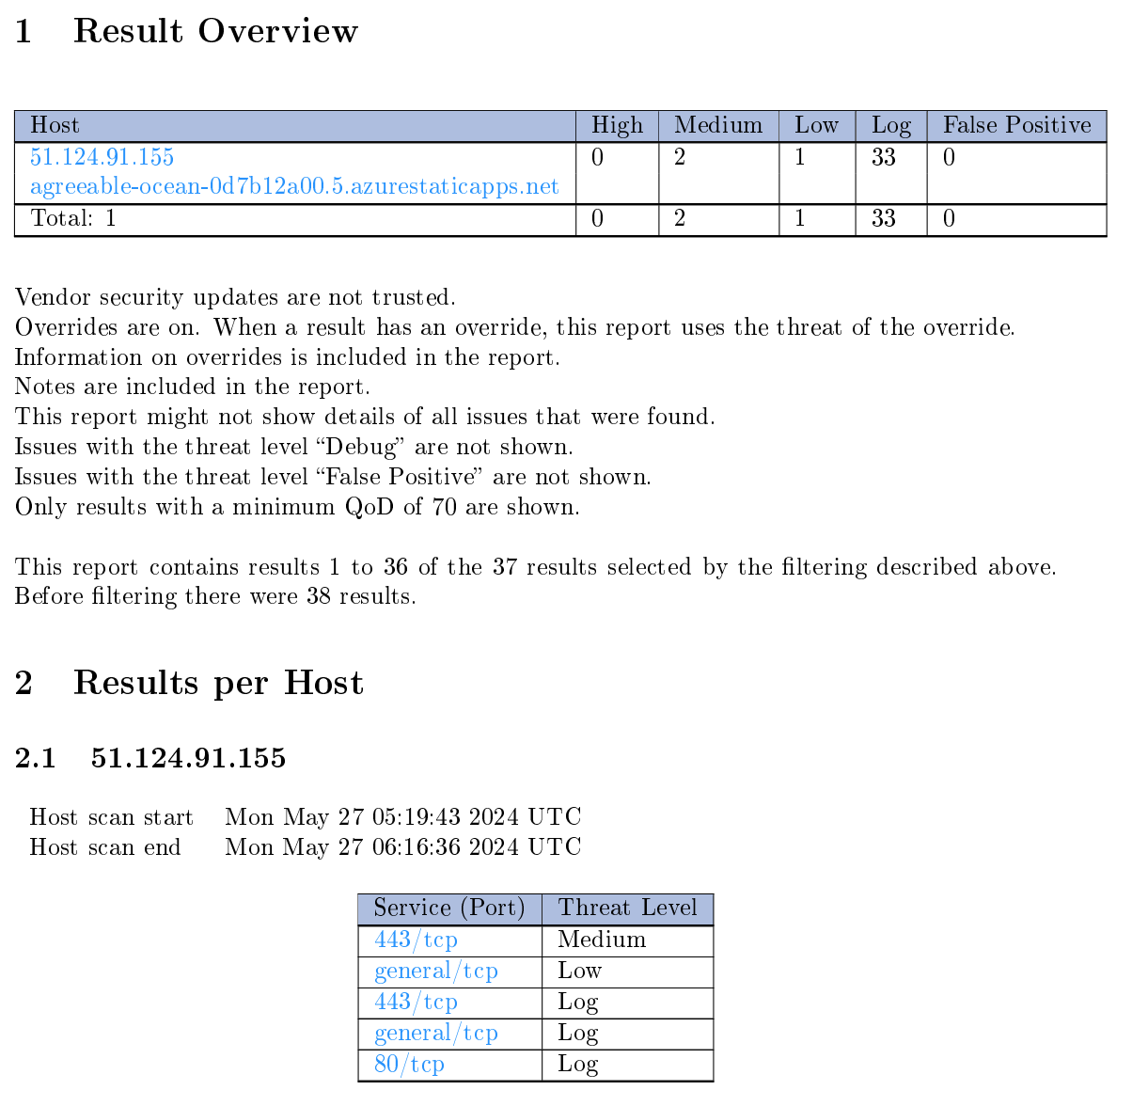
Figure 17. Online Penetration Testing Results
to evaluate the system's resilience and response mechanisms, penetration testing mimics actual cyberattacks
Organizations can use this technique to prioritize remediation efforts and gain a better understanding of their security posture. By reducing the possibility of data breaches, illegal access, and other cybersecurity concerns, VAPT ultimately improves the overall security posture of web applications.
The VAPT was conducted through a systematic process. (1) Automated Scanning. Automated vulnerability scanners are used to scan the web application for known vulnerabilities. These tools can identify issues such as outdated software versions, misconfigurations, injection flaws (e.g., SQL injection, XSS), broken authentication, and sensitive data exposure. (2) Input Validation Testing. This involves testing how the web application handles various types of user input, such as form submissions, URL parameters, and file uploads. The goal is to identify vulnerabilities related to input validation, such as injection flaws and XSS vulnerabilities. (3) Authentication and Session Management Testing. This involves testing the effectiveness of the web application's authentication and session management mechanisms. Testers may attempt to bypass authentication controls, manipulate session cookies, or exploit weaknesses in password management to gain unauthorized access to the application. (4) Error Handling and Logging Analysis. Testers examine how the web application handles errors and logs security-related events. This includes testing for information disclosure vulnerabilities that could reveal sensitive information to attackers, as well as assessing the effectiveness of logging mechanisms for detecting and responding to security incidents.
Deployment Planning
Deployment planning includes the conduct of a thorough assessment of hardware, software, and network infrastructure requirements for system deployment. A deployment plan was developed to outline the tasks, timelines, and responsibilities for system setup and configuration. Coordination with the IT personnel and stakeholders to ensure the system deployment works properly.
System Configuration
This includes installation and configuration of the Solana Blockchain nodes, smart contracts, and application servers according to technical specifications and best practices. Configure the databases, data schemas, and access controls to support accreditation processes and ensure data integrity. Last is to perform system integration tests to verify interoperability and functionality across components.
Solana Blockchain Configuration
The comprehensive process of establishing a blockchain on the Solana platform. The Solana blockchain, renowned for its high throughput and scalability, presents a compelling framework for decentralized applications. This delineates the intricate steps involved in setting up a blockchain on Solana, encompassing development environment setup, smart contract creation, deployment, validator node configuration, network parameter tuning, testing, and launch procedures.
Upon successful testing and debugging, the blockchain application is primed for deployment on the mainnet. The launch phase encompasses the dissemination of the blockchain network to the broader ecosystem. Subsequent to deployment, continuous monitoring of network performance and stability is imperative to proactively address any emergent issues or challenges.
Sustained engagement with the Solana community is instrumental in fostering collaboration, garnering feedback, and promoting the blockchain project. Active participation in forums, developer communities, and social media platforms serves to cultivate a vibrant ecosystem conducive to innovation and growth.
The establishment of a blockchain on the Solana platform necessitates meticulous planning, rigorous development, and diligent testing. Through adherence to the outlined procedures and best practices, stakeholders can realize the transformative potential of decentralized applications within the Solana ecosystem.
DUDE Web App
Sends Instruction Data
Solana Program
Solana Validators
Transaction Finalized

Figure 18. HEI Accreditation System and Solana Framework
The figure 18 shows how the DUDE Web system interacts with the Solana blockchain. First, the DUDE Web sends instruction data to the Solana Program, which processes the request. Once processed, the Solana Program passes the data to the Solana Validators. These validators play a critical role because they are the ones who check, verify, and agree (through consensus) that the transaction is valid before it moves forward. Finally, after the validators reach agreement, the transaction is finalized and becomes part of the blockchain record.
What makes this process powerful is that once the transaction is finalized, it becomes immutable, it cannot be altered or tampered with. The validation happens across a distributed network of nodes, not just in a single server, ensuring that no single party controls or manipulates the data. This distributed verification across multiple nodes guarantees the integrity and trustworthiness of the system, making the DUDE Web’s integration with Solana both secure and reliable. Actual Framework is available on Github (see Appendix G).

Data Management
To manage the data, regular data backup should be implement and follow the recovery procedures to protect against data loss and ensure business continuity. Established data retention policies and procedures in compliance with regulatory requirements and organizational policies. Archiving of historical data for long-term storage and audit purposes, ensuring accessibility and integrity over time.
Operation Procedure
To offer thorough policies and procedures for the implementation, upkeep, and continuous functioning of Solana Blockchain-based accreditation systems in schools and accrediting organizations. Throughout the course of the solutions' lifecycle, this document seeks to guarantee customer happiness, data integrity, and efficient system operation.
Monitoring
Deploy monitoring tools and systems to track system performance, resource utilization, and security events. Regular generating of reports on system health, performance metrics, and user activity for management review and decision-making. Set up alerts and notifications were included to proactively identify and address issues before they impact system operations.
Maintenance and Updates
A schedule for software updates, patches, and system upgrades to address security vulnerabilities and improve system functionality were developed. Conduct a regular maintenance tasks, such as database optimization, server maintenance, and security audits, to ensure system reliability and performance. Each maintenance activities and update standard operating procedures accordingly to maintain system integrity and compliance were recorded or documented.
Node Governance and Management
Central to the maintenance of the Solana blockchain network is the governance and management of network nodes. Validator nodes, archivers, and full nodes collectively comprise the network infrastructure and are responsible for transaction processing, block propagation, and consensus protocol enforcement. Effective node governance involves the deployment, configuration, and monitoring of these nodes to ensure optimal performance, reliability, and resilience. Node operators must employ advanced techniques such as load balancing, fault tolerance mechanisms, and distributed consensus algorithms to mitigate latency issues, network partitions, and denial-of-service attacks.
Network Optimization and Scalability
Optimizing the Solana blockchain network for scalability and throughput is paramount to accommodate growing transaction volumes and user demand. Network optimization strategies encompass various techniques, including sharding, parallel transaction processing, and data compression algorithms. Furthermore, implementing efficient peer-to-peer communication protocols, such as gossip-based dissemination and network overlays, facilitates rapid propagation of transactions and consensus messages across the network. Additionally, fine-tuning network parameters such as block size, block time, and transaction fees enables dynamic adjustment of network capacity to accommodate fluctuating demand and mitigate congestion issues.
Software Updates and Protocol Enhancements
The Solana blockchain ecosystem is characterized by rapid innovation and continuous development, necessitating timely software updates and protocol enhancements to integrate new features, performance improvements, and security patches. The process of updating the Solana software stack involves meticulous planning, rigorous testing, and coordinated deployment across the network. Node operators must diligently monitor upstream software repositories, participate in protocol governance discussions, and collaborate with core developers to ensure seamless integration of software updates while minimizing disruption to network operations.
Security Measures and Threat Mitigation
Preserving the security and integrity of the Solana blockchain network requires robust security measures and proactive threat mitigation strategies. Node operators must implement cryptographic key management practices, secure network communication protocols, and access control mechanisms to safeguard against unauthorized access, data breaches, and malicious attacks. Furthermore, conducting regular security audits, penetration testing, and code reviews helps identify and remediate potential vulnerabilities in the network software stack. Collaboration with security researchers, participation in bug bounty programs, and adherence to industry best practices foster a culture of security consciousness and resilience within the Solana community.
Community Engagement and Decentralized Governance
Community engagement and decentralized governance play a pivotal role in shaping the future direction of the Solana blockchain ecosystem. Active participation in community forums, developer meetups, and governance proposals empowers stakeholders to contribute to network development, protocol upgrades, and ecosystem initiatives. Moreover, transparent decision-making processes, decentralized governance structures, and token-based voting mechanisms enable inclusive participation and consensus formation within the Solana community. Initiatives such as grants programs, hackathons, and developer incentives foster innovation, collaboration, and knowledge sharing among ecosystem participants.
Then maintenance of the Solana blockchain network demands a comprehensive and proactive approach encompassing node governance, network optimization, software updates, security measures, and community-driven initiatives. By leveraging advanced technical solutions, engaging with stakeholders, and fostering a culture of innovation and collaboration, the Solana ecosystem can continue to evolve and thrive as a leading platform for decentralized applications and digital assets in the rapidly evolving landscape of blockchain technology.
User Support
A comprehensive helpdesk support services to assist users with system access, functionality, and troubleshooting. To facilitate user onboarding and ensure smooth adoption of the system, the researcher develop extensive user training materials, guides, and documentation. Additionally, we establish effective communication channels and feedback mechanisms to gather user input and address user needs and concerns promptly.
Responsibilities
The IT department or designated personnel are responsible for system deployment, configuration, and maintenance. System administrators oversee day-to-day operations, monitoring, and user support activities. End-users are responsible for adhering to system usage policies and procedures and reporting any issues or concerns to system administrators.
Solana Maintenance
The Solana blockchain ecosystem, renowned for its high-performance capabilities and innovative design, requires a robust support infrastructure to facilitate the seamless operation, development, and adoption of decentralized applications (dApps) and digital assets. This chapter explores the multifaceted support mechanisms that underpin the Solana ecosystem, encompassing developer resources, community engagement initiatives, technical support channels, and ecosystem partnerships.
Developer Resources and Documentation
Central to the success of the Solana ecosystem is the availability of comprehensive developer resources and documentation, empowering developers to build, deploy, and maintain decentralized applications on the Solana blockchain. Solana provides extensive developer documentation, including guides, tutorials, and API references, covering various aspects of smart contract development, node operation, and network integration. Moreover, developer toolkits, software libraries, and code samples streamline the development process and enable rapid prototyping of dApps across diverse use cases.
Community Engagement Initiatives
Community engagement initiatives play a vital role in fostering collaboration, knowledge sharing, and ecosystem growth within the Solana community. Solana hosts a vibrant ecosystem of developers, validators, token holders, and enthusiasts, facilitated by online forums, social media channels, and community meetups. Additionally, Solana organizes hackathons, developer workshops, and educational programs to encourage innovation and skill development among ecosystem participants. By nurturing a strong sense of community ownership and participation, Solana cultivates an inclusive and dynamic ecosystem conducive to innovation and growth.
Technical Support Channels
Providing timely and effective technical support is essential for addressing user inquiries, resolving issues, and ensuring the smooth operation of the Solana blockchain network. Solana offers various technical support channels, including community forums, developer chat rooms, and dedicated support portals staffed by experienced engineers and developers. These support channels facilitate rapid response times, collaborative problem-solving, and knowledge sharing among community members. Furthermore, Solana conducts regular AMA (Ask Me Anything) sessions and office hours with core developers to address user questions, gather feedback, and provide updates on the project roadmap.
Ecosystem Partnerships and Collaborations
Strategic partnerships and collaborations play a pivotal role in expanding the reach, adoption, and utility of the Solana ecosystem. Solana collaborates with leading blockchain projects, technology companies, and academic institutions to explore synergies, co-develop solutions, and drive ecosystem growth. Additionally, Solana actively engages with industry consortia, standards bodies, and regulatory authorities to promote interoperability, compliance, and standardization within the broader blockchain ecosystem. Through strategic partnerships and collaborative initiatives, Solana aims to accelerate the mainstream adoption of decentralized technologies and foster a vibrant and interconnected blockchain ecosystem.
Funding and Grants Programs
Funding and grants programs provide critical financial support to developers, entrepreneurs, and ecosystem participants building on the Solana blockchain. Solana offers various funding opportunities, including grants, seed investments, and venture capital funding, to support innovative projects and initiatives that contribute to the growth and development of the ecosystem. Additionally, Solana collaborates with incubators, accelerators, and venture capital firms to provide mentorship, resources, and networking opportunities to early-stage startups and entrepreneurs. By fostering a supportive funding environment, Solana empowers innovators to realize their vision and drive meaningful impact within the blockchain industry.
The support infrastructure for the Solana ecosystem encompasses a diverse array of resources, initiatives, and partnerships aimed at empowering developers, engaging the community, providing technical support, and fostering ecosystem growth. By leveraging comprehensive developer resources, fostering community engagement, providing technical support channels, nurturing strategic partnerships, and offering funding and grants programs, Solana cultivates an inclusive and vibrant ecosystem that drives innovation, collaboration, and adoption in the rapidly evolving landscape of decentralized technologies.
Instruments and Techniques Used
The target population for this study is made up of the specialists, professionals, and end users who can best give the researcher the information required to answer the research question. There was a representative sample of the general public that comprised professors, end users, and experts. A technique known as stratified random sampling was used to choose the participants. To ensure that the study's variables were fairly evenly represented, this technique was employed.
One of the methods for gathering data for this project is the labeled-scaled response question, which is a scaling-type question, an evaluation survey based on the Dimensions of Usability (see Appendix A). Likert scales with five points were used to construct the questionnaire.
Likert Scale

A Likert scale is frequently used to gauge changes in behavior as well as attitudes, knowledge, beliefs, and values. It involves a selection of statements from which respondents can rate their answers to evaluative questions (Vogt, 1999). Additionally, it is a form of psychometric response scale where respondents indicate their level of agreement to a proposition in one of five ways: (1) Strongly disagree; (2) Disagree; (3) Neither agree nor disagree; (4) Agree; and (5) Strongly agree (Springer Link, 2010).

Table 3. The 5-point scale with its mean range and verbal interpretation
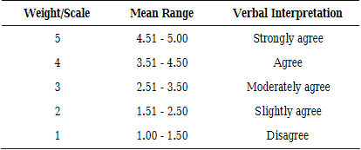
Source: Bringula, 2012

Alpha Test
An important turning point in the project's development lifecycle was reached when the digital certification system entered its Alpha test phase. The testing process ends with alpha testing. It is an important and well-liked testing technique that aids the researcher in producing high-quality and practical software. Additionally, this testing was done prior to the product's release. It can also be described as the initial phase of dependent testing, which verifies that the software functions in accordance with the requirement plan.
This was essentially done to make sure a higher-quality product had been made before the beta test. Additionally, it gives a more accurate early impression of the software's dependability. It assists in simulating user behavior and environment in real time and in identifying several catastrophic or major problems. During this stage, a small group of internal stakeholders and early adopters tested the system's fundamental functions and workflows, enabling early problem detection, requirement validation, and user experience improvement.
Beta Test
Beta testing is among the most crucial forms of user acceptability testing. It is done before the software is released. Moreover, it is acceptable as an external user acceptability test. After alpha testing, this testing is conducted by actual users. User acceptance testing is a type of beta testing, according to A. (2021), (External testing).
The beta test was carried out at the university level once the issues and worries raised during the alpha test had been addressed. And how to use the web application were demonstrated. Teaching and non-teaching staff were the main attendees. The presenter explained the system and then asked the audience to take part in the beta test. In the end, twenty (20) randomly selected individuals took part in the experiment.
Evaluation Procedure
ISO/TR 23455:2019
To determine the acceptability of the project, the researcher administered the evaluation instrument to respondents composed of faculty members, department head, and staff who have been involved in the accreditation process of the school. Before the actual evaluation, the researcher conducts an actual demonstration on how the project operates. The details and specification of the project were also discussed. The researcher explains the contents of the evaluation instrument and its rating scale. The evaluation instrument to be used is based on the ISO/TR 23455:2019 Blockchain and distributed Ledger technologies, standards in the field of blockchain and smart contracts.
ISO/TR 23455:2019 provides guidelines for the evaluation of smart contracts systems. This outlines a structured approach to assess the functionality, security, reliability, and performance of smart contracts. These characteristics are further broken down into sub-characteristics. The model includes both software and computer systems (ISO, 2018).
Functionality Evaluation. This step is about making sure the smart contract system does what it’s supposed to do.
Security Evaluation. Security is crucial for smart contracts because they are immutable and decentralized. This evaluation aims to spot vulnerabilities like reentrancy attacks, overflow/underflow issues, and unauthorized access. Common techniques include security audits, code reviews, and penetration testing.
Reliability Evaluation. This evaluates how the system is trustworthy and robust is. This involves the checking of error-handling mechanisms, resilience to unexpected inputs or conditions, and recovery procedures for failures.
Performance Evaluation. This measures how efficient and scalable the smart contract system is. It includes looking at transaction throughput, latency, gas consumption (for Ethereum-based contracts), and resource use under different workloads.
Compliance Evaluation. The system needs to check if it follows all the necessary rules and laws such as industry standards or regulations like GDPR for data protection or AML for preventing money laundering.

Documentation and Traceability. According to ISO/TR 23455, it is important to keep detailed records throughout the evaluation process. This means writing down what you’re checking, how you’re checking it, what you find, and any suggestions you have. This ensures everything is clear and can be reviewed later.
Data Processing
This is the guidelines for gathering, storing, processing, and evaluating the data produced during the investigation of improving accreditation procedures using Solana Blockchain technology. In order to meet the goals of the research, this document attempts to guarantee the accuracy, confidentiality, and integrity of the data that was gathered as well as to make meaningful analysis and interpretation easier.
Data Collection
Procedures for collecting data from diverse sources, includes surveys, interviews, system logs, and transaction records. Determine the sources and types of data to be collected, including quantitative and qualitative data related to accreditation processes and blockchain technology. Design data collection instruments, such as surveys, interview protocols, and observation guides, to gather relevant information from stakeholders. Establish procedures for obtaining informed consent from participants and ensuring confidentiality and anonymity of data.
Data collection is a fundamental aspect of blockchain technology, enabling the recording, verification, and storage of information in a decentralized and immutable manner. This chapter provides a detailed examination of how blockchain handles data collection, encompassing various mechanisms, protocols, and considerations involved in the process.
Data Collection Process
Transaction Recording. Blockchain records data through transactions, which are bundles of information representing a change in state or ownership. Each transaction contains data inputs, outputs, and metadata, which are cryptographically signed by the sender and verified by network participants. Transactions are grouped into blocks, which are subsequently added to the blockchain in a sequential and append-only manner.
Data Structure. Blockchain employs a distributed ledger structure, where data is stored across a network of nodes in a synchronized and replicated fashion. The data structure of blockchain consists of blocks linked together in a chronological order, forming an immutable chain of blocks. Each block contains a header and a body, with the header containing metadata such as timestamp, block number, and reference to the previous block, while the body contains the actual data (transactions).
Decentralized Data Collection
Peer-to-Peer Network. Blockchain operates on a peer-to-peer network, where each node maintains a copy of the entire blockchain ledger. Data collection occurs in a decentralized fashion, with transactions propagated and validated by network nodes in a distributed manner. This decentralized architecture ensures redundancy, fault tolerance, and censorship resistance, enhancing the reliability and security of data collection.
Consensus Mechanisms. Consensus mechanisms ensure agreement among network nodes on the validity of transactions and the state of the blockchain. Through mechanisms such as Proof of Work (PoW), Proof of Stake (PoS), and Byzantine Fault Tolerance (BFT), blockchain achieves consensus on the order and validity of data collection. Consensus algorithms mitigate the risk of double-spending, Sybil attacks, and other malicious activities, ensuring the integrity of the data collection process.
Security and Integrity
Cryptographic Hashing. Blockchain utilizes cryptographic hashing algorithms to secure data integrity and prevent tampering. Each block in the blockchain is associated with a unique cryptographic hash, calculated based on the block's contents. Any alteration to the block's data would result in a change in the hash value, alerting network participants to the tampering attempt.
Immutable Ledger. Once data is recorded on the blockchain, it becomes immutable and resistant to modification. The append-only nature of blockchain ensures that historical data remains unchanged, preserving the integrity and auditability of the ledger. Immutability is achieved through cryptographic techniques and consensus mechanisms that enforce the integrity of the data collection process.
Privacy and Confidentiality
Pseudonymity. Blockchain offers pseudonymous data collection, where participants are identified by cryptographic addresses rather than real-world identities. While transactions are publicly visible on the blockchain, the identities of the parties involved remain pseudonymous, providing a degree of privacy and confidentiality.
Privacy-enhancing Technologies. Various privacy-enhancing technologies, such as zero-knowledge proofs, homomorphic encryption, and ring signatures, can be integrated into blockchain to enhance privacy and confidentiality. These technologies enable selective disclosure of information and secure computation without revealing sensitive data to unauthorized parties.
Considerations and Challenges
Scalability. Scalability remains a key challenge in blockchain data collection, particularly as transaction volumes and network activity increase. Solutions such as sharding, layer 2 protocols, and off-chain scaling aim to improve the throughput and efficiency of blockchain networks to accommodate growing data demands.
Interoperability. Interoperability between different blockchain platforms and legacy systems poses challenges for seamless data collection and integration. Standardization efforts, interoperability protocols, and cross-chain communication mechanisms seek to address interoperability challenges and facilitate data interoperability across heterogeneous networks.
The data collection process in blockchain technology is characterized by decentralization, security, and integrity, enabled by cryptographic techniques, consensus mechanisms, and distributed ledger architecture. While blockchain offers several advantages for data collection, including transparency, immutability, and pseudonymity, challenges such as scalability, interoperability, and privacy remain areas of ongoing research and development. By addressing these challenges and leveraging emerging technologies, blockchain has the potential to revolutionize data collection across various industries, enabling secure, transparent, and decentralized data management solutions.
Data Storage. Protocols for storing data securely in designated repositories, databases, or cloud storage solutions, ensuring accessibility and integrity. Select appropriate storage solutions, such as databases, data warehouses, or cloud storage platforms, based on scalability, security, and accessibility requirements. Implement access controls, encryption, and backup mechanisms to protect data from unauthorized access, loss, or corruption. Document data storage protocols, including file naming conventions, directory structures, and version control procedures.
Data storage is a critical component of blockchain technology, facilitating the secure and immutable recording of information across a distributed network. This chapter delves into the intricate mechanisms and principles governing data storage in blockchain systems, highlighting its decentralized, cryptographic, and tamper-resistant nature.
Data Storage Mechanisms
Blockchain employs a decentralized approach to data storage, distributing information across a network of nodes rather than relying on centralized servers or databases. This distributed ledger architecture ensures redundancy, fault tolerance, and resilience against single points of failure.
Decentralization. In a blockchain network, each node maintains a copy of the entire ledger, ensuring that data is replicated and synchronized across the network. Decentralization enhances the reliability and availability of data by eliminating the need for a single central authority or intermediary.
Cryptography. Cryptographic techniques are employed to secure data stored on the blockchain, protecting it from unauthorized access and tampering. Each transaction is cryptographically signed by the sender, ensuring the integrity and authenticity of the data. Hash functions are used to generate unique identifiers for each block, facilitating efficient data retrieval and verification.
Immutability. Once data is recorded on the blockchain, it becomes immutable and resistant to modification. The append-only nature of blockchain ensures that historical data remains unchanged, preserving the integrity and auditability of the ledger. Immutability is achieved through consensus mechanisms and cryptographic hashing, which enforce the integrity of the data storage process.
Data storage is a critical component of blockchain technology, facilitating the secure and immutable recording of information across a distributed network. This chapter delves into the intricate mechanisms and principles governing data storage in blockchain systems, highlighting its decentralized, cryptographic, and tamper-resistant nature.
Data Structures
Blockchain employs a structured approach to data storage, organizing information into blocks linked together in a chronological order. Each block contains a header and a body, with the header containing metadata such as timestamp, block number, and reference to the previous block, while the body contains the actual data (transactions).
Transaction Model. Transactions represent changes in state or ownership recorded on the blockchain. Each transaction contains inputs, outputs, and metadata, which are cryptographically signed by the sender and verified by network participants.
Block Structure. Blocks serve as containers for grouping transactions together. Each block is associated with a unique cryptographic hash, calculated based on the block's contents, which ensures data integrity and tamper resistance. The linking of blocks through cryptographic hashes forms an immutable chain of blocks, known as the blockchain.
Security Considerations
Blockchain incorporates several security measures to protect data stored on the network:
Cryptographic Hashing. Cryptographic hash functions are used to generate unique identifiers for blocks and transactions. Any alteration to the data would result in a change in the hash value, alerting network participants to the tampering attempt.
Consensus Mechanisms. Consensus mechanisms ensure agreement among network nodes on the validity of transactions and the state of the blockchain. Through mechanisms such as Proof of Work (PoW) or Proof of Stake (PoS), blockchain achieves consensus on the order and validity of data storage.
Privacy and Confidentiality
Blockchain provides pseudonymous data storage, where participants are identified by cryptographic addresses rather than real-world identities. While transactions are publicly visible on the blockchain, the identities of the parties involved remain pseudonymous, providing a degree of privacy and confidentiality.
Data storage in blockchain technology is characterized by its decentralized, cryptographic, and immutable nature, ensuring the security, integrity, and availability of information across a distributed network. By leveraging cryptographic techniques, consensus mechanisms, and decentralized architecture, blockchain provides a robust framework for storing data in a secure and tamper-resistant manner. As blockchain technology continues to evolve, ongoing research and development efforts will focus on addressing scalability, interoperability, and privacy challenges to further enhance the capabilities and adoption of blockchain-based data storage solutions.
Data Cleaning. Methods for cleaning, preprocessing, and standardizing raw data to remove errors, inconsistencies, and outliers that may affect analysis. Develop data cleaning procedures to identify and rectify errors, missing values, and inconsistencies in the collected data. Perform data validation, verification, and imputation techniques to ensure data quality and completeness. Document data cleaning steps and transformations applied to raw data, maintaining an audit trail for reproducibility and transparency.
Data cleaning is a crucial process in ensuring the integrity and reliability of information stored on the blockchain. This chapter explores the various techniques and methodologies employed to maintain the quality and consistency of data within blockchain systems, addressing issues such as data validation, verification, and error correction.
Data Validation and Verification
Data validation involves ensuring that the data stored on the blockchain adheres to predefined rules and standards. This process verifies the accuracy, completeness, and consistency of the data, mitigating the risk of errors or inconsistencies.
Consensus Mechanisms. Consensus mechanisms play a central role in validating and verifying data on the blockchain. Through mechanisms such as Proof of Work (PoW) or Proof of Stake (PoS), network participants collectively agree on the validity of transactions and the state of the blockchain. Consensus algorithms ensure that only valid transactions are added to the blockchain, maintaining data integrity and consistency.
Smart Contracts. Smart contracts are self-executing contracts with predefined rules and conditions encoded on the blockchain. Smart contracts enable automated validation and execution of transactions, ensuring that data adheres to predefined criteria before being recorded on the blockchain. By automating data validation processes, smart contracts enhance the efficiency and reliability of data cleaning operations.
Data Correction and Error Handling
Data cleaning also involves correcting errors or inconsistencies that may arise during the data collection or storage process. This includes identifying and rectifying invalid or erroneous data to maintain the accuracy and reliability of the blockchain ledger.
Immutable Ledger. While blockchain is designed to be immutable and resistant to modification, certain errors or discrepancies may still occur in the data. In such cases, corrective measures can be implemented through consensus mechanisms or governance protocols to address the issue and rectify the data.
Fork Resolution. Forks occur when there is a temporary divergence in the blockchain due to conflicting transactions or consensus issues. Fork resolution mechanisms aim to reconcile the divergent branches of the blockchain and restore consensus, ensuring that the correct version of the data is maintained.

Data Pruning and Archiving
Data pruning involves removing or archiving obsolete or redundant data from the blockchain to improve performance and efficiency. This process helps reduce the size of the blockchain ledger and optimize storage resources without compromising data integrity.
Pruning Algorithms. Pruning algorithms selectively remove older or less relevant data from the blockchain while preserving the integrity of the ledger. By discarding unnecessary data, pruning algorithms improve the scalability and performance of the blockchain network, enabling faster transaction processing and lower storage requirements.
Archival Nodes. Archival nodes store complete historical data of the blockchain, allowing users to access past transactions and data states. Archival nodes provide a valuable resource for data analysis, auditing, and compliance purposes, ensuring that historical data remains accessible and retrievable.
Data cleaning in blockchain technology is essential for maintaining the integrity, reliability, and efficiency of the blockchain ledger. Through data validation, error correction, and data pruning techniques, blockchain systems ensure that the stored data adheres to predefined standards and remains accurate and consistent over time. As blockchain technology continues to evolve, ongoing research and development efforts will focus on optimizing data cleaning processes and enhancing the scalability, reliability, and usability of blockchain-based data storage solutions.
Data Analysis. Techniques for analyzing data to extract insights, identify patterns, and draw conclusions relevant to the research objectives. Choose appropriate data analysis techniques and tools, such as statistical analysis, machine learning algorithms, or qualitative coding methods, based on research questions and data characteristics. Conduct exploratory data analysis to identify trends, patterns, and relationships within the data, using visualization techniques to communicate findings effectively. Interpret analysis results, draw conclusions, and derive actionable insights relevant to the research objectives.
Table 4. Schedule of Activities
Task Description | Duration  (Weeks) | Start Date | End Date | Dependencies
1. Project Planning and Conceptualization | 4 | 5/1/23 | 5/28/23 | -
2. Literature Review | 6 | 5/29/23 | 7/10/23 | 1
3. Research Design Development | 4 | 7/11/23 | 8/7/23 | 2
4. Prototyping Development | 8 | 8/8/23 | 10/2/23 | 3
5. Data Collection | 4 | 10/3/23 | 10/30/23 | 4
6. Data Processing and Analysis | 6 | 10/31/23 | 12/11/23 | 5
7. System Deployment and Testing | 8 | 12/12/23 | 2/6/24 | 6
8. User Training and Documentation | 4 | 2/7/24 | 3/6/24 | 7
9. Final Report Writing | 6 | 3/7/24 | 4/17/24 | 8
10. Presentation Preparation | 2 | 4/18/24 | 5/1/24 | 9
11. Project Review and Finalization | 2 | 5/2/24 | 5/15/24 | 10

Table 4 provides a visual representation of the project timeline, illustrating the sequence of activities and their interdependencies. It serves as a roadmap for project planning, monitoring progress, and ensuring timely completion of deliverables. Adjustments can be made to the chart as needed throughout the project lifecycle to accommodate changes in priorities, resource availability, or project requirements.

Chapter 4
RESULTS AND DISCUSSION
This chapter provides a detailed technical description of the project, encompassing several key components. It includes an in-depth technical overview of the application, outlining its functionalities, architecture, and design principles. Additionally, it presents the technical specifications and costing, offering a comprehensive breakdown of the hardware and software requirements, as well as the associated costs. The chapter also covers the test results, documenting the performance, reliability, and any issues identified during the testing phase. Lastly, it includes the evaluation results, analyzing the system's effectiveness and efficiency based on predefined criteria and stakeholder feedback.
Project Technical Description
The project developed a secure, transparent, and efficient digital accreditation system utilizing blockchain technology to streamline the accreditation process for educational institutions, professional certifications, and other credentialing entities. This system ensured that all accreditation records were tamper-proof and securely stored on a decentralized ledger, preventing unauthorized alterations and enhancing the security and integrity of the accreditation process.
A key feature of the system was its transparency, allowing authorized parties to easily verify records. All transactions and modifications were visible and traceable, ensuring stakeholders could trust the accreditation process. The system also significantly reduced the time and cost associated with traditional accreditation methods by automating various processes and minimizing manual intervention. Additionally, the system offered user-friendly access, enabling stakeholders to efficiently access and verify accreditation credentials. This feature allowed educational institutions, employers, and other relevant parties to authenticate credentials quickly, thereby enhancing trust and reliability in the accreditation process.
A. System Architecture
The system architecture diagram in Figure 19 illustrates a web application infrastructure utilizing various Azure services. The Internet represents users accessing the web application via their browsers or client devices. The authentication component ensures that users are authenticated before accessing the application, leveraging Azure services such as Azure AD (Active Directory) and OAuth.
The DNS service translates the web application’s domain name into its IP address, enabling users to reach the application. The Web Application Firewall (WAF) protects the web application from common threats and attacks. Additionally, the Content Delivery Network (CDN) distributes content to users with high availability and performance. The web application's frontend is hosted on Azure App Service, where the user interface resides and users interact directly.
Messages or tasks are placed in a queue component to be processed asynchronously, helping to manage load and ensure the system remains responsive. This architecture ensures a secure, high-performance, and user-friendly web application experience.

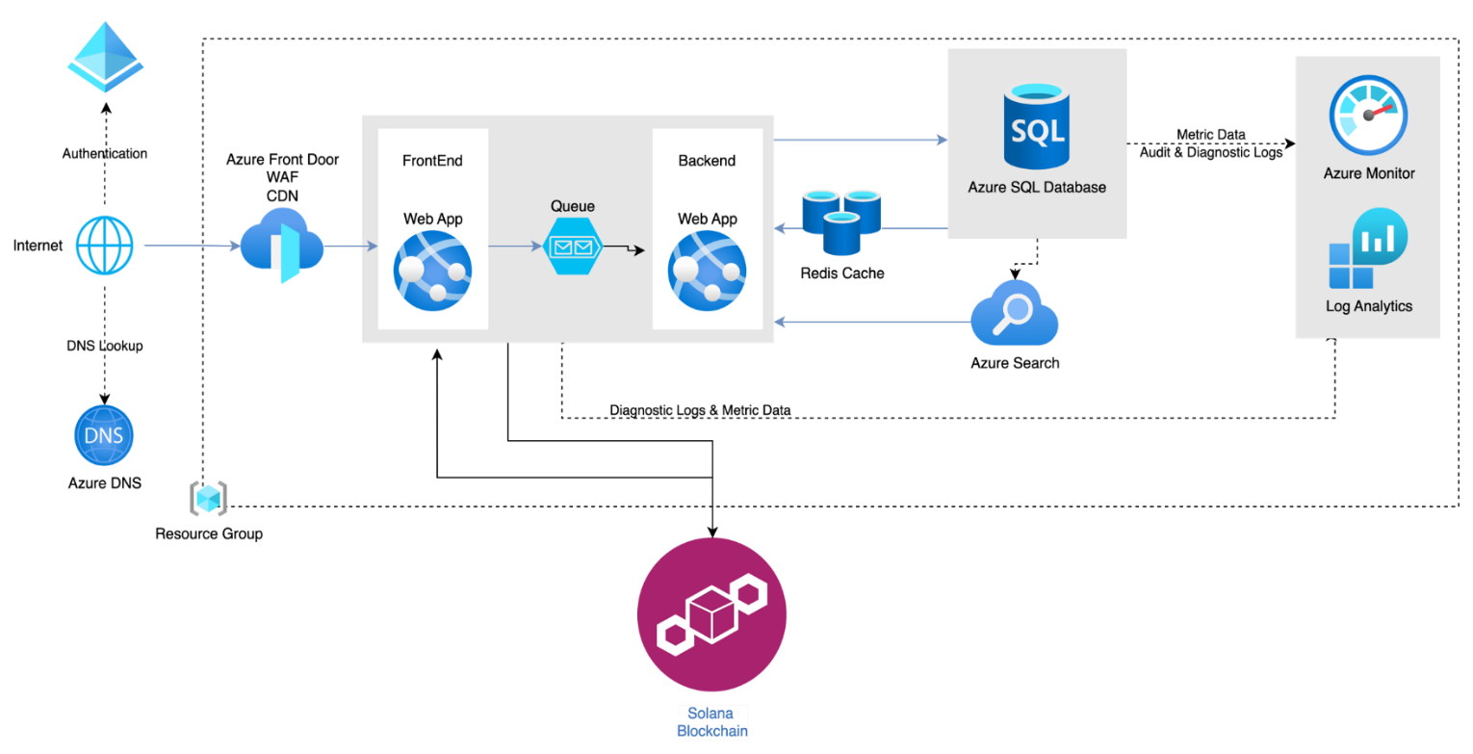

Figure 19. System Architecture Diagram
The backend logic of the web application is also hosted on Azure App Service. It processes requests, executes business logic, and interacts with the database. The application utilizes Azure SQL Database, a managed relational database service, to store its data, ensuring scalability, reliability, and security. An in-memory data structure store acts as a cache to enhance performance and responsiveness by storing frequently accessed data.
Azure Search provides powerful search capabilities for the data stored in Azure SQL Database, enabling users to perform complex searches quickly and efficiently. Azure Monitor collects and analyzes telemetry data from the application to ensure its performance and availability. Log Analytics allows for querying and analyzing log data from various Azure resources for diagnostics and troubleshooting.
The application interacts with the Solana blockchain for decentralized transactions, smart contracts, and other blockchain functionalities. A Resource Group component organizes related resources for the Azure solution, simplifying management and billing. Diagnostics Logs and Metric Data are collected from various components (e.g., Web App, SQL Database) and sent to Azure Monitor and Log Analytics for comprehensive analysis and monitoring.
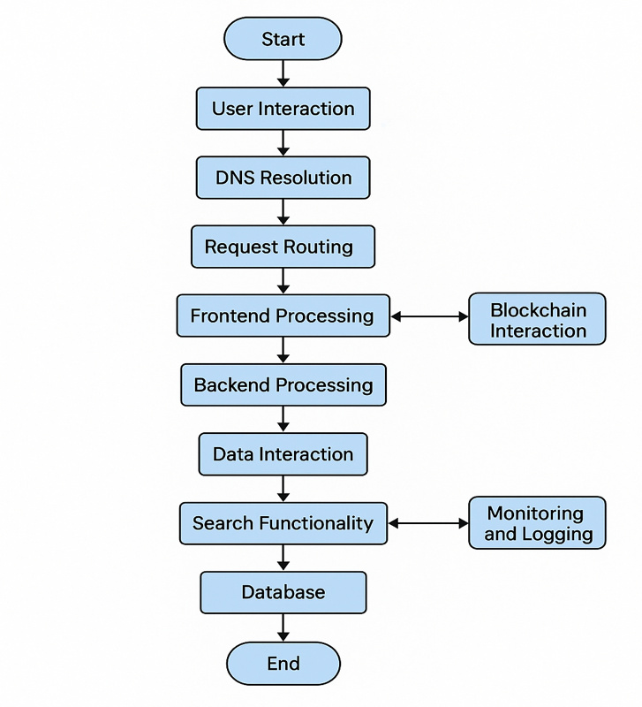
Flow of Interaction

Figure 20. System Flow of Interaction
The figure 20 shows the flow of interaction with the following discussion on each.
User Interaction. Users access the web application over the internet, authenticating through Azure’s authentication services
DNS Resolution. The Azure DNS service resolves the application’s domain name to its IP address.
Request Routing. Requests are routed through Azure Front Door, which applies WAF rules and delivers content using CDN for improved performance.
Frontend Processing. The request reaches the Frontend Web App where initial processing and rendering of the user interface happens.
Queue Management. Tasks that require backend processing are placed into the queue.
Backend Processing. The Backend Web App processes the queued tasks, performs business logic, and may interact with the database and cache.
Data Interaction. For data storage and retrieval, the Backend Web App interacts with Azure SQL Database. Frequently accessed data is stored in Redis Cache for faster access.
Search Functionality. Users can perform search operations that are handled by Azure Search.
Blockchain Interaction. Certain transactions or operations are sent to the Solana Blockchain for processing.
Monitoring and Logging. Throughout the process, diagnostic logs and metrics are collected and sent to Azure Monitor and Log Analytics for real-time monitoring and analysis.
This architecture ensures high availability, scalability, security, and performance of the web application, leveraging various Azure services to manage and optimize different aspects of the application’s operation.
Technical Architecture
The context diagram provides a high-level overview of how the system, functions by connecting various user roles and integrating blockchain technology as shown in figure 21. At the core of the diagram is DUDE, which acts as the central platform that facilitates the management, review, and accreditation of university-related documents. Surrounding the system are five main external entities that interact with DUDE.
On the left, the System Admin holds the most comprehensive control within the platform. This user is responsible for configuring the system, managing user roles, creating new projects, and ensuring that documents are properly categorized and tracked. Beneath the System Admin is the Document Reviewer, who plays a critical role in examining submitted documents for accuracy, completeness, and compliance with institutional or accreditation standards.
On the right side of the diagram, two more supporting roles were seen. The Admin Assistant typically handles clerical and organizational tasks, such as uploading documents, inputting metadata, or communicating with users regarding document status. The Accreditor, on the other hand, represents external evaluators or authorities who assess the submitted documents against official accreditation benchmarks. This role is essential for validating that academic programs meet quality standards.
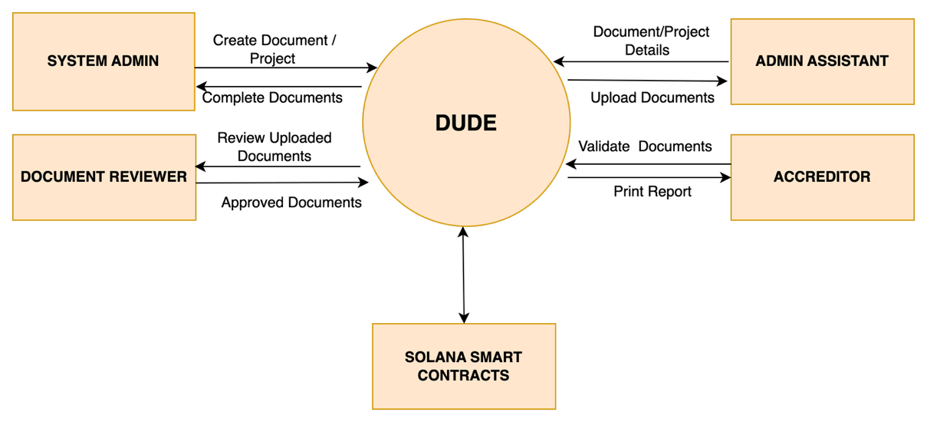
Figure 21. Context Diagram of the System
The system integrated with Solana Smart Contracts is shown at the bottom of the diagram. Solana is a high-performance blockchain, and its smart contracts enable the system to securely log, verify, and time-stamp all document-related actions. This ensures that the data is tamper-proof, traceable, and transparent, important features for audit trails and credibility in the accreditation process. Through this, all stakeholders, from administrators to accreditors, can interact within a secure, decentralized framework, reducing the risk of fraud, loss, or manipulation of academic documents.
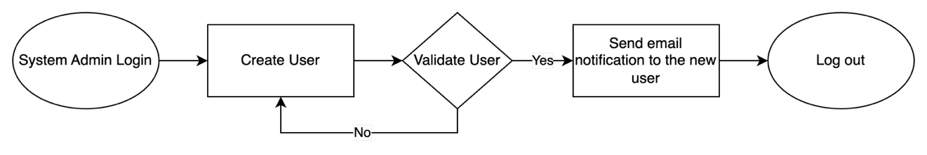
Figure 22. System Access Creation Process
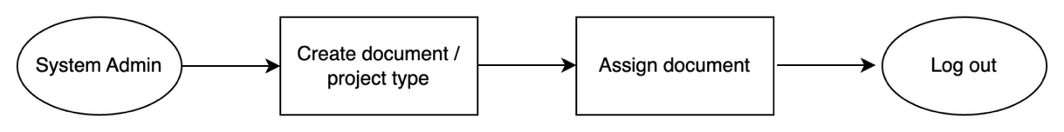
Figure 22 illustrates the System Access creation process within the system, managed by the System Admin. The process begins with the administrator logging into the system, followed by the creation of a new user account. Once the user is created, the system proceeds to validate the information provided. If the validation fails, the process returns to the user creation step to allow for corrections. If the validation is successful, an email notification is automatically sent to the new user. The process ends with the System Admin logs out, concluding the process. This streamlined approach ensures that users are promptly notified and able to access the system efficiently.
Figure 23. Create Document / Project type
Figure 23 illustrates a simple process flow diagram illustrating the key actions a System Admin can perform within the system. It starts with the System Admin, who first creates a document or selects a project type. After setting up the document, the next step is to assign the document to the appropriate users, such as Admin Assistant. Once the task is completed, the admin has the option to log out of the system. This diagram highlights the system admin’s role in initializing and organizing document tasks within the system.
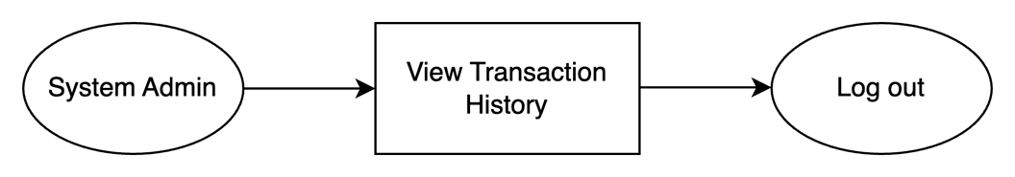
Figure 24. Transaction
Figure 24 illustrates the simple process a System Admin follows when using the system. The System Admin can review both transaction history and access logs, which track key activities such as document creation, updates, and user access within the system. These logs are securely recorded through system’s integration with Solana Smart Contracts, which leverages blockchain technology to ensure all actions are time-stamped, tamper-proof, and permanently stored. This not only reinforces transparency and data integrity but also builds trust in the system’s operations. After completing their review, the System admin logs out, marking the end of a secure and efficient session.
The swimlane diagram of Accreditation flow shows in Figure 25, four key roles collaboratively manage the document review and accreditation process, each with distinct responsibilities that ensure a smooth and accountable workflow.
The System Admin initiates the process by creating user accounts, creating documents and assign the project type, and delegating tasks to the appropriate personnel. Once tasks are assigned, the Admin Assistant takes over by reviewing the assigned task and uploading the required documents into the system. This role acts as the main support in preparing and organizing the necessary content for review.
Next, the Document Reviewer carefully examines the uploaded documents. If the documents are found lacking or incomplete, the reviewer provides feedback and updates the progress status accordingly, sending the documents back for rework. Once the documents meet the required standards, the reviewer approves it and updates the progress to 100%, which indicates completion. The System Admin checks the completed documents and then assigned to the appropriate Accreditor.
Finally, the Accreditor steps in to validate the approved documents. This role involves inputting scores and offering final feedback. The accreditor ensures that all standards for accreditation are met, effectively completing the quality assurance phase of the process. Together, these roles create a structured and efficient flow of tasks that promotes thoroughness and accountability in accreditation.
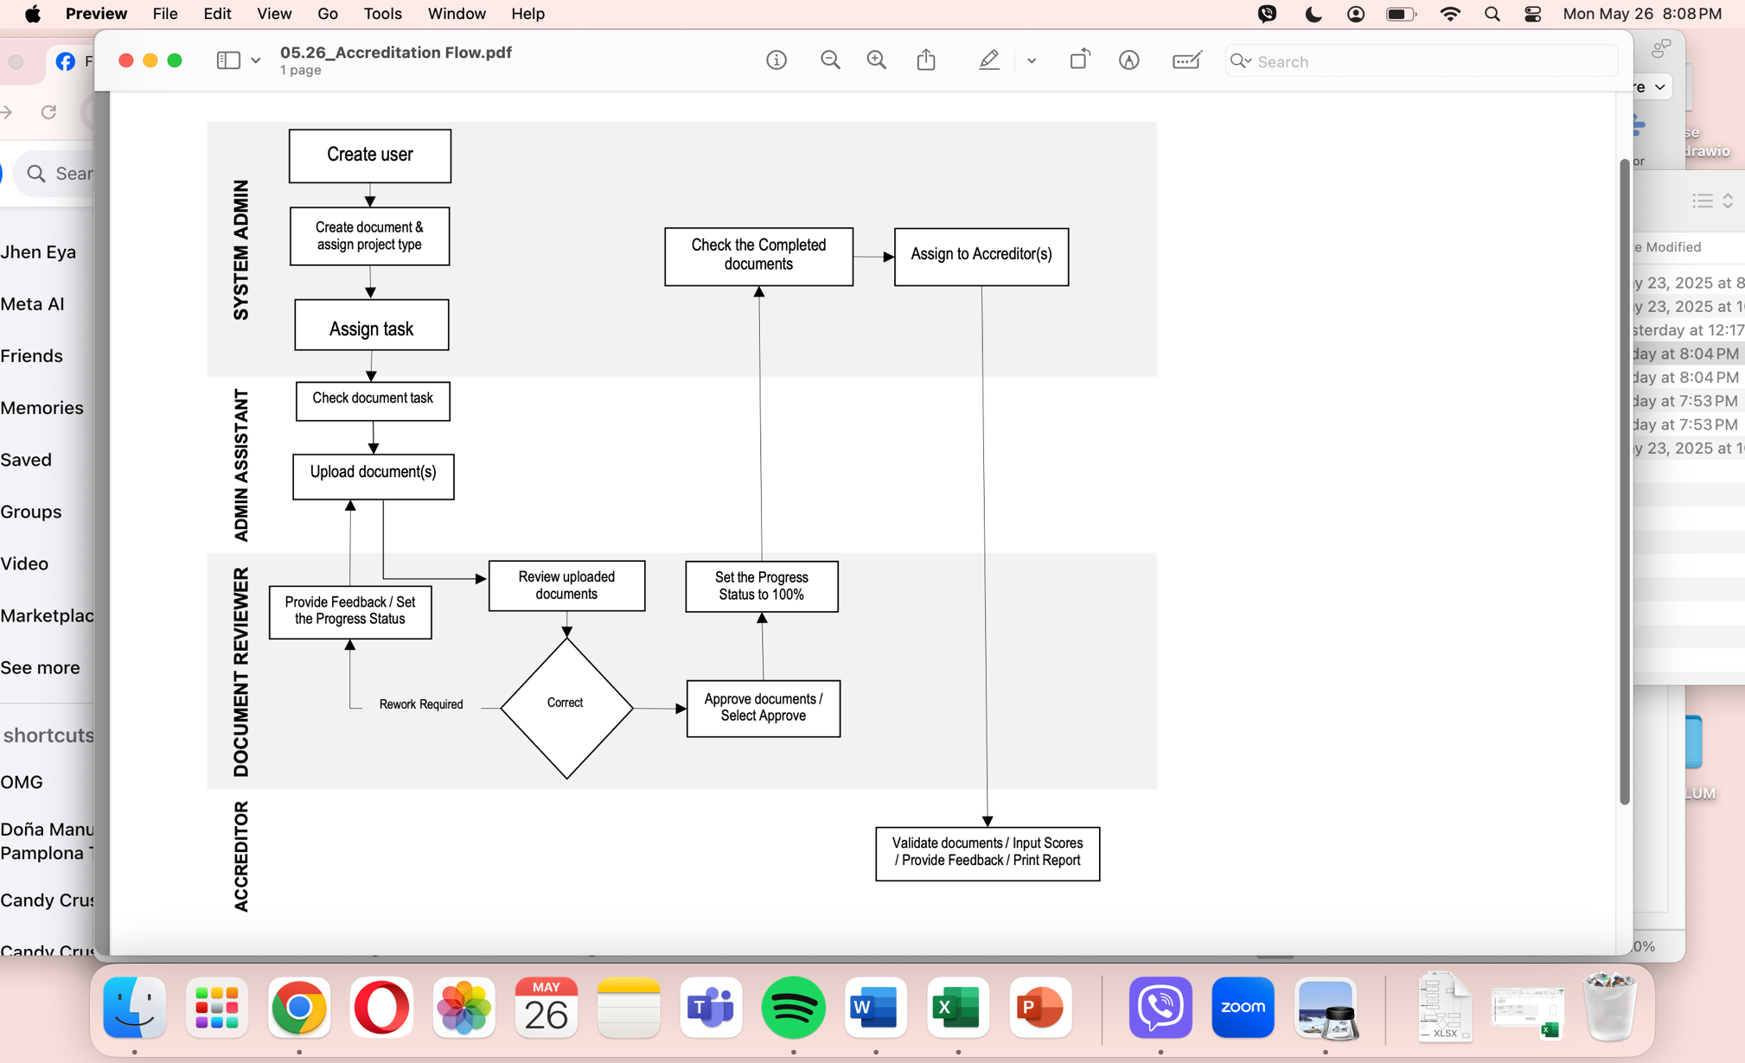
Figure 25. Swimlane Diagram of Accreditation Flow
Functional Requirements
Table 5 details the system's functional requirements, which encompass user management, the accreditation process, verification and authentication, document management, messaging and notifications, reporting and analytics, integration with external systems, security and compliance, usability and accessibility, scalability and performance, maintenance and support, and documentation and training. Each requirement is essential for ensuring the system's comprehensive functionality, effectively addressing user needs, and maintaining efficient operations.
Table 5. Functional Requirements
Functional Requirement | Description
1. User Management
Registration | Users should be able to register on the platform by providing necessary information such as name, email, and password.
Authentication | Registered users should be able to log in securely using their credentials.
Profile Management | Users should have the ability to manage their profiles, including updating personal information and credentials.
Role-based Access Control | Different user roles (e.g., administrators, accrediting bodies, applicants) should have access to specific functionalities based on their permissions.
2. Accreditation Process
Application Submission | Applicants should be able to submit accreditation applications through the platform, providing required documentation and information.
Review and Approval | Accrediting bodies should be able to review accreditation applications, verify submitted documentation, and approve or reject applications accordingly.
Issuance of Accreditation Certificates | Upon approval, the system should generate and issue digital accreditation certificates to successful applicants, securely stored on the Solana blockchain.
Renewal and Maintenance | The system should support processes for accreditation renewal and maintenance, including updating accreditation statuses and expiration dates.
3. Verification and Authentication
Credential Verification | Third parties should be able to verify the authenticity of accreditation certificates issued through the platform by accessing the Solana blockchain.
Immutable Record Keeping | All accreditation-related transactions and data should be recorded immutably on the blockchain to ensure transparency and integrity.
4. Document Management
Document Upload and Storage | Users should be able to upload and store relevant documents and files (e.g., accreditation applications, supporting evidence) securely on the platform.
Version Control | The system should support version control for documents, allowing users to track changes and updates over time.
Document Sharing | Users should have the ability to share documents securely with other authorized parties as part of the accreditation process.
5. Messages and Notifications
Notification System | The system should have a notification mechanism to inform users about important updates, such as application status changes or document requests.
Messaging | Users should be able to communicate securely within the platform, facilitating collaboration and clarification during the accreditation process.
6. Reporting and Analytics
Data Analytics | The system should provide analytics and insights into accreditation processes, such as application timelines, approval rates, and bottlenecks.
Reporting | Users should have access to customizable reports summarizing accreditation activities and outcomes for internal and external stakeholders.
7. Integration with External Systems
Integration APIs | The system should provide APIs for seamless integration with external systems, such as educational institutions' databases or government registries.
Data Synchronization | Data exchanged between the platform and external systems should be synchronized securely and efficiently to ensure consistency and accuracy.
8. Security and Compliance
Data Encryption | All sensitive data stored and transmitted by the system should be encrypted to prevent unauthorized access.
Compliance with Regulations | The system should comply with relevant data protection regulations and industry standards to ensure user privacy and security.
Access Control | Access to sensitive functionalities and data within the system should be restricted based on user roles and permissions.
9. Usability and Accessibility
Intuitive User Interface | The platform should have a user-friendly interface that is easy to navigate and use, catering to users with varying levels of technical expertise.
Accessibility Features | The system should be accessible to users with disabilities, adhering to accessibility standards and guidelines.
10. Scalability and Performance
Scalable Architecture | The system should be designed to accommodate increasing numbers of users, transactions, and data volumes without compromising performance.
High Availability | The platform should be highly available and resilient to ensure uninterrupted service for users.
11. Maintenance and Support
Software Updates | The system should receive regular updates and maintenance to address bugs, security vulnerabilities, and feature enhancements.
Technical Support | Users should have access to technical support resources and assistance to resolve issues and queries in a timely manner.
12. Documentation and Training
User Documentation | Comprehensive documentation should be provided to guide users through the functionalities and usage of the platform.
Training Materials | Training materials and resources should be available to help users familiarize themselves with the platform and its features.

System Persona
Table 6 introduces the system personas, also known as user or customer personas, which are fictional characters representing the various types of users or stakeholders interacting with the system, product, or service. These personas are developed through comprehensive research and analysis of the target audience, aiming to understand their needs, behaviors, motivations, and goals. By defining these personas, designers and developers can create user-centered solutions that effectively address the diverse requirements of the user base.
Key functionalities associated with these personas include accreditation issuance, verification, and user management. The accreditation issuance feature enables authorized entities to issue digital accreditations, with the Document Admin user setting up processes to trigger the accreditation flow and assign tasks to relevant users. The verification function facilitates third-party checks of blockchain entries via Solana Transactions, ensuring data integrity. User management allows the System Admin to oversee different user types (e.g., administrators, issuers, verifiers) and their permissions, with defined users receiving notification emails about their roles and access levels.

Table 6. System Persona
User Types / Persona | Description
System Admin | Has access to creating a document, select a project type, and assign users. Provide access to the accreditors.
Document Reviewer | Review documents and provide feedback. Updates status of each task on a Document Project then Approved the documents
Admin Assistant | Has access to Document Management and can upload the required documents.
Accreditors | Has access to review the final document uploaded on the system. Can provide feedback and input scores through the provided standard template

Non-Functional Requirements (Evaluation)
- Scalability – The system is running on the Microsoft Azure cloud which support scalability. It can handle increasing numbers of users, data, or transactions without slowing the system performance. This will ensure that it can manage the increased load smoothly.
- Performance – The system quickly and efficiently operates and can process requests and transactions rapidly, without unnecessary delays.
- Reliability – The system being a reliable application is always available anytime the user needs it. Data and other required documents during the accreditation is store within the system.
- Usability - The system is easy to use by all stakeholders. The application was designed based on user perspective in mind, this gives the opportunity for the users to navigate and operate the system without extensive training or confusion.
User Stories
Table 7 presents user stories, which are concise, informal descriptions of a product or function written from the perspective of the end user. These user stories are commonly used in agile software development methodologies, such as Scrum, to capture requirements and prioritize tasks. They serve as a crucial tool for understanding user needs and guiding the development process to ensure that the final product meets the intended goals and expectations of its users.
Table 7. User Stories
ID | As a <type of user> | I want to  <perform some task> | so that I can <achieve some goal>
1 | System Admin | Create User | Provide access to the system
2 | System Admin | Create Document Tasks | Assign user to the document task
3 | System Admin | Check and review the completed documents | Assign to the Accreditors
4 | System Admin | View Report | See the Results and Accreditors feedback
5 | Document Reviewer | Check the document information | Review the uploaded documents
6 | Document Reviewer | Review the document | Provide comments or status
7 | Document Reviewer | Approve documents | Approve documents if meet the requirements
8 | Admin Assistant | Access task assign | Check the document information
9 | Admin Assistant | Upload documents | Upload the required documents/ evidence
10 | Admin Assistant | Provide initial feedback | Give status on the document task
11 | Accreditors | Evaluate an assign Project | Provide score based on the template
12 | Accreditors | Validate the documents | Provide comments / Print Report

Database Schema
The data schema of the system, encompassing entities (or tables), attributes (or fields), data types, and lengths represents the logical and physical layout of a database (see Appendix B). It defines how data is organized, stored, and accessed within the database system.
Cloud Architecture
The researcher aims to transform the accreditation process by utilizing cloud technologies and blockchain. The system is designed to function within the cloud environment, which ensures scalability, accessibility, and reliability. Through the use of the cloud, the system is capable to efficiently handle a large volume of data and users without slowing the system performance.
The integration of the smart contracts in the system are hosted on a blockchain, providing a secure, transparent, and tamper-proof mechanism for managing accreditation procedures.
The cloud structure supports in providing robust infrastructure for data storage, processing, and management, ensuring that all stakeholders which includes accreditation bodies, educational institutions, and regulatory agencies can interact with the system in real time.
Web Application User Interface
A Web Application User Interface (UI) is the visual component of a web application that users interact with. Below are the key features of the system, along with brief descriptions of their usage:


Figure 26. Login Screen of the System
Figure 26 illustrates that users can log in using their existing email accounts, with validation handled by Google Authentication. The System Admin has the capability to add new users by entering their email addresses, after which an email notification is sent to the newly added users. This process ensures a secure and streamlined user authentication and onboarding experience.
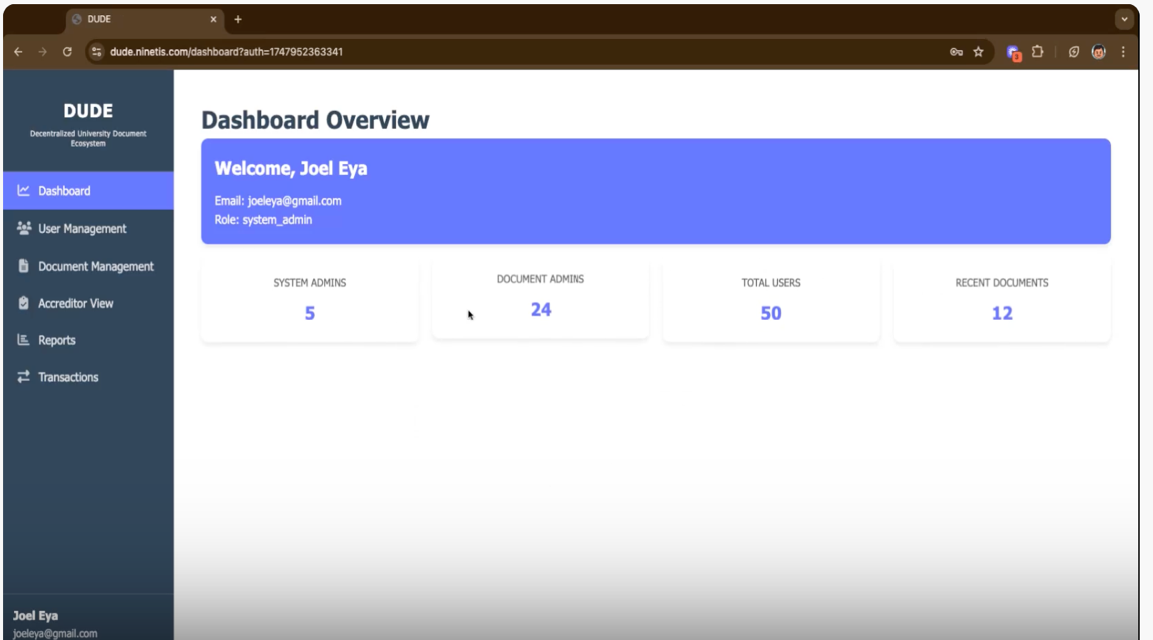
Figure 27. System Admin Landing page
Figure 27 displays the landing page for the System Admin user. Immediately, the dashboard interface of the DUDE system, which stands for Decentralized University Document Ecosystem was seen. This web-based platform is used to manage users and academic documents within a university setting. At the top of the dashboard, a welcome message greets the logged-in user, showing his email address and identifying him as a system administrator, which implies that he has full access to the system's features and controls.
On the left side, a navigation menu provides access to different sections of the system, including Dashboard, User Management, Document Management, Accreditor View, Reports, and Transactions. The main content area of the dashboard presents a quick overview of key system metrics. It shows that there are currently 5 system administrators, 24 document administrators, a total of 50 users, and 12 recently added documents. This summary allows administrators to quickly assess the state of user engagement and document activity within the platform.
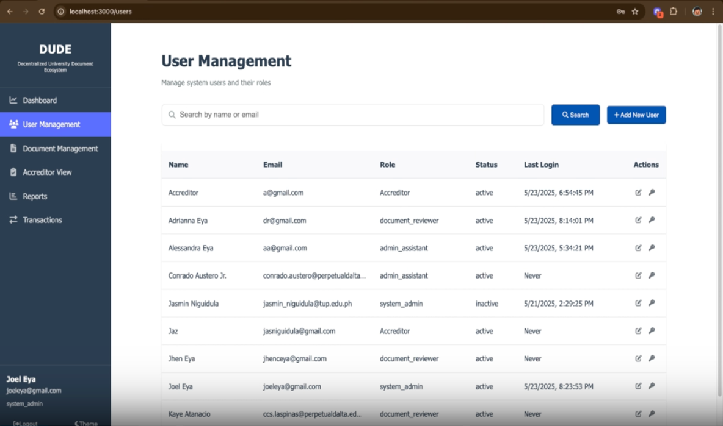
Figure 28. User Management
Figure 28 displays the User Management page of the system, which is used by administrators to manage all system users. On the left side, there is a navigation panel highlighting the active "User Management" section, indicating that the admin is currently working within the user access area. At the top of the main panel, a search bar allows for quick lookup of users by name or email, and a "+ Add New User" button provides a straightforward way to register new users into the system and its specific role (Document Reviewer, Admin Assistant, and Accreditor). Below this, a table presents key details of existing users including their name, email, role (such as Accreditor, Document Reviewer, Admin Assistant, or System Admin), account status (active or inactive), and their last login date and time. Action icons on each row allow the admin to either edit or remove users.
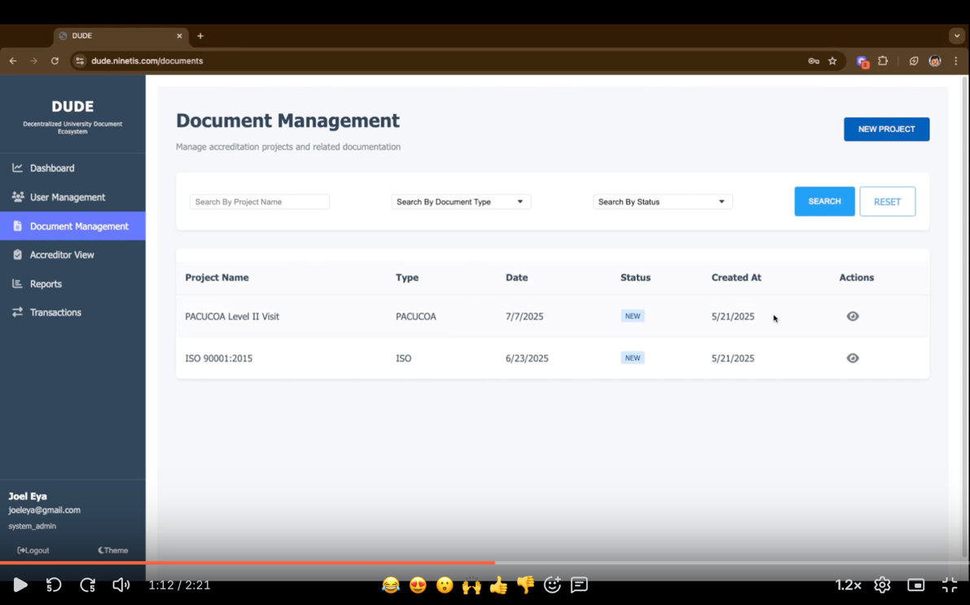
Figure 29. Document Management
Figure 29 shows the Document Management Module in action. At the top of the screen is a search bar that lets users quickly find documents by entering a project name, document type, or status. Below that is a table listing all the documents or projects that have been created. Each entry in the list includes details like the project name, its type, the date it was added, its current progress in percentage, when it was created, and available actions the user can take, such as viewing or editing the document. This layout helps users easily locate and manage their documents.
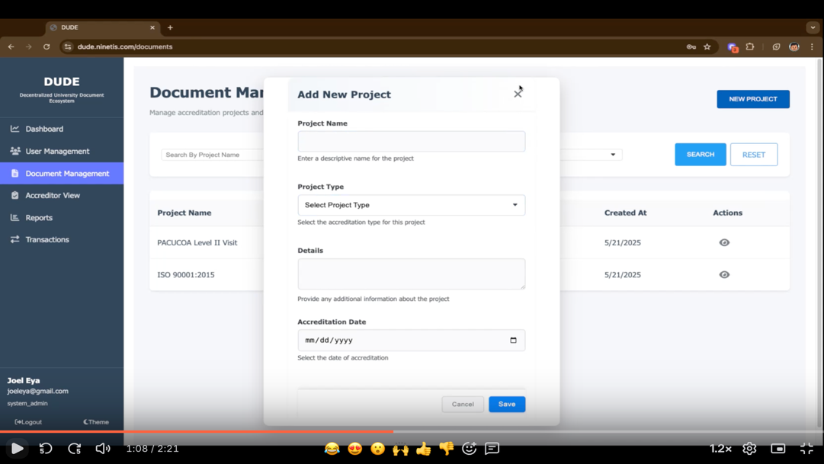

Figure 30. Document Management – Creation of Project
Figure 30 shows how to create a new document within the Document Management module. In the upper right corner of the screen, the System Admin can click the “New Project” button to start the process. From there, the admin can enter the name of the document and choose a project type, examples include PACUCOA, AACUP, and ISO. Additional information about the document can also be filled in, along with the scheduled date for the accreditation visit. This feature makes it easy to organize and track accreditation-related documents.
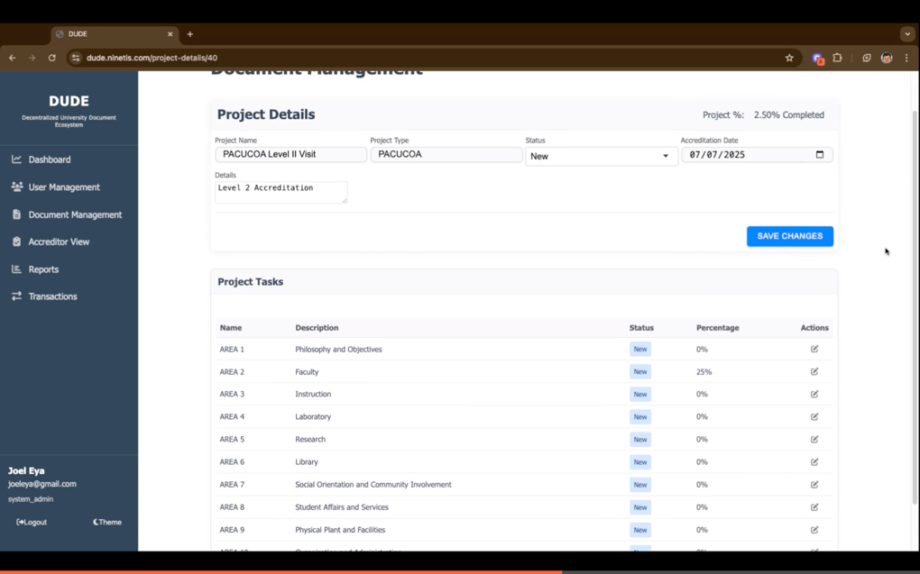

Figure 31 Document Management – Project Details
Figure 31 presents the detailed view of a project within the Document Management module. This view is accessed when the System Admin clicks the "eye" icon under the Actions column for a specific project. It displays all the information related to the selected document or project that was created earlier, as shown in Figure 30. In this section, each area of the project is listed along with its category name, description, current status, completion percentage, and available actions.
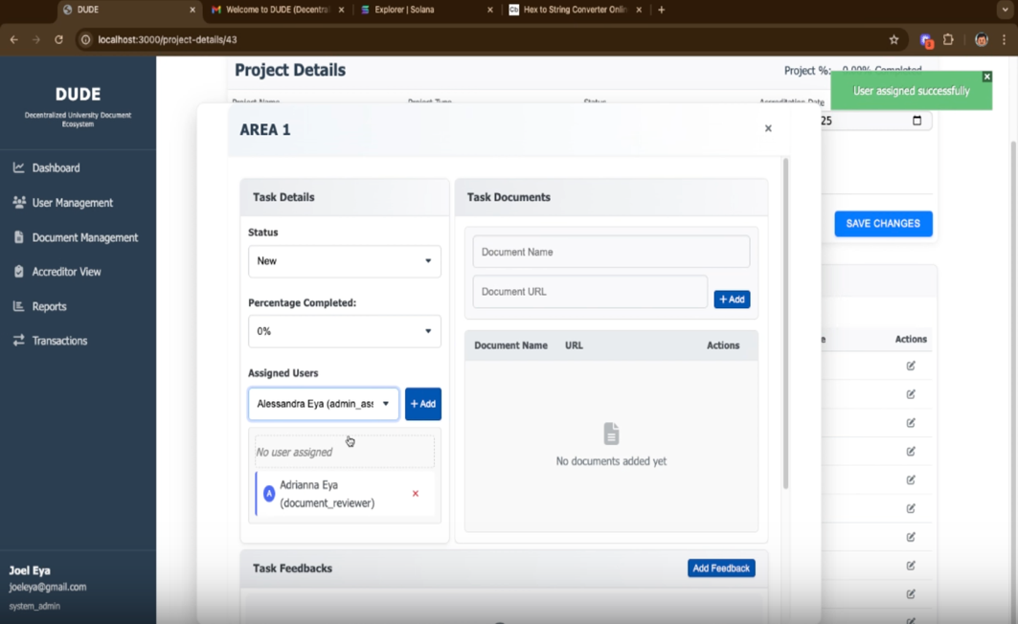
When the System Admin clicks the “eye” icon in the Actions column for a category such as “Area 1,” a detailed view of that category appears as shown in figure 32. From there, the admin can select Status such as New, ongoing, and others, set the percentage completed, and assign that category to specific users, like an Admin Assistant. This assignment feature allows the same category or task to be assigned to multiple roles or users, making it easier to delegate responsibilities and collaborate efficiently within the system. A feedback button can be select to provide comments or specific instruction to the tasks.
Figure 32. Project Task
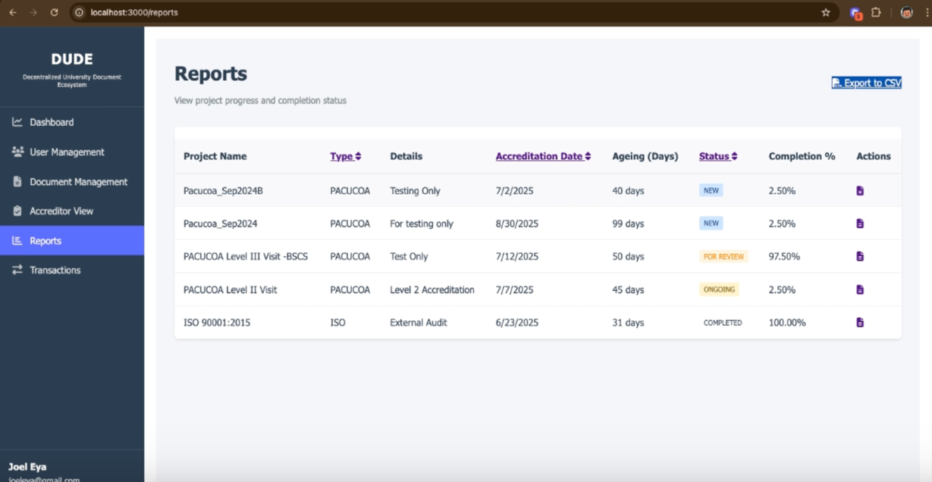
The System Admin is needs to enter the name of the document such as "Faculty Line-up", to clearly indicate what the assigned user needs to prepare or upload. Along with the document name, the admin also provides a URL link to the supporting evidence, typically saved as a PDF file. This setup serves as a helpful reference for the assigned user, giving them a clear idea of what kind of document is expected, making the process of uploading and organizing files more efficient and guided.
Figure 33. Reports

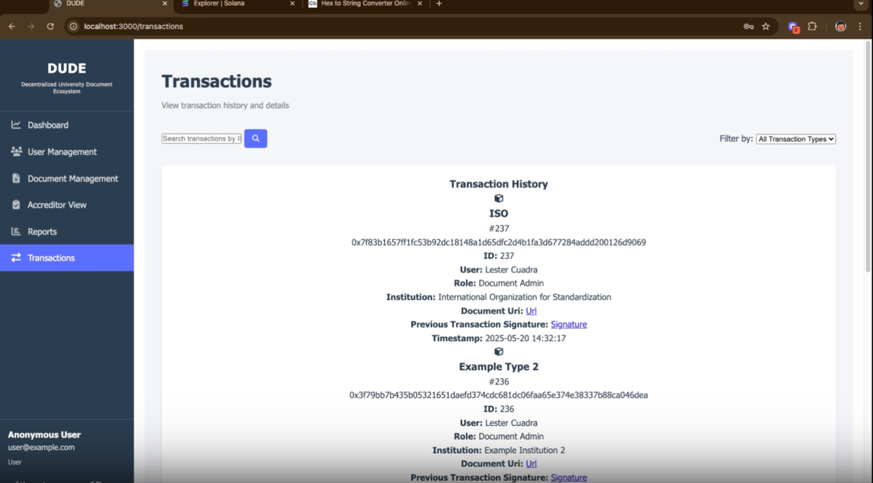
Figure 33 displays the Reports page of the system, which is designed to help users monitor the progress and completion status of various accreditation and audit projects. At the upper right corner top, there is a “Export to CSV” button available, allowing users to download the data for external use or documentation. Below is a table listing different projects with details such as the project name, type (e.g., PACUCOA or ISO), specific notes or descriptions, and the scheduled accreditation date. The table also includes the number of days that have passed since each project began (referred to as "Ageing"), the current status of each project (with tags like NEW, FOR REVIEW, ONGOING, or COMPLETED), and the percentage of completion. Each row ends with an action icon, represented by a lock, which likely provides secure access to more detailed project information. Overall, this section offers a comprehensive yet easy-to-understand summary of ongoing and completed accreditation efforts, allowing system administrators to effectively track institutional compliance and documentation readiness.
Figure 34. Transactions

The Transactions page which serves as a detailed log of all document-related activities within the system is shown in figure 34. At the top, users are provided with a search bar to easily look up specific transactions by keyword, such as document titles or usernames. Additionally, there is a dropdown filter that allows users to sort the transaction records by type.
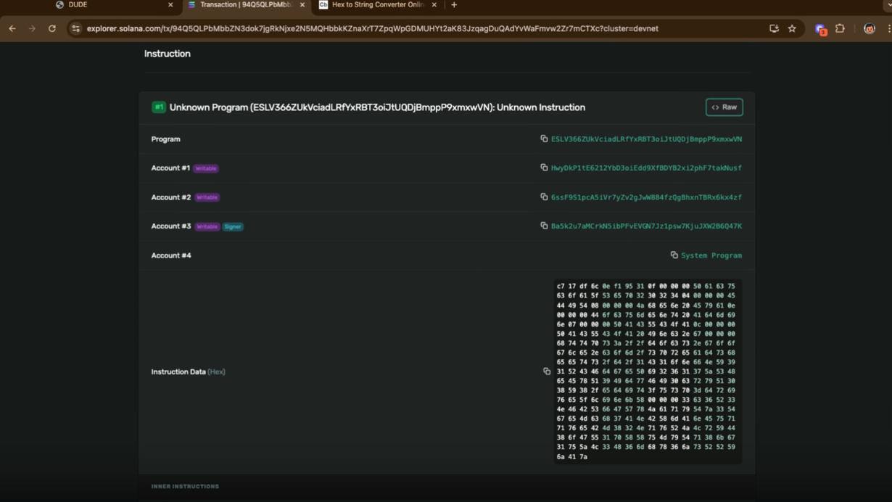
The main section of the page lists individual transaction entries, each containing important details. These include the transaction type and ID (e.g., "ISO #237"), a unique blockchain hash that securely identifies the document, the name and role of the user involved (such as Document Admin), and the institution linked to the transaction. Each entry also features a clickable Document URI that leads to the actual file, a link to the previous transaction’s signature to verify document history, and a precise timestamp indicating when the action took place. This layout reflects the system’s integration of blockchain principles to maintain transparency, traceability, and security, ensuring that all document transactions are accountable and tamper-proof, key features in managing academic accreditation and compliance.

Figure 35. Solana Checking

This figure displays the detailed breakdown of a Solana transaction instruction involving an unknown program which is not part of the system. It shows multiple accounts, each labeled based on their role, such as writable or signer, and includes a reference to the system program. At the bottom, the instruction data is presented in hexadecimal format, which contains the encoded action of the transaction. This screen is accessed by copying a transaction ID and pasting it into the Solana Explorer. It is a valuable tool for developers to inspect and verify on-chain activities during testing on the Devnet

Backend Hashing Process
The backend system of the accreditation process every transactions acts as a signing and submission engine for Solana transactions without relying on user wallets shows in figure 36. The system uses the Solana Web3.js library to programmatically construct, sign, and submit transactions to a smart contract (Solana program). The key steps include:
- Transaction Composition: The backend builds a transaction object containing instructions, such as invoking the create_transaction_log method on the deployed Solana program, along with specifying the involved accounts.
- Fetching Recent Blockhash: The backend requests a recent blockhash from the Solana cluster to prevent replay attacks and ensure transaction freshness.
- Signing: Instead of prompting a wallet, the backend holds a private key (authority keypair) and signs the transaction internally. This is critical because the transaction signature forms the cryptographic foundation for verification.
- Serialization: The signed transaction is serialized into a binary format, ready for transmission.
- Submission and Hashing: Upon submission, the Solana network computes the transaction signature (hash), which uniquely identifies the transaction and ties it to the signed content and blockhash.
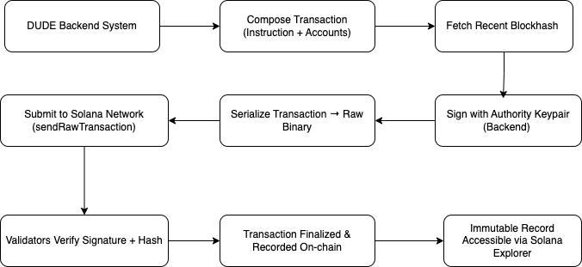
- Validation and Finalization: Validators check the hash and signature, confirm the transaction’s validity, and finalize it by including it in a block, making it immutable and accessible through explorers like Solana Explorer or Solscan.
Figure 36. Hashing Process of the Application Backend
Actual Code use in creating the hash keys once a Transaction is triggered by Accreditation Process:

const {
Connection,
Keypair,
Transaction,
SystemProgram,
sendAndConfirmTransaction,
clusterApiUrl
} = require('@solana/web3.js');

async function sendDudeTransaction() {
// Connect to Devnet
const connection = new Connection(clusterApiUrl('devnet'), 'confirmed');

// Backend-held authority keypair (this replaces wallet signing)
const authority = Keypair.generate(); // or load from secret

// Get a recent blockhash (needed for freshness)
const { blockhash } = await connection.getLatestBlockhash();

// Build transaction
const transaction = new Transaction({
recentBlockhash: blockhash,
feePayer: authority.publicKey
});

// Add your DUDE-specific instruction here (example: simple transfer)
transaction.add(
SystemProgram.transfer({
fromPubkey: authority.publicKey,
toPubkey: authority.publicKey, // dummy self-transfer just for demo
lamports: 1000
})
);

// Sign the transaction (DUDE backend does this, no wallet needed)
transaction.sign(authority);
// Serialize & get raw signature (hash)
const rawTransaction = transaction.serialize();
const signature = await connection.sendRawTransaction(rawTransaction);

console.log('Transaction signature (hash):', signature);

// Wait for confirmation
await connection.confirmTransaction(signature);
console.log('Transaction confirmed on-chain!');
}
sendDudeTransaction().catch(console.error);
Consensus Mechanism
Solana uses a hybrid consensus model combining:
- Proof of Stake (PoS): Validators are selected based on the amount of SOL they stake, incentivizing honest participation.
- Tower BFT (Byzantine Fault Tolerance): A lightweight, asynchronous consensus mechanism optimized for speed, where validators vote on blocks and lock in decisions to prevent rollback.
The DUDE backend system does not itself participate in consensus, instead, it interacts with the consensus network by:
- Preparing valid transactions.
- Signing them properly using the authority keypair.
- Submitting them to the Solana validator network.
Once submitted, DUDE’s transactions go through the following Solana consensus flow:
- A designated leader validator collects the transaction.
- Validators vote to confirm the block containing the transaction.
- Once ≥2/3 of the total stake agrees, the block is finalized and locked into the ledger.
- DUDE (or anyone) can query the blockchain to confirm the transaction’s success and permanence.

Technical Details of Solana Consensus
- Leader Rotation. In each slot (~400ms), a validator acts as the leader, bundling transactions into a block.
- Validator Voting. Validators vote on the leader’s proposed block. Using Tower BFT, they lock in votes over time, making rollbacks progressively harder.
- Finality. When ≥2/3 of validators lock in votes, the block is finalized. DUDE’s submitted transactions inside that block become immutable.
- Fork Protection. Tower BFT penalizes validators who vote on conflicting forks, ensuring the network converges on a single canonical chain.
B. Testing
Table 9 presents the actual System Test Results of users of the system. Table 9 provides a comprehensive overview of the actual System Test Results, reflecting the experiences and feedback from users who have interacted with the system. This table includes detailed metrics and evaluations on various aspects of the system's performance, usability, security, and functionality. It captures key performance indicators (KPIs) such as response times, error rates, and user satisfaction levels, offering insights into how well the system meets its intended objectives and user needs. Additionally, it documents any issues encountered during testing, along with the steps taken to address them, ensuring a thorough understanding of the system's strengths and areas for improvement. This detailed analysis helps inform further development and optimization efforts, ensuring the system continues to evolve in alignment with user expectations and requirements.
In the Dashboard Module, several medium-priority tasks were successfully tested. These include viewing the user overview (number of System Admins, Document Reviewers, Admin Assistants, and Accreditors) and access logs, both tested by the System Admin. Viewing blockchain utilization was successfully tested by all roles, demonstrating robust accessibility and functionality. The total document project’s view, which included tasks for testing and UI design improvements, was also tested successfully by the System Admin. The Document Reviewer successfully tested the view of total pending for review, which included tasks for testing and UI design improvements. The total assigned number of document types and their usage were successfully tested by the System Admin, Document Reviewer, and Admin Assistant. The view of total pending updates was also successfully reviewed.
In the User Module, low-priority tasks such as searching, filtering, and resetting search and filter were successfully managed by System Admin. High-priority tasks, including adding and editing users with validation error handling, were also successfully tested by System Admin.
The Access Logs Module's high-priority task of viewing access logs was successfully tested by the System Admin. In the Settings Module, the high-priority task of updating system configurations was successfully tested by the System Admin.
The Transaction History Module's high-priority task of viewing transaction history was successfully tested by all roles, pending confirmation of visibility for all users.
In the Document Type Module, low-priority tasks such as searching, filtering, and resetting the search filter were successfully tested by the System Admin. High-priority tasks, including viewing, creating, and editing document types with validation error handling, were also successfully tested by the System Admin.
In the Document Project Module, medium-priority tasks such as searching, filtering, and resetting search and filter were successfully tested by the System Admin, Document Reviewer, Admin Assistant, and Accreditor. High-priority tasks, including viewing, creating, and editing document projects, were successfully tested by the System Admin, Document Reviewer, and Admin Assistant. Adding new tasks, which included error handling for invalid URLs and improved task sorting, updating tasks, deleting tasks (with page refresh to reflect changes), and adding feedback were all successfully tested by the System Admin, Document Reviewer, Admin Assistant, and Accreditor.
In the Messaging Module, medium-priority tasks such as viewing conversations and sending messages, which require frontend integration, were successfully tested by the System Admin, Document Reviewer, and Admin Assistant.
Other features, including high-priority tasks like login and logout, were successfully tested by all roles. Viewing the icon and school name, which included an issue with fetching after page refresh, was also successfully tested by all roles.
The system test results indicate successful validation across most features, ensuring functionality and accessibility for various roles. Key areas such as user management, document handling, and blockchain utilization have been rigorously tested, with only minor issues noted. Continuous improvements in UI design and error handling, along with frontend integration for messaging, will further enhance the system. The system is well-prepared for deployment, providing a reliable platform for managing accreditation processes and user interactions.
Table 9. System Test Results
 | Module | Task | Priority | Comments | System Admin |  | Document Admin |  | Document Reviewer |  | Document User |  | Accreditor
 |  |  |  |  | Required | Remarks | Required | Remarks | Required | Remarks | Required | Remarks | Required | Remarks
 | Dashboard Module | View User Overview (No of: System Admins, Reviewers, Document Admins, Accreditors, Users) | Medium | Tasks:  - For Testing | ✔ | Pass
 | Dashboard Module | View Access Logs | Medium |  | ✔ | Pass
 | Dashboard Module | View Blockchain Utilization | Medium |  | ✔ | Pass | ✔ | Pass | ✔ | Pass | ✔ | Pass | ✔ | Pass
 | Dashboard Module | View Total Document Projects | Medium | Tasks:  - For Testing  - Improve UI design | ✔ | Pass
 | Dashboard Module | View of Total Number of Document Type (ISO, Pacucoa and QStar etc) | Medium | Tasks:  - For Testing  - Improve UI design |  |  | ✔ | Pass
 | Dashboard Module | View of Total Number of Document Type Usage  Sample ISO - 2 Document Project  E.g. ISO_August_2023 - 5 User, Status Completed  ISO_January_2024 - 8 User, Status: Ongong | Medium | Tasks:  - For Testing  - Improve UI design |  |  | ✔ | Pass
 | Dashboard Module | View of Total Pendings for Review | Medium | Tasks:  - For Testing  - Improve UI design |  |  |  |  | ✔ | Pass |  |  |  | Pass
 | Dashboard Module | View of Total Assigned Number of Document Type (ISO, Pacucoa and QStar etc) | Medium | Tasks:  - For Testing  - Improve UI design |  |  |  |  | ✔ | Pass |  | Pass |  | Pass
 | Dashboard Module | View of Total Assigned Number of Document Type Usage  Sample ISO - 2 Document Project  E.g. ISO_August_2023 - 5 User, Status Completed  ISO_January_2024 - 8 User, Status: Ongong | Medium | Tasks:  - For Testing  - Improve UI design |  |  |  |  | ✔ | Pass |  | Pass |  | Pass
 | Dashboard Module | View Total Pending for Updates | Medium | Tasks:  - For Testing  - Improve UI design |  |  |  |  |  |  |  | Pass
 | User Module | Search Users | Low | Document Admin must be able to manage users | ✔ | Pass | ✔ | Pass
 | User Module | Filter Users | Low |  | ✔ | Pass | ✔ | Pass
 | User Module | Reset Search And Filter | Low |  | ✔ | Pass | ✔ | Pass
 | User Module | Add New User | High | Disable the button when there is a validation error | ✔ | Pass | ✔ | Pass
 | User Module | Edit User | High | Disable the button when there is a validation error | ✔ | Pass | ✔ | Pass
 | Access Logs Module | View Access Logs | High |  | ✔ | Pass
 | Settings Module | Update System Configs | High |  | ✔ | Pass
 | Transaction History Module | View Transaction History | High | Waiting for broel if this is visible to all users | ✔ | Pass | ✔ | Pass | ✔ | Pass | ✔ | Pass | ✔ | Pass
 | Document Type Module | Search Document Type | Low |  |  |  | ✔ | Pass
 | Document Type Module | Filter Document Types | Low |  |  |  | ✔ | Pass
 | Document Type Module | Reset Search Filter | Low |  |  |  | ✔ | Pass
 | Document Type Module | View Document Type | High |  |  |  | ✔ | Pass
 | Document Type Module | Create Document Type | High | Disable the button when there is a validation error |  |  | ✔ | Pass
 | Document Type Module | Edit Document Type | High | Disable the button when there is a validation error |  |  | ✔ | Pass
 | Document Project Module | Search Document Project | Medium |  |  |  | ✔ | Pass | ✔ | Pass | ✔ | Pass | ✔ | Pass
 | Document Project Module | Filter Document Project | Medium |  |  |  | ✔ | Pass | ✔ | Pass | ✔ | Pass | ✔ | Pass
 | Document Project Module | Reset Search And Filter | Medium |  |  |  | ✔ | Pass | ✔ | Pass | ✔ | Pass | ✔ | Pass
 | Document Project Module | View Document Project | High |  |  |  | ✔ | Pass | ✔ | Pass | ✔ | Pass | ✔ | Pass
 | Document Project Module | Create Document Project | High |  |  |  | ✔ | Pass
 | Document Project Module | Edit Document Project | High |  |  |  | ✔ | Pass | ✔ | Pass |  |  | ✔ | Pass
 | Document Project Module | Add New Task | High | Bad Request Error - When the URL entered is invalid  Disable the button when there is a validation error  New Task Created is better if sorted from newest to oldest |  |  | ✔ | Pass | ✔ | Pass | ✔ | Pass | ✔ | Pass
 | Document Project Module | Update Task | High |  |  |  | ✔ | Pass | ✔ | Pass | ✔ | Pass | ✔ | Pass
 | Document Project Module | Delete Task | High | Need to Refresh the page to reflect changes |  |  | ✔ | Pass | ✔ | Pass | ✔ | Pass | ✔ | Pass
 | Document Project Module | Add Feed Back | High |  |  |  | ✔ | Pass | ✔ | Pass | ✔ | Pass | ✔ | Pass
 | Messaging Module | View Conversations | Medium | Tasks: - Frontend integration. Backend is already done |  |  |  |  | ✔ | Pass | ✔ | Pass | ✔ | Pass
 | Messaging Module | Send a Message | Medium | Tasks: - Frontend integration. Backend is already done |  |  |  |  | ✔ | Pass | ✔ | Pass | ✔ | Pass
 | Other Features | Login | High |  | ✔ | Pass | ✔ | Pass | ✔ | Pass | ✔ | Pass | ✔ | Pass
 | Other Features | Logout | High |  | ✔ | Pass | ✔ | Pass | ✔ | Pass | ✔ | Pass | ✔ | Pass
 | Other Features | View Icon and School Name | High | When you refresh the page and you are not in the Dashboard or Settings page, the icon and name is not being fetched. You need to navigate to the dashboard/settings for the icon and name to load. | ✔ | Pass | ✔ | Pass | ✔ | Pass | ✔ | Pass | ✔ | Pass

Table 9 further outlines the tasks and priorities associated with various system modules, detailing roles, responsibilities, and comments for implementation and testing. Each module lists specific tasks, priority levels (e.g., low, medium, high), and additional instructions or notes. Roles involved include System Admin, Document Reviewer, Admin Assistant, and Accreditor, with checkmarks indicating necessary roles for each task and relevant comments on their participation.
Dashboard Module: Medium-priority items include viewing user overviews, access logs, blockchain usage, total document projects, document types, and outstanding reviews. Emphasis is placed on testing and UI enhancements. While System Admins handle most tasks, Document Reviewers have specialized responsibilities. Document Reviewers and Admin Assistant focus on document types and usage statistics, with Accreditors assisting in review tasks.
User Module: Low-priority tasks include searching, filtering, and resetting filters for users. High-priority tasks involve adding and editing users due to the importance of accurately managing user data. Both System Admins and Document Reviewers play critical roles in these tasks.
Access Logs Module: Managed by the System Admin, this module's high-priority task involves viewing access logs.
Settings Module: High-priority tasks for updating system configurations are handled by the System Admin.
Transaction History Module: This module offers a high-priority task for accessing transaction history, accessible to all roles but requiring confirmation from the System Admin.
Document Type Module: Functions include searching, filtering, resetting filters, reading, creating, and editing document types, with tasks ranging from low to high priority. System Admins and Document Reviewers primarily control these duties.
Document Project Module: Prioritized tasks involve searching, filtering, resetting filters, viewing, creating, and editing projects, as well as adding, updating, and deleting tasks and providing feedback. These responsibilities require collaboration among System Admins, Document Reviewers, Admin Assistant, and Accreditors.
Messaging Module: Focuses on medium-priority tasks such as monitoring chats, sending messages, and integrating frontend and backend systems. Document Reviewers, Admin Assistant, and Accreditors share these responsibilities.
Other Features: High-priority tasks include login and logout, and viewing icons and school names. All roles are involved, ensuring the system's core features are accessible and operational for all users.
C. Deployment
Deployment planning includes the conduct of a thorough assessment of hardware, software, and network infrastructure requirements for system deployment. A deployment plan was developed to outline the tasks, timelines, and responsibilities for system setup and configuration. Coordination with the IT personnel and stakeholders to ensure the system deployment works properly.
System Configuration
System configuration involves several critical steps to ensure optimal performance and functionality, including setting up Solana Blockchain nodes, smart contracts, and application servers according to technical specifications and best practices to ensure robustness and reliability. Additionally, it requires configuring databases and data schemas to support accreditation processes while implementing access controls to maintain data integrity and security. Finally, comprehensive system integration tests must be conducted to verify interoperability and functionality across all components, ensuring a cohesive and efficient accreditation platform.
Solana Blockchain Configuration
Establishing a blockchain on the Solana platform involves a comprehensive process that leverages Solana's renowned high throughput and scalability, providing a robust framework for decentralized applications. This chapter outlines the intricate steps required for setting up a blockchain on Solana, including the development environment setup, smart contract creation and deployment, validator node configuration, network parameter tuning, testing, and launch procedures.
Following successful testing and debugging, the blockchain application is ready for deployment on the mainnet. The launch phase involves disseminating the blockchain network to the broader ecosystem. Continuous monitoring of network performance and stability post-deployment is crucial for addressing any emergent issues or challenges proactively.
Ongoing engagement with the Solana community is vital for fostering collaboration, garnering feedback, and promoting the blockchain project. Active participation in forums, developer communities, and social media platforms helps cultivate a vibrant ecosystem that encourages innovation and growth.
Establishing a blockchain on the Solana platform requires meticulous planning, rigorous development, and diligent testing. By adhering to the outlined procedures and best practices, stakeholders can harness the transformative potential of decentralized applications within the Solana ecosystem.
D. Evaluation
Alpha Test Results
The Alpha test phase marked a significant milestone in the project's development lifecycle, as detailed in Table 10. This phase was designed to evaluate the system's performance, usability, and functionality in a controlled environment. A small group of internal stakeholders and early adopters tested the system's core functions and workflows during this stage, facilitating early problem detection, requirement validation, and user experience enhancement.
The Alpha test results, as presented in Table 10, indicate that the system performed well across several key metrics.

Table 10. Alpha Test Results of the Web Application
Evaluation | Mean | Std. Dev.
A. Functionality | 4.20 | 0.48
B. Security | 4.30 | 0.40
C. Reliability | 4.10 | 0.46
D. Performance | 4.10 | 0.50
E. Compliance | 4.17 | 0.48
F. Documentation and Traceability | 4.20 | 0.48

Functionality obtained a high average score of 4.20 out of 5, suggesting that users found the system to work effectively with a high level of agreement among respondents. Security scored even higher, with an average of 4.30, reflecting a strong consensus that the system is highly secure. Reliability had an average score of 4.10, indicating that the system is dependable, although there was some variation in user opinions. Similarly, Performance scored 4.10, showing that the system performs well, albeit with more diverse perspectives. Compliance was rated at 4.17, demonstrating that the system effectively meets standards. Lastly, Documentation and Traceability also scored 4.20, indicating that users found the system's documentation to be excellent and consistent in quality.
Summary of Alpha Testers Results
1. Functionality Testing
The system's core functionality, including document management, progress monitoring, and compliance tracking, was tested comprehensively. Overall, the system performed as expected, with users able to perform tasks such as document uploading, tracking accreditation progress, and generating reports without encountering significant issues.
However, minor bugs were identified in the document upload feature, where some file formats were not supported consistently. Additionally, there were occasional delays in data synchronization between the frontend and backend components, leading to discrepancies in real-time updates.
2. Usability Testing
Usability testing focused on evaluating the system's user interface (UI), navigation flow, and overall user experience (UX). Feedback from alpha testers indicated that the UI design was intuitive and user-friendly, with clear navigation paths and informative tooltips provided throughout the application.
However, some testers reported issues with the responsiveness of certain UI elements, particularly on mobile devices, where screen rendering and touch interactions were less smooth compared to desktop browsers. This highlighted the need for further optimization and responsive design enhancements.
3. Performance Testing
Performance testing aimed to assess the system's responsiveness, load handling capabilities, and scalability under simulated user traffic and data loads. The system demonstrated satisfactory performance under normal usage conditions, with acceptable response times for most operations.
However, during peak load scenarios, such as simultaneous document uploads by multiple users, the system experienced occasional slowdowns and performance degradation. This was attributed to resource contention and insufficient server-side optimizations, indicating areas for improvement in backend processing and resource management.
4. Bug Reporting and Issue Resolution
Throughout the alpha testing phase, testers actively reported bugs, issues, and enhancement requests using the designated bug tracking system. Development teams promptly addressed reported issues, providing regular updates and patches to resolve identified issues and improve system stability.
A collaborative approach between testers and developers facilitated efficient bug triaging, prioritization, and resolution, ensuring that critical issues were addressed promptly to maintain testing momentum and minimize disruptions to the testing process.
Result Evaluation of Alpha Testers
Prior to the system's introduction, the alpha testing phase allowed for the early discovery and resolution of difficulties by offering insightful information about the digital accreditation system's performance, usability, and functionality. The system's capabilities were improved, usability was increased, and performance was optimized with the help of feedback from alpha testers, resulting in a more reliable and user-friendly certification solution. As the system moves into beta testing and final deployment, the findings of the alpha testing phase will guide additional revisions and enhancements.
Beta Testers Evaluation
The beta test was carried out at the university level once the issues and worries raised during the alpha test had been addressed. And how to use the web application were demonstrated. Teaching and non-teaching staff were the main attendees. The presenter explained the system and then asked the audience to take part in the beta test. In the end, forty (20) randomly selected individuals took part in the experiment. The beta test results are shown in table 11.
Table 11. Beta Test Results using FURPS of the Web Application
FURPS Evaluation | Mean | Std. Dev.
A. Functionality | 4.50 | 0.24
B. Security | 4.55 | 0.39
C. Reliability | 4.60 | 0.39
D. Performance | 4.53 | 0.23
E. Compliance | 4.60 | 0.31
F. Documentation and Traceability | 4.50 | 0.24

The table presents the results of a Beta testers FURPS evaluation for the application, including the mean and standard deviation scores for each aspect: Functionality, Usability, Reliability, Performance, and Supportability.
1. Functionality (Mean: 4.50, Std. Dev.: 0.24)
The mean functionality score is 4.50, indicating that the respondents generally perceive the system's functionality as high.
The low standard deviation of 0.24 suggests that there is relatively low variability in the responses regarding functionality, meaning that most respondents are consistent in their assessment of this aspect.
2. Security (Mean: 4.55, Std. Dev.: 0.39)
The mean security score is 4.55, indicating that respondents perceive the system's usability favorably.
The slightly higher standard deviation of 0.39 suggests that there is slightly more variability in the responses regarding security compared to functionality. This could indicate that opinions on usability are slightly more diverse among respondents.
3. Reliability (Mean: 4.60, Std. Dev.: 0.39)
The mean reliability score is 4.60, indicating that respondents perceive the system's reliability positively.
The standard deviation of 0.39 is similar to that of usability, suggesting that there is a similar level of variability in the responses regarding reliability.
4. Performance (Mean: 4.53, Std. Dev.: 0.23)
The mean performance score is 4.53, indicating that respondents generally perceive the system's performance as good.
The relatively low standard deviation of 0.23 suggests that there is low variability in the responses regarding performance, similar to functionality.
5. Compliance (Mean: 4.60, Std. Dev.: 0.31)
The mean compliance score is 4.60, indicating that respondents perceive the system's supportability positively.
The standard deviation of 0.31 suggests slightly more variability in the responses regarding supportability compared to functionality and performance, but less than security and reliability.
6. Documentation and Traceability (4.50, 0.24)
The mean documentation and traceability is 4.50, indicating that it is rated very highly by the respondents. The low standard deviation of 0.24 means that the ratings are very consistent, showing strong agreement among the evaluators that the system's documentation and traceability are excellent. This suggests that users find the documentation thorough and easy to follow, and the system's ability to track changes and updates is highly effective.
Overall, the mean scores for all aspects of the digital accreditation system are high, indicating positive perceptions among stakeholders. The relatively low standard deviations suggest that there is generally a high level of agreement among respondents regarding the system's functionality, security, reliability, performance, compliance, and documentation and traceability.
Costing
The infrastructure cost is presented in the table 12 with the following key features discussion.
Cloud Computing. The cost of cloud services, such as Microsoft Azure, will depend on factors such as compute instances, storage, bandwidth, and data transfer. Estimates should consider the anticipated usage and scalability requirements of the accreditation system.
Database Services. Costs associated with database provisioning, storage capacity, read/write operations, and backup services should be factored into the budget. Considerations for both relational and NoSQL databases, such as Azure Cosmos DB or MongoDB Atlas, should be evaluated.

Table 12. Infrastructure Cost
Service category | Service type | Region | Description | Estimated monthly cost
Databases | Azure SQL Database | SEA | Single Database, vCore, General Purpose, Provisioned, Standard-series (Gen 5), Locally Redundant, 1 - 2 vCore Database(s) x 730 Hours, 32 GB Storage, RA-GRS Back up Storage Redundancy, 0 GB Point-In-Time Restore, 0 x 5 GB Long Term Retention | $372.97
Compute | App Service | SEA | Basic Tier; 1 B1 (1 Core(s), 1.75 GB RAM, 10 GB Storage) x 730 Hours; Windows OS; 0 SNI SSL Connections; 0 IP SSL Connections; 0 Customised Domains; 0 Standard SLL Certificates; 0 Wildcard SSL Certificates | $54.75
 |  | Total |  | $427.72

Blockchain Services. If utilizing blockchain technology, costs may include transaction fees, gas fees, and network usage charges specific to the chosen blockchain platform, such as Solana. Estimates should account for smart contract deployment, data storage on the blockchain, and API interactions.
Blockchain Transactions Fees. Solana charges fees for each transaction performed on the network. The cost per transaction can vary based on factors such as network congestion and the complexity of the transaction.
Data Storage Costs. Storing data on the Solana blockchain incurs costs based on the amount of data stored and the duration it remains on the network.
Table 13. Cost Component
Cost Component | Estimated Cost (USD)
Blockchain Transaction Fees | $100 (Based on estimated 10,000 and current transaction fee)
Data Storage Costs | $100 (Based on estimated 10 Gig data storage requirements)
Total Estimated Cost | $200
Infrastructure | $450.00 – rounded
Blockchain | $200.00
Total Estimated Monthly Cost | $650

Deployment and Operations
Deployment Services. Costs associated with deployment automation, containerization, orchestration, and continuous integration/continuous deployment (CI/CD) pipelines should be considered. Budget for deployment engineers, DevOps specialists, and cloud architects to manage deployment workflows and infrastructure configurations.
Monitoring and Maintenance. Expenses for monitoring tools, log management solutions, and incident response services should be factored into the budget. Considerations should include subscription fees, usage charges, and support contracts for monitoring and maintenance of the accreditation system in production.

Chapter 5
SUMMARY OF FINDINGS, CONCLUSIONS AND RECOMMENDATION
This chapter provides a comprehensive summary of the study's findings, conclusions, and recommendations. It begins with a detailed summary of the results obtained in the previous chapters. Based on these findings, the chapter then draws well-supported conclusions. Finally, it offers recommendations aimed at guiding future researchers in improving the developed system, with a focus on enhancing the culture of volunteerism in community development.
Summary of Findings

The findings of this study are summarized as follows:
      - The study successfully designed, developed, and deployed a functional web application that automates the accreditation process for both local and international accrediting agencies, such as AACUP, PACUCOA, and ISO. This system is deployable and usable by any educational institution and includes the following functionalities: 1.1. Document management 1.2. Progress monitoring 1.3. Authentication and security.
      - The digital accreditation system was designed and developed using JavaScript for frontend development, with Microsoft Azure serving as the cloud provider hosting the SQL Server database. Solana was used for the development of smart contracts to record transactions.
      - The study successfully deployed a smart contract blockchain integrated into the accreditation process, covering all development stages from start to finish. The application provides a platform for collaboration, communication, and real-time access to data.
      - The study was evaluated using a usability instrument, yielding high and positive results, which serve as evidence of the system's effectiveness and impact. The results demonstrate how the integration of advanced technologies and collaborative techniques can create tangible value and innovation. With a commitment to quality and continuous development, the project is poised to expand in scope and capability. As a pioneering force in the Philippine blockchain ecosystem, the system not only sets standards for future projects but also paves the way for groundbreaking advancements in certification procedures and other domains.
Conclusions
Based on the findings of the study, the following conclusions were drawn:
- The successful design, development, and deployment of a web application for automating accreditation processes highlight the system's comprehensive capabilities. This application, which supports document management, progress monitoring, and robust authentication and security measures, is highly adaptable and can be utilized by any educational institution, thus streamlining both local and international accreditation workflows.
- The adoption of JavaScript for frontend development, Microsoft Azure for cloud hosting, and Solana for smart contract development demonstrates a strategic use of contemporary technologies. This combination ensures a scalable, secure, and efficient digital accreditation system, emphasizing the importance of selecting appropriate tools and platforms to meet system requirements.
- Integrating smart contract blockchain technology into the accreditation process signifies a significant advancement in ensuring data integrity, transparency, and security. This integration covers all stages of development, providing a collaborative platform that enhances communication and real-time data access, thus facilitating a more efficient accreditation process.
- The high and positive results from the usability evaluation confirm the system's effectiveness and user-friendliness. These findings underscore the value of leveraging advanced technologies and collaborative methods to achieve tangible improvements and innovation. The commitment to continuous development and quality assurance positions the project for future growth and scalability.
- By setting new standards and paving the way for future projects, this digital accreditation system establishes itself as a trailblazer in the Philippine blockchain ecosystem. Its success not only enhances certification procedures but also opens the door for groundbreaking advancements in various domains, demonstrating the system's potential to drive significant technological and procedural innovation.
Recommendations
Based on study results and conclusions, the following recommendations are made:
- When working with limited resources in a basic cloud setup, it is crucial to use resources efficiently and prioritize essential tasks. Conducting performance testing can identify issues and areas for improvement. Consider utilizing cloud tools designed for resource efficiency, such as serverless computing, to maximize available resources without compromising performance.
- Given Solana's selection as the blockchain provider due to its speed, it is important to harness its unique capabilities to optimize system performance and handle higher workloads. Engage with the Solana community to stay informed about platform developments and best practices. Consider implementing temporary storage or other methods to manage large volumes of information, thus avoiding data overload issues. Additionally, explore caching mechanisms or off-chain solutions to address potential scalability challenges within the Solana blockchain environment.
- To maintain security, adopt well-established security protocols and practices for cross-blockchain communications. Investigate options such as private networks or trusted bridges to enable secure collaboration between Solana and other blockchains. Regularly audit and address any security vulnerabilities to ensure the system remains robust and resilient against potential threats.

BIBLIOGRAPHY
Balva, C. (2017). La Blockchain: Réinventer les rapports de confiance. Retrieved May 28, 2021, from https://www.youtube.com/watch?v=JID9c-MABis

Benefits of Accreditation. Retrieved March 12, 2024, from https://accreditation.org/accreditation-resources/benefits-accreditation#:~:text=Accreditation%20protects%20the%20interests%20of,by%20experts%20in%20the%20field.

Gekht, N. (2020). Create Better backlog and Engage the Development Team with FURPS. Retrieved May 28, 2021, from https://gehtsoftusa.com/blog/create-better-backlog-and-engage-the-development-team-with-furps/#:~:text=FURPS%20is%20an%20acronym%20for,Reliability%2C%20Performance%2C%20and%20Supportability.

Koksal, I. (2019). The Benefits of Applying Blockchain Technology in any Industry. Retrieved, December 2020, from https://www.forbes.com/sites/ilkerkoksal/2019/10/23/the-benefits-of-applying-blockchain-technology-in-any-industry/?sh=2e288f9849a5
Logan, M. (2024). Microsoft Azure Explained: What and Why It Matters. Retrieved February 2024, from https://ccbtechnology.com/what-microsoft-azure-is-and-why-it-matters/#:~:text=What%20is%20Azure%3F,%2C%20networking%2C%20and%20much%20more.

Marvin, R. (2017). Blockchain: The Invisible Technology That's Changing the World. Retrieved, January 2021, from https://www.pcmag.com/news/blockchain-the-invisible-technology-thats-changing-the-world

Marr, B. (2018). A Very Brief History of Blockchain Technology Everyone Should Read. Retrieved, January 2021, from https://www.forbes.com/sites/bernardmarr/2018/02/16/a-very-brief-history-of-blockchain-technology-everyone-should-read/?sh=288378ef7bc4

Nakamoto, S. (2008). Bitcoin Whitepaper. Retrieved, February 2024, from https://bitcoin.com.au/education/the-bitcoin-whitepaper/

Sharma, T. (2019). Public vs. Private Blockchain: A Comprehensive Comparison. Retrieved, October 2020, from https://www.blockchain-council.org/blockchain/public-vs-private-blockchain-a-comprehensive-comparison/

Sumitra, V. et al (2021). Decentralized Accreditation of Educational Attainments using Blockchain. Researchgate, https://www.researchgate.net/publication/349140293

Messari. What is Solana? Retrieved March 2024, from https://messari.io/project/solana/profile

Tapscott, D. et al (2016). How the Technology Behind Bitcoin is Changing Money, Business, and the World. Retrieved, November 2020, from https://dl.acm.org/doi/10.5555/3051781

Warburg, B. (2016). How the blockchain will radically transform the economy.
https://www.ted.com/talks/bettina_warburg_how_the_blockchain_will_radically_transform_the_eeonomy/up-next?language=en

Zwitter, A., Hazenberg, J. (2020). Decentralized Network Governance: Blockchain Technology and the Future of Regulation.

Zwitter, A., and Boisse-Despiaux, M. (2018). Blockchain for humanitarian action and development aid. J. Int. Hum. Act. 3, 16. doi: 10.1186/s41018-018-0044-5

X. Li et al. (2022). Two-layer adaptive blockchain-based supervision model for off-site modular housing production Comput. Ind.

T. El-Diraby et al. (2021). BIM-based collaborative design and socio-technical analytics of green buildings. Autom. Constr.

X. Yin et al. (2017). Building information modelling for off-site construction: review and future directions. Autom. Constr.

M. Das et al. (2019). BIM security: a critical review and recommendations using encryption strategy and blockchain. Autom. Constr.

X. Tao et al. (2021). Distributed common data environment using blockchain and interplanetary file system for secure BIM-based collaborative design. Autom. Constr.

N. Nizamuddin et al. (2021). Decentralized document version control using ethereum blockchain and IPFS. Comput. Electr. Eng.

X. Tao et al. (2019). Confidentiality-minded framework for blockchain-based BIM design collaboration. Autom. Constr.

X. Tao et al. (2022). Enhancing BIM security in emergency construction projects using lightweight blockchain-as-a-service. Autom. Constr.

M. Das et al. (2023). Securing interim payments in construction projects through a blockchain-based framework. Autom. Constr.

L. Wu et al. (2020). A blockchain-based model with an incentive mechanism for cross-border logistics supervision and data sharing in modular construction. J. Clean. Prod.

F. Xue et al. (2022). A semantic differential transaction approach to minimizing information redundancy for BIM and blockchain integration. Autom. Constr.

X. Tao et al. (2020). Smart contract swarm and multi-branch structure for secure and efficient BIM versioning in blockchain-aided common data environment. Comput. Ind.

A. Pandit et al. (2023). An ontology-based approach to support decision-making for the design of ETO (engineer-to-order) products. Autom. Constr.

M. Niknam et al. (2007). A shared ontology approach to semantic representation of BIM data. Autom. Constr.

Y.-C. Lee et al. (2017). Validations for ensuring the interoperability of data exchange of a building information model. Autom. Constr.

M. Juszczyk et al. (2015). Current issues of BIM-based design change management, analysis and visualization. Procedia Eng.

D. Mehran (2016). Exploring the adoption of BIM in the UAE construction industry for AEC firms. Procedia Eng.

G. Arslan et al. (2016). Improving sub-contractor selection process in construction projects: web-based sub-contractor evaluation system (WEBSES). Autom. Constr.

J.C.P. Cheng et al. (2008). Construction cost management using blockchain and encryption. Autom. Constr.

Y. Liu et al. (2023). BIM-BVBS integration with openBIM standards for automatic prefabrication of steel reinforcement. Autom. Constr.

R. Sacks et al. (2021). SeeBridge as next generation bridge inspection: overview, information delivery manual and model view definition. Autom. Constr.

V.J. Gan et al. (2018). Holistic BIM framework for sustainable low carbon design of high-rise buildings. J. Clean. Prod.
R. Yang et al. (2018). Public and private blockchain in construction business process and information integration. Autom. Constr.

Z. Wang et al. (2020). Precast supply chain management in off-site construction: a critical literature review. J. Clean. Prod.

W. Lu et al. (2019). Exploring smart construction objects as blockchain oracles in construction supply chain management. Autom. Constr.

M. Isaja et al. (2021). A blockchain-based framework for trusted quality data sharing towards zero-defect manufacturing. Comput. Ind.

N.O. Nawari et al. (2023). Blockchain and the built environment: potentials and limitations. J. Build. Eng.

Ž. Turk et al. (2019). Potentials of blockchain technology for construction management. Procedia Eng.

Y. Celik et al. (2017). Integrating BIM and blockchain across construction lifecycle and supply chains. Comput. Ind.

H. Hamledari et al. (2023). Construction payment automation using blockchain-enabled smart contracts and robotic reality capture technologies. Autom. Constr.

Y. Celik et al. (2021). Blockchain supported BIM data provenance for construction projects. Comput. Ind.

J. Song et al. (2023). Research advances on blockchain-as-a-service: architectures, applications and challenges. Digit. Commun. Netw.

C.-C. Yang et al. (2022). A (t, n) multi-secret sharing scheme. Appl. Math. Comput.

W. Sun et al. (2004). Critical success factors for implementing blockchain technology in construction. Autom. Constr.

Y. Xu et al. (2023). Suitability analysis of consensus protocols for blockchain-based applications in the construction industry. Autom. Constr.

M. Das et al. (2023). A blockchain-based integrated document management framework for construction applications. Autom. Constr.

Z. Wang et al. (2022). Blockchain-based framework for improving supply chain traceability and information sharing in precast construction. Autom. Constr.

W. Lu et al. (2020). Construction e-inspection 2.0 in the COVID-19 pandemic era: A blockchain-based technical solution. J. Manag. Eng.

Banks, J. (1998). Handbook of Simulation: Principles, Methodology, Advances, Applications, and Practice. Wiley-Interscience.

Law, A. M., & Kelton, W. D. (2000). Simulation Modeling and Analysis. McGraw-Hill.

Nielsen, J. (1993). Usability Engineering. Morgan Kaufmann.

Schrage, M. (1999). Serious Play: How the World’s Best Companies Simulate to Innovate. Harvard Business Review Press.

Ruan, K., Carthy, J., Kechadi, M. T., & Crosbie, M. (2011). Cloud forensics: An overview. In Proceedings of the 7th IFIP WG 11.9 International Conference on Digital Forensics (pp. 35–46). Springer. https://doi.org/10.1007/978-1-4419-7802-4_3

