Performance Analysis Of Yolo2026 For Multi-Label Waste Detection With Web-Based Real-Time Deployment
Gajanan Ghule¹ ,Jegmath Norpal² ,Mishthi³ ,Rahul Aggarwal⁴
Department of Computer Science And Engineering
Dr BR Ambedkar National Institute Of Technology
Jalandhar ,Punjab ,India
ABSTRACT
The rapid increase in urban waste generation necessitates intelligent and automated waste classification systems. In 2026, Ultralytics released YOLO2026, a recently launched object detection model designed to improve architectural efficiency, inference optimization, and detection robustness. This research evaluates the performance of YOLO2026 (YOLO26s variant) for multi-label waste detection using a custom annotated dataset consisting of 2000 images and 14,593 labeled waste instances. The implemented model contains 122 fused layers, 9,467,502 parameters, and computational complexity of 20.5 GFLOPs. Experimental evaluation yields an mAP50 of 0.8658 and mAP50–95 of 0.6616, with precision of 0.8744, recall of 0.7642, and F1-score of 0.8121. Training curve analysis demonstrates stable convergence, with maximum mAP50 achieved during later training epochs. Furthermore, the trained model was integrated into a web-based application enabling real-time image capture and multi-label prediction. Results confirm that YOLO2026 provides reliable detection performance and practical applicability for automated smart waste management systems.
Keywords: YOLO2026, Multi-label detection, Waste classification, Object detection, mAP50
INTRODUCTION
Waste management remains a significant environmental challenge due to increased urbanization and industrial development. Traditional manual segregation is inefficient, time-consuming, and prone to inconsistencies. Deep learning–based object detection systems offer scalable and automated solutions for waste classification.
In early 2026, Ultralytics introduced YOLO2026, the latest evolution in the YOLO object detection series. Unlike earlier versions, YOLO2026 incorporates architectural refinements aimed at enhancing computational efficiency, faster inference, and improved detection stability. The model retains the single-stage detection framework while improving feature fusion and optimization processes.
This study focuses exclusively on evaluating YOLO2026 for multi-label waste detection and analyzing its training behavior, detection metrics, and real-time deployment feasibility.
DATASET DESCRIPTION
The dataset consists of 2000 annotated waste images containing 14,593 object instances. The dataset includes six waste categories:
- BIODEGRADABLE
- CARDBOARD
- GLASS
- METAL
- PAPER
- PLASTIC
Images were labeled using bounding box annotations in YOLO format, enabling multi-label detection in a single image.
METHODOLOGY
The YOLO2026 model was trained using transfer learning on the provided dataset. Performance was evaluated using standard object detection metrics:
- Precision (P)
- Recall (R)
- mAP50
- mAP50–95
- F1-score
Inference speed analysis indicates:
- 0.8 ms preprocessing
- 215.8 ms inference per image
- 0.3 ms postprocessing
These values demonstrate efficient real-time detection capability.
TRAINING ANALYSIS
The Epoch vs. Accuracy (mAP50) curve illustrates the progressive learning behavior and convergence stability of the YOLO2026 model during training. In the initial training phase (epochs 1–10), a steep increase in mAP50 is observed, reflecting rapid feature extraction and early learning of prominent object characteristics. This phase indicates that the model quickly captures fundamental visual patterns and bounding box relationships within the dataset.
During the intermediate training period (epochs 10–30), the improvement rate becomes more gradual but steady, demonstrating consistent refinement of classification confidence and localization accuracy. The model continues optimizing its parameters, reducing prediction error and enhancing detection reliability across classes. This steady upward trend confirms effective gradient updates and stable learning dynamics.
Beyond approximately epoch 40, the growth in mAP50 begins to plateau, with only marginal improvements observed toward the later epochs. The maximum mAP50 of approximately 0.86–0.87 is achieved around epochs 54–55. The flattening of the curve suggests that the model has reached convergence, where additional training yields minimal performance gain. Importantly, no significant fluctuations or sharp drops are observed in the later epochs, indicating absence of overfitting and confirming stable generalization performance.
Overall, the accuracy progression demonstrates efficient training convergence and validates the suitability of the selected training duration for optimal model performance.

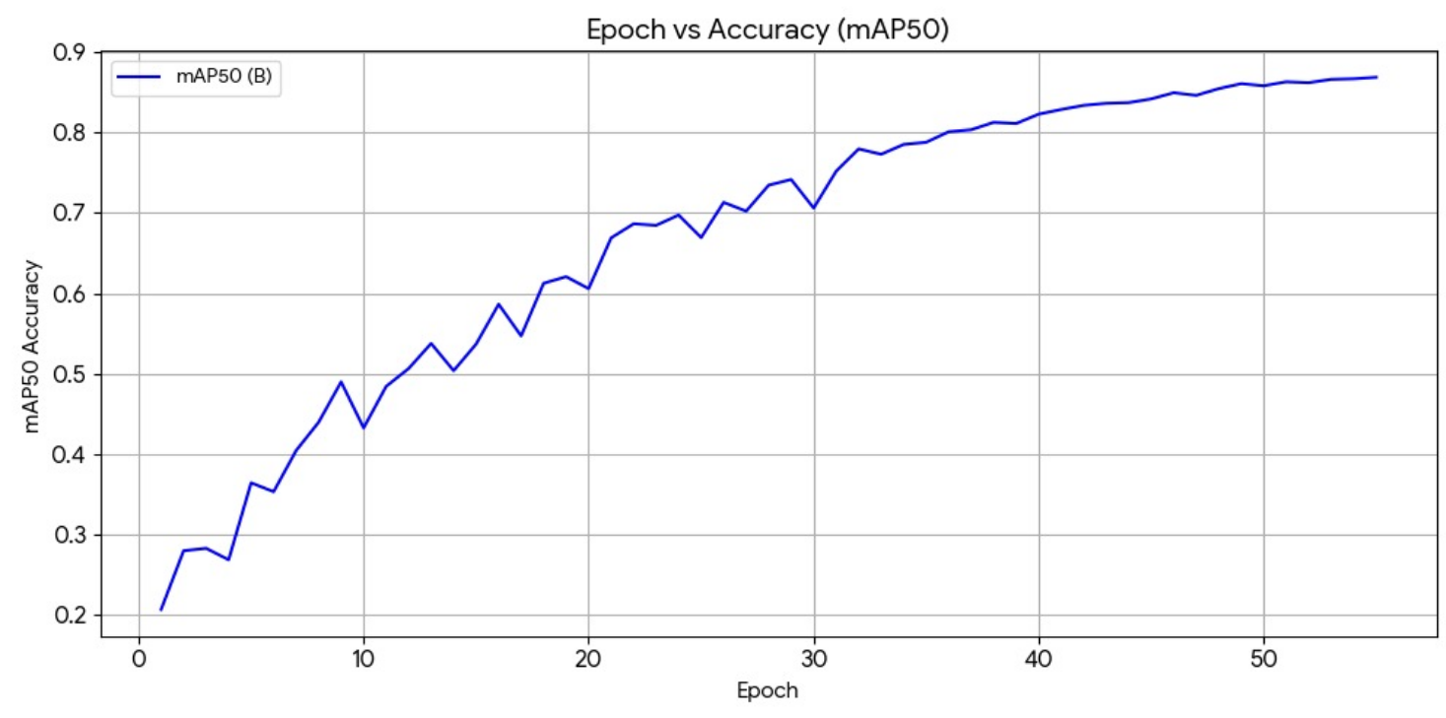
Figure 1: Epoch vs mAP50 performance curve of YOLO2026
The training and validation loss curves further illustrate the learning behavior of the YOLO2026 model. The train/box_loss, train/cls_loss, and train/dfl_loss decrease consistently over successive epochs, indicating progressive improvement in bounding box regression and classification accuracy. The validation loss curves follow a similar declining trend without significant divergence from training losses, suggesting stable generalization and minimal overfitting. The smooth reduction in losses confirms that the model effectively optimized both localization and classification components.
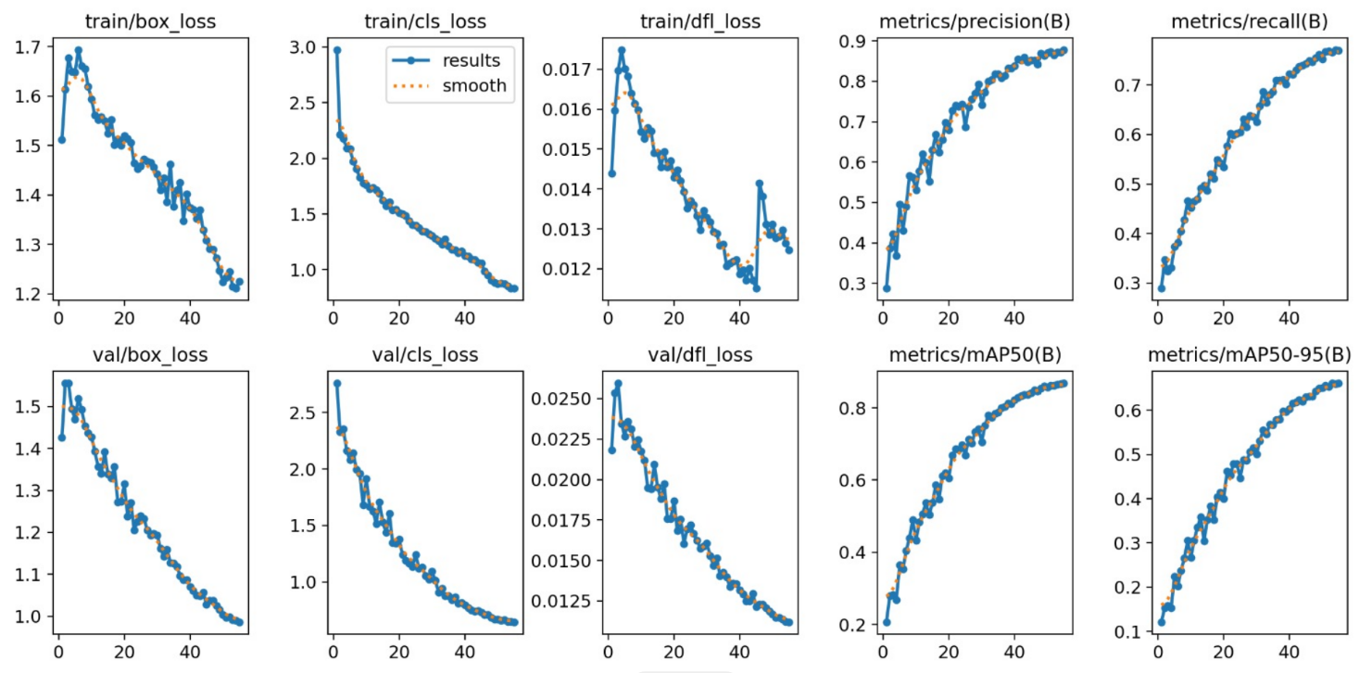
Figure 2: Training and Validation Loss Curves of YOLO2026
The precision and recall metrics gradually increase across training epochs and stabilize during later stages. Precision improves steadily toward approximately 0.87, while recall reaches approximately 0.76. This balanced increase indicates that the model effectively minimizes false positives and false negatives over time. The simultaneous improvement of mAP50 and mAP50–95 further confirms consistent multi-object detection capability under stricter IoU thresholds.
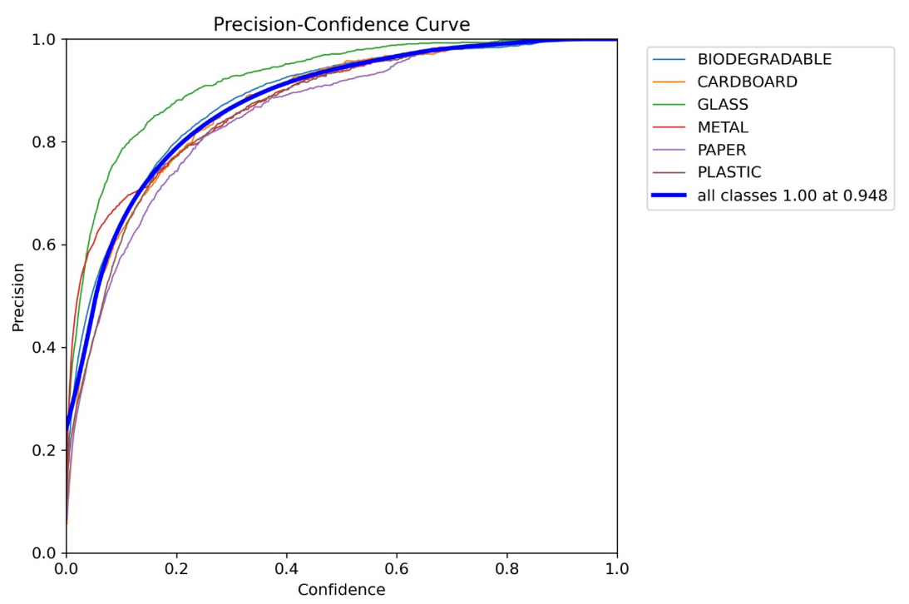
Figure 3: Precision–Confidence Curve for All Waste Classes
The normalized confusion matrix provides a detailed class-wise evaluation of the model. High diagonal values for GLASS (0.89), METAL (0.88), and PAPER (0.85) indicate strong classification performance for these categories. BIODEGRADABLE shows relatively lower classification accuracy (0.65), which may be attributed to higher intra-class variability. The low off-diagonal values demonstrate limited inter-class misclassification, confirming the model’s ability to distinguish between visually similar waste categories.
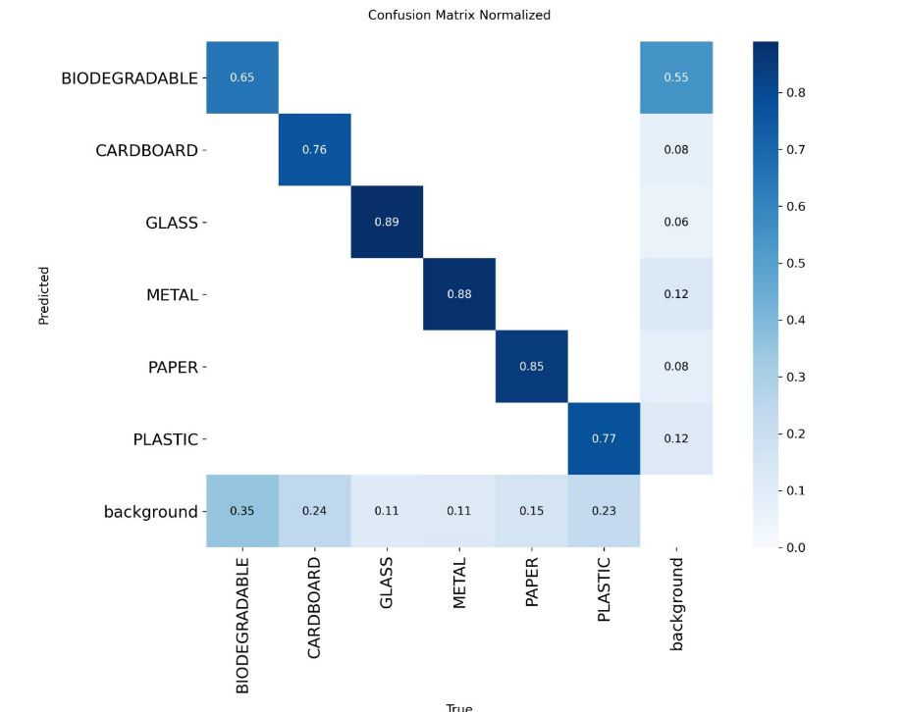
Figure 4: Normalized Confusion Matrix of YOLO2026
EXPERIMENTAL RESULTS
Overall Model Performance:
- mAP50: 0.8658
- mAP50–95: 0.6616
- Precision: 0.8744
- Recall: 0.7642
- F1-score: 0.8121
Table 1: Class-wise Performance Metrics of YOLO2026
Class | Images | Instances | Precision (P) | Recall (R) | mAP50 | mAP50–95
All (Overall) | 2000 | 14593 | 0.874 | 0.764 | 0.866 | 0.662
BIODEGRADABLE | 457 | 9458 | 0.888 | 0.590 | 0.760 | 0.453
CARDBOARD | 277 | 867 | 0.875 | 0.732 | 0.845 | 0.670
GLASS | 493 | 1185 | 0.928 | 0.880 | 0.943 | 0.809
METAL | 365 | 1069 | 0.854 | 0.855 | 0.922 | 0.721
PAPER | 334 | 761 | 0.846 | 0.806 | 0.888 | 0.713
PLASTIC | 281 | 1253 | 0.857 | 0.722 | 0.836 | 0.603
REAL-TIME WEB DEPLOYMENT
To demonstrate practical applicability, the trained YOLO2026 model was integrated into a web-based waste detection system that enables real-time image capture and prediction. The application allows users to either upload an image or capture one directly through the camera interface. Once an image is submitted, it is transmitted to the backend server where the YOLO2026 inference process is executed. The model performs object localization and classification in a single forward pass and returns bounding boxes along with predicted waste categories and corresponding confidence scores. The detection results are then visualized on the user interface with labeled bounding boxes.
Figure 2 illustrates sample outputs from the deployed system. The first image demonstrates accurate detection of a METAL object (metal bottle) with high confidence scores. The second example shows multi-label detection of BIODEGRADABLE waste items inside a container, where multiple instances are correctly identified despite cluttered arrangement. The third image displays PLASTIC object detection in handheld packaging materials, indicating the model's robustness in close-range scenarios. The fourth sample highlights simultaneous detection of PLASTIC and METAL waste types within mixed garbage bags, confirming the model’s multi-label capability. The final image represents a complex outdoor waste scene containing PLASTIC, METAL, GLASS, and BIODEGRADABLE elements, where the model successfully identifies multiple categories in a single frame.
These results validate the practical effectiveness of YOLO2026 in real-world environments. The model demonstrates stable real-time inference performance, accurate localization, and multi-object detection capability across varied backgrounds and lighting conditions. The deployment confirms the feasibility of integrating YOLO2026 into intelligent waste management systems for automated segregation and monitoring applications.
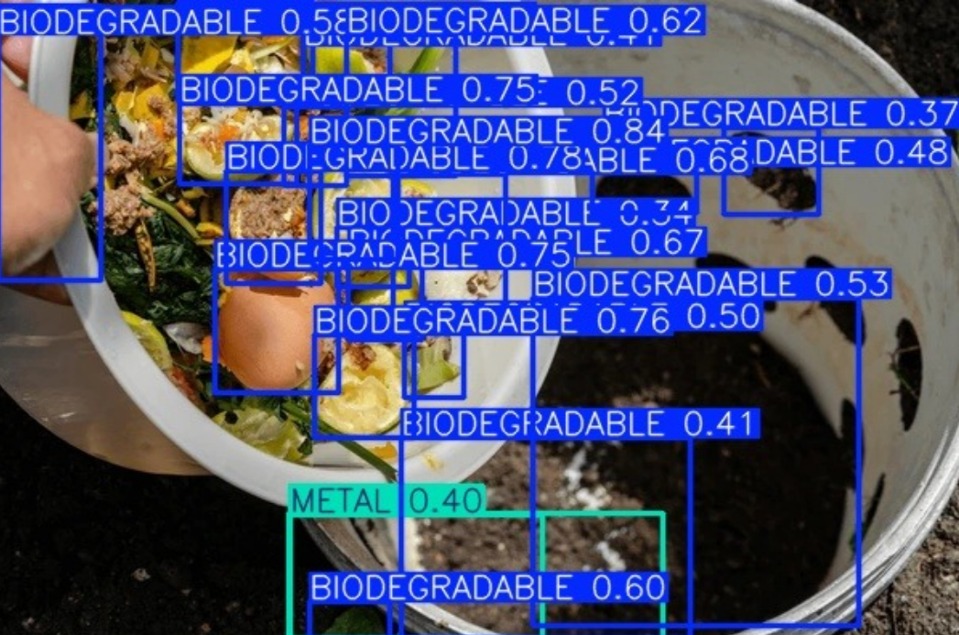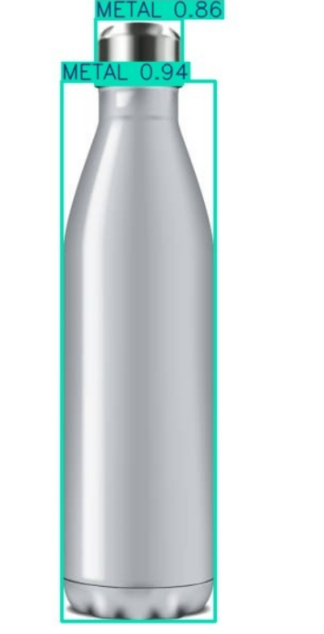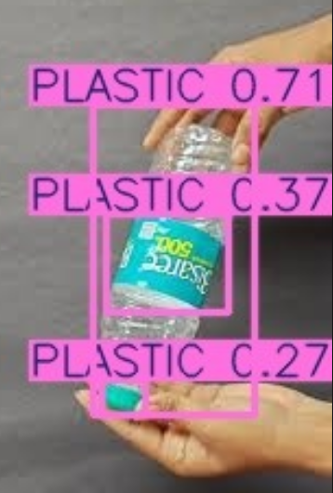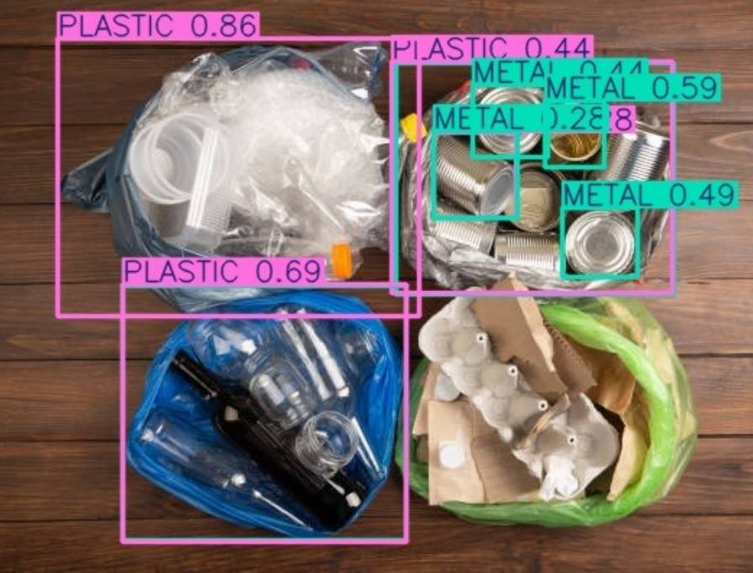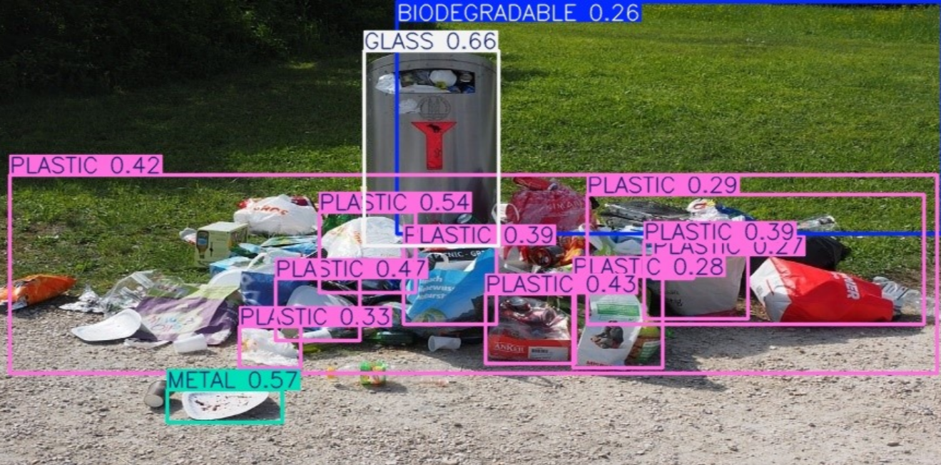
Figure 5: Sample Real-Time Waste Detection Outputs Using YOLO2026
DISCUSSION
Experimental results indicate strong object localization accuracy and balanced precision–recall performance. The mAP50 score of 0.8658 confirms reliable bounding box prediction, while the F1-score of 0.8121 reflects stable classification performance.
Training curve analysis suggests proper convergence and efficient learning across epochs. The real-time deployment further demonstrates feasibility for smart waste management applications.
CONCLUSION
This study evaluated the recently launched YOLO2026 model for multi-label waste detection. The model achieved an mAP50 of 0.8658 with strong precision and balanced recall. Training analysis confirmed stable convergence with maximum performance achieved in later epochs.
Successful integration into a web-based real-time detection system validates the practical applicability of YOLO2026 for intelligent waste segregation systems. Future work may focus on dataset expansion, hyperparameter optimization, and edge-device deployment for enhanced efficiency.
REFERENCES
- Adedeji, O., & Wang, Z. (2019). Intelligent waste classification system using deep learning convolutional neural network. Procedia Manufacturing, 35, 607–612. https://doi.org/10.1016/j.promfg.2019.05.086
- Fotovvatikhah, F., Ahmedy, I., Noor, R. M., & Munir, M. U. (2025). A systematic review of AI-based techniques for automated waste classification. Sensors, 25(10), 3181. https://doi.org/10.3390/s25103181
- Li, J., Chen, J., Sheng, B., Li, P., Yang, P., Feng, D. D., & Qi, J. (2022). Automatic detection and classification system of domestic waste via multimodel cascaded convolutional neural network. IEEE Transactions on Industrial Informatics, 18(1), 163–174. https://doi.org/10.1109/TII.2021.3085669
- Liang, S., & Gu, Y. (2021). A deep convolutional neural network to simultaneously localize and recognize waste types in images. Waste Management, 126, 247–257. https://doi.org/10.1016/j.wasman.2021.03.017
- Noman, A. A., Afrin, S., Mila, N. J., Naina, N. I., Bornil, A. H., & Bijoy, M. H. I. (2025). An automated effective waste classification and sorting using YOLOv8. In 2025 International Conference on Quantum Photonics, Artificial Intelligence, and Networking (QPAIN) (pp. 1–6). IEEE. https://doi.org/10.1109/QPAIN66474.2025.11172269
- Umar, N., Asrul, B. E. W., & Yuyun. (2026). Type deep learning model for multi-label waste classification in canal environments: A comparative study with CNN architectures. Journal of Applied Data Sciences, 7(1), 261–276. https://doi.org/10.47738/jads.v7i1.1066
- Wu, R., Liu, X., Zhang, T., Xia, J., Li, J., Zhu, M., & Gu, G. (2024). An efficient multi-label classification-based municipal waste image identification. Processes, 12(6), 1075. https://doi.org/10.3390/pr12061075
- Wang, H. (2020). Garbage recognition and classification system based on convolutional neural network VGG16. In 2020 3rd International Conference on Advanced Electronic Materials, Computers and Software Engineering (AEMCSE) (pp. 252–255). IEEE. https://doi.org/10.1109/AEMCSE50948.2020.00061

