Manashvi S. Ghagre¹, Aayushi J. Rana¹, Jignasha Parmar²*, Dr. Vandana J Rao
¹ B.E. Students, Department of Metallurgical and materials Engineering, [The maharaja Sayajirao university], Baroda, India
² Assistant Professor, , Department of Metallurgical and materials Engineering, [The maharaja Sayajirao university], Baroda, India
³ Associate Professor, Department of Metallurgical and materials Engineering, [The maharaja Sayajirao university], Baroda, India
*Corresponding Author:-Jignashap-metallurgy@msubaroda.ac.in
Effect of Heat Treatment on Microstructure and Hardness of Low Carbon Steel

Abstract
Low carbon steel is widely used in structural and engineering applications due to its excellent formability and weldability; however, its mechanical properties are highly dependent on microstructure. In the present study, the influence of different heat treatment processes on the microstructure and hardness of low carbon steel was investigated. Different heat treatment conditions, namely annealing, normalizing, conventional hardening (water quenching), Neem Bath ,Ice Bath,Salt Bath,brine Bath quenching were applied. Metallographic analysis was carried out using optical microscopy at magnifications of 100× and 500×. The results reveal significant variations in phase distribution, grain size, and morphology due to different cooling rates. Fine pearlitic structures were observed in normalized samples, whereas martensitic structures were dominant in quenched specimens. Hardness values increased with increasing cooling rate, with brine-quenched samples showing maximum hardness. The study establishes a clear correlation between heat treatment, microstructure, and hardness of low carbon steel.

1. Introduction
Mechanical properties of steels are strongly dependent on their microstructure, which can be controlled through heat treatment processes. Heat treatment involves controlled heating and cooling operations to modify the internal structure of materials without altering their chemical composition.
Low carbon steel (≤0.25% C) is extensively used in construction, automotive, and manufacturing industries due to its low cost and high ductility. However, its relatively low hardness and wear resistance limit its applications in severe environments.
The transformation of austenite into ferrite, pearlite or martensite depends on cooling rate and heat treatment conditions. By selecting appropriate heat treatment techniques such as annealing, normalizing, quenching. it is possible to tailor the microstructure and thereby enhance mechanical properties.
The present work focuses on:
- Studying microstructural evolution under different heat treatments
- Comparing hardness variations
- Establishing structure-property relationships
2. Experimental Methodology
2.1 Material
Material: Low carbon steel (TMT bar)
Composition: Use Specroscopy

2.2 Sample Preparation for Metallography
- Specimens cut 1 inch in size & has diameter of 20mm.
- Grinding using SiC papers (220–1000 grit)
- Polishing using diamond paste
- Etching using 2% Nital

- 2.3 Heat Treatment Conditions
Sample No | Heat Treatment | Temperature (°C) | Holding Time (min) | Cooling Medium
1 | Annealing | 940 | 60 | Air cool
2 | Normalizing | 940 | 60 | Furnace cool
3 | Hardening | 940 | 60 | Neem Bath (121 gm of neem in 1L of water)
4 | Hardening | 940 | 60 | Ice Bath (300gm of ice in 250ml of water)
5 | Hardening | 940 | 60 | Salt Bath (38gm of salt in 1L of water)
6 | Hardening | 940 | 60 | Brine Solution(125gm of salt, 45gm of dish-wash, & 12.5gm of laundry detergent in 1L of water)

3. Microstructure Observation:-
  - Annealing Sample:-
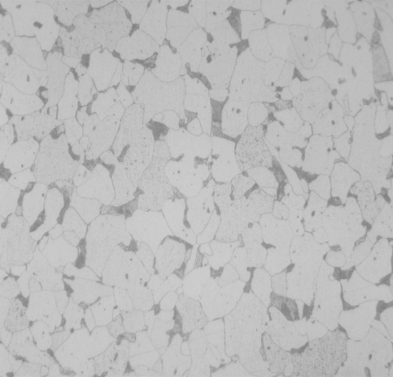
100X 500X

- Normalizing Sample:-

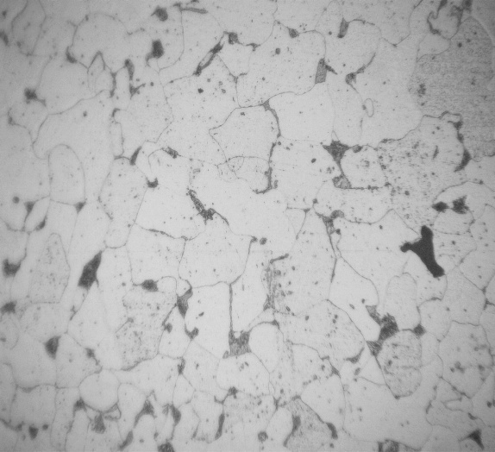
100 X 500X
- Hardening (Neem Bath):-
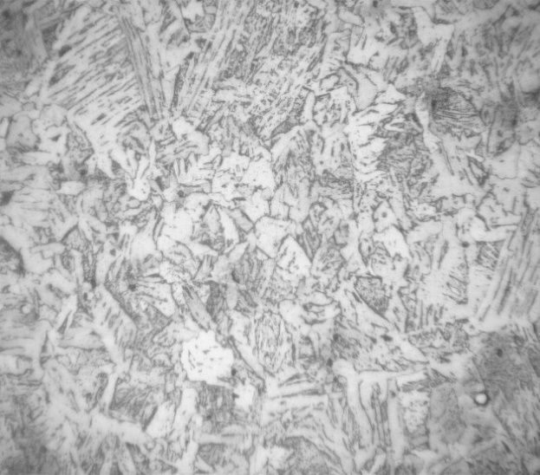
- x 500X

- Hardening (Ice Bath):-
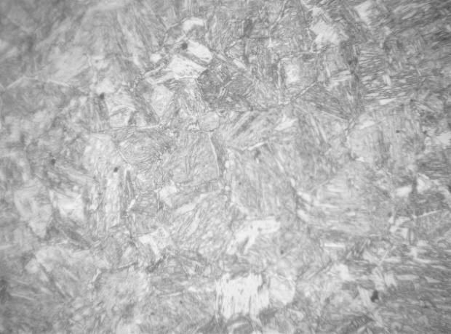
100 X 500X
- Hardening (Salt Bath):-
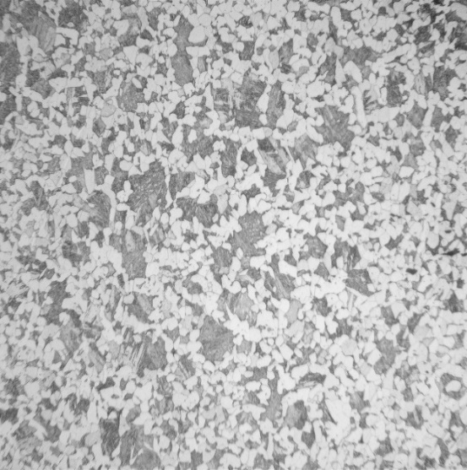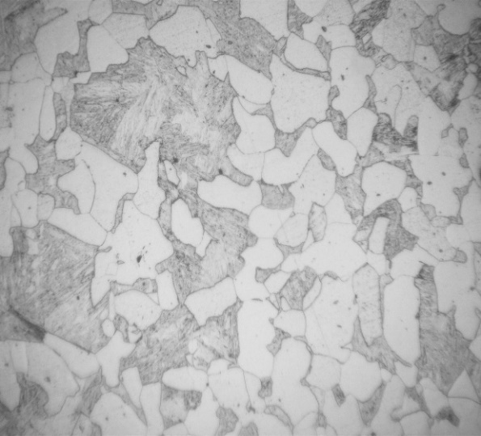
100 X 500 X

- Hardening (Brine Solution):-
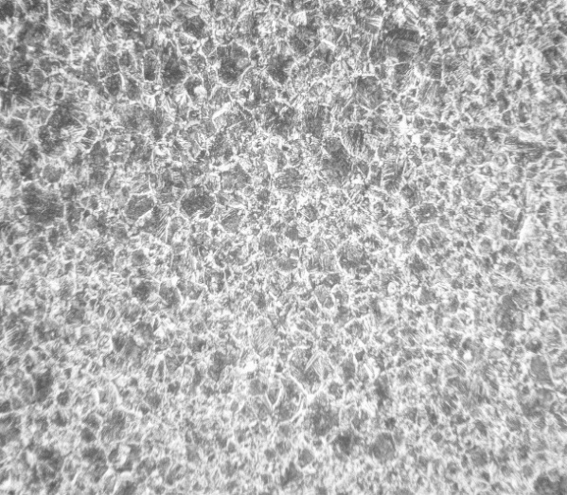 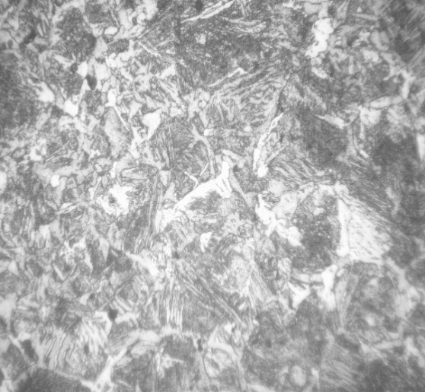 100 X 500 X

4. Results and Discussion :-
Chemical analysis of Specimen by spectroscopy :-
Element | Observed Value
Carbon | 0.213
Silicon | 0.238
Manganese | 0.627
Phosphorus | 0.0275
Sulphur | 0.0171

Hardness value :-

Heat Treatment & Quenching Media | Average Hardness (HRC)
Air Cooling (Annealing) | 11
Furnace Cooling (Normalizing) | 13-14
Neem Bath | 11.16
Ice Bath | 43
Salt Bath | 39.33
Brine Solution | 27.91

Graph:- Hardness vs Quenchingmedia

Conclusion:-
Based on the heat treatment processes performed in this study, the following conclusions are drawn:
- Neem bath quenching resulted in a refined ferrite–pearlite structure with fragmented cementite, indicating the initiation of a partially bainitic structure.
- Annealing and normalizing produced a uniform distribution of ferrite and pearlite, leading to a stable and homogeneous microstructure.
- Quenching in brine solution and ice bath led to the formation of fine martensitic laths, contributing to higher hardness.
- Salt bath quenching resulted in a mixed microstructure of martensite and retained austenite.
- The highest hardness was observed in ice bath quenched samples, while the lowest hardness was obtained in annealed and neem Bath..

