Cam Follower Dynamic Modelling Experimental Design setup for Impact and Fatigue Loads Studies

I. O .Nyah $Type equation here.$ C. M. Orazulume * W. A. Akpan E.J. Awaka-Ama V. A. Amba
Department of Mechanical Engineering, Faculty of Engineering University of Uyo, Akwa Ibom
State, Nigeria
Department of Electrical and Electronics Engineering, Faculty of Engineering, TopFaith
University Mkpatak, Akwa Ibom State, Nigeria.
Department of Mechanical Engineering, School of Engineering and Engineering Technology,
Federal University of Technology, Ikot Abasi, Akwa Ibom State, Nigeria.
Department of Mechanical Engineering of Mechanical Engineering, Faculty of Engineering
University of Uyo, Akwa Ibom State, Nigeria.
Department of Mechanical Engineering of Mechanical Engineering, Faculty of Engineering
University of Uyo, Akwa Ibom State, Nigeria.

*Corresponding author: greatwhyteman@gmail.com; whyteakpan@futia.edu.ng

Abstract
Cam follower mechanism constitutes an important component of mechanical power transmission and control operations. The mechanism may fail due to impact and fatigue loads during operations. Such failure in critical machines, systems and operations can be catastrophic leading to loss of lives, money or low performance in non-critical cases. Though analysis of impact and fatigue tests of the elements in use may give an insight, various other factors like dynamic loading, friction, inertia, damping may make the problem more complex than it appears. Setting up an experiment with these elements in place can assist the engineers to investigate the effects of dynamic loads on the impact and fatigue failure of cam follower mechanism. This research rests on such pinnacle. With proper setup, mathematical models developed can be effectively used to study its dynamic behaviour and predict when and how such failures can occur. It is hoped that further setup to include improper lubrication and creep will undoubtedly continue to contribute in advancement the of research and knowledge in this area.
Keywords: Experimental, cam, follower, dynamic, modelling, impact, fatigue, load.
- Introduction

Cam and follower mechanism is a preferred mechanism due to its important functions of almost all the reciprocating machines used in transportation, medical, and production industries. A cam is a rotating or translating part of the cam follower mechanism that can transmit from one type of motion to another. Cam follower mechanism can be used to transmit regular to irregular motion at a very low cost that is very difficult even at higher costs by using other available sophisticated means.
Cam-follower system is an intermittent motion mechanical device used for the transmission of motion in a machine by direct contact of the follower and cam feature. The cam feature is the driver while the follower is the driven member. The cam-follower systems are usually designed for specified motion characteristic required for a desired machine operation usually of high speed. The mechanism is widely used in printing press machinery, shoe machinery, textile machinery and internal combustion engines [1]. An important task in the design of cam-follower system is the determination of the cam profile needed to induce the required motion on the follower, and cam profile error could bring a damaging dynamic performance of high-speed follower cam system.

Automatic assembly machines have many cam-driven linkages that provide motion to tooling. Newer machines are typically designed to operate at higher speeds and may need to handle products with small and delicate features that must be assembled precisely every time. In orde to design a good tooling mechanism linkage, the dynamic behaviour of the components must be considered; this includes both the gross kinematic motion and self-induced vibration motion. Dynamic models were created to obtain insight into dynamic behavior of the system prior to manufacturing. These models were mathematical tools used to simulate and predict the behaviour of physical systems. They contain systems’ properties which are masses, stiffness, constants, and damping coefficients. One widely used model is a simplified, two- mass, single degree of freedom dynamic model of the cam-follower system. Unfortunately, the dynamic model being used is not ideal because it lacks impact and over-travel event and has only one degree of freedom.

The motion characteristic of the follower often depends on the profile of the cam [2]. The design of the cam profile which determines the kinematics of the follower has been a subject of discourse over the years. [3] extends the envelope theory for cam design to the swinging roller follower cam in which the profile of the plate cam was developed. The equation for the cutter points coordinates of the profile was derived and the cam profile was obtained for the specified motion of a narrow strip weaving loom. In [4] [5] non-uniform rational B-spline approach was developed for improving the cam follower performance through the redesign of its cam profile. The approach used the B-spline curve to represent the follower motion and a CAD/CAM system was used to develop for the follower, the distance, velocity, acceleration, jerk, pressure angle and cam profile for the B-spline. The deviation in the cam profile contour was a challenge to the follower kinematic output [6], [7] and the use of computer modeling for the design of cam profile in order to annihilate such challenges had been attempted by [8], [9].
In general, the classification of cam-follower systems is based on shapes of cams and followers. The basic shapes of a cam are shown in Figure. 1 They are: a plate cam or a disk cam(a) , a wedge cam (b), a cylindrical cam or barrel cam(c) , and a face cam (d). In these types of cams, plate cams are commonly used in machines. For this cam, with a given continuous input motion of the cam element, the follower moves forward and backward in a straight line.

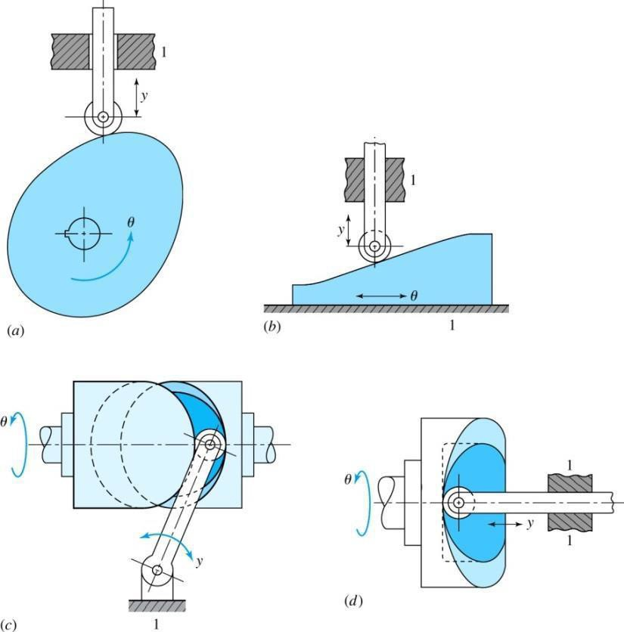

Figure 1: Basic camp shapes [10]

The basic shapes of the follower comprise four different types, such as a knife-edge follower, flat-face follower, roller follower and a spherical face [10]. Figure 2 presents the basic types of followers.

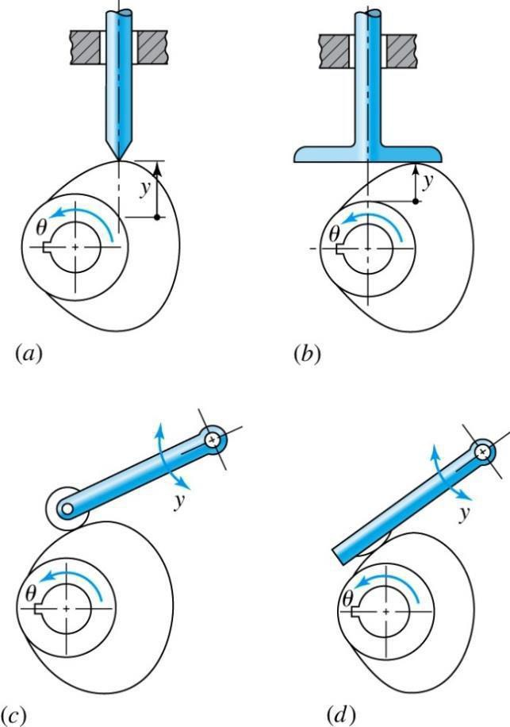

Figure 2: Basic types of followers

For the other way of classification based on the motion of the follower, they are reciprocating (translating) followers and oscillating (rotating) followers, [10]. On the other hand, reciprocating followers are cataloged by the centerline of the follower as the offset cam and the radial cam.
The efficiency of the cam manufacture had also been found to determine the kinematics of the follower. Optimum tolerance design and synthesis ensures good quality product at low cost [11],[12]. A computerized approach based on the simulated higher-pair contact analysis was developed to minimize the influence of manufacture tolerance of the cam on the follower kinematics for disc cam mechanisms with a flat-faced follower and roller follower [13]. The tolerance analysis results show that, the follower motion was influenced considerably due to the combine effects of the design parameters.[14] proposed method which employed homogenous coordinate transformation and conjugate surface theory to develop a kinematic model for cam profile design.

The cam profiles are often modified by advance design methods based on dynamic synthesis and optimization such as the polydyne methods of algebraic polynomial and the envelope theory.[15] used the algebraic polynomial method to specify the follower motion as aback substitution for the determination of the cam profile. A3- 4-5 polynomial cam profile with extended control providing zero acceleration at the end points of stroke was obtained. [16] developed the parameterized design system of disc cams with translating roller follower using the AutoCAD tool. Earlier attempt by [17] analyzed the size of the cam disc in a cam mechanism with translating roller follower using nonlinear programming techniques and family of parametric polynomials to describe the motion curve. The attempt extensively considered the kinematic feature of the mechanism.
The main cause of high contact stress on the cam profile is the clearance between the follower and its guide and when the follower moves with three degrees of freedom at high cam speeds. Many researchers have studied the nonlinear dynamics phenomenon in the cam- follower system but the effect of the nonlinear dynamics phenomenon on the contact stress between the cam and the follower at high speeds has not been discussed yet. The proposed cam-follower system can be found in textile machines, automatic lathe machines, hydraulic systems, and internal combustion engines. There are some factors that affect the contact stress between the cam and follower: (a) when the cam spins at non-constant speeds in the presence of follower offset; (b) using the cam with a small radius of curvature for the nose or when the cam has a discontinuities profile; (c) due to the impact and the friction between the follower and its guide and between the cam and the follower.

Cam-follower systems are essential components in mechanical devices such as engines, automated machinery, and manufacturing systems, where they convert rotary motion into linear motion. Despite their widespread use, cam-follower systems are often subjected to high levels of stress due to impact and fatigue loads during operation. These loads can lead to material deformation, wear, and eventual failure, compromising the reliability and efficiency of the system. The ability to accurately model the behaviour of cam followers under such loading conditions is critical for optimizing their design and ensuring their longevity. However, traditional methods of cam-follower analysis often fail to account The significance of this research lies in its ability to contribute meaningfully to both academic research and industrial applications. By presenting a useful experimental setup for cam followers under impact and fatigue loads, this research has provided engineers with valuable insights to optimize the design of cam-follower systems. Such optimization can lead to the development of components that are lighter, more efficient, and durable, ultimately enhancing their performance and lifespan. Additionally, a deeper understanding of the stresses and failure mechanisms that affect cam followers will improve the reliability and safety of machinery, reducing the risk of unexpected failures.
From an industrial perspective, the findings of this study hold the potential to significantly lower operational costs. By decreasing the frequency of maintenance and minimizing the likelihood of system failures, industries such as automotive, aerospace, and manufacturing can benefit from increased efficiency and reduced downtime. Furthermore, the developed model has direct practical applications, as it can be used in industries to predict the lifespan of cam followers, schedule preventive maintenance, and improve overall system efficiency. gap in understanding has led to increased maintenance costs, unexpected downtimes, and reduced operational efficiency in applications that rely heavily on cam-follower mechanisms.
This research is addressing the need for a comprehensive behavioural model that captures the dynamic response of cam followers under impact and fatigue loads. By developing such a model, the research seeks to enhance the understanding of cam-follower mechanics and provided a framework for improving their design and fatigue loads, for this to be achieved an experimental setup is necessary.

1.1 Characterization of Dynamic Loads

A dynamic load refers to a load that is subjected to change over the time. When objects are in motion there is a dynamic load counts for all types of forces. These include external, inertial, friction and damping forces. In contrast, a static load refers to a load on a structure whose amplitude and direction remain constant over the time. An external load with slow change can be simplified as a static load. The dynamic load must be determined to evaluate the variables for fatigue analysis. These variables include mean and alternating stresses, as well as their dependences on time factors. In characterization of a dynamic load, the time is viewed as a reference variable, and the damage growth depends on both of time factor and stress level [18].
Many researchers used the experiments to identify dynamic loads of structures or products. For examples, [19] established a procedure to evaluate dynamic loads and they developed a dynamic model for the testing of wheel drums.[20] evaluated the dynamic loads and performed the fatigue failure on a railway bridge; they used the seismographs that were fixed with tri-axle accelerometers for measurements. An FEA model with 3D beam elements were built to analyze the dynamic behaviors of bridge. In addition, the mean stress effect caused by the weight was considered, and equivalent alternating stress was determined using the Goodman criterion. To characterize a dynamic load, [21] proposed to use a vertically mounted accelerometer to track the engaged force when the vehicle passed over the bumps. The accelerometer was placed at the center of gravity approximately. Quantifying the effect of a dynamic load on a component is not a trivial task. Note that understanding a dynamic load with continuous impact forces is essential to analyze fatigue life of a part. One option to obtain the dynamic load is through the motion simulation, which can be performed using commercially available software tools such as the Motion Study in Solid-. These tools allow engineers to investigate the dynamics of moving parts, so that the forces involved in mechanical components can be determined. Early computer aided tools for motion analysis can be traced back to the computer codes such as SEURBNUK, REXCO and ICECO [22]. Motion Study will help to calculate the effect of transient loads on the structure. It is desirable that an FEA package can be integrated with a motion-analysis package so that the loading conditions of an FEA model can be directly retrieved for finite element analysis. In addition, when these two types of numerical simulation tools are integrated, the impact of design variables in a product can be accessed using a parametric study to optimize product design. For example, ADAMS was applied to investigate the combination of most critical loading conditions in an FEA model [23]. As a summary, the integration of motion simulation and FEA helps to build and examine virtual models of mechanical systems in a shortened time. One limitation of an FEA is that the model cannot evaluate the forces of a rigid body subjected to motion. Therefore, the motion simulation is widely used to characterize of dynamic loads. For example,[23] and [24] ADAMS to define dynamic loads for the fatigue analysis of a connecting rod in piston assembly. [25] presented an analytical model of a multi-body railroad vehicle; it dealt with the dynamic coupling of 3D contacts with rail track, both the cases of a flexible rail track and a rigid rail track were taken into consideration.

The method of motion study was widely applied in some scenarios such as the case where a wheel experiences dynamic loads due to track joint locations and track turn out locations. In these locations, the load at contacts will be fluctuated. Besides, the issue of wheel flatting has been widely studied over the years; a flatted wheel in motion was another good example of dynamic loads over the structure.[26] and [27] developedthenumericalmethodtocharacterizethedynamicloadsofwheel-railinteraction; this was for the scenario of flatted tires in the high-speed motion. [28] proposed a theoretical model to predict the rail interaction of the flat induced wheel. An extended state-space vector approach was used together with the complex modal superposition for the track; the relative displacement excitation was determined using the Kalker’s methods. [29] [30] used the finite element analysis structure to analyze the simply supported beams on an elastic foundation of arbitrary length. Unfortunately, the accuracy of the simulation output of the dynamic contact model was unsatisfactory in contrast to the real values in the application.
the dynamic behavior of railway and load under the higher-velocity motion. The dynamic load of the structure and load due to action of multi-roller carriage was identified using an FEA model. [26] considered the wheel with the real time dynamics of high-speed motion. The wheel rail was involved in the dynamic interaction, and this depended on many factors such as design parameters of wheel and rail, material properties, and contact nonlinearities. They found that the impacting force at the wheel-track contact was greater than static axial load on wheel. [30] developed an ANSYS implicit and LS- DYNA explicit code to solve the model, and they concluded that train speed affected contact force more than the axial force of wheel.

1.2 Dynamic Modeling of Cam Follower System

Dynamic modeling is a mathematical tool that is used to describe the behaviour of physical systems. These systems may be represented by single or multiple differential equations and may be a mechanical, electrical, thermal, or any other time-varying system. In this case, only dynamic models for mechanical systems are considered. Every real mechanical system has infinite degrees of freedom. The higher the degree of freedom in the model, the more accurate the simulation will be, at the price of model complexity and computation time. In order to have a reasonable computation time and acceptable results, the model needs to be simplified. This simplification may be done by reducing the degrees of freedom by combining masses, stiffness constants, and damping coefficients. The simplest dynamic model is a single degree of freedom model with one mass, one spring, and one damper. More complex models have multiple degrees of freedom with multiple masses, springs, and dampers. Simplifications of complex models to simple models are shown in the following sections. The application of dynamic modeling to cam- follower systems was first seen in the automotive industry in 1953 when a single-degree-of- freedom dynamic model was created with good correlation between experimental and simulated data (Barkan 1953). Superior correlation was obtained when a twenty-one degree-of-freedom dynamic model was created for the valve-train system. The disadvantage of the latter model was a longer modeling and computational time. Other applications included modeling of a robotic arm with impact (Ferretti etal.1998) and modeling of industrial cam- follower systems. By creating a dynamic model, the designer can determine the behaviour of a system prior to expensive manufacture, assembly, and testing. If the requirements are not met, appropriate fundamental changes may be made early in the product cycle to obtain acceptable behaviour.

A single degree of freedom (SDOF) model is the simplest dynamic model. An SDOF model can have one or two lumped masses and is typically used as a quick approximation of the dynamic behavior of a system prior to increasing the complexity of the model for a more accurate analysis. The application and derivation of one-mass SDOF model was explicitly shown in 1953 by Barkan. Prior to Barkan’s work, there were limited uses of dynamic models in the simulation of mechanical systems in the automotive industry. A dynamic model was developed for the high- speed motion of a cam-actuated engine valve and overhead valve linkage shown in Figure 3.
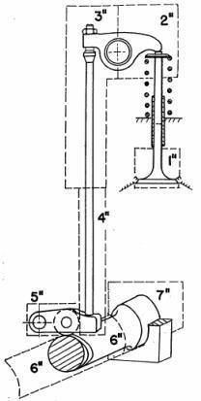

Figure 3: Overhead valve linkage [32]

To simplify the system shown in Figure 2, Barkan divided the valve-train into several concentrated masses, and then relocated the masses to the valve head’s axis of translation using the appropriate lever ratios to create one lumped mass. Once the lumped parameters were obtained, equations of motion were developed. To create the equations of motion, the forces acting on the system were identified. These comprised the spring force, inertia force, linkage compression force, friction force, and gas force. Barkan resolved the spring force into valve spring compression force, valve spring preload force, and the force produced due to the vibration of the springs. Three types of friction were taken into account for the damping, namely coulomb friction, viscous friction proportional to relative velocity, and viscous friction proportional to absolute velocity. The most complex portion of the equation was determined to be the gas force, which occurred when there was a difference in pressures. Barkan excluded spring vibration and gas force from the equations of motion because the spring surge had been determined to be insignificant (Oliver and Mills 1945). Other authors disagreed with the elimination of the spring surge and stated that unacceptable errors may occur. The gas force was very complex to model and would have required experimental data, which was not readily available, therefore it was neglected. The equations of motion were created for the simplified one mass model show in Figure 4.
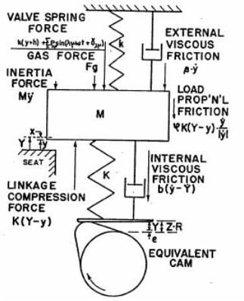

Figure 4: Schematic of the overhead valve linkage mechanism[32]

The main objective of the research is to present experimental setup for modelling and simulation of cam follower dynamic behavior for impact and fatigue loads.
A single degree of freedom (SDOF) model is the simplest dynamic model. An SDOF model can have one or two lumped masses and is typically used as a quick approximation of the dynamic behavior of a system prior to increasing the complexity of the model for a more accurate analysis.

2.1 Experimental Design

The Experimental design involves the use of Cam Dynamics Test Machine (CDTM). The output data were divided into three groups: shaft data, primary cam, and secondary cam. The output signals of the shaft data have driveshaft position, torque, and camshaft position, while the output signals for primary and secondary cams are positions, velocities, and accelerations as depicted in Figure 5.
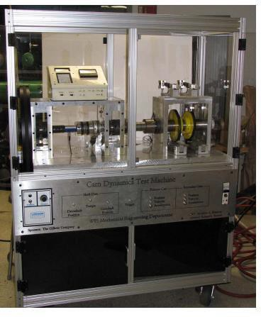
Figure 5: Overview of CDTM

2.2 Method

The essential components of the research include experimental design, computational modeling testing, and data analysis. The basic assumptions include:
- Perfect rigidity of cam and follower.

- Negligible frictional losses

- Hooke's law compliance

- Uniform application of impact loads

Modelling of CDTM

Once the best impact force approximation was found thorough derivations of the new dynamic model was performed. A few assumptions were made to simplify the problem; these assumptions were that mass M1was always in contact with the cam, the preload force of the spring K23 maintained contact between the impact mass M3 and the intermediate mass M2 up to the point of impact, and the condition of impact did not change from wear caused by multiple impacts. With these assumptions, detailed derivations of the dynamic model were performed for three possible conditions and are presented and discussed in this section.
Besides, dynamic modeling is essential for understanding the response of the system under different operational conditions, ensuring performance optimization and failure prevention. In this study, three critical dynamic phenomena—no contact, impact, and over-travel—were considered, each representing a unique challenge in cam dynamic.

The Universal Schematic and Free Body Diagram of a cam dynamic test machine represent the physical and dynamic elements of the machine used for studying the behavior of cam-follower systems under dynamic conditions such as impact, vibration, and fatigue.

Discussion
Cam follower mechanism is a very important mechanical linkage that found applications in Engineering. It is used in low and high-speed operations. The system can be subjected to thousands of hours of operations and the mechanism in this case experiencing thousands of cycles of operations. The load is dynamic and include external, inertial, friction and damping forces. The amplitude may vary due to dynamic nature of the load. All these have significant effect on the performance of the cam follower system. These loads can lead to material deformation, wear, and eventual failure, compromising the reliability and efficiency of the system. It is hereby subjected to impact during contact and fatigue due to several continuous operations. In examining the effect of a dynamic load, the time is considered as a reference variable, and the damage growth depends on both of time factor and stress level. The right experimental setup is required to practically study this behaviour. The presented experimental setup serves as a better means to under study the effects of impact and fatigue loads on the members.
Conclusion
Dynamic loads have effect on the performance of cam follower system. These are reflected in wear, noise, vibration and in a long run failure. The failure consequence might be huge depending on the consequences of failure. Imagin the cam follower system powering the engine of the jet engine in US-Israel-Iran on either side, it can down the plane without any enemy attack. It can also be disastrous in medical, nuclear and high temperature and pressure operations. Therefore, the right experimental setup is the antidote for proper dynamic load modelling for impact and fatigue failure of the cam follower system.

References
[1] Huang, C., Cheng-Kang, H., Chih-Jie, Y. and Cheng-Kuo, S. (2013). Experimental Investigation on the Performance of a Compressed-Air Driven Piston Engine. Energies, 6(3): 1731-1745.
[2] Wu, L., Wen-Tung, C. and Chun-Hsien, L. (2007). The design of varying-velocity translating cam mechanisms. Mechanism and Machine Theory, 42(3): 352-364.
[3] Raji, N. A, and Adegbuyi P. A. O. (2003). Synthesis of Cam Follower System for the Beater Mechanism of a Narrow Horizontal Loom. Nigerian Journal of Mechanical Engineering, 1: 37-48.
[4] Xiao, H. and Zu J. W (2009). Cam profile optimization for a new cam drive." Journal of Mechanical Science and Technology, 23: 2592-2602.
[5] Sateesh, N. (2014). Improvement in Motion Characteristics of Cam-Follower Systems Using Nurbs. International Journal on Design & Manufacturing Technologies, 8(2): 15-21
[6] Chang, W. T. and Long-Iong, W. (2009). Computerized tolerance analysis of disk cam mechanisms with a roller follower. Engineering with Computers, 25: 247-260
[7] Nguyen, V. T., & Kim, D. J. (2007). Flexible cam profile synthesis method using smoothing spline curves. Mechanism and Machine Theory, 42(7), 825–838. https://doi.org/10.1016/j.mechmachtheory.2006.07.005
[8] Alaci, S., Florina, C. C., Dumitru, A. C. F., Simion, P. C. and Dorel. P. (2011). Some Aspects Regarding Computer Aided Design of Cam Mechanisms with Flat Face Oscillating Follower. Viability & Durability 1(7): 65-70.
[9] Pourghodrat, A. and Carl, A. N. (2011). A case study of designing a cam-follower mechanism with cycloidal motion." 13th World Congress in Mechanism and Machine Science.
[10] Shigleys Mechanical Engineering Design. NewYork: McGraw-Hill, 265-344.
[11] Zhang, C., and Ben Wang, H. P. (1993). Tolerance analysis and synthesis for cam mechanisms.
International Journal of Production Research, 31, (5):1229-1245.
[12] Singh, P. K, S C Jain, and P K Jain. (2004). A genetic algorithm-based solution to optimum tolerance synthesis of mechanical assemblies with alternate manufacturing processes— benchmarking with the exhaustive search method using the Lagrange multiplier." Proceedings of the Institution of Mechanical Engineers. Journal of Engineering Manufacture, 218(7): 765-778.

[13] Chang, W. T. and Long-Iong, W. (2009). A computerized approach for tolerance analysis of disk cam mechanisms with a flat-faced follower. Transactions of the Canadian Society for Mechanical Engineering, 33(3): 459-485.
[14] Hsieh, J 2011). Design and analysis of offset slider-crank with translating roller follower.
Transactions of the Canadian Society for Mechanical Engineering, 35(3):419-436.
[15] Kirana, T. and Srivastavab, S. K. (2013). "Analysis and Simulation of Cam Follower Mechanism Using Polynomial Cam Profile. International Journal of Multidisciplinary and Current Research, 1: 211-215.
[16] Wang, Linyan, Tao Shen, Yunbo Shen, and Shaokang, L. (2012). Development of Parametric Design System for Disc Cams with Translating Roller Followers. Advanced Materials Research, 411: 83-87.

[17] Yu, Q. and Lee, H. P. (1998). Size optimization of cam mechanisms with translating roller followers. Proc Instn Mech Engrs, 21(2): 381-385
[18] Dattakumar, S. and Ganeshan, V. (2017). Converting dynamic impact events to equivalent static loads in vehicle chassis, MSc Dissertation, Chalmers University of Technology, Gothenburg, Sweden, 77p.
[19] Redfield, R.C. and Sutela, C (2012). Mountain bike wheel endurance testing and modeling.
Procedia Engineering, 34: 658-663.
[20] Marques, F., Moutinho, C., Magalhães, F., Caetano, E. and Cunha, Á. (2014). Analysis of Dynamic and Fatigue Effects in an Old Metallic Riveted Bridge. Journal of constructional steel research, 99: 85-101.
[21] Pozuelo, D., Gauchia, A., Olmeda, E. and Diaz, V (2014). Bump Modeling and Vehicle Vertical Dynamics Prediction. Advances in Mechanical Engineering, 6: 736-576.
[22] Kendall, K. and Benuzzi, A. (1980). The COVA program—Validation of the fast reactor containment code seurbnuk. Nuclear Engineering and Design, 57(1): 79-105.
[23] Jianfeng, L., Gang, C., Jie, S. and Yi, L. (2013). Finite Element Analysis of the Fatigue Life for the Connecting Rod Re manufacturing. Journal of Applied Sciences, 13(9): 1436- 1442
[24] Sha, L. R. and Shi, Y. C. (2014). Fatigue Reliability Analysis on Connecting Rod of Automobile Engine Using Artificial Neural Network Method. Applied Mechanics and Materials, 501-504: 1092-1095.
[25] Rathod, C., Chamorro, R., Escalona, J. L., El-Sibaie, M. and Shabana, A. A. (2009). Validation of three-dimensional multi-body system approach for modelling track flexibility. Proceedings of the Institution of Mechanical Engineers, Part K: Journal of multi-body dynamics, 223(4): 269-282.
[26] Han, L., Jing, L. and Liu, K. (2015). A dynamic simulation of the wheel–rail impact caused by a wheel flat using a 3-D rolling contact model. Journal of Modern Transportation, 25(2): 124-131.
[27] Vyas, N. S. and Gupta, A. K. (2017). Modeling Rail Wheel-Flat Dynamics. Engineering Asset Management, 222-1231
[28] Baeza, L., Roda, A., Carballeira, J. and Giner, E. (2006). Railway train-track dynamics for wheel flats with improved contact models. Nonlinear Dynamics, 45:385–397.
[29] Pieringer, A., Kropp, W. and Nielsen, J. C. O. (2014), The influence of contact modelling on simulated wheel/rail interaction due to wheel flats wear, 314: 273–281.
[30] Cai, C. W., Cheung, Y. K. and Chan, H. C. (1988). Dynamic Response of Infinite Continuous Beams Subjected to a Moving Force, Journal of Sound and Vibration, (123): 461 - 472.
[31] Bian,J., Gu,Y.T. and Murray, M. H. (2013). A dynamic wheel–rail impact analysis of railway track under wheel flat by finite element analysis. Vehicle System Dynamics,51:784–797
[32] Barkan P. Calculation of high-speed valve motion with a flexible overhead linkage (1953) ‘’SAE technical paper’’ http. // doi.org./10.4271/530261 accessed 20th June 2025)

