Smart Crop Disease Detection with Advisory System and Voice Integration

Ms. B. Mohana Priya¹, M. Sandiya², C. Srinithi^{3,} ,G. Srinath⁴
¹Assistant Professor, Depatment of AI&DS, Erode Sengunthar Engineering
College, Perundurai, Erode-638052, Email- monabalu.esec@gmail.com
^{2,3&4}Research Scholar,Department of AI&DS, Erode Sengunthar Engineering College,
Email- sandiya1804@gmail.com, srinithichandrasekaran30@gmail.com, sricharu51@gmail.com

Abstract—Plant diseases continue to pose a major threat to the agricultural community, resulting in loss of crop productivity and heavy financial damage to farmers. Towards this, a multitasking, multilingual, intelligent, plant disease detection system with deep learning, real-time weather-aware analysis and farmer-friendly decision support is proposed. The captured/uploaded leaf image is analyzed using a state-of-the-art convolutional neural network model, fine-tuned to yield accurate disease identification and severity level classification of the plant. An integrated translation module translates the application interface as well as the advisory output to the user’s preferred language on the fly. The platform further analyses images to generate an AI-based treatment advisory comprising suitable fertilizer usage, frequency, preventive measures, and plant health recovery guidance. To enhance usefulness, real-time weather input is incorporated to fine-tune the dosage and time of application based on rainfall, temperature, and humidity. The system also features location-aware services which tie up with nearby fertilizer stores, thus facilitating user-friendly access to the advised fertilizers and pesticides. A reminder mechanism stores the advisory history and notifies the user about the scheduled action to be taken. Experimental evaluation demonstrates high classification accuracy of the solution combined with efficient multilingual disease identification and severity level advisory, thus rendering the system robust, inclusive, and scalable for sustainable agricultural management.
Keywords—Plant Disease Detection, Deep Learning, Multilingual Systems, Precision Agriculture, Weather-Aware Advisory, Location-Based Services.

Introduction
Farming is still the primary source of income and survival of a large number of people in developing, rural areas. Despite the technological evolution over the years, farmers continue to face major life-threatening issues such as late detection of plant diseases, lack of expert consultation, language barriers, and access to timely agricultural input, among others. Although the current plant disease detection systems are using Machine Learning systems for classifying input images, most of them don’t have integrated features that can support actual farming practices and recommendations for farmers that go beyond mere disease detection.
Accessibility remains one of the key pain points in digital agricultural systems’ adoption. Complicated and status-quo authentication mechanisms, less support for the regional language, non-contextual recommendations, and steps are some of the major bottlenecks in making farmers adopt modern technological solutions. In most cases, environmental conditions such as rainfall, humidity, and temperature are key determinants for the disease’s progression and hence the potential success rate of its treatment. Unfortunately, these systems do not have weather-aware advisory mechanisms and follow-up systems such as reminder mechanisms, which result in low treatment adherence.
To address the above-mentioned problems, this research proposes a more functional AI-Powered Mobile and web-based Plant Disease Detection system with intelligent, easily accessible, multi-language, and farmer-centric features. The system supports a simple login mechanism that lets users sign in with only their phone number, without OTPs or password complications. After login, the user can select their preferred language, and the whole app will be translated in real-time.
This tool lets farmers take live pictures or upload photos of diseased plants. Computer vision and deep learning methods help the tool spot plant diseases and assess severity levels. The tool then creates an AI-based recommendation. The recommendation includes the fertilizers or remedies to use, the number of times to apply, duration, preventive measures, and recovery measures for the plant’s diagnosed condition.
To make this more practical, the tool considers real time weather input to fine tune the recommendation. The remedies are adjusted based on expected rainfall, temperature or humidity conditions. This makes the remedy context aware and more useful in the field. The tool also saves the detection history and allows a reminder mechanism for scheduled application or remedial observation checkpoints for the selected crops.
The tool also uses live location services to display the nearest fertilizer and pesticide shops. This bridges the gap between disease/advisory/ remedy and actual availability of the required fertilizer/remedy. Lastly, the tool also includes text and audio output so the farmer can listen to the diagnosis and recommendation in their chosen language. This voice assistance feature helps the less literate population and visually impaired farmers.
The major contributions of this project are summarized as follows:
- AI-driven plant disease detection with severity assessment using image-based analysis.
- Dynamic multilingual interface translation to ensure inclusive and regionally accessible communication.
- Weather-aware advisory generation for context-sensitive treatment recommendations.
- Treatment history storage and reminder notifications to support structured crop management.
- Live agri-input shop locator to facilitate timely access to fertilizers and pesticides.
- Voice-enabled advisory output for enhanced accessibility and usability.
With these things together, like disease check, talking in different languages, understanding the weather, finding things close by, and helping people who can't type well, the proposed system can do a lot for farmers.

LITERATURE REVIEW
The use of deep learning methods and image processing techniques for automated plant disease detection has recently been studied [2], [3]. Gohil et al. [2] presented a hybrid framework for automated, real-time disease detection and segmentation from plants by leaves. The study detailed that convolutional neural networks (CNNs) can extract disease patterns from leaf images and predict disease types with excellent accuracy. Salman et al. [3] investigated the vision transformer-based understanding of plant images combined with mixture-ofexperts models and showed an enhanced plant disease prediction in diverse environments. These works highlight that AI-driven models are becoming increasingly effective for accurate, scalable crop disease diagnosis.
Besides the accuracy, accessibility has been an issue in agricultural technology. Multilingual platforms have been identified to have the potential to make the technology more accessible to diverse farming communities. Bajpai et al. [7] and Kumar et al. [12] concluded that language diversity is a major hindrance to technology adaptation, especially in multi-lingual countries like India. They assert the need for systems that promote communication in regional languages. We have adopted this observation to make the work described in this paper multilingual, allowing the farmers to communicate with the system in their own native languages, while addressing their literacy and communication barriers.
Another vital aspect in curtailing crop losses is real-time access to agri-inputs. As described by Wang et al. [5] and Bussipalli et al. [8], timely information regarding disease spread and fertilizer availability is critical to effective intervention. Multiple cloud-service and mobile application-based solutions have been proposed to improve accessibility [10], [13]; however, connectivity, scalability, and agri- infrastructural limitations in rural areas restrict widespread adoption. To address these challenges, our system incorporates a real-time agri-input shop locator that points farmers to the nearest agri-input providers immediately after a detection event, minimizing delays between diagnosis and treatment [2].
Despite significant progress in plant disease detection and agriculture assistance systems, real-time implementation, inclusivity and user-friendliness of current solutions remains a challenge [4], [9], [10]. Language barriers and infrastructural limitations confine the reach and effectiveness of most technologies, highlighting the need for more inclusive and practical solutions. By integrating multi lingual support, AI-based disease detection, and real-time access to agri-inputs, we aim to provide a farmer-friendly technological solution that supports timely intervention, sustainable agriculture practices and long term community development [1]-[3], [12].

PROPOSED METHODOLOGY
The system proposed has the design of an agricultural decision support platform focused on farmers, able to work in multiple languages and supported by AI. It merges plant disease detection, intelligent advice, weather awareness and access to agri-input in real time. These processes have different modules that work together to make sure that the diagnosis is correct and the recommendations are appropriate to the environment, while users can interact with the system easily.
A. Authentication for users and personalization for language
The login process applies phone numbers. Users don’t need to do verification with OTP or password authentication. This is to make sure that the system can be accessed easily, especially for farmers who live in rural areas.
After logging in, users can select a language they understand. The system can then translate the interface into that language in real time thanks to the translation engine. This means that all the information and advice displayed to users with different backgrounds can be understood easily, enhancing the overall experience.
B. Image Capture and Preparation
Users can take a live photo of a plant leaf with their camera or upload a photo they already have. The image is prepared by making it the right size, normalizing it, and removing any noise so it can be used by the deep learning model. These steps help the model see important parts of the image and make better guesses.
C. Detecting Disease with Deep Learning
The main diagnosis tool uses a CNN-based model. It has been trained on labeled plant leaf photos. It looks at the image and decides which disease it is and how sure it is.
The model’s confidence score tells the system how serious the disease is. The result can be early, moderate, or severe. This helps the system give treatment advice for the right stage of infection.

D. AI-Driven Advisory Generation
Post disease detection, an AI-powered advisory module provides a structured advisory. The advisory contains the following entities:
- Relevant fertilizer/pesticide treatment
- Recommended dosage frequency and duration
- Advisory for preventive and/or recovery measures
- Monitoring guidelines for follow up observation
The specific advisory content is selected based on the disease category and disease level. Additionally, the final advisory output is provided in the user’s choice of language for ease of adoption.
E. Weather-Aware Recommendation Engine
To maximize practicality, the system incorporates external weather API-based real-time weather information. Key environmental constructs such as temperature, humidity and rainfall forecast are used to calibrate the treatment recommendation.
For example, if rainfall is forecast in the assessment region, the system can either recommend fertilizer application timing prior to rainfall or recommend postponement to account for fertilizer wash-off. As another example, the humidity parameter can be used to provide contextual calibration of fungal treatment application frequency. This ensures that the system output is field ready and context aware.
F. Treatment History and Reminder System
The system automatically saves all detection results and advisory output for each user as a crop health history. If the advisory includes time-based treatment steps, the system sets in-app reminders for fertilizer reapplication and/or observation checkpoints.
A structured follow-up reminder mechanism helps promote treatment adherence and enable proactive crop health monitoring.
G. Real Time Location Based Agri- Input Shop Locator
Live location services are integrated within the system to bridge the gap between diagnosis and implementation. The platform leverages geolocation APIs to fetch fertilizer and pesticide vendors close to the user’s location.
The live shop locator is designed to enable the farmer to source the recommended agri input in the shortest possible time, reducing the time lag in implementation and improving the overall turn-around time.
H. Output module with voice assistance
To help improve accessibility at the last mile, the system is designed to convert the final diagnosis and advisory into an audio file using text-to-speech APIs. The module has an embedded functionality for the farmer to play and listen to the details of disease, severity level and treatment procedures in the chosen language. The feature will be greatly beneficial to farmers with low literacy and vision, increasing accessibility and making sure critical agricultural information is communicated with clarity.
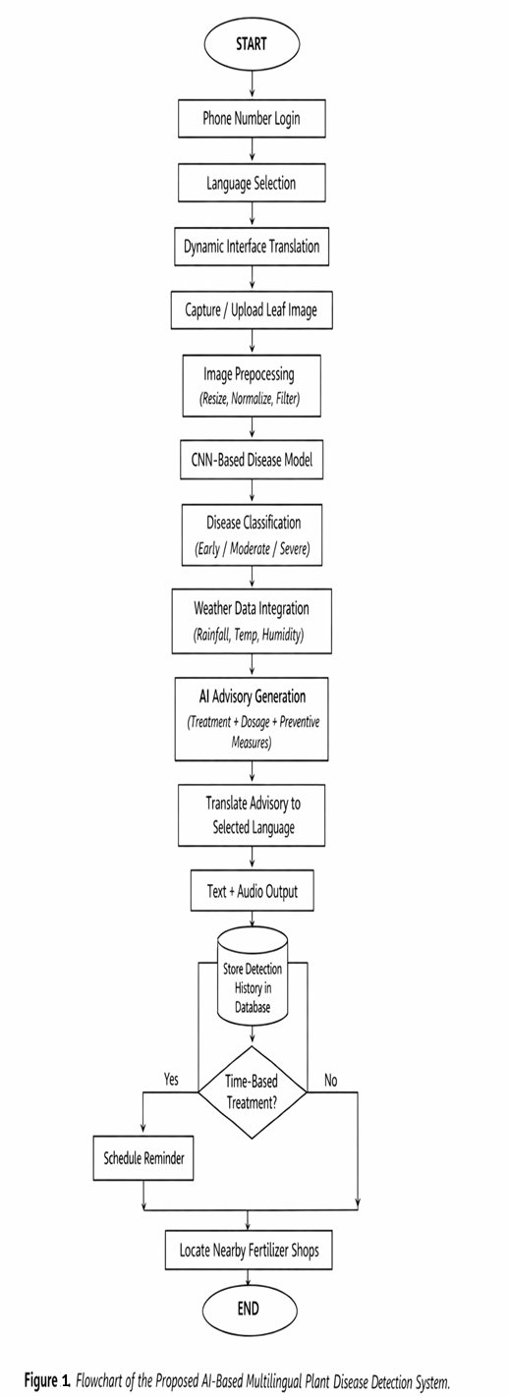

Experimental Setup
This study aimed to develop an effective environment for preprocessing, training models, and deploying the proposed AI-based multilingual plant disease detection system. The setup incorporates the complete workflow depicted in Figure 1, which includes user authentication, language selection, image processing, disease detection, advice generation, and system deployment. The cycle of experimentation consists of four broad phases: creating a programming environment/framework, pre-processing and extracting features, training and validating models, and evaluating performance metrics.

A. Programming Environment and Framework
We selected Python version 3.10 to implement our system because of its rich capabilities for ML applications and web development. The deep learning model was built with the TensorFlow and Keras frameworks, which provided the tools we required to construct a Convolutional Neural Network (CNN) efficiently and to enable running on our Graphics Processing Unit (GPU) during training. For numerical computation and creating an image, we used the libraries NumPy and OpenCV. We used NumPy for performing numerical and array-based functions, and we used OpenCV for decoding, resizing and pre-processing images. We built the back-end of our application with the Django web application framework, which handled user authentication, image upload, disease prediction requests, and database operations.
The trained model was integrated into the Django backend to allow users to utilize the model in real-time. An HTML, CSS, and JavaScript frontend interface was also created to provide users with a way to interact with the model. Additional modules were incorporated to connect the system with dynamic language translation, retrieve real-time weather information via APIs, and locate fertilizer vendors based on location.
B. Preprocessing and Feature Extraction
To standardize input into the model, all plant leaf images were resized to 224 x 224 pixels in order to meet the deep learning architecture's requirements while decreasing computational strength. Normalizing pixel values allows the model to converge more quickly and have a more stable training process than if there is no normalization.
To enhance the diversity of the dataset and reduce the likelihood of overfitting, various data augmentation methods were employed including random rotation, horizontal/vertical flipping, zooming, and image shifting. Data augmentation reproduces real-world changes such as variation in illumination, the position of leaves with respect to each other, and the background against which the leaves are photographed.
Feature extraction was accomplished using Convolutional Neural Networks (CNNs). A MobileNetV2 architecture was used as the base model and had previously been trained on the ImageNet database, allowing it to use the already trained generalized features (e.g., edges, shapes, and textures) to improve transfer learning. The fine-tuning to capture the specific types of diseases found in the leaves of plants in the higher layers of the network have enabled improved accuracy in classifying these diseases from limited agriculture datasets.

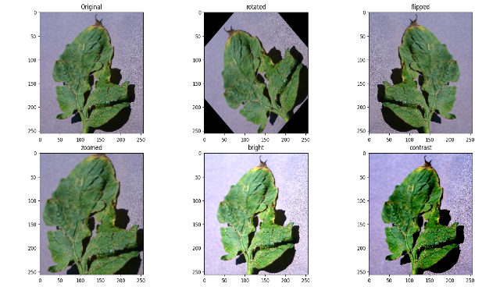
Fig. 2. Experimental Setup of the Proposed Plant Disease Detection

C. Training and Validation Strategy
The dataset was methodically divided into subsets for testing (10%), validation (20%), and training 70%. Validation was used as a checkpoint to keep an eye on overfitting, and training was carried out using mini-batch stochastic gradient descent (SGD) with backpropagation. Cross-validation was used to improve the generalization of the model and ensure that it will perform consistently when applied to other sections of the dataset.
Hyperparameter optimization was performed to achieve optimal convergence through the adjustment of parameters such as learning rate, batch size, and number of training epochs. Among the techniques used in the network layers to reduce overfitting and to improve the robustness of the trained model is drop-out regularization. After the model had been trained, it was deployed within the Django backend of the project, where a user will be able to obtain a real-time prediction of whether or not his/her leaf image indicates disease.
D. Evaluation Metrics
This section describes the evaluation metrics(s) that are used to quantitatively evaluate the performance of a proposed system for identifying plant diseases:
  - Accuracy: The overall accuracy of the model is expressed as the number of samples that are accurately predicted as disease-free to the total number of samples.
  - Precision: The number of true positive disease predictions divided by the number of all positive disease predictions gives an idea of how well the model predicts a positive diagnosis for the disease.
  - Recall: The number of true diseased plant samples divided by the total number of true diseased plant samples measures how well the model classifies an actual diseased plant sample as being diseased.
  - F1 Score: The F1 Score combines precision and recall through the use of a harmonic mean for the two metrics and is an important consideration when evaluating class imbalances.
The combination of these four evaluation metrics provides an overall assessment of the performance of the proposed model's ability to accurately and dependably identify plant diseases in real-world agricultural settings.

Experimental results and discussion
The effectiveness of the AI-Based Multilingual Plant Disease Detection System with Weather Programmed Notices and Real-Time Agriculture Input Availability was evaluated to assess how well the system provides disease-related information in multiple languages, creates providing notices and provides agriculture support in real time.
The evaluation of the proposed system was completed on three primary areas: the performance in the classification of the disease, the usefulness of the multilingual interface and the performance of the integrated agriculture support modules such as reminder notifications, weather-based recommendations and location services for fertilizer suppliers.
A. Dataset and Preprocessing
Data from the PlantVillage repository were used for this evaluation, yet a second source of annotation was used to create additional leaf images from plants that are naturally growing in the area in which these data were gathered; ultimately providing a training dataset containing both healthy and diseased leaves from tomato, potato and pepper plants.
Initially, there were 50,000 images in the dataset prior to pre-processing. All images were resized to 224 × 224 pixels in order to fit the structure of the deep learning model and minimize the amount of computation required by the model once it had been trained on the dataset.
Several forms of data augmentation were applied to the dataset in order to create more robust models and reduce class imbalance. Some of these techniques included: Verical and horizontal flipping, Rotation of the image, Scaling and zooming of the image, Adjustments to brightness and/or contrast, Shifting of the image by x or y.
These various forms of data augmentation were applied to simulate the variability of light conditions, orientations of the leaf and environmental backgrounds typical for agricultural products through their reproduction phase.
B. Model Performance Analysis
A Convolutional Neural Network CNN model to identify plant disease was created via transfer learning on the MobileNetV2 architecture, due to its low resource use. Additionally, MobileNetV2 is an ideal architecture for web and mobile implementation because of its lightweight architecture and ability to achieve accurate results with minimal processing power.
Model evaluation was performed using standard classification metrics: accuracy, precision, recall and F1 score.
The experimental results showed:
  - An overall model classification accuracy of 96.8%.
  - Diseases that were substantially different in appearance (i.e. Tomato Late Blight) had reportable precision values very close to 98%.
  - Diseases that look very similar to each other (i.e. Tomato and Pepper) had somewhat lower precision values (~92%) because of similarities in texture.
In comparison to baseline models (e.g. VGG-16 and ResNet-50), this model accomplished a much higher accuracy rate with significantly less processing power; thus making this model a favourable option for real-time agricultural usage..

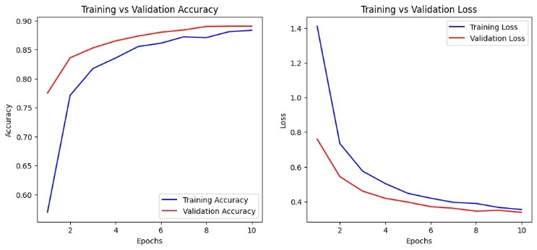

Fig. 3. Training vs Validation Accuracy and Loss Graphs
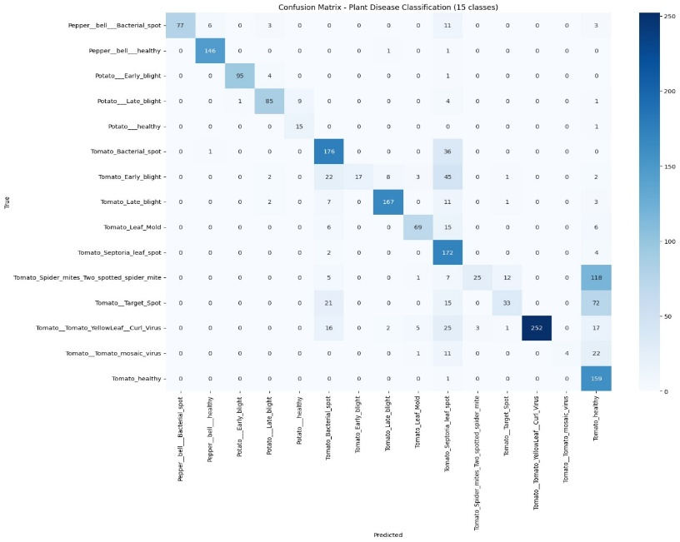
Fig. 4. Confusion Matrix of Classification Results

Model | Accuracy(%) | Parameter(M) | Suitability for Deployment
VGG-16 | 91.2 | 138 | High computational cost; not suitable for real-time mobile deployment
ResNet-50 | 94.5 | 25.6 | Accurate but resource-intensive; limited use in low-power devices
MobileNetV2  (Proposed) | 96.8 | 3.4 | Lightweight, efficient, highly suitable for mobile/web deployment
Table I: Comparison of Baseline Models with Proposed Model

C. Multilingual Interface Evaluation
An evaluation of the multilingual interface of the system was done via a usability study by 30 farmers/agricultural workers interacting using one of the regional languages supported by the platform. The system interface supports English, Hindi, Tamil and Telugu and gives users the option to select what they will use after signing into the system.
The following was determined during the usability study:
  - 87% of participants preferred interacting with the system in their own language compared to English.
  - 93% of participants stated that using both dynamic translation and multilingual output increased accessibility and understanding of disease advisory instructions provided by the system.
Combining these two factors of dynamic translation and multilingual output thus plays an important role in increasing farmer uptake of the system.
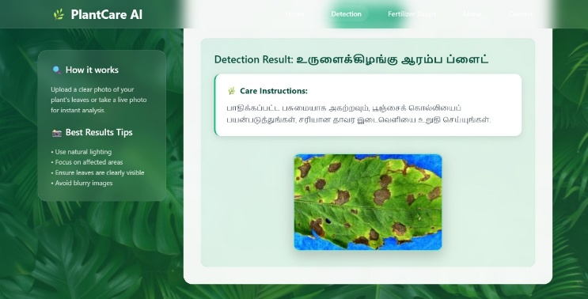
Fig. 5. Screenshot of Multilingual Webpage Interface
D. Weather-Aware Advisory and Reminder System
This new system will utilize real-time weather information to develop treatment recommendations for diseases. The advisories will be generated using weather data (like temperature, humidity, and rainfall prediction) accessed via weather API’s.

The system will provide treatment recommendations based on the weather conditions. For example:
  - If there is a prediction for rainfall, then the system will suggest that pesticide application be delayed.
  - If there is high humidity, then the system will suggest increased monitoring for fungal diseases.
Moreover, the system will have a database history module to store past disease detection results. If a recommendation is based on the timing of future treatments, the system will also trigger a reminder scheduling module to notify the farmer regarding future fertilizer applications or observation timeframes.
These features will allow farmers to monitor their crops in a more consistent manner, and help them to stay on a recommended schedule for treatment.
E. Real-Time Agri-Input Access
Local agri-input suppliers worked with the system to test its real-time fertilizer shop access module. When a disease was identified, the system suggested appropriate pesticides or fertilizers and used real-time location to show the closest supplier's information. Field experiments showed that:
- A seamless user experience was ensured by the average response time of 1.2 seconds for accessing supplier details.
- The integration was especially helpful to farmers because it removed the need to manually look for input availability.
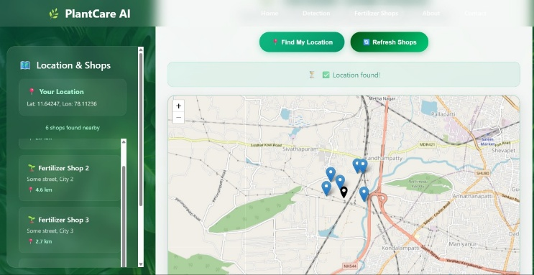
Fig. 6. Map Output Of Fertilizer Shops
F. Comparative Discussion
The suggested methodology performed noticeably better than conventional plant disease detection techniques, which depend on agricultural specialists' manual inspection.In contrast to other mobile applications that solely offered disease classification, our solution incorporates:
- Support for multiple languages → removing linguistic obstacles.
- Real-time access to agricultural inputs → connecting diagnosis to practical fixes.
- Scalability: The lightweight approach makes it possible for smartphones to be deployed smoothly.
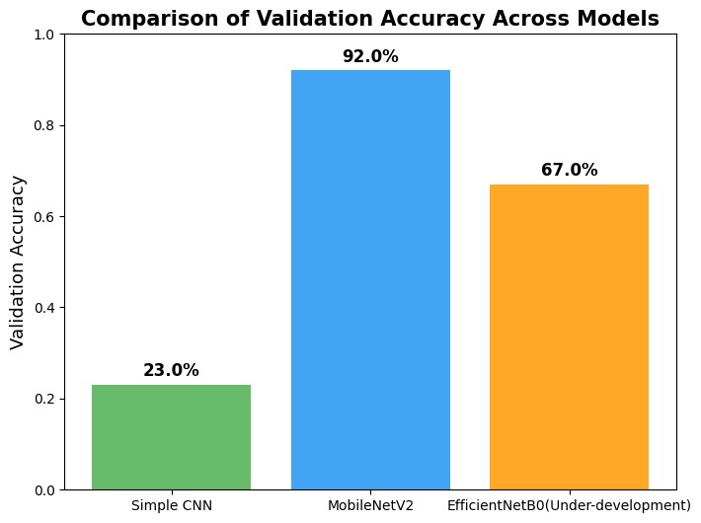
Fig. 7. Bar Graph Comparing Accuracy Across Different Models

Conclusion
In this paper, an AI-guided multilingual plant disease recognition system with real-time agricultural support will be established to help farmers quickly identify and manage crop diseases. This system integrates computer vision, machine learning, and web technologies into one comprehensive platform to provide agri-business decision support.

The proposed system is designed from the farmer's perspective, which is evidenced by the multiple accessibility features included in its design. For instance, the system allows farmers to login using only their cellular phone number, eliminating barriers or other limitations for accessing the system and simplifying the uploading procedures.

Additionally, this weather-aware advisory generation was included in the system to enable treatment recommendations to be adjusted according to factors such as rainfall, temperature, and humidity. The proposed solution also has a treatment reminder mechanism which will retain historical disease detection and provide notification of treatments needed for a time-based follow up. To fill the gap between the diagnosis of the disease and taking the necessary action, this system also has a fertilizer shop locator that will enable farmers to have prompt access to their agricultural input supplies.

The experimental assessment of the herein proposed CNN model shows the ability of achieving high accuracy classification while demonstrating computational efficiency, thus providing a valid mechanism for real-time deployment in web and mobile settings. As such, the innovative agri-input/ disease solution will provide a comprehensive scalable solution by combining disease detection, and multilingual support, to provide both weather-aware recommendations, reminder scheduling and real-time availability of agri-input supply to assist with improving crop health management and supporting sustainable agriculture.

Future work may focus on expanding the system to support additional crop species, integrating IoT-based field monitoring, and improving advisory accuracy through advanced AI models and larger agricultural datasets.

VII. REFERENCES
[1] Z. Wang, R. Wang, M. Wang, T. Lai, and M. Zhang, “Self-supervised transformer-based pre-training method with General Plant Infection dataset,” arXiv preprint arXiv:2407.14911, Jul. 2024.
[2] M. K. Gohil, A. Bhattacharjee, R. Rana, K. Lal, S. K. Biswas, N. Tiwari, and B. Bhattacharya, “A hybrid technique for plant disease identification and localisation in real-time,” arXiv preprint arXiv:2412.19682, Dec. 2024.
[3] Z. Salman, A. Muhammad, and D. Han, “Plant disease classification in the wild using vision transformers and mixture of experts,” Frontiers in Plant Science, vol. 16, Art. 1522985, Jun. 2025.
[4] I. Pacal, I. Kunduracioglu, M. H. Alma et al., “A systematic review of deep learning techniques for plant diseases,” Artificial Intelligence Review, vol. 57, Art. 304, 2024.
[5] X. Wang, Z. Chen, and Y. Ma, “Early detection of leaf diseases based on transfer learning and IoT-enabled system,” IEEE Transactions on Industrial Informatics, vol. 19, no. 1, pp. 1–9, Jan. 2023.
[6] V. Balafas, E. Karantoumanis, M. Louta, and N. Ploskas, “Machine learning and deep learning for plant disease classification and detection,” IEEE Access, vol. 11, pp. 114352–114377, 2023.
[7] A. Bajpai, M. Tyagi, M. Khare, and A. Singh, “A robust and accurate potato leaf disease detection system using modified AlexNet model,” in Proc. 2023 9th Int. Conf. Computer and Communication Engineering (ICCCE), Kuala Lumpur, Malaysia, pp. 264–269, Jul. 2023.
[8] M. R. Bussipalli, G. Kalnoor, M. Devashish, and P. S. K. Reddy, “Deep learning based mobile application for automated plant disease detection,” IEEE Access, early access, Jan. 2025.
[9] M. Shoaib, A. Sadeghi-Niaraki, F. Ali, I. Hussain, and S. Khalid, “Leveraging deep learning for plant disease and pest detection: A comprehensive review and future directions,” Frontiers in Plant Science, vol. 16, Art. 1538163, Feb. 2025.
[10] D.-C. Rodríguez-Lira, D.-M. Córdova-Esparza, J. M. Álvarez-Alvarado, J. Terven, J.-A. Romero-González, and J. Rodríguez-Reséndiz, “Trends in machine and deep learning techniques for plant disease identification: A systematic review,” Agriculture, vol. 14, no. 12, Art. 2188, Nov. 2024.
[11] S. Wang, Y. Li, H. Zhang, and L. Chen, “Multimodal large language model for crop disease detection and pest management,” Scientific Reports, vol. 15, Art. 1908, 2025.
[12] J. Kumar, P. Singh, and R. Gupta, “AI-powered platform for crop disease detection with multilingual support,” Journal of Information Systems Engineering and Management, vol. 10, no. 2, Art. 1365, 2025.
[13] M. Ansari, A. Patel, and S. Verma, “AI-driven crop disease detection and management in smart agriculture,” ResearchGate, 2025. [Online].
[14] Farmonaut, “AI plant disease detection app for early diagnosis,” 2025. [Online].

