Comparative Analysis of Monolithic and Microservice Architectures for Scalable IoT Middleware

- Introduction
The Internet of Things (IoT) ecosystem has witnessed significant growth over recent years, resulting in an extensive network of interconnected devices exchang-
ing real-time data within heterogeneous environments [1]. The effective management of interactions among such diverse devices demands a robust and adaptable middleware layer capable of ensuring seamless com-munication, interoperability, and system scalability [2]. Traditional monolithic middleware architectures, despite being simpler to deploy, usually become less efficient and rigid when they are subjected to large-scale, dynamic IoT scenarios [3]. The systems of these kinds have the tightly coupled components which make it hard for them to be updated, maintained, and scaled horizontally, thus resulting in the occurrence of performance bottlenecks, and reduction of fault tolerance [4].
By contrast, microservices-based architectures have been considered a revolutionary idea for the restructuring of the middleware [5]. The idea behind microservices is the division of the system functionalities into separate services each of which can be independently deployed, and thus this results in higher scalability, modular devel-opment, and fault isolation [6]. However, the issues of latency, synchronization, and communication overhead that are inherent in microservices-based designs may become a new set of problems for middleware of real-time IoT systems to cope with [7].
This research is intended to the design and realization of a middleware architecture for the IoT using Mosquitto to enable secure and scalable communication between IoT devices [8]. The study will assess and compare archi-tectural models Monolithic and Microservices based on scalability, latency, resource utilization, and fault toler-ance. The objective of the study is to get a deeper under-

standing of the trade-offs between these two approaches and to figure out which architectural pattern leads to the best performance in IoT deployments. The outcomes of this investigation are supposed to contribute to the knowledge of the middleware design which is about the trade-off between the aspects of flexibility, performance, and maintainability in the future IoC ecosystems.
The rest of this paper is organized as follows: Section II covers the literature and presents a review of exist-ing IoT middleware frameworks. Section III provides information about system architecture and methodol-ogy adopted in this research. Section IV is about the performance evaluation, and the results are discussed in Section V. System Architecture and methodology adopted in this research paper is shown in Section III, Performance Evaluation is in Section IV and the Section provides the Results.
- LITERATURE REVIEW
The fast growth of the IoT ecosystem was the main reason that,research on middleware systems have been conducted extensively. These systems provide interop-erability, secure communication, and real-time data ex-change. A number of influential papers have underlined that the middleware determines to a large extent the scalability and the performance of IoT deployments ( [1], [2]).
- IoT Middleware Foundations
The growing intricacy of IoT ecosystems that func-tion on scalable network infrastructures has raised the demand for middleware systems that can manage in an efficient manner heterogeneous devices, large-scale connectivity, and real-time data exchange. According to Zanella et al. ( [1]), middleware was recognized as an essential integration layer in smart city infrastructures. This allows the devices to interact without any hurdle and middleware also guarantees communication which is up to the task. Similarly, according to Khan et al. ( [2]), middleware should be able to sustain varying environments, handle fluctuating workloads and provide the necessary flexibility so that the network can adapt to different conditions. Both papers highlight that designing an IoT system in a way that it can scale and adapt is the main requirement.
- Limitations of Monolithic Architectures in IOT
To date monolithic architectures of the old school have been frequently a choice of IoT middleware making use of their easy deployment and simple structure. Neverthe-less, they carry serious disadvantages. According to Li et al. ( [3]) monolithic systems face performance issues
when the number of connected devices increases. In particular, this is a result of tightly coupled components and absence of modular scalability. On top of that, the researchers Kim et al. ( [4]) point out that monolithic middleware is limited in its capability to tolerate faults. If one component is faulty, it can infect the entire system. The publications gives evidence that monolithic architectures are not able to keep up with modern, fast-moving IoT sphere.
- Emergence of Microservices for Distributed IoT Sys-tems
The microservices architectural model has been put under thorough scrutiny as a potential solution for dis-tributed IoT middleware systems. Dragoni et al. ( [5]) have stated that microservices architecture is a good promoter of main features, such as modularity, inde-pendent deployment, and fault isolation. These aspects are life-giving for IoT ecosystems raising. Taibi et al. ( [6]) asserted that microservices improve the mainte-nance and flexibility by decomposing the services and allocating the resources. Although these benefits signal that microservices are more suitable for large-scale IoT environments, the distributed nature of such systems raises some challenges, e.g. communication overhead between services and increased operational complexity.
- Mqtt-Based Middleware and Performance Evaluation
Communication protocols that rely on messages are a major factor in the improvement of middleware. With its facile publish-subscribe architecture MQTT is the prime candidate for a messaging protocol. Singh et al. ( [7]) evaluated microservices and monolithic architectures in terms of MQTT. They concluded that microservices al-low greater scalability, but inter-service communications via messages may increase latency. Mosquitto, a popular MQTT broker, is considered to be a low overhead and dependable solution for resource-constrained environ-ments. But most of the researches currently going on, are only concerned with MQTT performance independently and neglect other parts of the middleware architecture.
- Identified Research Gap
While existing research provides insightful informa-tion on architectural patterns and communication pro-tocols, a significant difference remains. There is no previous research that has fully implemented or eval-uated a complete IoT middleware framework comparing monolithic and microservices architectures with a real-world MQTT broker such as Mosquitto. Present studies either concentrate exclusively on the behavior of proto-cols ( [7], [8]) or discuss architectural concepts without

TABLE I
Gap Analysis of Existing Literature and Contribution of the Proposed Work

Aspect / Research Gap | Zanella et al. | Khan et al. | Li et al. | Dragoni et al. | Singh et al. | Proposed Work (This Paper)
End-to-End IoT Middleware Implemen-  tation | × | × | ✓ | ✓ | ✓ | ✓
Comparison of Monolithic vs Microser-  vices Architecture | × | × | × (Conceptual) | × | - (Limited) | - (Full Experimental)
Use of Real MQTT Broker (Mosquitto) | × | × | × | ×
Controlled Experimental Environment | × | × |  | × | ×
Scalability Evaluation under Increasing  Load | × | - (Theoretical) |  | ×
Latency & Throughput Measurement | × (Theoretical) | × |  | ×
Fault Tolerance Analysis | × | × | × | - (Theoretical) | ×
Unified Architecture + Protocol Evalu-  ation | × | × | × | × | ×

✓= Addressed × = Not Addressed

testing integration of systems ( [5], [6]) . The absence of comprehensive practical experiments underlines the necessity for a more thorough evaluation.
- Contribution of This Study
This research designs and evaluates a complete IoT middleware system using both monolithic and microser-vices models, with the Mosquitto MQTT broker as the communication backbone, in order to close the gap identified above. This work provides a detailed by assessing the performance in terms of scalability, throughput, and fault tolerance. The outcomes are to help the development of the future middleware be led to systems that, among other features, are modular flexible, and can support IoT deployments on a large scale.
- Monolithic Architecture in IoT Systems
Monolithic middleware architectures bring together all the functional parts—data ingestion, processing, storage, and application services—into one single deployable unit. Li et al. ( [3]) proved that, under a small number of deployments, such architectures are able to attain very low latency but performance is significantly impaired as the volume of data rises. Kim et al. ( [4]) added that fault tolerance in monolithic systems is very scarce because the failure of one component can be the reason for the whole middleware operation to stop. All these drawbacks render monolithic architectures unsuitable for the sophisticated IoT scenarios of the present day that encompass a large number of devices.
- Microservices-Based Middleware Approaches
One of the most important reasons why microservices architecture has been so successful and considered as a viable alternative to monolithic design is its modular nature and endless scalability possibilities. Dragoni et al. ( [5]) said that microservices are units that can be deployed independently one from another, thus, they
raise maintainability and fault isolation levels. Taibi et al. ( [6]) evidenced that microservices architectures give the ability to scale only the necessary service(s) and this is extremely useful in cases when IoT workloads are involved because they are often characterized by uneven traffic distribution.
Numerous papers have taken the use of microservices in IoT as the subject of their deep-dives. A. Singh, R. Gupta, and P. Sharma’s ( [7]) comparative study on the topic revealed that microservices have better perfor-mance in terms of scalability and resilience than mono-lithic systems but at the same time, there is additional communication overhead due to them. Despite these benefits, the majority of works are focused on proposing conceptual frameworks rather than actual experimental implementations.

- Communication Protocols and MQTT-Based Middle-ware
Without efficient communication protocols, IoT mid-dleware would be very slow and inefficient. One of the main reasons why MQTT has been so popular is the lightweight publish–subscribe model it implements. Sasaki et al. ( [16]) performed a series of tests to evaluate MQTT under different workloads and concluded that the protocol is appropriate for environments with limited bandwidth and low power consumption. A lightweight and very reliable open-source MQTT broker, Eclipse Mosquitto, has been widely used in real middleware scenarios ( [8]).
However, research work on protocol performance mostly does not take the middleware architecture into account. Very few papers discuss how MQTT differs from one architecture to another, for example, monolithic vs. microservices-based middleware systems.

- Edge-Cloud Integration and Emerging Trends
Another aspect discussed in recent research is the merging of edge computing with IoT middleware to alle-viate the issues of latency and bandwidth consumption. Ouyang et al.( [13]) suggested an IoT platform based on microservices and serverless that allocates workloads between edge and cloud resources in a real-time manner. Similarly, Trilles et al. ( [17]) showed that the combi-nation of microservices and serverless computing could improve scalability while lowering the support required for the infrastructure. Nevertheless, these solutions also come with the disadvantage of added orchestration com-plexity and the limited resources at the edge.
- Methodology
- System Design Overview
The proposed methodology involves developing two functionally identical IoT middleware systems that differ only in their architectural style:
  - Monolithic Architecture – all components deployed as a single integrated unit.
  - Microservices Architecture – functionality decom-posed into independently deployable services.
Both setups use the Mosquitto MQTT borker as the main communication unit because of its light, publish-subscribe architecture, which make it very suitable for real-time IoT environments. Core middleware functions
- device registration, message handling, data processing, and API management - are realized in both schematics to guarantee fairness during the assessment.
- Architectural Implementation
  - Monolithic Middleware Implementation - The monolithic version combines all the components in a single server application.
Main features: One deployment package, shared memory space for communication, centralized ser-vice execution, unified data pipeline for MQTT message flow. The main idea behind this architecture is simple and it has low internal communication overhead but the developers anticipate that it will have issues
  - Microservices Middleware Implementation - The microservices version breaks down the middleware into a set of independent services: DeviceRegistra-tionService, MessageProcessingService, DataStor-ageService, APIGateway, MQTTCommunication-Handler. The services interact with each other through lightweight REST APIs or internal message queues. Any of the services can be independently scaled by containerized deployment (for instance,

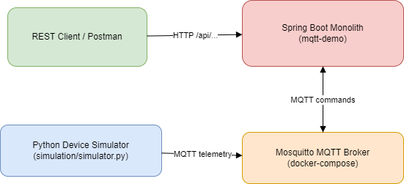

Fig. 1. Monolithic Architecture of IoT Middleware with REST and MQTT Integration

Docker). The design features of this architecture are modularity, distributed execution, and fault isolation.
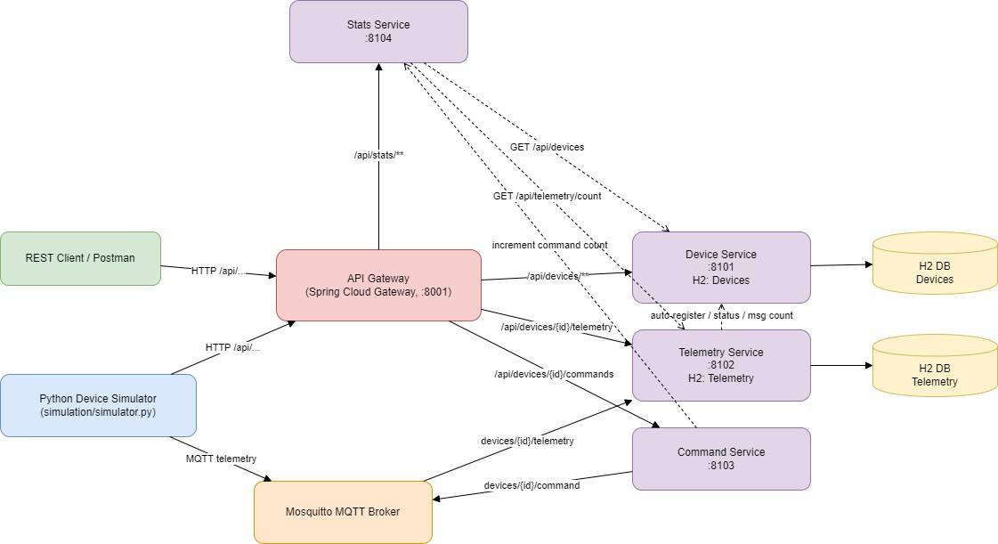
Fig. 2. Microservice Architecture of IoT Middleware with REST and MQTT Integration

- Integration of MQTT Using Mosquitto Broker
The MQTT communication layer is standardized to maintain experimental consistency, for both architec-tures.
Steps:
  - Configure Mosquitto as the MQTT broker.
  - Connect IoT publisher clients to send sensor data periodically.
  - Connect subscriber components within the middle-ware to receive and process messages.
  - Maintain identical QoS settings, message frequency, and payload structure across both architectures.
This ensures that any performance differences arise from architecture, not protocol variations.
- Experimental Setup
Hardware/Software Environment - Both systems are deployed under identical conditions: Same server hard-ware i.e. Hp victus Intel i5 12450H, 512 SSD 16 GB RAM, NVIDIA Geforce GTX 1650 4GB, Intel UHD

Graphics, Same operating system environment i.e. Win-dows 11, Same MQTT message rate and device, Same resource constraints (CPU, RAM limits).

- Performance Metrics
The following quantitative metrics are measured- Met-ric Description Purpose: Throughput Number of mes-sages processed per second Indicates system efficiency, CPU and Memory Utilization Resource usage during operation Evaluates efficiency and load-handling, Scal-ability Behavior Ability to maintain performance as devices increase Determines architecture suitability at scale, Fault Tolerance System behavior under partial failure Measures robustness. These metrics are recorded using python scripts.

- Data Collection And Analysis
Every test scenario is repeated several times to confirm the reliability of the results. The outcomes are recorded in a uniform manner with the help of automated scripts. Comparative graphs/tables are created from the aggre-gated data. Statistical analysis methods (mean, trend evaluation) are used. The results are interpreted in terms of: Design effects, System limitations, Real-world IoT needs. The purpose is to generate unbiased, evidence-driven understanding of the interaction of monolithic and micorservices middleware systems. The goal is to pro-duce objective, evidence-based insights into the behavior of monolithic and microservices middleware systems.

- RESULT

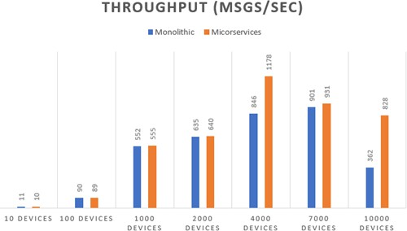

Fig. 3. Graphical Comparison of throughput(msg/sec) between Monolithic and Microservice Architectures

B. Key Findings
- Scalability Advantage (4,000+ devices) - Microservices significantly outperforms monolithic at scale: - 4,000 devices: 39% higher throughput (1,178 vs 846 msg/s) - 10,000 devices: 129% higher throughput (828 vs 362 msg/s) - Message process-ing: 69% more messages at 10K scale (1.5M vs 0.9M).
Analysis: Monolithic architecture shows severe degradation at 10,000 devices, with throughput dropping 60% from 7K to 10K scale. Microservices maintains consistent performance.
- Memory Efficiency Microservices uses 85-97% less memory across all scales.

TABLE III
Monolithic vs Microservices Memory Usage Comparsion

Scale Monolithic Memory Microservices Memory Reduction

A. Test Results Overview | 10  100 | 52 MB  57 MB | 38 MB  41 MB | 27%  28%
 | 1,000 | 109 MB | 43 MB | 70%
 | 2,000 | 279 MB | 46 MB | 88%
TABLE II | 4,000 | 493 MB | 50 MB | 93%
Monolithic vs Microservice Architecture Performance | 7,000 | 1,402 MB | 53 MB | 97%
Comparison Table | 10,000 | 2,133 MB | 58 MB | 97%

Scale Architecture Throughput(msg/sec) Total Messages Sent 10 devices Monolithic 11. 406
 | Microservice | 10 | 411
100 devices | Monolithic | 90 | 7,177
 | Microservice | 89 | 7,146
1,000 devices | Monolithic | 552 | 328,273
 | Microservice | 555 | 331,755
2,000 devices | Monolithic | 635 | 431,854
 | Microservice | 640 | 418,361
4,000 devices | Monolithic | 846 | 1,054,411
 | Microservice | 1,178 | 1,498,212
7,000 devices | Monolithic | 901 | 1,195,886
 | Microservice | 9301 | 1,749,353
10,000 devices | Monolithic | 362 | 913,493

Analysis: Monolithic memory grows exponentially (41x increase), while microservices memory grows linearly (1.5x increase). This demonstrates better resource utilization in microservices.

- Performance Degradation Patterns -
Monolithic Architecture: Stable up to 2,000 devices, Degradation begins at 4,000 devices, Severe degra-dation at 10,000 devices (60% throughput drop), Memory exhaustion at high scales.
Microservice 828 1,547,150 Microservices Architecture: Consistent performance
across all scales, No significant degradation ob-

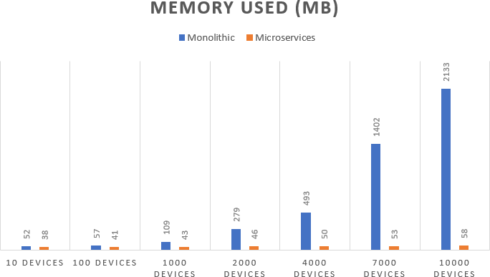

Fig. 4. Graphical Comparison of Memory Used(MB) between Monolithic and Microservice Architectures

served, Linear memory growth, Better resource management.
- DISCUSSION
- Important Contribution and Investigations
The IoT middleware based on microservices architec-ture has a performance advantage over the monolithic one in several aspects such as delivering more stable real, time MQTT processing even under a high load, enabling easier scalability by allowing the scaling of individual services, and providing better fault tolerance by isolating the failures so that they do not bring the entire system down.
- Key Insights of Microservices over Monolithic Archi-tecture
In this study, microservices received a strong endorse-ment as a result of providing better modularity, flexi-bility, efficiency, and reliability compared to monolithic architecture.
- Limitations and Challenges
Even though the results are very promising, there are still some issues with microservices. For example, they might increase the communication delay when the system is heavily loaded, and the security risks are also likely to go up because the attack surface becomes big-ger. Additionally, edge, cloud workload balancing would become more complex. On top of that, microservices might put too much load on low, resource edge devices and this could be solved with better optimization and the use of lightweight alternatives such as serverless/FaaS.
- Future Directions
The present study opens up a number of possibilities for further research:
  - Enhanced Fault Tolerance: One idea is to develop self-healing services that can detect their failure patterns and fix themselves without human interven-tion.
  - Improving IoT Edge Efficiency: IoT edge devices can be equipped with lightweight microservices or WASM-based modules that will make them perform better and have less overhead.
  - Strengthened Security Frameworks: The implemen-tation of different security measure, such as de-centralized identity management, zero-trust service communication, and the use of strong encryption mechanisms, is among the most powerful methods of enhancing the security of base layer systems.
References
- A. Zanella, N. Bui, A. Castellani, L. Vangelista, and M. Zorzi, “Internet of Things for Smart Cities,” IEEE Internet of Things Journal, vol. 1, no. 1, pp. 22–32, 2014.
- JR. Khan, S. U. Khan, R. Zaheer, and S. Khan, “Future Internet: The Internet of Things Architecture,” IEEE Communications Magazine, vol. 50, no. 5, pp. 66–72, 2012.
- X. Li, R. Lu, X. Liang, and X. Shen, “Challenges in IoT Middleware,” Journal of Systems Architecture, vol. 88, pp. 53–64, 2018.
- Y. Kim, M. Park, and J. Kim, “Scalability Issues in Monolithic IoT Middleware,” IEEE Access, vol. 8, pp. 125300–125312, 2020.
- N. Dragoni, S. Giallorenzo, A. Lluch Lafuente, M. Mazzara, F. Montesi,
R. Mustafin, and L. Safina, “Microservices: Yesterday, Today, and Tomorrow,” in Present and Ulterior Software Engineeribing. Cham, Switzerland: Springer, 2017, pp. 195–216.
- R. Taibi and A. Lenarduzzi, Patterns for Microservices Architectures. Cham, Switzerland: Springer, 2018.
- A. Singh, R. Gupta, and P. Sharma, “Performance Comparison of Monolithic and Microservice Architectures for IoT,” in Proc. IEEE ICICCT, Ghaziabad, India, 2021, pp. 492–498.
- Eclipse Foundation, “Mosquitto: An Open Source MQTT Broker,” 2024. [Online]. Available: https://mosquitto.org/Mosquitto Offical Page
- M. K. Verma, A. Kumar, and R. Singh, “A Systematic Review of IoT Middleware Frameworks,” Advances in Intelligent Systems Research, Atlantis Press, 2021.
- V. Seoane, J. C. Garc´ıa, and D. F. Llorente, “Performance Evaluation of CoAP and MQTT with Security,” Computer Networks, vol. 196, pp. 108269, 2021.
- D. Taibi, V. Lenarduzzi, and C. Pahl, “From Monolithic Systems to Microservices: A Comparative Study of Performance,” IEEE Cloud Computing, vol. 4, no. 6, pp. 12–20, 2017.
- A. Pahlavan, M. Rashid, and A. Hussain, “A Comparative Study of Microservices-Based IoT Platforms,” International Journal of Advanced Computer Science and Applications, vol. 11, no. 8, pp. 402–410, 2020.
- R. Ouyang, L. Wang, Y. Zhang, and H. Chen, “A Microservice and Serverless Architecture for Secure IoT,” Sensors, vol. 23, no. 10, pp. 4868, 2023.
- M. Al-Shdifat, M. Al-Sarayreh, and A. Bsoul, “Edge Computing Archi-tectures for Cloud-Based IoT Middleware Platforms,” Journal of Cloud Computing, 2022.
- A. Al-Fuqaha, M.Guizani, M. Mohammadi, M. Aledhari, and M. Ayyash, ”Middleware Solutions for the Internet of Things : A Survey,” IEEE Comminications Surveys & Tutorials, vol. 17, no. 4, pp.2343-2381, 2015.
- Y. Sasaki, T. Kurokawa, and H. Otsuka, “Performance Evaluation of MQTT as a Communication Protocol,” International Journal of Com-puter Applications, vol. 157, no. 6, pp. 1–6, 2017.
- S. Trilles, J. Torres-Sospedra, R. Montoliu, and J. Huerta, “An IoT Platform Based on Microservices and Serverless Paradigms for Smart Farming,” Sensors, vol. 20, no. 8, pp. 2418, 2020.
- M. K. Aydin and H. Demir, “Experiences and Considerations on Perfor-mance Test of MQTT,” Turkish Journal of Computer and Mathematics Education, vol. 12, no. 6, pp. 1345–1352, 2021.

- A. Rahman, M. Hasan, and S. Ahmed, “An Efficient Microservice-Based Middleware Architecture for IoT (MSMIoT),” International Journal of Computer Science and Network Security (IJCSNS), vol. 22, no. 9, pp. 90–98, 2022.
- S. Kumar and P. Verma, “Performance Monitoring of MQTT-Based Messaging Server,” Journal of Library and Information Science Studies, vol. 9, no. 1, pp. 58–65, 2022.

