GRIT AND EMOTIONAL INTELLIGENCE IN RELATION TO JOB SATISFACTION AMONG SCHOOL TEACHERS: A CONCEPTUAL ANALYSIS
Surakshitha¹, Eshwar²
¹ III B.Sc Psychology
² Assistant Professor
Department of Psychology, Rathinam College of Arts and Science,
Coimbatore, Tamil Nadu, India
Abstract
Teaching is widely regarded as a profession that demands sustained emotional involvement, perseverance, and psychological resilience. Job satisfaction among school teachers is a critical determinant of teaching effectiveness, professional commitment, and psychological well-being. In the contemporary educational context, teachers face increasing emotional labour, workload pressures, and institutional demands, which often contribute to stress, burnout, and reduced satisfaction at work. Consequently, identifying internal psychological resources that promote job satisfaction has become essential.This conceptual paper explores grit and emotional intelligence as two vital psychological constructs that contribute to job satisfaction among school teachers. Grit, characterized by perseverance and passion toward long-term goals, supports sustained professional engagement despite challenges. Emotional intelligence, encompassing the ability to perceive, understand, and regulate emotions, enables teachers to manage classroom stress, maintain positive relationships, and adapt to emotionally demanding situations. By synthesizing existing theoretical perspectives and empirical insights, this paper presents a conceptual understanding of how grit and emotional intelligence independently and jointly foster job satisfaction. The paper emphasizes the importance of cultivating these traits through teacher education and institutional support to enhance teacher well-being and professional fulfillment.
Keywords: Grit, Emotional Intelligence, Job Satisfaction, School Teachers, Psychological Well-being

1. Introduction
Teaching is frequently described as one of the most emotionally demanding professions, requiring patience, adaptability, empathy, and sustained commitment. School teachers are not only responsible for academic instruction but also for managing classroom behavior, addressing students’ emotional needs, engaging with parents, and complying with institutional expectations (Partington, 2010). These multifaceted responsibilities often lead to emotional exhaustion, occupational stress, and diminished job satisfaction.
Job satisfaction refers to the extent to which individuals feel contented and fulfilled in their professional roles. For teachers, job satisfaction is closely linked to motivation, instructional quality, psychological health, and long-term commitment to the profession. When teachers experience low job satisfaction, the consequences may include burnout, absenteeism, and attrition, ultimately affecting the quality of education.
Recent psychological perspectives emphasize the role of internal personal resources in shaping occupational experiences. Among these, grit and emotional intelligence have gained increasing attention for their potential to enhance teachers’ ability to cope with professional challenges. Understanding how these psychological qualities contribute to job satisfaction provides valuable insights into promoting teacher well-being and sustainability in the profession.

2. Conceptual Understanding of Key Constructs
2.1 Grit
Grit is defined as perseverance and passion for long-term goals (Duckworth et al., 2007). It reflects an individual’s capacity to sustain effort and maintain interest over time despite obstacles, setbacks, or slow progress. In the teaching profession, grit enables educators to remain committed to their roles even in the face of heavy workloads, limited resources, and systemic challenges.
Teachers with high levels of grit are more likely to view challenges as opportunities for growth rather than as deterrents. This sustained engagement fosters a sense of purpose, professional identity, and achievement, which are fundamental components of job satisfaction.

2.2 Emotional Intelligence
Emotional intelligence refers to the ability to perceive, understand, manage, and regulate one’s own emotions as well as the emotions of others (Salovey & Mayer, 1990). In educational contexts, emotional intelligence is essential for managing classroom dynamics, responding empathetically to students, and maintaining constructive relationships with colleagues and parents.
Emotionally intelligent teachers are better equipped to cope with stress, regulate negative emotions, and create supportive learning environments. These emotional competencies contribute to positive work experiences and enhance feelings of professional fulfillment and satisfaction.

3. Job Satisfaction in the Teaching Profession
Job satisfaction among teachers encompasses emotional, cognitive, and behavioral components related to their professional roles. It is influenced by factors such as work environment, recognition, autonomy, interpersonal relationships, and personal meaning derived from teaching.
Given the emotionally demanding nature of teaching, job satisfaction is closely linked to teachers’ psychological coping capacities. Personal traits that enhance resilience, emotional regulation, and sustained motivation play a crucial role in determining how teachers perceive and experience their work.

4. Conceptual Relationship Between Grit, Emotional Intelligence, and Job Satisfaction
From a conceptual perspective, grit and emotional intelligence can be understood as complementary psychological resources that contribute to job satisfaction among school teachers.
Grit provides the motivational foundation that encourages teachers to persist in their professional roles over time. It supports long-term commitment, goal orientation, and perseverance, even when immediate rewards are limited. Emotional intelligence, on the other hand, facilitates adaptive emotional functioning by enabling teachers to manage stress, regulate emotions, and maintain positive social interactions.
Together, grit and emotional intelligence create a synergistic effect: grit sustains effort and purpose, while emotional intelligence ensures emotional balance and effective coping. This combination enhances teachers’ capacity to experience fulfillment, meaning, and satisfaction in their work.
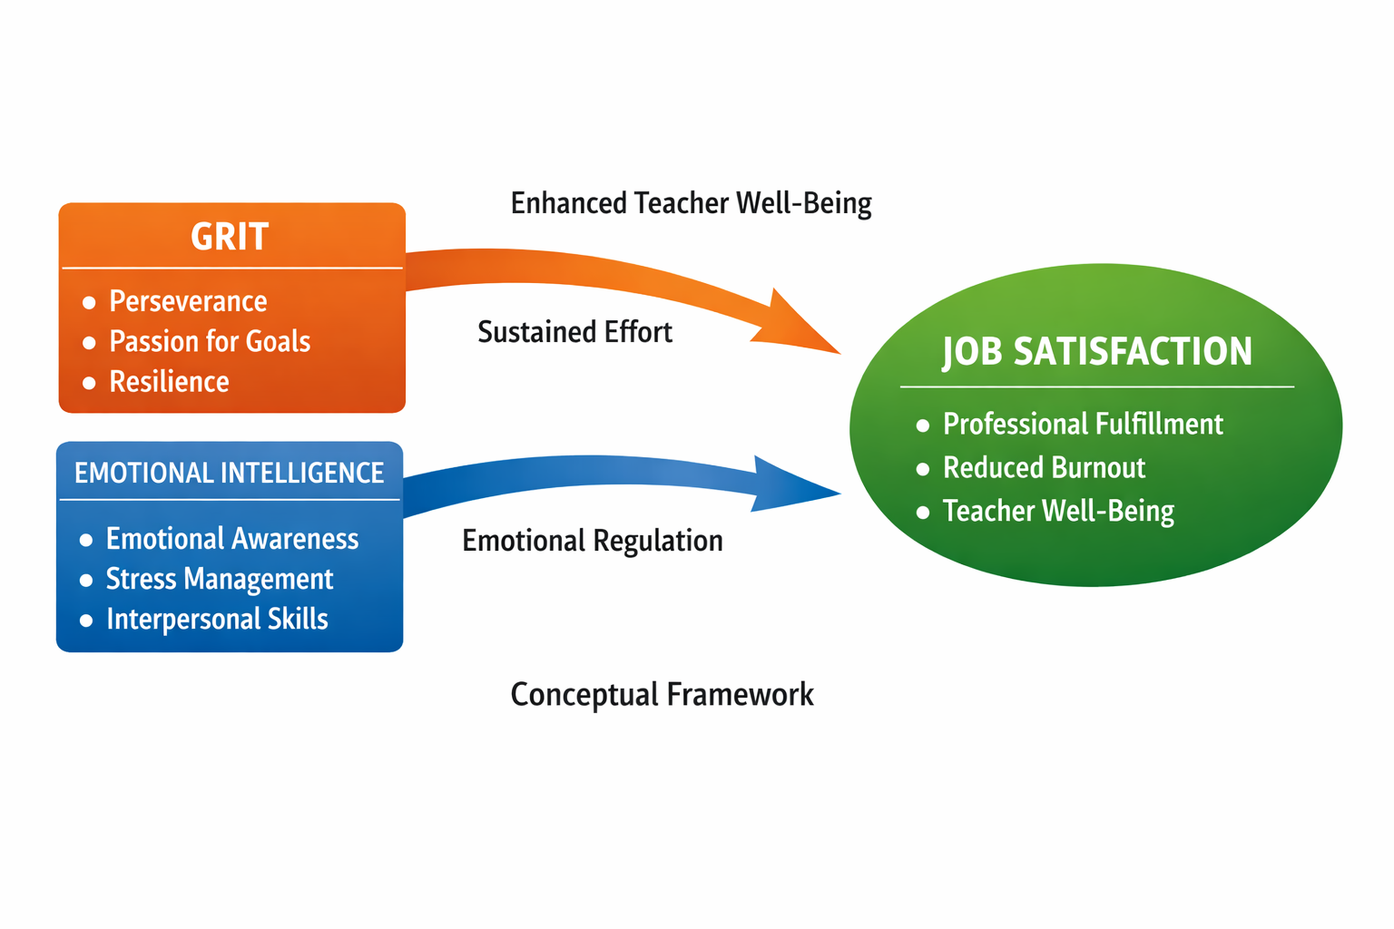

5. Application on Teacher Development and Educational Practice
Recognizing grit and emotional intelligence as essential psychological resources has important implications for teacher education and professional development. Teacher training programs may benefit from incorporating components that foster perseverance, emotional awareness, and emotion regulation skills.Institutional support systems that promote emotional well-being, reflective practices, and resilience-building initiatives can further enhance job satisfaction. By nurturing these internal qualities, educational institutions can contribute to healthier, more satisfied, and more committed teaching professionals.

6. Conclusion
This conceptual analysis highlights grit and emotional intelligence as fundamental psychological attributes that contribute to job satisfaction among school teachers. Teaching, as an emotionally demanding profession, requires both sustained perseverance and effective emotional regulation. Grit enables teachers to remain committed to long-term professional goals, while emotional intelligence supports adaptive coping and positive interpersonal relationships.By fostering these qualities through teacher education, institutional policies, and supportive work environments, it is possible to enhance teacher well-being, reduce burnout, and promote long-term professional satisfaction. Future research may build upon this conceptual framework to further explore the mechanisms through which these traits influence teachers’ occupational experiences.

7. Implications
This conceptual paper highlights grit and emotional intelligence as important psychological resources that contribute to teachers’ job satisfaction. Teacher education and professional development programs may incorporate training that promotes perseverance, emotional awareness, and emotion regulation to enhance teacher well-being. School administrators may also use this framework to design supportive environments that acknowledge the emotional demands of teaching. Additionally, the proposed framework offers a theoretical base for future research on teacher satisfaction and resilience.

8.Limitations
The study is conceptual in nature and does not include empirical data to validate the proposed relationships. It focuses primarily on individual psychological traits and does not consider organizational or contextual factors influencing job satisfaction. Cultural differences across educational settings are also not addressed. Future studies may empirically test and expand the framework across diverse contexts.

References
Brackett, M. A., Palomera, R., Mojsa-Kaja, J., Reyes, M. R., & Salovey, P. (2010). Emotion-regulation ability, burnout, and job satisfaction among teachers. Psychology in the Schools, 47(4), 406–417.
Chan, D. W. (2006). Emotional intelligence and components of burnout among Chinese secondary school teachers. Teaching and Teacher Education, 22(8), 1042–1054.
Duckworth, A. L., Peterson, C., Matthews, M. D., & Kelly, D. R. (2007). Grit: Perseverance and passion for long-term goals. Journal of Personality and Social Psychology, 92(6), 1087–1101.
Goleman, D. (1995). Emotional intelligence. New York: Bantam Books.
Robertson-Kraft, C., & Duckworth, A. L. (2014). True grit: Perseverance and passion predict teache reffectiveness and retention. Teachers College Record, 116(3), 1–27.
Salovey, P., & Mayer, J. D. (1990). Emotional intelligence. Imagination, Cognition and Personality, 9(3), 185–211.

