Hand Gesture Control System for Robotic Hand Using Computer Vision
¹M. AISHWARYA,²T.K. Yogeshwarn, ³N.R. Chandru
¹Assistant professor, Dept of EEE, Fatima Michael College of Engg & Tech
²UG sudent, Dept of EEE, Fatima Michael College of Engg & Tech
³UG sudent, Dept of EEE, Fatima Michael College of Engg & Tech

Abstract - Human–machine interction plays an important role in modern industrial automation systems. In many industrial environments, operators are required to interact directly with machines through switches, buttons, and control panels. In hazardous environments such as chemical plants, radioactive facilities, and high-voltage power stations, this direct interaction may expose operators to serious safety risks. This paper presents a computer vision–based hand gesture control system that enables contactless interaction with machines. The proposed system uses a camera to capture hand gestures, which are processed using Python with OpenCV and MediaPipe libraries. The system detects hand landmarks and interprets gestures in real time. The recognized gesture is converted into control signals and transmitted to an Arduino microcontroller through serial communication. The Arduino generates PWM signals to control servo motors connected to a robotic hand mechanism that replicates the user’s gesture. The developed prototype demonstrates the feasibility of integrating artificial intelligence and embedded systems for safer human–machine interaction in industrial environments.
Keywords - Hand Gesture Recognition, Computer Vision, OpenCV, MediaPipe, Arduino, Human Machine Interface.

Introduction
Industrial automation systems rely heavily on human–machine interaction for monitoring and controlling equipment. Conventional control systems commonly use mechanical switches, push buttons, and touch-based human–machine interfaces (HMIs). Although these systems provide reliable and precise control, they require direct physical interaction between operators and machines. In hazardous environments such as chemical processing plants, nuclear facilities, and high-voltage electrical stations, direct interaction may expose workers to dangerous substances, toxic gases, or electrical hazards.
Recent advancements in artificial intelligence and computer vision have enabled the development of gesture-based control systems that allow users to interact with machines using natural body movements. Hand gesture recognition is an important technique in computer vision that enables machines to understand human gestures through image processing algorithms. Gesture-based interfaces provide a contactless and intuitive method of interaction that can improve safety and usability.
This research proposes a vision-based hand gesture control system capable of controlling a robotic hand using computer vision techniques and embedded hardware. The system captures hand gestures using a camera, processes them using OpenCV and MediaPipe, and transmits control signals to an Arduino microcontroller to actuate servo motors.

II. Existing System
Traditional industrial control systems rely on mechanical switches, push buttons, and touch-based control panels to operate machinery. These systems have been widely used in industries due to their reliability, accuracy, and predictable performance. Operators interact with these interfaces to send commands to control units such as programmable logic controllers (PLCs) or relay-based systems. The control unit processes the input signals and activates actuators such as motors, valves, or relays.
Despite their reliability, traditional control interfaces require direct physical interaction between the operator and the machine. In hazardous environments, such as chemical plants or power generation facilities, this interaction may expose operators to dangerous substances or unsafe working conditions. Therefore, there is a need for alternative control mechanisms that allow operators to control machines without physical contact.

III. Proposed System
To address the limitations of traditional control systems, a vision-based gesture recognition system is proposed. The system enables users to control a robotic hand using hand gestures detected through computer vision techniques. A camera captures real-time video frames of the user’s hand. These frames are processed using the OpenCV library for image processing and the Media Pipe framework for hand landmark detection.
The Media Pipe model detects multiple landmarks on the hand and determines the position of fingers and joints. Based on these landmarks, the system identifies specific gestures performed by the user. Once a gesture is recognized, the system converts it into a digital command that is transmitted to an Arduino microcontroller through serial communication.
The Arduino receives the gesture command and generates pulse width modulation (PWM) signals to control servo motors attached to the robotic hand mechanism. Each servo motor controls the movement of a finger in the robotic hand. As a result, the robotic hand mimics the gesture performed by the user, demonstrating a contactless method for controlling robotic systems
Fig. 1. System Architecture of the Proposed Hand Gesture Control System

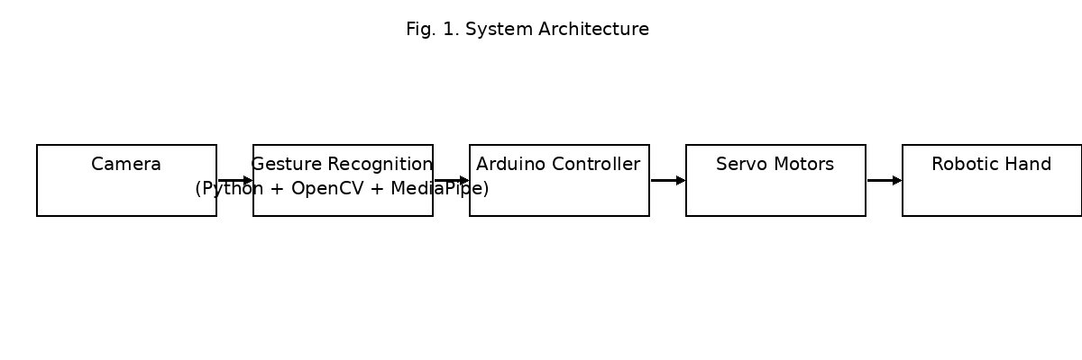IV. Methodology

The proposed system operates through a sequence of image processing and control operations. Initially, the camera captures real-time video frames of the user’s hand. The captured frames are preprocessed to improve detection accuracy by resizing the image and reducing noise. The MediaPipe library is then used to detect hand landmarks and track the position of fingers in each frame.
Based on the detected landmarks, the system analyzes finger positions to determine the gesture performed by the user. Once a valid gesture is detected, the system generates a corresponding control signal in the form of numerical data. This data is transmitted to the Arduino microcontroller through serial communication.
The Arduino program receives the gesture data and maps it to appropriate PWM signals. These signals drive the servo motors connected to the robotic hand mechanism. Each servo motor controls a specific finger, allowing the robotic hand to replicate the user’s gesture. The process continues continuously to detect new gestures in real time.

II. Fig. 2. Hand Gesture Recognition using MediaPipe
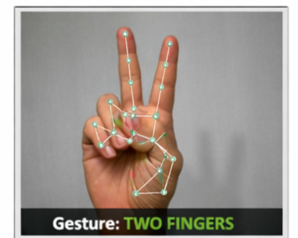

V. Hardware and Software Implementation
The proposed hand gesture control system integrates both hardware and software components to achieve real-time gesture recognition and robotic hand control. The hardware setup mainly consists of an Arduino UNO microcontroller, servo motors, a robotic hand mechanism, and a camera used for capturing hand gestures. The Arduino UNO acts as the main control unit responsible for receiving gesture commands and generating appropriate signals to drive the servo motors. Servo motors are used for finger actuation in the robotic hand. Each servo motor is connected to a finger mechanism of the robotic hand, allowing the system to mimic human hand movements.
A standard webcam or laptop camera is used to capture real-time video frames of the user’s hand gestures. These frames are transmitted to the computer where the gesture recognition algorithm processes the images. The camera plays a crucial role in capturing high-quality visual data that enables accurate gesture detection.
On the software side, the system is developed using the Python programming language due to its strong support for computer vision and machine learning libraries. The OpenCV library is used for image processing tasks such as capturing video frames, resizing images, and performing basic pre-processing operations. The MediaPipe framework is used for detecting hand landmarks and tracking finger positions in real time. MediaPipe provides a pre-trained hand tracking model capable of identifying multiple key points on the human hand.
Once a gesture is recognized by the software, the corresponding control data is transmitted to the Arduino microcontroller through serial communication. The Arduino program, written using Embedded C in the Arduino IDE environment, interprets the received command and generates pulse width modulation (PWM) signals. These PWM signals control the rotation angle of the servo motors connected to the robotic hand, enabling the robotic hand to replicate the gesture performed by the user

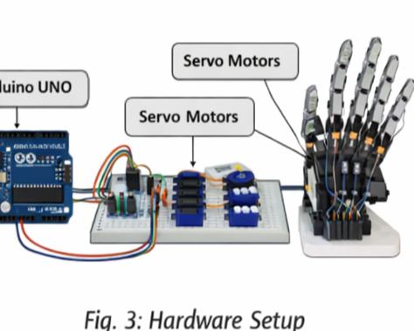

VI. System Architecture and Implementation Details
The overall architecture of the proposed hand gesture control system consists of three major modules: gesture acquisition, gesture processing, and robotic actuation. These modules work together to achieve real-time hand gesture recognition and robotic hand movement replication. The gesture acquisition module captures the user’s hand gestures through a camera, which continuously records video frames during system operation. These frames are transmitted to the computer where the gesture recognition algorithm processes the visual data. The accuracy of gesture detection largely depends on the quality of captured frames, lighting conditions, and camera positioning.
The gesture processing module performs several computer vision operations to identify the gesture performed by the user. Initially, each captured frame is converted into a format suitable for processing using the OpenCV library. Image preprocessing operations such as resizing, color conversion, and noise reduction are performed to improve detection accuracy. After preprocessing, the MediaPipe framework is used to detect hand landmarks. MediaPipe provides a machine learning-based hand tracking model that identifies 21 key points on the human hand. These key points represent important finger joints and palm locations that allow the system to understand the orientation and position of the hand.
Once the hand landmarks are detected, the system analyzes the relative positions of the fingers to determine the gesture performed by the user. For example, when all fingers are extended, the system recognizes an open-hand gesture. When all fingers are folded, the system interprets the gesture as a closed fist. Similarly, when two fingers are extended while others remain folded, the system identifies a two-finger gesture. These gestures are mapped to specific control commands that correspond to the movement of the robotic hand.
The recognized gesture is converted into digital control signals and transmitted to the Arduino microcontroller through serial communication. The communication between the computer and the microcontroller is achieved using a serial port interface. The Python program sends encoded data representing the detected gesture, which is then received by the Arduino microcontroller. The Arduino program interprets this data and determines the appropriate motor control signals required to replicate the gesture.
The robotic actuation module is responsible for converting the digital control commands into physical movement of the robotic hand. Servo motors are used to control the movement of individual fingers. Each servo motor is connected to a specific finger mechanism in the robotic hand. The Arduino microcontroller generates pulse width modulation (PWM) signals that determine the angular position of each servo motor. By adjusting the PWM signal, the servo motor rotates to a desired angle, thereby moving the finger of the robotic hand.
The integration of these modules allows the system to perform gesture recognition and robotic control in real time. The entire process—from gesture detection to robotic movement—occurs within a short time interval, enabling smooth and responsive interaction between the user and the robotic hand. This architecture demonstrates the effectiveness of combining computer vision algorithms with embedded systems to create an intuitive and contactless human–machine interface.

VII. Experimental Setup
To evaluate the performance of the proposed system, a prototype experimental setup was developed using commonly available hardware and software components. The system was implemented on a computer running Python, where the OpenCV and MediaPipe libraries were used for gesture detection and processing. A standard webcam was used to capture hand gestures, while an Arduino UNO microcontroller controlled the robotic hand mechanism through servo motors.
During experimentation, different hand gestures were performed in front of the camera to test the system’s recognition capability. The system successfully detected the hand landmarks and classified gestures in real time. The recognized gestures were transmitted to the Arduino microcontroller, which generated appropriate PWM signals to control the servo motors. The robotic hand replicated the gestures performed by the user, demonstrating the effectiveness of the system in translating visual gestures into physical robotic movement.
The experimental setup confirms that the proposed system is capable of achieving real-time gesture recognition and robotic actuation with minimal delay. The results indicate that the combination of computer vision techniques and embedded systems can provide an efficient and reliable approach for gesture-based control applications.

VIII. Results and Discussion
The developed prototype was tested under different lighting conditions and hand positions to evaluate the performance of the gesture recognition system. The MediaPipe hand tracking model successfully detected hand landmarks in real time and provided accurate finger position data. The system was capable of recognizing common gestures such as open hand, closed fist, and two-finger gestures with reliable accuracy.
Experimental results demonstrated that the recognized gestures were correctly transmitted to the Arduino microcontroller through serial communication. The Arduino successfully generated PWM signals corresponding to each gesture command. As a result, the servo motors controlling the robotic hand responded appropriately and reproduced the user’s gestures.
The response time of the system was found to be sufficiently fast for real-time interaction. The use of optimized computer vision libraries such as OpenCV and MediaPipe contributed to efficient image processing and gesture detection. The results confirm that the proposed system can provide an effective contactless control mechanism suitable for applications in industrial automation and human–machine interaction.
However, certain limitations were observed during testing. Variations in lighting conditions and camera positioning can affect gesture detection accuracy. Additionally, the current system operates as an open-loop control system without feedback sensors in the robotic hand. Future improvements may include incorporating machine learning techniques for more advanced gesture recognition and integrating feedback sensors to improve control precision.

IX.Conclusion
This paper presented the design and implementation of a vision-based hand gesture control system for robotic applications. The proposed system combines computer vision techniques with embedded hardware to enable real-time gesture recognition and robotic hand actuation. By utilizing Python, OpenCV, MediaPipe, and Arduino technologies, the system demonstrates a practical approach for contactless human–machine interaction.
The developed prototype successfully detects hand gestures using a camera and converts them into control commands that drive servo motors connected to a robotic hand mechanism. The system reduces the need for direct physical interaction with control interfaces and therefore improves operator safety in hazardous environments such as chemical processing plants and high-voltage facilities.
Future work may focus on improving gesture classification accuracy using advanced machine learning models and extending the system for controlling industrial robots or automated machinery. The integration of additional sensors and feedback mechanisms can further enhance system reliability and performance.
XI. References
[1] J. Qi, L. Ma, Z. Cui, and Y. Yu, “Computer vision-based hand gesture recognition for human–robot interaction: A review,” Complex & Intelligent Systems, 2023.
[2] H. H. Li, “Dynamic Hand Gesture Recognition Using MediaPipe and Transformer Model,” MDPI Engineering Proceedings, vol.108, no.1, 2025.
[3] M. Altayeb, “Hand Gestures Replicating Robot Arm Based on MediaPipe,” International Journal of Electrical Engineering and Informatics, 2023.
[4] S. Chavan et al., “Real-Time Hand Gesture Recognition Based Control of Arduino Robot,” International Journal of Trend in Scientific Research and Development, vol.6, no.4, pp.79-83, 2022.
[5] A. S. Amirtha Varshini et al., “Real-Time Hand Gesture Recognition for Robotic Arm Control,” ACM International Conference Proceedings, 2021.
[6] I. Darmawan et al., “Hand Gesture Recognition for Collaborative Robots Using Lightweight Deep Learning Models,” arXiv, 2025.
[7] V. Chaudhari, P. Mhatre, and J. Bind, “Hand Gesture Control Robot Using Arduino,” VIVA-Tech International Journal for Research and Innovation, 2024.
[8] A. Ahmed et al., “Tracked Robot Control with Hand Gesture Based on MediaPipe,” ResearchGate Technical Paper, 2024.
[9] M. Oudah et al., “Hand Gesture Recognition Based on Computer Vision: A Review,” Sensors Journal, 2020.
[10] “Real-Time Robotic Hand Interaction Control Using MediaPipe for Gesture-Based Applications,” Robotics Research Article, 2025.

