- Introduction
Women’s micro-enterprises have become an important component of local economic development in India. Built around self-help groups (SHGs), this initiative have enabled many women from low-income households to engage in micro-enterprise activities, including food processing, handicrafts, fabrics and household products (Deininger & Liu, 2013).
In Keralam, the Kudumbashree Mission has played a significant role in supporting such initiatives by providing organisational platforms, entrepreneurial training and access to start-up capital (Devika & Thampi, 2007). While many women have been able to initiate micro-enterprises through these efforts, securing regular market access continues to be a major challenge. This results in limited market access, confining sales to immediate local circles (John, 2009; Chandrasekar, 2014; Sulaiman, 2014).
Recognising this gap between production and marketing, Kudumbashree introduced the ‘Home Shop model’ as an alternative distribution arrangement (Kudumbashree Mission, n.d-a, n.d-b). This creates a structured link between women producers and consumers, through a community-based retail network, rather than expecting each producer to market independently.
This paper presents an evaluative case study of the ‘Home Shop’ under Kudumbashree. The study examines the distribution system, the scale of sales facilitated through the network, and the value and income opportunities shared within the producer–retail system. Overall, the study highlights the role that community-based intermediary systems can play in strengthening market linkages for women-led micro-enterprises.
- Literature Review
Literature on SHG-linked women’s entrepreneurship increasingly notes that enterprise sustainability depends on the systems that connect small producers to markets. Research on small-scale entrepreneurship frequently points out that production capabilities alone are not sufficient; access to markets, reliable distribution channels and stable consumer demand are equally critical in determining whether micro-enterprises survive beyond their initial stages (Alvarez & Barney, 2014). Evidence from Keralam also suggests that enterprise sustainability is shaped not only by production capability, but also by market connections and competitiveness-related practices such as customer retention and branding (Chacko et al., 2024).
Marketing requires time, mobility and social networks, which are not always easily available to women operating home-based or neighbourhood units. For women, this means balancing production activities, procurement of raw materials and household responsibilities alongside the task of finding customers. In many micro-scale production settings, the producer is also expected to handle sales and marketing. This constraint is commonly discussed in the literature as a ‘marketing trap’. The marketing trap refers to a situation where small producers, operating with limited capital and managerial bandwidth, are forced to handle sales, marketing and distribution in order to sustain their business (Ministry of Micro, Small and Medium Enterprises, 2017). As a result, products are often sold only within limited local circles, during occasional exhibitions, or through irregular orders (Minniti, 2010; Kannan & Raveendran, 2026).
Studies also discuss these constraints in terms of value chains and market linkages. Works on value chains argue that dispersed small producers face high transaction costs when they attempt to access markets individually. In the absence of aggregation, standardisation and distribution support, producers face limited market reach, unpredictable demand and weak bargaining power (Kaplinsky & Morris, 2001).
Scholarships on producer-market linkages similarly note that marketing systems and distribution infrastructure are central to enabling small producers to reach stable consumer markets, especially when enterprises are geographically scattered (Shepherd, 2007). It shows that the key gap is the lack of coordinated distribution systems that connect producers and consumers.
Many scholars point to ‘social intermediation’ as a way to address these gaps. Emerged from the micro-finance field, the term refers to investments in institutional capacity, skills and collective organisation that help marginalised groups participate more effectively in economic systems (Bennett, 1992; Edgcomb & Barton, 1998). In market and enterprise settings, this idea is used to explain how intermediary institutions can connect dispersed producers to markets by coordinating transactions and easing the marketing burden carried by individual entrepreneurs (Kistruck et al., 2013). Such intermediary institutions act as a bridge between small producers and markets through coordination, aggregation and marketing support. They also reduce transaction costs and manage key logistical functions on behalf of producers.
While themes like social intermediation, and operational models that separate production from marketing are well discussed in the global literature, there is limited case-based evidence from India. Studies on women’s entrepreneurship in Keralam, particularly within the Kudumbashree framework, mainly focus on institutional mechanisms and broader empowerment outcomes. Much of this literature highlights Kudumbashree’s strengths in social mobilisation, credit access and group-based enterprise promotion. However, the role of community-based distribution networks in strengthening market linkages and sustaining women-led micro-enterprises remains underexplored. This study responds to this gap by examining the ‘Home Shop model’ as a practical form of social intermediation for women’s market access.
- Objectives of the Study
This paper examines the ‘Home Shop model’ under Kudumbashree as a community-based distribution mechanism addressing the ‘marketing trap’ faced by women-led micro-enterprises. The specific objectives are:
- To document the evolution and operational functioning of the Home Shop model under Kudumbashree.
- To examine the scale and performance of the Home Shop network across eight selected districts in Keralam.
- To understand how the ‘Home Shop model’ supports market access and livelihood opportunities for women-led micro-enterprises and the local retail network of Home Shop Owners.

- Methodology
This paper adopts an evaluative case study approach to examine the ‘Home Shop model’. The analysis is descriptive and focuses on how the community-based distribution network functions and the economic scale it has achieved. The study covers eight districts in Keralam, namely, Thiruvananthapuram, Kollam, Kottayam, Idukki, Thrissur, Malappuram, Kozhikode, and Kannur, selected primarily based on the availability of current programme data at the state level.
On the quantitative side, data were extracted from Kudumbashree’s administrative records, programme management information systems (MIS) and district-level sales data available with Kudumbashree district missions for the year 2025. The dataset includes indicators such as blocks covered, number of women micro-enterprises linked to the network, number of products marketed, number of Home Shop Owners engaged, and average monthly sales turnover. The analysis uses simple descriptive statistics and comparative profiling to examine district-wise variations.
The paper also draws on key informant interviews (KIIs) and focus group discussions (FGDs) with Home Shop Management Unit members, Home Shop Owners, women micro-enterprises and Kudumbashree officials, undertaken between December 2025 to February, 2026. It included seven key informant interviews (KIIs) - one with a state-level Kudumbashree official, three with district-level Kudumbashree officials (one each from three districts), and three with Home Shop Management Unit (HSMU) representatives (one each from three districts). In addition, four group discussions (FGDs) were conducted - two in North Keralam and two in South Keralam with Home Shop Owners and women micro-entrepreneurs. These qualitative inputs are used mainly to document the evolution of the model and to clarify the operational processes. Given the nature of available information, the study offers a case study of the Home Shop model as a community-based intermediary system for strengthening market access for women-led micro-enterprises.
- Findings
5.1 Evolution and Functioning of the Home Shop Model
This sub-section summarises qualitative findings from KIIs and FGDs, focusing on the model’s evolution and operational functioning.
5.1.1 Origin and evolution
From the KIIs and FGDs, a fairly clear story emerged about why the Home Shop model was taken up. In the early years, Kudumbashree relied heavily on event-based marketing like monthly markets, fairs, and festival exhibitions, to help women-led micro-enterprises sell their products. These platforms created visibility and helped producers gain confidence. However, many respondents pointed out a basic limitation that exhibitions are temporary. They do not solve the everyday problem of selling products consistently. Several producers recalled that sales often dropped sharply once the exhibition or festival season ended, leading to irregular cash flows and uncertainty in production.
Against this backdrop, Kudumbashree moved towards building more regular distribution channels. Stakeholders noted that the State already had practical community marketing experiences, especially doorstep selling and local consumer networks, which showed that local demand could be organised if there was a reliable system. Kudumbashree formalised this approach through the ‘Home Shop model’ and initiated it in Kozhikode in 2010, later replicating it in Kannur and expanding it further to all districts.
Respondents also linked the idea to the wider context of local development in the State. After the ‘People’s Plan Campaign’, gram panchayats and Kudumbashree began experimenting more actively with local economic development. In that period, local movements that encouraged people to use locally produced goods, supported by organisations such as the ‘Keralam Sasthra Sahithya Parishad’, which helped strengthen the wider acceptance of ‘local products for local consumption’. The ‘Home Shop model’ fits into this context because it offers a routine channel for local products, rather than relying on fairs, festivals, and occasional bulk orders.
A key informant interview also referred to the early experience from Koyilandy in Kozhikode district, where regular doorstep selling reportedly resulted in repeat purchases from the same neighbourhood households. The informant noted that this trust-based selling approach encouraged replication and later scaling up, including the expansion to Kannur and other districts (P. Kaithakkal, KII/personal communication, January, 2026). (The interview also highlighted Mr. Prasad Kaithakkal’s role in conceptualising and operationalising the ‘Home Shop model’ in Kozhikode and in supporting orientation and replication in other districts.
5.1.2 Operational structure and role clarity
Participants described the Home Shop system as a distribution arrangement that separates production from retail outreach. In simple terms, it operates through three linked roles.
Production layer (women-led micro-enterprises): Micro-enterprises supply the products. Producers emphasised that a key advantage of the model is that they are not required to spend their time travelling and selling. This allows them to focus more on production continuity, procurement planning, and product quality.
Intermediary layer (Home Shop Management Unit - HSMU): The HSMU was described as the unit that makes the system run on a day-to-day basis. In most districts, it functions as a small team (often around five members) that coordinates procurement, aggregates products from multiple units, supports basic quality checks, facilitates packaging improvements where needed, manages storage and transport, and ensures products reach the retail network on time.
Retail layer (Home Shop Owners / Home Shoppers): Home Shop Owners sell the products within their neighbourhoods. They typically rely on household visits, local contacts and Kudumbashree platforms such as NHG meetings. Many also keep small stocks at home so that nearby households can purchase items easily when needed.
5.1.3 Selection of micro-enterprises and supply readiness
Respondents explained that micro-enterprises are not selected randomly. The selection of enterprises is undertaken by the HSMU in consultation with the district mission, following a transparent process. KIIs indicated that supply readiness matters, especially product quality, consistency of production and the ability to meet regular demand cycles. This was seen as important because consumer trust depends on reliability of supply as much as on product quality.
5.1.4 Value addition and logistics at the HSMU level
A recurring point from the qualitative discussions was that the HSMU adds value by taking on functions that are difficult for individual enterprises to manage otherwise. This includes coordinating supply from multiple producers, storage, arranging transportation and maintaining basic quality assurance. Stakeholders repeatedly mentioned that consistent packaging, proper labelling and routine quality checks matter because many products are repeat-purchase items. Households are more likely to buy regularly when they feel confident about quality and presentation. Interviewees referred to the use of dedicated storage space (including warehouse facilities) and goods carrier vehicles to maintain supply across the district. In some districts, community facilitators were also described as field-level links who support stock points, help consolidate orders, and assist Home Shop Owners during routine operations.
5.1.5 Sales through Home Shop Owners and relationship marketing
FGDs with Home Shop Owners highlighted that selling is closely tied to local relationships. Buyers often prefer to purchase from familiar women in the neighbourhood, and doorstep access makes routine buying easier. Respondents also reported that informal credit is common in some localities, especially where transactions are trust-based and repeated.
Another point that came through strongly is that customer base building takes time. Home Shop Owners noted that sales improve when fast-moving essentials are available consistently. Once households start depending on the system for routine items, selling shifts from occasional purchases to repeat consumption-based buying.
Stakeholders also noted that some early-performing districts such as Kozhikode and Kannur used additional support measures to strengthen motivation and retention of Home Shoppers. Respondents referred to support such as uniforms, group insurance, facilitation of two-wheeler loans, educational scholarships for children and festival allowances as part of HSMU’s efforts to keep the retail network active.
5.1.6 Order cycles, feedback loop, and performance drivers
Operationally, respondents described the Home Shop system as working through periodic order and replenishment cycles. Demand signals gathered by Home Shop Owners are consolidated and used to plan procurement and distribution. A feedback loop was repeatedly mentioned. Home Shop Owners convey customer preferences and complaints during review meetings or routine interactions, and this information is used to adjust product mix, packaging and quality.
Participants also pointed out that district performance depends greatly on how many Home Shop Owners remain active. Even in districts with large registered networks, sales may be concentrated among a smaller active segment, which affects average per-seller outcomes. Respondents also highlighted the importance of local institutional support from Kudumbashree community based network, and in some cases, support from local governments in sustaining mobilisation, coordination and trust in the system.
5.1.7 Revenue-sharing arrangement and product basket
Respondents repeatedly referred to the revenue-sharing arrangement as an important part of the model’s functioning. As per operational guidelines, a small share of turnover is retained by the HSMU for coordination and distribution costs. Home Shop Owners receive a retail margin for last-mile selling and customer servicing, while the largest share accrues to the supplying micro-enterprises as producer realisation. The guideline framework specifies 5% to 10% retention for the HSMU, a micro-enterprise share of 60% to 70%, and a Home Shop Owner margin in the range of 20-30%, depending on product categories and local operational conditions. (For district-level comparability, this paper uses 5% for HSMU retention, 30% for the Home Shop Owner margin, and 65% as the micro-enterprise share, based on guidelines ranges, midpoint values and local practices).
The product basket described by stakeholders covers routine household essentials and non-farm products, including bathing soap, detergent powder, washing soap, floor cleaners, curry powders, spice powders, pickles, flours, snacks, dental and health care products, fabrics, and beauty products.
Several participants brought out a wider intent behind the Home Shop approach. They framed it as a way to strengthen local production-consumption linkages by promoting Kudumbashree products as viable alternatives to corporate FMCG brands. They also stressed that the model performs best when there is a supportive consumer culture for local products and when households begin to treat locally produced items as part of everyday consumption.
5.2 District-level performance patterns
This section presents the key findings from the district-level administrative and sales data for 2025.
5.2.1 District-level coverage and network scale
The Home Shop network shows wide variation in scale across districts, both on the producer side (micro-enterprises) and the retail side (Home Shop Owners). District-level coverage and network scale is given below.
Table 1
District-level coverage and network scale
District | Number of blocks covered in the Homeshop Network | No. of MEs | Number of kudumbashree products selling through Homeshop | No. of Home Shop Owners
Thiruvananthapuram | 10 | 66 | 91 | 54
Kollam | 4 | 28 | 66 | 36
Kottayam | 10 | 104 | 188 | 446
Idukki | 5 | 78 | 238 | 176
Thrissur | 6 | 36 | 65 | 156
Malappuram | 11 | 71 | 86 | 1059
Kozhikode | 12 | 46 | 124 | 888
Kannur | 11 | 22 | 69 | 440
Source: Compiled from MIS
Kottayam has the largest ME base (104), indicating relatively broad producer participation compared to other districts. In contrast, Malappuram and Kozhikode have the largest Home Shop Owner networks (1,059 and 888, respectively), suggesting deeper retail outreach. Idukki records the widest product basket (238), indicating stronger product diversity within the network.
Overall, the district profile suggests that network strength is shaped by a mix of coverage, product basket, and retail intensity rather than any single factor. Notably, a large retail network does not necessarily require a proportionally large producer base: Kozhikode supports 888 retailers with only 46 micro-enterprises, pointing to concentrated, high-volume production at the enterprise level.
5.2.2 Economic scale of the Home Shop network
The network operates at a meaningful economic scale, but turnover is highly concentrated across districts. Economic scale of the Home Shop network given in Table 2 below.
Table 2
Economic scale of the Home Shop network
Rank | District | Grouping | Avg. monthly turnover 2025 (Rs.) | Share of total (%) | Cumulative share (%)
1 | Kozhikode | High | 6,05,13,312 | 45.14 | 45.14
2 | Malappuram | High | 3,10,49,923 | 23.16 | 68.29
3 | Kannur | Medium | 1,44,23,694 | 10.76 | 79.05
4 | Kottayam | Medium | 1,05,00,062 | 7.83 | 86.88
5 | Idukki | Medium | 79,23,747 | 5.91 | 92.79
6 | Kollam | Medium | 54,94,030 | 4.1 | 96.89
7 | Thrissur | Emerging | 23,33,326 | 1.74 | 98.63
8 | Thiruvananthapuram | Emerging | 18,33,647 | 1.37 | 100
Source: Compiled from MIS and sales data
Kozhikode (Rs.6.05 crore) and Malappuram (Rs.3.10 crore) together contribute about 68% of the combined turnover across the eight districts, indicating two mature, high-volume ecosystems. The next tier - Kannur, Kottayam, Idukki, and Kollam forms a ‘medium’ group and accounts for much of the remaining turnover. Thrissur and Thiruvananthapuram fall into an emerging category, showing comparatively low turnover despite the presence of the network. Overall, the model appears highly adaptable, scaling from emerging operations generating roughly Rs.18 lakh per month (Thiruvananthapuram) to high-performing ecosystems generating over Rs.6 crore per month (Kozhikode). This uneven distribution suggests that the model has moved beyond pilot scale, but market depth and maturity differ sharply across districts.
5.2.3 Monthly Turnover and Product Diversity
High product diversity does not inherently translate into higher aggregate sales volumes. Monthly Turnover and Product Diversity is shown below.
Table 3
Monthly Turnover and Product Diversity
District | Number of kudumbashree products selling through Homeshop | Avg monthly turnover in year 2025 (Rs.)
Thiruvananthapuram | 91 | 18,33,647
Kollam | 66 | 54,94,030
Kottayam | 188 | 1,05,00,062
Idukki | 238 | 79,23,747
Thrissur | 65 | 23,33,326
Malappuram | 86 | 3,10,49,923
Kozhikode | 124 | 6,05,13,312
Kannur | 69 | 1,44,23,694
Source: Compiled from MIS and sales data
Idukki (238 products) and Kottayam (188 products) have large product baskets, yet their turnover remains below the top-performing districts, indicating that market penetration and retail productivity matter as much as product range. Kozhikode combines both scale and variety (Rs.6.05 crore turnover with 124 products), suggesting a stronger balance between supply and market absorption. Malappuram records high turnover despite a smaller product basket (86 products), pointing to the role of sales volume and network reach rather than product count alone. Overall, the pattern suggests that the distribution network performs best when it focuses on a streamlined and optimised inventory of fast-moving daily consumables (such as curry powders, milled flours, and cleaning supplies) rather than an overextended catalogue of niche items.
5.2.4 Value Distribution Across the Supply Chain
The financial architecture of the Home Shop model retains most of the economic value within the local women-led ecosystem, with 95% of turnover flowing beyond the HSMU layer and circulating between producers and the decentralised retail network.
Table 4
Value Distribution Across the Supply Chain
District | Avg monthly turnover 2025 (Rs.) | HSMU retention 5% (Rs.) | Home Shop Owners share 30% (Rs.) | Micro-enterprises share 65% (Rs.)
Thiruvananthapuram | 18,33,647 | 91,682 | 5,50,094 | 11,91,871
Kollam | 54,94,030 | 2,74,702 | 16,48,209 | 35,71,120
Kottayam | 1,05,00,062 | 5,25,003 | 31,50,019 | 68,25,040
Idukki | 79,23,747 | 3,96,187 | 23,77,124 | 51,50,436
Thrissur | 23,33,326 | 1,16,666 | 6,99,998 | 15,16,662
Malappuram | 3,10,49,923 | 15,52,496 | 93,14,977 | 2,01,82,450
Kozhikode | 6,05,13,312 | 30,25,666 | 1,81,53,994 | 3,93,33,653
Kannur | 1,44,23,694 | 7,21,185 | 43,27,108 | 93,75,401
Source: Compiled from MIS and sales data
The HSMU retains a small share (5%) to meet coordination and distribution costs, while the major flows remain within the women-led supply chain. The micro-enterprise layer receives the largest share (65%) across districts, reflecting the model’s primary intent of strengthening producer market realisation. The Home Shop Owner share (30%) provides a meaningful retail incentive, although district-level outcomes per seller depend heavily on overall turnover and the intensity of active selling. Notably, high-turnover districts such as Kozhikode and Malappuram generate the largest absolute value flows to both micro-enterprises and Home Shop Owners, underlining the importance of scale for livelihood outcomes. Overall, the structure allows micro-enterprises to retain the majority share for cost recovery and enterprise margins, while the retail commission provides a sustained incentive for last-mile selling and continued market penetration.
5.2.5 Livelihood intensity for Home Shop Owners (average monthly HSO share per HSO)
The Home Shop network creates livelihood opportunities for women who function as Home Shoppers or decentralised retailers within their neighbourhoods. However, seller-side value varies widely across districts, reflecting different levels of market maturity. Table 5 below describes the livelihood intensity for Home Shop Owners.
Table 5
Livelihood intensity for Home Shop Owners
Rank | District | No. of Home Shop Owners | Avg. monthly HSO share per HSO (Rs.) | Pattern note
1 | Kollam | 36 | 45,784 | Small network, very high intensity
2 | Kozhikode | 888 | 20,444 | Large network, high intensity
3 | Idukki | 176 | 13,506 | Moderate network, good intensity
4 | Thiruvananthapuram | 54 | 10,187 | Small network, moderate intensity
5 | Kannur | 440 | 9,834 | Large network, moderate intensity
6 | Malappuram | 1,059 | 8,796 | Very wide network, thinner average sales
7 | Kottayam | 446 | 7,063 | Wide network, low-to-moderate intensity
8 | Thrissur | 156 | 4,487 | Low intensity (risk of weak incentives)
Source: Compiled from MIS and sales data
Based on the guideline-based allocation used in this analysis, average monthly value per Home Shop Owner ranges from relatively modest levels (around Rs.7,000-Rs.10,000 in some districts) to much higher levels in stronger-performing systems (above Rs.20,000 and up to about Rs.45,000). Kollam (Rs.45,784 per HSO) stands out with very high per-seller value, likely influenced by a small HSO base (36) and higher concentration of sales among active sellers. Kozhikode (Rs.20,444) and Idukki (Rs.13,506) also show stronger seller-side intensity, indicating better livelihood potential for active Home Shop Owners. Kozhikode reflects a notable balance, sustaining a large retail workforce (888 HSOs) while maintaining relatively high per-seller value, whereas Malappuram’s wide network (1,059 HSOs) generates a more moderate per-HSO value (Rs.8,796), suggesting a “wide but thin” pattern where sales may be spread across many sellers. Thrissur (Rs.4,487) and Kottayam (Rs.7,063) show comparatively low per-HSO values, which may weaken incentives and increase the risk of attrition unless sales volumes rise.
Overall, the ranking reinforces two broad patterns: high-intensity models (such as Kollam and Kozhikode) that deliver higher per-HSO value, and wide-but-thin models (such as Malappuram and Kottayam) where scale in numbers does not translate into stronger average value per seller. This matters for sustainability because seller incentives are closely linked to retention, and low per-HSO value can become a constraint over time, often pointing to operational issues such as lower sales intensity, limited demand or weaker product–market fit.
5.2.6 Producer-side market access intensity (women micro-enterprises)
Producer-side intensity differs sharply across districts, indicating that the Home Shop model supports market access in different ways depending on district maturity and procurement patterns. Producer-side market access intensity is depicted in Table 6 below.
Table 6
Producer-side market access intensity
Rank | District | No. of MEs | Avg. monthly ME share per ME (Rs.) | Interpretation note
1 | Kozhikode | 46 | 8,55,079 | Very high per-ME realisation (intensive procurement)
2 | Kannur | 22 | 4,26,155 | High per-ME realisation (concentrated supply base)
3 | Malappuram | 71 | 2,84,260 | High per-ME realisation (strong market access for active MEs)
4 | Kollam | 28 | 1,27,540 | Moderate-to-high per-ME realisation (smaller ME base)
5 | Idukki | 78 | 66,031 | Moderate per-ME realisation (broader distribution)
6 | Kottayam | 104 | 65,625 | Moderate per-ME realisation (broad producer participation)
7 | Thrissur | 36 | 42,129 | Lower per-ME realisation (dispersed benefit / lower scale)
8 | Thiruvananthapuram | 66 | 18,059 | Low per-ME realisation (emerging procurement linkages)
Source: Compiled from MIS and sales data
In high-performing districts such as Kozhikode and Kannur, the average monthly micro-enterprise realisation per unit reaches Rs.8.55 lakh and Rs.4.26 lakh, respectively, suggesting more intensive procurement from a smaller set of supplying enterprises and a shift towards concentrated, higher-volume production among active units. Malappuram also shows strong producer-side market access for active enterprises, with an average of about Rs.2.84 lakh per ME. In contrast, Kottayam and Idukki (around Rs.65-66 thousand per ME) reflect more moderate per-unit realisation, consistent with turnover being distributed across a larger ME base. Overall, the model appears capable of improving producer market realisation, but the pattern varies: some districts exhibit high intensity for active suppliers, while others show broader participation with thinner average realisation per enterprise.
The ranking also indicates that market access gains are strongest in a few districts - Kozhikode, Kannur, and Malappuram, where procurement linkages appear more regular and higher in volume, whereas Thiruvananthapuram and Thrissur show lower per-ME values, pointing to early-stage or weaker procurement intensity. By delegating marketing and sales functions to the HSMU and the decentralised retail network, the model reduces the marketing burden on producers and can support higher production scale, although outcomes depend on how effectively the distribution system converts network coverage into sustained sales volume.
5.3 Key performance patterns and district typology
Across the eight districts, the Home Shop data point to distinct operational patterns that help interpret how the model addresses the ‘marketing trap’ through structured social intermediation.
- Kozhikode reflects a high-turnover, higher-intensity pattern, where both seller-side and producer-side realisations are strong, suggesting a more mature distribution ecosystem.
- Malappuram represents a high-turnover, wide-network pattern, combining large overall turnover with a very large Home Shop Owner base and moderate average value per seller.
- Kottayam and Idukki show a moderate-turnover, broader producer/product-base pattern, with relatively higher ME participation and product diversity, though average per-unit realisations remain moderate.
- Kannur reflects a medium-turnover, high producer-intensity pattern, with high per-ME realisation despite a smaller ME base, indicating concentrated procurement from active enterprises.
- Thiruvananthapuram and Thrissur fall into an emerging pattern with lower turnover and lower intensity, suggesting that market depth is still developing.
Taken together, these patterns suggest that Home Shop functions as a practical form of social intermediation by separating marketing from production and creating a community retail layer. However, the extent to which this intermediation translates into stable livelihoods and producer realisation depends on district-level market maturity, seller productivity and the depth of consumer demand.
- Discussion
The Kudumbashree ‘Home Shop model’ is best understood as a three-tier community distribution arrangement that separates production from marketing. Women-led micro-enterprises form the production base, supplying a basket of household products. A Home Shop Management Unit (HSMU) performs the intermediary functions, like procurement, basic quality and packaging support, storage and movement of goods, and coordination across the network. The retail layer is formed by Home Shop Owners, who take products to neighbourhood households and use local networks, including SHG meetings, to reach consumers.
This functional separation reduces the marketing burden of micro-enterprises, which otherwise need to spend time and resources on selling and customer outreach. Instead, enterprises can concentrate more on production continuity and quality. The model also draws strength from relationship-based local marketing. Home Shop Owners are community members who sell within familiar neighbourhood settings, which helps build trust, repeat purchases, and, in many cases, informal credit-based transactions. These features are consistent with the idea of social intermediation, where community-level institutions bridge the gap between dispersed producers and consumer markets through trust and coordination.
- Limitations
This evaluative case study is based on programme MIS, district-level administrative records, and a limited set of KIIs and FGDs. As a result, the analysis is primarily descriptive and does not attempt causal attribution or impact estimation.
- Policy implications
The findings suggest that enterprise promotion programmes should treat distribution architecture as a core support rather than an optional add-on. Livelihood missions across the country have traditionally emphasised credit and training, but market access often remains the binding constraint for women-led micro-enterprises. Strengthening intermediary units like the HSMU through operational funding, logistics support, and routine performance monitoring can improve the viability of community-based distribution networks. The Home Shop experience also indicates a potential pathway for replication under programmes such as DAY-NRLM particularly in States with dispersed women producers and weak last-mile channels. However, replication would require local adaptation, including product selection aligned to local demand, quality and packaging support and seller activation strategies.
- Conclusion
This evaluative case study shows that structured community-based distribution can reduce the marketing burden faced by women-led micro-enterprises. By organising last-mile retail through an intermediary system, the Home Shop model strengthens market linkages and creates new livelihood opportunities within the producer-retail network. The Home Shop model offers a practical, adaptable approach for strengthening women’s enterprise sustainability through social intermediation, with relevance for other states seeking to institutionalise market access mechanisms under livelihood missions.
Acknowledgements:
The authors thank the Kudumbashree State Mission for facilitating access to programme information and field-level inputs, including the administrative and MIS records used in this study. We are grateful to the officials of Kudumbashree State and District Missions, Home Shop Management Units (HSMUs), Home Shop Owners and women micro-enterprise representatives who participated in the key informant interviews and group discussions and shared their operational experiences.
References
Alvarez, S. A., & Barney, J. B. (2014). Entrepreneurial opportunities and poverty alleviation. Entrepreneurship theory and practice, 38(1), 159-184.
Bennett, L. (1996). Social Intermediation: Building systems and skills for sustainable financial intermediation with the Poor. In Washington, DC: The World Banks Sustainable Banking with the Poor project, Rural Finance Seminar: May (Vol. 1).
Chacko, A., Narayanan, A., & Boraian, M. P. (2024). A study on the ‘Year of Enterprises 1.0’ campaign of Keralam State. Humanities and Social Science Studies, 13(2), 49–54.
Chandrasekar, K. S. (2014). A study on the marketing effectiveness of selected successful women micro and small enterprises in Keralam. Keralam Institute of Labour and Employment, Trivandrum.
Deininger, K., & Liu, Y. (2013). Economic and social impacts of an innovative self-help group model in India. World Development, 43, 149-163.
Devika, J., & Thampi, B. V. (2007). Between ‘Empowerment’and ‘Liberation’ The Kudumbashree Initiative in Keralam. Indian Journal of Gender Studies, 14(1), 33-60.
Edgcomb, E., & Barton, L. (1998). Social intermediation and microfinance programs: A literature review. Bethesda: Microenterprise Best Practices.
Garg, S., & Agarwal, P. (2017). Micro, small and medium enterprises in India: A review of growth and challenges in the present scenario. International Journal of Applied Business and Economic Research, 15(4), 579-590.
John, J. (2009). Kudumbashree project A Poverty Eradication Programme in Keralam. New Delhi: Planning Commission of India, GOI.
Kannan, K. P., & Raveendran, G. (2026). Poverty, Women and Capability: A Study of the Impact of Keralam’s Kudumbashree System. In Women and Work in India: Challenges, Opportunities and Perspectives for Policy (pp. 539-562). Singapore: Springer Nature Singapore.
Kaplinsky, R., & Morris, M. (2000). A handbook for value chain research (Vol. 113). Brighton: University of Sussex, Institute of Development Studies.
Kistruck, G. M., Beamish, P. W., Qureshi, I., & Sutter, C. J. (2013). Social intermediation in base‐of‐the‐pyramid markets. Journal of Management Studies, 50(1), 31-66.
Kudumbashree Mission. (n.d-a). Home shop. https://www.kudumbashree.org/pages/512
Kudumbashree Mission. (n.d.-b). Sales and marketing. https://kudumbashreestory.in/index.php/programmes/economic-empowerment/enterprises/sales-and-marketing
Local Self Government Department, Government of Keralam. (2021). Home shop project progressing with good growth.
https://lsgKeralam.gov.in/en/kudumbashree/news/home-shop-project-progressing-good-growth
Minniti, M. (2010). Female entrepreneurship and economic activity. The European Journal of Development Research, 22(3), 294-312.
Ministry of Micro, Small and Medium Enterprises. (2017). Report of the One Man Committee constituted to make recommendations for National Policy for Micro, Small and Medium Enterprises. Government of India.
Rajan, S., & Panicker, S. (2016). Still a long way to go: Literature review of the issues of the phenomenal struggle of women's entrepreneurs in MSMEs. IOSR Journal of Business and Management, 18(11), 1-20.
Shepherd, A. W. (2007). Approaches to linking producers to markets: A review of experiences to date (Agricultural Management, Marketing and Finance Occasional Paper No. 13). Food and Agriculture Organization of the United Nations (FAO).
Sulaiman, E. K. (2014). Women empowerment through micro-enterprises: An empirical analysis of kudumbashree units in Keralam. Journal of Rural and Industrial Development, 2(1), 1.

Annexure A.
Photographic documentation of the Home Shop model
This annexure provides a small set of photographs to visually document key operational features of the Home Shop model, including last-mile retailing by Home Shop Owners and the typical product basket marketed through the network. The figures are included as supplementary evidence to support the qualitative description of model functioning. The photographs are sourced from Kudumbashree programme materials and public communications and are reproduced here with permission and due acknowledgement.
Figure 1. Home Shop Owner demonstrating products to neighbourhood customers (field documentation, 2025).
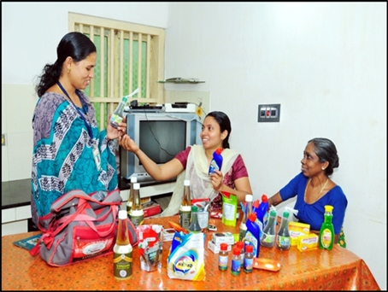
Figure 2. Home Shop Owner carrying product kit for neighbourhood outreach (field documentation, 2025).
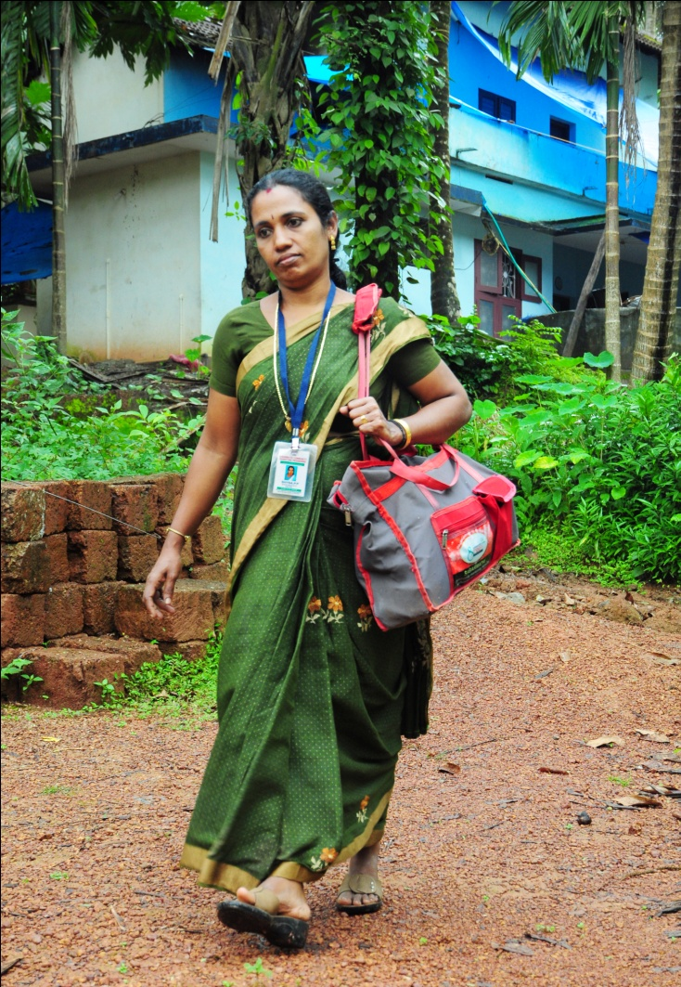

Figure 3. Home Shop retail interaction with consumers during community outreach (field documentation, 2025).
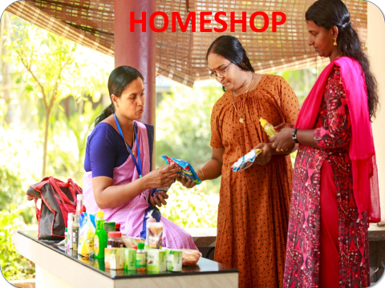

Figure 4. Post-FGD interaction with participating women micro-entrepreneurs, Kozhikode district (2026).
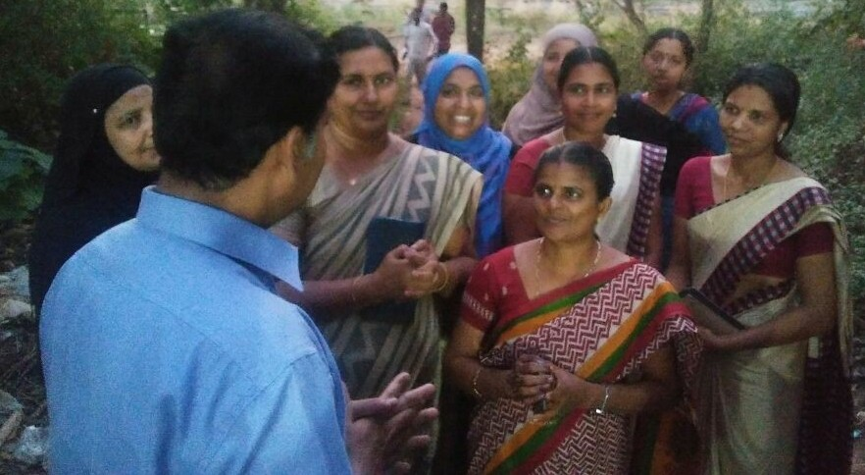
Figure 5. Illustrative Home Shop product basket and branding (programme material/field documentation, 2025).
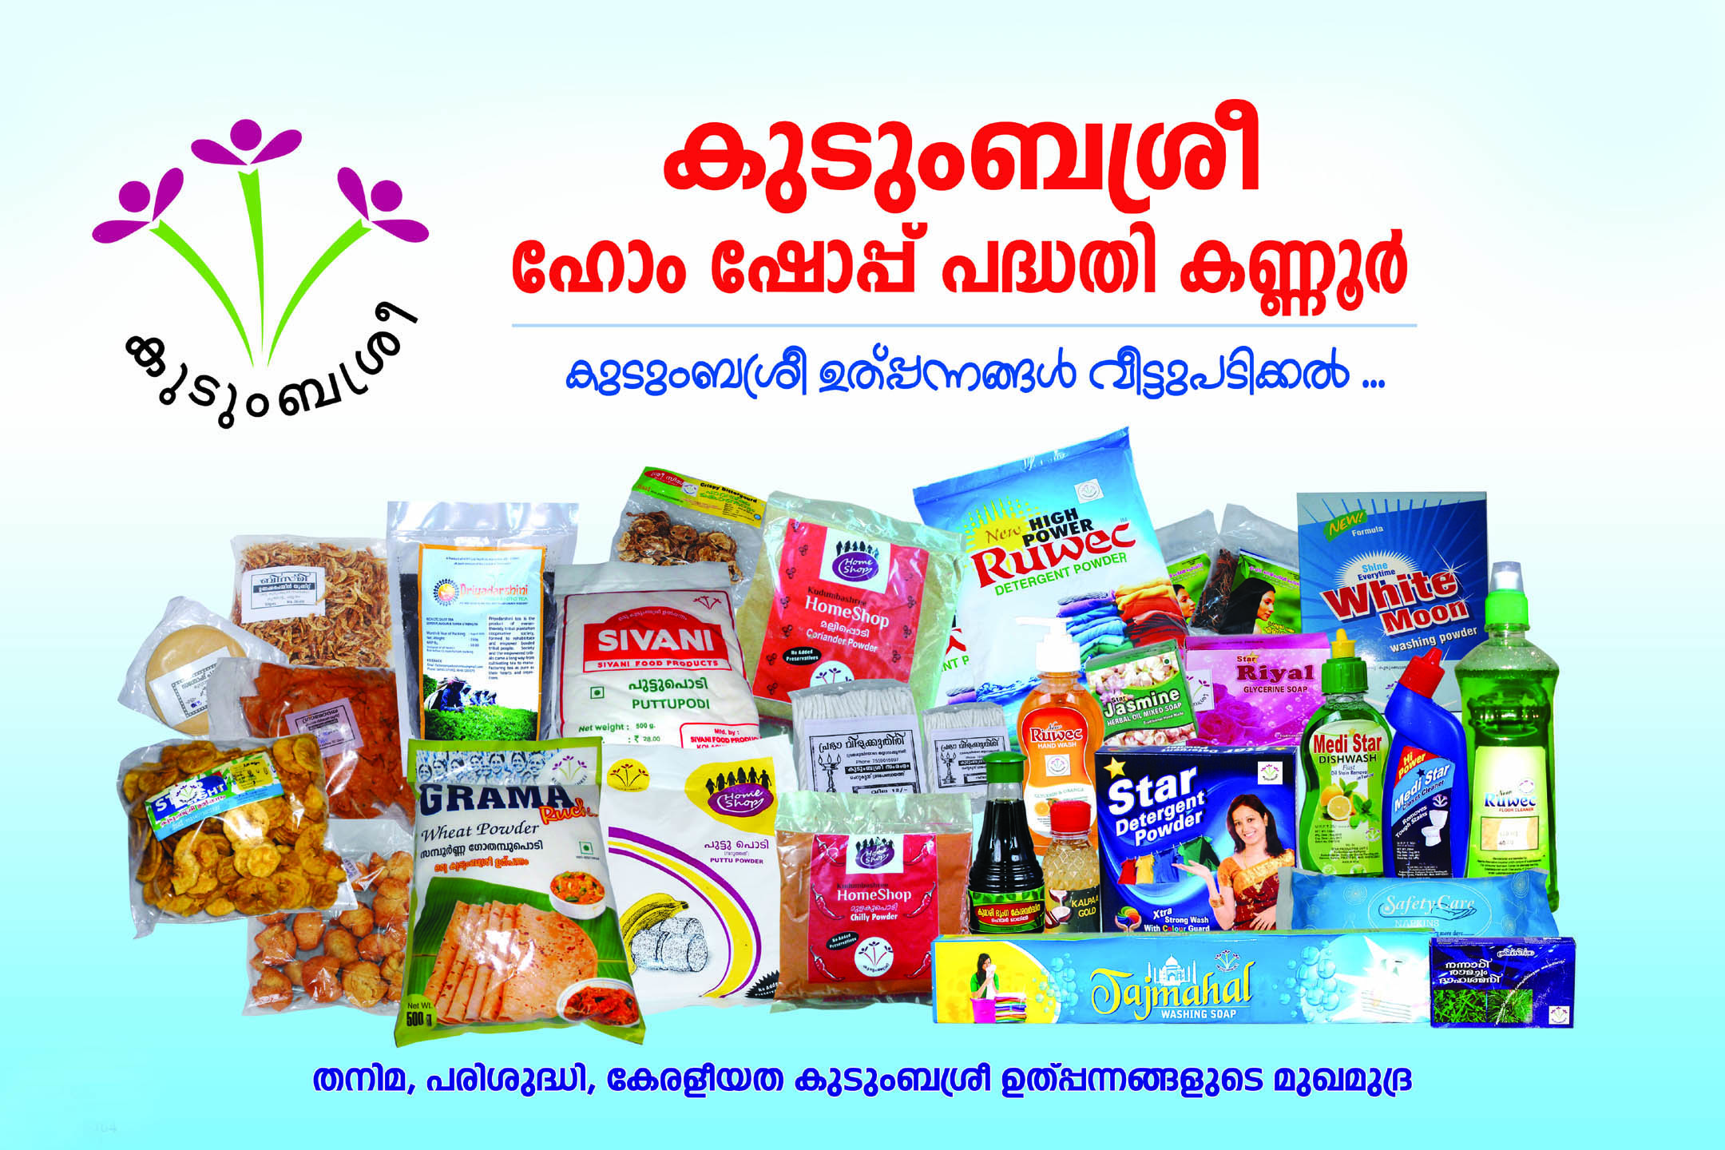
AI Use Declaration: Minimal/negligible use (below 19%).
AI tools were used only for language support (grammar, clarity, and formatting). No AI was used to generate academic arguments, analysis, interpretation of findings or conclusions.

Kudumbashree' means 'prosperity of the family’ in Malayalam. ‘Kudumbashree’ is the ‘State Poverty Eradication Mission’ (SPEM) of Government of Kerala and the State’s flagship programme for women’s social and economic empowerment.
The People’s Plan Campaign (1996) refers to Kerala’s pioneering decentralisation movement which shifted the focus of planning from the state level to local bodies.

