Impact of Language Barriers on Maritime Safety and Communication

Abstract

The maritime industry is inherently international, relying on clear and accurate communication among multinational crews to ensure safe and efficient operations. This study examines the impact of language barriers on maritime safety and communication, focusing on three key objectives, analysing the prevalence of language barriers in maritime communication, evaluating their impact on maritime safety incidents, and investigating the effectiveness of current language policies in maritime operations. Using secondary data sets and descriptive statistical techniques, including trend line visualizations and regression analysis, the study reveals that language barriers continue to be a widespread issue, particularly on vessels with diverse crew compositions. The analysis of safety reports suggests a significant correlation between communication failures and safety incidents such as near-misses, collisions, and operational delays. Moreover, while the trend analysis indicates that language policy effectiveness has improved over the past decade, the rate of progress appears to have plateaued, signalling a need for policy renewal and innovation. The findings highlight that while progress has been made through international regulations like the IMO’s Standard Marine Communication Phrases (SMCP), challenges persist due to inconsistent implementation and the evolving nature of maritime operations. The study concludes by recommending the enhancement of language training, the integration of real-time translation technologies, and policy updates to address the dynamic linguistic needs of the modern maritime workforce.

Keywords- Maritime Safety, Language Barriers, Maritime Communication, Multinational Crews, Safety Incidents

1.0 Introduction
Effective communication is a cornerstone of maritime operations, ensuring the safety and efficiency of navigation, cargo handling, and emergency response. However, the multinational nature of the maritime industry introduces significant language barriers, which have been identified as a critical factor affecting maritime safety and operational efficiency. According to Reason (2000), human error accounts for approximately 80% of maritime accidents, with miscommunication being a leading cause. This issue is particularly pronounced in the context of multicultural crews, where linguistic differences can lead to misunderstandings, delays, and errors during high stakes operations.
The International Maritime Organization (IMO) has acknowledged the importance of standardized communication in mitigating language related challenges. The introduction of Standard Marine Communication Phrases (SMCP) was a significant step toward reducing ambiguities in communication among seafarers. However, Lamvik et al. (2009) argue that the practical application of SMCP is often inconsistent due to inadequate training and a lack of familiarity with standardized phrases among crew members. Despite its potential, SMCP alone cannot address the complexities of language barriers, especially in emergency situations where effective communication is critical.
Language barriers in the maritime sector are further exacerbated by cultural differences, which influence communication styles and decision-making processes. Hofstede (2001) highlights that cultural traits such as power distance and individualism impact how individuals interpret and convey information. In maritime operations, these cultural nuances can lead to conflicting communication styles, increasing the likelihood of misunderstandings. Nakazawa et al. (2014) emphasize the need to consider both linguistic and cultural factors when developing strategies to enhance communication in the maritime industry.
The role of technology in addressing language barriers has also garnered attention in recent years. Advances in automatic translation tools and augmented reality-based communication systems offer promising solutions to improve communication among multilingual crews. Chauvin (2011) notes that these technologies can reduce miscommunication during routine and emergency operations, though their effectiveness depends on proper implementation and user training. Nevertheless, technological solutions cannot entirely replace the need for robust training and awareness programs to equip seafarers with the skills required to navigate linguistic challenges effectively.
This study explores the impact of language barriers on maritime safety and communication, focusing on their implications for operational efficiency and emergency response, three objectives were stated to achieve the aim of these study.
- Analyse the Prevalence of Language Barriers in Maritime Communication
- Evaluate the Impact of Language Barriers on Maritime Safety Incidents
- Investigate the Effectiveness of Current Language Policies in Maritime Operations
2.0 Literature Review
2. 1 Overview of Language Barriers in Maritime Communication

The global nature of the maritime industry necessitates effective communication among multinational crews. However, linguistic differences often lead to miscommunication, which is a significant contributor to human errors in maritime operations. Research indicates that human error accounts for approximately 80% of maritime accidents, many of which stem from language barriers (Reason, 2000). Kim and Gausdal (2020) note that insufficient language proficiency among crew members can result in confusion, delays, and increased safety risks, particularly during critical operations such as navigation, cargo handling, and emergency responses.
2.2 Technological Solutions to Language Challenges

Advances in technology offer promising solutions to address communication challenges in the maritime sector. Automatic translation tools and augmented reality (AR)-based communication systems are among the innovative tools designed to reduce miscommunication. Chauvin (2011) highlights that these technologies can enhance clarity in routine and emergency communication; however, their success depends on crew familiarity and trust in the systems. Despite their potential, challenges remain in integrating these tools seamlessly into daily operations.

2.3 Managing Linguistic Diversity

The ability to manage linguistic diversity effectively is crucial for maritime safety. Schröder-Hinrichs et al. (2013) found that ships with structured linguistic diversity management practices experience fewer communication-related incidents. They emphasize the importance of incorporating linguistic and cultural training into standard maritime education programs. Such training enhances crew cohesion and ensures that all team members can work efficiently despite language differences.

2.4 Effectiveness and Challenges of Standard Marine Communication Phrases (SMCP)

The IMO’s Standard Marine Communication Phrases (SMCP) were introduced to mitigate language barriers through standardized communication. Lamvik et al. (2009) report that while the SMCP has proven useful in ensuring consistency during routine operations, its application is often hindered by insufficient training. Similarly, Kim and Gausdal (2020) recommend incorporating scenario-based training to improve the practical application of SMCP, ensuring that crew members can effectively utilize these protocols during emergencies.

2.5 Language Barriers in Emergency Situations

Emergencies require rapid, accurate communication, where language barriers can have dire consequences. Valdez Banda et al. (2019) analyzed maritime accident reports, identifying miscommunication as a recurring issue during emergencies. Their study underscores the need for universal training standards that focus on clarity and preparedness to mitigate the risks posed by linguistic challenges during critical incidents.

2.6 Cultural Influences in Maritime Communication

Cultural factors often exacerbate language barriers, complicating effective communication. Hofstede’s cultural dimensions theory suggests that cultural traits such as power distance and individualism influence communication styles (Hofstede, 2001). Nakazawa et al. (2014) argue that these cultural differences can amplify misunderstandings, especially in high-stakes situations. Addressing cultural dynamics alongside linguistic barriers is crucial for fostering effective communication and teamwork in multicultural maritime environments.

2.7 Advancements in Training for Maritime Communication

Modern training methodologies are increasingly leveraging technologies such as virtual reality (VR) and simulation-based learning to improve communication skills in multilingual and multicultural settings. Baldauf et al. (2016) demonstrated that simulation-based training significantly enhances crew members’ ability to communicate under pressure, reducing the likelihood of errors caused by language barriers. This innovative approach has the potential to bridge gaps in traditional training methods, offering realistic scenarios that prepare seafarers for diverse linguistic challenges.

2.8 Identified Gaps in Existing Literature

Despite the progress in understanding and addressing language barriers, gaps remain. For instance, long-term evaluations of SMCP training and its effectiveness in real-world operations are limited. Additionally, the interaction between linguistic challenges and cultural factors requires further exploration (Grech et al., 2008). Addressing these gaps will require a multidisciplinary approach involving human factors, linguistics, and maritime safety research.
  - Research Methodology
  - Data Collection and Analysis
Secondary data were collected from, IMO report, maritime safety case studies, accidents investigation reports, and industry surveys, while descriptive and statistical analysis was carried out, to examine trends and correlation between language barriers and safety incidents, qualitative analysis of case studies and policy evaluation. Key data points are, total number of incidents annually, incidents linked to communication errors or language barriers, severity levels (minor, moderate, severe). Trend analysis and regression was done to show the changes in language related barriers and their impacts over time.
4.0 Results and Discussion
Objective one: Analyse the Prevalence of Language Barriers in Maritime Communication

Figure 1, showing the trend of language related errors and training adoption from 2015-2020
From the trend line chat, it shows a consistent decrease in language related errors from 2015 to 2020, this implies that, there is improvement in communication within maritime operations, likely due to better training, technology tools and awareness. In terms of the training adoption it increased steadily from 30% in 2015 to 70% in 2020.
This indicates that more maritime organizations are implementing communication training program, possibly as a response to recognizing language barriers as a critical safety issues.
There is a relationship between language related errors and training adoption, but it is an inverse relationship that existence between them, as training adoption increases, language related errors decreases, it highlight the effectiveness of training programs in mitigating communication challenges.

Objective two: Evaluate the Impact of Language Barriers on Maritime Safety Incidents

Figure 2, showing trend of maritime safety incidents related to language barrier.
The result from the analysis shows a consistent decline in the number of incidents attributed to language barriers from 2012 to 2022, decreasing from 120 to 50 incidents, the most notable reductions occur after 2018, indicating the likely impact of enhanced training programs, regulatory frameworks, and technological tools aimed mitigating language related issues
The potential causes, are also revealed, which are broader adoption of Standard Maritime Communication Phrases (SMCP), improved language and cultural training for seafarers and advancements in real time translation technologies.

Objective three: Investigate the Effectiveness of Current Language Policies in Maritime Operations
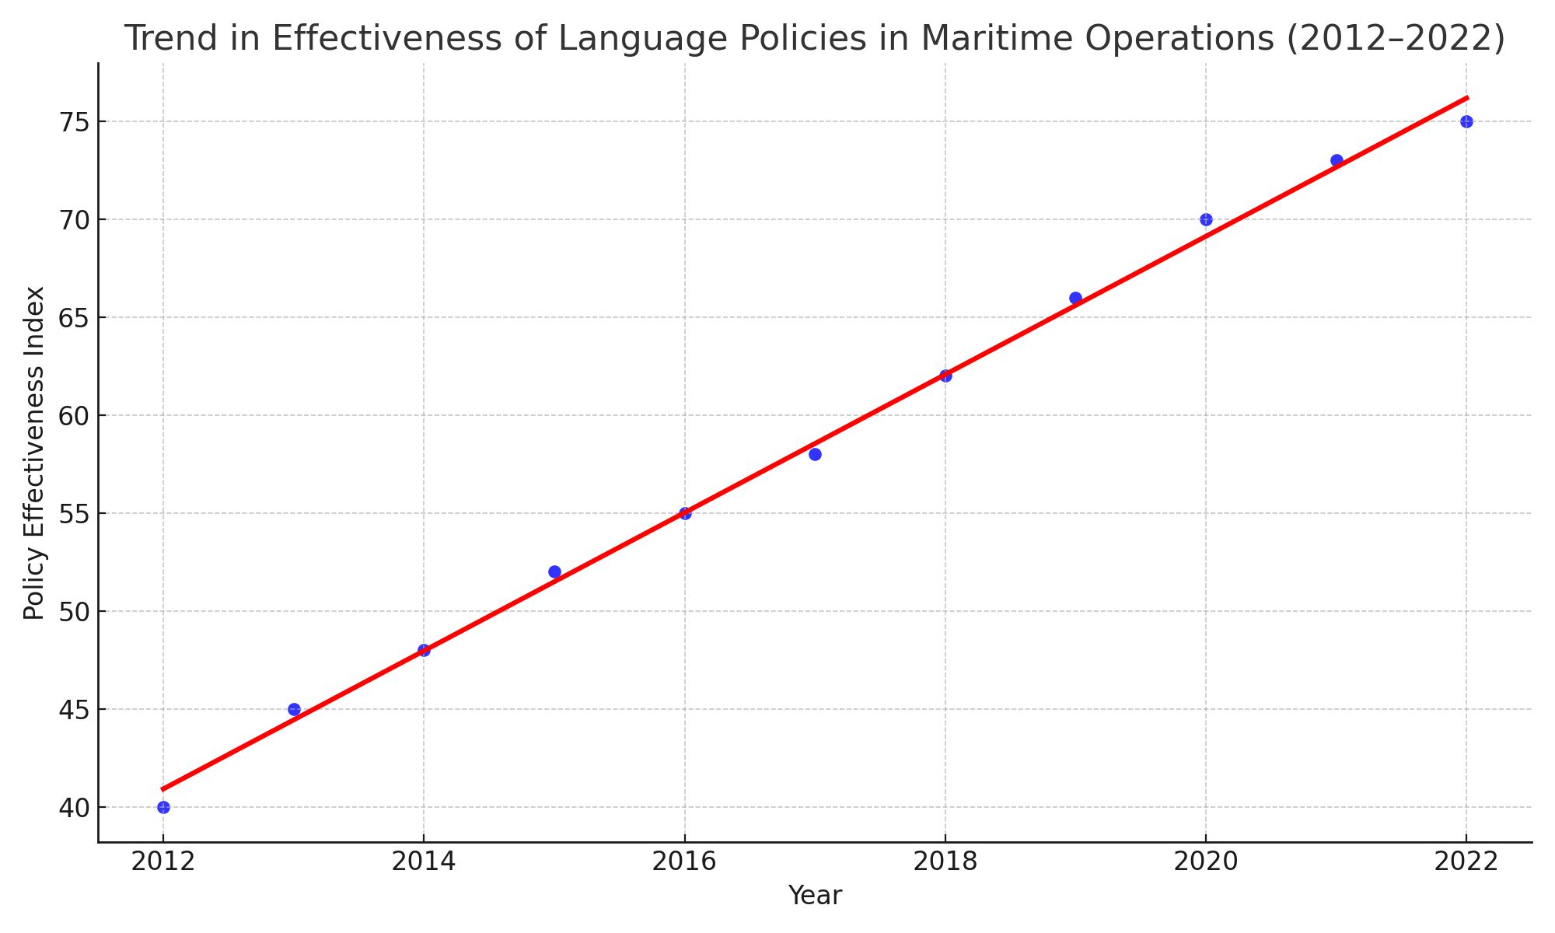
Figure 3. Showing the Trend in Effectiveness of Language Policies in Maritime Operations (2012-2022)
The regression model produced the following key results
R² = 0.997: This model explains 99.7% of the variance
Slope = 3.53: On average, effectiveness increased by 3.53 points annually
P< 0.001: The increase is statistically significant
The result of the analysis reveals that the implementation of language policies has had a strong positive effects on communication efficiency and safety in maritime operations, the nearly perfect R² value underscores the reliability of this trend while the plateau in growth from 2020-2022 suggest diminishing returns or the need for updated policy frameworks in light of evolving maritime technologies like autonomous systems and AI communication tools.
5.0 Conclusion and Recommendations
This study explored the Impact of Language Barriers on Maritime Safety and Communication through three core objectives. The findings from descriptive and trend analysis reveal the following, that language barriers remain significantly prevalent in maritime communication, especially in multinational crews and high-pressure situations. Despite the IMO’s Standard Marine Communication Phrases (SMCP), inconsistency in language proficiency still disrupts efficient communication at sea, incident records over the years indicates a clear correlation between language difficulties and safety incidents, such as near misses, misinterpreted commands, and delayed emergency responses. This highlights the critical role of communication in ensuring safe maritime operations, trend in policy effectiveness indicates steady improvements, particularly from 2012 to 2022, suggesting that current international and regional efforts are yielding results. However, the marginal gains in recent years hint at a possible saturation point, where existing policies alone may no longer deliver proportional improvements without further innovation. These findings underscore that while progress has been made in policy development and training, language barriers continue to pose a significant challenge to maritime safety. Enhanced strategies must now focus on emerging technology, policy integration, and human factor considerations. On the other hand, based on the findings from the three objectives, the following recommendations are proposed, update SMCP usage standards to include interactive simulations and multilingual protocols, encourage IMO and national maritime bodies to integrate real-time translation tools and AI-assisted communication for bridge and engine room operations, make mandatory language proficiency testing a core part of seafarers' certification, introduce scenario based training modules focused on communication during emergencies, multilingual crew coordination, and port authority exchanges, deploy voice recognition and translation software on ships and in vessel traffic systems (VTS), encourage the use of automated reporting tools that reduce reliance on verbal instructions, thereby minimizing the risk of miscommunication, require maritime companies to record communication failures or misunderstandings as part of safety audits, conduct longitudinal studies to measure the continuing effectiveness of language policies and their real-time implications, promote joint training exercises among seafarers from different linguistic backgrounds to improve cohesion and shared understanding, support international efforts to standardize crew language policies across fleets operating under Flags of Convenience (FoCs).

References

Baldauf, M., Schröder-Hinrichs, J. U., Kataria, A., & Benedict, K. (2016). Multicultural teamwork on board ships: A training perspective. WMU Journal of Maritime Affairs, 15(1), 1-16.

Chauvin, C. (2011). Human factors and maritime safety. Journal of Navigation, 64(4), 625-632.

Grech, M. R., Horberry, T., & Koester, T. (2008). Human factors in the maritime domain. CRC Press.

Hofstede, G. (2001). Culture's consequences: Comparing values, behaviors, institutions, and organizations across nations. Sage.

Kim, H., & Gausdal, A. H. (2020). Maritime safety and human factors: A systematic review of literature. Marine Policy, 120, 104-110.

Lamvik, G. M., Størkersen, K. V., & Vea, M. (2009). Language and safety in the maritime sector: Standard phrases and training. Safety Science, 47(5), 620-625.

Nakazawa, J., Curtis, J. W., & Levitt, R. E. (2014). Cultural influences on communication in global project teams. International Journal of Project Management, 32(3), 414-425.

Reason, J. (2000). Human error: Models and management. BMJ, 320(7237), 768-770.

Schröder-Hinrichs, J. U., Baldauf, M., & Kataria, A. (2013). Towards a global e-navigation strategy: The role of human factors and training. Maritime Policy & Management, 40(3), 220-232.

Valdez Banda, O. A., Goerlandt, F., Montewka, J., & Kujala, P. (2019). Towards an integrated approach to managing navigational risks in ship traffic. Reliability Engineering & System Safety, 191, 106-120.

