An IT Governance Framework for Blockchain-Enabled Information Integrity in Philippine Private Higher Education Institutions

Abstract— Information integrity is a critical priority for private higher education institutions (PHEIs) as it supports institutional credibility, graduate employability, and compliance with accrediting and regulatory bodies. Academic recordkeeping in Philippine PHEIs continues to evolve as part of broader digital transformation initiatives. Although blockchain technology offers features such as immutability, decentralization, and verifiability, its adoption should not be approached solely as a technical undertaking. Effective implementation requires IT governance mechanisms that align technological initiatives with institutional goals, ensure responsible resource allocation, manage organizational and security risks, and facilitate coordination among key stakeholders. This study proposes an adaptable IT Governance Framework for blockchain-enabled information integrity in Philippine private higher education institutions. Developed from the perspectives of stakeholders within a PHEI context, the framework highlights the coordinating role of the IT Department while integrating the responsibilities of the Registrar, Finance Office, Accreditation or Quality Assurance Unit, and Senior Management. The framework combines blockchain capabilities with governance practices involving strategic alignment, resource and investment management, risk management and security, roles and accountability, and performance and compliance monitoring. Using a mixed-method approach involving surveys and interviews with key institutional stakeholders, the findings provide empirical support for governance-driven blockchain adoption characterized by clear policies, phased implementation, stakeholder collaboration, and adequate resource allocation. The study concludes that blockchain adoption should be regarded not merely as a technology upgrade but as an IT governance initiative that may be adapted by Philippine PHEIs operating within similar governance and regulatory environments.
Keywords: IT Governance, Blockchain, Information Integrity, Academic Recordkeeping, Resource Management, Accreditation, Change Management.

I. INTRODUCTION

The accuracy and reliability of academic records remain fundamental responsibilities of higher education institutions. Transcripts, diplomas, and certificates represent more than evidence of student achievement; they reflect institutional credibility, support graduate employability, and demonstrate compliance with accrediting and regulatory bodies. Any compromise in the authenticity or integrity of these records can erode stakeholder trust, damage institutional reputation, and undermine confidence in the educational system (Wang et al., 2024; Delgado-von Eitzen & Pisani, 2021). As higher education institutions continue to pursue digital transformation, safeguarding academic information has become both a technological imperative and a governance concern.
In private higher education institutions (PHEIs), the responsibility for maintaining information integrity extends across multiple functional units. The Registrar serves as the custodian of academic records and ensures their accuracy, consistency, and accessibility. The Information Technology (IT) Department oversees the technological infrastructure that supports data security, system reliability, and the integration of emerging technologies. The Finance Office evaluates the sustainability of technology investments and allocates the resources necessary for implementation, while the Accreditation Unit ensures adherence to regulatory requirements and quality standards. Senior Management provides strategic direction and institutional oversight, enabling these units to work collaboratively toward shared organizational objectives. The effectiveness of academic recordkeeping, therefore, depends not only on the technologies adopted but also on the governance structures that coordinate institutional efforts (Bianchi et al., 2021).
Blockchain technology has emerged as a promising innovation capable of enhancing the integrity of academic records through its features of immutability, decentralization, and verifiability (Bhaskar et al., 2021; Kuleto et al., 2022). These characteristics offer opportunities to reduce credential fraud, streamline verification processes, and strengthen trust among students, employers, accrediting bodies, and other stakeholders (Castro & Oliveira, 2021; Raimundo & Rosário, 2021). However, the successful adoption of blockchain requires more than technical implementation. Without clear governance mechanisms, defined responsibilities, adequate resource allocation, and effective risk management practices, institutions may encounter implementation challenges that limit the realization of its potential benefits.
Recognizing these considerations, this study proposes an adaptable IT Governance Framework for blockchain-enabled information integrity in Philippine private higher education institutions. The framework highlights the importance of strategic alignment, resource and investment management, risk management and security, roles and accountability, and performance and compliance monitoring in guiding blockchain adoption. Developed from the perspectives of stakeholders within a specific PHEI context, the framework is intended to serve as a practical guide for Philippine private higher education institutions operating within similar governance and regulatory environments. While institutions may differ in organizational structures, resource capacities, and operational practices, the proposed framework may be adapted to their specific contexts while preserving its core governance principles. By positioning blockchain adoption within a broader IT governance perspective, the study provides a roadmap for strengthening academic information integrity, supporting institutional accountability, and advancing long-term digital transformation initiatives.

METHODOLOGY

The study employed a management-oriented approach to examine information technology (IT) governance practices, strategic alignment, resource management, and stakeholder perspectives concerning blockchain adoption within a Philippine private higher education institution (PHEI) context. To ensure a comprehensive and balanced analysis, a mixed-method research design integrating quantitative survey data and qualitative interview findings was utilized. Although grounded in a specific institutional setting, the study sought to identify governance practices and institutional functions commonly found among Philippine PHEIs, thereby informing the development of an adaptable framework that may be applied within similar governance and regulatory environments.

The management-oriented, mixed-method approach highlights the importance of aligning institutional strategies with governance mechanisms and resource allocation, reflecting the governance principles discussed by Bianchi et al. (2021). At the same time, it captures the diverse experiences, insights, and expectations of institutional stakeholders. Through the integration of quantitative and qualitative data, the study achieves methodological triangulation, thereby enhancing the credibility, reliability, and interpretative depth of the analysis. This design offers a holistic understanding of organizational impact, policy adherence, and decision-making efficiency, which would be less robust if only a single-method approach were used.

The conceptual framework illustrates how IT governance principles and blockchain technology can be integrated to strengthen information integrity within the PHEIs. It demonstrates how effective governance mechanisms ensure that blockchain adoption promotes transparency, compliance, and strategic alignment. The framework also underscores the collaborative role of multiple institutional units, emphasizing that blockchain implementation is not purely a technological endeavor but a coordinated governance process requiring cooperation across administrative, financial, and accreditation domains.

The framework identifies the IT Department as the key driver of institutional coordination, responsible for ensuring that blockchain-enabled initiatives align with PHEIs long-term digital transformation objectives. Through structured communication, policy alignment, and oversight, the IT Department facilitates the integration of blockchain technology in ways that reinforce institutional accountability and data integrity.

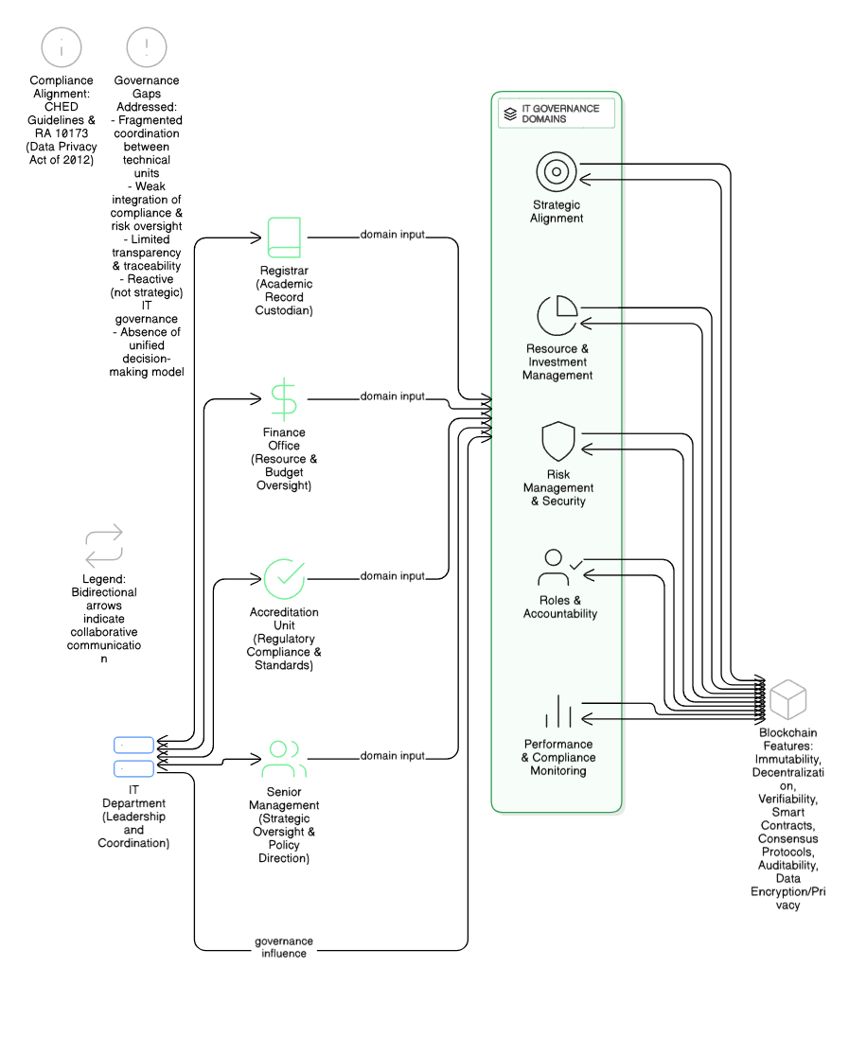
Figure 1. Conceptual Framework for Blockchain-Enabled Information Integrity

As shown in Figure 1, the conceptual framework positions blockchain adoption as a governance-driven initiative built upon cross-departmental collaboration. The Registrar, Finance Office, Accreditation Unit, and Senior Management function as the primary domain contributors, each providing specialized expertise in record management, resource allocation, regulatory compliance, and policy formulation. Within this configuration, the IT Department acts as the central coordinating body that connects these institutional units, promoting unified decision-making and information sharing.

The framework directly addresses governance challenges such as fragmented coordination, insufficient risk oversight, and limited transparency by establishing a structured process of accountability and performance monitoring, consistent with the governance principles emphasized by Tan et al. (2021) and van Pelt et al. (2020). At the core of the model are five key IT governance domains: Strategic Alignment, Resource and Investment Management, Risk Management and Security, Roles and Accountability, and Performance and Compliance Monitoring. These domains collectively form the structural foundation for aligning blockchain initiatives with institutional strategies, ensuring effective resource distribution, mitigating operational and cybersecurity risks, and tracking performance and compliance outcomes.

On the right side of the framework, these governance domains are linked to blockchain's defining features, including immutability, decentralization, verifiability, smart contracts, consensus protocols, and data encryption, which have been identified as key attributes supporting secure and trustworthy educational record systems (Bhaskar et al., 2021; Delgado-von Eitzen & Pisani, 2021). These technological capabilities strengthen data reliability and protect academic records from unauthorized access or tampering. By interconnecting governance functions with blockchain attributes, the model establishes blockchain adoption as a management and governance innovation rather than merely a technical upgrade. It thereby enhances institutional credibility, operational efficiency, and adherence to data privacy and accreditation standards.

Data Collection Methods
To gather empirical insights and inform the development of the proposed framework, the study employed four primary data collection methods: document review, surveys and interviews, comparative analysis, and framework design.
- Document Review- Existing institutional policies, procedures, and IT systems related to academic recordkeeping were analyzed to identify governance gaps, process inefficiencies, and operational challenges. This review provided a foundational understanding of PHEIs current information management practices and informed the development of the governance-based blockchain framework.
- Surveys and Interviews- Structured surveys and semi-structured interviews were conducted with key institutional stakeholders to evaluate readiness for blockchain adoption, identify existing challenges, and assess resource constraints. The participants represented institutional units commonly found in Philippine private higher education institutions and were selected based on their involvement in governance, academic recordkeeping, resource allocation, regulatory compliance, and strategic decision-making related to emerging technologies. Their perspectives provided insights into governance practices that informed the development of an adaptable framework for blockchain-enabled information integrity within similar PHEI contexts.

- Registrar – Custodian of academic records (n = 10)
- IT Department – Technical lead for blockchain implementation and system maintenance (n = 10)
- Finance Office – Oversees budget allocation and resource sustainability (n = 5)
- Accreditation Unit – Ensures regulatory compliance and accreditation readiness (n = 5)
- Senior Management – Provides oversight, institutional direction, and policy approval (n = 5)
The surveys measured stakeholder perspectives across five governance dimensions: strategic alignment, resource and investment management, risk management and security, roles and accountability, and performance and compliance monitoring. Open-ended interview questions elicited qualitative insights on perceived benefits, challenges, and practical considerations for blockchain adoption. The integration of survey metrics and interview narratives allowed for both quantitative assessment of the governance model and qualitative exploration of stakeholder experiences.
- Comparative Analysis- Academic and industry literature concerning blockchain adoption in higher education was reviewed to benchmark best practices and identify governance models that ensure information integrity (Delgado-von Eitzen & Pisani, 2021; Wang et al., 2024). This comparison facilitated the contextualization of PHEIs institutional needs within broader international trends, highlighting governance structures that successfully integrated blockchain technology in academic recordkeeping.
- Framework Design- Findings from document review, stakeholder surveys, interviews, and comparative analysis were synthesized to formulate the proposed IT governance framework. The design process emphasized the alignment of blockchain functionalities with institutional priorities, ensuring that technology adoption supports compliance with national education and data privacy policies, as well as internal operational objectives.
Interpretative Discussion

The results of the data collection and comparative analysis were consolidated into a governance-oriented design, reflecting the interdependence of strategic, operational, and technological functions within PHEIs. The proposed framework (see Figure 2) integrates the five IT governance domains: Strategic Alignment, Resource and Investment Management, Risk Management and Security, Roles and Accountability, and Performance and Compliance Monitoring, under the coordination of the IT Department.

Each institutional unit contributes to the governance process through specific responsibilities and feedback mechanisms. The Registrar ensures data integrity in academic recordkeeping, the Finance Office manages resource sustainability and investment monitoring, the Accreditation Unit ensures regulatory compliance, and Senior Management provides strategic oversight and institutional direction. The IT Department serves as the core facilitator of communication, system integration, and policy alignment, ensuring that governance activities remain coordinated across institutional units commonly found in Philippine PHEIs.

The governance configuration creates a clear chain of accountability and minimizes coordination gaps between technical and administrative units. It also strengthens internal communication, enabling more agile responses to compliance and security challenges.

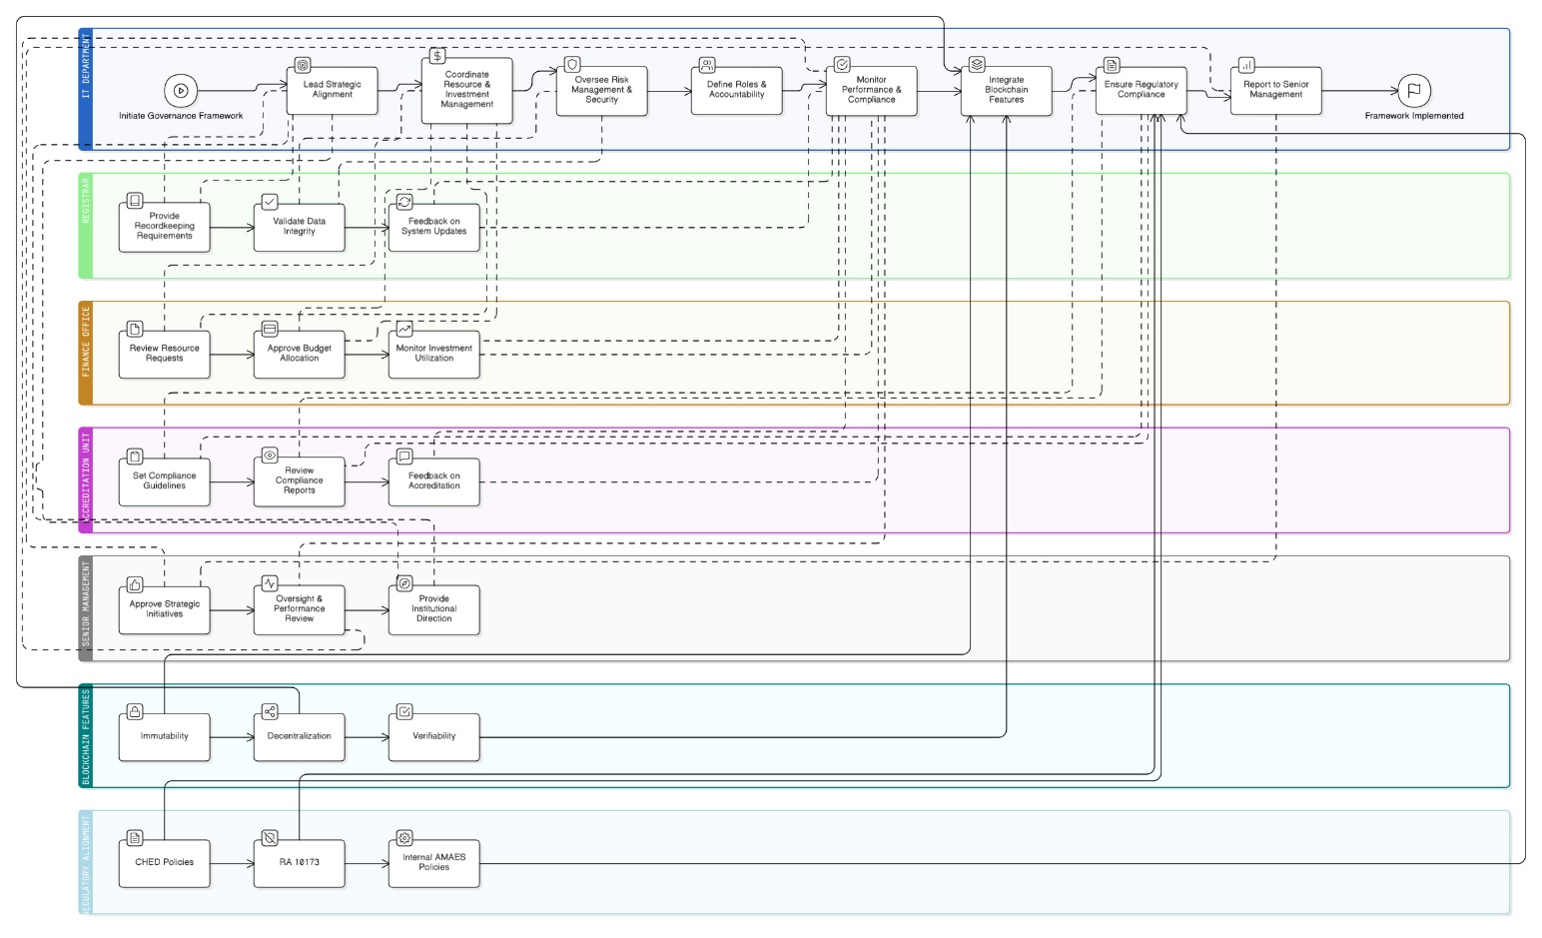

Figure 2. Proposed IT Governance Framework for Blockchain Integration

As illustrated in Figure 2, the proposed framework for blockchain-enabled information integrity positions the IT Department as the central coordinating authority overseeing the integration of blockchain technology into PHEIs governance processes. Each governance domain contributes to a specific management dimension:

- Strategic Alignment ensures that blockchain projects directly support institutional goals, accreditation standards, and long-term digital transformation strategies.
- Resource and Investment Management oversees budgeting, funding allocation, and system integration to maintain financial sustainability and technological readiness.
- Risk Management and Security focuses on mitigating cybersecurity threats, ensuring compliance with the Data Privacy Act of 2012 (Republic Act 10173), and safeguarding institutional data assets.
- Roles and Accountability clarifies the decision-making hierarchy, delineating responsibilities across institutional units to prevent overlap and ensure transparency.
- Performance and Compliance Monitoring establishes performance indicators and continuous evaluation mechanisms to measure the success of blockchain adoption initiatives and ensure adherence to institutional and regulatory standards.

Supporting these domains are the core technological features of blockchain, namely immutability, decentralization, and verifiability, which form the foundational layer of the governance framework and have been widely recognized as mechanisms for strengthening the integrity and traceability of educational credentials (Bhaskar et al., 2021; Kuleto et al., 2022). These features ensure that academic records are securely stored, tamper-resistant, and auditable, thereby enhancing trust among stakeholders and accrediting bodies.

The model aligns with key regulatory frameworks in the Philippines, particularly the Commission on Higher Education (CHED) policies, the Data Privacy Act of 2012 (Republic Act No. 10173), and internal PHEIs IT and academic policies. By embedding blockchain functionalities within established governance systems, the framework ensures that innovation remains compliant with national regulations while advancing institutional transparency and efficiency, consistent with the governance perspective advanced by Tan et al. (2021).

Summary of Methodological Rationale

The integration of governance principles with blockchain capabilities demonstrates that effective technology adoption requires not only technical infrastructure but also strategic leadership, stakeholder engagement, and regulatory compliance, consistent with the observations of Bianchi et al. (2021) and Tan et al. (2021). The mixed-method design supports this conceptualization by combining empirical stakeholder input with governance theory and industry practice (Bianchi et al., 2021; Tan et al., 2021).
The comprehensive methodological approach establishes a practical roadmap for educational institutions aiming to strengthen information integrity through blockchain technology while ensuring regulatory compliance, operational sustainability, and institutional accountability. The proposed IT governance framework for blockchain integration functions both as an analytical model and as an actionable management guide that may inform strategic decision-making among Philippine private higher education institutions operating within similar governance and regulatory contexts. While developed from the perspectives of stakeholders within a specific PHEI setting, the framework is intended to be adaptable to institutions with comparable organizational structures and information integrity requirements.

RESULT

A. Respondent Profile

A total of 35 key institutional personnel representing functional units commonly found in Philippine private higher education institutions participated in the survey within the selected PHEI context. The respondents were composed of the following groups: IT Management (n = 10), Registrar Staff (n = 10), Finance Office (n = 5), Accreditation or Quality Assurance Unit (n = 5), and Senior Management (n = 5). These participants were selected based on their direct involvement in governance, resource allocation, and academic recordkeeping processes that influence blockchain adoption.

All items were evaluated using a five-point Likert scale, where 5 = Strongly Agree, 4 = Agree, 3 = Neutral, 2 = Disagree, and 1 = Strongly Disagree.

B. Weighted Mean Scores per Governance Domain

The survey measured five governance domains corresponding to the proposed IT Governance Framework for Blockchain-Enabled Information Integrity: Strategic Alignment, Resource and Investment Management, Risk Management and Security, Roles and Accountability, and Performance and Compliance Monitoring.

Table 1 presents the computed weighted mean (WM) values across respondent groups.
Table 1. Weighted Mean Scores by Governance Domain and Respondent Group
Respondent Group | Strategic Alignment | Resource & Investment Management | Risk Management & Security | Roles & Accountability | Performance & Compliance Monitoring
Accreditation Unit | 4.93 | 4.93 | 4.80 | 4.93 | 5.00
Finance Office | 4.73 | 4.60 | 4.73 | 4.67 | 4.60
IT Management | 4.77 | 4.77 | 4.73 | 4.73 | 4.73
Registrar Staff | 4.97 | 4.87 | 4.83 | 4.87 | 4.93
Senior Management | 5.00 | 5.00 | 5.00 | 5.00 | 5.00
Overall Mean | 4.88 | 4.83 | 4.81 | 4.83 | 4.85
All domains received ratings between 4.81 and 4.88, which correspond to Strongly Agree (Very High Agreement). This indicates a strong institutional consensus on the importance of governance-driven blockchain adoption.
C. Computation of Weighted Mean

Formula:
∑(fi​⋅xi​)​
Weighted Mean (WM) =
N
Where:
fi = frequency of each response
xi = weight assigned to each response
N = total number of responses

D. Domain-Specific Results

1) Strategic Alignment

Table 2. Weighted Mean Scores of Strategic Alignment Governance Domain
Scale | Weight (w) | Frequency (f) | f × w
Strongly Agree | 5 | 93 | 465
Agree | 4 | 11 | 44
Neutral | 3 | 1 | 3
Disagree | 2 | 0 | 0
Strongly Disagree | 1 | 0 | 0
Total |  | 105 | 512

512
WM = = 4.88
105
Interpretation: Strongly Agree (Very High Agreement). The respondents emphasized that blockchain initiatives should align with PHEIs strategic goals and accreditation mandates.
2) Resource and Investment Management
Table 3. Weighted Mean Scores of Resource and Investment Management Governance Domain
Scale | Weight (w) | Frequency (f) | f × w
Strongly Agree | 5 | 89 | 445
Agree | 4 | 14 | 56
Neutral | 3 | 2 | 6
Disagree | 2 | 0 | 0
Strongly Disagree | 1 | 0 | 0
Total |  | 105 | 507

507
WM = = 4.83
105

Interpretation: Strongly Agree (Very High Agreement) Adequate budget allocation, infrastructure, and training are essential for blockchain implementation success.

3) Risk Management and Security

Table 4. Weighted Mean Scores of Risk Management and Security Governance Domain

Scale | Weight (w) | Frequency (f) | f × w
Strongly Agree | 5 | 87 | 435
Agree | 4 | 16 | 64
Neutral | 3 | 2 | 6
Disagree | 2 | 0 | 0
Strongly Disagree | 1 | 0 | 0
Total |  | 105 | 505

505
WM = = 4.81
105
Interpretation: Strongly Agree (Very High Agreement) there is a clear recognition of the importance of cybersecurity, privacy protection, and operational safeguards.

4) Roles and Accountability

Table 5. Weighted Mean Scores of Roles and Accountability Governance Domain

Scale | Weight (w) | Frequency (f) | f × w
Strongly Agree | 5 | 89 | 445
Agree | 4 | 14 | 56
Neutral | 3 | 2 | 6
Disagree | 2 | 0 | 0
Strongly Disagree | 1 | 0 | 0
Total |  | 105 | 507

507
WM = = 4.83
105

Interpretation: Strongly Agree (Very High Agreement) Clear delineation of roles and accountability mechanisms are critical to ensure integrity in academic recordkeeping.
5) Performance and Compliance Monitoring

Table 6. Weighted Mean Scores of Performance and Compliance Monitoring Governance Domain

Scale | Weight (w) | Frequency (f) | f × w
Strongly Agree | 5 | 90 | 450
Agree | 4 | 14 | 56
Neutral | 3 | 1 | 3
Disagree | 2 | 0 | 0
Strongly Disagree | 1 | 0 | 0
Total |  | 105 | 509

509
WM = = 4.85
105

Interpretation: Strongly Agree (Very High Agreement) Continuous performance evaluation and compliance monitoring are viewed as vital for maintaining information integrity.

E. Qualitative Findings
Open-ended responses identified data security, transparency, immutability, and efficiency as the primary perceived benefits of blockchain adoption. Respondents highlighted faster verification processes, enhanced trust with accrediting bodies, and improved operational efficiency as significant advantages.

Key challenges include financial constraints, technical complexity, and training needs. Respondents also recommended management support, phased implementation, and clear policies to address these concerns.

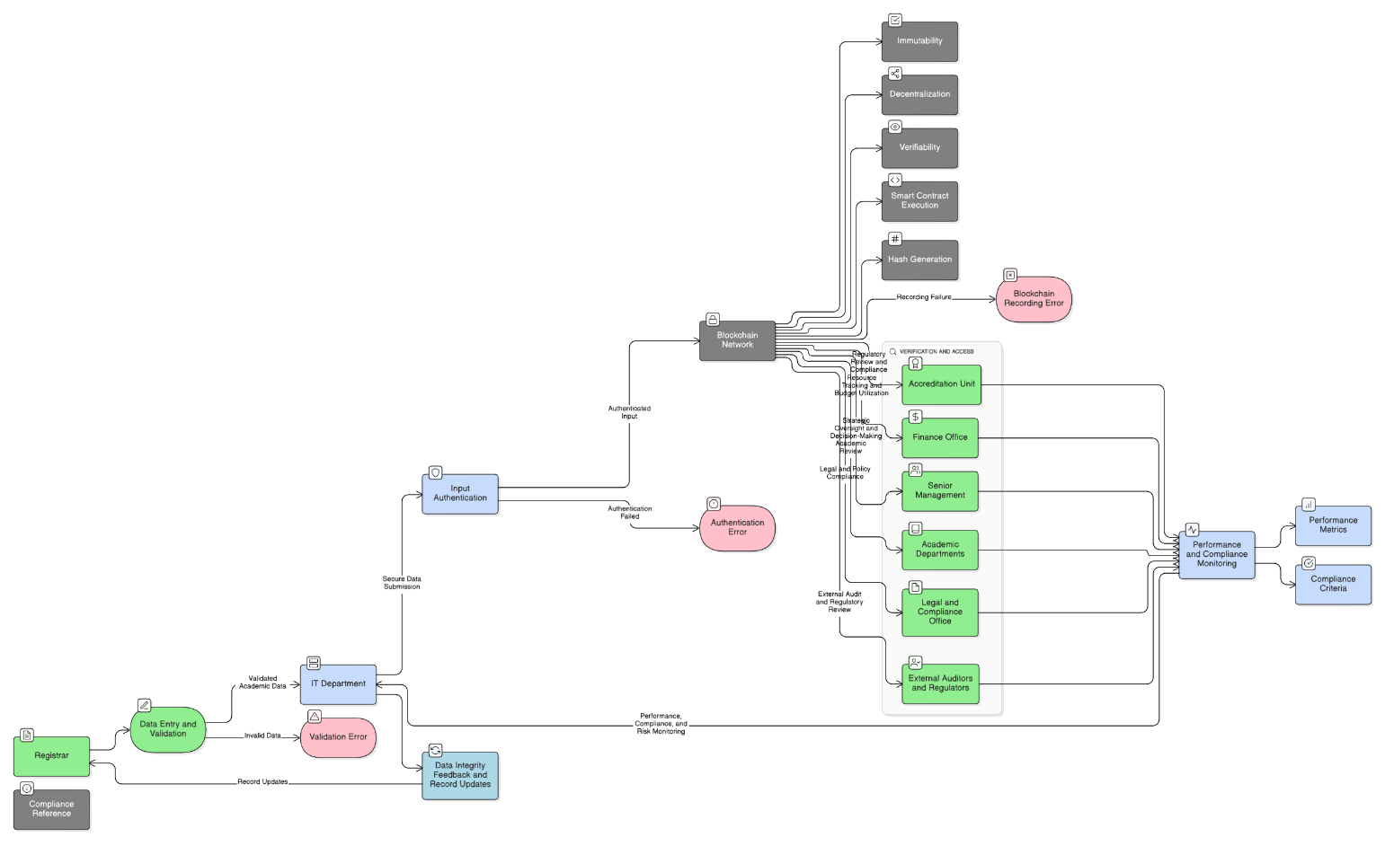

Figure 3. Process Flow for Blockchain-Enabled Academic Recordkeeping

The process flow clarifies how governance decisions are operationalized within the blockchain ecosystem. It highlights accountability checkpoints, ensures transparency of academic record transactions, and provides a mechanism for continuous improvement through structured monitoring and evaluation, reflecting the principles of performance monitoring and accountability emphasized by Bianchi et al. (2021).

The process flow illustrates how each governance domain contributes to blockchain-enabled recordkeeping, from strategic alignment and resource allocation to risk control, accountability, and performance monitoring.

IV. DISCUSSION AND CONCLUSION

Discussion

The findings reveal a strong institutional consensus that blockchain adoption in PHEIs should be governed through a structured IT governance framework rather than implemented solely as a technological initiative. The consistently high weighted mean scores (WM = 4.81–4.88) suggest that respondents recognize governance mechanisms as essential prerequisites for ensuring information integrity and successful digital transformation.

The highest-rated domain, Strategic Alignment (WM = 4.88), indicates that respondents perceive blockchain initiatives as most effective when aligned with institutional objectives, accreditation requirements, and long-term digital transformation goals. This finding supports the argument of Bianchi et al. (2021), who emphasized that IT governance in higher education must ensure that technology investments contribute directly to organizational objectives and institutional value creation. Similarly, Wang et al. (2024) noted that blockchain initiatives in education often fail when implemented as isolated technological projects without integration into broader institutional strategies. The high level of agreement among respondents suggests that PHEIs recognize that blockchain adoption should reinforce, rather than disrupt, existing educational missions and governance structures.

The results for Resource and Investment Management (WM = 4.83) highlight stakeholders' awareness that blockchain implementation requires substantial organizational commitment beyond software acquisition. Respondents emphasized the importance of financial sustainability, infrastructure readiness, and workforce capability. These findings align with Mohammad and Vargas (2022), who identified financial constraints and limited technical expertise as major barriers to blockchain adoption in higher education institutions. Likewise, Alshareef et al. (2022) argued that leadership support and strategic investment decisions significantly influence organizational readiness for emerging technologies. Therefore, successful blockchain adoption in PHEIs depends not only on technological feasibility but also on sustained institutional investment and capacity-building initiatives.

Although Risk Management and Security obtained the lowest weighted mean among the five domains (WM = 4.81), it still reflected very high agreement among respondents. This result suggests that respondents acknowledge cybersecurity, privacy protection, and operational resilience as critical governance concerns. Given the sensitive nature of academic records, blockchain implementations must comply with data protection requirements, including the Philippine Data Privacy Act of 2012 (Republic Act No. 10173). Previous studies similarly emphasize that while blockchain offers immutability and transparency, institutions must address risks related to privacy, access control, and governance mechanisms (Delgado-von Eitzen & Pisani, 2021; Tan et al., 2021). The findings imply that PHEIs are aware that blockchain alone does not eliminate security risks and must be complemented by robust governance controls.

The high agreement in Roles and Accountability (WM = 4.83) demonstrates respondents' recognition of the need for clearly defined responsibilities across institutional units. Blockchain initiatives involve multiple stakeholders, including the IT Department, Registrar, Finance Office, Accreditation Unit, and Senior Management. The findings support van Pelt et al. (2020), who argued that clearly articulated governance structures are fundamental to blockchain success because they establish decision rights, accountability mechanisms, and stakeholder coordination. The respondents' perspectives indicate that effective implementation requires cross-functional collaboration rather than isolated decision-making within technical departments.

Similarly, Performance and Compliance Monitoring (WM = 4.85) underscores the importance of continuous evaluation and regulatory oversight. Respondents recognized that governance effectiveness should be measured through performance indicators, audits, and compliance reviews. This finding is consistent with Bianchi et al. (2021), who emphasized that effective IT governance in higher education requires continuous monitoring and evaluation mechanisms to ensure alignment with institutional objectives, accountability, and ongoing improvement. Moreover, blockchain adoption within higher education must remain responsive to evolving accreditation standards and institutional policies to sustain stakeholder trust.

Overall, the findings extend existing literature by demonstrating that, within the context of Philippine PHEIs, stakeholders perceive blockchain adoption primarily as a governance challenge rather than merely a technological innovation. While previous studies predominantly focused on blockchain's technical capabilities, such as immutability and verifiability (Bhaskar et al., 2021; Kuleto et al., 2022), the present study highlights the equally critical role of governance structures in ensuring successful implementation. The results therefore provide empirical support for the proposed IT Governance Framework as a practical and context-sensitive model that may serve as an adaptable guide for Philippine private higher education institutions operating within similar governance and regulatory environments.

B. Conclusion

The study concludes that key institutional personnel in PHEIs exhibit very high levels of agreement regarding the integration of blockchain technology within a structured IT governance framework. The findings affirm that blockchain adoption should not be viewed solely as a technological upgrade but as an organizational transformation requiring strategic leadership, policy support, resource commitment, and accountability mechanisms.
The consistently high weighted mean scores across all governance domains demonstrate that strategic alignment, sustainable investment, risk management, role clarification, and continuous performance monitoring are essential conditions for successful blockchain-enabled academic recordkeeping. The study contributes to the growing body of literature on blockchain in higher education by emphasizing that governance readiness is equally important as technological readiness.
Consequently, the proposed IT Governance Framework provides an adaptable roadmap for Philippine private higher education institutions seeking to strengthen information integrity while ensuring compliance, operational sustainability, and stakeholder trust. Although developed from the perspectives of stakeholders within a specific PHEI context, the framework may be tailored to institutions with comparable governance structures and regulatory requirements while preserving its core governance principles.

C. Limitations of the Study
This study was developed from the perspectives of stakeholders within a specific Philippine private higher education institution (PHEI) context and did not involve actual blockchain pilot implementation or multi-institutional testing. While the findings provide empirical support for the proposed framework and its adaptability to similar Philippine private higher education institutions, further studies involving broader institutional participation and real-world implementation are recommended to strengthen its generalizability and practical applicability across diverse higher education settings.

D. Recommendations

Based on the findings of the study and the proposed IT Governance Framework, the following recommendations are offered to support the successful adoption of blockchain-enabled academic recordkeeping in PHEIs:

- Adopt a Phased Implementation Approach. PHEIs should initiate pilot blockchain projects within the IT Department and Registrar's Office before institution-wide deployment. A phased approach enables institutions to identify technical and operational challenges, assess stakeholder readiness, and minimize implementation risks. This recommendation is consistent with Wang et al. (2024), who emphasized incremental adoption strategies to improve the sustainability of blockchain initiatives in educational settings.
- Establish a Governance Committee. Institutions should create a multi-unit IT Governance Council composed of representatives from the IT Department, Registrar, Finance Office, Accreditation Unit, and Senior Management. Such a committee can oversee policy formulation, decision-making, and accountability mechanisms. This aligns with van Pelt et al. (2020), who highlighted the importance of clearly defined governance structures in ensuring successful blockchain implementation.
- Ensure Sustainable Budgeting and Resource Allocation. Dedicated funding should be allocated for technological infrastructure, cybersecurity measures, system maintenance, and staff development. Since financial constraints remain a major barrier to blockchain adoption, long-term investment planning is necessary to support institutional readiness and sustainability (Mohammad & Vargas, 2022).
- Define Performance Metrics and Compliance Mechanisms. PHEIs should establish key performance indicators (KPIs), conduct periodic audits, and implement compliance reviews to evaluate the effectiveness of blockchain initiatives. Continuous monitoring ensures that blockchain systems remain aligned with institutional objectives and regulatory requirements, consistent with the governance principles emphasized by Bianchi et al. (2021), particularly the importance of continuous monitoring and evaluation in ensuring that IT initiatives remain aligned with institutional objectives.
- Promote Capacity Development and Change Management. Institutions should provide continuous technical and governance training programs for personnel involved in blockchain operations. Leadership support, stakeholder engagement, and capability-building initiatives are essential to reducing resistance to change and enhancing organizational readiness for digital transformation (Alshareef et al., 2022).
- Encourage Future Empirical Validation of the Framework. Future studies may apply and evaluate the proposed IT Governance Framework in actual blockchain pilot implementations across a broader range of higher education institutions. Expanding the sample size and examining implementation outcomes will enhance the generalizability and practical applicability of the framework.

References

Wang, X., Younas, M., Jiang, Y., & Imran, M. (2024). Transforming education through blockchain: A systematic review of applications, projects, and challenges. IEEE Access, 13, 13264–13284. https://doi.org/10.1109/ACCESS.2024.3519350

Mikroyannidis, A., Third, A., & Domingue, J. (2024). Blockchain-based decentralised micro-accreditation for lifelong learning. Interactive Learning Environments. Advance online publication. https://doi.org/10.1080/10494820.2024.2401485

Alshareef, N., Sandhu, K., Shahzad, K., & Hussain, W. (2022). Role of leadership in adoption of blockchain technology in small and medium enterprises in Saudi Arabia. Frontiers in Psychology, 13, Article 911432. https://doi.org/10.3389/fpsyg.2022.911432

Kuleto, V., Ilić, M., Dumangiu, M., Ranković, M., Martins, O. M. D., Păun, D., & Mihoreanu, L. (2022). The potential of blockchain technology in higher education as perceived by students in serbia, romania and Portugal, 14(2), Article 749. https://doi.org/10.3390/su14020749

Mohammad, A., & Vargas, S. (2022). Barriers affecting higher education institutions' adoption of blockchain technology: A qualitative study. Informatics, 9(3), Article 64. https://doi.org/10.3390/informatics9030064

Siddiqui, S. T., Ahmad, M. O., Khamruddin, M., & Gupta, A. K. (2022). Blockchain and IoT for educational certificates generation and verification. In 2022 2nd International Conference on Computing and Information Technology (ICCIT). IEEE. https://doi.org/10.1109/ICCIT52419.2022.9711656

Alam, S., Abdullah, H., Abdulhaq, R., & Hayawi, A. (2021). A blockchain-based framework for secure educational credentials. Turkish Journal of Computer and Mathematics Education, 12(10), 5157–5167. https://doi.org/10.17762/turcomat.v12i10.5298

Bhaskar, P., Tiwari, C. K., & Joshi, A. (2021). Blockchain in education management: Present and future applications. Interactive Technology and Smart Education, 18(1), 1–17. https://doi.org/10.1108/ITSE-07-2020-0102

Bianchi, I. S., Sousa, R. D., Pereira, R., van Hillegersberg, J., & Mezzomo, A. (2021). Information technology governance for higher education institutions: A multi-country study. Informatics, 8(2), Article 26. https://doi.org/10.3390/informatics8020026

Bucea-Manea-Țoniș, R., Martins, O. M. D., Bucea-Manea-Țoniș, R., & Gheorghiță, C. (2021). Blockchain technology enhances sustainable higher education. Sustainability, 13(22), Article 12347. https://doi.org/10.3390/su132212347

Castro, R. Q., & Oliveira, M. A.-Y. (2021). Blockchain and higher education diplomas. European Journal of Investigation in Health, Psychology and Education, 11(1), 154–167. https://doi.org/10.3390/ejihpe11010013

Delgado-von Eitzen, C., & Pisani, F. (2021). Blockchain applications in education: A systematic literature review. Applied Sciences, 11(24), Article 11811. https://doi.org/10.3390/app112411811

Raimundo, R., & Rosário, A. (2021). Blockchain system in higher education. European Journal of Investigation in Health, Psychology and Education, 11(1), 276–293. https://doi.org/10.3390/ejihpe11010021

Tan, E., Mahula, S., & Crompvoets, J. (2021). Blockchain governance in the public sector: A conceptual framework for public management. Government Information Quarterly, 39(6), Article 101625. https://doi.org/10.1016/j.giq.2021.101625

van Pelt, R., Jansen, S., Baars, D., & Overbeek, S. (2020). Defining blockchain governance: A framework for analysis and comparison. Information Systems Management, 38(1), 21–41. https://doi.org/10.1080/10580530.2020.1720046

Awaji, B., Solaiman, E., & Albshri, A. (2020). Blockchain-based applications in higher education: A systematic mapping study. arXiv preprint. https://arxiv.org/abs/2006.14528

Mahamatov, N., Kuvnakov, A., & Yokubov, B. (2020). Application of blockchain technology in higher education. In 2020 International Conference on Information Science and Communications Technologies (ICISCT). IEEE. https://doi.org/10.1109/ICISCT50599.2020.9351424

Salandanan, M. T. (2020). Blockchain technology as a competitive advantage for higher education institutions in the Philippines. Millennium Journal of Humanities and Social Sciences, 1(3), 1–15. https://doi.org/10.47340/mjhss.v1i3.16

