ISOLATION AND STRUCTURAL ELUCIDATION OF THE LEAVES EXTRACTS OF Cissampelosowariensis
Apolmi G.¹Oladimeji R.U²Abbas Babbanyaya³ and Onoja A.⁴
¹Department of Pure and Industrial Chemistry, NnamdiAzikiwe University Awka, Nigeria.
²Department of Science Laboratory Technology, Federal Polytechnic,Bauchi State.
³Abubakar Tafawa-Balewa University, Bauchi Nigeria.
⁴Department of Chemistry, Federal College of Education (Technical) Bichi, Kano State. Nigeria.
Orcid Number : 0009-0008-8228-3038
Correspondence Email: ap.gambo@unizik.edu.ng

ABSTRACT
Two compounds were isolated from the methanol extract: hexadecanoic acid (1) and octadecanoic acid (2). Three compounds were isolated from the hexane extract: heptadecane (3), eicosane (4) and 2-(octadecyloxy)ethylhexadecanoate (5). The Mass Spectrometry of compound 1 and 2 gave a base peak at 73 m/z and their Infrared spectra gave a C=O stretch at 1698.56 cm⁻¹, an O-H broad band 3388.86 cm⁻¹ - 2658.68 cm⁻¹, a C-O stretch at 1277.32 cm⁻¹. Also, the Mass Spectrometry of compound 3 and 4 gave a base peak at 57 m/z while their IR was typical of alkanes. Finally, the base peak of compound 5 was 239 m/z in its GC and its IR bands were as follows: C=O stretch at 1716.26 cm⁻¹, two C-O band at 1220.07 cm⁻¹ and 1091.89 cm⁻¹ and an ether C-O bond stretch at 1168.61 cm⁻¹. Additional research can be done on the leaves of Cissampelosowariensis to test for its analgesic, anti-inflammatory and anti-malarial properties. More compounds can be isolated and characterized from the roots and stems of Cissampelosowariensis.
Keywords: Cissampelosowerriensis, hexadecanoic acid, octadecanoic acid, heptadecane, eicosane, 2-(octadecyloxy)ethylhexadecanoate.

- INTRODUCTION
Cissampelosis a family that is comprised of about 20 species 13 of which are found in tropical Africa, Cissampelos owarriensis roots, bark and leaves are used as anthelmentic, dysmenorrhoea, sedative, gastrointestinal complaints such as diarrhoea, dysentery, colic, intestinal worms and digestive complaints and also urogenilla such as menstrual problems, venereal diseases, infertility, to induce contraction of the uterus to start labour or abortion and also to expel the placenta (Habilaet al., 2011).
Cissampelosowariensis is commonly known among the Hausa people of northern Nigeria as “Jibjarkasa”. Information on the use of medicinal plants has been obtained from herbalists, herb sellers and indigenous people of Africa over many years (Sofoworaet al., 2000). Many conventional drugs originated from plant sources: a century ago, most of the few effective drugs were plant based. Examples include aspirin (willowbark), digoxin (from foxglove), quinine (from cinchona bark), and morphine (from the opium poppy) (Vickers and Zollman, 1999).
a medicinal plant is any plant which, in one or more of its organs, contains substances that can be used for therapeutic purposes or which are precursors for chemo-pharmaceutical semi synthesis. Such a plant will have its parts including leaves, roots, rhizomes, stem bark, flowers, fruits, grains or seeds, employed in the control or treatment of a disease condition and therefore contains chemical components that are chemically active. These non-nutritional plant chemical compounds or bioactive compounds are often referred to as phytochemicals ( ‘phyto’ is a greek word which means ‘plant’) or phytoconstituents and are responsible for protecting the plant against microbial infections by pests (Abo et al., 1991; Liu, 2004; Nwezeet al., 2004 and Doughariet al., 2009). The study of natural product on the other hand is called phytochemistry.The extraction of the root of Cissampelosowariensis has led to the isolation of two new compounds. These compounds identified on the basis of spectroscopic analysis were bis (2-methoxy ethyl) phthalate and hexa hydro-1, 3-dimethy l-4-phenyl-IH-azepine-4-carboxylic acid (Efiom, 2010).
Olutayoet al. (2013) subjected air dried root of Cissampelosowariensis to steam distillation which yielded 0.82% (w/w) of essential oil. Gas chromatography–mass spectrometry (GC-MS) analysis of the oil resulted in the identification of 11 compounds. The antioxidant features of the three extracts (methanol, chloroform, and n-hexane) of the plant were also evaluated by UV-visible spectrophotometer at 517 nm using inhibition of 2, 2 –diphenyl-1-picrylhyrazyl radical (DPPH) and vitamin C as standard. Out of all the extracts evaluated, only the methanolic extract exhibited potent antioxidant activity that was concentration dependent, followed by chloroform extract as compared with vitamin C.
Chromatographic separation of the Hexane-soluble fraction of the crude methanol extract of Cissampelos owariensis has given two partially pure extractives which on gas chromatography/mass spectrometry (GC/MS) analysis and comparison with Library computer data led to the identification of two compounds, namely 2H,cyclopropa[a]naphthalene-2,5-dione,1,1a, 3, 4, 6, 7, 7a, 7b octahydro-1, 1, 7a, 7b-tetramethyl, and 1,2-benzenedicarboxylic acid, di-octyl ester (Akandeet al., 2013).
2.0 Materials and Methods

2.1 Sample collection
The fresh naturally grown plants of cissampelosowariensiswere obtained from Marti village of Tafawa-Balewa L.G.A. Bauchi state. The leaves of the plant were removed from the plant and shade dried for four weeks. The plant leaves were powdered using mortar and pestle and was stored in a bottle.

2.2 Extraction
The pulverized leave sample (100g) was soxhlet extracted using serial extraction method (polarity guided). The solvents used for the extraction were hexane, chloroform, acetone, ethyl acetate and methanol in this order of their polarity. The crude extracts were transferred into 500 cm³ beakers and were allowed to dry in an oven at 37 °C and were scrapped and transferred into a bottle and stored.
2.3 Isolation of the methanol extract
The solid methanol extract, in a 500cm³ beaker, was washed twice with 50cm³ of buthanol twice and transferred to a 250cm³ beaker and then allowed to dry in an ovem. The dried buthanol extract was also washed with 50 cm³ of methanol three times and transferred to another 250cm³ beaker and allowed to dry. This dried sample was also washed with 50cm³ of formic acid twice and was transferred to a 250cm³ beaker and allowed to dry. Finally, the dried formic acid extract was washed with 20cm³ of dichloromethane twice and was transferred to a 50cm³ beaker and allowed to dry. The sample was spotted on a thin layer chromatographic plate to test its purity. It was then eluted (with acetone and hexane of the ratio of 1:1) in a column packed with silica gel. The eluent was collected, labeled as MBMFD, dried and characterized.
2.4 Isolation of the hexane extract
Solid sample of hexane extract was washed with 50cm³ of formic acid three times and was transferred to a 250cm³ beaker and allowed to dry. The sample was spotted on a thin layer chromatographic plate to test its purity. It was then eluted (with a mixture of chloroform and hexane in a ratio of 1:1) in a column packed with silica gel. The eluent was collected in a 50cm³ beaker, labeled as HF, dried and was characterized.

3.0 RESULTS AND DISCUSSION

Plate1: Thin layer chromatographic plate of sample MBMFD and HF

3.1 Solvent extraction

Table 1: Nature of extracts and recovery of solvents:
Solvent | Nature |  | Recovery  Per 100g |  | Recovery
Hexane |  | Yellow | 3.5 | 25.0
Chloroform |  | Brown | 3.1 | 22.1
Ethyl acetate |  | Brown | 2.4 | 17.1
Acetone |  | Dark-Brown | 2.9 | 20.7
Methanol |  | Dark-Brown | 2.1 | 15.0

Plate2: Percentage recovery of phytochemicals.
Key:Sample MBMFD = Compound 1 and 2, Sample HF = Compound 3, 4 and 5
Compound 1 = Hexadecanoic acid, Compound 2 = Octadecanoic acid
Compound 3 = Heptadecane, Compound 4 = Eicosane and
Compound 5 = 2-(octadecyloxy)ethylhexadecanoate
R. Time = Retention time, BP = Base Peak, M⁺ = molecular ion

Figure 1: IR of sample MBMFD in Dichloromethane
Figure 2: IR of sample HF in Dichloromethane
Figure 3: IR of pure Dichloromethane (Blank)

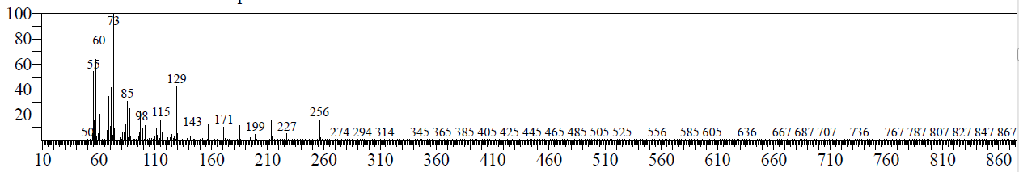
Figure 4: Mass spectrometry of compound 1
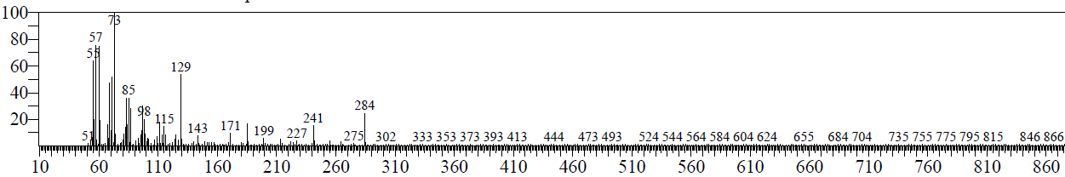
Figure 5: Mass Spectrometry of compound 2
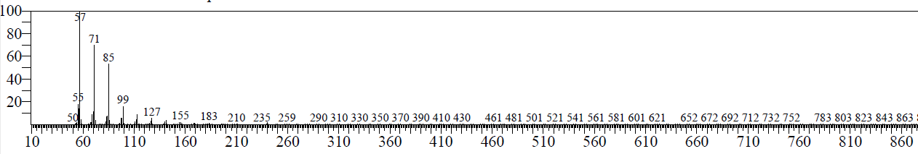
Figure 6: Mass Spectrometry of compound 3

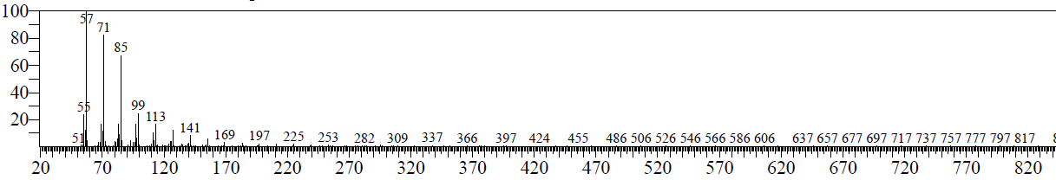
Figure 7: Mass Spectrometry of compound 4
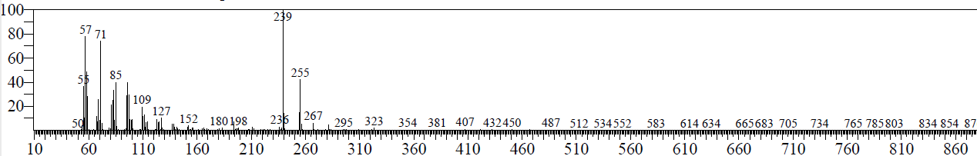
Figure8:Mass Spectrometry of compound 5

3.2 Discussion
3.2.1 Nature of extracts and recovery of solvents
The hexane extract was jelly and chloroform extract was fatty which implies that they took the oily parts of the leaves while the acetone, ethyl acetate and methanol extracts were solid and powdery in nature. As in Table 1, the hexane gave the highest recovery which could be due to the high quantity of non polar compounds because the hexane is non polar solvent and so it extracts the non polar components of the leave in obedience to the principle that says “like dissolve like”. Chloroform, acetone and ethyl acetate also took a reasonable quantity which is due to the reasonable amount of polar compounds it contains and finally methanol had the least recovery despite its polarity due to the fact that most of the polar compounds have been recovered by the polar solvents, it also shows that the most polar component of the leaves of this plant are few.

3.2.2 Characterization of compound 1 and 2
Scheme 1: Fragmentation patterns of compound 1
Scheme 2: Fragmentation patterns of compound 2
Compounds 1 and 2 are all aliphatic acids and so they give similar peaks in IR.
The presence of O-H band starting from 3388.86 cm⁻¹ to 2658.68 cm⁻¹ and sloped into aliphatic C-H bond absorption (2936.42 cm⁻¹) is due to the presence of carboxylic acid functional group. It is confirmed by the carbonyl band at 1698.56 cm⁻¹ and the band at 3545.28 cm⁻¹ is for free O-H stretch monomer. The band at 1277.32 cm⁻¹ is due to a C-O bond of carboxylic acid because of the partial double bond character as a result of electron delocalization by resonance. The band at 2936.42 cm⁻¹ indicates an sp³ hybridized C-H bond due to its small s-character. The smaller the s-character the weaker the bond hence, less energy is needed to stretch the bond. This is confirmed by the presence of the band at 1416.14 cm⁻¹ for methylene and 1317.14 cm⁻¹ for methyl. To also confirm the presence of methylene a band at 712.59 cm⁻¹ is observed.
3.2.3 Characterization of compound 3, 4 and 5
Scheme 3: Fragmentation patterns of compound 3
Scheme 4: Fragmentation patterns of compound 4
Compound 3 and 4 are aliphatic alkanes and the band at 2926.62 cm⁻¹ shows the presence of sp³ hybridized C-H bond. The confirmation of this is shown at 1542.22 cm⁻¹ for methylenes and 1376.90 cm⁻¹ and 1361.77 cm⁻¹ for methyls.
Scheme 5a: Fragmentation patterns of compound 5

Scheme 5b: Fragmentation patterns of compound 5 continuation
Compound 5 also has bands at the aliphatic alkane region but it also shows a band due to the presence of C=O bond at 1716.26 cm⁻¹. The band at 1220.07 cm⁻¹ and 1091.89 cm⁻¹ indicate the C-O bond of ester due to electron delocalization by resonance which makes one C-O bond to have pure single bond character while the other partial single bond as in the figure below:
Scheme 6: Resonance stabilization of compound 5
The band at 1168.61cm⁻¹ is due to the oxygen carbon bond of the ether that withdraws electron from both of its adjacent carbons.
Conclusion
This research validates the local use of the leaves of Cissampelosowariensis as anti-inflammatory due to the presence of hexadecanoic acid (palmitic acid) used as anti-inflammatory.It opens a possibility of discovering and isolating new clinically effective antibacterial compounds, thereby decreasing the burden of drug resistance and cost of management of diseases. However, the effect of this plant on pathogenic organisms, toxicological investigations and further purifications, needs to be carried out.

References

Abo, K. A., Ogunleye, V. O., Ashidi, J. S. (1991). Antimicrobial poteintial of Spondias mombin, Croton zambesicus and Zygotritoniacrocea. Journal of Pharmaceautical Resources, 5(13), 494-497.
Akande, R., Okwute S. K., Iliya, I.,Efiom, O. O. (2013). Chemical constituents and anti-
tuberculosis activity of the root extracts of Cissampelosowariensis(P. Beauv.) Menispermaceae.African Journal of Pure and Applied Chemistry, 7(1), 21-30.

Dougari, J. H., Human, I. S., Bennade, S.,Ndakidemi, P. A. (2009). Phytochemicals as
Chemotherapeutic agents and antioxidants: Possible solution to the control of antibiotic resistant verocytotoxin producing bacteria. Journal of Medicinal Plants Research, 3(11), 839-848.

Efiom, O. O. (2010) Isolation and Characterization of Bis (2 – Methoxyethyl) Phthalate and
Hexashydro-1 3 – Dimethyl– 4 – Phenyl – 1h – Azepine 4 – Carboxylic Acid from the Root of CissampelosOwariensis(P. Beauv). Nigerian Journal of Basic and Applied Science, 18(2), 189-192.

Habila, J. D., Bello, I. A., Dzikwe, A. A., Ladan, Z., Sabiu, M. (2011). Comparative Evaluation of Phytochemicals, Antioxidant and Antimicrobial Activity of Four Medicinal Plants Native to Northern Nigeria. Australian Journal of Basic and Applied Sciences, 5(5): 537-543.

Liu, R. H. (2004). Potential synergy of phytochemicals in cancer prevention: mechanism of action; Journal of Nutrition, 134(12), 3479-3485.
Nweze, E. L., Okafor, J.L., Njoku, O. (2004). Antimicrobial Activityies of Methanolic extracts of Trumeguineesis (Scchumn and Thorn) and Morindalucinda used in Nigerian Herbal Medicinal practice. Journal of Biological Resourses of Biotechnology, 2(1), 34-46.
Olutayo, O., Abayomi, O., Olakunle, F., Temitope, A., Ibrahim, I. (2013) The chemical composition of essential oil from the root of Cissampelosowariensis(p.beauv) and free radical scavenging activities of its extracts.African Journal of Pure and Applied Chemistry, 7(6), 225-230.

Sofowora, A.(2000).Plants in African traditional medicine-an overview. In: Evans WC (ed)
Trease and Evans pharmacognosy, Edn 15.W.B.Saunders, Edinburgh. 488-496.

Vickers, A.,Zollman, C., (1999). ABC of complementary medicine: herbal medicine.British Medical Journal, 319:1050 -3.

