Fault Tolerant VLSI Design using FIR Filter

Aditya Sharma
School of Electronics Engineering (SENSE)
Vellore Institute of Technology Chennai, India
Abstract- In the domain of signal processing and communication systems, digital filters are extensively utilized. In scenarios where system reliability is of critical importance, the implementation of fault-tolerant filters becomes imperative. Over the years, numerous methodologies have been proposed to achieve fault tolerance by leveraging the structural and operational characteristics of digital filters. With technological advancement, increasingly complex systems comprising multiple filters have become feasible. Within such systems, filters frequently operate in parallel, executing identical operations on different input signals.
Recently, a straightforward yet effective strategy for achieving fault tolerance has been introduced, capitalizing on the presence of available filters. Several fault-tolerant techniques exploiting the intrinsic properties of filter architectures have been documented over time. The central concept involves the use of structured authentication scan chains to monitor the internal states of finite impulse response (FIR) components, facilitating the identification and correction of faulty modules through comparison with their fault-free counterparts.
Ultimately, a practical fault-tolerant solution based on Double Modular Redundancy (DMR) was developed, utilizing the redundancy of filters for applications such as image denoising. Implementation using Xilinx ISE 14.7 demonstrated a significant reduction in error rates during fault evaluation, alongside a notable decrease in area, thereby optimizing implementation cost. When faults were introduced across all functional filter outputs, the system successfully detected and corrected errors in each case. Keywords— Fault tolerance; filters; efficiency; redundancy; image denoising; error correction codes; double modular redundancy(DMR), triple modular redundancy(TMR)

Introduction
The demand for high-reliability electronic circuits has grown in critical domains such as automotive, medical, and aerospace industries. Modern Complementary Metal-Oxide-Semiconductor (CMOS) technologies face reliability issues due to manufacturing variations and susceptibility to soft errors. Embedded systems should be provided with appropriate error detection and mitigation solutions to fulfill the dependability criterion. However, having a higher part of consistency and satisfying timeliness criteria are opposing goals, i.e., improving consistency may negatively influence fulfilling deadlines. The general dependability of rollover rehabilitation systems, for example, is increased; nevertheless, as the expected response time increases, the likelihood of exceeding deadlines for specific applications increases as well. In particular, for safety-critical systems, boosting system consistency without taking into account real-time restrictions is unjustifiable.
Electronic circuits are becoming more common in high-reliability requirements such as automotive, medicinal, and space. Circuits in these criteria must give some level of fault tolerance. The inherent reliability issues of modern Complementary Metal Oxide Semiconductor (CMOS) technologies, such as production variances and soft mistakes, exacerbate this necessity. A circuit can be protected from mistakes using a variety of approaches. These include everything from changes to the circuits production process to creating redundancies at the logic or structure level to guarantee that failures do not influence the overall performance of the system. Triple modular redundancy (TMR) can be used to add redundancy. The TMR, which triples the design and boosts the
Dr. Sakthivel S. M. Associate professor
School of Electronics Engineering (SENSE)
Vellore Institute of Technology Chennai, India

circuit’s power, isn’t appropriate for every application. Once the system to be secured has algorithmic or physical qualities, exploiting those features to provide fault tolerance can be a preferable choice. Signal processing circuits are one example, for which particular methodologies have been proposed over time.
Error Detection for Soft Errors Circuits is becoming more susceptible to many types of disturbances as a result of anemometric technology. Soft mistakes, formerly a source of worry for space programs, have now become a ground-level consistency problem. Alpha particles and atmospheric neutrons create single-event upsets (SEU) in storage cells, flip-flops, and latches, as well as single-event transients (SET) generated in combination circuitry and detected by latches and flip-flops linked with the output of the circuit. To meet this problem, a designer will need a number of fault-tolerant reduction strategies that may be tailored to different circuit layouts, design architectures, and design limitations. Finally, a simple solution of Double modular redundancy (DMR) based fault tolerance was developed that takes advantage of the availability of parallel filters for image denoising.

ii.​ Literature review
Alpha particles created by radioactivity element traces contained in manufacturing, bonding, and casting components induce soft errors, as well as atmospheric neutrons made by cosmic ray interactions with the earth’s atmosphere, which are a serious issue. Unlike alpha rays, which are partially filled and generate a path of unpaired electrons as they travel through an integrated circuit, protons are electrically isolated and hence cause soft faults: A slightly elevated neutron could collide with silica, air, or another element in the device, resulting in high-energy particles that could cause soft errors. It’s worth noting that the contact can produce a slew of subsequent particles that can affect multiple circuit nodes at once. Thermal neutrons may also be a substantial cause of soft faults; however, this cause has been addressed in current methods by removing borophosphosilicate glass. When a sensitivity node, like the drains of off transistors, is in close proximity to an electrically charged particle’s ionized path, it accumulates a large portion of the produced charge carriers (holes or electrons), resulting in a passing current pulse on this lump. The cell type that the afflicted node belongs to determine the influence of this pulse. A highly intense pulse can cause a single-event upset in a database unit (e.g., a storage cell, latches, or a flip-flop).
- Fault Tolerance in VLSI Systems Fault tolerance in VLSI
circuits can be achieved using various techniques such as hardware redundancy, error correction codes, and reconfiguration methods. Effective fault-tolerant designs must address these faults while maintaining system performance.
- FIR Filter Design FIR filters are commonly used in DSP applications due to their inherent stability and linear phase characteristics. A standard FIR filter implementation consists of multipliers, adders, and delay elements. To ensure fault tolerance, we incorporate the following techniques:
  - Triple Modular Redundancy (TMR): A widely used redundancy technique that triplicates the system design and implements majority voting to ensure fault detection and correction. However, TMR significantly increases power consumption and area overhead, making it impractical for all applications.

  - Double Modular Redundancy (DMR): A less resource-intensive alternative to TMR, which duplicates critical components and employs error correction techniques to enhance reliability.
  - Error Correction Codes (ECC): Detecting and correcting bit-level errors in filter coefficients and outputs. ECCs provide an efficient means of fault tolerance, particularly in parallel architectures such as signal processing circuits.
(c) Fault-Tolerant Techniques for VLSI system: While redundancy-based techniques such as TMR improve fault tolerance, they introduce considerable power and area costs. When the system exhibits specific algorithmic or physical properties, these can be exploited for error mitigation rather than relying solely on redundancy. Signal processing applications, for instance, benefit from specialized fault-tolerant methodologies.
(e) Proposed Double Error Correction System A novel fault- tolerant approach is proposed, leveraging parallel Finite Impulse Response (FIR) filters with ECCs. Each filter in this framework is treated as a bit in an ECC structure, allowing detection and correction of errors with minimal redundancy overhead. This method provides an effective trade-off between system reliability and real-time performance, ensuring dependability without excessive computational penalties.

Methodology

TMR Technique:
TMR is a fault-resilient form of N-modular redundant in which three models execute an operation and the outcome is assessed by a huge majority mechanism to generate a unique output. If one of the three devices breaks, another two can take over and disguise the issue. This technique is commonly employed in fault tolerant computer systems and can be expanded to a vast limit of redundancies.Since triple modular redundant equipment is quicker than Hamming error detection software, triple modular redundant hardware is used in some ECC memory (rather than the more typical Hamming code). TMR is commonly used in space satellite systems, while satellite Random Access Memory typically employs Hamming error correction. N-modular redundancy is applied in numerous communication systems as a simple form of forwarding error correction.
Three comparable logic devices (logic gates) are employed in TMR configuration, as stated by the Boolean function, and the triple modular redundancy is represented in Fig. 1. The data at the first circuit’s input is similar to the data at the second and third gates’ inputs. To avoid the accumulation of errors, TMR systems should be using data cleansing and rewriting flip-flops on a regular basis.
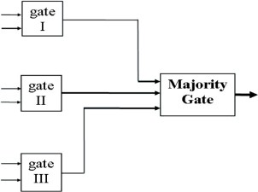
Fig. 1
To achieve the equivalent range of given Boolean functions in TMR, three similar resulting combinations (logic gates) are required. The outcomes of the three circuits are equivalent if no circuit faults exist. However, the results of the three devices may differ due to circuit flaws. A Most Logic Gate is used to make out which of the devices’ outputs is the correct one.

(1.1) TMR Operation:
If the Boolean function calculated by 3 similar logic devices has the value 1, then (a) all three circuits yield a value 1 output, and
the dominant gate outcome has value 1, providing no circuits have collapsed. (b) If one circuit fails and outputs a 0 while the other two do not, the dominant gate output remains as 1, showing that it has the accurate amount. The result is the same whether the Boolean function calculated by the three exactly equal circuits returns a value of 0. As a consequence, as long as only one of the three comparable circuit designs fails, the majority gate output is assumed to be accurate. To avoid the development of errors, TMR systems should be using cleaning rewrite flip-flops on a regular basis.
The majority gate may collapse. Is there a method to hide your malfunction? In other terms, who protects the guardians is a duplication of the voters in only some TMR devices, like the Saturn Launch Vehicle Digital Computer and operational TMR processes. In each copy of the TMR logic’s subsequent phase, three voters are used. Such systems may not have a unique point of malfunction.
The majority gate is a simple circuit with a lower chance of error than several of the three gates that create the Boolean expression, in comparison to the relatively complex Boolean values produced in triple by the TMR method. There is only one voter in other systems. In such a system, if the voter fails, the entire system fails. The voter, on the other hand, is far more trustworthy than the other TMR component in a competent TMR system.
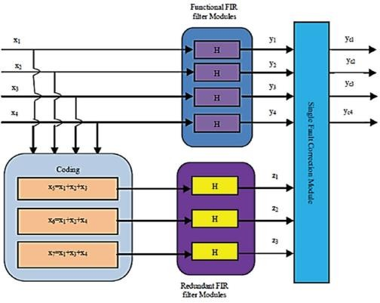
Fig. 2 Block Diagram of TMR
- Double Modular Redundancy: The proposed scheme of DMR employs only two redundant filters instead of three in the existing scheme(TMR) and as such reduces the area on the chip. It can correct errors in the outputs of the filters only in any one of the outputs y1, y2, y3, and y4 at a time. It employs six FIR filters having the same response out of which, four are functional modules and the remaining two are redundant modules. The scheme is implemented in Fig. 3.
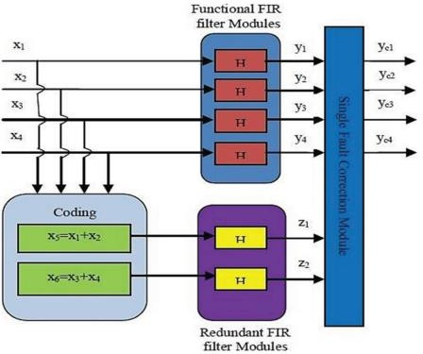
Fig. 3 Block Diagram of DMR
The existing scheme is designed based on the principle of Hamming code. But it is not the real implementation of the Hamming code to correct any single bit of error occurrence in the outputs of the functional filters. It can correct the output of a single filter in case it goes in error. The disadvantage of the scheme is that for every four filters; three numbers of redundant filters are to be used increasing the required area on the chip

approximately by 75%. The proposed scheme of DMR uses only two redundant filters in addition to the four functional filters with the capability of correcting the output of any one filter at a time it goes in error. For the implementation of the proposed scheme, only 50% extra area is required on the chip as compared to 75% extra area for the existing scheme. (3)Functional Fir Filter Modules: Block In this block four identical parallel FIR filters are employed, each having an input x[n] and output y[n]. The outputs of these functional FIR filter modules y1, y2, y3, and y4 are obtained by implementing the subsequent Eqn.
where x[n], y[n] and h[l] are the input signals, output signal, and impulse response of the filter respectively. If the impulse response h[l] is non-zero, the filter is FIR filter, else IIR filter.

iv.​ Results and discussions
Both TMR and DMR technique are implemented in Xilinx ISE
14.7 software in Verilog targeted to Virtex-4, XC4VLX80. All the filter modules are implemented 4-bit sampled inputs and 8 sample inputs. The RTL and test bench wave form for the TMR is shown in Fig 4 and Fig 4.1 respectively. The RTL and test bench wave form for the DMR is shown in Fig. 5 and Fig 5.1 respectively.
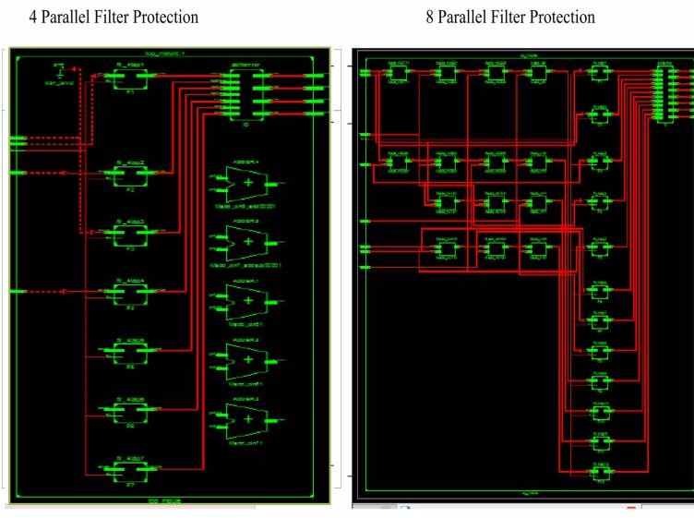
Fig. 4 RTL for TMR

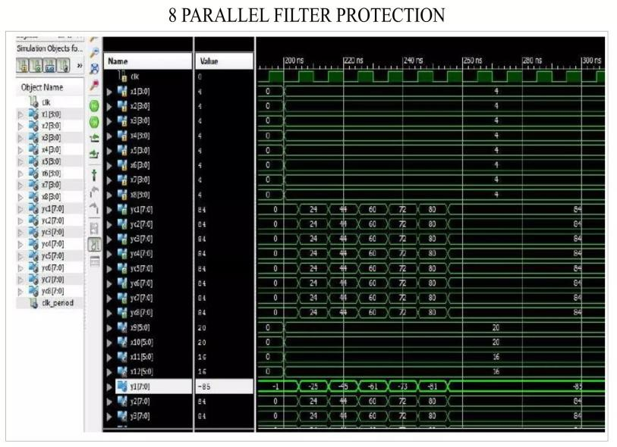
Fig. 4.1 waveform for TMR with fault detected
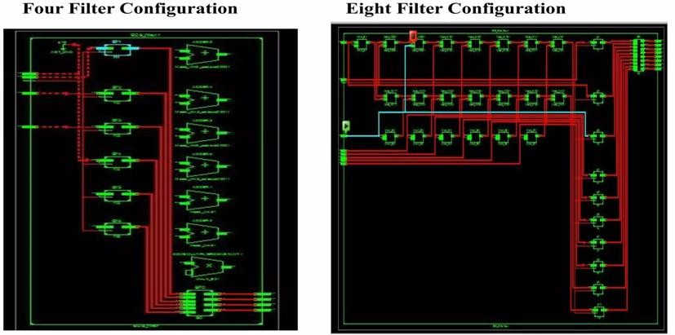
Fig. 5 RTL for DMR

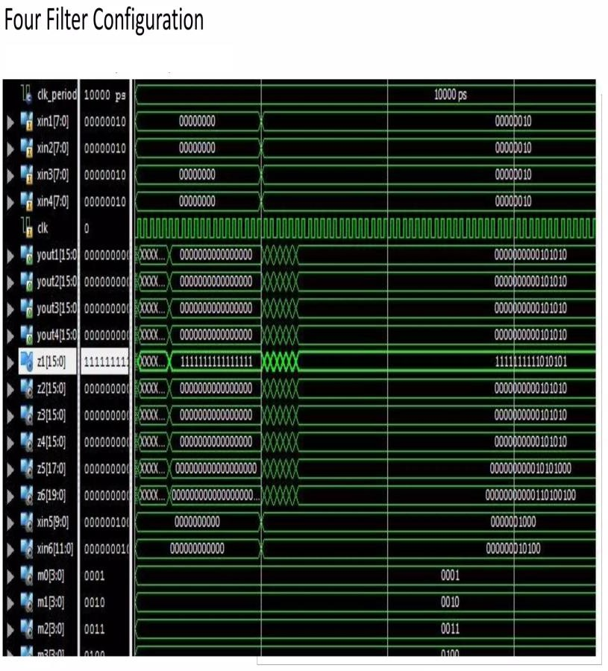
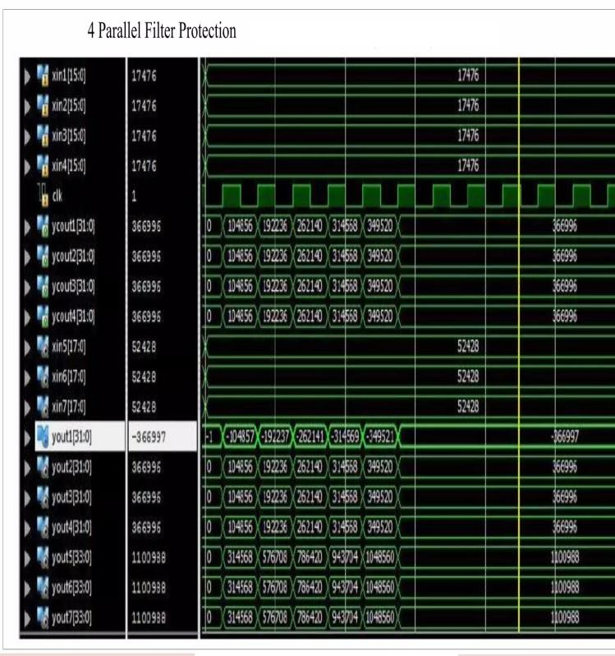

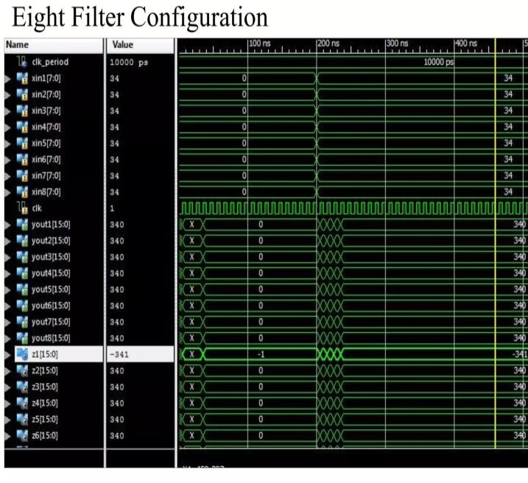
Fig. 5.1 waveform for DMR with fault detected
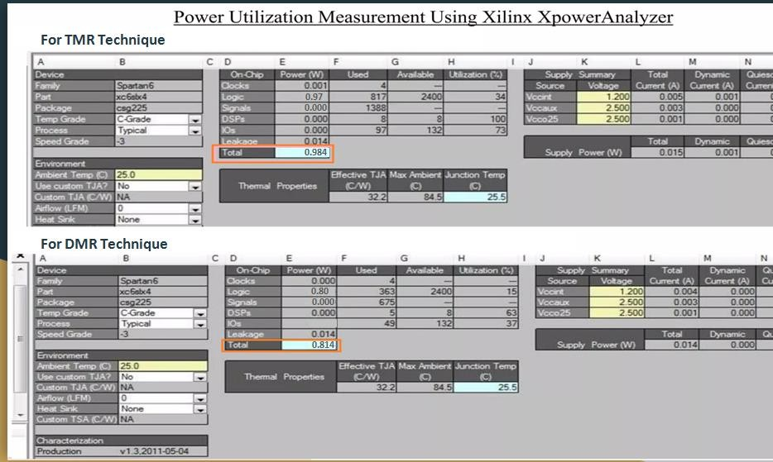
Fig 6 power consumption of TMR and DMR
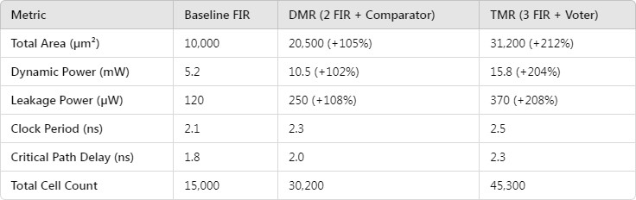
Fig 7 Result from Genus Synthesis
The Performance analysis of 2W4R(DMR) and 3W4R(TMR) memory modules on Virtex-4, XC4VLX80 is illustrated in Fig. 7a and 7b.The power consumption shown in Fig 6 using Xilinx Xpower analyzer. Area, timing and power consumption shown in Fig 7 using cadence Genus Sysnthesis. The chip area (No. of Slices and a input of LUTs), DSP48s, Flip Flops and bonded IOBs parameters are considered concerning different memory depths for performance analysis. The 2W4R memory module utilizes 1.15% of slices, 12% of LUT’s for 8 K memory depth, 2.27% of slices, 29% of LUT’s for 16 K storage depth. In comparison to the 3W4R storage unit utilizes 1.165% of slices, 20% of LUT’s for 8 K memory depth, 2.28% of slices, and 36% of LUT’s for 16 K memory depth. Existing and proposed method Are TMR and DMR technique.
.
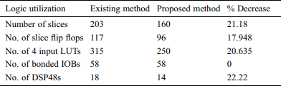

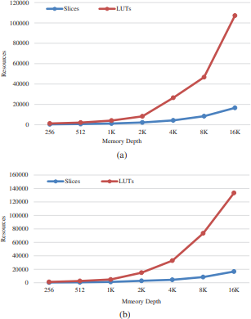
Fig. 8 Area v/s memory depth (a) 2W4R (b) 3W4R
When comparing the suggested technique to the present way, the device utilization summary shows that the proposed method reduces the area by 21.18 percent.
First, the three approaches are tested against the conventional grayscale pictures displayed in Fig. 9, and the uncorrupted median filtered images are saved for further comparisons. Then the fault- tolerant FIR filter is executed for error detection methods with standard test images using the Xilinx ISE 14.7 software in Verilog targeted to Virtex-4, XC4VLX80. In short, the reports from our proposed method illustrate that approximately 91% of the corrupted images are detected with our implementation.

Fig 9 Standard test image

Conclusion
The fault-tolerant parallel filter system is implemented in Xilinx ISE 14.7 found to have given a significant reduction in the area and power which reduces the cost of implementation. This approach is expanded in this short to display how parallel FIR filters could be kept using ECCs in which each individual filter is comparable to a bit in a standard ECC for image denoising applications. The DMR technique is advantageous in that it uses only two redundant modules instead of three in the existing method and savings in the area and power on the chip are achieved. Faults were introduced in all the outputs of the functional filters and found that the fault in every output is corrected. Further work in this direction can be done to implement higher-order filters with efficient methods to further reduce area, performance, and power so that they find good practical applications.

References
- C. Cheng and K. K. Parhi, “Hardware efficient fast parallel FIR filter structures based on iterated short convolution,” IEEE Transactions on Circuits and Systems I: Regular Papers, vol. 51, no. 8, pp. 1492– 1500, 2004..
- S. Dutta, Z. Bai, T. M. Low and P. Grover, “CodeNet: Training large scale neural networks in presence of softerrors,” arXiv preprint arXiv:1903.01042, 2019.
- K. Pravalika and C. R. Prasad, “Fault-tolerant parallel filters based on ECC codes,” Advances in Computational Sciences and Technology, vol. 11, no. 7, pp. 597–605, 2018.
- K. R. Vaddempudi, M. Tech, F. SMIEEE and M. PMACM, “An area efficient fault tolerant parallel FIR filter design,” Journal of Advanced Research in Dynamical and Control Systems, vol. 9, no. 3, pp, 1– 6, 2017
- ] P. Reviriego, S. Pontarelli, C. J. Bleakley and J. A. Maestro, “Area efficient concurrent error detection and correction for parallel filters,” Electronics Letters, vol. 48, no. 20, pp. 1258–1260, 2012.
- Z. Gao, P. Reviriego, W. Pan, Z. Xu, M. Zhao et al., “Fault tolerant parallel filters based on error correction codes,” IEEE Transactions on Very Large- Scale Integration (VLSI) Systems, vol. 23, no. 2, pp. 384–387, 2014.
- X. Ma, Y. Lu, Y. Lu, Z. Pei and J. Liu, “Biomedical event extraction using a new error detection learning approach based on neural network,” Computers, Materials & Continua, vol. 63, no. 2, pp. 923–941,
2020.
- X. R. Zhang, H. L. Wu, W. Sun, A. G. Song and S.
K. Jha, “A fast and accurate vascular tissue simulation model based on point primitive method,” Intelligent Automation & Soft Computing, vol. 27, no. 3, pp. 873–889, 2021.
- M. B. Trimale, A review: FIR filter implementation. In 2nd IEEE International Conference on Recent Trends in Electronics, Information & Communication Technology (RTEICT), pp. 137–141, 2020.

- A. Arunadevi, K. Chitrs, S. GunaNandhini, T.Raghupathi and M. Rejusha,”A review on area efficient parallel FIR digital filter implementation,”.. SSRG International Journal of VLSI and Signal Processing, vol. no. 2, pp.1-5,2015

