A Dual-Phase Hyperparameter Tuning Approach for Emotion Detection using Boosting-Based Machine Learning Algorithms
Dennis S. Nava*, Roman B. Villones, John Joshua E. Mendoza,
Rhayz Steven Kyle P. Bautista, Alfred Brian C. Bautista

Graduate School, La Consolacion University Philippines, Malolos, Bulacan, Philippines
*Corresponding author’s email address: johnjoshua.mendoza@email.lcup.edu.ph
ABSTRACT
This study proposes a dual-phase hyperparameter tuning approach to improve emotion detection using boosting-based machine learning algorithms. The methodology employed a structured pipeline involving data preprocessing, TF-IDF vectorization, model training, and evaluation using a balanced Kaggle emotion dataset. Six boosting algorithms were analyzed: XGBoost, LightGBM, CatBoost, AdaBoost, GradientBoosting, and HistGradientBoosting. The tuning process consisted of two stages: coarse optimization using RandomizedSearchCV followed by fine-tuning through GridSearchCV. Results revealed mixed effects of hyperparameter tuning across models. LightGBM achieved the highest performance with 92.24% accuracy, followed by XGBoost at 91.49% and GradientBoosting at 91.14%. CatBoost experienced a decline in performance after tuning, while AdaBoost and HistGradientBoosting were excluded due to limitations and compatibility concerns. Findings indicate that hyperparameter tuning is highly model-dependent and requires careful validation to ensure optimal performance and generalization in emotion detection tasks.
Keywords: Emotion Detection, Hyperparameter Tuning, Boosting Algorithms, Text Classification, Natural Language Processing.

INTRODUCTION
In an increasingly digitized and interconnected world, the ability to detect human emotions through computational methods has become critically important across a wide range of applications. Emotion detection also known as affective computing, allows machines to recognize and respond to human emotional states, enhancing user experience, and personalization. As modern societies grapple with rising mental health challenges, detecting emotions through text or social media expressions has also gained prominence in early diagnosis and intervention strategies.

Recent advancements in machine learning (ML) and natural language processing (NLP) have significantly improved the ability of systems to understand emotional cues from textual activity. Alswaidan and Menai (2020) emphasize that emotion recognition from textual data has gained momentum, particularly with the rise of social media where users frequently express emotions in short and unstructured formats. In healthcare, emotion detection is increasingly used for monitoring mental health conditions such as depression or anxiety, especially through analyzing patients’ speech or online activity as explained by Prabhudesai et al. (2021). In education, emotion-aware tutoring systems can adapt to students’ affective states by improving engagement and learning outcomes based on Gayed et al. (2022).

The primary objective of this study is to develop and evaluate a dual-phase hyperparameter tuning approach to enhance the performance of emotion detection systems using boosting-based machine learning algorithms. The approach involves a two-stage optimization process: coarse tuning using RandomizedSearchCV, followed by fine-tuning using GridSearchCV, then applied to multiple boosting algorithms such as XGBoost, LightGBM, CatBoost, GradientBoosting, AdaBoost, and HistGradientBoosting. The goal is to identify the most effective tuning strategy that optimizes predictive accuracy and computational efficiency in emotion classification tasks.

This study contributes to the growing field of affective computing by introducing a dual-phase hyperparameter tuning approach that systematically enhances the performance of boosting-based machine learning algorithms for emotion detection. The proposed methodology offers a balanced and efficient framework for model optimization. The study further provides a comparative analysis of six popular boosting algorithms and demonstrating how tuning strategies impact their classification performance in emotion detection tasks. The approach offers scalability and reproducibility, making it adaptable to other NLP and text classification problems beyond emotion detection.

LITERATURE REVIEW
Review of Related Studies
In the study conducted by Alswaidan and Menai (2020) emotion recognition from textual data has gained significant attention because social media platforms allow users to express their emotions through posts and online interactions. The researchers explained that affective computing improves human-computer interaction by enabling systems to identify and respond to emotional states. Similarly, Khalil et al. (2019) discussed the effectiveness of deep learning techniques in speech emotion recognition using facial expressions, speech, and audiovisual inputs, particularly in healthcare surveillance applications. Furthermore, Yan et al. (2022) explored emotion classification using physiological signals such as EEG and ECG, emphasizing the importance of preprocessing, feature extraction, and multimodal fusion techniques in improving classification accuracy.
The study of Bischl et al. (2023) provided a comprehensive review of hyperparameter optimization methods and compared the effectiveness of RandomizedSearchCV and GridSearchCV in improving machine learning model performance. In addition, Khansa et al. (2025) applied both optimization methods to the XGBoost algorithm for Parkinson’s disease classification and found that GridSearchCV achieved better predictive accuracy. Malhotra and Cherukuri (2024) also explained that hyperparameter tuning techniques significantly contribute to improving software quality prediction models by optimizing model generalization and predictive capability. These studies highlighted the importance of parameter optimization in machine learning systems.
According to Sadaf (2023) CatBoost and XGBoost algorithms achieved strong performance in phishing website detection systems by accurately classifying malicious URLs. Similarly, Kumar and Guleria (2024) utilized CatBoost and LightGBM algorithms in AI-enhanced cybersecurity datasets and reported high accuracy in detecting anomalous network traffic. The study of Athanasiou and Maragoudakis (2017) also demonstrated that GradientBoosting is effective in sentiment analysis tasks even in low-resource language environments. These studies collectively support the effectiveness of boosting algorithms in classification and sentiment analysis tasks.
Review of Related Systems
In the study conducted by Al-Zakhali et al. (2024) an XGBoost-based text classification system was developed to improve document classification performance through parallel processing and boosting tree techniques. The researchers highlighted that the system achieved efficient prediction speed and high classification accuracy when handling textual datasets. Similarly, Lokker et al. (2024) implemented a LightGBM-based classification system for biomedical research abstracts and demonstrated that the system could rapidly process high-dimensional textual data while maintaining strong predictive performance.
According to Narasamma and Sreedevi (2021) a CatBoost-based Twitter sentiment analysis system was designed to improve sentiment classification by efficiently handling textual and categorical data from social media platforms. In addition, Prabhakar et al. (2019) utilized AdaBoost in a sentiment analysis system for airline Twitter data, where the algorithm improved classification performance by iteratively correcting weak learner errors. Moreover, Maftoun et al. (2024) developed a HistGradientBoosting system for malicious URL and fake news detection, emphasizing its capability to process sparse and large-scale textual features efficiently. These systems demonstrate the practical applications of boosting algorithms in natural language processing and emotion detection environments.
The study of Gayed et al. (2022) introduced an AI-based emotion-aware tutoring system capable of adapting educational content according to students’ emotional states to improve learning engagement and performance. Similarly, Prabhudesai et al. (2021) developed a depression detection and analysis system using deep learning techniques to identify mental health conditions through speech and online activities. Furthermore, Yan et al. (2022) proposed an emotion recognition system using multichannel physiological signals combined with adaptive decision fusion methods to accurately classify emotional responses. These systems highlight the growing importance of emotion detection technologies in healthcare, education, and intelligent human-computer interaction systems.

METHODOLOGY

This study employed a structured machine learning pipeline to improve the performance of emotion detection using boosting-based algorithms. The methodology consisted of five main stages: data collection and preprocessing, feature engineering, model definition, hyperparameter optimization, and model training and evaluation.

Data Collection & Preprocessing
The dataset used in this study was sourced from Kaggle, a reputable platform for data science competitions and dataset sharing. It initially contained a total of 422,746 rows, each comprising two columns: one for the textual content “sentence” and another for the associated emotional label “emotion”. A thorough data validation process confirmed that there were no missing values, ensuring the dataset’s completeness and reliability for subsequent analysis.
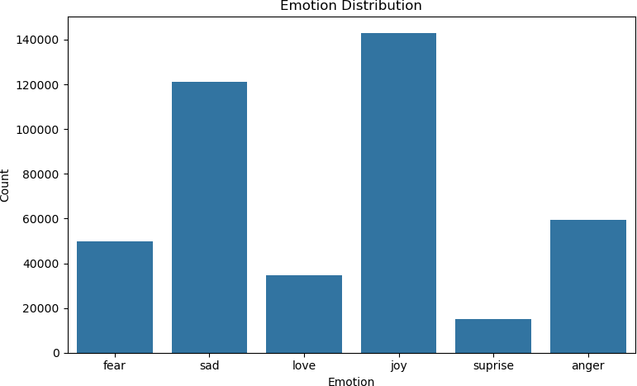
Figure 1. Emotion Distribution based on the dataset.

As illustrated in Figure 1, the dataset exhibited a significant imbalance in the distribution of emotional categories: 'fear', 'sad', 'love', 'joy', 'surprise', and 'anger'. Most of the instances were labeled as 'joy' (143,067) and 'sad' (121,187), followed by 'anger' (59,317), 'fear' (49,649), and 'love' (34,554). The category with the fewest samples was 'surprise' (14,972). However, an imbalance was observed in the distribution of samples across these classes, which posed a risk of bias during model training.

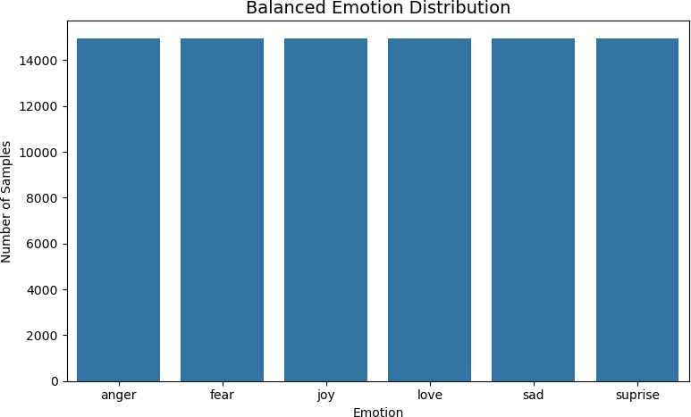
Figure 2. Emotion Distribution after balancing.

Figure 2 illustrates the transformation of the original imbalanced dataset into a balanced form by applying a down sampling technique. Initially, the dataset exhibited highly unequal class distributions, with the number of instances ranging from 14,972 ('surprise') to 143,067 ('joy'). To mitigate this imbalance and prevent model bias, the dataset was down sampled to ensure equal representation across all six emotion categories with each class containing 14,972 instances.

Feature Engineering
Feature engineering plays a critical role in transforming raw data into formats suitable for machine learning algorithms. In this phase, feature engineering involved two main steps:
- Target Encoding - The categorical target variable representing discrete emotion labels was numerically encoded using label mapping. Specifically, the six emotion classes were converted into integer labels as follows: 'anger': 0, 'fear': 1, 'joy': 2, 'love': 3, 'sad': 4, 'surprise': 5. This transformation was implemented using the ‘fit_transform’ method of a label encoder which ensures that the categorical labels are represented in a format compatible with classification models.
- Text Vectorization - The input feature is consisting of textual data and transformed into numerical representations using Term Frequency–Inverse Document Frequency (TF-IDF) Vectorization. According to Triana et al. (2025) the TF-IDF is a well-established technique in natural language processing that converts text into feature vectors while reducing the impact of commonly used words and highlighting more informative terms. The TF-IDF was configured with a
`max_features` parameter set to 5000, thereby limiting the feature space to the top 5000 most informative terms across the sentenses.

Model Definition
This study explores the effectiveness of advanced boosting algorithms in enhancing the accuracy of emotion detection systems and occurs the following:
- XGBoost - The study of Al-Zakhali et al. (2024) applied the TF-IDF-transformed text to efficiently classify documents and leveraging its parallel boosting trees to improve prediction speed and accuracy.
- LightGBM - As explained by Lokker et al. (2024) LighthGBM was employed to classifying the biomedical research abstract, demonstrating rapid training and strong performance, and high-dimensional textual data.
- CatBoost – Integrated with textual features from Twitter posts to improve sentiment classification and benefiting from its native handling of categorical and textual data as mentioned by Narasamma and Sreedevi (2021).
- AdaBoost – In the study conducted by Prabhakar et al. (2019) the AdaBoost was used to enhance sentiment classification of tweets by iteratively correcting errors from weak learners based on misclassified text samples.
- GradientBoosting – Based on Athanasiou and Maragoudakis (2017) GradientBoosting applied to TF-IDF features for sentiment analysis in Greek, demonstrating that boosting methods remain effective even in low-resource NLP settings.
- HistGradientBoosting – According to Maftoun et al. (2024) the HistGradientBoosting was used on n-gram-based textual features to detect fake news, benefiting from faster training time and effective handling of sparse data.

RESULTS

Hyperparameter Optimization
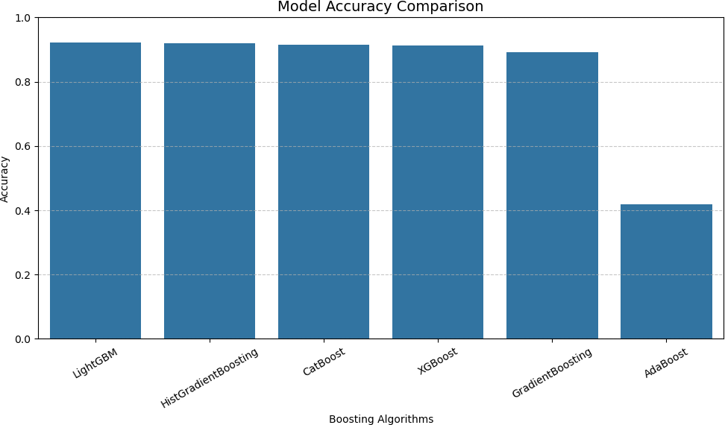
Figure 3. Model Accuracy Comparison in default parameters.

Figure 3 provides a visual representation of the accuracy scores of the six evaluated boosting algorithms. The bar chart clearly illustrates the performance gap between LightGBM and the other models, with a gradual decrease observed from HistGradientBoosting and CatBoost to XGBoost and GradientBoosting. The most striking aspect of the chart is the significant drop in performance observed in AdaBoost, which deviates substantially from the rest of the models.

Boosting Model | Accuracy | Rank
LightGBM | 92.20% | 1
HistGradientBoosting | 91.97% | 2
CatBoost | 91.61% | 3
XGBoost | 91.34% | 4
GradientBoosting | 89.11% | 5
AdaBoost | 41.82% | 6
Table 1. Ranking of Model by Accuracy in default parameters.

Table 1 summarizes the accuracy performance and corresponding ranks of six boosting-based machine learning algorithms applied to an emotion detection task. The results indicate that LightGBM outperformed all other models, achieving the highest accuracy score of 92.20%, followed closely by HistGradientBoosting 91.97% and CatBoost 91.61%. XGBoost achieved a respectable accuracy of 91.34%, placing fourth, while GradientBoosting performed moderately at 89.11%. Notably, AdaBoost showed the lowest performance with a significant accuracy drop to 41.82%, indicating that it may not be well-suited for the complexity of the textual emotion classification task used in this study.

Phase I – Coarse Hyperparameter Optimization with RandomizedSearchCV
This study adopts a coarse-to-fine tuning strategy, where RandomizedSearchCV is initially employed as a coarse hyperparameter optimization technique. Five boosting-based algorithms were subjected to coarse hyperparameter tuning: LightGBM, XGBoost, GradientBoosting, CatBoost, and HistGradientBoosting. Each model was independently tuned with a defined parameter distribution and 3-fold cross-validation (CV).

Boosting Model | Best Parameters
LightGBM | {'num_leaves': 31, 'n_estimators': 100, 'max_depth': -1,  'learning_rate': 0.05}
XGBoost | {'subsample': 0.8, 'n_estimators': 200, 'max_depth': 3,  'learning_rate': 0.2, 'colsample_bytree': 1.0}
GradientBoosting | {'subsample': 0.8, 'n_estimators': 200, 'max_depth': 5,  'learning_rate': 0.1}
CatBoost | {'learning_rate': 0.1, 'l2_leaf_reg': 1, 'iterations': 200,  'depth': 7}

HistGradientBoosting | {'max_leaf_nodes': 63, 'max_iter': 200, 'max_depth': 20,  'learning_rate': 0.05}
Table 2. Best Parameters of Model using RandomizedSearchCV

Table 2 presents the best hyperparameter configurations identified for each boosting algorithm through a two-stage tuning process. LightGBM, XGBoost, CatBoost, and GradientBoosting achieved optimal settings.

While HistGradientBoosting tuned effectively, it shows slightly lower accuracy despite its optimized parameters. This can be attributed to the use of TruncatedSVD with `n_components` of 300 for dimensionality reduction during preprocessing which may have limited the model’s ability to fully capture feature variance in high-dimensional text data.

Phase II – Fine-Tuning of Parameters with GridSearchCV
GridSearchCV is employed in the second phase for fine hyperparameter optimization. After the initial coarse search, GridSearchCV systematically evaluates combinations of hyperparameters within narrowed ranges to fine-tune model performance. Four boosting-based algorithms were subjected to fine hyperparameter tuning: LightGBM, XGBoost, GradientBoosting, and CatBoost. The tuning process was executed using 3-fold cross-validation (CV) to ensure robustness and generalization of the optimized models.

Boosting Model | Best Parameters
LightGBM | {'n_estimators': 100, 'max_depth': -1, 'learning_rate':  0.07, 'num_leaves': 31}
XGBoost | {'colsample_bytree': 0.9, 'learning_rate': 0.25,  'max_depth': 4, 'n_estimators': 220, 'subsample': 0.8}
GradientBoosting | {'n_estimators': 200, 'max_depth': 6, 'learning_rate':  0.08, 'subsample': 0.8}
CatBoost | {'iterations': 180, 'depth': 7, 'learning_rate': 0.12,  'l2_leaf_reg': 0.5}
Table 3. Best Parameters of Model after tuning using GridSearchCV

Table 3 presents the best hyperparameter configurations identified for each boosting algorithm through a two-stage tuning process. LightGBM, XGBoost, CatBoost, and GradientBoosting achieved optimal settings.

Model Training & Evaluation
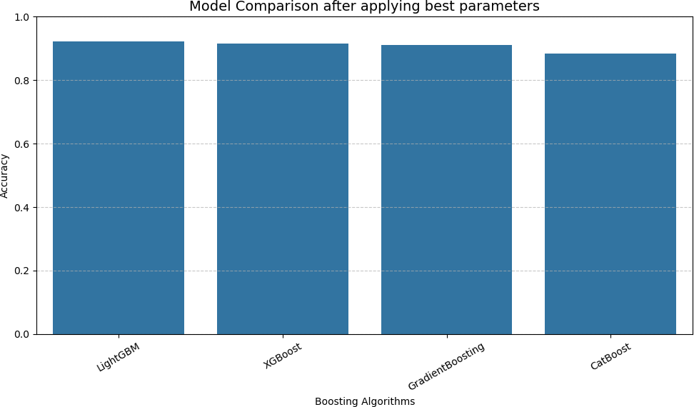
Figure 4. Model Accuracy Comparison in the best parameters.

Figure 4 illustrates the comparative accuracy of the four tuned boosting algorithms using a bar chart. Visually, LightGBM stands out as the top performer, followed closely by XGBoost and GradientBoosting, which exhibit only marginal differences. CatBoost shows a visible drop in performance, further supporting its lower ranking.

Boosting Model | Accuracy | Rank
LightGBM | 92.24% | 1
XGBoost | 91.49% | 2
GradientBoosting | 91.14% | 3
CatBoost | 88.37% | 4
Table 4. Ranking of Model by Accuracy in best parameters.

Table 4 presents the accuracy scores and corresponding ranks of four boosting algorithms evaluated after final hyperparameter tuning. Among the models, LightGBM achieved the highest accuracy at 92.24%, securing rank 1. XGBoost followed with an accuracy of 91.49%, benefiting from strong regularization and parallelized tree construction. GradientBoosting ranked third with 91.14%, showing consistent performance but slightly less optimized in handling complex patterns. CatBoost, despite its strength in categorical feature processing and recorded it as the lowest accuracy at 88.37%.

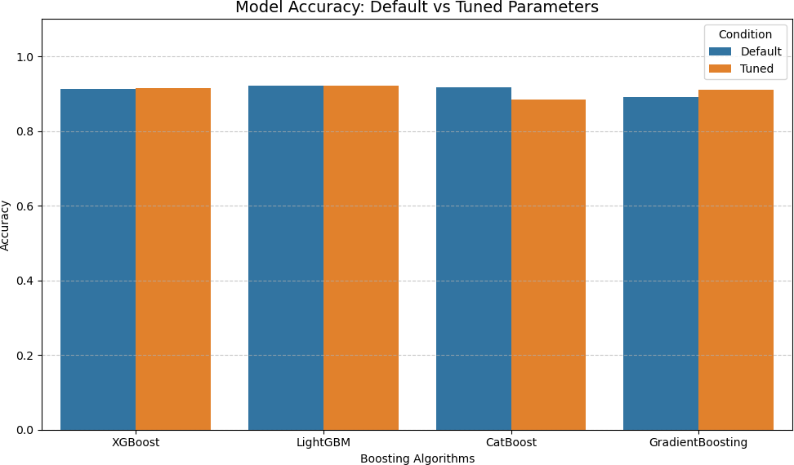
Figure 5. Model Accuracy Comparison using default and best parameters.

Figure 5 illustrates the changes in accuracy of four boosting algorithms when comparing their default configurations to their best-tuned versions. Most models exhibited slight to moderate improvements after tuning, particularly in cases where hyperparameter adjustments enhanced model generalization and learning dynamics. The figure demonstrates that while hyperparameter tuning is a valuable step in model development, its impact can vary depending on the model architecture and data characteristics.

DISCUSSION
The hyperparameter tuning process produced mixed results across the evaluated boosting algorithms, underscoring the fine effects of optimization on model performance in emotion detection.

Due to their relatively poor performance and compatibility issues, AdaBoost and HistGradientBoosting were excluded from the final comparison. HistGradientBoosting was affected using TruncatedSVD with `n_components` of 300 only, which may have limited its capacity to model complex and high-dimensional patterns in the dataset.

XGBoost showed a slight improvement in accuracy, increasing from 91.34% (default) to 91.49% (tuned). LightGBM, which initially achieved the highest accuracy of 92.20%, exhibited only a marginal gain after tuning and reaching 92.24%. On the other hand, GradientBoosting demonstrated the most notable improvement among the models, increasing from 89.11% to 91.14% after tuning. In contrast, CatBoost experienced a decline in accuracy, dropping from 91.61% to 88.37% post-tuning.

This suggests that the model benefited modestly from parameter adjustments, particularly in terms of learning rate and subsampling strategies which likely improved generalization without overfitting. The minimal change indicates that its default configuration was already well suited for the task and that further tuning offered limited benefit. Overall, the findings affirm that hyperparameter tuning is valuable, but its impact is model-specific. While certain algorithms like GradientBoosting and XGBoost, clearly benefited, others like CatBoost require more cautious optimization. The result emphasizes that the importance of careful validation as tuning can degrade performance if not properly managed.

CONCLUSION AND RECOMMENDATIONS
This study successfully developed and evaluated a dual-phase hyperparameter tuning approach for emotion detection using boosting-based machine learning algorithms. The findings revealed that hyperparameter tuning has a significant but model-dependent impact on classification performance. Among the evaluated algorithms, LightGBM achieved the highest accuracy, followed by XGBoost and GradientBoosting, demonstrating their effectiveness in handling text-based emotion classification tasks. The study also confirmed that combining RandomizedSearchCV and GridSearchCV provides a systematic optimization process that improves predictive capability and model generalization. However, the results also showed that improper or excessive tuning may negatively affect performance, as observed in the CatBoost model. Overall, the study highlights the importance of selecting appropriate optimization strategies and validation techniques when developing emotion detection systems.
Based on the findings, future researchers are encouraged to apply model-specific tuning strategies and explore advanced approaches such as deep learning and transformer-based architectures to further improve emotion classification accuracy. Educational institutions, healthcare organizations, and developers may also adopt boosting-based emotion detection systems for applications in sentiment analysis, mental health monitoring, and intelligent human-computer interaction. Furthermore, future studies should utilize larger and multilingual datasets, improve preprocessing techniques, and conduct continuous testing and evaluation to ensure system reliability, scalability, and real-world effectiveness.

REFERENCES
Al-Zakhali, O. A., Zeebaree, S., & Askar, S. (2024). Comparative analysis of XGBoost performance for text classification with CPU parallel and non-parallel processing. The Indonesian Journal of Computer Science,13(2). https://doi.org/10.33022/ijcs.v13i2.3798
Alswaidan, N., & Menai, M. E. B. (2020). A survey of state-of-the-art approaches for emotion recognition in text. Knowledge and Information Systems, 62(8), 2937-2987. https://doi.org/10.1007/s10115-020-01449-0

Athanasiou, V., & Maragoudakis, M. (2017). A novel, gradient boosting framework for sentiment analysis in languages where NLP resources are not plentiful: A case study for modern Greek. Algorithms, 10(1), 34. https://doi.org/10.3390/a10010034
Bischl, B., Binder, M., Lang, M., Pielok, T., Richter, J., Coors, S., Thomas, J. Ullmann, T., Becker, M., Boulesteix, A., Deng, D., & Lindauer, M. (2023). Hyperparameter optimization: Foundations, algorithms, best practices, and open challenges. Wiley Interdisciplinary Reviews: Data Mining and Knowledge Discovery, 13(2), e1484. https://doi.org/10.48550/arXiv.2107.05847
Gayed, J. M., Carlon, M. K. J., Oriola, A. M., & Cross, J. S. (2022). Exploring an AI-based writing Assistant's impact on English language learners. Computers and Education: Artificial Intelligence, 3, 100055.
https://doi.org/10.1016/j.caeai.2022.100055
Khalil, R. A., Jones, E., Babar, M. I., Jan, T., Zafar, M. H., & Alhussain, T. (2019). Speech emotion recognition using deep learning techniques: A review. IEEE access, 7, 117327-117345. https://doi.org/10.1109/ACCESS.2019.2936124
Khansa, S. F. A., Ulinnuha, N., & Utami, W. D. (2025). GRID SEARCH AND RANDOM SEARCH HYPERPARAMETER TUNING OPTIMIZATION IN XGBOOST ALGORITHM FOR
PARKINSON’S DISEASE CLASSIFICATION. BAREKENG: Jurnal Ilmu Matematika dan
Terapan, 19(3), 1609-1624. https://doi.org/10.30598/barekengvol19iss3pp1609-
1624Kumar, A., & Guleria, K. (2024, November). Leveraging Machine Learning Algorithms for Threat Detection Using AI-Enhanced Cybersecurity Datasets. In 2024 4th International Conference on Technological Advancements in Computational Sciences (ICTACS) (pp. 483-488). IEEE.
https://doi.org/10.1109/ICTACS62700.2024.10840478
Lokker, C., Abdelkader, W., Bagheri, E., Parrish, R., Cotoi, C., Navarro, T., Germini, F., Linkins, L., Haynes, R., Chu, L., Afzal, M., & Iorio, A. (2024). Boosting efficiency in a clinical literature surveillance system with LightGBM. PLOS Digital Health, 3(9), e0000299. https://doi.org/10.1371/journal.pdig.0000299
Maftoun, M., Shadkam, N., Komamardakhi, S. S. S., Mansor, Z., & Joloudari, J. H. (2024). Malicious URL Detection using optimized Hist Gradient Boosting Classifier based on grid search method. arXiv preprint arXiv:2406.10286. https://doi.org/10.48550/arXiv.2406.10286
Malhotra, R., & Cherukuri, M. (2024). A systematic review of hyperparameter tuning techniques for software quality prediction models. Intelligent Data Analysis, 28(5), 1131-1149. https://doi.org/10.3233/IDA-230653
Narasamma, V. L., & Sreedevi, M. (2021). Twitter based data analysis in natural language processing using a novel catboost recurrent neural framework. International Journal of Advanced Computer Science and Applications, 12(5). https://dx.doi.org/10.14569/IJACSA.2021.0120555

Prabhakar, E., Santhosh, M., Krishnan, A. H., Kumar, T., & Sudhakar, R. (2019). Sentiment analysis of US airline twitter data using new adaboost approach. International Journal of Engineering Research & Technology (IJERT), 7(1), 1-6.
Prabhudesai, S., Mhaske, A., Parmar, M., & Bhagwat, S. (2021, June). Depression detection and analysis using deep learning: study and comparative analysis. In 2021 10th IEEE International Conference on Communication Systems and Network Technologies (CSNT) (pp. 570-574). IEEE. https://doi.org/10.1109/CSNT51715.2021.9509707
Sadaf, K. (2023, February). Phishing website detection using xgboost and catboost classifiers. In 2023 International Conference on Smart Computing and Application (ICSCA) (pp. 1-6). IEEE. https://doi.org/10.1109/ICSCA57840.2023.10087829
Salvador, E. L. (2024). Use of Boosting Algorithms in Household-Level Poverty Measurement: A Machine Learning Approach to Predict and Classify Household Wealth Quintiles in the Philippines. arXiv preprint arXiv:2407.13061. https://doi.org/10.48550/arXiv.2407.13061
Sengar, S., & Liu, X. (2020). Ensemble approach for short term load forecasting in wind energy system using hybrid algorithm. Journal of Ambient Intelligence and Humanized Computing, 11(11), 5297-5314. https://doi.org/10.1007/s12652-020-01866-7
Triana, E., Purnamasari, A. I., Bahtiar, A., & Tohidi, E. (2025). Improved Spam Email Detection Performance Based on Naïve Bayes Approach TF-IDF Vectorizer with Multi-Metric Optimization. Journal of Artificial Intelligence and Engineering Applications (JAIEA), 4(3), 1667-1672. https://doi.org/10.59934/jaiea.v4i3.981
Yan, M., Deng, Z., He, B., Zou, C., Wu, J., & Zhu, Z. (2022). Emotion classification with multichannel physiological signals using hybrid feature and adaptive decision fusion. Biomedical Signal Processing and Control, 71, 103235. https://doi.org/10.1016/j.bspc.2021.103235

Acknowledgement
We would like to thank Kaggle.com for sharing the publicly available datasets for this study. Their platform made it possible for me to carry out the analysis and evaluation of the machine learning algorithms presented here. We are also grateful for the support provided by the Graduate School Department in helping with their support throughout this research.

Ethical Approval
This study did not get funding from any institution.

Conflict of Interest
The author declared that there is no conflict of interest.

Data Availability
The data that support the findings of this study are available from the authors upon reasonable request.

Authors Biography
Dennis S. Nava is pursuing his Doctorate degree in Information Technology in La Consolacion University Philippines, Malolos, Bulacan, Philippines. He also a college instructor in College of Engineering and Information Sciences, Trinity University of Asia, Quezon City, Philippines.
Roman B. Villones is pursuing his Doctorate degree in Information Technology in La Consolacion University Philippines, Malolos, Bulacan, Philippines. He also a college instructor and researcher in College of Informatics, Philippine Christian University, Manila, Philippines. He has authored several peer-reviewed publications on software engineering and now focuses on classification algorithms, model optimization, and educational data mining.
John Joshua E. Mendoza is pursuing his Doctorate degree in Information Technology in La Consolacion University Philippines, Malolos, Bulacan, Philippines. He also a college instructor and department head in College of Informatics, Philippine Christian University, Manila, Philippines.
Rhayz Steven Kyle P. Bautista is pursuing his Doctorate degree in Information Technology in La Consolacion University Philippines, Malolos, Bulacan, Philippines. He also a college instructor and information assurance security expert in College of Informatics, Philippine Christian University, Manila, Philippines.
Alfred Brian C. Bautista is pursuing his Doctorate degree in Information Technology in La Consolacion University Philippines, Malolos, Bulacan, Philippines. He also a college instructor at Manila Central University, Metro Manila, Philippines

