Chapter 1
THE PROBLEM
Introduction
The fiesta celebration in the Philippines is very common specially in the provinces, because the Municipalities or Barangay has a fiesta and that is an example of how people can come together with one common goal. It is a combination of spirituality and historical roots that has created a sense of pride and unity among the people. Most fiestas today began during the Spanish colonization of the Philippines; the Spanish missionaries would build missions or visitas to have a mass and teach Christianity. They were originally built for the purpose of spreading Christianity but they are now a symbol of faith and a heart of every community. The fiesta celebrating Our Lady of the Annunciation in Catarman, Northern Samar, exemplifies this connection to history.
The tradition was started over 400 years ago when there was a Jesuit Mission to establish Catholicism. From its humble beginnings as a small wood and nipa visita it grew into a large Cathedral centered fiesta representing the living memories of the town. Fiestas such as this one is considered part of the intangible cultural heritage of the Philippines living examples of faith, culture, and other aspects of life which need to be recorded and maintained in order to continue being relevant in a rapidly changing world. The fiesta acts as a Cultural Magnet to attract the town together with many ritualistic activities such as the nine-day novena, and solemn procession.
Through the use of Cultural Memory and Social Identity to view the Fiesta, one can see that this is much more than just honoring their Patroness. These are the things which help determine what being Catarmanon means. Trying to record the fiesta isn’t merely about one town’s tradition. Because of laws like the 1987 Philippine Constitution and Republic Act No. 10066 from 2009, such celebrations fall under what must be preserved nationally. These rules call attention to customs, stories passed by word, and ceremonies as valuable parts of identity something governments are required to safeguard.
Looking closely at the Our Lady of the Annunciation in Catarman, Northern Samar means seeing the event not only as celebration each year. Instead, it becomes part of ongoing heritage, worthy of care similar to old churches or historic sites across the country. Today, most attention goes to big urban celebrations as keepers of shared history yet little has been said about how Catarman’s quiet faith grew over time. What stands out most is how deeply tied this study is to who the Catarmanon are. Through tracing old traditions and changes over time, it shows the Feast of Our Lady of the Annunciation isn’t merely celebration rather, it carries weight as spiritual inheritance.
Catarman, Northern Samar, the Parish of Our Lady of the Annunciation stands as the spiritual seat of the province, having been elevated to a Cathedral in 1974. Survival shaped the soul of this place wars, storms, uprisings left marks none can ignore. Through it all, one thing stayed: people clung tight to what stood after each collapse. The old church remains not because stone lasts but because hands kept returning. Faith here grew thick like roots under rubble. Not spoken much. Felt instead when candles flicker on worn steps. Each crack in the walls holds someone’s breath from long ago.
This research begins where memory thins, as younger people drift further from history's hold. Though scholars pour effort into big Marian events across the Philippines, smaller ones like the festival in Catarman, Northern Samar slip through the cracks. Little has been written about how deep religious practice helped shift Catarman, Northern Samar from a remote mission post into a seat of regional power. With each passing year, old ways risk vanishing, not with noise but quiet erosion. Digital overload pulls young minds away, leaving ritual practices without listeners. Change sweeps fast now, fueled by global currents that rarely pause to ask what came before.
Some people who live their pastors, folks who help tourists get around say old stories are slipping away because nobody made videos or clear written histories. Because of that, pieces of the visita era might vanish if nothing changes. What happens next could depend on whether anyone steps in to collect what is left before it fades completely. A closer look at how the Our Lady of the Annunciation festival grew over time helps fill gaps others ignored. Instead of just talking about faith, this effort puts facts into one steady account anyone can check later. The spirit behind religious customs here isn’t meant to sit frozen in books. Future residents should recognize themselves in these pages, not just names from long ago. Keeping history alive means letting it shift slightly without losing its core.
Theoretical Framework
This study is anchored on three interrelated theories that explain the historical continuity, cultural preservation, and identity formation embedded in the celebration of the feast of Our Lady of the Annunciation in Catarman, Northern Samar. These frameworks guide the analysis of how the devotion evolved from a Jesuit visita into a central pillar of community identity.
Cultural Memory Theory – Jan Assmann, explains how communities keep their past alive through shared practices, rituals, and traditions. According to Assmann, memory is not only stored in books or written records; it is preserved through repeated actions such as celebrations, prayers, and ceremonies. These practices allow each generation to remember where they came from and what shaped their identity. This theory is important to the study because the Feast of Our Lady of the Annunciation serves as a living memory of Catarman’s beginnings as a Jesuit visita. Every novena prayed, every procession held, and every Mass celebrated is a reminder of the town’s early missionary roots.
Through these repeated acts of devotion, the community continues to honor its history. The theory connects directly to the problem of the study, which concerns the gradual fading of historical understanding among younger generations. By viewing the fiesta as a form of cultural memory, the study highlights the importance of documenting and understanding the celebration so that the town’s past will not be forgotten.
Social Identity Theory – Henri Tajfel and John Turner. Explains how people form their sense of identity through belonging to a group. Individuals feel connected to others when they share common traditions, beliefs, and experiences. Collective celebrations strengthen this feeling of belonging because they bring people together in meaningful ways. This theory was selected because the Our Lady of the Annunciation fiesta plays a major role in shaping what it means to be Catarmanon. During the celebration, people gather in prayer, music, and festivity. Even as traditions evolve, the fiesta continues to serve as a powerful symbol of community belonging. Understanding this role helps explain why preserving the celebration is important not only for religious reasons, but also for maintaining social cohesion and pride among the people.
Intangible Cultural Heritage Theory – UNESCO (2003 Convention Framework, strengthened in 2023). Intangible Cultural Heritage Theory is grounded in the 2003 Convention for the Safeguarding of Intangible Cultural Heritage adopted by UNESCO. The Convention recognizes that traditions, rituals, festivals, and community practices are valuable forms of heritage that must be protected and transmitted to future generations. Unlike physical structures such as churches or monuments, intangible heritage lives in people’s actions, skills, beliefs, and shared experiences. Heritage is considered “living” only when it continues to be meaningful in contemporary society.
This theory was chosen because the feast of Our Lady of the Annunciation in Catarman, Northern Samar clearly represents intangible cultural heritage. The celebration includes religious rituals, oral traditions, communal participation, and long-standing practices passed down from the early visita period to the present-day fiesta. Its transformation over time demonstrates how traditions can evolve while remaining deeply rooted in faith and history. The theory strongly supports the purpose of this study, particularly in relation to preservation and documentation. As modernization and globalization influence local communities, there is a growing need to safeguard traditions so they do not lose their meaning.
By tracing the historical development of Our Lady of the Annunciation fiesta, this research contributes to the protection and continued relevance of Catarman’s cultural heritage in line with both national policy and the strengthened 2023 heritage safeguarding principles. Together, these three theories provide a meaningful lens for understanding the celebration of Our Lady of the Annunciation in Catarman, Northern Samar Cultural Memory Theory explains how the fiesta keeps the town’s history alive. Intangible Cultural Heritage Theory emphasizes the need to preserve it as a living tradition. Social Identity Theory shows how the celebration strengthens unity and belonging.
Through these perspectives, the fiesta is seen not simply as an annual event, but as a living expression of faith, history, and identity. These theories support the study’s goal of exploring how the devotion began, how it evolved, and why it continues to matter in the life of the Catarmanon community today.

Social Identity Theory

Henri Tajfel and John Turner
Cultural Memory Theory

Jan Assmann,

Intangible Cultural Heritage Theory – UNESCO (2003 Convention Framework, strengthened in 2023).

The Celebration of Our Lady of the Annunciation in Catarman, Northern Samar
(Researchers Theory)

Figure 1.
Theoretical Paradigm

Conceptual Framework
The conceptual framework of the present study was based on the system’s view approach. This framework provides a systematic for understanding the dynamics of the research which shows the interplay of the important elements; the input, process and output.
Inputs. The inputs of this study includes the historical accounts from the key informants and from the documents that will be used for historical narrative.
Process. The process shows qualitative-historical approach, interpretation ang analysis. The study shall employ the interview analysis to gather the data accounts that are necessary for the study. These narratives shall be recorded and transcribed to have a viable source of information.
Output. The output of the study is the informative coffee table magazine that will benefit both the people for awareness and the locality for the record keeping purposes and contextualization. It also serves as an educational resource that foster historical appreciation and community people.
Feedback. The loop indicates that the output of this study is open to new developments, inclusions, and further improvements. The feedback mechanism is essential for monitoring the effectiveness of the proposed interventions. This involves continuous evaluation through community feedback, participant observation, and follow-up surveys to assess the impact of these actions on community identity and resilience.

.

PROCESS
OUTPUT
INPUT
- Historical n Roots of Our Lady of the Annunciation in Catarman, Northern Samar as Jesuit visita.
- Religious rituals and cultural traditions defining the community.
- Qualitative- Historical Design

- Interpretation Analysis

- Documentation

- Interview
“ A Heritage of Grace: The Legacy of the Our Lady of the Annunciation”

FEEDBACK

Figure 2.
Conceptual Paradigm
Statement of the Problem
This study aims to trace the celebration of Our Lady of the Annunciation in Catarman, Northern Samar, by documenting their contributions through the historical narratives of the selected key informants.
Specifically, it seeks answer to the following questions:
- What are the historical roots of Our Lady of the Annunciation in Catarman Northern Samar?
- What are the religious cultural practices associated in the celebration of Our Lady of the Annunciation?
- What material can be developed based on the findings of the study?
Assumptions of the Study
This study is premised on the following assumptions:
- The historical roots of Our Lady of the Annunciation in Catarman, Northern Samar are rich and diverse.
- The religious cultural practices associated with the Celebration of Our Lady of the Annunciation are deeply culturally ingrained.
- A meaningful documentary material can be made.
Scope and Delimitation
The study aimed to uncover the narratives surrounding of Our Lady of the Annunciation in Catarman, Northern Samar. The scope is delimited to "From Visita to Fiesta: A Historical and Cultural Study of the Celebration of Our Lady of the Annunciation in Catarman, Northern Samar." Key informants included long-time church servants and devotees; their testimonies served as a vital link to the past, offering personal insights that enriched the historical account. The research was conducted within the Municipality of Catarman and specifically covers the Jesuit visita period during the Spanish era.
Significance of the Study
The study is deemed beneficial to the following:
Catarmanon. As the primary participants and owners of this heritage, they benefit directly by gaining a deeper appreciation of their historical roots and cultural identity. The study aims to strengthen their personal sense of pride, unity, and the continuity of a faith passed through generations.
Catarman Community. The study provides a formal cultural record to preserve the town's living traditions. It serves as a catalyst for collective action, encouraging community participation in safeguarding heritage and inspiring future local cultural initiatives.
Learners. Students benefit from developing a stronger awareness of their identity and the value of preservation. The research provides a bridge for them to connect academic historical knowledge with the real-life cultural practices they experience in their community.
Administration (DepEd, Northern Samar District). The study offers institutional support by providing a reference for integrating local history and culture into the curriculum. This promotes contextualized learning and supports the development of heritage education programs and community-based projects.
Researchers. This sector benefits from the study as a scholarly resource. It serves as a valuable reference for future academics conducting related research on local history, culture, and heritage preservation within Northern Samar or similar contexts.
Definition of Terms
To ensure clarity and a deeper understanding of key concepts used throughout this study, the following terms are conceptually and operationally defined:
Catarmanon. The people of Catarman, Northern Samar, who share a collective identity grounded in faith, culture, and community life. Their participation in the annual fiesta demonstrates their unity and pride in their local heritage.
Cultural Heritage. The collective traditions, customs, practices, and expressions inherited from the past that a community recognizes as part of its identity. It includes both tangible (monuments, artifacts) and intangible elements.
Devotion. A form of religious expression characterized by deep love, reverence, and faith toward a divine figure. The devotion to Our Lady of the Annunciation reflects the people’s spiritual connection and trust in the Virgin Mary’s intercession.
Fiesta. A religious and cultural celebration held in honor of a patron saint, blending Catholic devotion with Filipino traditions. It includes novenas, processions, communal feasts, and cultural presentations that foster unity.
Intangible Cultural Heritage. Refers to living traditions, expressions, and knowledge that communities recognize as part of their cultural identity, such as the rituals and oral histories surrounding the celebration of Our Lady of the Annunciation.
Jesuit Mission. The religious mission established by members of the Society of Jesus during the Spanish colonial period to evangelize in the Philippines. The Jesuits played a vital role in shaping Catarman’s early religious foundation.
Franciscan. The member of a religious order within the Catholic Church that follows the teachings and spiritual path of Saint Francis of Assisi.
Novena. A devotional prayer lasting nine consecutive days, often conducted in preparation for a feast day. It serves as the spiritual preparation for the town’s annual celebration.
Oral History. The collection and study of historical information through interviews, memories, and personal accounts, providing insight into how Catarman’s traditions have been passed down through generations.
Our Lady of the Annunciation. This title refers to the Virgin Mary in her role during the Annunciation. She is the patroness of Catarman, and her feast day serves as the focal point of the town’s religious and cultural life.
Procession. A religious or cultural parade where participants walk together in prayer or celebration, often carrying sacred images this symbolizes faith, unity, and collective thanksgiving.
Rituals. Sacred or traditional acts performed in a specific order to express faith and reverence, including novena prayers, solemn processions, and the celebration of the Holy Mass.
Visita. A small mission chapel or settlement established during the Spanish colonial period. In this study, it pertains to Catarman’s early beginnings as a Jesuit mission station before it became a full parish.
Review of Related Literature and Studies
A thorough review of the relevant literature was conducted. Previous studies and literary reviews were directly compared with the current research.
In the study of Hui Jiang (2025) From Tradition to Modernity: Digital Transformation of Intangible Cultural Heritage. The Gelao People’s Rice Festival. Explores how ethnic minorities (Gelao) in China with small population use digital means (animation, digital archives, etc.) to preserve and transform their traditional festivals under pressure of modernization. It emphasizes ritual, origin stories, changing practices, and how digital tools help maintain relevance. Catarman’s festival adapts to modernization (media, younger generation, documentation), much like how the Gelao festival balances tradition and digital innovation.
On the other hand, Yatim, H., Jayadi, K., Jamilah, J., (2025) The study looks at how schools, local government, and cultural institutions in West Sulawesi partner to embed festival culture into education using experiential learning, ritual participation, costume, song to strengthen cultural literacy and social cohesion. Very applicable: one of your “outputs” or “feedbacks” might be the role of education in Catarman in preserving the fiesta, passing traditions to younger generations. You may consider how schools, church, community are engaged or could be engaged in your context.
Furthermore Fernández-Mostaza (2024) This ethnographic study analyzes the transnational Lord of Miracles procession in Barcelona, focusing on how migrant communities reproduce ritual dance and devotion in a new setting. It demonstrates how festival practices create cultural continuity, promote identity among migrants, and engage younger generations through performance. Helpful for understanding how festivals maintain identity across generations and locations. For Catarman, parallels may be drawn with returning emigrants (or children/grandchildren of Catarmanons) who participate in the fiesta revealing how the celebration helps reproduce communal identity even when people disperse.
Moreover, Oren Golan and Nurit Stadler (2024) Religious Mediatization and the Re-Enchantment of a Mega Symbol: Digital Mary. This research explores the mediatization of Marian devotion by studying Instagram content of European Marian pilgrimage sites. It finds that online curation (images, captions, hashtags) creates a “digital aura” around Marian symbols, amplifying affective responses and ritual participation in virtual spaces. The study highlights tactics used by sacred-site managers to frame Mary as a relatable and awe-inspiring figure online. Offers a theoretical and methodological lens for examining whether and how Catarman’s devotion is (or could be) represented online and how such representations influence local identity, devotion, and heritage preservation strategies.
Additionally, Rieger I.A. (2023) Popular Religion or Lived Religion? Exploring Indigenous Religious Festival Practice in Mexico. This studies two indigenous Mexican communities and their religious festival practices. It explores how material culture (objects, places), ritual performance, and participation sustain a sense of belonging, and how symbolic acts link human and non-human actors in religious identity. This ties closely with your interest in how rituals and festivities express identity, values, and beliefs. The idea of “lived religion” helps your study examine not just what the festival is, but how people experience it and how it shapes community life.
As well as of Alaknanda Munshi (2022) The Importance of Religious Festivals to Promote Cultural Heritage in Turkey and India. This qualitative study examines religious festivals in Turkey and India, showing how they are used to preserve cultural heritage, strengthen spiritual belief, promote local economy, and enhance tourism. It argues that such festivals are more than rituals they are public expressions of faith and cultural identity. Similar to Catarman’s fiesta, where a religious festival celebration of Our Lady of the Annunciation plays roles beyond liturgy identity, community cohesion, cultural continuity, possibly economic or social gathering. This study can help you frame how religious celebrations can contribute to heritage and identity in your Philippine context.
The study of Catalá-Pérez D. and Ponce-Herrero G. (2021) Music for the Moors and Christians Festivities as Intangible Cultural Heritage: A Specific Genre for Wind Bands in Certain Spanish Regions. This explores how a specific music genre (wind bands) developed around the Moors and Christians festivals in Spain, tracing history, musical practices, social identity, and how music has become a marker of regional identity and intangible heritage. My study looks at rituals, music, cultural practices, etc. It can contrast how in Catarman, Northern Samar musical, dance, or processional music contribute to identity, how musical practices are maintained or changed. Could provide a structure for analyzing the music/ritual component of your fiesta.
According to Eduardo Montero and Dean Yang (2021) Religious Festivals and Economic Development. Using historical and economic data, this working paper investigates how the timing and persistence of religious festivals influence local economic patterns and development outcomes. It shows that festivals can shape spending cycles, labor allocation, and local markets sometimes producing lasting economic effects. Offers an economic-culture angle: you can consider fiesta-related economic activities in Catarman, Northern Samar (food, vendors, return-migration, remittances) as part of the festival’s contemporary impact on community life.
Meanwhile Martínez L. and Rojas P. (2021) The role of religious festivals in strengthening cultural heritage in Latin America. Journal of Latin American Cultural Studies. This study investigates how Catholic festivals across Latin America particularly those devoted to the Virgin Mary act as vital mechanisms for cultural preservation and intergenerational transmission of values. Through fieldwork in Colombia, Peru, and Ecuador, the authors discovered that festivals not only serve religious functions but also sustain traditional music, local crafts, and community leadership. They argue that these celebrations form the backbone of communal identity and continuity. Similar to Catarman’s fiesta, this study highlights how Marian devotion operates as a form of living heritage that preserves both faith and culture. It provides comparative insights into how the Annunciation celebration can be understood as both a religious and socio-cultural phenomenon.
Futhermore, Navarro and Delgado (2020) This ethnographic study analyzes rural Spanish towns that continue to hold patron-saint fiestas despite modernization. It found that these festivals are not merely religious commemorations but dynamic social systems that unite diverse generations and sustain moral order within the community. Rituals such as processions, communal meals, and dances serve as expressions of solidarity and collective memory. Reflects the same patterns seen in Catarman’s devotion to Our Lady of the Annunciation where the fiesta brings together residents and returning migrants, strengthening social bonds and reaffirming the town’s cultural and spiritual identity.
In the study of Damayon et. Al (2025) Preserving Cultural Traditions among Ifugao Migrants: A Path to Sustainable Local Eco-Cultural Tourism in the Philippines (Nueva Vizcaya). This qualitative study looked at how Ifugao migrants in Diadi, Nueva Vizcaya maintain cultural practices (dance, music, handicrafts, costumes) in special occasions (weddings, fiestas, school/cultural competitions). The study identifies both hindrances (migration, modernization, elder deaths) and enablers (fiestas, cultural competition, school programs) that help sustain their traditions. Very similar to your study in that it examines how fiestas and communal events can enable transmission of culture, including among younger generations. It provides a comparative example of how traditions are preserved and change over time.
In addition, De Jesus, and Rabago (2025) The Socio-Economic, Educational, And Cultural Relevance of the Pamulinawen Festival of Laoag City, Philippine. This study focused on Laoag City’s Pamulinawen Festival, assessing its economic, cultural, and educational impacts. It found that the festival helps in preserving local history and values; teachers play a role as cultural advocates; and the festival contributes to local identity and tourism. Relates well to my study’s goal of exploring cultural value, identity, and religious traditions. It can help you frame questions about economic, educational, and cultural benefits of Catarman’s fiesta.
As well as Manuel Victor Sapitula (2024) Marian Piety and Modernity: The Perpetual Help Devotion as Popular Religion in the Philippines. This is a study of how Marian devotion (specifically Perpetual Help) adapts to urban transitions in Metro Manila, how devotees and authorities negotiate practices, and how modernity does not always erode tradition but can reshape it. Closely tied to your theme of how devotion evolves over time. Useful for comparing how Catarman’s devotion may also have transformed under modern pressures while retaining core elements.
Meanwhile Chan R.R.T. (2025) Artes: A celebration of culture and ingenuity. Multidisciplinary Science Journal. A qualitative and exploratory study of how the Artes Festival in Vigan evolved, its history, features (music, dance, literary arts, theater), and how it functions as a cultural learning platform. Helps you see how festivals outside strictly religious rites can integrate cultural learning and artistic expression. Might give comparative insight into the non-liturgical parts of your fiesta in Catarman.
According to Arnulfo Valderama Fortunado (2023) Flores de Mayo and Santacruzan engage Filipino youth in Marian devotion. This study shows how traditions like Flores de Mayo and Santacruzan draw in young people, involve catechesis, singing, communal prayer, and help pass on Marian devotion through youth engagement. Very relevant to your interest in how younger generations participate in and perceive devotion. Could help you ask about youth participation in Catarman’s fiesta.
In the study of Bautista G. (2023) Local Devotion, Global Faith: Understanding Marian Celebrations in the Philippines. The. study explores the enduring relevance of Marian devotions in the Philippines by examining how local communities integrate traditional religious expressions with global Catholic influences. The research focuses on how Filipino Marian celebrations, such as the Peñafrancia, Our Lady of Manaoag, and Our Lady of the Rosary feasts, function as both local acts of faith and reflections of the universal Church’s devotion to Mary. Connects Catarman’s Annunciation celebration to the wider context of Philippine Marian devotion and identity.
In addition, as David L. (2021) Preserving Local Faith Traditions: The Case of the San Isidro Festival in Lucban, Quezon. The research explores the enduring relationship between faith, culture, and local governance through the case of the San Isidro Festival more popularly known as the Pahiyas Festival—in Lucban, Quezon. The study emphasizes how community collaboration, local leadership, and cultural advocacy have allowed this religious tradition to remain vibrant despite modern challenges such as commercialization and shifting generational interests. This study provides valuable insights for the present research on the Our Lady of the Annunciation celebration in Catarman, Northern Samar. Like Lucban’s Pahiyas Festival, the Annunciation fiesta embodies a fusion of faith, culture, and community identity. David’s findings reinforce the idea that preserving such religious traditions goes beyond documentation it involves active engagement, education, and cooperation among community members, the Church, and local authorities. These lessons can guide efforts to safeguard Catarman’s intangible heritage and sustain its legacy for future generations (David, 2021).
According to Ramos M. (2022) Intangible Cultural Heritage Awareness Among Filipino Youth. study focusing on the awareness and understanding of intangible cultural heritage (ICH) among Filipino college students. The research aimed to assess how well young Filipinos recognize and value traditional practices, rituals, festivals, and oral histories as essential components of the nation’s cultural identity. Using surveys and interviews, Ramos discovered that while many students express pride in their cultural heritage, few possess in-depth knowledge about specific local traditions or their historical roots. This research is directly relevant to the present study on the Our Lady of the Annunciation celebration in Catarman, Northern Samar, as it underscores the importance of raising awareness among youth about their cultural roots. By documenting and promoting the historical and cultural significance of Catarman’s fiesta, the current study can help bridge generational gaps and ensure that younger Catarmanons remain connected to their local identity and traditions.
In the study of Lanuza P. (2021) Arts Festival in Vigan: Heritage Through Creativity. This study explored how Vigan’s arts and cultural festivals serve as platforms for creative expression, tourism promotion, and the preservation of local heritage. The study emphasizes that festivals are not merely spectacles for entertainment but dynamic spaces where artistry, education, and tradition intersect. Through qualitative documentation and interviews with artists, organizers, and local stakeholders, Lanuza found that Vigan’s festivals contribute significantly to cultural continuity by integrating traditional crafts, performances, and community participation into modern celebrations. This research holds strong relevance to the present study on the Our Lady of the Annunciation celebration in Catarman, Northern Samar. Like Vigan’s artistic festivals, the Catarman fiesta embodies both religious devotion and cultural creativity, reflecting the community’s ingenuity and spiritual values.
In the study to Villanueva A. (2020) Historical Continuity in Philippine Fiestas: From Spanish Missions to Modern Town Celebrations. examined the historical transformation of Philippine fiestas from their origins in the Spanish colonial period to their contemporary expressions in modern Filipino communities. The study traced how early visitas and reducciones mission settlements established by Spanish friars served as the foundation for present day towns, each anchored by a patron saint and annual fiesta celebration. Through historical analysis and ethnographic observation, Villanueva demonstrated that these religious festivities evolved beyond their missionary purposes to become vital symbols of local identity, collective memory, and social solidarity. This study is directly relevant to the current research on the celebration of Our Lady of the Annunciation in Catarman, Northern Samar. Much like the communities Villanueva studied, Catarman’s origins as a Jesuit visita reflect a deep rooted historical continuity that has shaped its people’s faith and cultural life. The transformation from a mission station to a vibrant town celebration exemplifies how tradition, history, and devotion intertwine to form a living heritage.
Furthermore, Widyawati F. and Jewadut, J.L. (2025) Marian Devotion in the Basic Ecclesial Communities (BEC) in The Diocese of Ruteng. This study explores how Marian devotion is practiced in small, grassroots communities (Basic Ecclesial Communities) in the Diocese of Ruteng, East Nusa Tenggara, Indonesia. Through qualitative methods interviews, observation the authors examine various forms of devotion (Rosary, Marian celebrations), how these are lived communally, and how the devotion shapes personal and collective identity among members of these small communities. Relation to your study: Similar to Catarman, where local community engagement (elders, church groups, families) sustains the celebration. It can give you insights into how devotion functions in smaller, community-based settings, especially outside formal parish structures, which might parallel local practices in Catarman.
Moreover Yatim H. et. al (2025) Integrating Cultural Heritage into Education: The Supportive Role of Schools in Traditional Festivals in West Sulawesi. This recent article investigates how schools in West Sulawesi, Indonesia, contribute to sustaining traditional festivals by integrating them into education. It focuses on the Sayyang Pattudu festival, looking at how schools collaborate with cultural practitioners, embed festival learning into teaching, and what outcomes such integration has for student awareness, heritage appreciation, and continuation of traditions. Relation to your study: Very relevant in showing how education plays a role in preserving tradition. In Catarman’s fiesta, you may find similar opportunities to engage schools or learners in heritage education, helping younger generations understand the festival’s meaning, not just participate in its festivities.
Additionally, Dima et. Al (2024) Mixed Reality Heritage Performance as a Decolonising Tool for Heritage Sites. This paper introduces Mixed Reality Heritage Performances (MRHP) that blend augmented reality / smart glasses with live theatre, held in heritage sites to reveal hidden, often difficult histories (like colonialism, slavery). It evaluates audience experience, emotional impact, and the role of embodied, immersive interaction in heritage awareness. Useful for thinking about how Catarman’s fiesta could be documented or presented using new technologies to highlight deep history (Jesuit visita, colonial roots, etc.), making heritage more experiential for younger people and visitors.
Meanwhile Estrada and Levy (2024) Can Massive Religious Festival Celebrations Encourage a Faster Spread of a Pandemic? The Case of COVID-19 in Israel. This article assesses how large religious gatherings in Israel affected the spread of COVID-19. It weighs public health concerns, religious freedom, and community cohesion. It also touches on how festivals were modified, postponed, or adjusted to minimize risk. Catarman’s fiesta may have experienced similar disruptions (e.g., during pandemics) and adaptations, which would be part of your historical evolution.
According to Liu et. al (2024) Promoting the Culture of Qinhuai River Lantern Shadow Puppetry with a Digital Archive and Immersive Experience. This recent work addresses how shadow puppetry, part of the Qinhuai River Lantern Festival, uses digital archiving and immersive experiences to preserve fragile traditions and enhance audience engagement. It examines sensory/emotional/cultural dimensions and audience perceptions. Provides a model for how local festivals can be preserved in ways that maintain their cultural and emotional resonance. You can draw parallels for archiving Catarman’s Annunciation fiesta (rituals, oral history, music, procession) using digital means.
According to Lee Y.G (2023) An Exploration of Marian Spiritual Practices: Toward a Daily Transcendent Spiritual Life with Mother Mary. This looks at daily Marian spiritual practices (beyond just feast days), exploring how devotees integrate Marian devotion into daily life, ritual, prayer, and mindset not only on festivals or processions. Relates to your study in terms of seeing how devotion in Catarman, Northern Samar may go beyond the annual fiesta there may be everyday practices, novenas, personal devotions, etc. that shape how the community lives their faith.
As well as Ma Zhao et. al (2023) Embodied Cognition Guides Virtual-Real Interaction Design to Help Yicheng Flower Drum Intangible Cultural Heritage Dissemination. This Uses embodied cognition theory to design interactive, virtual-real experiences for disseminating the Yicheng Flower Drum heritage. They test digital & immersive formats (VR/gesture recognition) to make intangible culture more engaging. This relates to your study in that it suggests ways to preserve the intangible aspects of the fiesta (songs, rituals, symbols) not just by recording them, but by making them interactive and accessible, especially for those far from Catarman or younger generations.
While Lonardi and Unterpertinger (2022) The Relevance of Intangible Cultural Heritage and Traditional Languages for the Tourism Experience: The Case of Ladin in South Tyrol. Examines how tourists’ experiences are enriched by intangible heritage (traditional language, customs) in Ladin-speaking communities in South Tyrol, Italy. The study looks at how tradition impacts tourist satisfaction, and how preserving intangible heritage helps sustain local culture in peripheral communities. Helps you think about how Catarman’s fiesta could not only be a religious/cultural event but also part of cultural tourism and local identity promotion. Useful when considering how outsiders or visitors perceive the fiesta, and how that shapes preservation and community pride.
The Roszak P. and Tanco Lerga J. (2022) Marian Devotion on the Camino de Santiago during the Middle Ages. A historical study of Marian devotion along pilgrimage routes in Europe, analyzing how ritual, movement, sacred geography, and religious memory intertwine to sustain devotion over centuries. Offers a broader historical comparison: though different context, it shows how pilgrimages and devotions preserve devotion through time and geography. You may analogize with how Catarman’s devotion has roots that go back and yet evolve in place.
Moreover Siuda-Ambroziak R. and Mariano F. P. (2021) Contemporary Transformations in the Brazilian Popular Catholic Festivals: the Case of the Holy Divine Spirit Festival. Examines how a popular Catholic festival in Brazil adapts to modern social changes, economic pressures, tourism, and changing social expectations, while trying to preserve its original meaning. Helps you think about Catarman’s fiesta in terms of transformation: what has changed in recent decades, how external pressures (modernity, tourism, mobility) affect the way the fiesta is celebrated.
In the article of Damayon S.B et al (2025) Marian Spirituality: Its Bases and Life Expressions in the Congregatio Immaculati Cordis Mariae (CICM) and its Missionaries. This paper explores what “Marian spirituality” means in a specific missionary congregation (CICM) context: how beliefs, devotions, rites, celebrations, and personal life are shaped by Marian belief. It reflects on how the congregation’s history and identity connect with their devotion. This helps in your study by contributing understanding of how devotion is lived (rituals, prayer life, celebrations) in local communities.
Meanwhile Richard G. Castor (2025) Whispers to Spotlight: Unveiling Agriculture and Arts Through Staging Bulungan as Calabanga’s Intangible Cultural Heritage. Focuses on how agriculture and arts are staged as part of an intangible cultural heritage component in Calabanga (Bicol). It documents community arts, agricultural practices, rituals or expressions that are becoming heritage in daily life. Useful for comparing how non-religious but cultural parts of a fiesta (arts, agricultural symbolism, communal creation) contribute to heritage. You may find similar patterns in Catarman’s fiesta (food, farming cycles, arts) to document.
According to Dencio D. and Abigail M. C. (2024) Socio-cultural Perspective of Fiesta Celebration. It traces the fiesta’s historical origins, including its growth under Spanish colonial influence and pirate attacks. It documents rituals and practices devoted to San Pascual Baylon, the community’s religious beliefs and how the fiesta serves as economic opportunity, but also notes financial challenges connected to the fiesta. Very relevant: This provides a direct comparison for how a Samar town (geographically close to Catarman) preserves its fiesta tradition, including the religious rituals, historical narratives, and how community identity is expressed and preserved. It offers useful methodological and thematic insights you might use.
Moreover Abad, J. P. (2023) Reimagining faith: The role of local festivals in sustaining Filipino Catholic identity. This illustrates how local fiestas act as dynamic spaces where faith, culture, and social interaction intersect. Abad argues that while these celebrations are rooted in religious devotion, they also embody the Filipino people’s collective memory, sense of belonging, and capacity for adaptation. The article highlights how festivals serve as both spiritual renewal and social cohesion mechanisms, especially in times of crisis or change. It further discusses how communities reinterpret traditional religious symbols such as processions, prayers, and feast days to reflect local concerns, thereby making Catholicism distinctly Filipino. Similar to the fiestas discussed in his research, Catarman’s annual celebration functions as a living symbol of unity and faith, where religious devotion reinforces community solidarity.
Furthermore Aguilar C. N. (2023) Rituals of belonging: Faith, politics, and identity in Samar fiestas. The article explores how religious ceremonies such as processions, novenas, and communal feasts serve as symbolic acts that reaffirm shared beliefs while subtly expressing local power relations and social hierarchies. Aguilar notes that these celebrations function not only as spiritual gatherings but also as arenas for cultural negotiation, where tradition, politics, and local pride converge. valuable insight for understanding Catarman’s celebration of the Our Lady of the Annunciation, as it shares the same regional and cultural context. Aguilar’s findings on how rituals serve as tools of memory, unity, and identity directly parallel the Annunciation fiesta’s role in Catarman.
According to Bautista G. (2023) Local devotion, global faith: Understanding Marian celebrations in the Philippines. The article discussed multiple Marian celebrations across the Philippines, showing how local ritual expressions adapt universal Catholic practices into locally meaningful forms. Uses ethnography and interviews to show resilience and adaptation of Marian piety. Relation: Helps place Catarman’s Annunciation fiesta in the wider Philippine pattern of localizing Marian devotion; supports your argument that local faith is both particular and connected to global Catholicism. citation please
The article of Cruz M. D. (2022) Faith and fellowship: Religious celebrations as social integration in rural communities. investigates how faith-based celebrations, particularly in rural Philippine towns, function as powerful instruments of social integration and community building, the study highlights how fiestas and other religious events create inclusive spaces where social divisions such as class, age, or occupation are temporarily set aside in favor of collective participation. The article emphasizes that these celebrations are not merely religious obligations but dynamic community practices that nurture cooperation, empathy, and shared responsibility. Catarman’s celebration of the Our Lady of the Annunciation by demonstrating how faith-centered festivities cultivate community cooperation and inclusiveness. Like the rural communities examined by Cruz, Catarman’s fiesta serves as a vital avenue for reinforcing collective identity, bridging social gaps, and sustaining traditions that define local heritage and togetherness.
Meanwhile Balerite G. (1996) North of Samar Island 400 years of Christianization. offers a vital historical framework for your study on the devotion to Our Lady of the Annunciation in Catarman. His research meticulously documents the arrival of the Gospel in 1596. This historical timeline provides the "General Background" and "Local Scenario" required for your introduction, tracing the evolution of the site from a remote mission station to the seat of the Diocese of Catarman. The research aligns with Balerite’s assertion that religious celebrations are integral to the identity and cultural life of the Samareño people. By utilizing his research as a primary historical basis, you can establish the long-standing continuity of the devotion, showing how the liturgical celebration of the Annunciation evolved into the modern cultural fiesta.
The article written by Diocesan Heritage Team (2023) Our Lady of the Annunciation Cathedral Parish, Identifying, Salvaging, and Inventory of church cultural heritage properties. The documents focused on the preservation of the ecclesiastical assets within the Our Lady of the Annunciation Parish. The paper outlines a systematic framework for safeguarding the parish’s history through three primary phases: the identification of historical artifacts, the salvaging of at-risk items, and the creation of a formal inventory. Here begins a plan built for keeping church history safe, centered on the building known as Our Lady of the Annunciation Cathedral Parish. It provides the tangible evidence for the historical narrative you are constructing.
Synthesis of the State-of-the-Art
In the study of Diocesan Heritage Team’s (2023) inventory and ritual performance creates a digital aura or virtual-real interaction that maintains relevance for younger, tech-savvy generations of Golan & Stadler, 2024; Ma et al., 2023. Studies across the Philippines and beyond demonstrate that these festivals serve as critical mechanisms for cultural continuity, especially for migrant and youth populations, by transforming traditional symbols into modern markers of belonging and social cohesion of Fernández-Mostaza, 2024; Ramos, 2022.
Successful preservation models, such as the Sayyang Pattudu festival in Indonesia or the Pahiyas Festival in Quezon, illustrate how integrating festival culture into school curricula and multi-sectoral partnerships safeguards intangible heritage by Yatim et al., 2025; David, 2025. Furthermore, recent scholarship explores the socio-economic and adaptive capacities of festivals, noting that they function as vital economic drivers and resilient social structures that can withstand and adapt to global crises like the COVID-19 pandemic by De Jesus & Rabago, 2025; Estrada & Levy, 2024. This shift suggests that the modern fiesta is a "platform for creative expression" that balances historical authenticity with contemporary socio-economic needs.
In the specific context of Catarman, Northern the literature provides a deep historical and regional foundation that links 16th-century mission history to modern identity. The foundational work of Balerite (1996) and Villanueva (2020) traces the evolution of communities from Jesuit visitas to vibrant town centers, establishing the celebration of Our Lady of the Annunciation as a centuries-old thread of historical continuity. Comparative studies of nearby Samar towns confirm that these rituals serve as arenas for cultural negotiation where faith, local politics, and regional pride converge to form a uniquely Samareño identity by Aguilar, 2023; Delmonte & Cabaguing, 2024. Consequently, the synthesis of current research positions Catarman’s fiesta not just as a religious commemoration, but as a living heritage site where the past is actively reclaimed and reproduced to ensure cultural survival in a globalized world.
Research Gap
Based on the review studies, although extensive research has been conducted on major Marian festivals in the Philippines, limited scholarly attention has been given to localized celebrations such as Catarman’s devotion to Our Lady of the Annunciation. Existing literature primarily centers on prominent fiestas, leaving a gap in the documentation of smaller communities’ historical and cultural development. This study seeks to address this gap by examining how Catarman’s celebration, rooted in its Jesuit visita origins, continues to influence local identity, faith, and heritage preservation.

Notes
Abad, J. P. (2023) Reimagining faith: The role of local festivals in sustaining Filipino Catholic identity. Philippine Studies: Historical and Ethnographic Viewpoints, 71(2), 145–168.
Aguilar, C. N. (2023) Rituals of belonging: Faith, politics, and identity in Samar fiestas. Southeast Asian Studies Journal, 12(2), 77–101.
Alaknanda, M. (2022) Faith and festivity: Religious expressions in contemporary society. Adabiya Journal, 17(1), 1336. https://doi.org/10.37680/adabiya.v17i1.1336
Balerite G. (1996) North of Samar Island 400 years of Christianization. Catarman, Our Lady of the Annunciation, page.31-33.
Bautista, G. (2023) Local devotion, global faith: Understanding Marian celebrations in the Philippines. University of Santo Tomas. https://doi.org/10.1177/2050303220945688
Catalá-Pérez, D., & Ponce-Herrero, G. (2021) Cultural heritage and identity in Mediterranean societies. In Sustainability and Heritage (pp. 145–160). Springer. https://doi.org/10.1007/978-3-030-76882-9_7
Chan, R. R. T. (2025) Artes: A celebration of culture and ingenuity. Multidisciplinary Science Journal. https://doi.org/10.31893/multiscience.2026052
Cruz, M. D. (2022) Faith and fellowship: Religious celebrations as social integration in rural communities. Humanities Diliman, 19(1), 89–112.
Damayon, S. B., Lagrio, M., Lorenzo, N., Noto, A., Del Rosario, L., & Castillo, P. (2025) https://rsisinternational.org/journals/ijriss/articles/preserving-cultural-traditions-among-ifugao-migrants
Damayon, S. B., Nantes, F. Jr., Ildefonso, L. L., & Rosario, L. A. (2025) Marian spirituality: https://dx.doi.org/10.47772/IJRISS.2025.90300298
David, L. (2021) Preserving local faith traditions: The case of the San Isidro Festival in Lucban, Quezon. Southern Luzon State University. https://doi.org/10.1007/s41603-023-0191z710
De Jesus, R., & Rabago, M. (2025) The Socio-Economic, Educational, And Cultural Relevance of the Pamulinawen Festival of Laoag City, Philippine. https://rsisinternational.org/journals/ijriss/articles/the-socio-economic-educational-and-cultural-relevance
Dencio, D., & Cabaguing, A. M. (2024) Socio-cultural perspective of fiesta celebration.https://www.researchgate.net/publication/378127291_Sociocultural_Perspective_of_Fiesta_Celebration
Dima, M., Daylamani-Zad, D., & Lympouridis, V. (2024) Mixed reality heritage performance as a decolonising tool for heritage sites. arXiv. https://doi.org/10.48550/arXiv.2404.07348
Diocesan Heritage Team (2023) Our Lady of the Annunciation Cathedral Parish, Catarman Northen Samar, Identifying, Salvaging, and inventory of church cultural heritage properties.
Estrada, L., & Levy, D. (2024) Can massive religious festival celebrations encourage a faster spread of a pandemic. The case of COVID-19 in Israel. Journal of Religion and Health. https://link.springer.com/article/10.1007/s10943-024-02153-x
Fernández-Mostaza, V., et al. (2024) This ethnographic study analyzes the transnational Lord of Miracles procession in Barcelona. Religions (MDPI), 16(6), 693. https://doi.org/10.3390/rel16060693
Hui, J. (2025). Cultural sustainability and festival heritage management in Asia. Arts,4(2),25–39.https://atripress.org/index.php/jcac/article/view/325
Lanuza, P. (2021). Arts Festival in Vigan: Heritage Through Creativity. https://artsfestival.edu/phstudies/index.php/ps/article/view/4123
Lee, Y.-G. (2023). An exploration of Marian spiritual practices: Toward a daily transcendent spiritual life with Mother Mary. Religions, 14(4), 554. https://doi.org/10.3390/rel14040554
Liu, X., Williams, M., Xie, Z., & Zuo, P. (2024). Promoting the culture of Qinhuai River lantern shadow puppetry with a digital archive and immersive experience. arXiv. https://doi.org/10.48550/arXiv.2410.03532
Lonardi, C., & Unterpertinger, A. (2022). The relevance of intangible cultural heritage and traditional languages for the tourism experience: The case of Ladin in South Tyrol. Sustainability, 14(5), 2729. https://doi.org/10.3390/su14052729
Ma, Y., Zhao, L., Zhang, W., & Gao, Y. (2023). Embodied cognition guides virtual-real interaction design to help Yicheng flower drum intangible cultural heritage dissemination. Asian Social Science Review, 15(3), 1159.
Manuel Victor, S. (2025). Marian piety and modernity: The Perpetual Help devotion as popular religion in the Philippines. Philippine Studies Journal. https://archium.ateneo.edu/phstudies/index.php/ps/article/view/4123
Martínez, L., & Rojas, P. (2021). The role of religious festivals in strengthening cultural heritage in Latin America. Journal of Latin American Cultural Studies, 30(2), 145–162. https://doi.org/10.1080/13569325.2021.1895674
Montero, E., & Yang, D. (2021). Religious festivals and economic development. National Bureau of Economic Research. https://www.nber.org/system/files/working_papers/w28821/revisions/w28821.rev1.pdf
Navarro, J., & Delgado, M. (2020). Faith and festivity: Social cohesion through Catholic rituals in rural Spain. International Journal of Sociology of Religion, 12(3), 201–218. https://doi.org/10.1177/2050303220945678
Oren, G., & Stadler, N. (2024). Digital religion and the transformation of sacred communication. New Media & Society, 26(4), 655–678. https://doi.org/10.1177/14614448241265513
Richard, G. C. (2025). Whispers to spotlight: Unveiling agriculture and arts through staging Bulungan as Calabanga’s intangible cultural heritage. International Journal of Research and Innovation in Social Science (IJRISS). https://dx.doi.org/10.47772/IJRISS.2024.8120247
Rieger, I. A. (2023). Religious practice and social transformation in modern communities. Journal of Religion and Society, 25(1), 191. https://doi.org/10.1007/s41603-023-00191-z
Roszak, P., & Tanco Lerga, J. (2022). Marian devotion on the Camino de Santiago during the Middle Ages. Religions, 13(12), 1213. https://doi.org/10.3390/rel13121213
Siuda-Ambroziak, R., & Mariano, F. P. (2021). Contemporary transformations in the Brazilian popular Catholic festivals: The case of the Holy Divine Spirit Festival. Journal of Religion and Society, 18(4), 150–167. https://doi.org/10.1007/s41603-021-00150-6
Widyawati, F., & Jewadut, J. L. (2025). Marian devotion in the Basic Ecclesial Communities (BEC) in the Diocese of Ruteng. EAI Conference Proceedings. http://dx.doi.org/10.4108/eai.13-12-2024.2355546
Yatim, H., Jayadi, K., & Jamilah, J. (2025). Integrating cultural heritage into education: The supportive role of schools in traditional festivals in West Sulawesi. Cultural Education Review, 7(1), 847–863. https://doi.org/10.1007/s44217-025-00847-2

Chapter 2

RESEARCH METHODOLOGY
This chapter presents the methodology, sources of data, and procedures that were systematically employed by the researcher to address the research problem. It includes the research design, the criteria for selecting participants, the instruments used, the procedures for data gathering, and the strategies for ensuring validity and ethical compliance.
Research Design
The researcher employed a qualitative historical research design to examine the Our Lady of the Annunciation in Catarman, Northern Samar during the Jesuits visita. Historical research, as defined by Dua (n.d.), refers to the systematic study of past events, processes, and institutions to gain an understanding of their influence on present social realities.
The research integrated oral history as a primary method. Oral history involves the documentation of firsthand accounts through interviews and serves as a critical tool in capturing community-based knowledge and undocumented narratives.
Through this method, the researcher constructed comprehensive historical narratives of the Celebration of Our Lady of the Annunciation by relying on primary sources such as testimonies, photographs, and archival records. This approach not only preserved personal and collective memories but also gave voice to perspectives often excluded from official historical accounts.

This study centers on Our Lady of the Annunciation’s history as a Jesuit visita, beginning in 1697. By bypassing earlier eras like the initial Spanish conquest, the researcher maintained a focused lens on Catarman, Northern Samar, from the late 17th century to the contemporary era. This specific scope allowed for a deeper exploration of local identity and culture, demonstrating how regional histories provide essential depth to the overarching national narrative.
Key Informants
There were seven (7) key informants in this research who were purposively selected based on the following criteria: Informants include the one (1) Parish Priest and one (1) Religious Historian who will provide the historical and cultural background of the Our Lady of the Annunciation, two (2) Elderly Devotees will share their personal narratives and recollections, one (1) Tourism Officer will discuss how the fiesta fosters cultural preservation, community participation, local development and two (2) Youth Representative will provide modern viewpoints on how younger generations engage. These qualifications justify tier participation, as their lived experience and inherited narratives contribute to the depth and authenticity of the data.
Moreover, their personal connection to the subject matter fostered a deeper emotional resonance and enriched the storytelling process, allowing the researcher to access nuanced details.
The researcher ensured informed consent was obtained from all key informants. The objectives of the study were explained clearly, and they were informed of their right to withdraw at any time. The privacy and confidentiality of participants were preserved through careful anonymization, and all collected data were stored securely.
Additionally, ethical clearance was sought and granted by the appropriate review authority prior to data collection. Participants were treated with utmost respect and dignity, and cultural sensitivity was consistently observed throughout the entire research process to honor the memory of the individuals and communities involved.
Research Instruments
To ensure comprehensive data collection, the researcher employed a combination of the following instruments: Semi-structured and Unstructured Interviews: These were used to collect descriptive and contextual narratives. Open-ended questions guided the conversations, allowing participants to recount personal and inherited stories in vivid, heartfelt detail. Questionnaires: Close-ended questions were administered to informants who preferred a more structured approach. These questionnaires gathered data on community awareness, collective memory, and commemorative practices related to celebration of Our Lady of the Annunciation, offering qualitative insights.
Preparation and Validation. This section outlines the steps taken to prepare and validate the research instrument in the study.
Formulation of the Questionnaire. The researcher crafted the questionnaire in alignment with the study’s objectives. Experts in Social Studies reviewed the items for validity and clarity. Questions were designed to elicit detailed information regarding the history of the celebration of Our Lady of the Annunciation in Catarman, Northern Samar.
Administration and Retrieval. The researcher conducted all interviews and questionnaires face-to-face in the Catarman, Northern Samar where the informants resided. Audio recordings were made, with consent, to ensure the accuracy of the transcription and analysis. The collected data were then categorized thematically for interpretation.
Scheduling of the Interview. Interviews were scheduled in advance, based on the availability and convenience of the key informants. The researcher coordinated with Church and Municipality officials to ensure that the environment was comfortable and conducive for honest sharing.
Observation. The researcher conducted direct observations during the fiesta and its related religious and cultural activities. This allowed for firsthand insights into the practices, symbols, and participation of the community, complementing the data gathered from interviews.
Validation of Historical Data. To ensure data credibility, triangulation was applied. The researcher verified oral testimonies through comparison with available archival records and historical publications, analysis of old photographs and commemorative materials and cross-checking with government and community documents.
Any inconsistencies or gaps were addressed through follow-up interviews or re-examination of sources. The convergence of multiple data forms confirmed the authenticity and reliability of the historical narratives.
Ethical Considerations
The researcher adhered strictly to ethical research practices throughout the study. Informed consent was secured prior to each interview. Participants were assured of their rights, including the right to privacy, anonymity, and voluntary participation. No informants were coerced, and data collection methods respected the dignity and autonomy of each participant.
All oral testimonies and documents used in the study were acknowledged, and prior approval was obtained for the use of personal photographs and records. The research also followed institutional guidelines for ethical fieldwork, ensuring that all findings are reported truthfully and respectfully. Informants were fully informed about the purpose of the study, and their consent was secured to protect their rights and privacy throughout the research process, fostering trust, transparency, and ethical accountability.

Notes
Pranava Dua, “Essay on Uses of Historical Methods in Sociology”, 2007 Retrived from htt://www.baylor.edu/oralhistory

Chapter 3
FROM VISITA TO FIESTA: A HISTORICAL AND CULTURAL STUDY OF THE CELEBRATION OF OUR LADY OF ANNUNCIATION IN CATARMAN, NORTHERN SAMAR
This chapter provides a detailed synthesis of the historical data and oral testimonies gathered through extensive fieldwork, tracing the evolution of Catarman’s devotion in From Visita To Fiesta: A Historical And Cultural Study of The Celebration of Our Lady of Annunciation In Catarman, Northern Samar.
Historical Root of Our Lady of Annunciation in Catarman, Northern Samar
Our Lady of Annunciation in Catarman, Northern Samar is the seat of Catholic faith in Northern Samar. Before the coming of the Jesuit missionaries, Catarman, Northern Samar was already a settlement named Calatman or Catadman which later would have renamed to Catarman. It was said that the founders of this settlement were Malay voyagers who came from Borneo now in Malaysia/Indonesia and Makassar Island in Indonesia. The Malay voyagers are the legendary sailors and pioneer in voyager in the island of the Southeast Asia. The Malay voyager did not arrive in Catarman, Northern Samar accidentally.
In a book written by Rev. Msgr. Jaspar Balerite, Roman Catholic Diocese of Catarman. North of Samar Island (400 years of Christianization) published in 1996. The area of Catarman, Northern Samar was positioned geographically as one of the first landing for the ship when you enter the central Philippines because of the Pacific Ocean. The Pacific Ocean in Catarman, Northern Samar is like a natural sea highway for the voyagers using the monsoon wind. When they arrived in Catarman, Northern Samar because of the strong wave and the big rocks along the sea they find a calm water where they can be land and they discovered the river of Catarman Northern Samar which is connected to the ocean.
In 1596, the Jesuits finally arrived in Tinago, Samar which is now known as Barangay Dapdap in municipality of Tarangnan, Samar. The initial mission of the Jesuits missionary in Tinago, Samar was to make a central based and to start the reducción, a reducción is a gathering of the scattered settlements of the family lived in the river and near the sea for the organized town or pueblo and make sure that the people will hear the sounds of the bell from the church. When the base in Tinago, Samar is functioning, the Jesuits missionary immediately look for the larger and not yet discover places in the island Samar.
Sometimes in 1597, The Jesuits missionary Father Miguel Gomez received a task to explore and discover more hidden places in Northeastern territory of Samar Island. He immediately planned their expedition, they discover that the pathway in the forest is hard to pass by and there’s no exact highway, Father Gomez decided to pass by using the large river of Gandara for their safety, using only a banka or balsa going to the center of Samar Island. After their hard work in the expedition, they reached the Catubig Valley in Northern Samar, before they called it the Ibabao. Father Gomez established the first mission of Christianity in the Ibabao of the northeastern side of the Samar sland.
In 1605, Catarman, Northern Samar was founded and was included among of the 13 mission stations under Catubig, Northern Samar Mission, and by 1612, Catarman, Northern Samar was placed under the newly transferred Residencia de Palapag, Northern Samar and has a 330 paying tributes or taxes. By 1650's, the Jesuits missionary started the concept of quasi-parishes, quasi-parish is town with catholic faith that the Jesuit missionary is preparing to become a Parish. Catarman, Northern Samar and Bobon, Northern Samar shared a priest who only visit or visita the chapel to conduct a mass, it continued until 1768. It was in 1696 when Catarman, Northern Samar and Bobon, Northern Samar had its first permanent missionary priest assigned.
One of the Jesuit missionary and historian, Fr. Francisco Ignacio Alcina on his work titled Historia de las Islas e Indios de Bisayas, in 1668 he shared a brief history and information on the pueblo of Catarman, Northern Samar and its neighboring towns. He wrote that the areas along Balikwaton and sandbars near the rivers were said to be dangerous places for docking boats particularly in Pambujan, Northern and Catarman, Northern Samar. Chalices (holy cup), missals (liturgical books), sacred vessels (holy container) and vestments (garments of priest) of the Jesuit missionaries were being swallowed by the strong currents of the river and dangerous waters brought by strong Easterly winds.
Also, during the time of the Palapag, Northern Samar Rebellion in 1649, he mentioned that Agustin Sumuroy visited the town when he was delayed preparing supplies and men. There is a brief source dating from years 1715-1716 about an epidemic or disease in Catarman, Northern Samar that had killed many children. Through the intercession of San Francisco Javier, they made novenas and petitions to the saint and the result the epidemic was restrained. "En Catarman, por intercesion de San Francisco Xavier, novena que hicieron al Santo se libraron dias pasados de una Epidemia de que morian muchos niños: de suerte que despues no murio ninguno de aquella enfermedad." This means that in Catarman, through prayers and novena to San Francisco Xavier they save the children who suffered from disease or pandemic.
These are the Jesuits Missionaries of Catarman, Northern Samar and Bobon. Northern Samar from 1696 to 1768: In 1696 the Jesuits missionary assigned is Fr. Pedro Raymundo Clarumont, followed by Fr. Francisco Diaz in 1701, next is Fr. Pedro Vello in 1703, Fr. Juan de Eguia in 1712, Fr. Martin Gil in 1715, Fr. Pedro de Estrada in 1718, Fr. Bernardino Ortiz in 1722, followed by Fr. Antonio Javier Mir and Fr. Cayetano Martin in 1724. In 1727 is Fr. Florencio Consbruc, next is Fr. Matias Guerrero in 1731 and Fr. Pedro de Baeza 1735 after two year it change to Fr. Pedro de Baeza in 1737 and after a year it changes to Fr. Giovanni Battista Lena in 1738, he served for almost eight years, after eight years it was replaced by Fr. Ildefonso Ximenez in 1746, and followed Fr. Joseph Maurer in 1751 and being replaced by Pedro Nicolas Garcia in 1754, in 1766 is Fr. Jose Anda, and the last Jesuits missionaries in Catarman, Northern Samar and Bobon Northern Samar is Fr. Jose Bremont in 1768. (Roman Catholic Diocese of Catarman, North of Samar Island. 400 years of Christianization, 1996 published in 1996.)
There's a massive turning point in the history of Northern Samar when King Charles III of Spain issued a Royal Decree expelling the Jesuits from all territories of the Spanish Empire in year 1768. According to Lewis Twiby his Past and Present article Spanish crown was committed in Bourbon Reforms, it is a series of removing the political and economic changes that will centralize absolute power under the King of Spain. After the expulsion of the Jesuits missionary, the church of Catarman, Northern Samar together with its patroness Nuestra Señora de la Anunciacion, Nuestra Señora de la Anunciación or Our Lady of the Annunciation is a title of the Blessed Virgin Mary. It is from the biblical event of the Annunciation, where the Archangel Gabriel appeared to Mary to announce that she would conceive and become the mother of Jesus Christ through the power of the Holy Spirit (Luke 1:26–38). The church was ceded by Fr. Jose Bremont to Fray Nicolas Antonio de Herrera, he is the first Franciscan parish priest. The succeeding Franciscans have done great efforts to renovate the church, improved and strengthened the religiosity of the people and to develop the entire town both economic and political aspects.
These are the Franciscan Missionaries who devotedly serve the Our Lady of the Annunciation in Catarman, Northern Samar from 1768 to 1898. In 1768 to 1772 Fray Nicolas Antonio de Herrera, In 1774 to 1775 is Fray Antonio Husano de San Francisco next is Fray Francisco Suarez in 1777, followed by Joaquin Jose Martinez de las Rosas in 1778, in 1780 to 1781 was Fray Francisco Suarez followed by Fray Antonio Husano de San Francisco 1783 to 1808 after 25 years of service he died here on December 31, 1808. In 1810 to 1820 Fray Geronimo de Hervas , 1825 to 1832 the church has no preceding priest for seven years Vacant, in 1834 to 1841 is Fray Pascual Gomez, he died in the church on April 25, 1843, in 1843 to 1852 is Fray Jose Diaz, 1853 to 1867 is Fray Sebastian Moraleda o de Almonacid, 1868 is Fray Salustiano Bus, in 1870 is Fray Mariano Casanova, in 1873 to 1880 is Fray Sebastian Moraleda o de Almonacid, in 1882 is Fray Braulio Jambrina, in 1883 Left to the discretion of the Franciscan Provincialm in 1885 to 1886 is Fray Francisco Mendez and in 1888 to 1898 was Fray Jorge Fernadez Trujillo.
The first church of Catarman, Northern Samar was built of woods and Nipa. Because of the major storms and flooding of the river the church repeatedly destroy that’s why the Franciscan missionary decided to build a new church construct in 1843. Around 1850, the poblacion had 1,369 houses with rectory, tribunal and school house. In 1865, Fray Huerta wrote that the church and convento, which also served as a school, were of wood. In 1886, Redondo reported that the church was no much better, in fact, a wooden structure with a nipa roof and in disrepair. The convento was likewise of similar material. In 1855, Fray Jose Diaz completed the road project that leads to the town of Bobon which he had started in 1845.
On December 8, 1851, the church and the casa parroquial of Catarman, Northern Samar were destroyed by a strong typhoon which also devastated half of the town. Thus, the people petitioned to the Spanish Government of the Philippines through Fray Romualdo Ximeno Ballesteros, then Bishop of Cebu for permission to construct a new church and parish house. The petition was approved in July 1852.
In 1894, Don Quintin Mendiola of Catarman, Northern Samar was awarded by the Cruz Sencilla de Caballero de la Real Orden Americana of the Catholic Queen Isabel. He was probably the only gobernadorcillo in Northern Samar that was given the prestigious award. The award thanked Mendiola for being "the most dedicated agent in the collection of tribute and, especially, in the new municipal taxes, matters which everywhere are a source of annoyance but which in Catarman, Northern Samar have been imposed without the least complaint.
On August 4, 1863, Bobon, Northern Samar was decided to separate from its matriz Catarman, Northern Samar by virtue of the decree of Superior Gobierno but remained as a visita of Catarman from 1866 to 1867 until it had its first resident priest. La Granja, a former parochial territory of Catarman, Northern Samar and Calbayog, Eastern Samar was became a parish on December 1, 1863. In the year 1882, Mondragon, Northern Samar was the last visita that separated from Catarman, Northern Samar and was also becoame a parish in 1894.
In 1890, Catarman, Northern Samar has eighty-five settlements under it’s jurisdiction and by 1895, a new church was constructed that is made of stone. In 1898, after a long stayed and devotion of the Franciscan missionaries, Fr. Jorge Fernande Trujillo, was the last Franciscan as parish priest that serve of Catarman, Northern Samar left his parish church without a priest. The period of transition and the second advent of the Franciscans. The church of Catarman was left without an assigned parish priest until in 1900 when Fr. Pablo Cui, a Secular priest from Catbalogan became its cura parroco. The Franciscans returned in 1902 and departed in 1941.
These are the Franciscan parish priests assigned in Catarman, Northern Samat from 1902 to 1941: 1902 to 1904 is Fray Agustin Delgado. From 1904 to 1906 was Fray Francisco Merida, 1906 to 1907 Fray Felipe Mata, 1907 to 1929 Fray Paulino Camba (In 1907, Fray Angel Ranera was his assistant pastor and in 1913 was Fray Felix Pinto both are now Blessed). In 1929-1935 Fray Jose Solana followed by Fray Pedro Hierro in 1935 to 1939, and the last Franciscan priest is Fray Manuel Mora in 1939 to 1941.
Before the Franciscans left Northern Samar in 1898, Catarman has produced sons who entered to the Sacred Priesthood. Foremost Catarmanons who became priests were: Fr. Jose Diasnes was ordained on September 22, 1877, Fr. Wenceslao Singzon ordained on September 2, 1894, Fr. Claro Balite ordained on August 13, 1899. More Catarmanons were ordained to the Sacred Priesthood: Fr. Sofronio Balite 1912 , Fr. Jose Singzonn1920, Fr. Francisco Unay 1935, Fr. Juan Franzuela 1938 and Fr. Anastacio Balite 1959.
The Province of Northern Samar was created by virtue of Republic Act no. 4221 on June 19, 1965 which provided for the division of Samar Island into three provinces the Northern Samar, Eastern Samar and Western Samar and now called Samar and the municipality of Catarman, Northern Samar was made as the capital. In 1971, the provincial board of the Province of Northern Samar sent a resolution to His Holiness, Pope Paul VI through the Papal Nuncio which seeks for the creation of Northern Samar.
In the article written by Ann-Jill T. Dineros, Heritage Team in Catarman Northern Samar. In 1996 the center of the celebration of the 400 years of Christianization in samar island happened here attended by the Papal Nuncio Archbishop Moreni, Bishops and the faithful of the Diocese of Catarman. Pentecost Vigil and Family day Celebration started here in the seat of the Diocese on 1997 attended by the different parishes and Mission Center of the entore diocese. During the time of Rev. Msgr. Sosing the former Vicar General restored the Retablo that was made during the Franciscan Missionaries commisisone the Heritage Festival headed by Ar. Manolo Noche.
In 2015 the 40th Canonical Erection of the Diocese of Catarman also celebrated here together with the CBCP President Archbishop Socrates Villegas, Visiting Bishops and the priest in Samar and Leyte. The Fist Bishop Catarman Most Rev. Angel T. Hobayan, JCD, DD his remains rested in the right wing of the Altar, He died last March 11, 2023. The Funeral Mass was presided by the Papal Nuncio Archbishop Brown. The present Administration of the Team Ministry headed by Rev. Fr. Potenciano E. Dulay the Rector of the Cathedral and Rev. Fr. Jimel Varela together with Rev. Fr. Wendel A. Rotamula.
Bishop Nolly Buco was appointed as the new Local Ordinary of the Diocese of Catarman by His Holiness Pope Francis. Bishop Buco is a seasoned and esteemed canon law expert, entrusted with the pastoral care of our diocese. His wealth of experience and steadfast commitment to serving the Church will undoubtedly steer the Diocese of Catarman, Northern Samar towards continued growth and spiritual nourishment for the faithful in Our Lady of the Annunciation.
The MIO Catarman, Northern Samar write the article about the The Our Lady of the Annunciation in Catarman Northern Samar celebrated 50th Golden Founding Anniversary on March 11, 2025. The Golden Jubilee grand thanksgiving Mass was held at the Our Lady of the Annunciation Parish Cathedral in Catarman, Northern Samar It was presided over by His Excellency Most Rev. Charles John Brown, the Apostolic Nuncio to the Philippines, and concelebrated by Catarman's third bishop, Most Rev. Nolly Buco, along with several bishops and priests from all around the Northern Samar.
The celebration has a theme of Journeying Together: Communion, Participation, Mission with the broader goals of the local Church of Northern Samar. A ribbon cutting ceremony for the official Jubilee Exhibit venue is in the Sacred Heart Plaza, lot of devotees attended together with the local government officials. The Jubilee spirit continued to resonate together with the other activities, such as the 26th Diocesan Pentecos Vigil Family Day was held on June 7 and 8, 2025 that participated by the Vicariates, parishes, delegates, volunteers from the other regions, it strengthen the faith of the Catarmanon after the Pentecos is the activity followed by Family Day, the family share sessions, and some spiritual activities, that is the major milestone for the Our Lady of the Annunciation Catarman, Northern Samar.
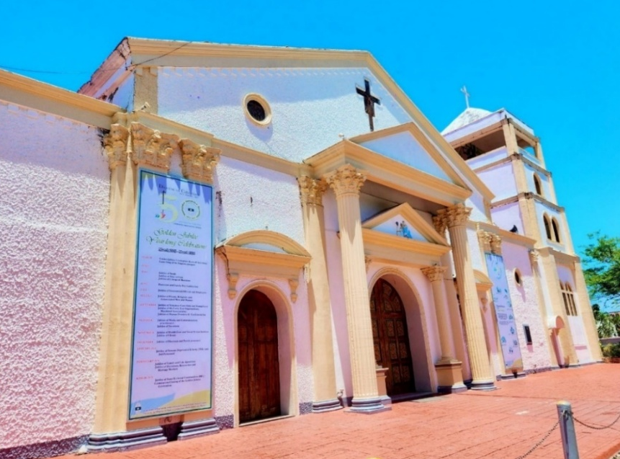

Plate 1
Our Lady of the Annunciation in Catarman, Northern Samar
Photo Source: Taken by the Researcher

Our Lady of the Annunciation Parish Church is more than just a church building, it is the heart of Catarman, Northern Samar carrying the marks and memories of more than 400 years of Catarmanon struggle. It has weathered countless hardships, both literal and figurative, such as the typhoon of 1851 which almost destroyed it, but it always stood back up, like its parishioners.

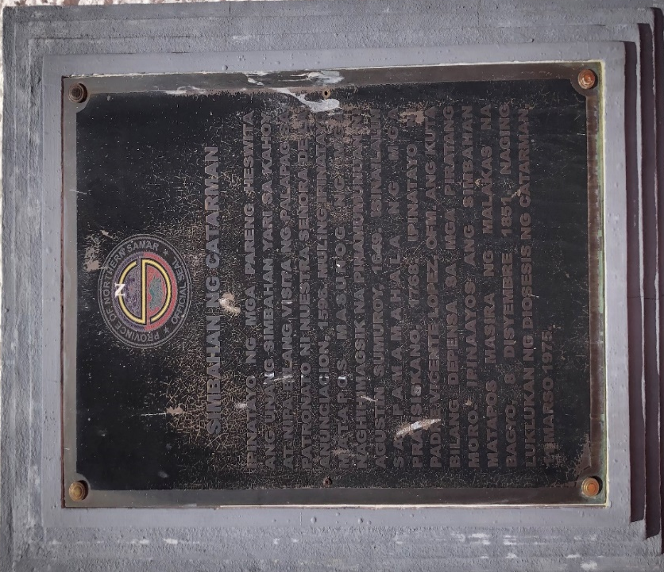

Plate 2
Historical marker for the "Simbahan ng Catarman
Photo Source: Taken by the Researcher

The “Simbahan ng Catarman” is a site of a historical endurance in Northern Samar. Its journey began in 1596 as a Jesuit mission made of wood and nipa, acting as a visita of Palapag, Northern Samar. Over the centuries, it became a focal point of colonial struggle; it was burned down in 1649 during the Agustin Sumuroy rebellion and later transformed into a stone kuta (fortress) by Franciscan Father Vicente Lopez to defend the town against Moro pirate raids.
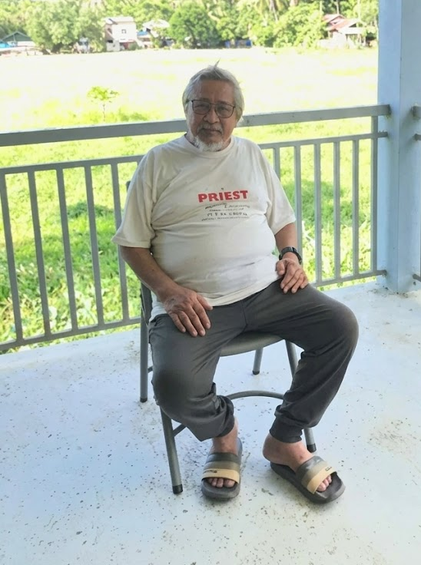

Plate 3
Key Informant Rev. Msgr. Gaspar D. Balerite, H.P., S.Th.D.
Photo Source: Taken by the Researcher
Based on the interview conducted with Rev. Msgr. Gaspar D. Balerite, the researcher, gathered the historical root of the Our Lady of the Annunciation Parish in Catarman, Northern Samar. Msgr. Balerite, a distinguished theologian and the retired Vicar General of the Diocese of Catarman, framed the parish's evolution within the broader context of Spanish colonial geography and ecclesiastical transitions.
According to Msgr. Balerite, Catarman’s current status as a provincial capital belies its humble beginnings as an insignificant area within the vast Provincia de Ibabao. The researcher learned that the Jesuit missionaries began planting the seeds of faith in the region around 1649. For a significant period, the parish lacked a resident priest and functioned merely as an outpost or visita. The historical evidence cited by Msgr. Balerite indicates that as early as 1697, Fr. Raymundus Claramont would travel from Bobon to provide spiritual services to the local population.
A pivotal shift occurred in 1768 when King Charles III expelled the Jesuits from Spanish territories. The researcher noted that Fr. Joseph Bremont was the last Jesuit to serve in Catarman, Northern Samar before the Franciscans took over administration. This era was characterized by extreme instability and danger due to frequent Moro raids.
Msgr. Balerite metioned the courage of Fr. Vicente Lopez, who served as both a spiritual leader and a military defender of Our Lady of the Annunciation in Catarman, Northern Samar. Following the kidnapping of his predecessor by raiders, Fr. Lopez learned to use firearms and supervised the construction of defensive forts. Beyond human conflict, the parish faced natural disasters; a devastating typhoon in December 1851 destroyed half the municipality and the church structure. It was not until 1890 that the church was fully rebuilt, with a newer structure completed around 1895, marking the end of the Spanish era.
The 20th century saw a steady rise in the parish’s importance. The researcher documented two landmark dates in this progression. On January 1, 1968 Catarman, Northern Samar was declared the capital of Northern Samar, and on March 11, 1975 The Diocese of Catarman, Northern Samar was canonically erected, elevating the Parish of Our Lady of the Annunciation to the See (Cathedral) of the diocese.
Regarding the parish’s cultural life, Msgr. Balerite emphasized that the fervor of the annual fiesta remains unchanged. The celebration follows a traditional nine-day novena followed by the feast day mass. Interestingly, the researcher inquired why the feast is celebrated on August 29th rather than the liturgical Solemnity of the Annunciation on March 25th. Msgr. Balerite explained that the date was strategically chosen to ensure a sequential "fiesta system" among the municipalities of Northern Samar (e.g., Bobon on the 10th, Palapag on the 15th, and Lavezares on the 22nd).
While there are no canonized miracles in the formal sense, Msgr. Balerite posited that the church’s very survival is a tale of divine intervention. He suggested that the church’s endurance through centuries of raids and the miraculous way it remained a focal point after the 1851 typhoon serves as a testament to the devotion of its clergy and people.
The researcher noted Msgr. Balerite’s commitment to preserving this history for future generations. Despite his retirement in January 2026, he continues to write and update catechisms and historical texts, often providing them at a nominal cost or for free. His goal is to ensure that the three-century legacy of the Our Lady of the Annunciation Parish remains a living foundation for the youth of Northern Samar.
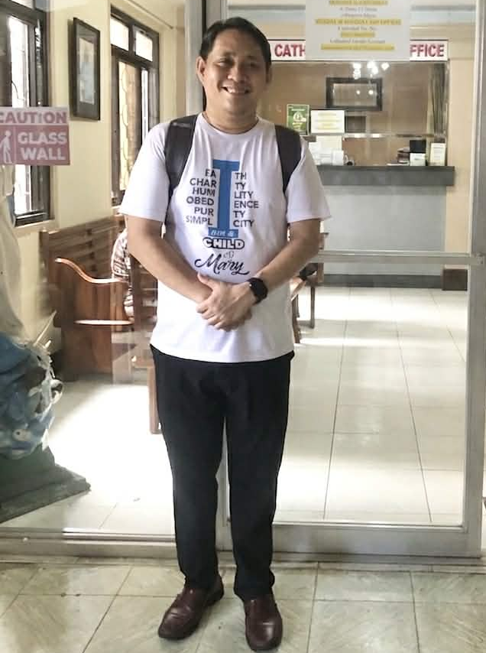

Plate 4
Key Informant Rev. Father Julius Agustus R. Balanquit
Photo Source: Taken by the Researcher
Through an interview with Rev. Fr. Julius Augustus R. Balanquit, the researcher uncovered a narrative where cultural heritage and spiritual devotion are inextricably linked, beginning with the Jesuit mission at Lumbang in 1596. Fr. Balangquit framed the parish’s history as one of profound resilience, recounting how the original structure was lost to the Sumuroy Rebellion of 1649 and how the church later evolved into a fortress against Moro piracy, where the bells functioned as a vital cultural tool for communal survival.
According to Fr. Balanquit the annual celebration of Our Lady of Annunciation in Catarman, Northern Samar is celebrated every August 29. It combines solemn Roman Catholic traditions with lively cultural practices to encourage the community to be one, share identity, and spiritual reflection. The celebration starts with Nine-days of novena masses. The Nine-day novena mass or Siyam na-aldaw in waray, all of the devotees of Our Lady of the Annunciation would pray the Holy Rosary, the specific Novena to Our Lady of the Annunciation, asking for her intercession and guidance. Each day has a sponsored from the different local organizations, barangays, and institutions, local schools and community it is their faith and service.
The parish priest will share reflections about the Blessed Mother, particularly her fiat or her "yes" to God's will, that inspired the community. The novena mass include in the events is the living rosary, flower offerings to Our Lady of the Annunciation, and the community processions together with the devotees. Fr. Balangquit illustrated how the devotion remains a living legacy, sustained by intentional outreach to the youth to ensure that the ancient veneration of Our Lady of the Annunciation continues to flourish amidst modern distractions.

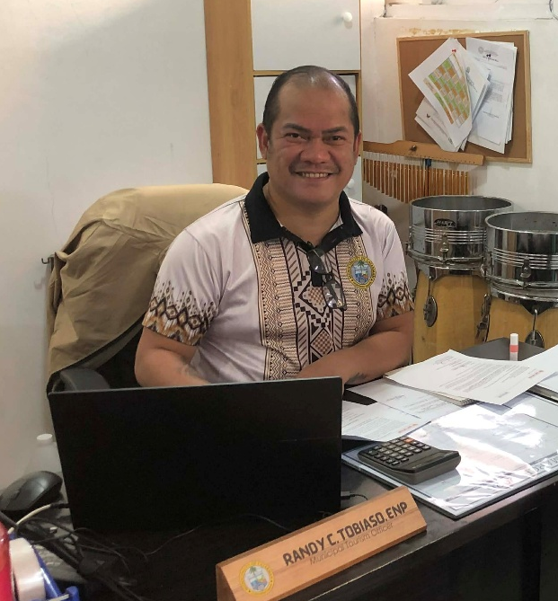

Plate 5
Key Informant Mr. Randy C. Tobiaso, ENP
Municipality Tourism Officer
Photo Source: Taken by the Researcher
Mr. Randy C. Tabiaso, the Municipal Tourism Officer of Catarman, the historical roots of Our Lady of the Annunciation, Catarman Northern Samar is one of reclaiming identity through a blend of oral tradition and ecclesiastical records. As an Environmental Planner with a background in provincial administration, Mr. Tabiaso highlights the unique challenges faced by a municipality whose official founding documents remain scarce.
For a long time, Catarman, Northern Samar lacked a definitive founding date in the civil registry. Mr. Tabiaso notes that because official records transitioning the town from a visita, small settlement with a chapel to a full municipality are rare, the local government historically relied on oral history. To address this gap, a data collection initiative was launched last year to formalize the town’s historical narrative.
The establishment of Catarman’s official Founding Anniversary on October 17 was a strategic legislative move initiated by Mr. Tabiaso’s predecessor. The logic behind this date is rooted in the "Pueblo-Parroquia" system of the Spanish colonial era. He said that according to historian Rev. Msgr. Gaspar Balerite, a town and its church were traditionally founded as a single entity. Church records cite the founding of the parish on October 18. By decree, the town’s foundation is celebrated on the preceding day, October 17. Mr. Tabiaso views the new founding anniversary as a secular anchor that balances Catarman Northern Samar primary religious celebration, the Feast of Our Lady of the Annunciation.
Mr. Tabiaso added that aside from the fiesta the celebration of Our Lady of the Annunciation, Catarman, Norther Samar also celebrating the Tarum festival it is story of an old man sharpening his “sundang” or bolo, when a group of foreign travelers asked a question he didn’t understand. Thinking they were asking about his blade, he replied “Kataruman”, he said the sharpness of his bolo. From that simple exchange, a name emerged, Catarman. But Tarum is more than just a word, it is became the town’s identity. It stands for sharpness, not because of the blades, but of mind, spirit, and heart. It reflects the strength of their ancestors, the grace of their culture, and the courage they carry in their hearts.
During the Festival Tarum Dance night, Catarman, Northern Samar shared a very colorful and variant celebration, and a story of Catarman, Northern Samar. A story of a humble family, a mother and father who found hope and purpose in weaving beauty from tikog grass. With calloused hands and unwavering faith, they craft mats and bags, building a life in the quiet corners of Catarman. But their hearts ached for their young son, born without sight. While the child dreamt of helping his parents, they dreamt of giving him the gift of vision.
With each weave, each knot, they prayed. They worked. And with every thread of grass, they held on to hope. Their prayers reached the heavens, and through the grace of Ginangam nga Inang Kalipay, Our Lady of the Annunciation, their son’s eyes opened. What once was darkness become light. What once was hardship become triumph. Their simple craft became a thriving livelihood, reaching not just other towns, but the world beyond. This is the purpose of the Tarum Dance Festival. It is a tribute to their roots, resilience, and radiant future. A celebration of family, faith, and fierce pride that defines every Catarmananon in Catarman, Northern Samar.
To ensure cultural traditions that will survive in time in a modern world, he proposes a modernization of local storytelling like making and produce more materials tp preserved the history example of these is the coffee table magazines, brochures and digital documentaries, Mr. Tabiaso also metioned that the youth now a days are often disconnected because of the gadgets. They urges that a joint effort between the Church and the Local Government Unit (LGU) for the preservation of the cultural and history of the church and Catarman, Northern Samar.
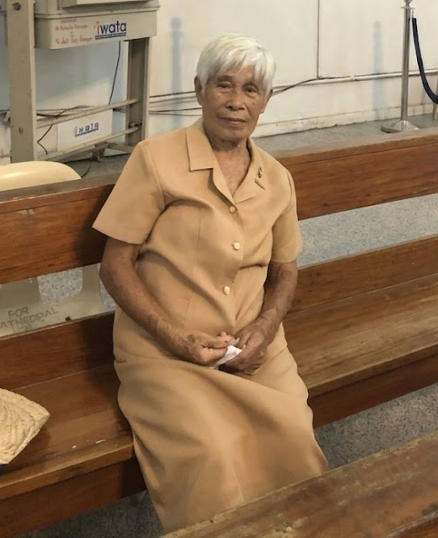

Plate 6
Key Informant Ms. Lea
Mother Butler in Our Lady of the Annunciation
Photo Source: Taken by the Researcher
Ms. Lea has served as the Mother Butler of the Our Lady of the Annunciation Parish for twenty-six years, a tenure that reflects her profound devotion to the Blessed Mother. During an interview, she recounted the early days of the parish, noting that the original structure was a much smaller concrete building that constituted only a fraction of the current edifice. Her journey began in 1981 under the guidance of Msgr. Victorio Galit, where she gained a foundational understanding of the church's history through regular catechism classes knowledge she now diligently passes down to her children and grandchildren.
Regarding the parish festivities, Ms. Lea observed that while time has passed, the core rituals of the fiesta in Catarman, Northern Samar remain unchanged, centered primarily around a nine-day novena to Our Lady of the Annunciation. As a dedicated Mother Butler, she remains a constant presence at both Masses and celebrations, viewing the fiesta as a vital time for family reunions. In the day of the celebration of Our Lady of the Annunciation in Augusr 29, is the Pontifical Feast Mass it is traditionally led by the Bishop of the Diocese of Catarman, Northern Samar alongside all of the priests from the local parishes in Northern Samar. She describe that the mass will begin with a grand entrance of the bishop and priest, the cathedral’s bells ring continuously while a long, formal procession moves up the center aisle, the altar servers bearing a crucifix and incense, followed by dozens of visiting priests from different local parishes in Northern Samar, and finally the Bishop wearing his full liturgical vestments, including the mitre the bishop's hat and holding his crozier the pastoral staff.
Ms. Lea her expressed concern for the future, noting a disconnect with the younger generation whose attention is often captured by mobile devices even during sacred services. To ensure that both the faith and the history of the parish endure, she continues her tireless service, hoping to preserve the real spirit of the Mass for those who follow.

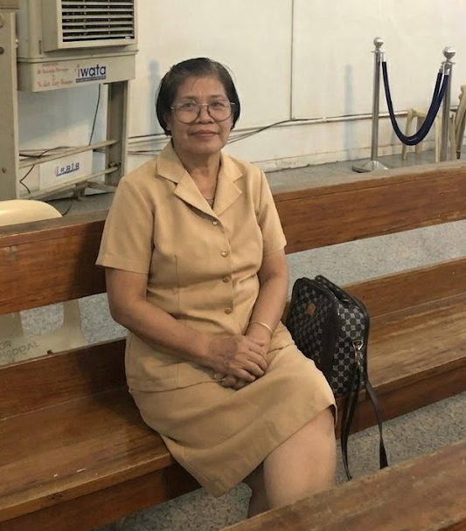

Plate 6
Key Informant Ms. Zenaida
Devotee/Mother Butler in Our Lady of the Annunciation
Photo Source: Taken by the Researcher
Ms. Zenaida, who has officially served as a Mother Butler at the Parish of Our Lady of the Annunciation for five years, though her active participation in church festivities spans a much longer period. Driven by a desire to share her devotion to Our Lady of the Annunciation and find fellowship with friends, she described the parish as her ultimate comfort zone, where the act of prayer serves as an immediate emotional and spiritual release.
Her reverence for the church is deeply informed by the oral histories shared by parish elders. However, she expressed concern over a growing modernization gap, noting that the younger generation appears increasingly distant from their faith, often distracted by mobile phones even during the celebration of the Mass. Despite these contemporary challenges, Ms. Zenaida maintains a hopeful outlook, believing that the church can bridge this generational divide by organizing specialized activities that re-engage the youth and invite them back into the heart of the community.
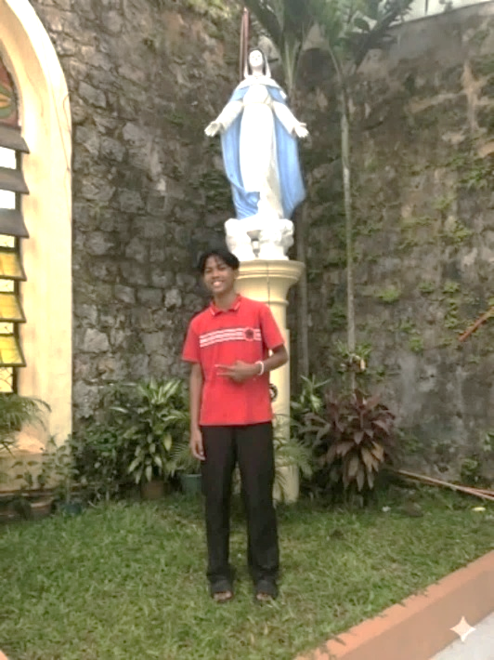

Plate 6
Key Informant Fritz A. Batino
Altar Server in Our Lady of the Annunciation
Photo Source: Taken by the Researcher
Fritz has served as a dedicated altar server at Our Lady of the Annunciation Parish in Catarman, Northern Samar, for four years, a journey that began through the invitation of his cousin. While his service is deeply rooted in faith, he admits that his knowledge of the parish’s formal history is limited to oral accounts from parishioners and information displayed on local tarpaulins.
From these stories, he understands that the church was originally established by Franciscan missionaries and began as a humble structure made of wood and nipa, much like a traditional kubo. Over time, the parish was elevated to a Cathedral, with Most Rev. Angel T. Hobayan serving as its first bishop; a man so revered that he was buried within the church walls following his passing. For Fritz and his family, the devotion to Our Lady of the Annunciation is a central part of their identity. He faithfully participates in the nine-day novena masses, while his family upholds the Filipino tradition of hospitality by preparing meals to welcome relatives who travel from afar for the fiesta.
He also join the penitential walks, reflecting on the Passion of Christ along the main roads. Together with his fellow altar server, family and friends they also participated the the Good Friday procession ,a life-sized religious statues or pasos representing the Christ's passion with the satatue of Our Lady of the Annunciation are pulled or carried through the darkened streets, accompanied by a sea of devotees holding candles.
Fritz believes that a lack of interest among the younger generation poses a significant threat to these traditions. Consequently, he hopes for more organized activities and historical orientations in the future, as he is eager to deepen his own understanding of the Cathedral’s legacy and ensure its history is passed on correctly.

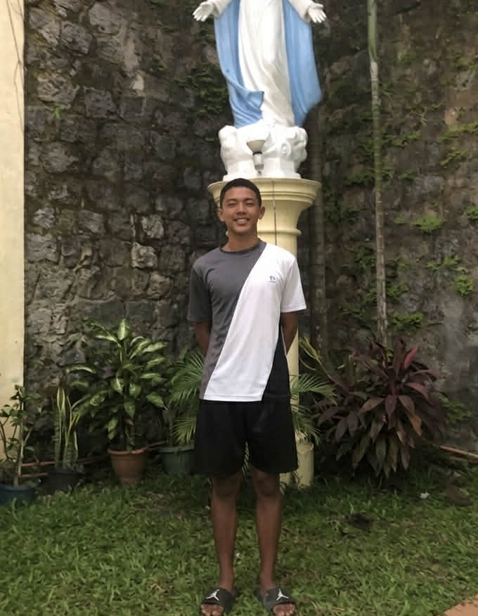

Plate 6
Key Informant Napoleon Trex P. Fuentes
Altar Server in Our Lady of the Annunciation
Photo Source: Taken by the Researcher
Trex, a resident of Allen, Northern Samar, who relocated to Catarman, Northern Samar has dedicated five years of service as an altar server at Our Lady of the Annunciation Parish. While he admits that some details of the church's history have faded from his memory over time, he clearly recalls that the original structure was built from humble wood and nipa before being destroyed by a powerful storm. He credits the resilience of the Franciscan priests for the eventual rebuilding and strengthening of the church, ensuring it became the well-protected landmark it is today. As a highly regarded member of the parish community, Trex remains deeply committed to his spiritual duties, actively participating in the nine-day novena masses, pilgrimages, the veneration of sacred images, and the traditional procession of saints.
Reflecting on the modern challenges facing the parish, Trex identifies the pervasive use of digital gadgets among the youth as a primary reason why local history and religious traditions are losing their significance. He observes that technology often distracts the younger generation from engaging with their cultural heritage. Despite this concern, he remains optimistic about the preservation of these customs. Trex points to the successful initiatives of the Diocesan Heritage Team as a model for the future; he believes that by strategically placing historical information and educational displays outside the parish building, the church can effectively bridge the gap between past and present, ensuring its legacy remains visible and relevant to all.
Religious Cultural Practices Associated in the Celebration of Our Lady of Annunciation.
Rev. Father Julius Agustus R. Balanquit said the annual celebration of Our Lady of Annunciation in Catarman, Northern Samar is celebrated every August 29. It combines solemn Roman Catholic traditions with lively cultural practices to encourage the community to be one, share identity, and spiritual reflection. The celebration starts with Nine-days of novena masses. The Nine-day novena mass or Siyam na-aldaw in waray, all of the devotees of Our Lady of the Annunciation would pray the Holy Rosary, the specific Novena to Our Lady of the Annunciation, asking for her intercession and guidance. Each day has a sponsored from the different local organizations, barangays, and institutions, local schools and community it is their faith and service. The parish priest will share reflections about the Blessed Mother, particularly her fiat or her "yes" to God's will, that inspired the community. The novena mass include in the events is the living rosary, flower offerings to Our Lady of the Annunciation, and the community processions together with the devotees.
According to Mr. Randy C. Tobiaso, Municipality Tourism Officer on the Vesperas in August 28, a day before the Our Lady of the Annunciation town fiesta, they held a lively and colorful civic grand parade with Local Government Units, Pulisya ng Catarman and every school band in Catarman Northern Samar form elementary to college level is participating, and after the parade is the competition for the exhibition in every participating school. The Vesperas is one of the busiest days before the fiesta.
On the evening of Vesperas the mass is often presided over by the Bishop of the Diocese of Catarman along with visiting clergy from the other region. After the mass a solemn procession of the Our Lady of the Annunciation image will be conducted together with the devotees and church servants, accompanied by the community, they will walk alongside the carozza carrying the image of Our Lady of the Annunciation with candles while they are reciting the rosary, and singing hymns of praise to Our Lady of the Annunciation.
After the solemn procession, there are lot of traditional activities that Catarmanon is busy with,like Community Social Nights that Catarmanon will enjoy themselves dancing with their friends and family, the other one is coronation balls of Mr. King and Ms. Queen of Catarman, Northern Samar which is organized by the Local Government Units with the special participations of the Mayor of Catarman, Northern Samar.
And the main event of the Vesperas evening is the The Kuratsa Dance, Catarman, Northern Samar fiesta is not complete without the traditional Kuratsa dance. In the article of Hernani, Province of Eastern Samar the ultimate expression of the Catarmanon joy, community bond, and the cultural pride is Kuratsa dance it is a performance of flirtation, pursuing, and storytelling of a man and a woman with the distinct phases, first is the: The Approach, it is a dance begins with a man and a woman going to the floor as the traditional string band Tugtog san Kuratsa with Kuratsa Mayor the major key and Kuratsa Menor the minor key. They will dance gracefully toward each other, acknowledging their partner with respectful bows.
Second is The Courtship, the man begins to actively pursue the woman, attempting to win her attention and affection, the man will dance around her with expressive, energetic steps. The woman playfully evades him, using her skirt or a handkerchief to tease, retreat, and coquet, keeping him at a distance while maintaining eye contact. And the last is The Match the music is very a lively, joyful crescendo, the woman will finally accept the man. The man and woman will be dance synchronize. The evening end with the free drinks for all the Catarmanon enjoying the company of the friends and families.
On the day of the Fiesta of Our Lady of the Annunciation, Mother Butler Ms. Lea a key informants mentioned in the interview of the researcher that in the morning is the Pontifical Feast Mass it is traditionally led by the Bishop of the Diocese of Catarman, Northern Samar alongside all of the priests from the local parishes in Northern Samar. The mass will begin with a grand entrance of the Bishop and priest, the cathedral’s bells ring continuously while a long, formal procession moves up the center aisle, the altar servers bearing a crucifix and incense, followed by dozens of visiting priests from different local parishes in Northern Samar, and finally the Bishop wearing his full liturgical vestments, including the mitre the bishop's hat and holding his crozier the pastoral staff.
The cathedral choir will sing powerful, triumphant Waray-Waray liturgical entrance hymns. Because of the solemnity of the feast day, incense will used throughout the mass. The Bishop incenses the altar and the beautifully decorated statue of Our Lady of the Annunciation, which is mostly displayed near the sanctuary, surrounded by massive arrangements of a colorful flowers. The sermon is about the local history with faith. The Bishop speaks also talk about the Virgin Mary, reflects on the historical events of Our Lady of the Annunciation in Catarman, Northern Samar, who survived historical raids, fires, and destructive typhoons and the challenges of the community to live out unity, charity, and gratitude.The Holy the Pontifical Feast Mass is attended by the devotees of Our Lady of the Annunciation together with their families. It also serves as a meaningful way to reunite family members who have been separated by time or distance.
After the Pontifical Feast Mass traditionally the Catarmanon prepares some foods for the salo-salo to welcome thier relatives, friends from the other places in Northern Samar, they also prepare a small altar of Our Lady of the Annunciation and place it in the entrance of the house. The Catarmanon also prepare their houses by hanging new window curtains, cleaning the surroundings, and painting some walls. For the Catarmanon, this is the only time of the year they open their house to the public to celebrate the feast of Our Lady of the Annunciation, which is why they prepare for it with such deep devotion
Aside from the Feast of Our Lady of the Annunciation, the parish also have religious cultural practices during the Holy Week or Semana Santa, the Panaet or Station of the Cross, many Catarmanon participating in the traditional station of the cross, especially the younger generations,one of the key informants Fritz mentioned that they join the penitential walks, reflecting on the Passion of Christ along the main roads. Together with his fellow altar server, family and friends they also participated the the Good Friday procession ,a life-sized religious statues or pasos representing the Christ's passion with the statue of Our Lady of the Annunciation are pulled or carried through the darkened streets, accompanied by a sea of devotees holding candles.
The Our Lady of the Annunciation Parish in Catarman Northern Samar also celebrating variant of Festival one of them is the Tarum Festival, tarum festival is a colorful cultural celebration held annually in Catarman, Northern Samar, every late January it is to honor Señor Sto. Niño de Catarman, Northern Samar. The festival has grand street dances, tribal competitions came from the local barangays of Norther Samar, and theatrical performances of town's history, faith, and resilient.
According to Municipality tourism officer Mr. Tabiozo. Tarum, a word deeply-rooted in the soul of Catarman, Northern Samar it is a name born from a legend. A story says the old man sharpening his “sundang” or bolo, when a group of foreign travelers asked a question he didn’t understand. Thinking they were asking about his blade, he replied “Kataruman”, he said the sharpness of his bolo. From that simple exchange, a name emerged, Catarman. But Tarum is more than just a word, it is became the town’s identity. It stands for sharpness, not because of the blades, but of mind, spirit, and heart. It reflects the strength of their ancestors, the grace of their culture, and the courage they carry in their hearts.
During the Festival Tarum Dance night, Catarman, Northern Samar shared a very colorful and variant celebration, and a story of Catarman, Northern Samar. A story of a humble family, a mother and father who found hope and purpose in weaving beauty from tikog grass. With calloused hands and unwavering faith, they craft mats and bags, building a life in the quiet corners of Catarman. But their hearts ached for their young son, born without sight. While the child dreamt of helping his parents, they dreamt of giving him the gift of vision.
With each weave, each knot, they prayed. They worked. And with every thread of grass, they held on to hope. Their prayers reached the heavens, and through the grace of Ginangam nga Inang Kalipay, Our Lady of the Annunciation, their son’s eyes opened. What once was darkness become light. What once was hardship become triumph. Their simple craft became a thriving livelihood, reaching not just other towns, but the world beyond. This is the purpose of the Tarum Dance Festival. It is a tribute to their roots, resilience, and radiant future. A celebration of family, faith, and fierce pride that defines every Catarmananon in Catarman, Northern Samar.
The other festival that Our Lady of the Annunciation Parish in Catarman Northern Samar celebrate is the The Ibabao Festival it is also called Northern Samar Foundation Day. The festival starts from mid of May to June 19, it is an annual and month-long celebration held of Catarman, Northern Samar it value the Northern Samar heritage and historical identity, as Samar Island was formerly known as Ibabao on June 19, 1965 before the province's was made. There are The Grand Float parade the participants are from the Municipalities of al over the Northern Samar they are showcasing a colorful floats that tells the story of each town, they are proudly showing off the food they grow, the life in their waters, and the culture they live by every day.
From the Provincial Municipality of Northern Samar they said that the highlights of the Tarum Festival is the Festival Dance Competition there are twelve (12) contingents from the different municipalities of Northern Samar, they will showcasing their town’s festival through lively music and dance. The twelve (12) festival tribes came from the municipalities of Catarman Northern Samar, Gamay Northern Samar, Silvino Lubos Northern Samar, Las Navas Northern Samar, Lapinig Northern Samar, Catubig Northern Samar, Lope de Vega Northern Samar, Laoang Northern Samar, San Roque, Bobon Northern Samar, San Jose Northern Samar and Pambujan Northern Samar, they will perform with passion and colors that reflect the heritage, culture and identity of Northern Samar.
More than a competition, the Ibabao Festival Dance also serves as a platform to promote cultural preservation and foster a sense of community and identity to Norther Samar. Behind the performances of every Municipalities, the panel of judges meticulously evaluated the participating tribes, led by the head of the dance committee of the National Commission for Culture and the Arts together with National Committee on Museums of NCCA. The winner of the competration will be given a trophy and a cash prizes, there’s also a consolation prize for the participating contestant.
.Documentary Material
” A Heritage of Grace: The Legacy of Our Lady of the Annunciation” is a documentary work presented in a style of a coffee table magazine. It serves as a visual and cultural tribute to the spiritual legacy of Our Lady of the Annunciation in Catarman, Northern Samar. By pairing evocative photography with scholarly historical roots, this keepsake archives the town’s religious identity from the meditative atmosphere of the novena to the vibrant celebration of the fiesta and festivals ensuring these cultural traditions remain a living legacy for future generations.

Notes
Balerite G. (1996) North of Samar Island 400 years of Christianization. Catarman, Our Lady of the Annunciation, page.31-33.
Diocesan Heritage Team (2023) Our Lady of the Annunciation Cathedral Parish, Catarman Northen Samar, Identifying, Salvaging, and inventory of church cultural heritage properties.
Diocese of Catarman Pastoral Secretariat Office (2025) Catarman Fiesta 2025 Journeying Together with Mary in the Spirit of Synodality. https://www.facebook.com/profile/100089121168805/search/?q=august%2029
Wkimedia common (2023) Our Lady of the Annunciation Catarman Cathedral, Osmeña Street, Catarman, Northern Samar. https://commons.wikimedia.org/wiki/File:Our_Lady_of_the_Annunciation_Catarman_Cathedral_(Osme%C3%B1a_Street,_Catarman,_Northern_Samar;_04-27-2023).jpg

Chapter 4
SUMMARY, FINDINGS, CONCLUSION, AND RECOMMENDATIONS
This chapter presents the summary of the research process, highlights key findings, draws insightful conclusion, and provides relevant recommendations based on the results of the study on From Visita to Fiesta: A Historical and Cultural Study of the Celebration of Our Lady of the Annunciation in Catarman, Northern Samar.
Summary
The this study was to document the historical roots and cultural practices of the devotion to Nuestra Señora de la Anunciación or Our Lady of the Annunciation in Catarman, Northern Samar, examining its role as a “Cultural Magnet” in constructing community identity and spiritual resilience. Utilizing a qualitative historical research design, this study gathered archival data and oral histories from key informants, including local religious historians, tourism officials, church servers, and longtime devotees to trace the town's transition from a humble 16th-century Jesuit mission outpost visita into a prominent, cathedral-centered provincial capital.
A historical data show that Catarman (originally Calatman or Catadman) was founded by Malay voyagers and was later a Jesuit mission station under Catubig in 1605. It was made a visita in 1612 under the Residencia de Palapag and had a missionary in common with Bobon until it received permanent missionary assignments. The town had its share of historical hardships. It suffered the Agustin Sumuroy Rebellion in 1649, lethal childhood epidemics in 1715-1716, destructive raids by Moro pirates and a calamitous typhoon on December 8, 1851 that wrecked half of the town and the church building. The Franciscans took over pastoral leadership after the global expulsion of the Jesuits in 1768, while actively reinforcing the stone church infrastructure and the local socioeconomic terrain. The 20th century was filled with great milestones, most especially the canonical erection of the Diocese of Catarman on March 11, 1975, which made the parish church a Cathedral See. On March 11, 2025, the parish celebrated its historic 50th Golden Founding Anniversary under the leadership of Apostolic Nuncio Archbishop Charles John Brown.
The study explores the rich traditions surrounding the feast day of August 29. This date was deliberately chosen to fit in with the sequential regional "fiesta system", apart from the liturgical Solemnity of the Our Lady of the Annunciation on March 25. The festivities include the Siyam na-aldaw or novena masses for nine days, a festive civic grand parade on the Vesperas (August 28), the performance of the traditional Kuratsa dance and the solemn Pontifical Feast Mass. The parish also celebrates bigger socio-cultural events such as the observances of Holy Week, the Panaet and Good Friday processions, the Tarum Festival in January in honor of Señor Sto. Niño, and the Ibabao Festival that is celebrated all over the province. To protect the historical roots and cultural practices from the ravages of fast-paced modernity and digital temptations among present-day youth, the study ended with the production of a high-caliber documentary-type material in the form of a coffee table magazine, A Heritage of Faith: The Legacy of Our Lady of the Annunciation.
The research is based on the following assumptions of the study: 1. The historical roots of Our Lady of the Annunciation in Catarman, Northern Samar are rich and diverse. 2. The religious cultural practices associated with the Celebration of Our Lady of the Annunciation are deeply culturally ingrained and 3. A meaningful documentary material can be made.
Findings
The following are the salient findings of the research:
- The study finds that the historical roots of Our Lady of the Annunciation in Catarman are rich and diverse. They come from pre-colonial Malay voyagers from Borneo and Makassar Island who established Calatman or Catadman along the natural sea route of the Pacific Ocean. These roots expanded with formal Christianization through early Jesuit missionary expeditions led by Father Miguel Gomez in 1597. This effort led to Catarman becoming a mission station under Catubig in 1605 and its placement under the Residencia de Palapag in 1612.
This diversity includes a long line of 20 Jesuit missionaries who served the shared visita with Bobon until King Charles III expelled them in 1768. After that, Fray Nicolas Antonio de Herrera took over the pastoral leadership, followed by a series of dedicated Franciscan friars who served until 1898. The historical timeline shows remarkable resilience. The devotion endured being burned during the Agustin Sumuroy Rebellion in 1649. It also survived a deadly childhood epidemic in 1715 to 1716, which was controlled through novenas to San Francisco Javier. Continuous Moro pirate raids were met by the strengthening of a stone kuta (fortress) under Father Vicente Lopez. Additionally, a terrible typhoon on December 8, 1851, destroyed half the town and the church building. This rich history led to the construction of a stone church around 1895. In 1900, the clergy became secular. Catarman was declared the capital of Northern Samar in 1968. The Diocese of Catarman was officially established on March 11, 1975. Finally, the 50th Golden Founding Anniversary will be celebrated on March 11, 2025.
- The liturgical Solemnity of Our Lady of the Annunciationin Catarman, Northern Samar on March 25, the main custom is the town fiesta, which is held annually on August 29. This date was carefully chosen by church leaers to create a sequential regional fiesta system in Northern Samar. The Siyam na-aldaw or Nine-day novena masses is the praying of the Holy Rosary, living rosaries, flower offerings, and solemn community processions are examples of spiritual pillars that endure across generations and play a crucial role in establishing a common social identity and a connection to the community's ancestors.
The vibrant Vesperas civic grand parade on August 28, which includes neighborhood schools and the Pulisya ng Catarman, community social nights, and the commitment of longtime volunteers like the Mother Butlers who provide decades of service are examples of how this cultural ingrainedness extends to civic and communal cohesion. It is further expressed through Holy Week celebrations like the Panaet penitential walks and Good Friday candlelit processions, as well as the traditional Kuratsa dance, which is the pinnacle of group joy and pride and features distinct phases like The Approach, The Courtship, and The Match set to the music of the Tugtog san Kuratsa string band. These long-standing customs also include more widespread regional festivities, such as the Tarum Festival, which honors Señor Sto in late January. Niño depicts the province-wide Ibabao Festival dancing competitions and big float parades, as well as the local tale of honing the sundang (bolo) and the ancestral craft of tikog grass weaving.
- The key output of the study is the proposed development of a coffee table magazine titled: “A Heritage of Faith: The Legacy of Our Lady of the Annunciation”. This material will include the compiled life stories, photographs, and personal reflections, serving as an educational and commemorative resource.
Conclusion
In light of the foregoing findings, the following conclusion were drawn:
- The devotion to Our Lady of the Annunciation is the ultimate basic cornerstone of the Catarman Northern Samar civil, historical, and social history, as evidenced by the Catarman, Northern Samar faith community's historical change from a precarious 16th-century visita to a flourishing Cathedral Now. The town's rich and varied history, which includes pre-colonial Malay migrations, multiple Jesuit and Franciscan successions, and systemic survivals through wartime uprisings, childhood diseases, pirate raids, and devastating typhoons, demonstrates how the local faith and its church structure have remained an unwavering source of resilience for the Catarmanon people over centuries of change.
- The serves as a primary "Cultural Magnet" that is deeply rooted in the local consciousness, as demonstrated by the regularity of the Siyam na-aldaw novena masses, the Vesperas grand parade, the traditional Kuratsa dance, Holy Week processions, and regional festivals like the Tarum and Ibabao festivals. In addition to fostering strong social cohesiveness and guaranteeing that intangible cultural legacy continues to be a dynamic, unifying force in contemporary civic life rather than a static relic of the past, this dynamic ritual system successfully bridges the gap between secular municipal governance and spiritual devotion.
- The development of meaningful documentary materials, such as the proposed coffee table magazine, is a vital strategy for heritage preservation. By integrating aesthetic visual storytelling with formal historical research, the study concludes that such materials can effectively bridge the generational gap.
Recommendations
The light of the forementioned findings and conclusion, the researcher strongly recommends the following.
- For the Local Government Unit (LGU) and Tourism Office, It is recommended that the Municipal Government of Catarman, Northern Samar officially integrate the documented historical timeline into their local tourism and cultural maps. Recognizing the "Vesperas" and the architectural transition of the church as key cultural landmarks can help secure funding for continued structural preservation and heritage promotion.
- For the Education Sector (DepEd Northern Samar), Social Science and History teachers are encouraged to utilize the findings of this study specifically the pedagogical potential of oral histories to enrich localized curriculum content. The study provides a primary source for teaching students about Spanish colonial influence and the evolution of local faith-based traditions.
- For the Church and Religious Organizations, The Diocese and parish leadership should consider establishing a dedicated parish archive or a small heritage gallery. This space could house the historical narratives, archival records, and oral testimonies gathered in this study, providing a permanent physical location for residents and pilgrims to learn about the "Visita to Fiesta" journey.
- For Future Researchers future studies may expand on this research by conducting a comparative analysis of other visitas within Northern Samar. This would help determine if the architectural and social patterns found in Catarman, Northern Samar are consistent across the region or unique to the capital, further enriching the provincial historical narrative.

